**Wind Energy Potential in Bonny Island Coastal Area of Nigeria Using Weibull Method**

**Abstract**

*This study presents a detailed assessment of the wind energy potential of Bonny Island, Nigeria using the Weibull method. This study evaluated the wind energy potential of Bonny Island using 7-years historical wind data (2017–2023) and advanced modeling techniques, including Weibull distribution analysis. The findings highlight that the average wind speed on Bonny Island is 4.15 m/s, with a power density averaging 157.9 W/m² with a 50th percentile of 129 W/m². These metrics, though modest compared to global standards, provide a stable resource for energy generation, making Bonny Island a viable candidate for wind power development. Turbulence intensity was found to be moderate, with about 35% of the observed days falling within the range of 0.15 to 0.20, indicating relatively stable turbulence levels over time The statistical analysis of wind speed and power density revealed variability across seasons, with the rainy season demonstrating stronger wind regime and higher power density than the dry season*

**Keywords: Wind Power Density, Power Assessment, Weibull Probability Distribution Function.**

1. **INTRODUCTION**

Despite the abundance of energy sources in Nigeria, the country still suffers from shortage and erratic power supply. In view of these, there is need to harness the available renewable energy sources (hydro, solar, wind, tidal, ocean wind) to meet country’s energy requirement for a reliable power supply system to the populace (Muhammad *et al*. 2015).

According to PWC 2018 report, Nigeria current electricity demand is about 98 Gigawatts (GW), with about 13 GW of installed generating capacity, however actual power generation stand at 7 GW. In 2019, Nigeria struggled to sustain an average daily generation of 3.8 GW in the first half of the year.

The rising quest in Nigeria for cost effective and clean energy, has led in recent years to the assessment and mapping of suitable renewable energy resources within the country for energy farms. Among the energy sources, wind energy tops among the promising renewable options with extensive likelihood to meet Nigeria energy needs.

The concept of renewable sources electricity generation is becoming popular among nations as chief substitute solution to our energy crises. Therefore, the rising cost and environment issues associated with large scale electricity generation have prompted clean energy sources exploration.

In more developed countries like America and Europe, wind power generation is renowned as promising green energy source. Among the African nations, Egypt, Morrocco and Tunisia leads in wind energy deployment with installed base of 550 MW, 291 MW and 114 MW separately at the end of year 2011 (Ayodele *et al*. 2018). According to studies, Nigeria coast regions (Lagos, Delta, Ondo, Bayelsa, Rivers and Akwa-Ibom) shows significant potential of reliable wind energy resource year-round. However, these claims are not fully verified with empirical confirmatory field data and model tests using available wind turbine converter technology in the market to precisely assess attainable wind power output potential.

In Nigeria where power supply is epileptic and grossly inadequate, steady generation of electricity and supply is essential. Wind power generation detail assessment along the coastal region is required to bridge this energy gap (Akintoye *et al*. 2016. Due to the Bonny Island proximity to the Atlantic Ocean and its associated wind resource, Bonny Island holds competitive advantage aiding the development of wind energy farm. In view of these, an evaluation of Bonny Island's wind power potential becomes crucial to facilitate a transition towards a cleaner and more sustainable energy supply for the town.

The specific objectives of this study are to:

1. Collect and analyze wind data specific to Bonny Island.
2. Develop fundamental equations governing wind energy.
3. Utilize the Weibull method to model wind energy density distribution.

**Literature Review**

Wind is air in motion When the sun heat the earth, the heated warm air rises, while cooler air moves in to fill the void. The air has mass, and when it moves with a velocity, results in kinetic energy that can drive a wind turbine generator (Sami *et al* 2020).

An elementary wind turbine consists of a rotor blade, gearbox, generator, nacelle, power cables and the tower as the main components (Lebsir *et al.* 2015). Wind turbines are classified into vertical axis wind turbine (VAWT) and horizontal axis wind turbine (HAWT) based on the blade design (Bukala *et al*. 2015). It has been theoretically calculated that HAWT have a higher efficiency than similarly rated VAWT (Ko *et al*.2015; Bukala *et al*. 2015; Al-Hadhrami, 2014).

Many researchers had worked on renewable energy assessment such as wind, solar or hybrid cogeneration using related software like RETScreen and HOMER to assess wind energy viability within and outside Nigeria.

Devashish. *et al* (2016) presented a review of wind energy generations and the enabling technology. According to the study, wind energy generation account for 78% of world renewable energy production with a total of 422 GW of wind power mounted worldwide by the year 2015. The study projected installed world wind power to reach approximately 760 GW by 2020.

Feasibility studies of small wind farms usually rely on weather station measurements close to the proposed site in order to take account of the area topography and wind terrain. Such studies have been carried out in the past in many countries worldwide such as Iran (Mostafaeipour 2013) and Turkey (Bilir *et al*. 2015), Chuuk State remote island in Micronesia (Ko *et al*. 2015). Other studies such as those published by Bilir *et al*. (2015) and Ko *et al*. (2015) did not use actual site measurement nor included estimated cost of wind turbines; rather their focus was on to use the wind regime and small-scale turbines to generate power for residential home use. As such Bilir etbal (2015) inferred Turkish Ankara Incek region can boost at 30 meters hub height, a wind power density of 98 W/m2.

Hirmri *et al*., (2010) conducted a study of Algeria’s wind energy resource from 3 weather stations over a ten years period, to install energy conversion systems while Al-Hadhrami (2014), made analysis on small-scale wind turbines capacity factor adapted for off-grid application. Their results showed HAWT model is preferred turbine for small scale electricity generation,

DeMeij *et al*., (2016), evaluated Palestine state of Gaza and Hebron wind speed resource for determining annual energy production and wind power density. The study concluded Gaza wind resource is unsuitable for wind energy production while Hebron showed more promising location.

Ayodele *et al*. (2013), in a proposition to secure wind energy investment portfolio in Nigeria geopolitical zones, analyzed wind energy resource from 15 stations across the country using mean wind speed resource which is considered more accurate data over 14-years period. The authors used present value cost Method (PVC) method to compute the rated output power and capacity factor. From the results gotten, it was concluded the northern states showed more promising results than the southern states when integrated to the grid.

Satanakis (2019), did a comparative Wind Energy Analysis between RETScreen Energy Model and Virtual Farm Model (VFM) for Switzerland. The main drive of the study was to assess and compare the performance of two renewable energy models for energy production estimation by implementing them on six sites in Switzerland. Utilizing the Enercon E-101/3050 and an Enercon E-82/2000 wind turbines, annual energy production and capacity factors were calculated for each sites. The locations Le Moléson and Renan were best sites based on RETScreen results while Schützenhof and Ovronnaz were best sites based on VFM results.

A recent wind feasibility study in Mauritius by Dhunny *et al*. (2016) was also performed with the Weibull function and the results showed that the island has exploitable wind potential. Sliz-Szkliniarz *et al.* (2018) combined measured wind speeds and the Rayleigh distribution to predict the technical potential of a region in Poland and Siyal *et al*. (2018) suggest that Sweden has enough wind potential, using an approach based on GIS methods and Rayleigh distribution.

Another study in Southern Greece from Xydis *et al.* (2017) examined the expected annual energy production (referred as AEP) in ten different locations. Findings suggested speeds between 5.74 and 7.52 m/s and net AEP in the range of 13 to 18 GWh.

Adaramola *et al*. (2015) underscore that in Lagos, Nigeria a DeWind D7-1.5 MW with 70 m hub height can produce 3767.7 MWh/year at 4.93 m/s with a capacity factor of 28.7%.

Ali *et al*. (2017) examined the possibility of installing five different wind turbine models at three distinct sites in South Korea. The wind speeds were extracted with the Weibull distribution and graphical method of Gumble distribution. In the two sites the most feasible turbine was found to be a WinDS134/3000 (3 MW), which could potentially produce 6.37 GWh per year with a capacity factor of 24.3% in the first site and almost 10 GWh of electricity with capacity factor of 40% in the second. In the third site a HJWT 87/2000 (2 MW) machine performs best, with a hypothesized annual energy output of approximately 7 GWh with capacity factor of 40%.

Thi Thi Soe *et al.* (2017) studied wind power potential of Myanmar at 100 m height above ground level. The wind resource used for the study covered a period of 11-years (2005 – 2015). The result from the study indicated Myanmar wind power regime is suitable for large-scale and rural electrifications. The study identified promising wind energy sites in Yagon, Mandalay, Tanintharyi, Magway, Saagaing and Ayeyarwaddy regions. The peak wind power density computed from the study was 261 W/m2 with a projected wind power potential of 153 GW. The annual energy production was 4454.88 MWh/year at a capacity factor of 25 %.

Kasra *et al* (2014), studied the feasibility of wind energy electricity generation for Jarandagh –Iran using the Weibull distribution model. The study was done by analyzing wind resource data of the site for 2-years (2008 & 2009) at a height of 40 m and applying the extrapolated wind speed resource at 70m height on four different wind turbine models – Suzlon S66, Gamesa G80, HeWind HW77 and RE Power MM82. The results showed Jarandagh has great wind energy potential on 8-months annually with a power density ranged from 450.28 to 1661.62 W/m2 at 70m height. The RE Power MM82 had the highest annual energy production of 5705 MWh, while Suzlon S66 had the highest capacity factor yield of 0.676 and lowest unit cost of electricity production of 0.0357 $/kWh. This cost is lower than Iranian Government approved tariff for renewable energy purchase within the country, hence the feasibility of wind power generation is deemed feasible in Jarandagh.

Islam *et al.* (2017) analyzed the offshore wind of Bangladesh Saint Martin’s Island. They measured one year (2014 – 2015) wind speed data at 60 meters above ground level and analyzed it with some well-known statistical probability density functions namely, Normal distribution, Weibull distribution, Gamma distribution, and Rayleigh distribution. The best distribution technique among the four for the wind speed data of the offshore area of Bangladesh has been measured, and the Root Mean Square Error (RMSE) and Mean Bias Error (MBE) are the methods that have been employed throughout the study in order to select the best distribution function. The assessment reviewed the Weibull probability distribution as the most suitable while the Rayleigh distribution is the second most suitable method.

Shafiqur *et al.* (2019), assessed the wind power potential of Chennai, Erode and Coimbatore, Tamil Nadu, in India. Historical wind speed records of the three cities were collected over a 38-years period (1980-2017). The study revealed Chennai had the highest mean wind power density of 129 W/m2 followed by Coimbatore with wind power density of 97W/m2, while Erode had the lowest (76 W/m2). The paper concluded that Chennai is the most appropriate sites for wind power production out of the three studied sites.

Mustafa (2014) carried out ANN-based evaluation of wind power generation for the city of Kutahya, Turkey. Wind data was collected for the period July 2001 to June 2004 and evaluated. The data analyzed, indicated a maximum monthly average wind speed of 5.3 m/s in February, and a minimum wind speed of 3.9 m/s in September. Furthermore, the study evaluated the power generation capability of Kutahya by applying the Weibull and Rayleigh distribution methods on 17 different turbine models from four manufacturers. A comparative study of the selected turbines were also modelled using ANN approach to give the power generation capacity. The results of the ANN model indicate similarity but were more accurate than those of Weibull and Rayleigh models.

Agbakwuru and Akaawase (2017) carried out the assessment of wind energy potentials of selected Nigeria onshore and offshore locations. In the paper, wind potential of Bonga, Asabo, Bonny and Forcados in Nigeria were carried out. The approach used in the work was the Rayleigh and Weibull distribution techniques. The wind measurements were taken at 10m above sea level. Using the monthly mean speed data, the mean power densities and energy output were computed. The mean monthly wind speed at Bonga platform in 1980 averaged between 4.5 m/s to 9.7 m/s. Forcados readings taken in 1982 was between 1.2 m/s to 5.4 m/s. Bonny reading taken in 1980 ranged between 3.2 m/s to 5.4 m/s and that of Asabo platform in year 1982 was between 3.7 m/s to 7.1 m/s. Based on the collated wind speed regime, the wind energy potential of the locations were estimated. The analysis gave an annual wind power density (W/m2) of 199.2 for Bonga platform, 95.6 for Asabo platform, 45.1 for Bonny, and 46.5 for Forcados. The results revealed that mean wind speed and wind power output increased as one moves from onshore to offshore locations. As future work, the paper recommended development of free system and robust tool for predicting wind speed. The tool to combine current and relevant method into a software to predict wind speed, for every need.

Lawan *et al.* (2019) using MATLAB, studied the execution of a topographical Artificial Neural Network prediction model for assessing onshore wind power potential in Sibu and Sarawak. In the study, the daily wind speed data of Sibu for ten years period was analyzed. The assessment indicated a minimum daily mean speed of 2.8 m/s and a daily maximum mean of 21.0 m/s; while the wind monthly mean wind speeds were 1.9 - 3.0 m/s and 1.3 – 3.7 m/s respectively during the northwest and southwest monsoon periods. The annual mean wind speed observed from the study period was 4.5 m/s. The dormant wind direction identified from the study was south-south-west (SSW). A comparison between the monthly measured wind speed and the values gotten from ANN simulation for Sibu were made and they showed similar trends. The power and energy densities of Sibu was computed based on the wind speed data. At 10-40 m height, the values of the actual wind power density varied from 1.84 – 11.20 W/m2. The Weibull method was used to compute the wind power classification of Sibu and the values gotten were lower than 100 W/m2 with the lowest observed in December and peak in February-March. The results demonstrated the possibility of setting up small wind energy generation system for stand-alone or remote applications for Sibu.

In another review, Varlaan (2018) analyzed wind speed pattern of Bonny Island from data gotten from three weather stations between 2000 to 2006 and 2015 to 2017. The paper concluded that the dominant wind direction as observed was between SSW to WSW with clearly seasonal wind pattern. During the raining season, the SW winds are the strongest with monthly mean values close to 6 m/s, highest occurring in the period July to September. During the dry season (December- January), average wind speeds are lower, about 4 m/s. Squalls are wind event with a peak wind speed above a certain threshold. For Bonny weather station at 10-m elevation, this threshold is around 8.5 m/s. Squall winds are predominantly from directions between NNE and SE, almost opposite to the prevailing SW winds. Most squalls occurred in the 7-month period - February to June and in October-November. During the remaining 5 months, squalls hardly occurred in Bonny area.

Teimourian *et al* (2022), did a comparative analysis of eight Weibull methods for wind energy assessment using meteorological data from 14 provinces in Iran at 40m height. The methods include Energy Pattern Factor Method (EPF), Mean Standard Deviation Method (MSDM), Moment Iteration Method (MIM), Method of Moments (MOM), Empirical Method of Mabchour (EMM), Power Density Method (PDM), Maximum Likelihood Method (MLM) and Modified Maximum Likelihood Method (MMLM). The statistical tools performances were assessed in terms of various error indicating factors such as root mean squared error (RMSE), regression error (R2), chi-square (X2), and mean absolute error (MAE). While the analysis found most of the methods to have similar performances, it recommended the EMM as the most accurate estimation method for the region while the MOM and EPF can be used as alternatives.

Alanazi et al. (2023) investigated the most suitable Weibull methods for wind energy characterization and assessment of Saudi Arabia Qassim region using wind data resource from 2010 to 2015 at altitudes of 10m and 50m, collected from NASA database. The efficiency of the investigated Weibull parameter estimation methods: the graphical method (GM), standard deviation method (SDM), energy pattern factor method (EPF), moment method (MM), alternative maximum likelihood method (AMLM), and novel energy pattern factor method (NEPF) were compared based on the root mean square error (RMSE) and the relative wind power density error (RPDE). The results showed Qassim region has low wind power class of less than 100W/m2 and 200W/m2 at 10m and 50m hub heights respectively and the most suitable Weibull estimating method for the region as Moment Method (MM), with the lowest RPDE ratio of 0.2018%.

Seidu *et al* (2024), evaluated the wind energy potential of Auchi town in Nigeria using the Weibull distribution function and utilizing eleven years (2012 – 2023) wind resource data at height of 10m. The results gave an average wind speed and power density of 6.07 m/s and 153.64 W/m² for the town affirming the region has high potential of wind power for electricity generation use of the town.

1. **MATERIALS AND METHOD**

**Materials**

We analysed the long term wind regime dataset of Bonny Island from 2017 – 2023 using MATLAB.

**Study Area**

Bonny Island is an industrial town in Niger Delta region of Nigeria and situated about 40 km south-east of Port Harcourt in Rivers State, Nigeria (Akintoye *et al.* 2016). Geographically, it is located roughly 40 24’ North, 70 11’ East and South of the inter-tropical convergence zone (ITCZ). It is surrounded by the Atlantic Ocean on the southern part, Bodo on the North, Yellow Island on the West and Opobo on the East. Bonny Island is a Town and a Local Government Area in Rivers State, of southern Nigeria.

**Method**

**Wind Speed Measurements**

The daily historical wind data of Bonny Island was retrieved from NASA satellite-based weather station from Nigeria Meteorological Agency (NiMet) using Bonny Island coordinates (Latitude 4.4239 and Longitude 7.2437) at 50-m height. The wind speed information retrieved from the weather station for this study or work covers the period from January 2017 to December 2023 (7-years).

The captured energy by a wind farm turbine is directly related to the average speed of the wind.

According to Sami *et al.* (2020), wind turbine generated power is approximately given by equation 1

$P=\frac{1}{2}×C_{P}×ρAV^{3}$**(**1)

Where

$ρ$ = air density (1.225 kg/m3 at sea level)

$V$ = speed of wind (m/s)

A – area through which the wind passes (m2)

CP is the coefficient of power (turbine efficiency factor)

Past research on wind energy, has proven that wind shear declines with height, a phenomenon that causes wind speeds to increase with height (h) while taking cognizance of ground friction coefficient α (Crippa *et al*. 2021). At a specific hub height, wind speed can be obtained using the expression (Sasser *et al*., 2022):

$\frac{V}{V_{0}}={\left(\frac{h}{h_{0}}\right)}^{α}$

(2)

where v is wind speed at the designed hub height; v0 is wind speed at the in situ weather station height; α is the ground surface roughness coefficient; h0 is weather station height; and h is the turbine hub height.

The roughness coefficient of any surface is calculated using Equation 3 (Adaramola *et al*., 2014):

$α=0.37-\left[0.0881(ln⁡(h_{0})\right]$ (3)

**Weibull Distribution Function**

The variability of wind resources makes the prediction of wind energy quite complex and cumbersome. Most often, probability distribution functions and other known models have been used in published works and textbooks for the prediction of wind speed behavior with various accuracies (Shu *et al*., 2015). Nevertheless, the Weibull and Rayleigh probability distributions have been proven to provide more accurate curve fitting and classification of the variation of the mean wind speed of a location (Al-Mhairat and Al-Quraan, 2022; Sumair *et al*., 2022).

In view of this, this study employed the Weibull distribution technique to analyze, characterize, classify the wind resource of Bonny Island to achieve more detail and accurate results.

Equation 4 provides the formula for the Weibull probability distribution model (Jabbar, 2021)

$f\left(v\right)=\left(\frac{k}{c}\right){\left(\frac{v}{c}\right)}^{k-1}\exp\left[-{\left(\frac{v}{c}\right)}^{k}\right] (v>0;k>c, c>0$ (4)

Where,

f(v) is the probability of the observed wind speed v.

k and c (m/s) are the Weibull shape and scale parameters respectively.

The wind data mean speed (Vm) and variance (σ2 ) are computed using Eqs 5 and 6 (Usta, 2016):

$v_{m}=\left(\frac{1}{n}\right)\left[\sum_{i=1}^{n}{v_{ i}}\right]$ (5)

$σ^{2}=\left(\frac{1}{n-1}\right)\sum_{t-1}^{n}{{\left[v_{i}-v_{m}\right]}^{2}}$ (6)

Whereas, the Weibull parameters (k and c) are computed using Eq. 7 and 8, respectively (Usta, 2016):

$k={\left(\frac{σ}{V_{m}}\right)}^{-1.086}$*(1≤k≤10) (7)*

$c=\frac{V_{m}}{Γ\left(1+\frac{1}{k}\right)}$ (8)

An estimation of the gamma function is achieved using the expression on Eq. 9

$Г\left(k\right)=\int_{0}^{∞}{e^{-t}}t^{k-1}dt$ (9)

**Operating Probability of Wind Turbine**

When assessing the wind power potential, the two central speed parameters to consider are the turbine cut-in and cut-out wind speeds (Klerk & Venter, 2017). Cut-in speed defines the minimum wind speed required to generate usable power from the turbine. Typically, the cut-in speed for most available wind turbines is in the range of 3–5 m/s. The cutout speed is the rated wind speed at which the turbine controls system shut down the unit to prevent damage from wind turbulence. Wind turbine cut-out speed can be as high as 25 m/s (Mansi & Aydin, 2022). As such, wind speed spectral occurring within the region of “cut-in and cut-out” wind speeds are important for the precise evaluation of the operability and commercial feasibility of wind turbines in an area. Therefore, the distribution probability of a turbine is calculated deploying the cumulative Weibull distribution function, as shown in Eq. 10 (Ahmed, 2018):

$P\left(V_{1}<V<V_{2}\right)=\exp^{{\left(-\frac{V_{1}}{c}\right)}^{k}}-\exp^{{\left(-\frac{V_{2}}{C}\right)}^{k}}$ (10)

where V1 and V2 denote the turbine cut-in and cut-out wind speeds respectively.

Based on a plot of the wind profile Weibull distribution, the peak of the function graph represents the most probable wind speed, while the wind speed at which most energy is generated depicts the speed at which the most power is produced. The respective wind speeds depicted as most probable wind speed (Vmp) and speed carrying maximum energy (VmaxE) are calculated using Equations 11 and 12. For improved wind farm overall performance efficiency, a common recommendation is to have the rated wind speed as close as possible to the wind speed carrying maximum energy, since a wind turbine system produces maximum power output at its rated wind speed (Oyewole *et al*., 2019).

$V_{mp}=c{\left(1-\frac{1}{k}\right)}^{\frac{1}{k}}$**(**11)

$V_{\max{E}}=c{\left(1+\frac{2}{k}\right)}^{\frac{1}{k}}$**(**12)

**Wind Power Density**

The wind power density (WPD) of a wind profile is an indices that has been broadly accepted to establish the output capability of wind resources at a specific site (Li *et al*., 2022). The WPD from the Weibull distribution function is quantified using Eq. 13 (Sumair, 2021):

$WPD=\int_{0}^{∞}{\frac{1}{2}}{ρv}^{3}f\left(v\right)dv= \frac{1}{2}ρc^{3} Г\left(1+\frac{3}{k}\right)$ (13)

where ρ is the air density (kg/m3); c and k are the Weibull scale and shape factors declared hitherto.

**Wind Turbine Intensity**

Wind turbulence intensity (WTI) expresses the stress experienced by a wind turbine installed in a region and is computed by equation 14 (Okoth *et al*, 2023):

$WTI=\left(\frac{1}{n}\right)\left[\sum_{i=1}^{n}{\frac{\sqrt{{σ_{i}}^{2}}}{V}}\right]$ (14)

Where 𝜎, v and n represents standard deviation, mean wind speed and number of observations respectively.

1. **RESULTS AND DISCUSSION**

**Statistical Presentation and Discussion on the Wind Characteristics in Bonny**

The statistical analysis of the dataset is crucial for understanding the wind speed characteristics that influence wind energy generation potential at this location. Table 1 shows the averages, minimum and maximum wind speeds recorded for 2017 to 2023. Integrating wind speed data with renewable energy modelling is crucial for optimizing energy production, particularly in locations like Bonny Island. The processed data from this site indicates that the average wind speed is approximately 4.15 m/s, with measurements ranging from a minimum of 1.2 m/s to a maximum of 8.19 m/s. This consistency in wind speed is vital, as it directly influences the wind power density, which averages around 157.9 W/m² with a 50th percentile of 129 W/m². The wind power density data shows significant variability, with values fluctuating from 3 W/m² to 1009.43 W/m², marking regions with high potential for harnessing wind energy effectively. The climate in Bonny Island is characterized by an average temperature of 26.730C and relative humidity averaging 85.45%, creating a favourable environment for wind energy production. The region's wind conditions are further supported by the recorded average atmospheric pressure of 101.09 kPa, contributing to stable wind patterns.

Table 1 Summary of obtained wind data for Bonny from 2017 - 2023

|  |  |  |  |  |  |
| --- | --- | --- | --- | --- | --- |
| **Year** | Avg Wind Speed (m/s) | Max Wind Speed (m/s) | Min Wind Speed (m/s) | Avg Pressure (Pa) | Avg Temp (°C) |
| 2017 | 4.33 | 7.1 | 1.55 | 101.09 | 26.45 |
| 2018 | 4.16 | 7.32 | 2.13 | 101.10 | 26.64 |
| 2019 | 4.31 | 7.2 | 1.21 | 101.13 | 26.55 |
| 2020 | 4.13 | 7.22 | 1.44 | 101.10 | 26.92 |
| 2021 | 4.01 | 6.51 | 1.58 | 101.06 | 26.76 |
| 2022 | 4.05 | 7.77 | 1.89 | 101.07 | 26.77 |
| 2023 | 4.06 | 8.19 | 1.2 | 101.08 | 26.99 |

The results from the wind data table provide valuable insights for wind farm development in the specified region. Over the observed years from 2017 to 2023, the average wind speed fluctuated between 4.01 m/s and 4.33 m/s, indicating a relatively stable wind resource that can be harnessed for energy production. In 2017, the average wind speed was recorded at 4.33 m/s, with a maximum wind speed of 7.1 m/s and a minimum of 1.55 m/s. This pattern of variability in wind speeds is essential for assessing the reliability of wind energy generation. The highest average wind speed during the study period was also noted in 2017, suggesting favourable conditions for wind energy production that year. As we analyze the data further, it is notable that the average pressures remained consistently high, averaging around 101.08 kPa throughout the years. This stable pressure regime is conducive to maintaining consistent wind patterns, which benefits wind farm operations. The average temperature during this period varied slightly, ranging from 26.40C in 2017 to 26.90C in 2023, indicating a warm climate that may influence energy demand patterns.

The year 2020 showed the highest maximum wind speed recorded at 8.19 m/s, which, combined with an average speed of 4.13 m/s, signals a potential peak period for wind energy generation. Such peaks in wind speed can be leveraged for optimal energy production, particularly during peak demand times. Overall, the data reveals that while there are fluctuations in wind speeds year over year, the average wind speed remains within a range that is generally favourable for wind farm development. The consistent average pressure further enhances the viability of establishing wind energy projects in the region. Therefore, this information can guide developers in determining the best locations and technologies for wind energy harnessing, ensuring that they capitalize on periods of higher wind speeds while maintaining operational efficiency throughout varying conditions.

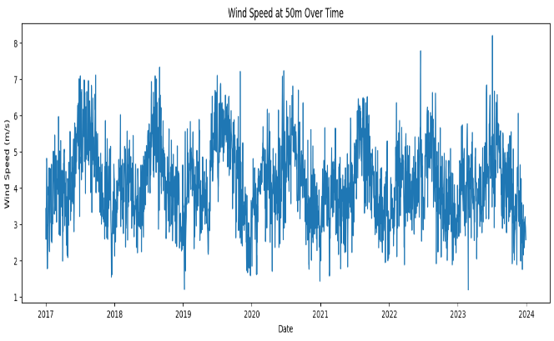

Figure 1 Wind speed values from 2017 to 2023

Figure 1 is a graphical plot of the wind speed variation at 50m height over a period from 2017 to 2023. The data displays consistent seasonal patterns with wind speeds generally ranging from approximately 1 m/s to over 8 m/s. Peaks in wind speed occur regularly, suggesting the influence of seasonal variations or meteorological factors such as monsoon patterns or frontal systems. The periodicity and reliability of these wind speed fluctuations indicate a potentially sustainable resource for wind energy production. The average wind speed fluctuated between 4.01 m/s and 4.33 m/s over the observed years, indicating a relatively stable wind resource.

While the fluctuations in wind speeds year over year are minimal, there are years that show significant variability in range. In 2022, for example, a range of 5.88 m/s is recorded. Although the average wind speed remains within a range that is generally favorable for wind farm development, there is a further need to ascertain consistent power delivery from prospective wind farms. Observable consistency in the average pressure further enhances the viability of establishing wind energy projects in the region. For development purposes, the location can be classified as a Class IV resource and therefore requires turbines designed for moderate wind speed applications (see appendix for wind classes).

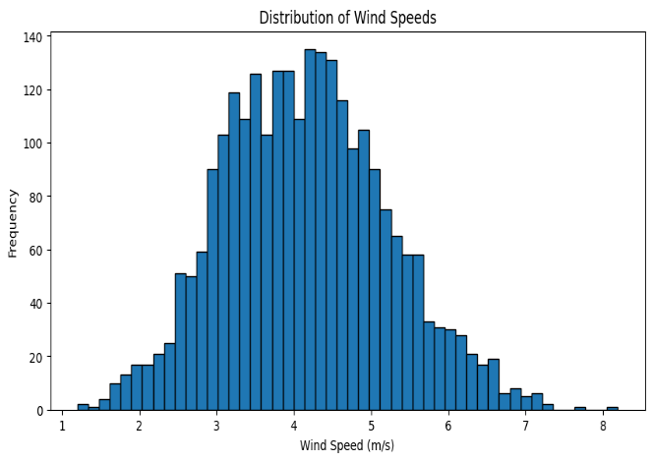

Figure 2 Distribution of Wind Speed in Site Data

Further analysis of the wind data shows a distribution with 4 - 5 m/s as the dominant peak speed about 65% of the time. Also, a skewed distribution to the right as indicated in Figure 2 Confirms the appearance of lower speeds than higher ones. The normal distribution curve seems to affirm the potential for energy production across a range of wind speeds, reducing the risk of low output during periods of low wind. The implied consistency in the wind may facilitate smoother integration into the power grid, reducing the need for additional energy storage or backup generation. However, due to the low speed, efficient storage must be employed to ensure the durability and serviceability of the farm

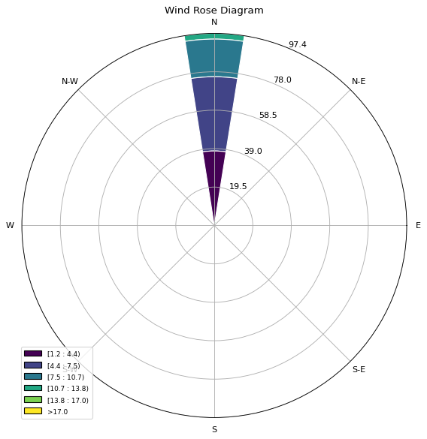

Figure 3 Cumulative Wind Rose diagram for the site from 2017 – 2023

The wind rose diagram in Figure 3 provides essential insights into the wind characteristics at the site, with prevailing winds primarily originating from the North (N). This is evident from the longest bar in the diagram, indicating that winds from the North occur most frequently. The wind speeds range from 1.2 m/s to over 8.2 m/s, with the majority concentrated in the lower ranges of 1.2–4.0 m/s, while higher wind speeds exceeding 6.8 m/s are less frequent. These observations suggest that wind turbines should be oriented toward the North to capture the maximum available wind energy.

**Discussion:** These results are comparable with those gotten by Agbakwuru and Akaawase (2017) and Varlaan (2018) for Bonny Island with average wind readings in the range 3.2 m/s to 5.4 m/s with dominant wind direction being South West.

Figure 4 is a bar chart depicting maximum wind speeds by season and year according to our data. It reveals significant year-to-year variation in both the dry and rainy seasons. The dry season consistently exhibits lower maximum wind speeds compared to the rainy season. This may be associated with the storms and heavy winds that occur during rainy days. Notably, 2020, 2022 and 2023 stand out as particularly windy years, with elevated maximum wind speeds observed during these seasons. Seasonality is a major contributing factor to all wind farm operational factors such as wind velocity, direction, pressure, and overall performance.

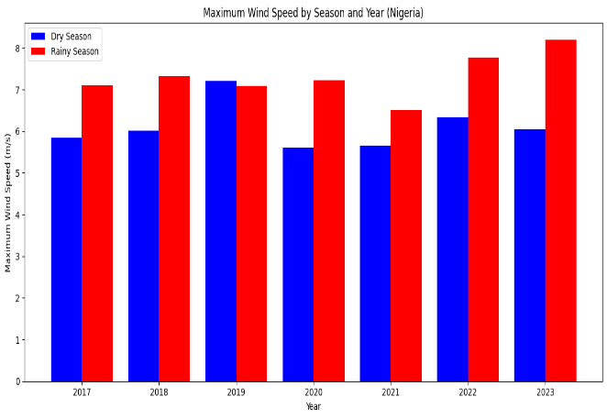

Figure 4 Wind speed distribution by season from 2017 – 2023

The consistent presence of high wind speeds, especially during the dry season, suggests a reliable wind resource for energy generation. This variability underscores the need for a diverse turbine selection, with a mix of turbine sizes optimized for both moderate and high wind speeds to maximize energy capture. Seasonal fluctuations in wind speeds, such as the pronounced differences between the dry and rainy seasons, could impact grid integration, necessitating energy storage systems or other grid-balancing mechanisms to ensure a stable power supply. Additionally, the higher wind speeds during the dry season could result in increased wear and tear on wind turbines, emphasizing the importance of regular maintenance and inspections to preserve turbine performance and longevity.

**The Weibull Method Results**

In Figure 5, we observe an unimodal Weibull distribution fit on the wind speed data. The Weibull fit, however, offers a mathematically smoothed approximation of this distribution, characterized by specific shape and scale parameters which lead to more reliable and consistent wind speeds and higher average winds for increased energy production and better wind turbine selection. These parameters enable the prediction of wind speed probabilities beyond the observed dataset, offering a reliable basis for design considerations.

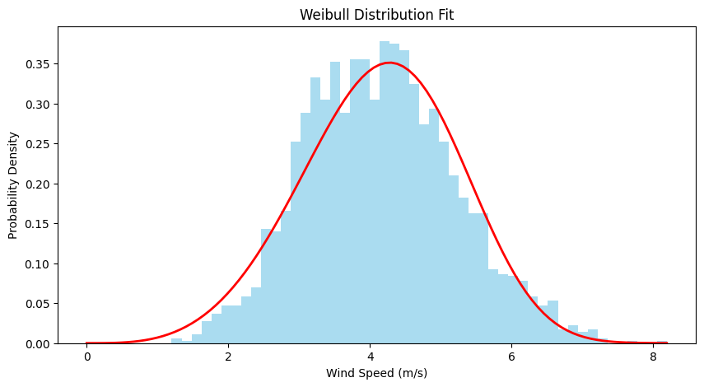

Figure 5 Weibull Distribution of wind speed and Probability Density

Through the Weibull fit curve (with shape parameter: 4.21 and scale parameter: 4.55), we establish a framework for designing systems that align with the probabilistic nature of wind speed occurrence. The recorded data informs the initial understanding of site-specific wind conditions, while the Weibull fit refines this insight into a predictive model. By this dual approach, we seek to develop a system design that leverages both the authenticity of recorded measurements, and the generalization offered by Weibull parameters, optimizing for energy capture and operational reliability in future conditions. For more practical purposes, we proceed to examine the turbulence intensity with the model data.

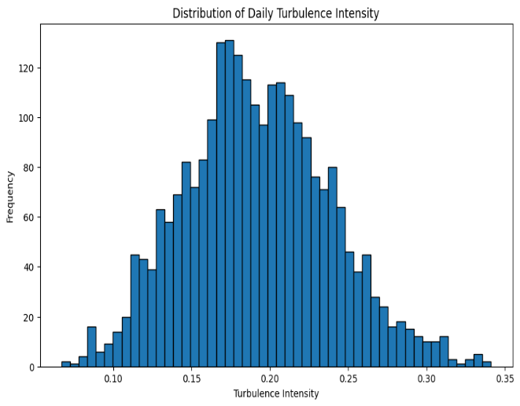

Figure 6 Turbulence intensity of the modelled data

The histogram in Figure 6 is that of daily turbulence intensity. It shows a clear unimodal distribution, with most values centered around 0.18. Approximately 35% of the observed days fall within the range of 0.15 to 0.20, indicating relatively stable turbulence levels over time. The peak frequency of around 120 days occurs at a turbulence intensity of approximately 0.18, suggesting that this range represents typical conditions for the site. The distribution extends from a minimum of approximately 0.05 to a maximum of 0.35, with a slight right skew. This skew indicates that while most days experience moderate turbulence, a small proportion of days are characterized by significantly higher turbulence levels.

The implications of this variability are critical for wind farm operations. Higher turbulence levels, especially those above 0.25, account for about 10% of the observations and pose potential challenges for turbine durability. Elevated turbulence intensity is known to increase dynamic loading on turbine components, resulting in faster wear and tear. For instance, wind turbine blades are particularly susceptible to fatigue under such conditions, which could lead to higher maintenance costs or reduced turbine lifespan. Conversely, days with turbulence below 0.10, which represent approximately 8% of the dataset, may correspond to calm conditions with lower energy capture efficiency.

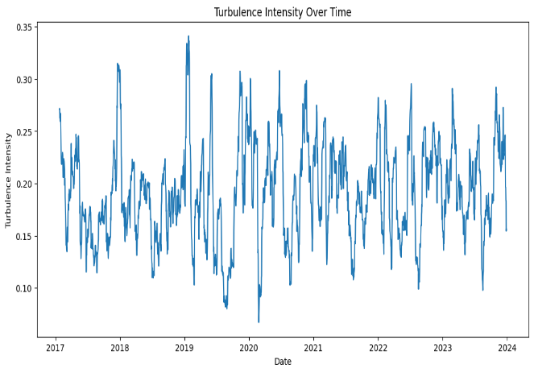

Figure 7 Analysis of Turbulence Intensity Over Time

The plot in Figure 7 depicting turbulence intensity over time from 2017 to 2023 shows significant fluctuations in the daily values of turbulence intensity. The values vary between approximately 0.10 and 0.35, with notable peaks and valleys. This variation reflects the inherent volatility of the wind resource over the years. It is clear that the turbulence intensity experiences episodic increases, often reaching above 0.30, and several periods of lower intensity, hovering closer to 0.10. These fluctuations could be indicative of seasonal patterns or extreme weather events influencing wind conditions. Understanding these temporal dynamics is essential for anticipating and mitigating the impacts of turbulence on turbine operation, particularly during periods of higher turbulence intensity that could result in greater fatigue on turbine components. Furthermore, the marked peaks in turbulence intensity suggest times when wind speeds are either highly variable or there are sudden gusts, which could affect the overall performance and power output of the wind turbines.

**Wind Power Density for Bonny Island**

The wind power density (WPD) of Bonny Island was computed based on the wind resource gathered from 2017 to 2023. The computed wind power density using Equation 13 plotted for each wind speed reading as shown in Figure 8 shows a fairly consistent pattern revealing seasonal impacts in possible power generation dynamics. With a high mean value of 157.9 W/m2, for the 2556 data points and a 129 W/­m2 at the 50th percentile, we are guaranteed useful power densities.

This confirms the wind energy potential of the region as documented by the International Renewable Energy Agency (IRENA) and the African Development Bank AfDB (Saavedra *et al* 2021).

A noteworthy characteristic of this data is that while the maximum WPD stands at 1009.43 W/m2, the recorded minimum is 3 W/m2 which signifies a complete absence of power production. This stark contrast between the maximum and minimum values underscores the critical need for effective energy storage solutions.

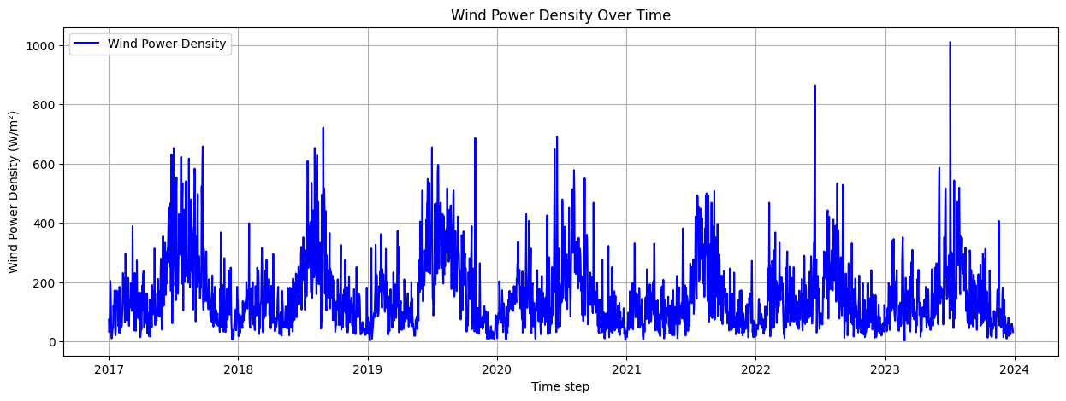

Figure 8 Wind Power Density at Bonny from 2017-2023

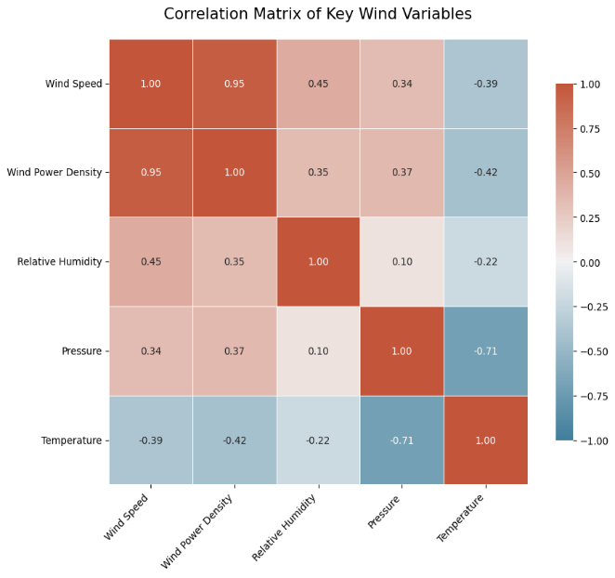

Figure 9 Correlation matrix for multiple parameters from the site

The correlation analysis of key wind parameters Figure 9 shows a coefficient of 0.951 between wind speed and wind power density indicating that as wind speed increases, the wind power density correspondingly rises. The relative humidity however has a moderately positive correlation of 0.449 with wind speed and 0.346 with wind power density. This suggests that higher humidity levels may be associated with increased wind speeds. Conversely, the analysis highlights a notable negative correlation between temperature and both wind speed (-0.390) and wind power density (-0.424). This inverse relationship indicates that as temperatures rise, wind speeds and, consequently, power densities may decline, which could impact energy generation capacity during warmer months. Additionally, the correlation between pressure and temperature of -0.710, while reflecting a typical atmospheric relationship, suggests that variations in pressure can significantly influence temperature and, indirectly, wind patterns. This correlation is relevant in monitoring possible operational parameters. Parameters such as wind speed, pressure and relative humidity would have a higher priority in both monitoring and possible control while parameters with less correlation to the power density may also be monitored but with less rigorous attention. This is to ensure efficient running, maintenance and management of the project.

**Discussion:** Contrary to the study results of Ohunakin *et al.* (2011) which considered northern Nigerian states of Katsina, Kano and Sokoto as more viable states for wind turbines installations, the wind power density from this thesis shows Bonny Island as a promising wind farm location.

1. **CONCLUSION**

This research has conducted a detailed assessment of the wind energy potential of Bonny Island, Nigeria for sustainable development using the Weibull method.

In the study, we evaluated the wind energy potential of Bonny Island using extensive historical data (2017–2023) and advanced modeling techniques, including Weibull distribution analysis.

The findings highlight that the average wind speed on Bonny Island is 4.15 m/s, with a power density averaging 157.9 W/m² with a 50th percentile of 129 W/m². These metrics, though modest compared to global standards, provide a stable resource for energy generation, making Bonny Island a viable candidate for wind power development. The statistical analysis of wind speed and power density revealed variability across seasons, with the rainy season demonstrating stronger wind conditions than the dry season. Turbulence intensity was found to be moderate, peaking at 0.35, posing some challenges for turbine durability but remaining manageable with proper design considerations.

Given the spatial constraints of fitting 150 turbines along the 1.5 km coastline (requiring 14.175 km²), it is recommended to either reduce the wind farm to 36 turbines (27 MW rated capacity, requiring 3.402 km²) or explore offshore wind installation to avoid nearshore land constraints. Offshore placement could leverage Bonny Island’s coastal location, though further feasibility studies on seabed conditions and costs are needed.

We suggest starting with a pilot project as proof of concept to validate the findings and refine the technology deployment before full-scale implementation.

By adapting the Weibull method for wind energy studies, the research could pave the way for more advanced and accurate models in wind energy assessments and detail analysis of Bonny Island wind energy potential, a region that have not been thoroughly studied before now. Understanding wind energy potential in this specific coastal area could help in tailoring energy solutions that are suitable for the region's unique conditions.

**Disclaimer (Artificial intelligence)**

Authors hereby declare that NO generative AI technologies such as Large Language Models (ChatGPT, COPILOT, etc.) and text-to-image generators have been used during the writing or editing of this manuscript.

**REFERENCES**

Adaramola, M., Agelin-Chaab, M., & Paul, S. S. (2014). Assessment of wind power generation along the coast of Ghana. A Journal of Energy Conversion and Management

77, 61–69.

doi:10.1016/j.enconman.2013.09.005

AFDB, USAID, PwC, Nigeria baseline report (2018). A Review of the Power Sector in Nigeria, 1 – 10.

Agbakwuru, J., & Akaawase B. (2017). Evaluation of Wind Potential in the Nigeria Onshore and Offshore Locations, Vol. 1, Pp. 90 – 100.

Ahmed, A. S. (2018). Wind resource assessment and economics of electric generation

at four locations in Sinai Peninsula, Egypt. J. Clean. Prod. 183, 1170–1183. doi:10.1016/j.jclepro.2018.02.182

Akintoye, O. A., Eyong, A. K., Agada, P. O., Digha, O. N. & Okibe, O. J. (2016). Socio-Economic Implication of Nigeria Liquefied Natural Gas (NLNG) Project in Bonny Local Government Area, Rivers State, *Nigeria. Journal of Geoscience and Environment Protection,* 4, 63-79. <http://dx.doi.org/10.4236/gep.2016.45007>.

Alanazi, M.A., Aloraini, M., Muhammad Islam, M., Alyahy, S., & Khan, S. (2023). Wind Energy Assessment Using Weibull Distribution with Different Numerical Estimation Methods: A Case Study. Emerging Science Journal, Vol 7(6).

Ali, S., Lee, S.M. and Jang, C.M., (2017). Techno-economic assessment of wind energy potential at three locations in South Korea using long-term measured wind data. Energies, 10(9), p.1442

Al-Mhairat, B., and Al-Quraan, A. (2022). Assessment of wind energy resources in Jordan using different optimization techniques. Processes 10 (1), 105. doi:10.3390/pr10010105

Ayodele T.R., Abdul-Ganiyu A.J., Munda J.L. & Agee J. (2013). Wind distribution and capacity factor estimation for wind turbines in the coastal region of South Africa, Energy Conversion and Management 64:614–625. DOI:[10.1016/j.enconman.2012.06.007](http://dx.doi.org/10.1016/j.enconman.2012.06.007)

Ayodele, T.R., Ogunjuyigbe, A.S.O., Odigie, O. & Munda, J.L. (2018). A multi-criteria GIS based model for wind farm site selection using interval type-2 fuzzy analytic hierarchy process

Bilir, L., İmir, M., Devrim, Y., & Albostan, A.(2015). An investigation on wind energy potential and small scale wind turbine performance at İncek region – Ankara, Turkey. Energy and Conversion and . Management, 103, 910-23.

Bukala J., [Damaziak](https://www.researchgate.net/profile/Krzysztof-Damaziak?_tp=eyJjb250ZXh0Ijp7ImZpcnN0UGFnZSI6InB1YmxpY2F0aW9uIiwicGFnZSI6InB1YmxpY2F0aW9uIn19) K., [Kroszczyński](https://www.researchgate.net/profile/Krzysztof-Kroszczynski?_tp=eyJjb250ZXh0Ijp7ImZpcnN0UGFnZSI6InB1YmxpY2F0aW9uIiwicGFnZSI6InB1YmxpY2F0aW9uIn19) K., & [Krzeszowiec](https://www.researchgate.net/profile/Marcin-Krzeszowiec?_tp=eyJjb250ZXh0Ijp7ImZpcnN0UGFnZSI6InB1YmxpY2F0aW9uIiwicGFnZSI6InB1YmxpY2F0aW9uIn19) M. (2015). Investigation of parameters influencing the efficiency of small wind turbines, Journal of Wind Engineering and Industrial Aerodynamics 146:29-38. DOI:[10.1016/j.jweia.2015.06.017](http://dx.doi.org/10.1016/j.jweia.2015.06.017)

Crippa P., Alifa M, Bolster D. & Genton M.G. (2021). A temporal model for vertical extrapolation of wind speed and wind energy assessment. Applied Energy 301(27):117378.

DeMeij A., Vinuesa J.F., Maupas V., Waddle J., Price I., Yaseen B. & Ismail A. (2016). Wind energy resource mapping of Palestinex, [Renewable and Sustainable Energy Reviews](https://www.sciencedirect.com/journal/renewable-and-sustainable-energy-reviews) [Volume 56](https://www.sciencedirect.com/journal/renewable-and-sustainable-energy-reviews/vol/56/suppl/C), Pages 551-562

Devashish, J., Thakur, A., Panigrahi, S., & Behera, R. R. (2016). A Review on Wind Energy Conversion System and Enabling Technology, 2016 International Conference on Electrical Power and Energy Systems (ICEPES) Maulana Azad National Institute of Technology, Bhopal, India Pp. 527 – 532.

Dhunny A.Z., Lollchund M.R. & Rughooputh S.D.D.V. (2016). Evaluation of a wind farm project for a smart city in the South-East Coastal Zone of Mauritius

Hirmri Y. Hirmri S. & Stambouli A.B. (2010). Wind speed data analysis used in installation of wind energy conversion systems in Algeria.

DOI:[10.1109/TDC.2010.5484699](http://dx.doi.org/10.1109/TDC.2010.5484699).

Islam, K.D, Chaichana, T., Dussadee N. & Intaniwet, A. (2-17). Statistical distribution and energy estimation of the wind speed at Saint Martin’s Island, Bangladesh. International Journal of Renewable Energy, Vol. 12(1).

Jabbar, R. I. (2021). Statistical analysis of wind speed data and assessment of wind power density using weibull distribution function (case study: Four regions in Iraq).

J. Phys. Conf. Ser. 1804 (1), 012010. IOP Publishing. doi:10.1088/1742-6596/1804/1/012010

Kasra Mohammadi, K., Mostafaeipour, A., Dinpashoh, Y. & Pouya N. (2014). Electricity Generation and Energy Cost Estimation of Large-Scale Wind Turbines in Jarandagh, Iran, Hindawi Publishing Corporation Journal of Energy Volume 2014, Article ID 613681, 8 pages. <http://dx.doi.org/10.1155/2014/613681>

Klerk, M. G. D., and Venter, W. C. (2017). Power calculation accuracy as a function of

wind data resolution. J. energy South. Afr. 28 (2), 1–14. doi:10.17159/2413-3051/2017/v28i2a1656

Ko, D.H., Jeong, S.T. & Kim, Y.C., (2015). Assessment of wind energy for small-scale wind power in Chuuk State, Micronesia. Renewable and Sustainable Energy Reviews, 52, pp.613–622

Lawan, S.M., Abidin W.A.W.Z., & Masri T. (2019). Implementation of a Topographical Artificial Neural Network Wind Speed Prediction Model for Assessing Onshore Wind Power Potential in Sibu, Sarawak, Egyptian Journal of Remote Sensing and Space Sciences, <https://doi.org/10.1016/j.ejrs.2019.08.003>, Pp. 1 -4.

Lebsir, A. et al (2015). Electric Generators Fitted to Wind Turbine Systems: An Up-to-Date Comparative Study, Pp. 281 – 295.

Li, M., Cao, S., Zhu, X., and Xu, Y. (2022). Techno-economic analysis of the transition

towards the large-scale hybrid wind-tidal supported coastal zero-energy communities.

Appl. Energy 316, 119118. doi:10.1016/j.apenergy.2022.119118

Mansi A. & Aydin D. (2022). The impact of trailing edge flap on the aerodynamic performance of small-scale horizontal axis wind turbine. [Energy Conversion and Management](https://www.sciencedirect.com/journal/energy-conversion-and-management), [Volume 256](https://www.sciencedirect.com/journal/energy-conversion-and-management/vol/256/suppl/C),

Mostafaeipour A. (2013). Economic evaluation of small wind turbine utilization in Kerman, Iran. Energy Conversion and Management 73:214–225. DOI:[10.1016/j.enconman.2013.04.018](http://dx.doi.org/10.1016/j.enconman.2013.04.018).

Muhammad, A.B., Sulaiman, A.T. & Shodiya, S. (2015). Model of Pre-Assessment Study of Wind Energy Potential for Borno State, University of Maiduguri Faculty of Engineering Seminar Series Vol. 6, Pp. 48 – 49

[Mustafa A](http://www.scielo.org.za/cgi-bin/wxis.exe/iah/?IsisScript=iah/iah.xis&base=article%5Edlibrary&format=iso.pft&lang=p&nextAction=lnk&indexSearch=AU&exprSearch=OZGUR,+MUSTAFA+ARIF). O. (2014). ANN-based evaluation of wind power generation: A case study in Kutahya, Turkey. J. energy South. Afr. [online]. 2014, vol.25, n.4, pp.11-22.

Okoth, S., Fredrick, O. & Motochi, I. (2023). Investigation of Wind Characteristics and Estimation of Wind Power Potential of Narok County Using Weibull Distribution

Oyewole, J. A., Aweda, F. O., and Oni, D. (2019). Comparison of three numerical methods for estimating weibull parameters using weibull distribution model in Nigeria.

Niger. J. Basic Appl. Sci. 27 (2), 08–15. doi:10.4314/njbas.v27i2.2

Sami, I., Ullah S., Ali Z., & Ulla N. (2020). A super twisting fractional order terminal sliding mode control for DFIG-based wind energy conversion system. Energies 13 (9), 2158.

Sasser, C., Yu, M., & Delgado, R. (2022). Improvement of wind power prediction from meteorological characterization with machine learning models. Renew. Energy

183, 491–501.

doi:10.1016/j.renene.2021.10.034

Satanakis, Grigorios (2019). A comparative Wind Energy Analysis using the RETScreen Energy Model and the Virtual Farm Model for Switzerland

Shafiqur R. Narayanan N., Mangottiri V., & Luai M.A, (2019).Assessment of wind energy potential across varying topographical features of Tamil Nadu, India.

Seidu, I.; Salisu, S., Masud. A.A., Musa, U., Almustapha, D.M., & Musa, I.K. (2024). Wind Energy Assessment in Auchi, Nigeria Using Weibull Distribution and NASA Data. *Arid Zone Journal of Engineering, Technology and Environment*; Vol. 20(2):417-426.

Shu, Z. R., Li, Q. S., and Chan, P. W. (2015). Investigation of offshore wind energy

potential in Hong Kong based on Weibull distribution function. Appl. Energy 156,

362–373. doi:10.1016/j.apenergy.2015.07.027

Siyal S.H., Mörtberg U., Mentis D., Welsch M., Babelon I. & Howells M. (2018). Wind energy assessment considering geographic and environmental restrictions in Sweden: A GIS-based approach.

Sliz-Szkliniarz, B. & Eberbach, J. & Hoffmann, B. & Fortin, M., (2019). "[Assessing the cost of onshore wind development scenarios: Modelling of spatial and temporal distribution of wind power for the case of Poland](https://ideas.repec.org/a/eee/rensus/v109y2019icp514-531.html)," [Renewable and Sustainable Energy Reviews](https://ideas.repec.org/s/eee/rensus.html), Elsevier, vol. 109(C), pages 514-531

Sumair, M., Aized, T., Bhutta, M. M. A., Siddiqui, F. A., Tehreem, L., and Chaudhry,

A. (2022). Method of Four Moments Mixture-A new approach for parametric

estimation of Weibull Probability Distribution for wind potential estimation applications. Renew. Energy 191, 291–304.

doi:10.1016/j.renene.2022.04.054

Teimourian, H.; Abubakar, M.; Yildiz, M.; & Teimourian, A. A (2022). Comparative Study on Wind Energy Assessment Distribution Models: A Case Study on Weibull Distribution. Energies 2022, 15, 5684.

<https://doi.org/10.3390/en15155684>

ThiThi Soe, Boopathi, K., Bastin, J., Rangaraj, A. G. & Gomathinayagam. S. (2017). Assessment of Technical Wind Power Potential in Myanmar, International Journal of Advance Engineering and Research Development (IJAERD) Volume 4, Issue 1, e-ISSN: 2348 - 4470, print-ISSN: 2348-6406, Pp. 312 – 31

Usta, I. (2016). An innovative estimation method regarding Weibull parameters for wind energy applications. Energy 106,301–314. doi:10.1016/j.energy.2016.03.068

Varlaan, P.A.J (2018). Metocean Reference Document for NLNG Train-7 Nigeria; A shell Global Solutions International B.V. Report, Pp. 3; 16-18.

Xydis, G.A., Liaros, S. and Botsis, K. (2017), “Energy demand analysis via small scale hydroponic systems in suburban areas–An integrated energy-food nexus solution”, The Science of the Total Environment, Vol. 593, pp. 610-617

**Appendix**

**A1: Table of Summary of IEC Wind Classes**

|  |  |  |  |
| --- | --- | --- | --- |
| Class | Description | Annual Average Wind Speed | Extreme 50-Year Gust |
| Class I | High Wind - Higher Turbulence | ≥ 10 m/s | 70 m/s |
| Class II | Medium Wind - Lower Turbulence | 8.5 m/s to < 10 m/s | 59.5 m/s |
| Class III | Low Wind - Higher Turbulence | 7.5 m/s to < 8.5 m/s | 52.5 m/s |
| Class IV | Very Low Wind | < 6 m/s | 42 m/s |