Performance Analysis of an Off-Grid System in The Gambia: A Case Study of a 120 kWp Solar Installation at Nyamanarri Village

Abstract
Aims: Despite recent improvements, providing universal access to electricity is still a significant problem in many sub-Saharan African nations, especially in rural areas. Due to this difficulty, solar photovoltaic (PV) mini-grid systems have become a viable off-grid electrification option. Their actual effectiveness and dependability in practical applications, however, are not well understood. This study investigates the dependability and performance of a 120 kWp off-grid photovoltaic mini-grid system erected in a remote village in The Gambia using real-time monitored data and IEC's evaluation standard.
Place of Study: A 120 kWp off-grid PV mini-grid was built in Nyamanarri (13⁰ 20’ 03” North and 13⁰ 52’ 08” West) in the Upper River Region of The Gambia.
Methodology: The study was based on data on energy production as a function of energy generation and consumption from 1st April 2022 to 31st March 2023. Analysis was carried out using R software to obtain some results.
Results: The results revealed that the mini-grid generated 449.98 kWh of electricity per day, which was 570.02 kWh fewer than the predicted 1020 kWh per day (62.54% less). The load, on the other hand, received 87.3% of the average daily electrical generation. The differences can be explained by system losses of 14.48 kWh/kWp/month and average PV capture losses of 62.87 kWh/kWp/month. The findings of the performance evaluation showed that the mini-grid system is not doing well; the average on-site module efficiency (ηpc), performance ratio (PR), capacity factor (CF), and overall system efficiency (ηsys) were 12.4 %, 56.37 %, 13.644 % and 19.53 %, respectively. The daily PV energy output was found to be insufficient to fulfill the daily demand. Consequently, the load shedding is 12 hours every day, from 13:00 to 15:00 and again 18:00 to 19:00 and again from 1:00 to 10:00.
Conclusion: To ensure high performance and reliability of off-grid PV mini-grid systems, the study showed that precise demand assessment and robust system sizing are essential, taking into account the influence of local meteorological conditions and future development in power demand.

Keywords: Off-grid PV mini-grids, Power generation, Performance ratio, Load-shedding, Reliability, Ethiopia

Introduction
“Global effort to track access to affordable, reliable, sustainable and modern energy for all, and is one of the co-custodians for tracking progress of Sustainable Development Goal 7 (SDG7). The number of people worldwide lacking access to electricity in 2023 declined to 750 million people, about 10 million less than in 2022, which was the first year in decades showing a global reversal in progress. The 2023 progress was mainly driven by renewed grid expansions and the adoption of Solar Home System (SHS) in Sub-Saharan Africa where 80% of people lacking electricity live today” (IEA, 2020). Extending national grid to remote village is challenging due to high transmission costs especially beyond 150 km (Alqahtani et al., 2023). “In light of this challenge, solar photovoltaic (PV) mini-grid systems have emerged as a promising solution for off-grid electrification, but their implementation faces numerous challenges” (Wassie et al., 2023; Odoi-Yorke et al., 2024). “Rapid decreases in technology costs have meant that off-grid renewable energy solutions are now the cost-competitive choice for expanding electricity in many unelectrified areas” (IRENA, 2019). Off-grid systems operate independently of the grid and provide electricity to local loads or community (Rao et al., 2023). Several countries, including India, Kenya, Tanzania, Nepal, and Namibia, have reported good experiences electrifying their rural areas with off-grid photovoltaic mini-grid systems. (Come-Zebra et al., 2021; Pedersen et al., 2021; Wassie et al., 2023). „However, other studies have discovered that many PV mini-grid systems built in developing countries are either underperform, have reliability problems, have failed, or have been abandoned permanently” (Azimoh et al., 2016; Hartvigsson et al., 2018; Katre et al., 2019; Numminen and Lund, 2019; Wassie et al., 2023).
In light of this, significant study has been carried out to assess the performance of PV power systems. For example, Kama et al (2024) assessed “the performance of Sugarkhal and Thabang solar mini grid that is two off-grid PV mini-grid in Nepal. The study found out that the performance ratio of Sugarkhal and Thabang were 54% and 47.92% respectively due to high energy losses in the energy capture and conversion process” (Karna et al., 2024). A 190 kWp grid-tied photovoltaic facility in northern India was the subject of an investigation by Sharma and Chandel (2013), who discovered that “the unit generated 98.8% of the projected annual energy yield. The annual average performance ratio, capacity factor and system efficiency are found to be 74%, 9.27% and 8.3% respectively.” (Shama et al., 2013). “Costa et al's case study of a hybrid PV-DG system in the Brazilian Amazon, used to extract minerals from the Tapajós-Arapiuns region, found that the load following dispatch method was the most viable choice due to solar energy providing 85.6% of the load demand, compared to the diesel generator set providing 14.4%. This suggests the system could be used for other energy needs in the reserve. Chimtavee et al evaluate d the performance of a 120 kWp PV microgrid system in Thailand and find out that the average overall PV plant efficiency is 10.41%. This and numerous other research shed light on PV mini-grid systems' performance. Most of these studies were simulations using synthetic (artificial) load profiles that were produced using presumptive energy consumption and demand. However, synthetic load profiles can be inaccurate and might not fully represent real energy consumption. The performance and reliability of PV mini-grid systems when operated in real-world conditions may therefore not be accurately measured by performance evaluations based on simulation load data. In rural West African villages, estimated night load per household based on appliance data often differs from actual consumption data due to factors like underestimation of appliance usage, inaccurate data collection, and variations in household activities. In a Tanzanian rural village study, interview-based estimates of night load per household (37W), impacting mini-grid performance assessments” (Hartvigsson and Ahlgren, 2018). Mini-grids appear to be less technically and financially feasible than measures, according to load profiles based on interviews (Hartvigsson and Ahlgren, 2018). This demonstrates how using predicted load data to evaluate mini-grid performance may result in inaccurate conclusions on the technical and financial feasibility of the system. The performance of solar mini-grids is often evaluated through technical metrics, yet this approach neglects the significant influence of local economic activities (Carabajal et al., 2024) and productive users on peak load dynamics (Wassie and Ahlgren, 2024). Recent studies emphasize the need for a holistic evaluation framework that incorporates social and economic factors alongside technical performance (Demirel et al., 2024).
“A small number of studies have evaluated PV mini-grid systems using actual data, but almost all of them concentrated on grid-connected systems. As a result, little is known about the performance, reliability and efficiency of off-grid PV mini-grid in real-world conditions especially in hot tropical regions of developing nations. This knowledge gap and lack of on-site practical experience may impede the future development and enhancement of off-grid PV mini-grid systems as a viable rural electrification solution.The main aim of this study is to investigate the actual performance, efficiency and power supply reliability of a 120 kWp off-grid PV mini-grid system with energy storage batteries installed in a remote village Nyamanarri in The Gambia using real-time measured data and power generation and load data. The paper essentially seeks to answer the following research questions”. (Wassie and Ahlgren,2023)

- What is the efficiency of PV modules in converting available solar energy to useful electrical energy under real conditions compared to under standard test conditions?
- How does the measured energy yield and performance of the mini grid system compare with its nominal capacity, nominal efficiency and estimated/calculated energy yield?
- How has the power supply reliability of the PV mini-grid system changed over time?
- What factors are affecting the energy performance and reliability of the PV mini-grid system?
“The novelty of this work is to explore the first ever Solar Mini Grid (SGM) plant in The Gambia located in remote village of Nyamanarri in the URR. The research area faces different difficulties like encountering obstacles in conventional power infrastructure development due to remote location, lack of transport infrastructure, and limited alternative energy sources. The establishment of SMG offers a decentralized and adaptable energy solution aligned to the specific needs of the community. The study of performance metrics of Nyamanarri SMG helps to evaluate the performance of the system and suggests the possibilities of improvement of the system which helps us to preserve energy and make the system more effective in different aspects like energy security, energy access, energy efficiency, losses of the system, performance ratio, capture factors, climate mitigation, etc. This study also helped the improvement of other SMG systems located in different parts of the subregion. In remote regions, where there is a lack of road infrastructure and a national grid such as SMG is more beneficial. Embracing clean and renewable solar energy aligns with sustainability dimension goals crucial for preserving the environment near SMG. The long-term cost-effectiveness of SMG, coupled with the potential for job creation and community empowerment, renders this solution economically viable and socially beneficial” (Demirel et al., 2024).

Location of the case study site
The case study was conducted on a stand-alone PV system installed in a small remote village of Nyamanarri in URR in The Gambia. The PV system was selected for the study owing to its location in hot tropical climate, the availability of operational data and the fact that the system is the first of its kind in the Gambia. The village is lies on 13⁰20’03” N latitude and -13⁰52’08” W longitude with an average elevation of 50 meters. The mean annual temperature in Nyamanarri is 30⁰ C. In 2015/16, the town had a population of 2786, which include 448 households. The system starts generating in February 2022. In April 2022, the number of customers served by the system was over 200. However, by the time this case study was completed in April 2023, the number of customers had climbed to over 268; of which the majority were ordinary households, and small enterprises mostly shops and only 2 were public institutions. As the number of customers grew sharply, the power generated by the system was no longer sufficient to meet the daily electricity demand. As a result, daily load shedding has been in effect since 2023. The figure 1 shows a view of the PV infrastructure in Nyamanarri and the map of Nyamanarri, Kantora, Upper River Region (URR) – The Gambia.

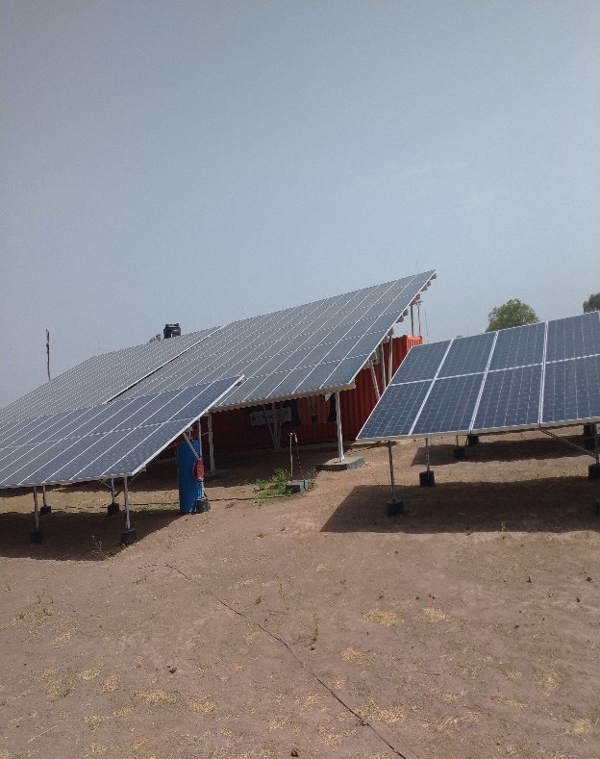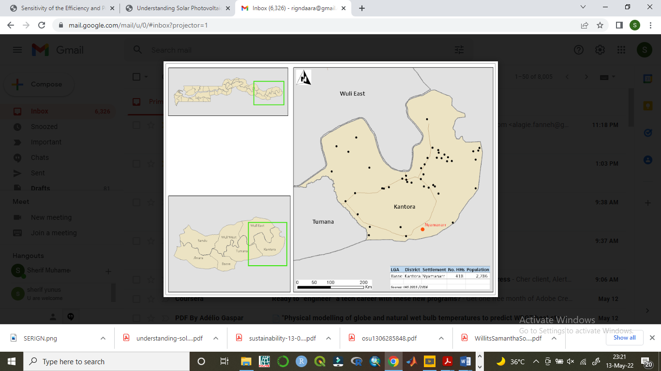
Fig. 1: A view of the PV infrastructure in Nyamanarri and the map of Nyamanarri, Kantora, Upper River Region (URR) – The Gambia

Technical Specification of the PV System
The PV system in Nyamanarri has a total installed capacity/rate power (P_{nom}) of 120kWp. The PV array consists of 310 series connected monocrystalline PV module from JA SOLAR (Model: JAM72S09-390/PR). Each PV module has a rated power of 390 Wp and a rated efficiency of 19.8%. The modules are assembled into three strings of 18x2 modules, one string of 21x2 module and two strings of 13x6 modules in 2 parallel rows. These strings are connected to two in build inverter systems of Sunny SMA (Model: SI8.0H-13) that has a maximum output of 6kWp. The system also has a core inverter which controls the direct supply to the load from the arrays. There are 12 inverters which are grouped into clusters of 3 inverters. Therefore, the system has 4 clusters, and each cluster is composed of 1 main inverter from which the load is sent and 2 support inverters. The system has 2 maximum power point trackers (MPPT). All the modules in each string are fixed on ground-mounted racks and positioned in a direction facing towards south at a tilt angle of 15⁰. The system is alternating current (AC)-coupled and is equipped with four HOPPECKE Sun Power VR L 2-1500 Series OPzV with a total rated capacity of 576 kWh.
The main system components include PV modules, converters (Solar direct current (DC) to alternate current (AC) inverters, and battery DC/AC inverters), battery energy storage system (BESS), monitoring and energy management system (MMEMS) and the loads.
The figure 2 shows PV Module, Inverter and Batteries in Nyamanarri, Kantora, URR – The Gambia.
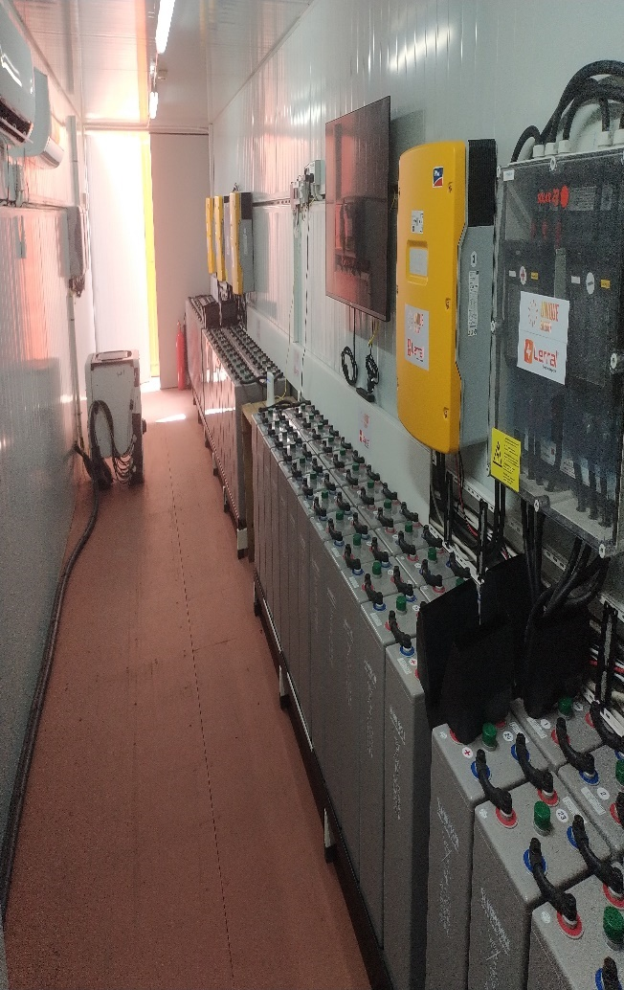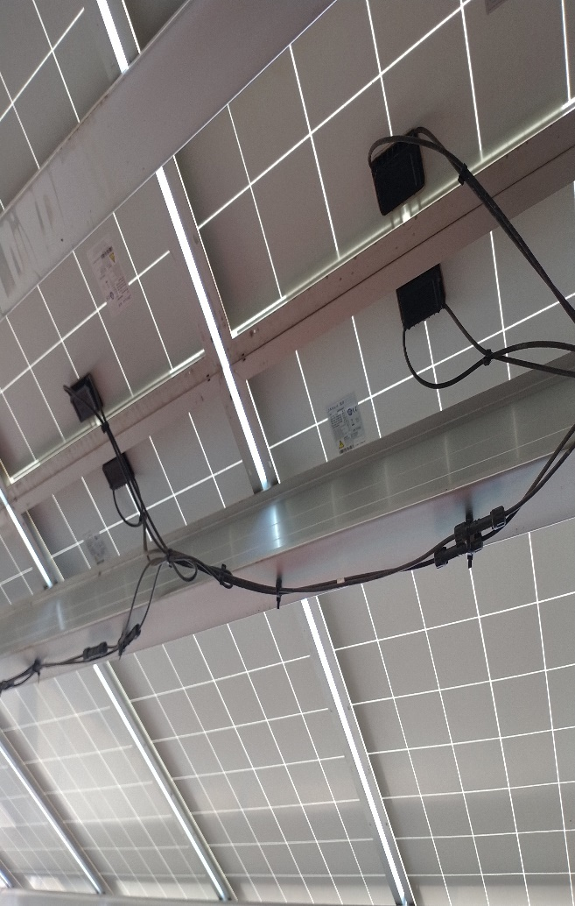
Fig. 2: PV Module, Inverter and Batteries in Nyamanarri, Kantora, URR – The Gambia

Data Sources and Collection methods
Measured meteorological data
Measured data on solar irradiation on the tilted panels and ambient temperature were obtained from https://power.larc.nasa.gov/data-access-viewer/. These values are used to estimate the reference yield of the array and calculate some of the performance metrics. The measurement of solar irradiance (kW/m²) and ambient temperature (⁰C) were done by the portal but not recorded.

Real-time PV electricity generation and load data
The study is based on actual on-site power generation and consumption data. The actual data on hourly DC output power from the PV array, hourly electricity generated by the PV inverters, and hourly energy consumed by the load were all retrieved directly from the portal as shown below.
As the system start operating on 25th February 2022, complete data of daily power generation, consumption and load were available for 12 months (April 2022 -March 2023) of the system’s operation by the time this case study was completed. The portal system captures data from the PV array, from the inverters to the battery system to the load. The data is made available from the portal on a daily basis in power report formats:
- Daily DC output power from the PV array
- AC output from the PV generator, the BESS
- Power supply to the loads
All the power reports are in kW. The daily AC report provides detailed information on the daily PV generation, peak generation amount and the day, the battery charging and discharging and depth of charging among other things. Likewise, the daily load report provides detailed information on hourly electrical loads, the peak load, shedding load, etc. Using these daily power and energy reports, a time series data was created for the 12 months. The data is utilized for many of the analysis of this research.

Field Visits, customer surveys and in-dept interviews
In addition to the real-time energy data extracted from the portal, data on the monthly electric consumption of each customer was obtained from the Local Billing office. Furthermore, surveys were conducted with customers from different sectors (households, productive/commercial users and public/state institutions). The survey was conducted using semi-structured questionnaires that were designed. The survey was conducted through face-to-face interviews. Throughout the field study, repeated visits to the solar plant as well as in-depth interviews and discussions with the site manager and the technician, community leader were conducted.

Methodology
Data analysis and evaluation parameters
The system is supervised by a portal for measuring and recording electrical parameters. The meteorological parameters are shown on the screen but cannot be retrieved. The electrical parameters include the current and voltage flowing from and into each balance of system component. The meteorological parameters include solar irradiance on the plane array, ambient temperature, cell temperature, relative humidity, wind speed and direction. There is a data logger used for measuring the electrical data sampled every 15 minutes.
Data was collected for a period of one year between April 2022 and March 2023. This data was used to evaluate the performance of this off-grid system based on certain normalized system performance parameters. This was done based on the IS/IEC 61724 1998 standards. These performance parameters are discussed below.
The yields have units of kWh/kW_{p}/day and indicate the amount of time during which the array would be required to operate at the array’s rated output power, P₀ to provide a particular quantity (Meyer et al., 2017; Wassie et al., 2023).
- Reference yield (Y_{R})
The reference yield is the theoretical possible energy output of the PV plant. It is defined as the anticipated output from the same system with nominal efficiency determined under STC of PV modules. In other words, the reference yield is the number of peak sun-hours. It is the ratio of the total in-plane solar radiation (H_{id}) [kWh/m²], to the reference irradiance (1 kWh/m²) at standard test conditions.
Y_{R} = H_{id}/G_{STC} (1)

- Array yield (Y_{A})
The Array Yield (Y_{A}) denotes that the total daily DC energy output from the PV array (kWh) normalized by the PV’s rate power (Wassie et al., 2023). The daily Y_{A} is given by the equation below.
Y_{A =} E_{DC}/P_{nom} (2)
Where E_{DC} is the DC output and P_{nom} is the rated power of the PV array (kW_{p})
The array yield represents the number of hours per day that the array would need to operate at its nominal or peak power to contribute the same quantity of energy to the system as that actually measured in practice. It is the ratio of the daily energy output of the PV array (E_{A}) to the peak power of the installed PV array.
Y_{A} = E_{A}/P₀ (3)

- Final yield (Y_{F})
In stand-alone PV systems, the Final Yield (Y_{F}) represents the energy actually delivered to the load by the PV plants in a given time period normalized by the rated power of the plant (IEC, 1998; Ma et al., 2013). The daily Y_{F} is expressed by the equation below:
Y_{F} = E_{AC}/P_{nom} (4)
E_{AC} is the daily load total AC energy actually delivered to the load (kWh/day) and P_{nom} is the rated power/nominal installed capacity the PV system (kW_{p})
The final yield is the usable portion (used by the load, E_{L}) of the energy derived from the PV modules (E_{PV}). In an off-grid system, the energy stored in the battery bank (E_{bat}) is equally taken into consideration. The final yield is obtained from:
Y_{F} = E_{PV}/P₀ where E_{Pv} = E_{L}/1+(E_{bat}/E_{A}) (5)

- Performance Ratio (PR)
The performance ratio is one of the most important parameters to consider when evaluating the performance of a PV system. It is the ratio of the actual energy output to the theoretically possible energy output. It is independent of the orientation of the PV plant and the incident solar radiation of the PV plant. This is why the performance ratio can be used to compare PV plants at different locations all over the world or for performance comparison of a particular system over the years. It is the ratio of utilizable AC electricity to the amount of energy which could be generated in case modules were operated under STC continuously and without any further losses in the system (Meyer et al., 2017; Van Sark et al., 2012).
PR = Y_{F}/Y_{R} (6)

- Losses
The losses in a PV system may be caused by high array temperature, incomplete utilization of the irradiation, improper system sizing and system component inefficiencies or failures (Meyanjo et al., 2023). Energy losses indicate the amount of time during which the array would be required to operate at its nominal power in order to produce power for the losses. The losses are in two parts: system losses (L_{s}) and array capture losses (L_{c}). The capture loss is the difference between the reference yield and the array yield. It is caused by incomplete utilization of the available radiation. The system loss is the difference between the array yield and the final yield. It mainly comes from the inverter in converting the DC power to AC (Kymakis et al., 2009) and from losses in the other balance of the system components.
L_{c} = Y_{R} – Y_{A} (7)
L_{S} = Y_{A} – Y_{F} (8)

- Efficiencies
The efficiencies involved in a PV system are at two major levels: at the level of the array and the whole system in general. The system efficiency embodied the efficiencies of the balance of the system component where losses are incurred is the inverter, the system efficiency is simply the product of the array efficiency and the inverter efficiency (Wassie et al., 2023; Joshi et al., 2009).
η_{array} = E_{A}/(A_{array}xG_{id})[100] (9)
η_{sys} = η_{array} x η_{inv} (10)

- Capacitor Factor (CF)
The capacity Factor (CF) also referred to as the capacity utilization factor, is defined as the ratio of the actual AC energy output (E_{AC}) of the PV system to the amount of energy that the system would generate if it operated at its rated power (P_{nom}) continuously 24 hours a day throughout the year (8760 hr) (Wassie et al., 2023). The annual CF of a PV plant is given by
CF_{Annual} = E_{AC}/(P_{nom}x8760h) [%] (11)

- Power supply reliability analysis
Reliability is an important indicator when assessing the performance of a stand-alone PV system. The reliability of the PV plant in this study is evaluated from the angle of energy reliability [24]. The energy reliability of a power system can be defined as the system’s ability to supply customers with sufficient energy to satisfy demand with minimum power interruptions [24][30]. The energy reliability of a power plant is typically assessed by calculating the System’s Average Interruption Duration Index (SAIDI) Wassie te al., 2023; Song et al., 201). SAIDI measures the monthly or annual power outage duration for a customer (or group of customers) served by a power plant. The monthly SAIDI values of the Solar Plant customers in this study were calculated based on the actual daily power interruption hours using equation below. Data on the number of customers in each day (N_{T}), the frequency of power interruption per day, and the total duration of power interruption per day (U_{i}) were collected from the daily reports of the Solar Plant’s and the customers surveys, plant manager and technician, and community leaders’ discussion.
$\text{SAIDI=}\frac{\sum_{\text{d=}1}^{N}{U_{i}N_{i}}}{N_{T}}$ (12)
Where N_{i} is the number of customers in the group, N_{T} is the total number of customers served by the Solar Plant, which is the same as N_{i} in tis case, U_{i} is the total duration of power outages (Hours) in the month and N is the total number of days in that particular month.

Results and Discussion
- Solar Irradiance and Ambient Temperature
According to the solar irradiation data, the total annual solar energy resource incident on the tilted PV array is 2121.79 kWh/m²/year. The average daily solar irradiation is 5 kWh/m², however, it varies between 4.5 and 6.7 kWh/m²/day. The monthly average daily solar irradiation and ambient temperature are shown below. Figure 3 shows that the lowest average daily irradiation 161.76 kWh/m²/day is recorded in September. The peak irradiation 218.32 kWh/m²/day is recorded in March. The average daily ambient air temperature at Nyamanarri is 27.67⁰ C, with a minimum of 22.97⁰ C in January and a maximum of 33.61⁰ C in March and April. Generally, figure 3 shows that the distribution of solar irradiation at the site has little season variation.

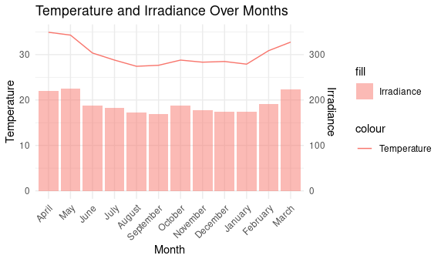
Figure 3: Mean Irradiation (kWh/m²/day) and Ambient Temperature (⁰C) in each month

- Module efficiency under real conditions (Power Conversion Efficiency)
The PV AC power efficiency (η_{pc}), in lieu of the nominal module efficiency at STC, is often used to determine the energy conversion and power generation efficiency of PV modules under real working condition [25]. According to our results obtained from equation (6), the average daily power conversion efficiency of the PV modules over a year period is 12.41 %. The result indicates that only 12.41 % of the solar energy incident of the PV plane is converted to usable electrical energy. It also reveals that the module efficiency under real outdoor working conditions is almost half of its nominal efficiency under STC (19.8 %). Figure 4 shows the monthly average module efficiency and temperatures.

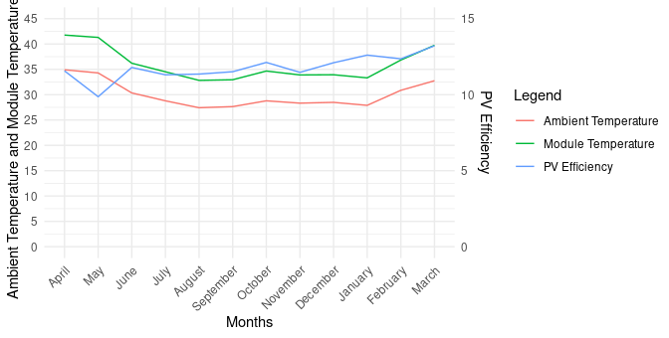
Figure 4: Monthly average Module efficiency against Ambient and Module Temperature

“Figure 4 shows that the monthly average PV efficiency ranges from 9.87% in May to 13.22% in March. However, it is found that the average daily PV module efficiency varies significantly from 9.87% to 13.22%. The lowest daily module efficiencies 9.87% were found in May, all of which coincided with daily radiation values below 6.5 kWh/m²/day. The highest module efficiencies 13.22% were observed in March and were paired with radiation levels close to the total average daily radiation 6 kWh/m². Despite the strong correlation between PV module efficiency and daily in-plane solar irradiance level, the variation in module efficiency between the years was not significant.The significant difference between the on-site module efficiency (η_{pc}) and the nominal efficiency at STC (η_{STC}) can be due in part to the effect of the high module operating temperatures. The outdoor performance of PV module primarily depends on the in-plane solar irradiance and the PV module temperature (Ma et al., 2013; Kymakis et al., 2009). The climate in Nyamanarri is warm and hot all year round. Our calculation from equation (9) indicates that the average daily operating temperature of the PV module is 40 2⁰ C. This figure is 15⁰ C above the STC (25⁰ C) and 10⁰C above the average ambient temperature (30⁰ C). According to Amalu and Fabunmi, the efficiency of monocrystalline PV module decreases by 0.45% for every 1⁰ C increase in module temperature above STC” (Amalu et al., 2022). Therefore, the high operating temperatures may have negatively and significantly affected the efficiency of the PV modules by lowering the output voltage, and as a result, reducing the power output. As will be discussed later in the article, the lower electrical efficiency of the PV modules is also related to the limited battery capacity.

- PV Energy Estimated, Electricity Generated vs Electricity Consumed/Load Analysis
We calculate the monthly and total electricity generated over the year by using the daily real-time AC power generation data retrieved from the system. The results showed that the total electricity generated was 164071.56 kWh. The average monthly electricity production during the same period is calculated at 13672.67 kWh/Month; but varies from 247 kWh/day to over 600 kWh/day. The fitted line illustrates that the daily electricity generation, given by the scattered points, is directly proportional to the solar irradiance level that hits the panel (Corr = 0.936 and adj R² = 0.87). The lowest monthly generation is 11912 kWh, and it was recorded in September when the average daily solar irradiation was the lowest 169.65 kWh/m²/day. The highest monthly electricity generation is 15472 kWh, which was recorded in March, when the average daily solar irradiation was the highest 218.32 kWh/m²/day. Figure 5 is the correlation daily electricity generation and the daily solar irradiance.

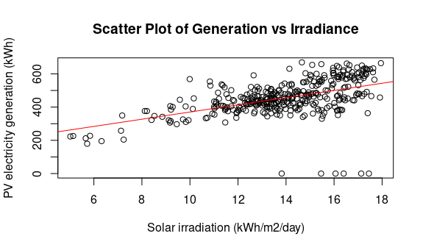
Figure 5: Daily PV electricity generation (kWh/day) and Daily Solar irradiation (kWh/m2/day)

Given the actual data electricity generated, and the daily electricity consumed by the load, the daily estimated DC energy output from the PV array was calculated using equations (1). The two energy yields: the electricity generated, and electricity delivered to the load daily are shown in figure 6. The daily estimated energy output of this PV system (Eqn. 1) is calculated to be 1020 kWh/day which is an estimate of 8.5 hours per day during which solar irradiance is strong to generate maximum output from the system. When this value is compared to the average daily electricity generated by the system 449.98 kWh/day, a significant difference of 570.02 kWh/day is observed. This shows that only 37.46 % of the rated power of the PV system is produced whereas the remaining 62.54 % is not. The average daily energy delivered to the load is 392.79 kWh/day. This means that 87.3 % of the daily electricity generated is actually consumed by the load whereas distribution and system losses account for the remaining 12.7 % of the power generated. The significantly lower AC power output and inefficiency in the energy capture and conversion process include losses inefficiencies. Hence, the high percentage of daily energy output actually delivered to the load shows that the load absorbs nearly all of the AC power generated by the plant each day.
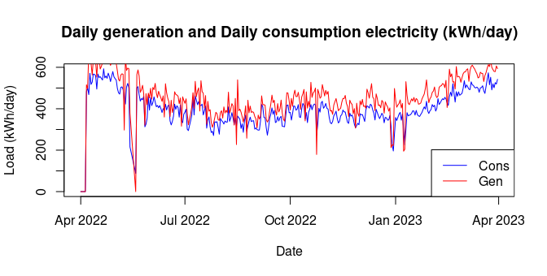
Figure 6: Daily generated and consumed electricity (kWh/day) from the PV system

“During the field study, it was observed that the main power feeder to the loads is disconnected between 13:00 and 15:00, and again between 18:00 and 19:00 daily. By 19:00, the battery supply begins, lasting until approximately 01:00 hours, at which point the system shuts down as the Depth of Discharge (DOD) is reached. The system remains off from 01:00 to 10:00 hours each day. This practice, managed by the operator, is part of a load management strategy aimed at charging the batteries in the morning. When the feeder is switched back on, the direct supply to the grid resumes. The cut-off period between 13:00 and 15:00 is specifically intended to maximize battery charging during peak solar generation. It was also noted that the load profile of productive-use customers includes various high-power appliances, such as welding machines, deep freezers, air conditioners, compressors, electric stoves, and hair dryers. These findings align with those of studies conducted in a rural village in Tanzania” [31] and Southern Ethiopia (Wassie et al., 2023).

- Hourly Energy Flow and Energy Balance Analysis
To assess the energy performance of the PV system, daily energy flow was analyzed using data on daily AC power generation, energy consumption, and battery power for December 2022 as an example. The results are illustrated in Figure 7. When the battery bank is fully charged, any excess PV AC power is directly supplied to the load through a core inverter. While the PV array generates excess power during certain hours, the battery bank continues to charge. The peak charging power, recorded at 419 kW, occurred on April 9, 2022, coinciding with the maximum solar generation.

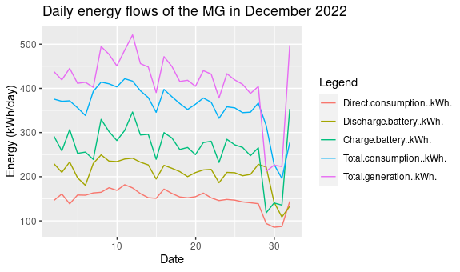
Figure 7: Daily energy flows in December 2022

The Generation profile is based on 12th February 2023 and 12th April 2023. The generation kicks around 07:15AM and shortly climbs to 89 kW at 12:00 AM and remains stable and mostly above 90 kW until it is shed off at 6:00PM. The power feeder is reconnected to the load at 7:00PM and the load reaches its peak (80 kW) at 8:00PM before being shed off again at 01:00. Throughout the 24 hours, the net energy balance remains close to zero. In general, the figure demonstrates two significant phenomena. The first is that, given the high daily load, the rated battery capacity is insufficient. This is clearly shown by the rapid depletion of the battery’s state of charge (SOC) within 5-7 hours of discharging between 1:00 and 3:00 AM. The second is that, even when the solar radiation is good and the battery is fully charged, the PV electricity production is insufficient to fully satisfy the demand at certain hours of the day (1:00 PM-3:00 PM). In light of the observed low PV module efficiency, this could indicate a mismatch between the PV array’s generation capacity and the demand, meaning that the installed capacity of the PV system, including the battery, is undersized compared to the actual load. Figure 8 shows the hourly energy generation from February 2023 to April 2023.

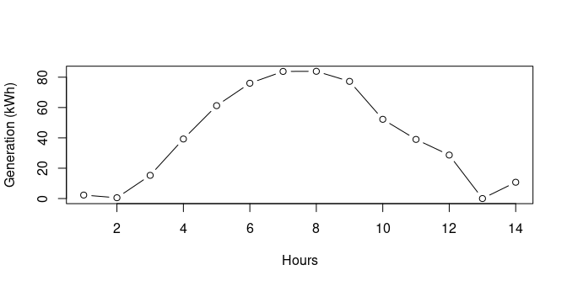
Figure 8: Hourly energy generation from February 2023 to April 2023

At the root of the PV generation and battery capacity shortages, lies a poor initial load assessment and subsequently undersizing of the Solar Plant. From our discussion and interviews with the community leaders, it was evident that the initial load assessment that laid the basis for the design and sizing of the PV system was inaccurate and incomplete. Apparently, the electricity demand of residents of the village was estimated simply based on the results of the house-to-house survey conducted in every household in the village. The underlying assumption in the initial load assessment was that the demand for electricity in the area is low since most of the community are farmers. Contrary to the initial load assessment, we found that the village is a border point with diverse economic activity and businesses. It was found that productive use of customers was consuming a significant amount of the daily power output and were responsible for keeping the electrical load stable and high during the day as well as for the evening peak load. The results suggest that the dimensioning of the PV system has failed to account for the impact of the hot weather condition (hence the use of electricity for air conditioning and refrigeration) from the beginning, the residents’ high-income level, and the growing urbanization of the rural village on the electricity demand. These findings strengthen the assertions of Numminen and Lung (2019) and Wassie et al (2023) that inaccurate “initial load assessment and poor technical design are among the main factors behind the poor energy performance and reliability of the PV system in developing countries” (Numminen et al., 2019; Wassie et al., 2023).

- Analysis of Battery Energy Flow at Nyamanarri Mini-grid Over the Year (April 2022 to March 2023)
This chapter provides a comprehensive analysis of the battery energy flows observed at the Nyamanarri Mini-grid in The Gambia throughout April 2022 to March 2023. Expanding on the previous discussions, this chapter integrates monthly trend evaluations, battery charge/discharge dynamics, correlation analysis of energy parameters and system efficiency ratios. These indicators provide deeper insights into the operational sustainability, performance reliability and optimization potential of the battery storage system (BESS) in an off-grid rural context.

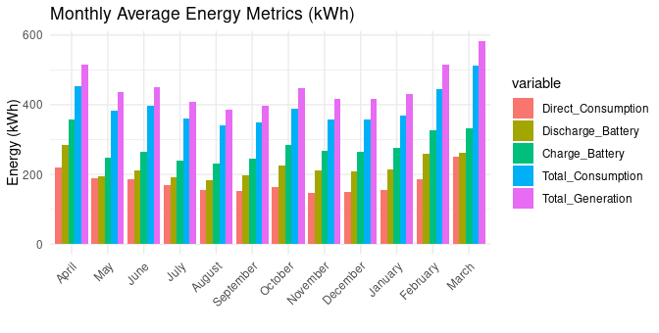
Figure 9: Monthly Average Values for Energy Parameters

Figure 9 illustrates the monthly average values for energy parameters. Peak Generation and Charging during March-May, aligning with the dry season when solar irradiance is higher. Lower Generation and Higher Discharge in the raining season (August-October), indicating increased reliance on stored energy due to reduced PV output. Stable Total Consumption throughout the year, suggesting consistent user demand. The system meets users’ needs across the seasons but relies more heavily on the battery in periods of low input. Battery energy storage systems have a critical role in transforming energy systems that will be clean, efficient, and sustainable (ADB, 2018).

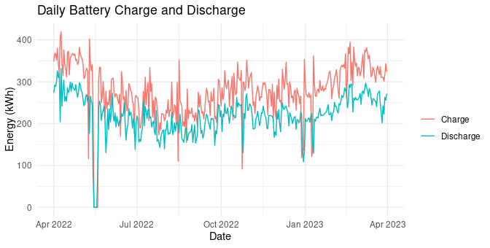
Figure 10: Daily Battery Charge and Discharge

Figure 10 presents a daily time-series plot of battery charge and discharge behavior. Charging peaks typically precede or follow high solar generation days. Discharging remains relatively stable, tracking load requirements consistently. Battery discharges align closely with daily demand while charging is subject to the variability of solar availability. These findings merge the assertion of Hull et al (2024) that Battery discharge is often managed to match daily energy consumption patterns, ensuring that power is available when needed most.

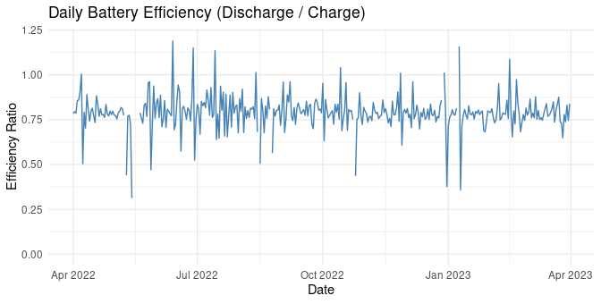
Figure 11: Daily Battery Efficiency (Charge/Discharge)
Figure 11 shows the Battery Efficiency graph calculated as Battery Efficiency = Discharge (kWh) / Charge (kWh). The efficiency ranges mostly between 0.75 and 0.85, consistent with typical off-grid BESS systems. The days with very low or zero charge result in undefined/infinite efficiency values, which were handled in the analysis. The system exhibits acceptable energy retention and conversion efficiency. However, occasional deviations point to potential losses or underutilized stored energy.

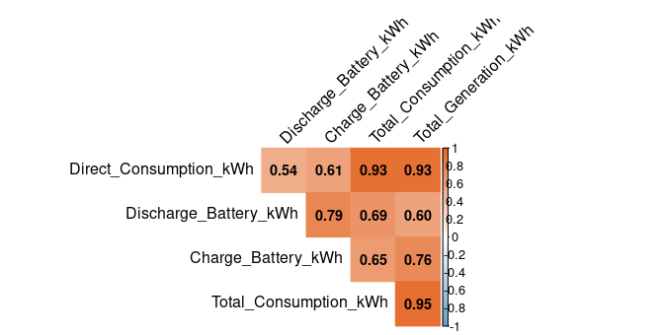
Figure 12: Correlation Heatmap

Figure 12 displays the correlation matrix for core energy metrics. The Total Generation correlates strongly with Battery Charge (r = 0.76) confirming solar energy as the dominant charge source. The Battery Discharge correlates with Total Consumption (r = 0.69) reflecting its role in meeting community load. The system’s energy flows are well-structured. Solar PV generation primarily dictates battery charging while consumption levels influence battery discharge patterns.
The analysis of the Nyamanarri battery system provides evidence of a well-performing energy storage infrastructure that responds effectively to solar generation fluctuations and seasonal demand. Key findings include:
- A consistently strong relationship between PV generation and battery charge.
- Battery Efficiency with expected operational limits.
- Seasonal variations are managed through battery discharges.
This holistic understanding supports ongoing optimization strategies such as adaptive charging controls, user education for load shifting and storage capacity planning to maintain energy reliability and project sustainability in rural off-grid systems.

- Reliability of Power Supply from The System
The power supply reliability of this system was analyzed by calculating the System’s Average Power Interruption During Index (SAIDI) values, and the average monthly electricity consumption per customer using equation 12. All calculations were made using the actual data on the monthly electricity consumption of each customer obtained from the billing records and our surveys. The results presented in figure 10 show how the SAIDI increases, and average power consumption decreases as the total number of customers increased from 200 in February 2022 to 208 in August 2022 and to 263 March in 2023.

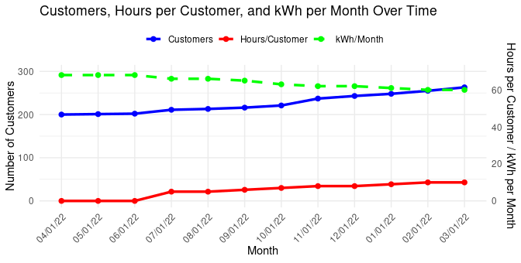
Figure 13: Monthly SAIDI values (Hrs) and average monthly electricity consumption per customer

“Following the rapid growth in the number of customers, the monthly power interruption hours (SAIDI) per customer increased from 00:00 hours per month (= 00 hours/day) in April 2022 to 300 hours per month in March 2023 (= 10 hours/day). However, the monthly electricity supplied by the PV plant has not changed significantly over the year. As a result, the average monthly electricity consumption per customer fell from 68 kWh in April 2022 to 60 kWh in March 2023 (a decline by less than 10%). The data showed that the power supply by the system in April 2022 was sufficient to meet the demand; with total power outage duration of 00 hours, mainly for operational reasons. In the months that followed, the number of customers grew while the supply remained essentially unchanged.The customers’ surveys and interviews with key informants revealed the earliest adopters of the system electricity service were the elites of the village; and they are the ones who are now losing much of their former access to reliable power. This in turn has consequences both for the small businesses and financial returns of the system. Overall, the results show that the PV system is currently unreliable in terms of power supply and the average monthly electricity consumption per customer observed in March (60 kWh) is rather a “suppressed demand” due to extended hours of load-shedding and power interruptions. A suppressed energy demand occurs when the energy supplied by a power system is insufficient to meet the basic needs of the customers due to the limited installed capacity of the power plant, inadequacy of supply, low user income, or other barriers” (Benavente et al., 2019). “The results demonstrate the impact of the dynamics of the electricity demand and usage behaviors of rural communities on the reliability of PV system and the need to account for such changes in initial system sizing of off-grid systems”. (Wassie and Ahlgren,2023)

- Overall System Performance Analysis
Findings from the evaluation of the overall system performance and efficiency based on the IEC standard normalized parameters and equations in the methodology indicated that the system is performing poorly. The results of the energy yield and efficiency analysis are summarized in table 1.

Table 1: Summary of the results of the energy performance and efficiency analysis
Parameter | Y_{R} | Y_{A} | Y_{F} | L_{C} | L_{S} | PR | CF | η_{SYS}
Month | kWh/  kWp/m | kWh/  kWp/m | kWh/  kWp/m | kWh/  kWp/m | kWh/  kWp/m | % | % | %
April | 212.66 | 128.93 | 113.41 | 83.73 | 15.52 | 53.33 | 15.75 | 22.27
May | 202.81 | 112.54 | 98.70 | 90.27 | 13.85 | 48.67 | 13.27 | 19.38
June | 178.63 | 112.46 | 99.08 | 66.17 | 13.38 | 55.47 | 13.76 | 19.46
July | 162.46 | 105.36 | 93.20 | 57.1 | 12.15 | 57.37 | 12.53 | 18.30
August | 158.8 | 99.79 | 87.84 | 59.01 | 11.95 | 55.32 | 11.81 | 17.25
September | 161.76 | 99.26 | 87.42 | 62.5 | 11.84 | 54.04 | 12.14 | 17.17
October | 170.7 | 115.92 | 100.64 | 55.78 | 15.28 | 58.96 | 13.53 | 19.76
November | 161.53 | 103.90 | 89.40 | 57.62 | 14.5 | 55.35 | 12.41 | 17.56
December | 159.79 | 107.33 | 92.67 | 52.46 | 14.66 | 58.00 | 12.46 | 18.20
January | 169.23 | 111.18 | 95.13 | 58.05 | 16.04 | 56.21 | 12.79 | 18.68
February | 165. 1 | 120.07 | 103.93 | 45.03 | 16.14 | 62.95 | 15.47 | 20.41
March | 218.32 | 150.51 | 132.1 | 67,82 | 18.41 | 60.51 | 17.75 | 25.94
Average | 178.81 | 113.94 | 99.46 | 62.87 | 14.48 | 56.37 | 13.64 | 19.53

“According to our results, the average daily reference yield (Y_{R}), array yield (Y_{A}) and final yield (Y_{F}) of the system over the year long period were 178.81 kWh/kWp/month, 113.94 kWh/kWp/month and 99.46 kWh/kWp/month respectively. These results confirm that only 63.7% of the potential solar energy available at the PV array’s surface (Y_{R}) is harvested by the modules (Y_{A}). As discussed earlier, the large disparity between the reference yield (Y_{R}) and the array yield (Y_{A}) relates to energy losses and inefficiencies incurred in the capture and conversion of the in-plane solar energy into useful electricity. The table also shows that the total average monthly energy loss of the system is 77.35 kWh/kW/month, which comes from average monthly capture losses (L_{C}) of 62.87 kWh/kW/month and average monthly system losses (L_{S}) of 14.48 kWh/kWp/month. These figures reveal that energy losses during energy capture and conversion account for most (77.8 %) of the total energy loss, while only 13.64% is a result of energy losses and inefficiencies in the distribution and system components.
The large capture losses can be linked to the low efficiency of the PV modules, power clipping and the effects of high temperatures. Given that this is an off-grid PV system with a storage battery and MPPT tracker, the PV array yield is also influenced by the quantity of energy needed to feed the instantaneous load and to charge the battery bank. In other words, how much of the available solar energy is harnessed by the inverter also depends on how much energy the battery bank can store, in addition to feeding the active load. The large difference between the reference yield and the array yield could thus be partly explained by the low storage capacity of the battery bank. Comparing the final yield (Y_{F}) with the reference yield (Y_{R}), we observe that 56.37% (99.46 kWh/kWp/month) of the total available solar energy on the PV array surface (Y_{R}) is delivered to the load each day.The results of the efficiency analysis showed that this PV power plant performs poorly with an average Performance Ratio (PR) of 56.37%. A PV power system is typically considered to have high performance when its PR value is above 70 %. Compared to this, the performance of the PV system falls within the low range”. (Benavente et al., 2019). The impact of temperature is most visible in May, where the system experienced a PR drop of nearly 7.7% despite the high level of solar irradiation of the month. However, it is important to note that a low PR value for an off-grid PV plant does not necessarily mean that the system is experiencing technical difficulties. Instead, it can be caused by a poor match between the PV system’s installed capacity and electricity demand. As noted by Hartvigsson et al (2021), “the viability and operational behavior of off-grid system heavily depends on the interactions and feedback between endogenous factors (example between electricity demand and supply) rather than exogenous factors. As such, the low PR value of this PV system might be due to more limited battery capacity limiting the amount of solar energy the system can capture and deliver” (Wassie et al., 2023).
“The average capacity factor (CF) of the system is 13.64 % indicating that the actual energy output of the plant is 143223.85 kWh of the theoretical energy output that the system would provide if it had operated 24 hours a day, including nights, at its rated capacity. The overall system efficiency (η_{sys}) of this PV power plant is 19.53 %. Previous research around the world indicates that the overall system efficiency of PV power system in tropical climates ranges between 5 % and 15 %” (Joshi et al., 2009; Kumar et al., 2015; Minai et al., 2022). A study on a 20 kWp PV system in a hot tropical climate in Columbia (Banguero et al., 2019), also found the overall system efficiency of the system to be 10.3-11%. Compared to these reports, the overall system efficiency of the current PV system is relatively high.

Conclusion
The real-time performance and supply reliability of 120 kWp off-grid PV system installed in a small remote village in The Gambia is analyzed using meteorological data and real time power generation and consumption data retrieved from the energy monitoring system of the system over one year period (1st April 2022 to 31st March 2023). Findings show that the average PV module efficiency (η_{PC}) under real condition is 12.41% compared to its nominal efficiency of 19.8% under STC. The disparity in module efficiency is related to the large PV array capture losses (L_{C} = 62.87 kWh/kWp/month). The mean monthly electricity produced by the PV system is 536 kWh/day. In contrast, 90% of the daily electricity generated was delivered to the road. System and distribution losses (L_{S} = 14.48 kWh/kWp/day), accounted for the remaining 10%. It is found that the system is performing poorly with an average monthly array yield (Y_{A}) of 113.94 kWh/kWp/month, monthly final yield (Y_{F}) of 99.46 kWh/kWp/monthly, Performance Ratio (PR) of 56.37%, capacity factor (CF) of 13.64% and an overall system efficiency (η_{SYS}) of 19.53%.
Analysis of the daily energy flow and power supply reliability showed that the energy delivered by the PV plant does not meet the daily demand to the extent that the load sheds off the power supply for 10 hours each day. The poor overall performance of the PV system can be attributed to three main factors:
- The low PV module conversion efficiency, largely because of the high temperature, large capture losses and active power curtailment.
- Mismatch between the PV’s installed capacity (120kWp) and the demand.
- Insufficient rated battery capacity (576 kWh) compared to the load.
The results suggest that the performance of PV power systems in hot tropical climates can be significantly reduced by large drops in PV module efficiency and energy capture losses that come with operating at high temperatures. Therefore, future deployment and system sizing of PV power plant in a hot tropical area of The Gambia and SSA at large should be critically assess and take into account the effect of local weather conditions, economic activities and potential growth in electricity demand on the performance and reliability of the PV system. In this sense, the research provides valuable knowledge and practical experience to inform policy makers, investors, PV system installers, researchers and organizations working on PV based rural electrification in the developing world.

Abbreviations
A PV array effective area (m2)
AC Alternating current
CF Capacity factor (%)
DC Direct current
DOD Depth of discharge
E_{DC} DC energy output (kWh)
E_{AC} AC energy output (kWh)
E_{AC Load} Energy consumed by the load (kWh)
G_{STC} Irradiance at standard test conditions (1, 000 W/m2)
G_{total} Total solar irradiance incident on the tilted PV array (kWh/m2)
IEC International Electrotechnical Commission
L_{C} Capture losses
L_{S} System losses
MG Mini-grid
MMEMS Mini-grid Monitoring and Energy Management System
MPPT Maximum power point tracker
P_{nom} Rated power/nominal capacity of the PV array (kWp)
PR Performance Ratio (%)
PV Photovoltaic
SAIDI System’s Average Power Interruption Duration Index
SDG Sustainable Development Goal
SHS Solar House System
SMG Solar Mini Grid
SOC State of charge
SSA Sub-Saharan Africa
STC Standard Test Conditions (25 ◦ C, 1 kW/m2; A.M. = 1.5)
U_{i} Total power interruption time per day (hours)
Y_{A} Array yield (kWh/kWp)
Y_{F} Final yield (kWh/kWp)
Y_{R} Reference yield (kWh/kWp)
η_{pc} Power conversion efficiency of PV modules under real working conditions
η_{STC} Module efficiency under STC (%)
η_{sys} Overall system efficiency (%)

Disclaimer (Artificial intelligence)
Option 1:
Author(s) hereby declares that NO generative AI technologies such as Large Language Models (ChatGPT, COPILOT, etc.) and text-to-image generators have been used during the writing or editing of this manuscript.
Option 2:
Author(s) hereby declares that generative AI technologies such as Large Language Models, etc. have been used during the writing or editing of manuscripts. This explanation will include the name, version, model, and source of the generative AI technology and as well as all input prompts provided to the generative AI technology
Details of the AI usage are given below:
1.
2.
3.

References
- IEA (2023), SDG 7: Data and Projections, IEA, Paris; http://www.uea.org/reports/sdg7-data-and-projections, Licence: CC BY 4.0
- Alqahtani, B. J., & Patino-Echeverri, D. (2023). Identifying economic and clean strategies to provide electricity in remote rural areas: Main-grid extension vs. Distributed electricity generation. Energies, 16(2), 958. https://doi.org/10.3390/en16020958
- Wassie, Y. T., & Ahlgren, E. O. (2023). Performance and reliability analysis of an off-grid PV mini-grid system in rural tropical Africa: A case study in southern Ethiopia. Development Engineering, 8, 100106. https://doi.org/10.1016/j.deveng.2022.100106
- Odoi-Yorke, F., Abbey, A. A., Abaase, S., & Mahama, M. (2024). Evaluation of research progress and trends in mini-grids for rural electrification: A bibliometric analysis. Energy Reports, 12, 4083-4104. https://doi.org/10.1016/j.egyr.2024.09.074
- Nagpal, D., & Parajuli, B. (2019). Off-grid renewable energy solutions to expand electricity access: An opportunity not to be missed. International Renewable Energy Agency (IRENA), Abu Dhabi. https://www.irena.org/publication
- Rao, J., He, Y., & Liu, J. (2023). Standalone versus grid-connected? Operation mode and its economic and environmental assessment of railway transport microgrid. Sustainable Cities and Society, 98, 104811. https://doi.org/10.1016/j.scs.2023.104811
- Karna, S. L., Jha, A. K., Yadav, K., & Kumar Mallik, J. (2024). Performance evaluation of solar PV mini grid system in Nepal: a case study Thabang and Sugarkhal. Frontiers in Energy Research, 11, 1321945. https://doi.org/10.3389/fenrg.2023.1321945
- Sharma, V., & Chandel, S. S. (2013). Performance analysis of a 190 kWp grid interactive solar photovoltaic power plant in India. Energy, 55, 476-485. https://doi.org/10.1016/j.energy.2013.03.075
- Chimtavee, A., Ketjoy, N., Sriprapha, K., & Vaivudh, S. (2011). Evaluation of PV generator performance and energy supplied fraction of the 120 kWp PV microgrid system in Thailand. Energy Procedia, 9, 117-127. https://doi.org/10.1016/j.egypro.2011.09.013
- Hartvigsson, E., & Ahlgren, E. O. (2018). Comparison of load profiles in a mini-grid: Assessment of performance metrics using measured and interview-based data. Energy for Sustainable Development, 43, 186-195. https://doi.org/10.1016/j.esd.2018.01.009
- Mayanjo, S., Justo, J. J. (2023). Development of Solar PV Systems for Mini-Grid Applications in Tanzania. Tanzania Journal of Engineering and Technology. 42(1), 200-212. https://doi: 10.52339/tjet.v42i1.889
- Meyer, E. L., Buma, C. L., and Taziwa, R., (2017) Performance Parameters of an off-grid building integrated photovoltaic system in South Africa. 33rd European Photovoltaic Solar Energy Conference and Exhibition, RAI Convention and Exhibition Centre, Amsterdam, The Netherlands. pp. 2450-2455.
- IS/IEC 61724, (1998). Performance monitoring – guidelines for measurement, data exchange and analysis. Indian standards
- Ma, T., Yang, H., Lu, L. (2013). Performance evaluation of a stand-alone photovoltaic system on an isolated island in Hong Kong. Applied Energy, 112, 663-672. https://doi:10.1016/j.apenergy.2012.12.004
- Van Sark, W. G., Reich, N. H., Muller, B., (2012). A review of PV performance ratio development. Proceedings of world renewable energy forum conference Vol. 6. https://doi:10.1344444140/2.1.2138.7204
- Kymakis, E., Kalykakis, S., Papazoglou, T. M., (2009). Performance analysis of a grid connected Photovoltaic Park on the island of crete. Journal of energy conversion and management, 50(3), pp. 433-438. https://doi.org/10.1016/j.enconman.2008.12.009
- Joshi, A. S., Dincer, I., Reddy, B. V. (2009). Performance analysis of photovoltaic systems: A review. Renewable and Sustainable Energy Reviews, Elsevier, vol. 13 (8), pp. 1884-1897. https://doi.org/j.rser.2009.01.009
- Song, X., Zhao, Y., Zhou, J., Weng, Z. (2019). Reliability Varying Characteristics of PV-ESS-Based Standalone Microgrid. IEEE Access, vol. 7. pp. 120872-120883. https://doi:10.1109/ACCESS.2019.2937623
- Amalu, E. H., & Fabunmi, O. A. (2022). Thermal control of crystalline silicon photovoltaic (c-Si PV) module using Docosane phase change material (PCM) for improved performance. Solar Energy, 234, 203-221.
- Hartvigsson, E., Ehnberg, J., Alhgren, E. O., Molander, S. (2021). Linking household and productive use of electricity with mini-grid dimensioning and operation. Energy for sustainable Development, vol. 60, pp. 82-89. https://doi.org/10.1016/j.esd.2020.12.004
- Numminen, S., Lund, P. (2019). Evaluation of the Reliability of Solar Micro-Grids in Emerging Markets – Issues and Solutions. Energy for Sustainable Development, vol. 48, 34-42. https://doi.org/10.1016/j.esd.2018.10.006
- Ma, T., Yang, H. X., Lu, L. (2017). Long term performance analysis of a standalone photovoltaic system under real conditions. Applied Energy, Elsevier, vol. 201 ©. pp. 320-331. https://doi.org/10.1016/j.apenergy.2016.08.126
- Benavente, F., Lundblad, A., Campana, P. E., Zhang, Y., Cabrera, S., Lindbergh, G. (2019). Photovoltaic/battery system sizing for rural electrification in Bolivia: Considering the suppressed demand effect. Applied Energy,vol. 235, pp. 519-528. https://doi.org/10.1016/j.openergt.2018.10.084
- Kumar, B. S., Sudhakar, K. (2015). Performance evaluation of 10 MW grid connected solar photovoltaic power plant in India. Energy Reports, vol. 1, pp. 184-192. https://doi.org/10.1016/j.egyr.2015.10.001
- Minai, A. F., Usmani, T., Alotaibi, M. A., Malik, H., Nassar, M. E. (2022). Performance Analysis and Comparative Study of a 467.2 kWp Grid-Interactive SPV System: A Case Study, 15(3), 1107. https://doi.org/10.3390/en15031107
- Banguero, E., et al. (2019). Renewable microgrid operational results and economic evaluation using RETScreenTM. International Journal of Electrical and Computer Engineering (IJECE), 9(2), 723-731. https://doi:1011591/ijece.v9i2
- Giri, N. C., Mishra, S. P., Choudhury, S., Mishra, B. P., Vennila, H., & Roja, M. (2021). Pragmatic Shift from Conventional to Solar Off-Grid Access to Electricity in Isolated Places. Current Journal of Applied Science and Technology, 40(23), 34–40. https://doi.org/10.9734/cjast/2021/v40i2331490
- Nshimyumukiza, T., Bananeza, C., Niyodusenga, J. M. V., Munyaneza, J. D. D., & Iraguha, E. (2021). Design and Cost Analysis of an Off-grid Solar Grain Mill. Journal of Energy Research and Reviews, 8(2), 52–76. https://doi.org/10.9734/jenrr/2021/v8i230209
- Asian Development Bank. (2018). Handbook on Battery Energy Storage System. https://doi.org/10.22617/TCS199791-2
- Hull, C., Wust, J., Booysen, M. J., & McCulloch, M. D. (2024). Techno-economic optimization and assessment of solar-battery charging station under grid constraints with varying levels of fleet EV penetration. Applied Energy, 374, 123990. https://doi.org/10.1016/j.apenergy.2024.123990

