Land Use Land Cover (LULC) Change Detection of East & South Eastern Coastal Plain of Odisha from 1990-2018 and its impact over Land Surface Temperature (LST)

Abstract


The study analyses land use/land cover (LULC) changes and their climatic impacts in Odisha’s East & South Eastern Coastal Plain from 1990 to 2018 using Landsat 5 and 8 imagery. The research identified significant transformations by applying a supervised Maximum Likelihood Classification (MLC) method with five classes (Forest, Water Bodies, Settlement, Barren Land, Agriculture). Forest cover declined by 228.32 km² (4,714.45 to 4,486.18 km²), while settlements expanded by 463.15 km² (1,233.46 to 1,696.65 km²). Water bodies and barren land decreased marginally, and agricultural areas were reduced by 65.05 km². Classification accuracy remained robust, with Kappa coefficients of 0.87 (1990) and 0.81 (2018), supported by error matrix accuracies of 84% and 80%, respectively. Land Surface Temperature (LST) analysis via the NDVI threshold method revealed stark warming trends. Low-temperature zones (<25°C) collapsed from 80.61% of the area in 1990 to near elimination by 2018, while medium-temperature zones (25–35°C) surged from 11.38% to 88.54%. High- temperature zones (>35°C), virtually absent in 1990, covered 11.46% of the region by 2018, concentrated around settlements. This spatial pattern highlights urban heat island (UHI) effects, as adjacent areas with similar land cover exhibited lower temperatures, implicating settlement expansion as a primary driver of localized warming. The findings underscore the environmental trade-offs of urbanization, with settlement growth correlating strongly with LST increases and UHI formation. The study demonstrates the utility of remote sensing in tracking LULC dynamics and their climatic consequences, providing critical insights for sustainable land-use planning and climate resilience strategies in rapidly developing coastal regions.

Keywords: land use/land cover (LULC), Land Surface Temperature, urban heat island, climatic consequences
Introduction
Land, the uppermost part of the lithosphere where various flora and fauna exists with several biotic and abiotic factors. Thus, it is considered as the most important natural resource (soil, water and air) that supports all forms of life over the earth. Despite of it, today humans are using it haphazardly. It changes rapidly due to the adverse effect of climate and geological causes. All the living beings in the land surface able to move along with these changes and evolve with it. Any quick changes in this system which leads to mass extinction of a species or wholesome which is evident in the past. Now a day the increase in population and human activities are increasing the demand on the land and soil resources for agriculture, urban and industrial uses. Which in turn causes some serious effects over other living being. As per the census of India, population of Odisha booms from 3.1Cr in 1991 to 4.2 Cr in 2011, a 30 % raise in 2 decades itself and it is expected to be 4.7 Cr in 2021. Out of the total population more than 26% population live in East and South Eastern Coastal Plains Zone of Odisha. But this area accounts only 11.77% of total land cover of the state.To meet the needs and fulfil the standard livelihood of the growing population more changes to be made. New settlements and transport structures were created; lot of agriculture lands were made to meet the food

requirements. Lann et al., (2018) studied the change in tropical forest area of Indonesian west Kutai and Mahakam Ulu districts in East Kalimantan from 1990–2009. The loss of forest is mainly due to mining and agriculture. In their study they figured out 1/3rd of their study area has been changed. Mishra et al., (2019) attempt to monitor the changes in LULC patterns of Rani Khola watershed of Sikkim Himalaya for the periods 1988–1996, 1996–2008 and 2008– 2017. Both landsat 5 and sentinel 2A image is used in this research. To reduce the negative effects, a planning should be done for future. So the trend of these changes should be studied. The most adverse effect of LULC change over climate is developing Urban Heat Islands (UHIs). John et al., (2020) assess LULC classified image and LST in Wayanad district and stated that there is negative correlation between vegetation and LST with a decrease of 1.75ºC. An urban heat island occurs when a city experiences much warmer temperatures than nearby rural areas. The difference in temperature between urban and less developed rural areas has to do with how well the surfaces in each environment absorb and hold heat. Night time temperatures in UHIs remain high. This is because buildings, sidewalks, and parking lots block heat coming from the ground from rising into the cold night sky. Because the heat is trapped on lower levels, the temperature is warmer. Keeping all these things in view the present study was planned to have a systematic change detection of land use and land cover and its consequential impact on the land surface temperature with the following objectives: To study the Land use land cover change detection in east and south eastern coastal plain Zone of Odisha (1989-2019). To assess the raise in urban area and alteration in forest and other natural land covers during the period of study. To study of the impact of LULC change on Land Surface Temperature (LST) through thermal remote sensing.
MATERIALS AND METHODS

Study Area is east and south eastern coastal plain of Odisha. Which includes 6 districts namely., Kendrapara, Khurda, Jagatsinghpur, Cuttack, Puri and Nayagarh. It extends 87º 01΄E to 84º 29΄ W and 20º 37΄N to 19º 27΄S. It covers total area of 18,339.25 sq.km. Data used are Landsat 5 and Landsat 8 (Rao et al.,2023) from 1990 to 2018 which is of 30m. Software used are ArcGIS (ArcMap 10.3), QGIS 3.12.
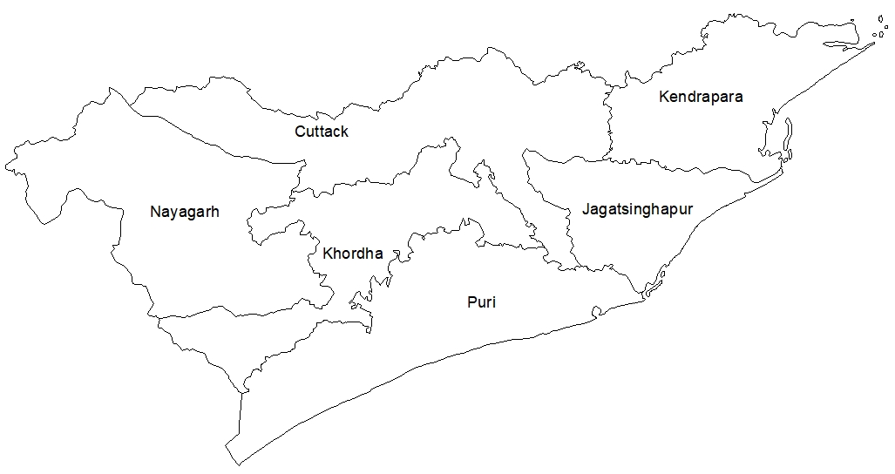
Fig. 1 Study area

Fig. 2 Flow chart of work

Data collection

Pre-processing (image correction) and image enhancement

Spectral indices, GCPs and digitized

Trained sample
Image classification by maximum likelihood supervised classification method

Classification of data with training sets

image difference and ratioing
Applying change detection algorithms (training sets) and change detection analysis

Accuracy assessment though error matrix and kappa scale
User accuracy, producer accuracy and overall

Calculate area of classes and from to change classes

Calculate surface temperature

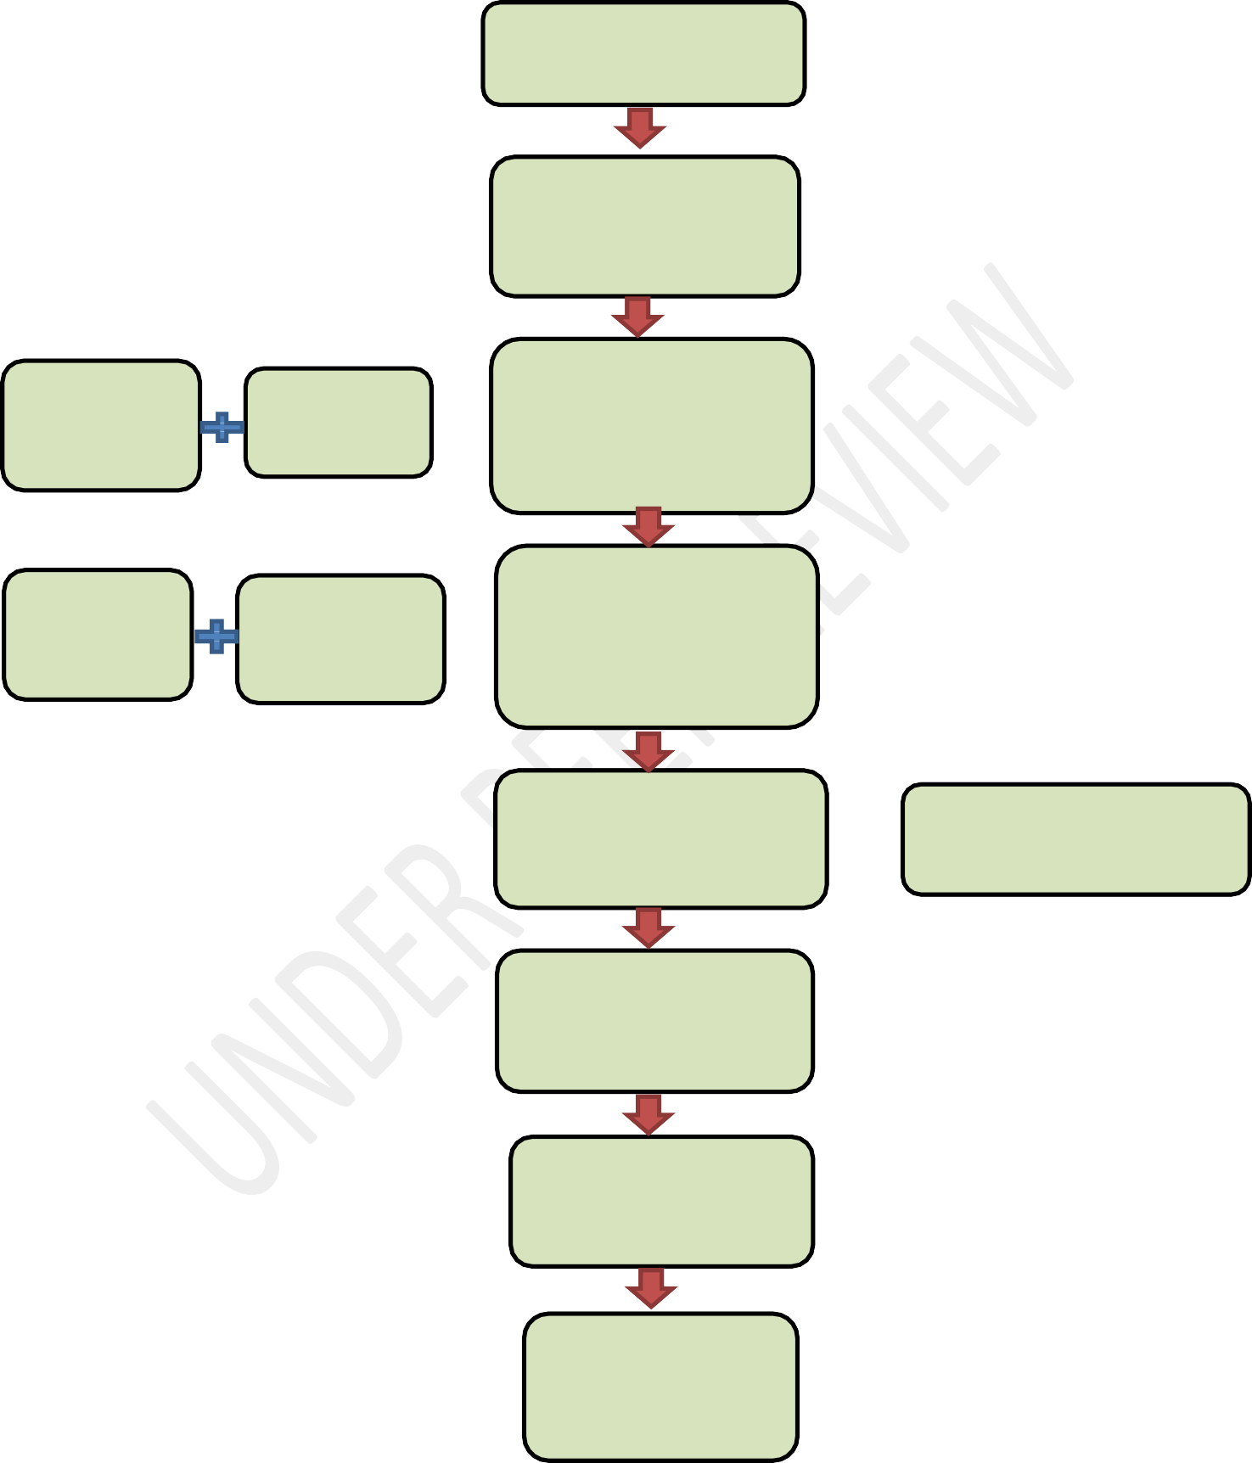










Comparing with thermal images and interpret
Applying formulae
Extraction of thermal band

Post Processing
Once the image is rectified with all sort of errors it is now ready to carry out for analysis and research.
Extraction of Area of Interest (AOI) from the data
Our research area lies in two images. So, prior to extraction mosaicking should be performed. Before extraction of data it should be geo-referenced (transforming images from geometric co-ordinate system to geographic co-ordinate system).
Landsat data used in this research is Level-1 products which auto rectified and geo- reference. Vector data (shape-files) also geo referenced.
Training Samples for Image Classification
For this study we are going to do Supervised Classification by Maximum Likelihood Classification (MLC).
It is not possible to check pixel by pixel whole image practically. So we are going to train the classification algorithm with our desired classes reflection value and run that algorithm for the whole set of data.
Once the AOI is extracted samples taken evenly throughout the AOI should be trained in respective classes. For a class minimum 50-70 samples should be taken.
These samples were made with the help of band combinations. In different combinations different features were highlighted.
Table 1. Band combination table

Features | Band combination for Landsat 5 | Band combination for Landsat 8
Natural Colour | 321 | 432
Traditional Infra-Red | 432 | 543
Urban | 653 | 764
Agriculture | 541 | 652
Land in water | 564 | 564

Classification
Once the training of samples over it will classify the whole image based on trained spectral values. For classification we used 5 major classes.
Table 2 Feature classes table

Class | Feature
1 | Forest
2 | Water bodies
3 | Settlements
4 | Barren land
5 | Agriculture

Classification Accuracy Assessment
There is no classification created from remote sensing data that can be completely accurate. As errors originate from different sources including the classification algorithm itself.
Accuracy assessment is to quantitatively determine how effectively pixels were grouped into the correct feature classes in the area under investigation.
Ground Reference test pixels
- These sites are not used to train the classification algorithm and therefore represent unbiased reference information.
- It is possible to collect some Ground Control Points (GCPs) prior to classification, perhaps at the same time as the training data.
- Most often collected after the classification using a random sample to collect the appropriate no. of unbiased observations per class.
- 30-50 reference points per class is ideal.
- Reference points should be derived from imagery or data acquired at or near the same time as the classified image.

Sample size
Sample size N to be used to assess the accuracy of a land use classification map can be derived from Binominal probability theory.
𝑍2 (𝑝) (𝑞)
𝑁 = − − − − − −
𝐸2

p = expected percent of accuracy
q = 100 – p
E = allowable error
Z = 2 (from the standard normal deviate of 1.96 for the 95 % 2 sided confidence level)
Error Matrix
Once a classification has been sampled a contingency table (also referred to as an error matrix or confusion matrix) is developed.
- This table is used to properly analyse the validity of each class as well as the classification as a whole.
- In this way we can evaluate in more detail the efficiency of the classification.
Contingency Table (model one)

Thematic map classes | Ground truth class A | Ground truth class B | Ground truth class C | No. of classified pixels
A | 35 | 2 | 2 | 39
B | 10 | 37 | 3 | 50
C | 5 | 1 | 41 | 47
No. of ground truth pixels | 50 | 40 | 46 | 136
Table 3 Model Contingency table

- Overall Accuracy
The diagonal elements tally the no. of pixels classified correctly in each class.
Total no. of corrected classification Overall accuracy = ------------------------------------------------
Total no. of classification

35+37+41
OA = = 83 %
136
But just because of 83% classification were accurate overall, does not mean that each category was successfully classified at that rate.

- User accuracy
A user of the imagery who is particularly interested in a class and might wish to know what portion of pixels assigned to that class where correctly assigned.

No. of correct classifications User accuracy = ----------------------------------------------
Total no. of classification in the category
35
User accuracy of class A = = 90%
39

- Producer Accuracy
Contrast to user accuracy, producer accuracy which has a slightly different interpretation. Producer’s accuracy is a measure of how much of the land in each category was classified correctly.

No. in diagonal cell of error matrix Producer Accuracy = --------------------------------------------------
No. in column total
35
Producer accuracy of class A = = 70 %
50

Kappa Analysis ̭
Kappa analysis yields a statistic, K which is an estimate of Kappa. It is a measure of agreement or accuracy between the remote sensing derived classification map and the reference data as indicated by the major diagonal and the change agreement, which is indicated by the row and column totals.
Kappa coefficient
It is not as sensitive to differences in sample sizes between classes and is therefore considered a more reliable measure of accuracy. Kappa should always be reported.

𝑘
𝑁 ∑
K = 𝑖=1
𝑖=1
𝑛𝑖𝑗−∑𝑘

𝑛𝑖+𝑛𝑗

𝑁2−∑𝑘
𝑖−1
𝑛𝑖−𝑛𝑗

Where,
k = no. of rows in error matrix
nij = no. of observations in row i and column j ni = total no. of observations in row i
nj = total no. of observations in column j N = total no. of observations in matrix
̭
𝐾 = 𝑁𝐴−𝐵
𝑁2−𝐵
N = no. of pixels in the error matrix (the sum of all k individual elements)
A= the sum of k diagonal elements
B= sum of the k products (row total x column total) Kappa coefficient values ranges from 0 - 1.
< 0.4 = poor
0.4-0.7= medium
>0.7 = good

From contingency table
̭ 136 𝑥 113 – [(39 𝑥 50) + (50 𝑥 40) + (47 𝑥 46)]
𝐾 = − − − − − − − − − − − − − − − − − − − − − − − − − − − − − −
136 2 − [(39 𝑥 50) + (50 𝑥 40) + (47 𝑥 46)]
̭
K = 0.74
0.74 means 74% of accuracy.

(Classification accuracy assessment by Dr.Poonam S.Tiwari Edusat IIRS)

Extraction of Land Surface Temperature (LST) from Thermal Image
From Landsat mission 5 and 8 sensors are capturing the earth scene in thermal band also.
Which is used for surface temperature studies and other thermal studies. Normalised Difference Vegetation Index threshold method (NDVI^{THM}) is used for LST calculation.

Step 1: Conversion of Top of Atmosphere (TOA) to Radiance
Top of Atmosphere is the light that reaches the sensor along with ground reflection to the sensors. So a foggy and bluish view is seen. In order remove such things the Digital Number (DN) of the thermal bands (Band 6 for Landsat 5, band 10 & 11 for Landsat 8) were converted into Radiance. (Barsi et al., 2014)
𝐿𝜆 = 𝑀𝐿 ∗ 𝑄 𝑐𝑎𝑙 + 𝐴𝐿
𝐿𝜆 = TOA spectral radiance (Watts/m² Srad µm)
𝑀𝐿= Band specific multiplicative rescaling factor from metadata. (Radiance Multi Band x, where x is band no.)
𝑄 𝑐𝑎𝑙= Quantized and calibrated standard product pixel values (DN)
𝐴𝐿= Band specific additive rescaling factor from metadata.

Step2: Conversion of Radiance into Brightness Temperature (BT)

𝐾2
𝑇 = − − − − − − − − −
𝑙𝑛 ( 𝐾1 / 𝐿 𝜆 + 1 )
Where,
T = Effective at-satellite temperature in Kelvin
K2 = Calibration constant 2
K1 = Calibration constant 1
L = Spectral radiance in watts/ (meter squared * ster * µm).

Step 3: Calculation of NDVI
Normalized Difference Vegetation Index is the commonly used index for identification of vegetation.
𝑁𝐷𝑉𝐼 = (𝑁𝐼𝑅 − 𝑅𝑒𝑑) / (𝑁𝐼𝑅 + 𝑅𝑒𝑑)
Value ranges from -1 to 1. Values more than 0 indicates shrubs, mild and dense vegetation. Less than 0 indicates mild or zero vegetation.
Step 4: Proportion of Vegetation (Pv)
PV is an essential parameter for calculating LSE according to NDVI^{THM}. In this study, PV was estimated following the NDVI traditional method (Rouse et al., 1974).
𝑃𝑣 = [(𝑁𝐷𝑉𝐼 − 𝑁𝐷𝑉𝐼 𝑚𝑖𝑚) / (𝑁𝐷𝑉𝐼 𝑚𝑎𝑥 – 𝑁𝐷𝑉𝐼 𝑚𝑖𝑛)]2
NDVI max = 1 NDVI min = -1
Step 5: Calculation of Land Surface Emissivity (LSE)
The land surface emissivity (LSE (𝜀)) must be known in order to estimate LST. The equation given by Sobrino et al. (2004) is used for LSE calculation
𝑒 = 0.004 ∗ 𝑃𝑣 + 0.986
Step 6: LST is calculated from LSE by the equation giver by Stathopoulou and Cartalis (2007).
𝑇𝐵
LST =
𝑇𝐵
[1+(𝜆∗
𝐶2)∗𝑙𝑛 (𝑒)

𝜆= Wavelength of emitted radiance

C2= h * c/s =14388 µm K
h = Planck’s constant (6.626 * 10⁻³⁴ J s⁻¹) s = Boltzman constant (1.38 * 10⁻²³ J K⁻¹) c = Velocity of light (2.998 * 10⁸ m s⁻¹)

4. RESULTS

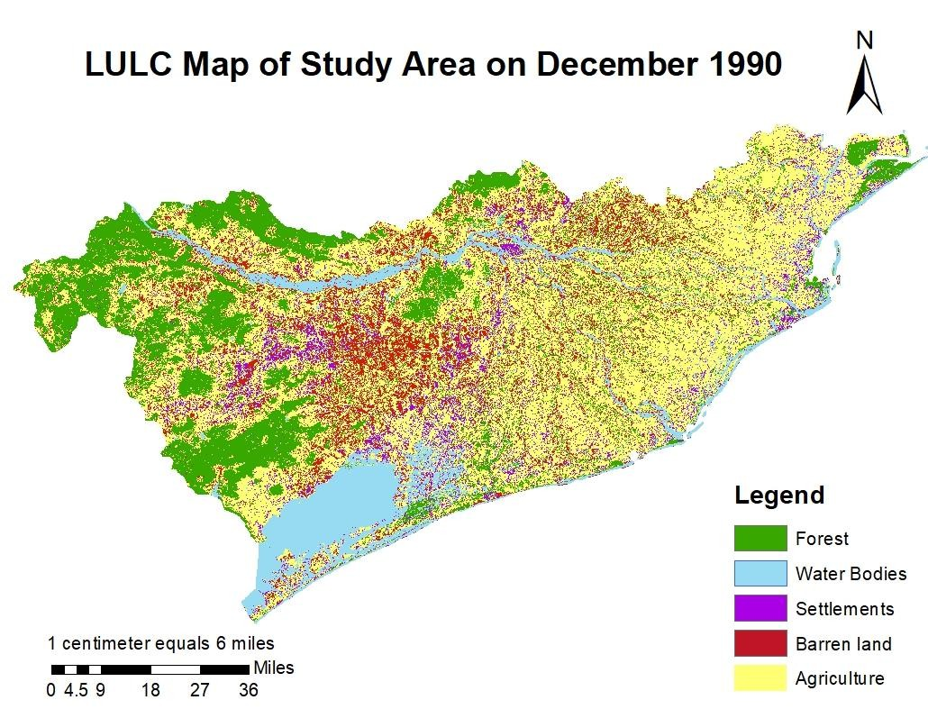
Land use land cover of any area has undergone a dramatic change over the years due to several reasons. To understand the changes in LULC of East and South Eastern Coastal Plain Zone of Odisha and its consequential effect on land surface temperature the present study was designed and the changes in LULC during past thirty years (1990 to 2019) of the zone studied carefully and quantified the changes in land use and its effect on the land surface temperature using geospatial technology. The output of the research is given in thematic maps, pie charts, bar diagrams and the comprehensive sequential comparison table for better understanding. The pertinent findings of the study is presented in this chapter and the structure of the results are fallows;
LULC Maps of the Study Area
LULC Maps of the study area were prepared for 1990, 2000, 2009 and 2018 by using Arc Map 10.3 tool. Supervised classification images contains 5 major classes of Forest, water bodies, settlements, barren land and agriculture. These classes were made on their spectral range variation in False Colour Composite image. Pixel values of the classified images were converted into real time field value in sq.km.

Fig. 3. LULC Map of Study Area in December 1990

Table 4 Different classes of land use and its coverage in 1990

Land Cover Classes | Area in sq.km | Percentage coverage
Forest | 4714.45 | 25.71
Water Bodies | 2181.92 | 11.90
Settlements | 1233.46 | 6.73
Barren land | 2209.02 | 12.04
Agriculture | 8000.40 | 43.62
Total | 18339.25 | 100.00

Distribution of Land use in 1990
East and South Eastern Coastal Plain Zone of Odisha was the study area and classified into five above classes by using the supervised classification in the satellite image of the study area collected in December 1990. The total coverage of the study area is 18330.25 sq. km. Then the area under each class was quantified and is presented in Table 5, Fig. 5 and 7. The coverage under each class clearly indicated that highest area is covered under agriculture (43.67%) followed by forest (25.17%), barren land (12.04%), water bodies (11.90%) and built up
/settlement area (6.73%), respectively.
25.71
Forest
43.62
Water Bodies

Settlements
11.90
Barren land
6.73
Agriculture
12.05
Fig. 4. Percentage coverage of different classes of land in the year 1990

Area in Sq.km


Fig. 5. Land cover distribution table 1990
9000
8000
7000
6000
5000
4000
3000
2000
1000
0
8000.3
4714.45
2181.92
2209.02
1233.46
Forest Water Bodies Settlements Barren land Agriculture
Forest
Water Bodies
Settlements
Barren land
Agriculture
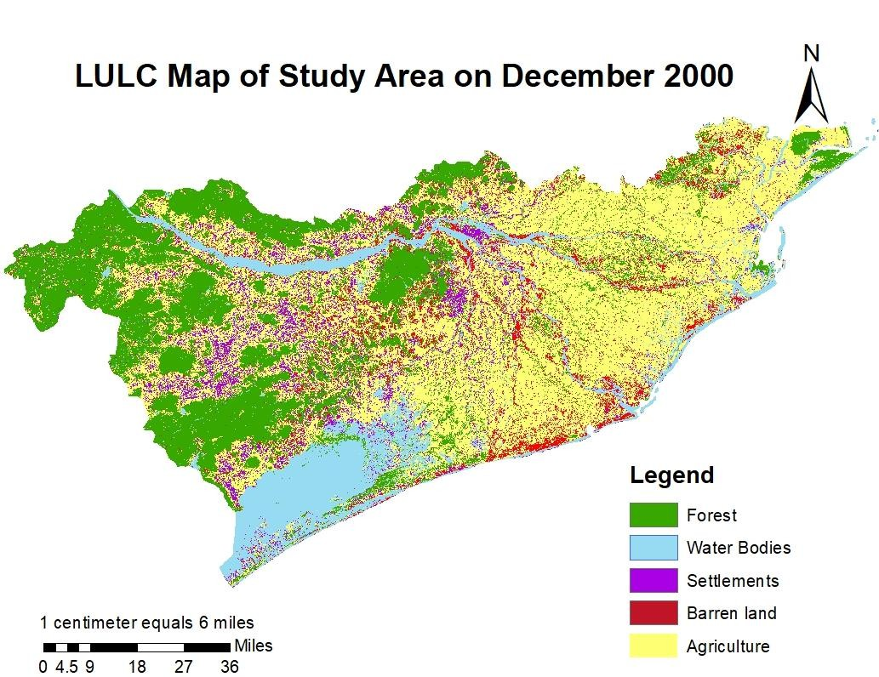
Fig. 6. LULC Map of the Study Area in Dec 2000

Table. 5 Distribution of land use in 2000

Land Cover Classes | Area in sq.km | Percentage coverage | Changes over 1990  (sq.km)
Forest | 4617.55 | 25.18 | -96.9
Water Bodies | 2316.47 | 12.63 | 134.55
Settlements | 1297.69 | 7.08 | 64.23
Barren land | 2126.82 | 11.60 | -82.20
Agriculture | 7980.72 | 43.52 | -19.68
Total | 18399.25 | 100.00 | 0.00

4.1.2 Distribution of Land use in 2000
25.18
Forest
43.52
Water Bodies

Settlements
12.63
Barren land
7.08
Agriculture
11.60
The supervised classes of different land use class in 2000 revealed the fact that the coverage under forest, barren land and agriculture decreased whereas the area under water bodies and settlements increased over the distribution of land in 1990. The extent of decline was by 96.9, 82.2 and 19.68 sq. km in forest, barren land and agriculture la, respectively. Whereas the water bodies and settlement area was increased by 134.55 and 64.23 sq. km over 1990.

Fig.7. Percentage coverage of different classes of land in the year 2000

Area in Sq.km


Fig. 8. Coverage of different classes of land in the year 2000
Agriculture
Barren land
Settlements
Water Bodies
Forest
Forest Water Bodies Settlements Barren land Agriculture
1297.69
2126.82
2316.47
4617.55
7980.72
9000
8000
7000
6000
5000
4000
3000
2000
1000
0
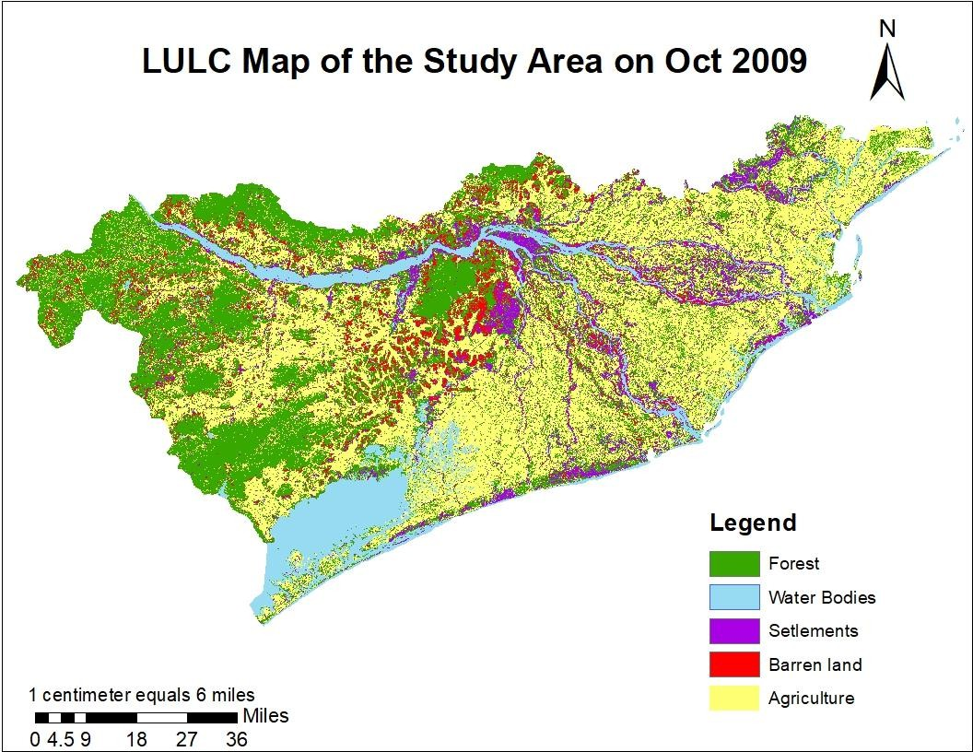
Fig. 9. LULC Map of Study Area on October 2009

Table. 6 Distribution of land use in 2009
25.06
Forest
43.07
Water Bodies

Settlements
11.61
Barren land

Agriculture
8.56
11.70

4.1.3 Distribution of Land use in 2009
The supervised classification of different types of land use and the coverage of each class presented in Table 7, Fig 10 and 11. The coverage area under different class pointed out that the area under forest, water bodies and agriculture decreased over the area in 2000. However, in 2009 the water bodies and decreased and the barren land area increased which was just reverse the case in 2000. The forest area and the area under agriculture was further decreased whereas, the settlement area increased further in 2009.

Land use classes | Area in sq.km | Percentage  coverage | Change over 2000  (sq. km)
Forest | 4595.47 | 25.06 | -22.08
Water Bodies | 2128.49 | 11.61 | -187.98
Settlements | 1570.62 | 8.56 | 272.93
Barren land | 2145.08 | 11.70 | 18.26
Agriculture | 7899.59 | 43.07 | -81.13
Total | 18399.25 | 100.00 | 0.00


Fig. 10. Percentage coverage of different classes of land in the year 2009
Agriculture
Barren land
Settlements
Water Bodies
Forest
Forest Water Bodies Settlements Barren land Agriculture
1570.62
2145.08
2128.49
4595.47
7899.59
9000
8000
7000
6000
5000
4000
3000
2000
1000
0
Area in Sq.km

Fig. 11. Coverage of different classes of land in the year 2009
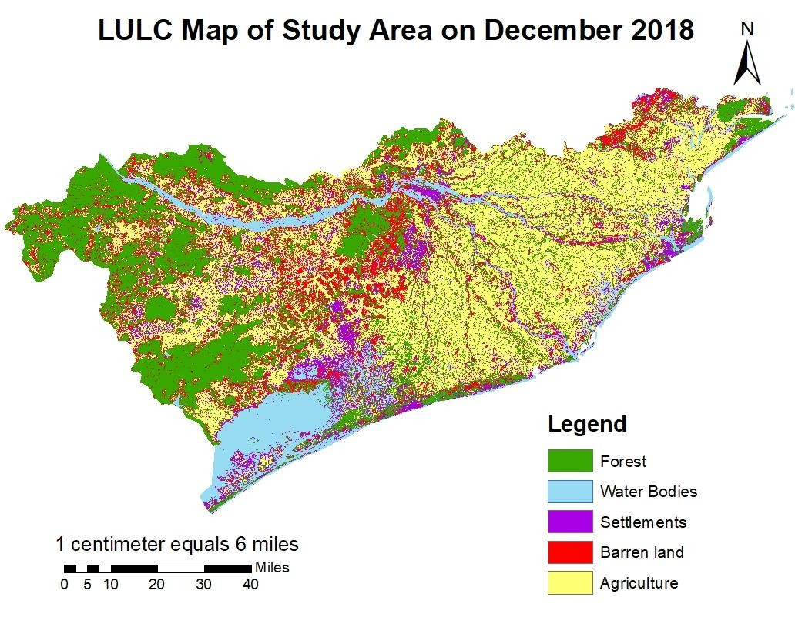

Fig. 12. LULC Map of Study Area on Dec 2018

Table. 7 Distribution of land use in 2018

Land use classes | Area in sq.km | Percentage coverage | Changes over 2009 (sq. km)
Forest | 4486.18 | 24.46 | -109.29
Water Bodies | 2117.95 | 11.55 | -10.54
Settlements | 1696.61 | 9.25 | 125.99
Barren land | 2103.16 | 11.47 | -41.92
Agriculture | 7935.35 | 43.26 | 35.76
Total | 18399.25 | 100.00 | 0.00

Distribution of Land use in 2018
The data on coverage of different land use classes graphically depicted in Fig. 13 and 14 which clearly explained that like 2009 the forest and water bodies’ expansion decreased and settlement area increased further (Kumar et al.,2023) but the barren land decreased and agriculture land increased which was just reverse of 2009. The extent of decrease in forest water bodies and barren land was to the tune of 109.29, 10.54 and 41.92 sq.km, respectively whereas, the increase in settlement area and agricultural land was by 125.99 and 35.76 sq. km over the year 2009.
24.46
Forest

Water Bodies
43.27
Settlements
11.55
Barren land

Agriculture
9.25
11.47

Fig. 13. Percentage coverage of different classes of land in the year 2018
Agriculture
Barren land
Settlements
Water Bodies
Forest
Forest Water Bodies Settlements Barren land Agriculture
2103.16
1696.61
2117.95
4486.18
7935.35
9000
8000
7000
6000
5000
4000
3000
2000
1000
0
Land cover distribution in Nov 2018
Area in Sq.km

Fig. 14. Coverage of different classes of land in the year 2018

Accuracy Assessment of the classified images
To check the accuracy of the classification made, two methods were implied viz., Error Matrix and Kappa Co-efficient. In order to evaluate these two Contingency table is formed which is nothing but summary of Sample classified data with Ground Control Points. For Error Matrix overall accuracy, user & producer accuracy were calculated. Results were given in percentage. For Kappa Co-efficient results were given in decimal points. The range is between 0.1-1.0
Accuracy Assessment for 1990 classification

For accuracy assessment of the LULC classification in 1990 the following contingency table was prepared using which the error matrix and kappa coefficient were estimated.
Table 8 Contingency table of 1990

Classes | Forest | Water Bodies | Settlements | Barren land | Agriculture | No. of classified pixels
Forest | 50 | 0 | 0 | 2 | 4 | 56

Water Bodies | 0 | 60 | 0 | 0 | 2 | 62
Settlements | 0 | 11 | 46 | 4 | 6 | 58
Barren land | 0 | 1 | 0 | 49 | 3 | 53
Agriculture | 0 | 0 | 3 | 4 | 64 | 71
No. Ground truth pixels | 50 | 63 | 49 | 59 | 79 | 300

By Error Matrix,

Overall accuracy = 𝑇𝑜𝑡𝑎𝑙 𝑛𝑜.𝑜𝑓 𝑐𝑜𝑟𝑟𝑒𝑐𝑡𝑒𝑑 𝑐𝑙𝑎𝑠𝑠𝑖𝑓𝑖𝑐𝑎𝑡𝑖𝑜𝑛
𝑇𝑜𝑡𝑎𝑙 𝑛𝑜.𝑜𝑓 𝑐𝑙𝑎𝑠𝑠𝑖𝑓𝑖𝑐𝑎𝑡𝑖𝑜𝑛

= 50+60+46+49+64 X 100
300
= ²⁶⁹ x 100
300
Overall accuracy= 89.7 %

User accuracy = 𝑁𝑜. 𝑜𝑓 𝑐𝑜𝑟𝑟𝑒𝑐𝑡 𝑐𝑙𝑎𝑠𝑠𝑖𝑓𝑖𝑐𝑎𝑡𝑖𝑜𝑛
𝑇𝑜𝑡𝑎𝑙 𝑛𝑜. 𝑜𝑓 𝑐𝑙𝑎𝑠𝑠𝑖𝑓𝑖𝑐𝑎𝑡𝑖𝑜𝑛 𝑖𝑛 𝑡ℎ𝑒 𝑐𝑎𝑡𝑒𝑔𝑜𝑟𝑦
User accuracy for Forest = ⁵⁰ X 100 = 89.2 %
56
User accuracy for Water Bodies = ⁶⁰ X 100= 96 %
62
User accuracy for Settlements = ⁴⁶ X 100= 79.3 %
58
User accuracy for Barren land = ⁴⁹ X 100 = 92.4 %
53
User accuracy for Agriculture = ⁶⁴ X 100 = 90.1 %
71

Producer Accuracy = 𝑁𝑜.𝑖𝑛 𝑑𝑖𝑎𝑔𝑜𝑛𝑎𝑙 𝑐𝑒𝑙𝑙 𝑜𝑓 𝑒𝑟𝑟𝑜𝑟 𝑚𝑎𝑡𝑟𝑖𝑥-
𝑁𝑜.𝑖𝑛 𝑐𝑜𝑙𝑢𝑚𝑛 𝑡𝑜𝑡𝑎𝑙

Producer accuracy for Forest = ⁵⁰ X 100 = 100 %
50

Producer accuracy for Water Bodies = ⁶⁰ X 100 = 95 %
63

Producer accuracy for Settlements = ⁴⁶ X 100 = 93.8 %
49

Producer accuracy for Barren land = ⁵⁰ X 100 = 89.2 %
56

Producer accuracy for Agriculture = ⁶⁴ X 100 = 81 %
79

By Kappa Co-efficient
̭
𝐾 = 𝑁𝐴−𝐵
𝑁2−𝐵
= (300 𝑋 269)−[(56 𝑋 50)+( 62 𝑋 63)+(58 𝑋 49)+(53 𝑋 59)+(71 𝑋 79)]
(300 𝑋 300) − [(56 𝑋 50)+( 62 𝑋 63)+(58 𝑋 49)+(53 𝑋 59)+(71 𝑋 79)]

= 80700−18284
90000−18284
= 0.87
The accuracy assessment of the LULC classification made in 1990 was made by using error matrix and Kappa coefficient value which were estimated from the contingency table. The error matrix of 89% and the Kappa coefficient value of 0.87 clearly explained that the classification of LULC in 1990 is acceptable.

Accuracy Assessment for 2000 Classification
For accuracy assessment of the LULC classification in 2000 the following contingency table was prepared using which the error matrix and kappa coefficient were estimated.
Table 9 Contingency table for 2000

Classes | Forest | Water Bodies | Settlements | Barren land | Agriculture | No. of classified pixels
Forest | 54 | 0 | 0 | 1 | 1 | 56
Water Bodies | 1 | 56 | 0 | 3 | 2 | 62
Settlements | 0 | 4 | 48 | 4 | 2 | 58
Barren land | 0 | 2 | 2 | 44 | 5 | 53
Agriculture | 0 | 1 | 3 | 2 | 65 | 71
No. Ground truth pixels | 55 | 63 | 53 | 54 | 75 | 300

By Error Matrix,

Overall accuracy = 𝑇𝑜𝑡𝑎𝑙 𝑛𝑜. 𝑜𝑓 𝑐𝑜𝑟𝑟𝑒𝑐𝑡𝑒𝑑 𝑐𝑙𝑎𝑠𝑠𝑖𝑓𝑖𝑐𝑎𝑡𝑖𝑜𝑛
𝑇𝑜𝑡𝑎𝑙 𝑛𝑜. 𝑜𝑓 𝑐𝑙𝑎𝑠𝑠𝑖𝑓𝑖𝑐𝑎𝑡𝑖𝑜𝑛

= 54+56+48+44+65 X 100
300

= ²⁶⁷ x 100
300

Overall accuracy= 89 %

User accuracy = 𝑁𝑜. 𝑜𝑓 𝑐𝑜𝑟𝑟𝑒𝑐𝑡 𝑐𝑙𝑎𝑠𝑠𝑖𝑓𝑖𝑐𝑎𝑡𝑖𝑜𝑛
𝑇𝑜𝑡𝑎𝑙 𝑛𝑜.𝑜𝑓 𝑐𝑙𝑎𝑠𝑠𝑖𝑓𝑖𝑐𝑎𝑡𝑖𝑜𝑛 𝑖𝑛 𝑡ℎ𝑒 𝑐𝑎𝑡𝑒𝑔𝑜𝑟𝑦

User accuracy for Forest = ⁵⁴ X 100 = 96.4 %
56
User accuracy for Water Bodies = ⁵⁶ X 100= 90.3 %
62
User accuracy for Settlements = ⁴⁸ X 100= 82.7 %
58
User accuracy for Barren land = ⁴⁴ X 100 = 83 %
53
User accuracy for Agriculture = ⁶⁵ X 100 = 91.5 %
71

Producer Accuracy = 𝑁𝑜. 𝑖𝑛 𝑑𝑖𝑎𝑔𝑜𝑛𝑎𝑙 𝑐𝑒𝑙𝑙 𝑜𝑓 𝑒𝑟𝑟𝑜𝑟 𝑚𝑎𝑡𝑟𝑖𝑥-
𝑁𝑜. 𝑖𝑛 𝑐𝑜𝑙𝑢𝑚𝑛 𝑡𝑜𝑡𝑎𝑙

Producer accuracy for Forest = ⁵⁴ X 100 = 98.1 %
55

Producer accuracy for Water Bodies = ⁵⁶ X 100 = 88.8 %
63

Producer accuracy for Settlements = ⁴⁸ X 100 = 90.5 %
53

Producer accuracy for Barren land = ⁴⁴ X 100 = 81.4 %
54

Producer accuracy for Agriculture = ⁶⁵ X 100 = 86.6 %
75
By Kappa Co-efficient
̭
𝐾 = 𝑁𝐴−𝐵
𝑁2−𝐵
= (300 𝑋 267)−[(56 𝑋 55)+( 62 𝑋 63)+(58 𝑋 53)+(53 𝑋 54)+(71 𝑋 75)]
300 𝑋 300 − [(56 𝑋 55)+( 62 𝑋 63)+(58 𝑋 53)+(53 𝑋 54)+(71 𝑋 75)]

= 80100−18247
90000−18247
Kappa Co-efficient = 0.86

The error matrix of 89% and Kappa coefficient value of 0.86 clearly indicated that the classification made in 2000 is quite acceptable.

Accuracy Assessment of 2009 Classification
For accuracy assessment of the LULC classification in 2009 the following contingency table was prepared using which the error matrix and kappa coefficient were estimated.
Table 10 Contingency table for 2009

Classes | Forest | Water Bodies | Settlements | Barren land | Agriculture | No. of classified  pixels
Forest | 52 | 0 | 0 | 1 | 3 | 56
Water Bodies | 0 | 59 | 0 | 3 | 0 | 62
Settlements | 0 | 5 | 41 | 7 | 5 | 58
Barren land | 0 | 3 | 0 | 44 | 6 | 53
Agriculture | 2 | 0 | 2 | 4 | 63 | 71
No. Ground  truth pixels | 54 | 67 | 43 | 59 | 77 | 300

User accuracy = 𝑁𝑜. 𝑜𝑓 𝑐𝑜𝑟𝑟𝑒𝑐𝑡 𝑐𝑙𝑎𝑠𝑠𝑖𝑓𝑖𝑐𝑎𝑡𝑖𝑜𝑛 -
By Error Matrix,
Overall accuracy = 𝑇𝑜𝑡𝑎𝑙 𝑛𝑜. 𝑜𝑓 𝑐𝑜𝑟𝑟𝑒𝑐𝑡𝑒𝑑 𝑐𝑙𝑎𝑠𝑠𝑖𝑓𝑖𝑐𝑎𝑡𝑖𝑜𝑛
𝑇𝑜𝑡𝑎𝑙 𝑛𝑜. 𝑜𝑓 𝑐𝑙𝑎𝑠𝑠𝑖𝑓𝑖𝑐𝑎𝑡𝑖𝑜𝑛
= 52+59+41+44+63 X 100
300
= ²⁵⁹ x 100
300
Overall accuracy= 86.3 %
𝑇𝑜𝑡𝑎𝑙 𝑛𝑜. 𝑜𝑓 𝑐𝑙𝑎𝑠𝑠𝑖𝑓𝑖𝑐𝑎𝑡𝑖𝑜𝑛 𝑖𝑛 𝑡ℎ𝑒 𝑐𝑎𝑡𝑒𝑔𝑜𝑟𝑦

User accuracy for Forest = ⁵² X 100 = 92.8 %
56

User accuracy for Water Bodies = ⁵⁹ X 100= 95.1 %
62

User accuracy for Settlements = ⁴¹ X 100= 70.6%
58

User accuracy for Barren land = ⁴⁴ X 100 = 83 %
53

User accuracy for Agriculture = ⁶³ X 100 = 88.7 %
71

Producer Accuracy = 𝑁𝑜. 𝑖𝑛 𝑑𝑖𝑎𝑔𝑜𝑛𝑎𝑙 𝑐𝑒𝑙𝑙 𝑜𝑓 𝑒𝑟𝑟𝑜𝑟 𝑚𝑎𝑡𝑟𝑖𝑥
𝑁𝑜. 𝑖𝑛 𝑐𝑜𝑙𝑢𝑚𝑛 𝑡𝑜𝑡𝑎𝑙

Producer accuracy for Forest = ⁵² X 100 = 96.2 %
54

Producer accuracy for Water Bodies = ⁵⁹ X 100 = 88 %
67

Producer accuracy for Settlements = ⁴¹ X 100 = 95.3 %
43

Producer accuracy for Barren land = ⁴⁴ X 100 = 74.5 %
59

Producer accuracy for Agriculture = ⁶³ X 100 = 81.8 %
77
By Kappa Co-efficient
̭
𝐾 = 𝑁𝐴−𝐵
𝑁2−𝐵
= (300 𝑋 259)−[(56 𝑋 54)+( 62 𝑋 67)+(58 𝑋 43)+(53 𝑋 59)+(71 𝑋 77)]
300 𝑋 300 − [(56 𝑋 54)+( 62 𝑋 67)+(58 𝑋 43)+(53 𝑋 59)+(71 𝑋 77)]

= 77700−18266
90000−18266
Kappa Co-efficient = 0.82
The overall accuracy value of 86.3% in error matrix and the kappa coefficient value of
0.82 clearly indicated that the classification of LULC made for 2009 is acceptable.
Accuracy Assessment of 2018 Classification
For accuracy assessment of the LULC classification in 2018 the following contingency table (Table 11) was prepared using which the error matrix and kappa coefficient were estimated.
Table.11 Contingency table for 2018

Classes | Forest | Water Bodies | Settlements | Barren land | Agriculture | No. of classified pixels
Forest | 53 | 0 | 0 | 0 | 3 | 56
Water Bodies | 0 | 59 | 2 | 0 | 1 | 62
Settlements | 0 | 0 | 40 | 9 | 9 | 58

Barren land | 0 | 5 | 0 | 42 | 6 | 53
Agriculture | 3 | 0 | 0 | 3 | 65 | 71
No. Ground truth pixels | 56 | 64 | 42 | 54 | 84 | 300

By Error Matrix,

Overall accuracy = 𝑇𝑜𝑡𝑎𝑙 𝑛𝑜.𝑜𝑓 𝑐𝑜𝑟𝑟𝑒𝑐𝑡𝑒𝑑 𝑐𝑙𝑎𝑠𝑠𝑖𝑓𝑖𝑐𝑎𝑡𝑖𝑜𝑛
𝑇𝑜𝑡𝑎𝑙 𝑛𝑜.𝑜𝑓 𝑐𝑙𝑎𝑠𝑠𝑖𝑓𝑖𝑐𝑎𝑡𝑖𝑜𝑛

= 53+59+40+42+65 X 100
300
= ²⁵⁹ x 100
300
Overall accuracy= 86.3 %
User accuracy = 𝑁𝑜.𝑜𝑓 𝑐𝑜𝑟𝑟𝑒𝑐𝑡 𝑐𝑙𝑎𝑠𝑠𝑖𝑓𝑖𝑐𝑎𝑡𝑖𝑜𝑛
𝑇𝑜𝑡𝑎𝑙 𝑛𝑜.𝑜𝑓 𝑐𝑙𝑎𝑠𝑠𝑖𝑓𝑖𝑐𝑎𝑡𝑖𝑜𝑛 𝑖𝑛 𝑡ℎ𝑒 𝑐𝑎𝑡𝑒𝑔𝑜𝑟𝑦
User accuracy for Forest = ⁵³ X 100 = 94.6 %
56
User accuracy for Water Bodies = ⁵⁹ X 100= 95.1 %
62
User accuracy for Settlements = ⁴⁰ X 100= 68.9%
58
User accuracy for Barren land = ⁴² X 100 = 79.2 %
53
User accuracy for Agriculture = ⁶⁵ X 100 = 91.5 %
71
Producer Accuracy = 𝑁𝑜.𝑖𝑛 𝑑𝑖𝑎𝑔𝑜𝑛𝑎𝑙 𝑐𝑒𝑙𝑙 𝑜𝑓 𝑒𝑟𝑟𝑜𝑟 𝑚𝑎𝑡𝑟𝑖𝑥
𝑁𝑜.𝑖𝑛 𝑐𝑜𝑙𝑢𝑚𝑛 𝑡𝑜𝑡𝑎𝑙

Producer accuracy for Forest = ⁵³ X 100 = 94.6 %
56

Producer accuracy for Water Bodies = ⁵⁹ X 100 = 92.1 %
64

Producer accuracy for Settlements = ⁴⁰ X 100 = 95.2 %
42

Producer accuracy for Barren land = ⁴² X 100 = 77.7 %
54

Producer accuracy for Agriculture = ⁶⁵ X 100 = 77.3 %
84

By Kappa Co-efficient

̭
𝐾 = 𝑁𝐴−𝐵
𝑁2−𝐵
= (300 𝑋 259)−[(56 𝑋 56)+( 62 𝑋 64)+(58 𝑋 42)+(53 𝑋 54)+(71 𝑋 84)]
300 𝑋 300 − [(56 𝑋 56)+( 62 𝑋 64)+(58 𝑋 42)+(53 𝑋 54)+(71 𝑋 84)]

= 77700−19338
90000−19388
Kappa Co-efficient = 0.82
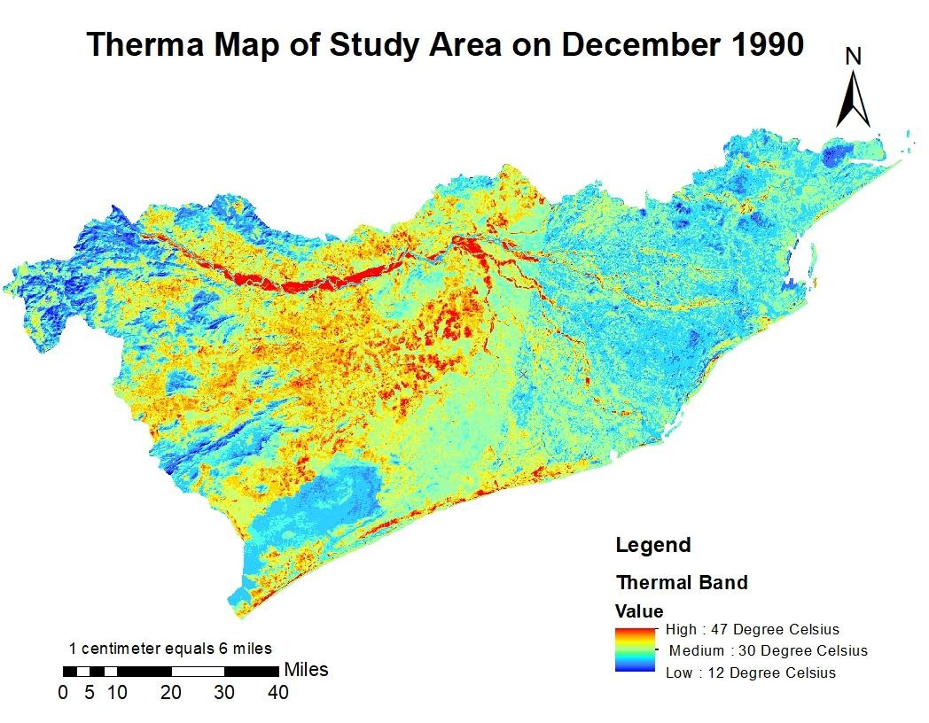
The overall accuracy value of 86.3% in error matrix and the kappa coefficient value of
0.82 clearly indicated that the classification of LULC made for 2009 is acceptable.
Thermal Maps of the Study Area
For understanding the impacts of change in land use and land cover, on land surface temperature the thermal maps were prepared for the corresponding years. Thermal data were extracted from the same satellite images using band 6 of Landsat 5, band 10 & 11 of Landsat
8. The thermal maps are prepared for visual interpretation and bar chart is prepared for grouping of area cover in following range. Each pixel in the images is grouped into its respective temperature range and quantified the area of coverage in different temperature ranges. Selected temperature ranges were as fallows.
Low < 25⁰ C; Medium 25- 35⁰ C; High > 35⁰ C
Each image has its unique maximum and minimum points with respect to date and month of acquisition.

Fig. 15. Thermal map of Dec 1990

Distribution temperature ranges in 1990
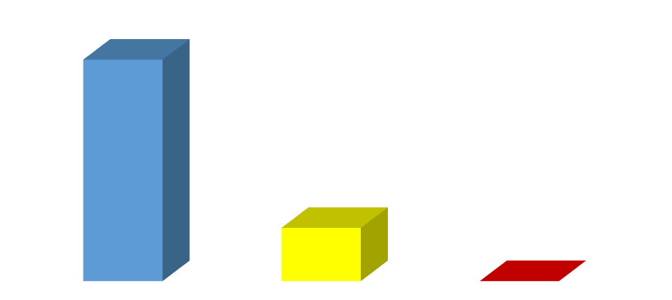
The coverage of different temperature ranges in the year 1990 are presented in Table 12 and Fig. 16 which clearly indicated that almost 80.61% of land covered by low temperature range and 19.39% of land covered by medium temperature range. However, very meagre area of 0.1 sq.km was covered by high temperature range which was marginal and does not any percentage value.
Table 12 Coverage of different temperature range category in sq. km
16000
14000
12000
10000
8000
6000
4000
2000
Low Medium
High
Temperature Category

Temperature category | 1990 | Percentage coverage
Low <25ºC | 14783.83 | 80.61
Medium 25 ºC-35ºC | 3555.32 | 19.39
High >35ºC | 0.1 | 0.00
TOTAL | 18339.25 | 100.00

0 | Low | Medium | High
Series1 | 14783.83 | 3555.32 | 0.1

Fig. 16. Distribution of different temperature category in 1990 Distribution temperature ranges in 2000
Area in sq. km
The visual interpretation of thermal map of 2000 (Fig. 17) clearly indicated the distribution of temperature ranges. Low temperature category covered 27.68, medium 72.28 and high 0.04%, respectively. The low temperature coverage declined drastically by 9707.44 sq. km whereas, medium category increased by almost 9700.32 sq.km. However, a marginal increase (7.12 sq. km) was also noticed in high category of temperature ranges Table 13 and Fig. 18 & 19.

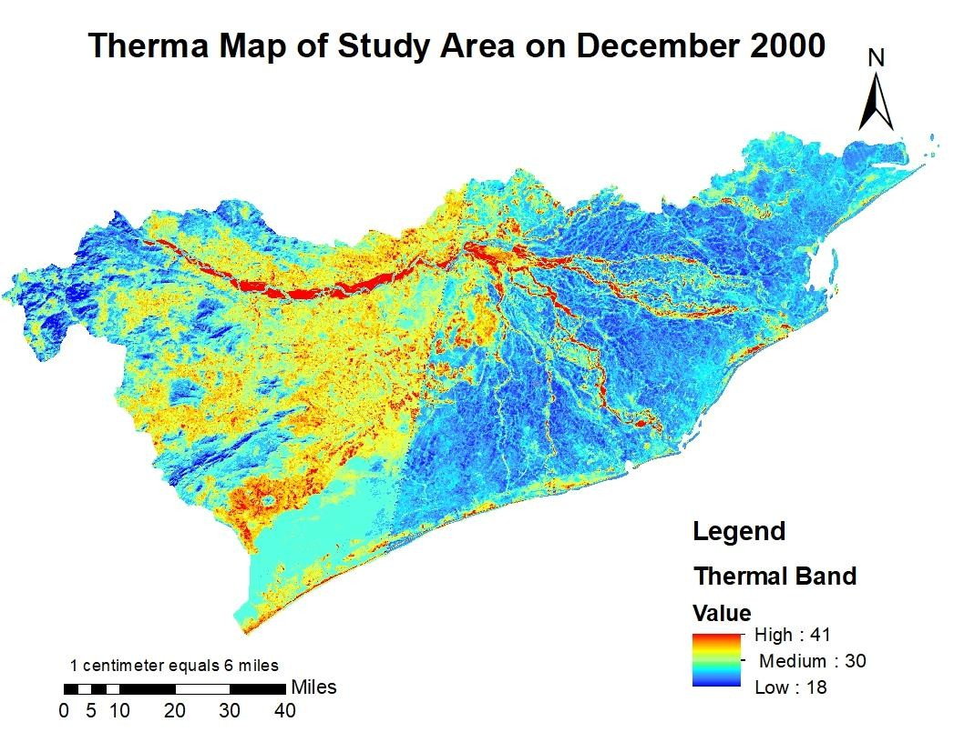
Table 13 Coverage of different temperature range category in sq. km in 2000

Temperature category | Area in sq. km | Percentage  coverage | Changes over 1990
Low <25oC | 5076.39 | 27.68 | -9707.44
Medium 25 oC-35oC | 13255.64 | 72.28 | 9700.32
High >35oC | 7.22 | 0.04 | 7.12
TOTAL | 18339.25 | 100.0 | 0.0

Fig. 17. Thermal Map of Dec 2000

0 | Low | Medium | High
Series1 | 5076.39 | 13255.64 | 7.22


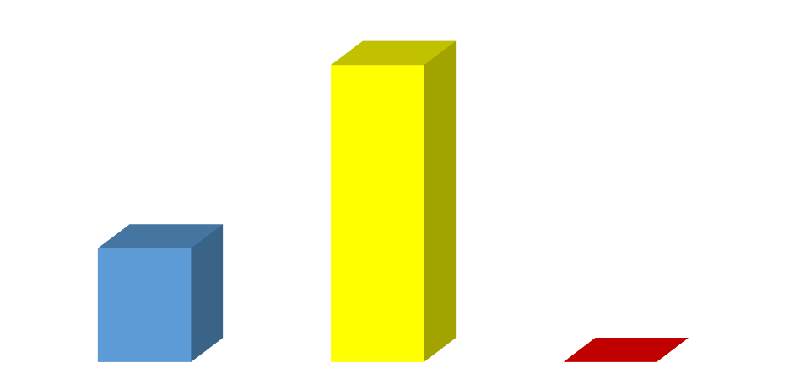
Fig. 18. Distribution of different temperature category in 2000
14000
12000
10000
Low
Medium
High
8000
6000
4000
2000
Temperature Category
Area in sq.km

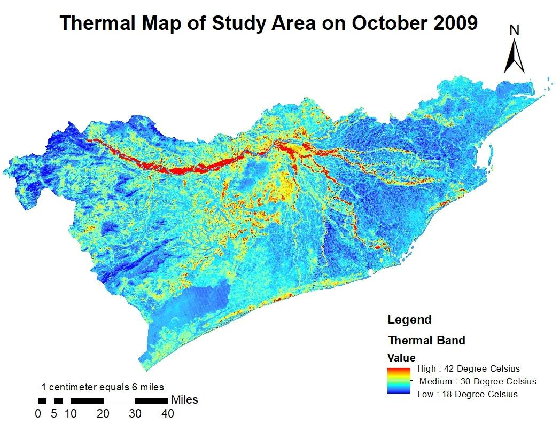
Fig. 19. Thermal Map of Oct 2009 Distribution temperature ranges in 2009
The distribution of different temperature category ranges in 2009 is presented in Table 14, Fig. 20 and 21. This distribution clearly pointed out the fact that the temperature in high

category range increased remarkably whereas the low and medium category ranges decreased. Almost more than 55% of coverage was in medium range while 25.59 and 18.57% of area covered with low and high temperature ranges.
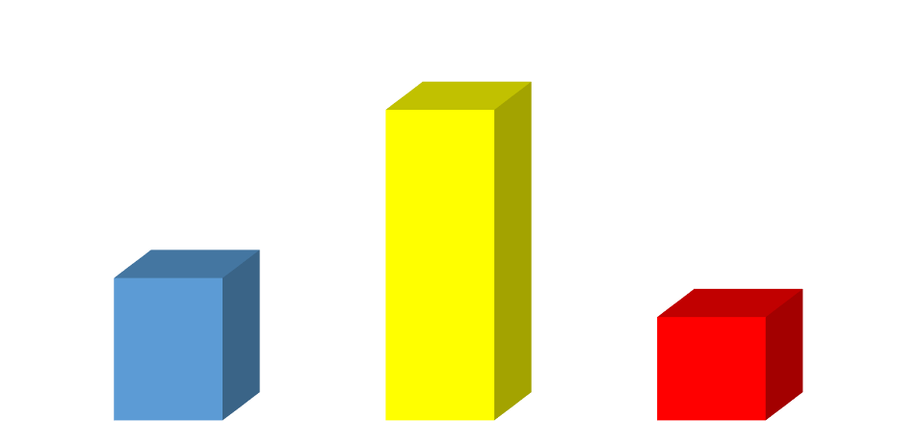
Table 14 Coverage of different temperature range category in sq. km in 2009
Low Medium High
12000

10000

8000

6000

4000

2000
Temperature Category

Temperature category | 2009 | Percentage coverage | Changes over 1990 | Changes over 2000
Low <25oC | 4693.84 | 25.59 | -10089.99 | -382.55
Medium 25 oC-35oC | 10240.21 | 55.84 | 6684.89 | -3015.43
High >35oC | 3405.2 | 18.57 | 3405.1 | 3397.98
TOTAL | 18339.25 | 100.0 | 0 | 0

0 | Low | Medium | High
Series1 | 4693.84 | 10240.21 | 3405.2

Fig. 20. Distribution of different temperature category in 2009
Area in sq. km

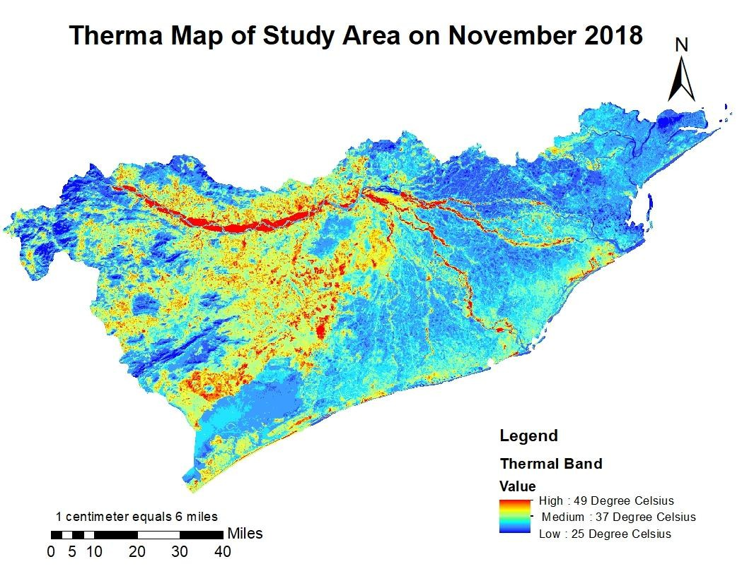
Fig. 21. Thermal Map of Nov 2018

4.3.3 Distribution temperature ranges in 2018
Looking into the distribution of different temperature category in 2018 it was clearly revealed the fact that no area of the zone is coming under the low temperature category whereas almost 64% was coming under medium temperature category range and 36% under high temperature range. The low temperature range decreased continuously from 1990 to 2018 and in 2018 it become absolute zero while the high temperature range increased continuously from a marginal 0.1 sq. km in 1990 to almost 6605 sq. km in 2018 (Table 15 and Fig. 22).
Table 15 Coverage of different temperature range category in sq. km in 2018

Temperature category | 2018 | Percentag e coverage | Changes over 1990 | Changes over 2000 | Changes over 2009
Low <25oC | 0.0 | 0.0 | -14783.8 | -5076.39 | -4693.84
Medium 25 oC-35oC | 11733.87 | 63.98 | 8178.55 | -1521.77 | 1493.66
High >35oC | 6605.38 | 36.02 | 6605.25 | 6598.13 | 3200.15

TOTAL | 18339.25 | 100.0 | 0.0 | 0.0 | 0.0

0 | Low | Medium | High
Series1 | 0 | 11733.87 | 6605.38

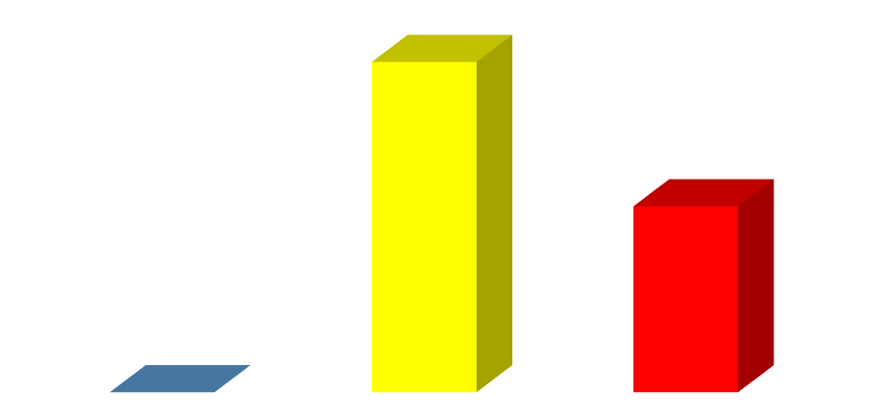
Fig. 22. Distribution of different temperature category in 2018
Low
Medium
High
12000
10000
8000
6000
4000
2000
Temperature Category
Area in sq. km

DISCUSSION LAND USE LAND COVER CHANGES
During 1990 forest cover was 4714.45 Sq.km but in 2018 it was reduced to 4486.18. The constant decrease in forest area was mostly because of the encroachment of the forest land for some other purposes like agriculture, infrastructure development, mining and similar developmental activities. The class water bodies include Ponds, Lakes, Rivers and other streams. In our study area the class water body covers 2181.92 sq. km during 1990 but in 2018 it was reduced to 2117.95 sq. km (Land use management in Odisha by Barath et al., 2013). But in 1999 classification, water bodies’ registered 134.55 sq.km increase compared to previous classification in 1990. Unlike forest, water bodies don’t show a constant decrease it increases then decreases. The unusual increase in water bodies in this zone during 1999/2000 was mostly because this zone experienced a devastating super cyclone accompanied with heavy rainfall during October 1999 which ultimately increased the waterlogged area that resembled like water bodies. In the subsequent years the area under water bodies decreased remarkably. Similar observations were also made in Mahanadi and coastal basins by Hsieh et al., 2002 under flood like situation. Besides, the decreasing of water bodies in later years after 2000 may be ascribed to the fact of encroachment of such areas for construction and other developmental activities. Both Residential and Non-residential commercial concrete constructions were included in the settlement class. This class of LULC has experienced a substantial periodic increase of 64.23 sq. Km from 1990 – 1999, 273.92 sq. Km from 1999- 2009 and 125.99 from 2009- 2018, respectively. Such a remarkable increase in settlement area over the years may be ascribed to the facts of rapid urbanisation, industrialisation and alarming increasing in population. Tiwari 2011 reported that the urban parts of the study area has been more densely urbanised, small towns and cities were developed gradually and contributed significantly to the constant increase in settlement area over the years. The land cover which doesn't fit into forest, water bodies, settlements and agriculture may come under the class barren land and the agriculture land without crops also considered as barren land. Such land occupied 2209.02 sq. km area during 1990 and it was 2103.16 sq. km in 2018. Nearly 105.86 sq.km of barren land has been utilised for other purposes. This barren land was constantly showing a decreasing trend but after 2000 there was a marginal hike of 18.26 sq. km in the year of 2009. Most of the times when the area experienced a good rain agriculture may be extended to barren lands and vice versa. The year 2009 was a drought year which contributed to the increase in uncultivated area which was reflected as barren lands in satellite images.

Agricultural lands were the major component of land cover in East and South Eastern Coastal Plain Zone of Odisha. It accounts more than one third of the land cover. Agriculture being the major occupation in this area the land cover under agriculture was almost constant throughout the period. However, it has already been established and continuously being experienced that we are losing the fertile lands at a faster rate year after year by encroaching the forest land, barren land, eroded and denuded land into the arena of agriculture to make it more or less static. The study reveals that the major changes have been occurred in two classes namely forest land and settlements. These changes were occurred to satisfy the needs of the growing population, but settlement shows positive progress and forest shows negative progress.
Thermal maps of the study were prepared from the same images used for classification so, the data of this image is specific to the date and month of the image taken. These maps contain Land Surface Temperature data of the location. For better understanding thermal data were grouped into 3 categories namely Low (<25º C), Medium (25-35 º C) and High (>35 º C).
1990 thermal maps were prepared by taking December month images. So, 80.69% area experienced low temperature and 19.31% area experienced medium temperature range very minimal area is under high temperature zone. The receipt of solar radiation during this period was very minimal which contribute to the temperature. In 2000 December month thermal maps reflected a significant increase (by 72.28%) the coverage under medium range while decrease in low range of temperature with 27.68%. Still high range is under 0.01 %. It shows clearly that surface temperature of the study area is constantly increasing (Fig.24).
In 2009 the thermal maps were prepared by taking October month data. During this month amount of net radiation was comparatively higher than December. Even though its shows how land cover has an influence over the temperature. Low range has 25.59%, Medium range has 55.84% and High range has 18.57 % cover (Fig.24).
2018 thermal maps were prepared from November month data. Notable thing in this map is there is no area experienced low temperature range. This clearly shows temperature is raised over a period of time (Saha et al., 2021, Tripathi et al., 2022 and Patra et al., 2025). Because November is trans-winter month. 63.98% in medium and 36.02% land cover in high range (Fig.24).


Area in sq.km
.4
.72
.59
.35
1990
2000
2009
2018
FOREST
WATER BODIES
SETTLEMENTS
BARREN LAND
AGRICULTURE
Land cover classes
Fig. 23.
Change detection of LULC (sq. km) during past three decades
37
4714.45
4617.55
4595.47
4486.18
2181.92
2316.47
2128.49
2117.95
1233.46
1297.69
1570.62
1696.61
2209.02
2126.82
2145.08
2103.16
8000
7980
7899
7935

Table. 16 Change detection of LULC (Area in sq.km) of East and South Eastern Coastal Plain Zone of Odisha during 1990-2018

Category of LULC | 1990 | 2000 | Change over  1990 | 2009 | Change over  1990 | Change over  2000 | 2018 | Change over 1990 | Change over 2000 | Change over 2009
Forest | 4714.45 | 4617.55 | -96.9 | 4595.47 | -118.98 | -22.08 | 4486.18 | -228.27 | -131.37 | -109.29
Water  bodies | 2181.92 | 2316.47 | 134.55 | 2128.49 | -53.43 | -187.98 | 2117.95 | -63.97 | -198.52 | -10.54
Settlements | 1233.46 | 1297.69 | 64.23 | 1570.62 | 337.16 | 272.93 | 1696.61 | 463.15 | 398.92 | 125.99
Barren land | 2209.02 | 2126.82 | -82.20 | 2145.08 | -63.94 | 18.26 | 2103.16 | -105.86 | -23.66 | -41.92
Agriculture | 8000.40 | 7980.72 | -19.68 | 7899.59 | -100.81 | -81.13 | 7935.35 | -65.05 | -45.37 | 35.76
Total | 18339.25 | 18339.25 | 9.09E-13 | 18339.25 | 4.55E-  13 | -4.5E-  13 | 18339.2  5 | 6.8212E-13 | -2.3E-13 | 2.27E-13

Table. 17 Change detection of LST (Area in sq.km) of East and South Eastern Coastal Plain Zone of Odisha during 1990-2018

Temperature category | 1990 | 2000 | Changes over 1990 | 2009 | Changes over 1990 | Changes  over 2000 | 2018 | Change  s over 1990 | Changes  over 2000 | Changes over 2009
Low <25ºC | 14783.83 | 5076.39 | -9707.44 | 4693.84 | -10089.99 | -382.55 | 0 | -14783.8 | -5076.39 | -4693.84
Medium  25 ºC-35ºC | 3555.32 | 13255.64 | 9700.32 | 10240.21 | 6684.89 | -3015.43 | 11733.  87 | 8178.55 | -1521.77 | 1493.66
High >35ºC | 0.1 | 7.22 | 7.12 | 3405.2 | 3405.1 | 3397.98 | 6605.3  8 | 6605.25 | 6598.13 | 3200.15

TOTAL | 18339.25 | 18339.25 | 0.0 | 18339.25 | 0 | 0 | 18339.  25 | 0.0 | 0.0 | 0.0

80.61%
19.38%
27.68%
72.28%
25.59%
56.16%
18.56%
88.54%



Fig. 24 Distribution of Area (%) in different Temperature Range
Low
Medium High
1990
1999
2009
2018
Temperature range in different years
Distribution of area in percentage
0
0
0%
11.46%

Conclusion
From 1990–2018, Odisha’s East & South Eastern Coastal Plain experienced notable land-use shifts: settlements expanded by 2.52% (6.73% to 9.25%), while forests declined by 1.25% (25.71% to 24.46%). Agricultural dominance persisted but slightly decreased (43.62% to 43.27%), reflecting urbanization pressures. Remote sensing analyses (Kappa >0.8, accuracy
>70%) confirmed reliable classifications. Low-temperature zones (<25°C) vanished (dominant in 1990) as medium (25–35°C) and high (>35°C) zones surged to 88.54% and 11.46% by 2018. Urban heat islands (UHIs) emerged, with settlements consistently exhibiting higher LST than surrounding areas (e.g., forests near Bhubaneswar stayed cooler than the city).
Implications:
- Urbanization directly correlates with warming, stressing the need for green
infrastructure to mitigate UHIs.
- Forest conservation is critical for local climate regulation, as vegetation buffers temperature extremes.
- LST’s monthly variability underscores the need for multi-temporal thermal studies to inform adaptive land-use policies.
This study highlights the urgency of integrating remote sensing into sustainable planning to balance development with climate resilience.

Authors Contribution: All authors have contributed equally to this work.

Disclaimer (Artificial intelligence)
Option 1:
Author(s) hereby declare that NO generative AI technologies such as Large Language Models (ChatGPT, COPILOT, etc.) and text-to-image generators have been used during the writing or editing of this manuscript.

References

Bharath Setturu, Rajan K.S. and Ramachandra T.V. (2013). Land Surface Temperature Responses to Land Use Land Cover Dynamics. Geoinfor Geostat: An Overview 2013, 1:4.
Carina van der Laan, Arif Budiman, Judith verstegan and Stefan C. Dekkar. Analyses of Land Cover Change Trajectories Leading to Tropical Forest Loss: Illustrated for the West Kutai and Mahakam Ulu Districts, East Kalimantan, Indonesia. (2018). Land, 7(3):108. DOI:10.3390/land7030108
Jovish John, G. Bindu, B. Srimuruganandam, Abhinav Wadhwa and Poornima Rajan (2020). Land use/land cover and land surface temperature analysis in Wayanad district, India, using satellite imagery. Annals of GIS.
Kumar, J., Sahu, R. K., & Prasad, S. (2023). Assessment of land use-land cover changes in Samastipur District of Bihar (India) using geo-informatics. International Journal of Environment and Climate Change, 13(6), 444-453.
Patra, P.K., Behera, D., Chettry, V., Jena, K.M., Goswami, S. and Jothimani, M., 2025. Geospatial analysis of unplanned urbanization: impact on land surface temperature and habitat suitability in Cuttack, India. Discover Sustainability, 6(1), pp.1-24.
Pi-Fuei Hsieh, Lou C. Lee, Nai-Yu Chen. Effect of spatial resolution on classification errors of pure and mixed pixels in remote sensing. (2002). IEEE Transactions on Geoscience and Remote Sensing 39(12):2657 – 2663. DOI: 10.1109/36.975000.
Prabuddh Kumar Mishra, Aman Rai and Suresh Chand Rai. Land use and land cover change detection using geospatial techniques in the Sikkim Himalaya, India. The Egyptian Journal of Remote sensing and Space science, vol (23): 133-143

Rao, B.V., Mani, A., Devi, B.S., Vishnuvardhan, S. and Rao, C.S., 2023. Spatial and Temporal Variations of Land Use and Land Cover In Kadiri Watershed Using Rs & Gis Techniques. International Journal of Plant & Soil Science, 35(15), pp.23-31.
Saha, S., Saha, A., Das, M., Saha, A., Sarkar, R., & Das, A. (2021). Analyzing spatial relationship between land use/land cover (LULC) and land surface temperature (LST) of three urban agglomerations (UAs) of Eastern India. Remote Sensing Applications: Society and Environment, 22, 100507.
Tripathi, R., Moharana, K. C., Chatterjee, D., Debnath, M., Mohanty, S., Kumar, A., ... & Nayak, A. K. (2022). Land surface temperature distribution in Mahanadi delta: impact of land use land cover change. Arabian Journal of Geosciences, 15(24), 1757.

