Synergistic Effects of Plant Growth Regulators (PGRs) and 3G Cutting on Enhancing Productivity in Bitter Gourd (Momordica charantia L.)

ABSTRACT
Bitter gourd (Momordica charantia L.) cultivation faces challenges in optimizing yield and seed production due to its inherent flowering behavior. This review synthesizes existing research on the individual and potential combined effects of plant growth regulators (PGRs) and the 3G cutting technique on the growth, yield, and seed quality of bitter gourd. PGRs like Gibberellic Acid (GA₃), Naphthalene Acetic Acid (NAA), Ethrel and Cycocel (CCC) have demonstrated the ability to manipulate vegetative growth, flowering time, and sex expression, often increasing female flower production and fruit yield. The 3G cutting technique, a pruning method that encourages tertiary branching, similarly promotes female flower development and enhances yield. While research on their combined application in bitter gourd is limited, evidence from other cucurbits suggests a potential for synergistic effects, particularly in promoting femaleness and improving fruit set. Strategic integration of 3G cutting with the timely application of specific PGRs at appropriate concentrations holds promise for significantly boosting bitter gourd productivity. Future research should focus on determining optimal PGR-3G cutting protocols and their impact on seed production and quality to provide evidence-based recommendations for growers.
Keywords: Bitter gourd, PGRs, 3G cutting, Yield, Pruning

Introduction
Bitter gourd (Momordica charantia L.) stands as a vital cucurbitaceous vegetable, particularly within Asian agricultural systems, where its nutritional value and purported medicinal properties are highly regarded [Ahmad et al. (2019), Priyadarshi et al. (2022), Shah et al. (2022)]. The crop contributes significantly to the livelihoods of farmers, underpinning local economies. A key challenge in bitter gourd cultivation lies in optimizing its growth, fruit yield, and seed production to ensure both economic viability and the availability of high-quality seeds for subsequent generations of crops [Phonia et al., (2024)]. The inherent flowering behavior of bitter gourd, characterized by a greater prevalence of male flowers over female flowers, often presents a natural constraint to achieving optimal fruit set and overall yield. To address this limitation, agricultural practices such as the application of plant growth regulators (PGRs) and the implementation of the 3G cutting technique have emerged as potential tools for manipulating the plant's physiological processes and enhancing desired agronomic traits. PGRs are known for their capacity to influence various facets of plant development, including vegetative growth patterns, the timing and nature of flowering, and the development of fruits [Kumar et al. (2024)].
Simultaneously, the 3G cutting technique, a pruning method, is specifically designed to promote the growth of higher-order branches that tend to bear a greater number of female flowers, thereby aiming to improve fruit set and overall yield, particularly in cucurbitaceous crops [(Sen (2018)]. This report endeavors to provide a comprehensive analysis of the existing body of research concerning the effects of both PGRs and the 3G cutting technique on the growth, yield, and seed production of bitter gourd. By synthesizing findings from various studies, this report aims to offer valuable insights and evidence-based recommendations for optimizing cultivation practices of this important vegetable crop.
The natural tendency of bitter gourd to produce a higher number of male flowers compared to female flowers inherently limits its fruit-bearing potential [Mia et al., (2014), Verma and Joshi (2025)]. As only female flowers develop into fruits, this skewed sex ratio results in a lower proportion of flowers contributing to the final yield. This biological characteristic underscores the need for interventions that can effectively shift the plant's resources and developmental pathways towards the production of more female flowers, thus enhancing fruit set and overall productivity [Gao et al., (2021)]. Techniques like the application of plant growth regulators and the implementation of the 3G cutting method directly target these physiological processes, offering promising avenues for overcoming the natural yield constraints in bitter gourd cultivation.

Methodology
During the Rabi season of 2023 and 2024, a field experiment was conducted in Krishi Vigyan Kendra Farm, Indira Gandhi Krishi Vishwavidyalaya, Raipur (C.G.). Bitter gourd is a naturally monoecious plant that typically exhibits a predominance of staminate (male) flowers over pistillate (female) flowers. This skewed sex expression is considered suboptimal for reproductive efficiency, often resulting in reduced fruit set and ultimately lower yield. To enhance productivity, it is essential to reduce the male-to-female flower ratio and achieve synchronized flowering. Sex expression and floral development in bitter gourd are highly influenced by environmental variables such as temperature, photoperiod, nutrient availability, and relative humidity.
Additionally, pollination efficiency, which is critical for fruit development, may be adversely affected by several factors. These include the phytotoxicity of insecticides, the mode and timing of pesticide application, the frequency and intensity of spraying, the proportion of foraging pollinators exposed to treated areas, the floral morphology of the crop, and the behavioral patterns of pollinators. Furthermore, the exogenous application of phytohormones has been shown to modulate sex expression in cucurbits, including bitter gourd, by influencing ethylene and gibberellin pathways. Genotypic variability among cultivars also plays a significant role in determining sex expression, flowering pattern, and yield potential [Shailendrakumar et al., (2017); Moniruzzaman et al., (2019); Reddy et al., (2020)].
Numerous agronomic and biotechnological interventions have been developed and standardized by various research institutions, State Agricultural Universities (SAUs), and private organizations to enhance the yield and productivity of cucurbitaceous crops, including bitter gourd.

Research Findings and Discussion
- Impact of PGRs on growth and development of bitter gourd:
Plant growth regulators exert a significant influence on the vegetative development of bitter gourd, affecting various parameters such as plant height, vine length, branching patterns, leaf area, and the timing of flowering. Research has explored the effects of several PGRs, including Naphthalene Acetic Acid (NAA), Indole Acetic Acid (IAA), Gibberellic Acid (GA₃), Ethrel and Cycocel (CCC), Brassinosteroids, and Tri-iodobenzoic acid (TIBA) etc., on these aspects of growth and development. A study conducted by [Mangave et al. (2016)] demonstrated that the application of NAA at a concentration of 75 mg L⁻¹, followed by a putrescine at 40 mg L⁻¹ as a foliar spray, led to a substantial increase in no. of branches per vine (22.71) with highest yield (1.99 kg/vine). Whereas, significantly highest vine length (3.15 m) was recorded in putrescine @ 20 mg/l. The increase in the fruit yield with NAA may be due to the effect of auxins to cause physiological modifications in the plants mainly on sex ratio, increased fruit set, fruit weight and higher photosynthetic activity, synthesis and translocation of metabolites from source to sink points (Hilli et al., 2010). This finding suggests a synergistic interaction between an auxin (NAA) and a spermine in promoting vegetative growth in bitter gourd.
Another investigation through [Ahmad et al. (2019)] revealed that untreated (control) plants took maximum days to male flower (45.66), while both GA₃ 100 mg L⁻¹ and GA₃ 50 + IAA 100 mg L⁻¹ treated plants behaved statistically alike with 41.00 and 42.33 days, respectively. Application of GA₃ 100 mg L⁻¹ depicted significant superiority for fruit length (18.33 cm), average fruit weight (113 g), fruit yield per plant (1.18 kg) and seed yield per plant (0.273 kg). They further revealed that increase in fruit length might be due to activation of cell division and cell elongation along with increase in metabolic activity. Similarly, increased fruit diameter has been documented by different researchers in bitter gourd by exogenous applications of GA₃ and NAA (Gedam et al., 1998; Ghani et al., 2013; Dostogir et al., 2006) concluded that PGRs have significant effect on yield and fruit related traits in cucurbits.
Similarly, [Impana et al., (2024)] observed that GA₃ at a concentration of 50 ppm was highly effective in increasing both the length of the vine (393 cm) and the number of branches per plant (15.33), reduced the number of days required for both the first female (32.50) and male flowers (43.00) to appear, node number on which first female flower appeared (9.80), male : female sex (5.87) and further solidifying the positive impact of GA₃ on vegetative biomass accumulation.
In contrast, a study by [Pandey et al. (2019)] found that higher concentrations of ethephon @ 600 ppm delayed the emergence of the first male flowers while simultaneously hastening the appearance of the first female flowers. This demonstrates the capacity of ethylene-releasing compounds to manipulate the sex expression and the temporal dynamics of flowering in bitter gourd.
Furthermore, in a separate study by [John and Meena (2019)] recorded that GA₃ at 100 mg L⁻¹ resulted in the earliest onset of flowering, as indicated by the minimum number of days to the first flower appearance as well as the combination of GA₃ and IAA, significantly reduced the male to female flower ratio. This suggests that gibberellins can also play a role in promoting early flowering in bitter gourd. Sex expression, particularly the ratio of male to female flowers, is a key target for PGR applications in bitter gourd, given its direct impact on fruit yield. This indicates the effectiveness of ethylene in promoting femaleness in bitter gourd.
Numerous other studies have consistently reported the ability of various PGRs, including NAA, GA₃, Ethrel, and CCC to alter the sex ratio in bitter gourd, typically by enhancing female flower production and/or inhibiting male flower production. The varied effects of PGRs on vegetative growth, often specific to the type of PGR and its concentration, highlight the importance of careful selection and application to achieve desired outcomes. While GA₃ appears to consistently promote vine length and branching, Ethrel and MH can influence flowering time and branching in different ways. Auxins like NAA are particularly effective in altering sex expression and shifting the sex balance towards a greater proportion of female flowers. This specificity suggests that growers can tailor their use of PGRs to target particular aspects of bitter gourd development, such as enhancing vegetative biomass or manipulating flowering patterns to optimize yield.
- Impact of plant growth regulators on yield attributes of bitter gourd:
The application of plant growth regulators generally results in a significant enhancement of bitter gourd yield. These overall yield increases are often accompanied by improvements in specific yield components. A common finding across numerous studies is an increase in the number of fruits per plant, higher fruit productivity, enhancement in fruit length, diameter, and weight as a result of PGR treatments. The percentage of fruit set is often improved by PGRs, likely due to the increased production of female flowers and potentially better pollination.
A study shows that [Aishwarya et al., (2019)] obtained result observed that application of Ethrel @ 200 ppm recorded maximum fruit diameter (8.39 cm), maximum fruit yield per plant (3.30 kg) and maximum fruit yield per hectare (17.51 ton). Significant increase in fruit yield per plant by ethrel application could be due to increase in female flowers per plant and metabolic activity of plants. NAA @100 ppm significantly recorded maximum fruit set percentage (87.60). An also one article reviewed by [Kokkirala et al., (2022)] revealed that yield parameters viz. fruit weight (105.89 g), fruit length (16.30 cm), fruit diameter (7.60 cm), number of fruits/plant (38.67), fruit yield/ha (35.25 ton) was recorded maximum with application of (GA₃ @ 60 ppm). The increase in fruit yield of treated plants with may be GA₃ attributed to the reason that plants remain physiologically more active to build up sufficient food stock for developing flowers and fruits ultimately leading to higher fruit yield.
Furthermore, in research by [Khatoon et al., (2019)] recorded that the foliar spray of NAA @ 150 ppm observed the number of fruits/plant (32.25), individual fruit weight (193.28 g), fruit yield/plant (5.85 kg) and fruit yield/ha (23.68 t) were also found maximum. The primary mechanism through which PGRs enhance yield appears to be their influence on flowering and fruit development. The consistent increase in the number of female flowers, leading to improved fruit set, seems to be a key factor in boosting overall yield. Since only female flowers develop into fruits, an increase in their number directly translates to a higher potential for fruit productivity. This suggests a dual action of PGRs on yield: increasing the number of fruits and enhancing the size and weight of individual fruits.
- Impact of plant growth regulators on seed production and its quality of bitter gourd:
Research indicates that plant growth regulators can also positively impact seed production and quality in bitter gourd. [Hirpara et al., (2015)] found that application of GA₃ @ 50 ppm exerted significantly the highest seed yield per plant (10.38 g) and maximum germination percentage (95.93 %), root length (14.55 cm), shoot length (13.96 cm), vigour index-I (1234), and vigour index-II (5856) were recorded with NAA @ 100ppm. Increasing in germination percentage may be due to adequate supplied the food reserves in adequate quantity to resume embryo growth and release enzymes responsible for degradation of macromolecules into micro-molecules to be utilized in growth promoting processes. Increase in seed quality attributes in NAA treatment may be due certain changes in metabolism, which helps in better seed development, greater accumulation of food reserves.
[Nagamani et al., (2015)] demonstrated that recorded that the application of GA₃ @ 50 ppm, NAA @ 200 ppm, Etherel @ 50 ppm were found effective for enhancement in vegetative growth, number of fruit (12.4,10,11) and seed yield (333.9, 240,180.5 kg/ha) and modification of sex expression but GA₃ @ 50 ppm sprayed twice at three leaf and tendril initiation stage was most effective for hybrid seed production of bitter gourd. The fruit and seed traits were also highest in GA₃ treated plants, which could be due to better enzyme induction and endogenous synthesis of growth regulators.
A review by [Arvindkumar et al., (2014)] resulted that the moisture content increases gradually as storage period increased in all the treatments. Boron at 4 ppm maintained lower moisture content of seed (7.07%, 7.19% and 9.16%), seed germination (88.50%, 91.00% and 85.50%), root length (13.31 cm, 13.99 cm and 13.43 cm), shoot length (7.96 cm, 8.50 cm and 8.17 cm) and speed of germination (19.17, 19.49 and 18.23) at the end of first, third and twelve months after storage, respectively. This increase in seed quality due to spray of micronutrient, especially boron might be due to adequate supply of food reserves to resume embryo growth and synthesis of hydrolytic enzymes which are secreted and act on starchy endosperm in turn affecting physiology of seed germination and establishment of seedling.
These findings collectively suggest that PGRs, particularly GA₃ and NAA, along with micronutrients like boron, play a crucial role in enhancing both the quantity and the quality of bitter gourd seeds. The positive effects on seed weight, germination percentage, and seedling vigor indicate that PGRs not only increase the number of seeds but also improve their viability and potential for growth. This implies that PGRs are involved in the efficient allocation of resources towards reproductive development, leading to the production of well-developed and robust seeds. The observed synergistic effect of boron with PGRs further highlights the importance of considering micronutrient availability when employing PGRs for optimizing seed production in bitter gourd.
(4) Impact of 3G Cutting on vegetative growth of bitter gourd:
The 3G cutting technique is a pruning method specifically designed to alter the branching pattern of cucurbitaceous plants, including cucumber, bottle gourd, bitter gourd, pumpkin etc. It involves the removal of the apical buds of the main stem (referred to as 1G or first generation) and the subsequent secondary branches (2G or second generation) to encourage the vigorous growth of tertiary branches (3G or third generation). The primary objective of this technique is to maximize the production of female flowers, as these are predominantly borne on the 3G branches in cucurbits.
Studies conducted on other cucurbits, such as bottle gourd, provide some insight into the effects of 3G cutting on vegetative growth. One such study found that while plants in the control group exhibited the longest vines, a specific 3G cutting treatment, involving a 25% reduction in the length of both primary and secondary branches (4.59, 3.13) suggesting that 3G cutting stress might impede normal plant growth, resulted in the highest number of third-generation branches (11.67) [Khan et al., (2023)]. Pruning treatments, combined with factors like optimum spacing and timely vine pruning, stimulated branch development. This indicates that 3G cutting, while potentially slightly reducing the overall vine length, effectively promotes the development of the targeted higher-order branches.
However, a study focusing on bitter gourd reported that plants that were not pruned had longer main stems and a greater number of nodes compared to those subjected to 2G and 3G cutting. This suggests that pruning, including the 3G technique, might lead to a reduction in the overall length of the vine, possibly due to the removal of the apical dominance, but it likely redirects the plant's resources and energy towards the development of lateral branches, which are crucial for increased flowering and fruiting in this method.
The 3G cutting technique is also known to influence the timing of flowering and sex expression in cucurbits. In bottle gourd, for instance, the application of 3G cutting has been shown to result in the earlier emergence of both male and female flowers, along with a reduction in the ratio of male to female flowers. Similar effects of enhanced femaleness (72.67) and a lower male:female ratio (1.69) compared to no pruning (4.38) have been observed in cucumber plants subjected to 3G pruning [Chapagain et al., (2022)].
The fundamental principle behind this shift in sex expression is that the initial growth, comprising the first and second-generation branches, tends to produce a higher proportion of male flowers (14:1). By removing these, the plant is stimulated to develop third-generation branches, which have a greater propensity to produce female flowers (2:1) [Chaurasiya et al., (2020)].
The primary mechanism underlying the effectiveness of 3G cutting in enhancing yield is the manipulation of the plant's architecture to favor the production of female flowers, which are predominantly borne on the tertiary branches in cucurbits. This strategic shift in sex expression directly addresses the natural tendency of bitter gourd and other cucurbits to produce more male flowers, thereby overcoming a significant limitation to fruit yield.

The ratio of males per female flowers was significantly lower on the tertiary branch by 3G cutting with 76.67% (↓) and 22.22% (↓) over primary and secondary branch, respectively.

Fig. 1. Males to per female ratio in different branches for corresponding years in bitter gourd
In tertiary branches, it was observed that there were relatively less number of male flower after the using 3G Cutting techniques.

Fig. 2. Comparative analysis of % change in male per female ratio in different branches in bitter gourd

(5) Impact of 3G Cutting on yield attributes of bitter gourd:
The 3G cutting technique is widely recognized for its ability to increase the yield in a variety of cucurbitaceous crops. Research on [Bhattarai and Ghimire (2024)] recorded that the ratio of male to female flowers (2.52) was significantly lower on the tertiary branch by 3G cutting with 78.50% and 26.10% over primary (4.75) and secondary branch (3.69), respectively. Similarly, the fruit yield (21.48 t ha⁻¹) and fruit number (6.05) were significantly higher by 3G cuttings with 7.24% and 18.15% increase in yield over 2G (20.03 t ha⁻¹) and no cutting (18.18 t ha⁻¹) respectively. 3G cutting has immense potential as it increases the number of female flowers in cucumber resulting in increased yield without using commercial chemical inputs. Therefore, farmers can use this technique to improve productivity and the quality of cucumbers.
A study specifically on bitter gourd found that 3G pruning, when combined with a higher level of nitrogen fertilization (200 kg ha⁻¹), resulted in the highest fruit yield (16.24 ton ha⁻¹). The researchers attributed this increased yield to a greater number of fruits produced per plant (7.25), as well as an increase in both the length (28.18 cm) and diameter (5.87 cm) of the fruits (Kandel and Sah, 2023). Similarly, in cucumber, 3G pruning has been shown to lead to the highest fruit yield, the greatest number of fruits per plant (3.20), and an increase in the weight of individual fruits [Mardhiana et al., (2017)].
The fundamental reason for this yield enhancement is that 3G cutting promotes the development of more female flowers, which subsequently leads to a higher number of fruits maturing on each plant, thus increasing the overall production. Some sources even suggest that the application of 3G cutting can lead to a dramatic increase in yield, in some instances doubling or even quadrupling the production compared to traditional methods. Furthermore, the quality of the fruits obtained from plants treated with 3G cutting is often reported to be of a higher grade, which can potentially lead to an increase in their market value.

Fig. 3. Comparative analysis between various yield attributing parameter in bitter gourd
- After implementation of cutting technique positive correlation was found between the number of fruits per plant, fruit yield per hectare. A negative correlation between the fruit weight and no significant change of fruit length and fruit diameter were observed after apply with 3G cutting techniques.

(6) Impact of 3G Cutting on seed production and its quality of bitter gourd:
The available research snippets contain limited information specifically addressing the direct effects of 3G cutting on seed production and quality in bitter gourd. However, it is logical to infer that the increased number of fruits per plant resulting from the application of 3G cutting could potentially lead to a higher quantity of seeds produced overall.
The alterations in the plant's hormonal balance and the allocation of resources that occur as a result of 3G cutting might indirectly influence the development and quality of seeds. However, the current research material does not provide direct findings on this aspect specifically for bitter gourd. One study that broadly examined bitter gourd seed production suggested that the timing of the fruit harvest and the selection of early-maturing fruits might be important factors in determining seed quality. This implies that while 3G cutting may increase the number of fruits and potentially the seed yield, the optimal timing for harvesting these fruits for seed production might need to be carefully considered to ensure high-quality seeds. Further research specifically focused on the impact of 3G cutting on seed production and quality in bitter gourd is needed to provide more definitive conclusions in this area.
Fig. 4 Comparative analysis between various seed yield traits in bitter gourd
- Positive correlation was found between the number of seed per fruit, seed yield per hectare and a negative correlation between the seed weight & test weight with 3G cutting techniques.
(7) Combined effects of plant growth regulators and 3g cutting on bitter gourd:
The research snippets provide limited direct evidence on the combined effects of plant growth regulators (PGRs) and the 3G cutting technique on bitter gourd. However, studies conducted on other cucurbitaceous crops, such as cucumber and bottle gourd, offer some valuable insights into potential interactions and outcomes.
One study on cucumber found by [Gyawali et al., (2024)] was observed that ethephon @ 300 ppm produced the highest yield (65.59 t/ha) with increased fruits per plant (13.19) and individual fruit weight (497.31 g). Highest fruit yield (66.97 t/ha), fruit number (13.47 per plant), and individual fruit weight (497.20 g) was observed with 3G pruning. Ethephon @ 300 ppm delayed male flowers, but female flowers were observed significantly earlier (34.21 DAT), with a similar effect observed in 3G pruning. Both ethephon @ 300 ppm (39.89) and 3G pruning (41.99) significantly increased the total number of female flowers in comparison with other treatments. This suggests that both methods are independently effective in enhancing yield, likely by promoting the production of female flowers and improving fruit set. The fact that their effects on yield were similar hints at the possibility of an additive or even synergistic effect if these techniques were to be used in combination. Such a combination might allow for the use of lower concentrations of PGRs while still achieving high levels of yield.
Another study on [Gogoi et al., (2022)] results revealed that the treatment combination of Ethrel 200 ppm and allowing 5 laterals per plant produced the maximum fruits (13.10), seeds per fruit (439.56), seed yield (148.45 g/plant) and total seed yield (2.37 q/ha) while Ethrel 100 ppm without pruning recorded minimum fruits per plant (9.98), seeds per fruit (392.70), seed yield (100.67 g/plant), total seed yield (1.65 q/ha). The minimum sex ratio (10.97) was observed in plants subjected to Ethrel 200 ppm spray with retention of 3 laterals followed by Ethrel 200 ppm and 5 laterals (11.19). Seed germination on storage over time was also showed a significant result with the application of growth regulator spray and canopy management. Computation of production economics revealed Ethrel 200 ppm spray with 5 lateral branches per plant to give the highest B: C ratio (1.87) for seed production in cucumber.
Given the limited direct research on bitter gourd, the evidence from related cucurbits suggests that combining PGRs and 3G cutting holds promise for achieving enhanced growth, yield, and potentially seed production. The fact that both methods appear to independently promote female flower production indicates a potential for an additive effect on this critical aspect of bitter gourd cultivation. However, further research is essential to determine the optimal combinations of specific PGRs, their concentrations, and the timing of their application in relation to the stages of 3G cutting in order to maximize any synergistic effects and avoid potential antagonistic interactions. Understanding these specific interactions will be crucial for developing effective strategies to optimize bitter gourd production.
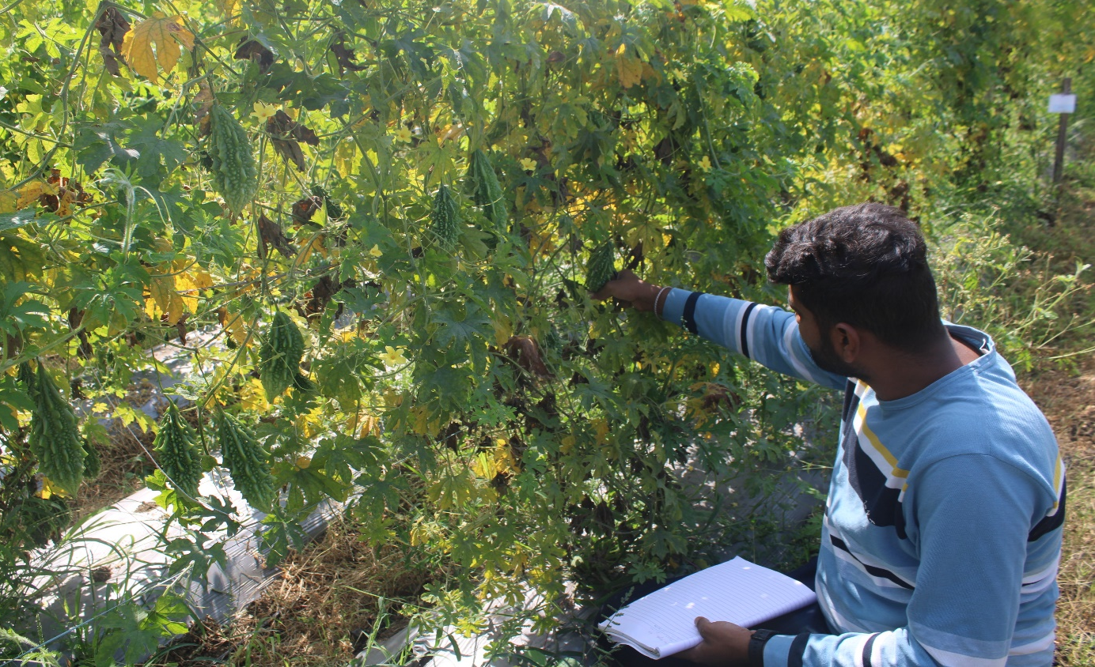

Plate 2. Heavy fruit yielding of bitter gourd by application of PGRs and 3G Cutting
Plate 1. Seed Production Program through implementation of PGRs and 3G Cutting
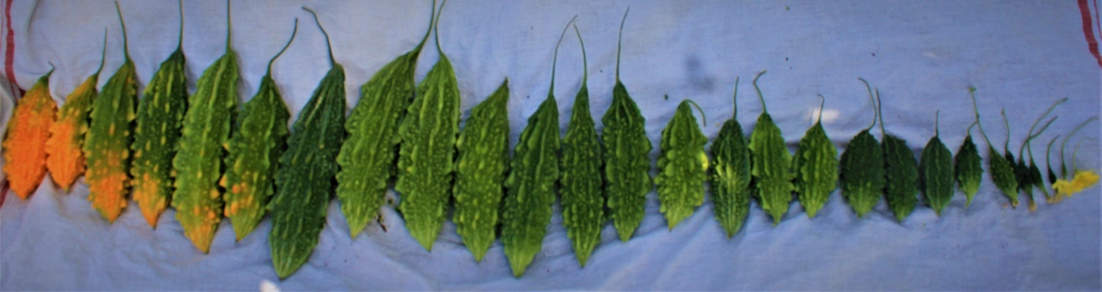
Plate 3. Stages of fruit development
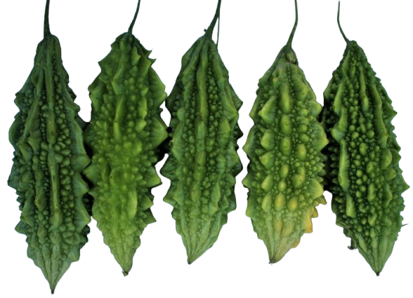
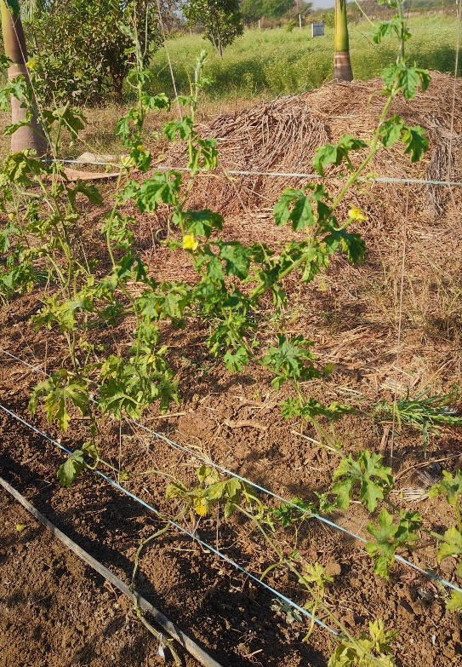
Plate 4. Bitter gourd fruits harvested through 3G Cutting Plant
Plate 5. 3G Cutting Plant

- Specific PGRs applications in conjunction with 3G Cutting:
Based on the reviewed research and articles, several plant growth regulators (PGRs) show promise for use in conjunction with the 3G cutting technique to enhance the growth, yield, and seed production of bitter gourd.
(1) Gibberellic Acid (GA₃): GA₃, particularly at lower concentrations ranging from 25 to 100 ppm, has demonstrated effectiveness in increasing the production of female flowers and improving the overall yield in bitter gourd. To complement the increased potential for female flower development resulting from 3G cutting, GA₃ could be applied as a foliar spray at the 2-4 leaf stage or around the time of flower initiation. A concentration of 50 ppm has been frequently reported as effective in various studies [Hossain et al., (2006)].
(2) Naphthalene Acetic Acid (NAA): NAA has also shown efficacy in suppressing the development of male flowers and promoting the production of female flowers, which subsequently leads to higher yields in bitter gourd. A foliar application of NAA at concentrations between 50 and 100 ppm, applied at the 2-4 leaf stage or during flower initiation, may prove beneficial when used in conjunction with the 3G cutting technique [Ghani et al., (2013)].
(3) Ethrel (Ethephon): As a compound that releases ethylene, Ethrel is known to promote femaleness and induce early flowering in cucurbits. Research suggests that effective concentrations range from 100 to 300 ppm, applied as a foliar spray starting approximately 15 days after sowing and repeated at weekly intervals. Given that Ethrel has shown comparable effects to 3G cutting in some studies, using a lower concentration might be sufficient when combined with the pruning technique [Gyawali et al., (2024)].
(4) CCC (Cycocel): These PGRs have demonstrated potential in increasing the yield of bitter gourd. Exploring the application of CCC as a foliar spray at concentrations of 100 to 400 ppm at intervals of 15 days in conjunction with 3G cutting might be worthwhile [Chovatia et al., (2010)].

- Strategies of implementation of PGRs and 3G Cutting:
The strategic timing of PGR application relative to the pruning stages in 3G cutting is crucial for maximizing the benefits of both techniques. Focusing on PGRs that enhance female flowering and fruit set after the development of tertiary branches is likely to be most effective. The physiological changes induced by 3G cutting might also allow for the use of lower PGR concentrations, potentially reducing costs and minimizing any risks associated with higher PGR levels. Foliar spraying appears to be the most prevalent and effective method for applying PGRs to bitter gourd. When combining PGRs with 3G cutting, the timing of the spray should be carefully coordinated with the pruning schedule.
(1) PGR selection and concentration: Considering the potential for additive effects when PGRs are used in combination with 3G cutting, it would be prudent to begin with lower concentrations of the chosen PGRs and adjust based on the observed response of the plants. For enhancing female flower production and yield in conjunction with 3G cutting, start with lower concentrations of GA₃ (around 50 ppm) or NAA (50-100 ppm) as foliar sprays. Ethrel (100-300 ppm) and CCC (100-500 ppm) can also be considered, potentially applied around the time of the first pruning. Further research is needed to definitively determine the optimal concentrations of specific PGRs when used in conjunction with the 3G cutting technique in bitter gourd cultivation.
(2) Application timing: It may be most strategic to apply PGRs that promote female flowering, such as GA₃ or NAA, after the main stem and secondary branches have been pruned and the tertiary branches are beginning to develop. This approach could capitalize on the plant's altered physiological state due to pruning and further enhance the production of female flowers on the targeted branches. The application of Ethrel might be initiated slightly earlier, around the time of the first pruning, to influence sex expression from the early stages of branching. Apply foliar sprays of PGRs at critical growth stages, such as the 2-4 leaf stage and around flower initiation, and potentially repeat applications at weekly intervals for Ethrel. Adjust the timing based on the specific PGR and the plant's response to 3G cutting.
(3) Implement 3G cutting: Adopt the 3G cutting technique to encourage the development of tertiary branches, which are more likely to produce female flowers. This involves pruning the main stem and secondary branches at appropriate growth stages.
(4) Consider Micronutrients: Recognize the importance of micronutrients like B, Ca, Mg etc. especially when aiming to improve seed production and quality in conjunction with PGRs and 3G cutting. Ensure adequate boron availability in the soil or through foliar application.

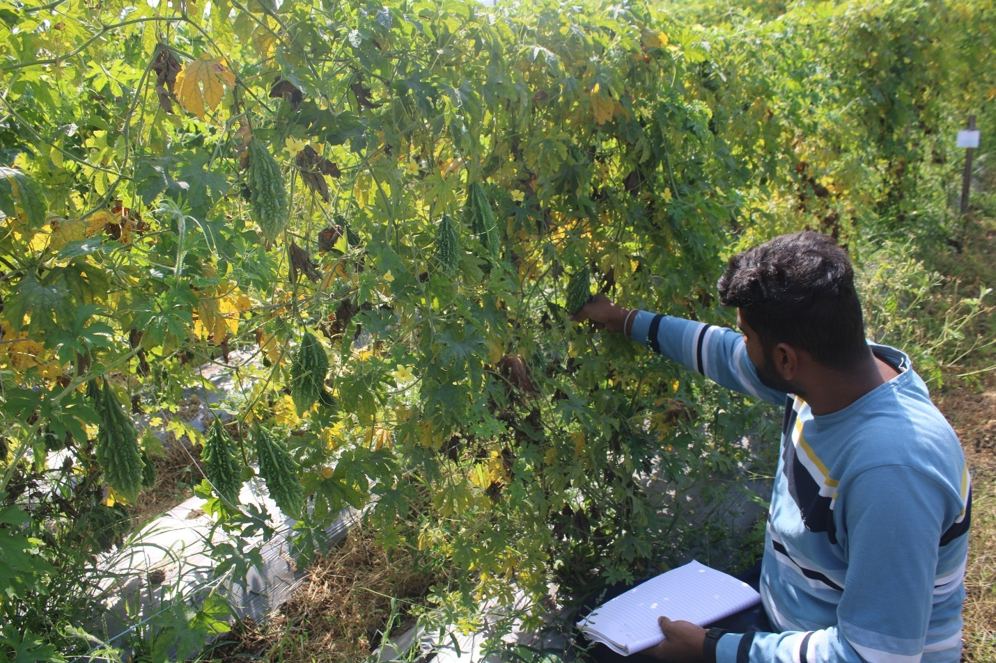
Conclusion:
The cultivation of bitter gourd can be significantly enhanced through the strategic application of plant growth regulators (PGRs) and the implementation of the 3G cutting technique. Research indicates that PGRs such as GA₃, NAA, Ethrel, and CCC can effectively manipulate the vegetative growth, flowering patterns, and sex expression of bitter gourd, leading to substantial increases in fruit yield and improvements in seed production and quality. The 3G cutting technique, by promoting the growth of tertiary branches that bear a higher proportion of female flowers, also contributes to increased fruit set and overall yield and production.
Further research is needed to specifically investigate the optimal combinations of PGRs, their concentrations, and application timing in conjunction with different 3G cutting protocols for bitter gourd. Studies focusing on the effects of these combined approaches on seed production and quality are also warranted. Additionally, research exploring the economic feasibility and practical implementation of these integrated techniques under various growing conditions would be valuable for growers. By strategically combining the benefits of PGRs and 3G cutting, bitter gourd cultivation and also cucurbits can become more efficient and productive, contributing to enhanced economic returns for farmers and a more sustainable agricultural system.
Disclaimer (Artificial intelligence)
Option 1:
Author(s) hereby declare that NO generative AI technologies such as Large Language Models (ChatGPT, COPILOT, etc.) and text-to-image generators have been used during the writing or editing of this manuscript.
Option 2:
Author(s) hereby declare that generative AI technologies such as Large Language Models, etc. have been used during the writing or editing of manuscripts. This explanation will include the name, version, model, and source of the generative AI technology and as well as all input prompts provided to the generative AI technology
Details of the AI usage are given below:
1.
2.
3.

References:
Ahmad T., Hassan S.M., Iqbal Q., Ghanib M.A., and Tariq R.M.S., (2019) Effect of PGRs on Vegetative and Reproductive Traits of Bitter Gourd (Momordica charantia L.): A Field Assessment. Journal of Horticultural Science and Technology. 2(2): 41-44.
Aishwarya K, Syam Sundar Reddy P, Sadarunnisa Syed, Ramaiah M and Srinivasa Rao G., (2019) Effect of plant growth regulators and stage of application on morphological and yield parameters of bitter gourd cv. VK-1 Priya. International Journal of Chemical Studies, 7(4): 2688-2692.
Arvindkumar P.R., Vasudeva S.N., Patil M.G., and Umesha U., (2014) Effect of PGR and boron on seed quality during storage in bitter gourd (Momordica charantia) cv. Pusa Visesh. Asian Journal of Horticulture. 9(1) : 18-23.
Bhattarai BR. and Ghimire R. (2024) Yield and quality of cucumber as influenced by 3G cutting. Far Western University, Nepal. ICIMOD; page no. 02.
Bhattarai, B. R., & Ghimire, R. (2024) Yield and quality of cucumber as influenced by 3G cutting. Poster presented at Far Western University, Faculty of Agriculture, Godawari Municipality, Kailali, Nepal.
Chapagain U., Bhandari S., Shrestha Y.M, Bista S., and Dahal J., (2022) Effect of Pruning and Fertilizers on Growth, Flowering and Yield of Cucumber (Cucumis sativus L.) under Protected Structure in Panchthar, Nepal. Int. J. Appl. Sci. Biotechnol. 10(3): 171-181.
Chaurasiya DK, Kumar M, Sahni S and Singh S., (2020) 3G Cutting: A Wonderful Technique to Redouble the Production of Cucurbits. Biotica Research Today. 2(12): 1308-1310.
Chovatia R.S., Ahlawat T.R., Kavathia Y. A., Jivani L.L. and Kaila D.C., (2010) Effect of plant growth regulators on vegetative growth, flowering and yield of bitter gourd cv. Priya. Indian J. Hort. 67(4): 254-258.
Dostogir, H., Karim, M.A., Pramanikm, M.H.R. and Rehman, A.A.M.S. (2006) Effect of gibberellic acid (GA₃) on flowering and fruit development of bitter gourd (Momordica charantia L.). International Journal of Botany, 2: 329-332.
Gedam, V.M., Patil, R.B., Suryawanshi, Y.B. and Mate, S.N. (1998) Effect of plant growth regulators and boron on flowering, fruiting and seed yield in bitter gourd. Seed Research, 26: 97-100.
Gao, L., Yu, G., Hu, F., Li, Z., Li, W., & Peng, C. (2021) The Patterns of Male and Female Flowers in Flowering Stage May Not Be Optimal Resource Allocation for Fruit and Seed Growth. Plants, 10(12), 2819.
Ghani M.A., Amjad M., Iqbal Q., Nawaz A., Ahmad T., Hafeez A., and Mazhar Abbas M. (2013) Efficacy of Plant Growth Regulators on Sex Expression, Earliness and Yield Components in Bitter Gourd. Pakistan Journal of Life and Social Sciences. 11(3): 218–224.
Gogoi S., Kachari M., Sarma I., Choudhury S, and Barooah A. (2022) Effect of growth regulators application and canopy management on seed production in cucumber. The Pharma Innovation Journal; SP-11(5): 1932-1935.
Gyawali, K., Dhital, P. R., Bhattarai, K., & Baral R., S., (2025) Effects of Ethephon and Pruning Practices on Sex Expression and Yield of Cucumber (Cucumis sativus L.) in Rupandehi, Nepal. Turkish Journal of Agriculture - Food Science and Technology, 13(2): 346–352.
Hilli, J. S., Vyakarnahal, B. S., Biradar, D. P. and Hunje, Ravi. (2010) Effect of growth regulators and stages of spray on growth, fruit set and seed yield of ridgegourd (Luffa acutangula L. Roxb). Karnataka J. Agric. Sci., 23(2) : 239-242.
Hirpara A.J., Vaddoria M.A. and Polara M.A., (2015) Seed Quality as Influence by Plant Growth Regulators in Bitter Gourd (Momordica charantia L.). J. Pure Appl. Microbiol. 9 (4): 3115-3118.
Hossain D., Karim MA., Pramanik MHR., Rahman A.A.M. (2006) Effect of Gibberellic Acid (GA₃) on Flowering and Fruit Development of Bitter Gourd (Momordica charantia L.). Intl. J. Bot. 2(3) : 329-332.
Impana M.N., Sonkamble A.M., Wagh A.P., Bawkar S.O. and Kankal D.S., (2024) Growth and yield of bitter gourd as influenced by plant growth regulators. Plant Archives. 24 (1) : 1070-1074.
John S.A. and Meena S.S., (2019) Plant Growth Regulators Mediated Growth and Yield Enhancement of Bitter Gourd (Momordica Charantia L.). Genet Mol Biol, 3.
Khan P.N., Bahadur V., Prasad V. M., Thomas T., Kerketta A. and Tiwari S., (2023) Influence of 3G Cuttings in Bottle Gourd (Lagenaria siceraria) for Growth, Yield and Fruit Quality. Int. J. Plant Soil Sci., 35:(15), pp. 407-415.
Khatoon R., Moniruzzaman M. and Moniruzzaman M., (2019) Effect of foliar spray of GA₃ and NAA on sex expression and yield of bitter gourd. Bangladesh J. Agril. Res. 44(2): 281-290.
Kokkirala LV., Mohiddin SAK., Prasad VM., and Bahadur V., (2022) Effect of different level of Gibberllic acid, naphthalene acetic acid and Cycocel on growth and yield of bitter gourd (Momordica charantia L.) C.V, Kashi Mayuri. The Pharma Innovation Journal, 11(6): 578-580.
Kumar T., Rinu, Sethiya R., Praddyum, Thakur S., and Saurabh. (2024) A comprehensive review of Plant Growth Regulators (PGRs) and their impact on flowering and ornamental crops with insights into effective application methods. Int. J. Adv. Biochem. Res. SP-8(1): 254-267.
Mangave, B. D., Dekhane, S. S., & Patel, D. J. (2016). Effect of plant growth regulators on growth and sex expression of bitter gourd. International Journal of Development Research, 6(4) : 7310–7312.
Mardhiana, Pradana AP, Adiwena M, Kartina, Santoso D, Wijaya R and Maliki A. (2017) Effects of pruning on growth and yield of cucumber (Cucumis sativus) Mercy variety in the acid soil of North Kalimantan, Indonesia. Cell Biol Dev; 1: 13-17.
Mia MA, Islam MS and Shamsuddin ZH. (2014) Altered sex expression by plant growth regulators: An overview in medicinal vegetable bitter gourd (Momordica charantia L.). J. Med. Plants Res. 8(8) : 361-367.
Moniruzzaman, M., Khatoon, R., Moniruzzaman, M., & Qamruzzaman, A. (2019) Influence of plant growth regulators on vegetative growth, sex expression and yield of summer bottle gourd. Bangladesh Journal of Agricultural Research, 44(4), 577–590.
Moosavi, S.F., Haghighi, M. & Mirmazloum, I. (2024) Interacting effects of phytohormones and fruit pruning on the morpho-physiological and biochemical attributes of bell pepper. Sci Rep 14, 14801. https://doi.org/10.1038/s41598-024-65855-y.
Nagamani S, Basu S, Singh SK, Lal S, Behera TK, Chakrabarty SK., (2015) Effect of plant growth regulators on sex expression, fruit setting, seed yield and quality in the parental lines for hybrid seed production in bitter gourd (Momordica charantia). Indian Journal of Agricultural Sciences, 85(9):1185–91.
Pandey P. Jha RK. and Kumar SA., (2019) Influence of Ethephon on Vegetative Character, Flowering Behaviour and Sex Expression of Cucumber in Pokhara Lekhnath, Kaski. North American Academic Research. 2(5): 1-13.
Phonia L. Debbarma A. Pal V. and Prasad L. (2024) Production Technology of Bitter gourd. P.K. Publishers & Distributors. ISBN: 978-81-19428-45-8
Priyadarshi S, Verma RB, Lal Babu and Singh VJ., (2022) Effect of different PGRs and stages of spray on growth attributes of bitter gourd. Vegetable Science, 49(1):109-112.
Reddy, A. M., Saravanan, D. S., & Bahadur, D. V. (2020) Effects of different plant growth regulators on plant growth, yield and fruit quality of Bitter gourd (Momordica charantia L.) cv. Kashi Mayuri. International Journal of Chemical Studies, 8(4), 1573–1575.
Sen A. (2018) Advances in training and pruning of cucurbitaceous of vegetable crop. Ph.D. Credit Seminar VSC – 691. Uttar Banga Krishi Viswavidyalaya. 1-49.
Shah, S. A. A., Ayub, G., Khan, M., Ayaz, A., Zeb, S., Ahmad, S., Azeem I., Sun, N., Xu, M. G., (2022) Influence of gibberellic acid on the growth and yield of bitter gourd in semi-arid climate, Applied Ecology and Environmental Research. 20 (6) : 5209-5221.
Shailendrakumar, V. M., Valia, R. Z., & Sitapara, H. H. (2017) Effect of plant growth regulators on growth, sex expression and yield of sponge gourd (Luffa cylindrica L.) Cv. Pusa Chikni. Annals of Horticulture, 10(2), 243–246.
Verma A. and Joshi A. (2019) A ROADMAP FOR SUSTAINABLE BITTER GOURD (MOMORDICA CHARANTIA L.) BREEDING: LEVERAGING GENETIC DIVERSITY AND EXPLOITING HETEROSIS. Plant Archives. 25(1) : 275-288.

