Farmer’s Access to Agricultural Finance through FPOs in Kurnool District of Andhra Pradesh, India

Abstract

In recent times, FPOs in partnership with state governments involves the small & marginal farmers for providing ease of access to credit, marketing facilities, technical advisory, and collective bargaining. Kurnool district has actively performing FPOs under different departments and was purposively selected as there is a good spread of crops across the mandals and potential scope exists for setting up of multi commodity FPOs in the district. Multi staged stratified random sampling technique was adopted. The sample size constituted of 100 FPO members and 50 Non-FPO members in the study area. The current study examined the sources of finance, credit utilization pattern of FPO and Non-FPO members in the study area. Sources of the finance for the FPO farmers were the public banks, owned funds, credit access through FPOs and the informal sources. For Non-FPO sources of finance were public banks, owned funds and informal sources. Tabular analysis revealed that major part of the credit requirements were met by public banks for both FPO and Non-FPO members and dependency on the informal sources was low among FPO members compared to Non-FPO members to meet their working capital requirements. Alternate sources of formal finance were more for FPO members than the Non-FPO where the credit through FPOs is lacking for Non- FPO members apart from many other collectivized benefits. The availed credit amount was utilized more towards the farming related activities than the personal activities by the FPO farmers. The more returns to the FPO members than the Non-FPO members were noticed due to the optimum and wise per rupee expenditure on farm activities by the FPO members.
Keywords: Finance, Farmer Producer Organization, Market access, Poverty, Public banks.

Introduction
Farmer Producer Organizations (FPOs) are important for poverty eradication and advancement of rural poor farmers. Aggregation of farmers helps to access the information required to produce, value addition, commodity marketing and maintain productive linkages with input agencies such as credit service providers as well as alternate markets.
Finance has an important role to playas it helps rural households and enterprises in making productive investments, smoothing consumption, managing risks and coping with shocks (Hollinger, 2011). Considering the priority of the rural sector for economic growth and poverty reduction, agricultural finance is now being widely acknowledged as the main frontiers of financial systems development. Small farmers don't just need credit for agricultural activities but they also need it for other household needs/activities, savings, payment systems and insurance.
The rural co-operatives, FPOs in India became a means of pooling the available resources of the needy and furnish them accessto different financial services. In recent times, FPOs in partnership with state governments involves the small & marginal farmers for providing ease for availability of credit, marketing facilities, technical advisory and collective bargaining. In view of this, an in- depth study on farmer’s access to agricultural finance through FPOs in Kurnool District of Andhra Pradesh was taken up to study the opportunities for accessing agricultural financefor FPO members.

Materials and Methods
FPOs were found functioning actively in the state of Andhra Pradesh. At present a total of 852 FPOs have been formed in thestate. Kurnool district has 61 actively performing FPOs under different departments and was purposively selected as there is a good spread of crops across the mandals and potential scope exists for setting up of multi commodity FPOs in the district. Among actively functioning FPOs, five FPOs wereselected one from each of NABARD, SERP, APDMP, Department of Horticulture and NGOs based on the maximum number of members. All the farmers registered under the selected FPOs were listed out and 20 farmers from each of the FPO were selected randomly, thus constituting to representative sample of 100 farmers. A sample of 50 Non-FPO farmers was selected randomly for comparison in the study area. The information related to the present study was collected using a well- defined and pre-tested schedule through personal interview method. Detailed information was collected and it pertained to the agricultural year 2020-21.

Results and Discussion
DIFFERENT SOURCES OF FINANCE OF FPO MEMBERS AND NON FPO MEMBERS
Finance plays a major role for purchasing the inputs and carry out all the cultivation operations on time thereby having a direct impact on enhancing the productivity of the farms particularly those of small farmers. Aggregation of farmers is found to be the reliable approach that enhances the producers access to timely and adequate credit and provide the profitable linkages to the market. The FPOs plays an efficient role in linking the member farmers to the reliable sources of finance to meet their credit needs without being reliant on the deceptive sources who exploit the vulnerable farmers by lending the credit at higher rates of interest that ultimately forces the farmer to fall into the debt trap. The results obtained below on the different sources of finance to FPO and Non- FPO respondents are in line with findings of Keerthi P et al 2017.
- Sources of finance to the FPO membersin the study area:

As shown in Table. 1 the total creditutilization of cotton farmers was Rs. 55,018 of which an amount of Rs. 40,264 availed from the bank, which constituted about 73.18 per cent of the total loan amount, an amount of Rs. 4,225 as an credit through the FPOs as a share which constituted about 7.68 per cent of the total loan amount, own funds of Rs. 3,650 comprised of 6.63 percent of the credit usage and an amount Rs. 6,909 from informal sources, which accounted for about 12.55 per cent of thetotal credit usage by the FPO cotton farmers were availed for meeting the workingcapital requirements.
The total credit utilization of the FPO groundnut respondents was Rs. 43,925/- of which an amount of Rs. 26,650 was availed from the bank, which constituted about 60.67 percent of the total loan amount ,an amount of Rs. 2,650/- as credit through the FPOs as a share which constituted about 6.03 percent of the total loan amount, an amount of Rs. 2735/- whichare their own funds that comprised of 6.23 percent of the credit usage and an amount Rs. 11,890/- has been availed from informal sources for meeting the working capital requirements, which accounted for about 27.07 percent of the total credit usage by theFPO Groundnut farmer
The total credit utilization of the FPO Redgram respondents was Rs. 29,546/- of which the amount of Rs.18,432/- was availed from the bank, which constituted about 62.38 percent of the total loan amount, an amount of Rs. 1565/- as credit through FPOs as a share

which constituted about 5.30 percent of the total loan amount, an amount of Rs. 1910/- which are their own funds that comprised of 6.46 percent of the credit usage and an amount Rs 7639/- has been availed from informal sources for meeting the working capital requirements, which accounted for about 25.85 percent of the total credit usage by the FPO redgram farmer.
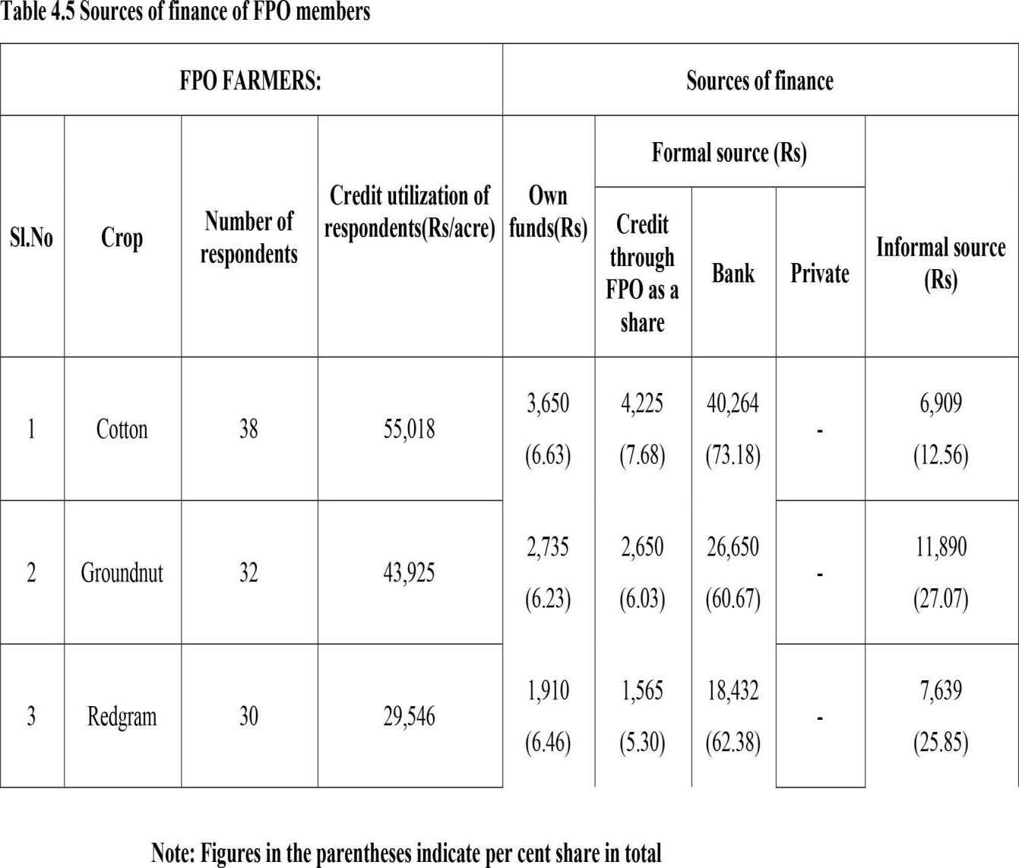
The total number of respondents cultivating cotton crop was 38 which accounted for 38 percent of the total respondents of the study area followed by the respondents cultivating groundnut and redgram were 32 and 30 which comprised of about 32 percent and 30 percent of the total FPO respondents in the study area.
Table. 1: Source of finance of FPO members

- Sources of finance for the Non-FPO members in the study area:

The sources of finance for the Non-FPOmembers mainly comprised of the owned funds, public banks, private banks and the informal sources who are the private money lenders, relatives, friends etc.
As shown in Table 2 the total credit utilization of cotton farmers was Rs. 58,125/-of which an amount of Rs. 39,450/- availed from the bank, which constituted about 67.87 per cent of the total loan amount ,an amount of Rs. 3,650/- which are their own funds that comprised of 7.31 per cent of the credit usage and an amount Rs. 14,425/- has been availed

from informal sources for meeting the working capital requirements, which accounted for about 24.82 per cent of the total credit usage by the Non-FPO cotton farmers.
The total credit utilization of the Non- FPO groundnut respondents is Rs. 47,575/- of which the amount of Rs. 26,650/- was availed from the bank, which constituted about 60.67 per cent of the total loan amount, an amount of Rs. 3215/- which were their own funds that comprised of 6.23 per cent of the Credit usage and an amount of Rs. 17,810/-has been availed from informal sources for meeting the working capital requirements, which accounted for about 37.44 percent of the total credit usage by the Non - FPO Groundnut farmer.
The total credit utilization of the Non- FPO Redgram respondents is Rs 32,736/- of which the amount of Rs 18,254/- was availed from the bank, which constituted about 55.76 per cent of the total loan amount , an amount of Rs 2180/- of own funds that comprised of
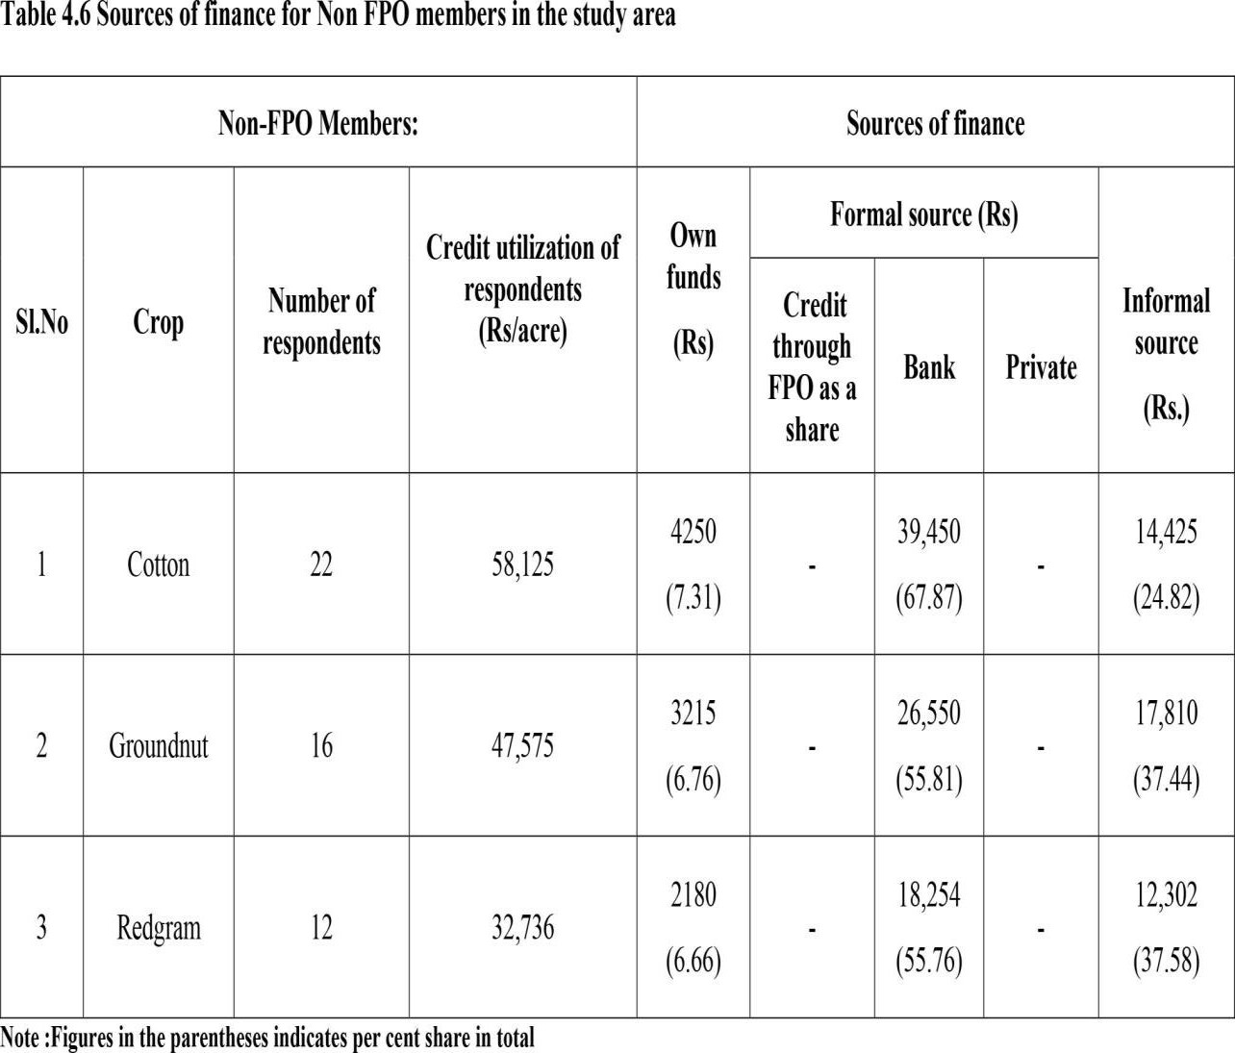
6.66 per cent of the credit usage and an amount Rs. 12,302/- has been availed from informal sources for meeting the working capital requirements, which accounted for about 37.58 per cent of the total credit usage by the Non- FPO Redgram farmer.
Table. 2: Source of finance for Non-FPO members
II. Feasible models of Joint Liability Design to access credit for small and marginal Farmers through FPOs:
- Joint Liability Group (JLG) Model:

In a JLG model, a group of 4-10 individuals is formed and the credit access given to each member of the group from their corpus and will be collectively ensured by the group. As the individuals of Joint liability group belong to the same locality and are well known about their financial discipline and credit rating of individuals belonging to the group. If any individual do not pay the installment, the fellowgroup members must aggregate in and furnish the delayed payment of delinquent person of the Group. In this model lending is done totallybased on the individual trust by the group and the social collateral instead of physical collateral. In this model, members by aggregating their borrowings can build the corpus of the FPO, which in turn can leverage them to raise higher quantum of money from the financial institutions with equity of FPO as the collateral.
- Multi Aided Co-operative Societies Federation Model:
This a three tier approach system, The Apex financial institutions lends to MACSs and SHGs based on their performance and management. Through amalgamation these multi aided co-operative societies (MACS) also have direct access to the loans from native banks and other financial institutions. The RBI, an apex financial institution of India had declared that associations like MACS were recognized to move as business coordinators. This can be achievable only by considering how these associations has led to good governance and management with the availablelimited resources. Because of the trustworthiness of promoting NGO’s, majority of MACS were able to gain funds from variousfinancial resources. Through this, easier access to credit is possible to the member farmers without depending on the informal source of credit at comparatively lower rate of interest. Apart from this market linkages are also provided through this model to the memberfarmers.
- Agro solutions Market facilitation Models:
The firms existence was to fulfill a crucial gap in the market for ‘gap financing’ of farmers. Farmers couldn’t sell their produce due to lack of access to profitable markets, or breaches like quality parameters and assurance, etc., making highly profitable markets beyond their reach. In the similar way, buyers of quality certified produce are looking for the alternative sources to purchase from. Hence, these models purchase the produce from the FPO and sell to the potential buyers. Through this, farmers have access to the working capital due to immediate sale and lack of this leads to difficulty to access finance for inputs and next cycle of crops.
NABCONS, Nabkisan Finance Limited, NABSAMRUDDHI Finance Limited which is subsidiaries of the NABARD offers the credit facilities and their financial services through

FPOs to the small and marginal farmers for their working capital requirement as a result of the better financial management and performance of the FPOs. Figure 1 and 2 depict the current flow of credit and suggestible flow of credit to FPO farmers, taking this as an opportunity these subsidiaries through their financial services provide gap financing to the small holder farmers without any collateral security at lower interest rate compared to the informal source for their requirements. This financial service from these subsidiaries is only possible with due assurance and good governance from the FPO as a whole.

Credit from Public Banks at 7% interest (60% of their credit needs)

Credit through FPO as a
share (6-7 % of their
credit need)
FPO
FARMER
Credit from informal
sources like private money lenders at the

Owned funds

Fig. 1: Current Flow of credit to FPO members


Credit from Public banks at 7% interest (60 % of their credit needs)
FPO
FARMER
Credit access from apex
financial institutions through adoption of feasible models like JLGs, MACS and other market
Owned funds
Credit through FPO as a share (6-7 % of their credit need)

Fig. 2: Suggested flow of credit to the FPO members

Utilization of credit by FPO and Non-FPO respondents cultivating Groundnut:

From Table 3 it can be depicted that, the total amount of loan received per acre by the FPO and Non-FPO respondents for cultivating groundnut from different sources of finance was Rs. 43,925 and Rs. 47,575 respectively.
The figures in the Table 3. reveals the amount spent in detail regarding, the land preparation that provide necessary soil conditions for sowing groundnut was done through machine labour for which the amount of Rs. 2,450 and Rs. 2,200 was spent by both the FPO and Non-FPO members which constituted 5.58 per cent and 4.62 per cent of the amount of loan received by both the FPO and Non-FPO members respectively.
The amount spent on purchase of seeds and sowing in groundnut was done manually by both FPO and Non-FPO members on an average was Rs. 7,500 and Rs. 8,000 which constituted 17.07 per cent and 16.82 per cent of the total amount of loan received by both the FPO and Non-FPO members respectively. The FPO members spent slightly less amount on seeds compared to Non-FPO members. As FPO member received the seeds at the subsidized amount through FPO. However, the seed and the sowing operations had contributed a major share in loan amount in cultivation of groundnut crop.
The weeding operation in Groundnut is usually done by the application of the herbicides and by the manual removal. The amount spent by the FPO and Non-FPO members on an average was Rs. 1,450 and Rs.1,670 which comprised of 3.30 per cent and
3.51 per cent of the total loan amount received by both respectively. Here, the FPO members spent fewer amounts than the Non- FPO due to the availability of the herbicides on subsidized amount to the FPO members and dependence of Non-FPO members on the manual weeding.
Manures are rich sources of the organic nutrients which enrich the soil health and improve the
crop productivity. The amount spent by the FPO and the Non- FPO members on manures for the groundnut crop was Rs. 2650 and Rs. 2500 which constituted 6.03 per cent and 5.25 per cent of the total amount loan received by both respectively. The amount spent by FPO members on the manures was more than that of the Non-FPO members as the application of manures in groundnut crop at recommended dosage is essential to prevent deficiencies of the plant to obtain maximum yield. Fertilizers are the inorganic compounds that are applied to soil to meet the nutrient requirement of the soil and for efficient growth of the crop. The loan amount spent by FPO members on the manures was more than that of the FPO members as the manures are available at the low prices due to the aggregation through FPOs compared to the individual farmer.
Fertilizers are the inorganic compounds that are applied to soil to meet the nutrient requirement of the soil for the efficient growth of the plants. The loan amount spent by FPO and Non FPO members was Rs. 2,994 and Rs. 3,240, which constituted 5.44 per cent and 5.57 per cent of the total loan amount received by both respectively. This is because the fertilizers are utilised as per the required amounts due to awareness programmes on the optimum fertilizer utilization.
Plant protection chemicals are applied to protect the crop from the attack of pest and diseases, which causes the reduction in yield. Pink boll worm was the major pest found in the cotton crop and other pests and diseases were also noticed. The amount spent on the plant protection chemicals was Rs. 7,942 and Rs. 8,500 which constituted 14.44 per cent and 14.62 per cent of the total amount of loan received by both FPO and Non-FPO members respectively. This reduction in the amount spent by the FPOs is due to the subsidies availed by the members through collectivization.
Harvesting is usually done manually in cotton in the study area through pickings and this operation utilises the major amount of the credit availed. The loan amount spent on harvesting is Rs. 8,658 and Rs. 8,750 respectively which constituted 15.74 per cent and 15.05 per cent of the total loan amount received by the FPO and Non FPO members respectively.
Small agriculture implements are used by the farmers for carrying out the simple cultivation operations like weeding, sowing, spraying, harvesting etc. Some of the implements are the sickles, spades, sprayers etc. The amount spent on these small implements is Rs. 4,515 and Rs. 2,025 respectively which constituted about 8.21 per cent and 3.48 per cent of the total amount received by both the FPO and Non-FPO farmers respectively. The FPO members spent more on new small implements useful to carry out the intercultivation operations more efficiently and effectively as compared to that of Non-FPO members.
Settling old debts which mean the debts which are taken for meeting the working capital requirements of theprevious season. The amount spent by the FPO and Non-FPO members on an average was Rs. 5,117 and Rs. 8,555respectively which constituted 9.30 per cent and
14.72 per cent of the total loan amount received by both the FPO and Non-FPO farmers respectively. Here the Non-FPO members spent more amount as they availed rates of interest than compared to the FPO members.
Consumption involves theutilization of loan amount for household maintenance. The amount spent by the FPO and Non-FPO members on an average was Rs. 5,421 and Rs. 5,825 respectively which constituted 9.85 per cent and 10.02 per cent of the total loan amount received by both the FPO and Non-FPO farmers respectively. The FPO members have utilized fewer amounts for personal expenditure when compared to the Non-FPO members.
Medical expenses are those that are spent on the medical emergencies of the family members. The amount spent by the FPO and Non-FPO members on an average was Rs. 5,507 and Rs. 4,890 respectively which constituted about 10.01 per cent and 8. 41 per cent of the total loan amount received by both the FPO and Non-FPO farmers respectively.
Miscellaneous expenses are those which are unexpected costs. The amount spent by the FPO and Non-FPO members on an average was Rs. 3,908 and Rs. 5,000 which constituted 7.10 per cent and 8.60 per cent of the total loan amount received by both the FPO and Non-FPO farmers respectively. The Non- FPO members spent much on miscellaneous expenses due to lack of aggregation. The results obtained here are in line with the findings of Manaswi B H et al 2018.
Utilization of credit by FPO and Non-FPO respondents cultivating Groundnut:

From Table 4 it can be depicted that, the total amount of loan received per acre by the FPO and Non-FPO respondents for cultivating groundnut from different sources of finance was Rs. 43,925 and Rs. 47,575 respectively.
The figures in the Table 4. reveals the amount spent in detail regarding, the land preparation that provide necessary soil conditions for sowing groundnut was done through machine labour for which the amount of Rs. 2,450 and Rs. 2,200 was spent by both the FPO and Non-

FPO members which constituted 5.58 per cent and 4.62 per cent of the amount of loan received by both the FPO and Non-FPO members respectively.
The amount spent on purchase of seeds and sowing in groundnut was done manually by both FPO and Non-FPO members on an average was Rs. 7,500 and Rs. 8,000 which constituted
17.07 per cent and 16.82 per cent of the total amount of loan received by both the FPO and Non-FPO members respectively. The FPO members spent slightly less amount on seeds compared to Non-FPO members. As FPO member received the seeds at the subsidized amount through FPO. However,the seed and the sowing operations had contributed a major share in loan amount in cultivation of groundnut crop.
The weeding operation in Groundnut is usually done by the application of the herbicides and by the manual removal. The amount spent by the FPO and Non-FPO members on an average was Rs. 1,450 and Rs.1,670 which comprised of 3.30 per cent and 3.51 per cent of the total loan amount received by both respectively. Here, the FPO members spent fewer amounts than the Non- FPO due to the availability of the herbicides on subsidized amount to the FPO members and dependence of Non-FPO members on the manual weeding.
Manures are rich sources of the organic nutrients which enriches the soil health and improve the crop productivity. The amount spent by the FPO and the Non- FPO members on manures for the groundnut crop was Rs. 2650 and Rs. 2500 which constituted 6.03 per cent and 5.25 per cent of the total amount loan received by both respectively. The amount spent by FPO members on the manures was more than that of the Non-FPO members as the application of manures in groundnut crop at recommended dosage is essential to prevent deficiencies of the plant to obtain maximum yield.
Fertilizers are the inorganic compounds that are applied to soil to meet the nutrient requirement of the soil and for efficient growth of the crop. The loan amount spent by FPO and Non-FPO members was Rs. 1,300 and Rs. 1,600, which constituted 2.96 per cent and
3.36 per cent of the total loan amount received by both FPO and Non-FPO members respectively. This is because the fertilizers are utilised as per the required amounts due to awareness programmes conducted through FPOs on the optimum fertilizer utilization.
Plant protection chemicals are those which are applied to protect the crop from the attack of pest and diseases, which ultimately causes the reduction in yield. Cercospora leaf spot was major pest found in the groundnut and other pests and diseases were also noticed. The

amount spent on the plant protection chemicals was Rs. 3950 and Rs. 4450 which constituted
8.99 per cent and 9.35 per cent of the total amount of loan received by both FPO and Non- FPO members, respectively. This reduction in the amount spent by the FPOs on the plant protection chemicals is due to the subsidies availed by the members through collectivization.
Harvesting of the groundnut crop is usually done manually by the Non- FPO members and mechanically by FPO members in the study area through stripping and this operation after seeds and sowing, which utilises major amount of the credit availed. The loan amount spent on harvesting was Rs. 6,100 and Rs. 6,600 which constituted 13.89 per cent and 13.87 per cent of the total loan amount received by the FPO and Non-FPO members, respectively.
Small agriculture implements are used by the farmers for carrying out the simple cultivation operations like weeding, sowing, spraying, harvesting etc. Some of the implements are sickles, spades, sprayers etc. The amount spent on these small implements and their repairs was Rs. 1,254 and Rs. 625 which constituted 2.85 per cent and 1.31 per cent of the total amount received by both the FPO and Non-FPO farmers respectively. The FPO members spent more on new small implements that are very useful tcarry out the intercultivation operations more efficiently and effectively as compared to that of Non- FPO members. Settling old debts which means the debts which are taken for meeting the working capital requirements of the previous season. The amount spent by the FPO and Non-FPO members on an average was Rs. 6,099 and Rs. 6,808 which constitutes about 13.89 per cent and 14.31 per cent of the total loan amount received by both the FPO and Non-FPO farmers respectively. Here the Non- FPO members spent more amount as they availed the loans from the informal sources at higher rates of interest compared to the FPO members.
Consumption involves the loan amount being utilised for the household maintenance. The amount spent by the FPO and Non-FPO members on an average was Rs. 5,048 and Rs. 6,364 which constituted 11.49 per cent and 13.38 per cent of the total loan amount received by both the FPO and Non-FPO farmers, respectively. The FPO members utilised less amount for personal expenditure when compared to the Non- FPO members.
Medical expenses are those that were spent on the medical emergencies of the family members. The amount spent by the FPO and Non-FPO members on an average was Rs. 3,324 and Rs. 3,508 which constituted 7.57 per cent and 7.37 per cent of the total loan amount received by both the FPO and Non-FPO farmers respectively.

Miscellaneous expenses are those which are unexpected costs. The amount spent by the FPO and Non-FPO members on an average was Rs. 2,800 and Rs 3,250 which constituted 6.37 per cent and 6.83 per cent of the total loan amount received by both the FPO and Non-FPO farmers respectively. The Non- FPO members spent much on miscellaneous expenses due to lack of aggregation.
Utilization of credit by FPO and Non- FPO respondents cultivating Red gram:

The total amount of loan received by the FPO and Non-FPO respondents cultivating redgram from different sources of finance was Rs. 29,546 and Rs. 32,736 per acre respectively. (Table 5.)
The figures in the Table 5. reveal the amount spent in detail regarding the land preparation that provide necessary soil conditions for sowing was done through machine labour for which the amount of Rs. 1,800 and Rs. 1,900 was spent by both the FPO and Non-FPO members which constituted 6.09 per cent and 5.80 per cent of the amount of loan received by both the FPO and Non- FPO members, respectively.
The amount spent on purchase of seeds and sowing in redgram was done manually by both FPO and Non-FPO members on an average was Rs. 2,490 and Rs. 2,560 which constituted
8.43 per cent and 7.82 per cent of the total amount of loan received by both the FPO and Non-FPO members, respectively. The FPO members spent slightly an less amount on seeds compared to Non- FPO members as FPO members have received the seeds at the subsidized amount through FPO.
The weeding operation in redgram is usually done by the application of the herbicides and by the manual removal. The amount spent by the FPO and Non- FPO members on an average was Rs. 2,740 and Rs. 3,450 which comprises of about 9.27 per cent and 9.10 per cent of the total loan amount received by both, respectively. Here, the FPO member spent less amount than the Non-FPO due to the availability of the herbicides on subsidized amount to the FPO members and dependence of Non-FPO members on the manual weeding.
Manures are rich sources of the organic nutrients which enriches the soil health and improve the crop productivity. The amount spent by the FPO and the Non-FPO members on manures for the redgram crop is Rs. 3,190 and Rs. 3,450 which constituted

10.08 per cent and 10.54 per cent of the total amount loan received by both, respectively. The amount spent Non- FPO members on manures was more than that of the FPO members due to the application of manures in redgram crop at recommended dosage by the FPO members.
Fertilizers are the inorganic compounds that are applied to soil to meet the nutrient requirement of the soil for the efficient growth of the plants. The loan amount spent by FPO and Non- FPO members was Rs. 1,420 and Rs. 1,600, which constituted 4.81per cent and
4.89 per cent of the total loan amount received by both FPO and Non- FPO members respectively. This is because the fertilizers are utilised as per the required amounts due to awareness programmes conducted through FPOs on the optimum fertilizer utilization.
Plant protection chemicals are those which are applied to protect the crop from the attack of pest and diseases, which causes the reduction in yield and this operation utilized major amount of the loan in the cultivation of redgram. The amount spent on the plant protection chemicals was Rs. 4,035 and Rs. 4,550 which constituted 13.66 per cent and 13.90 per cent of the total amount of loan received by both FPO and Non-FPO members respectively. This reduction in the amount spent by the FPOs on the plant protection chemicals is due to the subsidies availed by the members through collectivization.
Harvesting of the redgram crop is usually done manually in the study area. The loan amount spent on harvesting was Rs. 2,229 and Rs. 2,450 which constituted 7.54 per cent and 7.48 per cent of the total loan amount received by the FPO and Non-FPO members, respectively.
Small agriculture implements are used by the farmers for carrying out the simple cultivation operations like weeding, sowing, spraying, harvesting etc. Some of the implements are the sickles, spades, sprayers etc. The amount spent on small implements and their repairs was Rs. 1,624 and Rs. 1,579 which constituted about 5.50 per cent and 4.82 per cent of the total amount received by both the FPO and Non-FPO farmers respectively. The FPO members spent more on new small implements that are very useful to carry out the inter-cultivation operations more efficiently and effectively as compared to that of Non-FPO members.Settling old debts which mean the debts which are taken for meeting the working capital requirements of the previous season. The amount spent by the FPO and Non-FPO members on an average was Rs. 4,198 and Rs. 5,160 which constituted 14.21 per cent and
15.76 per cent of the total loan amount received by both the FPO and Non- FPO farmers, respectively. Here the Non-FPO members spent more amount as they availed the loans from informal sources at higher rates of interest compared to the FPO members.

Consumption involves utilization of loan amount for household maintenance. The amount spent by the FPO and Non-FPO members on an average was Rs. 3,151and Rs. 3,687 which constituted 10.36 per cent and 11.26 per cent of the total loan amount received by both the FPO and Non- FPO farmers, respectively. The FPO members utilised less amount for personal expenditure when compared to the Non-FPO members.
Medical expenses are those that were spent on medical emergencies of family members. The amount spent by the FPO and Non-FPO members on an average was Rs. 1,289 and Rs. 1,400 which constituted 4.36 per cent and 4.28 per cent of the total loan amount received by both the FPO and Non- FPO farmers, respectively.
Miscellaneous expenses are those which are unexpected costs. The amount spent by FPO and Non-FPO members on an average was Rs. 1,380 and Rs. 1,420 which constituted about 4.67 per cent and 4.34 per cent of the total loan amount received by both the FPO and Non-FPO farmers, respectively. The Non-FPO members spent much on miscellaneous expenses due to lack of aggregation.
Table. 3: Utilization of credit by FPO and Non-FPO members cultivating cotton

Particulars | Amount spent in Rs/acre
Particulars | FPO | Percentage | Non FPOs | Percentage
Amount of loan received by sample respondents | 55018 |  | 58125
Farming activities
Land Preparation | 3,000 | 5.45 | 3,000 | 5.16
Seed and sowing | 3,490 | 6.34 | 3,550 | 6.11
Weeding | 2,825 | 5.13 | 3040 | 5.23
Manures | 1,641 | 2.98 | 1750 | 3.01
Fertilizers | 2,994 | 5.44 | 3240 | 5.57

Plant protection chemicals | 7,942 | 14.44 | 8500 | 14.62
Harvesting | 8,658 | 15.74 | 8,750 | 15.05
Small implements | 4,515 | 8.21 | 2025 | 3.48
Personal Activities
Settling old debts | 5,117 | 9.30 | 8555 | 14.72
Consumption | 5,421 | 9.85 | 5825 | 10.02
Medical expense | 5,507 | 10.01 | 4890.00 | 8.41
Miscellaneous | 3,908 | 7.10 | 5000 | 8.60
Total | 55,018 | 100 | 58,125 | 100
Table. 4: Utilization of credit by FPO and Non-FPO respondents in cultivating groundnut
Particulars | Amount (Rs/acre)
Particulars | FPO | Per cent share | Non- FPOs | Per cent share
Amount of loan  received by sample respondents | 43,925 |  | 47,475
Farming activities
Land preparation | 2,450 | 5.58 | 2,200 | 4.62
Seed and sowing | 7,500 | 17.07 | 8,000 | 16.82
Weeding | 1,450 | 3.30 | 1,670 | 3.51
Manures | 2,650 | 6.03 | 2,500 | 5.25
Fertilizers | 1,300 | 2.96 | 1,600 | 3.36

Plant protection chemicals | 3,950 | 8.99 | 4,450 | 9.35
Harvesting | 6,100 | 13.89 | 6,600 | 13.87
Small implements | 1.254 | 2.85 | 625 | 1.31
Personal Activities
Settling old debts | 6,099 | 13.89 | 6,808 | 14.31
Consumption | 5,048 | 11.49 | 6,364 | 13.38
Medical expenses | 3,324 | 7.57 | 3,508 | 7.37
Miscellaneous | 2,800 | 6.37 | 3,250 | 6.83
Total | 43,925 | 100 | 47,575 | 100
Table. 5: Utilization of credit by FPO and Non-FPO respondents cultivating redgram

Particulars | Amount spent (Rs/acre)
Particulars | FPOs | Percentage | Non-FPOs | Percentage
Amount of loan received by sample respondents | 29,546 |  | 32,736
Farming activities
Land preparation | 1,800 | 6.09 | 1,900 | 5.80
Seed and sowing | 2,490 | 8.43 | 2,560 | 7.82
Weeding | 2,740 | 9.27 | 2,980 | 9.10
Manures | 3,190 | 10.80 | 3,450 | 10.54
Fertilizers | 1,420 | 4.81 | 1,600 | 4.89
Plant protection chemicals | 4,035 | 13.66 | 4,550 | 13.90

Harvesting | 2,229 | 7.54 | 2,450 | 7.48
Small implements | 1,624 | 5.50 | 1,579 | 4.82
Personal Activities
Settling old debts | 4,198 | 14.21 | 5,160 | 15.76
Consumption | 3,151 | 10.66 | 3,687 | 11.26
Medical expenses | 1,289 | 4.36 | 1,400 | 4.28
Miscellaneous | 1,380 | 4.67 | 1,420 | 4.34
Total | 29,546 | 100 | 32,736 | 100
Yield and profits from cotton crop earned by FPO and Non-FPO members

Table 6 reveals that the average loan amount utilized by the FPO members and the Non-FPO members per acre of cotton crop was Rs. 55,018 and Rs. 58,125, respectively. Out of which, an amount of Rs. 35,065 and Rs. 33,855 was the loan amount utilized for the farming purpose which constituted about 65.38 per cent and 58.24 per cent of the total amount spent by both FPO and Non-FPO members respectively. An amount of Rs. 19,953 and Rs. 24,270 was spent on the personal purpose which constituted 34.61 per cent and 41.75 per cent of the total amount spent by both FPO members and Non-FPO members respectively. Total yield of the FPO and Non-FPO members was 8.2 and 7.3 quintals per acre, respectively. This variation in the yield was due to the optimum input utilization and carrying out of timely operations. Price per quintal for FPO and Non-FPO members was Rs. 10,345 and Rs. 9,375, respectively. The difference in the price is due to the collective bargaining power and access to alternative markets by FPO members. Hence the Gross profits of the FPO and the Non- FPO members were Rs. 84,829 and Rs. 68,437 respectively. Net profits were Rs. 49,764 and Rs. 34,582 of both the FPO and Non-FPO farmers, respectively.
Yield and profits from groundnut crop earned by FPO and Non-FPO members:

Table 7 it can be observed that the average loan amount utilized by the FPO members and the Non-FPO members cultivating groundnut crop was Rs. 43,295 and Rs. 47,575 per acre respectively. Out of which an amount of Rs. 26,654 and Rs. 27,645 was the loan amount

utilized for the farming purpose which constituted 60.68 per cent and 58.10 per cent of the total amount spent by both FPO and Non-FPO members respectively. An amount of Rs. 17,271 and Rs. 19,930 was spent on the personal purpose which constituted 39.31 per cent and 41.89 per cent of the total amount spent by both FPO members and Non-FPO members respectively. Total yield of the FPO and Non-FPO members is 9.4 and 8.9 quintals per acre respectively. This variation in the yield is due to the optimum input utilization carrying out of timely operations. Price realised by FPO and Non-FPO members is Rs. 5,890 and Rs. 5,240 per quintal respectively. The difference in the price is due to the collective bargaining power and access to alternative markets by FPO members. The gross profits of the FPO and the Non-FPO members was Rs. 55,366 and Rs. 46,636, respectively. Net profit was Rs. 28,712 and Rs. 18,991 obtained by FPO and Non-FPO farmers, respectively.
Yield and profits from redgram crop earned by FPO and Non-FPO members:

Table 8 it revealed that the average loan amount utilized by FPO members and the Non-FPO members cultivating redgram was Rs. 29,546 and Rs. 32,736 per acre, respectively. Out of which an amount of Rs. 19,528 and Rs. 21,069 was the loan amount utilized for the farming purpose which constituted 66.09 per cent and 64.36 per cent of the total amount spent by both FPO and Non-FPO members respectively. An amount of Rs. 10,018 and Rs. 11,667 was spent on the personal purpose which constituted 33.90 per cent and 35.63 per cent of the total amount spent by both FPO members and Non-FPO members respectively. The yield of the FPO and Non-FPO members was 7.8 and 7.0 quintals per acre respectively. This variation in the yield is due to the optimum input utilization and carrying out of timely operations. Price per quintal for FPO and Non-FPO members is Rs. 5,780 and Rs. 5,120, respectively. The difference in the price is due to the collective bargaining power and access to alternative markets for FPO members. The gross profits of the FPO and the Non-FPO members was Rs. 45,084 and Rs. 36,864 respectively. Net profits were Rs. 25,556 and Rs. 14,771 of both FPO and Non-FPO farmers, respectively.
Table. 6: Yield and profits of FPO and Non-FPO members cultivating cotton crop

Particulars | FPOs |  | Non-FPO
Particulars | Amount (Rs.) | Per cent | Amount (Rs.) | Per cent
Average loan amount utilized by cotton | 55,018 |  | 58,125

Per cent share
farmer
Loan amount utilized for farming purpose | 35,065 | 65.38 | 33,855 | 58.24
Loan amount utilized for personal purpose | 19,953 | 34.61 | 24,270 | 41.75
Total Cost of Cultivation (rs) | 35,065 |  | 34,855
Total yield (qtls) | 8.2 |  | 7.3
Price per quintal | 10,345 |  | 9375
Gross Profits | 84,829 |  | 68,437
Net Profits | 49,764 |  | 34,582

70 |  | 65.38
60 |  | 58.24
50
40 |  | 34.61
30  20  10 |  | .75
FPO members Non-FPO members Loan Amount
41

Loan amount utilized for farming purpose Loan amount utilized for personal purpose

Fig. 3: Utilization pattern of Loan amount by FPO and Non-FPO farmers growing cotton
Table. 7: Yield and profits of FPO and Non-FPO farmers cultivating groundnut (Rs/acre)

 | FPOs | Non-FPOs

Particulars | Amount (Rs.) | Per cent | Amount (Rs.) | Per cent
Average loan amount utilized by Groundnut farmer | 43,925 |  | 47,575
Loan amount utilized for farming purpose | 26,654 | 60.68 | 27,645 | 58.10
Loan amount utilized for personal purpose | 17,271 | 39.31 | 19,930 | 41.89
Total Cost of Cultivation (rs) | 26,654 |  | 27,645
Total yield(qtls) | 9.4 |  | 8.9
Price per quintal | 5890 |  | 5240
Gross Profits | 55366 |  | 46636
Net Profits | 28,712 |  | 18,991

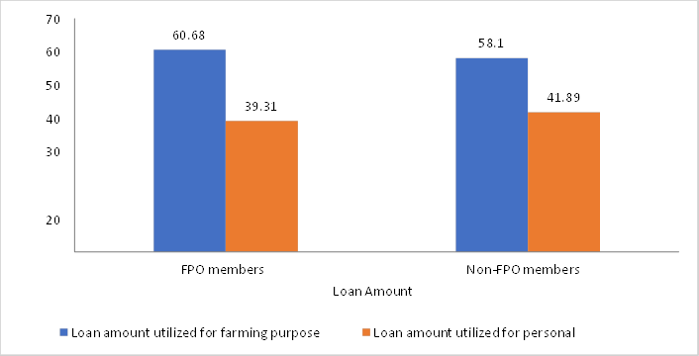
Fig. 4: Utilization pattern of loan amount by FPO and Non-FPO farmers growing Groundnut
Per cent share
Table. 8: Yield and Profits of the redgram crop cultivated by FPO and Non-FPO members(Rs./acre)

 | FPO | Non-FPO

Particulars | Amount | Per  cent | Amount | Per cent
Average loan amount utilized by redgram  farmer | 29,546 |  | 32,736
Loan amount utilized for farming purpose | 19,528 | 66.09 | 21,069 | 64.36
Loan amount utilized for personal purpose | 10,018 | 33.90 | 11,667 | 35.63
Total Cost of Cultivation (rs) | 19,528 |  | 21,069
Total yield(q) | 7.8 |  | 7
Price per quintal | 5780 |  | 5120
Gross Profits | 45084 |  | 35840
Net Profits | 25556 |  | 14771
66.09
70
60
64.36
50
33.9
35.63
40
30
FPO member Non-members LoanAmount Loan amount utilized for farming purpoe Loan amount utilized for personal purpose
Fig. 5: Utilization pattern of loan amount by FPO and Non-FPO farmers growing redgram
Per cent share
Conclusion
FPO members benefit from formal finance sources, accessing credit with fewer barriers compared to Non-FPO members, who face challenges in credit availability outside FPO channels. Public banks remain primary lenders for both groups, but FPO members exhibit lower reliance on informal sources for working capital. FPOs provide subsidized inputs like organic manures, fertilizers, and crop protection chemicals, reducing costs for members. They invest more in small implements, enhancing farming efficiency. Non-FPO members often allocate credit to settle old debts, while FPO members prioritize farming activities, leading to

higher productivity and returns. To improve finance access, Joint Liability Group models and tailored financial products should be promoted, alongside regular revisions of the Scale of Finance based on input costs and FPO potential.
Disclaimer (Artificial intelligence)
Option 1:
Author(s) hereby declare that NO generative AI technologies such as Large Language Models (ChatGPT, COPILOT, etc.) and text-to-image generators have been used during the writing or editing of this manuscript.

REFERENCES

Dewangan Deeptee. Socio-economic impact of farmer producer organisations (FPOs) in Bastar district of Chhattisgarh. Business 2018. 78(45):245-267.
Evengy L, Thomas B. Networks of rural producer organizations in Uganda: What can be done to make them work better. World Development 2016. 78 (1): 572-586.
Hollinger DF. Agricultural Finance- Trends, Issues and Challenges 2011.

Kumar V, Wankhede KG, Gena, H. C. Role of cooperatives in improving livelihood of farmers on sustainable basis. American Journal of Educational Research 2015. 3 (10): 1258-
1266.

Panda CK, and Singh, SR. Role of extension in leveraging FPO’s for marginal farmers. International Journal of Farm Sciences 2016. 6 (1): 243-254.
Rani CR, Reddy AA. Producer organisations in Indian agriculture: Their role in improving services and intermediaries. South Asian Research 2014. 34 (3): 209-224.
Raju KV, Kumar R, Vikraman S, Moses Shyam D, Srikanth R, Kumara Charyulu D, Wani SP. Farmer Producer Organization in Andhra Pradesh: A Scoping Study. Rythu Kosam Project. Research Report IDC-16. Patancheru 502324. Telangana, India: International Crops Research Institute for the Semi-AridTropics 2017.
Rima NS. Agricultural Credit flow of Commercial Banks and Impact on Agricultural production in Nepal. Scholars Journal of Art, Humanities and Social Science 2014. 2(2): 372- 376.
Sankri SK, Ponnuswamy KA. A Comparative analysis of the processes of formation of selected farmer producer companies. Indian Journal of Natural Sciences 2015. 18 (6): 9992-
9996

Singh G, Vattab K. Assessing the economic impacts of farmer producer organizations: a case study in Gujarat, India. Agricultural Economics Research Review 2019. 32, 139-148.
Soniya, Devi I, Aparna B, Murthy R. Performance of Farmer Producer Organizations in Kurnool District of Andhra Pradesh. Andhra Pradesh J. Agril. Sci 2021. 7(2): 81- 88.

