Characterization and evaluation of the agronomic suitability of three soil types for sorghum production in the Sudano-Sahelian zone of Burkina Faso

ABSTRACT

Declining agricultural fertility represent a major challenge to food security in the Sudano-Sahelian areas. In this context, it is essential to cultivate resilient cereals, such as sorghum, whose productivity depends heavily on the physical, chemical, and biological properties of the soil. This study aims to assess soil chemical fertility in order to improve soil management and optimize sorghum production. The spatial distribution of soils was determined using a Digital Elevation Model (DEM) from the ALOS PALSAR radar, with a spatial resolution of 12.5 meters. Soil data were analyzed using R software, applying descriptive statistics and principal component analysis (PCA). The soil prospecting identified three subgroups of soils: Haplic Cambisols located on the upper slope of the glacis, Ferric Lixisols on medium slopes and Gleyic Lixisols at the bottom of the glacis. Soil texture analysis showed a dominance of sandy fractions, varying from sandy-loam to sandy-clay, characteristic of soils in the Sudano-Sahelian zone. A gradient of organic matter, higher in brown soils (1.11%), compared to ferruginous soils (0.59%) and hydromorphic soils (0.40%). A strong positive correlation was observed between organic matter, nitrogen and phosphorus, suggesting that improving OM could increase soil fertility. Low N (0.013–0.099%) and P (2.17–7.81 mg/kg) contents reveal significant nutritional limitations for agricultural productivity. OM, N, and P contents are mainly concentrated in the surface horizons. Although classified as medium, the fertility of all soil types studied varies depending on the topography.
These results highlight the importance of knowledge of fertility parameters and the need for differentiated management of soils according to their agronomic suitability.
Keywords: Fertility, topography, sorghum, agricultural potential, Sudano-Sahelian zone

1. INTRODUCTION

In sub-Saharan areas, declining soil fertility represent a major challenge for food security (Sakho-jimbira & Hathie, 2020), where cultivated land degradation is one of the main constraints to agricultural production (Ouedraogo and al., 2022).
In Burkina Faso, soils are mainly poorly developed and have an average useful depth of around 40 cm, often characterized by a ferruginous carapace that limits the rooting depth of crops (Zongo and al., 2021). This physical constraint is added to a low organic matter content and deficiencies in essential nutrients, such as nitrogen, phosphorus and potassium, making these soils particularly vulnerable to continued degradation (Tully and al., 2015). In this context, the precise characterization of soil properties and the assessment of their cultivation suitability are becoming strategic priorities. Indeed, these approaches make it possible to identify the potential and limitations of each soil type in order to optimize their use for essential crops, such as sorghum, a cereal widely cultivated in Burkina Faso (Sanna and al., 2022). Sorghum (Sorghum bicolor) is a resilient cereal, adapted to arid and semi-arid conditions, and has an essential role in the diet of rural populations in Burkina Faso (Rattunde and al., 2013). According to Bationo and al. (2007), sorghum is a key crop in production systems in the Sudano-Sahelian zone, because of its resistance to droughts. However, sorghum productivity depends largely on soil quality, the cultivation of which is essential to maximize agricultural production. Analyzing soil suitability for the production of resistant crops such as sorghum is essential to optimize yields while preserving natural resources. A better understanding of the physical and, chemical properties of soils, as well as their ability to support sorghum cultivation, is therefore necessary to improve yields and ensure the sustainability of agricultural production systems. In this regard, previous studies have demonstrated that soil structure in the Sudano-Sahelian area directly influences crop productivity (Bationo and al., 2007; Koulibaly and al., 2016). Similarly, Guebre and al (2020) showed that sorghum growth and yields remain closely linked to the bulk density and porosity of tropical soils. On the other hand, very few authors are interested by the cultural suitability of soils taking into account their typology combined with their topographical position.
Thus, this study focuses on the suitability of three types of soils for sorghum cultivation, according to their topographical position, in the Sudano-Sahelian context of Burkina Faso. By combining modern analysis methods and integrated approaches, it seeks to identify limiting factors and propose recommendations to improve the fertility and productivity of these soils.
The main objective of this study is to optimize sorghum production in semi-arid conditions, through a better understanding and optimal management of soil cultural properties. Thus, we suggest that the cultural suitability of soils for sorghum production in this conditions, is highly dependent on their typology, itself conditioned by their intrinsic characteristics and topographical position.
In sub-Saharan areas, declining soil fertility represent a major challenge for food security (Sakho-jimbira & Hathie, 2020), where cultivated land degradation is one of the main constraints to agricultural production (Ouedraogo and al., 2022).
In Burkina Faso, soils are mainly poorly developed and have an average useful depth of around 40 cm, often characterized by a ferruginous carapace that limits the rooting depth of crops (Zongo and al., 2021). This physical constraint is added to a low organic matter content and deficiencies in essential nutrients, such as nitrogen, phosphorus and potassium, making these soils particularly vulnerable to continued degradation (Tully and al., 2015). In this context, the precise characterization of soil properties and the assessment of their cultivation suitability are becoming strategic priorities. Indeed, these approaches make it possible to identify the potential and limitations of each soil type in order to optimize their use for essential crops, such as sorghum, a cereal widely cultivated in Burkina Faso (Sanna and al., 2022). Sorghum (Sorghum bicolor) is a resilient cereal, adapted to arid and semi-arid conditions, and has an essential role in the diet of rural populations in Burkina Faso (Rattunde and al., 2013). According to Bationo and al. (2007), sorghum is a key crop in production systems in the Sudano-Sahelian zone, because of its resistance to droughts. However, sorghum productivity depends largely on soil quality, the cultivation of which is essential to maximize agricultural production. Analyzing soil suitability for the production of resistant crops such as sorghum is essential to optimize yields while preserving natural resources. A better understanding of the physical and, chemical properties of soils, as well as their ability to support sorghum cultivation, is therefore necessary to improve yields and ensure the sustainability of agricultural production systems. In this regard, previous studies have demonstrated that soil structure in the Sudano-Sahelian area directly influences crop productivity (Bationo and al., 2007; Koulibaly and al., 2016). Similarly, Guebre and al (2020) showed that sorghum growth and yields remain closely linked to the bulk density and porosity of tropical soils. On the other hand, very few authors are interested by the cultural suitability of soils taking into account their typology combined with their topographical position.
Thus, this study focuses on the suitability of three types of soils for sorghum cultivation, according to their topographical position, in the Sudano-Sahelian context of Burkina Faso. By combining modern analysis methods and integrated approaches, it seeks to identify limiting factors and propose recommendations to improve the fertility and productivity of these soils.
The main objective of this study is to optimize sorghum production in semi-arid conditions, through a better understanding and optimal management of soil cultural properties. Thus, we suggest that the cultural suitability of soils for sorghum production in this conditions, is highly dependent on their typology, itself conditioned by their intrinsic characteristics and topographical position.

2. material and methods

The study site (Fig. 1) covers an area of approximately 10 hectares between longitudes 1°17'49"W and 1°17'38"W and latitudes 12°30'13"E and 12°30'4"E. It is located in the town of Boudtenga, approximately 38 kilometers east of Ouagadougou, the country's capital. The village of Boudtenga is administratively part of the rural commune of Saaba in the central region of Burkina Faso.
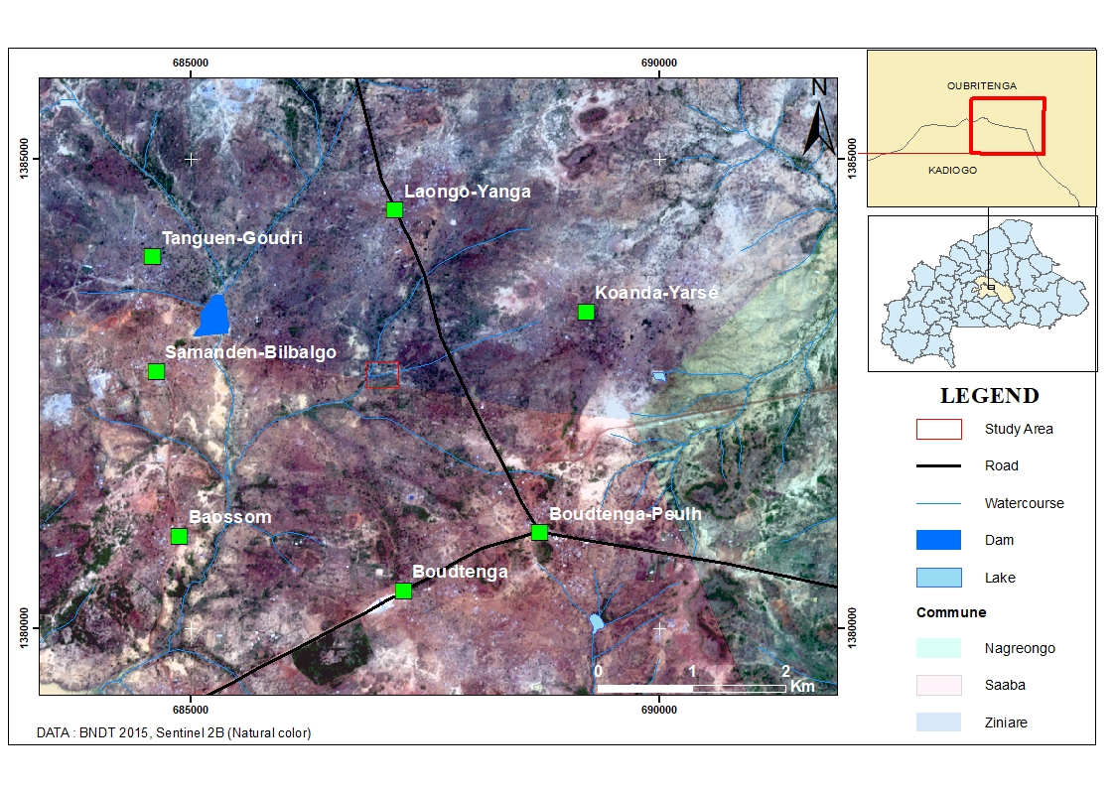
Figure 1: Map showing the location of the study site
The commune of Saaba is located in a dry tropical climate of the Sudano-Sahelian type, marked by two main seasons: a wet season that extends from June to September and a dry season that lasts from mid-November to April. Average annual rainfall ranges between 600 and 700 mm and the Standardized Precipitation Index (SPI) indicates a general downward trend in rainfall amounts (Karambiri & Gansaonre, 2023).
Average annual temperatures range between 20 and 28°C during the wet season, while they reach very high levels of 35 to 40°C during the dry season (Kambou, 2019).
Overall, the commune, like the province of Kadiogo, has low hydrogeological resource potential due to the geological structure and the subsoil dominated by plutonic and metamorphic rocks. The main rivers and their branches are connected to the Nakanbé watershed and are temporary, hence their rapid drying up during the dry season (Sankara, 2010).
The commune's relief corresponds to a plain with an average altitude between 260 and 300 m, characterized by an overall flatness and monotony, with slopes of around 1 to 2% leading to thalwegs whose embankments are most often reclaimed by erosion.
Saaba's soils are mainly tropical ferruginous, sandy-clay, or poor gravelly types with low agronomic potential and highly vulnerable to water and wind erosion. These soils have a higher silt and clay content in the depressions. In some places, they are completely bare and in the form of glacis or "zipélé" (Sankara, 2010).
On these soils, vegetation develops, characterized by the presence of grassy, shrubby and wooded savannahs (Fontès & Guinko, 1995). The vegetation found in the commune of Saaba is part of the variable-density savannah type (Sankara, 2010).
The grassy savannah is dominated by species such as Andropogon gayanus Kunth, Loudetia togoensis (Pilg.) C.E.Hubb, Cenchrus pedicellatus (Trin.) Morrone. The shrub savannah is mainly composed of Balanites aegyptiaca (L.) Del., Sclerocarya birrea (A.Rich.) Hochst .and Piliostigma reticulatum (DC.) Hochst, and the tree savannah of Vitellaria paradoxa C.F.Gaertn, Khaya senegalensis (Desr.) A. Juss. and Anogeissus leiocarpa (DC.) Guill. & Perr.
The population is predominantly young, and its main activities include agriculture, livestock farming, and trade. Agriculture, the main source of income, is rain-fed and extensive, and very vulnerable to climatic hazards, particularly the scarcity of rainfall. The population, in search of good agricultural land, is actively involved in the production of sorghum, an essential crop in production systems due to its resistance to drought. Livestock farming, often practiced in association with agriculture, represents the second activity of the population.
1.1. Data Collection
The site was chosen (Fig.2), based on the predominance of cereal crops, particularly sorghum, whose productivity is significantly affected by constraints related to chemical fertility and soil structure.
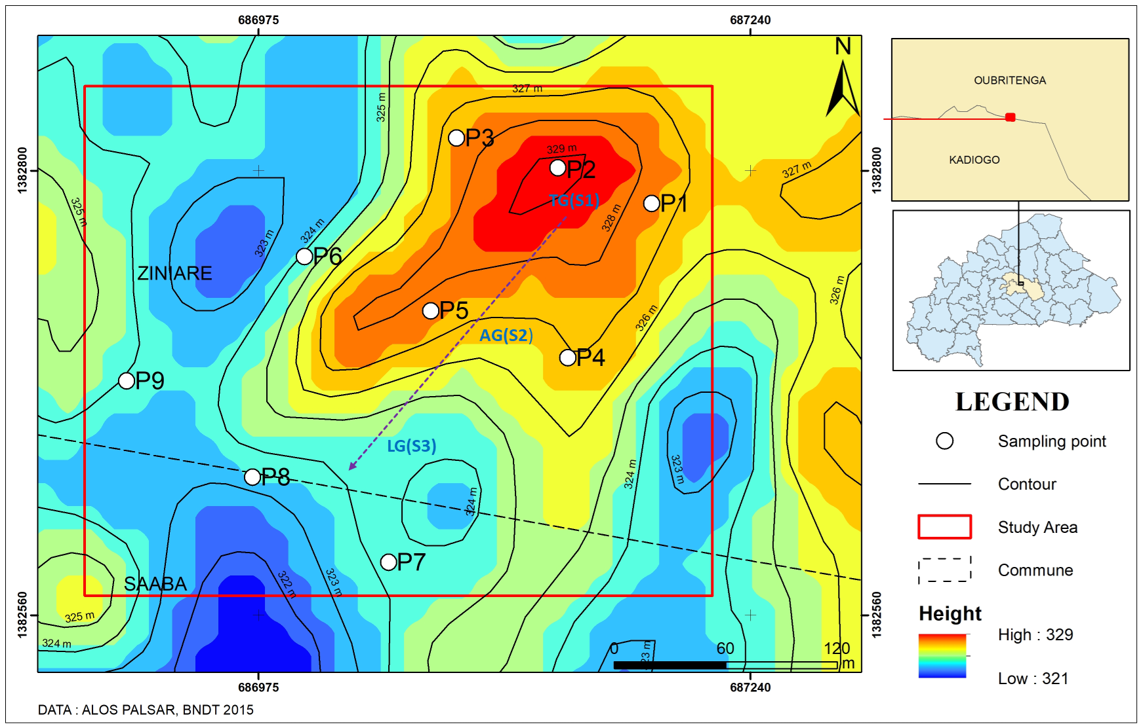
Figure 2: Map location of sampling points
Legend:TG= top of the glacis slope; AG= average slope of the glacis; LG= lower slope glacis; P = Profil.
The prospecting method used was that of systematic gridding of the middle toposequence comprising three geomorphological sub-units namely the high glacis zone, the medium slope zone and the low glacis zone. On each geomorphological sub-unit, a minimum of three pits were opened with a maximum depth of 1.4 m and generally oriented in a SE-NW direction. The profiles are positioned at different altitudes and slopes, allowing an understanding of soil variations depending on the topography. The spatial distribution of soils was determined using a Digital Elevation Model (DEM) from the ALOS PALSAR radar, with a spatial resolution of 12.5 meters. A validation method was implemented to verify the accuracy of the Digital Terrain Model (DTM). A total of 26 accurate elevation readings obtained in the field were used as reference points for validation. For each control point, the difference between the values recorded and those anticipated by the DTM was used to quantitatively assess prediction errors. The error statistics determined included the Mean Square Error (RMSE=0.0828 m), the Median Absolute Error (MAE=0.066 m) and the coefficient of determination (R²=0.897).
Soil samples were also taken using augers at a depth of 60 cm. A total of 9 soil pits were opened and described according to the FAO guidelines for soil description (FAO, 1994). Correlations were made with the World Reference Base for Soil Resources (WRB 2015). An average of three samples per pit were taken for laboratory analyses. Topographic maps and remote sensing data were used to define the area's topography and map soil distribution.
The spatial distribution of soils along the toposequence under consideration is determined by the topography, whose elevation ranges from 321 to 329 meters. Based on these topographic variations, three soil units were considered: S1, S2, and S3, each corresponding to specific positions within the toposequence. S1 soils are located at the top of the glacis slope, S2 soils on the middle glacis slope, and S3 soils at the base of the glacis.
1.2. Soil Analysis
Soil analyses were based on particle size 5-fraction particle size distribution using the international method adapted to the "Robinson Khöln" pipette. The pH of the soil solution was determined electrometrically using a pH meter in a 1:2.5 soil-water suspension (P/V = 1:2.5). Soil organic carbon (SOC) was quantified by oxidation of the soil sample in a mixture of potassium dichromate and sulfuric acid (Walkley & Black, 1934). Organic nitrogen was determined using the Kjeldahl method, which consists of soil digestion followed by distillation (Bremner, 1965). Available phosphorus was assessed using the Bray I method (Bray & Kurtz, 1945). The cation exchange capacity and exchangeable bases were measured by extraction in a buffered medium at pH 7 with ammonium acetate. Finally, the apparent density was determined by the cylinder method (the soil being non-gravelly) on the 0-5 cm layer (AFNOR, 1992).
The determination of soil suitability was carried out in accordance with the guidelines for land evaluation (FAO, 1994). Soil types were identified and classified according to the system of the Commission for Pedological Classification and Soil Mapping (C.P.C.S., 1967), establishing correspondences with the classification system of the IUSS Working Group (WRB). The assessment of soil fertility was based on the classification criteria of the National Soil Office of Burkina Faso.
(1990), which takes into account organic matter, the sum of exchangeable bases and water pH as the main parameters (Table 1). Each of these parameters is rated from 1 (unfavorable) to 5 (very favorable). The fertility class was determined by summing the ratings of these parameters.
Table 1: Soil fertility class standards
Fertility class | Very low | Low | Medium | High | Very high
Sum of quotation | <4,4 | 4,5-7,5 | 7,6-10,5 | 10,6-13,5 | > 13,6
Source: BUNASOLS (1990)

1.3. Soil identification
Soil surveys and soil analysis identified three soil subgroups on the toposequence under consideration: eutrophic tropical ferruginized brown soils (S1) located at the top of the slope, deep hardened tropical leached ferruginous soils (S2) on medium slopes, and low-humus hydromorphic ferruginized pseudogley soils (S3) at the bottom of the slopes. According to the World Reference Base classification, tropical eutrophic brown ferruginized soils correspond to Haplic Cambisols, tropical deep indurated leached ferruginous soils to Ferric Lixisols and low-humus hydromorphic ferruginized pseudogley soils to Gleyic Lixisols (WRB, 2015).
1.4. Statistical and Spatial Analysis
Statistical analysis of the collected data was performed using R-4.4.3 software. Descriptive statistics were used to establish correlations between the characteristics of different soil types and topographic variations. In addition, a principal component analysis (PCA) was performed to examine soil fertility factors based on the spatial distribution of the measured parameters and their functional relationships. The spatial analysis was based on the use of GIS tools to map soil distribution based on the topography of the toposequence studied.

3. results and discussion

3.1. Characterization of the fertility parameters of Boudtenga agricultural soils

3.1.1 Physical fertility parameters

The results shown a textural diversity ranging from clayey to sandy, with significant percentages of clay in the deep horizons: 29.41% (F1H3) for S1 soils and 25.49% (F2H5) for S2, and 23.53% (F3H3) for S3 (fig. 3). Although clay contents were generally low, they shown averages of 25.49% for S1 soils; 19.61% for S2 and 13.73% for S3. Silt is relatively less represented with contents varying between 9.80% and 23.53%.
Fine silt percentages range from 3.74% (F2H5, S2) to 8.25% (F1H1, S1), while coarse silt ranges from 5.00% (F3H1, S3) to 15.28% (F1H1, S1).
Sand predominates in all three soil types, with higher average contents in S3 (68.63%), followed by S2 (64.71%) and S1 (60.78%). Fine sand content ranges from 12.88% (F2H5) to 24.74% (F3H1), while coarse sand content ranges from 45.27% (F3H3) to 55.86% (F2H1). The horizon (F3H3) is distinguished by a very low sand content (7.30%) and a high proportion of clay (23.53%).

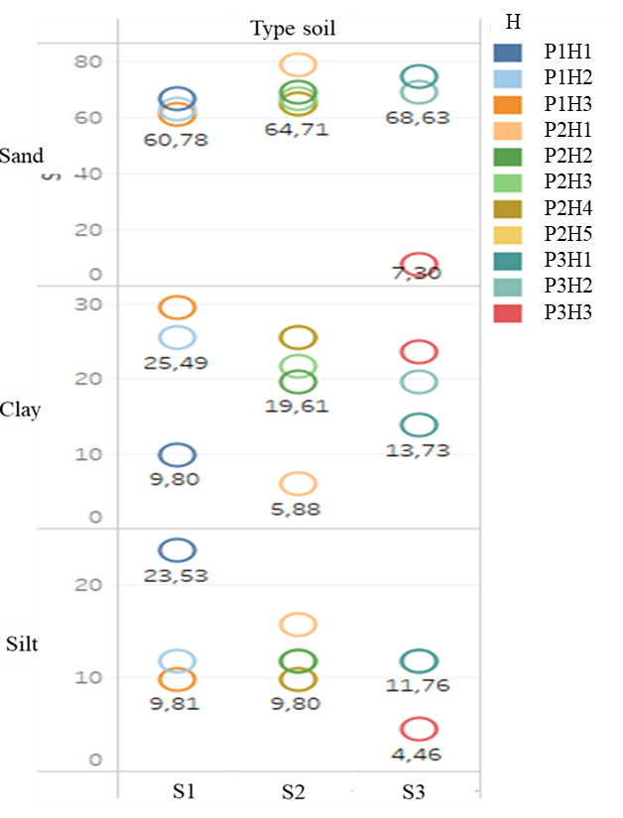

Figure 3: Analysis of soil texture
Legend: H= Horizon; PH= Pit horizon; S= Soil.
The distribution of shades in S1 soils is generally characterized by the dominance in the dry state of very dark gray (10YR 3/1) shades at the surface and dark grayish brown (2.5Y 4/2) at depth limited to 43 centimeters by a ferruginous shell. The massive structure with developed consistency has numerous fine to medium pores and roots, suggesting well-developed biological activity.
In the surface horizons of the S2, the observed color in the wet state is mainly brownish yellow (10YR6/8), while in the rest of the profile it is dark yellowish brown (10YR4/6). The structure, weakly developed and sub-angular polyhedral, is composed of coarse , medium and fine elements, conferring a consistency ranging from friable to hard. The root presence is low and decreases further with depth, while the faunal activity remains average throughout the profile.

In the S3 soil profile, which is medium deep (60 cm), the distribution of colors in the wet state revealed a predominance of red (2.5YR4/6) shades in the surface horizons, while at depth the shade is brown (10YR4/3). Its massive structure with a sub-angular polyhedral shape, weakly to moderately developed in medium and coarse elements. The pores are quite numerous in the first 50 cm and few in the rest of the profile. The roots are numerous on the surface and few in depth, and the biological activity is well developed.
3.1.2 Chemical Fertility Parameters
Analysis of the vertical distribution of chemical properties of soils S1, S2, and S3 (Fig. 4) highlights distinct dynamics in their fertility parameters. The OM content increases from 1.5% at the surface to about 0.5% at depth for S1 and S2, while it is less than 0.5% from the first horizons of S3. Regarding total nitrogen, it follows the same trend, increasing from 0.10% at the surface to less than 0.025% at depth. S3 soils appear to have lower OM and N content than S1 and S2. As for phosphorus, its concentration also decreases with depth, indicating its low mobility. It is 8 mg/kg at the surface in S1 and S2, but drops to about 3 mg/kg at depth. In S3 soil, the P content is constantly low (< 3 mg/kg), indicating a low phosphorus reserve.
Unlike other nutrients, K increases with depth, reaching more than 25 cmol/kg in some horizons, likely due to cation migration.
Base saturation (BS) is higher with depth for all three soil types, reaching more than 22.5% in S2 and S3, indicating better water retention in these soils.
The water retention capacity (pF4.2) shows an increase with depth, particularly for S2 and S3, suggesting a better water storage capacity in the deep horizons, probably due to a clayey texture.
The pH ranges from slightly acidic (5.7) to neutral (6.5), with S1 soil being more acidic than S2 and S3.
Overall, the most fertile soils (S1 and S2) are distinguished by higher organic matter and nutrient contents in the upper horizons. In contrast, S3 has lower fertility, with a low organic matter and nitrogen reserve. This analysis highlights more concentrated fertility in the surface horizons, particularly in organic matter, nitrogen, and phosphorus.
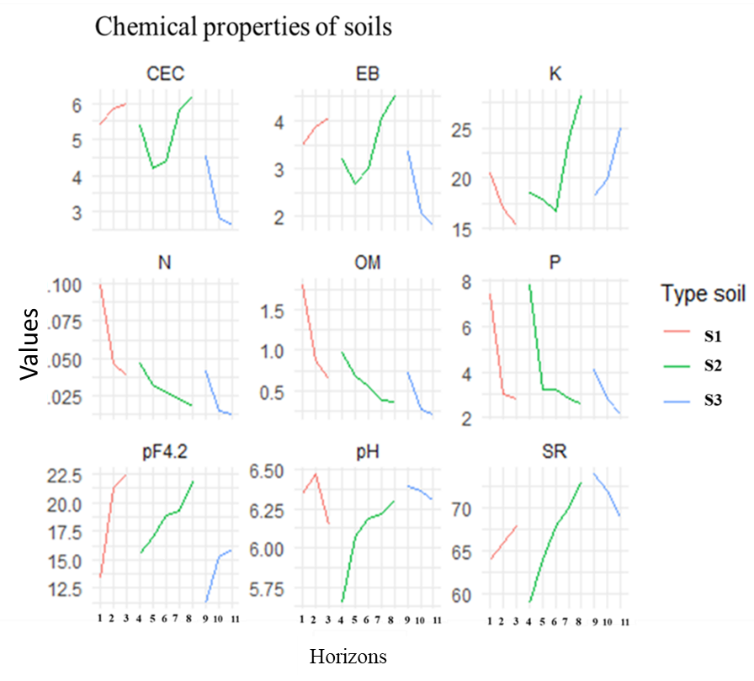

Figure 4: Analysis of soil chemical properties
Legend: S= Soil; CEC= Cation Exchange Capacity; EB= Exchangeable bases; K= Potassium; N= Nitrogen; OM= Organic Matter; P= phosphorus; pF4.2= Water potential; pH= hydrogen potential; SR= saturation rate.

Analysis of relationships between soil fertility parameters in Boudtenga
Principal component analysis was applied to simultaneously represent soil subgroups and their fertility characteristics in a two-dimensional space. The resulting biplot (Fig. 5) allowed us to identify relationships and visualize correlations between these parameters. The first two factor axes together explain approximately 71.06% of the variability in soil fertility parameters, indicating that they capture the majority of information about these parameters.
Axis 1 primarily reflects a fertility gradient, ranging from highly fertile soils, characterized by high levels of organic matter, nitrogen, and phosphorus, to less fertile soils, characterized by a high saturation rate (SR). Thus, the first principal component (PC1) primarily represents organic matter and nutrient (N, P) content. Axis 2, meanwhile, reflects the soil's capacity to retain and exchange nutrients. It reflects the exchangeable base content, the soil's cation
exchange capacity, and water retention (pF2.5), which influence nutrient availability and soil structure.
This spatial distribution of soil fertility parameters shows that brown soils, located in the negative sector of PC1, are characterized by high organic matter content, high nitrogen and phosphorus levels, and a lower saturation rate. In contrast, ferruginous soils, closer to the center, are distinguished by higher pH values, a higher saturation rate, and moderate potassium levels.
As for hydromorphic soils, in the negative sector of PC2, they are distinguished by a higher cation exchange capacity and exchange base, with a good water retention capacity (pF2.5). These properties indicate a good nutrient retention capacity but potentially lower organic matter.
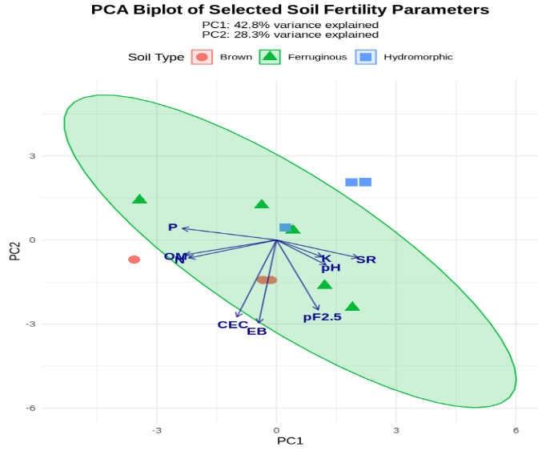

Figure 5: Factor analysis of fertility parameters by soil type
Legend: CEC= Cation Exchange Capacity; EB= Exchangeable bases; K= Potassium; N= Nitrogen; OM= Organic Matter; P= phosphorus; pF4.2= Water potential; pH= hydrogen potential; SR= saturation rate.
The analysis of the relationships between fertility parameters highlights several types of correlations. The strong positive correlation between organic matter, nitrogen and available phosphorus indicates that these parameters evolve in a similar way. These observations also highlight the synergistic relationship between OM, N and P in soil fertility. Conversely, pH and SR, oriented in a direction opposite to the previous ones, indicate a negative relationship with these three parameters. Exchangeable bases and CEC are strongly correlated (0.965), indicating their functional relationship in the dynamics of soil nutrients.
3.3. Assessment of the agricultural potential of the soils studied
Comparative analysis of soil fertility parameters (Fig. 6) shows a gradient in organic matter evolution, with higher levels in brown soils (1.11%), followed by ferruginous soils (0.59%), and finally hydromorphic soils (0.40%).
Brown soils have the highest values for organic matter (1.11%) and total nitrogen (0.099%), with potassium above 20 mg/kg and phosphorus at 7.81 mg/kg being more readily available. These soils, located at the top of the glacis slope, benefit from good drainage and good structure. Their pH values show low variations, although there is a buffer zone (5.65-6.47). These properties indicate good fertility and good agricultural potential.
As for the ferruginous soils on medium slopes of glacis, they are characterized by an average content of organic matter (0.59%) and nitrogen (0.05%), reflecting an intermediate fertility, with a notable limitation in phosphorus (5.2 mg/kg). These characteristics suggest a moderate fertility with potential chemical constraints.
Concerning hydromorphic soils, located at the bottom of the slope, they have the lowest nitrogen (0.013%) and organic matter (0.40%) contents. Phosphorus (2.17 mg/kg) and potassium (less than 15 mg/kg) are also in lower concentrations, which could limit the natural fertility of these soils, often subject to waterlogging which hinders soil aeration and the mineralization of organic matter.
To assess the availability of the main nutrients in the soils studied, we analyzed the trends of the four essential elements illustrated in Figure 6. Significant differences emerge. K values are relatively low for all three soil types, around 3 to 5 units, while N values are even lower, ranging from 2 to 4 units. Organic matter content is the lowest of the analyzed parameters, ranging from 0 to 2 units. Phosphorus, on the other hand, is distinguished by significant variations according to the soil subgroups, with values exceeding 20 units, particularly in hydromorphic and ferruginous soils.
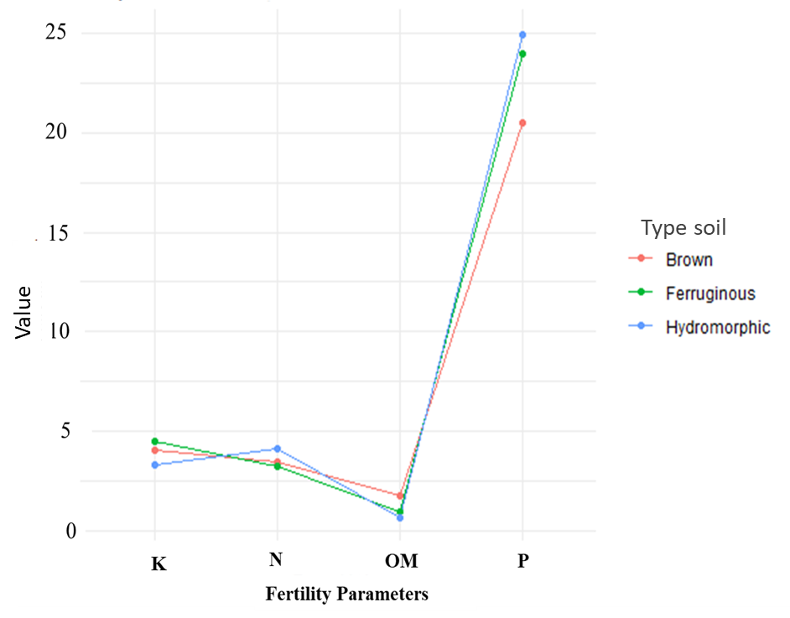
Figure 6: Chemical properties of soils
Legend: K= Potassium; N= Nitrogen; OM= Organic Matter; P= phosphorus.
This analysis reveals that brown soils are characterized by lower mineral content, displaying the lowest levels of P (21) and N (2.5) units, but benefit from slightly higher organic matter (2 units) compared to other soils. Ferruginous soils, for their part, stand out for higher levels of nitrogen (3.0 units) and potassium (4.5), surpassing brown soils by 20% and 12.5% respectively, as well as hydromorphic soils by 7.1% and 18.4%. P content is high (23) but OM content remains limited (0.3 units). Finally, hydromorphic soils have the highest P content (25.0 units), 25% more than brown soil (20.0 units) and 8.7% more than ferruginous soil (23.0 units), although OM remains the lowest (0.2). In summary, all three soils are extremely poor in organic matter, with brown soils showing a slight relative superiority (0.5 units), exceeding hydromorphic and ferruginous soils by 150% and 66.7%, respectively. Considering the classification criterion of the level of chemical fertility of the soil, proposed by BUNASOLS (1990), the analysis results showed that the chemical fertility of the soils is, in general, average. However, brown soils have better characteristics with an OM of 1.5%, a neutral pH (6.5) and EB (> 4), which makes them well suited for agriculture. They are the most fertile, followed by ferruginous and hydromorphic soils (Fig. 7). As for ferruginous soils, they display intermediate fertility with an OM of 1%, a slightly acidic pH (6.0) and moderate EB. Hydromorphic soils are characterized by an OM less than 0.5%, a more acidic pH (< 5.75) and low EB (< 3), making their fertility limited.

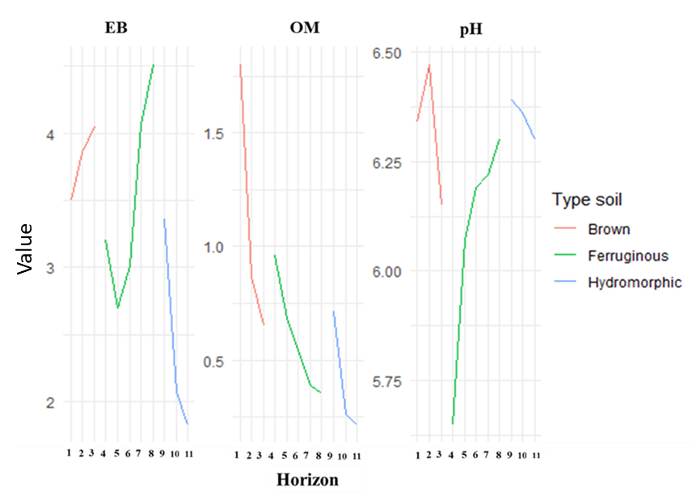
Figure 7 : Chemical soil fertility
Legend: EB= Exchangeable bases; OM= Organic Matter; pH= hydrogen potential.
Analysis of the soils studied reveals greater agronomic potential for brown soils, which are more suited to demanding crops, although they require moderate NPK correction. Their high organic matter, nitrogen, and phosphorus content provides a good nutrient reserve, particularly suitable for agriculture, especially for sorghum.
Ferruginous soils, on the other hand, have average agronomic potential and necessarily require improvement of their organo-mineral status.
Regarding hydromorphic soils, their potential is limited and requires prior specific improvement.

4. Discussion
4.1. Cultivation suitability of the soils studied
Soil surveys revealed the impact of topography on the distribution of soil types, placing Haplic Cambisols at the upper slopes, Ferric Lixisols at the mid-slopes and Gleyic Lixisols at the lower slopes. This variability is typical of West African landscapes, where topography has an important role in soil distribution (Seyni Bodo and al., 2019). In addition, erosion and redistribution of parent materials lead to the formation of a soil mosaic (Bationo, Kihara, and al., 2007).
Soils on plateaus and slopes are often different from those on lowlands and depressions, due to differences in drainage, erosion, and material accumulation (Seyni Bodo and al., 2019). The presence of brown, ferruginous, and hydromorphic soils along the toposequence reflects soil differentiation processes related to drainage and topographic position. Analyzing soil types in a toposequence in the Sudano-Sahelian zone of Burkina Faso, Kissou and al. (2018) noted that soils at the bottom of the slope are more hydromorphic and retain more water, while those at the top of the slope are subject to excessive drainage.
Our results showed that brown soils, located at the top of the slope, are distinguished from others by a deep clayey texture (29.41% clay, F1H3) and a porous polyhedral structure favoring biological activity. Thus, topography influences the physical and chemical properties of soils, making soils at the top of hills more acidic than those located in valleys (Coulibaly and al., 2020).
Our analysis of the spatial distribution of soils located ferruginous soils on average slopes, presenting a sub-angular structure, while the more massive hydromorphic soils, at the bottom of the slope, are marked by reduced porosity at depth and a more limited cation exchange capacity. The work of Zongo and al. (2024) on the cultivation capacity of soils in the same area also noted a low cation exchange capacity, between 5 and 10 meq/100 g of soil. According to Bassole and al. (2023), topographic variation also influences the availability of nutrients needed for the crop, including sorghum. These authors note that clay soils, located at the bottom of the slope, can be richer in nutrients but also more sensitive to waterlogging,
Our principal component analysis revealed that 71.06% of the variability in fertility parameters is explained by two axes. Axis 1 reflects a fertility gradient related to OM, nitrogen, and phosphorus. Brown soils, relatively richer in OM and nutrients, contrast with less fertile ferruginous and hydromorphic soils. Axis 2, PC2 (28.3%), illustrates cation exchange capacity and water retention, dominant in hydromorphic soils.
These observations corroborate the research of Bationo and al. (2006) and Epolyste and al. (2015) who showed that hydromorphic soils, despite a high CEC linked to their predominantly clayey texture, suffer from waterlogging and low OM, limiting their agricultural potential. In a similar study, Bassole and al. (2023) also observed that tropical eutrophic brown soils, located on high or medium slopes of glacis, are generally more fertile and have a very good useful water retention capacity and good rooting conditions for crops.
Addressing soil fertility in the semi-arid climate zone, Zongo and al. (2024) have already noted that nutrients such as OM, available phosphorus and total potassium have limited contents affecting soil fertility. The strong correlation revealed by our results, between OM, nitrogen and phosphorus, suggests that increasing one of these components could enhance the availability of the others. This observation is in line with the work of Somda and al. (2017) who emphasize that organic matter is an important source of nutrients for the soil, including nitrogen and phosphorus because its decomposition releases these nutrients in forms that can be assimilated by plants.
Concerning the dynamic relationship between soil fertility parameters, our results also highlighted a negative correlation between pH and OM, which in another form supports the observations of Bationo and al. (2006) that mineralization is increased in a neutral environment, leading to a reduction in organic matter stocks.
As for the strong correlation observed between CEC and exchangeable bases (0.965), it confirms the functional relationship between these two fertility parameters in the dynamics of soil nutrients. According to Ouedraogo and al. (2022), this relationship highlights the importance of the soil's capacity to store and release nutrients.
Regarding pH, its values range from 5.7 for ferruginous soils to 6.5 for brown soils, which is generally favorable for nutrient availability (Bationo and al., 2007).
Soils with a pH below 6.0 may have limited phosphorus availability, which is a crucial factor for plant growth (Zongo and al., 2024). The low levels of available phosphorus (2.17–7.81 mg/kg) confirm these nutritional limitations typical of the Sudano-Sahelian zone, as highlighted by Vincent & Bationo (2018).
We did not have access to sufficient data to examine the correlations between sorghum productivity and soil types according to their fertility. However, numerous research studies have clearly shown that soil fertility (notably availability of N, P, organic matter) is a key factor influencing sorghum yield, and that adapted agronomic practices can modulate this relationship (Sohoro et al., 1999; Sanna et al., 2022; Kafando et al., 2023; Togo et al., 2023). We propose a complementary study to further investigate these relationships in our study area.
4.2. Soil Fertility Management
Our results revealed highly variable organic matter levels, ranging from 0.21% in low-lying areas (hydromorphic soils) to 1.79% at the upper slopes (brown soils), requiring potential organic amendments. In such a context, agricultural practices adapted to topographic variation appear to be solutions that can improve agricultural yields (Vasseur and al., 2013; Ouedraogo and al., 2022).
In Sudano-Sahelian areas, an integrated approach is essential, combining various techniques adapted to topographic specificities such as plateaus, slopes, glacis and valleys (Guarnieri, 2021). The strong positive correlation observed between organic matter, nitrogen and phosphorus in our results is consistent with the research of GUEBRE et al. (2020) who demonstrated that soils amended with Ramial Wood Chips (BRF) present significant increases in soil organic carbon, nitrogen and phosphorus contents compared to control soils.
Soil fertility is closely linked to the presence of organic matter, which improves nutrient retention (Zongo and al., 2021). They also noted that sorghum-cowpea intercropping improves soil nitrogen content, thereby increasing the soil's capacity to retain and supply these nutrients to crops. Low available phosphorus is a known problem, as reported by Zongo and al. (2024), requiring phosphate fertilizer applications.
These authors explain this low level of total phosphorus by the granitic nature of the parent rock, which is poor in phosphorus. Research conducted in Burkina Faso also resulted in soil poverty, noting a 76.83% drop in organic carbon, 82.48% in available phosphorus and a decrease in pH after ten years of continuous cultivation (Coulibaly and al., 2020). In response to these challenges, Seyni Bodo and al. (2019) suggest that management practices adapted to topography and soil specificities can significantly improve agricultural productivity, including sorghum cultivation.
Our results indicate that brown soils (on high slopes) have good agricultural potential, even if they require moderate NPK correction. Their richness in organic matter, nitrogen and phosphorus provides a good nutrient reserve, particularly suitable for agriculture, especially for sorghum cultivation (Bassole and al., 2023).
On the other hand, ferruginous and hydromorphic soils located respectively on medium slopes and lower slopes of glacis have more moderate fertility characteristics. According to Ouedraogo and al. (2022), these soils require specific interventions to improve their productivity.
Eutrophic brown soils, with a weakly acidic to neutral pH, should benefit from organic and mineral amendments to improve their quality and productivity for sorghum (Bassole and al., 2023). Maintaining their fertility through organic matter additions (compost, manure), crop rotation, and legume crops should be a priority, while encouraging sustainable agronomic practices (Bationo and al., 2007). For ferruginous soils, targeted fertilization (N, P, K) and the integration of legumes would improve their organo-mineral status for sorghum cultivation, as recommended by Kissou and al. (2014).
As for hydromorphic soils, improving the drainage level and soil structure would prevent root asphyxiation and optimize the availability of nutrients for crops, particularly sorghum. The addition of compost or raw material is also a priority to stimulate biological activity, improve the structure and fertility of these soils (Dabre and al., 2017; Nambima and al., 2023).
Recent research also highlights the importance of optimizing fertilization practices by integrating organic and mineral inputs to improve the chemical properties of soils in the Sudano-Sahelian zone for cereal cultivation, particularly sorghum (Somda and al., 2017). These authors determined that optimal doses of 2 g of mineral fertilizer and 5 t ha-1 of manure can triple sorghum biomass yields, and that the integration of organo-mineral fertilizers significantly increases available phosphorus levels in the soil.
Our study highlighted a decreasing fertility from brown soil to hydromorphic soil, with a more marked nutritional limitation in nitrogen and phosphorus, essential for sorghum productivity. For its optimal growth, sorghum requires several soil nutrients, including phosphorus and potassium, calcium, nitrogen, magnesium (Chantereau and al., 2013).
Furthermore, intercropping sorghum and cowpea significantly increases yields, by more than 25% compared to traditional systems in the region (Bambara and al., 2008) (Dasmané and al., 2008). The sorghum-cowpea association improves nitrogen acquisition by sorghum, which is crucial in a region where soils are often lacking in nutrients (Zongo and al., 2021).

4. Conclusion

Our study aimed to assess the agricultural suitability of Boudtenga soils through the analysis of their physical and chemical characteristics, in order to assess their fertility potential. Soil description according to the toposequence revealed a diversity of soils properties, closely linked to the topographical position, which significantly affect the agronomic quality and productive potential of the soils. The results confirm that the cultural suitability of soils for cereal production in the Sudano-Sahelian zone of Burkina Faso depends largely on their physical and chemical characteristics which determine their chemical fertility. The implementation of integrated management practices, taking into account the specific topographical, textural, chemical characteristics of soils, is essential to sustainably improve fertility and optimize agricultural yields in this area. These results provide an essential basis for guiding farmers toward more resilient and sustainable agricultural practices in the fragile context of the Sudano-Sahelian region

Disclaimer (Artificial intelligence)
Author(s) hereby declare that NO generative AI technologies such as Large Language Models (ChatGPT, COPILOT, etc.) and text-to-image generators have been used during the writing or editing of this manuscript.

References

AFNOR. (1992). Soil quality - Physical methods - Measurement of the bulk density of an undisturbed soil sample - Cylinder method. In Nf X31-501.
Bassole, Z., Yanogo, I. P., & Idani, F. T. (2023). Characterization of leached tropical ferruginous soils and tropical eutrophic brown soils for agricultural use in the Goundi-Djoro lowland (Burkina Faso). International Journal of Biological and Chemical Sciences, 17(1), 247–266. https://doi.org/10.4314/ijbcs.v17i1.18
Bationo, A., Kihara, J., Vanlauwe, B., Kimetu, J., & Waswa, B. S. (2006). Integrated Nutrient Management: Concepts and Experience from Sub-Saharan Africa. Biological Approaches to Sustainable Soil Systems, 1–65. https://doi.org/10.1300/5426
Bationo, A., Kihara, J., Vanlauwe, B., Waswa, B., & Joseph, K. (2007). Soil organic carbon dynamics, functions and management in West African agro-ecosystems. Agricultural Systems, 94(1), 13–25. https://doi.org/https://doi.org/10.1016/j.agsy.2005.08.011
Bationo, A., Waswa, B., Kihara, J., & Kimetu, J. (2007). Advances in integrated soil fertility management in sub–Saharan Africa: challenges and opportunities. Nutrient Cycling in Agroecosystems, 1, 1–2. https://doi.org/10.1007/s10705-007-9096-4
Blanchard, M., Coulibaly, K., Bognini, S., Dugué, P., & Vall, É. (2014). Diversity in the quality of organic fertilizers produced by West African farmers: What are the consequences for fertilization recommendations? Biotechnology, Agronomy and Society and Environment, 18(4), 512–523.
Bray, R. H., & Kurtz, L. T. (1945). Determination of total, organic, and available forms of phosphorus in soils. Soil Science, 59(1), 39–46. https://webcache.googleusercontent.com/search?q=cache:BDsuQOHoCi4J:https://media.neliti.com/media/publications/9138-ID-perlindungan-hukum-terhadap-anak-dari-konten-berbahaya-dalam-media-cetak-dan-ele.pdf+&cd=3&hl=id&ct=clnk&gl=id
Bremner, J. (1965). Total nitrogen. In: Black C.A., ed. Methods of soil analysis, part 2. Madison, WI, USA: American Society of Agronomy, 2, 1149–1178.
BUNASOLS. (1990). Manual for land evaluation. Technical Documentations, 181p.
C.P.C.S. (1967). Soil classification. Commission on pedology and soil mapping. Chantereau, J., Cruz, J.-F., Ratnadass, A., & Trouche, G. (2013). Sorghum. Tropical Agriculture in Your Pocket.
Coulibaly, K., Traoré, M., Guiro, A., Bacyé, B., & Nacro, H. B. (2020). Relationship between soil fertility and rainwater productivity on maize (Burkina Faso). Climate Risks and Agriculture in West Africa (Vol. 84, Issue 75). https://books.openedition.org/irdeditions/36089/
Dabre, A., Hien, E., Some, D., & Drevon, J. J. (2017). Effects of organic and phosphate amendments under zaï on soil chemical and biological properties and organic matter quality in the Sudano-Sahelian zone of Burkina Faso. International Journal of Biological and Chemical Sciences, 11(1), 473. https://doi.org/10.4314/ijbcs.v11i1.38
Dasmané, B., Jean Sibiri, Z., & Jean-Pierre, T. (2008). Original study. Cahiers Agricultures Vol., 17(3), 297–301.
Epolyste, A., Yacouba, H., & Zombre, P. (2015). Soil fertility status of the Gouran gravity-fed irrigation scheme in the Sourou Valley, Burkina Faso: Findings and perspectives. International Journal of Biological and Chemical Sciences, 8(5), 2119. https://doi.org/10.4314/ijbcs.v8i5.17
FAO. (1994). Based on “Guidelines for soil description,” 3rd ed. FAO, Rome 1994.
Fontès, J., & Guinko, S. (1995). Vegetation and land use map of Burkina Faso. Explanatory note. French Ministry of Cooperation, Campus Project, 67, 881–3101.
Guarnieri, L. (2021). Main RWH techniques in the Sahel in North Africa (Vol. 3).
Guebre, D., Traore, S., Traore, M., Tockville, B. and Hien, E. (2020). Soil conservation in the Sudano-Sahelian zone: how efficient are woody amendments? Natural and Applied Sciences, 39(2 (1)): 5–220.

Kambou, D. (2019). Evaluation of technical irrigation performance in Burkina Faso. Liège. Karambiri, N. B. L. C., & Gansaonre, R. N. (2023). Spatio-temporal variability of rainfall in the climatic zones of Burkina Faso: Case of Bobo-dioulasso, Ouagadougou and Dori. European Scientific Journal, ESJ, 19(9), 262. https://doi.org/10.19044/esj.2023.v19n9p262
Kissou, R., Gnankambary, Z., Nacro, H. B., & Sedogo, M. P. (2018). Local classification and land use in the Sahelian zone of Burkina Faso. International Journal of Biological and Chemical Sciences, 12(1), 610. https://doi.org/10.4314/ijbcs.v12i1.46
Kissou, R., Traoré, E., Gnankambary, Z., Nacro, H. B., & Sédogo, M. P. (2014). Endogenous knowledge of soil classification and fertility in the South Sudanese zone of Burkina Faso. VertigO, Volume 14 Issue 1, 1–17. https://doi.org/10.4000/vertigo.14616
Kohio, E. N., Toure, A. G., Sedogo, M. P., & Ambouta, K. J. M. (2018). Constraint es to the adoption of good practices for Sustainable Land Management in the Sudanian and Sudano-Sahelian zones of Burkina Faso. International Journal of Biological and Chemical Sciences, 11(6), 2982. https://doi.org/10.4314/ijbcs.v11i6.34
Nambima, A. B., Houehanou, T. D., Gouwakinnou, G. N., & Biaou, H. S. (2023). Traditional agroforestry parklands in West Africa: A literature review on their contribution to improving soil fertility and mitigating the effects of climate change. Bulletin de La Recherche Agronomique Du Bénin (BRAB), 33(3), 1–13.
Ouedraogo, A., Kabore, F., & Kabore, O. (2022). Perception of soil fertility and adaptation strategies of agricultural producers in Samandéni (Burkina Faso). International Journal of Biological and Chemical Sciences, 16(4), 1536–1553. https://doi.org/10.4314/ijbcs.v16i4.15
Sakho-jimbira, S., & Hathie, I. (2020). The future of agriculture in sub-Saharan Africa. Policy Brief, 2, 20.
Sankara, B. T. (2010). Climate variability and natural resource management. Case of the Gonse classified forest and partial wildlife reserve in Burkina Faso [University of Ouagadougou]. http://www.memoireonline.com/01/13/6693/m_Variabilite-climatique-et-gestion-des-ressources-naturelles-Cas-de-la-fort-classee-et-reserve30.html
Sanna, S., Ouédraogo, M., Yonli, D., Nikiema, M. P., Traore, H., Salif, T., Middendorf, B. J., Stewart, Z., Stewart, Z. P., & Prasad, V. p. V. (2022). Effect of cereal-legume intercropping, water management, and soil fertility on improving agricultural productivity in eastern Burkina Faso. Sciences Naturelles et Appliquées, 41(2), 213–236. Sawadogo, S., Naba, S., Bouchez, J.-L., Jessell, M. W., Ouédraogo, A., & Tankoano, D. (2021). Geophysical signature of the Birimian formations in central Burkina Faso: Implications for crustal architecture. Journal of African Earth Sciences, 184, 104–397. https://doi.org/https://doi.org/10.1016/j.jafrearsci.2021.104397
Seyni Bodo, B., Morvan, X., Malam Issa, O., Tidjani Adamou, D., Ambouta Karimou, J., Marin, B., Ponthieu, M., & Fronteau, G. (2019). Local knowledge of soil surface variability and associated constraints for cowpea production in the Sahelian zone of Niger. Received: November 26, 79. http://www.afes.fr/publications/revue-etude-et-
Soma, A. (2021). Land management in the urbanized rural commune of Saaba in Burkina Faso.
Somda, B. B., Ouattara, B., Serme, I., Pouya, M. B., Lompo, F., Taonda, S. J. B., & Sedogo, P. M. (2017). Determination of optimal doses of microdose organo-mineral fertilizers in the Sudano-Sahelian zone of Burkina Faso. International Journal of Biological and Chemical Sciences, 11(2), 670. https://doi.org/10.4314/ijbcs.v11i2.11
Tully, K., Sullivan, C., Weil, R., & Sanchez, P. (2015). The State of soil degradation in sub-Saharan Africa: Baselines, trajectories, and solutions. Sustainability, 7(6), 6523–6552. https://doi.org/10.3390/su7066523
Vasseur, C., Joannon, A., Aviron, S., Burel, F., Meynard, J. M., & Baudry, J. (2013). The cropping systems mosaic: How does the hidden heterogeneity of agricultural landscapes drive arthropod populations? Agriculture, Ecosystems and Environment, 166(July 2019), 3–14. https://doi.org/10.1016/j.agee.2012.08.013
Vincent, B.B., & Bationo, A. (2018). Integrated management of soil fertility and land resources in Sub-Saharan Africa: involving local communities. Advances in Agronomy, 150(1), 1-33. https://doi.org/https://doi.org/10.1016/bs.agron.2018.02.001.
Walkley, A., & Black, I. . . (1934). An examination of the Degtjareff method for determining soil organic matter and a proposed modification of the chromic acid titration method. Soil Sci., 37, 29–38.
Zongo, K. F., Guebre, D., Coulibaly, A., Daramkoum, P. A. W., Sanou, I., & Hien, E. (2024). Characterization and evaluation of the cultural suitability of a soil for tomato production in a semi-arid tropical climate. European Scientific Journal, 27(20), 208–235. https://doi.org/10.19044/esj.2024.v20n27p208
Zongo, K. F., Hien, E., Mare, B. T., & GUEBRE, D. (2021). Performance of sorghum-cowpea mixed cropping system on sorghum and soil productivities in the Sudano-Sahelian zone of Burkina Faso. Int. J. Biol. Chem. Sci., 15(3), 987–1005.

