Enhancing Soybean Productivity through Spatial Arrangement and Nutrient Management

Abstract :
A field experiment conducted at the Research Farm of Tirhut College of Agriculture, Dholi, during the Kharif season of 2019 investigated the impact of spatial arrangement and nutrient application on soybean productivity. The study employed a factorial randomized block design with three replications, evaluating four crop geometry (30 x10 cm, 45 x5 cm, 45 x 10 cm and 45 x 15 cm) configurations and three fertilizer levels 100 % RDF, 120 % RDF, and 140 % RDF. The investigation revealed significant effects of crop geometry and nutrient levels on soybean growth and yield parameters, including:, Plant height (cm), Plant dry weight (g plant⁻¹), number of pods per plant, Number of seeds per pod, 100 seed weight (g), seed yield (q ha⁻¹), straw yield (q ha⁻¹) and harvest index (%).Plant height, number of pods per plant, plant dry weight, total and effective number of root nodules, dry weight of root nodules, maximum harvest index, number of seeds per pod with maximum seed yield (21.19 q ha⁻¹), and straw yield (26.30 q ha⁻¹) were all highest among crop geometry treatments for crop geometry P₂ (45 x 5 cm). Crop geometry P₃ (45 x 10 cm) recorded the highest test weight, while crop geometry P₄ (45 x 15 cm) had the lowest seed yield (17.84 q ha⁻¹).Out of all the nutrient level treatments, F₃-140% RDF (NPK) had the highest plant height, plant dry weight, number of pods per plant, number of seeds per pod, 100 seed weight (8.59 g), seed yield (20.02 q ha⁻¹), straw yield (25.45 q ha⁻¹), and harvest index (44.29%). This treatment was found to be significantly better than the others. The treatment F₂-120 percent RDF had the highest nodule count per plant (25.09), nodule dry weight (33.79 g plant⁻¹), and nodule effective dry weight (28.80 g plant⁻¹). Thus, crop shape P2-45 x 15 cm with fertility level F₂-120 % RDF was determined to be appropriate for the best soybean production.
Keywords: Soybean, crop geometry, nutrient level and yield
Introduction
Soybean (Glycine max L. Merr) is a premier oilseed crop globally and in India, renowned for its exceptional nutritional and economic value. With a history of commercial production spanning nearly four decades in India, soybean has witnessed remarkable growth, expanding its footprint across regions and development. In the rainfed agro-ecosystems of Central and Peninsular India, soybean has emerged as a prominent monsoon season crop, contributing significantly to crop intensity and productivity per unit area.
As a member of the Fabaceae family, soybean is a vital Kharif oilseed crop in India, holding a prominent position among modern agricultural commodities. Globally, soybean is the most common seed legume, accounting for approximately 25% of the world's edible oil production and around two-thirds of the protein concentrate for livestock. Additionally, soybean is a crucial component in processed feed for poultry and fish, as well as a valuable commodity for food manufacturers, the pharmaceutical industry, and various other industrial applications.
In India, soybean plays a pivotal role in the agricultural economy, contributing substantially to the country's edible oil supply. Soybean accounts for 43% of the total oilseed production and 25% of the country's overall oil supply, underscoring its importance in India's agricultural landscape. With its multifaceted uses and significant economic impact, soybean remains a vital crop for India's agricultural sector and economy.
Optimizing the best growth conditions of soybean varieties for high yield is crucial to obtain maximum yield of soybean. As a row crop, soybean's productive use of solar energy is vital for better crop production. Achieving maximum leaf area per unit ground area and ensuring sunlight infiltration to lower canopy levels are essential for enhancing crop growth rate and yield efficiency.
The ideal plant density and geometry depend on factors such as variety, growth habit, and agro-climatic conditions. Proper row-to-row spacing and plant population are critical in achieving optimal leaf area index and maintaining it for an extended period. This, in turn, boosts soybean yield efficiency Rajbhandari et al. (2008).
Maintaining soil productivity through balanced nutrient management is crucial for enhancing crop yields. Soybean, being a legume, derives approximately half of its nitrogen (N) requirement through biological N₂ fixation, Alam et al. (2009). while the remaining portion is sourced from the soil. Consequently, judicious application of N fertilizer is essential to augment soybean yield and efficiency.
Phosphorus (P) plays a vital role in soybean growth, particularly during the initial stages and throughout pod and seed production. Adequate P absorption and utilization are critical for proper nodule development and crop yield efficiency.
Potassium (K) is essential for maintaining plant water balance, preventing necrosis, and reducing the risk of insect-pest attacks. High-yielding soybean varieties require relatively higher amounts of K, Heinrichs et al. (2019)
The pre-requisite condition for sustainable crop production is the careful management of different nutrient resources i.e. organic manure and chemical fertilizer. For better soil health and higher production, integrated nutrient management would be followed. The most important is to integrate fertilizer level (100% RDF, 120% RDF and 140% RDF) with crop geometry (30x10cm, 45x5cm, 45x10cm and 45x15cm) for improving productivity.
Crop variety for the experiment JS-335 variety of soybean was chosen and it was disseminated from Jawaharlal Nehru Agricultural University, Jabalpur in 1994. It has high oil content (20-22 %) & protein content (40-42%), seed size is moderate and yellow in colour, maximum seed yield (20-30 q ha⁻¹). It flowers at about 45 DAS; this cultivar has an average height of 50-60 cm with erect branches and takes 95-100 days to mature. It performs well in Eastern and Southern states of India seeds and planting for seeding, JS-335 certified seeds were utilized. On July 17, 2019, the crop was planted using the suggested seed rate of 55–65 kg ha⁻¹. According to the experiment's strategy, seeds were sown in a furrow that had been manually ploughed to a depth of 4-5 cm at various row spacings.
Materials and Methods
Experimental site and Technology
The field experiment was performed during Kharif 2019 in plot No.4 of Dholi farm at “Tirhut College of Agriculture, Dholi (Muzaffarpur), Dr. Rajendra Prasad Central Agricultural University, Pusa (Samastipur), Bihar”. The field with uniform nutrient status & homogeneous textural makeup was picked for the research. The soil of the experimental plot was calcareous in nature having pH 8.32 and EC is 0.29 dSm⁻¹. Geographically, ‘TCA, Dholi (Muzaffarpur) is located on the southern bank of river Burhi Gandak @ an altitude of 58m above average sea level & lies at 25.59⁰ N latitude & 85.35⁰ E longitudes. Under humid sub-tropical climatic region’ that is strongly affected by monsoon.
Climate and weather conditions
According to the Meteorological observatory records at TCA, Dholi, “the average annual rainfall is about 1163 mm, out of which nearly 735.8 mm is received during the monsoon extending from the middle of June to middle of October. The maximum rainfall received during south-west monsoon from July to October. The period between Novembers to first half of the January, receives occasional and light winter shower. January is the coldest month of the year with an average maximum and minimum temperature of 23.2⁰C and 7.9⁰C, respectively. Normally temperature starts decreasing from the first fortnight of November and reaches the minimum in the end of December or early January. Again, it starts rising from the end of February and reaches the maximum in May-June” (Bharati, V. et al., 2023).
Method
Growth Parameters
Plant Height (cm): Measured at 30-day intervals from 30 DAS to harvest, from base to tip of main stem. Plant Dry Weight (g plant⁻¹): Five plants randomly selected, sun-dried, and oven-dried at 70°C to constant weight.
Nodulation
Number of Nodules plant⁻¹: Five plants randomly selected, uprooted, and nodules counted at 30 and 60 DAS.
Post-Harvest Studies
Number of Pods plant⁻¹: Counted from five randomly selected plants.
Number of Seeds pod⁻¹: Quantified from randomly marked plants.
100-Seed Weight (g): Representative sample taken, and weight expressed in grams.
Yield Studies
Grain Yield (q ha⁻¹): Threshed and cleaned grain weighed and converted to quintals per hectare.
Straw Yield (q ha-¹): Calculated by subtracting grain yield from total produce.
Biological Yield (q ha-¹): Total plot output (excluding roots) weighed after air drying
Harvest index (%) The HI is the proportion of economic output to the biological, which has been determined by using the formula.
$$HI(\%)=\frac{Economic output (grain yield) }{Biological output (grain yield + straw yield) }×100$$
Statistical Analysis
Data on plant growth parameters were analysed using Analysis of Variance (ANOVA) for Randomized Block Design (RBD) in a factorial design. Significance was tested using the F-test at p ≤ 0.05, and Critical Difference (CD) was calculated for significant F-values.

Results and discussion
Plant Height
Plant height on various growth phases of crop in terms of elevation taken at 30, 60, 90 DAS and to harvest has increased gradually as the crop progressed to harvest. Crop geometry and fertilizer levels significantly impacted plant height. Crop geometry on the various growths (30 DAS: 24.77 cm, 60 DAS: 46.08 cm, 90 DAS: 47.09 cm and at Harvest: 49.69 cm) under treatment P2 (45cm×5cm) consistently recorded the highest plant height at all growth stages and fertilizer levels on the various growths (30 DAS: 24.58 cm, 60 DAS: 46.68 cm, 90 DAS: 48.18 cm and at Harvest: 49.26 cm) under treatment F₃ (140% RDF) resulted in maximum plant height, significantly superior to F₁ (100% RDF). Because plants need sunshine to function, their height increased as their numbers increased. Different fertilizer levels showed a substantial impact on plant elevation, according to similar results. However, the F3 -140% RDF (NPK) had the maximum plant height, which was noticeably better than the F₁ -100% RDF. It was statistically comparable to the therapy F₂ -120% RDF at 30DAS, though. The plant height enhances with an increase in NPK levels, mainly nitrogen and essential mineral nutrient for plant growth. It is a part of chlorophyll, increases the rate of photosynthesis, imparts green colour, and ultimately increases plant growth. Similar results were concluded by Harpreet et al. (2014)
Plant Dry Weight
Data about dry weight revealed that it is significantly impacted by planting geometry & fertilizer levels on the various growths i.e. 30, 60, 90 DAS & @ harvest. Different plant spacing exhibited a considerable impact on plant dry weight on the various growths 30 DAS: P₄ (1.12 g plant⁻¹) recorded highest, 60 DAS: 7.36 g plant⁻¹, 90 DAS: 16.27 g plant⁻¹ at Harvest: 22.37 g plant⁻¹ under treatment P₂ (45cm×5cm) recorded the highest plant dry weight at most growth stages and nutrient levels on the various growths 30 DAS: 1.11 g plant⁻¹ , 60 DAS: 6.40 g plant⁻¹ , 90 DAS: 15.20 g plant⁻¹ and At Harvest: 20.25 g plant⁻¹ under treatment F₃ (140% RDF) resulted in maximum plant dry weight, significantly superior to F₁ (100% RDF). However, it was statistically equivalent with the treatment F₂-120% RDF @ 30 DAS. The plant dry weight recorded at 60, 90 DAS, & at harvest was followed similar trend. Maximum levels of fertilizers help to increase the total dry matter aggregation in plants. Plant dry weight increases with an increase in fertilizer levels. A similar output was also recorded by Raghuveer et al. (2015).
Root Nodule Parameters
Total Number of Root Nodules
Crop geometry under treatment P₂ (45cm×5cm) recorded the highest number of root nodules (26.53), significantly superior to P₃ (21.30) and P₄ (20.10) and nutrient levels under treatment F₂ (120% RDF) recorded the highest number of root nodules (25.09), significantly superior to F₃ (19.32). Similar results were concluded by Pavan et al. (2001)
Effective Number of Root Nodules
Crop geometry under treatment P₂ (45cm×5cm) recorded the highest number of effective root nodules (18.51), significantly superior to P₃ (15.68) and P₄ (13.00) and nutrient levels under treatment F₂ (120% RDF) recorded the highest number of effective root nodules (17.22), significantly superior to F₃ (14.24). Similar results were concluded by Patel et al. (2013)
Dry Weight of Root Nodules
Total Number of Root Nodules
Crop geometry under treatment P₂ (45cm×5cm) recorded the highest dry weight of total root nodules (35.11 g plant⁻¹), significantly superior to P₄ (25.86 g plant⁻¹) and nutrient levels under treatment F₂ (120% RDF) recorded the highest dry weight of total root nodules (33.79 g plant⁻¹), significantly superior to F3 (23.35 g plant⁻¹). These findings correlate the work of Vandana et al. (2017)
Effective Number of Root Nodules
Crop Geometry under treatment P₂ (45cm×5cm) recorded the highest dry weight of effective root nodules (29.56 g plant⁻¹), significantly superior to P₃ (24.35 g plant⁻¹) and P₄ (22.35 g plant⁻¹) and nutrient levels under treatment F₂ (120% RDF) recorded the highest dry weight of effective root nodules (28.80 g plant⁻¹), significantly superior to F₃ (20.19 g plant⁻¹). The highest quantity of nodules is found in P₂ and P₁ because of higher competition for nitrogen as population gradient was maximum which intern leads to production of higher number of nodules. Similar results were found by Yamika et al. (2012)
Yield Attributes and Yield
Number of Pods per Plant
Crop geometry P₂ (45cm×5cm) recorded the highest number of pods per plant (65.92), significantly superior to P₁ (62.14) and P₄ (61.03). However, it was equivalent with the P₃- (45x10 cm) treatment. Higher crop geometry leads to lower inter and intra row competitions as well as lower crop-weed competition aids in exploiting maximum yield potential and nutrient levels under F₃ (140% RDF) recorded the highest number of pods per plant (65.49), significantly superior to F₁ (61.15) levels of fertilizer because of lower competition for nutrients, which was superior to F₁ (100% RFD). However, it was at par with the F₂ (120% RDF) levels of fertilizer. Similar results were found by Waghmare et al. (2011)
Number of Seeds per Pod
Higher the crop geometry lower would be the competition stress leading to maximum vegetative growth which intern leads lowest economic yield. The average data on total quantity of seeds pod⁻¹ was found highest in P₂ – (45x5 cm) and minimum quantity of seeds pod⁻¹ was found in P₃- (45x10 cm) because of lower competition stress. In case of various fertilizer levels data, F₃- 140% RDF has recorded maximum quantity of seeds pod⁻¹ because of adequate nutrient availability and lower nutrient stress as compared to F₁- 100% RDF. However, it was at par with the F₂- 120% levels of fertilizer. Vyas et al. (2009)
Test Weight (100 seeds)
100 seeds weight was not influenced significantly by various plant spacing, lower seed weight in the high plant population (P₁- 30x10 cm and P₂- 45x5 cm) might be due to increased revelry among crops for available growth factors. Different fertilizer levels had a non-significant impact on 100 seed weight. Test weight is a genetic character that will not be affected by different treatments under study.
Seed yield
Seed yield (q ha⁻¹) of soybean was statistically evaluated & this information has been illustrated in table 4 & diagrammatically shown in fig 4. Evidently, seed yield data (q ha⁻¹) indicated that plant geometry had significant impact on economic yield. The significantly highest seed yield (21.19 q ha⁻¹) was registered in the treatment P₂- 45cm x 5cm which was superior to the P₄- 45cm×15cm (17.84 q ha⁻¹) & P₃- 45cm×10cm (18.10 q ha⁻¹) which was approximately equivalent to the P₁ - 30cm×10cm (20.20 q ha⁻¹). if the plant population is more than optimum than the plant undergoes a severe competition for available soil resources and if the plant population is lower than the optimum, as in the case of P₄- 45x15 cm leads to underutilization of available recourses, which intern reduces the total economic yield. Nutrient levels also cause notable impact on seed yield (q ha⁻¹). The highest seed outcome (20.02 q ha⁻¹⁾ was registered in the treatment F₃ -140% RDF (NPK) which was notably superior to the F₁ -100% RDF (18.02 q ha-¹). However, it was approximately equivalent with the treatment F₂-120% RDF (19.97 q ha⁻¹). Maximum nitrogen usage leads to rapid leaf area development, extends the life of foliage, increases leaf area duration after flowering & increases crop assimilation ultimately contributing to maximum yield. Soybean is a vital oilseed crop that removes a notable quantity of nutrients from the soil. Soybean has a high P requirement along with S leads to higher and better-quality oil production that & a shortage of N before to flower initiation leads to the reduced quantity of pods plant⁻¹, total quantity of seeds pod⁻¹, seed & oil yield. Potassium is the second important nutrient after phosphorus in limiting soybean production. Phosphorus is important for plant development & it is involved in energy transfer, photosynthesis, the transformation of sugars, starch, & nutrient movement within the plant Singh et al. (2013). The impact of interaction on seed yield due to crop geometry and nutrient management was found significant.
Straw yield
Straw yield (q ha⁻¹) of soybean was statistically analysed & these data have been illustrated in table 4 & diagrammatically represented in fig 4. It is evident from the statistics on straw yield (q ha⁻¹) that crop geometry had notable influence on straw yield. The significantly elevated straw yield (26.30 q ha⁻¹) was registered in the treatment P₂- 45cm x 5cm which was superior to the P₄- 45cm×15cm (23.88 q ha⁻¹) & P₃- 45cm×10cm (24.09 q ha⁻¹) which was approximately equivalent with P₁- 30cm×10cm (25.82 q ha⁻¹). Nutrient levels also caused significant effect on straw yield (q ha⁻¹). The highest straw yield (25.45 q ha⁻¹) was registered in the treatment F₃ -140% RDF (NPK) which was considerably superior to the F₁ -100% RDF (24.49 q ha⁻¹). However, it was statistically equivalent with the treatment F₂-120% RDF (25.13 q ha⁻¹). The impact of interaction on seed yield due to crop geometry and nutrient management was found non-significant”. Straw yield of soybean was closely associated with plant height, leaf area, stems girth, dry matter aggregation & partitioning of dry matter at seed filling stage. Adequate supply of nutrient under 140% RDF favoured photosynthetic activity resulting in greater plant height and dry matter aggregation that had finally reflected in maximum straw yield. These findings correlate the work of Patel et al. (2018)
Harvest Index (HI)
The harvest index was significantly influenced by crop geometry and nutrient levels. Crop Geometry: P₂ (45cm×5cm) recorded the highest harvest index (44.57%), significantly superior to P₄ (42.71%) and P₃ (42.88%). Nutrient Levels: F₂ (120% RDF) recorded the highest harvest index (44.29%), notably superior to F₁ (42.24%). The increased harvest index under 120% RDF over other fertilizer treatment was probably due to increased seed yields recorded as evident from the respective data. “Similar findings regarding higher harvest index under enhanced fertilizer application in soybean was also reported by Khanam et al. (2016)”.
Conclusion
The study reveals that crop geometry and nutrient management significantly impact soybean growth and yield. Specifically: Crop geometry: 45cm x 5cm spacing and nutrient management: 120% or 140% of recommended dose that optimizing crop geometry and nutrient levels can enhance soybean productivity.
Implications of the study
By adopting optimized crop geometry and nutrient management strategies, farmers and agricultural practitioners can potentially increase soybean productivity, contributing to improved crop performance and enhanced food security. These findings provide valuable insights for refining agricultural practices and promoting sustainable soybean production.

Disclaimer (Artificial intelligence)

Option 1:

Author(s) hereby declare that NO generative AI technologies such as Large Language Models (ChatGPT, COPILOT, etc.) and text-to-image generators have been used during the writing or editing of this manuscript.

Option 2:

Author(s) hereby declare that generative AI technologies such as Large Language Models, etc. have been used during the writing or editing of manuscripts. This explanation will include the name, version, model, and source of the generative AI technology and as well as all input prompts provided to the generative AI technology

Details of the AI usage are given below:
1.
2.
3.

References
Alam, M. A., Siddiqua, A., Chowdhury, M. A. H., and Prodhan, M. Y. (2009). Nodulation, yield and quality of soybean as influenced by integrated nutrient management. Journal of the Bangladesh Agricultural University, 7(2), 229-234.
Harpreet, K. V., Guriqbal, S. and Poonam, S. (2014). Productivity, nutrient uptake, energy indices and profitability of soybean (Glycine max L.) as influenced by planting methods, Bradyrhizobium and plant growth promoting rhizobactiria. Indian Journal of Agronomy 62(3): 341-347.
Khanam, M. Islam., M. S. Ali., M.H. Chowdhury., I. F. and Masum., S.M. (2016). Performance of soybean under different levels of phosphorus and potassium. Bangladesh Agronomy Journal 19(1): 99-108.
Patel, C.R. and Patel, J.R. (2013). Yield, economics and energetic of soybean as influenced by integrated nutrient management and genotype. Journal of Agricultural Research and Technology 38(1): 167-170.
Patel, U. K., and Tiwari, J. K. (2018). Effect of organic and inorganic fertilizer nutrients on yield of soybean crop. Int. J. Curr. Microbial. Sci. Special Issue-7, 392-396.
Pavan Chandra R, K. and Suryanarayana, R. M., (2001), Effect of different levels and sources of sulphur on dry matter production, yield, protein, and oil content of soybean in vertisols. Journal of oil seeds Research 18(2): 212-214.
Raghuveer, J. A., Hosmath, K. and. Chandranath, H. T. (2015). Effect of different levels of nitrogen and phosphorus on growth and Yield parameter of soybean (Glycine max l. Merrill). International Journal of Pure & Applied Bioscience 5(4): 1686-1690.
Rajbhandari, B. P., and Bhatta, G. D. (2008). Food crops: Agro-ecology and modern agro-techniques. Kathmandu, Nepal. Himalayan College of Agricultural Sciences and Technology, 72-75.
Singh, R., Sharma, H. B., Kumar, P., Paliwal, D. K., and Kumar, P. (2013). Effect of integrated nutrient management on growth, yield and nutrient uptake by soybean (Glycine max) cultivars. Indian journal of Agronomy, 58(3), 379-383.
Vandana, Shukla, P.S., Singh, K. and Singh, V.K. (2017). Morphological characterization and assessment of genetic variability in soybean varieties. International Journal of Current Microbiology and Applied Sciences 6(3): 361-369.
Vyas, M. D. and Rupenrda, K. (2009). Effect of row spacing and seed rate on morphological parameters, yield attributes and productivity of soybean (Glycine max L.) cultivars under rainfed condition of vindya plateau of Madya Pradesh. Soybean Research 12(1):82-91.
Waghmare, Y.M., Pawar, H.D. and Kalegore, N.K. (2011). Productivity and quality attributes of soybean (Glycine max (L.)Merill.) as influenced by bio-inoculants and farmyard manure under rainfed conditions. Journal of Agriculture Research and Technology 36: 427-429.
Yamika, W.S.D. and Ikawati, K.R. (2012). Combination of inorganic and organic fertilizer increased yield production of soybean in rain-fed Malan, Indonesia. American-Eurasian Journal of Sustainable Agriculture 6(1): 14-17.
Heinrichs, E. A., and Muniappan, R. (2019). Integrated pest management for tropical crops: soyabeans. CABI Reviews, (2018), 1-44.
Bharati, V., Lamani, K. N., Singh R., Prasad, S., Kumar, A., Dwivedi, D., Choudhary, C., and Singh H., 2023. Effect of crop geometry and nutrient levels on growth, yield and economics of soybean (Glycine max L.). The Pharma Innovation Journal. 12(5): 4699-4703

Table 1: Effect of crop geometry & nutrient levels on plant height (cm) at different growth stages.
 |  | Plant height (cm)
Treatments
 | 30 DAS | 60 DAS | 90 DAS | at harvest
Crop geometry
P1- 30 X 10 cm | 24.40 | 44.81 | 45.61 | 47.71
P2- 45 X 5 cm | 24.77 | 46.08 | 47.09 | 49.69
P3- 45 X 10 cm | 24.56 | 45.72 | 46.86 | 49.00
P4- 45 X 15 cm | 22.84 | 44.99 | 45.97 | 47.89
S.Em.± | 0.60 | 1.29 | 1.14 | 1.48
CD (P=0.05) | 1.75 | 3.80 | 3.33 | 5.00
Fertilizer levels
F1- 100% RDF | 24.01 | 43.63 | 44.99 | 47.85
F2- 120% RDF | 23.84 | 45.89 | 45.97 | 48.61
F3- 140% RDF | 24.58 | 46.68 | 48.18 | 49.26
S.Em.± | 0.52 | 1.12 | 0.98 | 1.48
CD (P=0.05) | 1.52 | 3.28 | 2.88 | 4.33


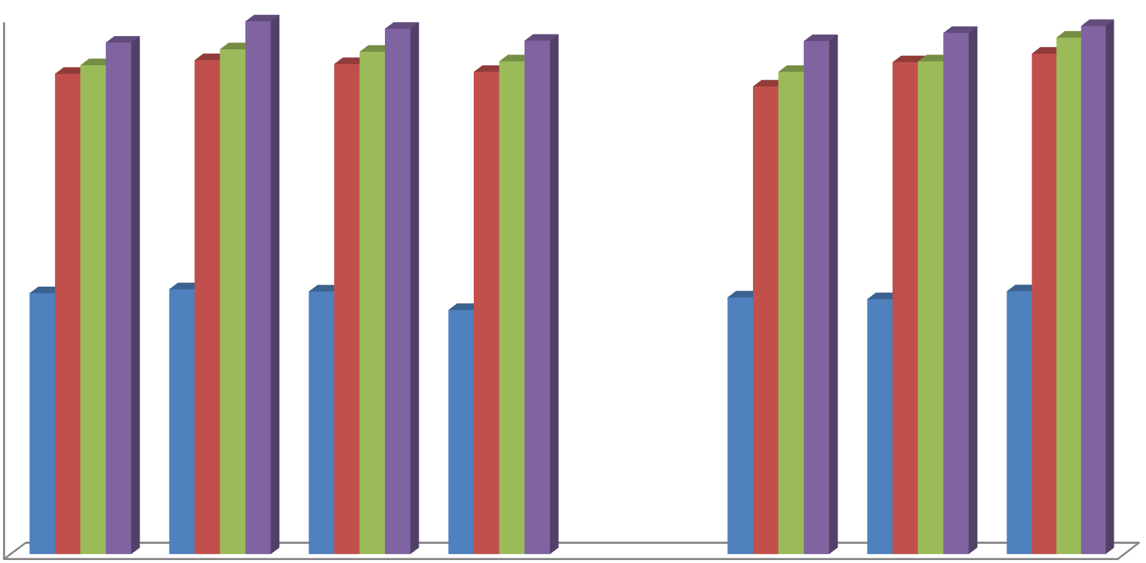
Fig 1: Plant height (cm) @ 30, 60, 90 DAS & at harvest as affected by different treatment
30DAS
60DAS
90DAS
At Harvest
50
45
40
35
30
25
20
15
10
5
0
P1
P2
P3
P4
F1
F2
F3
Planting geometry
Fertilizer levels

Table 2: Influence of crop geometry & nutrient levels on Plant dry weight (g plant-1) at different growth stages.

Treatments | Plant dry weight (gm)
Treatments | 30 DAS | 60 DAS | 90 DAS | At harvest

Crop geometry
P1- 30 X 10 cm | 1.01 | 6.17 | 14.78 | 21.20
P2- 45 X 5 cm | 1.01 | 7.36 | 16.27 | 22.37
P3- 45 X 10 cm | 1.09 | 5.40 | 13.82 | 18.16
P4- 45 X 15 cm | 1.12 | 5.66 | 13.07 | 18.13

S.Em.± 0.002 0.04 0.34 0.16
CD (P=0.05) 0.01 0.12 1.01 0.47

Fertilizer levels
F1- 100% RDF | 1.02 | 5.75 | 13.67 | 19.81
F2- 120% RDF | 1.06 | 6.29 | 14.58 | 19.83
F3- 140% RDF | 1.11 | 6.40 | 15.20 | 20.25

S.Em.± 0.04 0.17 0.51 0.35
CD (P=0.05) 0.12 0.50 1.49 1.02


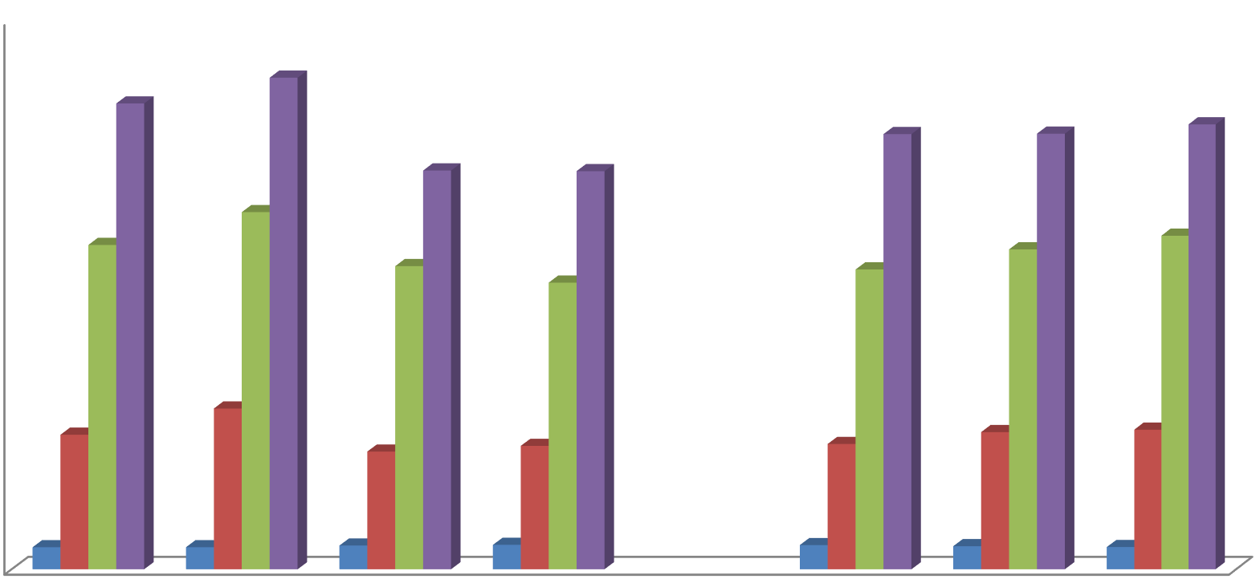
Fig 2: Plant dry weight (g plant₋₁) @ 30, 60, 90 DAS & at harvest as affected by various treatments
Fertilizer levels
Planting geometry
F3
F2
F1
P4
P3
P2
P1
0
5
10
15
20
30DAS 60DAS 90DAS At Harvest
25

Table 3. Effect of crop geometry & nutrient levels on total and effective quantity of root nodules.

Treatment | Total number of nodules | Effective number of nodules

Crop geometry
P1- 30 X 10 cm | 22.40 | 16.32
P2- 45 X 5 cm | 26.53 | 18.51
P3- 45 X 10 cm | 21.30 | 15.68
P4- 45 X 15 cm | 20.10 | 13.00

S.Em.± 0.60 0.43
CD (P=0.05) 1.77 1.26

Fertilizer levels
F1- 100% RDF | 23.34 | 16.18
F2- 120% RDF | 25.09 | 17.22
F3- 140% RDF | 19.32 | 14.24

S.Em.± 0.52 0.37
CD (P=0.05) 1.53 1.09


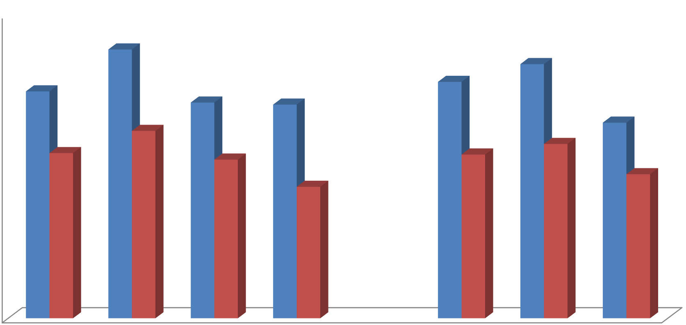
Fig. 3: Number of root nodules as affected by various treatments
Fertilizer levels
F3
F2
F1
P4
P3
P2
Planting geometry
P1
0
5
10
15
20
25
30
Effective number of nodules
Total number of nodules
Table 4. Effect of crop geometry & nutrient levels on dry weight of total & effective quantity of root nodules.

Treatment | Dry weight of total number of root nodules | Dry weight of effective number of root nodules

Crop geometry
P1- 30 X 10 cm | 28.49 | 24.48
P2- 45 X 5 cm | 35.11 | 29.56
P3- 45 X 10 cm | 28.49 | 24.35
P4- 45 X 15 cm | 25.86 | 22.35

S.Em.± 0.59 0.53
CD (P=0.05) 1.73 1.54

Fertilizer levels
F1- 100% RDF | 31.31 | 26.56
F2- 120% RDF | 33.79 | 28.80
F3- 140% RDF | 23.35 | 20.19

S.Em.± 0.51 0.46
CD (P=0.05) 1.50 1.34


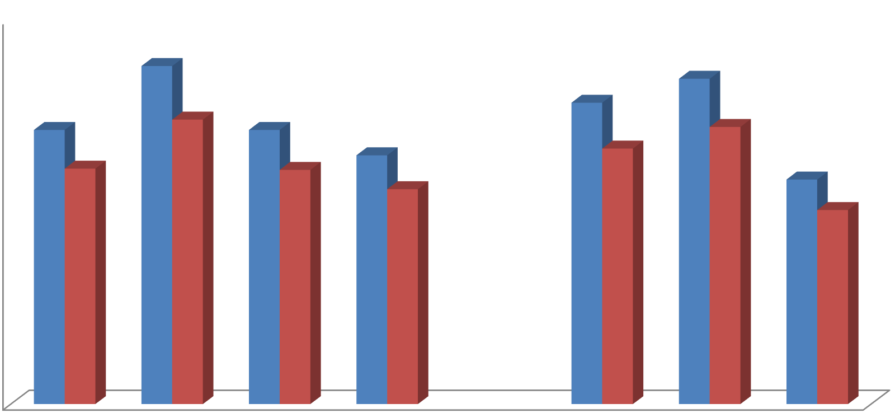
Fig 4: Dry weight of total & effective number of plant nodules as affected by different treatment
Dry weight of Total number of nodules
Dry weight of Effective number of nodules
40

35

30

25

20

15

10

5

0
P1
P2
P3
P4
F1
F2
F3
Planting geometry
Fertilizer levels

Table 5: Effect of crop geometry & nutrient levels on number of pods per plant at the time of harvest.

Treatments | Number of pods per plant
Treatments | at harvest
Crop geometry

P1- 30 X 10 cm | 62.14
P2- 45 X 5 cm | 65.92
P3- 45 X 10 cm | 63.80
P4- 45 X 15 cm | 61.03

S.Em.± 2.24
CD (P=0.05) 6.57

Fertilizer levels
F1- 100% RDF | 61.15
F2- 120% RDF | 63.03
F3- 140% RDF | 65.49

S.Em.± 1.94
CD (P=0.05) 5.69


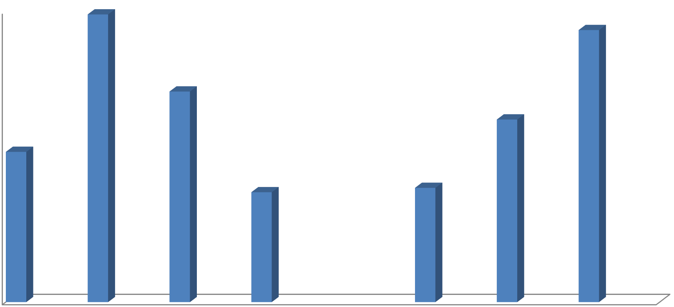
Fig 5: Number of pods plant₋₁ @ harvest as affected by various treatments
66

65

64

63

62

61

60

59

58
P1
P2
P3
P4
F1
Planting geometry
F2
Fertilizer levels
F3

Table 6: Effect of crop geometry & nutrient levels on number of seeds pod⁻¹ & test weight at the time of harvest.

Treatments | Number of seeds per pod | Test weight (100 seeds)
Treatments | at harvest | Test weight (100 seeds)
Crop geometry

P1- 30 X 10 cm | 2.68 | 8.56
P2- 45 X 5 cm | 2.81 | 8.56
P3- 45 X 10 cm | 2.41 | 8.58
P4- 45 X 15 cm | 2.44 | 8.57

S.Em.± 0.04 0.01
CD (P=0.05) 0.11 0.02

Fertilizer levels
F1- 100% RDF | 2.56 | 8.54
F2- 120% RDF | 2.57 | 8.57
F3- 140% RDF | 2.63 | 8.59

S.Em.± 0.03 0.08
CD (P=0.05) 0.09 0.22


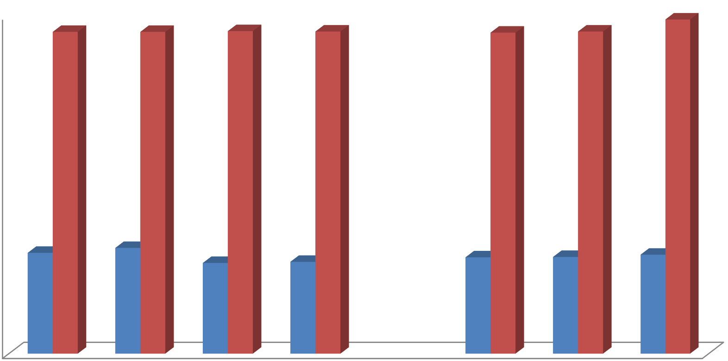
Fig 6: Number of seeds pod-1 @ the time of harvest as affected by various treatment
Number of seeds Test weight (
9

8

7

6

5

4

3

2

1

0
P1
P2
P3
P4
F1
F2
F3
Planting geometry
Fertilizer levels
Table 7: Effect of crop geometry & nutrient levels on seed, straw yield & harvest index at the time of harvest.

Treatments | Seed yield (q ha-1) | Straw yield (q ha-1) | Harvest index (%)

Crop geometry
P1- 30 X 10 cm | 20.20 | 25.82 | 43.89
P2- 45 X 5 cm | 21.19 | 26.30 | 44.57
P3- 45 X 10 cm | 18.10 | 24.09 | 42.88
P4- 45 X 15 cm | 17.84 | 23.88 | 42.71

S.Em.± 0.34 0.41 0.60
CD (P=0.05) 0.98 1.21 1.76

Fertilizer levels
F1- 100% RDF | 18.02 | 24.49 | 42.24
F2- 120% RDF | 19.97 | 25.13 | 44.29
F3- 140% RDF | 20.02 | 25.45 | 44.00

S.Em.± 0.29 0.36 0.52
CD (P=0.05) 0.85 1.04 1.52
Interaction between crop geometry and nutrient levels (P x F)

S.Em.± 0.58 0.71 1.04
CD (P=0.05) 1.70 NS NS


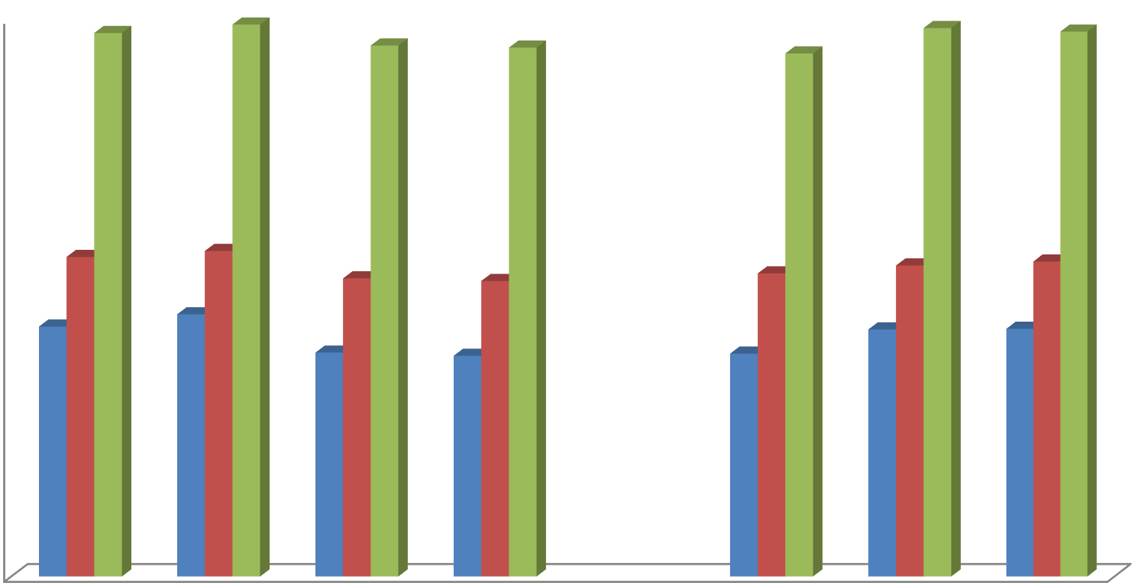
Fig 7: Effect of crop geometry & fertilizer levels on Seed yield (q ha⁻¹), Straw yield (q ha⁻¹) & Harvest index (%) of soybean
Seed yield (q ha⁻¹) Straw yield (q ha⁻¹) Harvest index (%)
45

40

35

30

25

20

15

10

5

0
P1
P2
P3
P4
F1
Planting geometry
F2 F3
Fertilizer levels

