Design and Development of Mini Tractor Operated Twin-Row Maize Planter

ABSTRACT
Modern agriculture demands innovation solutions to address the challenges of increasing food production while optimizing resource utilization. This research presents the design and development of a twin-row maize planter. The proposed planter incorporates a twin-row planting mechanism, departing from conventional single row systems, to maximize land usage and enhance crop productivity. Maize planted by using developed planter gives more equidistance and staggered plant spacing. This staggered spacing offer better photosynthetically active radiation. The physical properties of seeds were calculated initially. Three varieties of maize seed Rasi-3033, NMH-589 and KMH-2589 were selected. Two seed metering mechanisms namely roller type and cup type metering were selected and evaluated in the laboratory. A roller type metering mechanism with 5 cells on each side with an alternate pattern on its periphery was developed. A nylon roller of 55 mm width and 110mm diameter roller was used for development of seed metering device. In cup device, a vertical plate was used as a rotor. Mild steel of 3 mm thick plate was used to develop a rotor with a diameter of 110 mm. The frame of planter is of rectangular box type made up of 50 mm angular with a length of 1400mm and width of 350 mm, so that planter maintains suitable row to row spacing and can accommodate all the components on the frame. Field test was carried on January 2021 at Dr NTR College of Agricultural Engineering, Bapatla. Results obtained from actual field conditions the average seed spacing with roller type metering mechanism was 17.8, 19.1, and 20 cm at operating speed of 1.5, 2, and 2.5 kmh⁻¹ respectively. The acceptable seed spacing occurred at operating speed of 2.5 kmh⁻¹. Field efficiency of developed twin-row planter at 1.5, 2, and 2.5 kmh⁻¹ speed of operation was 76.9, 88.8, and 87%, respectively.
Keywords: Twin-row, Metering mechanism, Field efficiency, Planter, Roller metering device
INTRODUCTION
Maize (Zea mays L.) stands as one of the world’s most crucial crops, playing a fundamental role in global food security and agricultural economics. More than 49% of world maize is produced by America (FAO 2022). Among the maize-growing countries, India ranks 4th in area and 7th in production, representing around 4% of the world’s area and 2% of total production (iimr.icar.gov.in). Meeting the escalating demand for maize production necessitates not only innovative cultivation techniques but also the integration of advanced agricultural machinery. Traditional methods of manual or broadcast seeding have increasingly become insufficient in meeting the demands of modern agriculture. Manual seed planting method results in non-uniform seed spacing, less efficient and involves more drudgery (Ram et al. 2020).
The main objective of seed planting using enhanced seeding equipment is to obtain effective seed distribution in a row. Among these, the maize planter emerges as a key player as it enhances operational efficiency. Mechanical drilling practices or planters for seed sowing primarily affect the seed placement accuracy and uniformity in the seed-to-seed distance. Appropriate seed-to-seed spacing is essential for the seeds, which results in a higher yield than in manual planting. The time and method adopted for sowing decisively influence the germination and hence production (Abhishek and Singh 2021). With the increase in mechanization, large maize-producing nations have experienced an increase in yield. In India, the mechanical sowing & harvesting penetration has only been 5-7%. Farm losses due to poor sowing and harvesting practices can be potentially controlled through mechanization. An increase in thrust on promotion and adoption of mechanization could potentially assist in improving productivity and controlling farm losses.
Maize can be grown effectively in various soils are loamy sand to clay loam and soils with excellent natural organic matter. Maize planted by using a twin-row maize planter gives more equidistance and staggered plant spacing. Twin rows offer better photosynthetically active radiation (PAR), and improve aeration which increases crop and root growth (Balem et al., 2014). Furthermore, a quicker canopy leads to fewer weeds, and the humidity in the soil is conserved. A groove wheel-type seed-metering device, which realizes double rows in one ridge, separate application of seeds and fertilizers, and a precise and small amount of sowing (Qiao et al 2023). Two rows maize planter with a single horizontal plate seed metering mechanism was designed and fabricated. The developed planter has a field capacity of 0.16 ha⁻¹, average seed damage of 13.3%, and an average missing rate of 17.5% (Abubakar et al 2020). Inter-cropping practices offer advantages to small land-holding farmers. Current planters are intended for medium to high-range horsepower tractors. Such high-cost tractors and equipment are not within the reach of small and marginal farmers, though they are oriented towards mechanization. The main objective of this research work was to design and develop a twin-row maize planter operated by a mini-tractor.
MATERIALS AND METHODS
Physical properties of maize seeds
The physical properties of maize seeds play a crucial role in the design and function of seed metering devices and hoppers. Understanding the physical properties of seeds is essential for designing an effective and efficient seed metering system (Brar et al. 2017). Physical properties such as length, surface area, breadth, roundness, equivalent diameter, sphericity, angle of repose, and coefficient of friction were determined for the development of the seed metering unit. The physical properties of seeds were calculated initially. Three varieties of maize seed Rasi-3033, NMH-589, and KMH-2589 were selected. The mean values of seed length, width, thickness, sphericity, geometric mean diameter, surface area, bulk density, coefficient of static friction, angle of repose, and thousand kernel weight were 11.00 ± 0.39 mm, 7.75±050 mm, 4.58± 0.28 mm, 0.65±0.025, 7.09±0.14 mm, 158.14 mm², 746.4 kg m⁻³, 0.60±0.02, 28.17⁰, and 0.23±0.05 kg, respectively (Ajay et al. 2021).
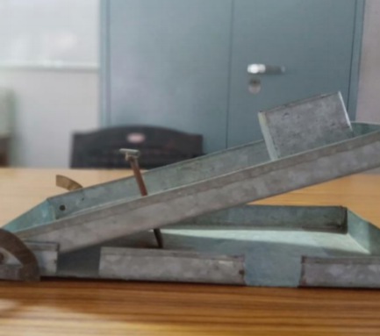
Fig.1 Measurement of coefficient of friction maize seeds
Design of seed metering mechanism
The number of cells to be assisted on the seed metering system and the diameter of the seed metering device was calculated (Sharma & Mukesh 2013).
Number of cells in the roller, n $=\frac{πD_{g}}{i×x}=\frac{π×30}{1 ×20}$= 4.71$≃$ 5
Where, n$=$ number of cells on the roller
D_{g}$=$ ground wheel diameter,(300 mm)
x$=$ required seed to seed spacing,(20 cm recommended)
i$=$gear ratio (1:1)

The seed metering device diameter is determined according to the following equation.
Diameter of seed metering device, d_{r}$= \frac{V_{r}}{π×N_{r}}=\frac{16.5}{π×50}≅$ 11 cm
Where, V_{r}$=$seed metering device peripheral velocity,(16.5 m min⁻¹)
N_{r}$=$ speed of the roller,(50-60 rpm assumed)
Design of seed box
The design of the seed box was follows (Sharma and Mukesh. 2013).
Volume of seed box is given by V_{b}$=$ 1.1 V_{s}$=$1.1$[\frac{0.5}{0.75}]≃$ 740 cm³ Seed
Where, V_{b}$=$ volume of seed box, cm³
V_{s}$=$volume of seed, cm³$=\frac{W_{s}}{γ_{s}}$
W_{s}$=$ weight of the seed in the box, g
$γ_{s}$= bulk density of seed, g cm⁻³

The hopper capacity is the number or quantity of seeds the hopper can bear. Consider freeboard is 10% in action to minimize spillage of seeds during the operation (Soyoye et al 2016). The total seed box volume was computed as
Volume of seed box V_{b}$=$ 740 + 74 $=$ 814 $≃$ 820 cm³
Power transmission system
The speed ratio of ground wheel and seed metering device is given as a function of number of teeth on the sprockets and is calculated by the following formula.
$\frac{N_{g}}{N_{s}}=\frac{T_{s}}{T_{g}} =\frac{12}{12}=$ 1
Where, N_{g} = Speed of the ground wheel, rpm
N_{s} = Speed seed metering device, rpm
T_{g} = Number of teeth on the sprocket of ground wheel = 12
T_{s} = Number of teeth on the sprocket of the seed metering device =12

Development of roller type metering mechanism
A roller-type metering mechanism with 5 cells on each side with an alternate pattern on its periphery was developed. A nylon roller of 55 mm width and 110 mm diameter roller were used for the development of seed metering device. The size and shape of cells on its periphery were selected to make it easy to pick maize seeds of variable size. The cell on the roller has a length of 12 mm and is oblique in shape. The size of the hole on the roller was selected based on the axial dimensions of the seed. The seed metering device was made of nylon material since it is light in weight and easy to do operations like drilling, cutting, etc. The actual developed roller-type metering mechanism is shown in Fig. 2.
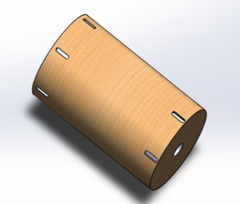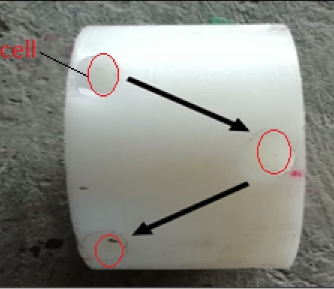
Fig.2 Roller type metering mechanism
Development of cup type metering mechanism
In this metering device, a vertical plate was used as a rotor. Mild steel of 3 mm thick plate was used to develop a rotor with a diameter of 11 cm. Ten holes were made on the periphery of the plate for mounting the cups alternately on both sides by using 5 cm lengths of strips. At the centre of the plate, a bush was arranged to rotate along with the shaft. The size and shape of the cup were determined in a way that the maize seeds of varying sizes could be easily picked. The shape of the cup was round, with sufficient depth to fit the maize seed properly in the cup after picking. The cups were fixed in an alternate pattern on both sides of the plates. The cup-type metering mechanism developed is shown in Fig. 3.
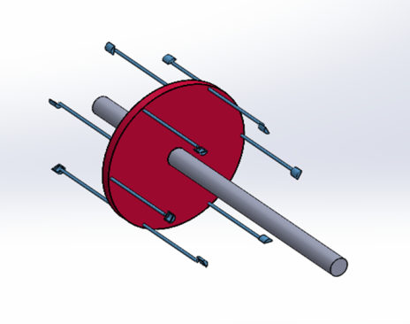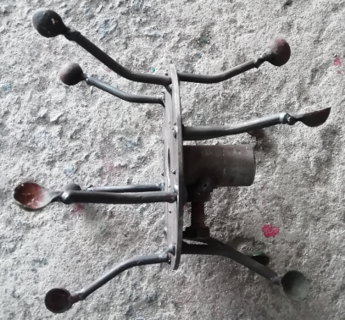
Fig. 3Cup type metering device

Development of furrow opener
The shoe-type furrow opener was selected for the present study. Based on design considerations and the availability of materials in the market, a mild steel (M.S.) flat piece measuring 400 × 50 × 16 mm was chosen to fabricate the tyne, with an effective length of 350 mm. Additionally, an M.S. flat piece of 150 × 120 × 10 mm was used to develop the boot, with a final boot size of 120 × 60 × 16 mm. Two holes, each with a 25 mm diameter, were drilled into an angle bracket fixed to the top portion of the tyne, allowing it to be securely fastened to the frame. Based on the operational requirements, four furrow openers were developed. The developed furrow opener is shown in Fig. 4.
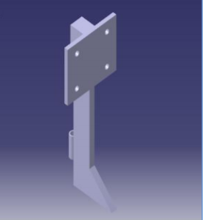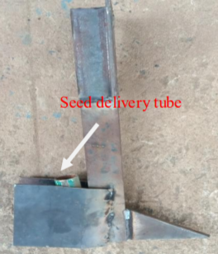
Fig. 4 Developed shoe type furrow opener
Development of frame
The frame of the planter was of rectangular box type, constructed using 50 mm angle iron, with an overall length of 1400 mm and width of 350 mm. The angular bar was cut into the required length and width, then welded together to form a rectangular section of 1400$×$350$×50$mm respectively.
Development of twin-row planter
All the parts were developed based on design requirements and drawn by using the SOLIDWORKS version 2019. The drawings were used for the machine fabrication. All components of the planter and fabrication of the machine were carried out in Dr. NTR CAE workshop at Bapatla, Andhra Pradesh, India. The schematic view of the twin-row maize planter is shown in Fig. 4.
The developed twin-row planter was attached to the mini tractor (18.5 hp) using a three-point linkage of the tractor hydraulic system (Fig. 5). The Hitch system of the tractor was developed by using 50 mm MS flat having a thickness of 10 mm. The 3-point hitch system (IS 4468-1993) was connected to the frame of the developed twin-row maize planter for connecting it to the tractor linkages. It was developed in such a way that it can be fitted to any make and model of lower hp (upto22 hp) tractors.
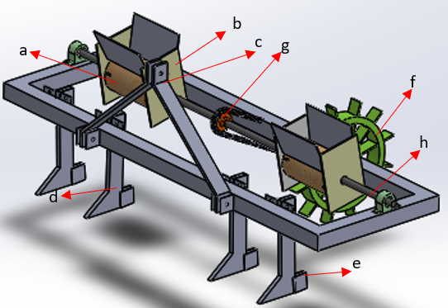

Fig. 5 Schematic view of twin-row maize planter (a. Roller metering mechanism, b. Seed box, c. Hitching point, d. Furrow opener, e. Boot, f. Ground wheel, g. Chain and Sprocket and h. Metering shaft)

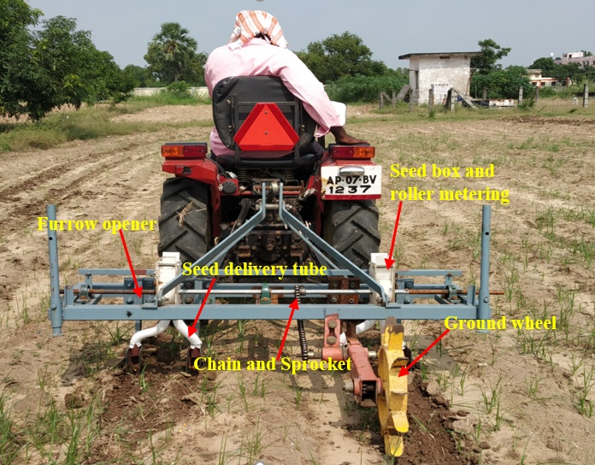
Fig.6 Developed Twin-row maize planter
Laboratory evaluation of developed seed metering mechanisms
Sticky belt setup
The sticky belt setup was used to examine the two seed metering devices used in this study. The experimental setup consists of a sticky belt, metering unit assembly, and power transmission system (electric motor with speed controller). For the preparation of the grease belt, a 60 cm width conveyor belt was taken. It was mounted on two rollers of diameter 10 cm, with 4 m. The rollers were powered by the variable speed of the belt (Fig. 7).
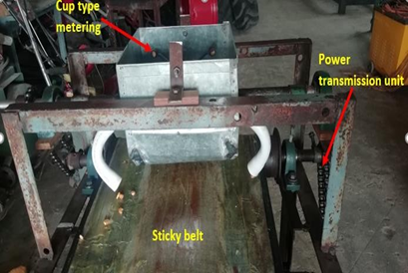

Fig.7 Laboratory setup of test rig for seed metering devices

The experiments were intended to evaluate the developed metering devices with 3 replications at different revolutions. So, it is easy to identify which metering device that performs better at specific rpm. Therefore, 4 different rotational speeds (10, 15, 20, and 25 rpm) were chosen and the average seed spacing, missing index, and multiple indexes were determined for two developed seed metering devices. A coating of grease was placed over the belt to allow proper embedding of seeds without any displacement of the seeds which are delivered from the seed tube.
Evaluation parameters
The field test was conducted at 15°54'53.1"N 80°29'20.2" E in sandy clay loam soil with a moisture content of 10.85 wb (%). The evaluation of the developed twin-row planter for maize includes seed-to-seed spacing, seed missing index, and seeds multiple index for two metering mechanisms. The field performance parameters i.e., actual field capacity, theoretical field capacity, field efficiency, ground wheel slip, and fuel consumption.
Seed to seed spacing
A steel rule was used to measure the distance between the two consecutive seeds on the sticky belt and results were recorded. The spacing was measured at various locations and the average value was noted.
Seed missing index
The missing index shows that the seed metering unit is incapable of dropping even a single seed within the intended seed spacing range. It was determined on the 4 m belt by counting the number of missing seeds along the length of the belt to the actual seeds on the belt that could be dropped. The missing rate was determined by the following equation (Katchman and Smith 1995).
Missing index, % = $\frac{n_{1}}{N}$ ×100
Where, n₁ = number of seeds missing by metering wheel into seed tube during pickup
N = number of seeds supposed to be dropped by metering wheel if no seed is missing

Seed multiple index
Multiple index includes two or more seeds collected and dropped by a single cell in the metering wheel. It was determined on the 4 m belt by counting the number of seeds multiplied along the length of the belt by more than one seed to the actual number of seeds that could be dropped on the belt. The following equation determines the multiple index (Katchman and Smith 1995).
Multiple index (%) = $\frac{n_{2}}{N}$ ×100
Where, n₂=number of times multiple dropping of seeds occurred from the delivery tube
N = number of seeds supposed to be dropped by metering wheel if no seed is missing
Seed rate and Seed damage
With half of its capacity, the seed hopper was filled, and the drive wheel was rotated 25 times in an elevated position. The time taken to complete revolutions was measured using a stopwatch (Sharma & Mukesh, 2013). Place a polythene bag under each boot to collect the metered seeds.
Seed rate (kgh⁻¹) = $\frac{Total amount of seed collected (W_{s})}{Area covered for 25 revolutions}$
Area covered by the planter in 25 revolutions is calculated as
Area covered in 25 revolutions, m² = ($π×D×N)×W$
Where, D= diameter of the ground wheel
N= number of revolutions of ground wheel
W= working width of planter, cm
Seed damage, % = $\frac{Total number of seed damaged }{Total number of seeds collected}×$100
Ground wheel slip
The rate of ground wheel slip was estimated under actual field conditions utilizing a fixed number of revolutions. The developed planter was first operated with load at different depths ranging from 6 to 10 cm and the total distance covered was measured after that it was operated with load condition (Sharma & Mukesh 2013).
Ground wheel slip, % = $\frac{N_{1}-N_{2}}{N_{1}}$
Where, N₁ = total number of revolutions of ground wheel without load
N₂ = total number of revolutions of a wheel with load
Theoretical field capacity
Theoretical field capacity (ha h⁻¹) = $\frac{s×w}{10}$ (Kepner et al., 1978).

Where, S= forward speed, kmh⁻¹
W= width of coverage, m
Effective field capacity
The planter's effective field capacity was determined by the time taken to cover the given area (Kepner et al., 1978).
Effective field capacity (ha h⁻¹) = $\frac{A}{T}$
Where, A= field coverage, ha, T = actual time of operation, h
Field efficiency
It is the ratio of effective field capacity to theoretical field capacity. It was calculated by the following equation (Kepner et al., 1978).
Field efficiency = $\frac{Effective feild capacity}{Theoretical feild capacity}$
Data Analysis
For the analysis of the data collected on the different aspects of the study, i.e. laboratory and field evaluation of the twin-row maize planter. A factorial completely randomized design (CRD) was used to analyze the data obtained from laboratory experiments. The critical difference was found at a 5% level of significance.

RESULTS AND DISCUSSION
Effect of speed on seed to seed spacing of two metering mechanism in laboratory
Two metering mechanisms were tested in the laboratory. The test results indicated that the mean spacing between the seed to seed spacing was 9.5 to 16 cm for cup type metering mechanism, in case of roller type metering mechanism it was observed as 11 to 20 cm on a belt speed of 10 to 25 rpm respectively. From the results, the cup-type metering system maintained insufficient spacing at various operating speeds. Whereas roller type metering system achieved acceptable seed spacing at a speed of 25 rpm. It may be due to the seeds being picked and dropped uniformly from the metering device. It shows that as the speed increased, the spacing between seeds also increased (Fig. 8).

Fig.8 Effect of speed on seed spacing of two metering mechanism

Effect of speed on multiple index of two metering mechanism in laboratory
The multiples are found in the range from 24% to 13.33% in the case of cup-type metering device, as the speed varied from 10 to 25 rpm respectively. For roller-type metering, multiples are 22.2% to 8.89% as the speed varies from 10 to 25 rpm. As the speed increases, the multiple index value decreases. The cup-type metering multiples occur because the seeds overlapped in the metering system and fell together with the seed that was contained in the cup (Fig. 9).

Fig.9 Effect of speed on multiple index in laboratory conditions for two metering devices

Effect of speed on missing index of two metering mechanism in laboratory
The metering device missing index was reported to range from 11.11% to 17 %, whereas speed ranged from 10 to 25 rpm. For the roller metering device missing index was reported to range from 2.38% to 15.29%, whereas revolutions range from 10 to 25 rpm respectively (Fig.10). The missing index value is reported to be greater with speed, because the seeds should not be picked into the cups of the metering device in less time of span.

Fig.10 Effect of speed on multiple index in laboratory conditions for two metering devices
Selection of metering mechanism
From the laboratory test results of the two metering devices namely cup-type and roller-type metering mechanisms, the two metering mechanisms were compared with seed spacing, missing index, and multiple indexes with a required seed spacing of 20 cm for maize. The roller type system was selected for planter development because it maintained the acceptable seed spacing and less amount of miss index at operating speed compared to the cup type system.
Seed rate and damage
The planter calibration was performed in the laboratory before the field assessment (Sahay, 2010). The average weight of the seeds obtained from the planter delivery tube with 25 ground revolutions is measured at the laboratory and was found to be 48.50 gm. The quantity of seed required to sow seeds in one hectare of area with the developed twin-row maize planter was noticed to be 25.7 kg ha⁻¹.
The percentage of seed damage from the planter has been determined under laboratory conditions. It has been that the total amount of seeds collected is 30 in each row for 10 revolutions of the ground wheel on the lifted position, where the number of seeds damage is noted as 2. The percentage of seed damaged was obtained by 5%.
Evaluation of developed twin-row maize planter under field conditions
The evaluation of the prototype twin-row planter for maize includes seed-to-seed spacing, seed missing index, and seeds multiple index for two metering mechanisms (Singh et al 2016). The field performance parameters i.e., actual field capacity, theoretical field capacity, field efficiency, ground wheel slip, and fuel consumption (Leela and Saravanakumar 2019). A field test conducted at Dr NTR CAE, Bapatla within an area of 40 m×40 m.
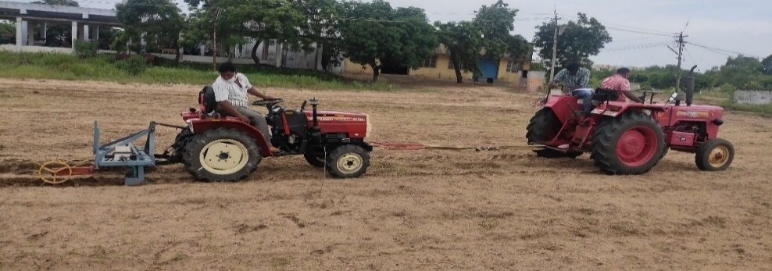
Fig.11Field testing of developed planter
Effect of speed on seed to seed spacing of roller metering mechanism in actual field condition
Under the field conditions, the distance between the two successive seeds was measured at different tractor operating speeds which are 1.5, 2.0, and 2.5 km h⁻¹ respectively. The mean spacing of maize seed increased with higher forward speed. It was found that the mean spacing was minimum at a speed of 1.5 kmh⁻¹ (17.8 cm) and maximum at a speed 2.5 kmh⁻¹ (20 cm). The increase in mean spacing with a speed increase is attributed to a reduced retention time for seed collection. The findings were also correlated with the mean spacing results obtained in laboratory testing of the rolling type system (Fig. 12).

Fig.12Effect of speed on roller type metering mechanism at field condition

Theoretical and effective field capacity
Twin-row maize planter's theoretical capacity was calculated as 0.13, 0.18, and 0.22 ha h-1 with a forward speed of 1.5, 2.0, and 2.5 km h-1 respectively. Effective field capacity was calculated as 0.10, 0.16, and 0.20ha-1 with a forward speed of 1.5, 2.0, and 2.5 km h-1 respectively. The planter's field capacity increased by increasing the planters operating speed. The payback period calculated on a year basis for the planter was 1.78 years. The cost of operation by twin row maize planter can save up to 20% as compared to the traditional methods (Ajay et al.2024).
Field efficiency
It was found during field evaluation that the field efficiency was 76.9, 88.8, and 87 % with a speed of operation is 1.5, 2.0, and 2.5 kmh⁻¹ respectively. The planter’s field efficiency little more at an operating speed of 2.0 kmh⁻¹.
Table 1: Specifications of twin-Row Maize Planter
Overall dimensions (L$×B×H)$ | 1400 $×$ 650 $×450 mm$
Source of power, hp | 18.5
Twin-Row Spacing, mm | 200
Plant Spacing, mm | 200
Seed metering mechanism | Roller type
Power transmission | Chain and sprocket

CONCLUSIONS
The following research findings were working width of the twin-row planter was 1.3 m and spacing between twin rows was 20 cm, and the distance between two sets of twin rows was 50 cm. From laboratory results, seed-to-seed spacing with cup-type metering was 9.5, 14.0, 14.2, and 16.0 cm, and with roller-type metering system was 11.0, 14.0, 19.8, and 20.0 cm at 10, 15, 20, and 25 rpm operational speed, respectively. Results obtained from actual field conditions the mean seed spacing with roller-type metering mechanism was 17.8, 19, and 20 cm at operating speeds of 1.5, 2.0, and 2.5 km h⁻¹ respectively. The acceptable seed spacing occurred at an operating speed of 2.5 km h⁻¹. It showed that the suitable forward speed for a developed twin-row maize planter was 2.5 km h⁻¹ at which the planter provides acceptable seed-to-seed spacing compared to the other operational speeds.
Disclaimer (Artificial intelligence)
We hereby declare that NO generative AI technologies such as Large Language Models (ChatGPT, COPILOT, etc.) and text-to-image generators have been used during the writing or editing of this manuscript.

REFERENCES
Abhishek Kumar; Singh TP. 2021. Development and Performance Evaluation of an Animal Drawn Single Row Zero Till Seed Drill for Sowing Pea (Pisum sativum). International Journal of Current Microbiology and Applied Sciences10(03): 1101-1117.
Abubakar A J; Iya S A; Kabri H U; Garba B. 2020. Development of A Manually Operated Two Row-Single Metering Plate Maize Planter. Nigeria Journal of Engineering Science and Technology Research 6(1) :(91-98).
Ajay A and Ramireddy, K V S.2024. Economic Evaluation of Twin Row Maize Planter: A Cost-Benefit Analysis. Environment and Ecology42(1):34-38.
Ajay A; Rami ReddyKVS; Ashok KumarA. 2021. Study of Physical Properties of Zea mays in the Development of Seed Metering Unit. International Journal of Agriculture Environment and Biotechnology14(2): 159-163.
Balem Z; Modolo A J;Trezzi,M M;Vargas TO;BaessoMM;BrandeleroE M; Emerson T. 2014. Conventional and twin row spacing in different population densities for maize (Zea mays L.). African Journal of Agricultural Research9(23):1787-1792.
BrarIS; DixitAK; KhuranaR; GautamA.2017. Studies on physical properties of maize (Zea mays L.) seeds. International Journal of Current Microbiology and Applied Sciences6(10): 963-970.
FAOSTAT. Food and Agriculture Organization. FAO statistical database. World Food and Agriculture – Statistical Yearbook 2023 (fao.org).
IS 4468 (Part 1) Agricultural wheeled tractors - Rear-mounted three-point linkage : Part 1 Categories 1, 2 and 3. Bureau of Indian Standards, New Delhi.
IS: 6316. 1993. Sowing equipment seed cum fertilizer drill. Indian Standards Institution, New Delhi.
Kachman DS and Smith JA 1995. Alternative measures of accuracy in plant spacing for planters using single seed metering. Transactions of the ASAE 38: 379-387.
Kepner, R.A., Bainer, R. and Barger, E.L. 1978. Principles of FarmMachinery. 3rd edition: 209-234
Leela C; Saravanakumar M. 2019. Development of electronically meterized maize planter. International Journal of Current Microbiology and Applied Sciences.8(4): 2432-2440.
Qiao X: Liu D; Wang X; Li W; Wang J; Zheng D. 2023. Design and Experiment of Double-Row Seed-Metering Device for Buckwheat Large Ridges. Agriculture13(10):1953.
Ram R C and Mishra V. 2020. Fabrication and Evaluation of Performance of Single Row Maize Planter: A Case Study. International Journal of Agriworld1(1):30-35.
SahayJ; 2010. Elements of Agricultural Engineering pp 283. Standard publishersdistributors, New Delhi.
Sharma D N and Mukesh. 2013. Design of seed sowing equipment. Farm Machinery Design Principles and Problems. Jain brothers New Delhi.
Singh N K; Ashok T; Srivastava A.2016. Development and testing of twin row drum planter for maize. Global Journal of Multidisciplinary Studies5(2): 199- 205.
SoyoyeBO; Adamson OC; Olu-Ojo EO. 2016. Development of a manually operated vertical seed-plate maize planter. Agricultural Engineering International: CIGR Journal18(4):70-80.
YengeGB; Kad V P; Nalawade SM. 2018. Physical properties of maize (Zea mays L.) grain. Journal of Krishi Vigyan7:125-128.

