Bibliometric Insights into the Use of Biochar as a Soil Amendment: A Study Based on Dimensions AI Database (2001–2024)

ABSTRACT
Biochar, a carbon-rich material derived from biomass through pyrolysis or other techniques, has gained significant attention as a soil amendment due to its potential to enhance soil fertility, agricultural production, and restoration of the environment. This bibliometric analysis utilizes the "Dimensions. AI" database to explore global research trends on biochar as a soil amendment from 2001 to 2024. After screening of 17975 articles, 17780 relevant articles were selected and subjected to bibliometric analysis using R-Studio and VOSviewer software. The findings revealed a continuous increase in research output over time, with China leading in publication volume and international collaborations, followed by the United States and India. Zhejiang University appears as the most prolific university, having a strong research relationship with the University of Chinese Academy of Sciences and other institutions or research organisations. The Science of the Total Environment is recognized as the leading journal in this domain, having the highest h- index. Among the most cited publications, Lehmann’s review paper – “Biochar effects on soil biota – A review” published in the year of 2011 received the highest number of citations. Overall, the bibliometric analysis highlights the expanding research interest in biochar application for sustainable agriculture and environment conservation. Future studies are expected to further explore its long- term benefits and practical applications of biochar in soil management and climate change mitigation.

Keyword: Biochar, Soil amendment, Bibliometric analysis, Dimensions. AI
- Introduction
Biochar is a solid carbon-rich product produced from biomass of agricultural crop residues, algal biomass, forest residues, manures, activated sludge, energy crops etc. through pyrolysis in an oxygen-limited condition at varied temperatures (300–900 °C) (Amalina et al., 2022, Daful & Chandraratne, 2020; Yadav et al., 2023). It has gained significant interest in a few decades due to its various uses in the agricultural and industrial sectors. Biochar is widely used as a soil amendment due to its beneficial properties, including high carbon content, elevated pH, stability, porosity, and large surface area. Consequently, numerous studies have been conducted in recent years to explore its global impact on various agricultural soils. It was reported that biochar can improve soil's chemical, physical, and biological properties as well as increase crop productivity (Burrell et al., 2016; Singh et al., 2022; Hussain et al., 2017, Yadav et al., 2023). Moreover, biochar is porous carbonaceous solid material (Daful & Chandraratne, 2020) with high specific surface that can be used for the remediation of soil and waste water to adsorb both organic and inorganic contaminants such as pesticide pollutants and heavy metals (Wang et al., 2019; Liu et al., 2025) and reduce their leaching to water courses (Komkiene & Baltrenaite, 2016). It also slows down the rate of decomposition of nutrients from the soil and hence, enhances the nutrient availability in the soil (Igalavithana et al., 2016). However, the use of biochar as a soil amendment in agriculture faces several challenges because the regulations often consider biochar as a waste or a hazardous material. It is also a challenge to produce biochar on a large scale with minimum costs (Tisserant & Cherubini, 2019). Therefore, scientists around the world are interested in investigating the effect of biochar on soil, plants, and the environment.
Bibliometric or scientometric analysis is a way to study the evolution and emerging trends in certain scientific fields and evaluate the performance and involvement of countries, regions, researchers, and research institutions in a certain research field (Haunschild et al., 2016; De Natale et al., 2023). Emerging systems provide databases and analytic tools that enable researchers to better view the scientific evolution and performance of countries and researchers in a certain field (de Souza Oliveira Filho, 2020). Several bibliographic databases, such as Web of Science (WoS), Scopus, Dimesnsion.ai and Google Scholar can be used to conduct bibliometric studies (Ajibade et al., 2022; Li et al., 2024; Yang et al., 2023).
Our study focus on bibliometric analysis of the scientific research on “Biochar as a soil amendment”, based on papers found in the “Dimension AI” database from the period 2001–2024. The main objectives of this study are: 1) to understand the trend and growth of publication over time in “Environmental Science” category; 2) to analyse the impact of researchers, countries and institutions regarding the scientific research 3) to identify the leading researchers, countries and organisation and their collaborations among them.
- Material and Methods
  - Data Collection
The database for the bibliometric analysis was obtained from Dimension.AI (https://www.dimensions.ai), which is a partially open-access platform for global research and innovation (Nandy et al., 2024; Thelwall, 2018). The study was conducted using the search terms - “biochar” AND (“soil amendment” OR “soil remediation” OR “soil amelioration”) from 2001 to 2024 in the research categories of “Environmental science” which comprises of six sub-field categories : Pollution and Contamination (44.12%); Environmental Management (35.64%); Ecological Application (6.13%); Soil Science (9.4%); Environmental Biotechnology ( 2.3%); and Climate Change ( 2.41%), in order to ensure a thorough analysis and minimize the potential of biases (Hakkaraki, 2024).
A total of 17975 documents (article: 16678 and chapter: 1297) were found in the Dimension.AI database that was exported in a CSV format on 14th February, 2025 for the scientific analysis (Figure 1). Data cleaning is often needed for analysis and network mapping based on the data (Lim et al., 2024), which was done by eliminating the duplicates and unwarranted text from the dataset using Microsoft Excel. After data eliminating process, a total of 17780 documents obtained for further bibliometric analysis.
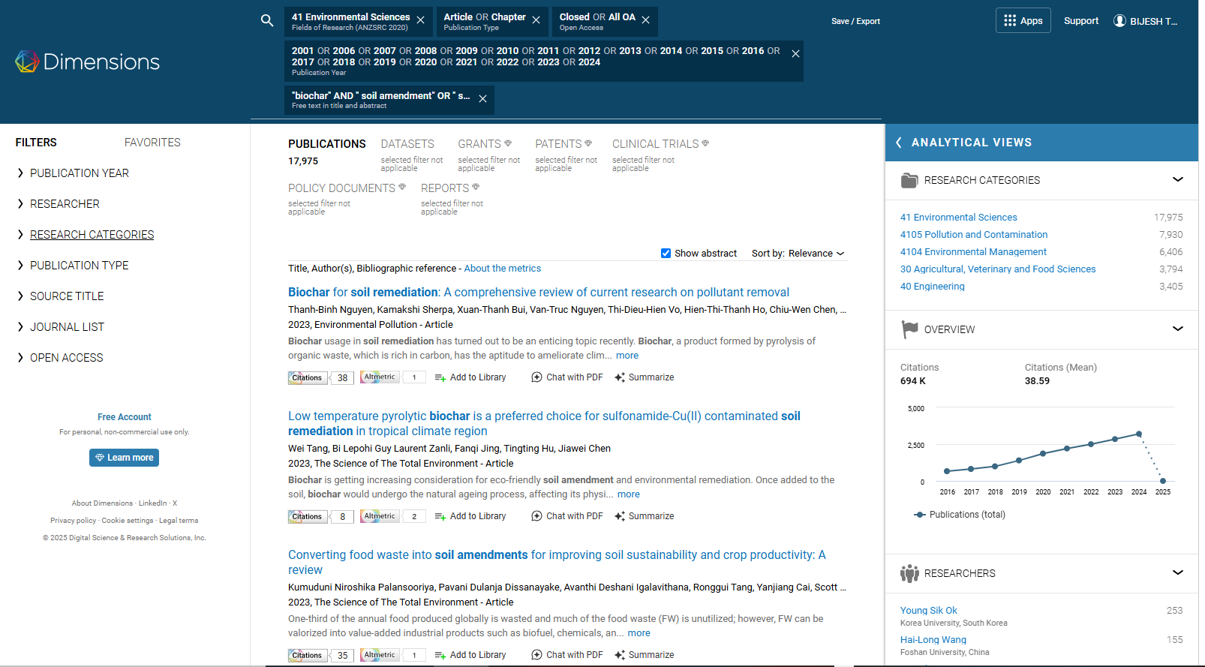

Fig 1: Searching database in Dimensions.AI (Search in: “biochar” AND “soil amendment" OR “soil remediation” OR “soil amelioration”; publication type: Articles & Chapter; Time range: 2001-2024; field of research: 41 Environmental Science; Access type: Closed & OA access) (Source: https://www.dimensions.ai)

  - Data Analysis
The variables a) publication over time, b) top 15 organisation, c) top 15 countries, d) top 15 journals, and e) Most cited documents were analysed using MS Excel 2021, R-studio 2022.02.0+443 and VOS viewer 1.6.20 (https://www.vosviewer.com). VOS viewer, a freely available computer program was used for the visualization and network mapping tool, which included a) collaboration among organisations and countries, and b) most-used keywords.
In the visualisation network, items were represented by labels and circles, the size of which indicated the number of documents and the frequency of keywords used (Gandasari et al., 2024; Van Eck & Waltman, 2013) line indicated connection or total link strength (TLS) between two items, size variation of lines indicated the link strength (i.e. thicker line means stronger link). Here, colour variations were used to create clusters of items for easier identification.
The H- index of journals was collected from their respective website of the journal and SCImago Journal Rank (SJR). It is an author-level metric that measures both the productivity and citation impact of the publications, was suggested in 2005 by Jorge E. Hirsch ( Hirsch, 2005) . It can be defined as the maximum value of h such that the given author/journal has published at least h papers that have each been cited at least h times. H-index can be expressed using below equation (Ajibade et al., 2022)-
H – index ( f) = max( h Ꞓ ℕ : f (h) ≥ h)
where H-index is equivalent to the maximum number (h) of cited publications in a countable set ℕ of journal or author publications with at least h number of citation.
- Result And Discussion
  - Biochar application on soil as an amendment
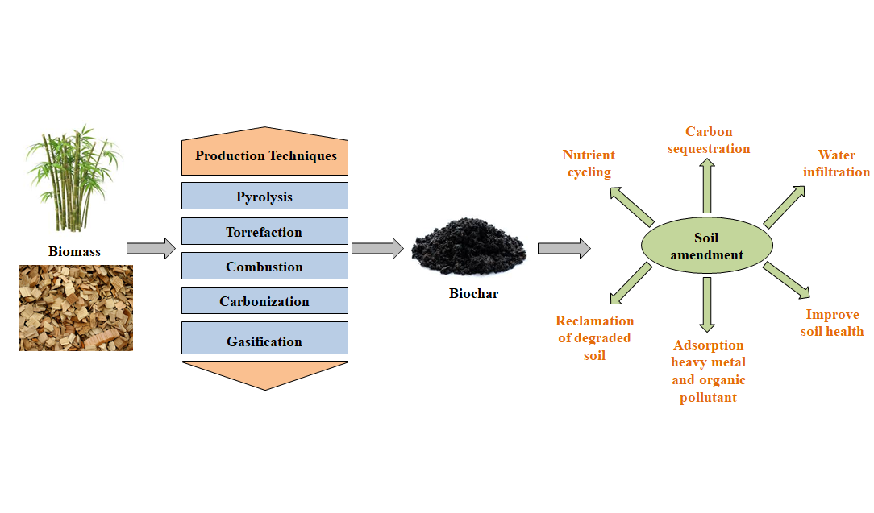
Biochar is produced through decomposition of biomass in the absence of oxygen at several thermal treatment methods (Lewandowski et al., 2020), including pyrolysis, torrefaction, combustion, gasification, and carbonization (Figure 2). Variation in production method and biomass type significantly affects the properties of biochar (Barbhuiya et al., 2024; Sun et al., 2014; Tomczyk et al., 2020)

Fig 2: Production of Biochar and its role as soil amendment

Biochar possesses various properties such as high carbon content, large surface area, high pH, adequate porosity, high water holding capacity, high nutrient content, and sufficient ash content, which makes it promising amendment for wide application (Weber & Quicker, 2018; Downie et al., 2012)
Biochar, when used as amendment, decreases bulk density by increasing porosity, forming aggregates, and thereby improving overall soil structure. High surface area and hydrophilic properties of biochar enable soil to hold more water after its application in soil [Adhikari et al., 2022]. Biochar amendment increases organic matter content in soil, which could increase microbial colonization and enhance microbial activity (Ali et al., 2024). Biochar improves pH of soil, alkaline pH of biochar enables it to neutralize degraded acid soils (Dai et al., 2017) and enhances soil cation exchange capacity, which aids in reducing leaching of nutrients and sustain nutrient status in soil profile (Wang et al., 2020). Biochar is used to remove organic contaminants, like dyes, polycyclic aromatic hydrocarbons, organic volatile pollutants, volatile organic compounds (Praveen et al., 2022; Zhang et al., 2013; Sadegh et al.,2024 ) and inorganic contaminants (such as heavy metal like Cd, Ni, As, Pb and Cr and others like H₂S, NH₄⁺, and NO₃ etc.) by decreasing mobility and bioavailability of contaminants in soil by the processes of physisorption and chemisorption, chemical transformation (oxidation-reduction), and biodegradation (Beesley et al., 2010; Komkiene & Baltrenaite, 2016; Ren et al., 2018). In addition, application of biochar in salt-affected soil enhances soil physicochemical properties, structure, fertility, nutrient availability, and microbial activity (Amini et al., 2016; Dahlawi et al., 2018.
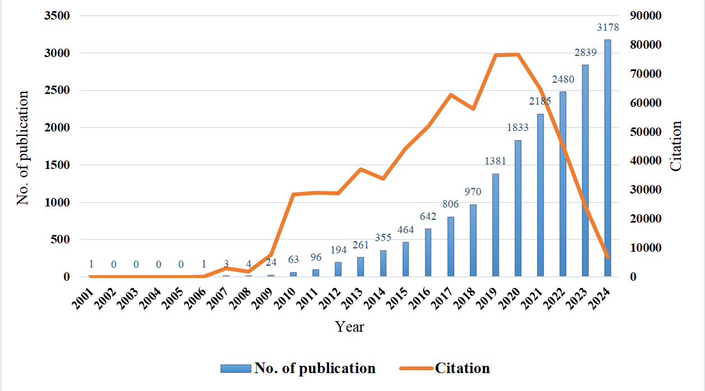

Fig 3: Trend of annual publication and citation from 2001-2024

  - Analysis of the trend of publication and citation over time
Figure 3 shows that the research on Biochar as soil amendment has experienced exponential growth over time. Between 2001 and 2005, only one research article was published on this topic. However, from 2006 onward the annual publication number increased exponentially, which indicates the increasing attention and interest among researchers in the field of importance of biochar application in soil as an amendment. In 2024, the highest numbers of publication accumulating 3178 papers with total 6849 citation were recorded. Given this strong upward trajectory, it is likely that publications will continue to rise in 2025.
The graph also illustrates the trend of citations which can be divided in three distinct phases i.e. initial phase, rapid growth phase and decline phase. Initial phase starting from 2001 up to 2009, the number of citations remained low, with little significant increase. This period with a low number of publications, indicate that the research field was in its early stages and had not gained widespread recognition. The rapid growth phase from 2010 to 2020 marks sharp increase of citations, this period suggests a surge in academic interest and widespread adoption of research findings. However, from 2020 onwards sharp decline in citations was observed. This decline could indicate that newer publications have not yet had enough time to be cited. The steep downward trend in citations suggests that the peak impact of recent research may be fading, signalling a transition in the research landscape.
  - Contribution of country and co-authorship
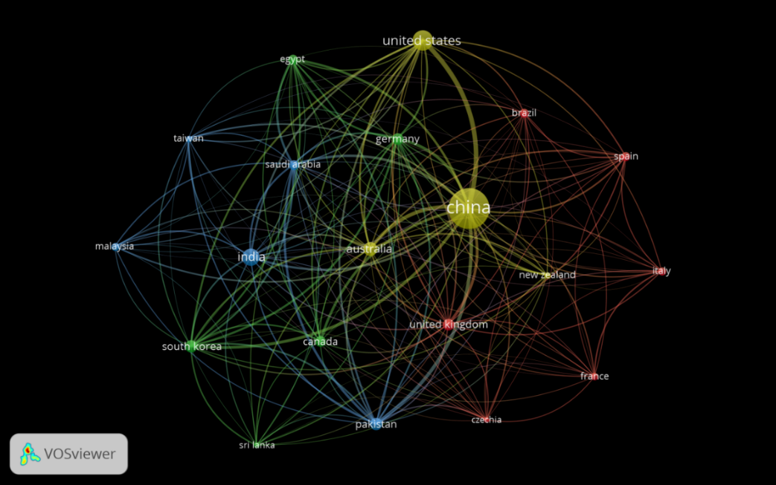
According to the database, 135 countries contributed to the research on Biochar as soil amendment. Among the top 15 countries, three were from Europe, seven from Asia, two from North America, one from South America, one from Africa, and one from Oceania. Most of the developed countries had high contribution to the domain topic, China (7589) and USA (2006) being the leading countries for exceeding other countries in the number of publications (Table 1).

Fig 4: Network visualization of country co- authorship from 2001-24

Citations per document (C/P) are a key indicator of research productivity and impact. China, with the highest number of publications, has an average C/P of 45.0, meaning that while it contributes extensively to the field, the influence of each individual paper is relatively moderate. This could be due to a high volume of research output, where some papers receive fewer citations. On the other hand, Australia (C/P: 87.0), despite having significantly fewer publications (892), demonstrates the highest citation impact. This suggests that Australian research is widely recognized and cited, likely due to high-quality publications, strong international collaborations, and contributions to influential journals.
Table 1 Top 15 country-based number of publications from 2001-2024
Country | Documents | Citations | C/P | TLS
China | 7589 | 341714 | 45.0 | 4171
United States | 2006 | 158267 | 78.9 | 2027
India | 1387 | 38302 | 27.6 | 1005
Australia | 892 | 77575 | 87.0 | 1414
Pakistan | 724 | 42393 | 58.6 | 1394
South Korea | 696 | 55999 | 80.5 | 1299
Germany | 621 | 49441 | 79.6 | 1393
United Kingdom | 619 | 50751 | 82.0 | 1019
Canada | 524 | 29371 | 56.1 | 635
Saudi Arabia | 438 | 17754 | 40.5 | 1142
Egypt | 436 | 17768 | 40.8 | 817
Brazil | 413 | 12392 | 30.0 | 317
Spain | 408 | 22523 | 55.2 | 533
Indonesia | 378 | 3306 | 8.7 | 104
Iran | 354 | 8067 | 22.8 | 230

Co-authorship analysis was performed on the selected 130 records by countries. When the minimum number of documents of a country was set to 5, 97 countries met the threshold. For clear visualization of countries co-authorship network 20 countries were selected based on Total link strength. Figure. 4 shows four clusters (in yellow, red, green and blue colour) that were formed based on co-authorship among countries.
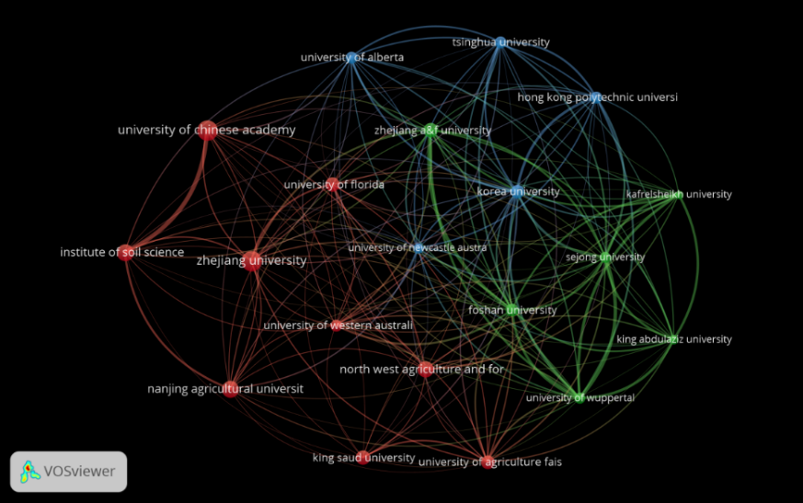
In Figure 4, China is represented at centre as largest yellow node, indicating the highest number of paper publication. It has strong link or collaboration with USA and Australia within same cluster as well as South Korea, Germany and Pakistan were shown in other cluster, highlights the huge number of collaborating research paper publication. Other countries were also shown in co-authorship network, collaborating with countries within or another cluster. Third biggest node representing India, has moderate collaboration with Asian countries like China, Saudi Arabia, Malaysia, Taiwan, Egypt, Pakistan and South Korea, along with other countries like USA, Canada, Spain and UK etc. Such international collaboration helps in sharing technical knowledge and in accelerating innovation for solving global challenges.

Fig 5: Visualisation network of organisational co- authorship from 2001-24

  - Scientific production per Organisation or institution and their Co-authorship

Country co-authorship refers to the collaboration between researchers from different organisations or research centre in publishing scientific papers regarding Biochar amendment from 2001-2024. Table 2 and Figure. 5 highlighted contribution of various research centre or universities and collaboration among them for scientific research on biochar and its application. It can be observed that total 10175 research institutions contributed in publication of research work on biochar as soil amendment. Zhejiang University, an institution of China, leading in publication with 418 papers and 27445 citations, collaborating with total 705 numbers of other intuitions, shows strong co-authorship. This was followed by University Chinese Academy of Science, China (403 publications, 20970 citations); Institute of Soil Science, China (306 publications, 17632 citations); Nanjing Agricultural University, China (284 publications, 18718 citations), and North West Agriculture and Forestry University, China (259 publications, 10646) citation). This highlights that Chinese research intuitions have made most significant contribution to publication of papers on biochar application on soil. Additionally, other institutions or centre such King Saud University, Saudi Arabia (217 publications, 8519 citations); University of Florida, United States (212 publications, 33172 citations); Korea University, Korea (189 publications, 18945 citations) and University of Agriculture Faisalabad, Pakistan (181publications, 14607 citation) also actively conduct research on biochar application on soil.
Table 2 Top 15 organisation or institutions in term of numbers of publications from 2001-2024
Organization | Documents | Citations | C/P | TLS
Zhejiang University, Hangzhou, China | 418 | 27445 | 65.66 | 704
University Of Chinese Academy of Sciences, China | 403 | 20970 | 52.03 | 957
Institute Of Soil Science, Nanjing, China | 306 | 17632 | 57.62 | 677
Nanjing Agricultural University, China | 284 | 18718 | 65.91 | 470
North West Agriculture and Forestry University, China | 259 | 10646 | 41.10 | 578
King Saud University, Riyadh, Saudi Arabia | 217 | 8519 | 39.26 | 681
University Of Florida, United States | 212 | 33172 | 156.47 | 488
China Agricultural University, China | 211 | 9647 | 45.72 | 434
Zhejiang A&F University, China | 207 | 15283 | 73.83 | 821
Korea University, Seoul, South Korea | 189 | 18945 | 100.24 | 841
University Of Agriculture Faisalabad, Pakistan | 181 | 14607 | 80.70 | 758
Nankai University, Tianjin, China | 169 | 10007 | 59.21 | 228
Northeast Agricultural University, China. | 169 | 6973 | 41.26 | 147
Foshan University, Foshan, China | 161 | 10150 | 63.04 | 897
Shanghai Jiao Tong University, China | 155 | 13806 | 89.07 | 310
Hong Kong Polytechnic University, Kong | 150 | 17887 | 119.25 | 564

The co-authorship network of research organizations in biochar amendment studies demonstrated a collaboration landscape among different research organisations (Figure 5). In the Figure 5, it can be seen that Chinese institutions were playing a dominant role. Zhejiang University emerges as the most prolific institution, possessing the largest node, which indicates its high in number of publications. It has strong co-authorship links with the Institute of Soil Science and the University of Chinese Academy of Sciences, creating a research community within China. Additionally, Zhejiang A&F University and Foshan University also shows strong interconnections, reinforcing the dominance of Chinese institutions in biochar research. Other than this, the University of Western Australia also has strong collaborations with various institutions, which demonstrate global research interaction beyond regional lines. King Saud University, North West Agriculture and Forestry University, and University of Agriculture Faisalabad indicate the active participation in research from the Middle East and South Asia. A second cluster that comprises Hong Kong Polytechnic University, Korea University, Sejong University, and the University of Wuppertal, which reflects regional co-operation in East Asia and Europe. The co-authorship link between institutions such as Zhejiang University, Institute of Soil Science, and University of Chinese Academy of Sciences indicates joint research publications that occur often and on a large scale. Moreover, global associations can be seen in the relationships between King Saud University, North West Agriculture and Forestry University, and the University of Western Australia, with the sign of collaboration towards biochar research. The network pattern emphasizes China's dominance in biochar research as well as an increasing global partnership across different institutions globally.
  - Most relevant scientific journals and documents
Table 3 presents top 15 journals under Environment science category based on number of publications related to soil amendment with biochar, including total citation, citation per document and H-index. These indicators help to assess the impact and influence of each journal. The Science of the Total Environment was found to be the leading journal in terms of research paper publication with 1389 documents and 83,249 citations, having average C/P ratio of 59.9, indicating its strong academic influence. Journal of Hazardous Materials has the highest C/P ratio (78.6), suggesting that its publications receive a high number of citations per paper, making it a highly influential journal. In contrast, Huan Jing Ke Xue = Huanjing kexue has a significantly lower C/P ratio (2.4), reflecting limited citation impact despite publishing 289 documents. The H-index, which measures both productivity and citation impact of the journals, is the highest for The Science of the Total Environment (353), followed by Journal of Hazardous Materials (352), reflecting popularity of paper publication in these journals among scientists or researchers
Table 3 Top 15 journal in term of numbers of publications from 2001-2024
Source | Documents | Citations | C/P | H- Index
The science of the total environment | 1389 | 83249 | 59.9 | 353
Chemosphere | 1090 | 75032 | 68.8 | 311
Environmental science and pollution research | 801 | 24590 | 30.7 | 179
Journal of hazardous materials | 662 | 52060 | 78.6 | 352
Journal of environmental management | 649 | 31848 | 49.1 | 243
Environmental pollution | 541 | 30990 | 57.3 | 301
Sustainability | 340 | 5720 | 16.8 | 169
Environmental research | 336 | 9313 | 27.7 | 179
Huan jing ke xue= Huanjing kexue | 289 | 705 | 2.4 | 47
IOP conference series earth and environmental science | 289 | 1018 | 3.5 | 48
Scientific reports | 264 | 11137 | 42.2 | 315
Journal of soils and sediments | 251 | 10231 | 40.8 | 97
Water, Air, & Soil pollution | 248 | 5045 | 20.3 | 133
Ecotoxicology and environmental safety | 238 | 13770 | 57.9 | 180
Geoderma | 193 | 18346 | 95.1 | 203

Table 4 lists the top-cited 15 research articles related to biochar application on soil. The article "Biochar effects on soil biota – A review" published by Lehmann et al. (2011) , was most cited paper, with 3,902 citations, discusses the effects of different type of biochar on soil biota to enhance soil properties and sustain soil fertility; followed by “Biochar as a sorbent for contaminant management in soil and water: A review of Ahmad et al. (2014) has been cited 3,631 times, emphasizing the role of biochar as a sorbent for contaminant management in soil and water, demonstrating its importance in environmental remediation. Keiluweit et al. (2010) presents a molecular-level assessment of the physical structure and chemical complexity of biochar, assess ability to persist in the environment and function as environmental sorbent in their paper “Dynamic Molecular Structure of Plant Biomass-Derived Black Carbon Biochar”. Several other key papers focus on effect of biochar on environment. Woolf et al. (2010) explores potential of biochar in carbon sequestration to soil helps to mitigate climate change. Jeffery et al. (2011) and Sohi et al. (2010) present their analyses on effect of biochar on soil productivity, and its role in enhancing agricultural production. Atkinson et al. (2010) studied the mechanisms and underlying agricultural benefits of biochar amendment in soil health improvement. Beyond agricultural applications, biochar's physicochemical properties and its impact on pollutant removal were studied by Tomczyk et al. (2020) and Tan et al. (2015). Other studies, such as Chan et al. (2007) and Lehmann (2007), addresses agronomic values and bio-energy aspects of biochar, respectively, showing its diverse applications. Li et al. (2017) in their paper, “Mechanisms of metal sorption by biochars: Biochar characteristics and modifications”, examines biochar’s effectiveness in metal sorption, while Beesley et al. (2010) conducted a comprehensive review of biochar production, properties, and its advancements in removing heavy metals, organic pollutants, and other contaminants. These top most cited papers reflect the substantial influence on scientists and researchers for advancing biochar research, making them working in environmental and agricultural sustainability.
Table 4. Top 15 document based on citation regarding biochar as soil amendment from 2001-2024
Document Title | Source link | Citation
Biochar effects on soil biota – A review  (Lehmann et al., 2011) | https://app.dimensions.ai/details/publication/pub.1005490706 | 3902
Biochar as a sorbent for contaminant management in soil and water: A review  (Ahmad et al., 2014) | https://app.dimensions.ai/details/publication/pub.1016854957 | 3631
Dynamic Molecular Structure of Plant Biomass-Derived Black Carbon Biochar  (Keiluweit et al., 2010) | https://app.dimensions.ai/details/publication/pub.1031966469 | 2526
Sustainable biochar to mitigate global climate change  (Woolf et al., 2010) | https://app.dimensions.ai/details/publication/pub.1020969083 | 2050
A quantitative review of the effects of biochar application to soils on crop productivity using meta-analysis  (Jeffery et al., 2011) | https://app.dimensions.ai/details/publication/pub.1016190369 | 1867
A Review of Biochar and Its Use and Function in Soil  (Sohi et al., 2010) | https://app.dimensions.ai/details/publication/pub.1014710475 | 1777
Potential mechanisms for achieving agricultural benefits from biochar application to temperate soils: a review  (Atkinson et al., 2010) | https://app.dimensions.ai/details/publication/pub.1036888283 | 1748
Biochar physicochemical properties: pyrolysis temperature and feedstock kind effects  (Tomczyk et al., 2020) | https://app.dimensions.ai/details/publication/pub.1124622846 | 1686
Application of biochar for the removal of pollutants from aqueous solutions (Tan et al., 2015) | https://app.dimensions.ai/details/publication/pub.1047133701 | 1574
Transitional Adsorption and Partition of Nonpolar and Polar Aromatic Contaminants by Biochars of Pine Needles with Different Pyrolytic Temperatures  (Chen et al., 2008) | https://app.dimensions.ai/details/publication/pub.1000334808 | 1544
Agronomic values of green waste biochar as a soil amendment (Chan et al., 2007) | https://app.dimensions.ai/details/publication/pub.1049359787 | 1485
Bio‐energy in the black (Lehmann, 2007) | https://app.dimensions.ai/details/publication/pub.1015071051 | 1437
Mechanisms of metal sorption by biochars: Biochar characteristics and modifications  (Li et al., 2017) | https://app.dimensions.ai/details/publication/pub.1084065434 | 1435
A review of biochars’ potential role in the remediation, revegetation and restoration of contaminated soils  (Beesley et al., 2010) | https://app.dimensions.ai/details/publication/pub.1052445053 | 1357
Biochar and its effects on plant productivity and nutrient cycling: A meta-analysis  (Biederman and Harpole, 2012) | https://app.dimensions.ai/details/publication/pub.1025415982 | 1322

  - Co-occurrence of keyword analysis
The word occurrence diagram for bibliometric analysis in biochar as soil amendment provides insights into key words that were used in the research papers; reflecting overall document content and representing the sustainable growing topics from 2001 to 2024 in the research area (Figure 6). There are 214624 keywords, where 1025 words meeting the threshold for mapping purposes (minimum of 100 occurrences). The most relevant words were shown in Figure 6, which contains hundred terms. Keywords were divided into main two huge clusters (red and green) for terms mostly related to biochar amendment in soil to enhance agricultural productivity and to remove inorganic and organic soil pollutants from soil. The five mostly used terms used in research paper can be seen with larger node were “adsorption” (total occurrence (TO) = 4044), "removal” (TO = 3979), "control" (TO = 2469), "amendment" (TO = 2188), and "growth" (TO = 2131), indicate that most of author or researcher discussed in their paper regarding biochar used to restore the environment.
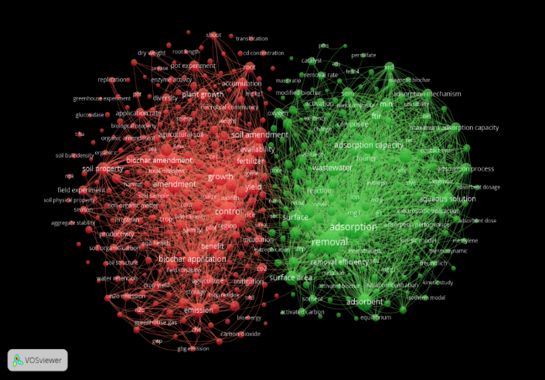

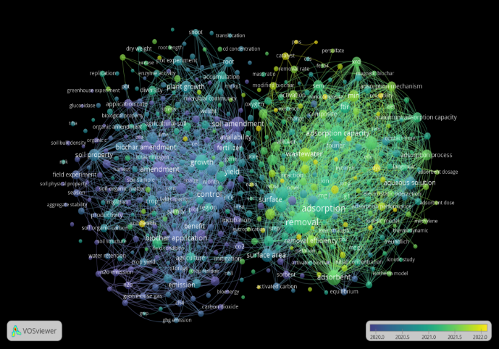

Fig 6: (a) Visualization network of word occurrence; (b) Overlay visualization for bibliometric analysis

The co-occurrence network highlights biochar amendment in soil has been extensively investigated for its benefits in soil health, plant growth, and environmental remediation. Researchers often use many important keywords such as "biochar application," "soil properties," and "growth" to explain role of biochar in enhancing soil fertility, nutrient availability, and microbial activity, which shown in the (Figure 6). Biochar improves soil organic carbon, water retention, and soil aggregation, making it ideal for crops. In addition, biochar helps to mitigate climate change by sequestering carbon in soil and lowering greenhouse gas emissions in environment (Mukherjee & Lal, 2013; Zhang et al., 2020). Beyond agriculture, biochar is essential for pollutant removal and soil restoration. Common words in this context include "adsorption characteristics", "heavy metal", "removal", and "degradation", indicating its efficiency in immobilising heavy metal like lead, cadmium, arsenic, and other organic contaminants in soil. Activated biochar are commonly used to purify water through removing antibiotics, pesticides and dye residue (Bocșa et al., 2023). The researchers also investigate sludge biochar's potential for waste management and environmental sustainability. Overall, biochar amendment in soil is a prominent issue in agricultural and environmental research, with studies focused on its long-term impacts in soil properties, microbial interactions, crop production and pollutant removal efficacy. In the earlier research, scientist/ researchers’ interest was raised in biochar as organic input due to its potential to improve soil properties as well as enhancing the agricultural productivity, while later the interest was shifted to investigate the properties of biochar and its ability to reduce environmental pollution like heavy metal, dye and some organic or inorganic contaminants.
- Conclusion
A Bibliometric approach was used to examine research literature on biochar as a soil amendment using database of Dimension.AI. This analysis provides valuable insights into the global research landscape, illustrating publication trends, and influential authors. It also emphasises collaboration among authors from various countries to advance scientific understanding and promote the long-term usage of biochar as a soil amendment. The number of publications on the topic has been increased considerably between 2001 and 2024, and the growth trend may continue from 2025.
From the total number of publications regarding biochar amendment on soil, the article type is the predominant. Exploring the production and collaboration between countries, China was the most productive and collaborative country, followed by USA and India. The institution, Zhejiang University, China, appears to be the most prolific institution in terms of paper publication related to the field of interest. Collaboration between institutions is found to be stronger between Institute Soil Science and the University of Chinese Academy of Sciences. The top journals with the largest output and co-citations include the science of the total environment that falls under ‘Environmental Science’ category and has the highest h-index value (353).
The analysis of the occurrence of keywords has shed light on the most influential topics in Biochar amendment. There two major clusters were identified that comprised number of keywords, highlighting the impact of biochar application on agricultural productivity and remediation of degraded soil, that reflects key interest of researches on the topic. The most relevant articles in terms of citation was published by Lehmann in 2011(Biochar effects on soil biota – A review), followed by Ahmad et al. in 2013 (Biochar as a sorbent for contaminant management in soil and water: A review). Overall, this analysis highlights the growing global interest among researcher to work in using biochar as a soil amendment for research in this field continues to grow for sustainable agriculture and environmental conservation.

Disclaimer (Artificial intelligence)
Author(s) hereby declare that NO generative AI technologies such as Large Language Models (ChatGPT, COPILOT, etc.) and text-to-image generators have been used during the writing or editing of this manuscript. .

References:
- Amalina, F., Abd Razak, A. S., Krishnan, S., Zularisam, A. W., & Nasrullah, M. (2022). A comprehensive assessment of the method for producing biochar, its characterization, stability, and potential applications in regenerative economic sustainability–a review. Cleaner Materials 3, 100045
- Daful, A. G., & Chandraratne, M. R., 2020. Biochar production from biomass waste-derived material. Elsevier: 370-378
- Yadav, S. P. S., Bhandari, S., Bhatta, D., Poudel, A., Bhattarai, S., Yadav, P., Ghimire,N., Paudel,P., Paudel,P., Shrestha,J., & Oli, B., 2023. Biochar application: A sustainable approach to improve soil health. Journal of Agriculture and Food Research 11, 100498
- Burrell, L. D., Zehetner, F., Rampazzo, N., Wimmer, B., & Soja, G., 2016. Long-term effects of biochar on soil physical properties. Geoderma 282: 96-102.
- Singh, H., Northup, B. K., Rice, C. W., & Prasad, P. V., 2022. Biochar applications influence soil physical and chemical properties, microbial diversity, and crop productivity: a meta-analysis. Biochar. 4(1): 8.
- Hussain, M., Farooq, M., Nawaz, A., Al-Sadi, A. M., Solaiman, Z. M., Alghamdi, S. S., Ammara,U., Ok,Y.S., & Siddique, K. H., 2017. Biochar for crop production: potential benefits and risks. Journal of Soils and Sediments 17, 685-716.
- Wang, Y., Zhong, B., Shafi, M., Ma, J., Guo, J., Wu, J., Ye, Z., Liu, D., & Jin, H., 2019. Effects of biochar on growth, and heavy metals accumulation of moso bamboo (Phyllostachy pubescens), soil physical properties, and heavy metals solubility in soil. Chemosphere 219: 510-516.
- Liu, C., Bolan, N., Rajapaksha, A. U., Wang, H., Balasubramanian, P., Zhang, P., ... & Li, F. (2025). Critical review of biochar for the removal of emerging inorganic pollutants from wastewater. Chinese Chemical Letters, 36(2), 109960.
- Komkiene, J., & Baltrenaite, E., 2016. Biochar as adsorbent for removal of heavy metal ions [Cadmium (II), Copper (II), Lead (II), Zinc (II)] from aqueous phase. International Journal of Environmental Science and Technology 13: 471-482
- Igalavithana, A. D., Ok, Y. S., Usman, A. R., Al‐Wabel, M. I., Oleszczuk, P., & Lee, S. S., 2016. The effects of biochar amendment on soil fertility. Agricultural and environmental applications of biochar: Advances and barriers 63: 123-144.
- Tisserant, A., & Cherubini, F., 2019. Potentials, limitations, co-benefits, and trade-offs of biochar applications to soils for climate change mitigation. Land 8(12): 179.
- Haunschild, R., Bornmann, L., & Marx, W., 2016. Climate change research in view of bibliometrics. PloS one 11(7), e0160393.
- De Natale, F., Alilla, R., Parisse, B., & Nardi, P. (2023). A bibliometric analysis on drought and heat indices in agriculture. Agricultural and Forest Meteorology, 341, 109626.
- De Souza Oliveira Filho, J. (2020). A bibliometric analysis of soil research in Brazil 1989–2018. Geoderma Regional, 23, e00345.
- Ajibade, S., Nnadozie, E. C., Iwai, C. B., Ghotekar, S., Chang, S. W., Ravindran, B., & Kumar Awasthi, M., 2022. Biochar-based compost: a bibliometric and visualization analysis. Bioengineered. 13(7-12): 15013-15032.
- Li, X., Su, J., Wang, H., Boczkaj, G., Mahlknecht, J., Singh, S. V., & Wang, C., 2024. Bibliometric analysis of artificial intelligence in wastewater treatment: Current status, research progress, and future prospects. Journal of Environmental Chemical Engineering, 113152.
- Yang, T., Zhang, Z., Zhu, W., & Meng, L. Y., 2023. Quantitative analysis of the current status and research trends of biochar research-A scientific bibliometric analysis based on global research achievements from 2003 to 2023. Environmental Science and Pollution Research 30(35): 83071-83092.
- Nandy, A., Tripathy, P., Ghosh, S. K., & Rout, D. S., 2024. Bibliometric Investigation of Climate Change Literature in Fisheries using Dimensions. AI Database. Science Digest 1: 8.
- Thelwall, M., 2018. Dimensions: A competitor to Scopus and the Web of Science?. Journal of informetrics 12(2): 430-435.
- Hakkaraki, V. P., 2024. Exploring the evolution of bibliometric analysis: A comprehensive study of scientific publications from 1974 to 2024 using the Dimensions AI database. Asian Journal of Information Science and Technology 14(1): 24-31.
- Lim, W. M., Kumar, S., & Donthu, N. (2024). How to combine and clean bibliometric data and use bibliometric tools synergistically: Guidelines using metaverse research. Journal of Business Research 182, 114760.
- Gandasari, D., Tjahjana, D., Dwidienawati, D., & Sugiarto, M., 2024. Bibliometric and visualized analysis of social network analysis research on Scopus databases and VOSviewer. Cogent Business & Management 11(1), 2376899.
- Van Eck, N. J., & Waltman, L., 2013. VOSviewer manual. Leiden: Univeristeit Leiden, 1(1): 1-53.
- Hirsch, J. E. (2005). An index to quantify an individual’s scientific research output. Proceedings of the National Academy of Sciences, 102(46), 16569–16572.
- Lewandowski, W. M., Ryms, M., & Kosakowski, W., 2020. Thermal biomass conversion: A review. Processes 8(5): 516.
- Barbhuiya, S., Das, B. B., & Kanavaris, F. (2024). Biochar-concrete: A comprehensive review of properties, production and sustainability. Case Studies in Construction Materials, 20, e02859.
- Sun, Y., Gao, B., Yao, Y., Fang, J., Zhang, M., Zhou, Y., Chen, H., & Yang, L., 2014. Effects of feedstock type, production method, and pyrolysis temperature on biochar and hydrochar properties. Chemical engineering journal 240: 574-578.
- Tomczyk, A., Sokołowska, Z., & Boguta, P., 2020. Biochar physicochemical properties: pyrolysis temperature and feedstock kind effects. Reviews in Environmental Science and Bio/Technology 19(1): 191-215.
- Weber, K., & Quicker, P., 2018. Properties of biochar. Fuel, 217: 240-261.
- Downie, A., Crosky, A., & Munroe, P., 2012. Physical properties of biochar. In Biochar for environmental management Routledge: (pp. 45-64).
- Adhikari, S., Timms, W., & Mahmud, M. P., 2022. Optimising water holding capacity and hydrophobicity of biochar for soil amendment–A review. Science of The Total Environment 851: 158043.
- Ali, B., Fatima, E., Javed, M. A., Suleman, F., Hafeez, A., Ali, S., Fathi,A., & Khan, M. N., 2024. Biochar-facilitated soil microbial diversity under contaminated soil. In Biochar-assisted Remediation of Contaminated Soils under Changing Climate. Elsevier: (pp. 143-165).
- Dai, Z., Zhang, X., Tang, C., Muhammad, N., Wu, J., Brookes, P. C., & Xu, J., 2017. Potential role of biochars in decreasing soil acidification-a critical review. Science of the Total Environment 581: 601-611.
- Wang, J., Yuan, G., Lu, J., Wu, J., & Wei, J., 2020. Variation of salts and available nutrients in salt-affected soil during leaching process under the influence of organic ameliorators. Chemistry and Ecology 36(3): 256-269.
- Praveen, S., Jegan, J., Bhagavathi Pushpa, T., Gokulan, R., & Bulgariu, L., 2022. Biochar for removal of dyes in contaminated water: an overview. Biochar 4(1): 10.
- Zhang, X., Wang, H., He, L., Lu, K., Sarmah, A., Li, J., Bolan, N.S., Pei, J., & Huang, H., 2013. Using biochar for remediation of soils contaminated with heavy metals and organic pollutants. Environmental Science and Pollution Research 20: 8472-8483.
- Sadegh, F., Sadegh, N., Wongniramaikul, W., Apiratikul, R., & Choodum, A. (2024). Adsorption of volatile organic compounds on biochar: A review. Process Safety and Environmental Protection, 182, 559-578.
- Beesley, L., Moreno-Jiménez, E., & Gomez-Eyles, J. L., 2010. Effects of biochar and greenwaste compost amendments on mobility, bioavailability and toxicity of inorganic and organic contaminants in a multi-element polluted soil. Environmental pollution 158(6): 2282-2287.
- Ren, X., Yuan, X., & Sun, H., 2018. Dynamic changes in atrazine and phenanthrene sorption behaviors during the aging of biochar in soils. Environmental Science and Pollution Research 25: 81-90.
- Amini, S., Ghadiri, H., Chen, C., & Marschner, P., 2016. Salt-affected soils, reclamation, carbon dynamics, and biochar: a review. Journal of Soils and Sediments 16: 939-953.
- Dahlawi, S., Naeem, A., Rengel, Z., & Naidu, R., 2018. Biochar application for the remediation of salt-affected soils: Challenges and opportunities. Science of the Total Environment 625: 320-335.
- Lehmann, J., Rillig, M. C., Thies, J., Masiello, C. A., Hockaday, W. C., & Crowley, D., 2011. Biochar effects on soil biota–a review. Soil biology and biochemistry 43(9): 1812-1836.
- Ahmad, M., Rajapaksha, A. U., Lim, J. E., Zhang, M., Bolan, N., Mohan, D., Vithanage, M., Lee, S.S., & Ok, Y. S., 2014. Biochar as a sorbent for contaminant management in soil and water: a review. Chemosphere 99: 19-33.
- Keiluweit, M., Nico, P. S., Johnson, M. G., & Kleber, M., 2010. Dynamic molecular structure of plant biomass-derived black carbon (biochar). Environmental science & technology. 44(4): 1247-1253.
- Woolf, D., Amonette, J. E., Street-Perrott, F. A., Lehmann, J., & Joseph, S., 2010. Sustainable biochar to mitigate global climate change. Nature communications 1(1): 56.
- Jeffery, S., Verheijen, F. G., van der Velde, M., & Bastos, A. C. (2011). A quantitative review of the effects of biochar application to soils on crop productivity using meta-analysis. Agriculture, ecosystems & environment, 144(1), 175-187.
- Sohi, S. P., Krull, E., Lopez-Capel, E., & Bol, R., 2010. A review of biochar and its use and function in soil. Advances in agronomy, 105, 47-82.
- Atkinson, Christopher J., Jean D. Fitzgerald, and Neil A. Hipps., 2010. Potential mechanisms for achieving agricultural benefits from biochar application to temperate soils: a review. Plant and soil. 337: 1-18.
- Tan, Xiaofei, Yunguo Liu, Guangming Zeng, Xin Wang, Xinjiang Hu, Yanling Gu, and Zhongzhu Yang.,2015. Application of biochar for the removal of pollutants from aqueous solutions. Chemosphere. 125: 70-85.
- Chen BaoLiang, C. B., Zhou DanDan, Z. D., & Zhu LiZhong, Z. L., 2008. Transitional adsorption and partition of nonpolar and polar aromatic contaminants by biochars of pine needles with different pyrolytic temperatures.
- Chan, K. Y., Van Zwieten, L., Meszaros, I., Downie, A., & Joseph, S., 2007. Agronomic values of greenwaste biochar as a soil amendment. Soil Research, 45(8), 629-634.
- Lehmann, J., 2007. Bio‐energy in the black. Frontiers in Ecology and the Environment 5(7): 381-387.
- Li, H., Dong, X., da Silva, E. B., de Oliveira, L. M., Chen, Y., & Ma, L. Q. (2017). Mechanisms of metal sorption by biochars: Biochar characteristics and modifications. Chemosphere, 178, 466-478.
- Biederman, L. A., & Harpole, W. S. (2013). Biochar and its effects on plant productivity and nutrient cycling: a meta‐analysis. GCB bioenergy, 5(2), 202-214.
- Mukherjee, A., & Lal, R., 2013. Biochar impacts on soil physical properties and greenhouse gas emissions. Agronomy 3(2): 313-339.
- Zhang, Q., Xiao, J., Xue, J., & Zhang, L., 2020. Quantifying the effects of biochar application on greenhouse gas emissions from agricultural soils: a global meta-analysis. Sustainability 12(8): 3436.
- Bocșa, M., Pintea, S., Lung, I., Opriș, O., Stegarescu, A., Humayun, M., Bououdina, M., Soran, M.L. & Bellucci, S., 2023. Biochar-based adsorbents for pesticides, drugs, phosphorus, and heavy metal removal from polluted water. Separations, 10(10): 533.

