# Investigations to identify the relationship between weather parameters and Okra Shoot and Fruit Borer Infestation

ABSTRACT

|  |
| --- |
| **Aims:** To correlate the population of the shoot and fruit borer, *Earias* spp., on okra with abiotic factors, such as minimum and maximum temperatures, relative humidity, and rainfall.  **Study design:** The study design involved five separate plots, each measuring 2.25 x 1.5 m², with a row-to-row distance of 45 cm and a plant-to-plant distance of 30 cm.  **Place and Duration of Study:** The investigations were conducted during the *Kharif* season of 2022 at the Horticulture Farm, S.K.N. College of Agriculture, Jobner.  **Methodology:** The Pusa Bhindi-5 variety of okra was sown on 14th July 2022, following the recommended crop cultivation practices, excluding plant protection measures. Data on shoot and fruit borer, *Earias* spp., were recorded on five randomly selected plants from two weeks after sowing until the last fruit picking. Percent infestations were calculated based on the number of infested shoots and fruits per observation. A simple correlation was computed between the percentage of infestations in shoots and fruits, and meteorological parameters.  **Results:** The infestation of *Earias* spp. on the shoots of okra began on 15th August (33rd SMW) and peaked in the 38th SMW with a maximum infestation of 12.04%. At that time, the minimum and maximum temperatures were 21.1°C and 33.1°C, respectively, and the relative humidity was 50%. Initially, the infestation on the fruits was low (2.84%), but it increased gradually, reaching 30.04% by the 42nd SMW. The highest infestation rate occurred at a minimum temperature of 12.3°C, a maximum temperature of 33.4°C, and a relative humidity of 40%. The correlation studies revealed that the infestation of *Earias* spp. on the shoots of okra showed a non-significant correlation with all abiotic factors (maximum and minimum temperature, relative humidity, and rainfall). However, the infestation of *Earias* spp. on the fruit of okra, based on the number of infestations, showed a non-significant positive correlation with maximum temperature (r = 0.12). It also exhibited a significant negative correlation with minimum temperature (r = -0.90), as well as non-significant negative correlations with relative humidity (r = -0.46) and rainfall (r = -0.22) at the 5% level of significance.  **Conclusion:** The infestation of *Earias spp.* on okra shoots and fruits demonstrated a complex relationship with abiotic factors. Although the correlation with maximum and minimum temperatures, relative humidity, and rainfall was generally non-significant, a significant negative correlation with minimum temperature on fruit infestation was observed. These findings suggest that while temperature plays a key role in infestation dynamics, other environmental factors may not significantly influence the pest's population on okra. |

*Keywords: Okra Shoot and fruit borer, Pusa Bhindi-5, Abiotic factors, Temperature and humidity, Pest infestation, Kharif*

1. INTRODUCTION

Okra (*Abelmoschus esculentus* L. Moench.), also known as ladyfinger, is a widely cultivated vegetable in tropical regions such as India, Nigeria, Pakistan, and Ghana. Despite its primary cultivation in non-European and non-North American regions, it is renowned for its nutritional benefits, including high levels of folic acid, vitamin A, carbohydrates, phosphorus, and magnesium. Okra plays a vital role in the human diet, offering a rich source of protein, carbohydrates, vitamins, minerals, and enzymes, which are essential in addressing nutritional deficiencies prevalent in developing countries (Saifullah *et al*., 2009; Gopalan *et al*., 2007). The composition of okra pods includes 88.6 g of water, 36 kcal energy, 2.10 g of protein, and various micronutrients like calcium (84.00 mg), phosphorus (90.00 mg), and iron (1.20 mg). Medicinally, okra is known for its benefits in treating ulcers, hemorrhoids, and genitourinary disorders (Gemede *et al*., 2015; Basnet *et al*., 2023).

However, the shoot and fruit borer (*Earias insulana* and *E. vittella*) is a major pest of okra, causing significant yield loss, with damage ranging from 24.6% to 100% (Pareek *et al*., 2003; Ray *et al*., 2019). The pest's population dynamics are influenced by climatic factors, making seasonal incidence studies crucial for effective pest management in regions like Rajasthan. This research will inform targeted pest control strategies, contributing to sustainable agricultural practices.

2. material and methods

The study aimed to investigate the succession and incidence of shoot and fruit borer, *Earias* spp., on okra (variety Pusa Bhindi-5). Five experimental plots, each measuring 2.25 x 1.5 m², were established with a row-to-row spacing of 45 cm and a plant-to-plant spacing of 30 cm. The crop was sown on 14th July 2022 and managed according to the recommended agronomic practices, excluding plant protection measures, to facilitate natural pest infestation. Each plot consisted of randomly assigned plants, with five tagged plants selected per plot for detailed observations. Pest infestation was monitored weekly, starting from the appearance of *Earias* spp. and continuing until harvest. Observations focused on both shoot and fruit borer incidences, with infestation being assessed in terms of both visual counting and percentage infestation. For shoot and fruit borer monitoring, observations were conducted starting two weeks after sowing and continued until the final harvest. The percentage of shoot infestation was calculated by determining the proportion of infested shoots relative to the total number of shoots on each tagged plant. Similarly, for fruit borer incidence, fruit infestation was assessed at each picking, beginning in the first week of September 2022 and continuing until the final fruit harvest. The percentage of fruit infestation was calculated based on the total number of healthy and infested fruits from the tagged plants. (Plate 1, Plate 2)

%Shoot infestation= Number of infested shoot ×100

Total number of shoot

%Fruit infestation= Number of infested fruit ×100

Total number of fruits

Data on pest infestation and environmental variables, including temperature, humidity, and rainfall, were statistically analyzed. Simple correlation analyses were performed to assess the relationship between *Earias* spp. infestation, and abiotic factors.

The following formula was used for calculating correlation coefficient (Gupta, 1996):

N ∑xy – (∑x) (∑y)

r =

√ N∑x2 - (∑x)2. N∑y2 - (∑y)2

Where,

r = Simple correlation coefficient

x = Independent variables, *i.e.,* abiotic components

y = Dependent variables, *i.e.,* pests

N = Number of observations

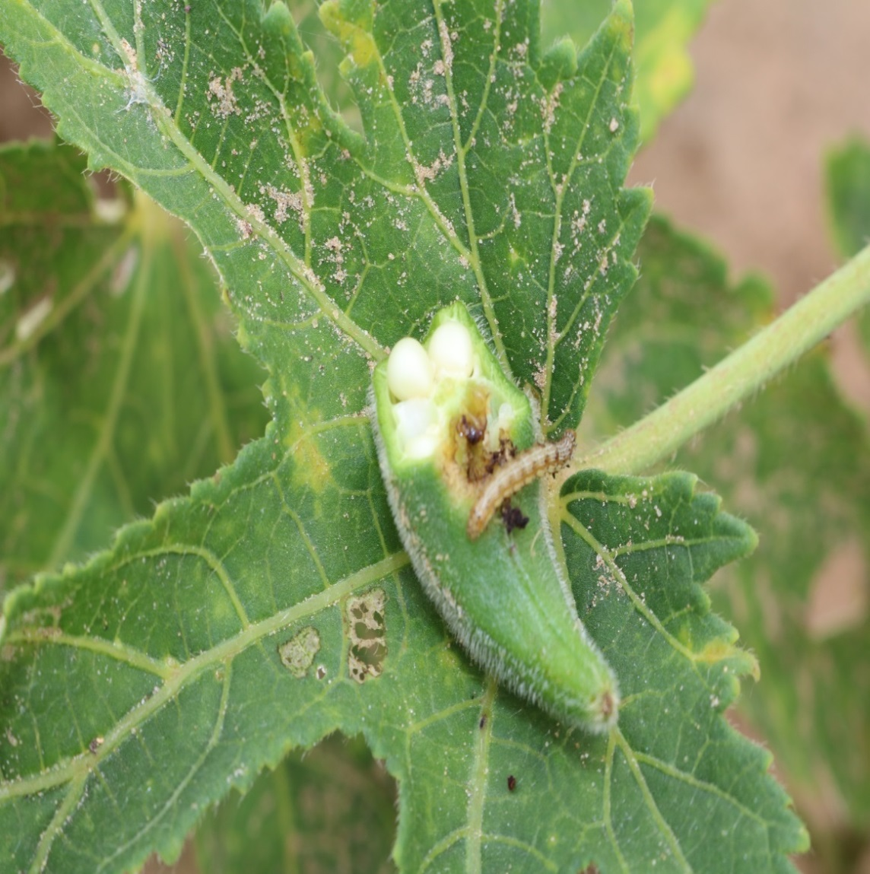

Plate 1: Larva of *Earias* spp.

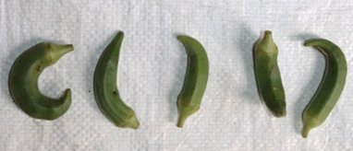

Plate 2: Fruits of okra infested by *Earias* spp.

3. results and discussion

The infestation data of shoot and fruit borer *Earias* spp. on okra crops during the *Kharif* season is shown in Table 1, Table 2 and Figure.1.

The infestation of *Earias spp.* on okra shoots was first observed in the 33rd Standard Meteorological Week (SMW), with an initial infestation rate of 5.26%. The infestation gradually increased and reached its peak during the 38th SMW, with a rate of 12.04%, when the minimum temperature was 21.1°C, the maximum temperature was 33.1°C, and relative humidity was 50%. By the 42nd SMW, at the end of the crop season, the infestation had decreased to 0.25%. This pattern of infestation, starting in the third week of August and gradually increasing, aligns with the findings of Yadav *et al*. (2007) and Yadav (2015).

Correlation studies revealed a non-significant positive correlation between the infestation of *Earias spp.* on okra shoots and all abiotic factors, including maximum and minimum temperatures, relative humidity, and rainfall. These results are consistent with those of Yadav (2015) and Choudhary and Sharma (2020), who also reported a non-significant correlation between shoot infestation and these climatic factors.

On okra fruits, *Earias spp.* infestation was first recorded in the 36th SMW, with a low initial infestation of 2.84% based on the number of infested fruits. The infestation increased and peaked at 30.04% in the 42nd SMW, when the minimum temperature was 12.3°C, the maximum temperature was 33.4°C, and relative humidity was 40%. The correlation studies indicated a significant negative correlation between fruit infestation and minimum temperature. While the correlation with maximum temperature was non-significant and negative, relative humidity and rainfall showed non-significant negative correlations. These findings align with those of Raju *et al*. (2017), who reported peak infestation in the 42nd SMW, with a non-significant negative correlation between fruit infestation and minimum temperature, relative humidity, and rainfall. Additionally, Yadav (2015) found a negative significant correlation between fruit infestation and minimum temperature, with no significant correlation with rainfall.

**Table 1 Weekly mean meteorological observations recorded during *Kharif*, 2022**

|  |  |  |  |  |  |  |  |
| --- | --- | --- | --- | --- | --- | --- | --- |
| **S.**  **No.** | **SMW\*** | **Duration** | | **Temperature**  **(°C)** | | **Relative**  **Humidity**  **(%)** | **Total**  **Rainfall**  **(mm)** |
| **From** | **TO** | **Max.** | **Min.** |
| 1. | 33 | 13.08.2022 | 19.08.2022 | 30.3 | 21.1 | 52 | 93.0 |
| 2. | 34 | 20.08.2022 | 26.08.2022 | 30.2 | 20.9 | 59 | 32.0 |
| 3. | 35 | 27.08.2022 | 02.09.2022 | 33.2 | 21.1 | 41 | 00.0 |
| 4. | 36 | 03.09.2022 | 09.09.2022 | 35.2 | 20.3 | 47 | 00.0 |
| 5. | 37 | 10.09.2022 | 16.09.2022 | 34.7 | 21.5 | 45 | 05.0 |
| 6. | 38 | 17.09.2022 | 23.09.2022 | 33.1 | 21.1 | 50 | 17.0 |
| 7. | 39 | 24.09.2022 | 30.09.2022 | 32.9 | 18.7 | 45 | 13.0 |
| 8. | 40 | 01.10.2022 | 07.10.2022 | 35 | 16.8 | 42 | 0.0 |
| 9. | 41 | 08.10.2022 | 14.10.2022 | 30.6 | 17.0 | 51 | 46.0 |
| 10. | 42 | 15.10.2022 | 21.10.2022 | 33.4 | 12.3 | 40 | 0.0 |

*\*SMW = Standard Meteorological Week*

**Table.2 Correlation analysis between seasonal incidence of shoot and fruit borer and abiotic factors during *kharif* 2022**

|  |  |  |  |  |  |  |
| --- | --- | --- | --- | --- | --- | --- |
| S.N. | SMW* | Date of observations | Mean percent infestation | | | |
|  | Shoots | Fruits  Number basis |  |
| 1 | 33 | 13.08.2022 |  | 5.26 | 0 |  |
| 2 | 34 | 20.08.2022 |  | 4.85 | 0 |  |
| 3 | 35 | 27.08.2022 |  | 4.35 | 0 |  |
| 4 | 36 | 03.09.2022 |  | 4.25 | 2.84 |  |
| 5 | 37 | 10.09.2022 |  | 8.81 | 5.96 |  |
| 6 | 38 | 17.09.2022 |  | 12.04 | 9.76 |  |
| 7 | 39 | 24.09.2022 |  | 9.96 | 14.28 |  |
| 8 | 40 | 01.10.2022 |  | 3.93 | 22.64 |  |
| 9 | 41 | 08.10.2022 |  | 3.85 | 26.96 |  |
| 10 | 42 | 15.10.2022 |  | 0.25 | 30.04 |  |
| Correlation with maximum temperature | | |  | 0.07 | 0.12 |  |
| Correlation with minimum temperature | | |  | 0.61 | -0.90** |  |
| Correlation with relative humidity | | |  | 0.15 | -0.46 |  |
| Correlation with rainfall | | |  | 0.02 | -0.22 |  |
|  | | |  |  |  |  |

*\*Standard Meteorological Week*

*\*\*Significant at 5 per cent level of significance*

**Fig. 1. Relationship between weather parameter and okra shoot and fruit borer.**

4. Conclusion

The infestation of *Earias* spp. on okra crops followed a distinct pattern, with a gradual increase in infestation on shoots and fruits throughout the *Kharif* season. The shoot infestation peaked in the 38th SMW, while fruit infestation reached its maximum in the 42nd SMW. Despite the variation in climatic factors, the correlation studies revealed no significant relationship between shoot infestation and most abiotic factors, while fruit infestation showed a significant negative correlation with minimum temperature. These findings highlight the dynamic nature of pest infestation and its complex interaction with environmental factors.

**Disclaimer (Artificial intelligence)**

Option 1:

Author(s) hereby declare that NO generative AI technologies such as Large Language Models (ChatGPT, COPILOT, etc.) and text-to-image generators have been used during the writing or editing of this manuscript.

Option 2:

Author(s) hereby declare that generative AI technologies such as Large Language Models, etc. have been used during the writing or editing of manuscripts. This explanation will include the name, version, model, and source of the generative AI technology and as well as all input prompts provided to the generative AI technology

Details of the AI usage are given below:

1.

2.

3.

References

Basnet S., Lamichane P., Meheta A. and Rajbanshi Y. 2023. A review on biochemical, nutritional, and medicinal properties of okra. International Congresses of Turkish Science and Technology Publishing, 46-53.

Gemede H.F., Ratta N., Haki G.D., Woldegiorgis A.Z. and Beyene F. 2015. Nutritional quality and health benefits of okra (*Abelmoschus esculentus*): A review. *Journal of Food Process Technology*,**6**: 458.

Gopalan C., Sastri S.B.V. and Balasubramanian S. 2007. Nutritive value of Indian foods. National Institute of Nutrition (NIN), ICMR, India.

Saifullah M. and Rabbani M.G. 2009. Evaluation and characterization of okra (*Abelmoschus esculentus* L. Moench.) genotypes. SAARC Journal of Agriculture, **7**: 92-99.

Pareek B.L. and Bhargava M.C. 2003. Estimation of avoidable losses in vegetable crops caused by borers under semi-arid conditions of Rajasthan. *Insect Environment*, 9: 59-60.

Ray A., Kerketta A., Awasthi A.K., Tomar R.K.S., Chandan M. and Chandravanshi D. 2019. Impact of weather aspects on the prevalence and correlation of okra shoot and fruit borer (*Earias vittella* Fab.) during the summer season. *Journal of Entomology and Zoology Studies*, **7**: 773-776.

Yadav A., Raghuraman M. and Choudhary S., 2015. Impact of abiotic factors on population dynamics of fruit and shoot borer in okra. *Journal of Experimental Zoology*, **18**: 765-768.

Yadav S.K., Kumawat K.C., Deshwal H.L., Kumar S. and Manohar S.V.S., 2017. Bioefficacy of newer and biorational insecticides against shoot and fruit borer, *Earias* spp. on okra. *Inernational Journal of Current Microbiology and Applied Sciences*, ***6****:* 1035-1044.

Raju, Reddy C. Narendra D., Anitha and Srinivasa, D. 2017. Seasonal incidence and correlation of abiotic factors against okra shoot and fruit borer (*Earias vittella* Fab.) during Kharif season. *AGRIS*, **2**: 554-558.

Gupta S.C. 1996. Correlation, Fundamentals of Statistics. Himalaya Publishing House, Mumbai, pp. 510-587.

Choudhary S. and Sharma A. 2020. Population dynamics of shoot and fruit borer, *Earias* spp. infesting okra. *Journal of Entomology and Zoology Studies,* **8**: 499-50.