***Original Research Article***

**Evaluation of substrates and carrier material for shelf life studies of *Streptomyces* bioformulation**

**Abstract**

Biological control with potential actinomycetes is receiving greater attention all over the world. Among actinomycetes, *Streptomyces* being root-colonizing and rich producer of secondary metabolites has become one of the important promising group of antagonists. Management of soilborne diseases using biocontrol agents is an sustainable option in agriculture. Studies were conducted on collection and isolation of actinomycetes, their shelf life studies for formulation development using different substrates and carrier material. Growth of actinomycetes on different media viz., Ken knights, Crawford broth, Starch casein hydrolysate broth and AFMS broth were observed. To find the suitable carrier for long shelf life of formulation, different carrier material viz., Talc, Kaolinite, whaetbran, lignite and vermicompost was used. The paramount need and challenge in plant protection is development of new, safe and more effective antifungal agents as bioformulation to control stem rot of groundnut and to improve pod yield.

**Key words: Actinomycetes, bioformulation, shelf life, *Streptomyces***

**Introduction**

The major factor that goes into success of any biocontrol programme is the effectiveness with which the biocontrol agents are delivered. This requires identification of effective strains of biocontrol agents against various plant pathogens. In addition, antagonistic strains must be combined with a suitable substrate to improve their biocontrol efficacy against soil borne diseases ( Zhu *et al*. 2012). Presently, there are a number of commercial isolates of *Streptomyces* available in the market. However, the native isolates of certain biocontrol agents showed superiority over other isolates for the management of crop diseases (Dubey and Patel, 2001). As the use of freshly prepared cultures is not convenient in agricultural systems, a formulation better suited for storage, transport and ease of application is an important requisite if a biocontrol agent is to be developed for commercial use. Many biocontrol agents including bioherbicides have been formulated in various forms of liquids, solids and powders. Dry formulations (granules or powders) are generally preferred over liquid formulations because of extended shelf life and ease in transportation and storage. Furthermore, application of biocontrol agents through different forms of formulations including talc, alginate, vermicompost and farm yard manure based preparations for soil application and seed treatment might be useful for managing soil borne pathogens (Deivamani and Muthamilan, 2016). Recently, secondary metabolite-based formulations have been receiving much interest because of a much longer shelf - life and a higher efficiency against soil borne plant pathogens. A bioformulation can improve product stability, shelf life and also protect bioagent against different environmental conditions (Prasad and Rangeshwaran, 2000).

There are few commercial formulations available in the market like Mycostop and Spinosad. The antagonistic actinomycetes, *Streptomyces griseoviridis* is commercially available with the trade name Mycostop® . Mycostop is recommended to control *Alternaria* and *Fusarium* diseases in crucifers and *Fusarium* wilt in carnations (Tahvonen and Avikainen, 1987).

**Methodology**

**Selection of media for actimycetes formulation**

The identified potential strains were grown on different media like

1. Ken Knight’s Broth ii. Starch casein hydrolysate Broth

iii. Crawford Broth iv. AF/MS broth

Growth was observed at different time intervals (cfu / ml at 2, 4, 6, 8 and 10 days after inoculation) to specify the suitable medium for luxurious growth.

**Carrier materials for formulation development**

To know the suitable carrier material for more shelf life, the culture grown on suitable medium were mixed with different carriers for formulation development.

The carrier materials used were

i) Talc (ii) Kaolinite (iii) Lignite iv) Wheat bran (v) Vermicompost

Growth and shelf life was observed at different time intervals

(cfu g-1 0, 15, 30, 45, 60, 75, 90, 105 and 120 days after storage).

**Development of formulation of actinomycetes**

The *Streptomyces* isolates were cultivated in Ken Knight’s broth. A 25 ml spore suspension was thoroughly mixed with 100 g of autoclaved carrier material, 1.5 g of calcium carbonate and 10 g of carboxy methyl cellulose. After drying the formulation overnight under a laminar flow chamber, the powder formulation was weighed and stored at room temperature in the dark. The purity of the formulations based on *Streptomyces* sp. was verified after the formulation processes. A 0.2 g of each formulation was mixed for a minute in 4 ml of sterile distilled water and 0.1 ml of the spore suspension was inoculated to KA plates and incubated at 30°C after 7 days incubation (Sabaratnam and Traquair., 2002). The viability of formulated *Streptomyces* sp. was determined in each formulation at every 15 days intervals for 120 days storage period. Viable spores of strain was determined by counting cfu g-1 using the counting plate method (Martinez-Alvarez., 2016). Formulations of actinomycetes were prepared using five carrier materials.

The formulations thus prepared were allowed to dry aseptically and then ground to powder. The formulation was packed with 35 % moisture content in sterile polythene bags, sealed and stored at room temperature (28 ± 2 °C). All of the formulation processes were performed under sterile laboratory conditions.

The formulation of potential isolates were assessed for its efficacy in controlling stem rot of groundnut under glasshouse conditions.

**Results and discussion**

**Growth of *Streptomyces* spp*.* on different liquid media**

Among the five potential strainsof *Streptomyces* spp. Ggd, Kdr and Kyd isolates were selected for shelf life studies on the basis of their *in vitro* antagonism in dual culture technique and biochemical characters. The isolates Ggd, Kdr and Kyd were grown on different liquid media like Ken Knight’s broth, Starch casein hydrolysate broth, Crawford broth and AF/MS broth to specify the suitable medium for optimum growth of *Streptomyces* spp. Mycelial growth (dry weight (mg / 500 ml)was observed at different intervals of time at 2, 4, 6, 8 and 10 days after inoculation ( Table 1).

The data in Table 1 revealed that the mycelial growth of all the three isolates was increased from 2 days to 10 days after inoculation. At two days after inoculation in Ken Knights broth, *Streptomyces* strain Ggd showed significantly superior growth recording mycelial growth of 234 mg / 500 ml. Least growth was recorded by Kyd (127 mg/500 ml). In starch casein hydrolysate broth highest growth (181 mg/500 ml) recorded by Ggd, least growth (106 mg / 500 ml) by Kyd. While the isolate Ggd recorded maximum growth (175 mg / 500 ml) and Kyd recorded minimum growth (107 mg / 500 ml) in AF/MS broth. In Crawford broth more growth was recorded by Ggd (162 mg / 500 ml) and less growth (94 mg /500 ml) by Kyd. In control Ggd recorded 104 mg / 500 ml and Kyd recorded 74 mg / 500 ml mycelial dry weight. The isolates Ggd, Kdr and Kyd showed variation in growth with respect to the media used. Among different media used the growth of the isolate Ggd showed significantly maximum growth (234 mg / 500 ml) in Ken Knight’s broth where as minimum growth was recorded by Kyd in control (74 mg / 500 ml).

It is evident from the data that at four days after inoculation in Ken Knight’s broth, *Streptomyces* strain Ggd recorded mycelial growth of 442 mg / 500 ml which was significantly highest among all the media and with the other isolates. Least growth was recorded by Kyd (322 mg / 500 ml). In starch casein hydrolysate broth, highest growth (384 mg / 500 ml) recorded by Ggd, least growth (281 mg / 500 ml) by Kyd. The isolate Ggd recorded maximum growth (363 mg / 500 ml) and Kyd recoded minimum growth (293 mg / 500 ml) in AF/MS broth. In Crawford broth more growth was recorded by Ggd (350 mg / 500 ml) and less growth (244 mg / 500 ml) by Kyd. In control Ggd recorded 314 mg / 500 ml and Kyd recorded 252 mg / 500 ml. The isolates Ggd, Kdr and Kyd showed variation in growth with respect to the media used. Among different media used the growth of the isolate Ggd showed significantly highest (442 mg / 500 ml) in Ken Knights broth whereas least growth was observed with Kyd in control (252 mg / 500 ml).

At six days after inoculation, significantly highest growth (589 mg / 500 ml) was recorded by Ggd in Ken Knight’s broth whereas least growth (545 mg / 500 ml) was recorded by Kyd. In starch casein hydrolysate broth, highest growth (584 mg / 500 ml) recorded by Ggd, least growth (512 mg / 500 ml) by Kyd. The isolate Ggd recorded maximum growth (525 mg / 500 ml) and Kyd recorded minimum growth (504 mg / 500 ml) in AF/MS broth. In Crawford broth more growth was recorded by Ggd (515 mg / 500 ml) and less growth (475 mg / 500 ml) by Kyd. In control Ggd recorded 423 mg / 500 ml and Kyd recorded 404 mg / 500 ml. Among different media used the growth of the isolate Ggd showed significantly highest (589 mg / 500 ml) in Ken Knight’s broth whereas least growth was observed by Kyd in control (404 mg / 500 ml).

At eight days after inoculation in Ken Knight’s broth, *Streptomyces* strain Ggd recorded mycelial growth of 654 mg / 500 ml which was significantly highest among all the media and with the other isolates. Least growth was recorded by Kyd (604 mg / 500 ml). In starch casein hydrolysate broth highest growth (621 mg / 500 ml) recorded by Ggd, least growth (585 mg / 500 ml) by Kyd. The isolate Ggd recorded maximum growth (602 mg / 500 ml) and Kyd recoded minimum growth (553 mg / 500 ml) in AF/MS broth. In Crawford broth more growth was recorded by Ggd (584 mg / 500 ml) and less growth (525 mg / 500 ml) by Kyd. In control, Ggd recorded 503 mg / 500 ml and Kyd recorded 466 mg / 500 ml. The isolates Ggd, Kdr and Kyd showed variation in growth with respect to the media used. Among different media used the growth of the isolate Ggd showed significantly highest (654 mg / 500 ml) in Ken Knight’s broth whereas least growth was observed by Kyd in control (466 mg / 500 ml).

Maximum mycelial dry weight was observed in all the media at ten days after inoculation. The isolate Ggd showed significantly highest growth (712 mg / 500 ml) in Ken Knight’s broth whereas least growth (666 mg / 500 ml) was recorded by Kyd. In starch casein hydrolysate broth highest growth (699 mg / 500 ml) recorded by Ggd, least growth (642 mg / 500 ml) by Kyd. The isolate Ggd recorded maximum growth (684 mg / 500 ml) and Kyd recoded minimum growth (633 mg / 500 ml) in AF/MS broth. In Crawford broth more growth was recorded by Ggd (673 mg / 500 ml) and less growth (603 mg / 500 ml) by Kyd. In control Ggd recorded 594 mg / 500 ml and Kyd recorded 497 mg / 500 ml. Among different media used the growth of the isolate Ggd showed significantly highest (712 mg / 500 ml) in Ken Knight’s broth whereas least growth was observed by Kyd in control (497 mg / 500 ml).

The *Streptomyces* spp. grown well in the Ken Knight’s broth forming more dry weight (mg / ml) at 2, 4, 6, 8 and 10 days after inoculation (Fig. 1). The variation in growth of different isolates in the media may depend on availability of specific nutrients. The utilization pattern of nutrient sources can be used as one of the criteria for species identification

**Development of bioformulation of *Streptomyces* spp*.***

To select the suitable carrier material for more shelf life, the culture grown on Ken Knight’s liquid medium was mixed with different carriers for formulation development. The carrier materials viz., Talc, Kaolinite, Lignite, Wheatbran and Vermi-compost were used (Plate 1). Growth and shelf life was observed at different intervals of time (cfu / g 0, 15, 30, 45, 60, 75, 90, 105 and 120 days of storage).

From the results (Table 2), it is evident that the survival of *Streptomyces* spp. in the prepared formulation was evaluated during 120 days storage at room temperature (28±2°C) and population of *Streptomyces* isolates was observed at every 15 days interval by soil dilution plate technique.

The results revealed that decreasing trend was observed with number of days progressed. The population of *Streptomyces* isolates was recorded in a decreasing trend from the initial population level to 120 days.

The talc formulation of Ggd, Kdr and Kyd had 86.45 x108, 83.24 x108 and 82.95 x 108 cfu g-1 respectively at the time of preparation. The cfu g-of talc formulation of Ggd, Kdr and Kyd had reduced to 85.66 x 108, 82.56 x 108 and 81.36 x 108  after 15 days, 83.25 x 108, 80.65 x 108 and 78.25 x 108  at the end of 30 days. After 45 and 60 days the Ggd, Kdr and Kyd cfug- in talc recorded was 79.33 x 108, 78.57 x 108 , 75.65 x 108  and 75.83 x 108, 74.23 x 108, 70.45 x 108  respectively. The reduction in cfu g- of Ggd, Kdr and Kyd observed was 70.55 x 108, 69.24 x 108, 64.24 x 108  and 63.25 x 108, 62.34 x 108, 58.46 x 108  after 75 and 90 days respectively. The cfu g- reduced (59.67 x 108, 55.35 x 108, 51.54 x 108 from 90 to 105 days after storage. The cfu g- of Ggd, Kdr and Kyd in talc had dropped to 48.47 x 108, 39.64 x 108, 36.25 x 108  at the end of 120 days. Four months after preparation the cfu g- of *Streptomyces* strains in talc formulation dropped approximately by 44-75 %.

The cfu g- of Ggd in lignite at the time of preparation was 86.32 x 108 showed significantly maximum whereas Kdr and Kyd had 83.15 x 108 and 82.67 x 108. At the end of 120 days the population decreased to 42.59 x 108, 38.54 x 108 and 37.25 x 108 respectively.

The reduction in mean cfu g- of Ggd, Kdr and Kyd was observed in kaolinite from 0 days to 120 days after storage. At the time of preparation the cfu g- of Ggd, Kdr and Kyd was 86.15 x 108, 83.07 x 108 , 82.42 x 108 while it was reduced to 24.52 x 108, 20.56 x 108, 19.85 x 108 respectively after 120 days of storage.

The mean cfu g-of 86.12 x 108, 83.07 x 108 and 82.14 x 108 at the time of preparation in vermicompost was recorded by Ggd, Kdr and Kyd respectively. At the end of 120 days, cfu g- was dropped to 10.54 x 108, 9.56 x 108 and 8.95 x 108.

Less cfu g- of Ggd, Kdr and Kyd was observed in wheatbran formulation. At the time of preparation 82.02 x 108, 81.04 x 108 and 80.32 x 108 colony forming units were observed. After 120 days, the cfu g- was decreased to 7.33 x 08, 6.97 x 108 and 6.50 x 108 cfu g-1 respectively.

Among different carriers tested, talc recorded the more cfug- of *Streptomyces* sp*.* (Ggd, Kdr and Kyd) (48.47 x 108, 39.64 x 108 and 36.25 x 10 8 cfu / g) at the end of 120 days. Less cfu g- of *Streptomyces* sp*.* (Ggd, Kdr and Kyd) was observed on wheat bran (7.33 x108, 6.97 x 108 and 6.50 x 108) at the end of 120 days (Fig. 4.5).

It is evident from the results that talc was found to be the suitable carrier material for formulation development and to deliver bio agent *Streptomyces* spp*.* (Ggd, Kdr and Kyd). The inert nature, powder form availability, low moisture equilibrium and mineral composition of talc might have the reason for longer storage of *Streptomyces* population in talc based formulation. The effectiveness of bioagent may be decided by their homogeny repartition, good germination of their spores and sufficient diffusion of antagonistic compounds in the carriers used.

Many *Streptomyces* species have been formulated and available commercially in India. *Streptomyces griseoviridis* (Mycostop®) has been formulated as a wettable powder containing spores as propagules (Tahvonen and Avikainen, 1987). Many biocontrol agents have been formulated into various forms of liquids, solids, and wettable powders to control plant pathogens. However solid or powder formulations, are generally preferred over liquid formulations because they contain dry propagules of biocontrol

agents and thereby, tend to withstand environmental extremes, thus, providing extended shelf life and ease of transportation and storage (Lewis *et al*., 1995).

These findings are in agreement with those of Sabaratnam and Traquair (2002) who reported talc as a better carrier for *Streptomyces* sp. Di-944 powder formulation for tomato plants. The results of the present study is in confirmation with Kalra *et al.* (2008) who reported that carrier substances used for the preparations of bioformulations should sustain appreciable number of bioinoculants for a certain period of time and it should have a good water holding capacity, good aeration characteristics, support growth and survival, non toxic, easily sterilizable, manufactured and handled in the field. Similarly Anitha and Rabeeth (2009) developed talc based formulation for *S. griseus* for biocontrol of *Fusarium* wilt in tomato. The first major concern in commercial production system involves the achievement of adequate growth of biocontrol agents. In many cases, biomass production of the antagonist is difficult due to the specific requirement of nutritional and environmental conditions for the growth of the organism. In addition antagonistic strains must be combined with a suitable substrate to improve their biocontrol efficacy against soil-borne diseases (Zhu *et al*., 2012). Similarly Harikrishnan *et al*. (2014) noted that talc-based formulation exhibited significant inhibition against sclerotial germination of *Rhizoctonia solani* and reduced Sheath blight in rice leaves. The present study also supported with findings of Shen *et al*. (2016) who used wheat bran and vermicompost for solid-state fermentation with *Streptomyces* strain B04. They reported that spore number peaked at 5.3x 1010 cfug- on the seventh day of fermentation. The present study was in agreement with the findings of Tamreihao *et al*. (2016) who developed powder formulation of the *Streptomyces corchorusii* strain UCR3-16, obtained from rice rhizospheric soils showed antifungal activities against *Rhizoctonia solani*. In shelf life studies, talc formulation recorded higher colony count than corn starch even after 6 months of storage. Pot and field trial experiments using talc powder formulation showed significant reduction of sheath blight disease besides significant enhancement in length and weight of shoot, weight of root, grain yield and weight of grain. Further they opined that the biocontrol activities of the strain may be due to production of antifungal metabolites, diffusible volatile compounds, siderophores and cell wall degrading enzymes.

Similar results were recorded by Zamoum *et al*. (2017) characterised the antagonistic *Streptomyces rochei* strain PTL2, isolated from root tissues of *Panicum turgidum*, in controlling the damping off caused by *R. solani* in tomato. They developed the *Streptomyces rochei* PTL2spores basedformulations viz., wettable talcum powder, sodium alginate pellets and sodium alginate clay pellets. They found that the amount of PTL2 spores in the alginate pellets and talc powder formulations remained relatively stable throughout the 12 months after the formulation process and formulation of PTL2 spores as wettable talc powder showed a high rate of viable spores after one year storage at room temperature. The strain PTL2 exhibited the highest protective activity by reducing the disease incidence (14.1%) along with greatest increase in the root and shoot length, dry weight of seedlings. Further they reported that disease suppression may be due to the production of volatile compounds, HCN, siderophores, chitinases.

This study is in agreement with the findings of Jebaraj *et al.* (2017b) who assessed the survival potential of biocontrol agents in different carriers like talc, gypsum, fly ash, vermiculite, bentonite, kaolinite, peat and proved that the talc based powder formulation of *Streptomyces* sp. (DA1) recorded the maximum population density of 25.91 x 107 cfu / g after 120 days of storage which was also found effective in pot and field conditions.

The efficacy of talc based formulations of Ggd, Kdr and Kyd were evaluated against *S. rolfsii* for their ability to reduce the stem rot incidence of groundnut under glasshouse conditions.

Among the five identified potential *Streptomyces* strains, three strains namely Ggd, Kdr and Kyd were selected for shelf life studies on the basis of their *in vitro* antagonism in dual culture technique and enzymatic studies. The isolates Ggd, Kdr and Kyd were grown on different liquid media like Ken Knight’s broth, starch casein hydrolysate broth, Crawford broth and AF/MS broth to identify the specific broth suitable for luxurious growth.

The growth of all the three isolates was increased from 2 days to 10 days after inoculation. At 10 days after inoculation, *Streptomyces* strain Ggd showed significantly higher growth on Ken Knight’s broth (712 mg / 500 ml) whereas least growth was recorded by Kdr in control (453 mg / 500 ml). The isolates Ggd, Kdr and Kyd showed variation in growth with respect to the media used. Among different media used the growth of the isolate Ggd showed significantly maximum (712 mg / 500 ml) in Ken Knight’s broth whereas it was minimum in control (594 mg / 500 ml).

To select the suitable carrier material for more shelf life, the culture grown on Ken Knight’s liquid medium was mixed with carrier materials like talc, kaolinite, lignite, wheat bran and vermicompost. The population of *Streptomyces* isolates decreased from the initial population level to 120 days. Among different carriers tested, talc recorded the maximum population of *Streptomyces* sp*.* (Ggd, Kdr and Kyd) (48.47, 39.64 and 36.25 x 108 cfu / g) at the end of 120 days. The minimum population of *Streptomyces* sp*.* (Ggd, Kdr and Kyd) was observed on wheat bran (7.33, 6.97 and 6.50 x 10 8 cfu / g) .

The talc formulation of Ggd, Kdr and Kyd had colony forming units of 86.45 x 108, 83.24 x 108and 82.95 x 108 per gram respectively at the time of preparation. After 120 days of storage at room temperature, the number of living cells in the talc formulation was reduced to 48.47 x 108, 39.64 x 108 and 36.25 x 108 cfu g- respectively.

After 120 days, talc based formulation recorded the maximum population of *Streptomyces* strain (Ggd) (48.47 x 108cfu / g) while minimum population was observed in wheat bran (7.33 x 108 cfu / g). Four months after preparation, the colony forming units of *Streptomyces* strains in the talc formulation decreased approximately by 44 to 75 %. The *Streptomyces* spp. strain 5406 has been used in China from past 35 years to protect cotton crops against soil borne plant pathogens (Valois *et al*., 1996). The commercial product Mycostop, based on strain K 61 of *S. griseoviridis* and *S. lydicus* WYEC108 were found useful in the control of root rot and wilt diseases caused by *Pythium* spp*., Phytophthora* spp*., Fusarium* spp*., Rhizoctonia* spp. (Mahadevan and Crawford,1997).

Sabaratnam and Traquair (2002) reported talc as a better carrier for *Streptomyces* sp. Di-944 powder formulation for tomato plants. Kalra *et al.* (2008) suggested that carrier substances used for the preparations of bioformulations should sustain appreciable number of bioinoculants for a certain period of time and it should have a good water holding capacity, good aeration characteristics, support growth and survival, non toxic, easily sterilizable, manufactured and handled in the field.

Anitha and Rabeeth (2009) have developed talc based formulation for *S. griseus* for biocontrol of *Fusarium* wilt in tomato. The first major concern in commercial production system involves the achievement of adequate growth of biocontrol agents. In many cases, biomass production of the antagonist is difficult due to the specific requirement of nutritional and environmental conditions for the growth of the organism. In addition antagonistic strains must be combined with a suitable substrate to improve their biocontrol efficacy against soil borne diseases (Zhu *et al*., 2012). Harikrishnan *et al*. (2014) noted that talc-based formulation exhibited significant inhibition against sclerotial germination of *R. solani* and reduced sheath blight in rice leaves. Agro-industrial waste materials, specifically wheat bran and vermicompost, were used for solid-state fermentation with strain B04 to produce bioorganic fertilizer. On the seventh day of fermentation, the spore number peaked at 1010 cfu / g(Shen *et al*., 2016). Tamreihao *et al*. (2016) developed powder formulation of the *Streptomyces corchorusii* strain UCR3-16, obtained from rice rhizospheric soils showed antifungal activities against *Rhizoctonia solani*. In shelf life studies, talc formulation recorded higher cell count than corn starch even after 6 months of storage. Pot and field trial experiments using talcum powder formulation showed significant reduction of sheath blight disease besides significant enhancement in length and weight of shoot, weight of root, grain yield and weight of grain. Further they opined that the biocontrol activities of the strain may be due to production of antifungal metabolites, diffusible volatile compounds, siderophores and cell wall degrading enzymes.

Jebaraj *et al.* (2017b) assessed the survival potential of biocontrol agents in different carriers like talc, gypsum, fly ash, vermiculite, bentonite, kaolinite, peat and proved that the talc based powder formulation of *Streptomyces* sp. (DA1) recorded the maximum population density of 25.91 x 107 cfu / g after 120 days of storage which was also found effective in pot and field conditions.

Gopalakrishnan et al., 2021 studied the effect of *Streptomyces* spp. and host-plant resistance induction on charcoal rot of sorghum

**Conclusion**

In the present study, talc was found to be the suitable carrier material for formulation development and delivery of *Streptomyces* species ( Ggd, Kdr and Kyd) as biocontrol agents . Among the five actinomycete isolates (Ggd, Kdr, Kyd, Lrp and Mkc), three potential isolates were selected for preparation of bioformulations. Five different formulations *i.e*., talc, kaolinite, lignite, wheat bran and vermicompost were prepared and evaluated for longer shelf life. It was found that talc based formulations were superior in maintaining the longer shelf life of the actinomycetes.

The population of *Streptomyces* sp*.* in the rhizosphere of groundnut was enumerated at 30, 75 and 105 days after sowing. Seed treatment followed by soil application at 45 DAS with talc powder formulation of *Streptomyces* sp. revealed that the *Streptomyces* colonies multiplied well in the rhizosphere and the rhizosphere population increased with increase in the age of the crop.

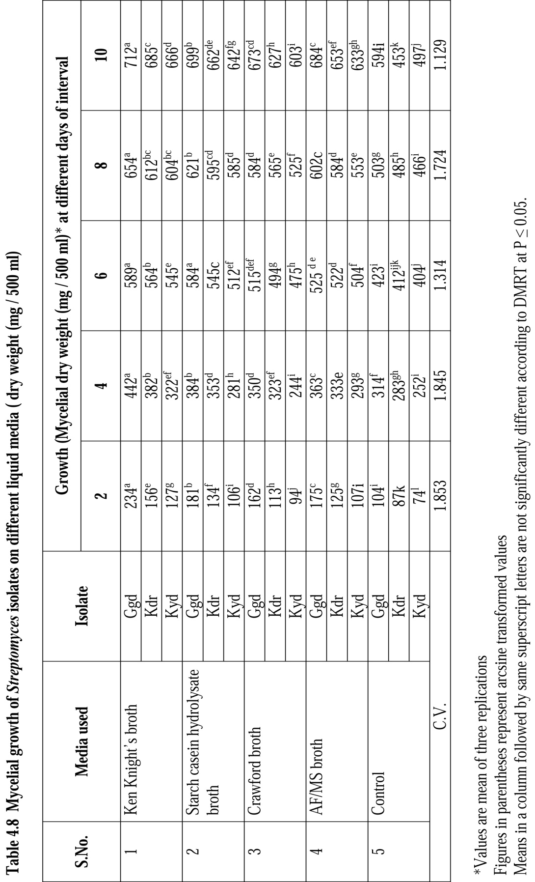

**Table 1. Mycelial growth of *Streptomyces* isolates on different liquid media**

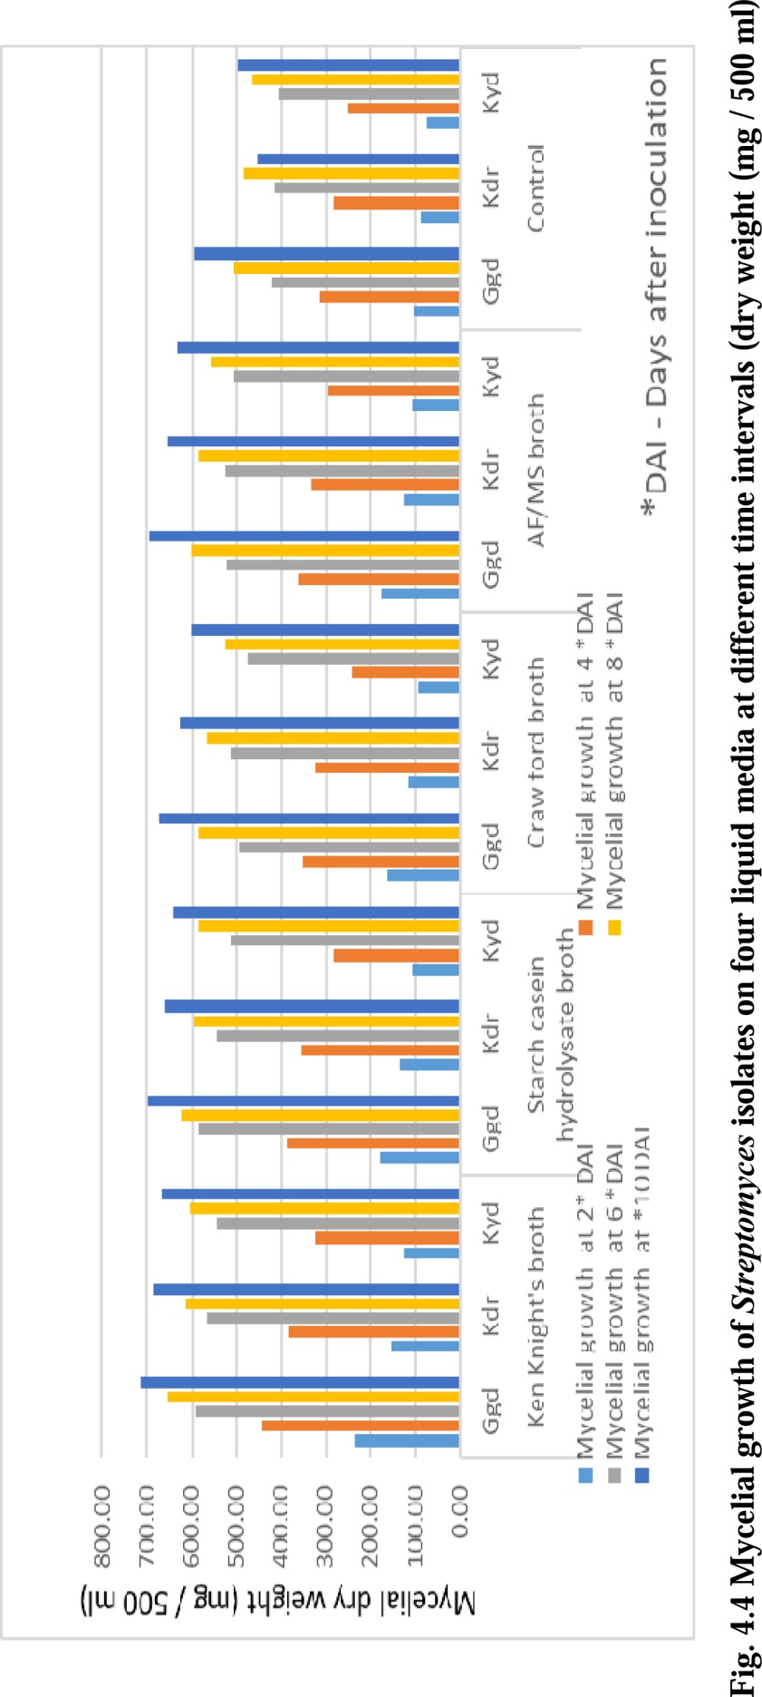

Fig. 1 Mycelial growth of *Streptomyces* isolates on different liquid media in four different intervals

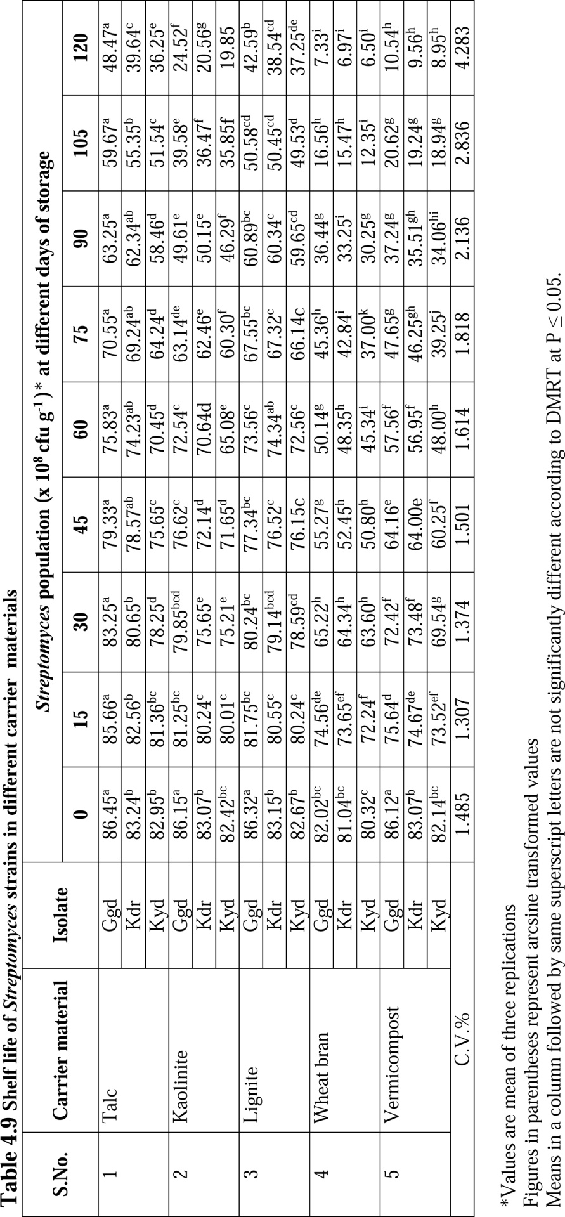

**Table 2. Shelf life of *Streptomyces* isolates on different carrier material**

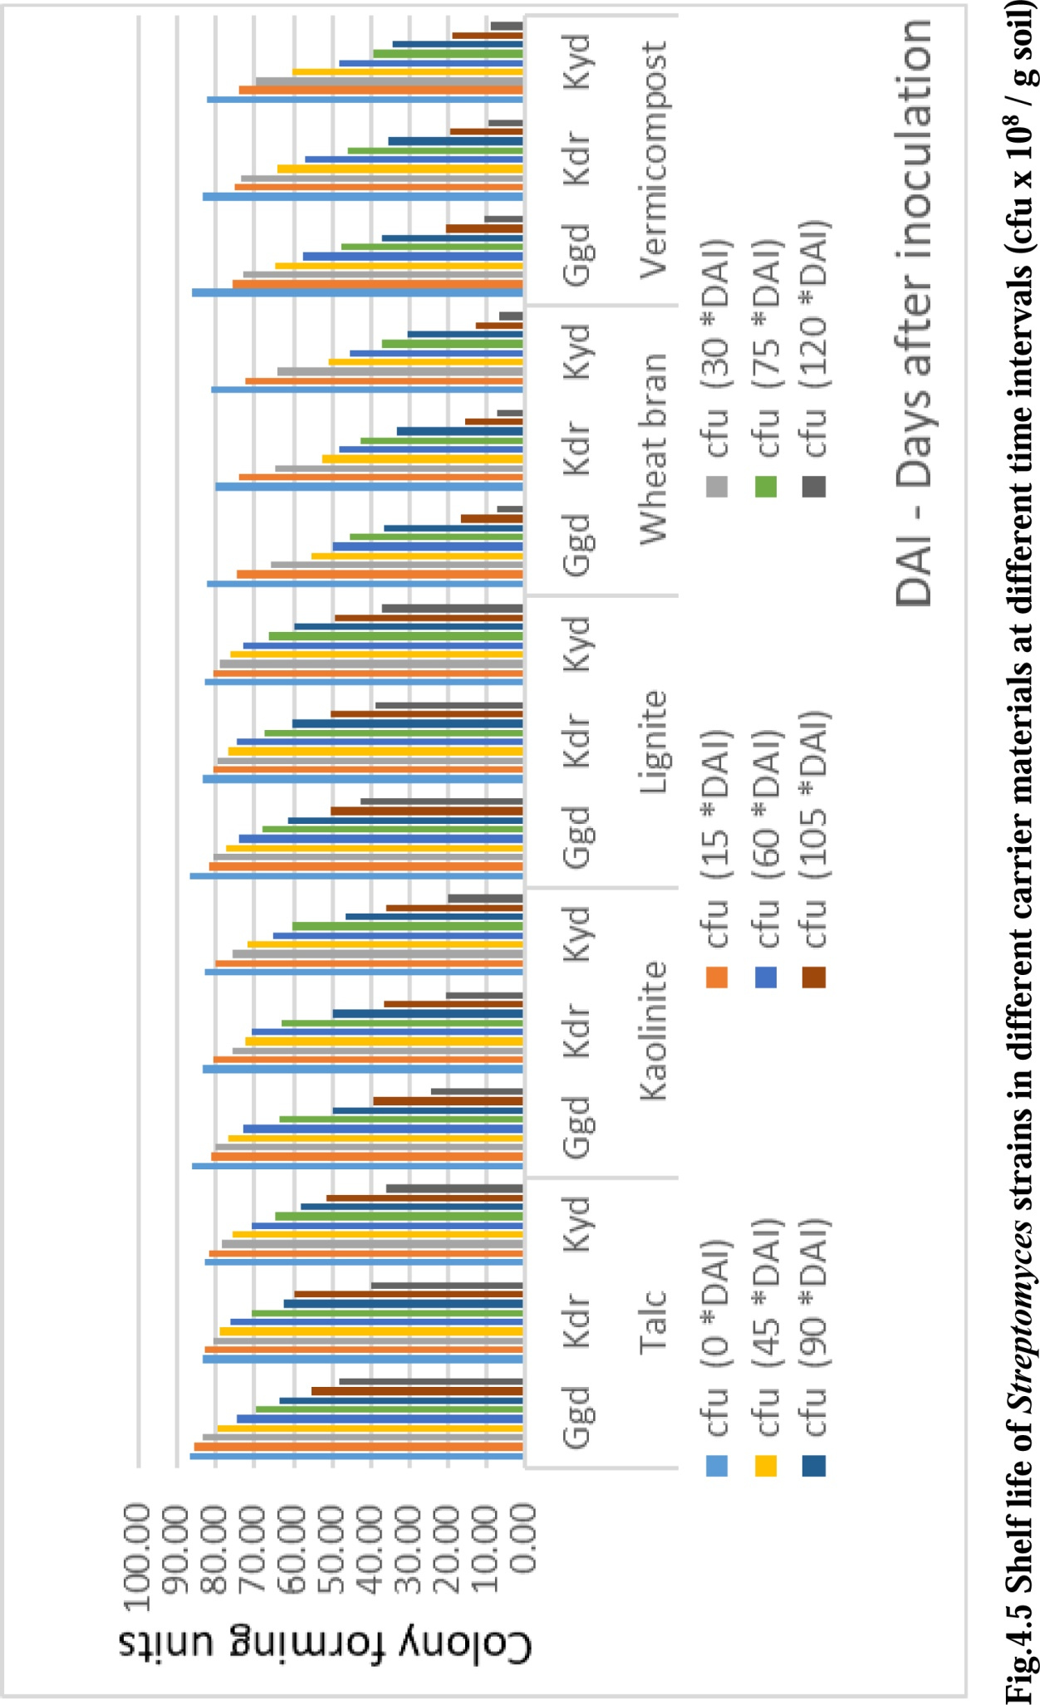

**Fig 2. Shelf life of *Streptomyces* isolates on different carrier material in different intervals**

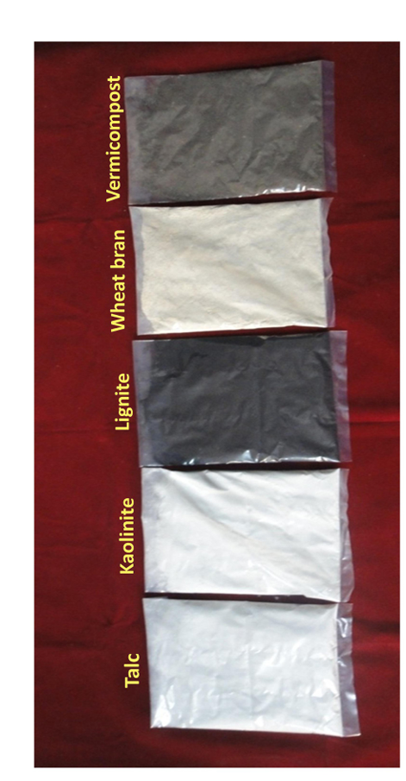

**Plate 1. Bioformulation of Streptomyces isolate Ggd on different carriers**

**DISCLAIMER**  (ARTIFICIAL INTELLIGENCE) Author(s) hereby declare that NO generative AI technologies such as Large Language Models (ChatGPT, COPILOT, etc.) and text-to-image generators have been used during the writing or editing of this manuscript.

**COMPETING INTERESTS** Authors have declared that no competing interests exist.

**References**

Anitha, A and Rabeeth, M. 2009. Control of *Fusarium* wilt of tomato by bioformulation of *Streptomyces griseus* in greenhouse condition. *African Journal of Basic and Applied Sciences*.1(2): 9-14.

Deivamani, M and Muthamilan, M. 2016. Studies on shelf life of *Streptomyces* spp. in different carrier materials. *International Journal of Processing and Post Harvest Technology*. 7(1): 16-20.

Dubey, S.C and Patel, B. 2001. Evaluation of fungal antagonists against *Thanetophorus cucumeris* causing web blight of urd and mung bean. *Indian Phytopathology*. 54(2): 206-209.

Gopalakrishnan S, Srinivas V, Naresh N, Pratyusha S, Ankati S, Madhuprakash J, Govindaraj M, Sharma R. Deciphering the antagonistic effect of Streptomyces spp. and host-plant resistance induction against charcoal rot of sorghum. Planta. 2021 Feb;253:1-2

Harikrishnan, H., Shanmugaiah, V., Balasubramanian, N., Sharma, M.P and Kotchoni, S.O. 2014. Antagonistic potential of native strain *Streptomyces aurantiogriseus*VSMGT1014 against sheath blight of rice disease. *World Journal of Microbiology and Biotechnology*. 30: 3149–3161.

Jebaraj, M.D., Aiyanathan, K.E.A and Nakkeeran, S. 2017b. Molecular characterization of S*clerotium rolfsii* sacc. isolates and development of bioformulation of antagonists for the management of stem rot disease of groundnut. Ph.D Thesis. Tamil Nadu Agricultural University, Coimbatore, India.

Kalra, A., Chandra, M and Khanuja, S.P.S. 2008. A novel vermicompost based formulation for bioinoculants with added plant and microbial growth promoting natural products. In: Fuchs, J.G., Kupper, T., Tamm. L., Schenk. K, editors. *Proceedings of the international congress on compost and digestate: sustainability, benefits, impacts for the environment and for plant production.* Ackerstrasse, Frick: Research Institute of Organic Agriculture FiBL. 193-194.

Mahadevan, B and Crawford, D.L. 1997. Properties of the chitinase of the antifungal biocontrol agent *Streptomyces lydicus*WYEC108. *Enzyme and Microbial Technology*. 20: 489-493.

Martinez-Alvarez, J.C., Castro-Martiez, C., Sanchez-Pena, P., Gutierrez-Dorado, R and Maldonado-Mendoza, I.E. 2016. Development of a powder formulation based on *Bacillus cereus* sensu lato strain B25 spores for biological control of *Fusarium verticillioides* in maize plants. *World Journal of Microbiology and Biotechnology*. doi:10.1007/s11274-015-2000-5.

Prasad, R.D and Rangeshwaran, R. 2000. Shelf life and control of *Sclerotium rolfsii* by *Trichoderma* formulated in various carrier materials. *Plant Management*. 32: 215-220.

Sabaratnam, S and Traquair, J.A., 2002. Formulation of a *Streptomyces* biocontrol agent for the suppression of *Rhizoctonia* damping-off in tomato transplants. *BioControl*. 23: 245–253.

Shen, Z., Xue, C., Penton, C.R., Thomashow, L.S., Zhang, N., Wang, B., Ruan, Y., Li, R and Shen, Q. 2019. Suppression of banana Panama disease induced by soil microbiome reconstruction through an integrated agricultural strategy. *Soil Biology and Biochemistry.* 128, 164–174.

Tahvonen, R and Avikainen, H. 1987. The biological control of seed-borne *Alternaria brassicicola* of cruciferous plants with a powdery preparation of *Streptomyces* sp. *Journal of Agricultural Science.* 59: 199-208.

Tamreihao, K., Ningthoujam, D. S., Nimaichand, S., Singh, E. S., Reena, P., Singh, S. H and Nongthomba, U. 2016. Biocontrol and plant growth promoting activities of a *Streptomyces corchorusii* strain UCR3-16 and preparation of powder formulation for application as biofertilizer agents for rice plant. *Microbiological Research.*192: 260–270.

Valois, D., Fayad, K., Barasubiye, T., Gagnon, M., Déry, C., Brzezinski, R and Beaulieu C. 1996. Glucanolytic actinomycetes antagonistic to *Phytophtora fragariae* var. *rubi*, the causal agent of raspberry root rot. *Applied Enviromental Microbiology.* 62: 1630-1635.

Zhu, Z., Zhang, G.Y., Luo,Y., Ran,W and Shen, Q.R. 2012. Production of lipopeptides by *Bacillus amyloliquefaciens* XZ-173 in solid state fermentation using soybean fluor and rice straw as the substrate. *Bioresource Technology*. 112: 54-260.