From Bench to Bedside: Medicinal Chemistry Strategies in the Development of Kinase Inhibitors for Cancer Therapy

.
ABSTRACT
Cancer, a multifaceted clinical challenge, is driven by dysregulation of protein kinases—key regulators of critical cellular function. The introduction of kinase inhibitors has transformed targeted cancer therapy, ushering in a change from traditional chemotherapy to precision oncology. These small-molecule therapies work by specifically blocking oncogenic kinases, interrupting aberrant signaling pathways that drive tumor growth. With nearly 70 kinase inhibitors licensed for clinical use, their creation is a success of translational science, fueled by breakthroughs in medicinal chemistry. This study is aimed at examining the critical role of medicinal chemistry in closing the gap between molecular target identification and clinically effective kinase inhibitors. The focus is on key design ideas, such as binding mode optimization, structure-based drug design, and strategies for enhancing selectivity and pharmacokinetics. Key developments like covalent inhibition, allosteric targeting, and prodrug methods are reviewed in terms of overcoming treatment resistance and increasing clinical efficacy. We demonstrate the evolution of kinase inhibitor design in response to clinical difficulties such as resistance driven by gatekeeper and bypass mutations and gene amplification of target kinases. Using extensive case studies of imatinib, osimertinib, vemurafenib, lorlatinib, and upcoming treatments. The review also discusses emerging trends in the field, such as the use of artificial intelligence, novel pharmacological modalities, and molecular-based individualized medicine. In conclusion, the success of kinase inhibitors demonstrates the revolutionary power of medicinal chemistry in specific/target based chemotherapeutic interventions and the ongoing need for innovation to address changing treatment environments.

Keywords: Protein kinases, Phosphorylation, Signal transduction pathways, Kinase inhibitors, Cancer therapeutics, Targeted therapy, Oncogenic signaling, Drug resistance mechanisms

1. INTRODUCTION

Cancer remains one of the major causes of death globally, characterized by dysregulation in cell growth and the evasion of regulatory mechanisms responsible for maintaining cellular homeostasis (1). In the face of remarkable advancements in cancer chemotherapy, radiotherapy, and, in recent times, target-specific treatment approaches like immunotherapy and precision medicine, significant hindrances like therapeutic resistance, toxicity, and limited specificity are still prevalent. Notably, the last 20 years have marked a paradigm shift in the field of cancer therapy, characterized by the emergence of molecularly targeted agents that offer more specific and effective treatment options. Kinase inhibitors have become fundamental in cancer treatment since they can particularly disturb dysregulated signaling pathways promoting carcinogenesis (2, 3).
Protein kinases are enzymes that change important biological processes by means of target protein phosphorylation. Aberrant kinase activity—caused by mutations, overexpression, or chromosomal rearrangements—can lead to constant proliferative signaling, apoptosis resistance, and higher metastatic capability (4). Given that the US Food and Drug Administration (FDA) has approved over 70 small-molecule kinase inhibitors, kinases are quite interesting pharmacological targets (5). However, the development of these medications is still met with numerous challenges, including achieving selectivity within the highly conserved kinase family, managing acquired resistance, and enhancing pharmacokinetic features.
Medicinal chemistry is crucial for turning biological knowledge into therapeutically effective kinase inhibitors. Medicinal chemists have built diverse libraries composed of compounds with tailored binding modes, better selectivity profiles, and desirable drug-like properties by means of successive cycles of structure-activity relationship (SAR) research, rational design, and optimization. The transition from first-generation broad-spectrum inhibitors to next-generation, mutation-specific medicines demonstrates the expertise and importance of current medicinal chemistry in oncology (6).
This study offers a detailed summary of the medicinal chemistry techniques applied in the development of kinase inhibitors for cancer therapy. It investigates the structural foundations of kinase targeting, fundamental design concepts, techniques to fight resistance, and the pharmacological optimization of prospective therapies. It also discusses changing trends and challenges affecting the future of kinase inhibitor development as well as historical case studies demonstrating successful transition from lab to clinical application. Furthermore, it provides historical case studies demonstrating successful transfer from laboratory to clinical application, along with changing trends and challenges affecting the future of kinase inhibitor development.
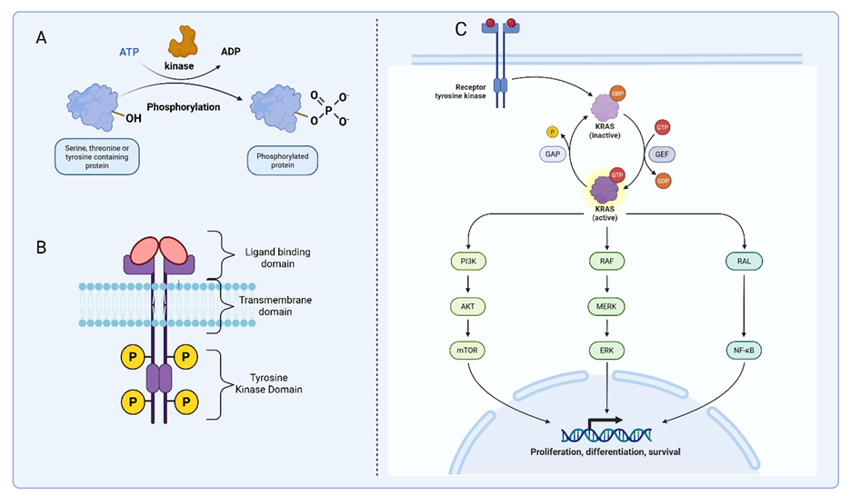
Figure 1: Overview of Kinase-Mediated Signaling Pathways in Cancer Progression
(A) General mechanism of kinase-mediated phosphorylation. Protein kinases catalyze the transfer of a phosphate group from adenosine triphosphate (ATP) to hydroxyl groups of serine, threonine, or tyrosine residues on target proteins. This post-translational modification induces conformational changes that regulate protein activity, localization, and interactions, forming the basis of intracellular signaling cascades. (B) Schematic representation of receptor tyrosine kinases (RTKs), a major class of transmembrane kinases. RTKs possess an extracellular ligand-binding domain, a single transmembrane domain, and an intracellular tyrosine kinase domain. Ligand binding induces dimerization and autophosphorylation of tyrosine residues, triggering downstream signaling. (C) RTK-activated downstream signaling pathways relevant to cancer. Upon activation, RTKs stimulate key oncogenic cascades, including the Phosphatidylinositol 3-Kinase / Protein Kinase B (AKT) / Mechanistic Target of Rapamycin (PI3K/AKT/mTOR) pathway (promoting cell survival and metabolism), the Rat Sarcoma Virus Oncogene / Rapidly Accelerated Fibrosarcoma / Mitogen-Activated Protein Kinase Kinase / Extracellular Signal-Regulated Kinase (RAS/RAF/MEK/ERK) pathway (driving proliferation and differentiation), and the RAS-Like Proto-Oncogene / Nuclear Factor kappa-light-chain-enhancer of activated B cells (RAL/NF-κB) axis (associated with inflammation and transcriptional regulation). KRAS (Kirsten Rat Sarcoma viral oncogene homolog) acts as a critical molecular switch, cycling between inactive GDP-bound (guanosine diphosphate-bound) and active GTP-bound (guanosine triphosphate-bound) forms, regulated by GEFs (guanine nucleotide exchange factors) and GAPs (GTPase-activating proteins). These pathways collectively contribute to hallmark cancer processes including proliferation, survival, and resistance to apoptosis.

2. Kinases as Drug Targets in Cancer
2.1. Kinase Structure and Function
Protein kinases are a broad class of enzymes that transfer phosphate groups from ATP to specific amino acid residues on substrate proteins, most commonly serine, threonine, or tyrosine (4). Among the many cellular functions this phosphorylation pathway governs are proliferation, differentiation, metabolism, and apoptosis (7,8). The fundamental structure of a kinase is a bilobed domain in which the smaller N-terminal lobe contains ATP and the larger C-terminal lobe interacts with substrate protein. The ATP-binding pocket between these lobes is a critical site for inhibitor interaction; small-molecule drug research has primarily concentrated on this (8). Kinases are classified as serine/threonine kinases or tyrosine kinases depending on the exact residue they phosphorylate. Tyrosine kinases—both receptor and non-receptor types—are crucial in cancer biology since they have great influence in signaling pathways including EGFR (Epidermal Growth Factor Receptor), ALK (Anaplastic Lymphoma Kinase), and BCR-ABL (Breakpoint Cluster Region–Abelson Murine Leukemia Viral Oncogene Fusion Protein). Carcinogenic processes are fundamentally dependent on serine/threonine kinases such as BRAF (v-Raf Murine Sarcoma Viral Oncogene Homolog B1) and AKT (Protein Kinase B) (9,10).
2.2. Kinase Dysregulation in Cancer
Many cancers exhibit unusual kinase activity resulting from various genetic and epigenetic modifications (11). As shown by BRAF-V600E in melanoma and EGFR-L858R in non-small cell lung cancer (12,13), mutations inside the kinase domain can lead to ongoing activation. In breast cancer, amplifications of Human Epidermal growth factor Receptor 2 (HER2) boost kinase expression and signaling output (14). Exemplified by BCR-ABL in chronic myeloid leukaemia (CML), chromosomal translocations create fusion proteins with altered or new kinase activity (15). These dysregulations compromise normal cellular regulatory systems, hence allowing uncontrolled growth, angiogenesis, metastasis, and anti-apoptosis (16). Understanding these changes has led to the identification of kinases as biomarkers and therapeutic targets, ushering in the era of precision oncology.
2.3. Targeting Kinases
Rationale
The several benefits of kinases as therapeutic targets clarify how well kinase inhibitors work in cancer therapy. Their precisely defined ATP-binding sites provide a chemically accessible but structurally stable environment for small-molecule interaction (17). Often functioning as driving mutations, dysregulated kinases imply that their inhibition can particularly target cancer cells while preserving normal tissue. Prognostic biomarkers—including specific kinase mutations—help to stratify patients and direct customized treatment by their presence (4, 18). Furthermore, kinase inhibitors have shown tolerable safety profiles and quick clinical efficacy (19), confirming kinases as promising therapeutic targets. Consequently, kinase-targeted pharmacological research remains at the cutting edge of precision oncology.

Research Gaps
While kinase-targeted therapies have revolutionized oncology, persistent research gaps continue to limit their full potential. One critical challenge lies in the incomplete understanding of kinase network dynamics and pathway crosstalk. Inhibiting a single kinase often triggers compensatory activation of parallel pathways, leading to transient responses and early resistance (20). Although systems biology offers network-level insights, its integration into drug development remains insufficient.
Another major hurdle is achieving target selectivity. Despite advances in medicinal chemistry, the high conservation of ATP-binding domains across kinases still predisposes to off-target effects and toxicity (21). Isoform-specific and mutant-selective inhibitors are rare, leaving room for resistance and treatment failures. Moreover, managing brain metastases remains difficult; most kinase inhibitors have poor CNS penetration due to the blood-brain barrier and efflux transporters, even with newer agents like lorlatinib showing only partial success (22).
Resistance mechanisms continue to evolve faster than therapeutic strategies. While next-generation inhibitors have been developed to overcome specific resistance mutations, tumors frequently bypass these by acquiring secondary mutations or activating alternative pathways (23). Current drug design remains reactive, emphasizing the urgent need for predictive models that can forecast resistance trajectories during early drug discovery.
Additionally, ATP-competitive inhibitors dominate the field, but their vulnerability to resistance mutations and selectivity issues necessitates broader exploration of allosteric modulators and protein-protein interaction disruptors (24). Personalized kinase therapy, although aided by biomarkers, still struggles with real-time adaptation based on evolving tumor genomics. Emerging modalities like PROTACs offer promise for degrading mutant kinases but are challenged by cell permeability, degradation pathway complexity, and off-target risks. Sustained progress in kinase therapeutics will require a multidisciplinary effort combining structural biology, translational science, systems pharmacology, and rational drug design.

3. Medicinal Chemistry Principles in Kinase Inhibitor Design
3.1. Binding Modes of Kinase Inhibitors: Mechanistic Insights and Evolutionary Trends
Table 1: Kinase inhibitors are classified by their interaction with ATP-binding sites and allosteric regions, with each category offering distinct advantages and limitations:

Inhibitor Type | Binding Conformation | Key Features | Clinical Example | Selectivity Rationale
Type I | Active (DFG-in) | ATP-competitive; hinge region H-bonds | Imatinib (BCR-ABL) | Limited by conserved ATP-pocket residues
Type II | Inactive (DFG-out) | Exploits hydrophobic back pocket | Sorafenib (RAF) | Targets DFG-out-specific interactions
Type III | Allosteric | Non-ATP-competitive; induces conformational changes | Trametinib (MEK) | Leverages unique allosteric pockets
Type IV | Covalent | Irreversible cysteine binding | Osimertinib (EGFR) | Combines covalent engagement with ATP-pocket specificity
Critical Enhancements:
- Type I/II Selectivity: Type II inhibitors exhibit superior selectivity due to interactions with the DFG-out conformation’s unique hydrogen-bond network (e.g., sorafenib forms 4–6 H-bonds vs. 1–3 in type I). However, their development is complicated by kinase plasticity; for example, 40% of kinases lack a stable DFG-out state.
- Allosteric Inhibitors (Type III): Recent bivalent inhibitors like compound 2 (EGFR) demonstrate 10⁶-fold potency over monovalent analogs by simultaneously occupying ATP and allosteric sites, achieving ΔΔG = −9.5 kcal/mol through optimized van der Waals and H-bond networks. Structural mobility of the linker (e.g., C-C bond rotation in 2) enables full displacement of high-energy water molecules, enhancing binding complementarity.
- Covalent Inhibitors (Type IV): Eight FDA-approved covalent kinase inhibitors target cysteine residues (e.g., afatinib’s Michael acceptor warhead). Emerging strategies now explore reversible covalent binding to lysine (e.g., KD-246) and aspartate residues, reducing off-target risks while maintaining sub-nM potency

3.2. Pharmacophore Identification and Optimization: Quantitative Frameworks
Pharmacophore development integrates structural and chemical features critical for kinase engagement:
Core Scaffold Optimization:
- VEGFR-2 Inhibitors: Require two H-bond donors (Glu915, Cys917), one acceptor (Asn921), and two hydrophobic groups for nanomolar activity.
- JAK2/3 Models: JAK2 pharmacophore (ADRR: 1 acceptor, 1 donor, 2 aromatic rings) vs. JAK3 (ADDRR) achieves 50-fold selectivity via aromatic feature positioning.
Structure-Activity Relationship (SAR):
- Hydrophobic Back Pocket Engineering: Lorlatinib’s chloro-difluorophenyl group reduces ALK WT binding by 100-fold compared to ROS1, exploiting ROS1’s larger back pocket (volume: 285 Å<sup>3</sup> vs. 198 Å<sup>3</sup>).
- Solubility-Lipophilicity Balance: Crizotinib’s logP reduction from 4.2 (early analogs) to 2.9 improved bioavailability while maintaining 0.4 nM IC<sub>50</sub> against MET.
Challenges in Selectivity:
- Kinase Polypharmacology: Midostaurin inhibits 94 kinases at 1 μM due to conserved H-bond patterns. Scaffold rigidification (e.g., gilteritinib’s macrocycle) reduced off-targets to 12 kinases while retaining FLT3 IC<sub>50</sub> = 0.29 nM.

3.3. Structure-Based Drug Design (SBDD): Bridging Computation and Experiment
Structure-Based Drug Design (SBDD) Structure-based drug design has changed kinase inhibitor discovery by merging high-resolution structural data with medicinal chemistry methods. X-ray crystallography offers atomic-level images of inhibitor-kinase interactions, therefore facilitating rational design and scaffold modification. Dynamic simulations and molecular docking forecast binding energies and conformations, therefore facilitating the discovery of attractive candidates. Scaffold hopping is a strategy that maintains pharmacophoric components even when the central structure changes, therefore allowing the discovery of novel chemical domains while preserving biological activity. Data on SAR and SBDD assist in precisely optimizing drug-like characteristics and have facilitated the transfer of inhibitors from the lab to the clinical candidate stage (30).

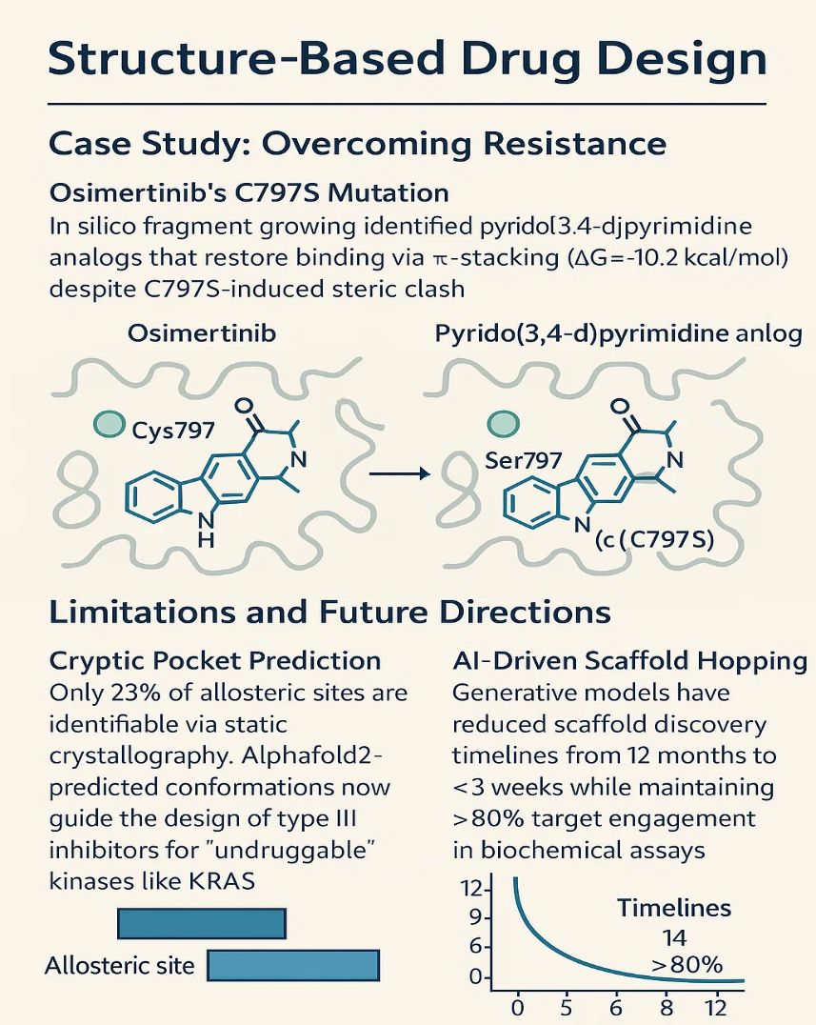

Figure 2: Structure-based drug design case study of overcoming osimertinib’s resistance and the application of medicinal chemistry strategies (C797S: a specific mutation where the cysteine (C) at position 797 in a protein, often the EGFR (epidermal growth factor receptor), is replaced by serine (S), commonly leading to resistance against certain targeted cancer therapies like tyrosine kinase inhibitors; KRAS: Kirsten Rat Sarcoma viral oncogene homolog)

4. Key Medicinal Chemistry Strategies
4.1. Enhancing Selectivity
The outstanding conservation of the ATP-binding site throughout the kinome presents a substantial challenge in the development of tailored kinase inhibitors. Using the specific structural states of individual kinases is one of the most effective strategies to enhance selectivity. For instance, type II inhibitors attach to the DFG-out inactive conformation, a characteristic does not present in all kinases.

Table 2: Overview of Cancer-Targeted Kinase Inhibitors Approved by the FDA (2005–2025): Structural and Mechanistic Classificationª
Year | Drug Name | Chemical Scaffold | Target Kinase(s) | Primary Indication(s)
2005 | Sorafenib | Diaryl urea | RAF, VEGFR, PDGFR | Renal cell carcinoma (RCC)
2006 | Sunitinib | Indolinone | VEGFR, PDGFR, KIT | RCC, Gastrointestinal stromal tumor (GIST)
2006 | Dasatinib | Thiazole | BCR-ABL, SRC family kinases | Chronic myeloid leukemia (CML)
2007 | Lapatinib | Quinazoline | EGFR, HER2 | HER2-positive breast cancer
2007 | Nilotinib | Aminopyrimidine | BCR-ABL | CML
2009 | Pazopanib | Indazolylpyrimidine | VEGFR, PDGFR | RCC
2011 | Crizotinib | Aminopyridine | ALK, ROS1 | Non-small cell lung cancer (NSCLC)
2011 | Vemurafenib | Aryl sulfonamide | BRAF V600E | Melanoma
2012 | Axitinib | Indazole | VEGFR1-3 | RCC
2012 | Bosutinib | Quinoline | BCR-ABL, SRC family kinases | CML
2012 | Cabozantinib | Pyrazolylpyridine | MET, VEGFR2 | Medullary thyroid cancer
2012 | Regorafenib | Diaryl urea | VEGFR, PDGFR, KIT | Colorectal cancer (CRC)
2013 | Ponatinib | Imidazopyridazine | BCR-ABL (T315I mutation) | CML
2014 | Ceritinib | Pyrazolylpyrimidine | ALK | NSCLC
2015 | Osimertinib | Pyrimidine | EGFR^{T790M} | NSCLC
2016 | Alectinib | Indazole | ALK | NSCLC
2017 | Brigatinib | Phosphine oxide | ALK, ROS1 | NSCLC
2017 | Midostaurin | Staurosporine derivative | FLT3 | Acute myeloid leukemia (AML)
2018 | Gilteritinib | Aminopyrazine | FLT3 | AML
2018 | Dacomitinib | Quinazoline | EGFR | NSCLC
2018 | Lorlatinib | Macrocyclic | ALK, ROS1 | NSCLC
2018 | Binimetinib | Triazine | MEK1/2 | Melanoma (in combination)
2018 | Encorafenib | Aryl sulfonamide | BRAF | Melanoma (in combination)
2018 | Larotrectinib | Oxindole | TRK (NTRK1/2/3) | NTRK fusion-positive solid tumors
2019 | Entrectinib | Indazole | TRK, ROS1, ALK | NTRK fusion-positive solid tumors, ROS1-positive NSCLC
2019 | Erdafitinib | Quinazoline | FGFR1-4 | Urothelial carcinoma
2019 | Pexidartinib | Pyrrolopyridine | CSF1R | Tenosynovial giant cell tumor (TGCT)
2019 | Alpelisib | Pyrimidine | PI3Kα | HR+/HER2- breast cancer
2020 | Capmatinib | Triazolopyridazine | MET | NSCLC (MET exon 14 skipping)
2020 | Selpercatinib | Pyrazolopyridine | RET | RET fusion-positive cancers
2020 | Pralsetinib | Pyrazolopyrimidine | RET | RET fusion-positive cancers
2020 | Tucatinib | Quinazoline | HER2 | HER2-positive breast cancer
2020 | Pemigatinib | Pyrrolopyridine | FGFR1-3 | Cholangiocarcinoma
2020 | Avapritinib | Indazole | PDGFRA, KIT | GIST
2020 | Ripretinib | Indolinone | KIT, PDGFRA | GIST
2020 | Selumetinib | Triazine | MEK1/2 | Neurofibromatosis type 1
2021 | Mobocertinib | Pyrimidine | EGFR exon 20 insertions | NSCLC
2021 | Amivantamab | Bispecific antibody | EGFR, MET | NSCLC
2021 | Asciminib | Allosteric inhibitor | BCR-ABL (myristoyl pocket) | CML
2021 | Infigratinib | Pyrazolopyrimidine | FGFR1-3 | Cholangiocarcinoma
2021 | Tepotinib | Triazolopyridazine | MET | NSCLC
2022 | Futibatinib | Pyrimidine | FGFR1-4 | Cholangiocarcinoma
2023 | Capivasertib | Pyrrolopyrimidine | AKT1-3 | Breast cancer
2023 | Pirtobrutinib | Pyrazolopyrimidine | BTK | Mantle cell lymphoma
2023 | Repotrectinib | Macrocyclic | TRK, ROS1, ALK | NTRK/ROS1 fusion-positive cancers
2025 | Vimseltinib | Pyrimidinone | CSF1R | TGCT

ªALK, Anaplastic Lymphoma Kinase; AML, Acute Myeloid Leukemia; BCR-ABL, Breakpoint Cluster Region–Abelson Tyrosine Kinase Fusion; BTK, Bruton's Tyrosine Kinase; CRC, Colorectal Cancer; CSF1R, Colony Stimulating Factor 1 Receptor; EGFR, Epidermal Growth Factor Receptor; ERBB2/HER2, Human Epidermal Growth Factor Receptor 2; FGFR, Fibroblast Growth Factor Receptor; FLT3, Fms-like Tyrosine Kinase 3; GIST, Gastrointestinal Stromal Tumor; HR+, Hormone Receptor Positive; KIT, Stem Cell Factor Receptor (CD117); MET, Mesenchymal-Epithelial Transition Factor; NTRK, Neurotrophic Tyrosine Receptor Kinase; NSCLC, Non-Small Cell Lung Cancer; PDGFR, Platelet-Derived Growth Factor Receptor; PI3K, Phosphoinositide 3-Kinase; RET, REarranged during Transfection; RCC, Renal Cell Carcinoma; ROS1, c-ros Oncogene 1, Receptor Tyrosine Kinase; SRC, Proto-Oncogene Tyrosine-Protein Kinase Src; TGCT, Tenosynovial Giant Cell Tumor; TRK, Tropomyosin Receptor Kinase; VEGFR, Vascular Endothelial Growth Factor Receptor.

This conformational trapping allows us to selectively inhibit kinases that are inclined to adopt such states (31).
The second approach is to stress allosteric regions, which exhibit greater variation than the ATP-binding pocket. Allosteric inhibitors—including those attaching to the myristoyl pocket in ABL or the hydrophobic back pocket in MEK—modulate kinase activity without directly opposing ATP. Often displaying better selectivity, these inhibitors can prevent resistance mutations affecting the ATP site. Irreversible inhibition could raise selectivity if meant to target nucleophilic residues peculiar to a kinase's active region. Covalent EGFR and BTK inhibitors target cysteine residues typically absent at equivalent locations in other kinases (32). Moreover, kinome-wide selectivity profiling by biochemical or cellular testing helps to uncover off-target interactions early, thereby guiding iterative modification to lower promiscuity and enhance therapeutic windows (33).
4.2. Improving Pharmacokinetics and Drug-Likeness
Medicinal chemistry initiatives are required to consider the pharmacokinetic (PK) profile of kinase inhibitors to ensure adequate absorption, distribution, metabolism, and excretion. Water solubility and lipophilicity (logP) are two traits that directly affect oral bioavailability. Although excessive lipophilicity could increase permeability, it also leads to poor solubility and rapid metabolic clearance. Thus, it is vital to balance these traits by altering molecular weight, hydrogen bond donors/acceptors, and polar surface area (34). Metabolic stability is a key issue since fast hepatic metabolism through cytochrome P450 enzymes could reduce systemic exposure. Half-life can be increased by structural alterations such as the addition of deuterium atoms or the removal of metabolically labile groups. Sometimes, prodrug strategies are employed to enhance solubility or permeability by enzymatic cleavage, converting inert precursors into active medicines in vivo. Moreover, especially for lipophilic kinase inhibitors, formulation methods such as dispersions, salt selection, and nanoparticle encapsulation could enhance distribution and address bioavailability concerns related to solubility (35).
4.3. Overcoming Resistance
The evolution of acquired resistance often impairs the efficacy of treatment. Gatekeeper mutations are a type of resistance mechanism that prevents binding of inhibitors. A well-studied example is the T315I mutation in BCR-ABL, which interferes with the binding of first- and second-generation inhibitors such as imatinib and dasatinib. Similarly, the T790M mutation in EGFR makes it resistant to early-generation EGFR inhibitors. As a result, next-generation inhibitors have been designed to demonstrate increased affinity and structural compatibility for mutant kinases. Osimertinib was designed to bind irreversibly to an adjacent cysteine residue via a covalent warhead, thereby specifically targeting EGFR^{T790M}. Often, these inhibitors demonstrate better binding geometries and higher metabolic stability to stay effective against resistant tumors (36).
Furthermore, mutation-specific design is a novel technique that customizes inhibitors to the structural environment of resistance-related mutations. To inform rational medication design, this precision method requires thorough structural and computational investigation, as well as patient-derived mutation profiling. Under certain conditions, combination therapy with inhibitors aimed at concurrent pathways or feedback mechanisms could reduce or lower the development of resistance (37).
4.4. Covalent and Irreversible Inhibitors
Covalent inhibitors have resurfaced in kinase pharmacology as a promising class with possible long-term target engagement and lower dose frequency. Typically, these compounds feature electrophilic warheads like acrylamides that attach inexorably to nucleophilic amino acids such as cysteine in the kinase active site. Covalent methods have been clinically effective in drugs such as ibrutinib (a BTK inhibitor) and osimertinib (an EGFR inhibitor). Although ATP levels are elevated, irreversible binding can provide ongoing inhibition, especially in fast-growing cancer cells (38). However, covalent inhibitors must be meticulously developed. Off-target reactivity can have especially bad effects if the electrophilic group interacts with non-kinase proteins or unrelated cysteines. Thus, warhead reactivity has to be carefully calibrated; its thoroughness should be assessed using proteomic and cellular profiling. Moreover, irreversible inhibitors raise regulatory concerns, as their long stay durations and potential immunogenicity demand comprehensive toxicological investigation. Notwithstanding these constraints, the benefits of covalent targeting—especially enhanced potency, specificity for mutations, and the ability to overcome resistance—make it a preferred strategy in the medicinal chemistry toolkit for the development of kinase inhibitors (29, 38).
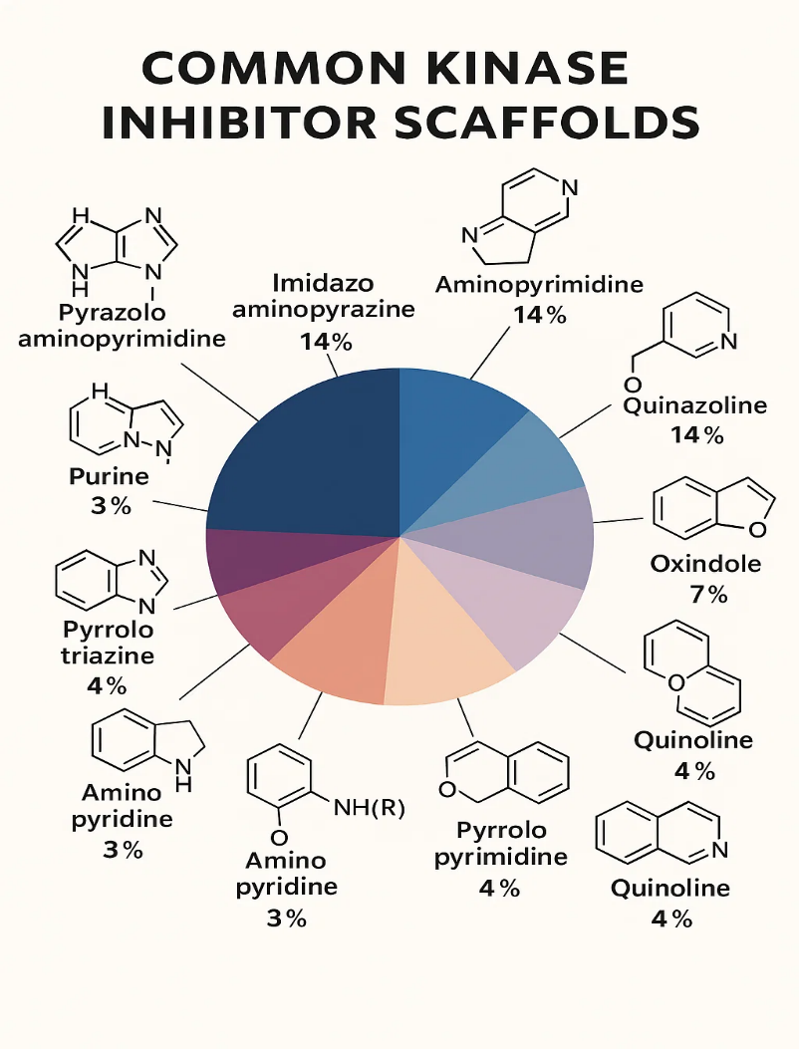
Figure 3: Approved kinase inhibitors' chemical scaffolds: The chemical makeup of the main hinge-binding scaffolds found in kinase inhibitors that have been approved. The architectures of the most often utilized moieties and the distribution of hinge-binding scaffolds for all ATP mimetic inhibitors (center) are displayed. Each chemotype has been numbered and colored to correspond to the central pie chart, and the number of approved medications that use each major scaffold is given in brackets. Red arrows show donors and acceptors of hydrogen bonds (39)

5. Case Studies of Kinase Inhibitors
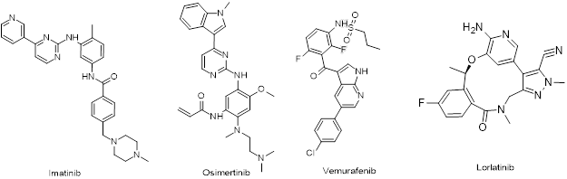
Figure 4: Structures of some selected kinase inhibitors

5.1. Imatinib (Gleevec) – The Pioneer
Imatinib mesylate (Gleevec), discovered in the late 1990s, was the first effective instance of a rationally designed small-molecule kinase inhibitor, therefore revolutionizing cancer treatment. It targets the BCR-ABL fusion protein, a constitutively active tyrosine kinase generated by the Philadelphia chromosomal translocation in chronic myeloid leukaemia (CML). Research on the molecular etiology of chronic myeloid leukaemia (CML) led to the discovery of imatinib (40). High-throughput screening and structure-activity relationship (SAR) studies produced a 2-phenylaminopyrimidine scaffold demonstrating significant ABL inhibition. By maintaining the inactive conformd of ation of the ABL kinase domain, imatinib stops the carcinogenic signaling cascade. Approved in 2001, imatinib changed CML treatment from a fatal disease to a manageable one (41). The information gained from imatinib emphasized the significance of targeting disease-specific kinases, ensuring selectivity to minimize off-target effects, and including structural biology into logical drug design. It laid the groundwork for the kinase inhibitor era, which finally produced multiple concentrated therapies. Resistance is mainly due to BCR-ABL kinase domain mutations, especially the T315I gatekeeper mutation, which blocks imatinib binding, or by overexpression of drug efflux pumps (like ABCB1) reducing intracellular drug levels (41).

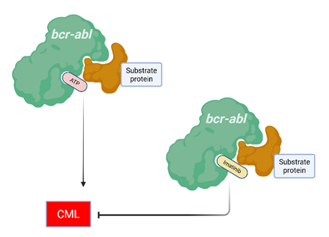
Figure 5: Mechanism of action of Imatinib: Imatinib binds to ATP binding site on BCR-ABL protein to halt phosphorylation at tyrosine residue and inhibit

5.2. Osimertinib – Targeting EGFR T790M
As a third-generation kinase inhibitor, osimertinib (Tagrisso) was discovered to address acquired resistance. Specifically, it targets the epidermal growth factor receptor (EGFR) containing the T790M mutation, a common resistance mechanism in non-small cell lung cancer (NSCLC) treated with first-generation EGFR inhibitors like gefitinib and erlotinib. Osimertinib was designed to respond to the rising resistance developed using other kinase inhibitors. The T790M mutation increases ATP affinity and decreases binding of inhibitors. Osimertinib has a covalent warhead that permanently attaches to cysteine-797 in the ATP-binding area of mutant EGFR, including T790M, virtually silencing wild-type EGFR. This selectivity lessens undesirable effects such diarrhea and erythema (42). Osimertinib's architecture has also evolved to allow it to traverse the central nervous system (CNS), which is vital for treating brain metastases, a frequent issue in EGFR-mutant lung cancers. Osimertinib now dominates treatment for EGFR-mutant NSCLC, therefore stressing the effectiveness of mutation-specific pharmacotherapy and the strategic application of irreversible binding (43). Resistance often arises through secondary mutations like EGFR C797S, which prevents covalent binding to the receptor, or by MET amplification and HER2 amplification, which activate bypass signaling independent of EGFR.

5.3. Vemurafenib – BRAF Inhibitor
Vemurafenib (Zelboraf), developed specifically to target the BRAF^{V600E} mutation driving melanoma and other cancers, induces uncontrolled growth by continually stimulating the MAPK signaling pathway. By preferentially targeting the mutant version of BRAF and sparing wild-type BRAF, vemurafenib clinically considerably lowers tumors (44). Unexpected challenges, though, hindered its development. A major consequence of paradoxical activation was Vemurafenib's ability to activate the MAPK pathway by raising RAF dimerization in wild-type BRAF and mutant RAS cells, hence promoting secondary malignancies including cutaneous squamous cell carcinoma (45) Resistance develops by reactivation of the MAPK pathway via NRAS mutations, BRAF splice variants that dimerize independently of RAS, or upregulation of PDGFRβ signaling to bypass BRAF inhibition. This case study revealed the intricacy of kinase signaling networks and the need for knowledge of downstream effects. Vemurafenib is mutation-specific targeting, but it also highlights the potential downsides of pathway feedback and the inadvertent effects of targeted therapy.
5.4. Lorlatinib – ALK/ROS1 Inhibitor
Lorlatinib (Lorbrena), a third-generation inhibitor, targets resistance mutations in anaplastic lymphoma kinase (ALK) and ROS1-rearranged non-small cell lung cancer (NSCLC) specifically. Carefully crafted to pass the blood-brain barrier, its structure features a macrocyclic core that increases binding affinity and selectivity. Previous ALK inhibitors, such as crizotinib and ceritinib, have low CNS efficacy and were vulnerable to resistance mutations like L1196M and G1202R (46). Specifically designed to maintain efficacy against these mutations, lorlatinib effectively targets CNS metastases, a typical issue in ALK-positive tumors. Although it was successful, lorlatinib brought up concerns about metabolic stability and toxicity, particularly neurocognitive ones. Resistance emerges through compound ALK mutations (e.g., G1202R, L1196M) that sterically hinder lorlatinib binding, or through activation of bypass pathways like KRAS mutations and EGFR activation. These challenges draw attention to the intricate trade-off of efficacy, selectivity, and pharmacokinetic features in the design of kinase inhibitors. Lorlatinib still represents a major development in meeting the unmet needs of individuals with metastatic and resistant disease (47).
5.5. Emerging Inhibitors and Trends
KRAS G12C Inhibitors (e.g., Sotorasib)
KRAS was considered "undruggable" for decades owing to its strong affinity for GTP/GDP and the lack of obvious binding locations. The discovery of a concealed pocket in the KRAS G12C mutant's GDP-bound form was a notable advance. Sotorasib (Lumakras) inactivates KRAS by covalently attaching to cysteine at position 12, using this flaw. Sotorasib, the first KRAS G12C inhibitor to be approved, is a major advance in the battle against RAS-driven malignancies. Already apparent are resistance mechanisms such secondary mutations and system reactivation, which underline the requirement of combination strategies and next-generation inhibitors (48).

PROTACs and Kinase Degraders
Protease-targeting chimeras (PROTACs) are a novel and quickly evolving technique for kinase targeting. Unlike traditional inhibitors, PROTACs destroy the target kinase using the cell's ubiquitin-proteasome pathway. This strategy has many advantages: it can prevent resistance mutations, emphasize non-enzymatic kinase activity, and allow prolonged pathway inhibition. PROTACs for kinases such as BTK (e.g., ARV-471) and BCR-ABL are at varying phases of development (49). Although issues like cell permeability and off-target degradation remain, this strategy represents a paradigm shift in drug development.

EGFR Kinase Inhibitors
Osimertinib: In 2024, the FDA approved osimertinib in combination with platinum-based chemotherapy for patients with locally advanced or metastatic non-small cell lung cancer (NSCLC) harboring EGFR exon 19 deletions or exon 21 L858R mutations. Additionally, it received approval for unresectable stage III NSCLC post-chemoradiation therapy. Resistance mechanisms, notably the C797S mutation, have prompted the development of fourth-generation EGFR inhibitors targeting allosteric sites (50).
Repotrectinib (Augtyro): Approved in November 2023, repotrectinib targets ROS1-positive NSCLC and, as of June 2024, received FDA approval for treating solid tumors with NTRK gene fusions in patients aged 12 and older. Its design addresses resistance mutations and central nervous system involvement (51)

6. Challenges to Kinase Inhibitors
6.1 Resistance and Tumor Heterogeneity
Resistance to kinase inhibitor treatment is a significant challenge often stemming from adaptive processes or tumor heterogeneity. Cancer cells can acquire secondary mutations that change the drug-binding site (e.g., EGFR-T790M, ALK-G1202R), upregulate alternative signaling pathways, or undergo phenotypic transformations such as epithelial-to-mesenchymal transition (EMT). Intratumoral heterogeneity makes treatment more challenging as numerous clones inside the same tumor may respond differently to therapy (50). Combination therapies provide a viable approach to control heterogeneity and resistance. Clinicians want to prevent resistance and improve long-term results by concurrently targeting numerous pathways or processes—such as the combination of kinase inhibitors with immune checkpoint inhibitors or chemotherapy. Rational combination therapies driven by tumor genetics and signaling network analysis are being increasingly assessed in clinical studies (52).

6.2. Balancing Potency, Selectivity, and Safety
A significant challenge in kinase pharmacotherapy research continues to be finding the perfect combination of strength, selectivity, and safety. Strong inhibitors that interact with kinases outside the primary therapeutic target may have significant deleterious consequences such cardiotoxicity, hepatotoxicity, or dermatological issues (53). Predictive toxicology methods help to lower these hazards early in the drug development process. High-throughput profiling with in-silico models, structural biology, and kinase panels allows one to estimate off-target hazards. Clinical trials are also examining dose adjustment and intermittent dosing plans to lower cumulative toxicity while preserving efficacy (54).

6.3. Targeting "Undruggable" Kinases
Structural limitations, absence of catalytic activity, or dependence on protein-protein interactions (PPIs) make many kinases challenging to exploit as therapeutic targets. Allosteric modulators—compounds that bind to sites other than the ATP-binding pocket—offer a means to modulate kinases with more particularity and less deleterious repercussions. Currently running clinical trials are MEK1/2 allosteric inhibitors and SHP2. Including virtual screening, binding affinity prediction, and the enhancement of drug-like qualities, artificial intelligence (AI) and machine learning (ML) are driving lead discovery forward (55). These methods boost the "druggable" kinome by assisting in the discovery of novel scaffolds and exposing unique binding sites.

Conclusion and Future Directions
The progress in kinase inhibitors development have significantly influenced the therapeutic landscape of oncology; by expanding the treatment options, and embodying the translation of molecular understanding into precision medicine. The trajectory from the first-generation ATP-competitive inhibitors to next-generation covalent, allosteric, and mutation-specific agents illustrates the sophistication achieved in medicinal chemistry and drug design. Structural biology, high-throughput screening, and computational modeling have synergistically enabled the rational design of inhibitors with enhanced potency, selectivity, and pharmacokinetic profiles. Moreover, the emergence of therapeutic strategies targeting previously "undruggable" kinases, such as KRAS G12C, underscores the innovative capacity of modern medicinal chemistry to surmount longstanding barriers.
Nevertheless, significant challenges persist. Resistance remains a ubiquitous and dynamic obstacle, driven by secondary mutations, pathway redundancies, tumor heterogeneity, and microenvironmental factors. The complexity of kinase signaling networks, characterized by extensive crosstalk and feedback loops, necessitates approaches that transcend simple target inhibition. Additionally, balancing maximal on-target efficacy while minimizing off-target toxicities demands continued refinement of molecular design principles and therapeutic index optimization. As the therapeutic armamentarium of kinase inhibitors expands, a parallel evolution in biomarker discovery, patient stratification, and adaptive therapeutic strategies becomes indispensable to fully harness their potential.
Ultimately, the future of kinase inhibitor therapy lies in a paradigm shift from static, single-agent intervention toward dynamic, system-informed, and personalized treatment regimens. The confluence of medicinal chemistry, structural biology, systems pharmacology, and artificial intelligence is poised to further accelerate this evolution, anchoring kinase inhibitors as central pillars of next-generation cancer therapeutics.

Future efforts in kinase inhibitor development must prioritize overcoming intrinsic and acquired resistance through multi-pronged strategies. One promising avenue is the rational design of next-generation covalent inhibitors with enhanced mutant selectivity and minimized immunogenicity. Incorporating reversible covalent binding modalities could allow for tunable pharmacodynamics, offering prolonged target engagement with reduced systemic toxicity.
The exploitation of allosteric and cryptic binding sites presents another critical frontier. Structural elucidation of kinase conformational dynamics, especially transient or inducible pockets, may enable the design of highly selective allosteric modulators, thereby minimizing ATP-competitive resistance mechanisms. The development of dual-site binding inhibitors, capable of simultaneously engaging orthosteric and allosteric domains, could confer superior efficacy against highly adaptive tumors.
Furthermore, degrader technologies, notably PROTACs and molecular glues, represent transformative modalities (56). By leveraging the ubiquitin-proteasome system to induce selective kinase degradation, these strategies circumvent classical enzymatic inhibition and offer solutions for non-catalytic oncogenic functions and scaffolding roles of kinases. Future research must address challenges in degrader pharmacokinetics, target selectivity, and tissue-specific delivery to fully realize their clinical utility.
Artificial intelligence (AI)-driven drug discovery is poised to revolutionize kinase inhibitor design. Machine learning algorithms trained on chemogenomic, proteomic, and structural datasets can predict resistance-evasive scaffolds, optimize multi-parametric drug properties, and identify novel kinase targets within the dark kinome (55). The integration of dynamic network modeling will enable real-time adaptation of therapeutic strategies in response to evolving tumor signaling landscapes.
Personalized kinase therapy, informed by comprehensive multi-omics profiling—including genomics, phosphoproteomics, and metabolomics—will become essential. Dynamic biomarker-driven treatment selection and adaptive dosing regimens will replace static treatment paradigms. Liquid biopsy technologies, particularly circulating tumor DNA (ctDNA) analysis, will allow for early detection of resistance mutations and real-time therapeutic modulation (57).
Finally, a deeper mechanistic understanding of kinase signaling plasticity under therapeutic pressure is crucial. Investigations into non-canonical kinase functions, kinase-independent oncogenic activities, and the impact of post-translational modifications on inhibitor susceptibility will expand the therapeutic arsenal. Combination therapies that simultaneously target kinase signaling, epigenetic regulators, and the tumor immune microenvironment will likely be necessary to achieve durable, curative outcomes.
In conclusion, the future of kinase-targeted cancer therapy lies not merely in better inhibitors, but in integrated, adaptable, and patient-centered therapeutic ecosystems, grounded in mechanistic insight, technological innovation, and translational precision.

DISCLAIMER
Authors hereby declare that NO generative AI technologies such as Large Language Models (ChatGPT, COPILOT, etc.) and text-to-image generators have been used during the writing or editing of this manuscript.

References

- WHO. Cancer [Internet]. Newsroom, World Health Organization; 2025 [cited 2025 Apr 16]. Available from: https://www.who.int/news-room/fact-sheets/detail/cancer
- Kumar R, Goel H, Solanki R, Rawat L, Tabasum S, Tanwar P, et al. Recent developments in receptor tyrosine kinase inhibitors: a promising mainstay in targeted cancer therapy. Med Drug Discov. 2024 Sep;23:100195
- Liu B, Zhou H, Tan L, Siu KTH, Guan XY. Exploring treatment options in cancer: tumor treatment strategies. Signal Transduct Target Ther. 2024 Jul 17;9(1):175
- Cipak L. Protein kinases: function, substrates, and implication in diseases. Int J Mol Sci. 2022 Mar 24;23(7):3560
- Latham B, Geffert R, Jackson K. Kinase inhibitors FDA approved 2018–2023: drug targets, metabolic pathways, and drug-induced toxicities. Drug Metab Dispos. 2024 Jun;52(6):479–492
- Satyanarayanajois SD, Hill RA. Medicinal chemistry for 2020. Future Med Chem. 2011 Oct;3(14):1765–1786
- Pang K, Wang W, Qin J, Shi Z, Hao L, Ma Y, et al. Role of protein phosphorylation in cell signaling, disease, and intervention therapy. MedComm. 2022 Dec;3(4):e175
- Arter C, Trask L, Ward S, Yeoh S, Bayliss R. Structural features of the protein kinase domain and targeted binding by small-molecule inhibitors. J Biol Chem. 2022 Aug;298(8):102247
- Eshaq AM, Flanagan TW, Hassan SY, Al Asheikh SA, Al-Amoudi WA, Santourlidis S, et al. Non-receptor tyrosine kinases: their structure and mechanistic role in tumor progression and resistance. Cancers. 2024 Aug 2;16(15):2754
- Ardito F, Giuliani M, Perrone D, Troiano G, Muzio LL. The crucial role of protein phosphorylation in cell signaling and its use as targeted therapy. Int J Mol Med. 2017 Aug;40(2):271–280
- Kanwal R, Gupta S. Epigenetic modifications in cancer. Clin Genet. 2012 Apr;81(4):303–311
- Castellani G, Buccarelli M, Arasi MB, Rossi S, Pisanu ME, Bellenghi M, et al. BRAF mutations in melanoma: biological aspects, therapeutic implications, and circulating biomarkers. Cancers. 2023 Aug 8;15(16):4026
- Harrison PT, Vyse S, Huang PH. Rare epidermal growth factor receptor (EGFR) mutations in non-small cell lung cancer. Semin Cancer Biol. 2020 Apr;61:167–179
- Cheng X. A comprehensive review of HER2 in cancer biology and therapeutics. Genes. 2024 Jul 11;15(7):903
- El-Tanani M, Nsairat H, Matalka II, Lee YF, Rizzo M, Aljabali AA, et al. The impact of the BCR-ABL oncogene in the pathology and treatment of chronic myeloid leukemia. Pathol Res Pract. 2024 Feb;254:155161
- Castellani G, Buccarelli M, Arasi MB, Rossi S, Pisanu ME, Bellenghi M, et al. BRAF mutations in melanoma: biological aspects, therapeutic implications, and circulating biomarkers. Cancers. 2023 Aug 8;15(16):4026
- Li M, Rehman A, Liu Y, Chen K, Lu S. Dual roles of ATP-binding site in protein kinases: orthosteric inhibition and allosteric regulation. In: Advances in Protein Chemistry and Structural Biology. 2021;124:87–119
- Sarkar N, Singh A, Kumar P, Kaushik M. Protein kinases: role of their dysregulation in carcinogenesis, identification, and inhibition. Drug Res (Stuttg). 2023 Apr;73(4):189–199
- Cipak L. Protein kinases: function, substrates, and implication in diseases. Int J Mol Sci. 2022 Mar 24;23(7):3560
- Ahn R, Ursini-Siegel J. Clinical potential of kinase inhibitors in combination with immune checkpoint inhibitors for the treatment of solid tumors. Int J Mol Sci. 2021 Mar 5;22(5):2608
- Hata AN, Niederst MJ, Archibald HL, Gomez-Caraballo M, Siddiqui FM, Mulvey HE, et al. Tumor cells can follow distinct evolutionary paths to become resistant to epidermal growth factor receptor inhibition. Nat Med. 2016;22(3):262–269
- Wu P, Nielsen TE, Clausen MH. Small-molecule kinase inhibitors: an analysis of FDA-approved drugs. Drug Discov Today. 2015;21(1):5–10
- Lin JJ, Riely GJ, Shaw AT. Targeting ALK: precision medicine takes on drug resistance. Cancer Discov. 2017;7(2):137–155
- Piotrowska Z, Thress KS, Mooradian M, Lennerz JK, Heist RS, Katayama R, et al. MET amplification (METamp) as a resistance mechanism to osimertinib. J Clin Oncol. 2017;35(15 Suppl):9020
- Canning P, Park K, Goncalves J, Li L, Christova Y, Apostolidi M, et al. Structural mechanisms of resistance to small-molecule protein kinase inhibitors. Cancer Drug Resist. 2019;2(4):618–639
- Roskoski R. Classification of small molecule protein kinase inhibitors based upon the structures of their drug–enzyme complexes. Pharmacol Res. 2016 Jan;103:26–48
- Tuley A, Fast W. The taxonomy of covalent inhibitors. Biochemistry. 2018 Jun 19;57(24):3326–3337
- Gagic Z, Ruzic D, Djokovic N, Djikic T, Nikolic K. In silico methods for design of kinase inhibitors as anticancer drugs. Front Chem. 2020 Jan 8;7:873
- Temml V, Kutil Z. Structure-based molecular modeling in SAR analysis and lead optimization. Comput Struct Biotechnol J. 2021;19:1431–1444
- Matthews TP, Jones AM, Collins I. Structure-based design, discovery and development of checkpoint kinase inhibitors as potential anticancer therapies. Expert Opin Drug Discov. 2013 Oct;8(6):621–640
- Alganem K, Hamoud AR, Creeden JF, Henkel ND, Imami AS, Joyce AW, et al. The active kinome: the modern view of how active protein kinase networks fit in biological research. Curr Opin Pharmacol. 2022 Feb;62:117–129
- Maity S, Pai KSR, Nayak Y. Advances in targeting EGFR allosteric site as anti-NSCLC therapy to overcome the drug resistance. Pharmacol Rep. 2020 Aug;72(4):799–813
- Liu Q, Kirubakaran S, Hur W, Niepel M, Westover K, Thoreen CC, et al. Kinome-wide selectivity profiling of ATP-competitive mammalian target of rapamycin (mTOR) inhibitors and characterization of their binding kinetics. J Biol Chem. 2012 Mar 30;287(13):9742–9752
- Pires DEV, Blundell TL, Ascher DB. pkCSM: predicting small-molecule pharmacokinetic and toxicity properties using graph-based signatures. J Med Chem. 2015 May 14;58(9):4066–4072
- Zhao M, Ma J, Li M, Zhang Y, Jiang B, Zhao X, et al. Cytochrome P450 enzymes and drug metabolism in humans. Int J Mol Sci. 2021 Nov 26;22(23):12808
- Oaxaca DM, Yang-Reid SA, Ross JA, Rodriguez G, Staniswalis JG, Kirken RA. Sensitivity of imatinib-resistant T315I BCR-ABL CML to a synergistic combination of ponatinib and forskolin treatment. Tumor Biol. 2016 Sep;37(9):12643–12654
- Waarts MR, Stonestrom AJ, Park YC, Levine RL. Targeting mutations in cancer. J Clin Invest. 2022 Apr 15;132(8):e154943
- Tang T, Luo J, Zhang D, Lu Y, Liao W, Zhang J. Innovative design and potential applications of covalent strategy in drug discovery. Eur J Med Chem. 2025 Feb;284:117202
- Attwood MM, Fabbro D, Sokolov AV, Knapp S, Schiöth HB. Trends in kinase drug discovery: targets, indications and inhibitor design. Nat Rev Drug Discov. 2021 Nov;20(11):839–861
- Iqbal N, Iqbal N. Imatinib: a breakthrough of targeted therapy in cancer. Chemother Res Pract. 2014 May 19;2014:357027
- Maddeboina K, Yada B, Kumari S, McHale C, Pal D, Durden DL. Recent advances in multitarget-directed ligands via in silico drug discovery. Drug Discov Today. 2024 Mar;29(3):103904
- Lamb YN. Osimertinib: first-in-class BRAF-mutated inhibitor for the treatment of unresectable or metastatic melanoma. Target Oncol. 2021 Sep;16(5):687–695
- Liao YY, Tsai CL, Huang HP. Optimizing osimertinib for NSCLC: targeting resistance and exploring combination therapeutics. Cancers. 2025 Jan 29;17(3):459
- Shelledy L, Roman D. Vemurafenib: first-in-class BRAF-mutated inhibitor for the treatment of unresectable or metastatic melanoma [Internet]. J Adv Pract Oncol. 2015 Jul 10 [cited 2025 Apr 16];6(4):356–360. Available from: http://www.advancedpractitioner.com/issues/volume-6,-number-4-(julaug-2015)/vemurafenib-first-in-class-braf-mutated-inhibitor-for-the-treatment-of-unresectable-or-metastatic-melanoma.aspx
- Kim A, Cohen MS. The discovery of vemurafenib for the treatment of BRAF-mutated metastatic melanoma. Expert Opin Drug Discov. 2016 Sep;11(9):907–916
- Yun KM, Bazhenova LA. Update on lorlatinib: role in reducing the risk of disease progression in ALK-positive NSCLC. Cancer Manag Res. 2022 Feb;14:843–850
- Wespiser M, Swalduz A, Pérol M. Lorlatinib in frontline treatment of advanced ALK-positive non-small cell lung cancer: a highly efficient new standard of care but still challenging to manage. Transl Lung Cancer Res. 2025 Jan;14(1):1–6
- Huang L, Guo Z, Wang F, Fu L. KRAS mutation: from undruggable to druggable in cancer. Signal Transduct Target Ther. 2021 Nov 15;6(1):386
- Rutherford KA, McManus KJ. PROTACs: current and future potential as a precision medicine strategy to combat cancer. Mol Cancer Ther. 2024 Apr 2;23(4):454–463
- FDA. FDA approves osimertinib with chemotherapy for EGFR-mutated non-small cell lung cancer [Internet]. U.S. Food and Drug Administration; 2024 Feb 16 [cited 2024 Feb 27]. Available from: https://www.fda.gov50. Ou X, Gao G, Habaz IA, Wang Y. Mechanisms of resistance to tyrosine kinase inhibitor-targeted therapy and overcoming strategies. MedComm. 2024 Sep;5(9):e694
- FDA. FDA grants accelerated approval to repotrectinib for adult and pediatric participants with neurotrophic tyrosine receptor kinase gene fusion-positive solid tumors". U.S. Food and Drug Administration. 13 June 2024. Archived from the original on 13 June 2024. Retrieved 13 June 2024
- Lei Z, Tian Q, Teng Q, Wurpel JND, Zeng L, Pan Y, et al. Understanding and targeting resistance mechanisms in cancer. MedComm. 2023 Jun;4(3):e265
- Smyth LA, Collins I. Measuring and interpreting the selectivity of protein kinase inhibitors. J Chem Biol. 2009 Aug;2(3):131–151
- Blomme EAG, Will Y. Toxicology strategies for drug discovery: present and future. Chem Res Toxicol. 2016 Apr 18;29(4):473–504
- Silnitsky S, Rubin SJS, Zerihun M, Qvit N. An update on protein kinases as therapeutic targets—Part I: protein kinase C activation and its role in cancer and cardiovascular diseases. Int J Mol Sci. 2023 Dec 18;24(24):17600
- Wang C, Zhang Y, Chen W, Wu Y, Xing D. New-generation advanced PROTACs as potential therapeutic agents in cancer therapy. Mol Cancer. 2024 May 21;23(1):110
- Doll S, Gnad F, Mann M. The case for proteomics and phospho-proteomics in personalized cancer medicine. Proteomics Clin Appl. 2019 Mar;13(2):1800113

