Minireview Article
"The Role of Circulating Tumor DNA in Early Detection of HER2-Positive Breast Cancer"

.
ABSTRACT

Breast cancer remains one of the major global health challenges, the Human Epidermal Receptor-2 (HER-2) subtype is characterized by aggressive tumor growth due to overexpression of the HER2-positive. Early detection of HER2-positive breast cancer is crucial for improving patient’s outcomes and reducing the risk of metastatic disease. Circulating Tumor DNA is DNA fragments which are released by cancer cells into the bloodstream, and has emerged as a promising non-invasive biomarker for early cancer detection.

This review will explore the role of ctDNA in the early detection of HER2-positive breast cancer and its role in prognosis. Studies have shown the high relevance of ctDNA as a diagnostic biomarker, particularly in early-stage disease. Multiple studies have evaluated the role of ctDNA in breast cancer patients, which results consistently showed a strong relation between ctDNA detection and early-stage disease. Additionally, research has indicated that high ctDNA levels are related with a higher risk of recurrence and poorer survival outcomes. The non-invasive nature of ctDNA testing offers several advantages compared to traditional methods, including the ability of monitoring disease progression and treatment response without any need for invasive procedures. Early detection of HER2-positive breast cancer through ctDNA analysis can potentially improve patient outcomes by enabling timely intervention and targeted therapies. By identifying patients with high risk and monitoring disease status, ctDNA testing may contribute to more effective management of HER2-positive breast cancer.

While ctDNA analysis shows great promise, it is also important to acknowledge the current limitations and challenges associated with its clinical application. Issues such as standardization of detection methods, sensitivity, and specificity need to be addressed to ensure the widespread adoption of ctDNA testing in routine clinical practice.

In conclusion, ctDNA represents a promising biomarker for the early detection and management of HER2-positive breast cancer. Further research and advancements in ctDNA analysis are essential to completely realize its potential and improve patient outcomes.

Keywords: [ctDNA, HER2+, Breast Cancer, Detection, prognosis}

1. INTRODUCTION

Breast cancer is the second most common type of cancer worldwide, with an estimated 2.29 million new cases diagnosed in 2022, accounting for 11.5% of all cancer cases. The incidence rates vary across continent with Asia recording the highest and Oceania recording the lowest (Asia: 42.8%, Europe: 24.3%, Northern America: 13.3%, Latin America and Caribbean: 9.6%, Africa: 8.6% and Oceania: 1.2%). ⁽¹⁾ Breast cancer is responsible for the fourth-highest number of cancer-related deaths worldwide, with 666,103 (6.8%) deaths recorded. The variation in mortality rates between different regions is less than that for incidence rates (Asia: 47.3%, Europe: 21.7%, Africa: 13.7%, Latin America and the Caribbean: 7.5% and the Oceania: 0.82%) because of the higher survival rates from breast cancer in developed areas where incidence rates are higher. ⁽¹⁾
Another subtype of breast cancer is HER2-positive breast cancer, which has higher level of proteins called Human Epidermal growth factor receptor (HER2-positive). These proteins involved in fast growing and division of breast cancer cells and the higher expression of this proteins is related to faster growth, recurrence, poor survival and more aggressive tumor. ⁽²⁾ HER2-positive breast cancer accounts for 15-20% of cases, characterized by overexpression of the HER2 protein. These tumors typically grow more aggressively and have a higher likelihood of metastasis compared to HER2-negative tumors. ⁽³⁾ Even some factors have strong influence that can lead to brain metastasis in patients with HER2+ Breast Cancer. ⁽⁴⁾ Recent advancements in treatment, particularly the use of neoadjuvant chemotherapy combined with targeted therapies like trastuzumab, have improved outcomes for patients with HER2-positive breast cancer. Achieving a pathological complete response (PCR) through these approaches has been linked to better prognosis and survival rates, highlighting the importance of targeted treatment strategies for this aggressive subtype. ⁽⁵⁾
The introduction of trastuzumab, a monoclonal antibody designed to bind to the HER2 protein’s outer region, marked a major step forward in treating HER2-positive breast cancer. Trastuzumab has transformed the landscape of treatment for HER2-positive breast cancer, providing significant improvements in patient outcomes. Continues research into its mechanisms of action and long-term efficacy is essential to optimize treatment strategies and enhance survival rates for such patient population. As our understanding deepens, future therapies may build on these foundational insights to further improve management of HER2-positive malignancies. ⁽⁶⁾ Although there have been advancements in treatment results, resistance to trastuzumab continues to pose a major clinical challenge, highlighting the need for new therapeutic approaches. ⁽⁷⁾
Despite progress in diagnosing and treating breast cancer, traditional methods have limitations, including invasiveness, high cost, inapplicability to all patients, and low accuracy. Common diagnostic and monitoring techniques involve imaging (Mammography, Ultrasound, MRI, CT, PET, and X-ray) and tissue biopsy. Mammography can produce false results, expose patients to unnecessary radiation, and lead to excessive biopsies, and may not quickly detect changes in tumor size. Tissue biopsy is invasive, cannot fully assess the genomic makeup of breast tumors, and is not suitable for monitoring treatment response. ⁽⁸⁾ Circulating-Tumor DNA (ctDNA) is circulating in the bloodstream, shows promises for various uses in different cancers. The better applications range from early detection to tracking disease advancement and tailoring treatment plans. Unlike invasive tumor biopsies, ctDNA analysis offers a less intrusive approach to gathering essential information about tumor features. ⁽⁹⁾ The high levels of ctDNA, reflecting proliferative disease and poor prognosis. Molecular profiles obtained from ctDNA are consistent with those from metastatic tissue. ⁽¹⁰⁾
Circulating tumor DNA (ctDNA) analysis offers significant advantages for breast cancer patients, especially those with advanced or metastatic disease. It can help predict outcomes, track treatment effectiveness, identify actionable mutations, and even be used in early-stage cancer detection. These advancements have the potential to transform breast cancer care by providing valuable data for personalized treatment and improved patient outcomes. ⁽¹¹⁾ Urinary DNA analysis also provided a non-invasive way to monitor disease progression in HER2-positive breast cancer. Research shows its clinical value in identifying high-risk patients for early-stage recurrence. This could complement existing monitoring methods and potentially enable earlier interventions. ⁽¹²⁾
The primary objective of this article is to investigate and elucidate the significant potential of ctDNA as a non-invasive biomarker for the early detection of HER2-positive breast cancer. In addition to early detection, this article will also explore the role of ctDNA in monitoring disease progression and guiding treatment decisions in HER2-positive breast cancer patients. By providing a comprehensive overview of ctDNA's potential, this article seeks to contribute to the advancement of breast cancer care and improve patient outcomes.

2. Background.

Globally, breast cancer is the most prevalent cancer affecting women and the primary cause of cancer-related mortality in this population. ⁽¹³⁾ Breast cancer is a global issue, impacting nations with diverse economic resources. While incidence rates are higher in high-income countries, mortality rates are higher in low-income countries due to limited access to timely detection and treatment. Breast cancer incidence is increasing worldwide, particularly in low-income countries. ⁽¹⁴⁾ In the United States alone, over 268,000 new cases were reported in 2018. Understanding the diverse presentations of Breast Cancer is crucial for effective diagnosis and treatment. Based on molecular and histological features, Breast Cancer can be classified into three main groups, Hormone Receptor-Positive (HR+), This group includes cancers that express estrogen receptor (ER+) or progesterone receptor (PR+). HER2-Positive, this group comprises cancers that overexpress the human epidermal growth factor receptor 2 (HER2). Triple-Negative Breast Cancer This group encompasses cancers that do not express ER, PR, or HER2. ⁽¹⁵⁾⁽¹⁶⁾ There are different treatment options better than surgery for breast cancer such as chemotherapy, targeted therapies, and immunotherapy. ⁽¹⁷⁾ Breast cancer treatment often involves a combination of therapies tailored to the specific stage and subtype of the cancer. For example, Early-stage breast cancer (stages 0-II) may involve surgery, radiation therapy, chemotherapy, hormone therapy, or targeted therapy. Later-stage breast cancer (stages III-IV) typically requires a more aggressive approach, often involving a combination of surgery, chemotherapy, hormone therapy, targeted therapy, and immunotherapy. Breast cancer has various subtypes, each requiring unique treatment approaches in different stages. Understanding these subtypes are crucial for accurate diagnosis and effective treatment. ⁽¹⁸⁾

Human Epidermal Growth Factor Receptor 2 (HER2+) Breast Cancer
HER2+ breast cancer is a type of breast cancer characterized by the overexpression of the HER2 gene. This overexpression leads to aggressive tumor growth and can make the treatment more challenging. However, targeted therapies have shown promising results in managing this disease. HER2 is a protein that plays a crucial role in cell growth and division. When it is overexpressed, it can cause cancer cells to grow and divide rapidly. This aggressive growth can lead to larger tumors and a higher risk of metastasis. ⁽¹⁹⁾
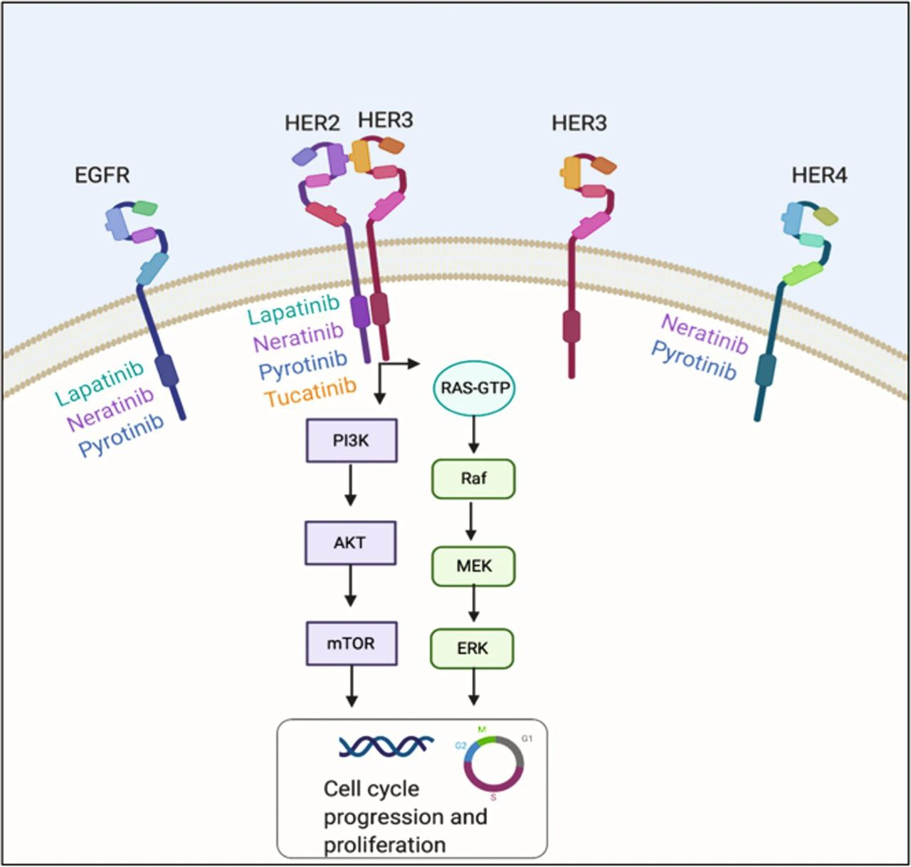
Figure 1: The HER2 receptor family (targeted by lapatinib, neratinib, pyrotinib, and tucatinib) includes HER2, which lacks a known ligand. Activation occurs via homo- or heterodimerization (e.g., HER2-HER3), triggering tyrosine kinase phosphorylation in the cytoplasmic domain. This recruits downstream proteins that activate PI3K and MAPK pathways, promoting cell proliferation. ⁽³⁸⁾

Increased levels of HER2 are found in about 25-30% of invasive breast cancers, leading to more aggressive tumor growth and a less favorable prognosis. HER2 is one of four similar receptors (HER1-4) in the EGFR family, all of which are transmembrane tyrosine kinases. When activated by a ligand, these receptors dimerize and initiate signaling pathways that promote cell survival, proliferation, and gene transcription. Unlike other EGFR family members, HER2 lacks a known natural ligand and primarily relies on heterodimerization with other receptors for activation. ⁽²⁰⁾
HER2, a vital protein in cell development and growth, is encoded by the ERBB2 gene on chromosome 17. Which is part of the EGFR family. HER2 plays a key role in signaling pathways that control proliferation and survival processes. The HER 2+ Breast Cancer has overexpression of HER2 receptors while HER2-negative breast cancers have normal levels of HER2 and don't respond to HER2+ targeted treatments. Furthermore, there are HER2-low breast cancers, exhibiting reduced HER2 expression, and HER2 ultralow breast cancers, demonstrating very limited HER2. Understanding the characteristics of these subgroups is vital as their clinical course may vary from HER2-negative tumors. While these classifications are still being researched, they're important for understanding how different breast cancers respond to treatment. ⁽²¹⁾
Our understanding of the HER2 protein has advanced significantly, leading to the development of targeted therapies that specifically attack this protein. HER2 is a receptor with three distinct parts: a portion that binds to signaling molecules outside the cell, a portion that anchors it to the cell membrane, and a portion that transmits signals inside the cell. When signaling molecules bind to HER2, it pairs up with other HER proteins, triggering a chain reaction that promotes cell growth and division. HER2 is unique because it doesn’t have its own signaling molecule. However, it readily pairs with other HER proteins, particularly HER3, contributing to the abnormal growth of cancer cells. When HER2 is overexpressed or amplified in cancer cells, it can pair with other proteins without needing a signaling molecule, leading to uncontrolled cell growth and division. The effectiveness of HER2-targeted therapies is most pronounced in cancers with elevated HER2 levels, referred to as “HER2-positive” tumors. Trastuzumab, the first humanized monoclonal antibody (mAb) against HER2, revolutionized the treatment of HER2-positive breast cancer. It binds to the extracellular domain of HER2, inhibiting it’s signaling pathways and leading to cell death. While trastuzumab has shown significant success, many patients develop resistance to Trastuzumab. To address this, Pertuzumab, another HER2-targeting mono clonal antibody was developed. It binds to a different part of HER2, preventing its dimerization with other receptors and blocking downstream signaling. Combination therapy with trastuzumab and Pertuzumab, often with chemotherapy, has demonstrated improved outcomes for patients with HER2-positive breast cancer. More recently, Margetuximab, a mono clonal antibody with an engineered Fc domain for enhanced ADCC (Antibody-Dependent Cell-Mediated Cytotoxicity) activity, has also been approved for the treatment of HER2-positive metastatic breast cancer. These advancements in HER2-targeted therapies have significantly improved the prognosis for patients with HER2-positive breast cancer. ⁽²²⁾
Some studies found that while screening programs are primarily effective in detecting slow-growing breast cancers, they can also identify a significant proportion of HER2-positive and triple-negative cancers. These aggressive subtypes are often associated with larger tumor size, lymph node involvement, and poorer prognosis. Despite their aggressive nature, screening can detect these cancers at earlier stages, leading to improve their outcomes. However, developing improved therapies for these subtypes are essential for breast cancer treatment. ⁽²³⁾ Another study highlights the importance of considering both metastatic heterogeneity and histological heterogeneity in predicting the prognosis of patients with HER2-positive metastatic breast cancer (MBC). Early detection through screening programs can identify these cancers at earlier stages, leading to improved outcomes. ⁽²⁴⁾ HER-2 positive breast cancer has poorer survival and bad prognosis compared to Triple negative breast cancer and this outcome was observed regardless of hormone receptor status. ⁽²⁵⁾ HER2-targeted therapies have demonstrably improved long-term outcomes and disease-free survival for patients with early-stage HER2-positive breast cancer, providing crucial evidence for treatment decisions and leading to significant improvements in patient prognosis. ⁽²⁶⁾

2.1 Current Diagnostic Methods
The incidence of breast cancer is increasing worldwide, particularly among younger women. Identifying and treating the condition in its initial stages significantly boosts survival outcomes. Various diagnostic methods, including imaging techniques and molecular biomarkers, have been developed to aid in early detection. A range of diagnostic methods, such as mammography, ultrasound, MRI, nucleic acid hybridization, real-time PCR, protein hybridization, and flow cytometry, are utilized for breast cancer diagnosis. While each method offers distinct advantages, they also possess inherent limitations and potential drawbacks. ⁽²⁷⁾
Imaging plays a vital role in breast cancer diagnosis, providing detailed information about tumor characteristics and potential spread. While various imaging techniques, including Mammography (MG), Ultrasound (US), Magnetic Resonance Imaging (MRI), Positron Emission computed Tomography (PET), Computed Tomography (CT), and Single‐Photon Emission Computed Tomography (SPECT), offer valuable insights, it’s crucial to weigh their benefits against their potential risks, particularly the use of radiation and contrast agents. While PET, CT, and SPECT are not typically recommended for routine breast cancer diagnosis due to their cost, practical limitations, and radiation exposure, they can be valuable in specific situations, such as screening for metastatic cancer or identifying bone and lymph node involvement. For routine breast cancer screening, MG, US, and MRI are often preferred due to their balance of effectiveness and safety. Clinicians must carefully assess the suitability of each technique to optimize diagnostic strategies, enhance patient care, and contribute to the advancement of breast cancer detection. ⁽²⁷⁾
Although mammography is the only proven screening method to reduce breast cancer mortality, and is recommended by the American Cancer Society starting at age 45 (or earlier in some cases), it has drawbacks such as false positives, radiation exposure, and psychological stress. The US Preventive Task Force recommends biennial screening for women aged 50-74, with less frequent screening for younger women due to a higher rate of false positives. However, risk-based models can help determine the need for screening in younger women. ⁽²⁸⁾ Early detection of breast cancer through screening can significantly improve patient outcomes by allowing for earlier and less invasive treatments. While mammography is a commonly used screening tool, it has limitations in sensitivity and size especially in women with dense breasts. Digital breast tomosynthesis can improve detection rates, but it still has limitations. ⁽²⁹⁾ This situation has led researchers to seek out alternative techniques. Near-Infrared Fluorescence (NIRF) imaging is a promising technique that can provide detailed images of tissue, potentially improving early detection. Other imaging techniques like CT and MRI, while useful, have limitations in detecting small tumors. Additionally, the frequent use of mammography over many years can increase the risk of false positives. While thermography can provide information about tumor heat, it's not sufficient for diagnosis alone. ⁽³⁰⁾
Advances in breast cancer diagnosis and treatment have led to significant improvements in patient survival, resulting in a longer lifespan for many. Personalized medicine, particularly the emerging field of Theranostics, offers a promising approach to further optimize treatment outcomes. Theranostics integrates diagnostic imaging and targeted therapy, enabling clinicians to identify patients who are most likely to benefit from specific treatments. By targeting specific molecular markers such as HER2. Theranostics aims to enhance treatment efficacy, minimize adverse effects, and ultimately improve overall patient survival. ⁽³¹⁾. Determining the HER2 status in breast cancer is crucial for guiding treatment decisions. For this assessment, the most common and FDA-approved techniques are immunohistochemistry (IHC) and Fluorescence In Situ Hybridization (FISH). IHC analyzes the protein levels of the HER2 marker, while FISH examines the DNA and RNA levels. ⁽³¹⁾
Immunohistochemistry (IHC) is a common method used to assess the level of HER2 protein expression on the surface of breast cancer cells. This technique involves staining tissue samples with antibodies that bind to the HER2 protein. The intensity of staining is then evaluated to determine the level of HER2 expression. According to current guidelines, a score of 0 or 1+ indicates negative HER2 expression, while a score of 3+ indicates positive expression. Patients with HER2-positive tumors may benefit from targeted therapies. However, a score of 2+ is considered equivocal, and further testing, such as (FISH), is necessary to confirm HER2 gene amplification. While IHC is readily available and inexpensive, its accuracy can be influenced by factors such as sample preparation, antibody quality, personnel expertise, and the subjectivity of result interpretation, highlighting the need for standardized procedures and careful consideration of potential variability to ensure reliable results for personalized treatment decisions. ⁽³¹⁾
FISH is a laboratory method that uses fluorescently labeled probes to identify specific DNA sequences within a cell. This method utilizes fluorescent probes to count copies of the ERBB2 gene and chromosome 17 centromeres within cancer cells, detecting amplification when the ratio exceeds 2.2. If the number of HER2 genes is significantly higher than normal, it suggests gene amplification, which is often associated with more aggressive tumor behavior. Compared to IHC, FISH offers a more objective and quantitative assessment of HER2 status. This is because FISH analyzes DNA, which is more stable than proteins, and it includes internal controls from normal cells within the tissue sample. However, FISH is a more complex and time-consuming technique, requiring specialized equipment and highly skilled personnel to interpret the results. Additionally, FISH is significantly more expensive than IHC. ⁽³¹⁾
Liquid biopsy is one of the emerging non-invasive techniques that involves the analysis of biological fluids, such as blood or urine, to detect cancer cells or cancer-related biomarkers. This method offers several advantages over traditional tissue biopsies, including the non-invasive method for real-time tumor monitoring, early detection, and identification of drug resistance, ability to monitor tumor evolution over time and to identify potential resistance mechanisms. By analyzing circulating tumor cells and circulating tumor DNA (ctDNA) in blood samples, liquid biopsy can provide valuable information about a patient's tumor including its genetic makeup, molecular profile and response to treatment. This information can be used to guide treatment decisions, monitor disease progression, and detect early signs of recurrence. ⁽³²⁾. Molecular biomarkers like HER2 testing (using IHC and FISH) are crucial for guiding treatment decisions. Liquid biopsy is an emerging non-invasive method for analyzing circulating tumor cells and DNA. ⁽³³⁾.

2.2 Circulating tumor DNA (ctDNA)
Circulating tumor DNA (ctDNA) in blood offers a promising way to understand more about different cancers. In every cancer, ctDNA levels can be very high, reflecting aggressive disease and a poorer outlook. Studies have shown that ctDNA analysis can accurately reflect the genetic makeup of the cancer itself. ⁽¹⁰⁾. In the late 1940s, scientists first detected DNA circulating in the blood of a patient with an autoimmune disease. Since then, advancements in technology have made it possible to isolate and analyze circulating tumor DNA (ctDNA) from the blood of cancer patients. Cancer patients typically have higher levels of DNA circulating in their blood compared to healthy individuals. This circulating DNA can provide valuable information about the cancer. In healthy people, most of the circulating DNA originates from blood cells. However, the sources of ctDNA in cancer patients are more diverse. Cancer cells can invade nearby tissues and also spread through the bloodstream. These circulating cancer cells may contribute to the release of ctDNA. It is believed that ctDNA is primarily released when cancer cells die through processes like programmed cell death (apoptosis), cell injury (necrosis), or when they are broken down by immune cells (phagocytosis). However, other mechanisms, such as the release of DNA from living cancer cells, may also play a role. ⁽⁹⁾.
Circulating tumor DNA (ctDNA) is composed of short DNA fragments with a short half-life. This requires careful consideration of sample collection and storage methods for accurate analysis. Variant Allele Fraction (VAF), which represents the proportion of mutant DNA, is a crucial parameter for ctDNA quantification. VAF can vary greatly depending on the stage of cancer, with higher levels observed in metastatic disease and lower levels in early stages or minimal residual disease. The applications of ctDNA analysis are rapidly expanding. It is now approved for detecting EGFR mutations in lung cancer and guiding treatment selection. Furthermore, ctDNA analysis is being explored for monitoring metastatic cancer and predicting treatment outcomes in various cancers, including breast cancer. ⁽⁹⁾.

2.3 Circulating tumor DNA (ctDNA) and cell free DNA (cfDNA)
Cell-free DNA (cfDNA) fragments in circulation primarily originate from the breakdown of apoptotic or necrotic cells within various tissues. These fragments often exhibit a characteristic size of 180 base pairs, consistent with the size of nucleosomes. cfDNA is inherently unstable and undergoes rapid degradation by nucleases, leading to a median half-life (1–2 hours). While cfDNA typically exists as naked fragments in circulation, it can also be associated with proteins or encapsulated within extracellular vesicles, potentially enhancing its stability and influencing its release into bodily fluids. Cell-free DNA (cfDNA) has been implicated in various pathological conditions, including autoimmune diseases like Lupus Erythematosus and Rheumatoid Arthritis, as well as various cancers. In the context of cancer, cfDNA released from tumor cells is specifically termed circulating tumor DNA (ctDNA). ⁽³⁴⁾⁽³⁵⁾.
Studies have shown that cfDNA levels are elevated in individuals with malignant gastrointestinal lesions compared to those with inflammatory conditions. However, cfDNA levels can also be within the normal range in a significant proportion of cancer patients, posing a challenge for diagnostic accuracy. Importantly, ctDNA has been shown to harbor genetic mutations associated with tumor development, such as mutations in genes like EGFR, KRAS, and TP53. This discovery established ctDNA as a valuable biomarker for cancer diagnosis, treatment guidance, and prognostic assessment. The recent FDA approval of the first ctDNA-based blood test for EGFR mutations marks a key milestone in the field. ⁽⁹⁾⁽¹⁰⁾⁽³⁴⁾.

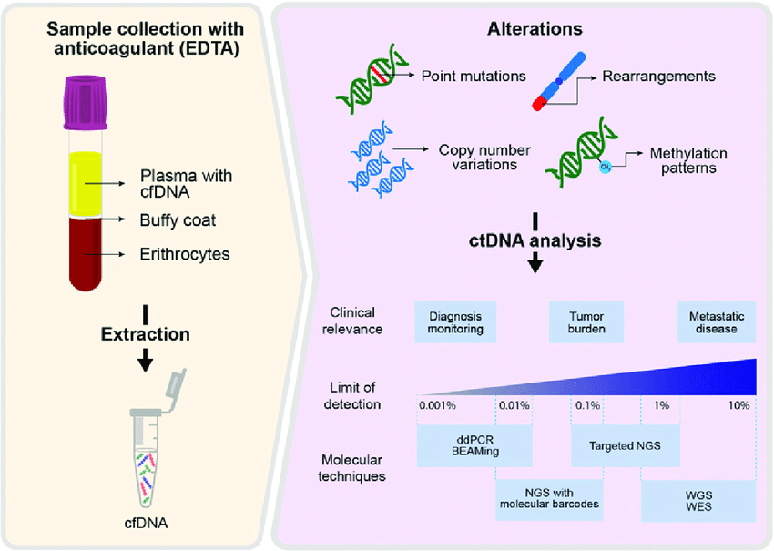
Figure 2: Schematic representation of ctDNA analysis. Plasma is processed for ctDNA extraction, it is then analyzed for detecting point mutations, chromosomal rearrangement, CNV, or methylation patterns to study their clinical relevance with the disease. Different detection methods have distinct limits of detection and clinical relevance. These methods include BEAMing, ddPCR, or NGS in various ways such as targeted sequencing, exome sequencing, or whole-genome sequencing. BEAMing, beads, emulsion, amplification, and magnetics; ddPCR, droplet digital polymerase chain reaction; WES, whole exome sequencing; WGS, whole-genome sequencing. ⁽³⁹⁾

3. Role of ctDNA in Early Detection of HER2+ Breast Cancer
Serial blood sampling at defined intervals during a patient's cancer journey enables the use of ctDNA for various clinical purposes. By analyzing ctDNA at regular time points, clinicians can assess the initial diagnosis, predict the likely course of the disease, and estimate the risk of cancer recurrence. Furthermore, this approach facilitates real-time monitoring of the disease progression and the patient's response to treatment. Digital PCR and modified NGS techniques are highly sensitive methods for detecting circulating tumor DNA (ctDNA) in early-stage cancers which makes them better candidates to be used for this application. These approaches can reliably identify even very low levels of ctDNA, down to 0.001% of the total circulating DNA. ⁽³⁵⁾.
Studies show promise for ctDNA in detecting breast cancer early, potentially avoiding unnecessary biopsies, but challenges include low ctDNA levels and distinguishing cancer-related mutations from those arising from Clonal Hematopoiesis of Indeterminate Potential (CHIP). In the neoadjuvant setting, ctDNA analysis can predict treatment response to NAT. researches show that ctDNA levels before, during, and after NAT correlate with disease progression and response to therapy and ctDNA clearance during treatment is associated with better outcomes. Challenges include the need to monitor multiple mutations and the potential influence of CHIP. Overall, ctDNA analysis holds significant potential as a valuable tool for managing breast cancer. ⁽³⁵⁾. New improvements in how we analyze ctDNA have made it easier to find even tiny amounts of this DNA in the blood. This means we can now detect ctDNA in the early stages of diseases, like breast cancer. For instance, in patients with early-stage breast cancer, the clearance of ctDNA from peripheral blood following therapeutic intervention is strongly associated with treatment efficacy and correlates with a reduced risk of disease recurrence. Today, doctors use ctDNA to keep a close watch on how breast cancer patients are doing. They can see if the treatment is working perfectly, find cancer cells that which are resistant to drugs, and understand how the cancer is changing over time. ⁽³⁶⁾.
They also use ctDNA to find specific changes in the cancer that they can target with special treatments. It’s also useful for detecting any tiny bits of cancer that might still be around after treatment, and even for finding cancers on early stages. While there isn’t a standard amount of ctDNA that everyone with breast cancer has at the start, it seems that changes in the amount of ctDNA over time do reflect how much cancer is present. These changes can also help doctors predict how a patient will do and how well the treatment will work. ⁽³⁶⁾.
The circulating tumor DNA (ctDNA) in breast cancer diagnosis, emphasizing its potential to overcome limitations of traditional pathology. While pathology remains the gold standard, it has limitations, particularly in cases of occult breast cancer. Circulating Tumor DNA analysis can detect cancer in such cases and improving patient prognosis. Meta-analyses have shown that ctDNA has high sensitivity and specificity for breast cancer diagnosis, with ongoing improvements in assay technology. Qualitative ctDNA analyses, such as methylation PCR and microsatellite analysis, also demonstrate promising diagnostic accuracy. Additionally, ctDNA analysis has shown significant potential in diagnosing advanced breast cancer, particularly leptomeningeal metastases, where ctDNA analysis can outperform traditional CSF cytology. Overall, ctDNA analysis presents a valuable tool for improving breast cancer diagnosis and patient outcomes. ⁽³⁷⁾. Currently, the widespread use of ctDNA in clinical settings is hindered by its low levels in the bloodstream, necessitating highly sensitive techniques for accurate detection and measurement. Detecting ctDNA is especially problematic in the early stages of breast cancer because the tumors are small, resulting in extremely low levels of ctDNA in bodily fluids. However, recent advancements in assay technology have enabled the detection of ctDNA at incredibly low levels. This technological progress paves the way for the next crucial step, conducting large-scale clinical trials to evaluate the clinical value of ctDNA in diagnosing and managing early-stage cancers. ⁽³⁵⁾.

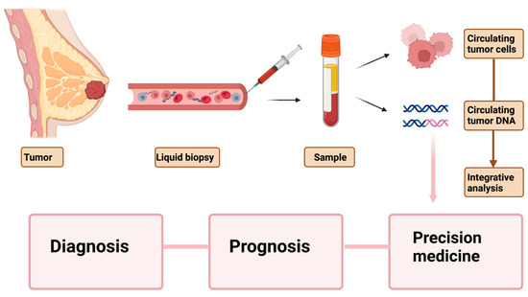
Figure 3: Peripheral blood-based biopsy for breast cancer diagnosis, prognosis, and precision medicine. Circulating blood markers such as CTCs and ctDNA are gaining prominence in cancer diagnosis, therapy monitoring, and development of personalized medicine. However, to bring these liquid biopsy markers into clinical practice, strategies for integrative analyses of these bio-analytes along with existing diagnostic tools need to be developed. ⁽⁴⁰⁾

3.1. Droplet based Digital PCR (ddPCR) and New Generation Sequencing (NGS).
Digital PCR (dPCR), first introduced in 1999, enables rare sequence detection by partitioning individual DNA molecules into discrete compartments for single-molecule amplification. Early microtiter plate-based systems suffered from low compartment numbers and large reaction volumes, limiting clinical utility. To overcome these constraints, microchamber and droplet-based systems were developed. While microchamber platforms offer ease of automation, their compartment number remains restricted, impacting sensitivity. In contrast, emulsion-based droplet digital PCR (ddPCR) generates thousands to millions of nanoliter-sized aqueous droplets in oil, creating a near-unlimited number of partitions. This innovation significantly enhances sensitivity, enabling detection of mutant alleles at frequencies below 0.001%. ⁽⁴¹⁾
In ddPCR, ctDNA samples are partitioned into droplets containing PCR reagents and TaqMan probes (fluorophore-labeled for mutant/wild-type discrimination). Post-amplification droplets are analyzed via fluorescence to quantify mutant sequences. However, contemporary multiplexing strategies are currently limited to 5-10 parallel analyzes to guarantee unambiguous sequence identification. ⁽⁴¹⁾

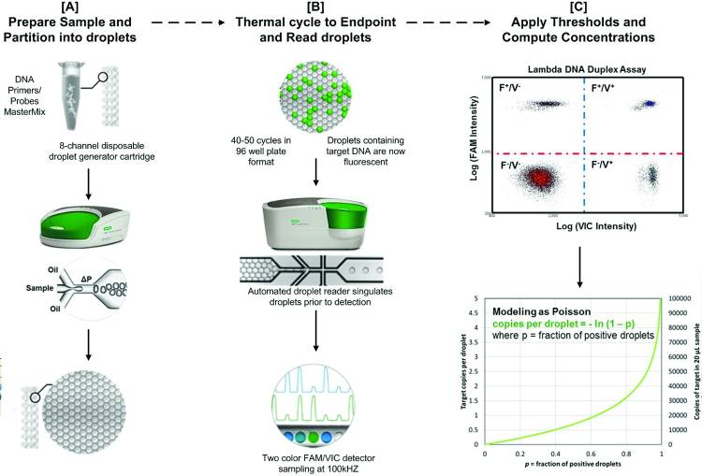
Figure 4: Schematic showing the ddPCR workflow: (A) A sample containing reagents and DNA is loaded into a droplet generator cartridge with oil. A vacuum creates water-in-oil droplets that collect in the cartridge. Droplets are then transferred to a 96-well plate, sealed, and amplified. (B) The plate is loaded into a droplet reader, which aspirates and streams droplets past a two-color fluorescence detector. (C) Fluorescence differences divide the droplet population into four clusters (no target, one target, or both targets). Fluorescence thresholds digitally classify droplets, and the average number of copies per droplet is calculated based on the fraction of positive droplets and Poisson modeling.⁽⁴²⁾

Next-generation sequencing (NGS) enables comprehensive analysis of ctDNA by simultaneously sequencing millions of DNA molecules aligned to a reference genome, capable of detecting both genetic and epigenetic alterations. While conventional NGS approaches like whole-exome or whole-genome sequencing typically provide only 30-100x coverage - insufficient for rare ctDNA variant detection and standard targeted panels (e.g., Ion AmpliSeq) offer limited ~2% sensitivity, advanced methodologies have significantly improved detection thresholds. Techniques such as CAPP-seq utilize selector probes to enrich driver mutation regions, achieving 10,000x coverage and 0.01% sensitivity through optimized bioinformatics, though remain susceptible to sequencing artifacts. Further refinements like iDES-enhanced CAPP-seq incorporate unique molecular identifiers (UMIs) for error suppression, pushing sensitivity to 0.001% with 96% specificity, while BPER methodology employs base position error rate calculations and binomial testing to reliably detect 0.1% allele frequencies at 95% specificity, collectively representing substantial improvements over conventional targeted sequencing for ctDNA analysis in clinical applications. ⁽⁴¹⁾

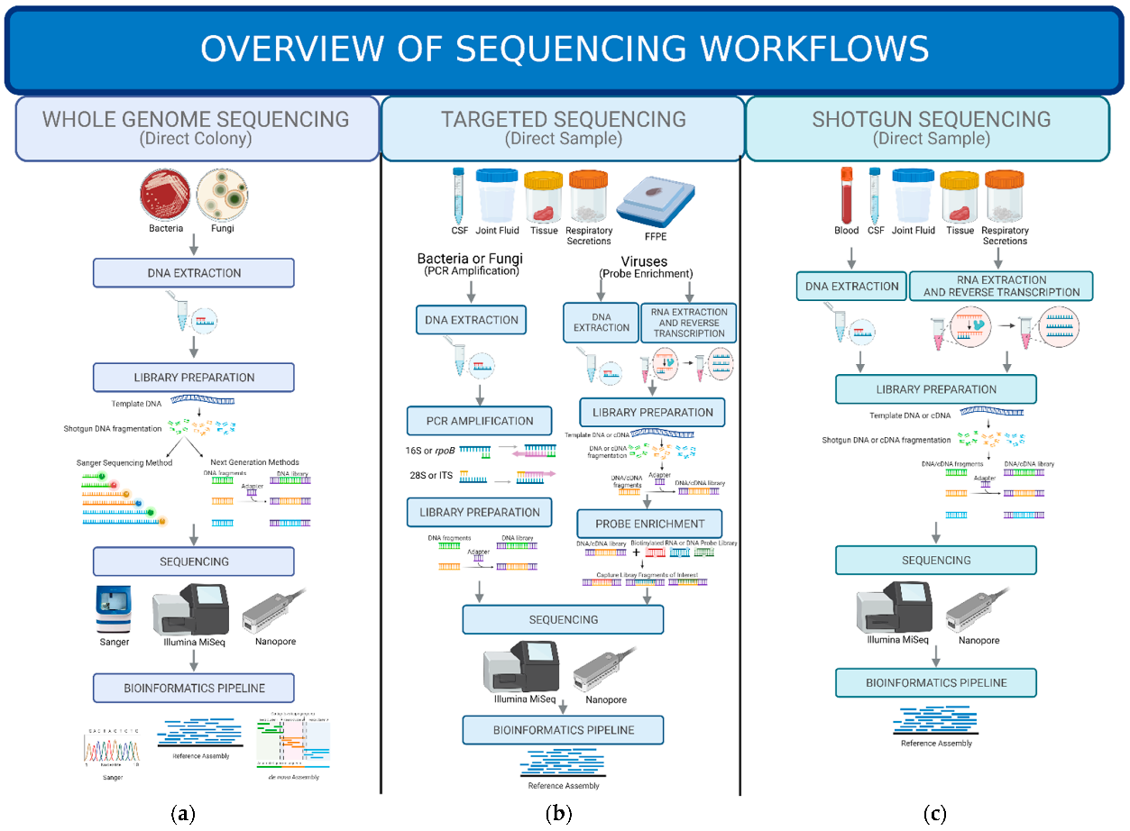
Figure 5: NGS applications in clinical diagnostics include: (a) Whole Genome Sequencing (WGS): DNA is extracted from a microbial colony, fragmented, prepped into a library, sequenced, and analyzed for comprehensive genomic information. (b) Targeted Sequencing: Clinical samples undergo selection/enrichment to focus on specific targets, followed by library prep, sequencing, and analysis. (c) Shotgun Metagenomic Sequencing: DNA/RNA is extracted directly from a clinical sample for unbiased analysis of all organisms present, then library prepped, sequenced, and analyzed. These methods provide varying levels of detail, from broad community profiling to in-depth analysis of individual genomes. ⁽⁴³⁾

Droplet based Digital PCR (ddPCR) and optimized NGS strategies offer complementary advantages and disadvantages for cell-free DNA (cfDNA) analysis. Droplet based Digital PCR (ddPCR) is easier to set up, faster, more sensitive, and requires less complex informatics support than NGS, but necessitates prior knowledge of target alterations and has limited multiplexing capabilities. While NGS can identify novel modifications and has high multiplexing potential, it’s time-consuming and requires significant bioinformatics expertise. Many studies combine NGS and ddPCR for liquid biopsy analysis, demonstrating high detection sensitivity and specificity, and good consistency between the two methods. While current technologies can detect ctDNA at levels as low as 0.001% with high accuracy, the often-limited quantity of ctDNA, especially in early-stage cancers, can be a limiting factor. Future research should focus on understanding ctDNA release mechanisms and optimizing sample collection and processing, including handling large plasma volumes. ⁽⁴¹⁾

4. Conclusion.
The analysis of circulating tumor DNA (ctDNA) represents a transformative step in the early detection and management of HER2-positive breast cancer. This review highlights the immense potential of ctDNA as a non-invasive biomarker capable of providing valuable insights into tumor characteristics, treatment efficacy, and disease progression. Unlike traditional diagnostic approaches, ctDNA offers real-time monitoring of cancer dynamics, minimizing the need for invasive procedures and reducing patient discomfort. Moreover, the detection of ctDNA in blood samples allows for early intervention, which is critical for improving survival rates and preventing disease metastasis in HER2-positive breast cancer patients.
Studies have demonstrated the ability of ctDNA to accurately reflect tumor genetic profiles and predict treatment outcomes, making it a crucial tool for personalized medicine. By identifying genetic mutations, ctDNA enables clinicians to tailor therapies to individual patient needs, ensuring more effective and targeted treatment strategies. Additionally, ctDNA testing can aid in identifying residual disease, monitoring minimal residual disease, and detecting potential drug resistance, all of which are vital for long-term disease management.
Despite its promising advantages, the clinical application of ctDNA still faces several challenges. Low ctDNA levels in early-stage cancers and the need for highly sensitive and specific detection methods remain significant hurdles. Furthermore, distinguishing ctDNA mutations from non-cancer-related genetic changes, such as those caused by clonal hematopoiesis, requires careful consideration. Addressing these issues through continued research and standardization of ctDNA testing methods will be essential to fully unlock its clinical potential.
In conclusion, ctDNA has the potential to revolutionize the diagnosis and treatment of HER2-positive breast cancer by enabling earlier detection, real-time monitoring, and personalized care. With advancements in assay technologies and further clinical validation, ctDNA testing could become an integral part of routine clinical practice, significantly enhancing patient outcomes and reducing the global burden of breast cancer.
We recommend future studies and research which should prioritize: (1) developing ultrasensitive assays for early-stage detection, (2) validating ctDNA as a dynamic biomarker for real-time therapy monitoring, and (3) understanding ctDNA release mechanisms

Competing Interests
Authors have declared that no competing interests exist.

Disclaimer (Artificial intelligence)
The authors affirm that the original research, data, and interpretation of results are solely their own and the AI technology was used only as an aid in for the purpose of homogenizing information, improving text flow, and enhancing scientific and grammatical structure. The AI tool did not generate new factual content or alter the core research findings and the authors are fully responsible for the accuracy and integrity of the scientific content presented in this manuscript.
1: AI Tool Details:
Name: Gemini
Version: Not Specified (current as of April 2025)
Model: Gemini Pro
Source: https://gemini.google.com/

References:
1. Ferlay J, Ervik M, Lam F, Laversanne M, Colombet M, Mery L, Piñeros M, Znaor A, Soerjomataram I, Bray F (2024). Global Cancer Observatory: Cancer Today. Lyon, France: International Agency for Research on Cancer. Available from: https://gco.iarc.who.int/today, accessed [21.04.2025].

2. American Cancer Society. (n.d.). Understanding a breast cancer diagnosis: Breast cancer HER2 status. Retrieved October 20, 2023, from, https://www.cancer.org/cancer/types/breast-cancer/understanding-a-breast-cancer-diagnosis/breast-cancer-her2-status.html.

3. Ben-Ari, E. (2021, October 19). *Enhertu may be preferred therapy for some metastatic breast cancers*. [National Cancer institute]. https://www.cancer.gov/news-events/cancer-currents-blog/2021/enhertu-her2-metastatic-breast-cancer.

4. Xu, D., Hu, Z., Wang, K., Hu, S., Zhou, Y., Zhang, S., Chen, Y., & Pan, T. (2024). Why does HER2-positive breast cancer metastasize to the brain and what can we do about it? *Critical Reviews in Oncology/Hematology*, 195, Article 104269. https://doi.org/10.1016/j.critrevonc.2024.104269.

5. Takada M, Toi M. Neoadjuvant treatment for HER2-positive breast cancer. Chin Clin Oncol. 2020 Jun;9(3):32. doi: 10.21037/cco-20-123. Epub 2020 Jun 3. PMID: 32527117

6. Arteaga, C. L., Sliwkowski, M. X., Osborne, C. K., Perez, E. A., Puglisi, F., & Gianni, L. (2011). Treatment of HER2-positive breast cancer: Current status and future perspectives. *Nature Reviews Clinical Oncology*. Advance online publication. https://doi.org/10.1038/nrclinonc.2011.177.

7. Ahmed, S., Sami, A. & Xiang, J. HER2-directed therapy: current treatment options for HER2-positive breast cancer. Breast Cancer 22, 101–116 (2015). https://doi.org/10.1007/s12282-015-0587-x

8. Wu HJ, Chu PY. Current and Developing Liquid Biopsy Techniques for Breast Cancer. Cancers (Basel). 2022 Apr 19;14(9):2052. doi: 10.3390/cancers14092052. PMID: 35565189; PMCID: PMC9105073.

9. Sant M, Bernat-Peguera A, Felip E, Margelí M. Role of ctDNA in Breast Cancer. Cancers (Basel). 2022 Jan 9;14(2):310. doi: 10.3390/cancers14020310. PMID: 35053474; PMCID: PMC8773730.

10. Vandekerkhove G, Struss WJ, Annala M, Kallio HML, Khalaf D, Warner EW, Herberts C, Ritch E, Beja K, Loktionova Y, Hurtado-Coll A, Fazli L, So A, Black PC, Nykter M, Tammela T, Chi KN, Gleave ME, Wyatt AW. Circulating Tumor DNA Abundance and Potential Utility in De Novo Metastatic Prostate Cancer. Eur Urol. 2019 Apr;75(4):667-675. doi: 10.1016/j.eururo.2018.12.042. Epub 2019 Jan 10. PMID: 30638634.

11. Vlataki K, Antonouli S, Kalyvioti C, Lampri E, Kamina S, Mauri D, Harissis HV, Magklara A. Circulating Tumor DNA in the Management of Early-Stage Breast Cancer. Cells. 2023 Jun 7;12(12):1573. doi: 10.3390/cells12121573. PMID: 37371043; PMCID: PMC10296563.

12. Guan G, Wang Y, Sun Q, Wang L, Xie F, Yan J, Huang H, Liu H. Utility of urinary ctDNA to monitoring minimal residual disease in early breast cancer patients. Cancer Biomark. 2020;28(1):111-119. doi: 10.3233/CBM-190523. PMID: 32176625.

13. Akram M, Iqbal M, Daniyal M, Khan AU. Awareness and current knowledge of breast cancer. Biol Res. 2017 Oct 2;50(1):33. doi: 10.1186/s40659-017-0140-9. PMID: 28969709; PMCID: PMC5625777.

14. Dey S. Preventing breast cancer in LMICs via screening and/or early detection: The real and the surreal. World J Clin Oncol. 2014 Aug 10;5(3):509-19. doi: 10.5306/wjco.v5.i3.509. PMID: 25114864; PMCID: PMC4127620.

15. Barzaman, K., Karami, J., Zarei, Z., Hosseinzadeh, A., Kazemi, M. H., Moradi-Kalbolandi, S., Safari, E., & Farahmand, L. (2020). Breast cancer: Biology, biomarkers, and treatments. International Immunopharmacology, ¹ 84, 106535. https://doi.org/10.1016/j.intimp.2020.106535.

16. Sant M, Bernat-Peguera A, Felip E, Margelí M. Role of ctDNA in Breast Cancer. Cancers (Basel). 2022 Jan 9;14(2):310. doi: 10.3390/cancers14020310. PMID: 35053474; PMCID: PMC8773730.

17. Xu, R.-C., Zhang, Y.-W., Liu, C.-C., Xu, Y.-Y., Shao, Z.-M., & Yu, K.-D. (2024). Immunotherapy and its racial specificity for breast cancer treatment in Asia: A narrative review. The Lancet Regional Health - Western Pacific, XX, 101180. https://doi.org/10.1016/j.lanwpc.2024.101180.

18. Maughan, K. L., Lutterbie, M. A., & Ham, P. S. (2010). Treatment of breast cancer. American family physician, 81(11), 1339–1346.

19. Tut, E., Kozgus Guldu, O., & Medine, E. I. (2024). Antitumor properties of bromelain loaded trastuzumab conjugated niosomes in HER2+ breast cancer cells. Journal of Drug Delivery Science and Technology, 101(106243). https://doi.org/10.1016/j.jddst.2024.106243.

20. Tut, E., Kozgus Guldu, O., & Medine, E. I. (2024). Antitumor properties of bromelain loaded trastuzumab conjugated niosomes in HER2+ breast cancer cells. Journal of Drug Delivery Science and Technology, 101(106243). https://doi.org/10.1016/j.jddst.2024.106243

21. Ahuja, S., Khan, A. A., & Zaheer, S. (2024). Understanding the spectrum of HER2 status in breast cancer: From HER2-positive to ultra-low HER2. Pathology - Research and Practice, 262, 155550. https://doi.org/10.1016/j.prp.2024.155550.

22. Swain, S. M., Shastry, M., & Hamilton, E. (2023). Targeting HER2-positive breast cancer: Advances and future directions. Nature Reviews Drug Discovery, 22(2), 101–126. https://doi.org/10.1038/s41573-022-00579-0.

23. Alanko, J., Tanner, M., Vanninen, R., Auvinen, A., & Isola, J. (2021). Triple-negative and HER2-positive breast cancers found by mammography screening show excellent prognosis. Breast Cancer Research and Treatment, 187(1), 267-274. https://doi.org/10.1007/s10549-020-06060-z

24. Wang, Y., Liang, Y., Ye, F., Luo, D., Jin, Y., Li, Y., Zhao, W., Chen, B., Wang, L., & Yang, Q. (2023). Histologic heterogeneity predicts patient prognosis of HER2-positive metastatic breast cancer: A retrospective study based on SEER database. Cancer medicine, 12(18), 18597–18610. https://doi.org/10.1002/cam4.6469.

25. Skenderi, F., Alahmad, M. A. M., Tahirovic, E., Alahmad, Y. M., Gatalica, Z., & Vranic, S. (2022). HER2-positive apocrine carcinoma of the breast: a population-based analysis of treatment and outcome. Breast cancer research and treatment, 193(2), 523–533. https://doi.org/10.1007/s10549-022-06578-4.

26. Hashem, M., Rehman, S., & Salhab, M. (2024). The Role of Human Epidermal Growth Factor Receptor 2 (HER2)-Targeted Therapies in Early-Stage Breast Cancer: Current Practices, Treatment De-escalation, and Future Prospects. Cureus, 16(2), e55230. https://doi.org/10.7759/cureus.55230 .

27. He, Z., Chen, Z., Tan, M., Elingarami, S., Liu, Y., Li, T., Deng, Y., He, N., Li, S., Fu, J., & Li, W. (2020). A review on methods for diagnosis of breast cancer cells and tissues. Cell proliferation, 53(7), e12822. https://doi.org/10.1111/cpr.12822.

28. McDonald, E. S., Clark, A. S., Tchou, J., Zhang, P., & Freedman, G. M. (2016). Clinical Diagnosis and Management of Breast Cancer. Journal of nuclear medicine : official publication, Society of Nuclear Medicine, 57 Suppl 1, 9S–16S. https://doi.org/10.2967/jnumed.115.157834.

29. Tagliafico, A. S., Piana, M., Schenone, D., Lai, R., Massone, A. M., & Houssami, N. (2020). Overview of radiomics in breast cancer diagnosis and prognostication. Breast (Edinburgh, Scotland), 49, 74–80. https://doi.org/10.1016/j.breast.2019.10.018.

30. Mambou, S. J., Maresova, P., Krejcar, O., Selamat, A., & Kuca, K. (2018). Breast Cancer Detection Using Infrared Thermal Imaging and a Deep Learning Model. Sensors (Basel, Switzerland), 18(9), 2799. https://doi.org/10.3390/s18092799.

31. Bragina, O. D., Deyev, S. M., Chernov, V. I., & Tolmachev, V. M. (2022). The Evolution of Targeted Radionuclide Diagnosis of HER2-Positive Breast Cancer. Acta naturae, 14(2), 4–15. https://doi.org/10.32607/actanaturae.11611.

32. Freitas, A. J. A., Causin, R. L., Varuzza, M. B., Calfa, S., Hidalgo Filho, C. M. T., Komoto, T. T., Souza, C. P., & Marques, M. M. C. (2022). Liquid Biopsy as a Tool for the Diagnosis, Treatment, and Monitoring of Breast Cancer. International journal of molecular sciences, 23(17), 9952. https://doi.org/10.3390/ijms23179952.

33. Cescon, D. W., Bratman, S. V., Chan, S. M., & Siu, L. L. (2020). Circulating tumor DNA and liquid biopsy in oncology. Nature cancer, 1(3), 276–290. https://doi.org/10.1038/s43018-020-004.

34. Li, C., Shao, J., Li, P., Feng, J., Li, J., & Wang, C. (2023). Circulating tumor DNA as liquid biopsy in lung cancer: Biological characteristics and clinical integration. Cancer letters, 577, 216365. https://doi.org/10.1016/j.canlet.2023.216365.

35. Vlataki, K., Antonouli, S., Kalyvioti, C., Lampri, E., Kamina, S., Mauri, D., Harissis, H. V., & Magklara, A. (2023). Circulating Tumor DNA in the Management of Early-Stage Breast Cancer. Cells, 12(12), 1573. https://doi.org/10.3390/cells12121573.

36. Alemzadeh, E., Allahqoli, L., Dehghan, H., Mazidimoradi, A., Ghasempour, A., & Salehiniya, H. (2023). Circulating tumor cells and circulating tumor DNA in breast cancer diagnosis and monitoring. Oncology research, 31(5), 667–675. https://doi.org/10.32604/or.2023.028406.

37. Xu, J., Gao, H., Guan, X., Meng, J., Ding, S., Long, Q., & Yi, W. (2024). Circulating tumor DNA: from discovery to clinical application in breast cancer. Frontiers in immunology, 15, 1355887. https://doi.org/10.3389/fimmu.2024.1355887.

38. Schlam, I., Swain, S.M. HER2-positive breast cancer and tyrosine kinase inhibitors: the time is now. npj Breast Cancer 7, 56 (2021). https://doi.org/10.1038/s41523-021-00265-1.

39. Oliveira, K. C. S., Ramos, I. B., Silva, J. M. C., Barra, W. F., Riggins, G. J., Palande, V., Pinho, C. T., Frenkel-Morgenstern, M., Santos, S. E. B., Assumpcao, P. P., Burbano, R. R., & Calcagno, D. Q. (2020). Current perspectives on circulating tumor DNA, precision medicine, and personalized clinical management of cancer. Molecular Cancer Research, 18(4), 517–528. https://doi.org/10.1158/1541-7786.MCR-19-0768.

40. Addanki, S., Meas, S., Sarli, V. N., Singh, B., & Lucci, A. (2022). Applications of circulating tumor cells and circulating tumor DNA in precision oncology for breast cancers. International Journal of Molecular Sciences, 23(14), 7843. https://doi.org/10.3390/ijms23147843.

41. Postel, M., Roosen, A., Laurent-Puig, P., Taly, V., & Wang-Renault, S. F. (2018). Droplet-based digital PCR and next generation sequencing for monitoring circulating tumor DNA: a cancer diagnostic perspective. Expert review of molecular diagnostics, 18(1), 7–17. https://doi.org/10.1080/14737159.2018.1400384.

42. Pinheiro, L. B., Coleman, V. A., Hindson, C. M., Herrmann, J., Hindson, B. J., Bhat, S., & Emslie, K. R. (2012). Evaluation of a droplet digital polymerase chain reaction format for DNA copy number quantification. Analytical chemistry, 84(2), 1003–1011. https://doi.org/10.1021/ac202578x.

43. Hilt, E. E., & Ferrieri, P. (2022). Next Generation and Other Sequencing Technologies in Diagnostic Microbiology and Infectious Diseases. Genes, 13(9), 1566. https://doi.org/10.3390/genes13091566.

