Innovative superdisintegrant strategy for the Formulation of rapidly disintegrating Lamotrigine tablets
ABSTRACT
Aims: Lamotrigine (LMG) is a poorly water-soluble antiepileptic drug (0.17 mg/mL at 25°C), commonly prescribed for epilepsy, including secondary generalized tonic-clonic seizures, as well as simple and complex partial seizures. Due to its low solubility and swallowing difficulty in some patients, the present study aimed to enhance its solubility and formulate it as oral disintegrating tablets (ODTs) for rapid onset of action.
Methodology: Lamotrigine ODTs were produced via the direct compression technique with varying concentrations of various superdisintegrants such as Pharmaburst 500 (a co-processed excipient containing 95% fructose and 5% starch), Croscarmellose sodium and Crospovidone. Seven formulations were made and assessed for parameters before and after compression.
Results: All tablets exhibited satisfactory results in terms of weight variation, hardness (2.8–4.0 kg/cm²), friability (<1%), and in vitro dispersion time (7.62–30 sec). Drug content uniformity ranged from 97.2% to 100%, indicating even distribution. FTIR analysis confirmed no significant interaction between Lamotrigine and the superdisintegrants. In vitro drug release studies conducted over 45 minutes revealed more than 97% drug release in all batches. Among them, formulation F3 containing Pharmaburst 500 demonstrated the highest release of 99.39% within 30 minutes.
Conclusion: The study concludes that ODTs of Lamotrigine prepared using Pharmaburst 500 and suitable superdisintegrants effectively enhance solubility and offer a patient-friendly dosage form with faster drug release, potentially improving therapeutic outcomes and patient compliance.
Keywords: Lamotrigine, Pharmaburst 500, Superdisintegrants, Direct compression, Oro-dispersible tablets

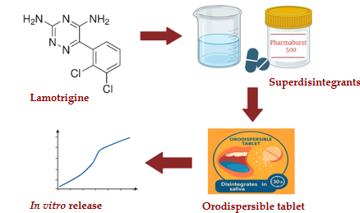

Graphical abstract

- INTRODUCTION
Epilepsy is a long-term brain disorder that causes repeated seizures due to unusual electrical activity in the brain, mainly in areas like the hippocampus and neocortex [1]. It affects around 65 million people around the world and can also lead to other mental health problems like depression and anxiety [2].

Chemically known as 3, 5-diamino-6-(2, 3-dichlo-rophenyl)-1,2,4-triazine, Lamotrigine is a broad-spectrum anti-epileptic drug that was first authorized in Ireland in 1990 and the US in 1994. Lamotrigine has a bitter taste. Following oral administration, lamotrigine is quickly and entirely absorbed with very little first-pass metabolism (absolute bioavailability of 98%). It belongs to BCS Class II (Low solubility & High permeability) and is very slightly soluble in water (0.17 mg/ml at 25°C). The immediate release formulation usually reaches its peak concentration 1.4–4.8 hours later [3]. Its poor aqueous solubility is the cause of this delay in the onset of action despite good bioavailability [4]. Since seizures often occur suddenly and unpredictably, a faster onset of action is essential to provide quick relief and improve patient safety [5].

One of the formulations that yields the rapid onset of action is an orally disintegrating tablet [6]. The US Food and Drug Administration defines ODTs as "a solid dosage form containing medicinal substances which rapidly disintegrates, usually within a matter of seconds, when placed upon the tongue." However, the European Pharmacopeia described them as "uncoated tablets intended to be placed in the mouth where they rapidly disperse before being swallowed," adding that the disintegration time is less than three minutes [7].

To create the ODTs, a variety of techniques have been used, including molding, extrusion, phase transition, compression, and sublimation. Because of its advantages, such as (1) ease of use and cost-effectiveness, (2) accessibility to manufacturing and packaging equipment, (3) availability of excipients, and (4) adaptability to large-scale or industrial-scale manufacturing, direct compression is a preferred manufacturing method among these [8].

For drugs which are poorly soluble when taken orally, the rate of dissolution often controls the rate of absorption. The rate of tablet disintegration can also affect a drug's dissolution. Tablets which break up more quickly release a fine suspension of drug particles, increasing their surface area and speed of dissolution [9]. Thus, superdisintegrants are used in the preparation of ODTs of lamotrigine to improve its solubility [10]. The effects of various superdisintegrants—pharmaburst 500, croscarmellose sodium and crospovidone—were investigated.
The aim of this study was to formulate lamotrigine ODT using direct compression technique and to investigate the effect of different superdisintegrants like pharmaburst 500, croscarmellose sodium and crospovidone on the disintegrating and dissolution properties of tablets.

- MATERIALS AND METHODS

Materials
Lamotrigine was purchased from Yarrow Chem Products. Magnesium stearate and Avicel pH 102 were procured from Loba Chemie Pvt. Ltd. Pharmaburst 500 was purchased from Opulent pharma, Hyderabad, Telangana. Croscarmellose sodium and crospovidone were purchased from S D Fine-Chem Limited, Mumbai. Silica dioxide and mannitol were purchased from Sisco Research Laboratories Pvt Ltd, Mumbai. All other chemicals and solvents were reagent grade and used as received.

Construction of calibration curve [4]
Lamotrigine that had been precisely weighed was added to a 50 ml volumetric flask. To create a standard stock solution with a concentration of 100 µg/ml, it was dissolved in 10 ml of methanol and the volume was adjusted with phosphate buffer pH 6.8. A secondary stock solution of 10 µg/ml is made by diluting 5 ml of this solution with 50 ml of buffer. A series of standard solutions containing 5, 10, 15, 20, 25, and 30 μg/ml of lamotrigine were prepared by diluting this solution with buffer. A Shimadzu 1900i UV spectrophotometer was used to analyze the solutions, and phosphate buffer (pH 6.8) was used as a blank to quantify the absorbance at 307 nm. The calibration curve of lamotrigine was plotted as shown in the Graph 1.

Preparation of ODTs [11]
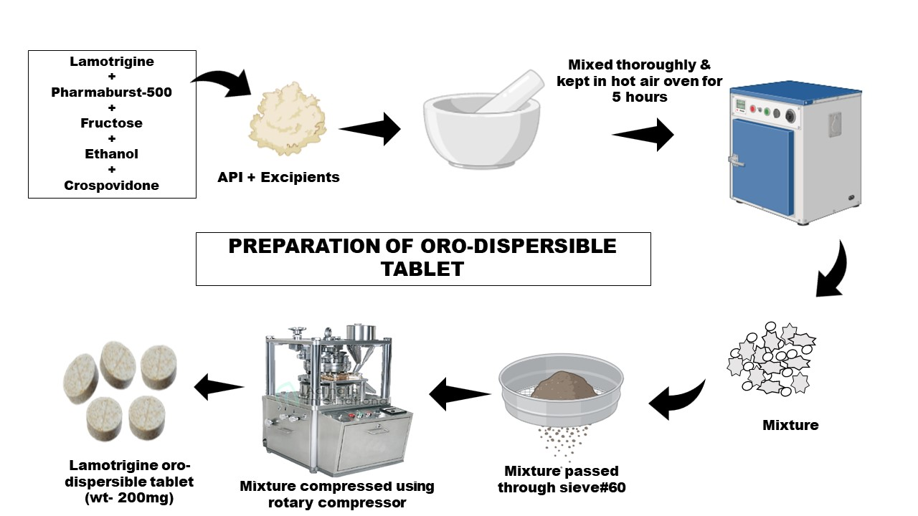
picture 1- Preparation of Oro- Dispersible tablet
Utilizing several superdisintegrants, lamotrigine ODTs with varying compositions were created via direct compression approach. Mannitol, MCC, superdisintegrant, and lamotrigine were all run through a 60 mesh filter. Magnesium stearate and silica dioxide were sieved independently using a 40 mesh screen. A 7 mm circular flat-faced punch on a rotary tableting machine (Rimek tablet compression machine) was used to compress the powder blend into tablets after a weighed amount of each ingredient was combined in a mortar and pestle. Table 1 lists the ingredients of each lamotrigine ODT formulation.
Table 1: Formulation table of lamotrigine ODTs
Ingredients | F1 | F2 | F3 | F4 | F5 | F6 | F7
Lamotrigine (mg) | 25 | 25 | 25 | 25 | 25 | 25 | 25
Magnesium stearate (mg) | 2.5 | 2.5 | 2.5 | 2.5 | 2.5 | 2.5 | 2.5
Microcrystalline cellulose (mg) | 75 | 67.2 | 56.4 | 69 | 58.5 | 82.75 | 77
Mannitol (mg) | 55 | 55 | 55 | 59 | 59 | 58.5 | 59
Silica dioxide (mg) | 5 | 5 | 5 | 5 | 5 | 5 | 5
Pharmaburst 500 (95% fructose, 5% starch) (mg) | 37.5 | 45.3 | 56.1 | - | - | - | -
Crospovidone (mg) | - | - | - | 39.5 | 50 | - | -
Croscarmellose sodium (mg) | - | - | - | - | - | 26.25 | 31.5

Assessment of powder mixtures
The bulk density, tapped density, and angle of response of powder blends have all been assessed. The bulk and tapped densities of the powder blends were used to compute the Compressibility Index and Hausner's ratio.

Bulk density [12]
The bulk density (Db) was calculated by pouring the powder mixture into a graduated cylinder and measuring the initial volume of the cylinder as the powder's mass (m) and bulk volume (Vb). The bulk density is calculated using the formula below:
D_{b} = m / V_{b}

Tapped density [13]
The tapped density (Dt) is calculated by placing a weighed mass (m) of powder in a 25 ml graduated cylinder and noting the cylinder's initial volume. After that, fifty mechanical taps are made on the cylinder. The volume of powder occupied (Vt) is measured following tappings. The following formula is used to determine the tapped density:

D_{t} = m / V_{t}

Angle of repose [14]
The powder was permitted to pass through the funnel, which was fixed at a certain height on a tripod platform. The angle of repose (θ) is then calculated by measuring the height (h) and radius (r) of the resultant powder pile. The angle of repose is calculated using the formula:

θ = tan⁻¹ (h/r)

Compressibility index [15]
Carr's compressibility index was used to calculate the powder's index of compressibility.

Carr’s index (%) = [(D_{t}-D_{b}) X 100] / D_{t}

Hausner’s ratio [16]
This is an additional metric that gauges the powder's flowability. Following formula was used to calculate it:

Hausner’s ratio = D_{b} / D_{t}

Tablet evaluation
Multiple quality control initiatives, including weight variation, hardness, thickness, friability, disintegration time in vitro, and drug content, were assessed for the tablets.

Weight variation [17]
Twenty randomly selected tablets were weighed on average. The percentage of deviation from the mean was computed.

Hardness [18]
The force needed to break a tablet when it was placed diametrically in a Monsanto hardness tester was used to measure the tablets' hardness. The tester is made up of two plungers and a barrel with a compressible spring inside. A zero reading was seen when the lower plunger contacted the tablet. By rotating a thread bolt, the upper plunger was pushed up against a spring until the tablet broke. A pointer travels along a gauge in the barrel to show the force—a measurement of hardness—as the spring was compressed.

Thickness [19]
The thickness of the produced tablets was measured with a vernier caliper. Tablet thickness is measured in millimeters (mm). Five pills of each formulation were tested, and the average values were determined.

Friability [20]
After being weighed collectively, ten tablets were put inside the friabilator chamber. Since the plastic chamber containing the tablets dropped them six inches away with each round, the friabilator was run for 100 revolutions at 25 rpm, subjecting the tablets to the combined effects of shock and abrasion. After that, the tablets were cleaned and weighed again.
Friability (%) = (Loss in weight / Initial weight) x 100

In vitro disintegration time [21]
The process of breaking down or breaking the tablet into smaller pieces is called disintegration. The USP disintegration apparatus was used for the in vitro disintegration test. Each tube of the disintegration apparatus, which contained 900ml of water at 37±0.5°C, contained six tablets from each formulation. The amount of time it takes for the entire tablet to dissolve is noted, and an average is calculated. Disintegration time for ODTs is measured in seconds.

In vitro dissolution study [22]
The formulation was subjected to in vitro dissolution tests at 75 rpm using USP class II (paddle type) equipment. The drug release profile was examined at 37±0.5°C in 900 mL of pH 6.8 phosphate buffer. At predetermined intervals, an aliquot of 10 milliliters of dissolution medium was removed and replaced with new medium to keep the sink condition stable. One milliliter of media was utilized for washing. After filtering the samples, UV spectroscopy was used to measure absorbance at 307 nm. The average readings were obtained after six pills were administered. At different time points, the percentage of drug released was computed.

Drug content [23]
Two tablets were taken and powdered. Accurately weighed quantity of powder equivalent to 50 mg of the drug was transferred to 50 ml volumetric flask. 6.8 pH phosphate buffer (10 ml) was added for dilution and kept it in the sonicator for 2 hours and then take out and filtered and appropriately diluted. It was analyzed by UV spectrometer at 307 nm.

FTIR Studies [24]
In addition to identifying the functional groups, incompatibilities between the drug and excipients can be ascertained through IR studies. To identify any potential drug-excipient interactions—which are indicated by a change in the position or disappearance of any characteristic peak of the compound—FTIR studies were conducted using Shimadzu FTIR for the pure drug, different excipients, and the optimized formulation blend.

- RESULTS AND DISCUSSION

Results

Construction of calibration curve
The absorbance of the standard solutions of concentrations 5 - 30 μg/ml of lamotrigine was checked. The absorbances are shown in the table. The calibration curve of lamotrigine was plotted as shown in the figure 1.

Table 2. Calibration table
Sl. No. | Concentration (μg/ml) | Absorbance at 307 nm
1 | 5 | 0.149
2 | 10 | 0.314
3 | 15 | 0.463
4 | 20 | 0.627
5 | 25 | 0.785
6 | 30 | 0.925

Figure 1. Calibration curve of lamotrigine

Evaluation of powder blends
For every prepared formulation, as shown in Table 3, a blend of medication and excipient was created, and its micromeritic properties were evaluated. The ranges for the angle of repose, bulk density, and tapped density were 20.80±1.220 to 38.99±0.550, 0.36±0.27g/cm³ to 0.47±0.12g/cm³, and 0.42±0.26g/cm³ to 0.59±0.46 g/cm³. Hausner's ratio varied from 1.10±0.32 to 1.51±0.21, and Carr's Index varied from 9.61±0.12% to 33.8±0.21% for various formulations.
Table 3. Precompression characteristics of different powder blends
Formulation code | Bulk Density (g/cm³) | Tapped Density (g/cm³) | Carr’s Index (%) | Hausner’s  ratio | Angle of repose (°)
F1 | 0.47±0.12 | 0.52±0.31 | 9.61±0.12 | 1.10±0.32 | 38.99±0.55
F2 | 0.41±0.21 | 0.47±0.14 | 12.76±0.21 | 1.14±0.22 | 26.56±0.90
F3 | 0.44±0.43 | 0.49±0.22 | 10.20±0.31 | 1.11±0.21 | 20.80±1.22
F4 | 0.36±0.27 | 0.42±0.26 | 14.28±0.42 | 1.16±0.23 | 35.52±0.38
F5 | 0.39±0.56 | 0.59±0.46 | 33.8±0.21 | 1.51±0.21 | 34.27±0.33
F6 | 0.41±0.44 | 0.51±0.34 | 19.60±0.22 | 1.24±0.32 | 31.59±0.24
F7 | 0.37±0.32 | 0.54±0.21 | 31.48±0.21 | 1.45±0.21 | 34.99±056

Evaluation of tablets
Weight variation and friability test results were found to be within the permitted limits, and the ODTs' hardness ranged from 2.1±0.14 kg/cm² to 4.1±0.11kg/cm² (Table 4). The tablet thicknesses of all ODTs ranged from 2.0±0.24mm to 2.90±0.41mm. The drug content for the formulations ranged from 90.42±0.98% to 99.26±1.43%.

Table 4. Post-compression parameters of formulations
Formulation code | Thickness (mm) | Hardness  (kg/cm²) | Weight variation (%) | Friability (%) | Drug content (%)
F1 | 2.85±0.21 | 2.4±0.33 | 1±0.02 | 0.63±0.26 | 97.2±1.11
F2 | 2.60±0.11 | 3.2±0.41 | 2±0.46 | 0.52±0.15 | 97.9±1.43
F3 | 2.0±0.24 | 3.6±0.26 | 2.9±0.11 | 0.73±0.25 | 99.26±1.43
F4 | 2.90±0.41 | 2.1±0.14 | 2±0.3 | 0.89±0.14 | 90.42±0.98
F5 | 2.15±0.26 | 2.5±-0.19 | 2.9±0.46 | 0.75±0.11 | 90.95±0.99
F6 | 3.0±0.19 | 4.1±0.11 | 2±0.5 | 0.45±0.17 | 99.1±0.75
F7 | 2.70±0.25 | 4.0±0.15 | 3±0.11 | 0.54±0.43 | 91.2±0.45

In vitro disintegration time
Seven (F1–F7) Lamotrigine oral disintegrating tablets (ODTs) were developed employing several superdisintegrants, including Pharmaburst 500, Crospovidone, and Croscarmellose sodium, in varying doses. The values derived from measuring the tablets' disintegration time are displayed in table 5:
Table 5. In vitro disintegration time of prepared lamotrigine ODTs
Formulation code | Disintegration time(sec)
F1 | 21.81±0.14
F2 | 19.2±0.23
F3 | 13.7±0.18
F4 | 7.65±0.33
F5 | 6.62±0.25
F6 | 25.34±0.31
F7 | 21.36±0.33

In vitro dissolution study [25]
One of the most important tablet quality characteristics that influences a drug's bioavailability and, consequently, its pharmacological action is its dissolution profile. The in vitro release profiles for each formulation at pH 6.8 are shown in Figure 2. The in vitro release study's findings generally showed that all tablets had a significantly higher dissolution rate because of the larger surface area that was available for dissolution following the tablets' quick breakdown into finer particles and smaller granules. In 30 minutes, formulation F3 demonstrated the highest percentage drug release of 99.39%. The graph and table 6 display the dissolution results. Based on the dissolution studies, F3 formulation was selected for drug-excipient compatibility study.
Table 6. In vitro drug release studies of prepared lamotrigine ODTs
Formulation code | 5 min | 10 min | 15 min | 20 min | 25 min | 30 min
F1 | 49.02±0.61 | 53.11±0.30 | 66.21±0.53 | 69.25±0.33 | 75.23±0.48 | 84.2±0.96
F2 | 52.42±0.42 | 58.24±0.46 | 64.04±0.83 | 68.33±0.94 | 74.33±0.64 | 86.47±0.34
F3 | 66.23±0.27 | 74.3±0.38 | 79.34±0.68 | 83.46±0.92 | 94.36±0.36 | 99.39±0.62
F4 | 32.21±0.6 | 42.4±0.26 | 49.71±0.48 | 61.3±0.66 | 70.3±0.33 | 74.31±0.46
F5 | 36.14±0.19 | 43.31±0.69 | 52.32±0.91 | 66.67±0.14 | 70.44±0.21 | 81.33±0.61
F6 | 27.82±0.61 | 32.59±0.22 | 47.54±0.31 | 59.23±0.94 | 66.67±0.46 | 74.31±0.28
F7 | 22.61±0.77 | 41.28±0.49 | 49.12±0.67 | 66.26±0.19 | 69.43±0.26 | 77.28±0.46

120
100
80
60
40
20
0
0
5
10
15
20
25
F5
30
F6
35
F7
40
45
F1
F2
F3
Time(min)nn)

Figure 2. Comparative graph showing dissolution profiles

FTIR Studies
In addition to identifying the functional groups, incompatibilities between the drug and excipients can be ascertained through IR studies. FTIR analysis was performed on the pure drug, Pharmaburst 500, and the physical mixture of the drug and Pharmaburst 500.

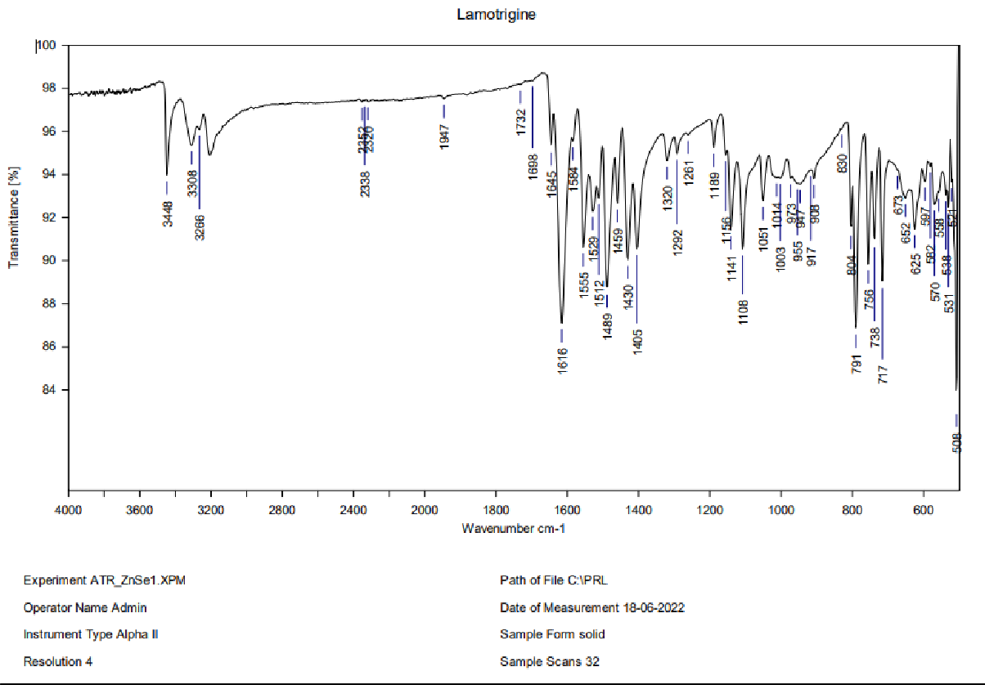
The drug sample showed characteristic functional group peaks at 3385cm⁻¹ that corresponds to –NH stretching (amino), 3203cm⁻¹ due to –CH (aromatic), 1629cm⁻¹ and 1431cm⁻¹ due to C=C ring, and 981cm⁻¹ indicates C-Cl of halides indicated in Figure 3 [26].

Figure 3. FTIR spectrum of Lamotrigine
The figure 4 shows the FTIR spectrum of the superdisintegrant, Pharmaburst 500 [27].
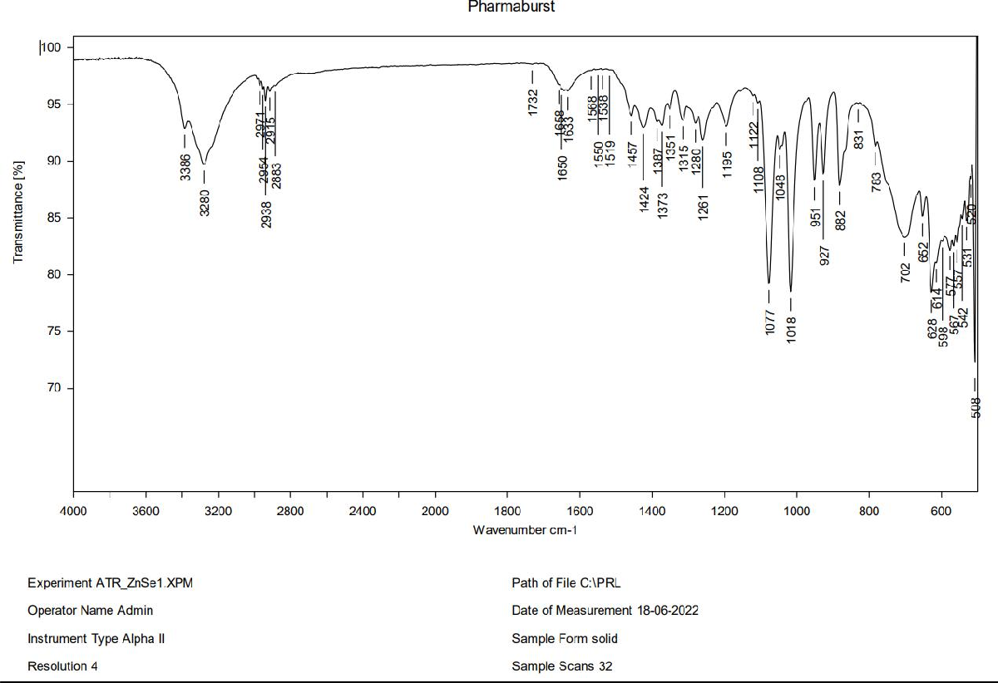

Figure 4. FTIR spectrum of Pharmaburst 500

The figure 5 depicts the FTIR spectrum of the blend of the Lamotrigine and Pharmaburst 500. The characteristic peaks of the lamotrigine were retained in this spectrum, suggests that no compatibility issue between those two.
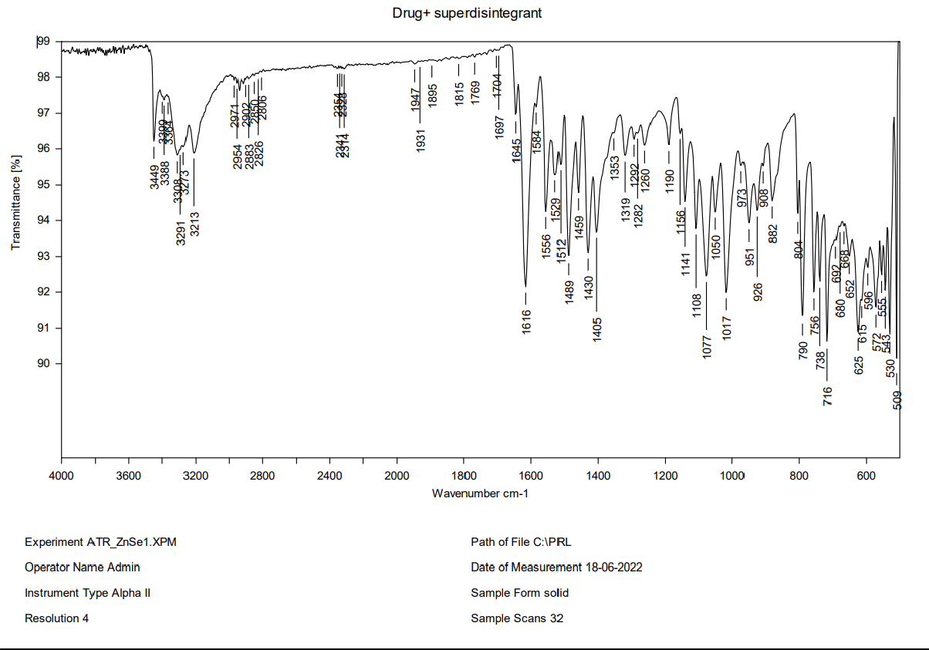
Figure 5. FTIR spectrum of Drug + Pharmaburst 500

Discussion

Lamotrigine's poor water solubility and lack of a rapid onset of action were the goals of the creation of oral disintegrating tablets (ODTs), which are crucial for treating sudden and unexpected seizures. The study investigated how the disintegration and dissolving behavior of the formulations were affected by three different superdisintegrants: Pharmaburst 500, Crospovidone, and Croscarmellose sodium.
Pre-compression evaluations such as angle of repose, Carr’s index, and Hausner’s ratio revealed acceptable flow properties for most of the powder blends, indicating good suitability for direct compression. Slight variations in compressibility and flow were observed based on the type and quantity of superdisintegrant and diluent used. Crospovidone-based formulations exhibited slightly higher Carr’s index values, suggesting lower flow, possibly due to its fine particle size and high-water uptake capacity [28].
Post-compression parameters like hardness, friability, and weight variation were within acceptable limits for all formulations, confirming mechanical strength and uniformity. Tablet hardness was generally influenced by the type of excipient; formulations with higher concentrations of microcrystalline cellulose showed better compactness. Friability values below 1% confirmed good tablet integrity [29].
The disintegration time of ODTs plays a crucial role in ensuring quick onset of action, particularly for drugs like Lamotrigine, which are intended for rapid relief. Among the seven formulations, F5 (containing 50 mg of Crospovidone) exhibited the shortest disintegration time of 6.62 sec, followed by F4 (39.5 mg of Crospovidone) with 7.65 sec. These results indicate that Crospovidone is highly effective in reducing disintegration time, likely due to its excellent swelling and wicking properties.
Formulations F1–F3, which incorporated increasing amounts of Pharmaburst 500, showed a gradual decrease in disintegration time, with F3 (56.1 mg) achieving a notable time of 13.7 sec. This demonstrates that Pharmaburst 500, being a co-processed excipient, also enhances disintegration, though not as rapidly as Crospovidone.
On the other hand, F6 and F7 containing Croscarmellose sodium showed higher disintegration times of 25.34 sec and 21.36 sec respectively, indicating relatively slower action compared to the other superdisintegrants.
Overall, the study confirms that both the type and concentration of superdisintegrant significantly impact the disintegration behaviour of Lamotrigine ODTs, with Crospovidone proving to be the most efficient in enhancing rapid disintegration [30].
Among all the formulations, the one containing Pharmaburst 500 (F3) showed the highest drug release (99.39%) within 30 minutes, which can be attributed to its high water solubility and rapid disintegration properties. The co-processed nature of Pharmaburst 500 (fructose and starch) likely contributed to both faster dispersion and improved wettability of the drug particles, leading to enhanced dissolution [31].
Formulations with Crospovidone (F4 and F5) showed moderate to good drug release, with improved disintegration but slightly slower dissolution compared to F3. This may be due to the formation of a gel-like matrix upon swelling, which can sometimes slow down the drug’s release, even if disintegration is rapid.
Formulations containing Croscarmellose sodium (F6 and F7) exhibited slower drug release, which might be related to its swelling behavior that delays the wetting and dispersion of drug particles.
Overall, the results confirm that faster disintegration does not always guarantee faster dissolution, as it also depends on the wetting, solubility, and interaction of excipients. The use of Pharmaburst 500 proved to be most effective in enhancing both disintegration and dissolution, making it the optimal choice among the tested superdisintegrants for Lamotrigine ODTs [32].
FTIR analysis was conducted to evaluate potential interactions between Lamotrigine and the selected excipients. The characteristic peaks of Lamotrigine, including those corresponding to –NH, –CH (aromatic), C=C ring, and C–Cl groups, were observed in both the pure drug spectrum and the spectrum of the drug-excipient mixture. The retention of these peaks in the physical mixture confirms the absence of any significant chemical interaction between Lamotrigine and Pharmaburst 500, indicating compatibility and stability of the formulation [33].

CONCLUSION
The present study successfully developed and evaluated Oro-dispersible tablets (ODTs) of Lamotrigine using various superdisintegrants to improve the drug’s solubility, disintegration time, and dissolution rate. Among the seven formulations, F3, which incorporated Pharmaburst 500 as a superdisintegrant, demonstrated superior performance with a rapid disintegration time of 13.7 seconds and maximum drug release of 99.39% within 30 minutes. While Crospovidone-based formulations showed faster disintegration, Pharmaburst 500 offered a balanced profile of quick disintegration and enhanced dissolution, making it the most effective overall. FTIR analysis confirmed compatibility between Lamotrigine and the excipients, indicating formulation stability. These findings suggest that the direct compression method using co-processed superdisintegrants like Pharmaburst 500 is a promising strategy for formulating patient-friendly Lamotrigine ODTs, which could improve therapeutic efficacy and patient compliance in epilepsy management.

COMPETING INTERESTS DISCLAIMER:
Authors have declared that they have no known competing financial interests OR non-financial interests OR personal relationships that could have appeared to influence the work reported in this paper.

Author(s) hereby declare that NO generative AI technologies such as Large Language Models (ChatGPT, COPILOT, etc.) and text-to-image generators have been used during the writing or editing of this manuscript.

REFERENCES:

- Scharfman, H. E. (2007). The neurobiology of epilepsy. Current Neurology and Neuroscience Reports, 7(4), 348–354.
- Hesdorffer, D. C., Beck, V., Begley, C. E., Bishop, M. L., Cushner‐Weinstein, S., Holmes, G. L., Shafer, P. O., Sirven, J. I., & Austin, J. K. (2013). Research implications of the Institute of Medicine Report, Epilepsy Across the Spectrum: Promoting Health and Understanding. Epilepsia, 54(2), 207–216.
- Ghourichay, M. P., Kiaie, S. H., Nokhodchi, A., & Javadzadeh, Y. (2021). Formulation and quality control of orally disintegrating tablets (ODTs): recent advances and perspectives. BioMed Research International, 2021(1), 6618934.
- Kuthuru, A., & Annammadevi, G. S. (2022). Formulation, optimization and evaluation of fast dissolving tablets of lamotrigine using natural disintegrant agent. International Journal of Health Sciences, 6(S5), 9651–9670.
- Akdag, Y., Gulsun, T., Izat, N., Cetin, M., Oner, L., & Sahin, S. (2020). Evaluation of preparation methods for orally disintegrating tablets. Medicine, 9(1), 265-269.
- Limpongsa, E., Tabboon, P., Pongjanyakul, T., & Jaipakdee, N. (2022). Preparation and evaluation of directly compressible orally disintegrating tablets of cannabidiol formulated using liquisolid technique. Pharmaceutics, 14(11), 2407.
- Alalaiwe, A., Fayed, M. H., Alshahrani, S. M., Alsulays, B. B., Alshetaili, A. S., Tawfeek, H. M., & Khafagy, E. S. (2019). Application of design of experiment approach for investigating the effect of partially pre-gelatinized starch on critical quality attributes of rapid orally disintegrating tablets. Journal of Drug Delivery Science and Technology, 49, 227–234.
- Cornilă, A., Iurian, S., Tomuță, I., & Porfire, A. (2022). Orally dispersible dosage forms for paediatric use: Current knowledge and development of nanostructure-based formulations. Pharmaceutics, 14(8), 1621.
- Alburyhi, M. M., Saif, A. A., Noman, M. A., Salim, Y. A., & Hamidaddin, M. A. (2023). Formulation and Evaluation of Lisinopril Orally Disintegrating Tablets. World Journal of Pharmacy and Pharmaceutical Sciences, 12(9), 357-369.
- Fouad, S. A., Malaak, F. A., El-Nabarawi, M. A., & Abu Zeid, K. (2020). Development of orally disintegrating tablets containing solid dispersion of a poorly soluble drug for enhanced dissolution: In-vitro optimization/in-vivo evaluation. PLoS ONE, 15(12), e0244646.
- Tawfeek, H. M., Hassan, Y. A., Aldawsari, M. F., & Fayed, M. H. (2020). Enhancing the low oral bioavailability of sulpiride via fast orally disintegrating tablets: Formulation, optimization and in vivo characterization. Pharmaceuticals, 13(12), 446.
- Musuc, A. M., Anuta, V., Atkinson, I., Popa, V. T., Sarbu, I., Mircioiu, C., ... & Ozon, E. A. (2020). Development and characterization of orally disintegrating tablets containing a captopril-cyclodextrin complex. Pharmaceutics, 12(8), 744.
- Giri, T. K., & Sa, B. (2009). Statistical Evaluation of Influence of Polymers Concentration on Disintegration Time and Diazepam Release from Quick Disintegrating Rapid Release Tablet. Yakugaku Zasshi, 129(9), 1069-1075.
- Dhahir, R. K., & Al-Kotaji, M. Y. A. S. A. R. (2019). Formulation of orally disintegrating tablets of cinnarizine by using direct compression method. Int J Appl Pharm, 11(1), 117-123.
- Poonuru, R., Cheruku, R., Juluri, P., Jabeen, K., Sreeramula, S., Bandari, S., & Madupu, A. (2020). Formulation and evaluation of orodispersible tablets of lamotrigine using discrete super disintegrants and coprocessed excipients. International Journal of Pharmacy and Pharmaceutical Sciences, 12(6), 28-35.
- DAVe, V., Yadav, R. B., AhuJA, R., & SAhu, A. K. (2017). Formulation and evaluation of orally dispersible tablets of Chlorpheniramine maleate by fusion method. Marmara Pharmaceutical Journal, 21(1), 67-77.
- Preethi, G. B., Banerjee, S., Shivakumar, H. N., & Ravi Kumar, M. (2017). Formulation of fast-dissolving tablets of doxazosin mesylate drug by direct compression method. Int J Appl Pharm, 9, 22-8.
- Gupta, S. S., Patel, H., Prajapati, B. G., & Shah, S. (2012). Formulation and Optimization of Lamotrigine Fast Dissolving Tablet. J Pharm sci Bioscinentific Res, 2(2), 68-72.
- Khinchi, M. P., Gupta, M. K., Bhandari, A., Sharma, N., & Agarwal, D. (2011). Design and development of orally disintegrating tablets of famotidine prepared by direct compression method using different superdisintegrants. Journal of Applied Pharmaceutical Science, (Issue), 50-58.
- Aly, A. M., Amro, B. I., & El Hajji, F. D. Research Paper Preparation and Evaluation of Rapidly Disintegrating Glimepiride Tablets.
- Madgulkar, A. R., Bhalekar, M. R., & Padalkar, R. R. (2009). Formulation design and optimization of novel taste masked mouth-dissolving tablets of tramadol having adequate mechanical strength. AAPS PharmSciTech, 10(2), 574-581.
- Seager, H. (1998). Drug-delivery products and the Zydis fast-dissolving dosage form. Journal of pharmacy and pharmacology, 50(4), 375-382.
- Sharma, I., & Sharma, V. (2011). A comprehensive review on fast dissolving tablet technology. Journal of applied pharmaceutical science, (Issue), 50-58.
- Bhardwaj, S., Jain, V., Jat, R. C., Mangal, A., & Jain, S. (2010). Formulation and evaluation of fast dissolving tablet of aceclofenac. International journal of drug delivery, 2(1).
- Keny, R. V., Desouza, C., & Lourenco, C. F. (2010). Formulation and evaluation of rizatriptan benzoate mouth disintegrating tablets. Indian journal of pharmaceutical sciences, 72(1), 79.
- Ishikawa, T., Mukai, B., Shiraishi, S., Utoguchi, N., Fuji, M., Matsumoto, M., & Watanabe, Y. (2001). Preparation of rapidly disintegrating tablet using new types of microcrystalline cellulose (PH-M series) and low substituted-hydroxypropylcellulose or spherical sugar granules by direct compression method. Chemical and pharmaceutical bulletin, 49(2), 134-139.
- Limpongsa, E., Tabboon, P., Pongjanyakul, T., & Jaipakdee, N. (2022). Preparation and evaluation of directly compressible orally disintegrating tablets of cannabidiol formulated using liquisolid technique. Pharmaceutics, 14(11), 2407.
- Ejeta, F. (2023). Orally disintegrating tablets. In Dosage Forms-Innovation and Future Perspectives. IntechOpen.
- Ahire, E., Thakkar, S., Borade, Y., & Misra, M. (2020). Nanocrystal based orally disintegrating tablets as a tool to improve dissolution rate of Vortioxetine. Bulletin of Faculty of Pharmacy, Cairo University, 58(1&2), 11-20.
- Abed, K. K., Hussein, A. A., Ghareeb, M. M., & Abdulrasool, A. A. (2010). Formulation and optimization of orodispersible tablets of diazepam. Aaps Pharmscitech, 11, 356-361.
- Okuda, Y., Irisawa, Y., Okimoto, K., Osawa, T., & Yamashita, S. (2009). A new formulation for orally disintegrating tablets using a suspension spray-coating method. International Journal of Pharmaceutics, 382(1-2), 80-87.
- Mohsin, A. A., Nimbalakr, N. E., Sanaullah, S., & Aejaz, A. (2010). Formulation and evaluation of mouth dissolving tablets of amitriptyline hydrochloride by direct compression technique. International journal of pharmacy and pharmaceutical sciences, 2(1), 204-210.
- Ganesan, S., Felo, J., Saldana, M., Kalasinsky, V. F., Lewin-Smith, M. R., & Tomashefski, J. F. (2003). Embolized crospovidone (poly [N-vinyl-2-pyrrolidone]) in the lungs of intravenous drug users. Modern Pathology, 16(4), 286-292.

