Bechet’s disease in absence of oral aphthosis: utility of updated criteria

Abstract :
Behçet disease (BD) is a chronic, relapsing, systemic vasculitis of unknown etiology with the clinical features of oral and genital ulcers, cutaneous vasculitic lesions, ocular, articular, vascular, gastrointestinal, neurologic, urogenital and cardiac involvement. Mucocutaneous lesions are considered hallmarks of the disease, and often precede other manifestations. Therefore, their recognition may permit earlier diagnosis and treatment with beneficial results for prognosis. Oral aphthosis is the main manifestation of BD and was reported in 97.3% of patients.
Objective : In a case study we investigate the prevalence, demographic and clinical parameters of Behçet cases without oral aphthosis, and the interest of the new ICBD criteria.
Methodology : In a retrospective study carried out in the internal medicine department of the university hospital Ibn Rochd de casablanca over an 18-year period, involving 563 patients with BD selected according to the new criteria proposed by the ICBD, we study the different characteristics of Behçet cases without oral aphthosis.
Result : Among 563 BD patients, 9 patients (1.6%) had no oral aphthosis. The sex ratio was 3.5 men/women. The mean age of onset was 28.3 years. Initial manifestations included genital aphthosis in (77.7%), ocular involvement (11.1%), and vascular involvement (11 .1%). During the course of the disease, 66.6% of patients had pseudofolliculitis lesions, and 22.2% had a positive pathergy test. Joint involvement was present in 1/3 of patients. 6 patients had ocular involvement. Vascular involvement was present in 66.6% of cases. Pleuropulmonary and central neurological parenchymal involvement were observed in only 1 patient. Therapeutic measures included bolus and oral corticosteroids, azathioprine and cyclophosphamide, in addition to colchicine. Progression was good in 66.66% of patients, with therapeutic resistance in 11.1%, and the onset of AA amyloidosis in 1 patient.
Conclusion : Bechet's disease is mainly diagnosed on the basis of clinical signs and symptoms, which often leads to delays in diagnosis. Revision of the criteria has improved sensitivity by making oral aphthosis a non-mandatory criterion, enabling diagnosis at an early stage and thus improving prognosis.

Keywords : Behçet disease, oral aphtosis, new ICBD criteria

Introduction :
Behçet's disease (BD) is a heterogeneous multifactorial autoinflammatory disease characterized by a plethora of clinical manifestations (1). It is a vasculitis of vessels of all calibers, affecting both arterial and venous territories, and progressing in relapses interspersed with remissions (2). Preferentially affecting younger people, it affects both men and women. Diagnosis is essentially clinical, in the absence of specific biological criteria (3). The clinical picture includes mucocutaneous, ocular, articular, vascular, gastrointestinal and nervous disorders. Mucosal lesions are thought to appear at an early stage of the disease (4). Oral aphthosis has been reported as the most frequent manifestation in the majority of cases, and is the most consistent sign in patients (5). However, a number of previous studies have addressed a minority of BD patients who does not develop oral aphthosis at any stage of disease (6) (7). This study was designed to investigate the prevalence and demographic and clinical parameters of Behçet cases without oral aphthosis, and the interest of new ICBD criteria.

Materials and methods:
In a case study carried out in the internal medicine department of the university hospital Ibn Rochd in Casablanca over a period of 18 years involving 563 patients with BD retained according to the new proposed ICBD criteria. we investigate the prevalence, demographic and clinical parameters of Behçet cases without oral aphthosis

Results:
Of the 563 patients with Behçet's disease, 9 (1.6%) had no oral aphthosis. The sex ratio was 3.5 men/women. The mean age of onset was 28.3 years. Initial manifestations included genital aphthosis in (77.7%), ocular involvement (11.1%), and vascular involvement (11 .1%). During the course of the disease, 66.6% of patients had pseudofolliculitis lesions, and 22.2% had a positive pathergy test. Joint involvement was present in 1/3 of patients. 6 patients had ocular involvement, including 3 panuveitis, 1 iridocyclitis, 1 intermediate uveitis and 1 posterior uveitis. Vascular involvement was present in 66.6% of cases (2 thromboses of the superior vena cava, 1 thrombosis of the inferior vena cava, 3 patients had thromboses of the lower limbs, including one with budd chiari and associated bilateral pulmonary embolism). Pleuropulmonary and central neurological parenchymal involvement were observed in only 1 patient. Therapeutic measures included bolus and oral corticosteroids, azathioprine and cyclophosphamide, in addition to colchicine. Progression was good in 66.66% of patients, with therapeutic resistance in 11.1%, and the onset of AA amyloidosis in 1 patient.

Discussion :

Epidemiology :
Behçet's disease is a rare disease whose prevalence varies between different regions of the globe. Initially described on the silk route linking Asia to the Mediterranean, the population pool now seems to be much more extensive. In Turkey, the prevalence of the disease varies from 19.6 to 420/100,000 inhabitants depending on the study, while in Japan it ranges from 7 to 13.5/100,000 inhabitants. In Europe, there is a north-south gradient, with the prevalence of the disease varying from one country to another (8).

Physiopathology :
The pathophysiology of Behçet's diseaseis poorly understood. There are predispositions, among which the presence of the HLA-B51 haplotype is the main predisposing factor. More recently, has shown a polymorphism in the loci of the genes coding for IL10, IL23 receptor, IL12 receptor beta and STAT4. This polymorphism is associatedwith an increased risk of developing Behçet's disease in Turkish, Japanese and Korean populations (9). The role of an infectious agent has also been suggested for many years (9). Streptococcus sanguis is found more frequently in the oropharyngeal flora of patients with Behçet's disease than in healthy subjects. The presence of this bacterium in saliva is correlated with a positive pathergic test (cutaneous hyperergy). The pathophysiology of Behçet's disease is poorly understood. There are involved in Behçet's disease via the production of heat shock proteins(Hsp). A homolog of Hsp60 produced by Streptococcus sanguis is capable of stimulating VEGF production, either directly or indirectly via the activation of T lymphocytes. This production of VEGF leads to damage of the vascular epithelium. Hsp stimulate lymphocytes, naturally present in mucous membranes, and whose number is increased in the circulating blood of patients with Behçet's disease. The γδ lymphocytes produce large quantities of TNFα and INFγ, which activate macrophages. These macrophages in turn secrete pro-inflammatory cytokines such as IL1, TNFα and CXCL8. There is also a more direct pathway for activating the immune response, in which antigen is presented by antigen-presenting cells to naive CD4+ T lymphocytes. Under the influence of IL1, IL6, IL23, IL21 and IL12, naïve T cells differentiate preferentially into Th17 and Th1 cells. These differentiated lymphocytes in turn secrete inflammatory cytokines such as IL17, INFγ and TNFα, respectively (9).
IL21-mediated Th17/ Th1 polarization and a decrease in the level of regulatory T cells in serum and cerebrospinal fluid of patients with Behçet disease have been demonstrated. This polarization correlates with disease activity (10). Several cytokines appear to play an important role in Behçet's disease. TNFα is present in significant quantities in the serum and aqueous humor of patients (11). IL1 is elevated in the serum and synovial fluid of patients (12). IL6 appears to play an important role in the development of damage to the central nervous system, since its level is elevated in cerebrospinal fluid (13) and correlated with disease activity (14) . INFγ levels are also correlated with disease activity.

Clinical manifestations :

- Mucocutaneous disorders (16)
Mucocutaneous disorders may precede or accompany other disorders. Oral aphthosis is present in 98% of cases, and is a major criterion in the diagnosis of the disease. Mouth ulcers may be single or multiple; they measure from 1 to 3 cm and may involve the tongue, palate, pharynx or labial mucosa. They disappear spontaneously within 10 days, and evolve in flare-ups. When aphthosis is severe, it can be very painful and prevent the patient from eating. However, this criterion is not essential to retain the diagnosis and several studies have reported its absence in certain patients with BD (1–2%) (15) .
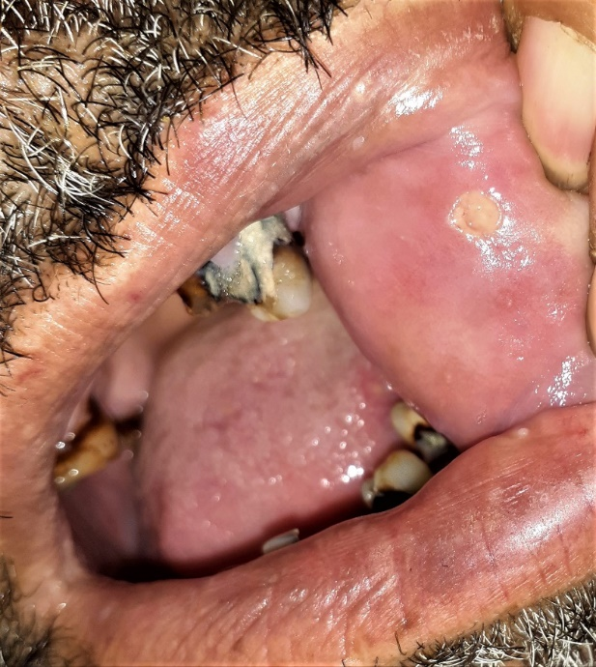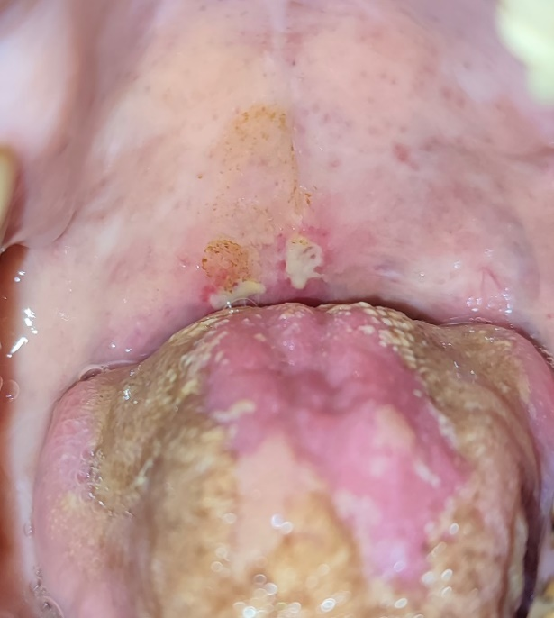

Figure 1 : Aphta in the jugal mucosa, and on the soft palate.

Genital aphthosis occurs in 60 to 65% of cases. Preferentially affecting the scrotum in men, the vulva or vagina in women. In almost half of all cases, one or more scars persist, helping with retrospective diagnosis. Pseudofolliculitis and erythema nodosum are also common.
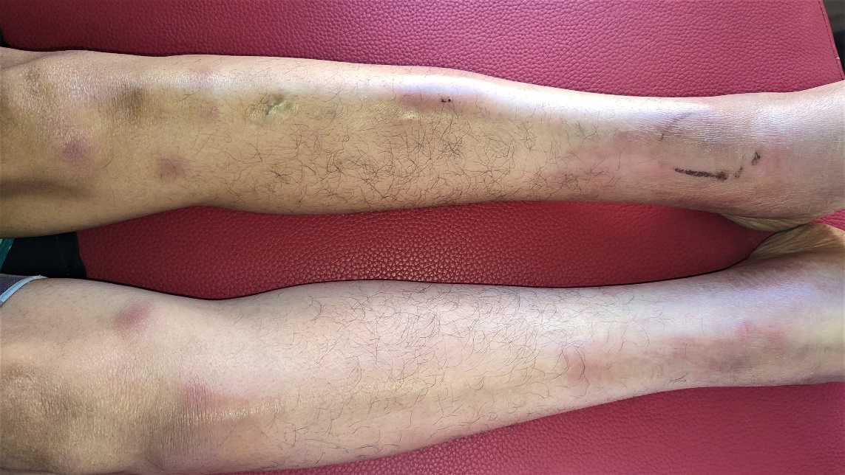
Figure 2: Painful purplish dermohypodermal nodules on the anterior surface of both legs.

- Joint symptoms
Arthritis or arthralgia are present in 45% of cases. They are not erosive and mainly affect the large joints (knees, ankles). They may precede or be concomitant with other disorders.
- Ocular involvement (16)
Ocular involvement is inaugural in 10-15% of cases. Typical involvement is bilateral panuveitis, which may be associated with retinal vasculitis. Uveitis develops in relapses and is the most frequent severe form of Behçet's disease (35-70%). They may be complicated by macular edema and optic atrophy , leading to blindness.

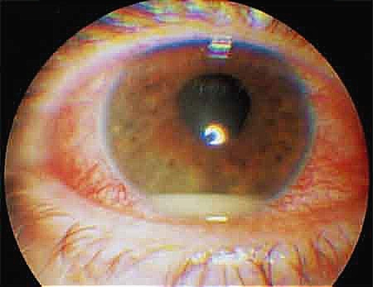
Figure 3: Hypopyon uveitis.

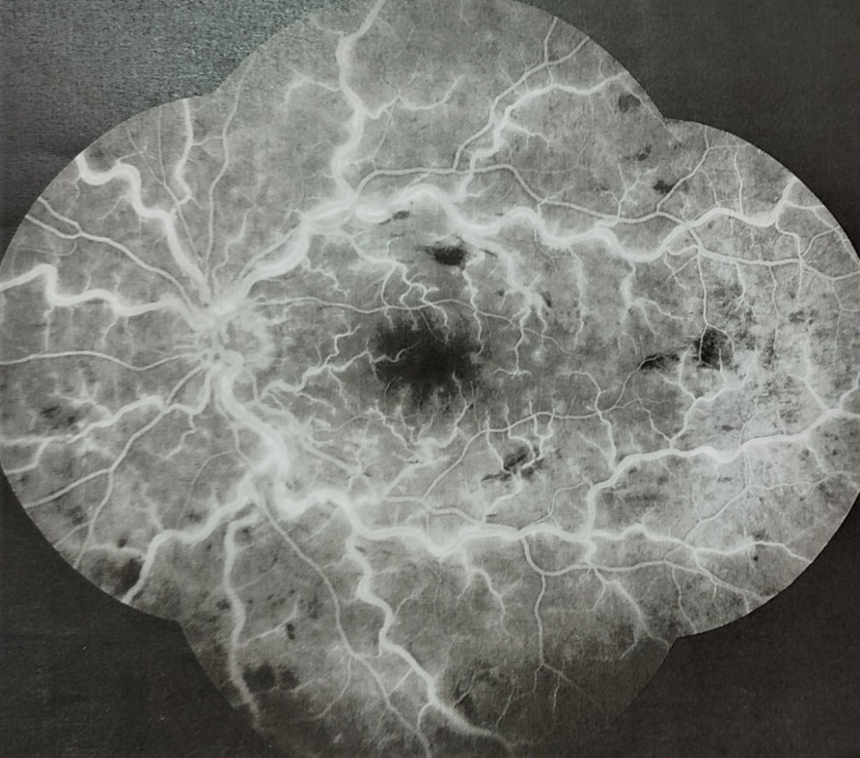
Figure 4 : Vascularite rétinienne au cours d’une maladie de Behçet.

- Neurological damage (17)
Neurological damage occurs in 5.3% to 50% of cases. Parenchymal involvement predominates in the form of meningoencephalitis. Myelitis and pseudotumors are much rarer.
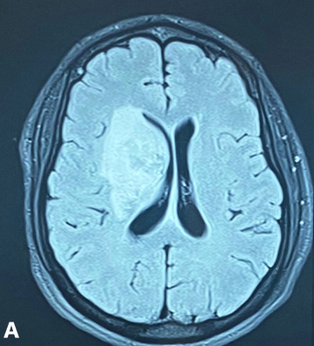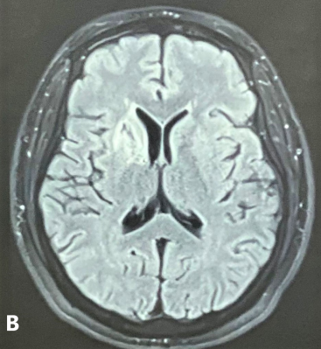

Figure 5 : Pseudotumoral lesion in neuro-Behçet. A: Before corticotherapy. B: After corticotherapy.

Extraparenchymal involvement is represented by cerebral thrombophlebitis and arterial aneurysms, and joins the macrovascular involvement of the disease.

- Cardiovascular involvement (18)
Venous involvement, present in 14 to 39% of patients, is most often represented by superficial thrombosis or deep thrombosis of the lower limbs. Involvement of the large trunks is rarer but more severe: pulmonary embolism, vena cava thrombosis, Budd-Chiari syndrome, cerebral thrombophlebitis.

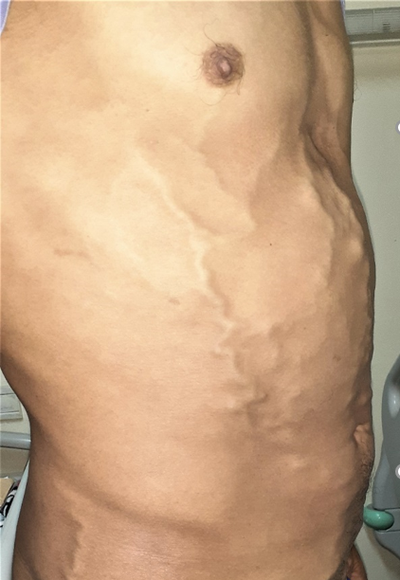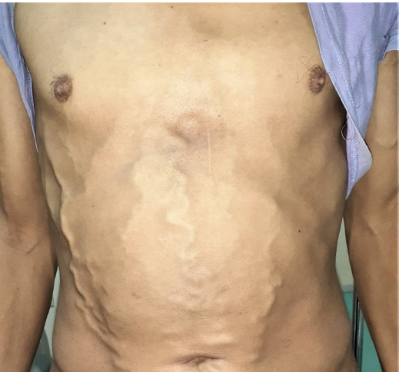
Figure 6 : Collateral venous circulation during thrombosis of the inferior vena cava.

Arterial involvement occurs in 4 to 17% of patients, mainly in large vessels (aorta, iliac, femoral and pulmonary arteries). The majority of cases involve aneurysms, but may also present as occlusions, stenoses or aortites. Cardiac involvement is rare (6% of cases) and may affect all three tunics. It is mainly represented by pericarditis, valvulopathy and intracardiac thrombus.

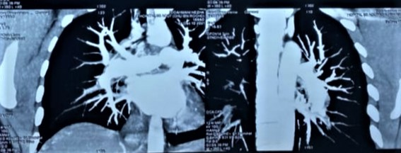
Figure 7 : Aneurysmal dilatation of lower lobar branches of both pulmonary arteries.

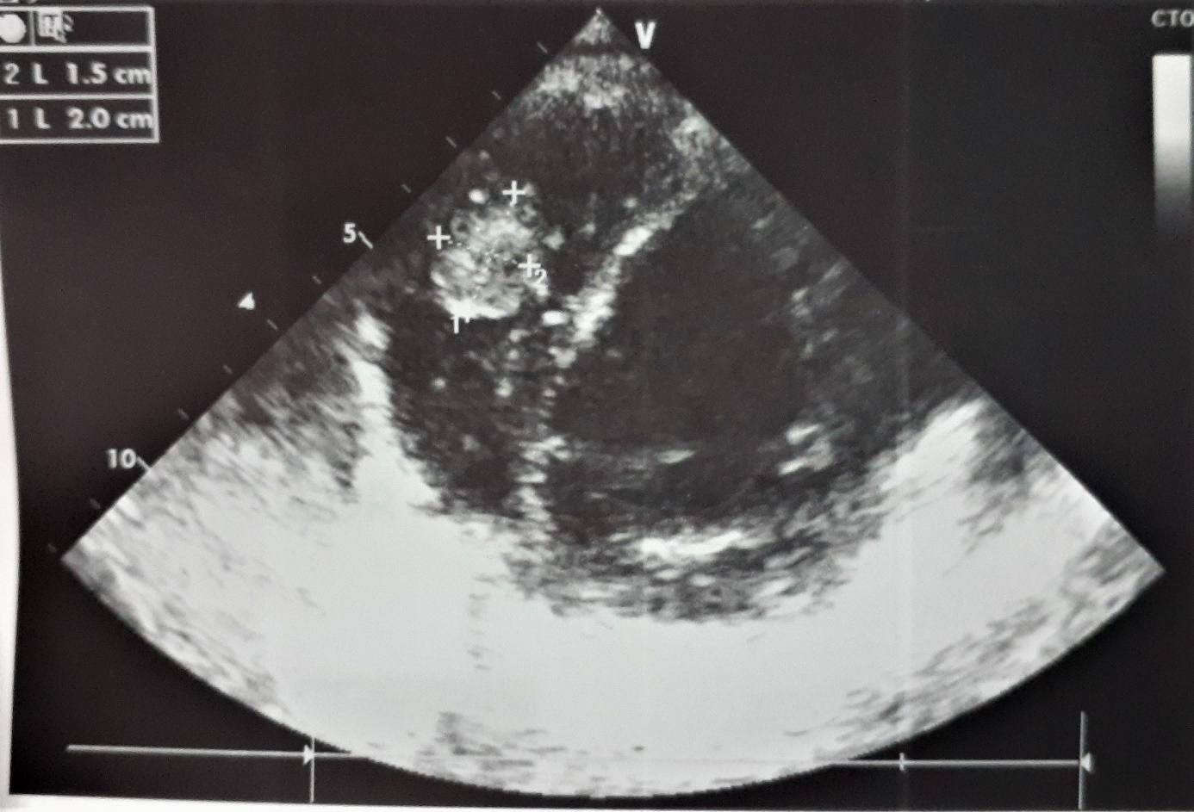
Figure 8: Intracardiac thrombus in a patient with vasculo-Behçet

- Digestive damage
This is very rare in Europe (< 5% of cases), but more frequent in Asia, particularly Japan. It manifests itself in the form of ulcerations that can affect the entire digestive tract. It is sometimes difficult to differentiate from Crohn's disease.

Diagnostic criteria :
Because there are no specific diagnostic laboratory tests or histopathologic findings, the diagnosis of the behcet disease relies on clinical criteria and often takes several years to establish a definitive diagnosis after the appearance of the initial manifestations. Manifestations of BD are not consistent among patients. Clinical phenotypes are very heterogeneous and evolution of the disease vary due to ethnic, geographical, and individual differences.
Moreover, the initial manifestations and the combination of clinical symptoms are very heterogeneous from patient to patient, even within the same ethnic group. Some patients present with only mucocutaneous symptoms, while some suffer from systemic involvement causing serious complications. (19).
As there are no pathognomonic clinical findings, various diagnostic criteria and classifications have been proposed during the years. According to criteria of International Study Group which was proposed in 1990, the presence of oral aphthous ulcerations and two of the following clinical manifestations is required for the diagnosis of BD: recurrent genital ulcerations, skin lesions such as erythema Nodosum-Like lesions, papulopustular lesions, ocular involvement, and positive pathergy test (20)

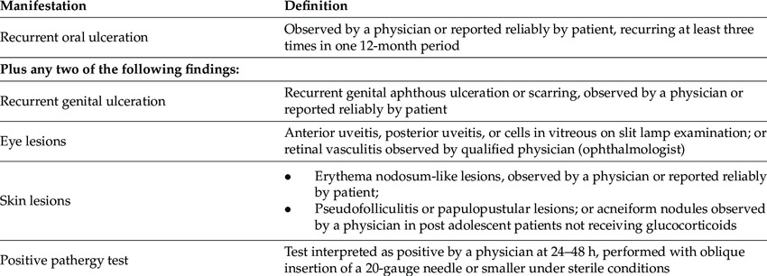

Table 1 : International Study Group criteria for the diagnosis of Behçet's disease. (21)

International Study Group for Behçet’s Disease criteria were created to guarantee uniformity in clinical studies rather than diagnose a single patient. Even if they were validated in different ethnical groups, a few items raised concern.
Firstly, since oral aphtosis was a mandatory feature, patients without oral ulcers (that represented 3% of 914 patients in the validation study) could not be diagnosed with BD (22).
International Study Group for Behçet’s Disease recruited patients from countries in which the pathergy phenomenon has a high degree of positivity; therefore, the sensitivity of this test could be low in countries where the positivity is not as common. Patients with bipolar aphtosis (oral ad genital), before the arrival of ISGBD criteria, were considered to suffer from a mild form of BD and, without a positive pathergy test, they could not meet the criteria for the diagnosis of BD (23)
In 2014, the International Team for the Revision of the International Criteria for Behçet’s Disease (ITR-ICBD) published in Journal of European Academy of Dermatology and Venereology study about the performance of the new criteria. The study involved scientists from 32 countries.
According to the new proposed ICBD criteria, BD can be diagnosed when a score of 4 or more points is reached. Ocular lesions, genital aphtosis, and oral aphtosis scored 2 points each; skin lesions, neurological manifestations, and vascular manifestations scored 1 point each. Pathergy test is optional, and when positive one extra point can be added . Comprehending a wide number of features (with the addition of neurological manifestation), the new ICBD criteria should let physicians to diagnose early BD in order to refer the patients to expert centers. Since pathergy test is no longer mandatory, these criteria can be used also in centers where pathergy is not a routinary test and in countries where the rate of positive pathergy test is low (24)

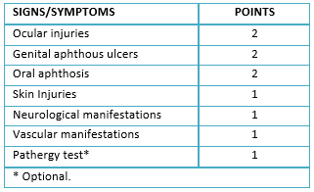
Table 2 : Diagnostic score according to the New International Criteria for the Behçet´s disease (25).

With the revision of the ISGBD criteria of 1990, patients without oral aphthosis with other specific clinical features can be diagnosed with BD and early treated.

Conclusion :
BD patients without oral aphthosis constitute a subgroup in whom the 1990 international criteria posed a diagnostic problem by requiring the presence of oral aphthosis. Hence the interest of the new proposed ICBD criteria, with a sensitivity clearly superior to that of the old criteria, while retaining a reasonable specificity

References :

1. . Martina D'Onghia, Unfolding dermatologic spectrum of Behçet's disease in Italy: real-life data from the International AIDA Network Behçet's disease Registry, Intern Emerg Med. 2023 Nov;18(8):2245-2252. doi: 10.1007/s11739-023-03410.
2. Abdullah Adil; Amandeep Goyal; Jessilin M. Quint, Behcet Disease, StatPearls, February 22, 2023. .
3. Isabelle KONE-PAUT1 , Stéphane BARETE2 , Bahram BODAGHI3 , Kumaran DEIVA4 , Anne-Claire DESBOIS5 , Caroline GALEOTTI1 , Julien GAUDRIC6 , Gilles KAPLANSKI7 , Alfred MAHR8 , Nicolas NOEL9 , Maryam PIRAM1 , Tu Anh TRAN10, Bertrand WECHSLER5 , David SAADOUN.
4. Khan A, Haroon M, Bashir F, Din ZU. Behcet’s Disease: Pakistani Experience. Pak J Med Sci 2020;36(5):1005–10.
5. Davatchi F, Chams-Davatchi C, Shams H, Shahram F, Nadji A, Akhlaghi M, et al. Behcet’s disease: epidemiology, clinical manifestations, and diagnosis. Expert Rev Clin Immunol 2015.7;13(1):57–6. .
6. Shahram F , Assadi K , Davatchi F , Nadji A , Jamshidi A , Chams C , Chronology of clinical manifestations in Behçet's disease. Analysis of 4024 cases, Adv Exp Med Biol. 2003:528:85-9. doi: 10.1007/0-306-48382-3_17.
7. Seyedeh Tahereh Faezi 1 , Pedram Paragomi 1 , Farhad Shahram 1 , Hormoz Shams 2 , Cheida Shams-Davatchi 3 , Zahra Ghodsi 3 , Abdolhadi Nadji 1 , Maassoumeh Akhlaghi 1 , and Fereydoun Davatchi, Clinical features of Behcet ’ s disease in patients without or.
8. MAHR A, MALDINI C. Epidemiology of Behçet’s disease. Rev Médecine Interne, 2014;35:81-89.
9. EMMI G, SILVESTRI E, SQUATRITO D et al. Behçet’s syndrome pathophysiology and potential therapeutic targets. Intern Emerg Med, 2014; Jan 12. [Epub ahead of print].
10. GERI G, TERRIER B, ROSENZWAJG M et al. Critical role of IL-21 in modulating TH17 and regulatory T cells in Behçet disease. J Allergy Clin Immunol, 2011;128:655-664.
11. SANTOS LACOMBA M, MARCOS MARTÍN C, GALLARDO GALERA JM et al. Aqueous humor and serum tumor necrosis factor alpha in clinical uveitis. Ophthalmic Res, 2001;33:251-255.
12. PAY S, ERDEM H, PEKEL A et al. Synovial proinflammatory cytokines and their correlation with matrix metalloproteinase-3 expression in Behçet’s disease. Does interleukin-1beta play a major role in Behçet’s synovitis? Rheumatol Int, 2006;26:608-613.
13. ZHOU ZY, CHEN SL, SHEN N et al. Cytokines and Behcet’s disease. Autoimmun Rev, 2012;11:699-704.
14. ADAM B, CALIKOGLU E. Serum interleukin-6, procalcitonin and C-reactive protein levels in subjects with active Behçet’s disease. J Eur Acad Dermatol Venereol, 2004;18:318-320.
15. AMBROSE NL, HASKARD DO. Differential diagnosis and management of Behçet syndrome. Nat Rev Rheumatol, 2013;9:79-89.
16. Hatemi G, Yazici Y and Yazici H. Behcet’s syndrome. Rheum Dis Clin North Am 2013; 39: 245–261.
17. NOEL N, DRIER A, WECHSLER B et al. Neurological manifestations of Behçet’s disease. Rev Méd Interne, 2014;35:112-120.
18. DESBOIS AC, WECHSLER B, CLUZEL P et al. Cardiovascular involvement in Behçet’s disease. Rev Méd Interne, 2014;35: 103-111.
19. Aysin Kokturk 1,* Clinical and Pathological Manifestations with Differential Diagnosis in Behçet's Diseas, Patholog Res Int. 2011 Nov 28;2012:690390. doi: 10.1155/2012/690390.
20. International Study Group for Behçet’s Disease [ISGBD]. Criteria for diagnosis of Behçet’s disease. Lancet. (1990) 335:1078–80. .
21. Alibaz-Oner, F.; Direskeneli,H. Update on the Diagnosis ofBehçet’s Disease. Diagnostics 2023.
22. Serena Bergamo, The diagnosis of Adamantiades-Behçet disease: Clinical features and diagnostic/classification criteriaFront. Med., 09 December 2022, Volume 9 - 2022 | https://doi.org/10.3389/fmed.2022.1098351
23. Lee S. Diagnostic criteria of Behçet’s disease; problems and suggestions. Yonsei Med J. (1997) 38:365–9. doi: 10.3349/ymj.1997.38.6.365.
24. International Team for the Revision of the International Criteria for Behçet's Disease (ITR-ICBD), The International Criteria for Behçet's Disease (ICBD): a collaborative study of 27 countries on the sensitivity and specificity of the new criteria, Multi.
25. Roberto A. Molina, Andrely Huerta-Rosario, Carlos Alexander Alva Díaz, Koni Katerin Mejía Rojas, Nicanor Mori, Roberto Romero Sánchez, Neuro-Behçet's disease in Peru: a case report and literature review, Medwave 2017 Jun;17(5):e6978 doi: 10.5867/medwave.2.

