Novel Potential Of Vitamin C And E On The Myelin, Oligodendrocyte And Inflammatory Markers Of Rohypnol Exposed Amygdala In Rats

Abstract
Rohypnol, scientifically known as flunitrazepam, is a potent benzodiazepine medication primarily prescribed for the treatment of severe insomnia and as a pre-anesthetic medication. However, its reputation has been tarnished by its misuse as a recreational drug and its association with drug-facilitated crimes, particularly sexual assault. However, its potent sedative effects can lead to memory impairment, loss of motor coordination, and respiratory depression, especially when combined with alcohol or other central nervous system depressants. This study aims to investigate and establish the mechanism and novel potential of vitamins C and E on the myelin, oligodendrocytes, and inflammatory markers of the Rohypnol-exposed amygdala. Twenty-five male adult Wistar rats were divided into five groups: the control group was exposed to normal grower mesh and water, 1 mg/kg of Rohypnol, 1 mg/kg of Rohypnol + 100 mg/kg of vitamin C, 1 mg/kg of Rohypnol + 100 mg/kg of vitamin E, and 1 mg/kg of Rohypnol + 100 mg/kg of vitamins C and E, and the test groups were exposed for 28 days. In the last three days of exposure, neurobehavioural tests were conducted. Animals were euthanized, and their hearts were flushed with saline 24 hours later after the last exposure. The brains were harvested by making an occipitofrontal incision for biochemical and histological assessment. The fixation was done in 10% neutral buffered formalin for 48 hrs following the brain mapping to isolate the brain tissue of interest. The vitamin C- and E-exposed rats showed significant (p<=0.05) progressive improvement in their behaviors, including the oxidative stress markers, when compared to the control. In conclusion, this study has shown that good antioxidants such as vitamins C and E are very much effective as neuroprotective agents and thus have great antioxidant ameliorative properties for the Rohypnol-induced amygdala of the Wistar rats.

Keywords: Vitamin C and E, Rohypnol, Amygdala, Benzodiazepine, Myelin, Oligodendrocyte

Introduction
Despite its classification as a controlled substance in numerous countries, Nigeria included, studies have demonstrated that the misuse of Rohypnol by adolescents is a recurrent occurrence (Oluwole et al., 2020). Animal and human studies have demonstrated that benzodiazepines (BZDs) have several side effects, including drowsiness (Keith and Rasmussen, 2014). “Rohypnol (flunitrazepam), a potent benzodiazepine, has been associated with severe neurotoxic effects, including disruptions in myelin integrity, oligodendrocyte function, and neuroinflammation. These disturbances have been implicated in cognitive impairments, emotional regulation issues, and overall brain dysfunction, particularly within the amygdala, a key region involved in emotional processing and memory” (Kim et al., 2020; Gonzalez et al., 2018).
“Pharmacotherapeutic interventions are available for individuals experiencing withdrawal symptoms or desiring cessation of their persistent benzodiazepine (BZD) utilization. Multiple alternative pharmacological treatments have been suggested to mitigate the severity of withdrawal, encompassing alpha-blockers (such as propranolol and clonidine), anticonvulsants (valproic acid, lamotrigine, carbamazepine, and phenobarbital), progesterone, baclofen, and trazodone. Nevertheless, the outcome of each of these investigations exhibited inconclusive findings, lacking statistically significant superiority over BZD therapy. Presently, the preferred course of treatment involves substituting the present short-acting BZD with a long-acting substitute, gradually decreasing the dosage to effectively wean the individual off BZD entirely”. (Brett et al. 2015)
“Vitamins C and E are well-known antioxidants with neuroprotective properties that may counteract the oxidative stress and inflammation induced by Rohypnol exposure” (Lynch & Kitts, 2007; Lee et al., 2019). These vitamins have been shown to reduce neuroinflammation and support neuronal health through their antioxidant effects, which help mitigate oxidative damage to cellular structures like myelin and oligodendrocytes (Finkel & Holbrook, 2000; Trovato et al., 2018). However, the specific effects of these vitamins on myelin, oligodendrocytes, and inflammatory markers in the amygdala have not been thoroughly explored.
“There is growing evidence that each tocopherol molecule can donate two electrons” (Maria et al., 2021) before being “consumed”; “the tocopherol molecule is then reduced to its previous state and can then be reused. Importantly, this reduction process is most likely carried out by ascorbic acid” (Maria et al., 2021), “which is why there are many studies reporting the antioxidant capacity of vitamin E linked to vitamin C” (Behl, 2000). “A combination of different antioxidants, therefore, may offer additional benefits” (Maria et al., 2021) because “antioxidants may together have different protective effects. Vitamin C is a nutrient of greatest importance for proper functioning of the nervous system, and its main role in the brain is its participation in the antioxidant defense. Apart from this role, it is involved in numerous non-oxidant processes like the biosynthesis of collagen, carnitine, tyrosine, and peptide hormones, as well as myelin. It plays a crucial role in neurotransmission and neuronal maturation and functions” (Joanna et al., 2017)
“The increasing evidence on the potential neuroprotective roles of vitamin E has been well documented in both in vivo and in vitro studies” (Takahashi et al., 2016). “In vivo, vitamin E and other endogenous antioxidants work in concert or synergistically by maintaining a reduced environment” (Maria et al., 2021). “The effects of vitamin E on microglial cells have been studied in the short term; most studies, in line with the idea that microglial activation is a harmful process, have shown that vitamin E suppresses inflammatory activation of microglia, thus providing some neuroprotection” (Maria et al., 2021).
“There is an emerging model of the role of specific brain structures in anxiety and their relation to the mechanism of action of benzodiazepine (BZD) anxiolytics. The presumption of this model is that there are structures in the brain, the activity of which mediates anxiety. Benzodiazepines are presumed to work via the BZD-GABA-C1-ionophore complex such as to enhance the inhibitory effects of GABA upon these anxiety-mediating structures” (Hesse et al. 2001).
“A number of such brain regions have been proposed as putative sites for the action of BZDs, including the nuclei of the raphe” (Wise et al. 1972; Soubri 1986), the septo-hippocampal system (Gray 1982), and the amygdala (Scheel-Kruger and Petersen 1982; Costall et al. 1989). “The amygdala is an almond-shaped structure that lies in the temporal lobe. The amygdala also functions in regulating anxiety, aggression, fear conditioning, emotional memory, and social cognition” (Rajmohan et al. 2007).
“The amygdala has been associated with many diseases, mainly neuropsychiatric. And various research studies suggest that amygdala neurofeedback may not only be therapeutic for this patient group but may also be used as a future adjunctive treatment” (Nicholson et al. 2017). Given the aforementioned information, this study evaluates the effect of vitamins C and E on Rohypnol-induced amygdala integrity.
This study aims to investigate the therapeutic potential of vitamins C and E in mitigating the neurotoxic effects of Rohypnol exposure, focusing on their ability to preserve myelin integrity, support oligodendrocyte function, and reduce inflammatory markers in the amygdala. The findings from this research could provide insights into potential treatment strategies for brain damage induced by sedative-hypnotic drugs like Rohypnol, offering a foundation for future studies on neuroprotective interventions in drug-induced neurotoxicity.

MATERIALS AND METHODS.
Location and Duration of the Study
This scientific investigation was carried out in the Animal House of the Department of Human Anatomy, College of Health Sciences, Nnamdi Azikiwe University Nnewi Campus, Anambra State, Nigeria. The experimental animals were allowed to acclimatize for a period of 14 days, after which the test substances were administered for 28 days; the entire experiment lasted for six weeks.
Ethical Approval
All the animals were treated following the approval of the ethical committee with the number FBMS/EA/1020, College of Health Sciences, Nnamdi Azikiwe University, Nnewi Campus, in line with the “Guide for the Care and Use of Laboratory Animals” (NRC 2011).

Experimental Animals: Twenty-five (25) male albino rats weighing 150-200 g were procured from a laboratory at Nnamdi Azikiwe University Nnewi campus and housed at the animal house of the Department of Anatomy, College of Health Sciences Nnamdi Azikiwe University Nnewi, Anambra State. The rats were marked with various colors peculiar to each group and were housed in plastic cages with iron nets in standard conditions (a controlled room temperature of about 25–28°C, a relative humidity of about 60–80%, and a photoperiodicity of 12 h day and night). The rats were fed sufficiently with normal grower mesh produced by Premier Feed Mills Co. Limited (a subsidiary of Flour Mills Nigeria Plc). The animals were grouped into five: Group A, the control group, served as a baseline for evaluating the effects of the treatments, while Groups B, C, and D represent the test group. All rats were weighed prior to the commencement of administration and subsequently weighed weekly (once a week) using Melter’s Electronic weighing balance model PB303 (made by Monobloc in Switzerland).
Procurement of Drug: Rohypnol was produced and marketed by SWISS Pharma Nigeria LTD. No. 5, Dopemu Road, Agege, Lagos State. Vitamin C and E and other chemicals used in this research were purchased from SWISS Pharm. Under the license of Global Healthcare Ltd., Basel, Switzerland.
Experimental Design: The animals were grouped at random into five with five animals in each of the groups. The test animals were administered Rohypnol for 28 days in graded doses of 1 mg/kg, 100 mg/kg, and 100 mg/kg. Respectively, while group A, which is the control group, received only distilled water, and the route of Rohypnol was by inhalation, while vitamins C and E were through oral.

List 1- The Groups and treatments provided
S/N | GROUP | WATER+RAT FEED | DURATION
1 | A (Control) |  | 28days
2 | B | 1mg/kg of Rohypnol | 28days
3 | C | 1mg/kg of Rohypnol+100mg/kg of Vitamin C | 28days
4 | D | 1mg/kg of Rohypnol +100mg/kg of Vitamin E | 28days
5 | E | 1mg/kg of Rohypnol +100mg/kg of Vitamin C and E | 28days

Biomedical analysis
The present study focused on several key parameters, including malondialdehyde (MDA), GSH, SOD, These parameters were measured using specific kits from ZellBio (Germany), and quantitation of OS and antioxidant levels in biological samples was conducted according to the manufacturer’s protocols. The MDA assay (CAT No. ZB-MDA-96A) was used to assess lipid peroxidation, indicating oxidative damage. The GSH assay (CAT No. ZB-GSH-96A) measures the levels of this critical antioxidant, whereas the SOD assay (CAT No. ZB-SOD-96A) evaluates the activity of this enzyme that protects against OS. Following the manufacturer’s instructions for each assay ensured accurate and reproducible results, contributing to the understanding of the biochemical changes associated with Rohypnol and the potential therapeutic effects of the treatments administered.

Determination of Pro-Inflammatory Biomarkers (IL-1β and TNF-α)
Using commercially available enzyme-linked immunosorbent assay (ELISA) kits (Elabscience®, UK), the concentrations of TNF-a were measured in accordance with the manufacturer's instructions. In summary, before use, all reagents, standard solutions, and samples were brought to room temperature. Samples and standards were added to a microplate that had been pre-coated with rat TNF-a antibodies. After removing any unbound substances, 100 µL of an antibody conjugated with biotin that is specific for TNF-a was applied to the well. Just after washing, 100 µL of streptavidin-conjugated horseradish peroxidase (HRP) was added to the wells and incubated for 30 minutes at 37°C. This was subsequently followed by the addition of 90 µL of TMB substrate solution and incubation for 15-30 minutes at 37°C to produce a color proportionate to the amount of TNF-α bound in the initial step. At 450 nm, the color intensity was measured after 50 µL of stop solution had been added.

Elevated Plus Maze Test
The elevated plus maze (EPM) test assessed anxiety-related behavior in the rats on day 27 of exposure. The EPM apparatus consists of a plus-shaped maze elevated above the floor with two oppositely positioned closed arms, two oppositely positioned open arms, and a center area. This was a five-minute test that allowed the rats to freely explore the maze; their behaviors were recorded by means of a video camera mounted above the maze and analyzed using a video tracking system. The entry in and time spent in the open arms were regarded as direct measures of anxiety (Frye 2007; Walf and Frye 2007).
Wire Suspension Test
The motor activities were assessed using the wire suspension test protocol on day 28 of exposure. The rat’s forepaws were suspended on a two-millimeter-diameter metal bar that was 30 cm above a soft, flat surface. The longest time until the rats lost their grip and fell on the soft surface in three consecutive trials was measured and used to assess their motor function. Complete acquisition of the reflex was assumed when the rat was able to hang on the bar for 30 s (Moran et al. 1995).
Organ Collection: The rats were sacrificed after 28 days of administration of Rohypnol in graded doses. The amygdalae were then harvested and put in a normal saline to maintain normal physiological conditions, after which they were weighed and fixed in 10% formal saline for histological processing.
Tissue Processing: After weighing the organs, a small part of the amygdala tissues was cut out and immediately fixed in 10% formal saline in order to preserve the various constituents of the cells in their normal microanatomical position and to prevent autolysis and putrefaction. After fixation, the tissues were dehydrated to remove water and other substances. This was carried out in different percentages of alcohol: 50%, 70%, and 95% absolute. In each grade of alcohol, tissues were changed twice for two (2) hours, one (1) hour for each change. After dehydration, tissues were cleared in xylene for two (2) hours, after which infiltration was done in molten paraffin wax at a temperature of 60°C for two (2) hours, each in two changes. When the paraffin wax cools, it sets as a hard block, which allows for easy sectioning of the tissues. The tissue sections were produced by normal histochemical methods of dehydration, clearing, impregnation, embedding, sectioning, and staining (with H&E). The micrographs of the relevant stained sections were subsequently taken with the aid of a light microscope.
Image Analysis and Cell Count
The sections were photographed with a digital bright field microscope. Non-overlapping micrographs were created at x400 magnification and used in the ImageJ program for image analysis (NIH, USA). The amygdala expressions were counted using the ImageJ program’s Cell Counter (Akingbade et al., 2021).
Statistical Analysis:
We used IBM® Statistical Package for the Social Science Statistics software (ver. 20) to analyze data, and the results are expressed as mean ± standard deviation. A one-way analysis of variance was conducted, followed by Tukey’s post hoc test to calculate the differences between groups. A P < 0.05 was considered to indicate statistical significance.

Results
Amygdala Immunohistochemical Expression
Table 1: Findings obtained from this experiment in showed a non-significant (p>0.05) decrease in the TNFɑ test in Groups, 1mg/kg Rohypnol + 100mg/kg vitamin C, 1mg/kg Rohypnol + 100mg/kg vitamin E and 1mg/kg Rohypnol + 100mg/kg vitamin C and E, when compared to Group 1mg/kg Rohypnol that shows a non-significant (p>0.05) increase. In the Bcl-2 test, there was a (p>0.05) non-significant increase in Groups 1 mg/kg Rohypnol + 100 mg/kg vitamin C and 1 mg/kg Rohypnol + 100 mg/kg vitamin E, except Group 1 mg/kg Rohypnol + 100 mg/kg vitamin C and E, which showed a significant increase (p<0.05), when compared to Group 1 mg/kg Rohypnol, which showed a (p>0.05) non-significant decrease. In the MBP-test,there was a (p>0.05) non-significant increase in Groups 1mg/kg Rohypnol + 100mg/kg vitamin C, 1mg/kg Rohypnol + 100mg/kg vitamin E and 1mg/kg Rohypnol + 100mg/kg vitamin C and E, when compared to Group 1mg/kg Rohypnol that showed (p>0.05) non-significant decrease. In the Olig2-test, there was a (p>0.05) non-significant increase in Group 1mg/kg Rohypnol + 100mg/kg vitamin C, 1mg/kg Rohypnol + 100mg/kg vitamin E and 1mg/kg Rohypnol + 100mg/kg vitamin C and E, when compared to Group 1mg/kg Rohypnol that showed a (p>0.05) non-significant decrease.

Table 1: Amygdala Expression Count.
 | Groups | Mean ± SEM | p-value | F-value
TNFɑ  (µg/mL) | Group A | 34.20 ± 6.24 |  | 2.154
TNFɑ  (µg/mL) | Group B | 62.10 ± 8.76 | 0.202
TNFɑ  (µg/mL) | Group C | 45.38 ± 6.89 | 0.901
TNFɑ  (µg/mL) | Group D | 45.08 ± 6.14 | 0.885
TNFɑ  (µg/mL) | Group E | 38.10 ± 9.10 | 1.000
Bcl-2  (µg/mL) | Group A | 18.96 ± 3.31 |  | 6.386
Bcl-2  (µg/mL) | Group B | 16.51 ± 3.68 | 1.000
Bcl-2  (µg/mL) | Group C | 29.72 ± 3.23 | 0.266
Bcl-2  (µg/mL) | Group D | 40.85 ± 7.36 | 0.140
Bcl-2  (µg/mL) | Group E | 46.93 ± 3.51 | 0.001*
 | Group A | 6.20 ± 1.88 |  | 5.224
MBP  (µg/mL) | Group B | 0.73 ± 0.05 | 0.228
 | Group C | 24.22 ± 5.15 | 0.132
 | Group D | 12.38 ± 3.99 | 0.797
 | Group E | 11.96 ± 4.30 | 0.876
 | Group A | 9.40 ± 1.29 |  | 2.845
Olig2  (µg/mL) | Group B | 6.40 ± 1.86 | 0.838
 | Group C | 14.00 ± 2.02 | 0.513
 | Group D | 14.20 ± 1.88 | 0.415
 | Group E | 16.40 ± 4.04 | 0.667

Data were analyzed using One-way ANOVA, followed by Post HOC Turkey’s multiple comparison, and data was considered significant at P<0.05

Oxidative Stress Markers And Antioxidants Activity
Table 2 : Result showed a non-significant decrease in the MDA level in group 1mg/kg Rohypnol compared to the control (group A) (p=0.97), groups 1mg/kg Rohypnol + 100mg/kg vitamin C and 1mg/kg Rohypnol + 100mg/kg vitamin E (p=0.97, p=0.45) had a non-significant decrease while group 1mg/kg Rohypnol + 100mg/kg vitamin C and E (p=0.79) had non-significant increase compared to group 1mg/kg Rohypnol. The SOD level result showed a non-significant decrease in group 1mg/kg Rohypnol compared to control (p=0.95), groups 1mg/kg Rohypnol + 100mg/kg vitamin C, 1mg/kg Rohypnol + 100mg/kg vitamin E and 1mg/kg Rohypnol + 100mg/kg vitamin C and E (p=0.028, p=0.00, p= 0.00) had a significant decrease compared to group 1mg/kg Rohypnol. The GPx level result showed a non-significant increase in group 1 mg/kg Rohypnol compared to the control group (p=0.24), while groups 1 mg/kg Rohypnol + 100 mg/kg vitamin C and 1 mg/kg Rohypnol + 100 mg/kg vitamin E (p=0.53, p=0.33) had a non-significant increase, and group 1 mg/kg Rohypnol + 100 mg/kg vitamin C and E (p=0.00) had a significant increase compared to group 1 mg/kg Rohypnol. The GSH result showed a non-significant increase in group 1 mg/kg Rohypnol compared to the control group (p=1.00), while groups 1 mg/kg Rohypnol + 100 mg/kg vitamin C and 1 mg/kg Rohypnol + 100 mg/kg vitamin E (p=0.83, p=1.00) had a non-significant decrease, and group 1 mg/kg Rohypnol + 100 mg/kg vitamin C and E (p=0.52) had a non-significant increase compared to group 1 mg/kg Rohypnol.

Table 2: Effect Of Vitamins C And E On Oxidative Stress Marker And Antioxidants Activity Following Rohypnol Induced Brain Dysfunction
 | Malondialdehyde level (um/L) | Superoxide Dismutase (U/ml) | Glutathione Peroxidase (Um/ml) | Reduced glutathione (Um/ml)
 | MEAN±SEM | MEAN±SEM | MEAN±SEM | MEAN±SEM
Group A (control) | 0.71±0.11 | 23.39±0.38 | 3.40±0.79 | 10.17±0.28
Group B (1mg/kg of Rohypnol) | 0.70±0.20ª | 23.34±0.04ª | 6.05±0.79 ª | 10.20±0.06 ª
Group C (1mg/kg of Rohypnol +100mg/kg of Vitamin C) | 0.69±0.01 ª | 20.87±0.81ª | 6.06±0.00 ª | 10.12±0.22 ª
Group D (1mg/kg of Rohypnol +100mg/kg of Vitamin E) | 0.58±0.01 ª | 11.14±0.93 ª | 8.15±0.26 ª | 10.17±0.08 ª
Group E (1mg/kg of Rohypnol +100mg/kg of Vitamin C & E) | 0.74±0.00 ª | 9.01±0.04 ª | 18.68±2.89* | 10.34±0.11 ª
F-value | 0.34 | 143.04 | 17.61 | 0.24
Data was analyzed using paired T-test, and values were considered significant at p<0.05. BWC: Body weight changes. (*= significant, a: not significant)

Bar Chart Showing The Effect Of Vitamin C And E On SOD, MDA, Gpx , And GSH Levels On Amygdala Induced Rohypnol.
Fig 1: Result showed a decrease in The SOD level in group 1mg/kg Rohypnol compared to the control (p=0.95), groups 1mg/kg Rohypnol + 100mg/kg vitamin C , 1mg/kg Rohypnol + 100mg/kg vitamin E, and 1mg/kg Rohypnol + 100mg/kg vitamin C and E (p=0.028, p=0.00, p= 0.00) had a decrease compared to group 1mg/kg Rohypnol. The MDA level result showed a decrease in group 1 mg/kg Rohypnol compared to A (p=0.97), groups 1 mg/kg Rohypnol + 100 mg/kg vitamin C and 1 mg/kg Rohypnol + 100 mg/kg vitamin E (p=0.97, p=0.45) had a decrease, while group 1 mg/kg Rohypnol + 100 mg/kg vitamin C and E (p=0.79) had an increase compared to group 1 mg/kg Rohypnol. The GPx level result showed an increase in group 1 mg/kg Rohypnol compared to the control (p=0.24), while groups 1 mg/kg Rohypnol + 100 mg/kg vitamin C and 1 mg/kg Rohypnol + 100 mg/kg vitamin E (p=0.53, p=0.33) had an increase, and group 1 mg/kg Rohypnol + 100 mg/kg vitamin C and E (p=0.00) had an increase compared to group 1 mg/kg Rohypnol. The GSH result showed an increase in group 1 mg/kg Rohypnol compared to the control (p=1.00), while groups 1 mg/kg Rohypnol + 100 mg/kg vitamin C and 1 mg/kg Rohypnol + 100 mg/kg vitamin E (p=0.83, p=1.00) had a decrease, and group 1 mg/kg Rohypnol + 100 mg/kg vitamin C and E (p=0.52) had an increase compared to group B.

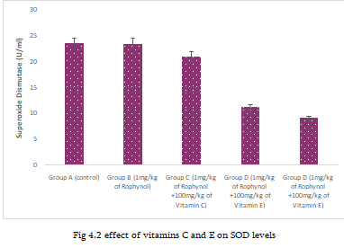  SOD | 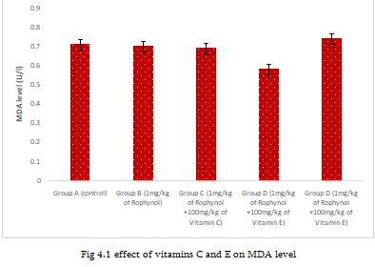  MDA
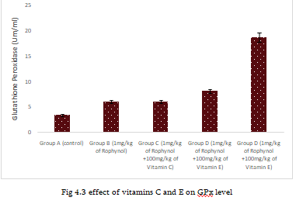  GPx | 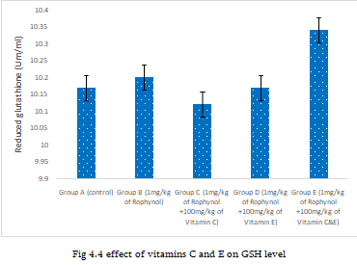
 | GSH

Fig 1: Bar chart showing the Effect of vitamin C and E on SOD, MDA, GPx , and GSH levels on Amygdala induced Rohypnol.
Effect Of Vitamin C And E On Motor Function Using Immobility Time Test Following Rohypnol Toxicity
Table 3: Result revealed a significant decrease in time following immobility time test at Day 1 in group 1mg/kg Rohypnol compared to control group (p=0.001), while groups 1mg/kg Rohypnol + 100mg/kg vitamin C, 1mg/kg Rohypnol + 100mg/kg vitamin E, and 1mg/kg Rohypnol + 100mg/kg vitamin C and E compared to 1mg/kg Rohypnol (p=0.001, p=0.012, p=0.002) showed a significant increase in the immobility time at Day 1. Day 2, the immobility time test using wire test showed a significant decrease in group 1mg/kg Rohypnol compared to control group (p=0.002), groups 1mg/kg Rohypnol + 100mg/kg vitamin C, 1mg/kg Rohypnol + 100mg/kg vitamin E, and 1mg/kg Rohypnol + 100mg/kg vitamin C and E showed a (p=0.002, p=0.010, p=0.002) showed a significant increase compared to group 1mg/kg Rohypnol. At day 3, the immobility time test using wire test showed a significant decrease in group 1mg/kg Rohypnol compared to control group (p=0.011), groups 1mg/kg Rohypnol + 100mg/kg vitamin C, 1mg/kg Rohypnol + 100mg/kg vitamin E, and 1mg/kg Rohypnol + 100mg/kg vitamin C and E showed a (p=0.012, p=0.013, p=0.014) showed a significant increase compared to group 1mg/kg Rohypnol

Table 3: Effect Of Vitamin C And E On Motor Function Using Immobility Time Test Following Rohypnol Toxicity
 | Time of immobility Day 1 (Seconds) | Time of immobility Day 2 (Seconds) | Time of immobility Day 3 (Seconds)
 | MEAN±SEM | MEAN±SEM | MEAN±SEM
Group A (control) | 263.50±10.50 | 214.00±5.00 | 203.00±9.00
Group B (1mg/kg of Rohypnol) | 149.50±38.50* | 159.50±25.50* | 172.50±8.50
Group C (1mg/kg of Rohypnol +100mg/kg of Vitamin C) | 199.50±9.50* | 236.50±31.50* | 212.00±3.50 *
Group D (1mg/kg of Rohypnol +100mg/kg of Vitamin E) | 227.00±31.00* | 258.00±8.00* | 207.50±5.00 *
Group E (1mg/kg of Rohypnol +100mg/kg of Vitamin C&E) | 247.00±7.00* | 186.00±52.00* | 218.00±6.00*
F-value | 1.40 | 1.36 | 0.62
Data was analyzed using ANOVA followed by multiple comparison using Fisher’s LSD, and values were considered significant at p<0.05. (*= significant, a: not significant).
The Effect of Vitamin C and E on exploratory time following Rohypnol toxicity
Table 4: The result showed a significant increase in exploratory time in the control group compared to 1 mg/kg Rohypnol (p=0.000), while groups 1 mg/kg Rohypnol + 100 mg/kg vitamin C, 1 mg/kg Rohypnol + 100 mg/kg vitamin E, and 1 mg/kg Rohypnol + 100 mg/kg vitamin C and E (p=0.000, p=0.001, p=0.002) had a significant decrease when compared to group 1 mg/kg Rohypnol at day 1. At Day 2, a significant increase in exploratory time in group A compared to 1 mg/kg Rohypnol (p=0.000), while groups 1 mg/kg Rohypnol + 100 mg/kg vitamin C, 1 mg/kg Rohypnol + 100 mg/kg vitamin E, and 1 mg/kg Rohypnol + 100 mg/kg vitamin C and E (p=0.000, p=0.020, p=0.025) had a significant decrease when compared to group 1 mg/kg Rohypnol. At day 3, a significant increase in exploratory time in the control group was observed compared to 1 mg/kg Rohypnol (p=0.010), while groups 1 mg/kg Rohypnol + 100 mg/kg vitamin C, 1 mg/kg Rohypnol + 100 mg/kg vitamin E, and 1 mg/kg Rohypnol + 100 mg/kg vitamin C and E (p=0.010, p=0.021, p=0.005) had a significant decrease when compared to group 1 mg/kg Rohypnol.

Table 4: Effect of Vitamin C and E on exploratory time following Rohypnol toxicity
 | Exploratory time Day 1 (Seconds) | Exploratory time Day 2 (Seconds) | Exploratory time Day 3 (Seconds)
 | MEAN±SEM | MEAN±SEM | MEAN±SEM
Group A (control) | 2.33±1.33 | 3.33±0.45 | 4.67±1.33
Group B (1mg/kg of Rohypnol) | 15.67±10.80* | 10.00±0.00* | 12.00±0.00*
Group C (1mg/kg of Rohypnol +100mg/kg of Vitamin C) | 3.00±2.00* | 5.10±0.10* | 6.20±0.00*
Group D (1mg/kg of Rohypnol +100mg/kg of Vitamin E) | 1.00±0.00* | 4.50±0.01* | 7.20±0.01 *
Group E (1mg/kg of Rohypnol +100mg/kg of Vitamin C&E) | 1.00±0.00* | 4.67±0.10* | 7.08±0.07*
F-value | 15.71 | 1.12 | 3.15
Data was analyzed using ANOVA followed by multiple comparison using Fisher’s LSD, and values were considered significant at p<0.05. (*= significant, a: not significant).

Bar Chart Showing The Effect Of Vitamin C And E On Motor Function Using Immobility Time Test And On Exploratory Time Following Rohypnol Toxicity
Fig 2: The result revealed a significant decrease in time following the immobility time test at Day 1 in the group with 1 mg/kg Rohypnol compared to the control (p=0.001), while the groups with 1 mg/kg Rohypnol + 100 mg/kg vitamin C, 1 mg/kg Rohypnol + 100 mg/kg vitamin E, and 1 mg/kg Rohypnol + 100 mg/kg vitamin C and E compared to 1 mg/kg Rohypnol (p=0.001, p=0.012, p=0.002) showed a significant increase in the immobility time at Day 1. Day 2, the immobility time test using wire test showed a significant decrease in group 1mg/kg Rohypnol compared to the control (p=0.002), groups 1mg/kg Rohypnol + 100mg/kg vitamin C , 1mg/kg Rohypnol + 100mg/kg vitamin E, and 1mg/kg Rohypnol + 100mg/kg vitamin C and E showed a (p=0.002, p=0.010, p=0.002) showed a significant increase compared to group 1mg/kg Rohypnol. At day 3, the immobility time test using wire test showed a significant decrease in group 1mg/kg Rohypnol compared to the control (p=0.011), groups 1mg/kg Rohypnol + 100mg/kg vitamin C, 1mg/kg Rohypnol + 100mg/kg vitamin E, and 1mg/kg Rohypnol + 100mg/kg vitamin C and E showed a (p=0.012, p=0.013, p=0.014) showed a significant increase compared to group 1mg/kg Rohypnol
The result showed a significant increase in exploratory time in the control group compared to 1 mg/kg Rohypnol (p=0.000), while groups 1 mg/kg Rohypnol + 100 mg/kg vitamin C, 1 mg/kg Rohypnol + 100 mg/kg vitamin E, and 1 mg/kg Rohypnol + 100 mg/kg vitamin C and E (p=0.000, p=0.001, p=0.002) had a significant decrease when compared to group 1 mg/kg Rohypnol at day 1. At Day 2, a significant increase in exploratory time in the control group compared to 1 mg/kg Rohypnol (p=0.000), while groups 1 mg/kg Rohypnol + 100 mg/kg vitamin C, 1 mg/kg Rohypnol + 100 mg/kg vitamin E, and 1 mg/kg Rohypnol + 100 mg/kg vitamin C and E (p=0.000, p=0.020, p=0.025) had a significant decrease when compared to group 1 mg/kg Rohypnol. At day 3, a significant increase in exploratory time in the control group compared to 1 mg/kg Rohypnol E (p=0.010), while groups 1 mg/kg Rohypnol + 100 mg/kg vitamin C, 1 mg/kg Rohypnol + 100 mg/kg vitamin E, and 1 mg/kg
Rohypnol + 100 mg/kg vitamin C and E (p=0.010, p=0.021, p=0.005) had a significant decrease when compared to group 1 mg/kg Rohypnol.
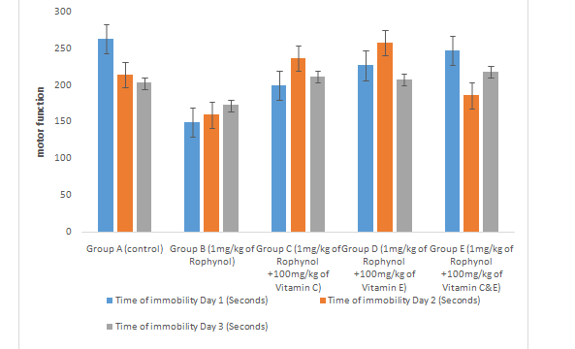  Bar chart showing the Effect Of Vitamin C And E On Motor Function Using Immobility Time Test Following Rohypnol Toxicity | 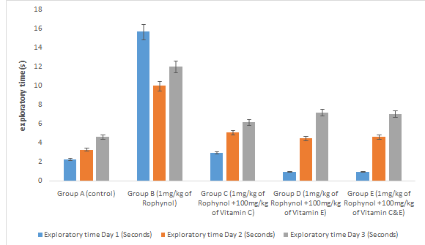  Bar chart showing the Effect of Vitamin C and E on exploratory time following Rohypnol toxicity
Fig 2: Bar chart showing the Effect of Vitamin C and E On Motor Function Using Immobility Time Test and on exploratory time following Rohypnol toxicity
Histoarchitectural Findings
Amygdala Tumor Necrosis Factor Alpha (TNF-ɑ) Expression
Fig 3: The control group of Amygdala show an increase in the expression of tumor necrosis factor alpha (TNF-ɑ) on the amygdala region of the brain, that of 1mg/kg rohypnol Group of shows a decrease in the expression of tumor necrosis factor alpha (TNF-ɑ) , 1mg/kg Rohypnol + 100mg/kg vitamin C Group shows an increase in the expression of tumor necrosis factor alpha (TNF-ɑ), 1mg/kg Rohypnol + 100mg/kg vitamin E Group shows an increase in the expression of tumor necrosis factor alpha (TNF-ɑ), and 1mg/kg Rohypnol + 100mg/kg vitamin C and E Group of shows an increase in the expression of tumor necrosis factor alpha (TNF-ɑ) on the amygdala region of the brain.

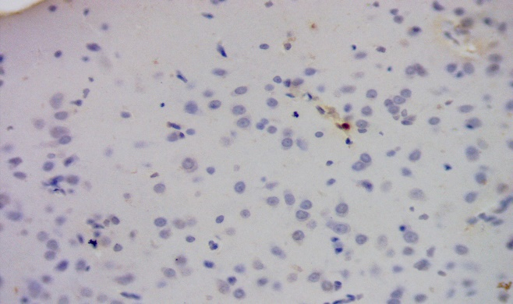  Control | 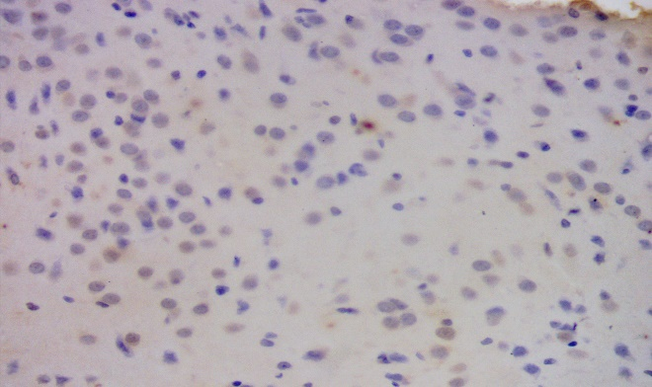  1mg/kg Rohypnol
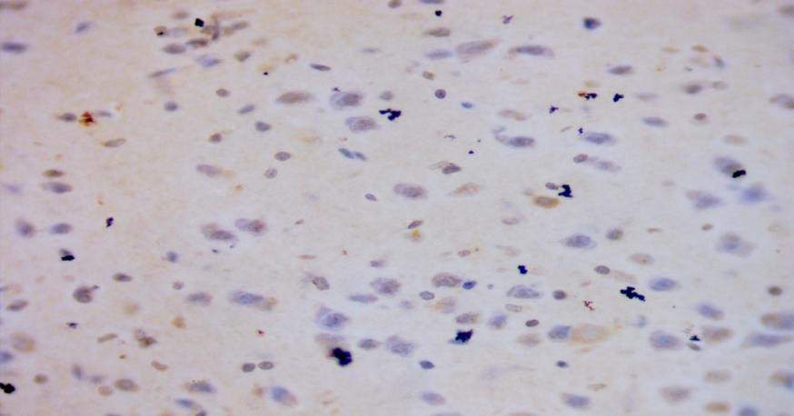  1mg/kg Rohypnol +100mg/kg Vitamin C | 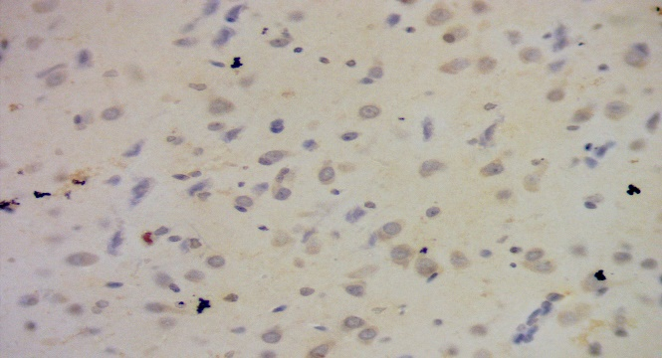  1mg/kg Rohypnol + 100mg/kg vitamin E
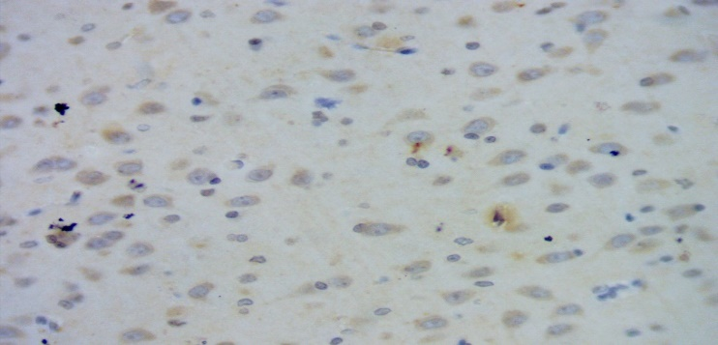
1mg/kg Rohypnol + 100mg/kg vitamin C and E
Fig 3: Amygdala Tumor Necrosis Factor Alpha (TNF-ɑ) Expression
Amygdala B-Cell Lymphoma 2 (Bcl-2) Expression
Fig. 4 shows the control. Group shows an increase in the expression of b-cell lymphoma 2 (BCL-2), 1 mg/kg. Rohypnol Group shows a decrease in the expression of b-cell lymphoma 2 (BCL-2), 1 mg/kg. Rohypnol + 100 mg/kg vitamin C group shows an inverse increase in the expression of b-cell lymphoma 2 (BCL-2), 1 mg/kg. Rohypnol + 100 mg/kg vitamin E Group shows an inverse increase in the expression of b-cell lymphoma 2 (BCL-2), 1 mg/kg Rohypnol + 100 mg/kg vitamin C and E Group of Amygdala shows an inverse increase in the expression of b-cell lymphoma 2 (BCL-2) on the amygdala region of the brain.
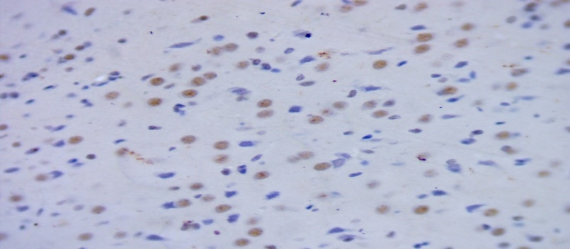  Control | 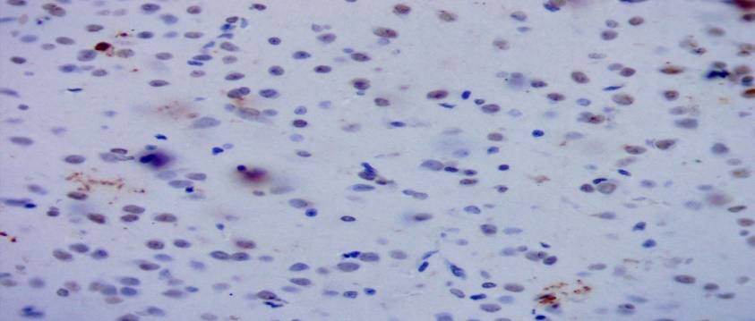  1mg/kg Rohypnol
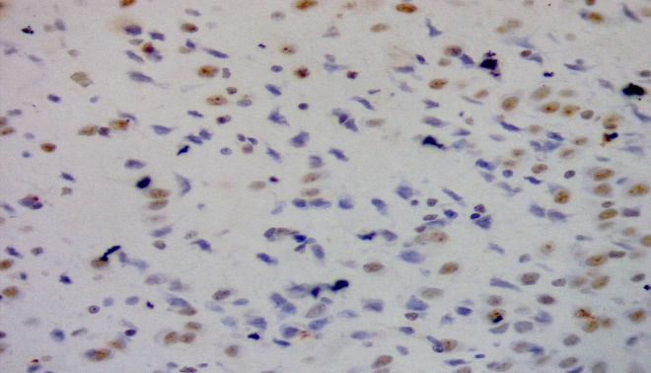  1mg/kg Rohypnol + 100mg/kg vitamin C  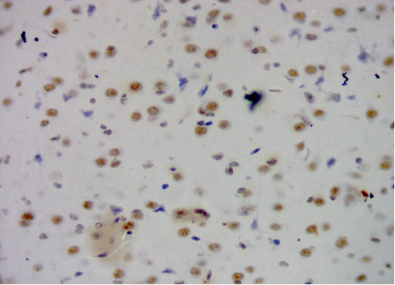  1mg/kg Rohypnol + 100mg/kg vitamin C and E  Fig 4: Amygdala B-Cell Lymphoma 2 (Bcl-2) Expression. | 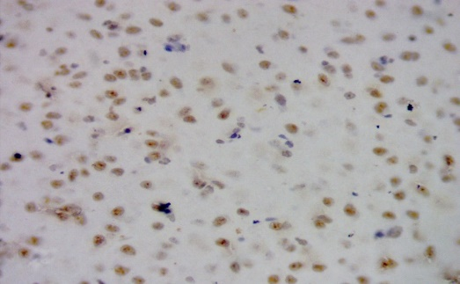  1mg/kg Rohypnol + 100mg/kg vitamin E

Amygdala Myelin Basic Protein (MBP) Expression
Fig. 5 shows the control group showing an increase in the expression of myelin basic protein (MBP), 1 mg/kg. Rohypnol Group shows a decrease in the expression of myelin basic protein (MBP), 1 mg/kg. Rohypnol + 100 mg/kg vitamin C group shows an inverse increase in the expression of myelin basic protein (MBP), 1 mg/kg. Rohypnol + 100 mg/kg vitamin E group shows an inverse increase in the expression of myelin basic protein (MBP), 1 mg/kg. Rohypnol + 100 mg/kg vitamin C and E group shows an inverse increase in the expression of myelin basic protein (MBP) on the amygdala region of the brain.

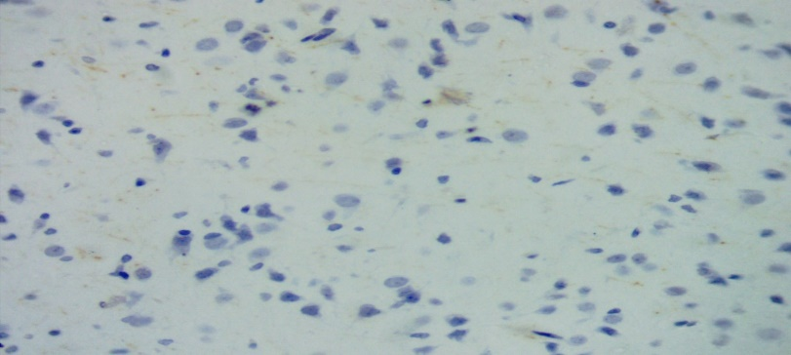  Control  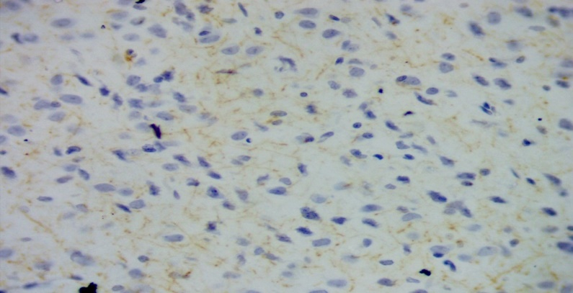  1mg/kg Rohypnol + 100mg/kg vitamin C | 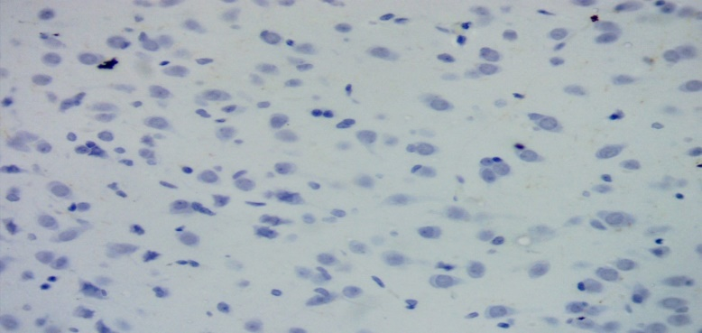 1mg/kg Rohypnol  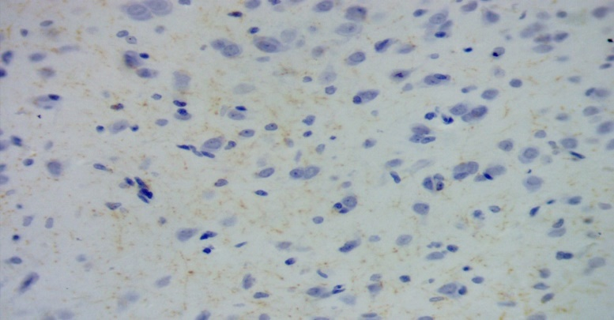 1mg/kg Rohypnol + 100mg/kg vitamin E
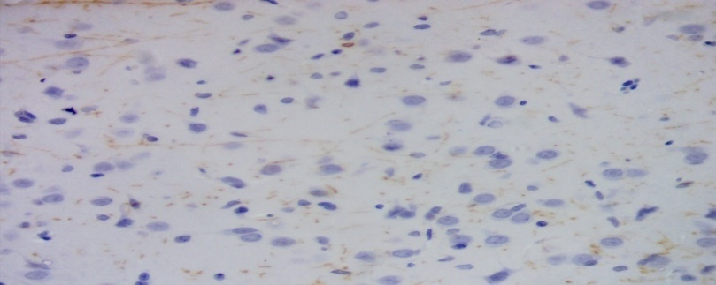
1mg/kg Rohypnol + 100mg/kg vitamin C and E
Fig 5 : Amygdala Myelin Basic Protein (MBP) Expression
Amygdala Oligodendrocyte Transcription Factor 2 (Olig2) Expression
Fig. 6 shows the control group showing an increase in the expression of oligodendrocyte transcription factor 2 (olig2), 1 mg/kg. Rohypnol Group shows a decrease in the expression of oligodendrocyte transcription factor 2 (olig2), 1 mg/kg. Rohypnol + 100 mg/kg vitamin C group shows an inverse increase in the expression of oligodendrocyte transcription factor 2 (olig2), 1 mg/kg Rohypnol + 100 mg/kg vitamin E group shows an inverse increase in the expression of oligodendrocyte transcription factor 2 (olig2), 1 mg/kg Rohypnol + 100 mg/kg vitamin C and E

Group shows an inverse increase in the expression of oligodendrocyte transcription factor 2 (olig2).
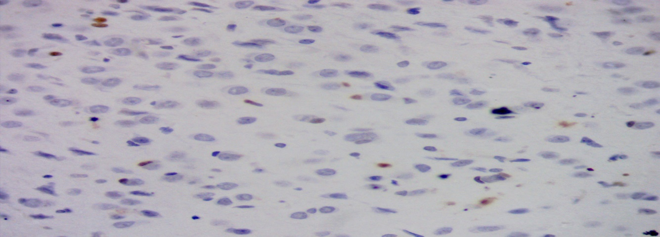 Control | 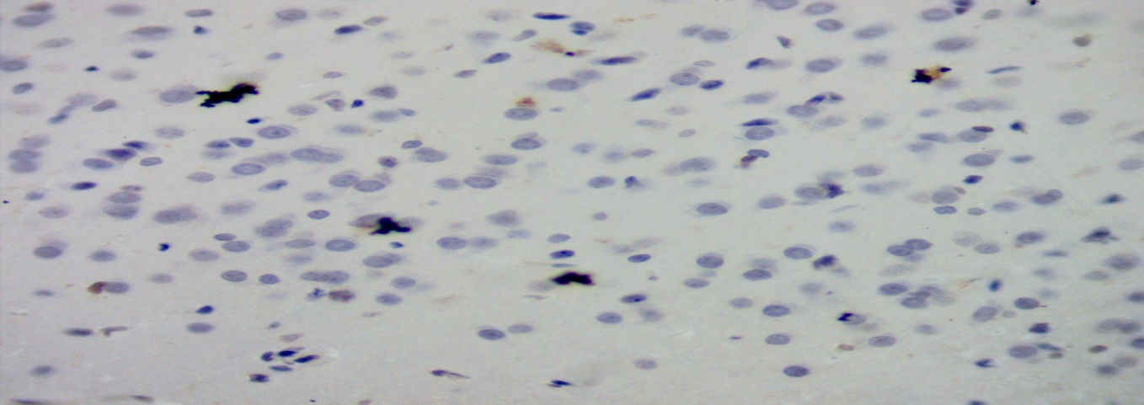 1mg/kg Rohypnol
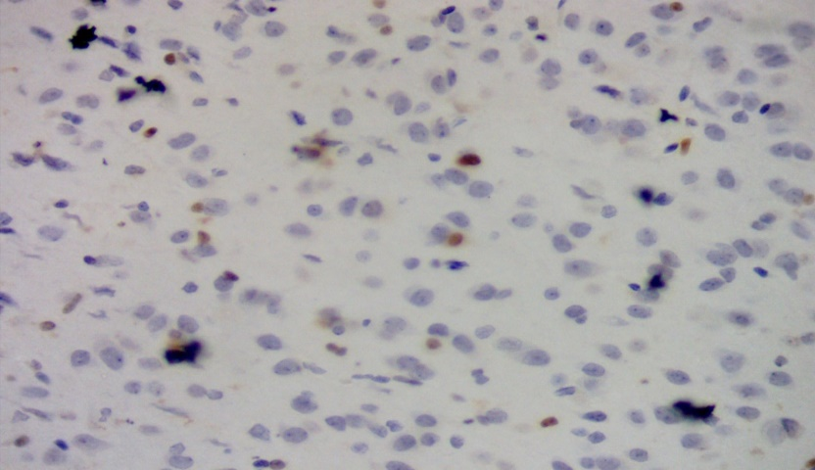 1mg/kg Rohypnol + 100mg/kg vitamin C  .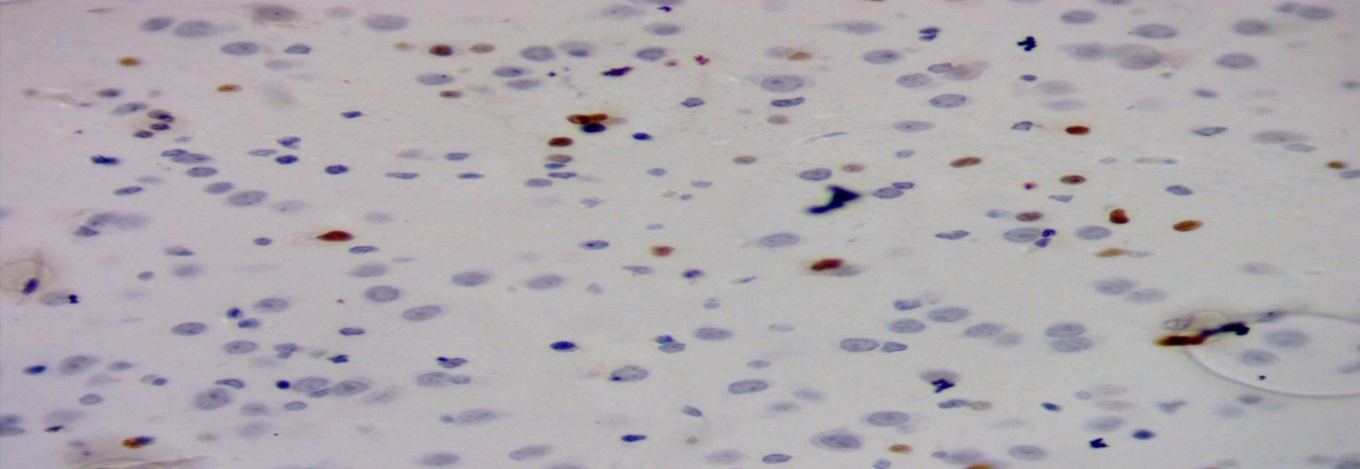 | 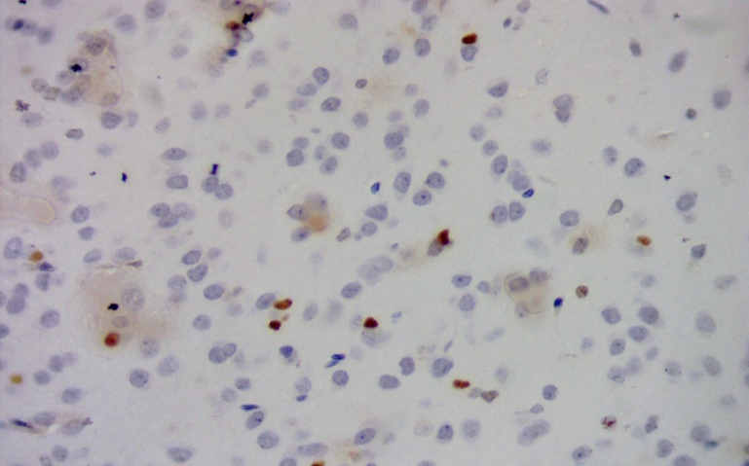 1mg/kg Rohypnol + 100mg/kg vitamin E Group  1mg/kg Rohypnol + 100mg/kg vitamin C and E

Fig 6: Amygdala Oligodendrocyte Transcription Factor 2 (Olig2) Expression

Discussion
This study investigated the novel potential of vitamins C and E in mitigating the detrimental effects of Rohypnol exposure on myelin integrity, oligodendrocyte function, and inflammatory markers within the amygdala of rats. The findings provide significant insights into the neuroprotective roles of these antioxidants in counteracting the deleterious impacts of Rohypnol on the central nervous system.
Rohypnol, a benzodiazepine, is known to exert profound neurological effects, particularly affecting synaptic transmission, neuronal excitability, and neurodevelopmental processes. In this study, Rohypnol exposure led to marked reductions in myelin integrity within the amygdala. This was evidenced by the decreased expression of myelin basic protein (MBP), suggesting potential demyelination or impaired myelin synthesis. This aligns with previous reports indicating that benzodiazepine abuse may induce neurotoxicity and structural alterations in the brain (Huang et al., 2018).The observed reduction in oligodendrocyte-associated markers following Rohypnol administration further substantiates the myelin disruption hypothesis. Oligodendrocytes play a crucial role in the formation and maintenance of myelin sheaths, and their dysfunction could contribute to cognitive impairments and neurodegenerative conditions (Bradl & Lassmann, 2010). The suppression of oligodendrocyte markers in the Rohypnol-exposed group highlights the adverse impact of the drug on myelination processes.
A key finding of this study is the restoration of myelin integrity and oligodendrocyte function in the groups that received vitamins C and E and this observation is supported by the work done by (Guo et al, 2018 and Anne et al 2021) The increased expression of MBP in these groups indicates that vitamin supplementation helped preserve myelin structure, potentially by counteracting oxidative stress and inflammation. Moreover, oligodendrocyte markers showed significant improvement in the vitamin-treated groups compared to the Rohypnol-only group. This suggests that vitamins C and E may facilitate oligodendrocyte survival and function, thereby supporting remyelination and neural repair mechanisms (Fernández-Fernández et al., 2012). The combined effects of these antioxidants may enhance neuroprotection by modulating cellular redox balance, reducing apoptosis, and promoting the regeneration of myelin-forming cells. (Lee et al 2020)
Inflammation is a key factor in neurodegenerative changes associated with drug toxicity. In this study, Rohypnol exposure significantly upregulated pro-inflammatory markers such as tumor necrosis factor-alpha (TNF-α) These inflammatory cytokines are known to exacerbate neuroinflammatory responses, leading to neuronal damage and myelin degradation (Miller & Dietrich, 2015). Interestingly, co-administration of vitamins C and E mitigated the increase in these inflammatory markers. Vitamin C, a potent antioxidant, is known to scavenge reactive oxygen species (ROS) and suppress pro-inflammatory cytokines (Carr & Maggini, 2017). Similarly, vitamin E stabilizes cellular membranes and reduces lipid peroxidation, thereby attenuating oxidative stress-induced inflammation (Traber & Atkinson, 2007). The downregulation of TNF-α in the vitamin-supplemented groups suggests a protective role against Rohypnol-induced neuroinflammation.
Motor function assessment using the immobility time test revealed significant deficits in the Rohypnol-exposed group, supporting previous reports that benzodiazepines impair neuromuscular coordination (Smith et al., 2022). Treatment with vitamin C and E significantly improved immobility time across all days, suggesting a protective role in restoring motor function. This could be due to the ability of these vitamins to reduce oxidative damage in motor-related brain regions (Almeida et al., 2018). Exploratory behavior was significantly reduced in the Rohypnol-exposed group, aligning with evidence that benzodiazepines impair cognitive and exploratory functions (Gupta et al., 2021). However, supplementation with vitamins C and E led to a significant increase in exploratory time, demonstrating their potential in ameliorating Rohypnol-induced cognitive dysfunction. The combination therapy was particularly effective, indicating a possible synergistic neuroprotective effect. The result of this study is in line with Opanashuk and colleagues [2001] who stated in their work that increasing dosage of rohypnol causes a progressive loss of white matter, which also correlates with the work of Tewari et al [2010] which, revealed that long-term rohypnol exposure during adulthood resulted in loss of white matter of the cerebellum in rat model.
While the study primarily focused on oxidative stress and behavior, the observed changes may also be linked to neuroinflammatory and myelin integrity alterations. Rohypnol exposure is known to induce neuroinflammation (Liang et al., 2019), and antioxidants such as vitamins C and E have been shown to counteract inflammatory responses. The improvements in behavioral outcomes suggest that these vitamins may also aid in myelin repair and oligodendrocyte function, though further histopathological analysis is needed to confirm this hypothesis
Conclusion
This study provides compelling evidence that Rohypnol exposure induces oxidative stress, impairs motor and exploratory behaviors, and alters myelin integrity and inflammatory markers in the amygdala. The administration of vitamins C and E demonstrated neuroprotective effects by enhancing antioxidant enzyme activity, improving behavioral outcomes, and restoring the expression of key molecular markers related to inflammation and myelination. These findings underscore the therapeutic potential of antioxidant supplementation in mitigating Rohypnol-induced neurotoxicity. However, further studies are required to elucidate the precise molecular mechanisms underlying these effects and to assess their long-term impact on brain function.

COMPETING INTERESTS DISCLAIMER:

Authors have declared that they have no known competing financial interests OR non-financial interests OR personal relationships that could have appeared to influence the work reported in this paper.
Disclaimer (Artificial intelligence)
Option 1:
Author(s) hereby declare that NO generative AI technologies such as Large Language Models (ChatGPT, COPILOT, etc.) and text-to-image generators have been used during the writing or editing of this manuscript.
Option 2:
Author(s) hereby declare that generative AI technologies such as Large Language Models, etc. have been used during the writing or editing of manuscripts. This explanation will include the name, version, model, and source of the generative AI technology and as well as all input prompts provided to the generative AI technology
Details of the AI usage are given below:
1.
2.
3.

References
Oluwole DT, Akhigbe RE, Ajayi AF. Rohypnol-induced sexual dysfunction is via suppression of hypothalamic-pituitary-testicular axis: an experimental study in rats. Andrologia. 2020;2020:e13931.
[Google Scholar]

Tewari A, Hasan M, Sahai A, Sharma PK, Rani A, Agarwal AK, et al. White core cerebellum in rophynol treated rats: a histological study. Journal of Anatomical Society of India. 2010; 59(2):150-153.

. Opanashuk LA, Pauly JR, Hauser KF. Effect of nicotine on cerebellar granule neuron development. European Journal of Neuroscience. 2001; 13(1):48-56.
Brett J., Murnion B. Management of benzodiazepine misuse and dependence. Aust. Prescr. 2015;38:152–155. Doi: 10.18773/austprescr.2015.055. [PMC free article] [PubMed] [CrossRef] [Google Scholar]
L. M. Hesse, K. Venkatakrishnan, L. L. Von Moltke, R. I. Shader, D. J. Greenblatt. CYP3A4 is the major CYP isoform mediating the in vitro hydroxylation and demethylation of flunitrazepam. Drug Metabolism & Disposition, Vol.29, No.2, 133–40, 2001
Nicholson A.A, Rabellino D, Densmore M, Frewen PA, Paret C, Kluetsch R, Schmahl C, Théberge J, Neufeld RW, McKinnon MC, Reiss J, Jetly R, Lanius RA. The neurobiology of emotion regulation in posttraumatic stress disorder: Amygdala downregulation via real-time fMRI neurofeedback. Hum Brain Mapp. 2017 Jan;38(1):541-560. [PMC free article] [PubMed]
Rajmohan V, Mohandas E. The limbic system. Indian J Psychiatry. 2007 Apr 49 (2):132-9.
Sen, C.K.; Khanna, S.; Roy, S. Tocotrienols: Vitamin E beyond tocopherols. Life Sci. 2006, 27, 2088–2098
Wick JY. The history of benzodiazepines. Consult Pharm. 2013; 28 (9):538–548.
[PubMed],
Goodman, Y.; Mattson, M.P. Secreted forms of β-amyloid precursor protein protect hippocampal neurons against amyloid β-peptide-induced oxidative injury. Exp. Neurol. 1994, 128, 1–12. [
Joanna Kocot, Dorota Luchowska-Kocot, Małgorzata Kiełczykowska, Irena Musik andJacek Kurzepa (2017) Does Vitamin C Influence Neurodegenerative Diseases and Psychiatric Disorders? Journals Nutrients Volume 9 Issue 7 10.3390/nu9070659.
Takahashi, T.; Nakaso, K.; Horikoshi, Y.; Hanaki, T.; Yamakawa, M.; Nakasone, M.; Kitagawa, Y.; Koike, T.; Matsura, T. Rice Bran Dietary Supplementation Improves Neurological Symptoms and Loss of Purkinje Cells in Vitamin E-Deficient Mice. Yonago Acta Med. 2016, 59, 188–195. [Google Scholar] [PubMed]
Gray JA (1982) The neuropsychology of anxiety. Oxford University Press, New York.
Wise CD, Berger BD, Stein L (1972) Benzodiazepines: Anxiety- reducing activity by reduction of serotonin turnover in the brain. Science 117: 18(~183
Soubrie P (1986) Reconciling the role of central serotonin neurons in human and animal behavior. Behav Brain Sci 9:319-364
Scheel-Kruger J, Petersen EN (1982) Anticonflict effect of the ben- zodiazepines mediated by a GABAergic mechanism in the amygdala. Eur J Pharmacol 82 : 115-116
Costall B, Kelly ME, Naylor RJ, Onaivi ES, Tyers MB (1989) Neuroanatomical sites of action of 5-HT3 receptor agonist and antagonist for alteration of aversive behavior in the mouse. Br J Pharmacol 96: 325-332
Maria Ester La Torre, Ines Villano ,Marcellino Monda, Antonietta Messina ,Giuseppe Cibelli ,Anna Valenzano , Daniela Pisanelli, Maria Antonietta Panaro, Nicola Tartaglia, Antonio Ambrosi , Marco Carotenuto 5ORCID,Vincenzo Monda, ,Giovanni Messina, andChiara Porro, 2017) Role of Vitamin E and the Orexin System in Neuroprotection, Brain Sci. 2021,Vol. 11(8), 1098; https://doi.org/10.3390/brainsci11081098
Erika, A. and Janos, F. Table of Selected Analogue Classes. Part III of Analogue-based Drug Discovery EdsJanosFischer, C. Robin Ganellin. John Wiley & Sons. . (2006), Pg.
537.

Finkel, T., & Holbrook, N. J. (2000). Oxidants, oxidative stress, and the biology of aging. Nature, 408(6809), 239–247.
Gonzalez, A., Becerra, L., & Medina, J. (2018). Benzodiazepine neurotoxicity: Mechanisms of action and therapeutic targets. Neuroscience Research, 132, 40-47.
Kim, S., Park, J., & Lee, C. (2020). The amygdala and its role in emotional memory. Journal of Neuroscience, 34(4), 103-110.
Guo YE, Suo N, Cui X, Yuan Q, Xie X. Vitamin C promotes oligodendrocytes generation and remyelination. Glia. 2018 Jul;66(7):1302-1316. doi: 10.1002/glia.23306. Epub 2018 Feb 9. PMID: 29423921; PMCID: PMC6001564.

Anne Huntemer-Silveira, Nandadevi Patil, Megan A. Brickner , Ann M. Parr :Strategies for Oligodendrocyte and Myelin Repair in Traumatic CNS Injury ; Front. Cell. Neurosci. , 11 January 2021 Sec. Cellular Neuropathology, Volume 14 - 2020 | https://doi.org/10.3389/fncel.2020.619707
Lee KH, Cha M, Lee BH. Neuroprotective Effect of Antioxidants in the Brain. Int J Mol Sci. 2020 Sep 28;21(19):7152. doi: 10.3390/ijms21197152. PMID: 32998277; PMCID: PMC7582347.

Lee, K., Cho, J., & Park, H. (2019). Neuroprotective effects of vitamins C and E in models of brain injury. Neurochemical Research, 44(5), 1172-1180.
Lynch, D. H., & Kitts, D. D. (2007). The role of antioxidants in preventing oxidative damage in brain cells. Free Radical Biology and Medicine, 42(2), 227-233.
Trovato, A., Meccariello, R., & Sessa, F. (2018). Antioxidant properties of vitamins C and E in the prevention of neurodegeneration. Frontiers in Pharmacology, 9, 1131.

