Case report

Gastric Neuroendocrine Carcinoma Presenting as Liver Abscess: A Rare Case Report

ABSTRACT
Gastric neuroendocrine carcinomas (NECs) are rare, accounting for less than 1% of stomach malignancies. Among these, poorly differentiated small cell subtypes comprise an even smaller proportion. These tumors often present with nonspecific gastrointestinal symptoms, making diagnosis and management challenging. We report the case of a 76-year-old female presenting with progressive epigastric pain. Clinical workup included a triphasic CT scan, endoscopy with biopsy, and immunohistochemical staining. A multidisciplinary team (MDT) approach was used to guide treatment planning. Imaging revealed a malignant-appearing gastric ulcer with liver perforation and associated multiloculated abscess. Biopsy confirmed a high-grade small cell NEC with a Ki-67 index of 90%. Following nutritional optimization via nasojejunal (NJ) feeding, the patient underwent a subtotal gastrectomy, left lateral segmentectomy of the liver, and reconstruction with gastrojejunostomy and jejunojejunostomy. Histopathology confirmed Grade III poorly differentiated NEC with lymphovascular and perineural invasion and 7 of 29 lymph nodes positive. Postoperative Gallium DOTATATE PET-CT showed no metabolically active disease. This case highlights a rare presentation of gastric NEC clinically presenting as a liver abscess. Early diagnosis and a coordinated MDT strategy were pivotal in guiding surgical and oncological management. Clinicians should maintain high suspicion for aggressive gastric malignancies in atypical abscess presentations. Further research is needed to establish standardized protocols for the diagnosis and treatment of gastric NECs.

Keywords: Gastric Neuroendocrine Carcinoma, stomach , malignancy, Liver Abscess

INTRODUCTION
Neuroendocrine neoplasms (NENs) are a rare and heterogeneous group of tumors originating from neuroendocrine cells, accounting for approximately 0.5% of all malignancies worldwide [1]. Since their initial description by Rudolf Heidenhain in 1870, ongoing research has enhanced our understanding of their classification, biology, and management. However, the low incidence and diverse presentation of NENs continue to pose challenges in establishing standardized diagnostic and therapeutic guidelines.

NENs are broadly classified into well-differentiated neuroendocrine tumors (NETs), which are typically slow-growing, and poorly differentiated neuroendocrine carcinomas (NECs), which are aggressive and rapidly proliferative [2]. NECs represent approximately 10–20% of all NENs. While nearly 90% of NECs originate in the lungs, extrapulmonary NECs—particularly those arising in the stomach—are extremely rare and less well characterized [2,3].

Gastric NECs comprise less than 1% of all gastric malignancies, and of these, only a minority are of the small cell subtype (~35%) [4]. These tumors often present with vague, nonspecific symptoms, further complicating diagnosis and delaying appropriate intervention. Here, we report a rare case of a poorly differentiated gastric small cell NEC presenting as a liver abscess and discuss the clinical, diagnostic, and therapeutic considerations, along with the importance of a multidisciplinary approach.

CASE PRESENTATION
A 76-year-old female presented to the emergency department with complaints of fever and abdominal pain localized to the epigastric region. The symptoms had been intermittently present for one year but had intensified over the preceding month. She also reported nausea and a sense of postprandial fullness. On physical examination, epigastric tenderness was noted without a palpable mass.

WORKUP
A triphasic contrast-enhanced computed tomography (CT) scan revealed a malignant-appearing gastric ulcer with raised, irregular edges perforating into the left lobe of the liver. A multiloculated lesion was noted in the liver, suggestive of an abscess. Additionally, a 1 cm lesion in segment II of the liver was suspicious for metastatic disease.

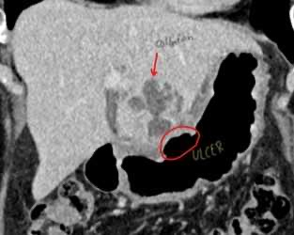
Fig 1: CT image showing a malignant ulcer along the lesser curvature of the stomach eroding into the liver resulting in a fluid collection

Endoscopic evaluation using esophagogastroduodenoscopy (EGD) revealed a malignant ulcer at the gastric incisura.

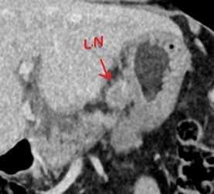
Fig 2: CT image showing enlarged lymph nodes adjacent to the site of the malignant ulcer

Ultrasound-guided percutaneous drainage of the liver abscess by interventional radiology (IR) produced purulent material, but cytology and culture were negative for malignancy. Biopsies taken during EGD were subjected to histopathological and immunohistochemical (IHC) analysis.

Microscopy revealed sheets of markedly atypical cells with hyperchromatic nuclei, high mitotic activity, and nuclear pleomorphism, consistent with a high-grade malignancy. IHC demonstrated diffuse positivity for synaptophysin, chromogranin A, cytokeratin AE1/AE3, CD56, cytokeratin 7, p16, and thyroid transcription factor-1 (TTF-1). The Ki-67 proliferation index was approximately 90%, confirming the diagnosis of a Grade III poorly differentiated small cell neuroendocrine carcinoma.

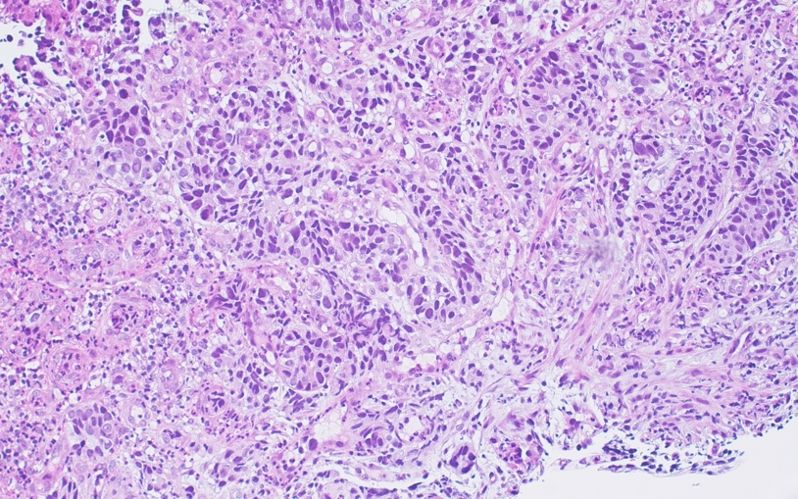
Fig 3: H&E staining, 20X

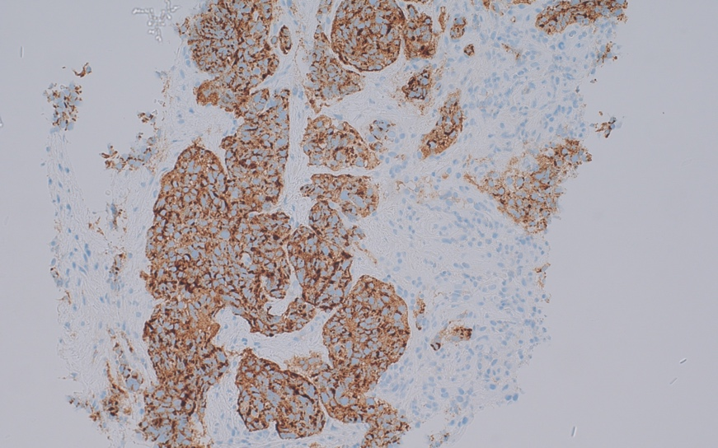
Fig 4: Chromogranin staining, 20X

MANAGEMENT
Given the patient’s septic condition and compromised nutritional status, she was initially unfit for chemotherapy. A multidisciplinary team (MDT) meeting recommended surgical management following preoperative stabilization. Nutritional optimization was achieved through a nasojejunal (NJ) feeding tube along with multivitamin supplementation. Sepsis was managed with intravenous antibiotics, and the patient was encouraged to perform incentive spirometry and early mobilization.

Surgical intervention included a subtotal gastrectomy, left lateral segmentectomy of the liver, and creation of a gastrojejunostomy and jejunojejunostomy. Postoperatively, total parenteral nutrition (TPN) was initiated, followed by resumption of NJ feeds. The NJ tube was removed once adequate oral intake was re-established. The patient was discharged after eight days with appropriate medications, including oral acetaminophen, multivitamins, and pantoprazole.

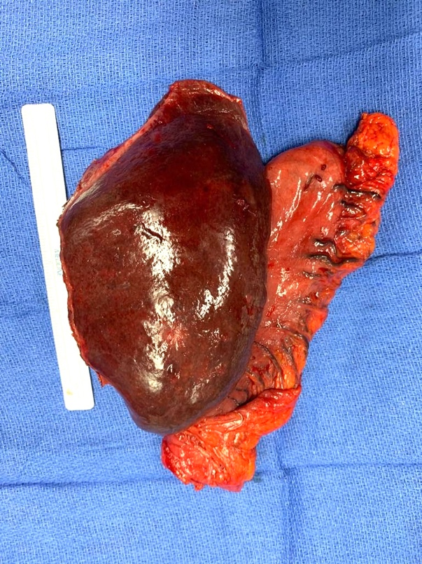
Fig 5: Gross specimen showing site of liver abscess access by IR.

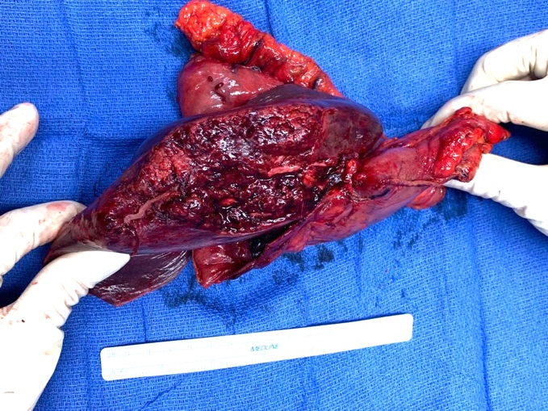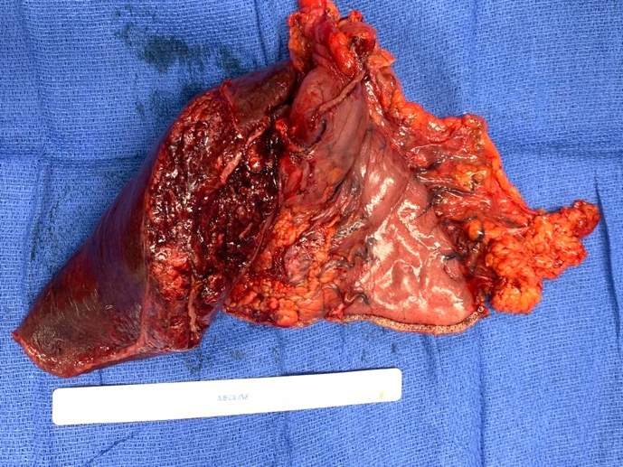
Fig 6 and 7: Gross specimen showing tumor extension from the stomach to the liver

Final histopathological analysis confirmed a Grade III poorly differentiated small cell neuroendocrine carcinoma of the stomach with lymphovascular and perineural invasion. The tumor measured 3 cm in diameter, and 7 out of 29 regional lymph nodes tested positive for metastasis. The resected liver tissue showed no evidence of malignancy. A postoperative gallium-68 DOTATATE positron emission tomography-computed tomography (PET-CT) scan revealed no residual or metabolically active disease in the abdomen. The patient was subsequently initiated on a chemotherapy regimen comprising carboplatin and etoposide.

DISCUSSION

Epidemiology and Clinical Presentation
Gastric NECs are exceedingly rare and represent a subset of highly aggressive malignancies. Among them, poorly differentiated small cell types comprise roughly one-third. Patients typically present with nonspecific symptoms such as abdominal pain, anorexia, or gastrointestinal bleeding, which often leads to delayed diagnosis. In rare cases, these tumors may invade adjacent organs and mimic infectious processes, as occurred in this patient with liver abscess formation.

Diagnostic Challenges:
The co-existence of a gastric ulcer and liver abscess posed a diagnostic dilemma. While fine-needle aspiration (FNA) is a common first-line diagnostic tool, its sensitivity can be limited in necrotic or inflammatory lesions [3,4]. In this case, FNA from the abscess cavity was negative, and the final diagnosis was established only after endoscopic biopsy and IHC. The histopathological findings ruled out hepatic metastasis, suggesting a non-metastatic, infective etiology. Recent studies, such as Liu et al. (2023), have emphasized that liver abscesses in non-hepatic malignancy patients can result from local spread of infection rather than metastatic disease, particularly when tumors erode adjacent structures [15]. This supports the hypothesis that the gastric NEC perforated into the liver, facilitating bacterial translocation and abscess formation despite the absence of malignant cells in the liver specimen.

Staging and Imaging:
Accurate staging is essential in guiding treatment strategy. While somatostatin receptor-based PET imaging such as gallium-68 DOTATATE is valuable for well-differentiated tumors, it is often less effective in high-grade NECs. Instead, fluorodeoxyglucose (FDG)-based PET imaging is more sensitive for detecting metastases in poorly differentiated NECs [6]. Interestingly, our patient’s DOTATATE PET-CT was negative postoperatively, suggesting the tumor might have expressed somatostatin receptors despite its high-grade features.

Management and Prognostic Considerations:
Due to the lack of large-scale studies on gastric NECs, treatment approaches are extrapolated from small cell lung carcinoma protocols. Chemotherapy with platinum-based agents such as cisplatin or carboplatin combined with etoposide remains the first-line treatment [12]. In our case, carboplatin was selected due to its favorable toxicity profile, especially in elderly patients.

Surgical resection was justified by the presence of sepsis, tumor-related bleeding, and compromised nutritional status. Several studies confirm that preoperative nutritional support reduces postoperative complications and hospital stay in gastrointestinal malignancies [9–11]. Post-surgical chemotherapy was pursued in accordance with guidelines and supported by studies such as the NORDIC NEC trial, which reported meaningful response rates to platinum-based regimens in NECs with high Ki-67 indices (>55%) [13,14].

This case illustrates the importance of individualized, multidisciplinary care. MDTs have been shown to significantly alter and optimize treatment plans in more than 50% of complex oncological cases [8].

CONCLUSION

Poorly differentiated gastric neuroendocrine carcinomas are rare and aggressive tumors with nonspecific clinical features that often mimic benign conditions such as abscesses. This case highlights the diagnostic complexity and therapeutic challenges associated with such malignancies. A high index of suspicion, early histopathological confirmation using immunohistochemistry, and coordinated care via a multidisciplinary team are essential for favorable outcomes.

In the absence of gastric NEC-specific guidelines, treatment must be guided by extrapolated evidence from other high-grade NECs. This case underscores the need for more robust data and prospective studies to establish tailored protocols for the diagnosis and management of gastric NECs.

Declaration of conflicting interests:The author(s) declared no potential conflicts of interest with respect to the research, authorship, and/or publication of this article.
Disclosures: The authors have no conflicts of interest to declare.The article describes a case report.
Ethical Approval : The Ethics Committee at Sheikh Khalifa Medical City waived ethical approval.

Consent : Written informed consent was obtained from the patient for publication of this case report and any accompanying images.
Disclaimer (Artificial intelligence): Author(s) hereby declare that NO generative AI technologies such as Large Language Models (ChatGPT, COPILOT, etc.) and text-to-image generators have been used during the writing or editing of this manuscript.

REFERENCES

1. de Herder WW, Rehfeld JF, Kidd M, Modlin IM. A short history of neuroendocrine tumours and their peptide hormones. Best Pract Res Clin Endocrinol Metab. 2016;30(1):3–17. doi:10.1016/j.beem.2015.10.004.

2. Das S, Dasari A. Epidemiology, incidence, and prevalence of neuroendocrine neoplasms: are there global differences? Curr Oncol Rep. 2021;23(4):43. doi:10.1007/s11912-021-01029-7.

3. Wee A, Nilsson B, Yap I, Chong SM. Aspiration cytology of liver abscesses with an emphasis on diagnostic pitfalls. Acta Cytol. 1995;39(3):453–62.

4. Aggarwal A, Gupta M, Gabriel J, Walker D. Metastatic neuroendocrine tumor masquerading as liver abscesses. Clin Case Rep. 2020;8(12):2530–5. doi:10.1002/ccr3.3224.

5. Frances N, Zeichner SB, Francavilla M, Cusnir M. Gastric small-cell carcinoma found on esophagogastroduodenoscopy: a case report and literature review. Case Rep Oncol Med. 2013;2013:475961. doi:10.1155/2013/475961.

6. Walter T, Tougeron D, Baudin E, et al. Poorly differentiated gastro-entero-pancreatic neuroendocrine carcinomas: are they really heterogeneous? Insights from the FFCD-GTE national cohort. Eur J Cancer. 2017;79:158–65. doi:10.1016/j.ejca.2017.04.009.

7. Iwasaki K, Barroga E, Enomoto M, et al. Long-term surgical outcomes of gastric neuroendocrine carcinoma and mixed neuroendocrine-non-neuroendocrine neoplasms. World J Surg Onc. 2022;20(1):165. doi:10.1186/s12957-022-02625-y.

8. Magi L, Mazzuca F, Rinzivillo M, et al. Multidisciplinary management of neuroendocrine neoplasia: a real-world experience from a referral center. J Clin Med. 2019;8(6):910. doi:10.3390/jcm8060910.

9. Heyland DK, Montalvo M, MacDonald S, Keefe L, Su XY, Drover JW. Total parenteral nutrition in the surgical patient: a meta-analysis. Can J Surg. 2001;44(2):102–11.

10. Bozzetti F, Gavazzi C, Miceli R, et al. Perioperative total parenteral nutrition in malnourished gastrointestinal cancer patients: a randomized clinical trial. JPEN J Parenter Enteral Nutr. 2000;24(1):7–14. doi:10.1177/014860710002400107.

11. Wu GH, Liu ZH, Wu ZH, Wu ZG. Perioperative artificial nutrition in malnourished gastrointestinal cancer patients. *World J Gastroenterol*. 2006;12(15):2441–4. doi:10.3748/wjg.v12.i15.2441.

12. Strosberg JR, Coppola D, Klimstra DS, et al. The NANETS consensus guidelines for the diagnosis and management of poorly differentiated (high-grade) extrapulmonary neuroendocrine carcinomas. Pancreas. 2010;39(6):799–800. doi:10.1097/MPA.0b013e3181ebb56f.

13. du Bois A, Lück HJ, Meier W, et al. A randomized clinical trial of cisplatin/paclitaxel versus carboplatin/paclitaxel as first-line treatment of ovarian cancer. JNCI J Natl Cancer Inst. 2003;95(17):1320–9.

14. Sorbye H, Welin S, Langer SW, et al. Predictive and prognostic factors for treatment and survival in 305 patients with advanced gastrointestinal neuroendocrine carcinoma (WHO G3): the NORDIC NEC study. Ann Oncol. 2013;24(1):152–60. doi:10.1093/annonc/mds276.

15. Liu YM, Ren YQ, Song SL, Zheng CS. Pyogenic liver abscess in non‐liver cancer patients and liver cancer patients treated with TACE: Etiological characteristics, treatment, and outcome analysis. Kaohsiung J Med Sci. 2023;39(1):87–94.

