Original Research Article

Effects of Perceived Mate Availability on Intrasexual Competition and Alcohol Use: Unseen Effects of Gender and Relationship Status

.
ABSTRACT

Aims: To investigate whether perceived mate availability influences intrasexual competitiveness and hypothetical alcohol consumption, and to examine the moderating role of gender and relationship status.
Study Design: Between-subjects, single-blind experimental design.
Place and Duration of Study: School of Psychology, University of Portsmouth, between March and June 2024, study was conducted online.
Methodology: A total of 129 participants initially took part. After applying exclusion criteria for non-drinkers, missing data, and poor-quality responses, 92 participants (52 females, 40 males; aged 18–54, M = 26.34, SD = 7.12) remained for analysis. Participants were randomly assigned to read priming articles simulating either mate abundance or mate scarcity. Participants completed the Intrasexual Competition Scale (ICS) and an Alcohol Purchase Task (APT). Four demand-related variables were analyzed: estimated consumption when drinks are free (Q₀), sensitivity to price increases (α), initial consumption level (intensity), and maximum spending (Omax). ANOVAs and MANOVAs were conducted to test the effects of priming condition, gender, and relationship status on these outcomes.
Results: No significant main effect of condition was found on intrasexual competitiveness. However, significant interaction effects emerged, particularly for females in romantic relationships, suggesting that relationship status moderates sensitivity to mate availability cues. For alcohol consumption, mate scarcity increased hypothetical demand (Q₀) and reduced price sensitivity (α), particularly among males in relationships. No significant effects were found for observed intensity or Omax overall, but significant interactions with gender and relationship status were present.
Conclusion: Mate availability cues influence hypothetical alcohol consumption, particularly among partnered males, supporting evolutionary models of risk-taking and mate signalling. The null effect on ICS underscores the need for improved manipulation checks and more sensitive measures of competitiveness. Given the potential health implications of increased alcohol consumption, interventions and public health campaigns should consider how mating-related cues in the social environment might indirectly promote risky drinking behaviour. Future studies should incorporate cultural and socioeconomic variables to enhance generalisability.

Keywords: Mate availability, Intrasexual competition, Alcohol consumption, Alcohol purchase task, Relationship status, Evolutionary theory

1. INTRODUCTION

Alcohol remains one of the most widely consumed psychoactive substances globally, second only to caffeine. In Europe, per capita alcohol consumption is among the highest in the world, contributing significantly to premature mortality and a wide range of health problems, including liver disease, cardiovascular issues, and psychiatric disorders such as depression and suicide (WHO, 2022; Shield et al., 2023; Rehm & Room, 2021). Beyond health consequences, alcohol misuse is also associated with social harms, including interpersonal violence, family disruption, and reduced economic productivity (Manthey et al., 2022).

Understanding the psychological mechanisms that underlie alcohol use remains a critical research priority. Traditional frameworks such as the motivational model of alcohol use (Cox & Klinger, 1988, 1990) propose that drinking is driven by interactions between valence (positive or negative reinforcement) and source (internal or external motivations). Cooper (1994) expanded this framework to identify four primary drinking motives: enhancement (to increase positive emotions), social (to facilitate social interaction), coping (to reduce negative affect), and conformity (to avoid social rejection). Similarly, expectancy theory posits that alcohol-related behaviour is shaped by beliefs about anticipated outcomes, both positive and negative (Jones et al., 2001). While these models have generated valuable insights, they rely heavily on conscious self-report and have yielded inconsistent findings across studies (Lee et al., 2020). Moreover, many studies are based on student populations and fail to account for unconscious or biologically-driven influences on behaviour, limiting their ecological validity.

These limitations have led researchers to explore alternative perspectives, including evolutionary psychology. This framework suggests that behaviours, particularly those with fitness trade-offs, may be shaped by reproductive goals rather than conscious deliberation. Sexual selection theory (Darwin, 1871; Trivers, 1972) explains how traits that may reduce survival can evolve if they enhance reproductive success. Due to lower obligatory parental investment, males in many species, including humans, tend to adopt riskier strategies to maximise mating opportunities (Emlen & Oring, 1977). Human males, for example, are more likely to engage in short-term mating and value physical attractiveness, while females tend to prioritise partner stability and resource acquisition (Buss & Schmitt, 2019). These sex differences influence intrasexual competition, with men more likely to engage in dominance- or status-oriented behaviours, while women may enhance physical appearance or compete indirectly for mates (Fisher & Cox, 2016).

Importantly, competitive behaviours may include risk-taking acts that signal fitness to potential mates. Just as the peacock’s tail serves as a costly signal of genetic quality, modern human behaviours, such as conspicuous consumption, aggression, or substance use, may function as socially strategic displays. While early theories viewed female competitiveness as a by-product of male aggression (Wallace, 1891), contemporary research recognises that both sexes engage in intrasexual competition when access to mates or mate-relevant resources is restricted (Rosvall, 2011; Arnocky et al., 2014). For example, women may enhance attractiveness or derogate rivals, while men may take physical or financial risks to gain status.

Emerging research suggests that alcohol consumption may also serve mating-related functions, especially among men. Studies have shown that drinking games are used as competitive displays in mating contexts (Hone & McCullough, 2015), and that men may increase their alcohol use when exposed to attractive peers or perceived mate competition (Vincke, 2016). Intrasexual competitiveness has also been linked to hazardous alcohol use and other high-risk behaviours (Harris et al., 2019; Galli et al., 2022), although causality is difficult to establish. Most of these studies rely on young, student samples and self-report measures, raising questions about generalisability and underlying mechanisms.

The present study aims to build on this emerging literature by testing whether perceived mate availability influences intrasexual competitiveness and hypothetical alcohol consumption in a more demographically diverse sample. It also examines the moderating roles of gender and relationship status, two variables known to influence both mating motives and substance use (Pedersen et al., 2009; Gervais et al., 2020). Alcohol demand was measured using the Alcohol Purchase Task (Murphy & MacKillop, 2006), which yields behavioural economic indicators such as consumption intensity and price sensitivity.

The following hypotheses were tested: (1) Mate scarcity would increase intrasexual competitiveness; (2) higher intrasexual competitiveness would be associated with increased alcohol consumption and reduced price sensitivity; (3) gender and relationship status would moderate these effects.

2. material and methods

2.1 Participants

A total of 129 participants completed the study. After applying exclusion criteria (see Section 2.4.1), the final sample included 92 participants (52 females), aged 18 to 54 years (M = 26.34, SD = 7.12). Participants were recruited online via Facebook, targeting individuals from the United Kingdom and Lithuania. Eligibility criteria included being 18 years or older and reporting any alcohol consumption. Participation was voluntary.
Table 1. Demographic characteristics by condition.

Variable | Mate Abundance (N=41) | Mate Scarcity (N=51)
Mean Age (SD) | 25.90 (5.44) | 26.69 (8.26)
Gender (M/F) | 20 / 21 | 20 / 31
White Ethnicity (%) | 80% | 80%
Single (%) | 37% | 39%
Drinking Frequency (%)
Monthly or less | 24% | 27%
2–4 times/month | 44% | 43%
2–3 times/week | 27% | 26%
4+ times/week | 5% | 4%

Notes. *Drinking frequencies: 1. Monthly or less, 2. 2-4 times per month, 3. 2-3 times per week, 4. 4 or more times per week.

2.2 Design

This was a single-blind, between-subjects experimental study conducted online using the Gorilla platform. Participants were randomly assigned to one of two conditions: mate abundance or mate scarcity. The independent variables were condition, gender, and relationship status. The dependent variables included intrasexual competitiveness and alcohol consumption, operationalised through four indices.

2.3 Ethical approval

Ethical approval was granted by the University of Portsmouth Department of Psychology Ethics Committee. Consent form was signed before partaking in this study.

2.4 Materials and Procedure

2.4.1 Demographics Questionnaire
Participants first completed a demographics questionnaire assessing age, gender, ethnicity, relationship status, and drinking frequency.

2.4.2 Priming Task
Participants were randomly allocated (1:1 ratio) to the mate abundance or mate scarcity condition. Each group read a brief fictitious article, adapted from Spielmann et al. (2009), designed to manipulate perceived mate availability. Articles in the abundance condition described favourable romantic prospects and high partner availability, while the scarcity condition emphasised limited opportunities and difficulty finding new partners. These manipulations have previously been validated and shown to affect intrasexual competition (Arnocky et al., 2014).

2.4.3 Intrasexual Competition Scale (ICS)
Participants then completed the 12-item ICS (Buunk & Fisher, 2009), which measures competitiveness toward same-sex individuals. Items were rated on a 7-point Likert scale (1 = not at all applicable to 7 = completely applicable). Example items include: "I can't stand it when I meet someone of the same sex who is more attractive than I am." A mean score was computed by averaging all item responses. Higher scores indicate stronger intrasexual competitiveness. The ICS has demonstrated good reliability in previous studies (e.g., α = 0.83; Harris et al., 2019).

2.4.4 Alcohol Purchase Task (APT)

Following the ICS, participants completed the APT (Murphy & MacKillop, 2006). This behavioural economic task measures hypothetical alcohol demand across increasing price points (£0 to £9 per drink). Participants imagined being at a bar with friends from 9 PM to 2 AM, where standard alcoholic drinks were available. They were asked how many drinks they would consume at each price point (e.g., "How many drinks would you purchase if each cost £1?").

The task generated four dependent variables: Derived Q₀: estimated consumption at zero price; Derived α: price sensitivity (elasticity); Observed Intensity: actual consumption at £0; Observed Omax: maximum monetary expenditure across prices.

The APT has demonstrated validity in both hypothetical and real settings (Amlung et al., 2012).

2.5 Data Analysis

2.5.1 Data Cleaning

A total of 129 participants initially completed the study. Of these, 37 participants were excluded based on predefined eligibility and data quality criteria, leaving a final sample of 92 participants. Three participants were excluded because they either did not report their gender or selected a non-binary option. Given that the study required binary gender categorisation for condition-specific analyses and defaulted to female-targeted measures, these participants could not be reliably classified and were therefore removed from analysis.

Seventeen participants indicated that they never consumed alcohol. Because the Alcohol Purchase Task (APT) relies on respondents' prior experience with alcohol to produce meaningful hypothetical consumption estimates, including abstainers would have undermined the validity of the behavioural economic indices and overall model assumptions.

In addition, eleven participants were excluded due to poor-quality APT data, based on the criteria outlined by Stein et al. (2015). Specifically, three participants failed to provide responses to one or more APT items, thereby preventing curve modelling. Six participants violated the “Bounce” criterion, which occurs when consumption unexpectedly increases across successive price points, reflecting inconsistency in price sensitivity. Two participants violated the “Reversals from Zero” criterion, indicating renewed consumption at higher prices after previously reporting zero demand, which compromises the logical structure of the demand curve. These types of violations are considered indicators of non-systematic responding and are widely excluded in behavioural economic research to ensure data integrity.

An additional five participants were removed as extreme outliers due to exceptionally high consumption values that substantially deviated from the group mean. These values distorted the distribution of key outcome variables and failed normality tests necessary for conducting parametric analyses.

After all exclusions, the final analytic sample consisted of 92 participants, with 41 in the mate abundance condition and 51 in the mate scarcity condition.

2.5.2 ICS Analysis

Mean ICS scores were analysed using a three-way between-subjects ANOVA with condition, gender, and relationship status as factors. Levene’s test indicated no violations of variance homogeneity.

2.5.3 Alcohol Purchase Task Analysis

Demand curves were modelled using Hursh and Silberberg’s (2008) exponential equation:
ln(Q) = ln(Q₀) + k(e^(–α × Q₀ × C) – 1), where: Q = consumption at price C, Q₀ = baseline consumption (at or near zero price), α = price elasticity, k = constant (set to 2.3, reflecting a log consumption range of 10). Zero values were replaced with 0.01 to enable log transformation. Curve fitting and model comparisons were conducted using GraphPad Prism 9.2.0.

Additionally, observed intensity and Omax values were directly analysed. Observed intensity corresponded to the number of drinks at £0. Omax was calculated by multiplying each consumption response by the corresponding price and extracting the highest value. As these variables were positively correlated (r = 0.52, p = .001), a multivariate analysis of variance (MANOVA) was used to assess effects of condition, gender, and relationship status. Assumptions of multivariate normality and equality of variance were met (Box’s M and Levene’s tests non-significant).

All statistical analyses were conducted using IBM SPSS Statistics Version 26.0 and GraphPad Prism Version 9.2.0.

3. results

3.1 Intrasexual Competition Scale

A three-way ANOVA was conducted with ICS scores as the dependent variable and condition, gender, and relationship status as between-subjects factors. There was no significant main effect of condition on ICS score, F(1, 79) = 0.34, p = .56, ηp² = .001, 95% CI [–0.22, 0.12], indicating that mate availability manipulation did not affect intrasexual competitiveness overall.
A significant main effect of gender was observed, F(1, 79) = 4.68, p = .03, ηp² = .06, 95% CI [0.01, 0.34], with males scoring higher on ICS than females. Relationship status showed no significant main effect, F(1, 79) = 1.42, p = .29, ηp² = .04.
However, there was a significant interaction between condition and relationship status, F(1, 79) = 4.90, p = .03, ηp² = .06, 95% CI [0.02, 0.38]. Pairwise comparisons revealed that, within the mate scarcity condition, participants in romantic relationships had higher ICS scores than single participants. Although the three-way interaction of condition × gender × relationship status was not significant (F(1, 79) = 0.42, p = .52, ηp² = .001), further comparisons showed that among females, relationship status influenced competitiveness under mate scarcity: partnered females scored higher than single females.
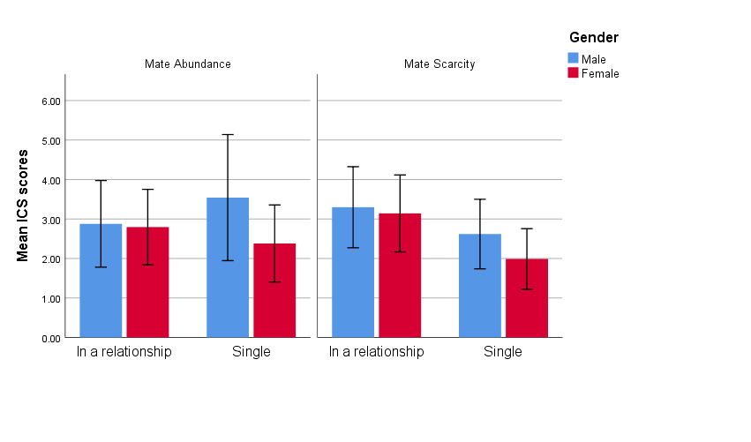
Note. Higher scores indicate stronger willingness to compete with same sex individuals.
Figure 1. Mean ICS scores (+/- 1 SD) of males and females based on relationship status for both conditions.
3.2 Alcohol Purchase Task

Exponential demand curves were fitted for each condition. The model fit was strong: R² = .98 for mate abundance and R² = .99 for mate scarcity. Mean derived Q₀ (i.e. estimated consumption at price zero) was 4.7 (SD = 0.79) in mate abundance and 5.2 (SD = 1.07) in mate scarcity. Derived α (price sensitivity) was 0.0063 (SD = 0.0043) in abundance and 0.0053 (SD = 0.0041) in scarcity.

Q₀ was significantly higher in mate scarcity, F(1, 21) = 7.60, p = .01, ηp² = .27, 95% CI [0.12, 0.85], indicating greater baseline demand. α was significantly lower under scarcity, F(1, 21) = 21.00, p = .001, ηp² = .50, 95% CI [–0.0015, –0.0006], indicating reduced price sensitivity. These results support the hypothesis that mate scarcity increases alcohol demand.
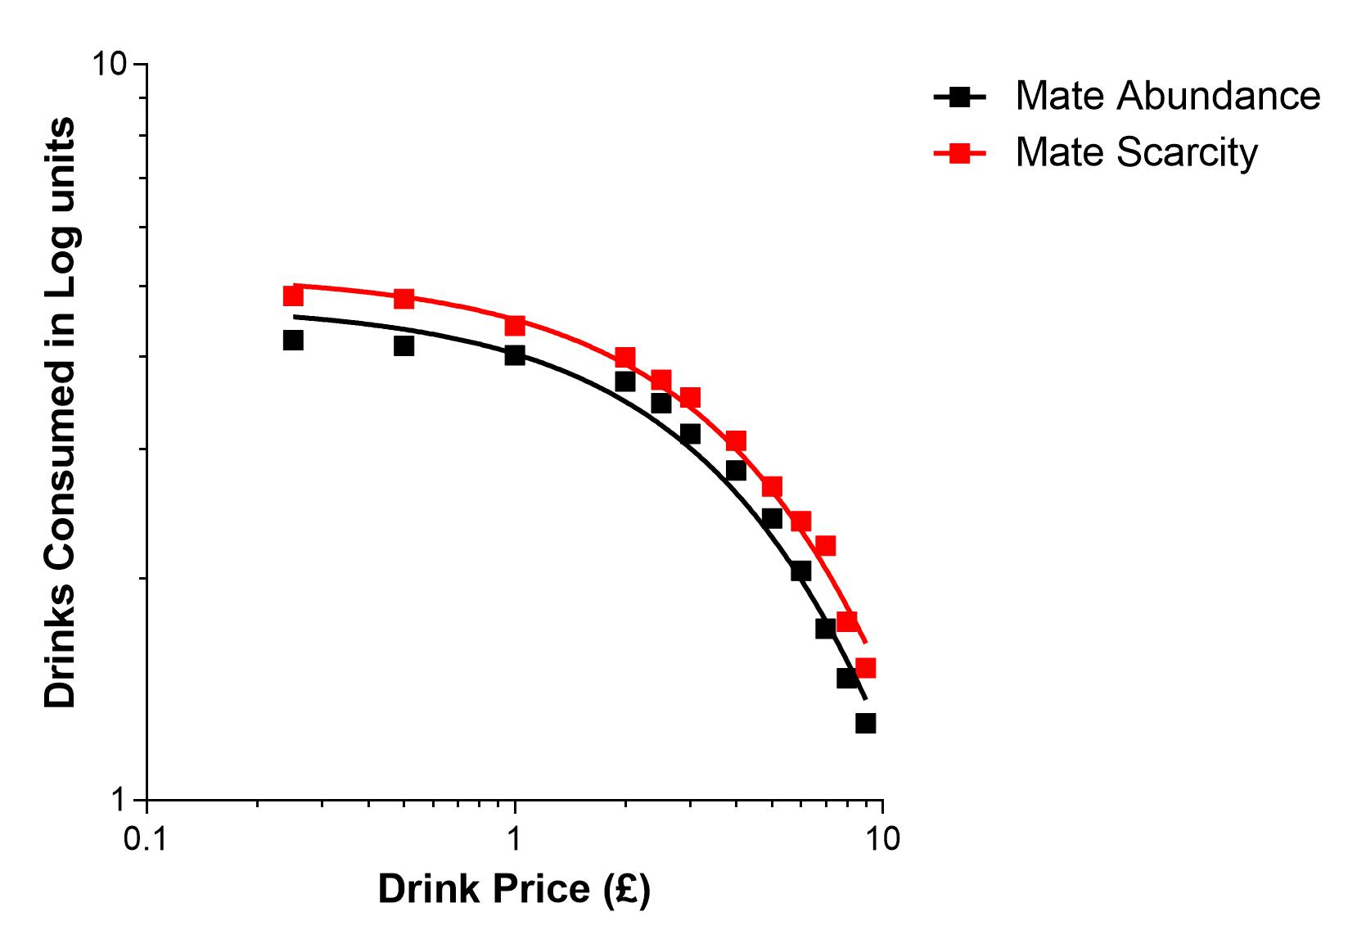
Figure 2. Demand curve (log consumption; price). Mean alcohol demand curve for both conditions.

To analyse observed values (consumption intensity and maximum expenditure), a MANOVA was performed with condition, gender, and relationship status as factors. There were no significant main effects of condition, F(2, 78) = 0.19, p = .82, Wilks’ λ = .99, ηp² = .005, or gender, F(2, 78) = 1.73, p = .18, Wilks’ λ = .96, ηp² = .04. Relationship status had a marginally significant effect, F(2, 78) = 2.43, p = .05, Wilks’ λ = .87, ηp² = .06, suggesting higher consumption among single participants.
A significant interaction was found between condition and relationship status, F(2, 78) = 4.19, p = .02, Wilks’ λ = .90, ηp² = .10. (Note: Wilks’ lambda is a multivariate test statistic indicating the proportion of unexplained variance.) Pairwise comparisons indicated that participants in relationships under mate scarcity reported higher observed intensity and maximum expenditure than their abundance counterparts.
The interaction between condition and gender was not significant, F(2, 78) = 1.27, p = .29, Wilks’ λ = .97, ηp² = .03. However, the three-way interaction (condition × gender × relationship status) was significant, F(2, 78) = 4.42, p = .02, Wilks’ λ = .90, ηp² = .10. Specifically, partnered males in mate scarcity showed higher observed Q₀ and Omax than partnered males in abundance. Additionally, single males in the mate abundance condition showed higher maximum expenditure than those in scarcity.
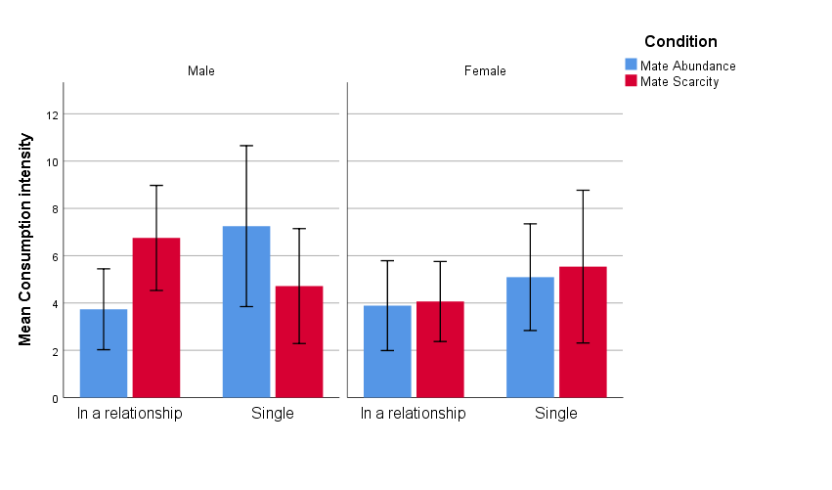
Figure 3. Mean consumption intensity values (+/- 1 SD) for both conditions separated by relationship status and filtered by gender.
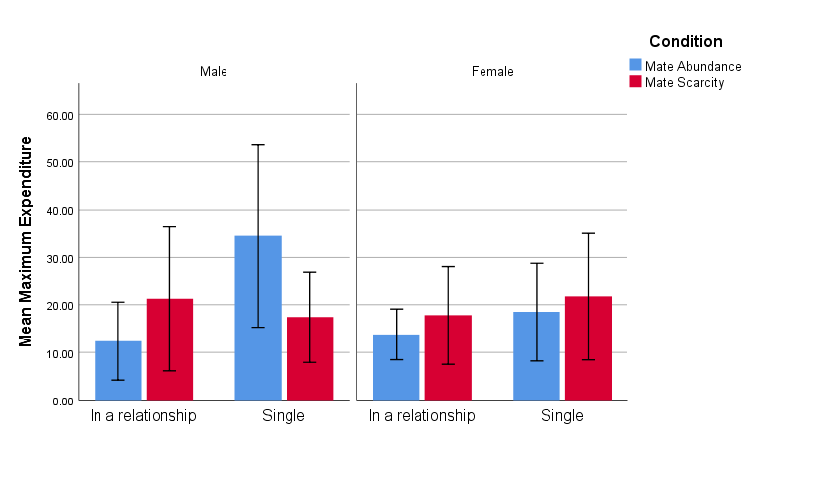
Figure 4. Mean maximum expenditure values (+/- 1 SD) for both conditions separated by relationship status and filtered by gender.
3.3 Awareness of Study Purpose

When asked to guess the purpose of the study, 15 participants (16%) provided responses that correctly or partially referenced intrasexual competition. The remaining 77 participants (84%) gave incorrect or unrelated responses. These results suggest that the priming manipulation was subtle enough to avoid demand characteristics for the majority of participants.

3.4 Summary of Results

In summary, perceived mate availability did not significantly affect ICS scores overall. However, gender and relationship status moderated competitiveness, especially among females. Mate scarcity significantly increased hypothetical alcohol demand (Q₀) and reduced price sensitivity (α), particularly in partnered males. No main effects emerged in observed consumption metrics, but significant interactions indicated that relationship context and gender shape alcohol-related responses to mate availability cues.

Table 2. Summary of ANOVA and MANOVA Results
Dependent Variable | Effect | F | p | ηp² | 95% CI
ICS Score | Condition (main) | 0.34 | .56 | .001 | [–0.22, 0.12]
 | Gender (main) | 4.68 | .03 | .06 | [0.01, 0.34]
 | Condition × Relationship | 4.90 | .03 | .06 | [0.02, 0.38]
Q₀ (hypothetical demand) | Condition (main) | 7.60 | .01 | .27 | [0.12, 0.85]
α (price sensitivity) | Condition (main) | 21.00 | .001 | .50 | [–0.0015, –0.0006]
Observed Q₀ / Omax (MANOVA) | Condition × Relationship | 4.19 | .02 | .10 | –
 | Condition × Gender × Relationship | 4.42 | .02 | .10 | –

4. Discussion

This study investigated whether perceived mate availability influences intrasexual competitiveness and hypothetical alcohol consumption, and whether these effects are moderated by gender and relationship status. The findings offer partial support for the proposed hypotheses. While the predicted increase in intrasexual competitiveness under mate scarcity was not observed at the main effect level, significant interaction effects emerged, particularly in relation to participants' relationship status. In contrast, mate scarcity did influence hypothetical alcohol consumption patterns, as predicted.
The absence of a main effect of mate availability on intrasexual competitiveness is inconsistent with prior research by Arnocky et al. (2014), who found that perceived mate scarcity increased competitiveness across both men and women. One possible explanation lies in methodological differences. For example, the present study used an online format and included a more demographically diverse sample, whereas earlier work often relied on young, homogenous student populations in laboratory settings. Additionally, the Intrasexual Competition Scale (Buunk & Fisher, 2009), while reliable in trait-level measurement, may lack sensitivity to detect situational fluctuations in competitiveness. As recent research suggests, context-sensitive measures and immediate post-manipulation checks may yield more accurate state-level assessments (Vincke & Vyncke, 2022).
Despite the lack of a direct effect on competitiveness, interaction analyses revealed that partnered females reported higher intrasexual competitiveness under mate scarcity, aligning with evolutionary theories that propose relationship status modulates mate-guarding tendencies (Arnocky et al., 2018). Women in relationships may be more attuned to cues of increased mating competition, responding with heightened competitiveness to protect their current mate. This supports prior findings indicating that relationship status influences emotional and behavioural sensitivity to mating threats (Fisher & Cox, 2016; Gervais et al., 2020).
By contrast, the alcohol-related outcomes provide clearer support for the hypothesis that mating cues affect consumption behaviour. Participants exposed to mate scarcity showed greater hypothetical alcohol demand and lower price sensitivity, especially among partnered males. This aligns with costly signalling theory, which posits that risk-taking behaviours, including excessive drinking, may serve as a display of social dominance, fearlessness, or resource availability, all of which may increase short-term mating appeal (Vincke, 2016; Otterbring et al., 2018). Drinking in competitive or public settings may thus function as a mating-relevant signal, especially among individuals already in relationships who may feel pressure to maintain mate value or deter rivals.
Notably, single males in the mate abundance condition also demonstrated elevated alcohol expenditure, suggesting that increased mating opportunity, not just scarcity, may stimulate display-oriented behaviour. This supports recent research showing that perceived mate abundance may activate mating effort, leading individuals to invest more in appearance, performance, or consumption (Zhuang et al., 2021). Such behaviours may reflect both short-term strategic pursuit and underlying reproductive psychology.
While the alcohol findings are consistent with studies linking alcohol use to mating motives (Hone & McCullough, 2015; Vincke, 2016), they diverge from others that have found limited or inconsistent associations (Diulio et al., 2014). This variability may reflect methodological differences or unmeasured moderators such as hormonal status, cultural norms, or trait impulsivity. Including physiological measures such as testosterone or cortisol in future work may help clarify the biological underpinnings of these behaviours (Arnocky et al., 2018; Nepomuceno & Stenstrom, 2021).
The present findings carry broader implications for public health and consumer psychology. They suggest that even subtle mating-relevant cues in the environment, such as media portrayals of mate competition or scarcity, may unconsciously influence health-risk behaviours like alcohol consumption. This highlights the value of integrating evolutionary models with public health frameworks to better understand and predict risk behaviour, especially in young adults and relationship contexts.

4.1 Limitations and Future Directions

This study has several limitations that should be acknowledged. First, the absence of a manipulation check limits confidence in whether perceived mate availability was successfully altered, particularly given the null findings on intrasexual competitiveness (Arnocky et al., 2014). Future studies should directly assess participants’ perceptions post-priming to validate the efficacy of such manipulations.
Second, the Intrasexual Competition Scale may not have been sensitive enough to detect subtle, state-level changes in competitiveness. While the ICS has shown strong reliability in student samples (Buunk & Fisher, 2009), its performance in more diverse, non-student populations remains under-evaluated. Future studies could consider using alternative or adapted measures that are more sensitive to situational fluctuations.
Third, although the sample included participants from the United Kingdom and Lithuania, it was predominantly White and recruited online. This introduces sampling bias, as participants were not representative of broader cultural or ethnic populations. Online recruitment may also select for more educated, internet-literate individuals, limiting generalisability. Future research should strive for more ethnically and culturally diverse samples, and consider cross-cultural comparisons where appropriate.
Fourth, the sample size within subgroups, particularly when split by condition, gender, and relationship status, was modest, which may have limited the statistical power to detect moderate interaction effects. Future research should aim to recruit larger and more balanced samples to enable more reliable testing of complex interactions.
Fifth, key socioeconomic indicators such as income and education were not collected. These may influence both alcohol purchasing patterns and sensitivity to mating-related cues. Including such variables in future studies would strengthen the ecological validity and allow for richer interpretation of results.
Finally, no attention checks were used in this online study, which raises concerns about participant engagement. Future research should incorporate simple but effective attention checks to ensure that participants read and respond to the priming materials thoughtfully.
5. Conclusion

This study investigated the effects of perceived mate availability on intrasexual competitiveness and alcohol-related decision-making. While no overall increase in competitiveness was observed, interaction effects suggest that relationship status, especially among females, may moderate responsiveness to mating cues. More robust effects were observed on hypothetical alcohol demand: mate scarcity increased estimated consumption and reduced price sensitivity, particularly among males in relationships. These findings partially support evolutionary models of mating-related behaviour and provide preliminary evidence that mating motives may influence economic decision-making around alcohol. Future research should incorporate manipulation checks, include cultural and socioeconomic variables, and use more sensitive measures to clarify these mechanisms.

Disclaimer (Artificial intelligence)
Option 1:
Author(s) hereby declare that NO generative AI technologies such as Large Language Models (ChatGPT, COPILOT, etc.) and text-to-image generators have been used during the writing or editing of this manuscript.

References

Amlung, M. T., Acker, J., Stojek, M. K., Murphy, J. G., & Mackillop, J. (2012). Is Talk “Cheap”? An Initial Investigation of the Equivalence of Alcohol Purchase Task Performance for Hypothetical and Actual Rewards. Alcoholism: Clinical and Experimental Research, 36(4), 716–724. https://doi.org/10.1111/j.1530-0277.2011.01656.x

Arnocky, S., Ribout, A., Mirza, R. S., & Knack, J. M. (2014). Perceived mate availability influences intrasexual competition, jealousy and mate-guarding behavior. Journal of Evolutionary Psychology, 12(1), 45–64. https://doi.org/10.1556/JEP.12.2014.1.3

Arnocky, S., Albert, G., Carré, J. M., & Ortiz, T. L. (2018). Intrasexual competition mediates the relationship between men’s testosterone and mate retention behavior. Physiology and Behavior, 186(July 2017), 73–78. https://doi.org/10.1016/j.physbeh.2018.01.007

Baker, M. D., & Maner, J. K. (2009). Male risk-taking as a context-sensitive signaling device. Journal of Experimental Social Psychology, 45(5), 1136–1139. https://doi.org/10.1016/j.jesp.2009.06.006

Bertholet, N., Murphy, J. G., Daeppen, J. B., Gmel, G., & Gaume, J. (2015). The alcohol purchase task in young men from the general population. Drug and Alcohol Dependence, 146(1), 39–44. https://doi.org/10.1016/j.drugalcdep.2014.10.024

Brady, J. (2006). The association between alcohol misuse and suicidal behaviour. Alcohol and Alcoholism, 41(5), 473–478. https://doi.org/10.1093/alcalc/agl060

Buunk, A. P., & Fisher, M. (2009). Individual differences in intrasexual competition. Journal of Evolutionary Psychology, 7(1), 37–48. https://doi.org/10.1556/JEP.7.2009.1.5

Buss, D. M. (1988). The Evolution of Human Intrasexual Competition: Tactics of Mate Attraction. Journal of Personality and Social Psychology, 54(4), 616–628. https://doi.org/10.1037/0022-3514.54.4.616

Buss, D. M., & Barnes, M. (1986). Preferences in Human Mate Selection. Journal of Personality and Social Psychology, 50(3), 559–570. https://doi.org/10.1037/0022-3514.50.3.559

Buss, D. M., & Greiling, H. (1999). Adaptive Individual Differences. Journal of Personality, 67(2). https://doi.org/10.1111/1467-6494.00053

Cooper, M. L. (1994). Motivations for alcohol use among adolescents: Development and validation of a four-factor model. Psychological Assessment, 6(2), 117–128. https://doi.org/10.1037/1040-3590.6.2.117

Cox, W. M., & Klinger, E. (1988). A Motivational Model of Alcohol Use. Journal of Abnormal Psychology, 97(2), 168–180. https://doi.org/10.1037/0021-843X.97.2.168

Cox, W. M., & Klinger, E. (1990). Incentive motivation, affective change, and alcohol use: A model. In W. M. Cox (Ed.), Why people drink: Parameters of alcohol as a reinforcer. Psychology Press.

Cox, W. M., & Klinger, E. (2003). A Motivational Model of Alcohol Use: Determinants of Use and Change. Handbook of Motivational Counseling Concepts, Approaches, and Assessment (pp. 121–138). John Wiley & Sons, LTD. https://doi.org/10.1002/9780470713129.CH6

Darwin, C. (1871). The Descent of Man and Selection in Relation to Sex. John Murray Press.

Diulio, A. R., Silvestri, M. M., & Correia, C. J. (2014). The role of personality variables in drinking game participation. Addictive Behaviors, 39(7), 1159–1162. https://doi.org/10.1016/j.addbeh.2014.02.005

Emlen, S. T., & Oring, L. W. (1977). Ecology, sexual selection, and the evolution of mating systems. Science, 197(4300), 215–223. https://doi.org/10.1126/science.327542

Ferguson, C. J., Winegard, B., & Winegard, B. M. (2011). Who Is the Fairest One of All? How Evolution Guides Peer and Media Influences on Female Body Dissatisfaction. Review of General Psychology, 15(1), 11–28. https://doi.org/10.1037/a0022607

Fernandez, A. M., Muñoz-Reyes, J. A., & Dufey, M. (2014). BMI, age, Mate Value, and Intrasexual Competition in Chilean Women. Current Psychology, 33(4), 435–450. https://doi.org/10.1007/s12144-014-9221-x

Fernie, G., Cole, J. C., Goudie, A. J., & Field, M. (2010). Risk-taking but not response inhibition or delay discounting predict alcohol consumption in social drinkers. Drug and Alcohol Dependence, 112(1–2), 54–61. https://doi.org/10.1016/j.drugalcdep.2010.05.011

Griskevicius, V., Tybur, J. M., Sundie, J. M., Cialdini, R. B., Miller, G. F., & Kenrick, D. T. (2007). Blatant benevolence and conspicuous consumption: When romantic motives elicit strategic costly signals. Journal of Personality and Social Psychology, 93(1), 85–102. https://doi.org/10.1037/0022-3514.93.1.85

Grønbæk, M. (2009). The positive and negative health effects of alcohol- and the public health implications. Journal of Internal Medicine, 265(4), 407–420. https://doi.org/10.1111/j.1365-2796.2009.02082.x

Harris, M. A., Jones, C. R., & Brown, D. (2019). Survival of the drunkest: The relationship between intrasexual competition and excessive alcohol consumption by university students. Evolutionary Behavioral Sciences, 13(4), 394–401. https://doi.org/10.1037/ebs0000153

Harris, M., Dunn, M., & Alwyn, T. (2019). Intrasexual competition as a potential influence on anabolic-androgenic steroid use initiation. Journal of Health Psychology, 24(9), 1210–1220. https://doi.org/10.1177/1359105317692145

Herman, A. M., & Duka, T. (2019). Facets of impulsivity and alcohol use: What role do emotions play? Neuroscience and Biobehavioral Reviews, 106(August 2018), 202–216. https://doi.org/10.1016/j.neubiorev.2018.08.011

Hone, L. S. E., Carter, E. C., & McCullough, M. E. (2013). Drinking games as a venue for sexual competition. Evolutionary Psychology, 11(4), 889–906. https://doi.org/10.1177/147470491301100413

Hone, L. S. E., & McCullough, M. (2015). Sexually selected sex differences in competitiveness explain sex differences in changes in drinking game participation. Evolutionary Psychology : An International Journal of Evolutionary Approaches to Psychology and Behavior, 13(2), 397–410. https://doi.org/10.1177/147470491501300206

Hursh, S. R., & Silberberg, A. (2008). Economic Demand and Essential Value. Psychological Review, 115(1), 186–198. https://doi.org/10.1037/0033-295X.115.1.186

Jacobs, E. A., & Bickel, W. K. (1999). Modeling drug consumption in the clinic using simulation procedures: Demand for heroin and cigarettes in opioid-dependent outpatients. Experimental and Clinical Psychopharmacology, 7(4), 412–426. https://doi.org/10.1037/1064-1297.7.4.412

Jones, B. T., Corbin, W., & Fromme, K. (2001). A review of expectancy theory and alcohol consumption. Addiction, 96(1), 57–72. https://doi.org/10.1046/j.1360-0443.2001.961575.x

Klingemann, H., & Gmel, G. (2001). Introduction: Social consequences of alcohol — the forgotten dimension? Mapping the Social Consequences of Alcohol Consumption, 1–9. https://doi.org/10.1007/978-94-015-9725-8_1

Manthey, J., Probst, C., & Rehm, J. (2022). The global burden of disease due to alcohol use in 204 countries and territories, 1990–2019. The Lancet Public Health, 7(5), e342–e351. https://doi.org/10.1016/S2468-2667(22)00045-0

Meda, S. A., Stevens, M. C., Potenza, M. N., Pittman, B., Gueorguieva, R., Andrews, M. M., Thomas, A. D., Muska, C., Hylton, J. L., & Pearlson, G. D. (2009). Investigating the behavioral and self-report constructs of impulsivity domains using principal component analysis. Behavioural Pharmacology, 20(5–6), 390–399. https://doi.org/10.1097/FBP.0b013e32833113a3

Meloni, J. N., & Laranjeira, R. (2004). The social and health burden of alcohol abuse. Revista Brasileira de Psiquiatria, 26(SUPPL.), 7–10. https://doi.org/10.1590/s1516-44462004000500003

Moeller, F. G., Barratt, E. S., Dougherty, D. M., Schmitz, J. M., & Swann, A. C. (2001). Psychiatric aspects of impulsivity. American Journal of Psychiatry, 158(11), 1783–1793. https://doi.org/10.1176/appi.ajp.158.11.1783

Morris, E. P., Stewart, S. H., & Ham, L. S. (2005). The relationship between social anxiety disorder and alcohol use disorders: A critical review. Clinical Psychology Review, 25(6), 734–760. https://doi.org/10.1016/j.cpr.2005.05.004

Murphy, J. G., & MacKillop, J. (2006). Relative reinforcing efficacy of alcohol among college student drinkers. Experimental and Clinical Psychopharmacology, 14(2), 219–227. https://doi.org/10.1037/1064-1297.14.2.219

Nepomuceno, M. V., & Stenstrom, E. (2021). Consumption on steroids: The effect of testosterone on preferences for conspicuous consumption and the moderating role of intrasexual competition. Journal of Behavioral Decision Making, 34(3), 457–475. https://doi.org/10.1002/bdm.2222

Norström, T., & Ramstedt, M. (2005). Mortality and population drinking: A review of the literature. Drug and Alcohol Review, 24(6), 537–547. https://doi.org/10.1080/09595230500293845

Otterbring, T., Ringler, C., Sirianni, N. J., & Gustafsson, A. (2018). The abercrombie & fitch effect: The impact of physical dominance on male customers’ status-signaling consumption. In Journal of Marketing Research, 55(1). https://doi.org/10.1509/jmr.15.0247

Pedersen, E. R., Lee, C. M., Larimer, M. E., & Neighbors, C. (2009). Gender and dating relationship status moderate the association between alcohol use and sex-related alcohol expectancies. Addictive Behaviors, 34(9), 786–789. https://doi.org/10.1016/j.addbeh.2009.04.015

Rajendram, R., Lewison, G., & Preedy, V. (2006). Worldwide Alcohol-related research and the disease burden. Alcohol and Alcoholism, 41(1), 99–106. https://doi.org/10.1093/alcalc/agh238

Rehm, J., Mathers, C., Popova, S., Thavorncharoensap, M., Teerawattananon, Y., & Patra, J. (2009). Global burden of disease and injury and economic cost attributable to alcohol use and alcohol-use disorders. The Lancet, 373(9682), 2223–2233. https://doi.org/10.1016/S0140-6736(09)60746-7

Rehm, J., Room, R., Graham, K., Monteiro, M., Gmel, G., & Sempos, C. T. (2003). The relationship of average volume of alcohol consumption and patterns of drinking to burden of disease: An overview. Addiction, 98(9), 1209–1228. https://doi.org/10.1046/j.1360-0443.2003.00467.x

Rosvall, K. A. (2011). Intrasexual competition in females: Evidence for sexual selection? Behavioral Ecology, 22(6), 1131–1140. https://doi.org/10.1093/beheco/arr106

Shield, K. D., Manthey, J., & Rehm, J. (2023). Alcohol use and the global burden of disease. Current Opinion in Psychiatry, 36(5), 319–325. https://doi.org/10.1097/YCO.0000000000000850

Snider, S. E., LaConte, S. M., & Bickel, W. K. (2016). Episodic Future Thinking: Expansion of the Temporal Window in Individuals with Alcohol Dependence. Alcoholism: Clinical and Experimental Research, 40(7), 1558–1566. https://doi.org/10.1111/acer.13112

Spielmann, S. S., MacDonald, G., & Wilson, A. E. (2009). On the rebound: Focusing on someone new helps anxiously attached individuals let go of ex-partners. Personality and Social Psychology Bulletin, 35(10), 1382–1394. https://doi.org/10.1177/0146167209341580

Stacy, A. W., Widaman, K. F., & Marlatt, G. A. (1990). Expectancy Models of Alcohol Use. Journal of Personality and Social Psychology, 58(5), 918–928. https://doi.org/10.1037/0022-3514.58.5.918

Stahre, M., Roeber, J., Kanny, D., Brewer, R. D., & Zhang, X. (2014). Contribution of excessive alcohol consumption to deaths and years of potential life lost in the United States. Preventing Chronic Disease, 11, 1–12. https://doi.org/10.5888/pcd11.130293

Stein, J. S., Koffarnus, M. N., Snider, S. E., Quisenberry, A. J., & Bickel, W. K. (2015). Identification and management of nonsystematic purchase task data: Toward best practice. Experimental and Clinical Psychopharmacology, 23(5), 377–386. https://doi.org/10.1037/pha0000020

Trivers, R. L. (1972). Parental investment and sexual selection. In B. Campbell (Ed.), Sexual selection and the descent of man (pp. 136-179). Aldine Publishing Company.

Tybur, J. M., Bryan, A. D., & Caldwell Hooper, A. E. (2012). An evolutionary perspective on health psychology: New approaches and applications. Evolutionary Psychology, 10(5), 855–867. https://doi.org/10.1177/147470491201000508

Vincke, E., & Vyncke, P. (2022). Affective context and sexual signaling: How arousal shapes mating displays. Evolutionary Psychology, 20(1), 1–12. https://doi.org/10.1177/14747049221079286

Wade, T. D., Keski‐Rahkonen, A., & Hudson, J. I. (2011). Epidemiology of eating disorders. Textbook of psychiatric epidemiology, 343-360. https://doi.org/10.1002/9780470976739.ch20

Wallace, A. R. (1891). Natural selection and tropical nature: Essays on descriptive and theoretical biology. Macmillan and Company.

World Health Organization. (2022). Global status report on alcohol and health 2022. Geneva: WHO. https://www.who.int/publications/i/item/9789240058731

Yuresak, A. M., Murphy, J. G., Clawson, A. H., Dennhardt, A. A., & MacKillop, J. (2013). Smokers report greater demand for alcohol on a behavioral economic purchase task. Journal of Studies on Alcohol and Drugs, 74(4), 626–634. https://doi.org/10.15288/jsad.2013.74.626

