Original Research Article

Do Different Brands of Dental Loupes and Their Magnification Influence Working Posture and the Quality of Tooth Preparations?

.
ABSTRACT
Aims: This study aimed to assess the effect of different commercial brands of dental loupes and their magnification systems on the working posture and quality of preclinical tooth preparations.
Methodology: An experimental laboratory study was conducted. The response variables were: 1) angular deviation of the neck; 2) working distance; and 3) quality of tooth preparation. The independent variables were the dental loupe brands (LumaDent, Design for Vision, Univet and Q-Optics) and type of magnification (naked eye, Galilean 2.5x, Galilean 3.0x and Ergonomic 3.0x). Class I tooth preparations were performed on artificial maxillary left-first molars in a dental mannequin (n=10, N=110). Angular deviations were measured using the Software for Postural Assessment and the working distance was measured using the Measure App. The quality of tooth preparations was assessed using the Class One Cavity Preparation Assessment method. Descriptive statistics were performed, and after verifying the assumptions, confidence intervals were created allowing comparisons between the means (α=.05).
Results: All magnification systems, regardless of their brands, promoted a greater working distance and a lower angular deviation of the neck compared to the naked eye. The Ergonomic loupes offered greater working distance and reduced angular deviation compared to the Galilean loupes. There was no statistical difference between both the Ergonomic loupes tested and among all the Galilean loupes tested. The quality of the tooth preparations was similar when done with naked eye and all magnification systems, regardless of their brands.
Conclusion: The working posture was more affected by the type of magnification system used, rather than their commercial brands. Ergonomic loupes, regardless their brands, provided the lowest angular deviation of the neck and the longest working distance, improving significantly the working posture. The quality of the tooth preparations was not affected by the dental loupe brands and their magnification systems.

Keywords: Dental loupes, dental students, ergonomics, quality of the procedure

1. INTRODUCTION

The magnification in dentistry began in endodontics and later was extended to other specialties due to its significant contribution to diagnosis and treatment, as well as its support of the principles of minimally invasive dentistry [1,2,3]. Additionally, dental magnification prevents musculoskeletal disorders associated with poor posture during operative procedures [1,3-5].
Obtaining a clear, magnified view while maintaining a comfortable working posture greatly enhances the clinical experience for both the professional and the patient [3].
With numerous magnification options available on the market, it is crucial for professionals to select the model and magnification level that best suits their needs, ensuring both precision in practice and musculoskeletal well-being [1]. It is important to note that improper selection of magnification can lead to poor posture, thereby increasing the risk of musculoskeletal disorders [1].
Loupes can be classified according to their optical design into four main types: simple, Galilean, Keplerian, and Ergonomic loupes — each defined by the type and configuration of lenses used. Simple loupes consist of a pair of positive meniscal lenses positioned side by side. Galilean loupes employ a system of concave ocular lenses and convex objective lenses, typically housed in a conical structure. In contrast, Keplerian loupes have a cylindrical shape and utilize a more advanced optical system that includes convex lenses and internal prisms, resulting in a longer overall structure [6-8]. The Ergonomic loupes combine a system of angled prismatic lenses, which allows the operators to view the work field without bending their neck [6]. Compared to simple loupes, binocular loupes such as Galilean, Keplerian, and Ergonomic loupes provide superior optical performance, reducing neck angulation during clinical procedures [6-8]. Improvement in the ergonomic posture and working distance has also been observed with the binocular loupes [7]. Although scientific evidence supports the positive impact of magnification during tooth preparations, loupes with higher magnification have not been shown to improve quality of tooth preparation compared to lower magnification levels [4]. According to Bud et al. [3], in restorative dentistry moderate magnification, such as 2.5x or 3.0x, is considered optimal, as it offers a clear view of the working area without compromising the depth of field.
Although the benefits of magnification are widely recognized [1,3,4,8,9], there is still a gap in the literature regarding the impact of various magnification loupe options and brands available on the market, particularly in terms of their effect on working posture and procedure quality [2,4,10,11].
The aim of this study was to evaluate the effect of different commercial brands and magnification systems on working posture and the quality of preclinical tooth preparations. The null hypothesis was that commercial brands of dental loupes and their magnification systems do not affect the angular deviation of the neck, working distance, or the quality of the tooth preparations. In contrast, the alternative hypothesis suggested that these factors do affect the angular deviation of the neck, working distance, and quality of the tooth preparations.

2. material and methods

2.1 Study Design
This experimental study was approved by the Stony Brook University Office of Research Compliance (IRB ID: IRB2024-00223) and written consent form was obtained. The response variables were: 1) angular deviation of the neck; 2) working distance; and 3) quality of tooth preparation. The independent variables were the dental loupe brands (LumaDent, Design for Vision, Univet, and Q-Optics), and the type of magnification (naked eye, Galilean 2.5x, Galilean 3.0x, and Ergonomic 3.0x). Class I tooth preparations were performed on artificial maxillary left-first molars. A total of ten tooth preparations were completed for each experimental condition (n=10, N=110).
2.2 Recording the Working Posture
Working postures were recorded during the tooth preparations by filming the entire procedure with a digital camera (GoPro Hero 4). The camera was placed on a tripod 1 meter away from the mannequin recording the side view of the operator.

2.3 Tooth preparation
Class I tooth preparations were performed by an operator with high expertise in dental loupes. The tooth preparations were done on a dental mannequin with artificial resin teeth, specifically designed for preclinical restorative procedures (Figure 1). The tooth preparations were done on maxillary left-first molars because they were located on the participant's working side. All preparations were done with a round 1012 diamond abrasive instrument in high speed with water irrigation. The bur was replaced after every 10 tooth preparations. As each tooth was prepared, it was removed and replaced with an intact resin tooth for the next preparation.
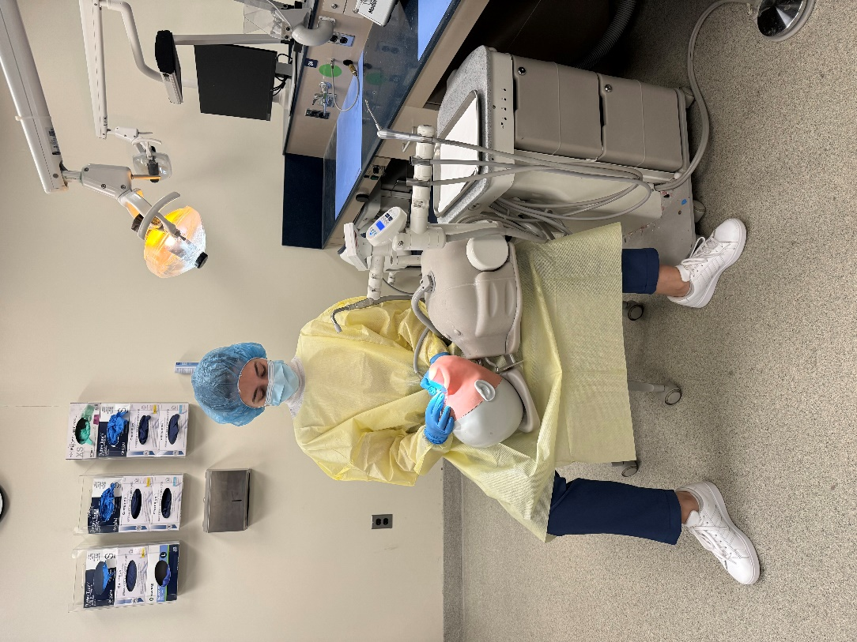
Figure 1. Dental mannequin simulating clinical environment
2.4 Angular Deviation
Angular deviations were measured using the Software for Postural Assessment (version 0.69). In this software, a reference point was placed at the C7 vertebra. Then, a vertical line was traced from this point along with another line following the inclination of the neck (Figure 2). The software calculated the angle formed by these two lines and provided quantitative data.
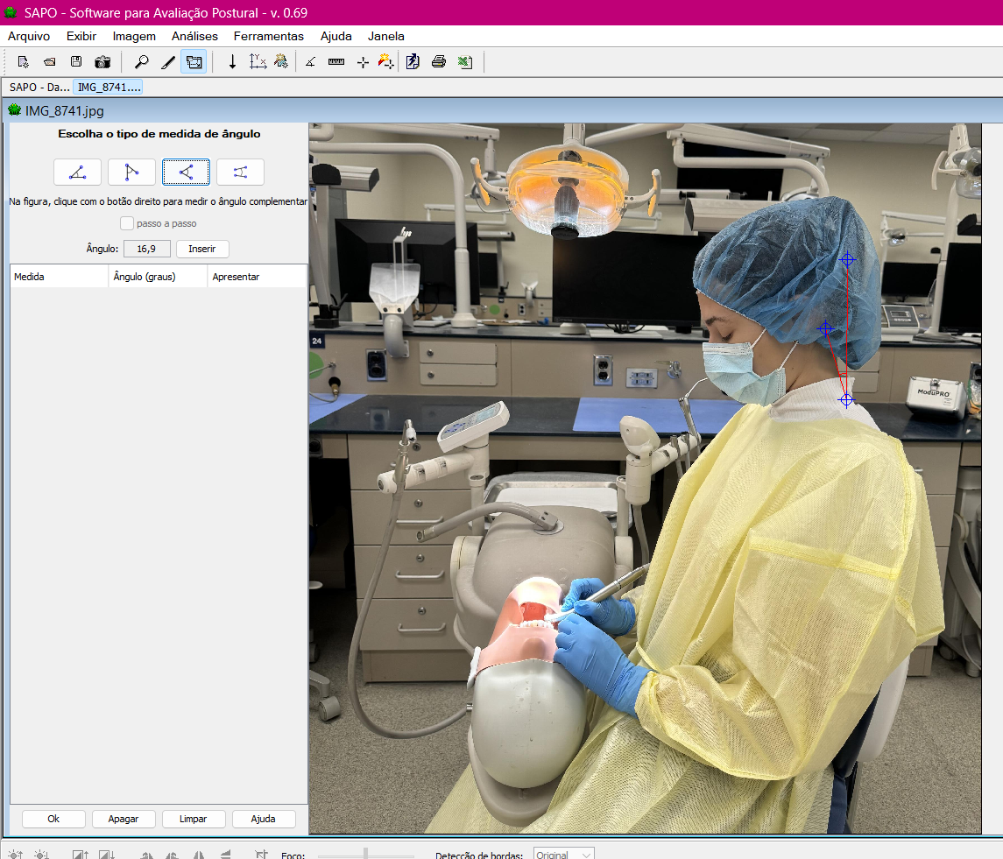
Figure 2. Measuring the angular deviation of the neck
2.5 Working Distance
The working distance measurements were obtained using the Measure app, available for the Apple iOS operating system (Apple Inc., USA). The starting point was the lens of the dental loupes or the eyes of the participant, and the endpoint was the occlusal surface of the maxillary left-first molar of the dental mannequin.
2.6 Assessment of the quality of tooth preparations
The quality of tooth preparations was assessed using the Class One Cavity Preparation Assessment (COCA) method [12], which evaluates the following aspects: 1) design; 2) mesiodistal extension; 3) buccolingual extension; 4) depth; and 5) roundness of internal angles. Each aspect was scored as two points for adequate items (in accordance with Class I tooth preparation recommendations), one point for partially adequate items (when the item was not completely correct), and zero points for inadequate items (when the item did not meet the recommendations). The scores for all items were then summed, with a maximum possible score of ten points. A blinded and calibrated researcher (ρ=0.922) conducted the quality assessment.
2.7 Statistical Analysis
Descriptive statistics were performed, and after verifying the assumptions, confidence intervals were created allowing comparisons between the means (α=.05).

3. results

Figure 3 presents the mean and 95% confidence interval (CI) of the working distance, categorized by the magnification system and dental loupe brand used. The mean and confidence interval for the naked eye are indicated by the red lines.

Figure 3. Mean and confidence interval of the working distance (cm), according to the magnification system and dental loupe brand.
The results showed that all magnification systems, regardless of the dental loupe brand, provided a greater working distance compared to the naked eye. The ergonomic loupes from both Design for Vision and LumaDent were similar to each other, offering a greater working distance than the other magnification systems. The working distance was similar for Galilean 2.5x and Galilean 3.0x, regardless of the dental loupe brand.
Figure 4 presents the mean and 95% CI of the angular deviation, categorized by the magnification system and dental loupe brand used. The mean and confidence interval for the naked eye are indicated by the red lines.

Figure 4. Mean and confidence interval of the angular deviation (°), according to the magnification system and dental loupe brand.
All magnification systems, regardless of the dental loupe brand, resulted in a lower angular deviation of the neck compared to the naked eye. The ergonomic loupes from both brands were similar, showing less angular deviation than the other magnification systems, which were also comparable to each other.
Figure 5 presents the mean and 95% CI of the quality of tooth preparation, categorized by the magnification system and dental loupe brand used. The mean and confidence interval for the naked eye are indicated by the red lines.

Figure 5. Mean and confidence interval of the quality of tooth preparation, according to the magnification system and dental loupe brand.
The quality of the tooth preparations was similar when done with the naked eye and all magnification systems, regardless of their brands.

4. DISCUSSION

This study aimed to assess the effect of different commercial brands of dental loupes and their magnification systems on the working posture and quality of preclinical tooth preparations.
The results showed that ergonomic loupes provided the greatest working distance. This is likely due to the operator being able to maintain a more neutral head position, without the need to tilt the neck to view the operative field, thus increasing the working distance [6,7]. Interestingly, in this study, Galilean loupes also provided a greater working distance compared to the naked eye, which contrasts with the findings of Pazos et al. [8]. This discrepancy may be explained by the fact that, in this study, the procedures were performed by an operator with high expertise in dental loupes and magnification systems, while in the other study, visual acuity tests were conducted by students without any experience wearing and adjusting their loupes. This highlights the importance of dental loupe training, as the postural benefits of magnification loupes are fully obtained only after a period of adjustment [2,4,13].
The results regarding the angular deviation of the neck in this study align with findings from the literature [5,8,9,14-16]. While Galilean loupes reduce angular deviation compared to the naked eye, they still result in more neck deviation than what is considered ideal for maintaining a neck posture with a low risk of developing musculoskeletal disorders [17]. In contrast, ergonomic loupes—regardless of brand or model—produced an angular deviation of less than 15º. This is due to the angled design of their lenses, which reflect the image into the operator's eyes without requiring them to tilt their head down [5]. This design helps reduce muscle strain in the neck region, directly benefiting the operator's occupational health [7].
The different magnification systems evaluated in this study did not show a significant impact on the quality of the tooth preparations. While these results differ from those reported by Braga et al. [2], Eggmann et al. [10], and Maggio et al. [18], they are consistent with the findings of Pazos et al. [19], who also observed that Simple, Galilean, and Keplerian loupes did not affect the quality of Class I tooth preparations. Additionally, Costa et al. [7] reported similar conclusions in their literature review. One possible explanation for this is that these loupes provide more ergonomic benefits than optical improvements, particularly for younger operators, who typically have better visual acuity and can discern important details even without magnification [10,20,21]. Another explanation is that magnification may influence the quality of certain tooth preparations, but not all types [10]. Therefore, different results might emerge when performing more complex preparations.
The limitation of this study is that the procedures were performed by an operator with high expertise in magnification. According to de Oliveira [4], assessing the impact of magnification on performance during tooth preparations is challenging, particularly when considering the different levels of clinical experience and familiarity of professionals with these devices in everyday clinical practice. As a result, the operator's experience may be considered a confounding variable [4].
On the other hand, selecting high-quality magnification loupes requires careful consideration of several factors, including the magnification system, the appropriate magnification level, the type of attachment (flip-up or through-the-lens), the choice between a headband or frame, and aligning the user's individual needs with available options on the market. This process often involves significant financial investment [2]. In this context, this study makes an important contribution by demonstrating that, in general, working posture is influenced more by the type of magnification system than the commercial brand.

4. Conclusion

The working posture was more affected by the type of magnification system used, rather than their commercial brands. Ergonomic loupes, regardless of their brands, provided the lowest angular deviation of the neck and the longest working distance, improving significantly the working posture. The quality of the tooth preparations was not affected by the dental loupe brands and their magnification systems.

Ethical approval
All authors hereby declare that all experiments have been examined and approved by the appropriate ethics committee and have therefore been performed in accordance with the ethical standards laid down in the 1964 Declaration of Helsinki

COMPETING INTERESTS DISCLAIMER:
Authors have declared that they have no known competing financial interests OR non-financial interests OR personal relationships that could have appeared to influence the work reported in this paper.

ARTIFICIAL INTELLIGENCE DISCLAIMER:
Authors hereby declare that NO generative AI technologies such as Large Language Models (ChatGPT, COPILOT, etc.) and text-to-image generators have been used during the writing or editing of this manuscript.
References

1. Doppalapudi N, Burugapalli RK. Benefits of utilization of magnification in dentistry: a review. Dent Res Oral Health. Dent 3(3):121–128. https://doi.org/10.26502/droh.0026
2. Braga T, Robb N, Love RM, Amaral RR, Rodrigues VP, de Camargo JMP, Duarte MAH. The impact of the use of magnifying dental loupes on the performance of undergraduate dental students undertaking simulated dental procedures. J Dent Educ. 2021;85(3):418-426. doi: 10.1002/jdd.12437
3. Bud MG, Pop OD, Cîmpean S. Benefits of using magnification in dental specialties - a narrative review. Med Pharm Rep. 2023 Jul;96(3):254-257. doi: 10.15386/mpr-2556
4. de Oliveira FAS, Moraschini V, de Almeida DCF, Dos Santos GO. Effects of magnification on restorative dental preparation performance: a scoping review and level of evidence mapping. Clin Oral Investig. 2024;28(8):447. doi: 10.1007/s00784-024-05852-7
5. Jyothikiran H, Nidharshana SN, Kumar IG, Raghunath N (2023) Loupes in orthodontic practice: a review. Int J Sci Res 12:19-24. Doi: 10.36106/ijsr.
6. Wajngarten D., Garcia PPNS. The Use of Magnification and Work Posture in Dentistry – A Literature Review. JAMMR. 2016;18(8): 1–9. https://doi.org/10.9734/BJMMR/2016/29885
7. Costa RT, Miranda SB, Montes MA, Ribeiro AK, Carreiro AF, Moraes SL. Impact of using magnifying dental loupes on clinical performance during tooth preparation: A systematic review. J Clin Exp Dent. 2024 Feb 1;16(2):e186-e197. doi: 10.4317/jced.61098.
8. Pazos JM, dos Santos CG, Dovigo LN, Garcia P. The effect of Galilean magnification loupes on the visual acuity and working distance of dental students. J Dent Educ. 2024;1-7. https://doi.org/10.1002/jdd.13451
9. Pazos JM, Regalo SCH, de Vasconcelos P, Campos JADB, Garcia PPNS. Effect of magnification factor by Galilean loupes on working posture of dental students in simulated clinical procedures: associations between direct and observational measurements. PeerJ. 2022; 10:e13021. https://doi.org/10.7717/peerj.13021
10. Eggmann F, Irani DR, Fehlbaum PA, Neuhaus KW. Do magnification loupes affect the precision of cavity preparations made by undergraduates? A randomized crossover study. BMC Oral Health. 2022;22(1):189. doi: 10.1186/s12903-022-02232-z
11. Ramesh A, Junxi Guo A, Patel HJ, Huang J, Huang CC, de Mello-Neto JM, Rodrigues Amaral R. The impact of magnification on undergraduate dental students' performance during cavity preparations: A systematic review. J Dent Educ. 2024 Aug;88(8):1091-1100. doi: 10.1002/jdd.13528
12. Wajngarten D, Pazos JM, Neves TC, Garcia PPNS. Development and validation of Class I preparation and restoration quality assessment methods. JAMMR. 2021; 33(11):18–23. https://doi.org/10.9734/jammr/2021/v33i1130920
13. Aboalshamat K, Daoud O, Mahmoud LA, Attal S, Alshehri R, Bin Othman D, Alzahrani R. Practices and Attitudes of Dental Loupes and Their Relationship to Musculoskeletal Disorders among Dental Practitioners. Int J Dent. 2020 Jul 30;2020:8828709. doi: 10.1155/2020/8828709
14. Wajngarten D, Garcia PPNS (2019) Effect of magnification devices on dental students’ visual acuity. PLOS One 14(3):e0212793. https://doi.org/10.1371/journal.pone.0212793
15. Kamal AM, Ahmed DRM, Habib SFK, Al-Mohareb RA. Ergonomics of preclinical dental students and potential musculoskeletal disorders. J Dent Educ. 2020; 84(12):1438–1446. https://doi.org/10.1002/jdd.12369
16. Abasseri T, Ha W. Value of including loupes in prosthodontic and endodontic components of dental degrees: a systematic review. Br Dent J. 2023 Aug 9. doi: 10.1038/s41415-023-6112-2
17. McAtamney L, Nigel Corlett E. RULA: a survey method for the investigation of work-related upper limb disorders. Appl Ergon. 1993 Apr;24(2):91-9. doi: 10.1016/0003-6870(93)90080-s
18. Maggio MP, Villegas H, Blatz MB. The effect of magnification loupes on the performance of preclinical dental students. Quintessence Int. 2011 Jan;42(1):45-55
19. Pazos JM, Wajngarten D, Dovigo LN, Garcia PPNS. Implementing magnification during pre-clinical training: effects on procedure quality and working posture. Eur J Dent Educ. 2020; 24(3):425–432. https://doi.org/10.1111/eje.12517
20. Eichenberger M, Perrin P, Ramseyer ST, Lussi A. Visual Acuity and Experience with Magnification Devices in Swiss Dental Practices. Oper Dent. 2015 Jul-Aug;40(4):E142-9. doi: 10.2341/14-103-C;
21. Perrin P, Bregger R, Lussi A, Vögelin E. Visual Perception and Acuity of Hand Surgeons Using Loupes. J Hand Surg Am. 2016 Apr;41(4):e9-e14. doi: 10.1016/j.jhsa.2015.12.033

