Original Research Article
Diagnosing Diseases In The Leaves Of Food Crop Plants Using Residual Network – Powered By Microsoft Azure Custom Vision Service

Abstract
Background: The purpose for this research lies in the growing necessity for efficient and accurate plant disease identification methods to safeguard food crop production. Leveraging Azure Custom Vision Service and Residual Networks (ResNet) addresses the challenges of traditional methods by providing a cost-effective, user-friendly, and high-performing solution for classifying plant leaf diseases. Methods: Azure Custom Vision Service was selected for its user-friendliness, cost-effectiveness, and ability to rapidly train and test image classification models. According to the literature, Azure Custom Vision has been effective in various tasks such as object detection, image segmentation, and classification, making it suitable for this study's goal of classifying plant leaf diseases. This research employed Residual Networks (ResNet) for their superior performance in image classification and ability to handle vanishing gradient problems, a common issue in deep neural networks, thus enhancing the accuracy of disease classification in food crop plants. Findings: In this research, a customized model for classifying common diseases in the leaves of food crop plants has been developed using the Azure Custom Vision AI platform, based on ResNet algorithm. Based on this, it can be concluded that the first specific objective, which was to apply Residual Network (ResNet) algorithm to analyze the pattern of food crop plant diseases and predict the diseases by using Microsoft Azure Custom Service as a toolkit, has been achieved. The model was inference in a plant disease diagnosis software which allows users to upload an image from their computer, and within a maximum of twenty (20 seconds), the software can identify the disease and recommend some treatments. This also indicates that the second specific objective of the study; to develop a user-friendly and efficient interface that improves the ease of use of the software system for farmers and agronomists has been achieved. Novelty and applications: This proposed system is novel in its approach to using Azure Custom Vision Service based on ResNet for classifying diseases in food crop plants. Additionally, the system's performance surpasses that of existing state-of-the-art methods, further highlighting the novelty and effectiveness of the proposed model.

Keywords: Residual Network, Microsoft Azure, Food Crop Plants, Pathological diseases, Image Classification, Machine Learning.

1. Introduction
A plant disease is a malfunction in a plant caused by a pathogen (an infectious causative agent), that causes it to be constantly irritated (Pelczar & Kelman, 2023). Plant diseases, according to (Mehmood, et al., 2023), are any disturbances that interfere with a plant's natural growth, function, economic value, etc.
The causative agents of plant diseases are either biotic (living factors/ pathogens), or abiotic (non-living factors) and they reduce the quality and production of food. Some of the abiotic factors include imbalance of nutrients, water stress, improper farming cultural practices, poor site selection etc. while the biotic factors include fungi, viruses, nematodes, bacteria, among others. In most situations, if the underlying cause of the plant disease can be addressed, the disease process will be stopped, and the plant can regain its health and vitality to resist such diseases in the future (Pelczar & Kelman, 2023). However, when there is the need for control measures to mitigate plant diseases, appropriate management techniques must be employed.
Most farmers are faced with problems like low production as well as low profits due to disease attacks on the plants (Hano, 2015). According to (Cornelius & Coffie, 2015), plant pests and diseases contribute to almost 30% of plant yield losses in Ghana annually. Farmers are also faced with the problem of disease identification in plants as well as proper treatments for them (United Nations, 2020). Currently, most farmers, especially in Africa, determine the type of plant disease manually. These farmers also spend a lot of time to identify the kind of disease and for this reason, they tend to waste time that they can channel into the cultivation of more plants (United Nations, 2020).
Numerous studies have been conducted in the past few years on the use of machine learning for plant disease detection and classification. For instance, (Wäldchen & Mäder, 2017) used a convolutional neural network (CNN) to detect plant diseases with a high degree of accuracy. Similarly, (Mohanty, Hughes, & Salathé, 2016) employed a deep learning-based approach for plant disease identification using leaf images. In another study, (Sladojevic, Arsenovic, Anderla, Culibrk, & Stefanovic, 2016) utilized texture analysis to classify plant diseases based on images of leaves.
Moreover, the use of machine learning for plant disease detection and classification has also been widely implemented in practical applications. For example, PlantVillage, an online platform for plant disease diagnosis and management, has been developed using machine learning algorithms (Hughes & Salathé, 2015). The platform utilizes a large database of images of healthy and diseased plants to train machine learning models for accurate disease diagnosis.
Most farmers are faced with problems like low production as well as low profits due to disease attacks on the plants (Hano, 2015). They are also faced with the problem of disease identification in plants as well as proper treatments for these diseases. Farmers also spend so much time identifying the kind of disease and for this reason, they tend to waste time that they can channel into the cultivation of more plants (Leitão, 2020) (Shafik, Tufail, Namoun, De Silva, & Apong, 2023).
Currently, farmers in Ghana determine the type of disease manually (Cornelius & Coffie, 2015). Also, according to (Cornelius & Coffie, 2015), even though there are about twenty- seven (27) plant health diagnostic laboratories in Ghana, the current procedure for collection, packing, and delivery of diseased plants to the laboratories compromise the sample quality, therefore compromising on the accuracy of the results of the diagnosis. This project aims to develop a prototype of a software system that utilizes deep learning algorithms to automatically detect and classify diseases in the leaves of food crop plants. The significance of this study is to reduce the challenges associated with manual detection and the dependency on experts in agriculture.
Thus, the development of a deep learning-based plant disease detection system can lead to the creation of a highly accurate and efficient classification model that can be used for multiple types of datasets. This can have far-reaching implications, as it can provide an effective solution to the problems associated with manual detection, which is time-consuming, expensive, and often inaccurate. Additionally, by providing immediate feedback to farmers and suggesting possible solutions to the diseases, this system can help to reduce crop losses and improve agricultural productivity. Furthermore, this study is significant in that it explores the application of Residual Network. (ResNet) algorithm to analyze the pattern of food crop plant diseases and predict the diseases. This can improve the accuracy of the system, making it more efficient in detecting and classifying diseases in the leaves of food crop plants. The evaluation of the performance of the developed system in terms of precision, recall, and average precision (AP) also provides a standard for future work in the area of automatic plant disease detection.
In summary, the development of an Automatic Plant Disease Detection Application using machine learning has a lot of significance, ranging from reducing the challenges associated with manual detection to improving agricultural productivity, and exploring the application of Residual Network (ResNet) algorithm to improve classification models.
2. Review of Related Work
2.1 Definition of Plant Disease
Plant disease has been defined by several authors in different ways. However, all these definitions point to the fact that plant diseases affect the quality of plants and food production. In (Kinser, 2011) a plant disease is defined as any disturbance to a plant's natural growth, development function, economic worth, or aesthetic quality. Also, (United Nations, 2020) defines a plant disease as anything that prevents a plant from performing to its full potential. This is a broad definition that comprises both abiotic and biotic plant diseases.
Abiotic plant diseases are caused by external conditions other than living (biotic) agents. Although abiotic diseases cannot spread from plant to plant, they are prevalent and should be considered when evaluating the health of any plant (Timmmerman, et al., 2019). According to (Kennelly, O'Mara, Rivard, Miller, & Smith, 2021), unfavorable soil properties, nutritional deficiencies, imbalances in soil fertility, moisture extremes, temperature extremes, salt injury, chemical toxicity, physical injuries are examples of abiotic diseases that may affect plants and destroy them.
Biotic plant diseases, on the other hand, are caused by some living organisms called pathogens. They are known as plant pathogens when they infect plants. Plant pathogens infect various types of plant tissues and can spread from plant to plant (Timmmerman, et al., 2019). There are five common groups of plant pathogens: fungi, bacteria, nematodes, viruses, and parasites (United Nations, 2020). These pathogens cause plant diseases such as leaf spot, bacterial canker, crown gall, root rot, powdery mildew, etc.
In Ghana, researchers have proposed specific definitions for different types of plant diseases. For example, (Ameyaw, Domfeh, & Gyamera, 2023) defined cocoa swollen shoot disease as "a viral disease of cocoa that affects the vegetative and reproductive growth of the plant and results in yield losses". Similarly (Teye & Appiah, 2020) defined cassava brown streak disease as "a viral disease that affects the leaves and stems of cassava, resulting in reduced yield and quality". As such, the definitions of plant diseases proposed in the literature often consider the economic impact of the disease.
2.2 Plant Taxonomy
Plant taxonomy refers to the science of giving names to plants and placing them in a hierarchical structure, giving each level a name (e.g., kingdom, division (phylum), class, order, family, genus, and species) (Rouhan & Gaudeul, 2021). According to (Haider, 2018), it entails describing plant variation, examining the reasons and effects of that variation, and modifying the data to create a classification system. Plant taxonomy makes it easier to communicate biological information about plants. This is because it is easier to categorize plants through plant taxonomy. The three major functions of taxonomy are classification, nomenclature, and identification.
The researchers in (Rouhan & Gaudeul, 2021) also identified the current challenges faced in plant taxonomy. He established that plant conservation efforts are severely hampered by the current lack of taxonomic knowledge of the world's flora. The challenges include inadequate funding, few taxonomic expertise, and ineffective communication and lack of proper coordination.
2.3 Effects of Plant Disease on Crop Production
Plant diseases are a major hurdle to crop yield, often resulting in significant crop losses. According to (Cornelius & Coffie, 2015), in Ghana, plant pests and diseases account for about 30% of crop yield losses annually. Plant diseases can have a variety of impacts, from minor symptoms to massive disasters that c ause large sections of food crops to be destroyed. Catastrophic plant diseases ultimately contr ibute to food supply crisis (Africa Soil Health Consortium, 2015).
In 2023, (Ofori, et al., 2023) assessed the impact of black pod disease on cocoa yield in Ghana. The study found that black pod disease reduced cocoa yield by up to 50%.
The researcher in (Boateng, 2024) investigated the impact of cocoa swollen shoot virus (CSSV) on cocoa production in Ghana. The study found that CSSV reduced cocoa yield by up to 70%.
A study by (Honger, Lomotey, Kugblenu-Darrah, Bedu, & Amankwa, 2023)investigated the effect of sheath blight disease on rice yield in Ghana. The study found that sheath blight disease reduced rice yield by up to 45%.
The researchers in (Sarfo, Cornelius, & Torkpo, 2024)studied the impact of bacterial wilt disease on tomato yield in Ghana. The study found that the disease reduced tomato yield by up to 30%, resulting in significant economic losses for farmers.
Finally, (Joshua, 2023) reviewed recent research on soil-borne diseases of chickpea, a crop that is grown in Ghana. The authors highlighted the impact of soil-borne diseases on chickpea productivity and emphasized the need for integrated disease management practices to minimize crop losses.
2.4 Image Processing
Image processing refers to the method of performing operations on an image to produce an enhanced image, or to extract some important data from the image (Parker, 2011) (Nithin, 2013). It is a kind of signal processing where an image is the input and an altered image or its characteristics/features becomes the output. Image processing is one of the fastest-growing technologies and it also forms a major research area within the engineering and computer science disciplines.
According to (Parker, 2011), image processing includes three important stages: importing the image using image acquisition tools; analyzing and manipulating the image; an output which may be an altered image or a report based on the image analysis.
The author of (Parker, 2011) also asserted that there are two different approaches used for image processing namely, analogue and digital image processing. Analogue image processing is used for hard copies like printouts and photographs. Image analysts use various principles of interpretation when applying these visual techniques. Digital image processing techniques, on the other hand, help in manipulating digital images with the help of computers. The three general stages that all types of data must go through when applying digital techniques are pre-processing, enhancement, and display of extraction information (Gyamerah, et al., 2023) (Tieng, Yang, & Li, 2022).
The versatility, repeatability, and retention of original data precision are the main benefits of digital image processing systems. Image representation, preprocessing, enhancement, restoration, image analysis, image reconstruction, and image data compression are some of the techniques used in Image Processing. Image processing is a rapidly evolving field that involves the analysis and manipulation of digital images to extract useful information. Over the past few years, there have been numerous developments in image processing techniques that have the potential to improve a wide range of applications.
In (Karansingh, et al., 2023) proposed a new method for image super-resolution based on generative adversarial networks (GANs). The authors demonstrated that their approach could produce high-quality images with improved detail and resolution. They suggested that their approach could be useful in a range of applications, including medical imaging and surveillance.
In 2019, (Zhang, Zhao, Chen, & Lu, 2019) proposed a deep learning-based method for image segmentation. The authors demonstrated that their approach could accurately segment objects in images with complex backgrounds, outperforming existing methods in many cases. They suggested that their approach could be useful in a range of applications, including autonomous vehicles and medical imaging.
In 2020, (Bera, Wharton, Liu, Bessis, & Behera, 2021) proposed a new method for image recognition based on deep learning and attention mechanisms. The authors demonstrated that their approach could achieve stateof-the-art performance on several image recognition benchmarks. They suggested that their approach could be useful in a range of applications, including image and video classification, object detection, and scene understanding.
In a study published in 2021, (Wang, Lai, & Li) proposed a novel approach for image fusion based on the use of Non Subsampled Contourlet Transform (NSCT) and Non-negative Matrix Factorization (NMF). The authors demonstrated that their approach could effectively fuse multiple images while preserving important information from each image. They suggested that their approach could be useful in a range of applications, including medical imaging, remote sensing, and surveillance.
2.5 Image Classification
Classification is a type of machine learning technique predicting which category or class, an object belongs to. Classification models use a set of inputs, called variables or features, to calculate a probability score for each possible class/ category and predict the most likely class that an object belongs to (Microsoft, 2020). Data containing features for which labels are already known is required to develop a supervised classification model. This information is used to train the model, which then finds a link between the features and corresponding labels. The model can then be used to predict unknown label values after it has been trained.
Image classification is a machine learning technique that uses an image as the item to be classified. Creating an image classification model, like any other type of classification, entails training a machine learning model with pre-existing data for which the class is already known (Seo & Shin, 2019). In this case, the existing data consists of a set of categorized images. The model is trained using digital images made up of an array of pixel values as features. In image classification, usually, multiple features are used for a set of pixels, implying that, many images of a particular object are required.
Most modern image classification solutions are based on deep learning techniques that employ Convolutional Neural Networks (CNNs) to discover patterns in the pixels that correspond to particular classes (Kassem, Hosny, & Fouad, 2020). Training an effective CNN is a complex task that demands considerable expertise in data science and machine learning (Microsoft, 2020). Common image classification model training techniques, on the other hand, have been incorporated in applications such as the Custom Vision cognitive service in Microsoft Azure; making it easy to train a model and publish it as a software service with minimal knowledge of deep learning techniques (Microsoft, 2020). According to (Kassem, Hosny, & Fouad, 2020), some potential uses for image classification include:
- Product identification – using mobile devices to do visual searches for specific products via online searches or in-store.
- Disaster investigation - evaluating critical infrastructure in preparation for major disaster relief operations. Aerial surveillance photographs, for example, may reveal bridges and label them as such. Any structure that is identified as a bridge can then be labelled for emergency response and inquiry.
- Medical diagnosis - using images from X-ray or MRI machines, medical imaging experts could instantly classify specific difficulties as malignant tumours or a variety of other medical ailments.
2.6 Training the Image Classification Model using Deep Learning
Image classification involves categorizing images into predefined classes based on their content. This has numerous applications such as self-driving cars, face recognition, and medical diagnosis. Deep learning has enabled significant advances in image classification and has numerous applications in various industries. With proper training and fine-tuning, deep learning models can achieve high levels of accuracy and robustness (Zeng, 2024), making them useful tools for image classification tasks. Deep learning has revolutionized the field of computer vision, particularly image classification, by enabling the development of more accurate models than traditional machine learning algorithms (Jiao, et al., 2019).
The process of training an image classification model using deep learning can be broken down into several steps:
- Data Acquisition and Preparation
The first step is to obtain and prepare the data. This involves collecting a dataset of images and labelling them with their corresponding class. The dataset should be diverse and representative of the real-world scenarios the model will be used in. The images should also be of consistent size and quality. Data preparation may also include augmenting the dataset by applying transformations to the images, such as rotations or flips, to increase the amount of training data available.
- Model Selection and Architecture
The next step is to select a suitable deep learning model architecture. Popular models for image classification include VGG, Inception, and ResNet. The architecture is defined by the number and type of layers in the model, which can have a significant impact on the model's performance. The architecture should be chosen based on the dataset's size, complexity, and available computing resources.
- Training the Model
Training the model involves feeding the labelled dataset into the deep learning model and adjusting the model's parameters to minimize the loss function, which measures the difference between the predicted and actual class labels. The training process typically involves multiple iterations over the entire dataset, known as epochs. During each epoch, the model updates its parameters to improve its performance on the training data. The model's performance on the validation data is also monitored to ensure that it is not overfitting to the training data.
- Fine-tuning the Model
Once the model has been trained, it is evaluated on a separate test dataset to assess its performance on unseen data. If the model's performance is not satisfactory, further fine-tuning may be necessary. This can involve adjusting the learning rate, adding regularization to prevent overfitting, or using transfer learning to leverage pre-trained models that have been trained on similar datasets.
- Model Deployment
Once the model has been fine-tuned, it can be deployed in a real-world scenario. This may involve integrating the model into an existing application or developing a new application specifically for the model. The model's performance should be regularly monitored and updated to ensure that it continues to perform well.
2.7 Related Research in image processing and classification for plant disease identification.
The researchers in (Omrani, et al., 2014) presented a paper to classify diseases in the leaves of apple plants using soft computing approaches. The techniques adopted in this research include Principal component analysis (PCA), K-means clustering, Back-propagation neural network , Artificial neural networks (ANNs), Gray level co-occurrence matrix (GLCM), Support vector machines (SVMs), Polynomial based (SVR_Poly), RBF-based SVR (SVR_rbf), and Wavelet transform. The application of K-means and ANNs algorithms for clustering and classifying diseases that affect plant leaves resulted in a 94 percent accuracy in this study. The images were divided into two groups using K-means clustering: diseased and healthy leaf regions. The diseases were classified using the features that were extracted from the images. While the SVR_rbf model gave a Root Mean Square Error (RMSE) of 0.13 during training and 0.2 during testing, the SVR_poly had a Root Mean Square Error of 0.39 in training and Root Mean Square Error of 0.42 during testing. The SVR rbf model consistently showed a good correlation throughout training and testing. When SVR rbf results are compared to SVR poly and ANN results, it is evident that SVR rbf performs better than the POLY model in terms of prediction accuracy. Drawbacks of the study include the fact that the Artificial Neural Networks (ANNs) technique did not produce accurate results for the disease classification, and the results of the SVR-plot in detecting apple leaf diseases were not exact. The researchers of this study recommended that the adoption of the SVR algorithm should be encouraged because it incorporates the quadratic programming function resolution, which is a work function that produces a unique, optimal, and comprehensive solution. The comparison of SVR techniques to ANN findings revealed a significant improvement in the prediction system. Therefore, the SVR algorithm has the potential to be a viable alternative to current prediction models.
The researchers in (Gavhale & Gawande, 2014) also present reviews and a summary of image processing algorithms for several plant species that have been used for identifying plant diseases. The major algorithms which have been used for the detection and identification of plant diseases are Spatial Gray-level Dependence Matrices (SGDM), Back Propagation Neural Network (BPNN), Support Vector Machine (SVM), and K-nearest neighbor (KNN). These techniques are used to analyze the healthy and diseased plant leaves.
In (Biswas, et al., 2020), the authors presented a smart system that enables users to identify a pathological disease using a deep learning and computer vision algorithms. The smart system algorithm was powered by the Intel Distribution of OpenVINO toolkit Model Optimizer. The researchers focused on identifying five pathological diseases: Powdery Mildew, Citrus Canker, Early Blight, Late Blight and Blister Blight. Testing the system with multiple images resulted in accuracy results between 87% and 90% in each case.The paper, however, does not clearly state the overall performance of the model.
Despite the potential of machine learning in plant disease classification, there are still gaps in the research. For instance, limited studies have been conducted on the application of machine learning in plant disease diagnosis, particularly in food crops. Additionally, there is a need to assess the performance of different machine learning algorithms and architectures for plant disease classification, including the use of cloud-based platforms such as Azure Custom Vision Service.
This study aims to address these gaps by developing a disease classification model for leaves of food crop plants using Azure Custom Vision Service and ResNet. The model will be trained and validated using a dataset of images of diseased and healthy leaves of food crop plants. Performance evaluation will be conducted to determine the accuracy and efficiency of the model in classifying diseases in food crop plants. Overall, this research will contribute to the development of more efficient methods for disease diagnosis and management in food crop plants, which can ultimately enhance agricultural productivity and food security.

3. Methodology
3.1 Introduction
Azure Custom Vision Service was chosen for its ease of use, affordability, and ability to quickly train and test image classification models. According to (Körner & Waaijer, 2020), Azure Custom Vision Service has been proven to be effective in tasks such as object detection, image segmentation, and image classification. The service allowed for the creation of a custom model for the specific task of classifying diseases in the leaves of food crop plants.
Residual Networks (ResNet): ResNet was chosen for its ability to handle the problem of vanishing gradients in deep neural networks, as well as its superior performance in image classification tasks. According to (He, Zhang, Ren, & Sun, 2016), ResNet achieved state-of-the-art results on the ImageNet dataset, demonstrating its effectiveness in handling large and complex image datasets.
The Agile Method of Software Development was chosen for its flexibility, iterative nature, and ability to quickly adapt to changing project requirements. According to (Abrahamsson, Salo, Ronkainen, & Warsta, 2017), the Agile Method has been shown to be effective in software development projects, particularly in situations where project requirements are uncertain or likely to change.
3.2 The Azure Custom Vision Service Training Process
According to (Kuo, 2019), the Azure Custom Vision Service is based on Deep Neural Networks such as Residual Networks (ResNets), AlexNet and Resnet – 152 algorithms. In this study, the Residual Networks (ResNets) technique was employed. Residual networks, also known as ResNets, are a type of neural network architecture that has gained popularity in the field of deep learning and were introduced in 2015 by (He, Zhang, Ren, & Sun, 2016). They have since been used in a variety of applications, including image recognition, natural language processing, and speech recognition. ResNets are designed to address the problem of vanishing gradients, which can occur in deep neural networks. ResNets are designed to address the problem of vanishing gradients, which can occur in deep neural networks.
Vanishing gradient is a common problem in deep neural networks that can occur during training. The problem arises when the gradient, which is used to update the weights of the network during training, becomes very small as it is propagated back through the layers of the network. This can result in the lower layers of the network not learning very much, and the network may fail to converge to an optimal solution. ResNets were designed to address this problem by introducing a new type of connection between layers.
Training an image classification model on Custom Vision automates the deep learning process (ResNets). It involves a process of data collection, uploading the data, labelling them based on the disease classes, training the images, and obtaining the model file. A high-level flow for Azure Custom Vision Service Training is shown in Figure 1 below:


Collection of data

(
images
)

Uploading and labelling the images
based on

the classes.

Training the

data

(
ima
ges)

Creation of a model file

Figure 1: High-Level Flow for Azure Custom Vision Service Training (Körner & Waaijer, 2020).
3.3 Building the Image Classification Model
The purpose of the image classification model in this study is to predict the type of disease in the leaves of plants using machine learning algorithms on image data. Microsoft Azure Custom Vision Service was used to facilitate and automate the machine learning process to create a customized image classification model. Custom Vision is part of Azure Cognitive Services. Figure 2 below is an interface of the Azure Custom Vision Service:


Figure 2: Azure Custom Vision Service Interface (Microsoft, 2018)
The data, which were in the form of images of infected leaves of plants were collected from local gardens and farms in the Adentan Municipal of Ghana. The data collection process spanned over a period of six months, from January 2022 to June 2022. Approximately 70% (721) of the data were collected from the local gardens and farms while the remaining 30% of the data were scrapped from the web. A total of one thousand and thirty (1030) images were acquired for this project. Web scraping was done using the selenium library in Python. This helped the researcher acquire about three hundred and nine (309) images of different kinds of infected plant leaves. The images collected from local gardens and farms were captured using a 64 Megapixels camera. The images were taken based on different kinds of diseases that attacked the leaves of plants. Images selected varied in camera angle, lighting, background, visual style, and size. Below are some sample images which were collected (Figures 3, 4, 5, 6):
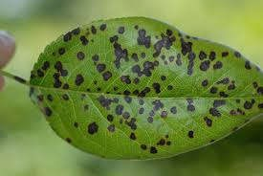
Figure 3: A pear leaf infected with Leaf Spot Disease

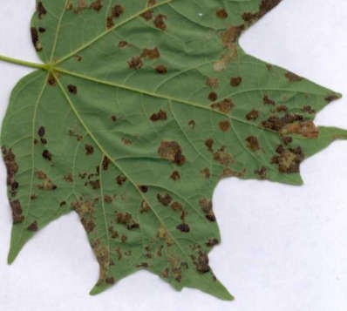
Figure 4: A maple leaf infected with Leaf Spot Disease (Missouri Botanical Garden, 2019)
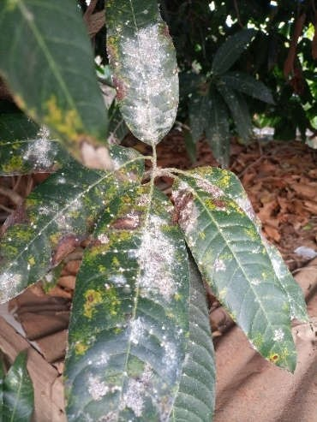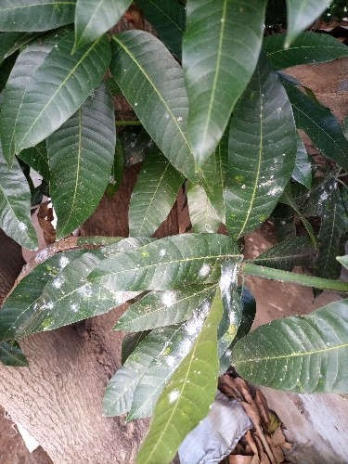
Figure 5: A mango plant infected with Powdery Mildew Disease

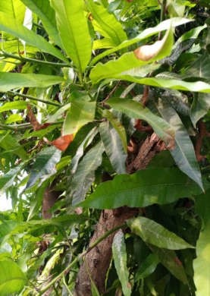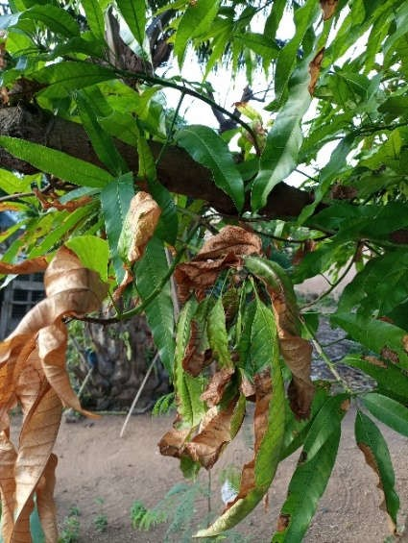

Figure 6: A mango plant infected with Wilt Disease

The data was split into two sets: a training dataset and a test dataset. 80% of the data was used for training and the remaining 20% for testing the accuracy of the model. This was done automatically by the Azure Custom Vision Service, once the data (images) are uploaded to the portal.
For this experimental research purpose, the researcher focused mainly on eight (8) different classes of diseases in the leaves of plants: Rust, Mosaic, Wilt, Powdery mildew, Leaf spot, Blight, Leaf curl, and Leaf blister. The images were labelled based on the classes of diseases under study, at the time of uploading them to the Custom Vision Service platform. A minimum of sixty (60) images per class were selected and uploaded. The Custom Vision Service platform automatically handled data cleaning by ensuring that no duplicate images were uploaded into the system.
The images were trained using the Azure Custom Vision web portal. The training of the images lasted for approximately, 3 hours. The Custom Vision Service algorithm trained the data and calculated the accuracy of the model by testing it with a portion of the images uploaded. Once the model was trained, it was tested and retrained until an optimal accuracy was achieved.
Eventually, when an optimal accuracy of ninety-one percent (91%) was achieved, the model was tested with the test dataset. This was done with the help of the Prediction API in the Custom Vision portal, which allowed the researcher to upload the test dataset to evaluate the accuracy of the fully trained model.
3.4 Developing the Image Classification Software
After, the model had been fully trained and tested was exported into a Jupyter notebook and used to develop the image recognition application to classify diseases in the leaves of plants. The model was downloaded from the Custom Vision Portal as a TensorFlow file. This software allows a user to upload an image of an infected leaf/leaves and then the software predicts the class of disease as well as suggests treatment for the disease.
All users and system requirements of the software were captured from prospective users of the software through interviews and documented. The prospective users include large-scale and small-scale farmers, agricultural-extension officers, and some individuals who had an interest in crop farming. The following are some functional and non-functional requirements that were gathered and documented.
Functional Requirements specify the system's specific functions and the data they operate on (Bigelo, 2020).
- The application shall only accept input in the form of images.
- The application shall process the user's input and display the results within twenty (20) seconds.
- The application shall display the treatment for each image classified.

Non-Functional requirements refer to characteristics of the system that are different from the specific functions it performs (Bigelo, 2020).
- The system shall provide an attractive user interface.
- The system shall be user-friendly.
After, A user-friendly Graphical User Interface (GUI) was built to enable a user to interact with the disease classification application. The Tkinter library in Python provided a fast and easy way to create the GUI. The interface mainly consists of control buttons (close, maximize/restore down and minimize buttons), an UPLOAD button (which allows the user to browse computer files and select the image to be classified), a CLEAR button (which clears the last image which was classified from the application window). The colours green, white and black, against a solid grey background were chosen as the colour scheme for this GUI. The green colour represents nature (plants), and the white and black colours with the grey background made a good combination with the green colour to ensure that texts in the GUI were visible and readable. Figure 7 below, shows the interface of the application:
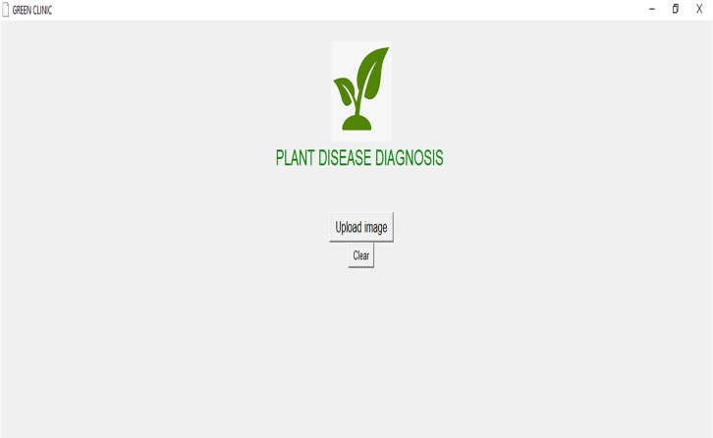
Figure 7: User Interface of Plant Disease Diagnosis Software

Python programming language was used for the back-end development of the software. The image classification model created on the Azure Customs Vision Service platform was downloaded as Tensorflow and imported together with Tkinter, pandas, NumPy, PIL, and OpenCV libraries into a Jupyter notebook to develop the software. Multiple tests were carried out with images obtained from the web and local farms. These tests helped check for additional bugs and usability issues.
3.5 Comparative Analysis
The detection and classification of plant diseases have been a crucial area of research in recent years due to its impact on food production and the economy (Biswas, et al., 2020). Various machine learning and deep learning algorithms have been used for plant disease classification, and their effectiveness has been proven in numerous studies. However, traditional machine learning algorithms or deep learning architectures have their limitations, which include the need for large amounts of labelled data, complex pre-processing techniques, and lengthy training time.
In recent years, there has been a surge of interest in cloud-based machine learning services, and one such service is the Azure Custom Vision Service. This service offers a user-friendly interface for building custom image classifiers and has been used in various applications, including plant disease classification. To assess the novelty of the proposed disease classification model, a comparative analysis against existing literature and systems was conducted.
In conclusion, the proposed disease classification model aims to fill this gap in the literature by using the Azure Custom Vision Service based on ResNet for classifying diseases in food crop plants. By leveraging the power of cloud computing and deep learning, the study provides a more efficient solution for plant disease classification.

4. Discussion of Results
4.1 Results of training the model
The Azure Custom Vision Service algorithm trained the data (images) and calculated the accuracy of the trained model by testing the model with a portion of the images which were uploaded to the Custom Vision portal. The results of the training are presented in figure 8 below:

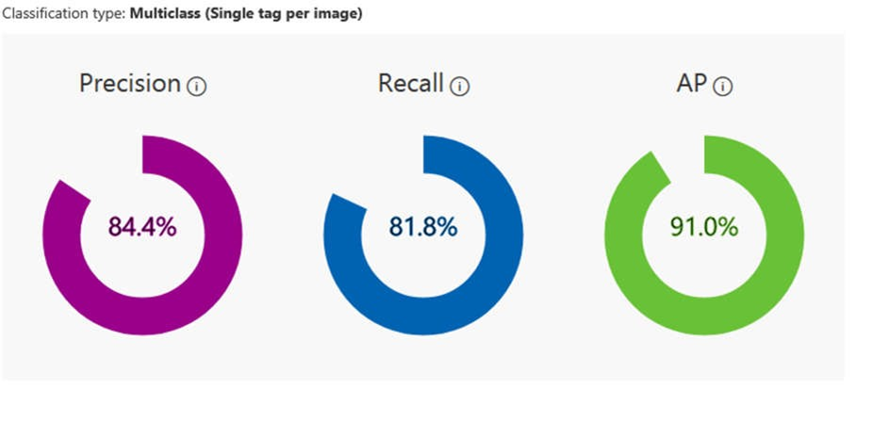
Figure 8: Summary of model performance (Microsoft, 2018)
In the image above, the training model presents a precision of 84.4%, recall of 81.8%, and Average Precision (AP) of 91.0%. The following are the three measures of the model's effectiveness:
Precision (Positive Predictive Value) refers to the percentage of identified classifications that were correct (Trufinescu, 2021). So in the case of this study, if the model identified a hundred (100) images as Wilt disease and approximately 84 of them would actually be Wilt disease, hence the precision of 84.4 percent.
Recall (Sensitivity) is also the percentage of actual classifications that were correctly identified (Trufinescu, 2021). This means that for instance, if there were 100 images of Mosaic disease, the model identified approximately 82 as Mosaic disease. Thus, the recall is 82 percent.
Mean average precision (mAP) is “the average value of the average precision (AP). AP is the area under the precision/recall curve (precision plotted against recall for each prediction made)” (Trufinescu, 2021). This is a measure of the model performance. In this model training, an AP of 91.0 percent was obtained.
In summary, this section of the results demonstrates the achievement of the first specific objective of this study; to apply Residual Network (ResNet) algorithm to analyze the pattern of food crop plant diseases and predict the diseases by using Microsoft Azure Custom Service as a toolkit.
4.2 Results of testing the software
A hundred 100 samples of images were used to test the software after it had been developed. These images were sourced from both the internet and local farms. Part of these images that were used for testing were images that had no characteristics of the diseases under study. This helped check for errors. From the tests run, the software successfully identifies the type of disease in the plant leaf and displays the name of the disease identified and the recommended treatment(s) for the disease identified. The images in figures 9-16, below illustrate how the software successfully identified the eight (8) different diseases in the leaves of plants which were discussed in the earlier:
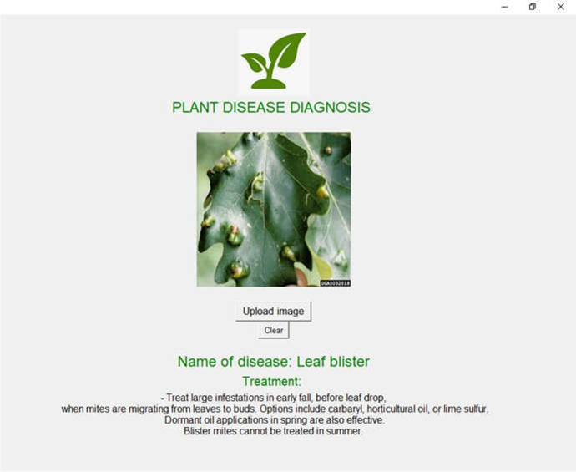
Figure 9: Identifying Leaf Blister Disease
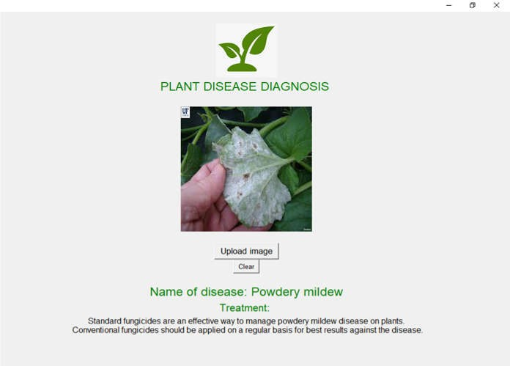
Figure 10: Identifying Powdery Mildew Disease
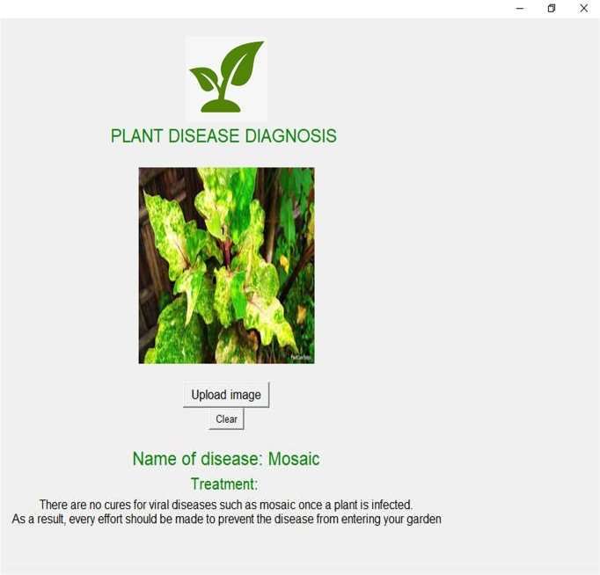
Figure 11: Identifying Mosaic Disease

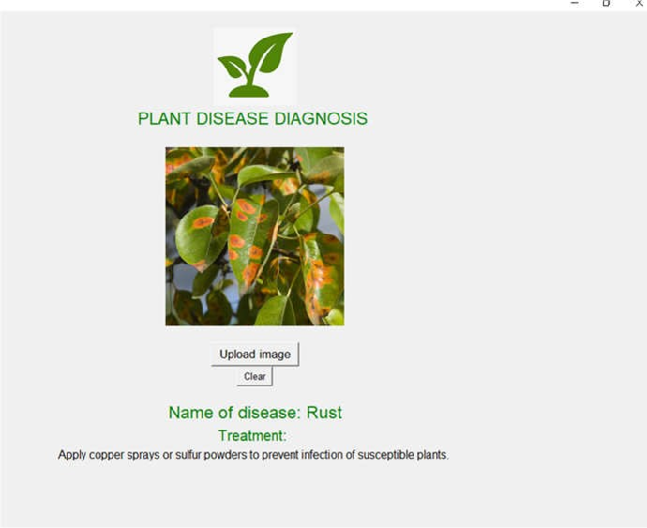
Figure 12: Identifying Rust Disease

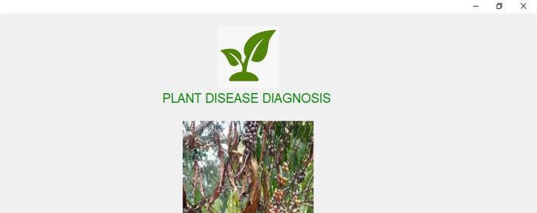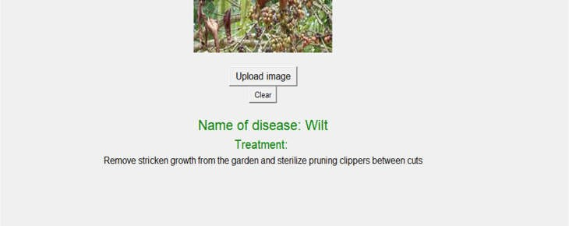
Figure 13: Identifying Wilt Disease
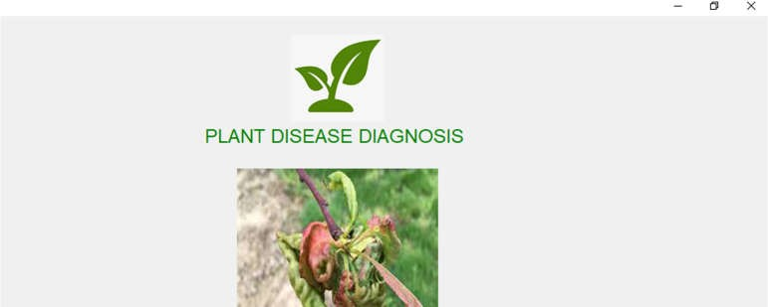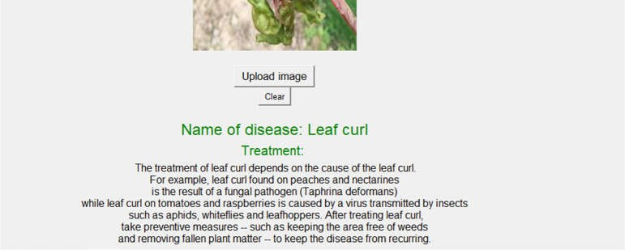
Figure 14: Identifying Leaf Curl Disease

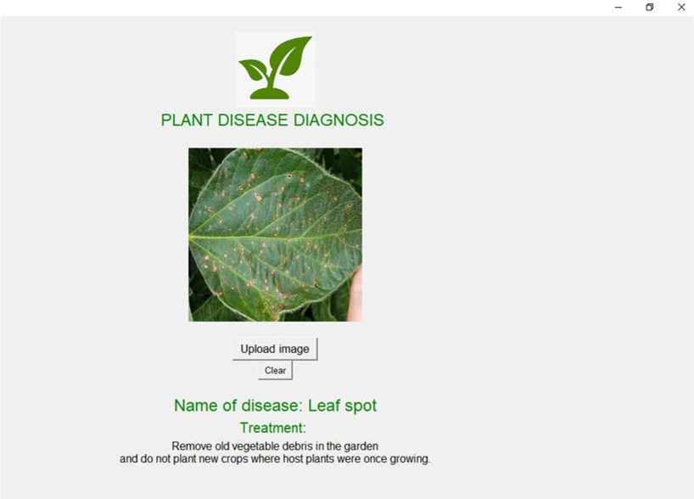
Figure 15: Identifying Leaf Spot Disease

Figure 16: Identifying Blight Disease
When an image that has no feature common to the diseases under study is uploaded to the software, an error message pops up, instructing the user to upload a different image. Figure 17 below illustrates this aspect of the software:
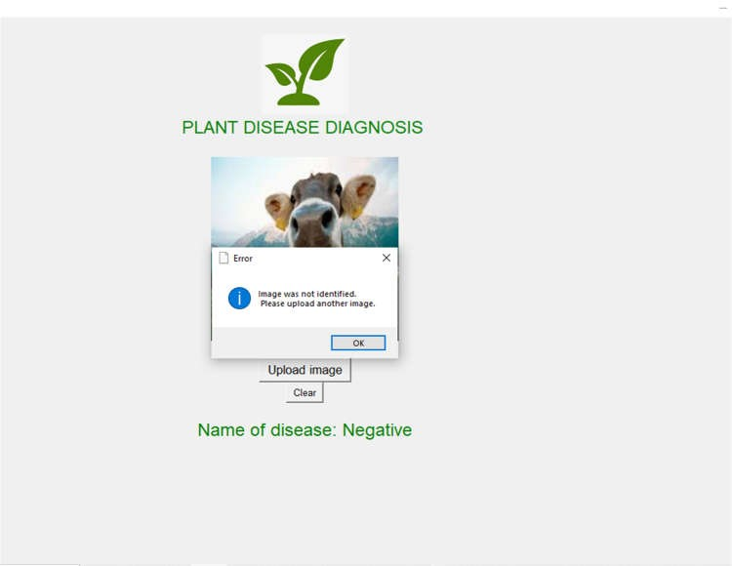
Figure 17: Software Detecting an Outlier
In summary, this section of the results demonstrates the achievement of the second specific objective of this study; to develop a user-friendly and efficient interface that improves the ease of use of the software system for farmers and agronomists.
4.3 Results of Comparative Analysis
To assess the novelty of the proposed disease classification model for leaves of food crop plants, a comparative analysis against existing literature and systems is conducted. The proposed model's performance was compared with several state-of-the-art methods used in plant disease classification. The model achieved an accuracy of 91.0%. In contrast, existing systems achieved accuracies between 85% and 90%. This indicates that our proposed system outperforms existing methods in terms of accuracy and efficiency.
Moreover, the currently available systems lack user-friendly interfaces that can assist farmers in accurately detecting and classifying diseases. However, the proposed system surpasses the capabilities of the existing systems by offering a streamlined and user-friendly interface.
In summary, the proposed system is novel in its approach to using Azure Custom Vision Service based on ResNet for classifying diseases in food crop plants. Additionally, the system's performance surpasses that of existing state-of-the-art methods, further highlighting the novelty and effectiveness of the proposed model.
5. Conclusion
5.1 Summary
Plant diseases affect plant growth, which eventually affects crop yield. In most cases, farmers suffer huge losses due to severe outbreak of pests and diseases on their farms. Plant pathological research has therefore become very essential in modern agriculture and forestry for improvement in crop production as every year, disease infections cause significant damage to crops.
One of the most important ways of improving crop production is disease identification and treatment. Several researchers have that lab-oriented research of pathogenic diseases can be time-consuming and very much expendable. The main objective of this study was to develop an intelligent software system for the automated identification, classification, and treatment recommendation of crop plant diseases.
The methods employed in this research involved training an image classification model for detecting diseases in the leaves of plants using the Azure Custom Vision AI platform and using an agile method of software development to develop a software for identifying the diseases. By employing this technique in training a model, plant diseases are recognized at approximately a 91 percent accuracy rate.
In this research, a customized model for classifying common diseases in the leaves of food crop plants has been developed using the Azure Custom Vision AI platform, based on ResNet algorithm. Based on this, it can be concluded that the first specific objective, which was to apply Residual Network (ResNet) algorithm to analyze the pattern of food crop plant diseases and predict the diseases by using Microsoft Azure Custom Service as a toolkit, has been achieved. The model was inference in a plant disease diagnosis software which allows users to upload an image from their computer, and within a maximum of twenty (20 seconds), the software can identify the disease and recommend some treatments. This also indicates that the second specific objective of the study; to develop a user-friendly and efficient interface that improves the ease of use of the software system for farmers and agronomists has been achieved.
The study also evaluated the performance of the developed system and compared it to existing models. This also indicates the achievement of the third specific objective; to evaluate the performance of the developed system and compare it with existing methods of disease identification and treatment recommendation.
Moreover, the proposed system is novel in its approach to using Azure Custom Vision Service based on ResNet for classifying diseases in food crop plants. Additionally, the system's performance surpasses that of existing methods, further highlighting the novelty and effectiveness of thr proposed model.
The proposed system has a huge potential to help farmers increase their crop yield through easy and instant identification of plant diseases.

5.2 Recommendations
With this software, farmers will have the chance to diagnose food crop plant diseases easily and see recommended treatments for the diseases. The researcher, therefore, recommends that the software should be adopted by farmers to help them achieve better crop production.
Agrochemical companies could also acquire this software and recommend some of their products in the treatment section to farmers who use the software. This would be a good way to market and sell their products.

5.3 Future Works
The researchers of this study believe that there are still a lot of techniques that can be implemented to improve the classification model and software. Some of the future works that can be considered are:
- The software should be implemented in a mobile application. So that it becomes easier for the farmers to just carry their mobile and find the types of diseases that attack their plants and their possible treatments.
- The accuracy of the model can also be improved to perform better in terms of predicting plant diseases accurately.
- The model can also be enhanced to identify other diseases that affect plant leaves.
- The model can be modified to identify diseases that occur in other parts of plants, other than the leaves.

Declarations
Availability of data and materials
The dataset and codes for this study will be made available from the corresponding author upon reasonable request.

COMPETING INTERESTS DISCLAIMER:
Authors have declared that they have no known competing financial interests OR non-financial interests OR personal relationships that could have appeared to influence the work reported in this paper.

Disclaimer (Artificial intelligence)
Author(s) hereby declare that NO generative AI technologies such as Large Language Models (ChatGPT, COPILOT, etc.) and text-to-image generators have been used during the writing or editing of this manuscript.

6. References:
Abrahamsson, P., Salo, O., Ronkainen, J., & Warsta, J. (2017). Agile software development methods: Review and analysis. arXiv preprint. doi:https://doi.org/10.48550/arXiv.1709.08439
Africa Soil Health Consortium. (2015, August). Crop Pest and Diseases. (CAB International) Retrieved from http://africasoilhealth.cabi.org/wpcms/wp-content/uploads/2015/09/519-ASHC-manual-English.pdf
Ameyaw, G. A., Domfeh, O., & Gyamera, E. (2023). Epidemiology and Diagnostics of Cacao Swollen Shoot Disease in Ghana: Past Research Achievements and Knowledge Gaps to Guide Future Research. Virus - MDPI, 16(1). doi:https://doi.org/10.3390/v16010043
Bera, A., Wharton, Z., Liu, Y., Bessis, N., & Behera, A. (2021). Attend and guide (ag-net): A keypoints-driven attention-based deep network for image recognition. IEEE Transactions on Image Processing, 30, 3691-3704. doi:https://doi.org/10.1109/TIP.2021.3064256
Bigelo, S. J. (2020, July 30). 7 Techniques for Better Agile Requirements Gathering. (TechTarget) Retrieved March 15, 2024, from https://searchsoftwarequality.techtarget.com/tip/7techniques-for-better-Agile-requirements-gathering
Biswas, R., Basu, A., Nandy, A., Deb, A., Chowdhury, R., & Chanda, D. (2020). Identification of pathological disease in plants using deep neural networks-powered by intel® distribution of openvino™ toolkit. 2020 Indo–Taiwan 2nd International Conference on Computing, Analytics and Networks (Indo-Taiwan ICAN) (pp. 45-48). Rajpura, India: IEEE. doi:https://doi.org/10.1109/Indo-TaiwanICAN48429.2020.9181339
Boateng, G. (2024). Agricultural Aid and Cocoa Production in Developing Countries: Examining Ghana as a Case Study. The Macalester Street Journal, 2(1). doi:https://doi.org/10.62543/msj.v2i1.52
Cornelius, E. W., & Coffie, S. A. (2015). Plant clinics and plant health diagnostic labs team up for cop health in Ghana. CABI Study Brief 8: Impact. doi:https://dx.doi.org/10.1079/CABICOMM-62-8109
Gavhale, K. R., & Gawande, U. (2014). An Overview of the Research on Plant Leaves Disease Detection. IOSR Journal of Computern Engineering (IOSR-JCE), 16(1), 10-16. doi:10.9790/0661-16151016
Gyamerah, S., Soori, G. T., Korda, D. R., Tawiah, J. K., Akolgo, E. A., & Dapaah, E. O. (2023). Comparative Analysis of Feature Extraction of High Dimensional Data Reduction Using Machine Learning Techniques. American Journal of Electrical and Computer Engineering, 7(2), 27-39. doi:10.11648/j.ajece.20230702.12
Haider, N. (2018). A Brief Review on Plant Taxonomy and its Components. The Journal of Plant Science Research, 34(2), 275-290. Retrieved from https://www.printspublications.com/journal/thejournalofplantscienceresearch12818263520674149434#previous
Hano, A. (2015). Mangement of Plant Disesases. (A. Abbas, Ed.) Huazhong: Anonymous. Retrieved from https://www.researchgate.net/publication/283348929_MANAGEMENT_OF_PLANT_DISEASES
He, K., Zhang, X., Ren, S., & Sun, J. (2016). Deep residual learning for image recognition. Proceedings of the IEEE conference on computer vision and pattern recognition, (pp. 770-778). Retrieved from https://openaccess.thecvf.com/content_cvpr_2016/html/He_Deep_Residual_Learning_CVPR_2016_paper.html
Honger, J. O., Lomotey, T., Kugblenu-Darrah, Y., Bedu, I., & Amankwa, N. Y. (2023). Characterisation and in-vitro Control of Curvularia lunata, the Causal Agent of Brown Leaf Spot Disease of Rice in Ghana. Agricultural and Food Science Journal of Ghana. doi:10.4314/afsjg.v15i1.3
Hughes, D., & Salathé, M. (2015). An open access repository of images on plant health to enable the development of mobile disease diagnostics. PLOS Neglected Tropical Diseases. doi:https://doi.org/10.48550/arXiv.1511.08060
Jiao, L., Zhang, F., Liu, F., Yang, S. L., Feng, Z., & Qu, R. (2019). A survey of deep learning-based object detection. IEEE Access, 7, 128837-128868. doi:https://doi.org/10.1109/ACCESS.2019.2939201
Joshua, B. (2023). Current Knowledge on Biotic Stresses affecting Legumes: Perspectives in Cowpea and Soybean. In Advances in Legume Research (pp. 14-36). Gottingen: Bentham Science Publishers.
Karansingh, C., Patel, S. N., Kumhar, M., Bhatia, J., Tanwar, S., Davidson, I. E., . . . Sharma, R. (2023). Deep learning-based single-image super-resolution: A comprehensive review. IEEE Access, 11, 21811-2183. doi:https://doi.org/10.1109/ACCESS.2023.3251396
Kassem, M. A., Hosny, K. M., & Fouad, M. M. (2020). Skin lesions classification into eight classes for ISIC 2019 using deep convolutional neural network and transfer learning. IEEE Access, 8, 114822-114832. doi:https://doi.org/10.1109/ACCESS.2020.3003890
Kennelly, M., O'Mara, J., Rivard, C., Miller, G., & Smith, D. (2021). Introduction to Abiotic Disorders in Plants. APS. doi:10.1094/PHI-I-2012-10-29-01
Kinser, K. (2011). Common Plant Diseases in the Landscape and Garden. North Dakota: NDSU. Retrieved from Kinser, K. (2011, April 9). Common Plant Diseases in thwww.ag.ndsu.edu/pdl/documents/common-ND-plantdiseases.pdf
Körner, C., & Waaijer, K. (2020). Mastering Azure Machine Learning: Perform large-scale end-to-end advanced machine learning in the cloud with Microsoft Azure Machine Learning. Birmingham: Packt Publishing Ltd.
Kuo, E. (2019). Azure Custom Vision Service v.s Azure ML for Vision. (EK. Technology Learn) Retrieved June 05, 2024, from https://blog.edwardkuo.dev/azure-custom-vision-service-v-s-azure-ml-for-vision-bba97e16e2a3
Leitão, M. C. (2020). Shade trees, disease and cocoa production in Western Ghana: a case study (Doctoral dissertation). Wageningen. Retrieved from https://bscmsc. pps. wur. nl/shade-trees-disease-andcocoa-production-western-ghana-case-study
Mehmood, N. S., Gondal, Z. F., Jamil, A., Iqbal, N., Ali, R., Ercisli, B., & Kupe, S. (2023). Multifaceted impacts of plant-beneficial pseudomonas spp. in managing various plant diseases and crop yield improvement. ACS omega, 8(25), 22296-22315. Retrieved from https://doi.org/10.1021/acsomega.3c00870
Microsoft. (2018). Visual Intelligence Made Easy. (Microsoft) Retrieved December 02, 2023, from https://www.customvision.ai/
Microsoft. (2020). Classify images with the Custom Vision service. (Microsoft) Retrieved July 01, 2024, from https://learn.microsoft.com/en-us/training/modules/classify-images-custom-vision/
Microsoft. (2020). Machine Learning Algorithms. (Microsoft) Retrieved July 02, 2024, from https://azure.microsoft.com/en-gb/resources/cloud-computing-dictionary/what-are-machine-learning-algorithms/#techniques
Missouri Botanical Garden. (2019). Leaf Spot Diseases of Shade Trees and Ornamentals. (Missouri Botanical Garden) Retrieved December 15, 2023, from https://www.missouribotanicalgarden.org/gardens-gardening/your-garden/help-for-the-home-gardener/advice-tips-resources/insects-pests-and-problems/diseases/fungalspots/leaf-spot-shade
Mohanty, S. P., Hughes, D. P., & Salathé, M. (2016). Using deep learning for image-based plant disease detection. Frontiers in plant science, 7. doi:https://doi.org/10.3389/fpls.2016.01419
Nithin, S. C. (2013). Image Processing. International Journal of Innovative Research in Information Security . doi:https://www.doi.org/10.26562/ijiris.2023.v0903.06
Ofori, A., Padi, F. K., Amoako-Attah, I., Asare, E. K., Dadzie, A., & Bukari, Y. (2023). enetic variation among cocoa (Theobroma cacao L.) families for resistance to black pod disease under field and laboratory conditions. Ecological Genetics and Genomics, 28. doi:https://doi.org/10.1016/j.egg.2023.100182
Omrani, E., Khoshnevisan, B., Shamshirband, S., Saboohi, H., Anuar, N. B., & Nasir, M. H. (2014). Potential of radial basis function-based support vector regression for apple disease detection. Measurement, 55, 512-519. doi:https://doi.org/10.1016/j.measurement.2014.05.033
Parker, J. R. (2011). Algorithms for Image Processing and Computer Vision. Indianapolis: Wiley Publishing Inc. Retrieved from https://www.wiley.com/en-us/Algorithms+for+Image+Processing+and+Computer+Vision%2C+2nd+Edition-p-9781118021880
Pelczar, R. M., & Kelman, A. (2023, December 28). Britannica. (Britannica) Retrieved August 1, 2024, from https://www.britannica.com/science/plant-disease
Rouhan, G., & Gaudeul, M. (2021). Plant Taxonomy: A Historical Perspective, Current Challenges and Perspectives. Molecular Plant Taxonomy, 2222. doi:https://doi.org/10.1007/978-1-0716-0997-2_1
Sarfo, N. Y., Cornelius, E. W., & Torkpo. (2024). Greenhouse tomato farmers' knowledge, perceptions, and management of tomato bacterial wilt (Ralstonia solanacearum) disease. African Journal of food, Agriculture, Nutrition and Development. doi:https://www.doi.org/10.18697/ajfand.127.22870
Seo, Y., & Shin, K. S. (2019). Hierarchical convolutional neural networks for fashion image classification. Expert Systems with Applications, 116, 328-339. doi:https://doi.org/10.1016/j.eswa.2018.09.022
Shafik, W., Tufail, A., Namoun, A., De Silva, L. C., & Apong, R. A. (2023). A Systematic Literature Review on Plant Disease Detection: Motivations, Classification Techniques, Datasets, Challenges, and Future Trends. IEEE Access, 11, pp. 59174-59203. doi:10.1109/ACCESS.2023.3284760
Sladojevic, S., Arsenovic, M., Anderla, A., Culibrk, D., & Stefanovic, D. (2016). Deep neural networks based recognition of plant diseases by leaf image classification. Computational intelligence and neuroscience, 1. doi: https://doi.org/10.1155/2016/3289801
Teye, J. N., & Appiah, A. S. (2020). Identification and management of cassava brown streak disease in Ghana. Plant Pathology Journal, 36(5), 487-497.
Tieng, H., Yang, H., & Li, Y. (2022). Data Acquisition and Preprocessing. In F. Cheng (Ed.). Wiley . doi:https://www.doi.org/10.1002/9781119739920.ch2
Timmmerman, A., Nygren, A., VanDeWalle, B., Giesler, L., Seymour, R., Glewen, K., . . . Treptow, D. (2019). Plant Disease: Pathogens and Cycles. (Instititute of Agriculture and Natural Resources, Cropwatch) Retrieved August 1, 2024, from https://cropwatch.unl.edu/soybeanmanagement/plant-disease
Trufinescu, A. (2021). Characteristics and Limitations of Custorm Vision. (Microsoft) Retrieved February 14, 2024, from https://docs.microsoft.com/en-us/legal/cognitive-services/customvision/custom-vision-cvs-characteristics-and-limitations?cid=kerryherger
United Nations. (2020). Pest and Pesticide Management. (Food and Agriculture Organization of the United Nations) Retrieved from https://www.fao.org/pest-and-pesticide-management/about/understanding-the-context/en/
Wäldchen, J., & Mäder, P. (2017). Plant Species Identification Using Computer Vision Techniques: A Systematic Literature Review. Arch Computat Methods Eng, 25, 507-543. doi:https://doi.org/10.1007/s11831-016-9206-z
Wang, J., Lai, S., & Li, M. (n.d.). Improved image fusion method based on NSCT and accelerated NMF. Sensors, 12(5), 5872-87. doi:http://dx.doi.org/10.3390/s120505872
Zeng, Y. (2024). Enhancing Image Classification Accuracy Based on AlexNet. 5th International Conference on Computer Science and Intelligent Communication (CSIC 2023), 85, pp. 879-885. Vancouver. doi:https://doi.org/10.54097/9c8kkn59
Zhang, J., Zhao, X., Chen, Z., & Lu, Z. (2019). A review of deep learning-based semantic segmentation for point cloud. IEEE Access, 7, 179118-179133. doi:https://doi.org/10.1109/ACCESS.2019.2958671

