***Review Paper***

**Speed Breeding in Wheat Crop: A comprehensive Review**

**ABSTRACT**

Speed breeding has emerged as a transformative strategy in modern plant breeding, offering the potential to significantly shorten breeding cycles and enhance genetic gains, particularly in wheat (*Triticum aestivum L.*), one of the world’s most critical staple crops. This review comprehensively examines the principles, methodologies, applications, and future prospects of speed breeding in wheat improvement. The technique relies on the manipulation of environmental parameters such as extended photoperiods, controlled temperature regimes, and optimized light intensity to induce rapid plant growth and early flowering, thereby enabling multiple generations per year up to 4–6 in wheat, compared to the traditional 1–2. Key techniques include the use of high-throughput phenotyping platforms, growth chambers, and LED lighting systems to accelerate generation turnover and facilitate the rapid fixation of desirable traits. Speed breeding has been successfully integrated with other modern breeding approaches such as marker-assisted selection, genomic selection, and CRISPR/Cas-based genome editing to improve yield, biotic and abiotic stress resistance, and climate adaptability in wheat cultivars. Notable case studies from Australia, the UK, and India demonstrate the successful application of speed breeding in developing elite wheat lines with enhanced agronomic traits. Despite its advantages, speed breeding faces several challenges, including limited infrastructure in developing regions, potential loss of genetic diversity, and the need for crop-specific protocol optimization. The review also highlights future directions, including automation, integration with artificial intelligence for trait prediction, and the expansion of speed breeding to underutilized cereals and legumes. Ultimately, speed breeding holds immense promise for achieving food and nutritional security under the looming threats of climate change and a growing global population. Its widespread adoption in wheat breeding programs can revolutionize the pace and precision of varietal development for sustainable agriculture.

***Keywords****: Speed breeding, Wheat crop improvement, Controlled environments, Genomic selection*

1. **INTRODUCTION**

Speed breeding, a novel approach in crop breeding, has emerged as a promising technique for accelerating the development of improved wheat varieties. By reducing the breeding cycle and facilitating a quicker generational transition, this novel approach seeks to accelerate varietal development in response to the growing needs for climate resilience and food security. Accelerated plant growth and reproduction can be achieved by speed breeding, which modifies growth parameters including temperature, light, and photoperiod. Compared to conventional field-based breeding procedures, this leads to shorter crop cycles, allowing many generations of wheat to be produced and assessed in a much shorter amount of time (Watson et al., 2018). Comparing speed breeding to traditional breeding methods reveals a number of benefits. First of all, because breeders may choose and develop potential wheat lines more quickly via repeated generations, it allows for more genetic gain per unit of time. Furthermore, speed breeding improves breeding accuracy by facilitating the controlled evaluation of a greater number of genotypes and attributes, which results in the development of superior varieties with desired agronomic qualities including yield, stress tolerance, and disease resistance (Hickey et al., 2019).

Notable progress has been made in varietal development as a result of the use of speed breeding in wheat crop improvement. The production of wheat varieties with superior features, such as increased yield potential, resilience to biotic and abiotic stressors, and adaptability to a variety of different environmental circumstances, has been effectively accelerated by researchers through the use of speed breeding. In order to mitigate the negative impacts of climate change on wheat output in warmer places, Mondal, for instance, demonstrated how to apply speed breeding to quickly generate wheat lines with enhanced heat tolerance (Mondal et al., 2018). Speed breeding has limitations and obstacles even with its bright future. To get the best outcomes, technical factors including controlling plant nutrition, optimising growth conditions, and maintaining genetic variety are essential. In addition, it is imperative to tackle the issues of speed breeding systems' scalability and cost-effectiveness to enable a wider use by breeding programmes around the globe (Watson et al., 2018).Top of Form

1. **IMPORTANCE OF SPEED BREEDING IN WHEAT AGRICULTURE**

In wheat agriculture, speed breeding has become a game-changing method that offers a viable answer to many of the problems that farmers and breeders confront. Through substantial reduction of the breeding cycle and a faster generation turnover, speed breeding facilitates the swift creation of enhanced wheat varieties featuring desired characteristics. This invention is especially important in light of climate change, as wheat cultivars that are climate-resilient are desperately needed. Research has shown that speed breeding may effectively accelerate crop research and breeding, leading to the generation of wheat varieties that are climate-resilient and able to survive harsh climatic circumstances. This has been proved in studies conducted (Watson et al., 2018). Furthermore, by boosting wheat production and guaranteeing steady food supply for expanding populations, speed breeding plays a significant role in resolving concerns about food security. As a staple crop, wheat is essential to the world's food security, and speed breeding has greatly aided in the quick production of high-yielding varieties to fulfil the growing demand for items made from wheat. Furthermore, as studies like, speed breeding makes it possible for breeders to introduce genes for disease and pest resistance into new wheat varieties, increasing their resistance against common infections and pests (Mondal et al., 2018).

Speed breeding has become a vital tool in modern wheat agriculture, addressing several pressing challenges related to crop improvement, climate resilience, and global food security. By significantly shortening the breeding cycle—from the typical 5–10 years to just 2–4 years—this approach enables rapid development of new wheat varieties with improved traits. The accelerated generation turnover, achieved through controlled environmental conditions such as extended daylight exposure and regulated temperatures, allows breeders to advance multiple generations per year. This not only speeds up the selection process but also enables quicker fixation of beneficial traits in breeding populations. In the face of increasingly erratic weather patterns and rising global temperatures, the ability to fast-track the development of climate-resilient wheat varieties is a major breakthrough. Speed breeding allows the swift incorporation of traits such as drought tolerance, heat resistance, and early maturity—traits essential for sustaining wheat productivity in stress-prone regions. Furthermore, it enhances the efficiency of introgressing resistance genes for major wheat diseases such as rusts and blights, reducing the risk of crop losses and minimizing the need for chemical controls. The importance of speed breeding also extends to food security. As wheat remains a primary calorie source for billions of people, improving yield potential and grain quality through faster breeding cycles is crucial. With global population growth increasing demand for staple foods, speed breeding offers a proactive solution by ensuring a steady pipeline of improved cultivars. Moreover, it complements advanced breeding technologies such as genomic selection and gene editing, creating a synergistic platform for next-generation crop improvement. In essence, speed breeding is not merely a technical innovation but a strategic approach that empowers wheat breeders to respond more rapidly and effectively to the dynamic challenges of modern agriculture.

1. **LIMITATIONS OF CONVENTIONAL BREEDING APPROACHES**

Although fundamental to crop improvement, conventional breeding methods have drawbacks that have prompted the creation and application of cutting-edge methods like speed breeding. A number of obstacles included in traditional breeding techniques hinder the effective creation of novel crop types. First of all, field experiments that are carried out across several growing seasons are frequently used in traditional breeding, which may be labour- and time-intensive. Many crop species, like wheat, have long generation periods and might take months or years to reach maturity, which adds to this protracted timescale (Tester et al., 2010). Moreover, because sexual reproduction is inherently unpredictable, traditional breeding techniques may have trouble producing desirable characteristic combinations. Relying too much on spontaneous genetic variation might lead to erratic results and make exact trait introgression difficult. Furthermore, it might be difficult to identify and choose better genotypes solely based on phenotypic qualities, particularly for complex traits that are impacted by environmental variables and controlled by several genes (Varshney et al., 2005). Furthermore, limited genetic variety within breeding populations frequently poses limitations to conventional breeding methods, especially for crops that self-pollinate. Narrow genetic bases can raise the likelihood of genetic sensitivity to biotic and abiotic stimuli and limit the availability of suitable alleles for improving a characteristic (Mondal et al., 2016).

Although conventional breeding has served as the foundation of crop improvement for decades, it presents several limitations that have led to the development of innovative techniques such as speed breeding. One of the most significant drawbacks of traditional breeding is its time-consuming nature. Field trials often span multiple growing seasons, making the process labor-intensive and slow. In crops like wheat, which have inherently long generation times, breeders may need several years to complete a single breeding cycle. This prolonged timeline severely limits the speed at which new varieties can be developed. Additionally, traditional breeding relies on natural sexual reproduction, which can be unpredictable and random, making it challenging to consistently achieve desired trait combinations. Another critical limitation lies in the difficulty of selecting superior genotypes based solely on phenotypic traits. Many economically important traits in wheat—such as yield, drought tolerance, and disease resistance are complex, controlled by multiple genes, and heavily influenced by environmental interactions. Moreover, environmental variability further complicates breeding efforts by affecting the expression of key traits across different locations and seasons. The lack of high-throughput phenotyping platforms limits the ability to efficiently evaluate large populations, while resource constraints such as limited infrastructure, funding, and skilled personnel impede the scalability of breeding programs. Finally, lengthy regulatory approvals, restricted access to diverse germplasm, and insufficient interdisciplinary collaboration further hinder progress. These cumulative challenges are summarized in Table 1, which outlines the key obstacles in wheat crop improvement through conventional breeding methods.

In response to the growing global demand for food and the limitations of conventional breeding, speed breeding has emerged as a promising strategy to significantly shorten crop generation times and accelerate the development of improved varieties. This approach utilizes controlled environmental conditions, such as extended photoperiods and optimized temperatures, to hasten plant growth and reproduction. Under controlled light regimes typically 22 hours of light and 2 hours of darkness—and moderate temperatures of 17–22°C, speed breeding enables the completion of up to 4–6 generations per year in crops like wheat, compared to only 2–3 generations under conventional conditions using natural light (Fig. 1). Speed breeding offers a transformative advantage over traditional methods in terms of time efficiency and breeding cycle compression. As shown in Fig. 1, line development under speed breeding protocols can be completed in 2–4 years, in contrast to the 8–12 years required under conventional field-based breeding systems. This is followed by 3–5 years of field testing and 1–3 years of multi-location trials before variety release, thus reducing the overall breeding timeline significantly. The process of speed breeding begins with early generation advancement (F1:2 to F5:6) under controlled conditions, followed by selection, multiplication, and phenotypic evaluations for key traits. Promising lines are then subjected to adaptation and yield trials, culminating in selection and eventual variety release. This pipeline ensures the rapid development and deployment of elite cultivars with desired traits such as stress tolerance, disease resistance, and improved yield performance. The central advantage of speed breeding lies not only in its time-saving capacity but also in its compatibility with modern breeding techniques such as genomic selection and CRISPR-based genome editing, allowing for precision breeding at an accelerated pace.

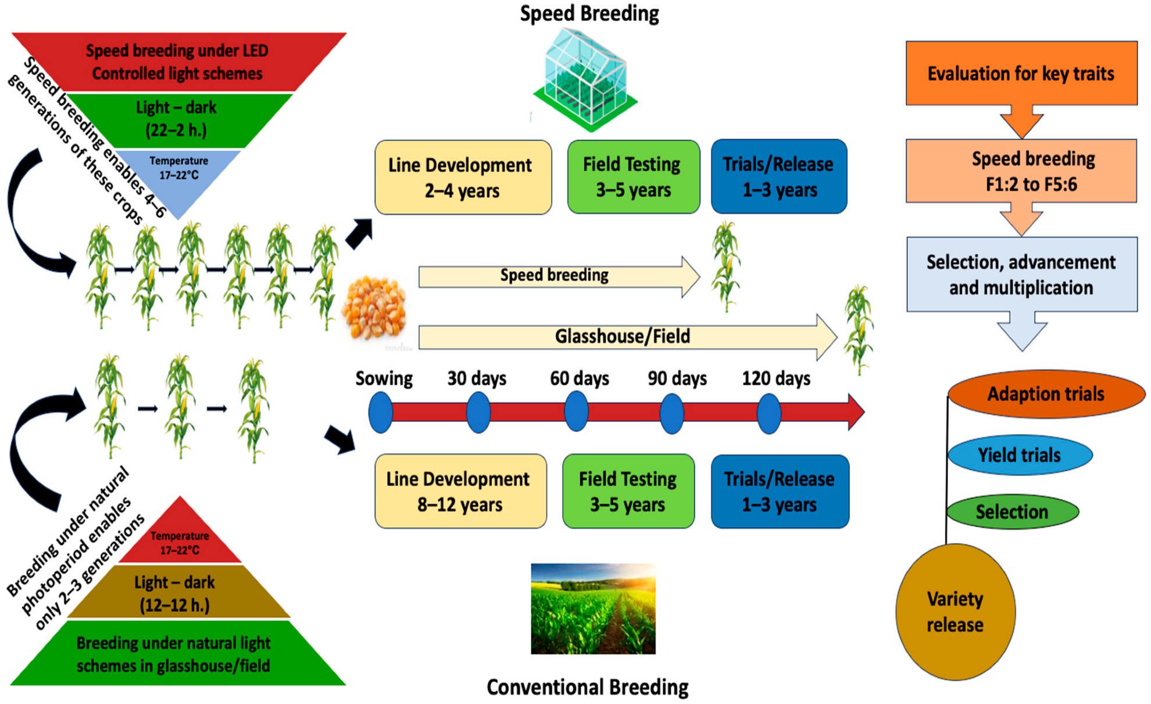

**Fig. 1: Enhanced Generation Turnover Through Speed Breeding Compared to Traditional Breeding Systems (Potts et al., 2023).**

Top of Form**Table 1: List of challenges in wheat crop improvement using traditional methods**

|  |  |  |
| --- | --- | --- |
| **Challenge** | **Description** | **References** |
| Time-consuming field trials | Field trials conducted over multiple growing seasons can be time-consuming and labor-intensive. | (Van evert et al., 2017) |
| Randomness of sexual reproduction | Achieving desired trait combinations can be challenging due to the unpredictable outcomes of sexual reproduction. | (Hickey & Gororo 2018) |
| Limited genetic diversity within breeding populations | Constrained by limited genetic diversity within breeding populations, particularly in self-pollinating crops like wheat. | (Zeng et al., 2017) |
| Long generation times | Wheat has relatively long generation times, which can slow down the breeding process. | (Li et al., 2020) |
| Complexity of target traits | Complex traits controlled by multiple genes and influenced by environmental factors pose challenges for precise trait introgression. | (Paux et al., 2008) |
| Difficulty in phenotypic selection | Identifying and selecting superior genotypes based on phenotypic traits alone can be challenging, especially for traits with low heritability. | (Montesinos -Lopez et al., 2018) |
| Genetic vulnerability to biotic and abiotic stresses | Narrow genetic bases can increase the risk of genetic vulnerability to pests, diseases, and environmental stresses. | (Saintenac et al., 2013) |
| Environmental variability | Environmental factors such as temperature, moisture, and soil conditions can impact the expression of traits and complicate breeding efforts. | (White et al., 2012) |
| Lack of high-throughput phenotyping platforms | Limited availability of high-throughput phenotyping platforms hinders the rapid and accurate phenotypic evaluation of large breeding populations. | (Araus et al., 2014) |
| Resource constraints | Limited financial resources, infrastructure, and skilled manpower can impede the scalability and efficiency of breeding programs. | (Atlin et al., 2017) |
| Lengthy regulatory approval processes | Regulatory approval processes for new crop varieties can be time-consuming and bureaucratic, delaying their commercialization. | (Smyth et al., 2015) |
| Inefficient trait introgression | Incompatibility barriers and linkage drag can hinder the efficient introgression of desired traits into elite breeding lines. | (Chiang et al., 2009) |
| Limited access to genetic resources | Access to diverse germplasm and genetic resources may be restricted, limiting the breadth of genetic variability available for breeding purposes. | (Dempewolf et al., 2017) |
| Lack of interdisciplinary collaboration | Limited collaboration between breeders, geneticists, agronomists, and other stakeholders may impede the integration of diverse expertise and perspectives in breeding programs. | (Des Marais et al., 2016) |

**Top of Form**

**4. CONCEPT AND PRINCIPLES OF SPEED BREEDING**

Speed breeding is a cutting-edge method that has drastically accelerated the breeding process, revolutionising the area of crop breeding. By modifying environmental factors to encourage quick plant growth and development, the idea of speed breeding makes it possible to cultivate and assess many crop generations much faster than using conventional techniques. This strategy works especially well for crops like rice, wheat, and barley that have extended generation periods. The optimisation of critical growth parameters, including as light, temperature, photoperiod, and nutrient availability, to produce an environment that promotes quick plant growth and reproduction, is the foundation of speed breeding theory. Through meticulous manipulation of these factors in growth chambers or greenhouses, scientists may encourage plants to mature more quickly. For instance, prolonged photoperiods or continuous lighting regimes can promote continuous growth and shorten the time it takes for plants to go from the vegetative to the reproductive phases (Ghosh et al., 2018). One of the main benefits of speed breeding is that it may speed up generation turnover, which enables breeders to assess a lot of plant populations and characteristics in a short amount of time. Compared to traditional breeding approaches, this higher throughput makes it possible to identify desired features and select superior genotypes much more quickly. Furthermore, speed breeding allows for more flexibility and accuracy in breeding since the environment may be adjusted to meet the needs of certain crops and breeding goals (Watson et al., 2018).

**5.**

**PRINCIPLES UNDERLYING ACCELERATED CROP BREEDING TECHNIQUES**

A number of fundamental ideas underpin accelerated crop breeding methods, such as speed breeding, which are designed to improve genetic gain and speed up the breeding process. These tenets centre on controlling the environment, making the best use of resources, and taking use of technology breakthroughs. The core ideas of rapid crop breeding techniques are listed below:

**5.1 Controlled Environmental Conditions**: In order to provide crops the best growth circumstances possible, accelerated breeding techniques manipulate environmental variables such light, temperature, humidity, and photoperiod. Researchers can speed plant growth and development in growth chambers or greenhouses by adjusting these factors. This results in shorter breeding cycles and a higher generation turnover rate (Cooper et al., 2014).

**5.2 Continuous Growth Stimulation**: Plants may be made to grow continuously by giving them longer photoperiods or continuous illumination schedules, which encourage continuous vegetative and reproductive development. In order to speed up the breeding process, breeders might shorten the time it takes for plants to mature and provide viable seeds by encouraging continuous development (Crossa et al., 2017).

**5.3 High Throughput Phenotyping**: High throughput phenotyping techniques, which provide the quick and precise evaluation of plant features at different developmental stages, are emphasised in accelerated breeding procedures. Breeders may more easily detect desired features and choose superior genotypes thanks to advanced phenotyping technologies such automated phenotyping platforms, imaging methods, and remote sensing. These technologies also make it easier to collect vast amounts of phenotypic data (Ghosh et al.,2018).

**5.4 Genomic Selection and Marker-Assisted Breeding**: Rapid crop breeding is made possible by genomic selection and marker-assisted breeding methods, which facilitate the accurate identification and introgression of desired alleles into breeding populations. Breeders may speed up the selection process, shorten the generation turnover time, and improve breeding precision by using molecular markers connected to target qualities. This will ultimately result in quicker genetic gain (Tardieu et al., 2017).

**5.5 Integration of Interdisciplinary Expertise**: Accelerated breeding techniques emphasize interdisciplinary collaboration between breeders, geneticists, agronomists, data scientists, and other stakeholders. By integrating diverse expertise and perspectives, breeding programs can leverage complementary knowledge and methodologies to overcome complex challenges, optimize breeding strategies, and maximize genetic gain (Watson et al., 2018).

**6. TECHNIQUES AND METHODS**

One of the basic ideas behind improved breeding methods is the modification of growing circumstances to hasten crop development. Through the manipulation of environmental elements including light, temperature, humidity, and photoperiod, scientists may provide ideal circumstances for crop growth, resulting in accelerated plant development. This method is frequently used in controlled conditions, such as growth chambers, where factors may be carefully managed to promote continuous development and reduce the breeding cycle.(Ghosh et al., 2018) Furthermore, prolonged photoperiods or continuous illumination regimes are made possible by the use of artificial lighting, such as LED or fluorescent lights, which support continuous vegetative and reproductive development.(Watson et al., 2018 ) Researchers are able to perform tests year-round in these controlled conditions, which not only expedite the production turnover but also eliminate the limits imposed by seasonal fluctuations in natural light and temperature. Molecular breeding methods facilitate the quick discovery and introgression of desired characteristics into breeding populations, hence improving the efficiency of selection processes even more (Crossa et al., 2017) By strategically adjusting growing conditions and using molecular technologies, breeders may accelerate the creation of better crop varieties with increased features, promoting agricultural sustainability and global food security.

Speed breeding has emerged as a transformative approach in modern plant breeding and genetic research by significantly shortening generation times, thereby accelerating breeding cycles and research outputs. As illustrated in Fig. 2, speed breeding supports various applications, including the rapid development of genetic mapping populations, which facilitates QTL identification and marker development; trait stacking for resilient crop varieties, enabling the integration and evaluation of multiple traits efficiently; genetic modification (GM) crop development, through shortened timelines for transformation and evaluation; and enhancing research across disciplines, by providing faster access to genetically diverse populations. These applications make speed breeding a cornerstone technology for advancing crop improvement programs. Supporting these insights, Table 2 summarizes the potential time savings and efficiency gains achieved through speed breeding across different crop breeding objectives.

**6. ADVANTAGES OF SPEED BREEDING**

Speed breeding offers several advantages that revolutionize conventional breeding methods and enhance breeding efficiency. First of all, by modifying environmental circumstances to encourage quick plant growth and development, it permits quicker generation turnover. Compared to traditional approaches, this abbreviated breeding cycle allows breeders to assess a greater number of plant populations and attributes in a much shorter amount of time (Watson et al., 2018). Speed breeding also makes it possible to identify and introduce desirable features more quickly, which speeds up the selection process and increases genetic gain per unit of time. Breeders can accelerate the development of superior crop varieties and attain higher rates of genetic improvement by maintaining regulated environmental conditions and stimulating growth continuously (Ghosh et al., 2018). Furthermore, by offering more flexibility and control over experimental circumstances, speed breeding improves breeding programmes' accuracy. By adjusting environmental factors to particular crop needs and breeding goals, researchers may maximise breeding tactics and reduce resource waste (Tardieu et al., 2018). All things considered, the benefits of speed breeding such as quicker generation turnover, more genetic gain per unit of time, and improved breeding programme precision—make it an effective instrument for tackling global agricultural difficulties and guaranteeing food security.

Speed breeding accelerates the development of genetic mapping populations, enhances interdisciplinary research, enables efficient trait stacking for resilient crop varieties, and shortens the timeline for developing genetically modified (GM) crops. These advantages make it a powerful tool in modern plant breeding and genetic research. As illustrated in **Fig. 2**, speed breeding plays a multifaceted role in crop science, ranging from the rapid development of mapping populations and genetically modified crops to facilitating trait stacking and interdisciplinary research.

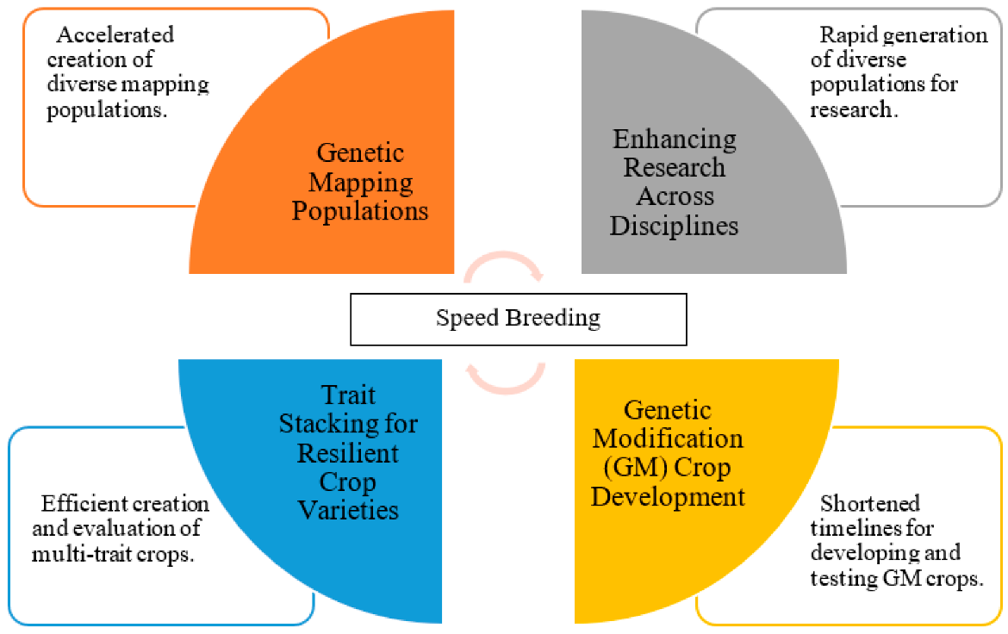

**Fig. 2: Applications of Speed Breeding in Crop Improvement**

**Table 2: The information presented in tabular form with different applications**

|  |  |  |
| --- | --- | --- |
| **Application** | **Description** | **References** |
| Enhancement of Yield and Stress Tolerance Traits | Speed breeding expedites the selection and introgression of traits associated with increased yield potential and resilience to environmental stresses such as drought, heat, and salinity. | (Watson et al., 2018) |
| Targeted Selection for Disease Resistance | Speed breeding enables rapid phenotypic evaluation and molecular marker-assisted selection for disease resistance, facilitating the identification and incorporation of resistance genes against prevalent wheat diseases. | (Borrill et al., 2019) |
| Accelerated Development of Climate-Resilient Varieties | By screening and selecting wheat germplasm with enhanced tolerance to heat, drought, and other abiotic stresses, speed breeding accelerates the development of climate-resilient wheat varieties. | (Hickey et al., 2017) |
| Rapid Introgression of Desired Traits | Speed breeding facilitates the quick introgression of desired traits into wheat germplasm, allowing breeders to rapidly incorporate traits such as high yield, quality, and disease resistance into breeding lines. | (Wingen et al., 2017) |
| Exploration of Genetic Diversity | Speed breeding enables the exploration of genetic diversity within wheat germplasm, allowing breeders to identify novel alleles and traits for crop improvement, leading to the development of genetically diverse wheat varieties. | (Alaux et al., 2018) |
| Accelerated Evaluation of Breeding Lines | With speed breeding, breeders can rapidly evaluate numerous breeding lines for agronomic performance, disease resistance, and quality traits, enabling timely selection of superior genotypes for further advancement. | (Li et al., 2019) |

**7. SUCCESS STORIES AND CASE STUDIES**

The successful implementation of speed breeding in wheat has resulted in remarkable advancements in crop productivity and adaptation to changing environmental conditions, as evidenced by various success stories and case studies. For example, speed breeding techniques have been used by researchers at the John Innes Centre in the United Kingdom to create wheat varieties with increased photosynthetic efficiency and higher nitrogen-use efficiency. These varieties have contributed to sustainable wheat production systems by demonstrating tolerance to nitrogen-deficient soils, exhibiting notable yield improvements, and incorporating genomic methods for trait selection. Furthermore, speed breeding has been effectively used by the International Centre for Agricultural Research in the Dry Areas to create wheat germplasm that is more resilient to heat stress and water constraint. Heat-tolerant genes have been found and introgressed into elite wheat lines by ICARDA breeders using quick phenotypic screening and marker-assisted selection. This has led to the introduction of heat-tolerant varieties that preserve yield stability in high-temperature environments. Beyond yield increases, speed breeding affects wheat crop productivity and adaptability by enhancing quality attributes and nutritional value. Speed breeding has been used by researchers at the University of Saskatchewan in Canada to create wheat varieties with improved nutritional profiles, including higher concentrations of micronutrients like zinc and iron. These biofortified wheat varieties offer improved nutritional benefits and have the potential to address micronutrient deficiencies in populations dependent on wheat-based diets (Ward et al., 2019).

**8. CHALLENGES AND LIMITATIONS**

Speed breeding faces various challenges and limitations that need to be addressed to fully realize its potential in crop improvement. Technical challenges in scaling up speed breeding platforms present significant hurdles for widespread adoption. Establishing and maintaining specialized infrastructure such as growth chambers or controlled environments can be costly and require substantial technical expertise (Watson et al.,2018) Moreover, optimizing growth conditions for different crop species and varieties poses technical challenges, as environmental parameters must be carefully controlled to ensure optimal plant growth and development (Dwivedi et al., 2018). The possible effects of speed breeding on genetic variety and the long-term viability of crop development initiatives are a further source of worry. There may be less genetic variety in breeding populations as a result of accelerated breeding cycles that favour some features or genetic origins over others. The capacity of future breeding attempts to adapt to new difficulties like developing diseases and pests as well as shifting environmental circumstances may be hampered by this limiting of genetic variety (Watson et al., 2018).

The long-term viability of speed breeding techniques is also a subject of worry, especially with regard to resource consumption and environmental effects. In order to maintain regulated development conditions, speed breeding frequently necessitates large inputs of energy, water, and other resources, which may not be environmentally sustainable over time. Furthermore, the adoption of intensive breeding techniques may make issues with synthetic input consumption and the environmental impact of agricultural production systems worse.

**9.**

**FUTURE DIRECTIONS AND INNOVATIONS**

The future of speed breeding holds promise with ongoing innovations and advancements poised to further enhance its effectiveness in crop improvement. The incorporation of phenotyping and genomic selection tools into speed breeding processes is one important area. Breeders may identify and select desired features more quickly, precisely, and efficiently by merging genetic information with high-throughput phenotypic data. Through this integration, breeders may quickly generate improved crop varieties that are suited to certain locations and end-user preferences by fully using the genetic diversity found within breeding populations. Furthermore, speed breeding methods have a great deal of promise for use in agricultural systems and crops other than wheat. Although the focus of speed breeding has primarily been on cereals like wheat, barley, and rice, its principles may be applied to a variety of crop species, such as oilseeds, legumes, vegetables, and fruits. Speed breeding is an adaptable and scalable technique that may be used to address emergent issues like pests, diseases, and climate change while also speeding up crop development in a variety of agroecological situations. Through investigating the use of speed breeding in many crop types and cropping configurations, scientists might uncover novel prospects for augmenting agricultural output, durability, and adaptability worldwide.Top of Form

**10. CONCLUSION**

In conclusion, speed breeding has emerged as a powerful tool for accelerating wheat crop improvement, offering novel avenues to address key challenges and unlock opportunities for enhancing agricultural productivity and sustainability. Through the integration of genomic selection, high-throughput phenotyping, and controlled growth environments, speed breeding enables breeders to expedite the development of high-yielding, stress-tolerant wheat varieties tailored to specific agroecological contexts. By shortening breeding cycles and accelerating the introgression of desirable traits, speed breeding has demonstrated its efficacy in increasing genetic gain per unit time and enhancing the precision of breeding programs. Success stories and case studies from research institutions and breeding programs worldwide underscore the transformative potential of speed breeding in revolutionizing wheat breeding strategies and ensuring food security in the face of climate change and population growth. Moving forward, the implications for the future of wheat crop improvement are profound. Speed breeding holds promise for further innovation and refinement, with ongoing advancements in genomic technologies, phenotyping platforms, and growth chamber technologies poised to enhance its effectiveness and scalability. The integration of speed breeding with emerging tools such as genome editing and machine learning presents new opportunities to accelerate the development of climate-resilient wheat varieties with enhanced nutritional quality and agronomic performance. Moreover, the potential for adopting speed breeding techniques in other crops and agricultural systems opens up new frontiers for enhancing global food security, promoting sustainable agriculture, and addressing pressing challenges facing humanity. Interdisciplinary collaborations among researchers, breeders, policymakers, and stakeholders will be crucial for driving innovation, overcoming technical barriers, and ensuring the equitable and sustainable deployment of speed breeding technologies to benefit farmers and consumers worldwide. In summary, speed breeding represents a paradigm shift in wheat crop improvement, offering unprecedented opportunities to meet the growing demand for food in a changing world while addressing the complex challenges of the 21st century.

**DISCLAIMER (ARTIFICIAL INTELLIGENCE)**

Author(s) hereby declare that NO generative AI technologies such as Large Language Models (ChatGPT, COPILOT, etc) and text-to-image generators have been used during writing or editing of this manuscript.

**Competing interests**

Authors have declared that no competing interests exist.

**Top of Form**

**REFERENCES**

Alaux, M., Rogers, J., Letellier, T., Flores, R., Alfama, F., Pommier, C., et al. (2018). Linking the International Wheat Genome Sequencing Consortium bread wheat reference genome sequence to wheat genetic and phenomic data. *Genome Biology, 19*(1), 111.

Araus, J.L., & Cairns, J.E. (2014). Field high-throughput phenotyping: The new crop breeding frontier. *Trends in Plant Science, 19*(1), 52-61.

Atlin, G.N., Cairns, J.E., & Das, B. (2017). Rapid breeding and varietal replacement are critical to adaptation of cropping systems in the developing world to climate change. *Global Food Security, 12*, 31-37.

Borrill, P., Harrington, S.A., Uauy, C. (2019). Genome-wide sequence and expression analysis of the NAC transcription factor family in polyploid wheat. G3: *Genes, Genomes, Genetics, 9*(10), 3845-3855.

Chiang, G.C., Barua, D., Kramer, E.M., Amasino, R.M., & Donohue, K. (2009). Major flowering time gene, FLOWERING LOCUS C, regulates seed germination in Arabidopsis thaliana. *Proceedings of the National Academy of Sciences, 106*(28), 11661-11666.

Cooper, M., Gho, C., Leafgren, R., Tang, T., & Messina, C. (2014). Breeding drought-tolerant maize hybrids for the US corn-belt: discovery to product. *Journal of Experimental Botany, 65(*21), 6191-6204.

Crossa, J., Pérez-Rodríguez, P., Cuevas, J., Montesinos-López, O., Jarquín, D., de Los Campos, G., ... & Burgueño, J. (2017). Genomic selection in plant breeding: methods, models, and perspectives. *Trends in plant science, 22*(11), 961-975.

Dempewolf, H., Baute, G., Anderson, J., Kilian, B., Smith, C., & Guarino, L. (2017). Past and future use of wild relatives in crop breeding. *Crop Science, 57*(3), 1070-1082.

Des Marais, D.L., & Juenger, T.E. (2016). Pleiotropy, plasticity, and the evolution of plant abiotic stress tolerance. *Annals of the New York Academy of Sciences, 1365*(1), 56-75.

Dwivedi, S. L., Ceccarelli, S., Blair, M. W., Upadhyaya, H. D., Are, A. K., Ortiz, R., & Varshney, R. K. (2018). Landrace germplasm Watsonfor improving yield and abiotic stress adaptation. *Trends in plant science, 23*(1), 68-98.

Top of Form Ghosh, S., Watson, A., Gonzalez-Navarro, O. E., Ramirez-Gonzalez, R. H., Yanes, L., Mendoza-Suárez, M., ... & Hickey, L. T. (2018). Speed breeding in growth chambers and glasshouses for crop breeding and model plant research. *Nature Protocols, 13*(12), 2944-2963.

Hickey, L. T., Hafeez, A. N., Robinson, H., Jackson, S. A., Leal-Bertioli, S. C. M., Tester, M., ... & Dolan, L. (2019). Breeding crops to feed 10 billion. *Nature Biotechnology, 37*(7), 744-754.

Hickey, L.T., & Gororo, N.N. (2018). Challenges and opportunities for accelerating the breeding of new specialty grain crops in the developing world. *Frontiers in Plant Science, 9*, 1557.

Hickey, L.T., Germán, S.E., Pereyra, S.A., Diaz, J.E., Ziems, L.A., Fowler, R.A., et al. (2017). Speed breeding for multiple quantitative traits in durum wheat*. Plant Methods, 13*(1), 1-12.

Li, H., & Zhou, M. (2020). Optimizing breeding strategies in wheat: A review of the current status and future prospects. *The Crop Journal, 8*(6), 792-805.

Li, H., Wang, X., Ji, J., Liu, J., & Liu, C. (2019). A strategy of increasing yield and stability for wheat production by optimizing sowing date. *Field Crops Research, 241*, 107581.

Mondal, S., Rutkoski, J. E., Velu, G., Singh, P. K., Crespo-Herrera, L. A., Guzmán, C., ... & Braun, H. J. (2016). Harnessing diversity in wheat to enhance grain yield, climate resilience, disease and insect pest resistance and nutrition through conventional and modern breeding approaches. *Frontiers in plant science, 7*, 991.

Mondal, S., Singh, R. P., Mason, E. R., Huerta-Espino, J., Autrique, E., Joshi, A. K., ... & Braun, H. J. (2018). Grain yield, adaptation and progress in breeding for early-maturing and heat-tolerant wheat lines in South Asia. *Field Crops Research, 216*, 55-65.

Montesinos-López, O.A., Montesinos-López, A., Pérez-Rodríguez, P., de los Campos, G., Eskridge, K.M., & Crossa, J. (2018). Threshold models for genome-enabled prediction of ordinal categorical phenotypes in plant breeding. G3: *Genes, Genomes, Genetics, 8*(6), 1913-1928.

Paux, E., Sourdille, P., Salse, J., Saintenac, C., Choulet, F., Leroy, P., & Feuillet, C. (2008). A physical map of the 1-gigabase bread wheat chromosome 3B. *Science, 322*(5898), 101-104.

Potts, J., Jangra, S., Michael, V. N., & Wu, X. (2023). Speed breeding for crop improvement and food security. *Crops*, *3*(4), 276-291.

Saintenac, C., Jiang, D., Wang, S., & Akhunov, E. (2013). Sequence-based mapping of the polyploid wheat genome. *GigaScience, 2*(1), 6

Smyth, S.J., Kerr, W.A., & Phillips, P.W.B. (2015). GM crops and regulatory delays: The limitations of technology-forcing policies. *GM Crops & Food, 6*(3), 141-153.

Tardieu, F., Cabrera-Bosquet, L., Pridmore, T., & Bennett, M. (2017). Plant phenomics, from sensors to knowledge. *Current Biology, 27*(15), R770-R783.

Tester, M., & Langridge, P. (2010). Breeding technologies to increase crop production in a changing world. *Science, 327*(5967), 818-822.

Van Evert, F.K., Van Bueren, E.T.L., Struik, P.C., & Haverkort, A.J. (2017). The need to breed crop varieties suitable for organic farming, using wheat, tomato and broccoli as examples: A review. NJAS - *Wageningen Journal of Life Sciences, 80*, 53-64.

Varshney, R. K., Graner, A., & Sorrells, M. E. (2005). Genomics-assisted breeding for crop improvement. *Trends in plant science, 10*(12), 621-630.

Ward, B. P., & Niederhauser, J. S. (2019). Accelerating plant breeding: A systematic review of genomic selection and speed breeding in wheat (*Triticum aestivum* L.). *Plant Science, 287*, 110207.

Watson, A., Ghosh, S., Williams, M. J., Cuddy, W. S., Simmonds, J., Rey, M. D., ... & Hickey, L. T. (2018). Speed breeding is a powerful tool to accelerate crop research and breeding*. Nature Plants, 4*(1), 23-29.

White, J.W., Andrade-Sanchez, P., Gore, M.A., Bronson, K.F., Coffelt, T.A., Conley, M.M., & Hunsaker, D.J. (2012). Field-based phenomics for plant genetics research. *Field Crops Research, 133*, 101-112.

Wingen, L.U., West, C., Leverington-Waite, M., Collier, S., Orford, S., Goram, R., et al. (2017). Wheat landrace genome diversity. *Genetics, 205*(4), 1657-1676.

Zeng, A., Chen, P., & Korth, K.L. (2017). Draft genome assembly for wheat genetic diversity analysis. *GigaScience, 6*(11), 1-8.