**Evaluation of hermetic storage technique for the management of *Lasioderma serricorne* in turmeric rhizomes**

**ABSTRACT**

A study was conducted to evaluate the effectiveness of various storage bags on the adult emergence of pests, moisture content, and weight loss in turmeric (*Curcuma longa*) rhizomes over a six-month storage period conducted at Department of Entomology, Agricultural College, Bapatla, during the academic year 2023-24. Five types of storage bags were assessed: Super bag, Triple layer polythene bag, Jute lined polythene bag, Jute bag, and Cloth bag. Results revealed that turmeric stored in Super bags exhibited zero adult emergence throughout the entire storage duration, significantly outperforming all other bag types. Minimal adult emergence was recorded in Triple layer polythene and Jute lined polythene bags, while Cloth bags recorded the highest pest infestation, with 134 adults at three months and 130.5 at six months after storage. Moisture content remained stable in Super bags (0.07%), while a noticeable increase was observed in Cloth (0.09% to 0.14%) and Jute bags (0.08% to 0.12%). Correspondingly, weight loss was negligible in Super and polythene bags but increased markedly in Cloth bags (0.88% to 9.23%) and Jute bags (0.67% to 6.76%) over time. From the results it is clear that Super bags offer good protection against the insect pest infestation with zero per cent weight loss and they can be recommended for farmer’s practice, for storage of turmeric rhizomes.

**Key words:** Turmeric rhizomes, *L. serricorne*, adult emergence, moisture content, weight loss, Super bag, Triple layer polythene bag, Jute lined polythene bag, Jute bag, and Cloth bag

**Introduction**

Turmeric (*Curcuma longa* L.) is a globally significant spice and medicinal crop valued for its bioactive compound curcumin. It is a rhizomatous herbaceous plant belonging to the family Zingeberaceae. Curcumin is the pigment that lends the bright stunning yellow colour to turmeric which can be used as a dye. Because of its brilliant yellow colour, it is also known as “Indian saffron (Narendhiran *et* al 2024). It reached China by 700 AD, East Africa by 800 AD and West Africa by 1200. It was introduced to Jamaica in the 18th Century and started becoming popular throughout the world. Turmeric was probably cultivated at first as a dye, and then became valued as a condiment as well as for cosmetic purposes. Turmeric was introduced to Europe by Arab traders in 13th century. Marco Polo,during his travels in China in 1280, was impressed by turmeric,and described it as a vegetable with saffron-like properties but distinct from saffron itself (Debata and Das 2024). Post-harvest losses due to insect infestations, particularly by *Lasioderma serricorne* (commonly known as the cigarette beetle), pose a substantial threat to turmeric quality and marketability during storage. It is a cosmopolitan insect, has spread across the world through the global trade of turmeric, tobacco and other materials. *L. serricorne* (Fabricius) is a small, brown beetle belonging to the family Ptinidae, order Coleoptera often known as the cigarette beetle, tobacco beetle or herbarium beetle (Chakma 2014). Traditional storage methods often rely on chemical pesticides, which raise concerns regarding food safety, environmental impact, and pest resistance. Hermetic storage, an oxygen-restrictive method that creates a modified atmosphere through the metabolic activity of stored commodities and insects, offers a promising non-chemical alternative. One of the critical factors influencing the protection of stored turmeric is the type of packaging material used. Packaging not only provides physical containment but also affects the internal environment of the storage system, potentially influencing the survival and reproduction of pests. Conventional packaging materials such as jute or cloth bags offer minimal resistance to insect infestation, while more advanced materials—such as multilayer plastic films or hermetically sealed containers—can offer enhanced protection by limiting oxygen flow or physically blocking pest entry. This study investigates the effectiveness of hermetic storage systems in controlling *L. serricorne* infestation in turmeric rhizomes, aiming to provide a sustainable and residue-free solution for post-harvest protection and long-term storage.

**Material and methods**

The turmeric rhizomes were procured from turmeric godown of duggirala. The hermetic bags that were taken for the experiment, Jute bags, cloth bags, triple layer plastic bags, super bags, jute bags lined polyethylene of one kg capacity. These bags were filled with one kg of disinfested whole cured turmeric rhizomes and one day old, newly emerged adult beetles, 20 pairs each bag were released. Then the bags were closed air tight. Six sets of the treatments were made in three replications to know the effect of hermetic storage at monthly interval up to six months storage period. The first set was opened after one month likewise second set after two months, third set after three months, fourth set after four months, fifth set after five months and sixth set after six months, respectively to record the data. The experiment was carried out at temperatures of 26 ± 2°C and relative humidity of 60-80 per cent, at Department of entomology, Agriculture College, Bapatla.

**List 1 :Treatments**

|  |  |  |  |
| --- | --- | --- | --- |
| 1. | cloth bag | : | They were purchased from local market, Bapatla, Andhra Pradesh, India. |
| 2. | jute bag | : | They were purchased from local market, Bapatla, Andhra Pradesh, India. |
| 3. | Jute lined polythene bag |  | The bag was made of polyethylene and jute, thickness was 100 μ (400 Gauge), purchased from local market, Bapatla, Andhra Pradesh, India. |
| 4. | Triple layer plastic bag | : | This bag consists of three layers [(as per the technical specifications of the Purdue Improved Crop Storage (PICS) bags developed by Purdue University, USA)]; inner and middle layers were made up of 80 μ thickness high density polyethylene (HDPE) material and do not allow diffusion of gases (Oxygen and Carbon dioxide) while the outermost layer was a normal woven sac made up of polypropylene that provides strength for handling. It was supplied by ICRISAT, Hyderabad, Telangana, India. |
| 5. | Super grain bag | : | The bag was made of polyethylene and thickness was about 80 μ, supplied by Grainpro Inc., Hyderabad, Telangana, India. |

**Experimental location:**

The present investigation was carried out in the Department of Entomology, Agricultural College, Bapatla, during the academic year 2023-24. The study was conducted under controlled laboratory conditions to evaluate the hermetic storage technique for the management of *L. serricorne* in turmeric rhizomes.

**Collection and Maintenance of *L. serricorne* Culture:**

The initial population of the test insect, *L. serricorne*, was collected from turmeric go-downs of Duggirala, located in guntur district, Andhra Pradesh. The samples were collected from infested turmeric rhizomes. The collected beetles were then transported to the laboratory for further rearing and experimentation.

Cultures of the cigarette beetle were maintained in the laboratory at room temperatures of 26 ± 2°C and relative humidity of 60-95 per cent, Agriculture College, Bapatla.

**Observations Recorded**

**Adult Emergence:** The total number of adults emerged from different bags were counted. The live beetles were collected and anesthetized with the help of ethyl acetate for easy counting.

**Moisture Percentage:** It was measured by using electronic moisture balance (MOC-120H, Shimadzu Corporation, Japan) (fig.1)which determines the moisture content of samples by heating under infrared illumination and measures changes in mass due to evaporation (drying loss method). The conditions of the moisture balance were as follows (i) drying temperature - 1200C (ii) measuring mode - Standard drying & Automatic ending mode (Change in water content of 0.05% over 30seconds). Ten grams sample of turmeric rhizomes were taken in the pan and allowed them to illuminate with infrared rays at 1200C. The moisture percentage was displayed after 2-5 min.

**Weight Loss (%):** The final weight of the grains was taken and the weight loss due to insect infestation was calculated by the following formula.

Weight Loss (%) = Initial weight of sample – Final weight of sample × 100

Initial weight of sample

**Statistical Analysis:** The recorded data were subjected to suitable transformations and then subjected to ANOVA (CRD) (Snedecor and Cochran, 1967).

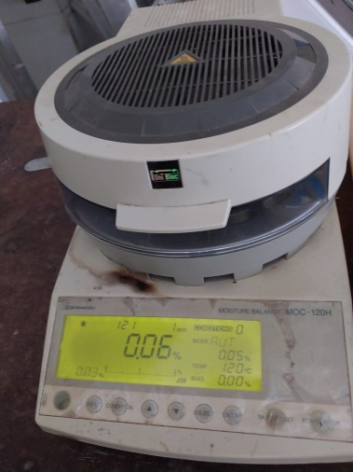

Fig. 1 Electronic Moisture Balance (MOC-120H, Shimadzu Corporation, Japan)

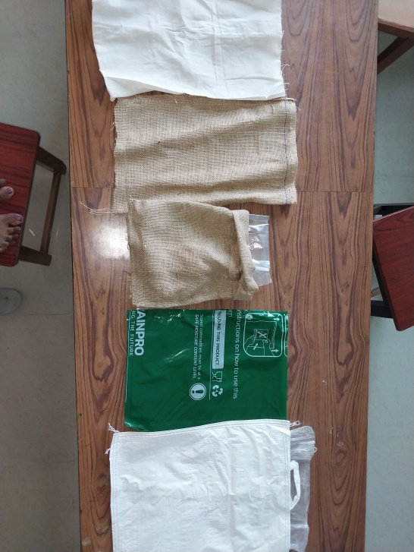

**1 2 3 4 5 5**

Fig 2**,** 1. Cloth Bag 2. Jute bag 3. Jute lined Polythene Bag 4. Super Bag 5. Triple layer Polythene Bag

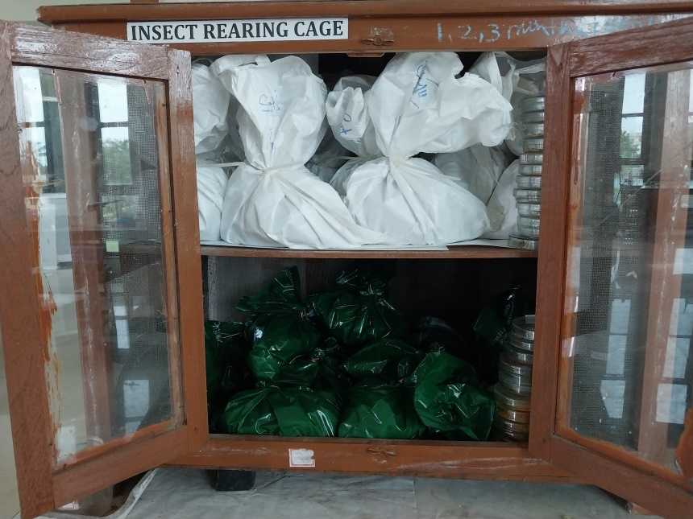

Fig 3. Turmeric Rhizomes sealed in different bags

**Results and Discussion:**

**Adult Emergence:**

Turmeric rhizomes that are stored in Super bag recorded zero adult emergence during one to six months after storage which was significantly different from other types of bags. At one month after storage Triple layer polythene bag and jute bag recorded minimum adult emergence, 0.25 which significantly differed from other bags. Highest number of adult emergence was recorded in cloth bags 134 adults at three month after storage which is on par with130.50 at six months after storage. (table 1)

At one month after storage adult emergence was recorded as follows Super bag (0.00), Triple layer polythene bag (0.25) is on par with jute bag (0.25) and jute lined polythene bag (0.35), Cloth bag is on par with jute lined polythene bag (0.35). At two months after storage Super bag recorded the minimum adult emergence (0.00), Jute bag (11.00) is on par with Triple layer polythene bag (6.50). Highest adult emergence at 2 MAS was recorded in cloth bag (18.25) which is on par with jute lined polythene bag (14.50) and jute bag (11.00).

Minimum number of adult emergence at three months after storage was observed in Super bag (0.00) followed by Triple layer polythene bag (14.25), jute lined polythene bag (27.50), jute bag (82.00) respectively. Highest adult emergence was observed in cloth bag (134.00).

Four months after storage super bag recorded minimum adult emergence (0.00). Next minimum adult emergence was observed in jute bag (6.25) is on par with jute lined polythene bag (5.25) and Triple layer polythene bag (3.00) followed by cloth bag (18.25). At five months after storage minimum adult emergence recorded in super bag (0.00) which is on par with Triple layer polythene bag (1.00). Followed by jute lined polythene bag (2.75) which is on par with Triple layer polythene bag (1.00), jute bag (5.25) is on par with jute lined polythene bag (2.75), cloth bag (10.25) is on par with jute bag (5.25).

Minimum number of adult emergence at six months after storage was observed in Super bag (0.00) followed by Triple layer polythene bag (15.00), jute lined polythene bag (29.25), jute bag (81.00) respectively. Highest adult emergence was observed in cloth bag (130.50).

The present findings are similar with the studies were done by Yewle *et al* (2021) super grainpro bags were effective with less adult emergence *i.e.,* 18.84 when compared with jute bags where the adult emergence was about 42.51.In studies done by Abdelghany *et al* (2016) the maximum number of adults were observed in the conventional bags jute bags. Likewise, alice *et al* (2015) for turmeric rhizomes where they found highest insect infestation in conventional bags *i.e.,* gunny bags. Whereas in the studies done by lu and ma (2015) in case of wheat flour for protection against *L. serricorne* non woven cloth bags had shown less protection against insect infestation. These findings are in similar with the other studies that had been done on other storage insect pest infestations, in cowpea stored for eight months showed the mortality of adult *Callosobruchus maculatus* ranging from 97 to 100% in different hermetic bags viz., PICSTM, SuperGrainbagTM, AgroZ®, EVAL™, and ZeroFly® bags (Bakoye *et al*. 2020). Other studies where survey has been done, showed that the use of hermetic storage technologies (HSTs) among farmers of eastern Kenya was increased from 53.7% in 2015 to 91.2% in 2017. The primary reason of farmers to use hermetic bags was the need to manage insect pests (87%). Purdue improved crop storage (PICS) bags were most used hermetic bags by farmers (84%) in 2017 to store legume and other crops.( Baributsa and Njoroge 2020)

Table 1.. Adult emergence of cigarette beetle, *L. serricorne* from turmeric rhizomes stored in different types of bags

|  |  |  |  |  |  |  |  |
| --- | --- | --- | --- | --- | --- | --- | --- |
| adult emergence |  | 1MAS | 2MAS | 3MAS | 4MAS | 5MAS | 6MAS |
| T1 | cloth bag | 1.75  (0.97)b | 18.25 (2.92)c | 134.00  (4.90)e | 18.25  (2.95)c | 10.25  (2.41)d | 130.50 (4.88)e |
| T2 | jute bag | 0.25  (0.17)a | 11.00 (2.46)b c | 82.00  (4.42)d | 6.25  (1.92)b | 5.25  (1.76)c d | 81.00  (4.41)d |
| T3 | Jute lined polythene bag | 0.50  (0.35)a b | 14.50 (2.71)c | 27.50  (3.34)c | 5.25  (1.82)b | 2.75  (1.14)b c | 29.25  (3.40)c |
| T4 | triple layer polythene | 0.25  (0.17)a | 6.50  (1.98)b | 14.25  (2.72)b | 3.00  (1.28)b | 1.00  (0.62)a b | 15.00  (2.77)b |
| T5 | super bag | 0.00  (0.00)a | 0.00  (0.00)a | 0.00  (0.00)a | 0.00  (0.00)a | 0.00  (0.00)a | 0.00  (0.00)a |
|  | Sem | 0.160 | 0.130 | 0.050 | 0.160 | 0.230 | 0.040 |
|  | CD (5%loss) | 0.480 | 0.390 | 0.160 | 0.480 | 0.690 | 0.140 |

Fig. 4 Adult emergence of cigarette beetle, *L. serricorne* from turmeric rhizomes stored in different types of bags

**Moisture Percentage:**

The initial moisture content of turmeric rhizomes before hermetic storage was 0.07. The moisture content of the rhizomes stored in super bags remained same *i.e.,* 0.07 per cent throughtout the six months of storage.

For triple layer polythene bag and jute lined polythene bag less variation was observed in per cent moisture content *i.e.,* 0.08 to 0.07 per cent and 0.09 to 0.010 respectively.

For cloth bag the moisture content increased from 0.09 to 0.14 percentage during the storage period of six months showing highest percentage of variation. For jute bags the moisture content increased from 0.08 to 0.12 percentage during the storage period of six months, which becomes the next highest percentage of variation in moisture per cent content.

These findings are similar with other stored grain pests where the Ognakossan *et al* (2013) recorded the moisture content of maize grains stored in Hermatic Grain Bags remained practically the same during storage, compared with the levels in Woven Polypropylene Bag. Atta *et al* (2019) observed that Hermetic bag proved resistance to external environment fluctuations in abiotic factors such as temperature and relative humidity. While grain moisture in all other bags *i.e.,*polypropylene bag, jute bag, plastic bag and cotton cloth bag fluctuated with external environment. Similarly, some more studies reported that in case of pulses, the moisture content stored in different bags viz., super bags, polythene bags, triple layer plastic bags and other hermetic containers remained unchanged or slightly changed (increased or decreased) from the initial moisture contents up to several months (Affognon *et* *al*. 2016., Silva *et al*. 2018 and Yewle *et al.* 2022)

Table 2.. Rhizomes moisture content of turmeric stored in different types of bags

|  |  |  |  |  |  |  |  |  |
| --- | --- | --- | --- | --- | --- | --- | --- | --- |
| moisture % | | Moisture content  Before  storage | 1MAT | 2MAT | 3MAT | 4MAT | 5MAT | 6MAT |
| T1 | cloth bag | 0.07 | 0.09b | 0.11 c | 0.11 c | 0.12 d | 0.12 c | 0.14 d |
| T2 | jute bag | 0.07 | 0.08b | 0.10 b c | 0.10 b c | 0.11 d | 0.11 c | 0.12 c |
| T3 | jutelined polythene bag | 0.07 | 0.09b | 0.10 b c | 0.10 b | 0.09 c | 0.09 b | 0.10 b |
| T4 | triple layer polythene | 0.07 | 0.08b | 0.09 b | 0.09 b | 0.08 b | 0.08 a b | 0.09 b |
| T5 | super bag | 0.07 | 0.07a | 0.07a | 0.07 a | 0.07 a | 0.07 a | 0.07 a |
|  | Sem | - | 0.003 | 0.004 | 0.003 | 0.002 | 0.003 | 0.002 |
|  | CD (5%loss) | - | 0.010 | 0.011 | 0.008 | 0.007 | 0.009 | 0.007 |

Fig. 5 Per cent increase in moisture content of cigarette beetle, *L. serricorne* stored in different types of bags

**Per cent weight loss:**

The per cent weight loss of grains remained zero up to six months of storage for super bags, polythene bags and triple layer plastic bags, whereas in jute lined polythene bags the per cent weight loss decreased from one to six months of storage period and it increased in all other types of bags i.e., conventional storage bags with the increase in storage period.

For cloth bags the per cent weight loss increased from 0.88 per cent at one month after storage to 9.23 per cent at six months after storage. Same trend was observed in jute bags the per cent weight loss increased from 0.67 per cent at at one month after storage to 6.76 per cent at six months after storage.

The present studies are Similar withYewle *et al* (2021) where the super grainpro bags were effective with less per cent weight loss *i.e.,* 3.12 when compared with jute bags where the per cent weight loss was about 16.30. Whereas in the studies done by lu and ma (2015) in case of wheat flour for protection against *L. serricorne* non woven cloth bags had shown less protection against insect infestation. These findings are in similar with the other studies that had been done on other storage insect pest infestations, the triple layer plastic bags against *C. maculatus* infesting mung bean and pigeon pea and observed no significant weight loss of the produce (Murdock *et al*., 2012). Also *Callobruchus chinensis* maximum weight loss per cent was observed in jute bags, jute lined polythene bags and cloth bags (Anandhi *et al,* 2007)

Table 3 Per cent weight loss of turmeric rhizomes caused by cigarette beetle, *L. serricorne* stored in different types of bags

|  |  |  |  |  |  |  |  |
| --- | --- | --- | --- | --- | --- | --- | --- |
| weight loss % | | 1MAT | 2MAT | 3MAT | 4MAT | 5MAT | 6MAT |
| T1 | cloth bag | 0.88  (0.94) c | 1.84  (1.36) c | 2.14  (1.46) b | 3.87  (1.96) c | 7.20  (2.69) c | 9.23  (3.04) c |
| T2 | jute bag | 0.67  (0.82) c | 0.83  (0.91) b | 1.78  (1.33) b | 2.40  (1.55) b | 4.79  (2.19) b | 6.76  (2.59) b |
| T3 | jutelined polythene bag | 0.08  (0.24) b | 0.07  (0.18) a | 0.07  (0.13) a | 0.02  (0.08) a | 0.01  (0.06) a | 0.00  (0.00) a |
| T4 | triple layer polythene bag | 0.00  (0.00) a | 0.00  (0.00) a | 0.00  (0.00) a | 0.00  (0.00) a | 0.00  (0.00) a | 0.00  (0.00) a |
| T5 | super bag | 0.00  (0.00) a | 0.00  (0.00) a | 0.00  (0.00) a | 0.00  (0.00) a | 0.00  (0.00) a | 0.00  (0.00) a |
|  | Sem | 0.042 | 0.049 | 0.062 | 0.038 | 0.031 | 0.015 |
|  | CD (5%loss) | 0.126 | 0.148 | 0.187 | 0.115 | 0.092 | 0.046 |

Fig. 6 Per cent weight loss caused by cigarette beetle, *L. serricorne* stored in different types of bags

From overall observations it is clear that the hermetic nature of super bag restrict oxygen entry and increase carbon dioxide (Murdock and Baribusta 2019) which restricts the growth of insects and the present findings are in similar with it showing zero adult emergence and weight loss, also per cent moisture content remained same throughout the six months of storage period, These hypoxic environments created by these technologies are unfavorable to the development and reproduction of insect pests and thus minimizes or stops the grain damage (Murdock *et al*., 2012) whereas the triple layer polythene bags gives a good resistance to oxygen concentration showing very limited adult emergence and no weight loss. The other conventional bag types, *viz.,* Jute lined polythene bag offers patial gaseous exchange whereas Jute bag, Cloth bag are highly permeable and the results obtained show high adult emergence, more weight loss and increase in moisture content.

**Conclusions:**

Turmeric rhizomes stored in super bags recorded complete protection against *L. serricorne*  where the adult emergence and per cent weight loss were zero upto six months storage period and found to be most effective when compared to other hermetic bags like triple layer polythene bag, jutelined polythene bag, jute bag and cloth bag. So this study concludes that the turmeric rhizomes can be effectively protected from insect pest infestation during storage and this becomes one of the sustainable post-harvest management practice.

Disclaimer (Artificial intelligence)

Option 1:

Author(s) hereby declare that NO generative AI technologies such as Large Language Models (ChatGPT, COPILOT, etc.) and text-to-image generators have been used during the writing or editing of this manuscript.

Yes there is no usage of ai

Option 2:

Author(s) hereby declare that generative AI technologies such as Large Language Models, etc. have been used during the writing or editing of manuscripts. This explanation will include the name, version, model, and source of the generative AI technology and as well as all input prompts provided to the generative AI technology

Details of the AI usage are given below:

1.

2.

3.

**References:**

Abdelghany, A.Y., Awadalla, S.S., Abdel-Baky, N.F., El-Syrafi, H.A. and Fields, P.G., 2016. Efficacy of reduced risk insecticides on penetration into jute and polyethylene bags by Lasioderma serricorne (F.) (Coleoptera: Anobiidae). *Journal of Stored Products Research*. 69: 190-194.

Affognon, H.D., Njoroge, A.W., Mutungi, C.M., Manono, J., Baributsa, D and Murdock, L.L. 2016. Storage of pigeonpea grain (*Cajanus cajan* (L.) Millsp.) in hermetic triple-layer bags prevents losses caused by *Callosobruchus maculatus* (F.) (Coleoptera: Bruchidae). In J.B. Golding et al. (eds.) Horticulture: Sustaining Lives, Livelihoods and Landscapes*. Proceedings XXIX International Horticultural Congress.* 245-252.

Alice, J., Sujeetha, R.P., Moses, J.A., Loganathan, M. and Meenatchi, R. 2016. Hermetic Storage of Turmeric Rhizomes. *Advances in Life Sciences*. 5(8): 3174-3178.

Anandhi, P., Varma, S and Sarvanan, L. 2007. Estimation of losses and evaluation of different storage containers against pulse beetle, *Callosobruchus chinensis* Linnaeus in bengalgram. *Journal of Insect Science*. 21 (1): 40-43.

Baributsa, D and Njoroge, A.W. 2020. The use and profitability of hermetic technologies for grain storage among smallholder farmers in eastern Kenya. *Journal of Stored Products Research.* 87: 101618.

Chakma, A. 2014. *Study on the biology of cigarette beetle, lasioderma serricorne (f.) And its damage assesment in different spices* (doctoral dissertation, department of entomology, sher-e-bangla agricultural university, dhaka.).

Debata, D.K. and Das, L.K.. 2024. Performance of Turmeric (*Curcuma longa* L) and Pigeon pea (*Cajanus Cajan* L.) Intercropping System under North Eastern Ghat Zone of Odisha, India. *Journal of Scientific Research and Reports*. 30(4).179-186.

Lü, J. and Ma, D.. 2015. Effect of wheat flour packaging materials on infestation by Lasioderma serricorne (F.). *Journal of Food Protection*. 78(5): 1052-1055.

Murdock, L.L. and Baribusta, D. 2019. Hermetic storage for those who need it most--subsistence farmers. *Gates Open Res*earch. 3(961). 961.

Murdock, L.L., Margam, V., Baoua, I., Balfe, S and Shade, R.E. 2012. Death by desiccation: effects of hermetic storage on cowpea bruchids*. Journal of Stored Products Research*. 49: 166-170.

Narendhiran, V. and Gangadharan, S. 2024. Impact of Seed Rhizome Size on. *Asian Journal of Soil Science and Plant Nutrition*.10(1). 60-63.

Ognakossan, K.E., Tounou, A.K., Lamboni, Y. and Hell, K. 2013. Post-harvest insect infestation in maize grain stored in woven polypropylene and in hermetic bags. *International Journal of Tropical Insect Science*. 33:71-81.

Snedecor, W.G and Cochran, W.G. 1967. Statistical methods. Oxford and IBH Publishing Co. New Delhi. 593.

Silva, M.G., Silva, G.N., Sousa, A.H., Freitas, R.S., Silva, M.S and Abreu, A.O. 2018. Hermetic storage as an alternative for controlling *Callosobruchus maculatus* (Coleoptera: Chrysomelidae) and preserving the quality of cowpeas. *Journal of Stored Products Research*. 78: 27-31.

Yewle, N.R., Swain, K.C., Mann, S. and Dhakre, D.S. 2021. Evaluating of hermetic bags for long-term storage of turmeric (*Curcuma longa* L.) rhizomes. *Journal of Stored Products Research*. 92: 101806.

Yewle, N., Swain, K.C., Mann, S and Guru, P.N. 2022. Performance of hermetic bags in green gram [*Vigna radiata* (L.) R. Wilczek] storage for managing pulse beetle (*Callosobruchus chinensis*). *Journal of Stored Products Research*. 95: 101896.