Original Research Article

Isolation and Morphological Characteristics of Sclerotium rolfsii inciting Collar Rot in Brinjal

ABSTRACT
Sclerotium rolfsii, a soil-borne omnipathogenic fungus, is a major threat to crop production due to its wide host range and aggressive pathogenicity. This study aimed to isolate and characterize twenty S. rolfsii isolates from infected brinjal plants using standard tissue segment methods on PDA medium. Cultural and morphological assessments revealed significant variability among isolates in colony morphology, mycelial growth, and sclerotial traits. Radial growth ranged from 59-90 mm at 72 hours, while sclerotial formation varied from 9-34 days. The number of sclerotia per plate ranged between 75 and 1,338, with differences in color, shape, and arrangement. Microscopic and SEM examinations confirmed the presence of diagnostic features such as septate hyphae with clamp connections. Isolate identity was further verified through deposition at NFCCI with accession number NFCCI 5791. The findings highlight the morphological diversity among S. rolfsii isolates, which may influence their pathogenic behavior and epidemiology.
KEYWORDS: Scleroitum rolfsii, mycelial growth, sclerotial formation
INTRODUCTION
Sclerotium rolfsii is a soil-borne, saprophytic, and omnipathogenic fungus associated with a wide array of plant diseases, including collar rot, stem rot, crown rot, foot rot, root rot, charcoal rot, seedling blight, Sclerotium wilt, damping-off, stem blight, and stem canker (Punja, 1985; Kumar and Thakur, 2021; Adhikari et al., 2022; Mullen, 2001; Arunasri, 2011; Khadka, 2024). This basidiomycetous pathogen is facultatively parasitic, polyphagous, non-host specific, and exhibits strong dependency on environmental moisture. It is capable of persisting under diverse agroecological conditions and is widely distributed across tropical and subtropical regions (Chen et al., 2020). The fungus has been documented to infect more than 600 plant species spanning approximately 100 families, with a substantial impact on economically important agricultural and horticultural crops (Yan et al., 2021). Its pathogenic activity poses a major threat to crop production both in India and globally (Tabing and Tiwari, 2018). High incidences of collar rot, ranging from 60-100%, have been reported in brinjal cultivation (Hasan and Meah, 2019). On Potato Dextrose Agar (PDA), S. rolfsii develops a cottony white mycelial growth that spreads radially. Microscopic examination reveals well-separated, septate, and branched hyphae, frequently exhibiting clamp connections. Sclerotia typically begin to form around the tenth day of culture, transitioning from white to yellow, and eventually becoming dark brown in color (Zheng et al., 2021). Pathogenesis is initiated through the secretion of oxalic acid, polygalacturonase, and cellulase enzymes that degrade host tissues and facilitate colonization (Chen et al., 2020). Symptoms commonly include dark brown lesions at the collar region, leading to plant wilting. As infection progresses, a characteristic mycelial girdle forms above the soil surface, often accompanied by the development of cream to dark brown sclerotia. Affected stem and root tissues exhibit pronounced soft rotting and maceration (Murmu et al., 2021).
MATERIALS AND METHODS
ISOLATION
Isolation of the pathogen was carried out using the tissue segment method on Potato Dextrose Agar (PDA) medium, as described by Agrios (2005). Infected plant specimens (Fig. 1) were initially washed under running tap water and then blotted dry. Small sections were excised from symptomatic tissues, surface-sterilized with 1% sodium hypochlorite for 30 seconds, rinsed three times with sterile distilled water, and dried on sterile tissue paper. Approximately 3–4 segments were aseptically placed onto Petri dishes containing 15 ml of PDA medium supplemented with streptomycin to inhibit bacterial growth. The plates were incubated at 25°C for three days. Emerging fungal colonies were purified via the hyphal tip method (Rangaswami, 1972), followed by incubation at 28 ± 2°C for 5–7 days to promote mycelial development and sclerotia formation (Fig. 2). Developed sclerotia were transferred to PDA slants and stored at 4°C for subsequent studies. Subculturing was performed at regular intervals to maintain the viability of the cultures. A total of 20 fungal isolates were obtained and designated as Sr1 to Sr20.
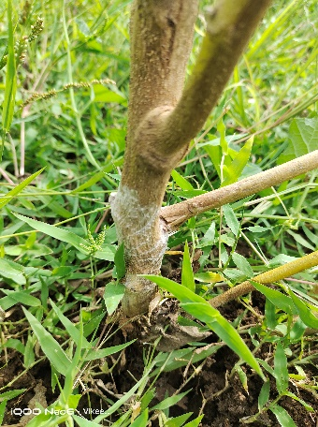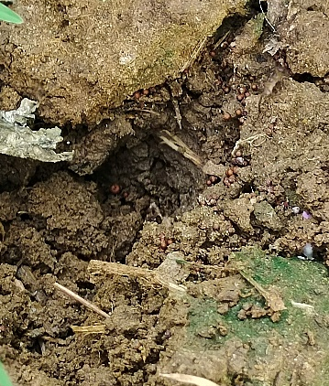
Fig.1: Symptoms of Brinjal collar rot
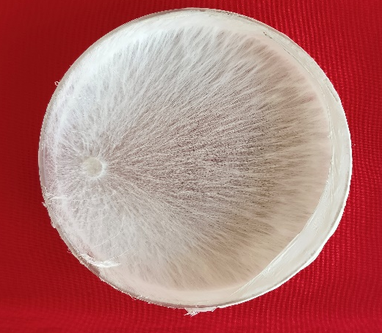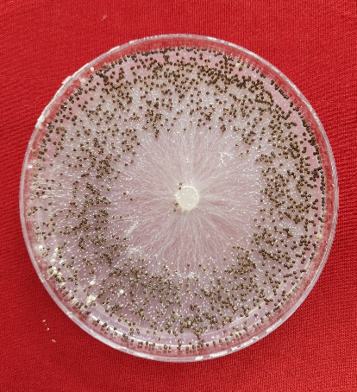
Fig.2: Pure culture of Sclerotium rolfsii
CULTURAL AND MORPHOLOGICAL CHARACTERISTICS
The identification of the fungal isolates as Sclerotium rolfsii was performed based on morphological characteristics as described by Butler and Hunter (1972). The isolates (Sr1–Sr20) were evaluated by assessing their mycelial growth and morphological traits. Radial growth measurements were taken at 24, 48 and 72 hours post-incubation. Observations included colony morphology and color, along with the color, shape, and arrangement of sclerotia. Additionally, the number of sclerotia formed per Petri plate and the number of days required for complete sclerotial development were recorded. Confirmation of the pathogen was further supported through microscopic examination and scanning electron microscopy (SEM) to validate characteristic structural features.
RESULTS AND DISCUSSION
CULTURAL AND MORPHOLOGICAL CHARACTERISTICS
ASSESSMENT OF MYCELIAL GROWTH AND COLONY MORPHOLOGY
Morphological characterization of twenty Sclerotium rolfsii isolates revealed considerable variation in colony appearance on Potato Dextrose Agar (PDA) medium. The isolates exhibited diverse mycelial growth forms, including fluffy white cottony growth, thin white mycelial mats, aerial cottony structures, and dull white thin mycelium, as presented in Table 1. By the third day after inoculation, several isolates (Sr1, Sr2, Sr3, Sr10, Sr11, and Sr14) demonstrated rapid radial growth, reaching the full diameter of 90 mm. Isolates such as Sr4, Sr9, Sr12, Sr13, Sr15, Sr16, Sr18, Sr19, and Sr20 exhibited moderate radial growth ranging from 84 to 89 mm. Slower growth was recorded for isolates Sr5 and Sr7, with radial growth of 79 mm and 73 mm, respectively. The lowest radial expansion was observed in isolate Sr17 (59 mm), followed by Sr8 (61 mm).
These findings align with those of Sekhar et al. (2017), who reported considerable variability in cultural characteristics among S. rolfsii isolates. Praveen and Kannan (2021) also observed morphological diversity in twenty isolates, including colony types such as fluffy white, profuse cottony white, dense cottony white, and dull white mycelium. Ayyandurai et al. (2022) further supported these findings by reporting that a virulent isolate (SR-8) exhibited rapid growth with pure white thin mycelium, whereas a less virulent isolate (SR-10) showed slower growth with dull white thin mycelium. These previous reports are consistent with the current observations.

Table1: Colony Morphology and Mycelial Growth of Sclerotium rolfsii

ISOLATES | COLONY MORPHOLOGY | MYCELIAL GROWTH (mm)
ISOLATES | COLONY MORPHOLOGY | 24 hrs | 48 hrs | 72 hrs
Sr1 | White fluffy cottony growth | 34 | 76 | 90
Sr2 | White fluffy cottony growth | 35 | 63 | 90
Sr3 | Fluffy aerial white mycelial growth | 40 | 75 | 90
Sr4 | Cottony white mycelial growth | 35 | 62 | 89
Sr5 | White with thin mycelial growth | 16 | 49 | 79
Sr6 | Aerial cottony mycelial growth | 17 | 38 | 63
Sr7 | White aerial cottony mycelial growth | 23 | 50 | 73
Sr8 | White with thin mycelial growth | 25 | 45 | 61
Sr9 | Cottony white mycelial growth | 28 | 57 | 86
Sr10 | White with thin mycelial growth | 31 | 73 | 90
Sr11 | Fluffy aerial white mycelial growth | 36 | 76 | 90
Sr12 | Cottony white mycelial growth | 25 | 59 | 88
Sr13 | Cottony white mycelial growth | 23 | 55 | 86
Sr14 | White with thin mycelial growth | 26 | 67 | 90
Sr15 | Aerial cottony mycelial growth | 29 | 54 | 87
Sr16 | White with thin mycelial growth | 23 | 50 | 86
Sr17 | White fluffy cottony growth | 18 | 38 | 59
Sr18 | Dull white with thin mycelial growth | 22 | 54 | 84
Sr19 | Aerial cottony mycelial growth | 23 | 59 | 88
Sr20 | White with thin mycelial growth | 19 | 51 | 87

SCLEROTIAL CHARACTERISTICS
The onset of sclerotial formation among the twenty isolates varied significantly, ranging from 9 to 34 days post-inoculation, as shown in Table 2. Isolates Sr1, Sr2, and Sr3 exhibited early sclerotial initiation within 9 days of incubation, whereas isolate Sr17 required the longest duration (34 days) for complete sclerotial development. The observed variability in the timing of sclerotial formation may reflect underlying physiological differences among the isolates, potentially associated with their survival strategies and pathogenic potential.
These observations are in agreement with Sekhar et al. (2017), who reported sclerotial production occurring between 8 to 14 days. Similarly, Praveen and Kannan (2021) documented sclerotial formation ranging from 9 to 14 days, corroborating the present results.
SCLEROTIAL NUMBER, COLOR, SHAPE, AND ARRANGEMENT
The number of sclerotia produced per Petri plate varied substantially among the isolates, ranging from 75 to 1,338 (Table 2). Isolate Sr3 produced the highest number of sclerotia (1,338), whereas isolate Sr17 yielded the lowest (75). The sclerotia also varied in shape, including oval, spherical, irregular, and round forms. Coloration ranged from light brown to dark brown, including shades such as brown and chocolate brown. Sclerotial distribution patterns differed among isolates, being either centrally clustered, scattered, or located peripherally on the medium.
These findings are consistent with those reported by Le et al. (2012), who observed sclerotial counts ranging from 79 to 1,080 per plate. Ayyandurai et al. (2022) reported sclerotial production ranging from 60 (Sr10) to 538 (Sr8) per plate. Praveen and Kannan (2021) recorded maximum and minimum sclerotial production by isolates Sr6 (330) and Sr13 (78), respectively, with variation in shape, color, and arrangement. Adhikari et al. (2022) also noted sclerotial numbers ranging from 340 to 890 per plate. Manu et al. (2018) highlighted morphological diversity in sclerotial shape and distribution, supporting the present findings.
Table 2: Sclerotial Characteristics of Sclerotium rolfsii

ISOLATES | SCLEROTIAL CHARACTERS
ISOLATES | DAYS TAKEN FOR COMPLETE FORMATION | No. OF SCLEROTIA PER PLATE | COLOR OF SCLEROTIA | SHAPE OF SCLEOTIA | ARRANGEMENTS OF SCLEROTIA
Sr1 | 9 | 537 | Dark brown | oval | Central
Sr2 | 9 | 540 | Dark brown | Spherical | Scattered
Sr3 | 9 | 1338 | Dark brown | Round | Central
Sr4 | 19 | 214 | Light brown | Round | Scattered
Sr5 | 31 | 125 | Brown | Spherical | Scattered
Sr6 | 14 | 610 | Dark brown | Spherical | Central
Sr7 | 27 | 211 | Dark brown | Round | Scattered
Sr8 | 15 | 530 | Dark brown | Spherical | Peripheral
Sr9 | 17 | 180 | Dark brown | Irregular | Peripheral
Sr10 | 15 | 455 | Dark brown | Irregular | Peripheral
Sr11 | 20 | 356 | Chocolate brown | Spherical | Scattered
Sr12 | 25 | 255 | Brown | Round | Peripheral
Sr13 | 31 | 118 | Chocolate brown | Round | Scattered
Sr14 | 25 | 316 | Chocolate brown | Spherical | Scattered
Sr15 | 26 | 115 | Dark brown | Spherical | Peripheral
Sr16 | 21 | 114 | Light brown | Irregular | Peripheral
Sr17 | 34 | 75 | Brown | oval | Scattered
Sr18 | 15 | 736 | Dark brown | Spherical | Peripheral
Sr19 | 22 | 478 | Dark brown | Round | Scattered
Sr20 | 31 | 126 | Brown | Round | Scattered

MICROSCOPIC IDENTIFICATION
Microscopic examination of all isolates confirmed the presence of hyaline, septate, and branched mycelium with characteristic clamp connections, consistent with the diagnostic features of Sclerotium rolfsii. We confirmed through SEM observation (Fig. 3) and also Further confirmed by NFCCI at Agharkar research institute and got a NFCCI accession number (NFCCI 5791) (Fig.4).
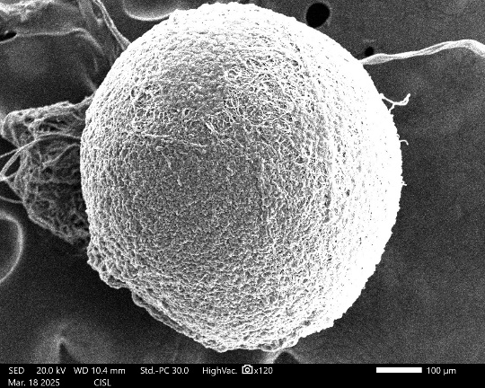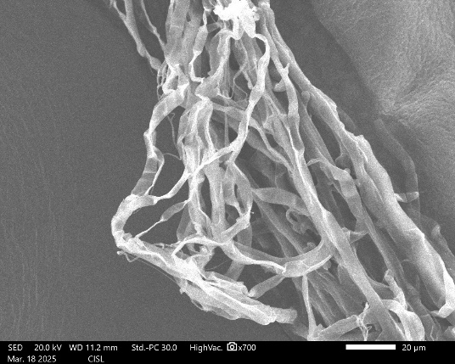
Fig.3: SEM observation of Sclerotium rolfsii
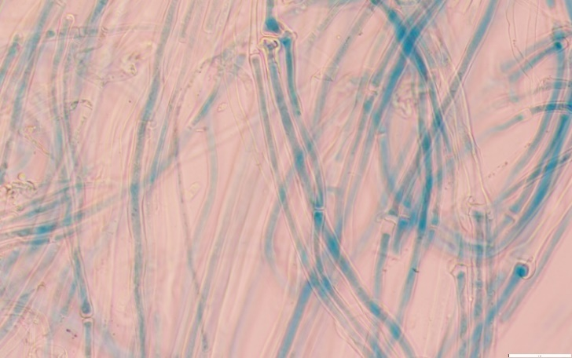
Fig.4: Microscopic observation of Sclerotium rolfsii
CONCLUSION
This study demonstrated considerable cultural and morphological variation among Sclerotium rolfsii isolates from brinjal. Differences were observed in mycelial growth, colony type, and sclerotial characteristics. Such diversity may influence pathogenicity and adaptability. Microscopic and SEM analyses confirmed the identity of the pathogen. These findings are valuable for future disease management and resistance screening efforts.
DISCLAIMER (ARTIFICIAL INTELLIGENCE)
Author(s) hereby declare that NO generative AI technologies such as Large Language Models (ChatGPT, COPILOT, etc) and text-to-image generators have been used during writing or editing of this manuscript.

References
- Agrios, G.N., (2005) Elsevier Academic Press.
- Rangaswami, G., (1972) Prentice Hall of India Pvt. Ltd, 520.
- Buttler, H.L., and B.H. Hunter (1972) 3rd Ed.Burgess Publishing Co., Minneapolls, 1972, pp. 208-209.
- Punja ZK. The biology, ecology and control of Sclerotium rolfsii. Annu. Rev. Phytopathol., 1985,23(1): 97-127.
- Kumar, R., & Thakur, N. B. (2021) Sclerotium rolfsii: A soil-borne fungal menace to crop production. International Journal of Botany Studies. 6(6):1471-1475
- Adhikari, P., Shrestha, S. M., Manandhar, H. K., & Marahatta, S. (2022). Morphology and cross infectivity of Sclerotium rolfsii Sacc. Isolated from different host plants in Nepal. Journal of Agriculture and Environment, 177-187.
- Mullen, J. (2001). Southern blight, southern stem blight, white mold. The plant health instructor. DOI: 10.1094. PHI-I-2001-0104-01.
- Khadka, B. (2024). Evaluation of Botanical Extracts for their efficacy against In-vitro growth of Sclerotium rolfsii. International Socioeconomic Review, 2(1), 33–50.
- Arunasri, P., Padmodaya, B., Kumar, M. R., Rao, S. K., Reddy, B. R., & Reddy, S. T. (2021). EVALUATION OF INTEGRATED MANAGEMENT STRATEGIES AGAINST STEM ROT OF GROUNDNUT (Sclerotium rolfsii) UNDER POT CULTURE. The Journal of Research ANGRAU, 49(2), 43-54.
- Chen, L., Wu, Y. D., Chong, X. Y., Xin, Q. H., Wang, D. X., & Bian, K. (2020). Seed-borne endophytic Bacillus velezensis LHSB1 mediate the biocontrol of peanut stem rot caused by Sclerotium rolfsii. Journal of Applied Microbiology, 128(3), 803–813. https://doi.org/10.1111/jam.14508
- Yan, L., Wang, Z., Song, W. et al. Genome sequencing and comparative genomic analysis of highly and weakly aggressive strains of Sclerotium rolfsii, the causal agent of peanut stem rot. BMC Genomics 22, 276 (2021). https://doi.org/10.1186/s12864-021-07534-0
- Tabing, R., & Tiwari, S. (2018). An eco-friendly approach for the management of collar rot of brinjal caused by Sclerotium rolfsii SACC. International Journal of Current Microbiology and Applied Sciences, 7(12), 929-936.
- Hasan, M. M. and Meah, M. B. (2019). Anatomy and biochemical study of collar rot resistance in eggplant. International Journal of Pathogen Research,2(2): 1-13.
- Zheng B, He D, Liu P, Wang R, Li B, Chen Q (2020) Occurrence of collar rot caused by Athelia rolfsii on soybean in China. Can J Plant Pathol 43:43-47. https://doi.org/10.1080/07060661.2019.1703819
- Murmu, J. J., Tiwari, S., Jennifer, G. M. J., & Singh, S. (2021). Eco-Friendly Management of Sclerotium rolfsii Causing Collar Rot of Brinjal (Solanum melongena L.). Int. J. Curr. Microbiol. App. Sci, 10(03), 373-381.
- Sekhar, Y.C., S.K. Ahammed, and T.N.V.K.V. Prasad, R.S.J. Devi (2017) Morphological and pathogenic variability of Sclerotium rolfsii isolates causing stem rot in groundnut. Int J Pure App Biosci. 5(5):478-487.
- Praveen, A., and C. Kannan (2021) "Disease incidence and severity of Sclerotium rolfsii on Arachis hypogea l."Plant Archives. 21(1): 344-349.
- Ayyandurai, M., Akila, R., Manonmani, K., & Mini, M. L. (2022). Isolation and morphological characterization of Sclerotium rolfsii inciting stem rot disease in groundnut (Arachis hypogaea L.). Madras Agricultural Journal, 109(special), 1.Le, C. N., Mendes, R., Kruijt, M., & Raaijmakers, J. M. (2012). Genetic and phenotypic diversity of Sclerotium rolfsii in groundnut fields in central Vietnam. Plant Disease, 96(3), 389-397.
- Adhikari, P., Shrestha, S. M., Manandhar, H. K., & Marahatta, S. (2022). Morphology and cross infectivity of Sclerotium rolfsii Sacc. Isolated from different host plants in Nepal. Journal of Agriculture and Environment, 177-187.
- Manu, T. G., Nagaraja, A., & Manjunatha, S. V. (2018). Morphological and cultural variability among the Sclerotium rolfsii isolates. Journal of Pharmacognosy and Phytochemistry7, 904-907.

