**Coccinellids of some cropping fields of eastern Uttar Pradesh, India**

**Abstract:**

An intensives surveys were made to explore the diversity of Coccinellid fauna from Rice (*Oryza sativa*L*.*), Wheat + mustard (*Triticum aestivum* L*.*+ *Brassica compestris* L.) and mustard (*Brassica compestris* L.) cropping field of the eastern Uttar Pradesh, India during 2018-2020. Different Diversity indices like Shannon diversity index (H); Simpson index (D); Simpson diversity index (1-D); Evenness (E) were used for studying diversity and abundance of coccinellid beetles. The results revealed that 2627 predator and phytophagous coccinellids were recorded belonging to 12 species under 10 genera from three tribes of the family Coccinellidae. The *Coccinella transversalis* Fab. (22.00%), was more common species whereas *Anegleis cardoni* (Weise) (1.0%) as least common species was recorded during the whole observation in the all-cropped field. The all indices showed very good diversity and richness of the coccinellid fauna in all the cropping fields during the investigation. The comparison of the indices, richness and evenness among the different cropping field, *T. aestivum*+*B. compestris* field showed that more coccinellid fauna diversity followed by the *B. compestris* field perhaps, more availability of prey and pollens.

**Keywords:** Biodiversity, *Coccinella* spp, *Oryza sativa*, *Triticum aestivum, Brassica compestris,* Predator

**Introduction**

Coccinellids are very well-known coleopteran beetle and more commonly known as Ladybird Beetle. They are very easily recognised by their bright colour, oval, convex shape like split pulses in adult stage and somewhat flattened, elongated, spotted or banded with bright colour larvae. There are about 375 genera and more than 6,000 described species are known to worldwide while about 550 known species of diverse coccinellid known from 90 genera (Poorani, 2019). They are one of the promising predators of different agro ecosystem except some phytophagous member of *Epilachina*. Their larvae and adults are the voracious predator. Their assemblages are more prevalent and abundant to those crops having the infestation of aphids, scale insects, mealy bugs, whiteflies, leafhoppers, mites and other sucking pests (Fathipour and Maleknia, 2016). Coccinellids are too much specilised to their prey. Due to their novel predacious capacity, they are considered as one of the successful biological agents for the Integrated Pest Management of the agricultural and horticultural crops. Climatic conditions are much influence the assemblage of coccinellids in respect of temporal and spatial within the ecosystem (Honek *et al.* 2017) but assemblage on crop depend on the availability of their prey and several other factors (Shanker *et al.*, 2018). India is the one of the diversity hot spot. The biodiversity of coccinellids vary crop to crop and location to location. Having more economic importance in biological control, the Indian coccinellid fauna have been studied from different parts of country and Uttar Pradesh also by certain well known personnel’s like, Afroze, 1999; Poorani, 2002; Omkar and Pervez, 2002; Omkar and Pervez, 2004 and Poorani, 2009 along with very notable work of Dr. A.P. Kapur but there is lack of any appropriate information regarding coccinellids in eastern south region of Uttar-Pradesh in reference of different cropping pattern. Therefore, present study was conducted to document the Coccinellid fauna from *Oryza sativa* L*.*, *Triticum aestivum* L*.*+*Brassica compestris* L.) and *Brassica compestris* L. cropping systems of the eastern-south region of Uttar Pradesh, India.

**Materials and Methods**

The present exploration was made from a series of surveys of the several locations to document the Coccinellid fauna from *Oryza sativa*, *Triticum aestivum*/*Brassica compestris* cropping systems of the eastern-south region of Uttar Pradesh, India with geographical coordinates as 25°12’79’’ N and 83°19’86’’ E.

The present exploration was made from a series of surveys of the several locations in eastern-south region of Uttar Pradesh, India from 2018 to 2020. The study sites were located in different areas of eastern Uttar Pradesh (figure 1). The coccinellids were collected by sweeping net and manual hand-picking methods. The collections were made during morning and night hours *i.e.*, 08.00–12.00 AM and 2.00-4.00 PM.

The survey of each locality was carried out weekly for the coccinellids collection and Collected coccinellids fauna were brought to laboratory processed and photographed its.

Collected specimens were killed in the killing bottle containing ethyl acetate. Subsequently, all the collected materials were cleaned with camelhair brush and pinned it, was kept for more than 50-62 hours for drying to avoid spoilage of the specimens during storage. The identification was made based on the morphological All the collected coccinellids fauna were identified with the help of available literatures and keys of the Bieńkowski (2018). Coccinellids were matched with standard identified materials and confirmed by Dr. J. Poorani, Principal Scientist, ICAR National Research Centre for Banana, Tiruchirappalli also. Classification of Coccinellidae was made following to Poorani (2019). The collected and confirmed specimens were deposited in the Department of Agricultural Entomology, R. M. D.C.R.A.S., Ambikapur, Chhattisgarh, India.

All the collected data were computed and analysed. The Shannon’s diversity index Shannon equality (evenness) index and Simpson’s index of dominance was calculated for the dominance of the species.

Shannon’s diversity index (*H*)’= - $\sum_{i=1}^{s}{\left(Pi\right)(In(Pi)}$

Whereas,

Pi= ratio of *‘ith’* species and is calculated as-

*“ni/N”,* where, *“ni”*= the number of individuals in *‘ith’* species and *N*= the total number of individuals in the sample

In (Pi) =natural log of the proportion

Shannon equality (evenness) index (*EH*) = = H’/In*S*

Whereas,

H= Shannon's diversity index

In*S*= log of the total number of species

Simpson’s index ($D)=\frac{\sum{n}(n-1)}{N(N-1)}$

Whereas,

n= number of individuals in *‘ith’* species

N= number of individuals in the sample

Simpson’s diversity index =1-D

Whereas,

D= Simpson’s index

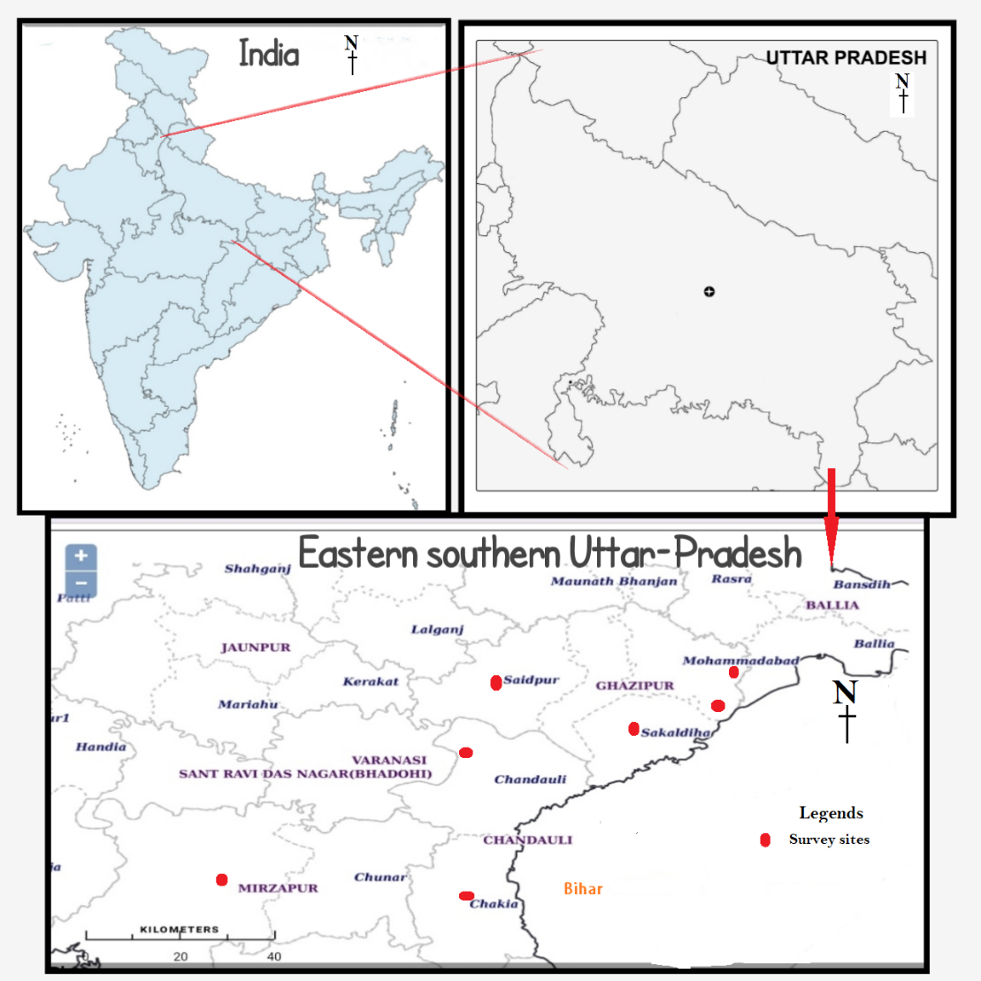

**Figure 1. Map of survey sites**

**Result and Discussion**

During the present investigation a total of 2627 predator and phytophagous coccinellids belonging to 12 species under 10 genera were recorded from three tribes (Table 1 and Image 1). Asni *et. al.* (2020) and Rasheed and Buhroo (2018) have also recorded 13 species of coccinellids from different agriculture cultivation in Jambi (Indonesia) and Kashmir respectively. The whole population of collected coccinellid fauna includes two species (*Brumoidessuturalis* (Fab.) and *Chilocorusnigrita*(Fab.)) from tribe *Chilocorini Mulsant* (12.67%), nine species (*Micrapsissp, Anegleiscardoni, Propyleadissecta*(Mulsant), *Coccinella transversalis* Fab., *Coccinella septempunctata*L., *Coccinella undecimpunctata*(L.), *Harmonia dimidiate* (Fab.), *Hippodamia variegate* (​Goeze) and *Menocheles sexmaculatus* (Fab.)) from tribe Coccinellini Latreille (84.00%) and only single phytophagous species (*Henosepilachna vigintioctopunctata* (Fab.)) from tribe *Epilachini Mulsant* (3.33%). Former eleven species were recorded are truly predacious coccinellid. The coccinellid fauna of tribe Coccinellini were most abundant represented in all three-cropping habitat namely *Oryza sativa*, *Triticum aestivum*and *Brassica compestris*e ether mixed or sole cropped fields. Tribe Coccinellini revealed more diverse tribe over rest of the two tribes in respect of species diversity as well as geographical distribution. *Coccinella transversalis* (22.00%), a more common species under the tribe Coccinelllini was the dominant species followed by *Micrapsis* sp (18.00%) of the same tribe and *Brumoidessuturalis* (6.67%) among the tribe Chilocorini (Figure. 2).

The *Micrapsis*sp. (26.00%), a Coccinellini species was recorded as dominant species in field among the all crops and *C*. *transvesalis* (26.00%), dominant species in the *Brassica compestris* field followed by *Triticum aestivum* + *Brassica compestris* mixed sown field. *Coccinella transversalis* shown dominant coccinellid fauna followed by *Micrapsis* sp. in all the field of the crops whereas *Anegleiscardoni* (1.0%) was the least common species during the whole observation in the all-cropped field. *Coccinella septempunctata* and *C. undecipunctata* were absent in the *Oryza sativa* field whereas *Anegleis cardoni* was absent in *Triticum aestivum*+*Brassica compestris* and sole cropped *Brassica compestris* field during the present investigation (Figure.3). Rashid and Buhroo (2018) recorded highest population of *C. septempunctata* from Kashmir whereas Hussain *et al.* (2000) recorded *Micrapsis* sp in *Triticum aestivum* field and Kandibane *et al.* (2006) recorded *Micrapsis* spp. as the dominant coccinellid fauna in *Oryza sativa* field. The values of Shannon’s diversity indices (1.981, 2.147 and 2.109), Simpson’s index of dominance (0.838, 0.861 and 0.856) and evenness indices (0.901, 0.895 and 0.879) of three habitats namely, *Oryza sativa* field, *Triticum aestivum* + *Brassica compestris* mixed cropped field and sole *Brassica compestris* field crop respectively (Table 2). The indices very clearly indicated high diversity, species abundance and uniform distribution of coccinellid fauna in these localities during present observations. The indices of coccinellids are more similar to Asni *et al.* (2020), Rashid and Buhroo (2018). The indices of Table 2 also revealed that the highest coccinellid diversity and number assemblage in *Triticum aestivum*+*Brassica compestris* field followed by the *Brassica compestris* field, probably due to more availability of prey, pollens and weeds. Kandibane *et al.* (2006) and Lokesh *et al.* (2017) also recorded the more numbers of coccinellids in partially weeded and without weeding field of *Oryza sativa* and *Vigna radiata* respectively.

**Table 1:** Collected coccinellid fauna during survey

|  |  |  |  |  |
| --- | --- | --- | --- | --- |
| **Subfamily** | **Tribe** | Coccinellid fauna | **Abundance** | **Distribution in India** |
| ChilocorinaeMulsant | ChilocoriniMulsant | *Brumoidessuturalis* (Fab.) | 12.67% | Goa, KN, TN, MH, PB, MA, UP (Poorani, 2002) |
|  |  | *Chilocorusnigrita*(Fab.) | KN, K, TN, AP, MA (Poorani, 2002) and UP |
| CoccinellinaeLatreille | CoccinelliniLatreille | *Micrapsis*sp*.* | 84.00% | Some species are recorded from UP (Omkar and Parvez, 1999) and RJ (Satpathi, 2009). |
|  |  | *Anegleiscardoni*(Weise) | TN, MP, UP, UK (Poorani, 2002) |
|  |  | *Propyleadissecta*(Mulsant) | AS, KN, TN, UP (Poorani, 2002) |
|  |  | *Coccinella transversalis* Fab. | All over India (Poorani, 2002) |
|  |  | *Coccinella septempunctata*L. | All over India (Poorani, 2002) |
|  |  | *Coccinella undecimpunctata*(L.) | J & K, UP (Poorani, 2002) |
|  |  | *Harmonia dimidiata*(Fab.) | AS, HP, RJ, PB, J & K, WB (Poorani, 2002) UP |
|  |  | *Hippodamia variegata*(​Goeze) | J & K, UP, HP, MH, (Poorani, 2002) |
|  |  | *Menocheles sexmaculatus*(Fab.) | All over India (Poorani, 2002) |
| *Epilachina Mulsant* | *Epilachini Mulsant* | *Henosepilachna vigintioctopunctata* (Fab.) | 3.33% | All over India (Poorani, 2002) |

**Abbreviations Note:** HP= Himanchal Pradesh, MH= Maharashtra, J&K= Jammu and Kashmir, PB= Punjab, WB= West Bengal, RJ= Rajasthan, AS= Assam, TN= Tamil Nadu, KN= Karnataka, MA= Manipur, AP= Andhra Pradesh, K= Kerala, MH= Maharashtra

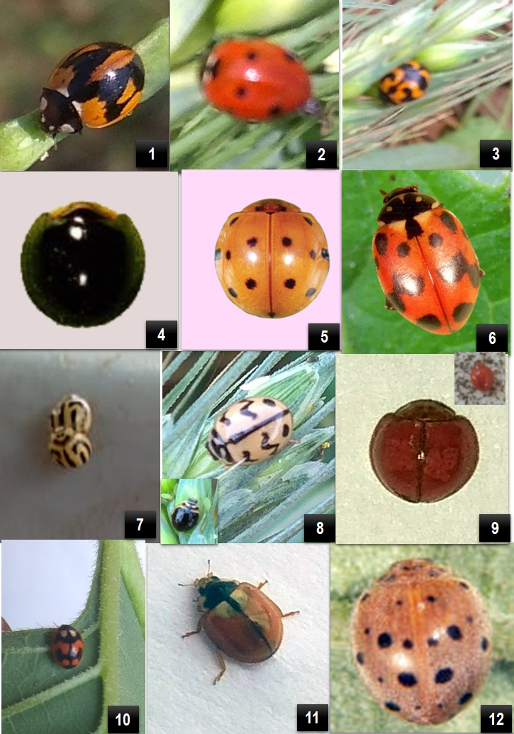

**Image 1:**1-2 *Coccinella septempunctata* 3. *Coccinella transversalis* 4. *Chilocorus nigrita* 5. *Harmonia dimidiate* 6. *Hippodamia variegata* 7. ***Anegleis cardoni*** 8. *Menocheles sexmaculatus* 9. *Micrapsis* sp*.*10-11. *Propylea dissecta*12. *Henosepilachna vigintioctopunctata*

**Figure 2:** Relative abundance of the Coccinellids fauna during study

**Table 2:** Different indices of diversity of the collected coccinellids fauna

|  |  |  |  |
| --- | --- | --- | --- |
| **Indices** | **Different habitats** | | |
| *Oryza sativa* | *Triticum aestivum*+ *Brassica compestris* | *Brassica compestris* |
| Simpson’s Index of Diversity (1-D) | 0.838 | 0.861 | 0.856 |
| Simpson’s Index of Diversity (D) | 0.162 | 0.139 | 0.144 |
| Shannon-Weiner index (H) | 1.981 | 2.147 | 2.109 |
| Evenness (E) | 0.901 | 0.895 | 0.879 |
| Species richness (S) | 9 | 11 | 11 |

**Figure 3:** Diversity and abundance of the Coccinellid fauna in different habitat during the study

**Conclusion**

The intensive surveys conducted in rice, mustard and wheat + mustard cropping systems revealed a significant diversity and abundance of coccinellid beetles. The most dominant species was Coccinella transversalis (22.00%) while Anegleis cardoni was the least common (1.0%). The application of various diversity indices indicated high species diversity and richness across all fields. Among the cropping systems, the wheat + mustard fields exhibited the highest diversity of coccinellid fauna, likely due to the greater availability of prey and pollen resources. These findings highlight the ecological importance of mixed cropping systems in promoting beneficial insect biodiversity, which is crucial for integrated pest management and sustainable agriculture.

Disclaimer (Artificial intelligence)

Option 1:

Author(s) hereby declare that NO generative AI technologies such as Large Language Models (ChatGPT, COPILOT, etc.) and text-to-image generators have been used during the writing or editing of this manuscript.

Option 2:

Author(s) hereby declare that generative AI technologies such as Large Language Models, etc. have been used during the writing or editing of manuscripts. This explanation will include the name, version, model, and source of the generative AI technology and as well as all input prompts provided to the generative AI technology

Details of the AI usage are given below:

1. Option 1

2.

3

**References**

Afroze, S. 1999. Some Indian predaceous Coccinellidae. *Indian J. Syst. Entomol.*, **11**: 27–34.

Asni, J., Wulan O.D. and Sari D.R. 2020. The Presence of ladybug beetle (Coleoptera: Coccinellidae) as a predator on agriculture in Jambi region. *J. Ent. Res.* **44**(1): 45-50.

Bieńkowski, A.O. 2018. Key for identification of the ladybirds (Coleoptera: Coccinellidae) of European Russia and the Russian Caucasus (native and alien species). [*Zootaxa*](https://www.researchgate.net/journal/Zootaxa-1175-5334), **4472**(2):233-260.

Honek A., Dixon A.F.G., Soares, A.O. Skuhrovec, J. Martinkova Z. 2017. Spatial and temporal changes in the abundance and composition of ladybird (Coleoptera: Coccinellidae) Communities. *Curr. Opin. Insect Sci.* **20**: 61–67.

Hussain M.A., Ahmad M.A. and Islam M.J. 2000. Abundance of coccinellid beetles on wheat crop. *Bangladesh J. Train and Dev.,***13**(1and 2): 81-86.

Kandibane, M., Raghuraman S. and, Mahadevan N.R. 2006. Taxonomic composition and diversity of coccinellids in an irrigated rice ecosystem of Tamil Nadu, India. *Internat. J. Agric. Sci.,* **2**(2): 433-435.

Lokesh S, Muthukrishnan N, Ganapathy N, Bapu J.R.K. and Somasundaram E. 2017. Ecological engineering cropping methods enhance coccinellids and supress aphid *Aphis gossypi* in blackgram. *J. Entom. Zool. Stud.,***5**(3):1288-1294.

Omkar and Pervez A. 2002. New record of coccinellids from Uttar Pradesh. III. *J. Adv. Zool.,* **23**: 63–65.

Omkar and Pervez A. 2004. Predaceous coccinellids in India: Predator-prey catalogue. *Orient. Insects,* **38**: 27–61.

Omkar and Pervez A. 1999. New record of coccinellids from Uttar Pradesh I. *J. Adv. Zool.,* **20**:106-112.

Poorani J. 2002. An annotated checklist of the Coccinellidae (Coleoptera) (excluding Epilachninae) of the Indian sub-region. *Orient. Insects*, **36**: 307–383.

Poorani J. 2019. Coccinellidae of the Indian Sub continent. ***In*:** Indian Insects: Diversity and Science, Ramani S., Mohanraj Prashanth and Yeshwanth H. M. (Eds.). *CRC Press, Florida.* 218-224.

Rasheed R. and Buhroo A. A. 2018. Diversity of coccinellid beetles (Coccinellidae: Coleoptera) in Kashmir, India. *Entomon*, **43**: 129–134.

Satpathi, C.R. 2009. List of predatory Coccinellidae (Coleoptera) of India and their preys: a review and bibliography. *J. Aphidol*., **23** (1 and 2): 11-42.

Shanker C., Sampathkumar M., Sunil V., Amudhan S., Sravanthi G., Jhansirani B., Poorani J. and Katti G. 2018. Biodiversity and predatory potential of coccinellids of rice ecosystems. *J. Biol. Cont.* **32**:25–30.