Original Research Article
Genetic diversity study of Andrographis paniculata (Burm. F.) Wall ex. Nees from the Southern Districts of Kerala using SSR markers

ABSTRACT
The study aims at finding the genetic diversity of 35 Kiriyathu (Andrographis paniculata (Burm. F.) Wall ex. Nees) ecotypes from the Southern districts of Kerala using SSR markers. Kiriyathu ecotypes were collected from nine different Agro Ecological Units (AEUs) of south Kerala and raised in College of Agriculture, Vellayani (AEU 8) from January to June, 2024. Diversity assessment was done using ten SSR primers, among which seven were found to be polymorphic viz., Ando 4-26, Ando 4-27-2, Ando 4-43/1, Ando 5-12-1, Ando 5-14-2, Ando 5-26-2 and Ando 5-29. The (Polymorphism Information Content) PIC value ranged from 0.16 to 0.64. The dendrogram representation could gather the ecotypes into three separate clusters viz., Cluster I, Cluster II and Cluster III. Cluster I was further divided into seven subclusters containing 27 ecotypes while cluster II and cluster III contained five and three ecotypes respectively. Furthermore, the scatter plot developed through Principal Coordinate Analysis (PCoA) could identify genetically distinct ecotypes viz., Karunagappally, Sasthamcotta, Vellimon and Chirakkara. In an overview, the genetic heterogeneity among the Kiriyathu ecotypes is possibly attributed to genetic mixing via germplasm transfer during its wide history of conventional usage. Moreover, the limited gene flow can be due to self-pollination, low pollen and seed dispersal rates.
Keywords: Andrographis paniculata, Genetic diversity, Kerala, SSR markers, Dendrogram

1. INTRODUCTION
Andrographis paniculata (Family- Acanthaceae) called as the "King of Bitters” and commonly known in the Indian subcontinent as Kiriyathu (Malayalam), Chirayetah (Urdu) and Kalmegh (Hindi). It is an annual plant growing to a height of about 1-3 ft. It is one of the most commonly used plants in the traditional systems of Unani and Ayurvedic medicines (Akbar, 2011). It has been used for centuries in Asia to treat gastro-intestinal tract and upper respiratory infections, fever, herpes, sore throat, and a variety of other chronic and infectious diseases (Mishra et al., 2007). The taste of Kiriyathu is very bitter due to the bitter principle andrographolide (Thakur et al., 2015). Andrographolide is related with its various pharmacological properties such as anti-biotic, antiviral, anti-microbial, anti-inflammatory, anti-venom and immunostimmulatory, anticancer, anti-HIV, anti-allergic, and hypoglycemic activity. Nowadays, the plant is used extensively as a hepatoprotective agent (Sutha, 2010).
Molecular techniques give a reliable judgement of plant diversity since, it uses a marker assisted selection method rather than traditional phenotype-based selection. Crude drugs of varying genetics and phytochemical properties questions the value of the pharmaceutical drugs hence, it is essential to identify a good quality genotype of Kiriyathu. Molecular markers are more reliable because the genetic information is unique for each species and is independent of age, physiological conditions and environmental factors (Joshi et al., 2004). Random Amplified Polymorphic DNA (RAPD) markers were used for the genetic diversity analysis of Kiriyathu by Maison et al. (2005) and Sharma et al. (2009). However, Inter Simple Sequence Repeats (ISSR) primers were utilised by Manjesh et al. (2016) and Hiremath et al. (2020) for analysing genetic differences between Kiriyathu accessions. Several Kiriyathu genotypes are distributed in different agro-ecological units (AEUs) of Kerala. The above mentioned scholarly evidences indicate genetic divergence of Kiriyathu accessions. Nevertheless, its germplasm collection from different AEUs, molecular diversity assessment have not yet been explored. Hence, he objective of the present study was to identify genetic diversity of Kiriyathu ecotypes from the southern districts of Kerala based on SSR markers.
2. MATERIALS AND METHODS
2.1 Collection of Plant Material
Kiriyathu accessions, 35 numbers were collected from nine different Agro-ecological Units (AEUs) covering the southern districts of Kerala. The collected plants were maintained in polybags at College of Agriculture, Vellayani (AEU 8) for further investigation. The AEUs and location of 35 Kiriyathu accessions collected are given in Table 1.
Table 1. Location of 35 Kiriyathu ecotype collected
AEUs | Location | Ecotypes
AEU 1 | Southern Coastal Plain | Kalakkode  Chirakkara  Perinad  Karicode  Vellimon  Kundara
AEU 3 | Onattukara Sandy Soil | Karunagappally  Kayamkulam  Thamarakkulam  Mavelikkara
AEU 4 | Kuttanad | Chengannur  Thiruvalla  Alappuzha  Kottayam
AEU 5 | Pokkali Lands | Chottanikkara  Ernakulam  Kodungallur  Mala
AEU 8 | Southern Laterites | Vellayani  Kattakkada  Neyyattinkara  Parassala
AEU 9 | Southern Central Laterites | Kachani  Adoor  Karakulam  Bharanikkavu  Sasthamcotta
AEU 12 | Southern and Central Foothills | Vellanad  Kadakkal  Pathanamthitta  Odakkali
AEU 14 | Southern High Hills | Palode  Vithura  Aryanad
AEU 16 | Kumily High Hills | Nedumkandam

2.2 DNA Extraction
The plant sample for DNA extraction was prepared by crushing fresh young leaves of Kiriyathu using liquid nitrogen (-196°C), preheating (65°C, 45 minutes) with Cetyl Trimethyl Ammonium Bromide (CTAB) extraction buffer [Tris HCl (0.5M), EDTA (0.1M), NaCl (4M), CTAB (2%), PVP (3%) and β-mercaptaethanol], transferring the resultant extract to a centrifuge tube and kept in a water bath (65°C for 45 minutes). The tubes were then centrifuged using a pre-chilled centrifuge at 10,000 rpm for 10 minutes, and the supernatant was collected. It was purified twice using isoamyl alcohol: chloroform (24:1) mixture and centrifuged at 12,000 rpm for 10 minutes.
The DNA was precipitated as DNA pellets by adding ice-cold isopropanol to the supernatant following one hour incubation at -20°C and centrifugation at 10,000 rpm for 15 minutes. The pellets were purified by washing twice using 70% ethanol (0.5ml) air-drying and further dissolution in Tris-EDTA solution (TE buffer, 20 µl). Finally, the DNA samples of Kiriyathu ecotype were stored at -20°C for molecular diversity studies (Porebski et al., 1997).
2.3 Quantification of DNA
DNA quantification is a key spectrophotometric tool for determining the quantity of DNA in a sample. The UV-VIS Spectrophotometer (PeikinElmer, SL21 UV-Vis Lambda 365+) could measure the absorption of ultraviolet (UV) rays by nucleotide bases of DNA molecules at, 260 wavelength. Meanwhile, the quantity of DNA was also determined as the ratio of absorbance at 260 nm to 280 nm. DNA samples having 1.8-2 purity range could be considered reasonably free of impurities (Porebski et al., 1997).
2.4 Agarose gel electrophoresis
Agarose gel electrophoresis is a method to sort DNA fragments based on its molecular weight. Agarose (1g) in the presence of 1X TAE buffer was dissolved by keeping in microwave-safe container to prepare 1% agarose gel solution. The solution was thoroughly mixed to remove any clumps and further heated at low temperature until the agarose was completely melted. Later, Ethidium Bromide (EtBr) dye was added to it for improved visibility of nucleic acids under UV light.
The prepared gel solution was then gently poured into a casting tray, containing a comb delicately placed on its surface. The gel was placed inside a tank containing 1X TAE buffer after it is hardened (20-25 minutes). Later, the comb was lifted up to develop wells for loading the isolated DNA samples (2 µl).
The gel electrophoresis unit (BIO RAD PowerPac HV) was operated at the specified voltage (75 V) for 1 hour to separate the DNA fragments or bands. The bands could be seen using the gel documentation system Gel Doc TM XR (Wavelength) and the program Image Lab TM .
2.5 Polymerase Chain Reaction
Amplification of the 35 DNA samples was done using Polymerase Chain Reaction (PCR) by employing ten distinct Simple Sequence Repeats (SSR) primers (Table 2). A reaction mixture (15 µL), containing DNA (1.5 µL), forward primer (1.5 µL), reverse primer (1.5 µL), nuclease-free water (3 µL), and PCR Master Mix (7.5 µL) was prepared, followed by setting up of PCR reaction conditions. The parameters (Table 3) included an initial denaturation at 94°C for four minutes, followed by 35 cycles of denaturation at 94°C for 30 seconds, annealing at a specified temperature (40-60°C) for 45 seconds, and extension at 72°C for two minute. The final extension phase lasted ten minutes at 72°C, after which the reaction was held at 4°C (Lade et al., 2020).
Table 2. SSR primers deployed for the molecular diversity analysis of Kiriyathu ecotypes
Primer name | Forward primer | Reverse primer
Ando 2-31-2 | ATTGATGCCCAAAGAGAAGAAG | CTCTCCCTATCTCGCACTATCG
Ando 4-26 | AGCTTCGGATCGTAGGGTTT | TCTGTATGTGTGCTCAACCTCC
Ando 4-27-2 | ATGACCCTCAACATAGCGTTTT | AGCTTCGGATCTCTCTCCACT
Ando 4-43/1 | CTCTCTCTCTCTCTCCACAGCC | TGACCCTCAACATAGCGTCTTA
Ando 5-12-1 | CTTCGGATCAGTTAGCCCCT | GTCTTGCACCCACTCTCTCTCT
Ando 5-14-2 | AGCTTCGGATCAGTTAGTCCCT | CGCACTCTCTCAGTTTTCCTCT
Ando 5-26-2 | ACCGAGCATCTCTCTCTGCTAT | TTCGGATCTGTCCTGTGTTTC
Ando 5-29 | CTTCGGATCAGTTAGTCCCTTC | TCTCTATCTCGCAGCTCTCCTT
Ando 4-35-1 | CAACCTCCATCATCTGAACAAA | CTCTCTCTCTCTCTCCACAGCC
Ando 2-30-2 | AGCTTCGGATCAGTTAGTCCCT | CGCTCGTAGTCTCTCTCTCACA

Table 3. PCR reaction conditions utilised in the molecular diversity analysis of Kiriyathu ecotypes
Profile | Temperature | Duration
Lid temperature | 98°C | -
Initial denaturation | 94°C | 4 min
Denaturation | 94°C | 30 sec
Annealing | 40-60°C | 45 sec
Extension | 72°C | 2 min
Final extension | 72°C | 10 min
Infinite hold | 4°C | ͚

2.6 Agarose Gel Electrophoresis of PCR Product
The amplified PCR products were analyzed using agarose gel electrophoresis. The size of bands and the reaction's specificity were measured and confirmed respectively using a DNA ladder containing fragments (100bp) employed alongside the samples. In addition, the ladder could aid in confirming presence of numerous bands, which might be the secondary amplification products or polymorphisms. The bands on the gel were carefully inspected and documented using the Gel Doc method (BioRad) for polymorphic SSRs. Finally, the polymorphism information content (PIC) was calculated using the given equation.
PIC = 1- $\sum{f^{2}}$
  - Dendrogram
The genetic relationship between the Kiriyathu ecotypes were represented using a dendrogram generated using the ‘SIMQUAL’ sub-programme of NTSYS-pc software.
3. RESULTS
Molecular diversity analysis of 35 Kiriyathu ecotypes was conducted by collecting the plants from different Agroecological units in the southern districts of Kerala using ten SSR markers. Ecotypes collected from AEU T1 (Kalakkode, Kollam), T2 (Chirakkara, Kollam), T3 (Perinad, Kollam), T4 (Karicode, Kollam), T5 (Vellimon, Kollam) and T6 (Kundara, Kollam). Ecotypes from AEU 3 consists of T7 (Karunagapally, Kollam), T8 (Kayamkulam, Alappuzha), T9 (Thamarakkulam, Alappuzha) and T10 (Mavelikkara, Alappuzha). T11 (Chengannur, Alappuzha), T12 (Thiruvalla, Pathanamthitta), T13 (Alappuzha) and T14 (Kottayam) were collected from AEU 4. AEU 5 provided T15 (Chottanikkara, Ernakulam), T16 (Ernakulam) T17 (Kodungallur, Thrissur) and T18 (Mala, Thrissur). T19 (Vellayani, Thiruvananthapuram), T20 (Kattakkada, Thiruvananthapuram), T21 (Neyyattinkara, Thiruvananthapuram) and T22 (Parassala, Thiruvananthapuram) were collected fron AEU 8. Ecotypes collected from AEU 9 consist of T23 (Kachani, Thiruvananthapuram), T24 (Adoor, Pathanamthitta), T25 (Karakualm, Thiruvananthapuram), T26 (Bharanikkavu, Kollam) and T27 (Sasthamcotta, Kollam). AEU 12 provided T28 (Vellanad, Thiruvananthapuram), T29 (Kadakkal, Kollam), T30 (Pathanamthitta) and T31 (Odakkali, Ernakulam). AEU 14 consist of three ecotypes viz., T32 (Palode, Thiruvananthapuram), T33 (Vithura, Thiruvananthapuram) and T34 (Aryanad, Thiruvananthapuram). Only one ecotype viz., T35 (Nedumkandam, Idukki) was collected from AEU 16.
The DNA of 35 Kiriyathu ecotypes was extracted using a modified CTAB method (Plate 1). Spectrophotometer readings were taken to calculate its concentration and purity of DNA. The concentration of the isolated DNA had a range from 262.5 µg/ml to 1016 µg/ml whereas purity of the samples ranged from 1.51 to 2.18. The intact bands observed in the gel image confirmed the quality of the DNA samples.
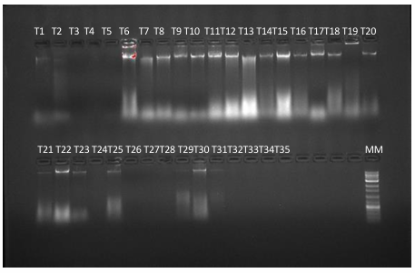
Plate 1. Gel profile of 35 Kiriyathu DNA samples

Molecular diversity analysis of Kiriyathu ecotypes was done using ten SSR primers viz., Ando 2-31-2, Ando 4-26, Ando 4-27-2, Ando 4-43/1, Ando 5-12-1, Ando 5-14-2, Ando 5-26-2, Ando 5-29, Ando 4-35-1 and Ando 2-30-2 reported by Kumar et al. (2020). Annealing temperatures of these ten SSR primers were standardised by running gradient PCR and it ranged from 40-60°C (specific for each primer). Among the above said ten primers, seven primers viz., Ando 4-26, Ando 4-27-2, Ando 4-43/1, Ando 5-12-1, Ando 5-14-2, Ando 5-26-2 and Ando 5-29 were found to be polymorphic while the remaining three primers viz., Ando 2-31-2, Ando 4-35-1 and Ando 2-30-2 showed no bands at all. The polymorphic ones produced 21 alleles and polymorphism % was found to be 64.08. The polymorphic information content (PIC) of the SSR primers viz., Ando 4-26, Ando 4-27-2, Ando 4-43/1, Ando 5-12-1, Ando 5-14-2, Ando 5-26-2 and Ando 5-29 were 0.48, 0.64, 0.32, 0.48, 0.11, 0.56 and 0.16 respectively (Table 4) among which, primer Ando 4-27-2 recorded the highest value (Plate 2).
Table 4. No. of alleles, Total no. of bands, No. of polymorphic bands, Polymorphism% % and PIC value of 7 Polymorphic SSR Primers
Primer name | No. of alleles | Total bands | Polymorphic bands | Polymorphism % | PIC value
Ando 4-26 | 4 | 29 | 11 | 37.93 | 0.48
Ando 4-27-2 | 3 | 31 | 21 | 67.74 | 0.64
Ando 4-43/1 | 3 | 28 | 14 | 50 | 0.32
Ando 5-12-1 | 4 | 45 | 28 | 62.22 | 0.48
Ando 5-14-2 | 3 | 36 | 2 | 61.11 | 0.56
Ando 5-26-2 | 2 | 32 | 24 | 75 | 0.11
Ando 5-29 | 2 | 34 | 15 | 44.11 | 0.16

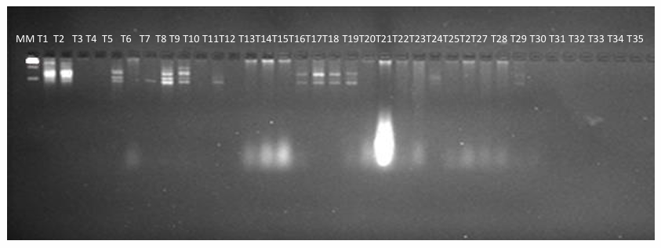
Plate 2. PCR amplification of 35 Kiriyathu ecotypes using the primer Ando 4-27-2

Molecular diversity among the 35 Kiriyathu ecotypes gathered from nine different agro-ecological units in southern Kerala was assessed using the SIMQUAL sub-program of the NTSYS-PC software.
The genetic diversity and relationship between the 35 Kiriyathu ecotypes are depicted in the dendrogram (Fig. 1.). The similarity coefficient ranged from 0.1 to 0.9. The Kiriyathu ecotypes could be categorised into, three clusters viz., Cluster I, Cluster II and Cluster III at a similarity coefficient, 0.5. Cluster I consist of seven subclusters viz., Subcluster I include three ecotypes viz., T22, T13 and T14. Subcluster II six ecotypes viz., T30, T25, T24, T23, T21 and T11. Subcluster III include three ecotypes viz., T28, T26, and T27. Subcluster IV include five ecotypes viz., T9, T6, T7, T10 and T3. Subluster V include five ecotypes viz., T32, T3, T13, T12 and T7. Subcluster VI include only one ecotype viz., T20. Subcluster VII include four ecotypes T35, T34, T8 and T1. Cluster II comprised of five ecotypes viz., T19, T18, T129, T33 and T16. Cluster III comprised of three ecotypes viz., T5, T2 and T4.
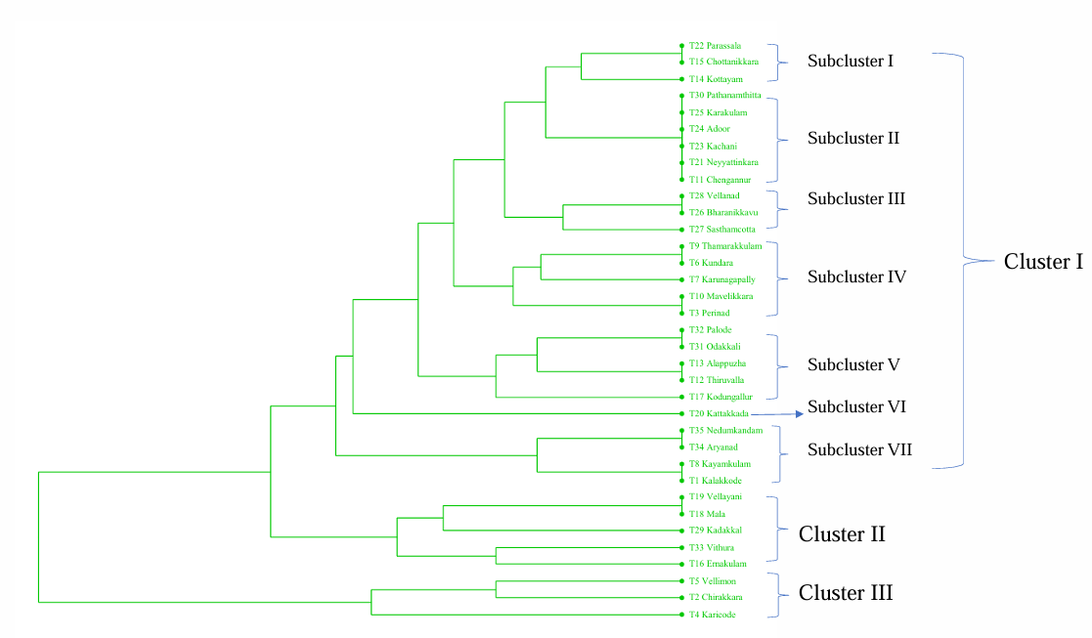
Fig. 1. Dendrogram showing genetic diversity of 35 Kiriyathu ecotypes
Subcluster I
Subcluster II
Subcluster III
Subcluster IV
Subcluster V
Subcluster VII
Cluster I
Cluster III
Subcluster VI
Cluster II

4. DISCUSSION
Molecular markers, mainly DNA markers, are those that identify polymorphism in cells at the macromolecular level (Gupta et al., 2001). Durability, affordability, and simplicity of molecular markers are an extends its applications in genome mapping, gene tagging, genetic diversity, phylogenetic analysis, and forensic investigations (Grover and Sharma, 2016). A molecular marker is a sequence of DNA situated at a known position on a chromosome or a gene whose phenotypic expression is often readily apparent and used to identify an individual, or as a probe to designate a chromosome, nucleus, or locus (Idrees and Irshad, 2014). Molecular markers provide several advantages over traditional phenotype-based methods, as they are stable and detectable in all tissues, irrespective of the cell's growth, differentiation, development, or defensive status, and are not influenced by environmental factors, pleiotropic, or epistatic effects (Khan, 2015). Restriction Fragment Length Polymorphism (RFLPs), Random Amplification of Polymorphic DNA (RAPD), Simple Sequence Repeats (SSR), Inter Simple Sequence Repeats (ISSR) and Single Nucleotide Polymorphisms (SNPs) are the different types of molecular markers employed commonly for analysing the genetic diversity in various organisms (Adhikari et al., 2017). Markers including Random Amplification of Polymorphic DNA (RAPD) (Maison et al., 2005; Sharma et al., 2009) and Inter Simple Sequence Repeats (ISSR) (Manjesh et al., 2016; Hiremath et al., 2020) were deployed for analysing similarities and differences in Kiriyathu accessions in India.
SSR primers employed by Kumar et al. (2020) were used in the present work concentrating on the molecular characterization of Kiriyathu ecotypes gathered from nine distinct agro ecological units in southern Kerala. The study included 35 ecotypes viz., T1 (Kalakkode, Kollam), T2 (Chirakkara, Kollam), T3 (Perinad, Kollam), T4 (Karicode, Kollam), T5 (Vellimon, Kollam), T6 (Kundara, Kollam), T7 (Karunagapally, Kollam), T8 (Kayamkulam, Alappuzha), T9 (Thamarakkulam, Alappuzha), T10 (Mavelikkara, Alappuzha) T11 (Chengannur, Alappuzha), T12 (Alappuzha), T13 (Thiruvalla, Pathanamthitta), T14 (Kottayam), T15 (Chottanikkara, Ernakulam), T16 (Ernakulam) T17 (Mala, Thrissur), T18 (Kodungallur, Thrissur), T19 (Vellayani, Thiruvananthapuram), T20 (Kattakkada, Thiruvananthapuram), T21 (Neyyattinkara, Thiruvananthapuram), T22 (Parassala, Thiruvananthapuram), T23 (Kachani, Thiruvananthapuram), T24 (Karakulam, Thiruvananthapuram), T25 (Bharanikkavu, Kollam), T26 (Sasthamcotta, Kollam), T27 (Adoor, Pathanamthitta), T28 (Vellanad, Thiruvananthapuram), T29 (Kadakkal, Kollam), T30 (Pathanamthitta), T31 (Odakkali, Ernakulam), T32 (Palode, Thiruvananthapuram), T33 (Aryanad, Thiruvananthapuram), T34 (Vithura, Thiruvananthapuram) and T35 (Nedumkandam, Idukki). SSR primers used in the study were Ando 2-31-2, Ando 4-26, Ando 4-27-2, Ando 4-43/1, Ando 5-12-1, Ando 5-14-2, Ando 5-26-2, Ando 5-29, Ando 4-35-1 and Ando 2-30-2. Out of these, seven primers viz., Ando 4-26, Ando 4-27-2, Ando 4-43/1, Ando 5-12-1, Ando 5-14-2, Ando 5-26-2 and Ando 5-29 were found to be polymorphic.
The ability of a marker to identify polymorphism within a population was tested by its Polymorphic Information Content (PIC). Markers with PIC value greater than 0.5 provide higher information on polymorphism among the population while those having range between 0.25 and 0.5 are moderately informative and those having PIC value less than 0.25 are least informative. In the current study, the PIC value ranged from 0.11 to 0.64 and the overall polymorphism rate was 64%. The primer, Ando 4-27-2 recorded the highest PIC value, 0.64 which signifies its higher reliability for genetic diversity studies in Kiriyathu. In a similar study conducted for analysing the genetic diversity of A. paniculata collected from different states of India during 2023 by Singh et al. (2023) using 39 SSR primers, 20 showed polymorphic bands. The overall polymorphism rate recorded was 68.33%, and the PIC value ranged from 0.099 to 0.59.
In the present study the genetic relationship among 35 Kiriyathu ecotypes gathered from nine different Agro Ecological Units of Southern Kerala implicated the usage of the seven polymorphic primers only. A dendrogram showing the genetic link among the ecotypes was built by means of cluster analysis using the SIMQUAL sub program of the NTSYS software. The 35 ecotypes could be grouped into three clusters based on the genetic relationships. Cluster I was divided into seven subclusters namely subcluster I, II, III, IV, V, VI and VII. Subcluster I includes three ecotypes viz., T22 (Parassala, AEU 8), T15 (Chottanikkara, AEU 5) and T14 (Kottayam, AEU 4). Subcluster II includes six ecotypes viz., T30 (Pathanamthitta, AEU 12), T25 (Karakulam, AEU 9), T24 (Adoor, AEU 9), T23 (Kachani, AEU 9), T21 (Neyyattinkara, AEU 8) and T11 (Chengannur, AEU 4). Subcluster III includes three ecotypes viz., T28 (Vellanad, AEU 12), T26 (Bharanikkavu, AEU 9) and T27 (Sasthamcotta, AEU 9). Subcluster IV includes five ecotpes viz., T9 (Thamarakkulam, AEU 3), T6 (Kundara, AEU 1), T7 (Karunagappally, AEU 3), T10 (Mavelikkara, AEU 3) and T3 (Perinad, AEU 1). Subcluster V includes five ecotypes viz., T32 (Palode, AEU14), T31 (Odakkali, AEU 12), T13 (Alappuzha, AEU 4), T12 (Thiruvalla, AEU 4) and T17(Kodungallur, AEU 5). Subcluster VI includes only one ecotype viz., T20 (Kattakkada, AEU 8). Subcluster VII includes four ecotypes viz., T35 (Nedumkandam, AEU 16), T34 (Aryanad, AEU 14), T8 (Kayamkulam, AEU3) and T1 (Kalakkode, AEU 1). Cluster II contains five ecotypes namely T19 (Vellayani, AEU 8), T18 (Mala, AEU 5), T29 (Kadakkal, AEU 29), T33 (Vithura, AEU 14) and T16 (Ernakulam, AEU 5). Cluster III contains three ecotypes namely T5 (Vellimon, AEU 1), T2 (Chirakkara, AEU 1) and T4 (Karicode, AEU 1). The Kiriyathu ecotypes exhibiting substantial molecular diversity could contribute to future breeding programs for SSR markers after genetic relationship analysis, species analysis and marker assisted selection breeding. A synonymous fingerprinting study of A. paniculata genetic diversity using Expressed Sequence Tags- Simple Sequence Repeats (EST-SSR) employed 15 polymorphic EST-SSR primers for grouping 24 accessions into two clusters (Chaturvedi et al., 2022). Moreover, SSR primers could generate the diversity fingerprints of different medicinal plants including Pseudostellaria heterophylla (Miq.) Pax (Xu et al., 2023), Gymnema sylvestre (Retz.) R.Br. ex Sm. (Polaiah et al., 2023), Polygonatum odoratum (Mill.) Druce (Pan et al., 2024), Burdock (Arctium lappa L.) (Su et al., 2025), Saussurea involucrata (Hu et al., 2024), Ilex asperella (Li et al., 2025), Zanthoxylum nitidum (Roxb.) (Zhu et al., 2023). The deployed SSR markers could classify 112 (10 cultivars+102 F₁ hybrids), 26, 24, 112, 64 and 25 genotypes of respective medicinal plants into different clusters based on genetic variation.
Principal Coordinate Analysis (PCoA), commonly referred to as classical multidimensional scaling, was also performed in this study. PCoA created a set of coordinates for every ecotype by converting the genetic data into a new coordinate system and thereby developing a scatter plot containing 35 points in which each point represented an ecotype. The plotting of each point explicates the genetic similarities and differences between the ecotypes. Ecotype clusters or groups were notably visible in the developed scatter plot with distant points signifying greater genetic dissimilarity and closely spaced points indicating higher genetic similarity. The 35 Kiriyathu ecotypes were plotted as seven different clusters in the scatter plot (Fig. 2.). Cluster I consisted of eight ecotypes T29 (Kadakkal), T16 (Ernakulam), T20 (Kattakkada), T33 (Vithura), T32 (Palode), T31 (Odakkali), T26 (Bharanikkavu) and T28 (Vellanad). Cluster II contained 12 out of the 35 ecotypes studied ie., the maximum number of ecotypes viz., T19 (Vellayani), T18 (Mala), T17 (Kodungallur), T13 (Alappuzha), T12 (Thiruvalla), T30 (Pathanamthitta), T25 (Karakulam), T35 (Nedumkandam), T34 (Aryanad), T23 (Kachani), T11 (Chengannur), T15 (Chottanikkara) and T24 (Adoor). Cluster III consisted of ten ecotypes viz., T14 (Kottayam), T22 (Parassala), T21 (Neyyattinkara), T3 (Perinad), T10 (Mavelikkara), T8 (Kayamkulam), T1 (Kalakkode), T4 (Karicode), T9 (Thamarakkulam) and T6 (Kundara). Cluster IV, V, VI and VII each contained only one ecotype - T7 (Karunagappally), T27 (Sasthamcotta), T5 (Vellimon) and T2 (Chirakkara), respectively. In an overview, the scatter plot developed through PCoA disclosed four individual ecotypes viz., T7 (Karunagapally, AEU 3), T5 (Vellimon, AEU 1), T2 (Chirakkara, AEU 1) and T27 (Sasthamcotta, AEU 9) as distinct from other ecotypes. Additionally, it implies a higher genetic variation available for Kiriyathu ecotypes available from Kollam district.
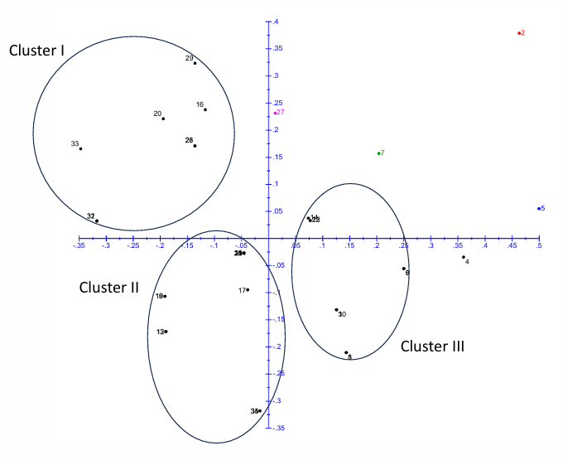
Fig. 2. Scatter plot
The high genetic similarity shown by some of the Kiriyathu ecotypes under the study may be due to many factors. Kiriyathu is self-pollinated, hence exhibiting limited gene flow analogous to many herbaceous plants including Rheum officinale (Wang et al., 2012); Epherda foliate (Meena et al., 2019) and Achillea fragrantissima (El-Shazly et al., 2020). Low dispersal rates of seeds and pollen, restrict the mixing of genetic material between populations, further contribute to genetic uniformity. Moreover, random genetic drift in small, isolated populations can lead to the fixation of alleles, reducing genetic diversity over time. However, being a medicinal plant having a vivid history of conventional usage could have facilitated genetic mixing via germplasm transfer (Wijarat et al., 2012).
5. CONCLUSIONS
As a result, it is stated that the Chirakkara (Kollam) ecotype collected from AEU 1 (Southern Coastal Plain) is defined as a quite different and genetically diverse Kiriyathu ecotype. In addition, it should be added that it is possible to develop new varieties with superior characteristics by including this ecotype in breeding programs. Thus, it should give a different direction to the breeding field.
DISCLAIMER (ARTIFICIAL INTELLIGENCE)
Author(s) hereby declare that NO generative AI technologies such as Large Language Models (ChatGPT, COPILOT, etc.) and text-to-image generators have been used during the writing or editing of this manuscript.

.
REEFERNCES
Akbar, S. (2011). Andrographis paniculata: a review of pharmacological activities and clinical effects. Altern. Med. Rev, 16(1), 66-77.
El-Shazly, H. H., Ahmed, H. I. S., Hamouda, M. M., & Badr, A. (2020). Genetic diversity and population structure of the medicinal plant Achillea fragrantissima (Forssk.) Sch. Bip. in the mountains of South Sinai, Egypt. Plant Gene, 21, 100212.
Grover, A., & Sharma, P. C. (2016). Development and use of molecular markers: past and present. Critical reviews in biotechnology, 36(2), 290-302.
Gupta, P. K., Roy, J. K., & Prasad, M. (2001). Single nucleotide polymorphisms: a new paradigm for molecular marker technology and DNA polymorphism detection with emphasis on their use in plants. Current Science, 524-535.
Hiremath, C., Greeshma, M., Gupta, N., Kuppusamy, B., Shanker, K., & Velusamy, S. (2020). Morphometric, chemotypic, and molecular diversity studies in Andrographis paniculata. J. Herbs Spices Med. Plants, 27(3), 1-14.
Hu, L., Wang, J., Wang, X., Zhang, D., Sun, Y., Lu, T., & Shi, W. (2024). Development of SSR markers and evaluation of genetic diversity of endangered plant Saussurea involucrata. Biomolecules, 14(8), 1010.
Idrees, M., & Irshad, M. (2014). Molecular markers in plants for analysis of genetic diversity: a review. European Academic Research, 2(1), 1513-1540.
Joshi, K., Chavan, P., Warude, D. % Patwardhan, B. (2004). Molecular markers in herbal drug technology. Current Science, 159-165.
Khan, F. (2015). Molecular markers: an excellent tool for genetic analysis. J. Mol, Biomark. Diagn, 6(03), 233.
Kumar, R., Kumar, C., Paliwal, R., Choudhury, D. R., Singh, I., Kumar, A., et al. (2020). Development of novel genomic simple sequence repeat (g-SSR) markers and their validation for genetic diversity analyses in Kalmegh [Andrographis paniculata (Burm. F.) Nees]. Plants 9(12), 17-34.
Lade, H., Kim, J. M., Chung, Y., Han, M., Mo, E. K., & Kim, J. S. (2021). Comparative evaluation of allplex respiratory panels 1, 2, 3, and BioFire FilmArray respiratory panel for the detection of respiratory infections. Diagnostics, 12(1), 9.
Li, J., Quan, C., Wei, R., Wei, F., Ma, Q., Huang, Y., Xu, M., et al. (2025) Genome-wide identification and development of SSR molecular markers for genetic diversity studies in Ilex asprella. Frontiers in Plant Science, 16, 1582154.
Maison, T., Volkaert, H., Boonprakob, U. & Paisooksantivatana, Y. (2005). Genetic diversity of Andrographis paniculata Wall. ex Nees as revealed by morphological characters and molecular markers. Agric. Nat. Res, 39, 388-399.
Manjesh, G. N., Himabindu, K., Chinapolaiah, A., & Suryanarayana, M. A. (2016). Estimation of genetic diversity in Kalmegh (Andrographis paniculata Nees). Int. J. Bio-resour. Stress Manag, 7(6), 261-264.
Meena, B., Singh, N., Mahar, K. S., Sharma, Y. K., & Rana, T. S. (2019). Molecular analysis of genetic diversity and population genetic structure in Ephedra foliata: an endemic and threatened plant species of arid and semi-arid regions of India. Physiology and Molecular Biology of Plants, 25, 753-764.
Mishra, S. K., Sangwan, N. S., & Sangwan, R. S. (2007). Andrographis paniculata (Kalmegh): A review. Pharmacogn. Rev, 1(2), 283-298.
Pan, G., Xie, J., Qin, Y., & Zhang, S. (2024). Development of SSR markers for genetic diversity analysis and species identification in Polygonatum odoratum (Mill.) Druce based on transcriptome sequences. Plos one, 19(9), e0308316.
Polaiah, A.C., Damor, P. R., Reddy, R. N., Manivel, P., Shivakumara, K.T., Suthar, M.K., et al. (2023). Development of genomic SSR markers in Gymnema sylvestre (Retz.) R. Br. ex Sm. using next generation DNA sequencing and their application in genetic diversity analysis. J. Appl. Res. Med. Aromat Plants, 34, 100455.
Porebski, S., Bailey, L. G., & Baum, B. R. (1997). Modification of a CTAB DNA extraction protocol for plants containing high polysaccharide and polyphenol components. Plant Molecular Biology Reporter, 15, 8-15.
Sharma, S. N., Sinha, R. K., Sharma, D. K., & Jha, Z. (2009). Assessment of intra-specific variability at morphological, molecular and biochemical level of Andrographis paniculata (Kalmegh). Current Science, 402-408.
Singh, R., Singh, A., Mahato, A. K., Paliwal, R., Tiwari, G., & Kumar, A. (2023). De novo transcriptome profiling for the generation and validation of microsatellite markers, transcription factors, and database development for Andrographis paniculata. International Journal of Molecular Sciences, 24(11), 9212.
Su, Y., Fu, J., Xie, H., Huang, Z., Li, Y., Luo, Y., et al. (2025). SSR markers development and their application in genetic diversity of burdock (Arctium lappa L.) germplasm. BMC Plant Biology, 25(1), 196.
Sutha, D. (2010). A study on the hepatoprotective effect of Andrographis paniculata (Burm. F) Nees on mice, J. Phytol. 2(11), 25-30.
Thakur, A. K., Chatterjee, S. S., & Kumar, V. (2015). Adaptogenic potential of andrographolide: An active principle of the king of bitters (Andrographis paniculata). J. Tradit. Complement. Med, 5(1): 42-50.
Wang, X. M., Hou, X. Q., Zhang, Y. Q., Yang, R., Feng, S. F., Li, Y., et al. (2012). Genetic diversity of the endemic and medicinally important plant Rheum officinale as revealed by inter-simpe sequence repeat (ISSR) markers. International Journal of Molecular Sciences, 13(3), 3900-3915.
Wijarat, P., Keeratinijakal, V., Toojinda, T., Vanavichit, A., & Tragoonrung, S. (2012). Genetic evaluation of Andrographis paniculata (Burm. f.) Nees revealed by SSR, AFLP and RAPD markers. J. Med. Plants Res, 6, 2777-2788.
Xu, L., Li, P., Su, J., Wang, D., Kuang, Y., Ye, Z., et al. (2023). EST-SSR development and genetic diversity in the medicinal plant Pseudostellaria heterophylla (Miq.) pax. J. Appl. Res. Med. Aromat. Plants, 33, 100450.
Zhu, Y., Ma, T., Lin, Y., Peng, Y., Huang, Y., & Jiang, J. (2023). SSR molecular marker developments and genetic diversity analysis of Zanthoxylum nitidum (Roxb.) DC. Scientific Reports, 13(1), 20767.

