Review Article
Advancements and Future Prospects of Artificial Intelligence for Sustainable Agriculture

ABSTRACT
Artificial intelligence (AI) in the sector of agriculture is still in the budding phase. Integrating AI in agriculture with multidisciplinary approach can provide enhanced results and revolutionize agriculture. AI is showing significant change in the agriculture by improving economic performance, precision farming, disease detection, crop monitoring, automated machines and management of livestock to improve the productivity and optimized use of resources. Integrating AI in the management of plant disease and soil health are helping farmers in reducing the cost on resources use and manpower. Machine learning algorithms are very helpful in analyzing the data for the use of fertilizers, herbicides, pesticides and water. It will further reduce agricultural waste and increases productivity of crop which align with sustainability and SDGs. Initial cost of implementation and data security are still the big challenges which need to be addressed for the robust implementation of AI in the field of Agriculture.
Key words- Artificial Intelligence (AI), machine learning, soil health, crop monitoring, autonomous tractors, Convolutional Neutral Networks (CNNs), food processing, sustainability, robotics

- INTRODUCTION
Artificial Intelligence (AI) is improving efficiency, efficacy, sustainability and productivity in the sector of Agriculture. By 2050, the population of earth is expected to reach to 9.7 billion. To feed such a large population there is an important need to revolutionize the agriculture. AI driven solutions are critical for the food security, optimized use of resources, improve the productivity of crops and climate and ecosystem resilience. The main objective of incorporating AI and other multidisciplinary knowledge in the sector of agriculture are increase crop yield by predictive analysis, reduce the use of pesticide and water by precise farming, automated labor intensive tasks in harvesting and weeding, and enhanced technologies for the detection of disease and stress using computer vision (Bannerjee et al., 2018; Javaid et al., 2023; Sharma, 2021). Through advanced technologies such as machine learning, computer vision, and IoT-enabled sensors, AI enables precision farming, optimizing resource use and minimizing environmental impact. For instance, AI-driven tools analyze soil health, weather patterns, and crop conditions in real time, allowing farmers to tailor irrigation, fertilization, insecticide and herbicide and pest control strategies. Autonomous machinery which includes drones and robotic harvesting mechanism reduces demand of manpower while improving efficiency. Predictive analytics also play a pivotal role in forecasting crop yields, disease outbreaks, and market trends, empowering stakeholders to mitigate risks and maximize profitability to the farmers. Furthermore, AI supports sustainable practices by promoting agro ecological balance and reducing waste through smart supply chain management. These practices help in mitigate the impact of climate change and global warming (FAO, 2023; Kamilaris et al., 2017; Liakos et al., 2018; Benos et al., 2021). Satellite imaging, AI based irrigation, autonomous tractors, laser weeding, crop monitoring, biotic and abiotic stress management and precise farming are few of the key applications of artificial intelligence in the sector of agriculture. Artificial intelligence (AI) adaptation in the field of agriculture has emerged as a driver of sustainability, productivity and efficiency in the global food system. AI technologies can help in combating with the climate change, population growth, food scarcity and resources scarcity.
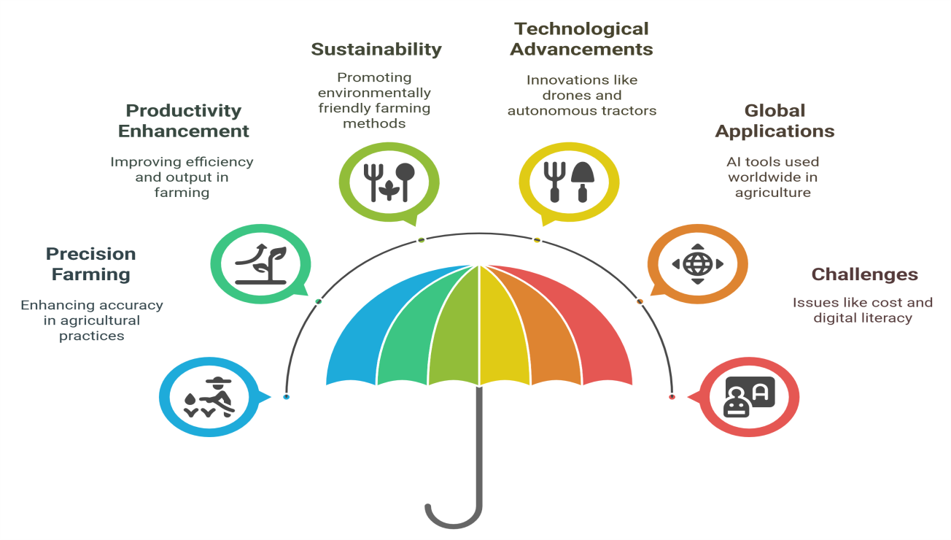
Fig 1: Impacts of Artificial Intelligence (AI) in Agriculture

- IMPORTANT AREAS FOR THE APPLICATION OF AI IN THE FIELD OF AGRICULTURE
2.1 AI for economic performance in Agriculture
Artificial intelligence’s innovation provides substantial benefits in the sector of Agriculture. It is expected that AI will ensure food safety and food security while considering environmental aspect (Ryan et al., 2023). Innovation with the artificial intelligence promises great future in the sector of agriculture and crop yield (Shepherd et al., 2020; Marvin et al., 2022). Using precise prediction, soil testing mechanism, biotic and abiotic stress detection and post harvest management can help in producing larger quantity and good quality of food products without harming the environment (Shepherd et al., 2020). In the coming years agriculture sector is expected to have huge investment to integrate AI in the field to improve computing power and cost-effective access in cloud technologies. The investment is expected to increase of 25.5% between the year 2020 and 2026 (Lajoie O'Malley et al., 2020). Integrating AI in agriculture need multidisciplinary approach of integrating five other disciplines like economic, ethical, social, technological and environmental sciences to get beneficial results and suitable benefits. To get the effective result from AI the quality and quantity of data is very important for accuracy and robustness. The lower willingness of farmers and lower technological penetration in the rural area is one of the biggest challenge (Ryan et al., 2021).
  - 1 Precision farming for improving yield
Precision farming by providing data driven insights can help AI to optimize resource use which can further improve the yield of crop by 20 to 30%. It will also reduce the use of resources such as water and fertilizers which will generate less toxic waste and reduce the degradation of soil (World economic forum, 2023). Machine learning models can analyze satellite image and IoT sensor data to predict soil health, enable variable rate irrigation which can save 25% of water in the drought prone areas (FAO, 2022). See & Spray™ system uses computer-based vision to target specific weeds and further cut down the use of herbicide by 80-90% (Leise et al., 2025).
  - Detection of disease and Crop monitoring
AI driven crop monitoring and disease detection system are transforming agriculture by helping in the identification of plant stress, pests, pathogens and disease with unprecedented accuracy. Machine learning models such as Convolutional Neutral Networks (CNNs) help to analyze drone images which are of high resolution, and other smartphone, camera and satellite. It helps in detection of anomalies which are created by fungal infection, bacterial infection, nematode infection, nutrient deficiencies and pest infestations. Algorithms are trained with large, accurate and robust databases to classify plant diseases in tomato, potatoes and wheat with over 95% of accuracy (Mohanty et al., 2016). Hyperspectral and multispectral imaging further enhance detection by capturing subtle changes in plant health before visible symptoms appear, reducing crop losses by up to 30%. CNN models have helped I achieving 95% of accuracy in identifying the disease like wheat rust (Zhang et al., 2018). AI-powered mobile apps, such as Farm Sense, provide real-time diagnostics to smallholder farmers, improving decision-making in pest management (FAO, 2023).
  - Automated machines and Robotics
Integration of AI powered robotics and automated machinery system is revolutionizing the Agriculture by improving efficiency, reducing manpower and labor cost by enabling precision base Agriculture practices. Self driving tractors which used GPS, computer vision and artificial intelligence to perform field operations with the accuracy of 2-5 cm and reduces the labor cost by 80% in the field (John Deere, 2023). Harvesting robots such as Agrobot (strawberries) and FF Robotics (apple pickers) utilize 3D vision and robotic arms to pick fruits with 90-95% accuracy, addressing labor shortages. AI powered weeding and spraying robots are helpful in eliminating weeds while avoiding crops and reduces the use of herbicide by 90%. Drone based farming and swarm robotics for large scale farms are helpful in autonomously plant monitor to treat crop and reduces the fuel use by 90% to support sustainability.
  - Management of livestock
Effective livestock management is essential for ensuring animal health, productivity, and sustainability in agricultural systems. It involves practices such as proper nutrition, housing, disease prevention, and ethical handling. Balanced diets tailored to species-specific needs, access to clean water, and rotational grazing systems optimize growth and reduce environmental impact. Shelter design must account for ventilation, space, and protection from extreme weather to minimize stress and disease transmission. Regular health monitoring, vaccinations, and parasite control are critical to prevent outbreaks and maintain herd immunity. Breeding programs focused on genetic diversity and resilience enhances long-term productivity and adaptability to changing climates. Additionally, animal welfare standards, including humane handling and reduced use of antibiotics, align with ethical consumer demands and global regulations. Sustainable practices like manure management and integrated farming systems further mitigate ecological footprints. By combining traditional knowledge with modern technology, such as precision farming and data analytics, livestock management can meet global food security needs while promoting environmental stewardship (Khan et al., 2021; Gwaka, 2017; FOA, 2020; OIE, 2018).
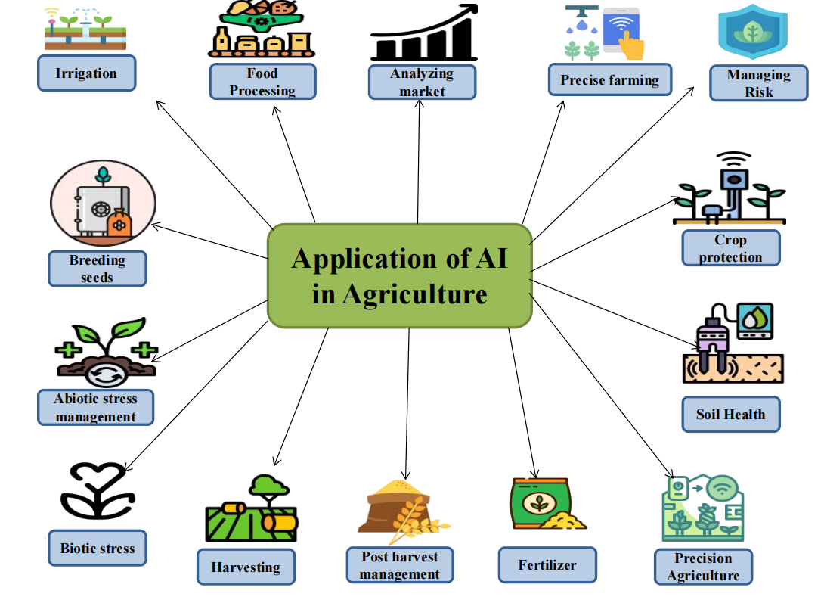
Fig 2: Application of Artificial Intelligence (AI) in the sector of Agriculture

- INTEGRATING AI FOR PLANT DISEASE MANAGEMENT IN AGRICULTURE
Agriculture has significantly shown advanced disease management system because of the integration of AI. In the sector of disease management, AI driven tools have enabled early detection, accurate diagnosis of disease and proactive mitigation of plant disease which addresses the struggle of traditional method (Delfani et al., 2024). Visual data from satellite, drones and other handheld devices can undergo AI powered image recognition systems, particularly Convolutional Neural Networks (CNNs) to identify disease symptoms on crops. According to Mohanty et al., 2016 and Pantazi et al., 2016 deep learning models are able to classify disease across multiple plants species with high accuracy and utilize machine learning algorithms like self organizing maps which are helpful in detecting disease mainly leaf disease in wheat crop which is emphasizing the role of automatic machines in reducing the human error. Machine learning models are very helpful in analyzing the environmental data of weather patterns, soil conditions and disease prevalence which enables the farmers to implement the preventive measures such as adjusting irrigation and apply targeted treatments (Kamilaris et al., 2017). Precision agriculture with the help of AI facilities such as automated guiding machineries like drones and robotic sprayers deliver treatments on the targeted areas of crop. It reduces the use of chemicals and environmental impact because of targeted interventions (FAO, 2021). To get the accurate result the characteristic of data must be analyzed to determine which algorithm must be used for the study ( Li and Wang, 2024).
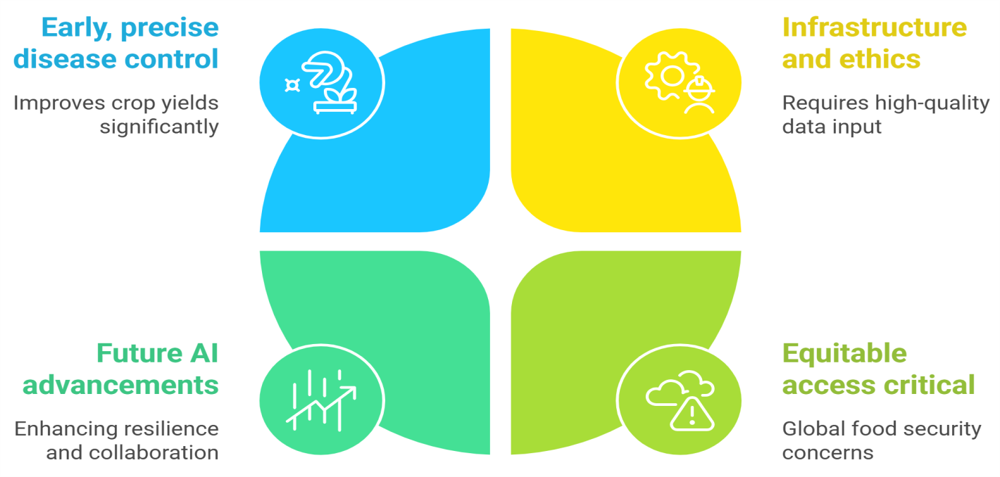
Fig 3: AI in Agricultural disease management

  - Artificial intelligence in managing the health of soil in Agriculture
Agriculture practices is being transformed with the help of AI by enhancing precision in nutrient use, soil management, optimized resource use which is resulting in the improved crop productivity. Site specific application of fertilizers can be determined by the analysis of soil data, weather pattern and crop requirement to recommend site specific application of fertilizer. Algorithms of machine learning (ML) such as random forest and neural networks, predict nutrient deficiencies and optimized schedule of fertilization reduces the waste output and environmental impacts (Liakos et al., 2018). Padarian et al., in 2020 demonstrated the use of CNNs to estimate soil organic carbon which aid in the sustainable land management. It collects the real time data of moisture, ph and organic level of carbon and provides the appropriate analysis of result. Robotic system with AI automated function for the sampling of soil improves the accuracy and reduces manpower. The results are analyzed by the machine learning mechanism which enables high frequency analysis without any human interventions (Bwambale et al., 2022; Kamilaris et al., 2017). AI combines IoT sensor data with satellite imagery to create comprehensive soil health dashboards. For example, neural networks trained on Sentinel-2 data detect soil salinity (Ivushkin et al., 2019), while IoT networks track micronutrient levels in real time.

- INTERVENTION OF AI IN GLOBAL AGRICULTURE
The companies John Deere in United States of America have deployed autonomous tractors and other equipment of harvesting which are AI driven and have GPS and computer vision which directly reduces the labor cost and improves the accuracy. In India, predictive analytic tools use to forecast market demands and risk of climate and aid farmers in decision making. Kisan Sabha which is a AI powered app help in providing localized advisories on schedule of plantation, pesticides, herbicides and irrigation. It is currently benefiting over 10 million of smallholders (NITI Aayog, 2023). Use of robotic in AI guided weeding machines, fruit picking robots are helpful in addressing the challenge of labor shortage in countries like Japan and Netherlands. Developed economies such as United States, Germany, Japan and China are prioritizing AI for the large scale automation and data driven decision making whereas emerging economies such as India and Brazil are focusing more on the AI driven advisories to support small shareholder farmers (USDA, 2022; NITI Aayog, 2023). To address the shortage of labor in countries like china and Japan uses AI to enhance the yield productivity, predictability with notable success in staple crop like soybean and rice (FAO, 2023; Japan misnistry of agriculture, 2022). However, disparities persist, particularly in regions like Africa, where infrastructural gaps and limited funding hinder widespread implementation, relegating AI to pilot projects in climate resilience and pest control.
Table 1: AI technologies and their adaptation rate
Technology | Key Benefit | Adoption Rate in 2023
Autonomous Tractors | 80% labor cost reduction | 35% (USA, EU)
Harvesting Robots | 90-95% picking accuracy | 20% (Global)
Laser Weeding | 90% herbicide use reduction | 15% (North America)
Farming Drones | 50% faster field monitoring system | 40% (Asia-Pacific)
Precision Farming | 25% water savings | 58% (USA)
Crop Monitoring | 95% disease detection accuracy | 65% (China)
Livestock AI | 15% lower mortality | 40% (EU)

Table 2: Intervention of Artificial Intelligence (AI) and their targeted effect in different countries
Country | AI Adoption (%) | Field of Adoption | Targeted Effect | Reference
USA | 58% | Precision Farming, Autonomous Tractors | Reduce water use by 25%, increase yield by 20% | USDA, 2024
China | 65% | AI Drones, Smart Greenhouses for improved production | Boost rice production by 30%, reduce labor costs | China AgriTech Report, 2023
India | 35% | Crop Disease management and detection, Soil Sensors and fertility check | Improve smallholder farm productivity by 15-20% which results in better economical condition of farmers. | NITI Aayog, 2024
Germany | 60% | Dairy farm automation system, AI harvesting and management | Reduces use of pesticide by 40%. It also enhances the yield of milk. | EU AgriTech, 2023
Brazil | 45% | AI for Soybean & Sugarcane farming and production management | Optimize fertilizer use, cut costs by 18% | Embrapa, 2024
Japan | 70% | Robotics in farming of rice, AI Drones | Address labor shortage, automate 50% tasks | MAFF Japan, 2023
Kenya | 20% | Mobile AI for Small Farms | Improve access to real-time weather data | FAO, 2024

- AI IN AGRICULTURAL FOOD PROCESSING INDUSTRY
Artificial intelligence is revolutionizing the sector of agricultural food processing by increasing productivity, optimizing use of resources and improves the efficiency of supply chain. Precision Agriculture with the help of AI driven tools such as drones, satellite image, real time monitoring of soil health, biotic and abiotic stress monitoring, crop growth, drones and environmental condition help in monitor crops. Data from Machine learning algorithms help in analyze the data to optimize irrigation, use of fertilizer, pest control, reduces agricultural waste and improve crop yield (Mohanty et al., 2016). Post harvest handling and management of crop by sorting product on the basis of size, ripeness and defects minimizes the human error in food processing unit (Liakos et al., 2018). Integrating robotics system with AI also streamline packaging and processing task. AI powered image recognition system with the help of drones and other equipment help in identifying plant disease early by analyzing the photographs of crops. CNNs classify plant diseases with high accuracy and time interventions (Mohanty et al., 2016). AI can also help in predicting the fluctuation of demand, optimization of logistics and reduce the waste generated in the processing of food products. It enhances tracebility, ensuring food safety and compliances (Tsolakis et al., 2023; Rana et al., 2021). Different models od AI recommends eco-friendly and sustainable practices such as reducing the use of pesticides and herbicides and optimizing the consumption of water. Predictive analyses also help in developing climate resilient farming methods (Van Klompenburg et al., 2020). Wearable sensors with AI monitors in monitoring the health of animals can help in detecting the illness and stress in the animals in their early phase (Neethirajan, 2020).
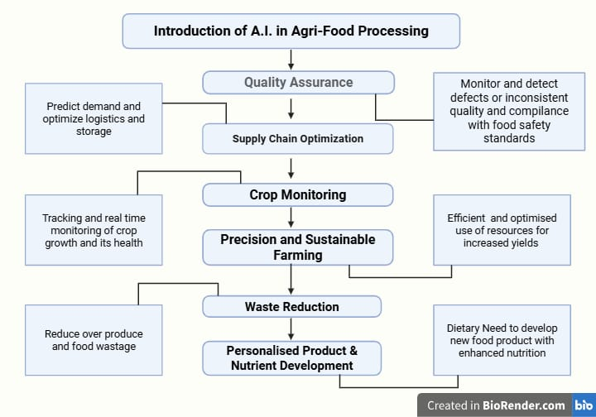
Fig 4: Role of Artificial intelligence in Agriculture food processing

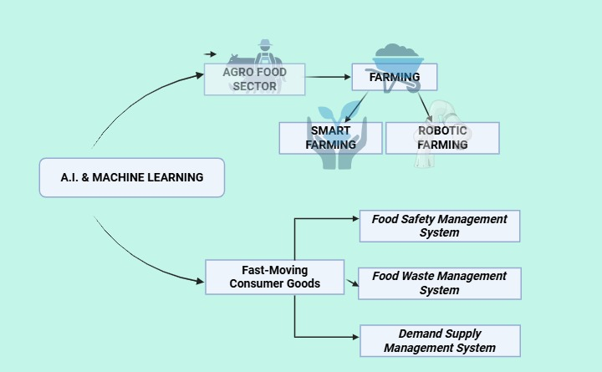
Fig 5: Role of AI and machine learning in the sector of Agriculture

- CHALLENGES AND FUTURE PROSPECTS
AI in the field of Agriculture is proving indispensible in building resilient and efficient agricultural systems globally and locally. Applications of AI have shown improvement in the productivity, sustainability, efficiency, food processing and resources utilization in the global food system.
- Despite these advantages, high initial and implementation cost is a big challenge for the implementation of AI technologies in the field of agriculture at large scale and because of the lack of digital literacy gaps in the developing countries it is more difficult to implement AI in the field.
- Need of digital infrastructure is very important for the implementation of AI in the sector of agriculture and it become very difficult to set up digital infrastructure in the remote areas of the world. AI models require large and high-quality datasets. In developing regions and some of the developed region, fragmented data infrastructure and lack of digitized records hinders adoption of AI.
- Farmer generated data risks misuse by corporation of hackers and other third party. Lack of the global standards for the AI ethics, liability and safety slow down its adaptation. Governments must address intellectual property and accountability framework at global and local level.
- Models which are trained from the data of high income and productivity region may fail to provide information from the context of diverse agro ecological groups which will lead to inequitable outcomes.
- Collaborative partnership between local and global governments, tech firms, farmers and researchers can help in democratizing the access of AI. Training programs can improve the digital literacy and trust on the AI systems.
- Edge cut AI technologies and deployment of digital lightweight AI models on local level reduces the dependency on cloud computing and cost of energy.

- CONCLUSION
AI is currently revolutionizing agriculture through precision, accuracy, resilience and sustainability. Advanced predictive analysis, autonomous farming machinery, AI driven genetic improvement of crop, integration of block chain and IoT, climate based smart agriculture, personalized farming solutions have helped in improving the productivity of crop quality and quantity wise. Currently AI is transforming food processing industry by enabling data driven decisions, improving efficiency and promoting sustainability in the field. It is still facing challenges of data quality and scarcity, high cost of implementation and other ethical and social concerns. AI holds transformative potential for agricultural disease management by offering tools for early detection, prediction and precision control and analysis. However, overcoming technical, infrastructural and ethical challenges is critical in ensuring equitable and sustainable implementation. By addressing the challenges of data gaps, costs, ethical risks and policy framework the benefits can be maximized. Co operations and collaborative efforts from government and international organizations as well as inputs from researchers and agritech firm can help in achieving the food security and meet the pressing challenges.

DISCLAIMER (ARTIFICIAL INTELLIGENCE)
Author(s) hereby declare that NO generative AI technologies such as Large Language Models (ChatGPT, COPILOT, etc.) and text-to-image generators have been used during the writing or editing of this manuscript.

REFERENCE

Bannerjee, G., Sarkar, U., Das, S., & Ghosh, I. (2018). Artificial intelligence in agriculture: A literature survey. international Journal of Scientific Research in computer Science applications and Management Studies, 7(3), 1-6.
Benos, L., Tagarakis, A. C., Dolias, G., Berruto, R., Kateris, D., & Bochtis, D. (2021). Machine learning in agriculture: A comprehensive updated review. Sensors, 21(11), 3758.
Bwambale, E., Abagale, F. K., & Anornu, G. K. (2022). Smart irrigation monitoring and control strategies for improving water use efficiency in precision agriculture: A review. Agricultural Water Management, 260, 107324.
China AgriTech Report. (2023). Ministry of Agriculture and Rural Affairs of the People’s Republic of China.
Delfani, P., Thuraga, V., Banerjee, B., & Chawade, A. (2024). Integrative approaches in modern agriculture: IoT, ML and AI for disease forecasting amidst climate change. Precision Agriculture, 25(5), 2589-2613.
Embrapa. (2024). Artificial intelligence in Brazilian agriculture. Brazilian Agricultural Research Corporation.
European Union AgriTech. (2023). Digital farming trends in Germany. European Commission.
FAO (2023). AI Innovations in Chinese Agriculture.
Food and Agriculture Organization (FAO). (2020). Sustainable Livestock Management: Practices for Resilience. Rome: FAO Publications.
Food and Agriculture Organization (FAO). (2023). Digital Agriculture: AI and Big Data in Farming. Rome: FAO Publications.
Food and Agriculture Organization (FAO). (2023). Digital innovation for sustainable crop production.
Food and Agriculture Organization (FAO). (2024). AI adoption in Kenyan smallholder farming. United Nations.
Food and Agriculture Organization. (2021). The role of artificial intelligence in achieving the Sustainable Development Goals. United Nations.
Gwaka, L. T. (2017). Digital technologies and sustainable livestock systems in rural communities. The Electronic Journal of Information Systems in Developing Countries, 81(1), 1-24.
Ivushkin, K., Bartholomeus, H., Bregt, A. K., Pulatov, A., Kempen, B., & De Sousa, L. (2019). Global mapping of soil salinity change. Remote sensing of environment, 231, 111260.
Japan Ministry of Agriculture (2022). Smart Agriculture Promotion.
Javaid, M., Haleem, A., Khan, I. H., & Suman, R. (2023). Understanding the potential applications of Artificial Intelligence in Agriculture Sector. Advanced Agrochem, 2(1), 15-30.
John Deere. (2023). Autonomous farming solutions.
Kamilaris, A., & Prenafeta-Boldú, F. X. (2018). Deep learning in agriculture: A survey. Computers and electronics in agriculture, 147, 70-90.
Kamilaris, A., Kartakoullis, A., & Prenafeta-Boldú, F. X. (2017). A review on the practice of big data analysis in agriculture. Computers and electronics in agriculture, 143, 23-37.
Khan, N., Ray, R. L., Kassem, H. S., Hussain, S., Zhang, S., Khayyam, M., ... & Asongu, S. A. (2021). Potential role of technology innovation in transformation of sustainable food systems: A review. Agriculture, 11(10), 984.
Lajoie-O'Malley, A., Bronson, K., van der Burg, S., & Klerkx, L. (2020). The future (s) of digital agriculture and sustainable food systems: An analysis of high-level policy documents. Ecosystem Services, 45, 101183.
Leise, A., Singh, M., La Menza, N. C., Knezevic, S., & Jhala, A. J. (2025). Evaluating precision sprayers for targeted weed management in corn and soybean. Agrosystems, Geosciences & Environment, 8(1), e70055.
Li, C., & Wang, M. (2024). Pest and disease management in agricultural production with artificial intelligence: Innovative applications and development trends. Advances in Resources Research, 4(3), 381-401.
Liakos, K. G., Busato, P., Moshou, D., Pearson, S., & Bochtis, D. (2018). Machine learning in agriculture: A review. Sensors, 18(8), 2674.
Marvin, H. J., Bouzembrak, Y., Van der Fels-Klerx, H. J., Kempenaar, C., Veerkamp, R., Chauhan, A., ... & Tekinerdogan, B. (2022). Digitalisation and Artificial Intelligence for sustainable food systems. Trends in Food Science & Technology, 120, 344-348.
Ministry of Agriculture, Forestry and Fisheries (MAFF), Japan. (2023). Smart agriculture initiatives in Japan.
Mohanty, S. P., Hughes, D. P., & Salathé, M. (2016). Using deep learning for image-based plant disease detection. Frontiers in plant science, 7, 215232.
Neethirajan, S. (2020). The role of sensors, big data and machine learning in modern animal farming. Sensing and Bio-Sensing Research, 29, 100367.
NITI Aayog (2023). Digital Farming in India.
NITI Aayog. (2024). AI and IoT in Indian agriculture. Government of India.
Pantazi, X. E., Moshou, D., Alexandridis, T., Whetton, R. L., & Mouazen, A. M. (2016). Wheat yield prediction using machine learning and advanced sensing techniques. Computers and electronics in agriculture, 121, 57-65.
Rana, R. L., Tricase, C., & De Cesare, L. (2021). Blockchain technology for a sustainable agri-food supply chain. British Food Journal, 123(11), 3471-3485.
Ryan, M., Isakhanyan, G., & Tekinerdogan, B. (2023). An interdisciplinary approach to artificial intelligence in agriculture. NJAS: Impact in Agricultural and Life Sciences, 95(1), 2168568.
Ryan, M., van der Burg, S., & Bogaardt, M. J. (2022). Identifying key ethical debates for autonomous robots in agri-food: a research agenda. AI and Ethics, 1-15.
Sharma, R. (2021, May). Artificial intelligence in agriculture: a review. In 2021 5th international conference on intelligent computing and control systems (ICICCS) (pp. 937-942). IEEE.
Shepherd, M., Turner, J. A., Small, B., & Wheeler, D. (2020). Priorities for science to overcome hurdles thwarting the full promise of the ‘digital agriculture’revolution. Journal of the Science of Food and Agriculture, 100(14), 5083-5092.
Tsolakis, N., Schumacher, R., Dora, M., & Kumar, M. (2023). Artificial intelligence and blockchain implementation in supply chains: a pathway to sustainability and data monetisation?. Annals of Operations Research, 327(1), 157-210.
United States Department of Agriculture (USDA). (2024). Precision agriculture and AI adoption statistics.
USDA (2022). Precision Agriculture Adoption Survey.
Van Klompenburg, T., Kassahun, A., & Catal, C. (2020). Crop yield prediction using machine learning: A systematic literature review. Computers and electronics in agriculture, 177, 105709.
World Economic Forum. (2023). AI in agriculture: New opportunities for sustainability.
World Organisation for Animal Health (OIE). (2018). Terrestrial Animal Health Code: Guidelines for Livestock Welfare. Paris: OIE.
Zhang, X., Qiao, Y., Meng, F., Fan, C., & Zhang, M. (2018). Identification of maize leaf diseases using improved deep convolutional neural networks. Ieee Access, 6, 30370-30377.

