Assessment of antifungal activity of henna (Lawsonia inermis) leaves extract (aqueous) with commercial antifungal drug by disc diffusion method against canine fungal dermatitis.

Abstract
This study investigates the antifungal activity of aqueous henna (Lawsonia inermis) leaf extract compared to ketoconazole and itraconazole using the disc diffusion method in canine fungal dermatitis. Isolated fungi, including Penicillium, Aspergillus, and Microsporum species, were tested, demonstrating varied inhibition zones. The zone of inhibition against penicillium spp was 24mm, for ketoconazole, 14mm for itraconazole, and 18mm for aqueous henna leaf extract. For Aspergillus spp 22mm for ketoconazole, 15 for itraconazole, and 17 for aqueous henna leaf extract in the same way for Microsporum spp 23mm for ketoconazole, 18 mm for itraconazole, and 16mm for aqueous henna leaf extract. For Curvularia spp, 30mm for ketoconazole and for Malasezzia spp, 28mm for ketoconazole. Henna extract exhibited significant antifungal effects comparable to conventional drugs, particularly against Penicillium and Aspergillus species. This suggests henna's potential as an alternative or adjunctive treatment for fungal infections in canines. Further research is warranted to optimize concentration and explore its broader applicability in veterinary dermatology, potentially offering a natural and effective therapeutic option against fungal dermatitis in dogs.
Keywords: Allopathic, antifungal, henna, Penicillium, therapy.
Introduction
Dogs of various breeds are extensively exposed to environments rich in fungal spores, potentially leading to fungal dermatitis under suitable conditions. Diagnosis based on dermatitis lesions often assumes fungal infection, leading to treatment with Azole group of antifungals like ketoconazole and itraconazole. However, challenges such as improper dosing, irregular timing, and incomplete treatment courses contribute to antifungal resistance. This resistance necessitates the search for alternative treatments due to the failure of conventional antifungals to eradicate fungi effectively. Medicinal plants can offer such alternatives, with Lawsonia inermis (henna) being one example. This plant has been used medicinally since ancient times to treat various diseases (Rao et al., 2016). Recent studies indicate that henna leaves possess anti-inflammatory, antipyretic, analgesic, antifungal, and antibacterial properties (Nawasrah et al., 2016). Dixit et al. (1980) reported that lawsone, isolated from henna leaves, has significant antifungal activity. Berenji et al. (2010) demonstrated that henna has antifungal activity against Malassezia, with aqueous extracts being more effective than methanolic and chloroformic extracts. The disc diffusion method is commonly used to assess antifungal susceptibility, providing ease of use, reproducibility, accuracy, and low cost (Esteban et al., 2005; Singh et al., 2007). This study compares the antifungal activity of aqueous henna leaf extract with ketoconazole and itraconazole by measuring the zone of inhibition in millimeters using the disc diffusion method. This manuscript highlights an important alternative therapeutic strategy for treating fungal dermatitis in dogs by comparing the antifungal activity of aqueous henna leaf extract with conventional drugs. As antifungal resistance rises globally, exploring plant-based antifungal agents is highly valuable. The study offers promising preliminary evidence supporting henna’s efficacy, promoting further research into natural, cost-effective treatments in veterinary medicine.
Materials and Methods
A total of 200 dogs with dermal lesions suspected of mycotic dermatitis were included, and samples were taken for fungal culture. Of these, 36 samples were positive for fungi and isolated on Sabouraud Dextrose Agar plates with the help of an inoculation loop, then incubated at 25°C (Simpanya et al., 1996). Briefly, 15 g of Sabouraud’s dextrose broth with chloramphenicol (ReadyMed-RDM-SDB-02) was dissolved in 500 ml of distilled water, heated to dissolve, and sterilized in an autoclave at 121°C for 15 minutes. The broth was cooled, labeled, and stored for further use. A loop full of test organisms was inoculated into the prepared broth and incubated for 48 hours at 25°C. Samples were observed twice a week for growth. Fungi were identified based on cultural, morphological, and conidial characteristics (Kidd et al., 2016). The isolated fungi were subjected to an antifungal sensitivity test using the disc diffusion method to measure the zone of inhibition in millimeters. The henna leaf extract was standardized as described by Bello (2020) with slight modifications. Briefly, 1 g of henna aqueous extract was dissolved in 1% DMSO solution. Antifungal discs and henna extract discs were placed on the agar, ensuring proper adhesion. Plates were incubated at 25°C and observed twice weekly for three weeks. Standardized commercial antifungal discs containing 30 mcg of ketoconazole and itraconazole were used for comparison. There was no ethical agreement needed as this was a clinical case-based study.
Results and Discussion
The study revealed a diverse range of fungi causing dermatitis. Microsporum spp, Malasezzia spp, Aspergillus spp, Penicillium spp, Curvularia spp, and Alternaria spp were among the identified fungi based on morphological and cultural characteristics (Kidd S et al., 2016). Employing the disc diffusion method, a widely recognized and cost-effective approach, the study compared the effects of commercially available antifungal discs containing Itraconazole and Ketoconazole with discs prepared using henna leaf extract. The assessment of antifungal efficacy involved periodic observation of the inoculated plate impregnated with the antifungal disc, scrutinizing the development of a zone of inhibition in millimeters. After 48 hours of incubation at 25°C, discernible zones of inhibition became apparent. The zone of inhibition against penicillium spp

Table 1: Showing zone of inhibition in mm
Fungi | Ketoconazole  (mm) | Itraconazole  (mm) | Aqueous Henna leaf extract (mm)
Penicillin spp | 24 | 14 | 18
Aspergillus spp | 22 | 15 | 17
Microsporum spp | 23 | 18 | 16
Curvularia spp | 30 | - | -
Malasezzia spp | 28 | - | -

was 24mm, for ketoconazole, 14mm for itraconazole, and 18mm for aqueous henna leaf extract (Fig 1E). Similarly for Aspergillus spp 22mm for ketoconazole, 15 for itraconazole, and 17 for aqueous henna leaf extract (Fig 1A), in the same way for Microsporum spp 23mm for ketoconazole, 18 mm for itraconazole, and 16mm for aqueous henna leaf extract (Fig 1D). For Curvularia spp, 30mm for ketoconazole (Fig 1B) and for Malasezzia spp, 28mm for ketoconazole (Fig 1C). The different degree of zone of inhibition by all the three components are shown in table 1. In the present study all three components viz ketoconazole, itraconazole, and aqueous henna leaf extract shows antifungal activity against Penicillium spp, Aspergillus spp, and Microsporum spp. However, only ketoconazole was found to be effective against Curvularia spp and Malasezzia spp with different degrees of zone of inhibition. Ketoconazole, represented by a 30mcg disc, demonstrated the highest sensitivity, manifesting a substantial and widespread zone of inhibition. In comparative terms, itraconazole (30mcg) followed closely, with a notable but comparatively narrower inhibition zone. Surprisingly, aqueous henna leaf extract exhibited greater antifungal activity than itraconazole against Penicillium spp and Aspergillus spp, showcasing a promising potential as an alternative or complementary antifungal agent. Henna has been used to treat skin infections such

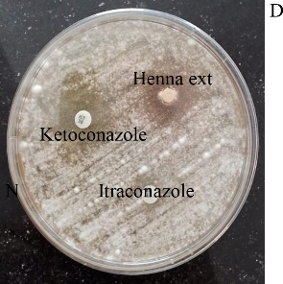
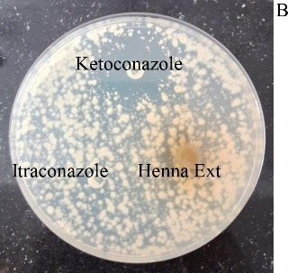
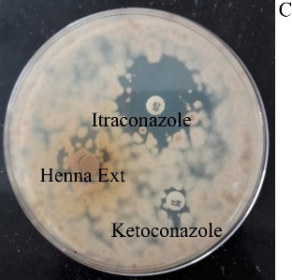
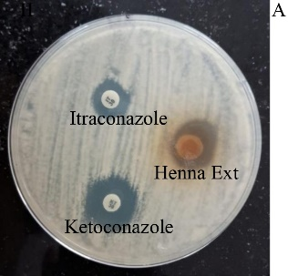
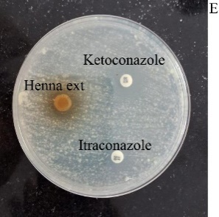
Fig 1: Showing zone of inhibition against different antifungal agents including leave extract of henna.A. Aspergillus spp. B. Curvularia spp C. Malasezzia spp D. Microsporum spp E. Penicillium spp.
as tinea capitis, alopecia and it is known to have antimicrobial properties, which is attributed to naphthoquinone including lawsone. Hasan et.al 2022 also reported the antifungal activity of henna leaves extract against candida. The absence of zone of inhibition in Henna leaf extract against Malasezzia spp and Curvularia spp may be due to insufficient concentration of antifungal component of extract and further research is required to explore the concentration- dependent antifungal activity of henna leaf extract.
Conclusion
In conclusion, this study highlights the promising antifungal activity of aqueous henna (Lawsonia inermis) leaf extract, showing comparable efficacy to ketoconazole and itraconazole against canine fungal pathogens. Henna extract demonstrated significant inhibition zones, particularly effective against Penicillium and Aspergillus species. These findings suggest that henna could serve as a viable alternative or supplementary treatment for fungal dermatitis in dogs. Further research should focus on optimizing formulation and concentration to enhance its therapeutic potential. Incorporating henna into veterinary dermatological practices may offer a natural, cost-effective, and potentially beneficial option in managing fungal infections in canine.

Disclaimer (Artificial intelligence)
Option 1: Not used
Author(s) hereby declare that NO generative AI technologies such as Large Language Models (ChatGPT, COPILOT, etc.) and text-to-image generators have been used during the writing or editing of this manuscript.
Option 2:
Author(s) hereby declare that generative AI technologies such as Large Language Models, etc. have been used during the writing or editing of manuscripts. This explanation will include the name, version, model, and source of the generative AI technology and as well as all input prompts provided to the generative AI technology
Details of the AI usage are given below:
1.
2.
3.

References
Bello R. Y. (2020). Antifungal Activity of Henna Leaves (Lawsonia inermis L.) against Trichophyton rubrum and Trichophyton interdigitale. I .J. of Res and Review.7:11.
Berenji F., Rakhshandeh H. and Ebrahimipour H. (2010). In vitro study of the effects of henna extracts (Lawsonia inermis) on Malassezia species. Jundishapur Journal of Microbiology. 3(3): 125-128.
Esteban A., Abarca M. L. and Cabanes F. J .( 2005). Comparison of disk diffusion method and broth microdilution method for antifungal susceptibility testing of dermatophytes. Med. Mycol. 43:61–66.
Hassan M, Fadayomi VK, Innocent IG, Suleiman M. (2022). Antifungal Effect of Henna (Lawsonia inermis) Extract on Pathogenic Fungi. Microbiol. Res. J. Int. Vol 32:15-26.
Kidd S., Halliday C., Alexiou H. and David Ellis D. (2016). Descriptions of Medical Fungi, Third Edition (revised November 2016), Australia.
Nawasrah A., Al-Nimr A and Aiman A. Ali. (2016). Antifungal Effect of Henna against Candida albicans Adhered to Acrylic Resin as a Possible Method for Prevention of Denture Stomatitis. Int. J. Environ. Res. Public Health. 13:520.
Rao N. B., Sita Kumari O. and Rajesh Goud G. (2016). Phytochemical analysis and antimicrobial activity of Lawsonia inermis (henna). J Plant Sci Res. 3(2):158.
Simpanya M. F. and Baxter M. (1996). Isolation of fungi from the pelage of cats and dogs using the hairbrush technique. Mycopathologia. 134:129-133.
Singh J., Zaman M. and Gupta A. K. (2007). Evaluation of microdilution and disk diffusion methods for antifungal susceptibility testing of dermatophytes. Med. Mycol. 45:595–602.
Uda M. N. A., Shaari N. H., Said N. S., Ibrahim N. H., Akhir M. A., Hashim M. K. R. and Gopinath S. C. (2018). Antimicrobial activity of plant extracts from aloe vera, citrus hystrix, sabah snake grass and zingiber officinale against pyricularia oryzae that causes rice blast disease in paddy plants. In IOP Conference Series: Materials Science and Engineering, 318(1):012009 IOP Publishing.

