Original Research Article
Exploring the Nutritional Significance of Kolakhar: An In-depth Analysis of a Traditional Assamese Culinary Ingredient

Abstract
Kolakhar is a traditional food ingredient used in different Assamese cuisine and mostly used as an antacid by different communities of Assam. A systematic investigation on chemical and spectroscopic estimation of Kolakhar produced from peels and rhizomes of four banana cultivars with different genomic groups viz. AAA (Amritsagar), AAB (Chenichampa), ABB (Kachkal) and BB (Bhimkal) was carried out to determine how genomic constituents of the cultivars have influence on the properties of Kolakhar. Chemical and mineral constituents of dried banana samples prepared from peels and rhizomes of the cultivars were also estimated during the course of study to identify the elements responsible for alkalinity in Kolakhar and to identify the changes in concentrations of the elements on burning. The results of the present findings revealed that Kolakhar contained considerable amounts of nutrient, anti-nutrient and mineral elements and these chemical constituents of Kolakhar varied among the cultivars. The four alkaline elements, i.e. calcium, carbonate, potassium and sodium contribute to the basic or alkalinity (higher pH) in Kolakhar. Suitability of the banana cultivars for Kolakhar preparation decreased with increase in the Musa acuminata (A) genomic character and with the increase of Musa balbisiana strains in banana cultivars, pH increases in Kolakhar. Kolakhar prepared from Bhimkal (BB) was found to be the best in quality among four selected cultivars based on mineral contents and pH.
Keywords: Kolakhar, Genomic constituents, Musa acuminata, Musa balbisiana, Food ingredient

INTRODUCTION
Kolakhar is an alkaline based delicacy, which is popular among different communities of Assam. The name “Kolakhar” has been derived from 'kol' means banana and 'khar' means alkali. It is an alkaline solution prepared from parts of banana cultivars. After consumption of the fruits, banana peels are typically discarded, and once the bunch is harvested, the banana plant becomes seemingly useless. However, in Assam India, people utilize banana peels and almost all the parts of the plant to prepare Kolakhar, a traditional alkaline food ingredient. This antacid is prepared by filtering water through the ashes obtained from different parts of a banana plant. With its distinct alkaline nature and historical significance, kolakhar plays a pivotal role in shaping the flavors of traditional dishes, adding a unique and irreplaceable touch to the Assamese cuisine. Khar plays a vital role as a seasoning in signature dishes of the region, lending its name to the entire dish itself. Khar, along with rice, is usually had as the first course in a traditional Assamese meal. It adds a delightful piquancy to the dish and has a very distinctive flavour. Although raw khar has a mildly bitter taste on its own, it mixes well with other ingredients and improves the flavor of vegetables or dishes it is cooked with (Borah et al., 2025). Due to its digestive properties, Khar is hailed as the ultimate palate cleanser.
Beyond its culinary significance, Khar also possesses medicinal and therapeutic properties. In fact, several modern studies have established its antioxidant and anti-microbial benefits. In the past, Khar was used as a shampooing agent to wash hair and also as a detergent for washing clothes (Kalita, 2022). When added to mustard oil and garlic, it becomes a potion to treat common cold. Khar is also believed to be beneficial for people suffering from high blood pressure and heart disease. A certain study also reported that Khar is helpful in treating fertility-related conditions in men (Anon., 2018). Khar's significance extends beyond the kitchen and the household. Khar has also been traditionally used as a pesticide in farming in the region. It is believed to contribute to balancing the acidic levels in the soil. Use of Kolakhar to kill leeches (ITK) while working in leech infected field can be considered as one of the popular ITK followed by the farmers in North-East India. Use of Kolakhar as a substitute of salt was also reported earlier. Khar is like a superhero ingredient in Assamese life: adding flavour to dishes, boosting gut health, fighting off diseases, and even protecting crops.
But majority of the people are not aware about the nutrient contents of Kolakhar prepared from different banana cultivars. Though chemical analysis of Kolakhar prepared from some prominent cultivars have been done earlier, but a systematic study on influence of genomic constituents of banana cultivars on properties of Kolakhar has not yet taken up. Keeping in view of the existing situation, an attempt has been made to study the chemical and spectroscopic estimation of Kolakhar produced from peels and rhizomes of four banana cultivars viz., Amritsagar (AAA), Chenichampa (AAB), Kachkal (ABB) and Bhimkal (BB) with the objectives to estimate the chemical and mineral constituents of Kolakhar produced from rhizomes and peels of different banana cultivars and to identify the cultivar suitable for preparation of Kolakhar.

MATERIALS AND METHODS
The experiment was conducted during 2010-2022 in the laboratory, Department of Horticulture, Biswanath College of Agriculture, Assam Agricultural University, Biswanath Chariali. The experiment was set up as a factorial completely randomised design with three replications. Peels of Amritsagar, Chenichampa and Bhimkal were collected at the ripe stages of the fruits and peels of Kachkal (culinary type) were collected at fully mature green stage of the fruits. Rhizomes were collected after harvesting of the bunch from the field.
Along with Kolakhar, chemical and mineral constituents of dried banana samples prepared from peels and rhizomes of the cultivars were also estimated during the course of study. For the dried samples, half of the dried rhizome slices and dried peels from each cultivar were separately grinded into powder with the help of an electric grinder. The ground materials were then sieved with the help of a 0.5 mm sieve (Fig. 1-Fig. 4). The dried powdered samples were then packed in plastic containers for further analysis. The left half of the dried rhizome slices and peels were burnt into ashes in a clean tray. The ashes thus produced were sieved with the help of a 0.5 mm sieve (Fig. 5-Fig. 8). The ash samples were then packed separately cultivar wise in different containers for further analysis.
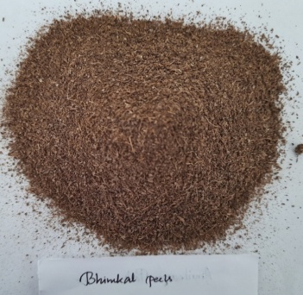
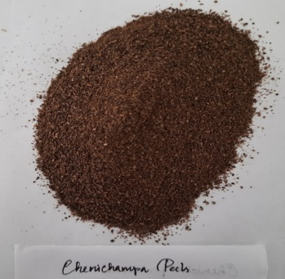
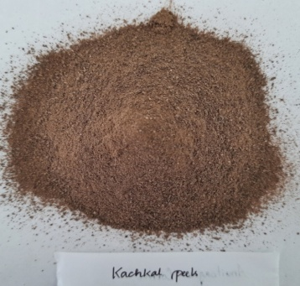
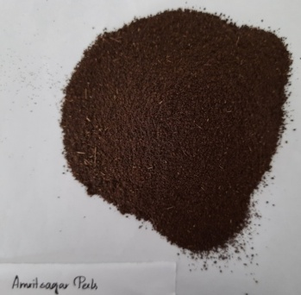
Fig 2 : Dried samples of Chenichampa peels

Fig 4 : Dried samples of Bhimkal peels
Fig 3 : Dried samples of Kachkal peels
Fig 1 : Dried samples
of Amritsagar peels

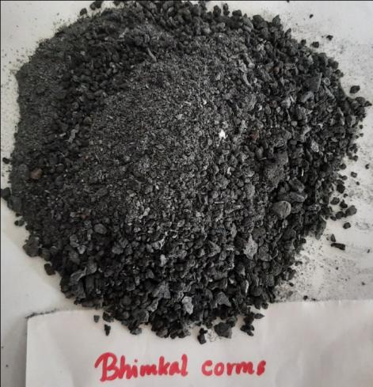
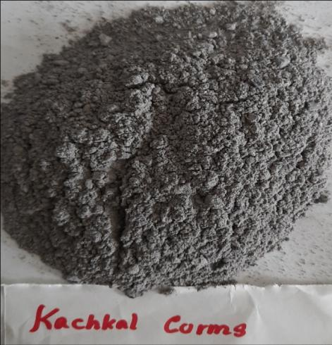
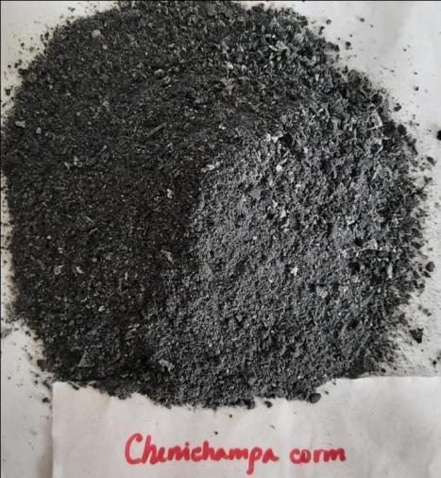
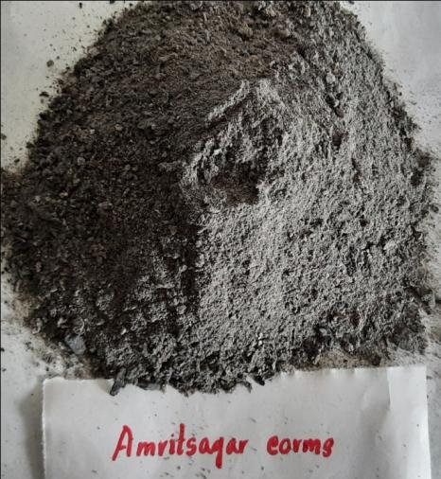
Fig 8 : Bhimkal rhizome ash
Fig 7 : Kachkal rhizome ash
Fig 6 : Chenichampa rhizome ash
Fig 5 : Amritsagar rhizome ash

pH of the ash and grinded samples of banana peels and rhizomes
Ten gram (10 g), twenty gram (20 g) and thirty gram (30 g) of ash or grinded sample was soaked in 100 ml water to make 10 per cent, 20 per cent and 30 per cent Kolakhar solution, respectively and kept overnight to determine the pH of the solution. The pH metre was calibrated using a pH 4 buffer solution. Then the electrodes were dipped in the sample solution and the pH value was recorded along with room temperature (Saini et al., 2012).
Chemical and spectroscopic estimation
Total carbohydrate was determined by using Anthrone method given by Hedge and Hofreiter (1962). The saponin content of the sample was determined by double extraction gravimetric method described by Harborne (1973).
For estimation of calcium (Ca), first 1 g sample was digested by following wet ashing method (Saini et al., 2012). Then 5 ml of 10% NaOH solution and 50 mg of murexide indicator was added to 5 ml of aliquot and titrated with 0.01N EDTA solutions till the color changes from pink to purple. A blank was also run similarly. Then Ca was calculated by the following formula.
Meq. of Ca/100 g of sample = (0.01 x V₂) x (V/V₁) x (100/1)
Where, V = Volume of the plant digest made
V₁ = Volume of the aliquot taken for analysis
V₂ = Volume of EDTA solution in titration (Titre value)
The concentrations of K and Na in the extracts were calculated as per the formula of Ward and Johnson (1962). Carbonate content was determined with the help of the formula given by Clesceri et al. (1989).
Statistical analysis
Observations recorded during the experiment were subjected to the statistical analysis of variance (ANOVA) by factorial Completely Randomized Design (CRD). Significance and non-significance of the variance due to different cultivars and different parts were determined by calculating the respective ‘F’ value as the method described by Panse and Sukhatme (1985). Graphs were prepared using Microsoft Excel (MS Office ver. 2007).
RESULTS AND DISCUSSIONS
It was noted that average pH of the dried and ash (Kolakhar) samples prepared from peels and rhizomes of different cultivars increased with increase in concentrations of solutions from 10 per cent to 30 per cent. Among the cultivars, dried and ash samples of Bhimkal recorded the highest pH in all the three concentrations which differed significantly from the other three cultivars. Kolakhar prepared from Chenichampa (V₂) recorded the lowest pH in all the three concentrations of solutions (Fig. 9). Increase in pH in the Kolakhar (ash) samples of all the banana cultivars as compared to the dried powdered samples might be due to increase in production of alkali elements after burning of samples. Bora et al. (2019) justified earlier that pH increased with increase in ash concentration (g/litre) due to the formation of hydroxides, carbonates of alkali and alkaline earth metals and stabilized at a certain level. This might be the reason of increased pH with increase in concentration of the prepared Kolakhar solutions in the present study. Hazarika and Nath (1992) also observed higher pH in Kolakhar prepared from Bhimkal followed by Kachkal and remarked that variation in pH of Kolakhar prepared from different cultivars was due to varietal character and genomic constituents of cultivars.

Fig. 9 : pH of dried and ash samples
27
Carbohydrate contents of dried banana samples varied according to the cultivars and parts used (Table 1). Dried samples prepared from each of the selected cultivar were found to be significantly different in their carbohydrate contents with the cultivar Kachkal (V₃) recorded the highest (117.25 g/kg) Comparatively, ash samples prepared from banana peels (S₁) noted significantly higher Carbohydrate contents (52.89 g/kg) than of rhizomes (S₂, 34.98 g/kg) in all the four cultivars (Table 1). The inspection of data of all the prepared ash samples revealed that the significantly highest Carbohydrate content (72.43 g/kg) was recorded in peels of Kachkal (S₁V₃). The higher carbohydrate content in ashes of Kachkal peel might be due to the presence of higher carbohydrate in fruits of Kachkal. The values of saponin contents ranged from 8.00 g/kg in dried peels of Chenichampa (S₁V₂) to 22.00 g/kg in dried rhizomes of Amritsagar (S₂V₁). Significant variations were found in saponin contents of ashes of peels and the rhizomes of the four cultivars (Table 2). The highest saponin was recorded as 16.80 g/kg in ashes of rhizomes of Bhimkal, which differed significantly from the rest of the cultivars. The lowest saponin was recorded in ashes of peels of Chenichampa (2.60 g/kg). The ash samples were found to contain carbohydrate and saponin in lesser amounts as compared to the dried samples and it might be due to the fact that these compounds might have broken down to some simpler compounds or might have lost to the environment on burning.
Table 1: Carbohydrate contents of dried and ash samples of peel and rhizomes of different cultivars of banana
Cultivars | Carbohydrate content (g/kg) of dried samples |  |  | Carbohydrate content (g/kg) of ash samples
Cultivars | Peel  (S₁) | Rhizome  (S₂) | Mean  (V) | Peel  (S₁) | Rhizome (S₂) | Mean  (V)
V₁: Amritsagar (AAA) | 106.01 | 54.62 | 80.32 | 41.59 | 30.49 | 36.04
V₂: Chenichampa (AAB) | 88.49 | 47.29 | 67.89 | 39.26 | 15.04 | 27.15
V₃: Kachkal (ABB) | 119.08 | 115.42 | 117.25 | 72.43 | 48.24 | 60.34
V₄: Bhimkal (BB) | 109.84 | 74.86 | 92.35 | 58.27 | 46.15 | 52.21
Mean (S) | 105.86 | 73.05 |  | 52.89 | 34.98
CD (P=0.05) | S = 2.25 V = 3.19 S x V = 4.51 |  |  | S = 0.96 V = 1.35 S x V = 1.91

Table 2: Saponin contents of dried and ash samples of peel and rhizome of different cultivars of banana
Cultivars | Saponin content (g/kg) of dried samples |  |  | Saponin content (g/kg) of ash samples
Cultivars | Peel  (S₁) | Rhizome  (S₂) | Mean  (V) | Peel  (S₁) | Rhizome (S₂) | Mean  (V)
V₁: Amritsagar (AAA) | 16.00 | 18.80 | 17.40 | 4.60 | 11.20 | 7.90
V₂: Chenichampa (AAB) | 8.00 | 9.60 | 8.80 | 2.60 | 6.60 | 4.60
V₃: Kachkal (ABB) | 15.60 | 16.00 | 15.80 | 3.40 | 7.60 | 5.50
V₄: Bhimkal  (BB) | 16.00 | 22.00 | 19.00 | 7.00 | 16.80 | 11.90
Mean (S) | 13.90 | 16.60 |  | 4.40 | 10.55
CD (P=0.05) | S = N.S. V = 6.85 S x V = N.S. |  |  | S = 1.15 V = 1.62 S x V = 2.30

Among all the dried samples, the highest calcium content 1.20 g/kg was recorded in both peels and rhizomes of Bhimkal (S₁V₄ and S₂V₄). No significant variation was observed between calcium contents of ashes of peels (2.61 g/kg) and rhizomes (2.81 g/kg) of Bhimkal (V₄). Among all the ash samples prepared, the highest calcium content was found as 2.81 g/kg, recorded in rhizomes of Bhimkal (S₂V₄) (Table 3). It is learnt that rhizomes of banana is considered as store house of different nutrients and the increase in calcium in rhizomes of banana as compared to peels might be due to the storage of calcium in rhizomes for further growth of the plants. Higher content of calcium in banana rhizomes was also reported earlier by Hassan et al. (2018). Calcium content recorded in ash samples prepared from Chenichampa peels was in accordance with the findings of Borah et al. (2019). The highest sodium (1.93 g/kg) was noted in dried rhizomes of Bhimkal (S₂V₄) and was at par with 1.86 g/kg in dried rhizomes of Kachkal (S₂V₃). Significantly lowest sodium 0.34 g/kg was recorded in the dried peels of Amritsagar (S₁V₁). There was no significant difference of sodium contents in the ashes of peels of all the four cultivars under the study and ashes of Bhimkal rhizomes (S₂V₄) recorded the highest (1.64 g/kg) sodium content. Sodium contents of dried Kachkal and Bhimkal peels were in the range reported by Hassan et al. (2018). Significantly highest carbonate content was found in dried rhizomes of Bhimkal (0.96 g/kg) (Table 4). Ashes of Bhimkal recorded the highest carbonate content (19.68 g/kg) and differed significantly from all other cultivars (Table 5). Among the four cultivars, dried samples of Bhimkal (V₄) recorded the highest potassium (38.72 g/kg). Again, Bhimkal recorded higher potassium content in ashes of both peels (81.42 g/kg) and rhizomes (49.38 g/kg) while Amritsagar recorded the lowest potassium content in ashes of both peels (49.18 g/kg) and rhizomes (15.23 g/kg) (Table 6). These alkali elements play an important role in determining pH of the dried banana samples. All the four alkali elements (Calcium, Sodium, Carbonate and Potassium) in the dried samples recorded in the order of potassium>sodium>calcium>carbonate. Decrease in carbonate, potassium and sodium contents were observed with decrease in Musa balbisiana strain and increase in Musa acuminata strain in the dried samples of the four cultivars under the study. It might be remarked that presence of different levels of these alkali elements in peels and rhizomes of banana depends on genomic constituents of the cultivars.
Table 3: Calcium contents of dried and ash samples of peels and rhizomes of different cultivars of banana
Cultivars | Calcium content (g/kg) of dried samples |  |  | Calcium content (g/kg) of ash samples
Cultivars | Peel  (S₁) | Rhizome  (S₂) | Mean  (V) | Peel  (S₁) | Rhizome (S₂) | Mean  (V)
V₁: Amritsagar (AAA) | 0.60 | 1.00 | 0.80 | 1.80 | 1.33 | 1.57
V₂: Chenichampa (AAB) | 0.30 | 0.60 | 0.45 | 1.34 | 0.80 | 1.07
V₃: Kachkal (ABB) | 0.93 | 1.10 | 1.02 | 1.57 | 2.61 | 2.09
V₄: Bhimkal (BB) | 1.20 | 1.20 | 1.20 | 2.61 | 2.81 | 2.71
Mean (S) | 0.76 | 0.98 |  | 1.83 | 1.89
CD (P=0.05) | S = 0.21 V = 0.29 S x V = 0.41 |  |  | S = 0.60 V = 0.85 S x V = 1.20

Table 4: Sodium contents of dried and ash samples of peels and rhizomes of different cultivars of banana
Cultivars | Sodium content (g/kg) of dried samples |  |  | Sodium content (g/kg) of ash samples
Cultivars | Peel  (S₁) | Rhizome  (S₂) | Mean  (V) | Peel  (S₁) | Rhizome (S₂) | Mean  (V)
V₁: Amritsagar (AAA) | 0.34 | 0.43 | 0.39 | 0.25 | 1.02 | 0.64
V₂: Chenichampa (AAB) | 0.38 | 1.21 | 0.80 | 0.26 | 1.47 | 0.87
V₃: Kachkal (ABB) | 0.88 | 1.86 | 1.37 | 0.30 | 1.53 | 0.92
V₄: Bhimkal (BB) | 1.08 | 1.93 | 1.51 | 0.34 | 1.64 | 0.99
Mean (S) | 0.67 | 1.36 |  | 0.29 | 1.42
CD (P=0.05) | S = 0.10 V = 0.14 S x V = 0.20 |  |  | S = 0.14 V = 0.20 S x V = 0.28

Table 5: Carbonate contents of dried and ash samples of peels and rhizomes of different cultivars of banana
Cultivars | Carbonate content (g/kg) of dried samples |  |  | Carbonate content (g/kg) of ash samples
Cultivars | Peel  (S₁) | Rhizome  (S₂) | Mean  (V) | Peel  (S₁) | Rhizome  (S₂) | Mean  (V)
V₁: Amritsagar (AAA) | 0.36 | 0.18 | 0.27 | 2.40 | 11.36 | 6.88
V₂: Chenichampa (AAB) | 0.40 | 0.32 | 0.36 | 4.32 | 13.48 | 8.90
V₃: Kachkal (ABB) | 0.60 | 0.84 | 0.72 | 7.92 | 16.20 | 12.60
V₄: Bhimkal (BB) | 0.84 | 0.96 | 0.90 | 17.04 | 22.32 | 19.68
Mean (S) | 0.55 | 0.58 |  | 7.92 | 15.84
CD (P=0.05) | S = N.S. V = 0.26 S x V = 0.37 |  |  | S = 0.56 V = 0.79 S x V = 1.12

Table 6: Potassium contents of dried and ash samples of peels and rhizomes of different cultivars of banana
Cultivars | Potassium content (g/kg) of dried samples |  |  | Potassium content (g/kg) of ash samples
Cultivars | Peel  (S₁) | Rhizome  (S₂) | Mean  (V) | Peel  (S₁) | Rhizome (S₂) | Mean  (V)
V₁: Amritsagar (AAA) | 13.56 | 13.30 | 13.43 | 49.18 | 15.23 | 32.20
V₂: Chenichampa (AAB) | 22.58 | 13.98 | 18.28 | 64.56 | 15.14 | 39.85
V₃: Kachkal (ABB) | 29.24 | 15.39 | 22.32 | 57.16 | 35.73 | 46.45
V₄: Bhimkal (BB) | 43.20 | 34.23 | 38.72 | 81.42 | 49.38 | 65.40
Mean (S) | 27.15 | 19.23 |  | 63.08 | 28.87
CD (P=0.05) | S = 0.52 V = 0.74 S x V = 1.05 |  |  | S = 0.46 V = 0.65 S x V = 0.92

CONCLUSION
Kolakhar contained considerable amounts of nutrients, anti-nutrient and mineral elements and these chemical constituents of Kolakhar varied among the cultivars. All the four alkaline elements, i.e. calcium, carbonate, potassium and sodium contribute to the alkaline pH of Kolakhar. The concentrations of the alkali elements recorded in the order of potassium>carbonate>sodium>calcium. The prevailing alkalinity observed in Kolakhar is primarily attributed to the presence of potassium carbonate. Suitability of the banana cultivars for Kolakhar preparation decreased with increase in the Musa acuminata (A) genomic character and decrease in the Musa balbisiana (B) genomic character. Kolakhar prepared from Bhimkal (BB) was found to be the best in quality among the four selected cultivars based on mineral contents and pH. Suitability of genomic groups for Kolakhar preparation can be ordered as Bhimkal(BB) > Kachkal(ABB) > Chenichampa(AAB) > Amritsagar(AAA).

Disclaimer (Artificial intelligence)
Authors hereby declare that NO generative AI technologies such as Large Language Models (ChatGPT, COPILOT, etc.) and text-to-image generators have been used during the writing or editing of this manuscript.
REFERENCE
A.O.A.C. (1980) Official Methods of Analysis. 13th Edn. Washington, D.C.
Bora, D.; Barbora, L. and Mahanta, P. (2019) An Assessment of Natural Base Solution Prepared from different Parts of Musa sp. as a Scrubbing Agent of CO₂ from Biogas, Journal of Basic and Applied Engineering Research; 6(1):1-4
Bora, S. S., Hazarika, D. J., Dullah, S., Sharma, D., Gogoi, R., Baruah, M., Sarmah, U., & Barooah, M. (2025). Traditional alkaline condiment ‘Kolakhar’ improves protein digestibility and nutrient availability in black gram (Vigna mungo L.). Journal of Food Measurement & Characterization. https://doi.org/10.1007/s11694-025-03136-6
Clesceri, L. S.; Greenberg, A. E. and Trussel, R. R. (1989). Standard method for the examination of water and waste water, 17th edn., American Public Health Association, Washington DC
Deka, D. C. and Talukdar, N. N. (2007) Chemical and Spectroscopic Investigation of Kolakhar and Its Commercial Importance, Indian Journal of Traditional Knowledge, 6(1):72-78
Harborne, J. B. (1973). PHytochemical methods, 1st edn., Chapman and Hall, London, p. 273
Hassan, P. and Peh, K. K. (2018) Chemical Compositions of Banana Peels (Musa sapientum) Fruits cultivated in Malaysia using proximate analysis, Research Journal of Chemistry and Environment; 22(2):108-113
Hazarika, D. N. and Nath, J. C. (1992) Comparative studies of pH content of banana corm ash, Banana Newsletter, 15: 5
Hedge, J. E. and Hofreiter, B. T. (1962) In: Carbohydrate chemistry 17. Whistler, R. L. and Be Miller, J. N., Eds., Academic Press, New York
Kalita, P. (2022). Kolakhar- Not just a food additive of Assam, India: An introduction and its pharmacological properties. In Medicinal & Aromatic Plants: Discoveries & Development in North East India (1st ed., Vol. 1, pp. 167–176). National Press Associate.
Mohd, D. Z.; Mujianto, L.; Azhar, A., Masaudin, S. and Samsudin, R. (2021) Physicochemical properties of banana peel powder in functional food products, Food Research; 5(1):209-215
Mondal, N. K. and Roy, A. (2018) Potentiality of a fruit peel (banana peel) toward abatement of fluoride from synthetic and underground water samples collected from fluoride affected villages of Birbhum district, Applied Water Science https://doi.org/10.1007/s13201-018-0729-3
Panse, V. G. and Sukhtme, P. V. (1985) Statistical Methods for Agricultural Workers, ICAR, New Delhi
Saini, R. S.; Sharma, K. D.; Dhankhar, O. P. and Kaushik, R. A. (2012) Laboratory manual of analytical techniques in horticulture, Agrobios, pp.33
Ward, G. M. and Johnson, F. B. (1962) Chemical methods of plant analysis, Canada Dept. of Agriculture Publication; 19-20

