Review Article

New Developments in Veterinary Vaccines

ABSTRACT
Over the past century, conventional vaccination technologies such as inactivated and attenuated live vaccines have saved millions of lives. Traditional vaccine techniques have disadvantages for responding to emergent viruses with pandemic potential, including suboptimal effectiveness, high costs, and limited scale-up production. Despite tremendous progress in research and development of vaccine, human vaccination science was arguably held at a standstill prior to the pandemic, with few novel vaccine strategies being approved. However, the research and marketing of innovative vaccine technologies might flourish in the veterinary field. Direct assessment of vaccination effectiveness in target species takes advantage of the increased interest in companion animal and cattle health, which propels veterinary vaccine development and innovation. The goal of this study is to draw attention to the latest advancements in veterinary vaccine research and to novel vaccine technologies that are being investigated and used to enhance animal health.
Keywords: Vaccine, new vaccine technologies, infectious diseases, animal health, immunity
- INTRODUCTION
Vaccinations are a highly significant way of preventing a wide variety of animal diseases. Vaccinology has produced a number of potent vaccines that have significantly lowered the prevalence of a number of serious diseases in livestock and companion animals. From Edward Jenner and Louis Pasteur in the eighteenth and nineteenth centuries to the elimination of rinderpest in cattle and smallpox in human populations by the twentieth century, vaccinations have played a key role in the survival, health, and overall well-being of humans and animals [1]. Veterinary vaccine serves a variety of purposes. It offers cost-effective infectious disease control and prevention, enhances animal wellbeing, and reduces food animal production expenses [2]. Smallpox, rinderpest, and other economically and zoonotically major infectious diseases that have been eradicated, demonstrating that vaccination is the most viable and cost-effective technique for preventing, controlling, and eradicating infectious disease [3].
Nowadays, live attenuated, cell membrane compounds, killed/inactivated microorganisms, or toxoids constitute the vast majority of certified veterinary vaccine [4]. Aida et al., [5] analysed commercially available new vaccine technologies for animal health, including recombinant protein/subunit vaccines, DNA constructs, viral vector technologies, and DIVA vaccines. Viral vector technologies accounted for 52% of licensed new vaccines for animal health, with subunit-recombinant protein vaccines ranking second. traditional vaccines that are inactivated and modified-live (IV and MLV), called as first-generation vaccine, provide people and animals with protection against pathogens. Because of the success shown in the animal sectors, these vaccines have also had an economic impact.
Live attenuated vaccines elicit humoral and cell mediated immune responses, they can be highly effective. However, the possibility of the microorganism reverting to a virulent state is a significant concern associated with vaccines of this nature. Compared to attenuated vaccines, killed or inactivated vaccines may be less efficacious, but they are usually safer [6]. Because they need complex elements in the culture medium, the commercial vaccines based on toxoids (inactivated toxins) have certain disadvantages. Vaccines should be safer and more effective that can prevent, control, or eradicate animal diseases because of the drawbacks of the three conventional vaccine types and the fact that many diseases have not yet been effectively treated by an effective vaccine [7].
Singh et al., [8] revealed that inactivated and attenuated live vaccines, which are first-generation vaccination technologies, are frequently reported to be less successful in providing adequate protection against a variety of diseases, such as porcine epidemic diarrhoea virus (PEDV), a swine enteric coronavirus. Developed a novel PEDV vaccine by combining components of attenuated live and inactivated vaccines to create an immunogenic construct that exhibits reduced but not eliminated viral replication, which is necessary to elicit mucosal immunity and defense against PEDV. The safety and production cost issues of first-generation vaccinations are appealingly replaced by second and third-generation vaccine technologies. subunit and recombinant protein vaccines that elicit antigen-specific immune response are the examples of second-generation vaccines [9].
Recombinant vaccines offer a promising solution to address the limitations of traditional vaccines. Several well-designed subunit vaccines have already entered the veterinary market. Global efforts are underway to produce vaccines using recombinant DNA technology for many diseases [10]. Recombinant vaccines are created using logically constructed, highly purified recombinant antigens by structure-based design, epitope-focused design, or genomic-based screening [11]. Molecular approaches have improved understanding of virulence genes and protective immune responses, leading to the development of novel vaccines for infectious, parasitic, and metabolic diseases. Recombinant vaccines can be less effective at triggering an immune response, so they often require adjuvants to enhance their effectiveness. Recombinant antigens often lack exogenous immune activating components, resulting in reduced immunogenicity. The immunomodulatory effects of recombinant antigens vary depending on the adjuvant utilized and the specific antigens [12].
Third-generation vaccines can be gene-based (DNA and RNA), viral-vector platforms, or live or inactivated chimera vaccines. DNA and RNA-based vaccines are a novel technique to vaccination, utilizing plasmid DNA administered through injection.
Molecular biology developments have made it possible for control polynucleotides, offering alternatives to conventional vaccines [13]. DNA vaccines contain a plasmid that encodes the intended antigen(s). After being implanted into host cells, the DNA-encoded antigens trigger an immunological response. DNA vaccines offer advantages such as safe administration to immunocompromised individuals, the ability to combine numerous plasmids for a broad-spectrum vaccine, and ease of engineering compared to traditional vaccines DNA vaccines provide multiple benefits, including eliciting humoral and cell-mediated responses and acting like pathogen-associated molecular patterns (PAMPs), reducing the need for adjuvants [14].
Aida et al., [5] provided an overview of veterinary vaccine technologies and discussed commercially available vaccination technologies for animal health, such as recombinant protein/subunit, viral vector technologies, DNA constructs and DIVA (Differentiating Infected from Vaccinated Animals) vaccines. According to this survey, viral vector technologies account for 52% of licensed advanced vaccines in animal health, with subunit recombinant protein vaccines accounting for 27%. Scientists are increasingly focusing on novel vaccine approaches for a variety of reasons, including protective efficacy, cost-effectiveness, and If the infectious agent can be created in vitro. Split-product, subunit, live vector. peptide, marker vaccine, and nucleic acid approaches are some of the vaccine technologies [15].

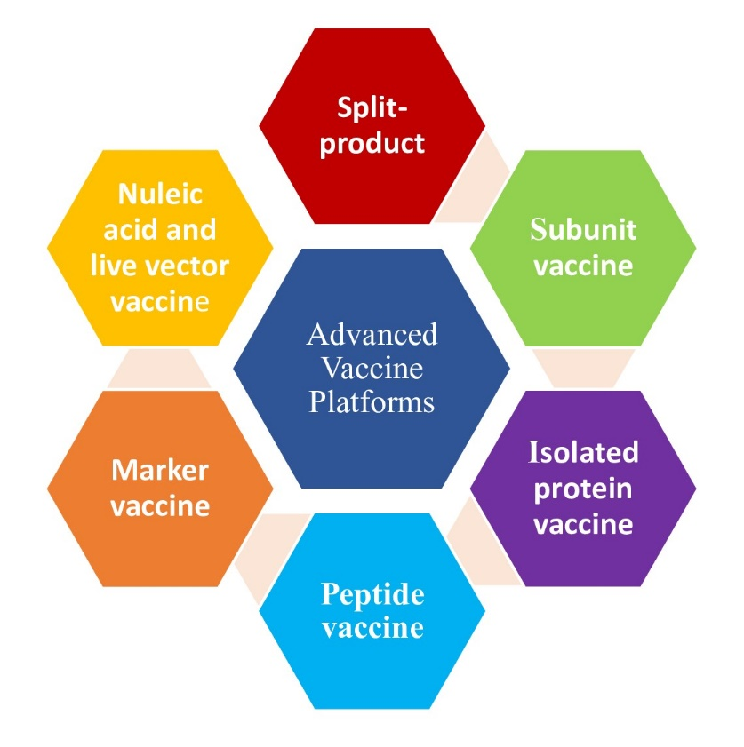

Fig. 1. Types of novel vaccine technologies

- BIOTECHNOLOGY USED TO GENERATE NEXT-GENERATION VACCINES
The direct change of an organism's genome by biotechnology is known as "genetic engineering”. Recent advances in genetics, molecular biology, immunology, microbiology, and knowledge of microbial pathogenesis have led to the development of numerous new approaches to develop safer and more efficient vaccines, some of which are marker vaccines with potential applications in DIVA diagnostics [16]. By first extracting and replicating the desired genetic material using molecular cloning procedures to create a DNA sequence, new DNA can be inserted into the host genome [17]. The focus of genomics in vaccine development has shifted in response to sequencing techniques. High-throughput in silico screening is used by researchers to identify a pathogen's whole genome to identify genes encoding proteins with characteristics of immunogenic vaccine targets [18]. Foreign protein expression vectors such as yeast, E. coli, insect, or mammalian cells are used to express the genes. Aside from limitations in terms of yield, posttranslational modification, and folding of produced recombinant proteins, Escherichia coli is the most widely used vector for protein expression as a heterologous host. Purified proteins are subsequently administered to the host in order to develop immunity. Low immunogenicity of a subunit vaccine can be resolved with a specific adjuvant [19].
The drawbacks of conventional vaccines can be mitigated by genetically modified vaccines. These Vaccines are safe to administer, affordable, and do not replicate. Additionally, they are free of any adverse effects caused by unwanted antigenic components. Mutations can be selectively incorporated into the genome of an attenuated vaccine to make it non-pathogenic but immunogenic [20]. Modern molecular approaches enable the development of improved vaccines by using live vectors or modified plasmids to deliver antigen-encoding genes, expressing antigens directly in the vaccine recipient and employing prime-boost techniques, which combine different antigen delivery methods to broaden the immune response. These approaches aim to enhance vaccine effectiveness and provide comprehensive protection [21].
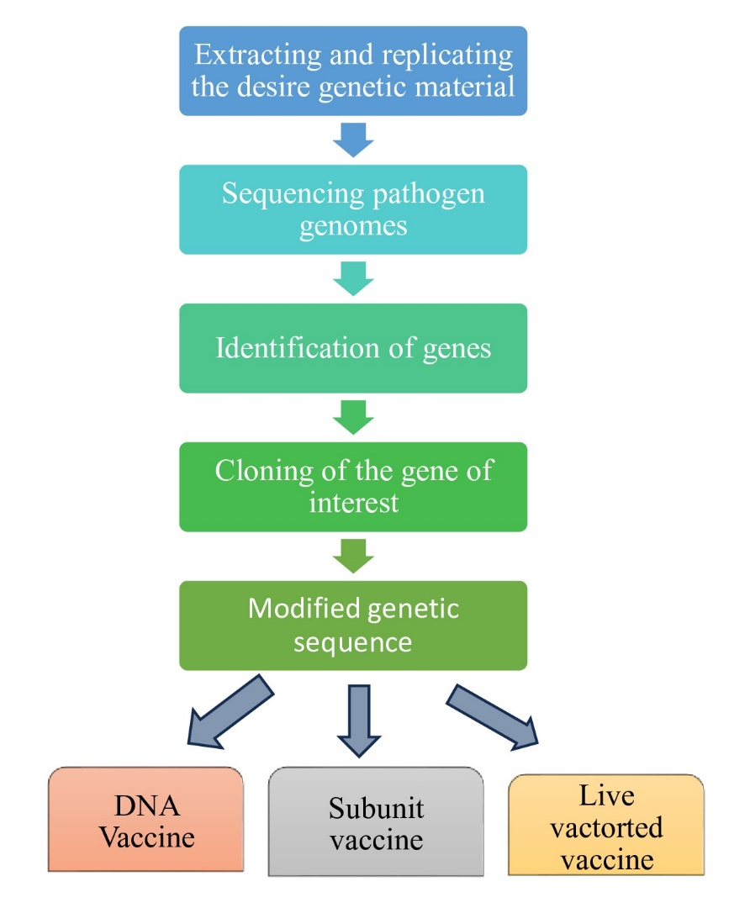

Fig. 2. Biotechnology used to generate vaccine
- ADVANCED VACCINE TECHNOLOGIES
3.1 Split-Product and Subunit Vaccines
To trigger the intended protective immune response, Natural split-product and subunit vaccines must be administered to the target animals by finding appropriate subunit, protein, or peptide antigens as vaccination candidates. The simplest and most fundamental subunit vaccine type is one in which the infectious agent has been deconstructed or broken down into its constituent parts [22]. Current influenza vaccines, known as split-product vaccines, are made from inactivated viruses that have been broken down to release their internal proteins (nuclear and matrix proteins) and surface proteins (envelope proteins). This process involves treating the viruses with formalin to inactivate them and then disrupting the viral membrane. Another improvement has been to reduce the likelihood of serious side effects by using the purified envelope glycoproteins hemagglutinin and neuraminidase alone in a subunit vaccination. Regretfully, split-product and subunit influenza vaccines have shown lower immunogenicity than whole viral products. Efforts to tackle this issue have focused on altering antigen presentation through the delivery of viral glycoproteins within lipid vesicles, which can be made up of either nonviral lipids (liposomes) or virus-derived lipids (virosomes) [15]. Artificial "empty" viruses can be created to improve immunogenicity. Polymeric preparations of isolated proteins in the form of micelles are also more immunogenic than protein monomers. These multimeric presentation systems are commonly referred to as virus-like particles (VLPs) [23].
The immunostimulating complex (ISCOM) is one of the developments that combines polymeric presentation with adjuvant activity to enhance immunogenicity. The first commercial veterinary use of this technology was for equine influenza, and vaccines have been tested for mucosal delivery. Currently, there are also split product and cell culture subunit vaccine available for the feline leukaemia virus (FeLV) disease [24].
Many current bacterial vaccines target specific pilus or toxin components. Veterinary viral vaccines also utilize similar approaches. Antipilus antibodies will stop colonization by blocking adhesion, whereas antitoxin antibodies will counteract the negative actions of the bacterial infection. The enterotoxigenic E. coli (ETEC) fimbrial adhesion antigens F4 (K88), F5 (K99), F6 (987P), F7 (F41), and F18 are excellent examples. These antigens are used in current vaccines to prevent neonatal diarrhoea in pigs and calves. Recombinant DNA technology was likely first used to develop better commercial vaccine using E. Coli strains that were designed to overproduction of these antigens [15].
3.2 Recombinant Subunit and Protein Vaccines
Subunit vaccines use pathogen-specific proteins that are non-infectious and cannot multiply within the host. Recombinant vaccines can be given safely and without replication due to protective antigens. Vaccines made with overexpressed proteins extracted from genetically engineered E. coli bridge the gap between vaccines produced using recombinant DNA technology and those generated using natural subunits. Although subunit vaccines derived from naturally occurring infectious pathogens continue to play an essential role, the expense of manufacturing and purifying immunogens can be prohibitive. Indeed, after the immunogenic proteins have been identified, it is the goal of many researchers to synthesize vast quantities of those proteins in a sufficiently pure form to make safe and efficacious vaccines. With the innovation of recombinant DNA technology, foreign genes might be placed into expression vectors and then injected into cells that operate as "production factories" for the foreign proteins encoded by those genes Inverse vaccinology is a potential approach for discovering recombinant vaccines for viral and parasite infections. Stronger, safer, and more precisely specified vaccines that can combine many antigens to provide protection against different disease strains are obviously needed [19].
Genes that code for protein antigens can be readily cloned into a variety of species. Live recombinant vaccines are live viral or bacterial vector that has undergone genetic modification to express a variety of foreign antigens in the target cells' cytoplasm. The recombinant organism can be used itself as a vaccine [16].
E. coli bacteria played a crucial role in developing the first recombinant expression system. This was the natural choice because it had been utilized to build the early principles and understanding of molecular biology. Cloning the gene that encodes for an antigen can improve its characterization and production. E. coli is commonly used for heterologous protein expression, although it has limitations in terms of yield, folding, and posttranslational modifications [25]. Pichia pastoris, a methylotrophic yeast, is an alternate host for E. coli. For the heterologous manufacture of recombinant proteins, this yeast strain has become a potent and affordable expression system that enables genetic changes, secretes expressed proteins, permits posttranslational modifications, and yield a high quantity. The p45 protein is a glycoprotein on the gp70 surface of FeLV synthesized in E. coli, was among the first successfully created recombinant veterinary vaccine [26].
Adenoviruses, poxviruses and herpesviruses are the most commonly employed viruses for developing live recombinant vaccines. Poxviruses like fowl pox, vaccinia, and canarypox are commonly used to develop live recombinant vaccines because of their vast and stable genomes, making it relatively easy to introduce new genes. Poxviruses have the capacity to carry a lot of foreign genes and infect mammalian cells, which causes a lot of encoded protein to be expressed. Many veterinary vaccines, such as those against West Nile virus (WNV), canine distemper virus, feline leukemia virus, rabies virus, and equine influenza virus, are currently based on the canarypox viral vector system. Salmonella, Mycobacterium Bovis, and Bacillus Calmette-Guérin (BCG) are examples of bacterial vectors that must produce an effective immune response by expressing a large number of antigens. Solid immunity can be induced by recombinant BCG, which has the potential to express a wide variety of heterologous antigens [21].
3.3 Peptide Vaccines
Defined peptides, which were attached in an unregulated manner to huge undefined carrier proteins, generated antipeptide antibodies that completely failed to identify the original protein [27]. Researchers have identified and sequenced immunogenic regions on infectious agents, which can be replicated using short chains of amino acids (peptides). The first evidence was demonstrated in 1963 where peptides showed vaccine potential against tobacco mosaic virus followed by 1982 where peptides demonstrated immunity against foot and mouth disease virus (FMDV) in laboratory and animal studies. These findings paved the way for peptide-based vaccine development. [28].
Peptide vaccines represent an interesting innovation in veterinary medicine. These vaccines trigger the animal's immune system by delivering small protein fragments (peptides). Unlike conventional vaccine, which often contain killed or weakened viruses, peptide vaccines stimulate immunity by targeting specific pathogen-associated proteins. Peptide-based vaccines, which have been used to elicit immune responses against a variety of veterinary viruses, including rabies virus, FeLV, bovine rotavirus, bovine enterovirus, canine parvovirus, respiratory syncytial virus, equine herpes virus, and bovine leukaemia virus, offer the opportunity to move vaccines from relatively undefined biological entities to more defined pharmaceutical-like products, despite the fact that only a small number of these vaccines have received licenses to date [29].
Peptide vaccines utilize short, synthetic protein fragments (peptides) to mimic specific parts of pathogens or cancer cells. They are particularly exciting for cancer immunotherapy, especially neoantigen-based vaccines targeting unique tumour mutations [30]. Recent clinical trials show promise when combined with checkpoint inhibitors. Researchers are now exploring ways to enhance peptide vaccines, such as linking them to adjuvants or carrier proteins, and using nanoparticles for improved delivery and stability. This approach aims to boost immune responses and simplify vaccine formulations [31].
3.4 Nucleic Acid Vaccines
The nucleic acid vaccine is a relatively recent vaccine technology that lies in between both of the live and killed approaches. These vaccines work by either injecting messenger RNA directly into the body or cloning DNA into a delivery plasmid. They are cost-effective to make, and the endogenous protein production simulates an infection. Consequently, the antigens are shown in their natural state and will trigger an antibody response in addition to MHC class I and class II T-cell responses. Furthermore, there is no chance of infection, and passive immunity can be bypassed with this vaccine. In 2005, this technology was first licensed for use in the management of West Nile Virus (WNV) in horses and infectious hematopoietic necrosis virus disease in Canadian Atlantic salmon. In Europe, DNA vaccines for salmon pancreatic disease have also been approved [32].
Nucleic acid vaccines, such as mRNA and DNA vaccines, work by instructing the body to produce specific antigens, rather than injecting the antigens themselves. They improve stability and delivery using enhanced formulations, like lipid nanoparticles (LNPs), which prevent the breakdown of mRNA and boost uptake by immune cells [33]. Besides, they also encode neoantigens specific to a patient's tumour, prompting the immune system to recognize and attack cancer cells [34].
3.4.1 DNA Vaccine/ Polynucleotide Vaccines
Polynucleotide vaccines represent the third revolution in vaccine development. Since the development of polynucleotide vaccines against viral, bacterial, and parasitic infections, plasmid immunization has been reported in almost every species. Modifying a bacterial plasmid, a circular DNA fragment used as a vector, allows for the incorporation of vaccine antigen DNA. Strong mammalian promoter sequences regulate the vaccine antigen gene. After injecting the genetically modified plasmid intramuscularly into an animal, host cells will absorb it. DNA coding for a vaccine antigen can be added to a bacterial plasmid, a circular DNA fragment that acts as a carrier. Strong mammalian promoter sequences regulate the gene that encodes the vaccine antigen, controlling its expression and ensuring the production of the desired immune response. The animal will receive an intramuscular injection of the genetically altered plasmid, which will then be absorbed by host cells. The endogenous vaccine protein is then produced by translating the messenger RNA from the DNA. Since the translated protein is regarded as foreign, the animal's immune system responds to it. The plasmid cannot replicate in mammalian cells like viral vectors can [35].
Potential benefits of this vaccine type include the development of long-lasting immunity, a vast range of immunological responses (including humoral and cell-mediated immunity), and the concurrent induction of protection against several diseases through the use of multivalent vaccine. There are no adjuvant-related problems or requirements with the polynucleotide vaccine [36].
DNA vaccination has shown promise in using animal models to treat or prevent various conditions, including cancer, infectious diseases, allergies and autoimmunity [37]. Advances in DNA vaccine involves liposomes which enhances DNA vaccine effectiveness by increasing transfection efficiency and providing an adjuvant effect, boosting the immune response. Besides, they are also being enhanced by pairing them with molecular adjuvants, such as cytokine genes like IL-12 or GM-CSF. These adjuvants boost the immune response, promoting both T-cell and antibody production, which can lead to more effective protection against diseases [38].
3.4.2 RNA Vaccine
mRNA vaccines are a viable substitute for conventional vaccination methods due of their high potency, speed of production, potential for low-cost manufacture, and potential for safe administration. mRNA vaccines cannot modify the host cells' genome and do not include infectious particles. These methods enable in-situ expression of complex antigens directly in the cytoplasm, bypassing the need to enter the cell nucleus [39]. The concept for developing an mRNA vaccine is relatively simple. First, the antigen of interest is extracted from the target pathogen. After that, the gene is developed, sequenced, and cloned into the DNA template of the plasmid. Once the vaccine has been translated into mRNA in vitro, it is given to the target host. For RNA vaccine to be effective, the mRNA needs to be stable and translatable. Purity is essential for measuring mRNA stability and protein synthesis during translation [40]. Unlike linear mRNA, circRNA is more strong and can potentially produce antigens over a longer period [41]. Self-replicating mRNA (saRNA) requires smaller doses to generate a potent immune response [42].
3.5 Marker Vaccine / DIVA Vaccine
The ability to distinguish between vaccinated and diseased animals makes new technology vaccines an invaluable tool for disease control and eradication programs. Marker vaccinations can distinguish between infected and vaccinated animals when used as a companion diagnostic approach. It has less antigenic proteins compared to the wild-type virus [43]. The wild-type virus triggers antibodies against the deleted genes' proteins, while DIVA vaccinations do not, allowing for differentiation through diagnostic procedures. Vaccinated animals are indistinguishable from infected animals carrying wild-type viruses. DIVA will need an additional diagnostic test for screening, and they
can make it easier to use vaccines in nonendemic situations. Scientists used genetically engineered viruses with specific deletions (like glycoprotein deletions) to develop vaccines against diseases such as pseudorabies and CSF in pigs as well as infectious bovine rhinotracheitis (IBR) in cattle [44].
There is an advancement in DIVA strategies through CRISPR and synthetic biology, enabling precise antigen deletion and novel diagnostic antigen design. This approach has been applied to diseases like Classical swine fever (CSF) and avian Influenza [45]. Subunit and nucleic acid vaccines are well-suited for DIVA, and new diagnostic tests, such as high-throughput ELISAs and lateral flow devices, are being developed to support DIVA technologies [46]. These concepts may also be applied to human vaccines for diseases like influenza, RSV, and malaria, and could play a crucial role in responding to emerging zoonotic and pandemic threats [47].
- IMPACT IN ANIMAL HEALTH
Innovative vaccine technologies can be developed and commercialized in the field of veterinary sciences. Direct assessment of vaccination effectiveness in target species takes advantage of the increased interest in companion animal and livestock health, which propels veterinary vaccine development and innovation [48].
Schutta et al., [49] reviewed that FMD is caused by a highly contagious aphthovirus that spreads between cloven-hoofed animals. The virus belongs to the Picornaviridae family and can spread by aerosol droplets, direct contact, and ingestion by susceptible animals. The terrible economic impact of FMD has accelerated research into vaccines employing new technology. Cattle infected by Bovine Herpesvirus 1 (BoHV-1) are susceptible to Infectious Bovine Rhinotracheitis (IBR), an acute and highly contagious upper respiratory tract disease. BoHV-1 infection can affect fertility, reproduction, and productivity. New vaccine development aims to provide humoral immunity to pregnant cattle, prevent viremia and offer passive immunity to calves through maternal antibodies [50].
Lee et al., [51] evaluated that a new adjuvant protects mice against deadly AIV (Avian Influenza virus) challenge and produces equivalent humoral responses to commercial adjuvants against AIV and Newcastle disease (ND) virus in vaccinated chickens. The IBV (Infectious Bronchitis Virus) is a different coronavirus that causes major economic losses in the poultry sector. While immunizations are the most effective method of disease prevention, restricts in vaccine efficacy against heterologous IBV strains pose a significant danger to disease control. Developing more effective IBV vaccines requires improving current serological techniques like ELISA. Swine, like poultry, are natural hosts of the influenza A virus (IAV), which has a significant economic impact on the pork industry. The use of commercial inactivated vaccines for disease control has consequences due to the complex global epidemiology of IAV [52]. Besides this, parasitic diseases consistently rank among the top infectious diseases globally, with regions near the equator and with hot, humid climates facing a higher risk of infection [53]. Several types of vaccines have been explored and are in use or under development [54]. Research suggests naloxone may be a potential alternative treatment for cutaneous leishmaniasis (CL), particularly given the side effects associated with traditional treatments like meglumine antimoniate. Studies in BALB/C mice infected with L. major showed promising results, indicating further investigation could be warranted [55]. Research highlights promising vaccine candidates against E. multilocularis, including combination of Em14-3-3 and BCG antigens, recombinant vaccines with EMY162, EM95, and EmII/3-Em14-3-3 antigens and crude/purified antigens with ribotan-formulated excretory/secretory antigens. These candidates show potential in eliciting protective immune responses [56].
List 1: Different Types of Vaccines in Veterinary Field [5]
No. | Species | Pathogen | Subunit and Recombinant Protein Vaccine
1 | Canine | Leishmania | Chimeric protein
1 | Canine | Leishmania | Subunit (Cell-free, serum-free culture system)
1 | Canine | Leishmania | Recombinant Protein
1 | Canine | Borrelia burgdorferi | Chimeric Protein
2 | Swine | Porcine Circovirus Type 2 | Subunit (BEVS)
2 | Swine | Classical Swine Fever | Subunit (BEVS)
 | Species | Pathogen | Recombinant viral vector vaccines.
1 | Canine | Canine Distemper Virus | Viral-Vector (canarypox)
2 | Feline | Rabies | Viral-Vector (canarypox
3 | Swine | Classical Swine) | Fever virus Chimeric Viral-vector (BVDV
3 | Swine | Porcine Circovirus | Type 2 Chimeric Viral-vector (PCV-1)
4 | Bovine | Foot and Mouth Disease | Viral-vector (adenovirus
5 | Equine | Equine Influenza | Viral-Vector (canarypox)
CONCLUSION
Over the last 25 years, the field of veterinary vaccinology has undergone considerable technological developments, including the introduction of various vaccines based on innovative recombinant DNA technology. These vaccinations are intended to provide farmers, owners, and clinicians with safer and more effective substitutes to current vaccine technology. They may also benefit from greater stability and ease of management. With the current interest in One Health approaches to humans, animals, and the environment, veterinary vaccines have an essential role to play in the innovation of novel technology. This topic displayed the most recent innovations and advancements in the dynamic field of veterinary vaccine research. If we want to effectively control infectious diseases in both human and animal health, we must continue to explore and investigate novel vaccine techniques.

Disclaimer (Artificial intelligence)
Option 1:
Author(s) hereby declare that NO generative AI technologies such as Large Language Models (ChatGPT, COPILOT, etc.) and text-to-image generators have been used during the writing or editing of this manuscript.
Option 2:
Author(s) hereby declare that generative AI technologies such as Large Language Models, etc. have been used during the writing or editing of manuscripts. This explanation will include the name, version, model, and source of the generative AI technology and as well as all input prompts provided to the generative AI technology
Details of the AI usage are given below:
1.
2.
3.
REFERENCES

- Carpenter A, Waltenburg MA, Hall A, Kile J, Killerby M, Knust B. Vaccine Preventable Zoonotic Disease Working Group. Vaccine preventable zoonotic diseases: challenges and opportunities for public health progress. Vaccines. 2022; 10(7): 993.
- Jarvis LS, Valdes‐Donoso P. A selective review of the economic analysis of animal health management. Journal of Agricultural Economics. 2018; 69(1): 201-225.
- Roth JA, Sandbulte MR. The role of veterinary vaccines in livestock production, animal health, and public health. Veterinary Vaccines: Principles and Applications. 2021; 1-10.
- Gupta S, Pellett S. Recent developments in vaccine design: from live vaccines to recombinant toxin vaccines. Toxins. 2023; 15(9): 563.
- Aida V, Pliasas VC, Neasham PJ, North JF, McWhorter KL, Glover SR, Kyriakis CS. Novel vaccine technologies in veterinary medicine: a herald to human medicine vaccines. Frontiers in Veterinary Science. 2021; 8: 654289.
- Andey T, Soni S, Modi S. Conventional vaccination methods: Inactivated and live attenuated vaccines. Advanced Vaccination Technologies for Infectious and Chronic Diseases. 2024; 37-50.
- da Costa C, Walker B, Bonavia A. Tuberculosis vaccines–state of the art, and novel approaches to vaccine development. International Journal of Infectious Diseases. 2015; 32: 5-12.
- Singh G, Singh P, Pillatzki A, Nelson E, Webb B, Dillberger-Lawson S, Ramamoorthy S. A minimally replicative vaccine protects vaccinated piglets against challenge with the porcine epidemic diarrhea virus. Frontiers in Veterinary Science. 2019; 6: 347.
- Chong P, Huang JH, Leng CH, Liu SJ, Chen HW. Recombinant lipoproteins as novel vaccines with intrinsic adjuvant. Advances in Protein Chemistry and Structural Biology. 2015; 99: 55-74.
- Khan S, Ullah MW, Siddique R, Nabi G, Manan S, Yousaf M, Hou H. Role of recombinant DNA technology to improve life. International Journal of Genomics. 2016; 2016(1): 2405954.
- Fatima SS, Khan MS, Saeed Z. Immunization Innovation: The Future of Veterinary Vaccines. Unique Scientific Publishers, Faisalabad, Pakistan, 2024; pp: 110- 119. https://doi.org/10.47278/book.CAM/2024.191
- Ali A, Waris A, Khan MA, Asim M, Khan AU, Khan S, Zeb J. Recent advancement, immune responses, and mechanism of action of various vaccines against intracellular bacterial infections. Life Sciences. 2023; 314: 121332.
- Limeres MJ, Toscanini MA, Devoto TB, Ladetto MF, Castro GR, Cuestas ML. Application in gene therapy and DNA/RNA vaccines. In Smart Nanomaterials for Bioencapsulation. Elsevier. 2022: pp. 39-62.
- Chapman R, Rybicki EP. Use of a novel enhanced DNA vaccine vector for preclinical virus vaccine investigation. Vaccines. 2019; 7(2): 50.
- Francis MJ. Recent advances in vaccine technologies. The Veterinary Clinics of North America. Small Animal Practice. 2017; 48(2): 231.
- Lloren KKS, Senevirathne A, Lee J H. Advancing vaccine technology through the manipulation of pathogenic and commensal bacteria. Materials Today Bio. 2024; 101349.
- Bertero A, Brown S, Vallier L. Methods of cloning. In Basic Science Methods for Clinical Researchers. Academic Press. 2017; pp. 19-39.
- Shi J, Zhang J, Li S, Sun J, Teng Y, Wu M, Hu Y. Epitope-based vaccine target screening against highly pathogenic MERS-CoV: an in-silico approach applied to emerging infectious diseases. PloS one. 2015; 10(12): e0144475.
- Jorge S, Dellagostin OA. The development of veterinary vaccines: a review of traditional methods and modern biotechnology approaches. Biotechnology Research and Innovation. 2017; 1(1): 6-13.
- Bouazzaoui A, Abdellatif AA, Al-Allaf FA, Bogari NM, Al-Dehlawi S, Qari SH. Strategies for vaccination: conventional vaccine approaches versus new-generation strategies in combination with adjuvants. Pharmaceutics. 2021; 13(2): 140.
- Nimmanapalli R, Gupta V. Vaccines the tugboat for prevention-based animal production. In Genomics and Biotechnological Advances in Veterinary, Poultry, and Fisheries. Academic Press. 2020; pp. 469-504.
- Bhattacharya S, Bohara VS, Sevda S, Kumar S. Vaccine and vaccine types. In Bioreactor Design Concepts for Viral Vaccine Production. Academic Press. 2024 pp. 73-82.
- Malonis RJ, Lai JR, Vergnolle O. Peptide-based vaccines: current progress and future challenges. Chemical Reviews. 2019; 120(6): 3210-3229.
- Ayele G. Review on recent advance of vaccine adjuvants. Journal of Vaccines and Vaccination. 2020; S5: 1-8.
- Heinson AI, Woelk CH, Newell ML. The promise of reverse vaccinology. International Health. 2015; 7(2): 85-89.
- Pliasas VC, Fthenakis GC, Kyriakis CS. Novel vaccine technologies in animal health. Frontiers in Veterinary Science. 2022; 9: 866908.
- Miller MJ, Foy KC, Overholser JP, Nahta R, Kaumaya PT. HER-3 peptide vaccines/mimics: Combined therapy with IGF-1R, HER-2, and HER-1 peptides induces synergistic antitumor effects against breast and pancreatic cancer cells. Oncoimmunology. 2014; 3(11): e956012.
- Ahmed RMS, Almofti YA, Abd-Elrahman KA. Analysis of foot and mouth disease virus polyprotein for multi peptides vaccine design: An in-silico strategy. Journal of Pure and Applied Microbiology. 2022; 16(3): 2083-2098.
- Brun A. Vaccines and vaccination for veterinary viral diseases: a general overview. Vaccine Technologies for Veterinary Viral Diseases: Methods and Protocols. 2016; 1-24.
- Gupta RG, Li F, Roszik J, Lizée G. Exploiting tumor neoantigens to target cancer evolution: current challenges and promising therapeutic approaches. Cancer Discovery. 2021; 11(5): 1024-1039.
- Wang J, Hu X, Xiang D. Nanoparticle drug delivery systems: an excellent carrier for tumor peptide vaccines. Drug Delivery. 2018; 25(1): 1319-1327.
- Pagliari S, Dema B, Sanchez-Martinez A, Zurbia-Flores GM, Rollier CS. DNA vaccines: History, molecular mechanisms and future perspectives. Journal of Molecular Biology. 2023; 435(23): 168297.
- Parvin N, Joo SW, Mandal TK. Enhancing Vaccine Efficacy and Stability: A Review of the Utilization of Nanoparticles in mRNA Vaccines. Biomolecules, 2024; 14(8): 1036.
- Peng M, Mo Y, Wang Y, Wu P, Zhang Y, Xiong F, Zeng Z. Neoantigen vaccine: an emerging tumor immunotherapy. Molecular Cancer. 2019; 18: 1-14.
- Pereira VB, Zurita-Turk M, Saraiva TD, Castro CP, Souza BM, Agresti PM, Miyoshi A. DNA vaccines approach: from concepts to applications. World Journal of Vaccines. 2014; 4(2): 50-71
- Lu B, Lim JM, Yu B, Song S, Neeli P, Sobhani N, Chai D. The next-generation DNA vaccine platforms and delivery systems: advances, challenges and prospects. Frontiers in Immunology. 2024; 15: 1332939.
- Grunwald T, Ulbert S. Improvement of DNA vaccination by adjuvants and sophisticated delivery devices: vaccine-platforms for the battle against infectious diseases. Clinical and Experimental Vaccine Research. 2015; 4(1): 1-10.
- Suschak JJ, Williams JA, Schmaljohn CS. Advancements in DNA vaccine vectors, non-mechanical delivery methods, and molecular adjuvants to increase immunogenicity. Human Vaccines and Immunotherapeutics. 2017; 13(12): 2837-2848.
- Pardi N, Hogan MJ, Porter FW, Weissman D. mRNA vaccines—a new era in vaccinology. Nature Reviews Drug Discovery. 2018; 17(4): 261-279.
- Zhang C, Maruggi G, Shan H, Li J. Advances in mRNA vaccines for infectious diseases. Frontiers in Immunology. 2019; 10: 594.
- Wan J, Wang Z, Wang L, Wu L, Zhang C, Zhou M, Zhao L. Circular RNA vaccines with long-term lymph node-targeting delivery stability after lyophilization induce potent and persistent immune responses. Microbiology. 2024; 15(1): e01775-23.
- Vallet T, Vignuzzi M. Self-Amplifying RNA: Advantages and Challenges of a Versatile Platform for Vaccine Development. Viruses. 2025; 17(4): 566.
- Ganguly S, Padhy A, Para PA, Pandey AK, Praveen PK, Wakchaure R, Sahu A. DIVA Vaccines: A Brief Review on its Novel Facets for the Eradication of Infections of Livestock and Poultry. World Journal of Clinical Pharmacology, Microbiology and Toxicology. 2015; 1(3): 22-23.
- Mossie T. Review on Recent Advance in Veterinary Vaccine. Animal and Veterinary Sciences 2022; 10(5): 148-154
- Viljoen GJ, Unger H, Wijewardana V, Naletoski I. Novel Developments and Next‐Generation Vaccines. Veterinary Vaccines: Principles and Applications. 2021; 119-134.
- Nandini P, Jakka P, Murugan S, Mazumdar V, Kumar D, Prakash R, Radhakrishnan G. Immuno-profiling of Brucella proteins for developing improved vaccines and DIVA capable serodiagnostic assays for brucellosis. Frontiers in Microbiology. 2023; 14: 1253349.
- Vrba SM, Kirk NM, Brisse ME, Liang Y, Ly H. Development and applications of viral vectored vaccines to combat zoonotic and emerging public health threats. Vaccines. 2020; 8(4): 680.
- Zhang M, Wang C, Pan J, Cui H, Zhao X. Advancing novel veterinary vaccines: From comprehensive antigen and adjuvant design to preparation process optimization. International Immunopharmacology. 2025; 145: 113784.
- Schutta C, Barrera J, Pisano M, Zsak L, Grubman MJ, Mayr GA, Neilan JG. Multiple efficacy studies of an adenovirus-vectored foot-and-mouth disease virus serotype A24 subunit vaccine in cattle using homologous challenge. Vaccine. 2016; 34(27): 3214-3220.
- Petrini S, Iscaro C, Righi C. Antibody responses to bovine alphaherpesvirus 1 (BoHV-1) in passively immunized calves. Viruses. 2019; 11(1): 23.
- Lee ES, Shim YJ, Chathuranga WG, Ahn YH, Yoon IJ, Yoo SS, Lee JS. CAvant® WO-60 as an effective immunological adjuvant for avian influenza and newcastle disease vaccine. Frontiers in Veterinary Science. 2021; 8: 730700.
- Mancera Gracia JC, Pearce DS, Masic A, Balasch M. Influenza A virus in swine: epidemiology, challenges and vaccination strategies. Frontiers in Veterinary Science. 2020; 7: 647.
- Ghorbani A. An overview of the science of parasitology simply for the general public. International Journal of Medical Parasitology and Epidemiology Sciences. 2023; 4(1): 12-18.
- Morrison W, Tomley F. Development of vaccines for parasitic diseases of animals: Challenges and opportunities. Parasite Immunology. 2016; 38(12): 707-708.
- Azizi H, Mahdavinik E, Hataminejad M, Khamesipour A, Montazeri S. Naloxone Effects Against Cutaneous Leishmaniasis Caused by Leishmania major Strain MRHO/IR/75/ER in the BALB/c Mice. Infectious Disorders-Drug TargetsDisorders. 2023; 23(6): 80-84.
- Hataminejad M, Anvari D, Khaleghi N, Nayeri T, Shirazinia R, Shariatzadeh S. A, Gholami S. Current status and future prospects of Echinococcus multilocularis vaccine candidates: A systematic review. Veterinary and Animal Science. 2024; 100345.

