Minireview Article

Herbicide Resistance in Canola: From Cytogenetics to CRISPR-Based Innovations

.
ABSTRACT

Herbicide resistance in canola (Brassica napus) has emerged as a major agricultural challenge, reducing herbicide efficacy, increasing weed pressure, and threatening sustainable crop production. This review examines the historical development of herbicide-resistant canola, focusing on the evolution of resistance mechanisms such as target-site resistance (TSR) and non-target-site resistance (NTSR), as well as the rising prevalence of multiple and cross-resistance in weed populations. Cytogenetic insights, including chromosome mapping and gene duplication studies, provide a deeper understanding of the genetic basis of resistance. Recent advancements in genomic breeding, marker-assisted selection (MAS), and CRISPR-mediated genome editing offer promising strategies for developing resistant cultivars with improved weed management efficiency. Additionally, integrating genomic data with agronomic practices—such as diversified crop rotations, herbicide mixtures, and biotechnological interventions—is essential to mitigate resistance evolution. However, challenges such as gene flow to wild relatives, regulatory constraints, and the environmental impact of genetically modified crops necessitate a balanced approach to herbicide resistance management. This review underscores the importance of combining cytogenetics, molecular breeding, and advanced genome editing tools to develop sustainable and resilient canola cultivars. Future research should focus on novel resistance genes, alternative herbicide targets, and eco-friendly weed management strategies to ensure long-term productivity and environmental sustainability.

Keywords: Canola, CRISPR/Cas9, Cytogenetics, Genomic breeding, Herbicide resistance, Sustainable agriculture, Weed management

1. INTRODUCTION

1.1. Canola production and its importance
Canola (Brassica napus) is a widely cultivated crop around the world due to its economic and nutritional value. It originated from rapeseed and is now the third most consumed plant-based oil after palm and soybean oil. Canola plays a critical role in meeting the global demand for vegetable oil. Breeders and researchers have contributed to its improvement by producing cultivars modified to end-user requirements, enlarging cultivation areas, and increasing yield potential (Roché, 2015). It can be grown in different environments, including mild winters and temperate zones, and grows well even in less fertile soils with minimal water, though its growth is influenced by factors like temperature, light intensity, soil nutrients, cultivar type, and water availability throughout its life cycle (Cherlinka, 2024; Canola Council of Canada, 2024). It is a highly valued crop in Canada, particularly in the Prairie areas, where it generated over ten million tonnes in 2008. Its seeds also produced canola meal, a high-protein animal feed (Casséus & Statistics Canada, 2009). Farmers should consider canola since it works well with crop rotation, helps manage weeds, and increases the production of subsequent crops (Pacific Northwest Canola Association, 2021).

1.2. Increasing issues of herbicide resistance canola
Herbicide resistance refers to a weed biotype's capacity to resist an application of a herbicide that would typically kill it at the recommended rate. Herbicide-resistant canola has gained great popularity in the current times, with numerous studies examining its effect on unwanted plant management and environmental conditions (Warwick & Miki, 2004). A study published in Weed Technology Journal which investigated weed control in canola fields in Georgia (Grey et al., 2006). Researchers evaluated various herbicide and cultivar combinations like “Hyola 357RR” with Roundup, “Pioneer 45A76” with imazamox, and “2573 Invigor” with phosphinothricin. The findings demonstrated that no canola cultivar was harmed by the timing or dosage of herbicide applications. However, higher doses of glufosinate and glyphosate were required to control approximately seventy-five percent of weeds such as Lolium multiflorum, wild garlic, and common henbit. Glufosinate was ineffective against wild radish at the tested concentrations. Another study in the Agronomy Journal reported the occurrence of genetically engineered herbicide-resistant traits in volunteer canola populations in western Canada, raising concerns about gene flow and resistance spread in the environment (Corrêa et al., 2016). A review in Science of the Total Environment also documented the unintentional growth of herbicide-resistant wild canola in countries including Switzerland, Canada, and Japan, potentially taking part in the rise of herbicide-resistant weed species (Sohn et al., 2021). Furthermore, research published in Genetic Resources and Crop Evolution highlighted that pollen flow from resistant canola to nearby non-resistant crops may lead to gene transfer and increased herbicide resistance risks (Beckie et al., 2003).

1.3. Genomic Approaches to Combat Herbicide Resistance
In present-day agriculture, the appearance of weedkiller insensitivity in crops, especially canola, is a serious issue. Using conventional breeding methods, herbicide resistance to imidazolone and triazines has been found and passed on to canola. (Warwick & Miki, 2004). However, recent advancements in genetic engineering now allow for precise targeting of herbicide resistance traits. The development of genome editing technologies, especially CRISPR-Cas9, presents encouraging prospects for sustainable farming practices. Scientists may solve weed problems in crop production by introducing particular point mutations at specified places in the genome to either boost or reduce gene activity. New genome-editing tools, such as base editors, have recently emerged, enabling trait improvement in various crops without introducing foreign DNA. Herbicide-resistant crops have been created using these methods without the need for conventional genetic manipulation, providing an unusual way forward. For example, CIBUS conducted one of the first herbicide-resistant (HR) canola field tests in the United States to provide cost-effective weed control methods. Along with commercializing glyphosate-tolerant genome-edited flax on about 50 million acres, Bayer Crop Science also plans to introduce XtendFlex, a triple herbicide-tolerant cultivar. Farmers' options for managing weeds may be further expanded by the creation of new herbicide modes of action (Hussain et al., 2021).

2. Historical Background of Canola Herbicide Resistance

2.1. Early signs of herbicide resistance development
'OAC Triton', the first herbicide-tolerant canola cultivar, was created by mutagenesis and registered in 1984. Imidazolinone-tolerant canola cultivars, like '45A71', were created by Cyanamid (now BASF) with mutagenesis and registered in 1995. But mutagenesis wasn't the only issue with herbicide resistance in canola. 'Quest' was the first transgenic canola cultivar created by Monsanto (now Bayer) in 1995, which was resistant to the herbicide glyphosate (Roundup). Furthermore, in 1995, Aventis (now Bayer) created two genetically modified canola cultivars (''Independence' and Innovator') that were resistant to glufosinate ammonium herbicide (Canola Council of Canada, 2024). The usage of chemicals increased significantly as a result of the creation of canola varieties that were resistant to herbicides. As a result, more weeds developed pesticide resistance. Using alternate pesticides with various modes of action is not enough to defeat these resistant plants (Reddy et al., 2012). The problem of resistant weed species in canola crops is not exclusive to Canada. In France, the United States, Australia, Great Britain, and Japan, canola plants have been observed growing in fields or in the wild as weeds with non-engineered populations (Schafer et al., 2011).

Table 1. Development of Herbicide-Tolerant Canola Cultivars

Year | Cultivar | Development Method | Herbicide Tolerance | Developer
1984 | OAC Triton | Mutagenesis | Herbicide-tolerant
1995 | 45A71 | Mutagenesis | Imidazolinone | Cyanamid (now BASF)
1995 | Quest | Transgenic | Glyphosate (Roundup) | Monsanto (now Bayer)
1995 | Innovator | Transgenic | Glufosinate ammonium | Aventis (now Bayer)
1995 | Independence | Transgenic | Glufosinate ammonium | Aventis (now Bayer)

(Canola Council of Canada, 2024)

2.2. Canola Yield Impact from Herbicide Resistance
Herbicide-resistant canola and weeds are becoming a bigger issue as a result of the extensive use of weedkillers and cultivars of herbicide-tolerant canola in recent years. An over dependence on weed killers has led to the creation of this resistance, which has decreased yields and increased production costs (Asaduzzaman et al., 2014). Significant infestations of Raphanus raphanistrum have reduced yield in Australia by up to ninety percent. Canada and India have also observed similar difficulties (Canola Production, 2024). The growing number of resistant weed species has been enhanced by the regular application of triazine herbicides with tolerant cultivars. Herbicide-tolerant crops have helped reduce weeds in the shorter term, but they are causing resistance problems in the long run. Since they compete for essential resources like sunlight, nutrients, and water, weeds tend to be one of the biggest challenges to canola cultivation, eventually lowering yield, seed quality, and market value. The losses of yield caused by weeds in Canada vary from 30% to 50%, depending on the density and persistence of the weeds. Canola systems require integrated weed management that incorporates non-chemical methods in order to address this. These include allelopathy and competition-induced crop interference. The rate of growth and resource consumption of a plant determine its capacity to outcompete weeds. By comprehending these characteristics, more competitive canola cultivars can be created (Asaduzzaman et al., 2014).

2.3. Advancement of herbicide resistance management techniques
Farmers' approaches to controlling weed killer-resistant weeds in canola crops have evolved significantly over time. Herbicide spraying was the main technique of weed management in the past. Crop rotation, cover crop planting, conservation tillage, and suitable herbicide use are some of the techniques that farmers now adopt. With 267 identified herbicide-resistant weed species worldwide, these modifications are necessary due to the expanding number of these species (Kumar et al., 2023). In 1957, Hawaii reported the first instance of herbicide-resistant weeds. Herbicide resistance has become a significant issue in Australia, where more than 250 broadleaf and grasses resistant weed species have been discovered in more than 70 different countries (Beckie et al., 2019). Despite the fact that herbicide-tolerant canola has contributed to better weed control, environmental factors, planting circumstances, pesticide scheduling, and plant variety competition still pose problems (Blackshaw et al., 2011). Although herbicides have numerous short-term advantages, excessive usage of them can result in resistant weed populations, which will decrease their long-term efficacy (O'Donovan et al., 2006). Researchers have developed fresh approaches to deal with this. Utilizing biobeds, a blend of soil, compost, and straw, is one such technique that helps in the breakdown of pesticide residues and keeps them out of the wild (Blackshaw et al., 2011). Other successful tactics include alternating herbicides with different modes of action or using herbicide mixtures.This lessens the possibility that weeds will become resistant. Furthermore, by interacting with weed growth cycles, cultural techniques like crop rotation and cover crops reduce the need for herbicides and the appearance of resistance (Beckie et al., 2019). In the future, scientists are investigating cutting-edge technologies like genome editing to produce new canola cultivars that are resistant to herbicides. According to Gosavi et al. (2022), these new crops may lessen the likelihood of resistance developing over time.

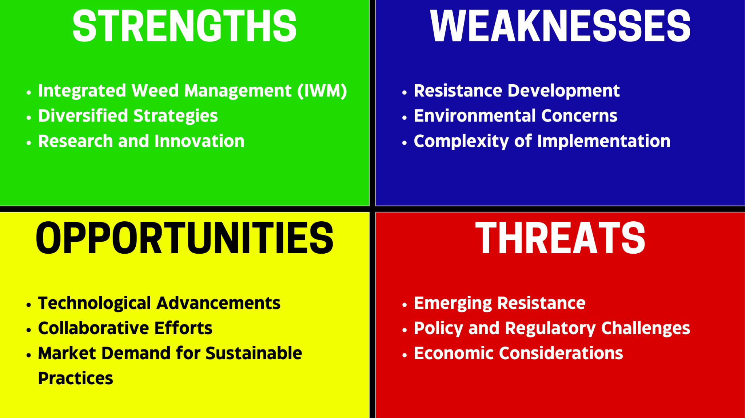
(Beckie et al., 2019; Blackshaw et al., 2011; Gosavi et al., 2022; Kumar et al., 2023; O'Donovan et al., 2006)

Fig. 1. SWOT study of resistance management strategies

3. Mechanisms of canola herbicide resistance

3.1. Resistance to Target site
One of the important mechanisms of herbicide resistance in weeds that impact crops such as canola is target-site resistance (TSR). It includes mutations that modify the molecular target of the herbicide, usually an enzyme, decreasing the herbicide's binding efficiency and decreasing its effectiveness (Murphy & Tranel, 2019). A famous instance is the N-(phosphonomethyl)glycine resistance present in Erigeron canadensis in the United States and rigid ryegrass (Lolium rigidum) in Australia. This resistance developed as a result of both modifications in glyphosate translocation within the plant and target-site mutations in the EPSPS enzyme. When TSR results in multiple resistance or cross-resistance, it presents a significant problem. While multiple resistance results from different processes triggered by the sequential or concurrent use of numerous herbicides, cross-resistance happens when just one resistance mechanism offers tolerance to multiple herbicides (Hanson et al., 2014).

3.2. Resistance to non-target site
Canola's non-target site resistance (NTSR) provides complicated problems since it involves processes such increased sequestration, decreased herbicide absorption or translocation, and metabolic degradation, which are frequently controlled by several genes (Torra et al., 2021). Glyphosate-resistant biotypes of horseweed in the USA and Lolium spp. in Australia, for instance, show changed glyphosate translocation, which impacts its passage through the xylem and phloem and contributes to remarkable resistance. NTSR is more complex than target-site resistance (TSR) and may provide greater stress tolerance, increasing a plant's resistance to herbicides. Furthermore, resistance to multiple different, unrelated herbicides may be a component of NTSR, which makes weed control methods even more challenging (Hanson et al., 2014). Enhanced detoxification through enzymes like glutathione S-transferases and cytochrome P450s is a major factor in metabolic resistance, a kind of NTSR (Yuan et al., 2007). A complete awareness of these resistance mechanisms, including their genetic basis and their influence on herbicide development and usage techniques, is necessary for the effective management of herbicide-resistant weeds (Kumar et al., 2023). Developing long-term strategies to combat herbicide resistance in canola requires further investigation into the vast gene families implicated in NTSR.

Table 2. Variation between TSR and NTSR

Aspect | TSR | NTSR
Definition and Mechanism | Altered molecular target (enzyme) (Murphy & Tranel, 2019) | Decreased herbicide absorption/translocation, enhanced sequestration, metabolism breakdown, participation of several genes (Torra et al., 2021)
Examples | Roundup resistance in annual ryegrass and colts tail (Hanson et al., 2014) | Roundup resistance in certain biotypes of Lolium spp. and Canadian fleabane (Hanson et al., 2014)
Challenges | Challenges in weed management, cross or multi-resistance (Hanson et al., 2014) | Complexity, involvement of numerous genes, difficulty in weed management approaches (Hanson et al., 2014)
Cross/Multiple Resistance | Resistance to a pair herbicide via the same mechanism (Hanson et al., 2014) | Resistance to numerous herbicides via various mechanisms (Hanson et al., 2014)
Stress Tolerance/Detoxification | Not mentioned | Increased stress tolerance, detoxification enzymes' involvement (Yuan et al., 2007) (Kumar et al., 2023)

3.3. Multiple & Cross-resistance
For farmers and scientists alike, herbicide-resistant canola generates a greater challenge. Herbicide application in canola can lead to the creation of resistance, categorized into cross-resistance (resistant to herbicides with the exact same method of action due to one mechanism) and multiple resistance (resistance to various herbicide groups via multiple mechanisms). Key resistance mechanisms include target-site resistance (mutation blocks herbicide binding), metabolic resistance (herbicide detoxification), and decreased absorption/translocation (herbicide fails to reach the target site). These kinds of mechanisms are essential for creating herbicide-resistant canola management plans that are successful. Herbicides alone may not be sufficient to manage canola populations because of cross-resistance and multiple resistance; other control strategies may be needed. These could include developing novel herbicides with distinct mechanisms of action and implementing cultural methods like crop rotation and tillage (Liu et al., 2019).
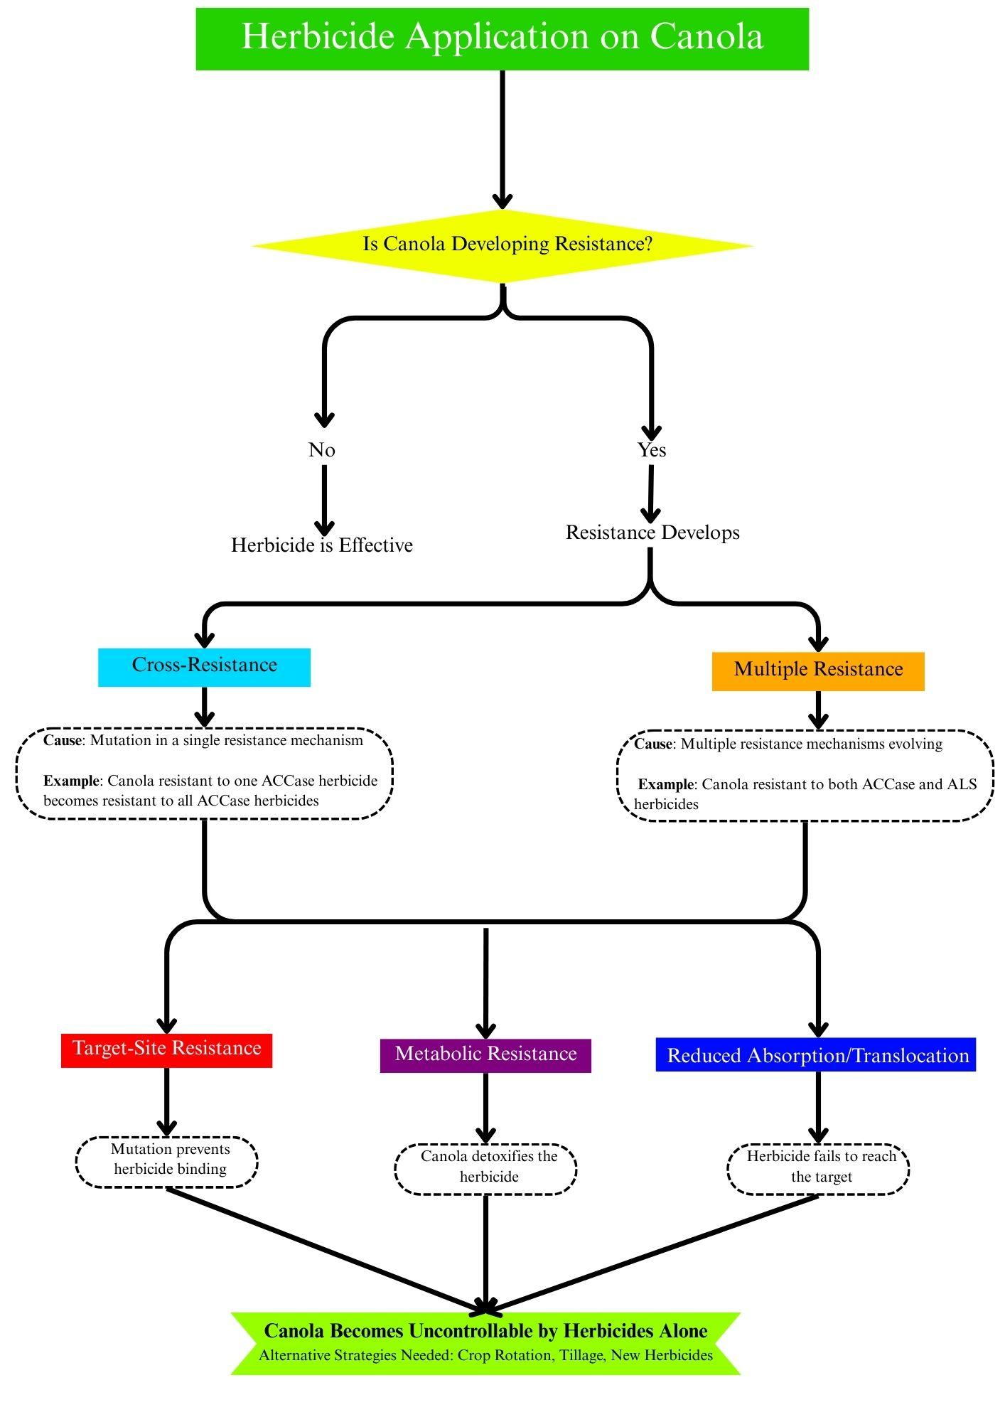
(Liu et al., 2019)

Fig. 2. Pathways of Herbicide Resistance Development in Canola

3.4. Genetic Foundations of Resistance Mechanisms
Herbicide resistance in canola is caused by genetic modifications that decrease the effectiveness of herbicides. One important mechanism is the mutation of the EPSP synthase gene, which is essential for the pathway of shikimate that produces aromatic amino acids. EPSPS is the target of herbicides such as glyphosate, which prevent the synthesis of amino acids and kill plants. Certain changes, like the replacement of proline at position 106, can lessen glyphosate binding, allowing plants to survive and lowering resistance levels. These resistant individuals are then selected for by ongoing pesticide usage, hastening the evolution of resistance. In addition to target-site modifications, resistance may also result in decreased glyphosate translocation to meristematic regions, which would restrict herbicide activity in growth zones. These characteristics, which are frequently passed down through single nuclear genes, demonstrate the genetic complexity of canola resistance. In order to maintain herbicide efficacy and stop the emergence of resistance, integrated weed management (IWM) techniques are crucial (Powles & Yu, 2010; Délye et al., 2013).

4. Understanding Herbicide Resistance through Cytogenetics

4.1. Resistance gene mapping on chromosomes
Chromosome mapping is a crucial tool in plant genetics for locating specific genes on chromosomes, particularly in understanding herbicide resistance in canola (Brassica napus) (Raman et al., 2020). Techniques like Fluorescent In Situ Hybridisation (FISH) and Genomic In-Situ Hybridisation (GISH) play a vital role in this process. Fluorescent probes are used in FISH to associate with particular DNA sequences, enabling precise localization of resistance genes, detection of chromosomal aberrations, and identification of herbicide resistance loci in canola (Shakoori, 2017). GISH differentiates between native and foreign genetic material by using genomic DNA from donor species as probes, making it useful for tracking the flow of herbicide-resistant genes from genetically modified canola to related species like Brassica rapa (Pandian et al., 2024; Ton et al., 2020). These techniques have been instrumental in identifying genes like EPSPS, which confers glyphosate resistance, allowing for targeted breeding strategies. Marker-Assisted Selection (MAS) leverages chromosome mapping data to accelerate breeding by identifying markers linked to resistance traits, reducing the need for phenotypic screening, and ensuring the integration of quantitative resistance traits into elite germplasm (Raman et al., 2020). These advancements are essential for sustainable agriculture and the development of resilient canola cultivars.

4.2. Cytogenetic markers associated with resistance traits
Cytogenetic markers are genetic elements located on chromosomes that play a crucial role in identifying herbicide-resistant varieties, particularly in crops like canola (Brassica napus). These markers enable researchers and breeders to pinpoint genetic variations conferring resistance to herbicides, facilitating the creation of improved cultivars through MAS. Molecular markers, such as microsatellites and single nucleotide polymorphisms (SNPs), are commonly used for this purpose. For instance, SNPs within the acetolactate synthase (ALS) genes (BnALS1 and BnALS3) have been linked to resistance against sulfonylurea herbicides, with specific SNPs like G1676T and G1667T identified as genotyping targets using kompetitive allele-specific PCR (KASP) assays (Shi et al., 2023). Chromosomal changes, including translocations or substitutions, can also contribute to herbicide resistance, as seen in studies on wheat, and similar approaches could be applied in canola. Cytogenetic markers accelerate the identification of herbicide-resistant lines by enabling early detection of resistance traits, reducing the time needed for phenotypic evaluations. However, the polyploid nature of canola complicates marker identification due to genome redundancy, and high-resolution mapping tools are necessary to address these challenges. Cost and throughput constraints also limit large-scale breeding applications of molecular markers like KASP assays. A recent study successfully developed KASP assays targeting SNPs in BnALS1 and BnALS3, which conferred resistance to sulfonylurea herbicides, with resistant cultivars showing no symptoms of chlorosis or necrosis after herbicide application. This study highlighted the importance of precise genotyping in breeding programs and demonstrated the synergistic effect of multiple mutated alleles in enhancing resistance levels. (Shi et al., 2023)

4.3. Genomic mapping techniques in understanding resistance mechanisms
Genomic mapping tools have significantly improved our understanding of herbicide resistance mechanisms in canola (Brassica napus), addressing challenges in sustainable agriculture. The identification of genetic loci linked to resistance traits has been made possible by techniques such as Linkage Mapping using Quantitative Trait Loci (QTL) analysis and Genome-Wide Association Studies (GWAS). GWAS analyzes genome-wide single nucleotide polymorphisms (SNPs) across diverse populations, revealing complex genetic architectures, including homoeologous and paralogous exchanges. For example, SNP markers on chromosomes A01, A03, and C01 are associated with increased resistance under controlled conditions. QTL analysis, using genetic linkage data, pinpoints genomic regions tied to herbicide resistance, helping to understand polygenic control of traits. Research has shown that gene flow from escaped canola populations can lead to stacked herbicide-resistant traits, highlighting the importance of containment strategies. The integration of GWAS and QTL analysis enables marker-assisted selection, allowing breeders to develop herbicide-resistant cultivars while minimizing unintended gene flow. These genomic mapping techniques offer valuable insights, guiding effective herbicide resistance management and improving canola breeding strategies. (Raman et al., 2020) (Knispel et al., 2008)

4.4. Structural and functional genomics approaches
Understanding herbicide resistance in canola has been greatly helped by genomics, especially when using structural and functional techniques. By introducing microbial genes that either encode for resistant enzymes or convert herbicides into non-toxic forms, genetic engineering techniques have produced herbicide-tolerant canola (Warwick & Miki, 2004). Using regulatory DNA sequences derived from plants, these genes are altered to allow for efficient expression in plants. Transcriptomics, the study of gene expression, has revealed insights into how resistance mechanisms act at the molecular level. It is still difficult to identify the precise alterations causing gene overexpression, though. The trans-acting elements and potential resistance genes that cause this overexpression have been found with the aid of genomic technologies such as genetic mapping. Resistance evolution is also influenced by the pattern of inheritance of resistance traits. Single-gene changes frequently control target-site resistance (TSR), and resistant alleles, which are frequently dominant, can spread rapidly through pollen or seed (Sammons & Gaines, 2014). However, non-target-site resistance (NTSR) covers extensive gene families that detoxify herbicides through metabolic alteration, including cytochrome P450s and glutathione S-transferases (GSTs). The significance of genomics and transcriptomics in interpreting intricate NTSR pathways is made clear by our growing understanding of how herbicides attach to their targets, particularly when numerous similar genes or deep active site interactions are involved (Gaines et al., 2020).

Aspect | Structural Genomics Approach | Functional Genomics Approach
Methodology | Concentrates on analyzing the physical structure of genes and genomes. (Warwick & Miki, 2004) | Focuses on elucidating the functions and interactions of genes. (Gaines et al., 2020)
Objective | Aims to identify genetic variations or mutations associated with resistance. (Sammons & Gaines, 2014) | Seeks to investigate gene expression and its role in resistance. (Gaines et al., 2020)
Techniques | Utilizes methods such as genetic mapping to pinpoint resistance genes. (Sammons & Gaines, 2014) | Employs transcriptomics to study gene expression patterns related to resistance. (Gaines et al., 2020)
Source of Information | Provides insights into the genetic basis of resistance mechanisms. (Warwick & Miki, 2004) | Reveals molecular changes leading to gene overexpression in resistance. (Gaines et al., 2020)
Identification of Genes | Identifies candidate resistance genes and trans-acting factors. (Warwick & Miki, 2004) | Helps pinpoint genes responsible for resistance and elucidate their function.
Trait Inheritance | Often focuses on single-gene traits inherited with dominant alleles. (Sammons & Gaines, 2014) | May uncover traits inherited from large gene families such as GSTs. (Gaines et al., 2020)
Understanding Resistance | Reveals how resistance mechanisms are inherited and disseminated. (Warwick & Miki, 2004) | Illuminates the molecular processes underlying herbicide resistance. (Gaines et al., 2020)
Implications | Provides insights into the genetic basis for developing resistant crops. (Warwick & Miki, 2004) | Offers potential targets for genetic engineering to bolster resistance. (Gaines et al., 2020)
Example Enzymes | Enzymes resistant to herbicides or those involved in metabolizing them. (Sammons & Gaines, 2014) | Enzymes like GSTs and cytochrome P450 are involved in metabolic alteration. (Gaines et al., 2020)

Table 3. Comparison of Structural and Functional Genomics Approaches in Canola

5. Genomic Treatments for Canola Herbicide Resistance

5.1. Resistance traits using marker-assisted selection (MAS)
For Both farmers and researchers, herbicide resistance in canola poses a serious problem. Addressing this problem now requires the application of genomic techniques, with Marker-Assisted Selection (MAS) being a popular tactic. By finding genetic markers that are closely associated with genes of interest, MAS makes it possible to select for desirable phenotypes (Barry et al., 1997). The creation of high-throughput genotyping arrays, especially large-scale SNP arrays, which make it easier to create high-density genetic maps, has greatly improved this technique. Herbicide-resistant characteristics have been selected for more quickly due to these maps. Crop development takes less time and effort because of MAS, which enables more targeted and efficient breeding than conventional breeding, which is frequently time-consuming and resource-intensive (Medina-Lozano & Díaz, 2022). By improving the selection of important tolerance-related genes, MAS has effectively contributed in the production of herbicide-resistant canola varieties, including glyphosate-tolerant lines. Even transgene-free homozygous mutants with increased herbicide resistance have occasionally been created using MAS. In addition to MAS, more recent genome-editing techniques such as Oligo-Directed Mutagenesis (ODM) have shown potential. ODM provides a long-term, transgene-free way to increase canola's resilience by enabling precise, targeted changes in particular genes linked to herbicide resistance (Mohd Saad et al., 2021). The production of next-generation canola cultivars resistant to herbicides can be facilitated by the combination of these genetic technologies.

5.2. Techniques for gene pyramiding resistance in genomic breeding
Canola is an excellent case study of how genomics may provide solutions to the urgent problem of herbicide resistance in present-day agriculture. By combining genes that carry herbicide-resistant enzymes with ones that can metabolize herbicides into non-toxic forms, genomic breeding techniques can be used to pyramid resistance genes. Genetic engineering advancements have made it possible to precisely modify canola to tolerate particular chemical treatments, whereas traditional breeding has historically introduced tolerance to herbicides such as imidazolinones and triazines (Warwick & Miki, 2004). The two primary methods by which genetically modified (GM) canola develops herbicide resistance are the production of enzymes that detoxify herbicides and the insertion of genes coding enzymes resistant to specific herbicides. Usually obtained from microbial sources, these genes are modified to express themselves in plants by the use of regulatory elements that are compatible with plants. Multiple resistance genes can now be loaded into a single plant according to new genome editing technologies like CRISPR/Cas9. Herbicide-resistant cultivars of crops such as oilseed rape, rice, maize, soybean, and wheat have been effectively created using this method. Furthermore, the insertion of several resistance features is made easier by the accurate modification of genes made possible by the homology-directed repair (HDR) pathway (Dong et al., 2021). These developments illustrate how genetic technologies can be used to create resilient crop types that resist herbicide resistance.

5.3. CRISPR/Cas9 genome editing methods for building resistant cultivars
Weeds drastically lower crop yields by interfering with crops for vital resources including water, nutrients, carbon dioxide, natural light, and space. When herbicide resistance restricts the ability to effectively control weeds, this competition becomes more challenging (Godfray et al., 2010). By introducing targeted mutations in genes linked to herbicide sensitivity, CRISPR-Cas9 genome editing system presents a viable approach to creating herbicide-resistant crops, enabling resistance through target-site resistance (TSR) mechanisms (Yang et al., 2022). The design of single guide RNAs (sgRNAs) is crucial to CRISPR/Cas9 effectiveness. EPSPS, phytoene desaturase and ALS (acetolactate synthase) are herbicide-related genes. In a study utilizing Agrobacterium-mediated transient expression in tomato cotyledons, sgRNAs targeting these genes demonstrated variable editing efficiency. Interestingly, sgRNAs focused against ALS were very effective, but one directed against PDS had no noticeable impact (Zhu et al., 2016). CRISPR technology has been effectively used in canola for functional genomics and genetic enhancement. In Brassica napus, a study on cytosine base editing showed that a single sgRNA could be used to generate particular mutations at many genomic loci, increasing the possibility for herbicide resistance (Wu et al., 2020).

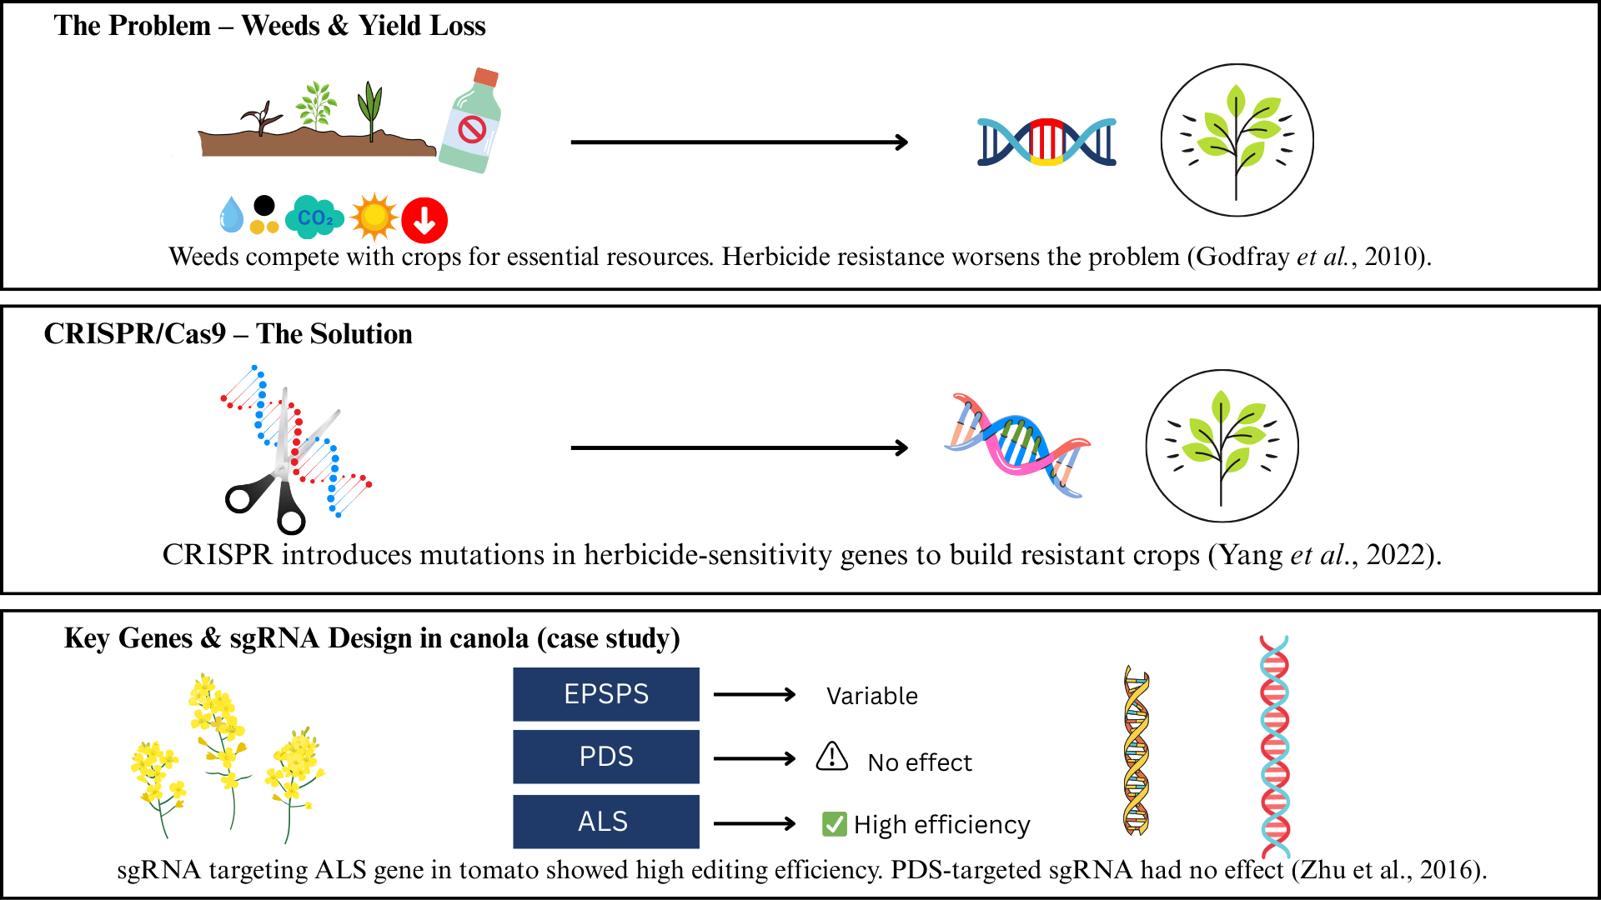
Fig.3: CRISPR/Cas9 Genome Editing for Developing Herbicide-Resistant Crops

5.4. Using agronomic techniques with genetic data to manage resistance properly
The overuse of herbicides with a single mode of action is a major cause of herbicide resistance in canola, which poses a serious problem for researchers and farmers both. Herbicide-resistant weed populations have resulted from this, damaging weed management methods. There are encouraging opportunities to create herbicide-resistant canola cultivars and sustainable herbicide resistance management strategies by utilizing genomic data and genetic technologies. The creation of genetically modified canola, including Roundup Ready (RR) canola, which expresses the CP4-EPSPS gene obtained from Agrobacterium sp. strain CP4, is one significant advancement. Because this gene imparts resistance to glyphosate, this pesticide can be used effectively to manage weeds (Ton et al., 2020). However, glyphosate-resistant weeds have evolved as a result of the extensive and frequent use of the herbicide, leading researchers to investigate alternate herbicide resistance mechanisms and methods. Gene editing using CRISPR/Cas9 has become a potent technique for introducing certain mutations that confer herbicide resistance. For instance, scientists have altered the activity of the ACCase enzyme in the non-GMO rice variety Provisia™, which confers resistance to herbicides such as sethoxydim (Dong et al., 2021). To widen herbicide resistance patterns beyond glyphosate, comparable approaches are being investigated in canola. The identification of genomic areas associated with herbicide tolerance in canola has been made possible by genomic methods like genome-wide association studies (GWAS). In a global canola germplasm collection, Abou-Khater et al. (2022) used GWAS to identify allelic variation in herbicide damage scores (HDS). According to their findings, canola accessions' varying tolerance responses may be caused by genotypic variations in the metabolic detoxification of herbicides. The management of resistance can be further improved by combining genetic knowledge with agronomic techniques. For example, herbicide application rates and timing can be optimized for various genotypes by using a reduction index (RI%), which is the ratio of trait performance in herbicide-treated versus controlled plots (Abou-Khater et al., 2022). However, there are also environmental issues with the use of genetically modified (GM) canola that is resistant to herbicides. Gene flow and unintentional release from GM crops to non-GM cultivars or wild relatives may occur. The glyphosate-resistant GT73 transgene (gox and CP4-EPSPS) was found in wild rapeseed populations at several places in Switzerland, according to Hecht et al. (2022), highlighting the necessity of strict containment and biosafety monitoring measures.

6. Challenges and Future directions
There are many challenges faced by researchers.The emergence of cross-resistance and multiple resistance structures is one of the main issues. This develops when weeds become resistant to several kinds of herbicides with different modes of action, making weed control difficult and requiring the development of new herbicides with different types of action. An additional issue is the potential for gene flow and unintentional environmental release of herbicide-resistant canola, which can contribute to the spread of herbicide resistance and the formation of wild canola populations. To overcome these challenges, researchers will focus on combining genetic treatments with agronomic practices for effective resistance control. Herbicide-resistant cultivars with pyramided resistance genes may be developed with the help of genomic tools such as genome editing techniques (CRISPR/Cas9) and marker-assisted selection (MAS). Additionally, transcriptome research and genomic mapping provide light on the mechanisms underlying resistance, providing up the possibility to the development of innovative herbicides and focused resistance control measures. Sustainable weed management solutions may benefit from cultural activities such as crop rotation, cover crops, and integrated pest management techniques.

7. Conclusion
Herbicide resistance in canola has become a significant concern due to its impact on weed management and environmental sustainability. Herbicide resistance can be blamed on early mutagenesis cases and to the development of transgenic plants that are resistant to certain herbicides. But excessive dependence of pesticides has led to resistant weeds growing, threatening agricultural output that can be continued. Herbicide resistance develops by two main mechanisms: non-target site resistance (NTSR), which is caused by complex mechanisms such increased sequestration, decreased herbicide absorption, or metabolic degradation, and TSR, which is linked to mutations in important genes. With the recognition of cytogenetic markers associated with resistance features and the genetic mapping of resistance genes, cytogenetic study has brought information on the genetic foundation of resistance mechanisms. The knowledge of these processes has been significantly expanded by methods like structural and functional genomics techniques, as well as genomic mapping. Genomic innovations like CRISPR/Cas9 genome editing, genomic breeding approaches for pyramiding resistance genes, & MAS have emerged as potential ways to fight herbicide resistance. Effective solutions for managing resistance may also be obtained through the integration of genetic data with agronomic techniques.

Disclaimer (Artificial intelligence)
Option 1:
Author(s) hereby declare that NO generative AI technologies such as Large Language Models (ChatGPT, COPILOT, etc.) and text-to-image generators have been used during the writing or editing of this manuscript.
Option 2:
Author(s) hereby declare that generative AI technologies such as Large Language Models, etc. have been used during the writing or editing of manuscripts. This explanation will include the name, version, model, and source of the generative AI technology and as well as all input prompts provided to the generative AI technology
Details of the AI usage are given below:
1.
2.
3.

References

Abou-Khater, L., Maalouf, F., Jighly, A., Alsamman, A. M., Rubiales, D., Rispail, N., Hu, J., Ma, Y., Balech, R., Aladdin, H., Baum, M., & Kumar, S. (2022). Genomic regions associated with herbicide tolerance in a worldwide faba bean (Vicia faba L.) collection. Scientific Reports, 12(1), Article 3861. https://doi.org/10.1038/s41598-021-03861-0

Asaduzzaman, M., Pratley, J., An, M., Luckett, D., & Lemerle, D. (2014). Canola interference for weed control. Springer Science Reviews, 2(1–2), 63–74. https://doi.org/10.1007/s40362-014-0022-2

Barry, G. F., Jr., Kishore, G. M., Padgette, S. R., Stallings, W. C., & Monsanto Company. (1997). Glyphosate-tolerant enolpyruvylshikimate-3-phosphate synthases (U.S. Patent No. 5,633,435). United States Patent and Trademark Office. https://patentimages.storage.googleapis.com/36/e1/8a/802e19eb511821/US5633435.pdf

Beckie, H. J., Ashworth, M. B., & Flower, K. C. (2019). Herbicide resistance management: Recent developments and trends. Plants, 8(6), 161. https://doi.org/10.3390/plants8060161

Beckie, H. J., Warwick, S. I., Nair, H., & Séguin-Swartz, G. (2003). Gene flow in commercial fields of herbicide‐resistant canola (Brassica napus). Ecological Applications, 13(5), 1276–1294. https://doi.org/10.1890/02-5231

Blackshaw, R. E., Brandt, S., Johnson, E. N., Harker, K. N., O’Donovan, J. T., Turkington, K., & Kutcher, R. (2011). Which crop inputs have the greatest impact on canola yield? In Proceedings of the 13th International Rapeseed Congress (pp. 389–392). Prague, Czech Republic. https://www.gcirc.org/fileadmin/documents/Proceedings/IRCPrague2011vol1/crop%20management/391-394.pdf

NDSU Agriculture. (2024, February 13). Canola production. https://www.ndsu.edu/agriculture/extension/publications/canola-production

Canola Council of Canada. (2024, March 28). Canola growth stages | Canola encyclopedia. https://www.canolacouncil.org/canola-encyclopedia/growth-stages/

Canola Council of Canada. (2024, April 10). History of canola seed development | Canola encyclopedia. https://www.canolacouncil.org/canola-encyclopedia/history-of-canola-seed-development/

Casséus, L., & Statistics Canada. (2009). Canola: A Canadian success story. Canadian Agriculture at a Glance. https://www150.statcan.gc.ca/n1/en/pub/96-325-x/2007000/article/10778-eng.pdf?st=OtID26Dq

Corrêa, M. R., Dayan, F. E., Owens, D. K., Rimando, A. M., & Duke, S. O. (2016). Glyphosate-resistant and conventional canola (Brassica napus L.) responses to glyphosate and aminomethylphosphonic acid (AMPA) treatment. Journal of Agricultural and Food Chemistry, 64(18), 3508–3513. https://doi.org/10.1021/acs.jafc.6b00446

Cherlinka, V. (2024, February 8). Canola growing: Higher yields through smart cultivation. EOS Data Analytics. https://eos.com/blog/growing-canola/

Bradley D. Hanson, Fischer, A. J., McHughen, A., Jasieniuk, M., Shrestha, A., & Jhala, A. J. (2014). Herbicide tolerant and resistant weeds. Principles of Weed Control, UNL Agronomy, 4(7). https://api.semanticscholar.org/CorpusID:15840456

Délye, C., Jasieniuk, M., & Le Corre, V. (2013, November). Deciphering the evolution of herbicide resistance in weeds. Trends in Genetics, 29(11), 649–658. https://doi.org/10.1016/j.tig.2013.06.001

Dong, H., Huang, Y., & Wang, K. (2021). The development of herbicide resistance crop plants using CRISPR/CAS9-mediated gene editing. Genes, 12(6), 912. https://doi.org/10.3390/genes12060912

Gaines, T. A., Duke, S. O., Morran, S., Rigon, C. A., Tranel, P. J., Küpper, A., & Dayan, F. E. (2020). Mechanisms of evolved herbicide resistance. Journal of Biological Chemistry, 295(30), 10307–10330. https://doi.org/10.1074/jbc.rev120.013572

Godfray, H. C. J., Beddington, J. R., Crute, I. R., Haddad, L., Lawrence, D., Muir, J. F., Pretty, J., Robinson, S., Thomas, S. M., & Toulmin, C. (2010, February 12). Food security: The challenge of feeding 9 billion people. Science, 327(5967), 812–818. https://doi.org/10.1126/science.1185383

Gosavi, G., Ren, B., Li, X., Zhou, X., Spetz, C., & Zhou, H. (2022). A new era in herbicide-tolerant crops development by targeted genome editing. ACS Agricultural Science & Technology, 2(2), 184–191. https://doi.org/10.1021/acsagscitech.1c00254

Grey, T. L., Raymer, P. L., & Bridges, D. C. (2006). Herbicide-resistant canola (Brassica napus) response and weed control with postemergence herbicides. Weed Technology, 20(3), 551–557. https://doi.org/10.1614/wt-05-061r.1

Hecht, M., Oehen, B., Schulze, J., Brodmann, P., & Bagutti, C. (2013). Detection of feral GT73 transgenic oilseed rape (Brassica napus) along railway lines on entry routes to oilseed factories in Switzerland. Environmental Science and Pollution Research International, 21(2), 1455–1465. https://doi.org/10.1007/s11356-013-1881-9

Hussain, A., Ding, X., Alariqi, M., Manghwar, H., Hui, F., Li, Y., Cheng, J., Wu, C., Cao, J., & Jin, S. (2021). Herbicide resistance: Another hot agronomic trait for plant genome editing. Plants (Basel, Switzerland), 10(4), 621. https://doi.org/10.3390/plants10040621

Knispel, A. L., McLachlan, S. M., Van Acker, R. C., & Friesen, L. F. (2008). Gene flow and multiple herbicide resistance in escaped canola populations. Weed Science, 56(1), 72–80. https://doi.org/10.1614/ws-07-097.1

Kumar, V., Singh, M., Kaur, R., & Jhala, A. J. (2023). The scenario of herbicide-resistant weeds: Management challenges and perspectives. Indian Journal of Weed Science, 55(2), 123–132. https://doi.org/10.5958/0974-8164.2023.00023.0
Liu, X., Xiang, S., Zong, T., Ma, G., Wu, L., Liu, K., Zhou, X., & Bai, L. (2019). Herbicide resistance in China: a quantitative review. Weed Science, 67(6), 605–612. https://doi.org/10.1017/wsc.2019.46

Medina-Lozano, I., & Díaz, A. (2022). Applications of genomic tools in plant breeding: Crop biofortification. International Journal of Molecular Sciences, 23(6), 3086. https://doi.org/10.3390/ijms23063086

Mohd Saad, N. S., Severn-Ellis, A. A., Pradhan, A., Edwards, D., & Batley, J. (2021). Genomics armed with diversity leads the way in Brassica improvement in a changing global environment. Frontiers in Genetics, 12, 600789. https://doi.org/10.3389/fgene.2021.600789

Murphy, B. P., & Tranel, P. J. (2019). Target-site mutations conferring herbicide resistance. Plants (Basel, Switzerland), 8(10), 382. https://doi.org/10.3390/plants8100382

O’Donovan, J. T., Harker, K. N., Clayton, G. W., & Blackshaw, R. E. (2006). Comparison of a glyphosate-resistant canola (Brassica napus L.) system with traditional herbicide regimes. Weed Technology, 20(2), 494–501. https://doi.org/10.1614/WT-05-092R.1

Pacific Northwest Canola Association. (2021, September 4). Why grow canola and tips for a successful crop. PNW Canola Association. https://pnwcanola.org/for-growers/production-strategies/

Pandian, S., Ban, Y., Shin, E., Thamilarasan, S. K., Muthusamy, M., Oh, Y., An, H., & Sohn, S. (2024). Introgression of herbicide-resistant gene from genetically modified Brassica napus L. to Brassica rapa through backcrossing. Plants, 13(20), 2863. https://doi.org/10.3390/plants13202863

Powles, S. B., & Yu, Q. (2010, June 2). Evolution in action: Plants resistant to herbicides. Annual Review of Plant Biology, 61(1), 317–347. https://doi.org/10.1146/annurev-arplant-042809-112119

Raman, H., McVittie, B., Pirathiban, R., Raman, R., Zhang, Y., Barbulescu, D. M., Qiu, Y., Liu, S., & Cullis, B. (2020). Genome-wide association mapping identifies novel loci for quantitative resistance to blackleg disease in canola. Frontiers in Plant Science, 11. https://doi.org/10.3389/fpls.2020.01184

Reddy, K. N., Nandula, V. K., & Crop Production Systems Research Unit, USDA-ARS. (2012). Herbicide resistant crops: History, development and current technologies. Indian Journal of Agronomy, 57(1), 1–7. https://www.ars.usda.gov/ARSUserFiles/60663500/publications/reddy/reddy%20and%20nandula_2-12_ija_57-1-7.pdf

Roché, K. J. (2015). Canola: A modern crop for a modern era. Doctoral Documents from Doctor of Plant Health Program. http://digitalcommons.unl.edu/planthealthdoc/6

Sammons, R. D., & Gaines, T. A. (2014). Glyphosate resistance: State of knowledge. Pest Management Science, 70(9), 1367–1377. https://doi.org/10.1002/ps.3743

Schafer, M. G., Ross, A. A., Londo, J. P., Burdick, C. A., Lee, E. H., Travers, S. E., Van de Water, P. K., & Sagers, C. L. (2011). The establishment of genetically engineered canola populations in the U.S. PloS One, 6(10), e25736. https://doi.org/10.1371/journal.pone.0025736

Shakoori, A. R. (2017). Fluorescence in situ hybridization (FISH) and its applications. In Springer eBooks (pp. 343–367). https://doi.org/10.1007/978-81-322-3673-3_16

Shi, J., Yu, H., Fu, Y., Wang, T., Zhang, Y., Huang, J., Li, S., Zheng, T., Ni, X., & Zhao, J. (2023). Development and validation of functional kompetitive allele-specific PCR markers for herbicide resistance in Brassica napus. Frontiers in Plant Science, 14. https://doi.org/10.3389/fpls.2023.1213476

Sohn, S. I., Pandian, S., Oh, Y. J., Kang, H. J., Ryu, T. H., Cho, W. S., Shin, E. K., & Shin, K. S. (2021). A review of the unintentional release of feral genetically modified rapeseed into the environment. Biology, 10(12), 1264. https://doi.org/10.3390/biology10121264

Ton, L. B., Neik, T. X., & Batley, J. (2020). The use of genetic and gene technologies in shaping modern rapeseed cultivars (Brassica napus L.). Genes, 11(10), 1161. https://doi.org/10.3390/genes11101161

Torra, J., Montull, J. M., Taberner, A., Onkokesung, N., Boonham, N., & Edwards, R. (2021). Target-site and non-target-site resistance mechanisms confer multiple and cross-resistance to ALS and ACCase inhibiting herbicides in Lolium rigidum from Spain. Frontiers in Plant Science, 12. https://doi.org/10.3389/fpls.2021.625138

Warwick, S. I., & Miki, B. (2004). Herbicide resistance. In Biotechnology in Agriculture and Forestry (pp. 273–295). https://doi.org/10.1007/978-3-662-06164-0_14

Wu, J., Chen, C., Xian, G., Liu, D., Lin, L., Yin, S., Sun, Q., Fang, Y., Zhang, H., & Wang, Y. (2020, March 10). Engineering herbicide‐resistant oilseed rape by CRISPR/Cas9‐mediated cytosine base‐editing. Plant Biotechnology Journal, 18(9), 1857–1859. https://doi.org/10.1111/pbi.13368

Yang, S. H., Kim, E., Park, H., & Koo, Y. (2022). Selection of the high efficient sgRNA for CRISPR-Cas9 to edit herbicide related genes, PDS, ALS, and EPSPS in tomato. Applied Biological Chemistry, 65(1). https://doi.org/10.1186/s13765-022-00679-w

Yuan, J. S., Tranel, P. T., & Stewart, C. N. Jr. (2007). Non-target-site herbicide resistance: A family business. Trends in Plant Science, 12(1), 7–13. https://doi.org/10.1016/j.tplants.2006.11.001

Zhang, Y., Malzahn, A. A., Sretenovic, S., & Qi, Y. (2019, July 15). The emerging and uncultivated potential of CRISPR technology in plant science. Nature Plants, 5(8), 778–794. https://doi.org/10.1038/s41477-019-0461-5

Zhu, M., Monroe, J. G., Suhail, Y., Villiers, F., Mullen, J., Pater, D., Hauser, F., Jeon, B. W., Bader, J. S., Kwak, J. M., Schroeder, J. I., McKay, J. K., & Assmann, S. M. (2016, February 16). Molecular and systems approaches towards drought‐tolerant canola crops. New Phytologist, 210(4), 1169–1189. https://doi.org/10.1111/nph.13866

