*Review Article*

A review on Novel era in plant phenological research: Integrating crop models with technological advancements

.

ABSTRACT

|  |
| --- |
| Plant phenology, the examination of cyclical biological occurrences in plants, is essential for comprehending crop growth, development, and yield under diverse environmental settings. This review methodically analyses the revolutionary impact of sophisticated crop models and technology-based methodologies in contemporary phenological research. Prominent crop models include MLCan (Multi-layer Canopy Model), AquaCrop 7.0, InfoCrop v2.1, Decision Support System for Agrotechnology Transfer (DSSAT), and OpenSimRoot, each providing distinct functionalities in simulating canopy processes, water productivity, root system dynamics, and yield forecasting. These models, supported by comprehensive meteorological, soil, crop, and management data, offer strong frameworks for comprehending the intricate relationships between crops and their environments. The review emphasises the incorporation of innovative technology, including UAV-mounted sensors, Normalised Difference Vegetation Index (NDVI), and sophisticated root imaging systems like MyROOT 2.0, which improve the accuracy, scalability, and temporal resolution of phenological observations. The integration of machine learning algorithms enhances predictive modelling by identifying non-linear interactions, refining agricultural management practices, and facilitating real-time decision-making. These inventions collectively offer robust solutions to the concerns of climate change, resource scarcity, and the necessity for sustainable agriculture methods. This analysis underscores the significance of utilising model-based and technology-driven methodologies to enhance crop yield, optimise resource efficiency, and bolster global food security amid changing environmental and socio-economic challenges. Subsequent research ought to concentrate on optimising these instruments, improving their accessibility, and incorporating them into holistic decision support systems to amplify their influence on agricultural sustainability and resilience. |

***Keywords:*** *Crop Modelling and Forecasting, Crop morphology, Biometrics observations, Growth and Development.*

1. INTRODUCTION

Growth is characterised as a fundamental process that induces a permanent and irreversible alteration in any plant or its component concerning its size, shape, mass, and volume. Growth is confined to living cells and is achieved through metabolic processes that synthesise macromolecules, including nucleic acids, proteins, lipids, and polysaccharides, utilising metabolic energy (Kriedemann, et al., 2017). The phrase growth refers to an increase in size through cell division and enlargement, along with the production of new cellulose components and the organisation of cellular organelles. Plant growth and development denote the dynamic processes via which plants enlarge, mature, and advance through several life stages. Genetic and environmental factors govern these processes and are crucial for the plant's capacity to reproduce and flourish in many situations (Tessmer et al., 2013).

Plant development is a fundamental biological process examined across various scientific disciplines, encompassing scales from physiology to community dynamics and ecological characteristics. Computational plant growth modelling facilitates enhanced comprehension and precise forecasting of many plants’ physiological issues. Specifically, Tessmer et al. (2013) indicate that the investigation of critical biological pathways responsive to biotic or abiotic stresses necessitates the development of a precise and more efficient computational model of plant growth to accurately capture the alterations in growth rate, which may reflect the regulation of photosynthetic activity or energy distribution by these pathways.

Notable declines in crop growth and production have been documented under several stress conditions, including elevated temperatures and increasing soil salinity (Ayankojo et al., 2023). Addressing these difficulties necessitates comprehension of genotype and phenotype interactions to enhance plant breeding for heat, drought, and disease-resistant agricultural cultivars that are high-yielding and resource-efficient (Yang et al., 2017). Enhanced crop resistance to stress circumstances has been shown to promote crop growth with negligible or no effects on production (Liu et al., 2017).

In the last twenty years, advancements in crop enhancement technologies have accelerated (Adeleke, 2024; Sheikh, 2024)); nonetheless, constraints in phenotyping methods persist, obstructing a thorough comprehension of the correlations between genetic data and phenotypic characteristics associated with crop growth, yield, and stress adaptation (Ahmad et al., 2022). Conventional phenotyping methods, predominantly reliant on visual evaluation, have underpinned selection breeding for more than a century; however, they are insufficiently efficient to adequately correlate phenotypic traits with the vast genetic data produced by genome sequencing. To improve the precision and efficacy of genomic selection models in breeding programs, there is an urgent requirement for sophisticated phenotyping technologies that can assess crop traits at scale and throughout different growth stages, thereby necessitating the incorporation of high-throughput plant phenotyping (HTPP) technologies to fully leverage contemporary genomic data and connect it to essential agronomic traits. The principal aim of HTPP technologies is to enable swift, non-destructive, and extensive evaluations of plant morphological and physiological traits through image-based data acquisition and processing systems, yielding accurate and thorough phenotypic measurements, thereby enhancing breeding efficiency and expediting genetic advancements in crop improvement initiatives.The present review study encompasses advanced modelling and the integration of new technologies to facilitate data-driven analysis of crop growth using machine learning algorithms.

2. Crop Modelling

A crop model is a scientific instrument that simulates the growth, development, and yield of crops by incorporating genotypic, environmental, and managerial variables. It employs mathematical equations to delineate the physiological processes of crops, encompassing photosynthesis, respiration, transpiration, and nutrient uptake, as they engage with variables such as temperature, solar radiation, water availability, and soil nutrients (Bhatia, 2014). Crop models are employed to forecast phenological stages, evaluate yield potential, and analyse the effects of climate variability and agronomic methods.

Crop models replicate the growth and development of crops under diverse environmental circumstances and management approaches. A minimum dataset is necessary for these models to yield trustworthy and relevant predictions. This information can be classified into four principal categories: meteorological data, soil data, crop data, and management data.

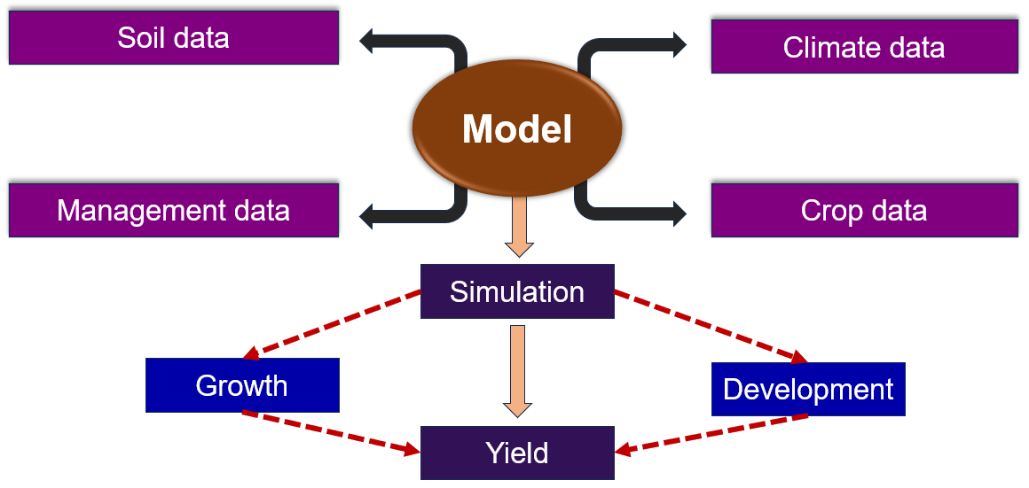

Figure 1: Functioning and data set requirement of crop models

**2.1 Climatic Data**

The climatic dataset necessary for operating a crop model include daily maximum, minimum, and mean temperatures, which are crucial for evaluating crop growth and development rates, as temperature directly affects physiological processes including germination, flowering, and maturity. Daily precipitation data is essential for water balance computations, facilitating the simulation of soil moisture dynamics and irrigation needs. Solar radiation data, encompassing incoming solar radiation or light interception, is essential for assessing photosynthetic potential and biomass output, as it determines the energy available for photosynthesis. Furthermore, relative humidity levels are essential for calculating evapotranspiration rates and assessing plant water requirements, which are crucial for modelling water stress and scheduling irrigation. Collectively, these climatic datasets furnish essential inputs for crop models to simulate the interactions between environmental conditions and crop growth, facilitating precise predictions of yield, resource use efficiency, and crop responses to diverse climatic scenarios (Chapagain et al., 2014; Pasquel et al., 2022)..

**2.2 Soil Data**

The soil information used for operating a crop model encompasses the categorisation of soil types, including sandy, loamy, or clay, which is crucial for comprehending differences in water retention, nutrient accessibility, and root penetration. Essential soil qualities, such as soil texture, bulk density, pH, organic matter content, and water retention capacity, are vital for modelling soil-crop interactions, as they affect nutrient cycling, hydrological processes, and overall soil vitality. Moreover, data regarding the effective root zone depth of the crop is essential to simulate the degree of root exploration and resource acquisition, which directly influences water and nutrient availability for plant development. The aggregated soil data serve as essential inputs for crop models, facilitating realistic simulations of the relationships among soil parameters, crop growth, and environmental circumstances, hence permitting precise forecasts of crop performance and resource use efficiency. (Chapagain et al., 2014; Pasquel et al., 2022).

**2.3 Crop Data**

The crop dataset used for operating a crop model contains comprehensive information on the crop variety, including unique cultivar attributes such as growth habits, phenological stages, and genetic features that affect development and yield potential. The planting date is a crucial factor, since it dictates the timing of growth phases and is vital for precise yield forecasting and modelling of crop reactions to climatic circumstances. Growth characteristics, including base temperature, photoperiod sensitivity, and maximum leaf area index, are essential for modelling physiological processes such as germination, flowering, and biomass accumulation. Collectively, these databases furnish the essential inputs for crop models to simulate growth dynamics, forecast yields, and assess the impacts of diverse agronomic and climatic factors on crop productivity. (Chapagain et al., 2014; Pasquel et al., 2022).

**2.4 Management Data**

The management dataset necessary for operating a crop model include comprehensive details on tillage techniques that affect soil structure and water retention, along with the expected harvest date, which is essential for yield estimation and model calibration. The dataset must include the dates of first soil condition measurements prior to planting or sowing, as they are crucial baseline data for simulating soil-crop interactions. Essential agronomic practices, including planting density, planting date, row spacing, and varietal data, are crucial for effectively modelling crop growth dynamics, resource allocation, and canopy development. Additionally, irrigation and fertilisation procedures must be incorporated to consider water and nutrient inputs, while weeding and other management actions are necessary to illustrate the effects of weed competition and pest control on crop yield. These management data collectively constitute the essential inputs for crop models, facilitating accurate simulations of crop development, production, and environmental interactions across diverse agricultural techniques. (Chapagain et al., 2014; Pasquel et al., 2022). Accurate data collection and input within these categories is crucial for dependable predictions in crop models, facilitating improved decision-making for crop management and resource allocation.

**2.5 Types of crop models**

**2.5.1 Empirical models:**

Empirical models are mathematical constructs constructed from observable data rather than from fundamental biological or physical principles. These models depend on statistical correlations between input variables (e.g., temperature and precipitation) and output variables (e.g., crop production and growth rates) to provide predictions. These models are generally developed by regression analysis or analogous statistical methods, utilising historical data to discern relationships between environmental conditions and the system's reaction. Although empirical models are typically more straightforward and require less data than mechanistic models, they may exhibit limited generalisability and precision when utilised beyond their intended settings. These models are frequently employed in agriculture to forecast crop yields, pest infestations, and growth rates utilising past climate or management data (Chapagain et al. 2014).

**2.5.2 Mechanistic models:**

Mechanistic models are advanced mathematical frameworks that replicate biological processes and interactions grounded in known physiological and biochemical principles. These models precisely delineate the fundamental systems that regulate plant growth, development, and reactions to environmental stimuli. They integrate processes including photosynthesis, respiration, water absorption, nutrient cycling, and phenological development to forecast crop performance under diverse settings. These models generally necessitate comprehensive input data concerning crop attributes, environmental factors, and management techniques. Although they are more intricate and data-demanding than empirical models, they provide enhanced accuracy and generalisability across many contexts and conditions (Pasquel et al., 2022).

**2.6 Steps in crop growth modelling**

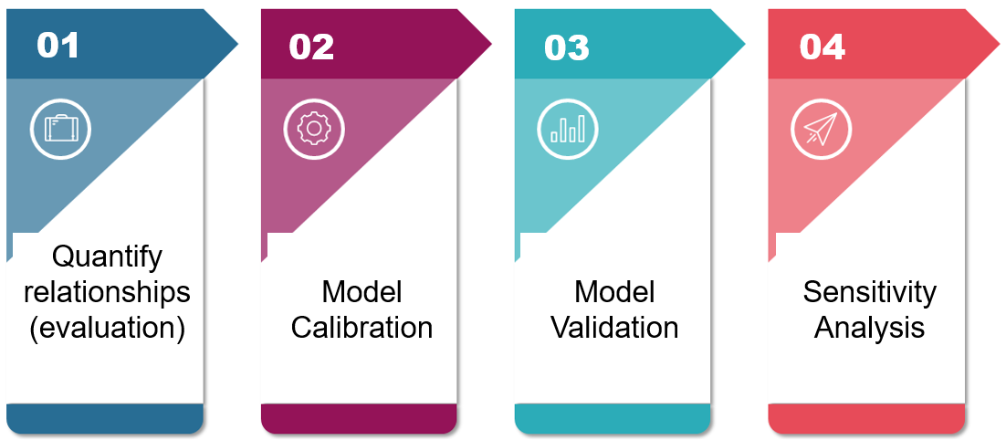

Figure 2: Steps involve in crop model performing.

**2.6.1 Define key variables in system:** State variables denote quantifiable metrics inside a system, including soil moisture levels and agricultural output. Conversely, rate variables denote the rates of diverse processes occurring inside the system, such as photosynthesis and transpiration rates. Driving variables are external forces that affect the system without being integral to it, such as sunlight and precipitation. Finally, auxiliary variables denote intermediary outputs inside the system, as illustrated by dry matter partitioning and water stress. (Chapagain et al., 2014; Pasquel et al., 2022).

**2.6.2 Quantify relationships (evaluation):** Quantifying connections in crop modelling entails assessing and parameterising the interactions among diverse elements that affect crop growth and development. This method is essential for precisely modelling crop performance under varying conditions.

**2.6.3 Calibration:** Model calibration involves the preliminary evaluation of a model and its adjustment to align with a specific dataset or the process of estimating model parameters by juxtaposing model predictions (output) under assumed assumptions with empirical data for identical conditions.

**2.6.4 Validation:** Evaluation of a model utilising a data set that reflects "local" field data. This dataset constitutes a distinct source, separate from the data. The data set constitutes an independent source distinct from the data utilised to establish the relationship.

**2.6.6 Sensitivity analysis:** The validated model is subsequently evaluated for its sensitivity to various parameters (e.g., temperature, precipitation, nitrogen dosage). This is conducted to ascertain whether the model is responsive to variations in those factors.

**2.7 Model comparison**

Model comparison is essential for comprehending the strengths and weaknesses of different agricultural and environmental models, especially in relation to varied cropping systems and climatic circumstances. This study assesses five prevalent models: MLCan (Multi-layer Canopy Model), AquaCrop 7.0, InfoCrop v2.1, the Decision Support System for Agrotechnology Transfer (DSSAT), and OpenSimRoot. Each model has distinct functionalities, including the simulation of canopy processes, water productivity, and the prediction of crop development, yield, and root system dynamics. We seek to elucidate their appropriateness for particular research or decision-making contexts by examining their theoretical frameworks, input needs, and applicability across various circumstances. This research underscores the significance of choosing a suitable model in accordance with the study's aims and the intricacy of the system being represented.

**2.7.1 MLCan (Multi-layer canopy model):** Integrating plant phenology dynamics into a biophysical canopy model. The developmental phases influence the diversity of vegetative carbon reservoirs and establish land surface characteristics, including leaf area index, canopy height, rooting depth, and root water absorption capacity (Farahani et al., 2022).

**Key Features**

***2.7.1.1 Layered Canopy Structure:*** MLCan segments the plant canopy into many levels, facilitating an in-depth examination of light distribution and shading impacts at different elevations. This stratified method evaluates the influence of high canopy leaves on light accessibility for lower leaves, which is essential for enhancing photosynthetic efficiency and biomass production.

***2.7.1.2 Radiative Transfer Modeling:*** The model utilises advanced algorithms to simulate radiative transfer, facilitating precise predictions of light transmission and absorption inside each canopy layer. This functionality is crucial for assessing the photosynthetic rate and growth potential of crops, as light serves as a main catalyst for photosynthesis and subsequent development.

***2.7.1.3 Photosynthetic Responses***: MLCan incorporates various physiological parameters related to photosynthesis, including leaf area index (LAI), photosynthetic efficiency, and the effects of environmental conditions such as temperature and humidity. By simulating these responses, the model can predict how different growing conditions affect crop growth and yield.

***2.7.1.4 Microclimate Simulation:*** The model considers microclimatic variations inside the canopy, encompassing temperature swings, humidity levels, and wind velocity. These parameters affect plant physiological processes and are essential for comprehending crop stress responses, particularly in fluctuating climatic conditions.

***2.7.1.5 Nutrient and Water Dynamics:*** While primarily concentrating on light interception and photosynthesis, MLCan can be combined with additional models to mimic nutrient uptake and water dynamics, hence augmenting its forecasting powers concerning crop growth and production.

**2.7.2 AquaCrop 7.0:** Utilised to replicate the impact of water on crop yield, hence serving as a valuable tool for evaluating agricultural water consumption and irrigation methodologies. Version 7.0 incorporated numerous enhancements, including updates for novel crops and augmented functionality for simulating various soil and water management scenarios. The most recent iteration of AquaCrop features enhancements for improved predictions of crop growth under diverse water availability scenarios, emphasising water productivity (Lu et al., 2021). The AquaCrop model was developed by the Land and Water Division of the FAO in 2009.

**Key feature**

***2.7.2.1 Multi-Crop Capability:*** AquaCrop is capable of simulating several crops, encompassing grains, legumes, vegetables, and fruit trees. It encompasses parameters for diverse growth phases and developmental traits relevant to particular crops.

***2.7.2.2 Yield Response to Water:*** The model includes a yield response function that measures the correlation between crop yield and water availability. It enables users to evaluate how diverse irrigation systems can enhance yields under fluctuating water circumstances.

***2.7.2.3 Irrigation Scheduling:*** The model offers instruments for enhancing irrigation scheduling according to crop water needs, soil moisture content, and weather factors. This function enhances water utilisation efficiency and productivity.

***2.7.2.4 Soil Water Dynamics:*** AquaCrop precisely simulates soil water dynamics, encompassing infiltration, evaporation, and drainage. It employs a streamlined methodology to depict the soil-water-plant-atmosphere continuum, facilitating accurate forecasts of water dynamics and accessibility.

***2.7.2.5 Crop Growth Processes:*** AquaCrop models critical crop growth processes, such as biomass buildup, phenological development, and canopy expansion. It employs a straightforward yet effective method to illustrate photosynthesis, transpiration, and dry matter allocation.

**2.7.3 Decision Support System for Agrotechnology Transfer (DSSAT):** The tools encompass database management software for soil, weather, crop management, experimental data, utilities, and application programs. The crop simulation models for more than 42 crops (version 4.8.2) simulate growth, development, and yield based on soil and plant-atmosphere dynamics (Jones et al., 2003).

**Key feature**

***2.7.3.1 Process-Based Modeling:*** The model utilises a process-oriented methodology, incorporating physiological, agronomic, and environmental factors that affect crop development, including photosynthesis, respiration, nutrient absorption, and water regulation.

***2.7.3.2 Phenological Modeling:*** DSSAT models the phenological progression of crops, encompassing essential growth phases like germination, blooming, and maturation. This feature facilitates the evaluation of the timing and duration of crop growth under varying conditions.

***2.7.3.3 Soil, Water and Nutrient Dynamics:*** The model integrates comprehensive soil water and nutrient dynamics, facilitating precise simulations of water movement (infiltration, drainage, and evaporation) and nutrient cycling (uptake and availability). This capacity is essential for comprehending the impacts of irrigation and fertilisation on crop yield.

***2.7.3.4 Weather Data Integration:*** DSSAT facilitates the incorporation of climate variables, including temperature, precipitation, and sun radiation, which are crucial for modelling crop growth under diverse weather conditions. Users may enter historical or forecasted climate data to assess effects on agricultural productivity and management strategies.

***2.7.3.5 Sensitivity Analysis and Calibration:*** DSSAT enables users to conduct sensitivity analysis to determine critical parameters affecting crop development and yield. It also offers tools for model calibration, allowing users to modify parameters according to local conditions and experimental data.

***2.7.3.6 Long-Term Simulation Capability:*** The model can replicate long-term agricultural growth scenarios, rendering it appropriate for examining the effects of climate change, soil degradation, and management approaches over prolonged durations. The model can replicate long-term agricultural growth scenarios, rendering it appropriate for examining the effects of climate change, soil degradation, and management approaches over prolonged durations.

**2.7.4 OpenSimRoot:** The model replicates the development of a root system over time within a three-dimensional virtual environment. The tool facilitates the examination of the impact of a certain root characteristic on resource acquisition under various resource limitations. The University of Nottingham (UK) and the International Crops Research Institute for the Semi-Arid Tropics (ICRISAT) jointly created this model in 2017 (González et al., 2020).

**Key feature**

***2.7.4.1 Root Architecture Simulation:*** OpenSimRoot offers a comprehensive depiction of root architecture, facilitating the simulation of diverse root growth patterns and structures. This feature facilitates the examination of how various root designs affect water and nutrient absorption.

***2.7.4.2 3D Root Growth Representation:*** OpenSimRoot models root growth in three dimensions, offering an accurate depiction of root systems under soil. This skill is essential for examining spatial interactions among roots, soil, and other vegetation.

***2.7.4.3 Dynamic Growth Simulation:*** OpenSimRoot facilitates the dynamic simulation of root growth over time, permitting users to examine the responses of root systems to varying environmental circumstances and management strategies.

***2.7.4.4 Nutrient and Water Uptake Modelling:*** The model replicates the absorption of water and nutrients by roots, considering variables such as soil concentration gradients, root distribution, and root length density. This functionality is crucial for comprehending the efficacy of resource utilisation in plants.

***2.7.4.5 Linkage to above-ground processes:*** OpenSimRoot can be connected to above-ground models to examine the relationships between root growth and shoot development, including the effects of alterations in root design on overall plant performance.

**3. ARIAL PHENOLOGICAL OBSERVATION**

Remote sensing is essential for monitoring and mapping agricultural crops at spatial and temporal resolutions that are difficult to attain with ground-based techniques. A range of sensor technologies and observational platforms has been established to enable data collection. Spaceborne sensors offer regular and comprehensive monitoring of the Earth's surface, especially in areas with restricted terrestrial access. Conversely, airborne sensors often provide superior spatial resolution but are limited by their temporal revisit frequency and coverage area (Ayankojo et al., 2023). Airborne platforms offer enhanced operational flexibility, as their deployment is mostly determined by the operator's needs and current weather conditions. These devices permit customisable acquisition setups, encompassing differences in incidence angles, aircraft paths, and altitude. Aircraft, helicopters, and unmanned aerial vehicles (UAVs), or drones, can be outfitted with diverse sensors, with UAVs and drones offering significant benefits for high-resolution data acquisition over relatively small areas at a reduced cost compared to satellite platforms (Herr et al., 2023).

AV-mounted sensors can evaluate crop biophysical properties, providing an alternative to conventional field scouting. Nevertheless, the elevated temporal precision provided by UAV platforms, essential for detecting minor variations in agricultural conditions, is infrequently utilised over the full growing season. Recent research indicates that it is feasible to parameterise a whole crop development cycle under varying conditions by amassing adequate data over time and employing logistic growth models to elucidate growth trends (Vigneault et al., 2024). Advancing the modelling of agricultural growth cycles at the plant level will facilitate the anticipation of ideal harvest dates for each plot and enable the swift identification of growth issues. Monitoring individual plants can be accomplished by integrating high spatial resolution imagery with precise segmentation algorithms.

Technologies for remote sensing utilised in evaluating crop biophysical parameters encompass passive optical sensors, multispectral and hyperspectral sensors, active microwave systems like synthetic aperture radar (SAR), and optical light detection and ranging (LiDAR) sensors. Multispectral optical sensors are extensively employed for intra-season crop mapping and monitoring (Bahrami et al., 2022). Vegetation indices (VIs) obtained from multispectral data have been thoroughly investigated for agricultural use, but SAR-based crop monitoring is rather under-researched. Research findings indicate that optical data, especially Vegetation Indices (VIs), typically surpass Synthetic Aperture Radar (SAR) data in the estimation of crop parameters and mapping. The reflectance and absorption characteristics of visible and infrared wavelengths are intricately linked to plant pigmentation and interior leaf architecture, rendering optical vegetation indices particularly sensitive to fluctuations in crop conditions. As a result, VIs have been extensively utilised for assessing crop biophysical characteristics and production. These indices are typically represented as normalised ratios, which assist in alleviating the impacts of air interference, bi-directional reflectance, and soil background reflectance. The normalised difference vegetation index (NDVI) is commonly employed to assess agricultural biomass and leaf area index (LAI).

**3.1 Normalized difference vegetation index (NDVI)**

NDVI serves as an index of vegetation vitality, determined by the reflection of specific ranges of the electromagnetic spectrum by plants.

The NDVI is computed using the subsequent formula: NDVI = (NIR - Red) / (NIR + Red)NIR denotes reflectance in the near-infrared range, while Red signifies reflectance in the red band. The resultant index spans from -1 to +1.

**Table 1: NDVI range from the different sources**

|  |  |
| --- | --- |
| Source | Range |
| Water Bodies | -1 to 0 |
| Barren rocks, sand and snow | -0.1 to 0.1 |
| Shrubs and grasslands | 0.1 to 0.5 |
| Dense vegetation and tropical rainforest | 0.5 to 1.0 |

**3.2 Moderate resolution imaging spectroradiometer (MODIS):**

A satellite-mounted sensor utilised for terrestrial and climatic assessments. It quantifies extensive global dynamics, encompassing alterations in cloud cover and radiation budget. Two MODIS sensors circle the Earth: the Terra and Aqua satellites, which are engineered to assess large-scale global dynamics, including variations in Earth's cloud cover and radiation budget on land (Wang et al., 2019).

**4. HIGH-TECH EQUIPMENT FOR PHENOLOGICAL STUDY**

Advanced technology for crop growth analysis is essential in contemporary agriculture, offering accurate data to assess and enhance plant development. These sophisticated instruments encompass sensors, imaging systems, and automated phenotyping platforms that assess diverse characteristics like as canopy architecture, leaf area, photosynthetic rates, and nutrient concentrations. The following are described below:

**4.1. MyROOT 2.0:** This is a sophisticated software program created for the automated measurement of root lengths in plants, particularly beneficial for academic and agricultural research. It can autonomously identify the measuring tape positioned on the agar plate, irrespective of its location. This capability enables the program to analyse the tape and derive the pixel-to-millimetre ratio essential for precise measurements.The principal features and functionalities of MyROOT 2.0 (González et al., 2020) are outlined below.

The software functions via a three-stage image processing pipeline:

**4.1.1 Detection and Analysis:** It identifies the measuring tape and the roots inside the image.

**4.1.2 Segmentation:** The roots are delineated from the backdrop for accurate measurement.

**4.1.3 Measurement:** Ultimately, it quantifies the length of each root and presents the results.

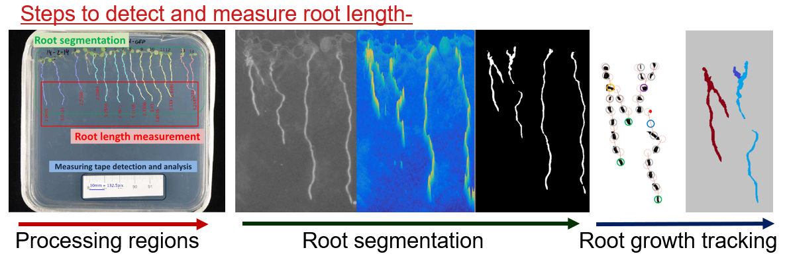

Figure 3: Steps to detect and measure root length (González et al., 2020).

**5. MACHINE LEARNING INTEGRATION IN PHENOLOGICAL STUDY**

Machine learning in crop modelling involves applying advanced algorithms to develop predictive models that simulate crop growth, yield, and responses to environmental factors by utilizing large datasets from sources like weather, soil properties, remote sensing, and historical yield records, thus capturing complex relationships between these variables; it includes feature selection to identify relevant factors affecting crop performance, predictive modelling using techniques such as decision trees and neural networks to forecast yield and growth stages, and robust calibration methods that enhance model reliability through comparisons with observed data; this approach effectively addresses non-linear interactions, integrates remote sensing data for real-time health assessments, optimizes management practices like irrigation and fertilization, aids in adapting to climate change impacts, and supports decision-making through decision support systems (DSS), ultimately advancing crop science and improving agricultural productivity and sustainability (Kganyago et al., 2024; Luo et al., 2023).

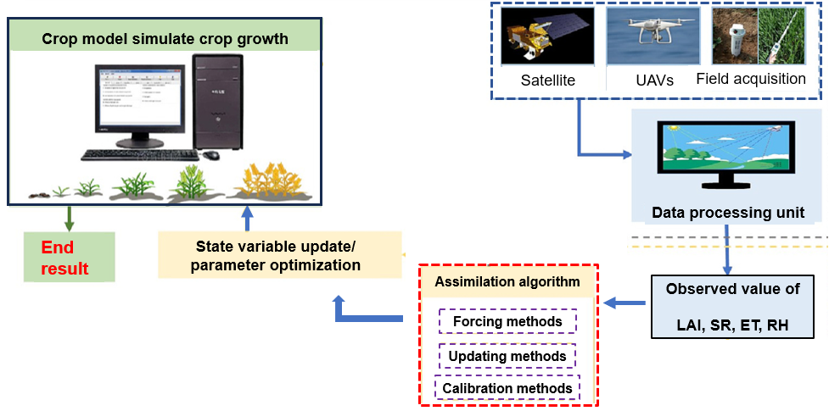

Figure 4: How machine learning algorithms work in crop modelling (Luo et al., 2023).

**6. CONCLUSION**

The incorporation of modern models and innovative technology has initiated a new age in plant phenological research, providing unparalleled chances to comprehend and enhance crop growth and development. This review emphasises the essential function of crop models, including MLCan, AquaCrop 7.0, InfoCrop v2.1, DSSAT, and OpenSimRoot, in simulating intricate interactions among genetic, environmental, and managerial variables. These models, spanning empirical to mechanistic methodologies, offer significant insights into crop phenology, yield forecasting, and resource utilisation efficiency, facilitating informed agricultural decision-making. The integration of new technology, including UAV-mounted sensors, NDVI, and sophisticated root imaging systems like MyROOT 2.0, has improved the accuracy and scalability of phenological observations. The incorporation of machine learning algorithms enhances the capabilities of these tools by identifying non-linear correlations and improving forecast accuracy. The agricultural industry has escalating problems from climate change and resource scarcity; thus, the integration of models, technologies, and data-driven methodologies will be crucial in establishing sustainable and resilient farming systems. Subsequent research must concentrate on enhancing these instruments, augmenting their accessibility, and incorporating them into real-time decision support systems to optimise their influence on global food security.However, these models and technologies still face limitations, including data availability constraints, model generalizability issues, and computational demands. Further research is needed to address these challenges and enhance their practical applicability in diverse agricultural settings.

**Disclaimer (Artificial intelligence)**

The authors hereby declare that no generative artificial intelligence (AI) technologies, including but not limited to Large Language Models (e.g., ChatGPT, Copilot) or text-to-image generators, were used in the writing, editing, or preparation of this manuscript.

References

Adeleke, A. A. (2024). Technological advancements in cotton agronomy: a review and prospects. Technology in Agronomy, 4(1).

Aggarwal, P. K., Kalra, N., Chander, S., & Pathak, H. (2006). InfoCrop: a dynamic simulation model for the assessment of crop yields, losses due to pests, & environmental impact of agro-ecosystems in tropical environments. Agricultural Systems, 89(1), 1-25.

Ahmad, U., Nasirahmadi, A., Hensel, O., & Marino, S. (2022). Technology & data fusion methods to enhance site-specific crop monitoring. Agronomy, 12(3), 555.

Ayankojo, I. T., Thorp, K. R., & Thompson, A. L. (2023). Advances in the application of Small Unoccupied Aircraft Systems (sUAS) for high-throughput plant phenotyping. Remote Sensing, 15(10), 2623.

Ayankojo, I. T., Thorp, K. R., & Thompson, A. L. (2023). Advances in the application of Small Unoccupied Aircraft Systems (sUAS) for high-throughput plant phenotyping. Remote Sensing, 15(10), 2623.

Bahrami, H., McNairn, H., Mahdianpari, M., & Homayouni, S. (2022). A meta-analysis of remote sensing technologies & methodologies for crop characterization. Remote Sensing, 14(22), 5633.

Band, L. R., Fozard, J. A., Godin, C., Jensen, O. E., Pridmore, T., Bennett, M. J., & King, J. R. (2012). Multiscale systems analysis of root growth and development: modeling beyond the network and cellular scales. The Plant Cell, 24(10), 3892-3906.

Bessembinder, J. J. E., Dhindwal, A. S., Leffelaar, P. A., Ponsioen, T. C., & Singh, S. (2003). Analysis of crop growth. In Water productivity of irrigated crops in Sirsa District, India.

Bhatia, A. K. (2014). Crop growth simulation modeling. In Modelling & Simulation of Diffusive Processes: Methods & Applications. Cham: Springer International Publishing.

Centorame, L., Gasperini, T., Ilari, A., Del Gatto, A., & Foppa Pedretti, E. (2024). An overview of machine learning applications on plant phenotyping, with a focus on sunflower. Agronomy, 14(4), 719.

Chapagain, R., Remenyi, T. A., Harris, R. M., Mohammed, C. L., Huth, N., Wallach, D., ... & Ojeda, J. J. (2022). Decomposing crop model uncertainty: A systematic review. Field Crops Research, 279, 108448.

Dhillon, M. S., Dahms, T., Kuebert-Flock, C., Borg, E., Conrad, C., & Ullmann, T. (2020). Modelling crop biomass from synthetic remote sensing time series: Example for the DEMMIN test site, Germany. Remote Sensing, 12(11), 1819.

Dlamini, L., Crespo, O., van Dam, J. & Kooistra, L. (2023). A global systematic review of improving crop model estimations by assimilating remote sensing data: implications for small-scale agricultural systems. Remote Sensing, 15(16), 4066.

Drees, L., Demie, D. T., Paul, M. R., Leonhardt, J., Seidel, S. J., Döring, T. F., & Roscher, R. (2024). Data-driven crop growth simulation on time-varying generated images using multi-conditional generative adversarial networks. Plant Methods. 20(1), 93.

Farahani, M. A., Vahid, A., & Goodwell, A. E. (2022). Evaluating ecohydrological model sensitivity to input variability with an information-theory-based approach. Entropy, 24(7), 994.

González, A., Sevillano, X., Betegón-Putze, I., Blasco-Escámez, D., Ferrer, M., & Caño-Delgado, A. I. (2020). MyROOT 2.0: An automatic tool for high throughput and accurate primary root length measurement. Computers and electronics in agriculture, 168, 105125.

Herr, A. W., Adak, A., Carroll, M. E., Elango, D., Kar, S., Li, C., ... & Singh, A. K. (2023). Unoccupied aerial systems imagery for phenotyping in cotton, maize, soybean, & wheat breeding. Crop Science, 63(4), 1722-1749.

Jamil, N., Kootstra, G., & Kooistra, L. (2022). Evaluation of individual plant growth estimation in an intercropping field with UAV imagery. Agriculture 12(1), 102.

Jiaying, M. A., Tingting, C., Jie, L., Weimeng, F., Baohua, F., Guangyan, L., ... & Guanfu, F. (2022). Functions of nitrogen, phosphorus and potassium in energy status and their influences on rice growth and development. Rice Science, 29(2), 166-178.

Jones, J. W., Hoogenboom, G., Porter, C. H., Boote, K. J., Batchelor, W. D., Hunt, L. A., ... & Ritchie, J. T. (2003). The DSSAT cropping system model. European journal of agronomy, 18(3-4), 235-265.

Kganyago, M., Adjorlolo, C., Mhangara, P., & Tsoeleng, L. (2024). Optical remote sensing of crop biophysical & biochemical parameters: An overview of advances in sensor technologies & machine learning algorithms for precision agriculture. Computers & Electronics in Agriculture, 218, 108730.

Kriedemann, P. E., Virgona, J. M., & Atkin, O. K. (2017). Chapter 6. Growth analysis: a quantitative approach. Price C, Munns R (Chapter editors). Plants in action. Australian Society of Plant Scientists 2nd edition. https://www. asps. org. au/plants-in-action-2nd-edition-pdf-files.

Li, C., Adhikari, R., Yao, Y., Miller, A. G., Kalbaugh, K., Li, D., & Nemali, K. (2020). Measuring plant growth characteristics using smartphone based image analysis technique in controlled environment agriculture. Computers and Electronics in Agriculture, 168, 105123.

Liu, S., Li, X., Larsen, D. H., Zhu, X., Song, F., & Liu, F. (2017). Drought priming at vegetative growth stage enhances nitrogen‐use efficiency under post‐anthesis drought and heat stress in wheat. Journal of Agronomy and Crop Science, 203(1), 29-40.

Lu, Y., Chibarabada, T. P., McCabe, M. F., De Lannoy, G. J., & Sheffield, J. (2021). Global sensitivity analysis of crop yield & transpiration from the FAO-AquaCrop model for dryland environments. Field Crops Research, 269, 108182.

Luo, L., Sun, S., Xue, J., Gao, Z., Zhao, J., Yin, Y., ... & Luan, X. (2023). Crop yield estimation based on assimilation of crop models & remote sensing data: A systematic evaluation. Agricultural Systems, 210, 103711.

Manschadi, A. M., Palka, M., Fuchs, W., Neubauer, T., Eitzinger, J., Oberforster, M., & Soltani, A. (2022). Performance of the SSM-iCrop model for predicting growth and nitrogen dynamics in winter wheat. European Journal of Agronomy, 135, 126487.

Meng, Y., Xu, M., Yoon, S., Jeong, Y., & Park, D. S. (2022). Flexible and high quality plant growth prediction with limited data. Frontiers in Plant Science, 13, 989304.

Pandey, R., Paul, V., Das, M., Meena, M., & Meena, R. C. (2017). Plant growth analysis. Manual of ICAR Sponsored Training Programme on “Physiological Techniques to Analyze the Impact of Climate Change on Crop Plants, 103-107.

Pasquel, D., Roux, S., Richetti, J., Cammarano, D., Tisseyre, B., & Taylor, J. A. (2022). A review of methods to evaluate crop model performance at multiple & changing spatial scales. Precision Agriculture, 23(4), 1489-1513.

Paturkar, A., Sen Gupta, G., & Bailey, D. (2021). Making use of 3D models for plant physiognomic analysis: A review. Remote Sensing, 13(11), 2232.

Paturkar, A., Sen Gupta, G., & Bailey, D. (2022). Plant trait measurement in 3D for growth monitoring. Plant Methods, 18(1), 59.

Rana, S. S., & Rana, R. S. (2014). Advances in crop growth and productivity. Department of Agronomy, Palampur, 2014, 29-54.

Rizkiana, A., Nugroho, A. P., Irfan, M. A., Sutiarso, L., & Okayasu, T. (2019, December). Crop growth prediction model at vegetative phase to support the precision agriculture application in plant factory. In AIP Conference Proceedings (Vol. 2202, No. 1). AIP Publishing.

Sheikh, M., Iqra, F., Ambreen, H., Pravin, K. A., Ikra, M., & Chung, Y. S. (2024). Integrating artificial intelligence and high-throughput phenotyping for crop improvement. *Journal of Integrative Agriculture*, *23*(6), 1787-1802.

Singh, J., Singh, L., & Kumar, A. (2021). Estimation of leaf area by mobile application: Fast and accurate method. Pharma Innov. J, 10(4), 272-275.

Tessmer, O. L., Jiao, Y., Cruz, J. A., Kramer, D. M., & Chen, J. (2013). Functional approach to high-throughput plant growth analysis. BMC systems biology. 7, 1-13.

Vigneault, P., Lafond-Lapalme, J., Deshaies, A., Khun, K., de la Sablonnière, S., Filion, M., ... & Mimee, B. (2024). An integrated data-driven approach to monitor and estimate plant-scale growth using UAV. ISPRS Open Journal of Photogrammetry and Remote Sensing, 11, 100052.

Wang, T., Qu, Y., Xia, Z., Peng, Y., & Liu, Z. (2019). Multi-scale validation of MODIS LAI products based on crop growth period. ISPRS International Journal of Geo-Information, 8(12), 547

Yang, G., Liu, J., Zhao, C., Li, Z., Huang, Y., Yu, H., ... & Yang, H. (2017). Unmanned aerial vehicle remote sensing for field-based crop phenotyping: current status and perspectives. Frontiers in plant science, 8, 1111.