Soilless Cultivation of Lettuce (Lactuca sativa): Impact of Fertilizers on Growth and Disease Reduction in Burkina Faso
Soura Hervé^{1,3,5}, Dianda Issa¹, Sama Hemayoro², Koita Kadidia³, Gnancadja Léopold⁴, Savadogo Aly⁵
1-University of Fada N’Gourma/Higher Institute of Sustainable Development
2- Joseph Ki-Zerbo University/ Laboratory of Biochemistry and Applied Chemistry (LABIOCA)
3-Joseph Ki-Zerbo University/Biosciences Laboratories
4-University of Abomey Calavi/Department of Plant Biology
5-Joseph Ki-Zerbo University/Laboratory of Biochemistry and Applied Immunology (LABIA)
Corresponding author: Soura Hervé, Email: sbanemane@yahoo.fr; 0022675181446
Original Research Article
Abstract
In market gardening, some common agricultural practices pose environmental and health concerns. Indeed, household waste, biomedical waste, sewage sludge and many others are used as fertilizer for production. Also the acidification of soils due to the mineral fertilizers used constitutes real problems. Lettuce is the fourth market garden product cultivated with approximately 8% of the cultivated areas. Its cultivation requires even more attention as it is consumed without any prior cooking. In addition, lettuce is considered one of the species that accumulates heavy metals. It is within this framework that this study takes place, the objective of which is to contribute to the improvement of lettuce production. Four types of fertilizers were used: cow dung, poultry manure, compost and NPK. The methodology used consisted of using disused of 1.5 liter cans, serving as containers. Each can has two openings serving as pockets into which coconut fibers constituting the substrate are introduced. The entire system is installed at a height of 1 m. At maturity, the average agro-morphological parameters measured give the following results: 38 leaves with compost and 35 with NPK, 17 cm and 14.13 cm in height respectively with compost and NPK, 14.13 cm with compost and 12.2 cm with NPK for leaf width, 15.13 cm with compost and 13.40 cm with NPK for leaf length. For total fresh biomass, we obtained an average mass of 156.86 g with compost and 147.2 g with NPK. Compost is the fertilizer best suited to the experimented system, followed by NPK. We did not observe any symptoms of leaf disease, proof that the device can help eradicate infections. Soilless agriculture can be a sustainable solution for food security in addition to other environmentally friendly agricultural systems.
Keywords: diseases, fertilizers, lettuce, pests, soilless

Introduction
Preserving the environment is a concern for the national and international community (Ahouangninou, 2013). Since the publication of the Brundtland report of the United Nations Commission on Environment and Development in 1987, the environmental dimension is now taken into account in any development strategy (Ahouangninou, 2013). The established term “sustainable development” is often used to describe different sectors of development. Thus in the agricultural sector, the concept of sustainable agriculture designates productive agriculture, economically profitable, transmissible, respectful of the environment and human health and which is able to resolve the problem of food security.
In this sector, market gardening is an activity that is widely practiced in urban and peri-urban areas, thus constituting a source of supply for cities with foodstuffs as well as a source of income for market gardeners mainly from the disadvantaged segment of the population (FAO, 2020). However, certain practices observed in this activity may raise concerns. Indeed, waste (household, biomedical, sewage sludge, etc.) is used as fertilizer for market gardening soils mainly in urban and peri-urban areas. If such practices allow the development of plants thanks to the provision of organic matter, they are also potential, even proven, sources of contamination of these same soils and also of the foods resulting from these practices (Bagbila, 2007; Wang et al, 2015; Maucieri et al, 2019; Kiba et al., 2012; Dauvergne, 2014).
In addition, it appears from the general agricultural census in 2010 that the exploitation of the majority of market gardening sites is seasonal, i.e. 79.5% of sites. Yet, vulnerable landless families in the urban environment need daily, year-round availability of fresh vegetables for home consumption and sale (FAO, 2020). Indeed, according to the FAO (2016), legumes constitute the second contributing link to food energy availability (DEA) at 11% behind cereals in Burkina Faso.
Among the products from market gardening in Burkina Faso, lettuce occupies fourth place with around 8% of the areas planted behind bulb onions, tomatoes and cabbage. Its cultivation requires even more attention as it is consumed without any prior cooking. In addition, lettuce is considered one of the species that accumulates heavy metals (Zorrig, 2011). To overcome all these numerous problems, soilless crops can be an alternative.
According to the FAO (2020), soilless crops bring a series of improvements for the farmer. They allow better control of the supply of water and mineral elements, to lighten certain heavy tasks such as plowing the soil, hoeing, weeding. Also, they promote the obtaining of better quality products, the valorization of all available spaces, as well as production throughout the year. Thus, it seems crucial to find good methods to optimize production while reducing the risks of various contamination and diseases.
Material and methods
Presentation of the study site
The Boucle du Mouhoun region constitutes one of the thirteen (13) administrative regions of Burkina Faso. It is made up of six (6) provinces (Balé, Banwa, Kossi, Mouhoun, Nayala and Sourou), six (6) urban communes, forty-one (41) rural communes and 985 villages. The geographical position of the region, the abundance of its natural resources and its agricultural production as well as the presence of the Abidjan-Ouagadougou railway make it the “breadbasket of Faso” and a hub for inter-regional trade in agricultural products. The Boucle du Mouhoun records nuances from North to South. Indeed, in the North in the South-Sahelian sector, the vegetation evolves from shrub steppe to tree steppe and in the South, to savannah. In the Center, in the North Sudanese sector, shrub and tree savannahs, mixed formations of valleys associated with hills dominate. Finally, to the South in the South Sudanese sector, the wooded savannah extends with gallery forests along the watercourses (Medev, 2005). These plant formations provide shelter for a fairly rich and varied fauna. It is largely made up of small game (hares, small antelopes, rats, squirrels, doves, etc.). The big game encountered consists mainly of a few herds of hippos, buffaloes, elephants (fully protected species), warthogs, hyenas, lions and panthers (Medev, 2005).

Plant material
We used the Ballerina RZ lettuce variety. It is a dwarf variety which adapts better to our device. Indeed, the height of our device requires the use of dwarf varieties in order to obtain more stable plants in order to avoid the effect of gravity.
Material for the experimental setup
The material used as part of the installation of the experimental device essentially consisted of 150 1.5 liter cans recovered after use which will serve as containers, 60 pieces of wood including 30 pieces of 1 m wood and 30 pieces of 1.10 m wood which were fixed vertically to support the boards. 30 boards of 1.6 m in length fixed to the wood and used as support for the installation at height of the containers; in fact, the 1.5 l cans are fixed to the boards using strings. The boards are first fixed to the wood using tacks. The coconut fibers used as a substrate are then introduced into the openings of the cans. These coconut fibers were obtained after using and discarding coconuts. These nuts are cut using a steel blade and the fibers are removed from the nuts by hand. NPK fertilizer with formula 14-23-14, organic manure, poultry (chicken) droppings and cow dung were used as fertilizers and thus represent our different treatments.

Methods
The device used is a Ficher block with three completely randomized repetitions.
The method used is as follows: 150 1.5 liter drums are used as containers. Two openings are made on the surface of each can representing the pockets. The base of each can is opened using a pre-heated No. 17 pipe wrench. After each opening, a perfect fit immediately follows with the upper part of another can of the same type. The coconut fibers constituting our substrate are introduced into each surface opening (pocket).
The antlers are fixed as follows:
A 1 m long log and another 1.1 m long are well fixed to the ground and aligned following the general direction (east-west) of the high winds in the area. A board with a minimum width of 1.6 m is fixed using No. 8 spikes on each line of planted wood.
The cans fitted together and numbering 5 cans per line are fixed to the boards using strings. Figure 1 shows a summary of the different stages of setting up the experimental device.

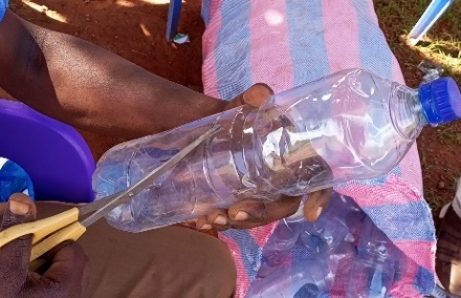
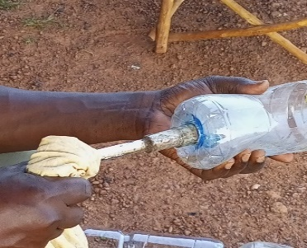
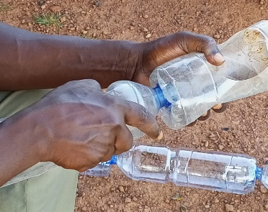

a
d
b
c
e

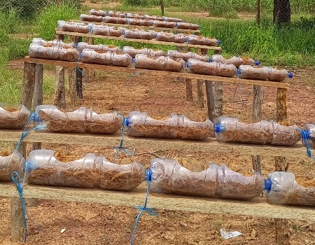
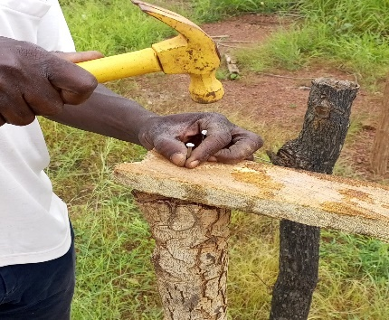
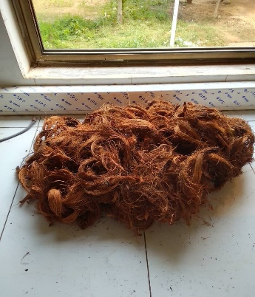
f
Figure 1: Summary of the implementation of the system
Legend: a: drilling of cans; b: perforation of the base of the cans; c: nesting of the cans; d: fixing the boards at a height of 1 m; e: coconut fibers; f: final device.
Five treatments were carried out:
T0 = ​​controls without fertilizer
T1 = fertilization with NPK 15-15-15 at a rate of 1 g per pocket
T2 = fertilization with compost at a rate of 150 g per pocket
T3 = fertilization with chicken droppings at a rate of 150 g per pocket
T4 = fertilization with cow dung at a rate of 150 g per pocket
In each replication, each treatment contains two seed lines and each seed line consists of 5 cans with 2 pockets per can. Figure 2 gives an overview of the experimental setup.

0,5 m
10,5 m

8,5 m

1,5 m

1,5 m
3 m

Figure 2: Experimental setup

Data collection
Agromorphological and yield parameters, as well as disease assessment were evaluated. The following measurements were carried out:
• the emergence rate 7 days after sowing (JAS)
• the number of leaves (NbF) per plant on the 14th and 45th DAS
• plant height (HtP) in cm on the 14th and 45th DAS
• the width of the leaves (LaF) in cm at the 14th and 45th DAS
• the length of the leaves (LoF) in cm at the 14th and 45th DAS
• evaluation of total fresh biomass
• assessment of disease incidence
𝐈𝐧𝐜 (%) = (𝐍DP/𝐓N𝐏) ∗ 𝟏𝟎𝟎
Inc: Incidence
NDP: number of diseased plants
TNP: total number of plants
- pest identification
Pests were assessed by direct observation on plants. The insects were counted by species and the damage caused by each species was evaluated according to the following formula:
%PR = (NPD/NTP) ∗100
%PR: percentage of plants destroyed;
NPD: number of plants destroyed;
NTP: total number of plants per elementary plot

Statistical data processing
The data collected were entered and organized with the Excel 2021 spreadsheet. These data were subjected to an analysis of variance (ANOVA) using the XLSTAT software version 2016. The means were separated using the Newman and Keuls test at the 5% probability threshold.

Results and discussions
Results
Diseases and pests
During the conduct of the trial, we carried out careful daily monitoring of all the plants. No diseases were observed on the crops. On the other hand, we observed the presence of locusts on a few plants at the start of cultivation, but there was no remarkable damage.
Pod rate emerged on the 7th day after sowing
Sowing was carried out at the rate of two (2) seeds per pocket. A pocket is considered not emerged when no sign of germination is observed in the pocket on the 7th DAS. The raised poult rate evaluated on the 7th DAS showed in ascending order (figure 3) poultry droppings having the lowest rate followed by the control, NPK, cow dung and compost.

Figure 3: Emergence rate at 7th after sowing

Study of growth parameters in lettuce
All data on growth parameters were subjected to analysis of variance and pairwise comparison made with the Newman and Keuls test at the 5% threshold.
Effect of treatments on the number of leaves of plants on the 14th and 45th day after sowing
The analysis between the treatments on the 14th day after sowing revealed a very highly significant difference (P<0.0001) between the number of leaves of the plants fertilized with compost and NPK, between the plants fertilized with compost and those fertilized with cow dung, poultry droppings and the control (table 1).
Likewise, the analysis showed a very highly significant difference between plants fertilized using NPK and those fertilized with cow dung, poultry droppings as well as the control. On the other hand, no significant difference was observed between plants treated with poultry droppings, cow dung and the control.
On the 45th day after sowing, the control plants, the plants fertilized with cow dung and those with poultry manure all died. The average number of leaves was 38 for the compost treatments and 35 for the NPK treatments. The analysis revealed that there was no significant difference between the compost and NPK treatments.
Table 1: Average number of leaves on the 14th and 45th day after sowing
Treatments | NbF14 | NbF45
FO | 5,8 ± 0,17a | 38,2 a
NPK | 4,86 ± 0,16b | 34,73 b
FV | 3,4± 0,16c | 0 c
TM | 3,06 ± 0,11c | 0 c
BV | 2,93± 0,15c | 0 c
Probability | < 0,0001 | < 0,0001
R² | 0,7763 | 0,9964
Signification | VHS | VHS
Legend: FO: Compost; NPK: nitrogen, potassium, phosphorus; FV: poultry droppings; TM: witness; BV: cow dung; NbF14: number of leaves on the 14th day after sowing; NbF45: number of leaves on the 45th day after sowing; HRT: very highly significant.
Effect of treatments on plant height on the 14th and 45th day after sowing
The analysis between the treatments at the 14th DAS showed a very highly significant difference between the height of the plants of all the treatments except fertilizations with poultry manure and those with cow dung which presented no significant difference between them (table 2).
At the 45th DAS, the analyzes made it possible to observe a very highly significant difference between the height of plants treated with compost and those treated with cow dung (table 2). The average heights were 17 cm and 14 cm for the compost and NPK treatments respectively.

Table 2: Average plant height on the 14th and 45th day after sowing
Treatments | HtP14 | HtP45
FO | 5,8 ± 0,17a | 17± 0,28a
NPK | 4,93 ± 0,18b | 14,13± 0,33b
FV | 3,6± 0,26c | 0c
TM | 2,53 ± 0,13d | 0c
BV | 3,13± 0,13c | 0c
Probability | < 0,0001 | < 0,0001
R² | 0,7328 | 0,9755
Signification | VHS | VHS
Legend: FO: compost; NPK: nitrogen, potassium, phosphorus; FV: poultry droppings; TM: witness; BV: cow dung; HtP14: plant height on the 14th day after sowing; HtP45: plant height on the 45th day after sowing; HRT: very highly significant.

Effect of treatments on plant leaf width on the 14th and 45th day after sowing
The analysis between treatments on the 14th day after sowing revealed that there was no significant difference between the leaf width of plants fertilized with compost and those fertilized with NPK. But there is a significant difference with other treatments cow dung, poultry droppings. Also, there is no significant difference between treatments with cow dung and poultry droppings.
On the 45th day after sowing, the analysis revealed a very highly significant difference between the widths of the leaves of the plants treated with compost and those with NPK. The average width was 14.13 cm and 12.2 cm for the compost and NPK treatments respectively (table 3).

Table 3: Average leaf width on the 14th and 45th day after sowing
Treatment | LaF14 | LaF45
FO | 5 ± 0,33a | 14,13± 0,33a
NPK | 4,46 ± 0,21a | 12,2± 0,19b
FV | 2,06± 0,24b | 0c
TM | 1,73 ± 0,18b | 0c
BV | 1,86± 0,13b | 0c
Probability | < 0,0001 | < 0,0001
R² | 0,7216 | 0,9743
Signification | VHS | VHS
Legend: FO: Compost; NPK: nitrogen, potassium, phosphorus; FV: poultry droppings; TM: witness; BV: cow dung; LaF14: leaf width on the 14th day after sowing; LaF45: leaf width on the 45th day after sowing; HRT: very highly significant.

Effect of treatments on plant leaf length on the 14th and 45th day after sowing
The analysis between treatments on the 14th day after sowing showed that there was no significant difference between the length of the leaves of plants fertilized with compost and those fertilized with NPK (table 4). On the other hand, each of these two treatments presented a very highly significant difference with the control, the treatment based on cow dung and that based on poultry droppings. The analysis showed that there is no significant difference between the cow dung and poultry manure treatments.
On the 45th day after sowing, the analysis revealed a very highly significant difference between the treatments with compost and NPK.

Table 4: Average leaf length on the 14th and 45th day after sowing
Treatments | LoF14 | LoF45
FO | 5,13 ± 0,16a | 15,13± 0,31 a
NPK | 4,80 ± 0,17a | 13,40± 0,28 b
FV | 2,53± 0,13b | 0c
TM | 1,93 ± 0,11c | 0c
BV | 2,60± 0,19b | 0c
Probability | < 0,0001 | < 0,0001
R² | 0,8303 | 0,9722
Signification | VHS | VHS
Legend: FO: compost; NPK: nitrogen, potassium, phosphorus; FV: poultry droppings; TM: witness; BV: cow dung; LoF14: leaf length on the 14th day after sowing; LoF45: leaf length on the 45th day after sowing; HRT: very highly significant.

Total fresh biomass
After weighing the total fresh biomass (root and aerial biomass), we obtained an average weight of 156.86 g per plant for plants resulting from fertilization with compost and an average weight of 147.2 g for plants resulting from fertilization with NPK (figure 4).

Figure 4: Average total fresh mass of lettuce plants 45 days after sowing

Some images of the evolution of the plants at 14 days after sowing (figure 5), 21 days after sowing (figure 6) and 45 days after sowing (figure 7).

a 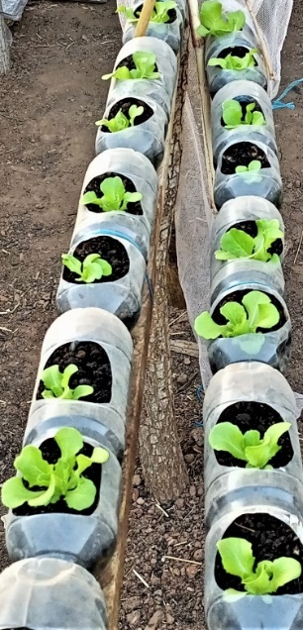 b 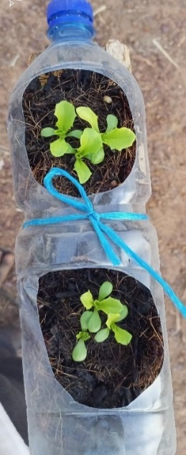 c 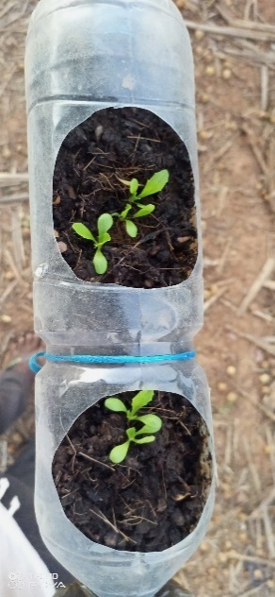 d 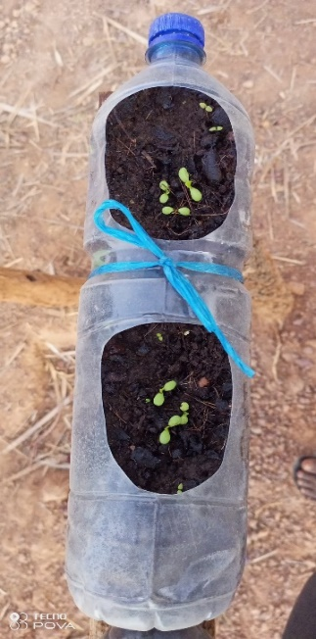
Figure 5: Crop overview on the 14th day after sowing
Legend: a: plants fertilized with organic manure; b: plants fertilized with NPK; c: plants fertilized with poultry droppings; d: plants fertilized with cow dung

a 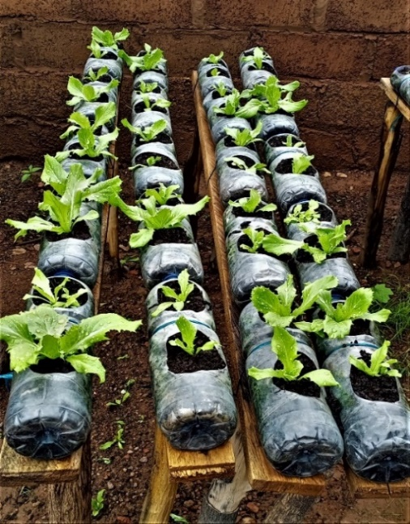 b 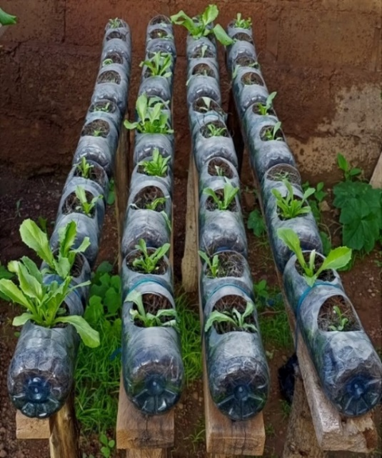
Figure 6: Overview of crops fertilized with FO and NPK on the 21st day after sowing
Legend: a: plants fertilized with compost; b: plants fertilized with NPK

a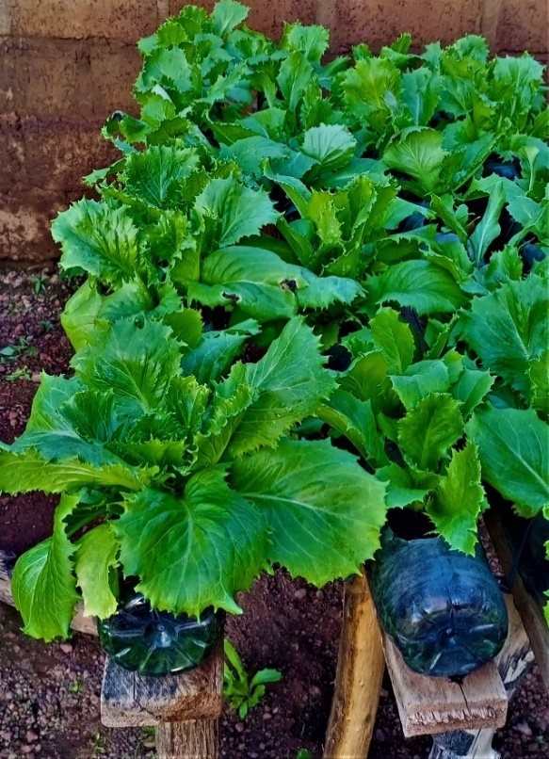b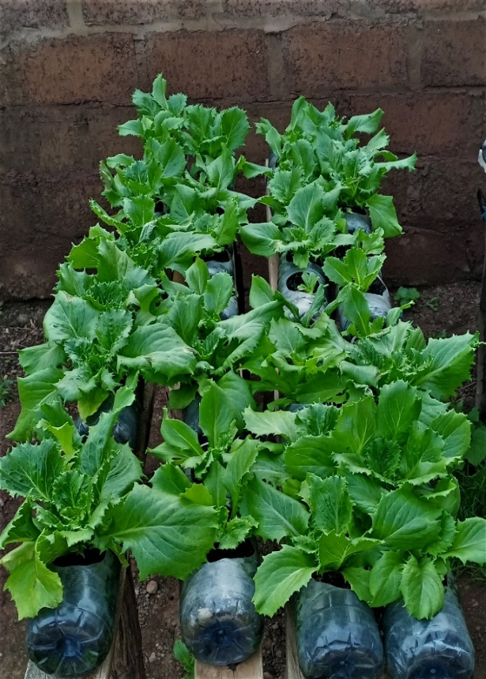
Figure 7: Overview of crops fertilized with FO and NPK on the 45th day after sowing
Legend: a: plants fertilized with compost; b: plants fertilized with NPK

Discussion
Despite careful observations throughout the cycle, no disease was detected on the crop. This could be explained on the one hand by the non-use of land which is generally a significant source of diseases and on the other hand by the fact that our system was at height. These observations are contrary to those of Barjon F. and Fogliani V., (2016) who identified Cercosporiosis and fire blight on lettuce grown above ground. This difference can be linked to the environment, the climate, but also to cultural conditions. In fact, they explained that these two diseases mainly occurred during periods of extreme heat and high humidity. So the fact that we produced in dry and cool countryside could therefore explain the absence of these diseases.
The observation of locusts as the only pests could be explained by the height of our device which can therefore escape most non-flying pests, but also certain pests which do not fly so high. The presence of locusts can be explained by the presence of a shed covered with a large quantity of straw near the study site. Indeed, we were able to observe the presence of a large number of locusts in this shed which served as their habitat.
According to the results, we notice a relatively low germination rate (51%) in the treatment with poultry droppings. This could be explained by an immediate availability of the elements nitrogen, phosphorus and potassium in the pots, which with the constant humidity would have affected the gemmules from the start of germination. Mokolo et al. (2024) in Congo found that from 200 g of chicken droppings per pocket, the emergence of certain cultivars was considerably reduced. The highest germination rate was observed in the compost treatment. This could be explained by the fact that at the compost level, the availability of mineral elements is slower and progressive.
Analyzes of all the parameters measured showed that fertilization with compost and NPK gave the best results. Regarding agro morphological parameters, most studies on lettuce fertilization have focused most on the number of leaves because leaves are the most important part in most lettuce production. On average, the number of leaves was 4 and 6 respectively for the NPK and compost treatments on the 14th day after sowing and 35 and 38 on the 45th day after sowing in the same order. This shows good plant growth with these two treatments. These results are similar to those of Konaté et al., (2022) who reported during their work to determine the optimal dose of compost on lettuce; that the best dose made it possible to obtain between 4 and 6 leaves per plan on the 15th day after transplanting.
The average number of leaves (35 and 38) obtained respectively with NPK and compost are contrary to the work of Garba et al., (2022) who reported an average of 27 leaves per plant. In fact, they had used a headed variety and their counting only concerned the spreading leaves; this could therefore explain this difference in number of leaves observed. Also, this result differs from those of Tchaniley et al., (2020) who obtained a better average of 29 leaves per plant. This difference could also be explained by the fact that they had only counted well-developed leaves.
At the 45th day after sowing, the average leaf widths were 14.13 cm and 12.2 cm for the compost and NPK treatments respectively. These data corroborate those of Garba et al., (2022) who found average lengths of 12 cm after fertilizing lettuce with phosphocompost and NPK.
The average lengths of 15.13 cm and 13.4 cm found with compost and NPK respectively corroborate those of Garba et al., (2022). In fact, they measured on average 12 cm and 13 cm respectively for the treatments with compost and NPK.
Treatments with cow dung and poultry droppings did not have positive effects on the agro-morphological parameters measured. In the case of cow dung, this weak effect could be linked to its lack of nutrients available to plants in the short term. Indeed, Jenni (2013), by comparing poultry droppings to cattle manure, concluded that cattle manure was relatively poor in nutrients and released them very slowly. In the case of poultry droppings, poor plant development could be explained by an excess of one or more major elements N, P and K, but also trace elements such as calcium (Ca) and magnesium (Mg). Thus, applying poultry manure in its raw state without the presence of soil could have considerable harmful consequences on the seedlings. Indeed, Koffi-Nevry et al., (2012) who found in their analyzes that chicken droppings have a very high nitrogen and potassium content compared to all the animal droppings they had studied. These same authors add that the nitrogen contained in chicken droppings is quickly available to the plant.
The total fresh masses (root and aerial mass) weighed were 156.86 g and 147.2 g respectively for the treatments with compost and NPK. These results corroborate those of Adouane et al., (2022) who found masses of which the best were between 140 g and 160 g per plant during their research on optimal doses of poultry manure for the production of lettuce.
Conclusion
The results of our work show that coconut fiber can be used as a substrate in 1.5 liter cans for the production of lettuce if the fertilizer used is suitable. As for fertilizers, it appears from this study that among the fertilizers used (cow dung, poultry droppings, NPK, and compost), some such as NPK and compost adapt and give better results compared to poultry droppings and cow dung. Regarding diseases and pests, no diseases were observed and only one type of pest was identified at a given period of cultivation. In order to improve production, productivity and ensure better popularization of this above-ground lettuce cultivation system in our country, this study requires additional experiments, namely carrying out the study in several different climatic zones in order to see its adaptation according to the climate, developing a semi-automatic irrigation system to make irrigation easy and optimize the use of water; test other types of fertilizers to better understand the most suitable ones. With global warming, population growth, mining, fertile agricultural land is becoming increasingly scarce. It is therefore important to move towards other agricultural systems to achieve food self-sufficiency. Food security is a big challenge today. and some practices like soilless agriculture can help fill the gap.
Disclaimer (Artificial intelligence)
Author(s) hereby declare that NO generative AI technologies such as Large Language Models (ChatGPT, COPILOT, etc.) and text-to-image generators have been used during the writing or editing of this manuscript.

References
Abid, G. ; Muhovski, Y. ; Mingeot, D. ; Watillon, B. ; Toussaint, A. ; Mergeai, G. ; M'hamdi, M. ; Sassi, K. ; Jebara, M. (2015). Identification and characterization of drought stress responsive genes in faba bean (Vicia faba L.) by suppression subtractive hybridization. Plant Cell Tiss Organ Cult, DOI 10.1007/s11240-014-0707-x.
Ahouangninou, C. (2013). Sustainability of vegetable production in southern Benin: a test of the ecosystem approach. Doctoral Thesis: Environmental Management. Environment, health and sustainable development: University of Abomey-Calavi. Cotonou, Bénin, 349 p.
Bagbila, J. (2007). “Use of urban waste in market gardening: risks of contamination of plants by heavy metals”. Final dissertation for rural development engineer, Agronomy option, Polytechnic University of Bobo-Dioulasso, Institute of Rural Development (IDR), Bobo-Dioulasso, Burkina, 75p
Barjon, F; Fogliani, V. (2016). Improvement 2 SM2 Management and control of diseases and pests of above-ground crops. Directorate of Rural Development of the South province (New Caledonia) 66 p.
De Vries, I. M. (1997). Origin and domestication of Lactuca sativa L. Genet. Resour. Crop Evol. 44, 165–174. doi: 10.1023/A:1008611200727 cadmium chez la laitue " Lactuca sativa ".Thèse. Montpellier SupAgro, 250p.
Dauvergne, S. (2014). Urban and peri-urban spaces for agricultural use in cities of sub-Saharan Africa (Yaoundé and Accra): an approach to intermediality in geography. Thesis, UNS of Lyon, France. 390 p.
FAO. (2022). Presentation of FAO Burkina's soilless production. Burkina Faso Food Security Cluster. Food and Agriculture Organization of the United Nations 21 p.
FAO. 2020. Country nutrition overviews – case of Burkina Faso. April 98.
FAO. (2016). The biodiversity and humanity service. Archives of documents of FAO (on ligne). Disponible safe: http://www.fao.org/docrep/004/v1430f/V1430F04.htm.
Garba, O.; Zanguina, A.; Mella, M.T.; Addam Kiari, S.; Saidou, I.M. (2022). Study of the agronomic effectiveness of harvest waste composts on two market garden crops: tomato and lettuce. IOSR Journal of Applied Chemistry (IOSR-JAC) e-ISSN: 2278-5736.Volume 15, Issue 8 Ser. I (August 2022), PP 68-77.
Jenni, S. (2013). Heat and lettuce: a duo that does not go well together. CRDH-AAFC. 6p. FAOSTAT (Statistical of Food and Agriculture Organization), 2019: Data from the FAOSTAT Statistical data. Available from www.fao.org.
Kiba, T.; Feria-Bourrellier, A.B.; Lafouge, F.; Lezhneva, L.; Boutet-Mercey, S.; Orsel,
M. (2012). The Arabidopsis nitrate transporter NRT2.4 plays a double role in roots and shoots of nitrogen-starved plants. Plant Cell 24, 245–258. doi: 10.1105/ tpc.111.092221.
Koffi-Nevry, R. ; Assi-Clair, B.J. ; Assemand, E.F.; Affou, S.W. ; Koussemon, M. (2012). Origin of witnesses of faecal contamination of lettuce (Lactuca sativa) irrigation water grown in the peri-urban area of ​​Abidjan. Journal of Applied Biosciences 52: 3669– 3675.
Konate, Z.; N’ganzoua. K.R.; Bi-Zro, F.G.; Bakayoko, S.; Camara, M. (2022). Effect of different doses of chicken manure compost on soil fertility and agronomic parameters of lettuce (Lactuca sativa L.) Agronomy Africaine Sp. 34 (1): 117 – 131
Medev. (2005). Mouhoun loop region: Strategic framework for combating poverty, 105p
Mokolo, J.B; Issali, E.E; Ossete, B.C;Mpika, J; Attibayeba. (2024). Effect of two doses of chicken droppings on the emergence and growth of four local cultivars of edible Cucurbitaceae grown in the Republic of Congo J. Appl. Biosci. Flight: 194.
Maucieri, C.; Nicoletto, C., Junge, R., Schmautz, Z., Sambo, P., Borin, M. (2019). Hydroponicsystems and water management in aquaponics: areview. Italien Journal of Agronomie. 13:1–11.
Tchaniley, L.; Ayisah, K.; Dewa, K.K.A. (2020). Effect of the combination of organic and mineral fertilizers (NPK 15-15-15 and urea) on the yield of lettuce (Lactuca sativa L.) in southern Togo. Journal of Applied Biosciences 151:15540–15549. https://doi.org/10.35759/JABs.151.3.
Wang, Y., Lu, H., Raid, R.N., Nuessly, G.S., Faroutine, G. (2015). Diverse responses of lettuce cultivars and germplasm lines to infections of three isolates of Xanthomonas campestris pv. vitians. HortScience, 50, 650-655.
Zorrig, W. (2011). Search and characterization of determinants controlling the accumulation of http://www.Google, 2023.

