Original Research Article

Deciphering the Morpho-molecular and physiological characterization of Rhizopus stolonifera affecting Jackfruit rot

Abstract
Fruit rot caused by Rhizopus stolonifer (Ehrenb.) Vuill. is a common fungal disease of jackfruit (Artocarpus heterophyllus L.) that leads to fruit rotting in vegetative and maturity phases which restrains the emergence of flowers and fruits. Further identification of the pathogen was done by performing cultural, morphological, molecular and physiological characterization. On potato dextrose agar R. stolonifer produced whitish grey cottony growth initially followed by blackish mycelial growth in later days as its growth advanced. The fruit rot pathogen exhibited diverse mycelial growth patterns ranging from flat, raised to fluffy and densely cottony growth as it has the tendency to spread rapidly that covers entire Petri plate (90 mm). Morphologically, brownish straight sporangiophores along with globose sporangium was identified. Rhizopus stolonifer (black bread mold), thrive on damaged or decaying fruits. The fungus rapidly colonizes fruits under warm and humid conditions. It is highly destructive, with visible colonization and spoilage occurring within 24–48 hours. Fruit injuries and sugar content significantly influence fungal growth rates and spread​. Potato starch serves as a carbon source for Rhizopus, supporting its growth in industrial and laboratory settings. Rhizopus stolonifer are used in fermentation processes to saccharify starch into sugars. Growth is typically optimized with additional nutrients or under controlled conditions, as ungelatinized starch alone isn't fully utilized by the fungus. Columella was hyaline and cylindrical shaped that measured about 25.17 µm. Rhizoids were present profusely and stolons were also found. Among six different temperatures levels examined using potato dextrose broth, the highest average fresh and dry mycelium weight (920.17 and 260.62 mg) was observed at 35 °C and least dry mycelium weight (0.00 mg) was observed at 15 °C and at 40 °C on liquid media (potato dextrose broth). Among six different pH levels studied using potato dextrose broth, maximum growth of the fungus was recorded at pH 7.0 (981.76 mg of fresh and 302.78 mg of dry weight respectively) followed by pH 7.5 (924.13 mg and 269.26 mg) and pH 6.5 (748.51 mg and 183.32 mg). Least growth of the fungus was observed at pH 5.0 (330.71 mg and 82.43 mg).Pathogen was identified as Rhizopus stolonifer having 99.99 per cent homology and accession number PQ26879.
Keywords- Rhizopus stolonifer, Fruit rot, Jackfruit, CTAB
Introduction
Jackfruit (Artocarpus heterophyllus L.), a member of the Moraceae family, is a large tropical fruit tree widely cultivated in regions such as India, Bangladesh, Sri Lanka, the Philippines, Indonesia, Malaysia, and Australia. It has a diploid chromosome number of 56, typical of many species in the Artocarpus genus. Due to its highly perishable nature, managing jackfruit post-harvest and during transportation presents significant challenges (Dalavi et al., 2017). The tree bears flowers in spikes on short footstalks. Its branches, originating from the main trunk and auxiliary branches, are deciduous. Staminate branches typically terminate in smaller staminate spikes, except for a few thicker footstalks that carry pistillate and sterile blossoms, which later develop into fruits. Pollination is primarily wind-driven. The edible portion of the fruit is the fleshy carpel, botanically referred to as the perianth. Jackfruit contains high amounts of starch in its perianth and seeds. The fruit is rich in amino acids, including arginine, histidine, cystine, lysine, leucine, tryptophan, methionine, and threonine. Every 100 grams of ripe jackfruit flakes provides 280-312 milligrams of potassium and 25-70 milligrams of calcium. It is also abundant in magnesium, which plays a vital role in calcium absorption, strengthening bones, and preventing osteoporosis. Additionally, the iron content in jackfruit supports proper blood circulation and helps prevent anemia (Boruah and Barua, 2014).
Along with these minerals, jackfruit contains trace amounts of vitamins A and C. Uniquely, it is one of the few fruits rich in B-complex vitamins, including significant amounts of vitamin B6, riboflavin, folic acid, and niacin (Ranasinghe et al., 2019). Despite its significant production and numerous nutritional and health benefits, jackfruit is susceptible to several plant diseases. Notable among these are leaf spot caused by Colletotrichum lagenarium, pink disease caused by Corticium salmonicolor, stem rot caused by Phytophthora palmivora and brown rot caused by Fomes noxious (Parashar et al., 2018). Rhizopus fruit rot of jackfruit, caused by Rhizopus stolonifer, R. artocarpi and R. oryzae (Ghosh et al., 2015; Estrada et al., 2019; Partida et al., 2023), is a significant pre- and post-harvest issue, leading to substantial losses if not effectively managed. The disease initially manifests as soft, water-soaked lesions, which rapidly progress to severe decay accompanied by brown to black discoloration and a layer of white, cottony fungal growth, emitting a foul odour. In advanced stages, the entire fruit may collapse (Haque et al., 2023).
Young fruits and male inflorescences are particularly vulnerable, with only a limited number of fruits reaching full maturity (Patil, 2020). Many infected fruits deteriorate at the early stages of infection. Warm, humid, and rainy conditions promote the development of the rot, while wind, rain, and insects aid in dispersing the microscopic spores responsible for spreading the disease (Gerrits et al., 2019).
Among these, fruit rot caused by Rhizopus stolonifer is particularly critical leading to substantial economic losses (Sabtu et al., 2019). Rhizopus, a member of the Kingdom Fungi, belongs to the Phylum Zygomycota, Class Zygomycetes, Order Mucorales, Family Mucoraceae and Genus Rhizopus (Rogers et al., 2004). This pathogen is characterized by the presence of rhizoids, stolons and sporangiophores. It produces enzymes like pectinases and cellulases, which degrade plant cell walls, resulting in tissue maceration and rot. The fungus spreads via airborne sporangiospores and can infect jackfruit during storage, transportation, or in the field. While Rhizopus is primarily saprophytic, thriving on decaying organic matter, it can also act as an opportunistic pathogen (Benny et al., 2016).
As there is a meagre information available on physiological, cultural and molecular characterization of this prominent disease in jackfruit, the present paper is focussed on unravelling the molecular, cultural and physiological characterization of Rhizopus inciting fruit rot.
Material and method
Morphological Characterization of the Fruit Rot Pathogen
For morphological studies, a loopful of mycelial bits from a seven-day-old culture of the pathogen was collected. Slides were prepared by mounting the mycelia in water and examined under a compound microscope at varying magnifications. Observations included cultural characteristics such as colony color and growth pattern, as well as morphological traits like the size and shape of sporangiospores, color of sporangium, shape and size of columella, and the presence of rhizoids and stolons.
Physiological Characterization of the Fruit Rot Pathogen
Effect of Temperature on Pathogen Growth
The influence of temperature on fungal growth was assessed at six different temperature levels: 15 °C, 20 °C, 25 °C, 30 °C, 35 °C and 40 °C. One hundred milliliters of potato dextrose broth (PDB) were aseptically added to 250 mL conical flasks and sterilized at 121 °C under 15 psi pressure for 20 minutes. After cooling, the flasks were inoculated with 5 mm mycelial discs from a six-day-old fungal culture and incubated in a biological oxygen demand (BOD) incubator. Each temperature treatment was replicated three times. After 14 days of incubation, the cultures were filtered using Whatman No. 1 filter paper (12.5 cm diameter). The mycelial mat was dried in a hot air oven at 60 °C for two days. The fresh and dry weights of the mycelia were measured and subjected to statistical analysis.
Effect of pH on Pathogen Growth in Liquid Media
The growth of Rhizopus stolonifer was tested in potato dextrose broth (PDB) at different pH levels: 5.0, 5.5, 6.0, 6.5, 7.0, 7.5 and 8.0. The pH was adjusted using 0.1 N sodium hydroxide (alkali) or 0.1 N hydrochloric acid (acid). Mycelial discs (5 mm) were taken from a six-day-old culture using a cork borer and inoculated into 100 mL of PDB at each pH level. The flasks were incubated for 14 days, after which the cultures were filtered through Whatman No. 1 filter paper (12.5 cm diameter). Each pH treatment was replicated three times. The mycelial mats were air-dried in a hot air oven at 60 °C for two days, and their dry weights were recorded and analyzed statistically.
Molecular characterization
DNA extraction
Total fungal DNA was extracted from mycelia obtained from 100ml of potato dextrose broth for 4-6 days at 25 ± 1°C. Mycelium was harvested from liquid cultures by filtration through Whatman No. 3 filter paper, blot dried and subsequently ground into a fine powder in liquid nitrogen. DNA was extracted from the frozen mycelial powder by incubating at 37 °C for 10 min after the phenol: chloroform: isoamyl alcohol (25: 24: 1) precipitation. This was followed by precipitation with 0.54 volumes of isopropyl alcohol and centrifugation at 10,000 × g for 2 min. The DNA pel- let was washed with 70 % cold ethanol, dried at room temperature overnight (16 h) and then Pellet was re-suspended in 30 μl 10 mM TE buffer (pH 8.0). The DNA was preserved at a temperature of -20 °C.
Diagnostic PCR with universal fungal primers
The ITS region of rDNA of fungal isolates were amplified by PCR with universal primer pairs (White et al., 1990): ITS1 (5'-TCCGTA GGTGAACCTGCGG-3') and ITS4 (5'-TCCTCCGCTTATTGATA TGC-3) together with ITS 4 (expected fragment size of amplified product, 490 bp), expected to yield a 450-bp PCR product. PCR reactions (50 μl) were performed with primer pair ITS1/ITS4 and species- specific primer/ITS4 in an Eppendorf master cycler by 34 cycles of denaturation at 94°C for 60 s, annealing at 55°C for 60 s, and extension at 72°C for 1.5 min with an initial denaturation of 5 min at 94°C before cycling and final extension of 5 min at 72°C after cycling. Amplified PCR products were separated in 2% agarose gels in Tris-Borate-EDTA (TBE) buffer and visualized under UV after staining with ethidium bromide (0.5 μg/ml). Primers, all the reagents and restriction enzymes used in this study were procured from Fermentas Life Sciences, Bangalore, India.
Sequencing of the ribosomal ITS region
Amplified ITS region of rDNA products (789 bp) with primer pair (ITS 1 and ITS 4) were purified using PCR product purification kit KT 72 (Genei, Bangalore). The purified product (10-12 ng) was used for PCR cycle sequencing using Big Dye Terminator ready reaction Mixture kit (Applied Bio systems, USA) and analyzed with ABI 3100 analyzer capillary machines. The nucleotide sequence generated from R. stolonifer were deposited in the NCBI data base (http://www.ncbi.nlm.nih. gov/) to get accession number.
Phylogenetic analysis
A multiple-sequence alignment was performed with similar reference sequences of other Rhizopus isolate available in the NCBI database using CLUSTAL X (Thompson et al., 1994) and a BLAST similarity test was also performed. The regions of sequence ambiguity and positions that were not available for all of the sequences compared were omitted before undertaking the phylogenetic analysis. Phylogenetic tree was constructed from the aligned sequences with the original data set and 100 bootstrap data sets generated by Clustal X.
Results and Discussion
The fruit rot pathogen R. stolonifer was isolated from infected rind portion of the fruit depicting representative symptoms. The isolation of collected fruits was performed on Potato Dextrose Agar medium by employing the standard tissue isolation.
Morphological characterization of R. stolonifer
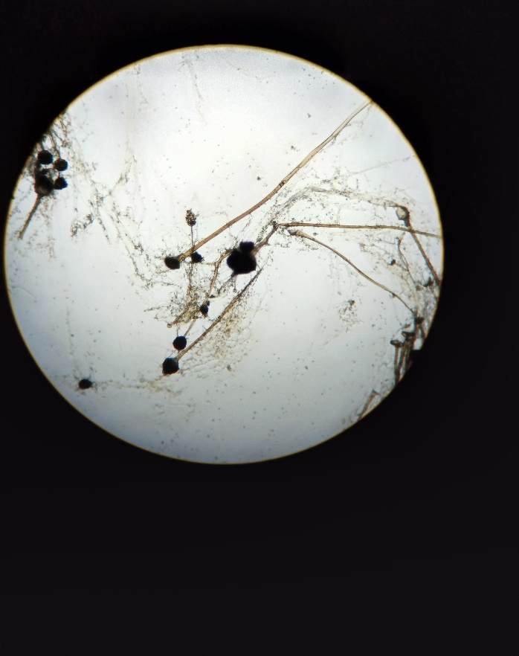
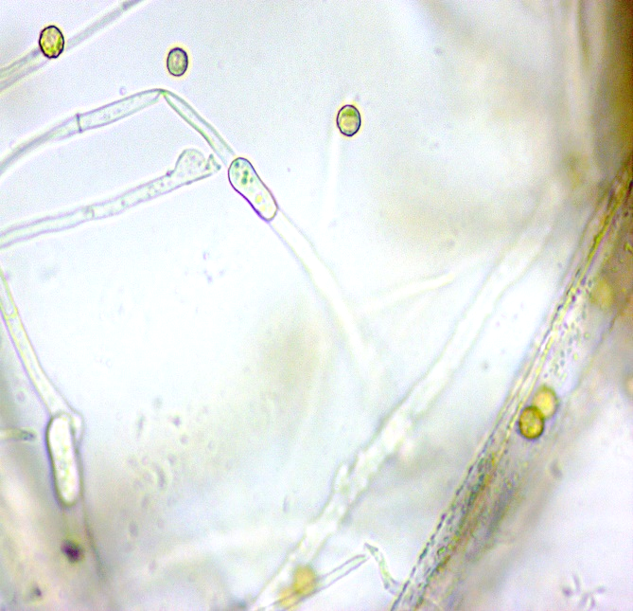
The microscopic observations of Rhizopus stolonifer revealed the presence of pale brownish sporangiophores which arised in groups of 3-5 from stolons and were smooth walled, non-septate and measured about 287.52 µm in length and 12.85 µm in diameter. Sporangiospores were 14.8 µm in length and 194.81 µm in diameter. Sporangia produced were globose and hyaline during initial stages of growth which appeared black during maturity. Columella was cylindrical in shape and hyaline. It measured about 65.11 µm in length and 71.45 µm in diameter. Rhizoids were hyaline to dark brown, root-shaped and present abundantly. Stolons were pale brownish, smooth walled and measured 10.23 µm in diameter (Fig1, Table 1). These characters were similar to the earlier descriptions given by Kumud et al. (2018), Abbasi et al. (2020) and Khan et al. (2021).
Sporangiospores under 40x
Sporangiophores under 10x

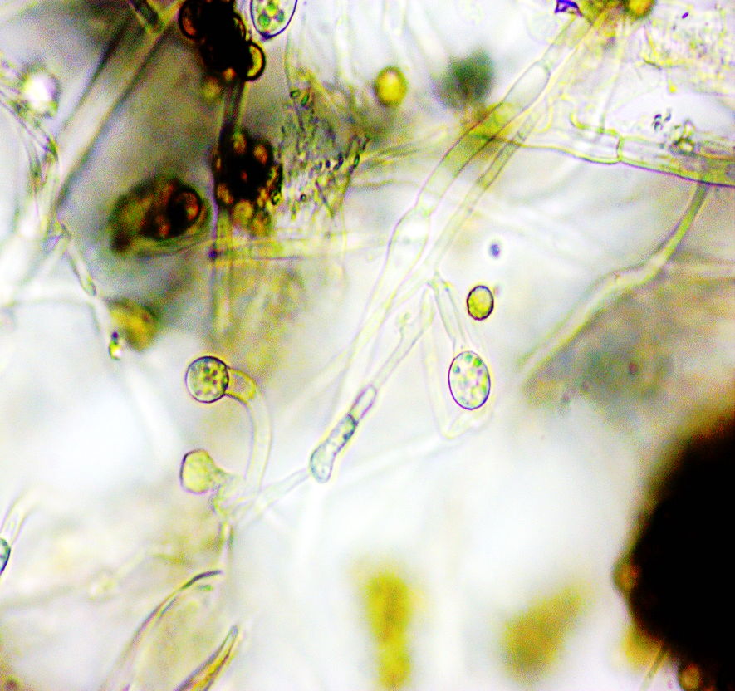
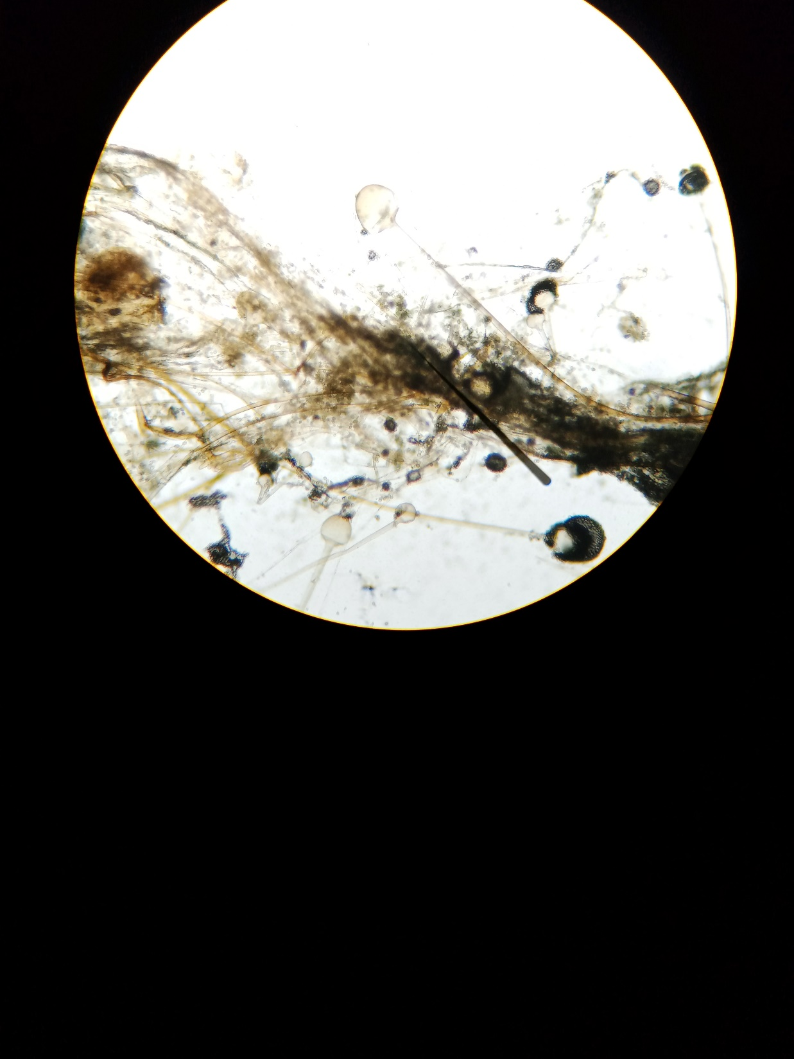
Columella under 40x

Sporangia under 40x

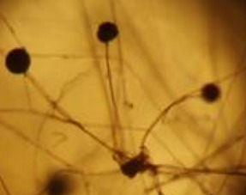
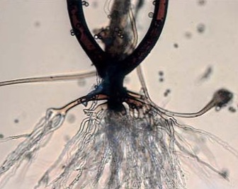

Stolons under 40x
Rhizoids under 100x

Fig 1. Morphological characterization of Rhizopus stolonifer

Sl. No. |  | Morphological Characters
1. | Sporangiospores
 | Shape | Size
 | Round to oval | 14.8 µm in length and 194.81 µm in diameter
2. | Sporangiophores
 | Colour | Size
 | Pale brownish | 287.52 µm in length and 12.85 µm in diameter
3. | Sporangia
 | Colour | Shape
 | Black | Globose
 | Columella
4. | Shape | Size
 | Cylindrical | 65.11 µm in length and 71.45 µm in diameter
5. | Rhizoids
 | Shape | Colour
 | Root shaped  Stolons | Hyaline to dark brown
6.
 | Colour | Size
 | Pale brownish | 10.23 µm in diameter
Table 1: Morphological characterization of Rhizopus stolonifer on PDA medium

Cultural characterization
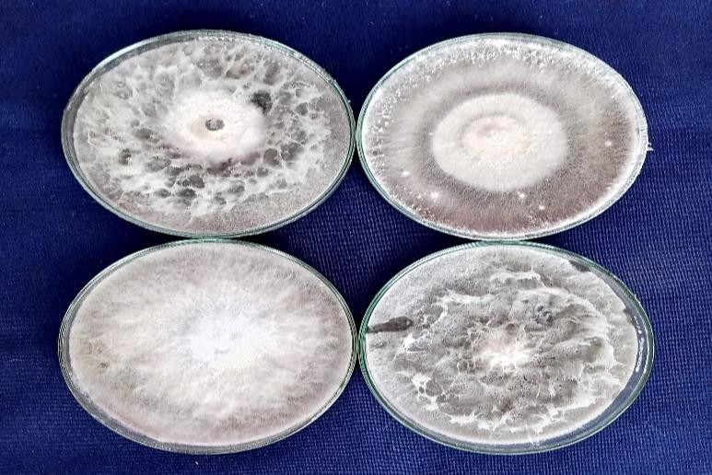
The cultural characteristics of fruit rot pathogen R. stolonifer was investigated on potato dextrose agar medium at room temperature (25 ± 2 ºC) as described under “Material and Methods” and the results obtained are presented. The results revealed that the pathogen exhibited diverse mycelial growth patterns ranging from flat, raised to fluffy and densely cottony growth as it has the tendency to spread rapidly that covers entire Petri plate within six days. Abundant aerial mycelium was concentrated in central area of the colony. Filamentous, coenocytic hyphae was produced. The colony colour was whitish at the beginning stages of growth of R. stolonifer. Later, it turned out to be greyish black. The growth of the fungus was observed in potato dextrose agar (PDA) media (Fig 2). Results showed that the colony colour was whitish grey initially, which later developed to black as pathogen growth progressed. Coenocytic hyphae was produced. Mycelial growth patterns of flat, raised to fluffy and densely cottony growth was observed. Similar growth of fungal mycelia was observed by Babu et al. (2018) and Yamin et al. (2020) on potato dextrose agar (PDA).

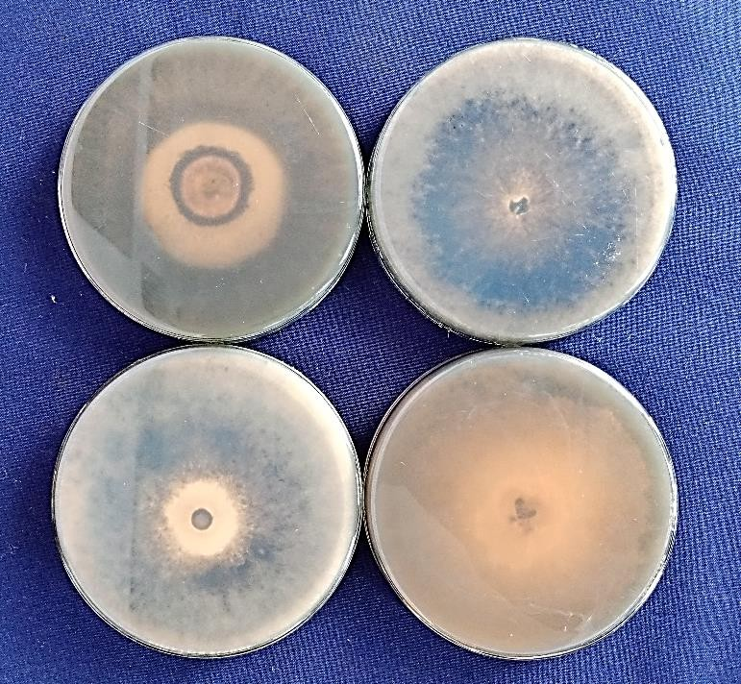
Fig 2. Culture view of R. stolonifer
Physiological characterization of fruit rot pathogen
Influence of temperature on the growth of Rhizopus stolonifer in potato dextrose broth
Temperature plays a significant role in influencing the growth and development of various organisms. Different fungi exhibit diversified temperature essentials during different growth phases. In the current experimentation, effect of physiological conditions on the growth of fruit rot pathogen was examined at various temperature. This investigation involved the determination of fresh and dry mycelial weight derived from fungal inoculated potato dextrose broth. The data represented revealed statistically significant influence of different temperature regimes on the growth of R. stolonifer. The outcome of this analysis showed that the maximum fresh mycelial weight recorded on liquid media was 920.17 mg and dry mycelial weight that measured about 260.62 mg was observed when incubation temperature in the biological oxygen demand (BOD) incubator was set at 35 °C. This temperature level turned out to be most significant compared to others. Subsequent optimal temperature regimes for growth was observed at 30 °C in which the fresh mycelial weight was 890.31 mg and dry mycelial weight was observed to be 244.74 mg, 25 °C (fresh mycelial weight of 650.25 mg and dry mycelial weight of 160.80 mg) and 20 °C (482.68 mg and 112.15 mg). There was no mycelial growth spotted at temperature regime of 15 °C and at 40 °C. These findings aligned with the research work of Prasad et al. (2017) and Gerrits et al. (2019) as they depicted that the optimum temperature for mycelial growth of R. stolonifer was between 30-35 °C. Highest mycelial growth was observed at 35 °C (Naik et al., 2010). Rawal et al. (2011) observed that R. stolonifer had good mycelial growth in the temperature range of 25- 35 °C and less growth at 10-15 °C. Anand et al. (2015) reported that there was less mycelial growth observed at 15 °C (Table 2, Fig 3, Fig 4).

Table 2. Effect of temperature on growth of Rhizopus stolonifer

Treatment No. | Temperature (ºC) | Fresh mycelial weight (mg)* | Dry mycelial weight (mg)*
T₁ | 15 | 0.00 | 0.00
T₂ | 20 | 482.68 | 112.15
T₃ | 25 | 650.25 | 160.80
T₄ | 30 | 890.31 | 244.74
T₅ | 35 | 920.17 | 260.62
T₆ | 40 | 0.00 | 0.00
 | S. Em. ± | 0.14 | 0.29
 | C.D @ 1% | 1.02 | 1.36

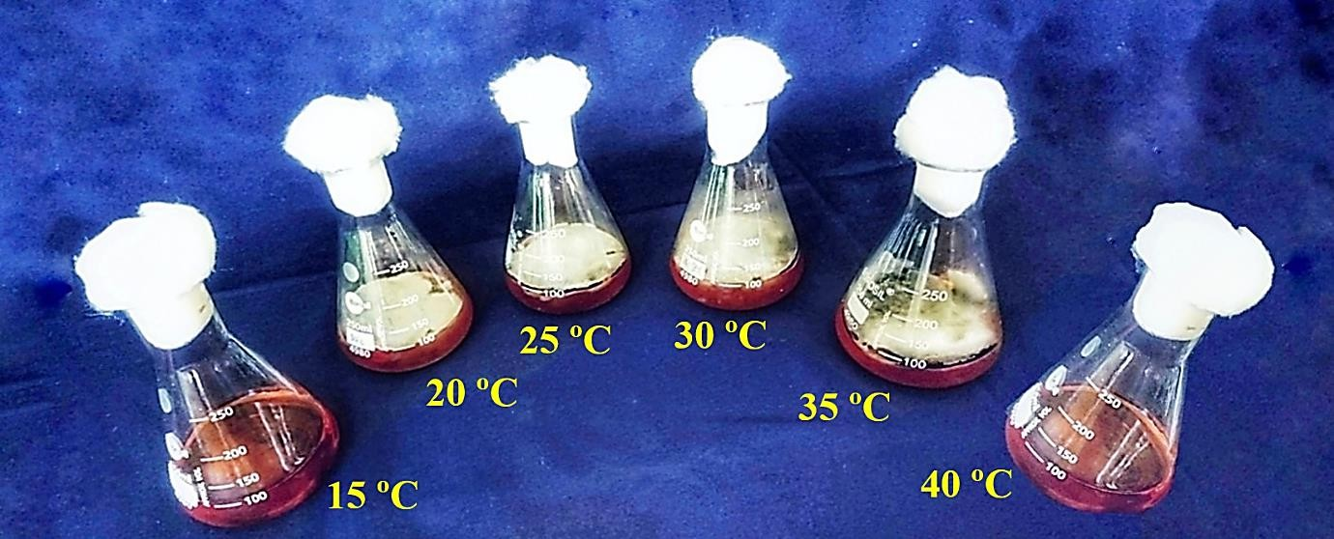
* Mean of three replication
Fig 3. Effect of temperature on growth of Rhizopus stolonifer

Temperature range (°C)

Mycelial weight in milligrams (mg)

Fig 4. Effect of temperature on growth of Rhizopus stolonifer

Effect of pH on the growth of R. stolonifer in liquid media
The pH range plays a vital part in growth and development of pathogens as they flourish in an optimal way within specific levels. Pathogens display slightest or negligible growth below the minimum or beyond paramount pH constraints. In this peculiar study, the impact of physiological conditions on the growth and development of Rhizopus stolonifer was determined focusing pertinently on pH variations. This was achieved by procuring the fresh as well as dry mycelial weight obtained from mycelia of R. stolonifer produced in potato dextrose broth (PDB) at various pH levels. The data presented emphasizes the notable conditions of varied pH ranges on the growth of R. stolonifer which were constituted to be statistically significant. The first and foremost aim of this study subsisted to determine the optimal pH requisites for the growth of R. stolonifer. The measures of fresh and dry mycelial weight were taken across variegated pH levels viz., 5.0, 5.5, 6.0, 6.5, 7.0, 7.5 and 8.0. The results shown in Table 4 and Plate revealed that the highest fresh and dry mycelial weight of R. stolonifer was captured at a pH range of 7.0 (981.76 mg and 302.78 mg), succeeded by pH 7.5 (924.13 mg and 269.26 mg) and pH 6.5 (748.51 mg and 183.32 mg). The pH level of 6.0 (712.60 mg and 170.65 mg), 8.0 (415.08 mg and 131.14 mg) and pH 5.5 (514.46 mg and 121.08 mg) recorded comparable growth, whereas the minimal growth was observed at pH 5.0 (330.71 mg and 82.43 mg). These outcomes were comparable with Adeji et al. (2024), Gandhi et al. (2011) and Gautam et al. (2019) as they reported that the optimum pH necessary for survival of fruit rot pathogen was 7.0. Sandoval et al. (2022) discovered that R. stolonifer showed maximum mycelial growth at a pH of 7.0 to 8.0 and at a pH level of 5.0 less mycelial growth was observed (Table 3, Fig 5, Fig 6).
Table 3. Effect of pH on growth of Rhizopus stolonifer

Treatment No. | pH | Fresh mycelial weight (mg)* | Dry mycelial weight (mg)*
T₁ | 5.0 | 330.71 | 82.43
T₂ | 5.5 | 514.46 | 121.08
T₃ | 6.0 | 712.60 | 170.65
T₄ | 6.5 | 748.51 | 183.32
T₅ | 7.0 | 981.76 | 302.78
T₆ | 7.5 | 924.13 | 269.26
T₇ | 8.0 | 415.08 | 131.14
 | S. Em. ± | 0.92 | 0.28
 | C.D @ 1% | 2.84 | 1.59

* Mean of three replications
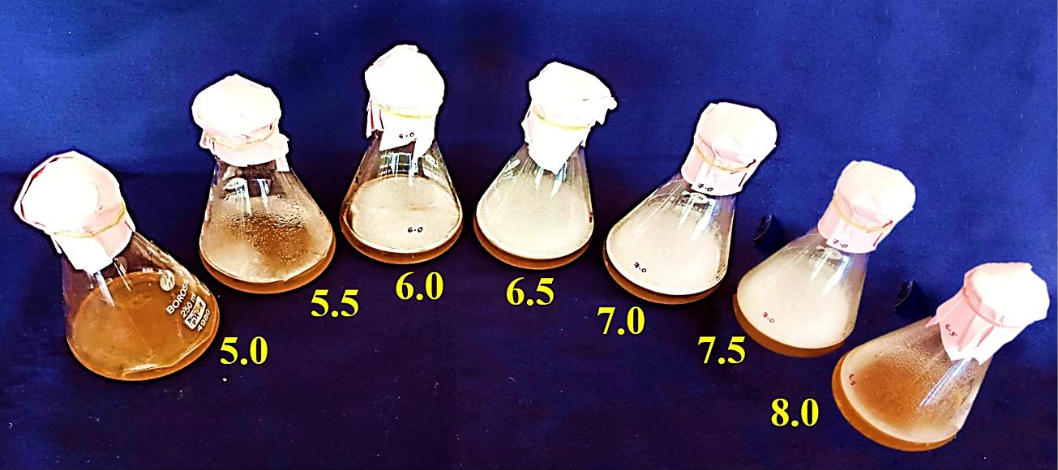

Fig 5. Effect of pH on growth of Rhizopus stolonifer

Fig 3: Effect of pH on growth of Rhizopus stolonifer

Level of pH

Mycelial weight in milligrams (mg)

Fig 6. Effect of pH on growth of Rhizopus stolonifer
Molecular characterization
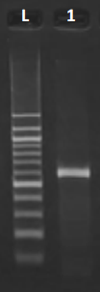
DNA from Rhizopus stolonifer were obtained and the full length ITS rDNA region was amplified. The primers used for Rhizopus stolonifer were ITS-1 (5’- TCCGTAGGTGAACCTGCG-3’) and ITS-4 (5’TCCTCCGCTTATTGATATGC-3’). The DNA amplicon was observed at the region 789 bp. After this the DNA sequences were obtained. The sequence obtained was deposited in National Center for Biotechnology information (NCBI) Genbank and accession number was obtained. DNA sequences of Rhizopus stolonifer was compared using bioinformatics tool NCBI BLAST programme (Fig. 7, Table 4). Based on the sequence comparision, ITS region showed the maximum identification of 99.99 per cent with Rhizopus stolonifer having gene bank accession number of PQ268796 and NCBI BLAST hit result was Rhizopus stolonifer. The maximum identification of R. stolonifer isolate 1 was 99.99 per cent with gen bank accession number PQ268796 and NCBI BLAST hit result confirmed as Rhizopus stolonifer. The results were similar to the findings of Febriani et al. (2018), Aisha et al. (2019) and Aslam et al. (2019). Ragazzo et al. (2021) conducted the molecular characterization and amplification of 789 bp fragment corresponding to the ITS 1 and ITS 4 regions of the rDNA gene of the Rhizopus stolonifer.

789 bp

Fig 7: Gel picture showing amplified ITS rDNA region of Rhizopus stolonifer
L - Marker 100 bp
1 - Rhizopus stolonifer

Table 4. A quick recap of molecular characterization result
Primer  used | Gene Bank Accession No. | Submission number | Homology  percent | Identified  pathogen
ITS1and ITS 4 | PQ268796 | SUB14762613 | 99.99 | Rhizopus stolonifer

Conclusion
Morphological characters viz., straight, brownish sporangiophores and globose sporangium with abundant rhizoids and smooth walled stolons with columella were exposed under the microscope. Physiological studies displayed that the highest fresh and dry mycelial weight of R. stolonifer was produced at incubation temperature of 35 °C in liquid media. Maximum fresh and dry mycelial weight of R. stolonifer was disclosed at a pH of 7.0. Molecular characterization revealed the pathogen as Rhizopus stolonifer by polymerase chain reaction (PCR) assay using ITS rDNA. Following future lines of work are being listed.Screening of different jackfruit varieties resistant to this disease can also be taken up to recognize the unsusceptible genotypes. Molecular characterization using multi-gene phylogeny should be accomplished to identify fruit rot pathogen upto species and subspecies level as it provides valuable insights into effective management strategies.

Disclaimer (Artificial intelligence)
Option 1:
Author(s) hereby declare that NO generative AI technologies such as Large Language Models (ChatGPT, COPILOT, etc.) and text-to-image generators have been used during the writing or editing of this manuscript.

References:-
ADEJI AO, FADARA AB, ADENIYI DO., 2024, Temperature and pH Factor on Cocoa Bean-Based Ochratoxin-A (OTA) and Detoxification Potential of Rhizopus stolonifer. Int. J. Plant Soil Sci. 7(3):1-7.
ABBASI, N. A., ASLAM, M. F., IRSHAD, G. AND NAZIA, F., 2020, Morpho-molecular identification of Rhizopus stolonifer causing postharvest soft rot of Loquat (Eriobotrya japonica). Mycopathology, 16: 342 – 350.
AISHA, P., GHERBEWY, Y. A., HUSSEIN, K. AND SINGH, H., 2019, Molecular characterization of Rhizopus stolonifer strains isolated from some Saudi fruits. Foodborne Pathogens and Disease, 7(6): 137-142.
ANAND, T., NAKKEERAN, S., RAGUCHANDER, HUBBALLI, M. T. AND RENUKADEVI, P., 2015, Physiological characterization of Rhizopus stolonifer, the incitant of soft rot disease of guava in India. Archives of Phytopathology and Plant Protection, 44(11): 1115-1124.
ASLAM, M. F., AJJAD, F. S., SAJID, M. AND BASHIR, M. Z., 2019, First report of Rhizopus stolonifer causing postharvest fruit rot of Jackfruit from Pakistan. Plant Dis., 103(6): 1410-1424.
BABU, D. N., NAGADESI, P. K., SUNEETHA, M. N. AND ANIL, K., 2018, Soft rot of Jackfruit (Artocarpus heterophyllus) by Rhizopus stolonifer in Andhra Pradesh, India. Annals of Plant Sciences, 701: 2451-2455.
BENNY, G. L., SMITH, M. E., KIRK, P. M., TRETTER, E. D. AND WHITE, M. M., 2016, Challenges and Future Perspectives in the Systematics of Kickxellomycotina, Mucoromycotina, and Zoopagomycotina. Biology of Microfungi, 78: 65–126.
BORUAH, N. B. AND BARUA, A. G., 2014, Minerals and functional groups present in the jackfruit seed: a spectroscopic investigation. J. Food Sci. Nutr., 55(6): 479-483.
DALAVI, R. B., KAMBALE, S. S. AND KAWALE, T. R., 2017, Efficacy of ridomil in combating fruit rot of jackfruit in Ratnagiri and Sindhudurg districts of Maharashtra. Biosci. Trends., 10(17): 3087-3088.
ESTRADA, G., LOPEZ, R. S., MEDINA, J. C., CRUZ, H. AND ZARK, L., 2019, First Report of Rhizopus stolonifer causing fruit rot in Jackfruit (Artocarpus heterophyllus) in Mexico. Plant Dis., 103(11), 2957-2966.
FEBRIANI, R. W., SJAMSURIDZAL, L. AND OETARI, S. B., 2018, ITS regions of rDNA sequence and morphological analyses clarify five Rhizopus strains from tempeh as Rhizopus oryzae. AIP Conf. Proc., 97: 1582-1590.
GANDHI, P., KUPPUSAMY, P., PEERAN, M. F., THANGAMANI, K. AND RAGUCHANDER, T., 2011, Morphological and physiological characterization of Rhizopus stolonifer causing soft rot of carrots. World j. agric. sci., 7(6): 743-754.
GAUTAM, R. K., KRISHNAN, S., KAARI, M., SAWHNEY, S., SHEORAN, N., MOHAN DAS, M. AND KUMAR, A., 2019, Studies on Rhizopus stolonifer causing fruit rot in jackfruit. J. Plant Pathol., 101: 760-768.
GERRITS, H. F., FIGUERAS, M. J., ENDE, A. H. G., MEIS, P., ALONSO, T. AND TAYLOR, J. S., 2019, The effect of medium, temperature and age on Rhizopus stolonifer causing fruit rot of jackfruit. Mycologia., 73: 362–367.
GHOSH, R., BARMAN, S., MUKHOPADHYAY, A. AND MANDAL, N. C., 2015, Biological control of fruit-rot of jackfruit by rhizobacteria and food grade lactic acid bacteria. Biol. Control., 83: 29-36.
HAQUE, M. U., RAHMAN, M. A., ADOR, M. H. AND AHMED, R., 2023, First Report of Rhizopus stolonifer Causing Premature Soft Rot of Jackfruit in Bangladesh. Plant Dis., 107(9): 28-43.
KHAN, A. H., ABDUL, M., MALEQUE, C. K. D., TALUCDER, M. S. A., MAUKEEB, A. R. M., EMA, I. J. AND ADNAN, M., 2021, Management of insect pests and diseases of jackfruit (Artocarpus heterophyllus L.) in agroforestry system. Acta Entomol. and Zool., 2(1): 37-46.
KUMUD, S., SARASWATI, P. N. AND CHOWDHURY, H. D., 2018, Some studies on Rhizopus rot of jackfruit. J. Indian Bot. Soc., 38(5): 42-50.
NAIK, M. K., HIREMATH, P. C., AND HEGDE, R. K., 2010, Physiological Studies on Rhizopus stolonifer. Mysore J. Agric. Sci., 22: 471-474.
PARTIDA, C. L., SOBERANO, P. A., GONZALEZ, R. AND MARTINEX, P. G., 2023, Antifungal potential of eco-friendly chitosan sodium benzoate to inhibit the development of Rhizopus stolonifer isolated from jackfruit. Journal of Plant Diseases and Protection, 130(4): 905-913.
PATIL, R. C., 2020, Diseases of jackfruit crops and their management. Diseases of Fruits and Vegetable Crops: Plant Dis., 105(2): 508-508.
RAGAZZO, SANCHEZ, J. A., GUTERRIEZ, ESCATEL, A., LUNA, SOLANO, G., GOMEZ, J. F. AND CALDERON, M., 2021, Molecular identification of the fungus causing postharvest rot in jackfruit. Rev Mex Micol., 34: 9-15.
RANASINGHE, R. A. S. N., MADHUWANTHI, S. D. T. AND MARAPANA, U. J. R., 2019, Nutritional and Health Benefits of Jackfruit (Artocarpus heterophyllus L.). International Journal of Food Science, 43: 271- 283.
RAWAL, R. D., SHARMA, K., AND KUMAR, K. L., 2011, Influence of temperature and pH on the growth and sporulation of some Indian isolates of Rhizopus oryzae causing soft rot of citrus. Tropical Agric. Res. Exten., 11: 43-48.
ROGERS, J., ROSSMAN, H., HARRIS, K., HOSAKA, R. C., LIM, Y., MATHENY, B. AND NISIDA, H., 2004, Assembling the fungal tree of life: progress, classification, and evolution of subcellular traits. Am J Bot., 91: 1446–1480.
SABTU, N. M., ISHAK, M. H. I. AND IDRIS, N. H., 2019, The spatial epidemiology of jackfruit pest and diseases. Int. J. Sustain., 6(1-2): 169-175.
SANDOVAL, T., MORENO, M., GARRIDO, L., RAGAZZO, J. A., NARVAEZ, J. A. AND SANTOYO, M., 2022, Effect of temperature and pH on the interaction between Rhizopus stolonifer and Colletotrichum spp. postharvest pathogens of jackfruit (Artocarpus heterophyllus L.). J. Gen. Plant Pathol., 14(28).
WHITE, T. J., BRUNS, F. D., LEE, S. I. AND TAYLOR, J. K., 1990, Amplification and direct sequencing of fungal ribosomal RNA genes for phylogenetics. In: PCR Protocols: a guide to methods and applications. Phytopathol., USA. 21: 315-322.
YAMIN, Q., WENXIO, L. AND QINGMIN, T, F., 2020, Direct antifungal activity of methyl salicylate on fruit rot caused by Rhizopus stolonifer in jackfruit and its membrane targeting mechanism. Postharvest Biology and Technology, 218: 113-122.

