INFLUENCE OF SILICON ON IMPROVING WATER DEFICIT STRESS TOLERANCE IN RICE GENOTYPES

ABSTRACT
This investigation was carried out to study the effect of silicon fertilization on drought conditions in rice. The experiment was laid in a split plot design with three replications. The main plots had four silicon treatments (T₁- Control (do not apply any chemical and follows the same package of practices), T₂- Spray at 0.6% silicon at tillering, PI, 50% flowering and milky grain stages. Most Important Treatment applications: silicon (ortho Silicilic acid) @ 400 ml in 200 litres/acre water (complete 200 litre water was given), T₃- Water Stress only and T₄-Silicon + water stress (Water stress to be imposed by withholding irrigation 12 days before flowering and again 10 days after anthesis (Total duration of stress will be 22 days) and sub plots had ten rice genotypes (27P63, HRI-174, IIRRH-131, IIRRH-132, IIRRH-143, JKRH-3333, US-312, US-314, KRH-4 and Sahabhagidhan, TNAU rice entries CB12-588, CB12-132, CB12-122, CB13-132, CB16-118, CB15138, CO51, CO52, CO53, ADT53, ADT54 and BPT 5204 were used as experimental material with all normal cultural practices followed for rice cultivation during Kharif 2020. Application of silicon solubilzer in the form of available silica SiLIXOL (as liquid stabilized orthosilicic acid) was sprayed at tillering, PI, 50% flowering and milky grain stages. Foliar application of SiLIXOL - Stabilized Orthosilicic acid (0.6%) influenced higher morphological parameters, growth parameters like., leaf area and leaf area index at flowering stage and there by increased mean photosynthetic rate and other physiological parameters. Foliar application of SiLIXOL - Stabilized Orthosilicic acid (0.6%) influenced lesser reduction in yield under stress conditions registered by 27P63 (12% reduction) in rice.
Key Words: Silica - Abiotic Stress tolerance – Rice genotypes.

Introduction
Rice (Oryza sativa) is a staple food that accounts for more than 22% of world’s population calorie intake (Wailes et al., 1997). China is the world’s leading rice producer, while India has the largest rice acreage and ranked second position in production. In 2017, the global rice production reached 502.2 million tons and 83% of it was consumed for food intake (FAOSTAT, 2017). The world population has grown at an exponential rate and increasing awareness on healthy lifestyles, which demands for more gluten-free foods, are intensifying the global consumption of rice (USDA-ARS, 2015). Along with higher consumption of rice, climate changes such as extreme weather, unexpected temperature and rainfall fluctuations have affected crop productivity, and strategies to increase yield have been studied (Georgescu et al., 2011 and Lobell et al., 2011). The major factor responsible for low yield of upland rice is draught due to the high speed of water infiltration and low moisture retention capacity of savannah soils. According to Antonia Nolla, (2012) who reported that, Low yield of rice due to drought and low moisture retention capacity of soils. Among the Abiotic stresses water deficit stress affects crop productivity and quality with increasing impact on the socioeconomic fabric and health, especially of the farming communities (Kant et al., 2024; Yehia et al., 2023). Water deficit is a serious problem in rice cultivations. It is recognized as major constraint in the production of rice crop where 40% drought can cause yield losses ≥ 60 per cent (Venkatesan et al., 2005). Reduced water content in the soil triggers physiological, biochemical, and morphological damage to plants, aggravated by nutritional deficiency. Short gun approaches to increase the water deficit Stress tolerance though foliar spray of Si. The beneficial element of silica was deposited in the cuticle layer (Fig. 1).
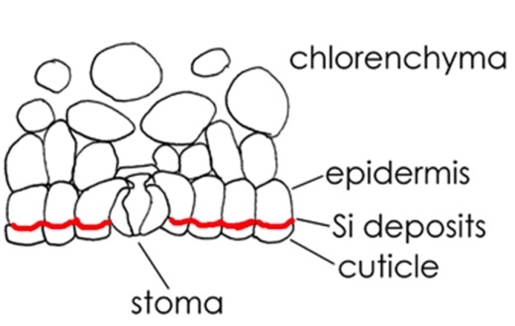
Fig 1. Silica deposition in cuticle
The main role of silica in plants are Increasing water uptake by roots, Maintaining nutrient balance, Decreasing water loss, Promoting photosynthetic rate, Improve antioxidant defense activities of antioxidant enzymes, Osmotic adjustment, Increase photosynthetic enzymes, induce the synthesis of endogenous plant hormones under stress conditions. Silicates, besides correcting soil acidity and supplying Ca and Mg in the soil solution, also supply Si. A Si accumulating plant can be more tolerant to draught because it can regulate transpiration more effectively, producing the same amount of dry matter with lower water consumption. Based on the constraints, one possible strategy to mitigate the effect of water deficit stress in rice comprises the use of silicon (Si). The aims of this work were to study the influence of silicon on morphology and physiology of rice and To analyze the yield and yield components of rice under silicon application in water deficit stress.

Materials and Methods
A field study was conducted in the Department of Rice research, Tamil Nadu Agricultural University, Coimbatore with the objectives to study the influence of silicon application on morphology and physiology of rice and to analyze the yield and yield components traits of rice under silicon application in water deficit stress. Ten rice genotypes were chosen for these experiments with four treatments T₁ Control (Irrigated), T₂ Spray of 0.6% silixol at tillering, PI, 50% flowering and milky grain stages., T₃ Spray of 0.6% silixol silicon + water stress and T₄ Water Stress only. The drought was imposed by withholding irrigation 12 days before flowering and again 10 days after anthesis with three replications. The data was analyzed by split plot design. All cultivation practices and field operations of application of silixol were explained in the Fig 2.
Varietal details
The experiment was conducted with ten rice genotypes viz., 27P63, HRI-174, IIRRH-131, IIRRH-132, IIRRH-143, JKRH-3333, US-312, US-314, KRH-4 and SAHABHAGIDHAN. The seeds for the experiment were obtained from National Rice research Institute, Cuttack under All India Co-Ordinated Research programme on Rice.
Observations recorded
The observations are Plant Height (cm), Leaf Area (cm²), LAI (Watson, 1947), Leaf weight (g m⁻²), Culm weight (g m⁻²), TDMP (g m⁻²), Number of panicle m⁻², Number of grains m⁻², Number of spikelet m⁻², Number of grains panicle⁻¹, Number of spikelet panicle⁻¹, 1000 grain weight and Grain Yield (g m⁻²) were recorded during maximum tillering, panicle initiation, flowering and maturity stages.

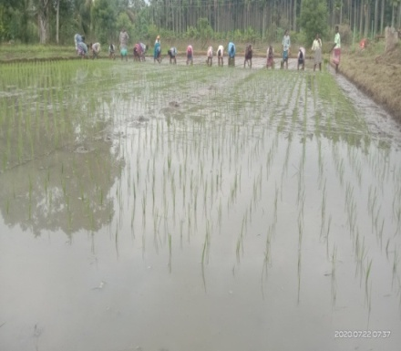 | 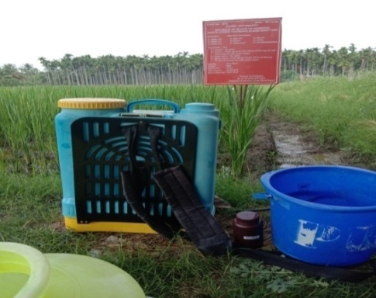 | 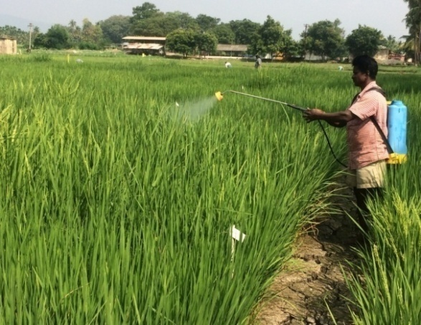
Transplanting | Silixol preparation  For foliar spray | Silixol spray under water stress
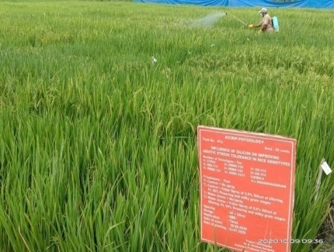 |  | 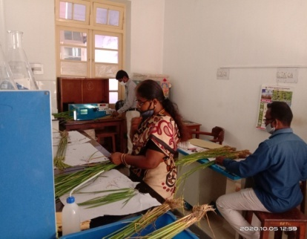
Silixol spray under irrigated |  | Leaf Area Measurement
Fig 2. Influence of silicon solubilizers on induced stress tolerance in rice genotypes

Results and Discussion
The genotype US 314 recorded lesser taken for 50% flowering under irrigated, irrigated with Si spray, water stress with Si spray and water stress alone conditions (74, 74, 78 and 73 days respectively) which was followed by Sahabhagidhan (78, 78, 75 and 75 days) and IIRRH-132 (86, 86, 79 and 84 days). However, the genotypes 27P63 registered longer days taken for 50% flowering under irrigated, irrigated with Si spray, water stress with Si spray and water stress alone conditions (97, 97, 91 and 95 days respectively) followed by HRI-174 (97, 97, 92 and 91 days respectively) than the other genotypes.
Foliar application of SiLIXOL - Stabilised Orthosilicic acid (0.6%) influenced higher leaf area and leaf area index at flowering stage and there by increased mean photosynthetic rate (21.8 μ mole of CO2 m2 s-1 ). Among the rice genotypes, HRI-174 and KRH-4 recorded highest mean leaf area (3500.0 cm² plant⁻¹ and 3204.0 cm² plant⁻¹), and leaf area index (8.75 and 8.01) at flowering stage. However, the genotypes, KRH-4 and 27P63 registered more leaf weight trait (301.7g and 300.3g) at flowering stage (Fig 3 & 4.). The data on culm weight recorded highest value of 778.0g and 771.3g by the genotypes of 27P63 and IIRRH-131 at flowering stage. Total dry matter productions were recorded at flowering stage in all the entries. Among the genotypes, IIRRH-132 and HRI174 maintained its superiority in Total dry matter production of about 968.2g and 494.9g and there by increased photosynthetic rate. Comparing the treatments, IIRRH-132 and KRH-4 registered lesser reduction (14 -15%) in leaf area, LAI, TDM and photosynthetic rate under stress (withholding irrigation 12 days before flowering and again 10 days after anthesis), which was followed by KRH-4 and CB-06-804 over control. This might be due to Si fertilization improving the resistance to lodging and also increases the erectness of leaves and leaf blades; which allow better light transmittance through plant canopies and thus indirectly improve whole plant photosynthesis in rice (Savant et al., 1997; Tamai and Ma, 2008). The higher reduction (23-25%) was observed in the genotypes of IIRRH-131 under stress conditions than the control at tillering, panicle initiation and flowering stages.
At maturity stage¸ IIRRH-132, IIRRH-143, and KRH-4 recorded higher grain yield (6342 kg ha⁻¹, 6254 kg ha⁻¹ and 5987 kg ha⁻¹) by 12-16 % increase under controlled conditions over the stress treatment of withholding irrigation 12 days before flowering and again 10 days after anthesis, which was followed by US314 (5831 kg ha⁻¹) recorded grain yield by 7-9% increase under control than the stress treatment of withholding of irrigation at 12 days before flowering and 10 days after anthesis. Foliar application of SiLIXOL - Stabilized Orthosilicic acid (0.6%) influenced highest reduction in yield under stress conditions was recorded by 27P63 (22% reduction) followed by BPT-5204 (28% reduction) (Table 1.). These are in agreement with the findings of Lavinsky et al., (2016). Increase in number of spikelets per panicle in rice by silicon over control was reported earlier by Patil et al., 2017 and Jan et al., 2018. This might be due to increased synthesis of carbohydrates and that might have increased the sink size and capacity. Silicon fertilizer, that may significantly reduce empty spikelet’s number in rice and also make increase fertility, increased spikelets per panicle that ultimately increased crop yield.

Fig 3. Influence of silicon solubilizers on stress tolerance on LA (cm² plant⁻¹), LAI, leaf weight (g m⁻²), culm weight (g m⁻²) and Total Dry Matter Production at different stages in rice.

Fig 4. Influence of silicon solubilizers on stress tolerance on LA (cm² plant⁻¹), LAI, leaf weight (g m⁻²), culm weight (g m⁻²) and Total Dry Matter Production at different stages in rice.

Table1.Influence of silicon solubilizers on stress tolerance on yield and yield components in rice.
Variety | Treatment | Maturity stage
Variety | Treatment | Shoot weight  g/m² | Panicle /Sqm | Pan wt. g/m² | Grains  /panicle | Spikelet /panicle | grain no/m² | Spikelet No/m² | 1000 gr.wt. | TDM | Grain Yield (kg ha⁻¹)
IIRRH-132 | T₁ | 1304.0 | 349.7 | 1302.9 | 199.7 | 222.3 | 57589.7 | 58594.0 | 22.1 | 1494.7 | 6342.0
IIRRH-132 | T₂ | 1353.0 | 364.0 | 1291.3 | 207.7 | 231.3 | 62324.3 | 63442.3 | 21.3 | 1553.7 | 6151.7
IIRRH-132 | T₃ | 1451.0 | 392.7 | 1268.2 | 158.7 | 177.0 | 51431.3 | 52429.3 | 14.8 | 1507.0 | 5581.0
IIRRH-132 | T₄ | 1402.0 | 378.3 | 1280.2 | 166.7 | 185.7 | 52048.0 | 52993.7 | 17.8 | 1362.7 | 5327.3
IIRRH-143 | T₁ | 1378.3 | 350.7 | 1308.2 | 190.7 | 213.3 | 54785.3 | 56046.7 | 21.5 | 1480.7 | 6254.0
IIRRH-143 | T₂ | 1426.0 | 365.0 | 1294.3 | 192.7 | 215.7 | 57590.7 | 58949.3 | 20.1 | 1485.3 | 6066.4
IIRRH-143 | T₃ | 1521.3 | 393.7 | 1267.1 | 149.7 | 167.3 | 48191.3 | 49280.7 | 14.2 | 1466.7 | 5503.5
IIRRH-143 | T₄ | 1473.7 | 379.0 | 1282.5 | 157.3 | 175.7 | 48801.0 | 49821.7 | 17.2 | 1326.7 | 5253.4
KRH-4 | T₁ | 1203.7 | 370.7 | 1420.4 | 192.7 | 215.7 | 59359.7 | 60702.0 | 22.8 | 1536.0 | 5987.0
KRH-4 | T₂ | 1244.0 | 351.0 | 1406.7 | 195.3 | 218.7 | 56675.0 | 57999.3 | 21.8 | 1556.0 | 5807.4
KRH-4 | T₃ | 1324.7 | 385.0 | 1383.8 | 151.7 | 169.3 | 48244.3 | 49243.3 | 15.5 | 1435.7 | 5268.6
KRH-4 | T₄ | 1284.3 | 368.3 | 1393.7 | 159.7 | 178.3 | 48588.7 | 49613.7 | 18.5 | 1467.0 | 5029.1
US-314 | T₁ | 1098.8 | 265.8 | 1315.5 | 87.8 | 110.8 | 59254.8 | 60597.2 | 21.9 | 1461.5 | 5831.0
US-314 | T₂ | 1139.2 | 246.2 | 1301.8 | 90.5 | 113.8 | 56570.2 | 57894.5 | 21.9 | 1439.8 | 5656.1
US-314 | T₃ | 1219.8 | 280.2 | 1279.0 | 46.8 | 64.5 | 48139.5 | 49138.5 | 21.9 | 796.5 | 5131.3
US-314 | T₄ | 1179.5 | 263.5 | 1288.8 | 54.8 | 73.5 | 48483.8 | 49508.8 | 21.9 | 1343.5 | 4898.0

Conclusion
The genotype US 314, IIRRH-132 and Sahabhagidhan were recorded lesser days (74 to 86 days) taken for 50% flowering. Foliar spray of silicon (Silixol 0.6 %) under middle of drought conditions the genotypes IIRRH-132, IIRRH-143, and KRH-4 recorded higher mean grain yield (6342 kg ha⁻¹, 6254 kg ha⁻¹ and 5987 kg ha⁻¹). (12-16 %). Due to foliar spray of silica, leaf erectness with lower light transmission ratio (6.2), higher leaf area index (6.1) and photosynthetic rate (33.3 μ mole of CO₂ m² s⁻¹ ) were recorded in Sahabhahidhan.
References
Antonio Nolla, Reginaldo Januario de Faria, G.H. Korndörfer and Tiago Roque Benetoli da Silva. 2012. Effect of silicon on drought tolerance of upland rice. Journal of Food Agriculture and Environment 10 (1) : 269-272.
FAOSTAT. 2017. Rice market monitor. XXI: http://www.fao.org. 21/02/2018.
Georgescu, M., Lobell, D.B and Field, C.B. 2011. Direct climate effects of perennial bioenergy crops in the United States. Proceedings of the National Academy of Sciences (USA). 108: 4307-4312.
Lavinsky, A.O., Detmann, K.C., Josimar, V.R., Avila, R.T., Sanglard, M.L., Pereira, L.F., Sanglard, M.V.P.L., Rodrigues, A.F., Wagner, L.A and DaMatta, F.M. 2016. Silicon improves rice grain yield and photosynthesis specifically when supplied during the reproductive growth stage. Journal of Plant Physiology. 206: 125-132.
Lobell, D.B., Schlenker, W and CostaRoberts, J. 2011. Climate trends and global crop production since 1980. Science. 333: 616-620.
Patil, A.A., Durgude, A.G., Pharande, A.L., Kadlag, A.D and Nimbalkar, C.A. 2017. Effect of calcium silicate as a silicon source on growth and yield of rice plants. International Journal of Chemical Studies. 5 (6): 545-549.
Savant, N.K., Snyder, G.H and Datnoff, L.E. 1997. Silicon management and sustainable rice production. Advances in Agronomy. 58: 151–199.
Tamai, K and Ma, J.F. 2008. Reexamination of silicon effects on rice growth and production under field conditions using a low silicon mutant. Plant and Soil. 307: 21-27.
United States Department of Agriculture Economic Research Service (USDAARS). 2015. Rice Outlook/RCS15L/December11.
Venkatesan G., M.Tamil Selvam, G. Swaminathan and S.Krishnamoorthi. 2005. Effect of Water Stress on Yield of Rice Crop. International Journal of Ecology & Development Fall 2005, Vol. 3 (F05): 77-89.
Wailes, E.J., Cramer, G.L., Chavez, E.C and Hansen, J.M. 1997. Arkansas global rice model: international baseline projections for 1997-2010. Arkansas Agricultural Experiment Station Special Report. 177.
Kant, Kamal, Shubham J. Baraiya, Alok Srivastva, Nilima Karmakar, Ajay V. Narwade, and P. B. Patel. 2024. “Effects of Water Deficit Stress at the Tillering Stage of Direct Seeded Rice (Oryza Sativa L.)”. International Journal of Plant & Soil Science 36 (1):1-9. https://doi.org/10.9734/ijpss/2024/v36i14322.
Mohamed Bassuny Yehia , Waleed, and Karima M. El-Absy. 2023. “Response of Cotton Genotypes to Water-Deficit Stress Using Drought Tolerance Indices and Principal Component Analysis”. Asian Journal of Advances in Agricultural Research 21 (1):13-27. https://doi.org/10.9734/ajaar/2023/v21i1407.

