PICT Effects and Anticancer Potential on Rosaniline and Spectral Characterisation of Rosaniline/ Cyclodextrin Covered ZnO/ Nanocrystals

Abstract
Rosaniline/Cyclodextrin covered ZnO nanocrystals are synthesized and characterized by various spectral and microscopic methods. The effect of different polarities of the solvents, α-cyclodextrin (α-CD) and β-cyclodextrin (β-CD) on RND was studied by various spectral methods. The inclusion behavior of RND on both CDs was determined by PM3 method. The doping effect of RND/CD on ZnO nano investigated by UV-visible, fluorescence, FTIR, DTA, XRD, FE-SEM and TEM methods. RND molecules exhibit single emission in non-polar and aprotic solvents, whereas in water, α-CD and β-CD exhibit dual emission. Solvent and PM3 studies indicate planar intramolecular charge transfer (PICT) in RND molecules. Absence of an isosbestic point suggests a 1:2 or 1:3 inclusion complex is formed. HOMO-LUMO gap for RND/β-CD inclusion complex was more negative, which supports that this complex is more stable than RND/α-CD inclusion complex. Compared to RND/CD inclusion complex, a red or blue shifted absorption and fluorescence maximum was seen in β-CD/RND doped ZnO nanocrystals. Nanoparticle size was measured by TEM-EDS and XRD methods. Molecular docking studies shows, RND has anticancer activity against 2oh4 interacting amino acid residues.
Keywords: Rosaniline, Zinc Oxide nano, Cyclodextrin, Planar Intramolecular Charge Transfer, Inclusion complex, Nanocrystal.

1. Introduction
“In the field of material science, the electron donor–acceptor π-conjugated (D-π-A) compounds have found numerous uses, including dye-sensitized solar cells” [1], electrogenerated chemiluminescence materials [2,3], nonlinear optical materials [4], and fluorescence probes [5]. “The exceptional optical and electrical capabilities of the D-π-A compounds are largely due to the photoinduced intramolecular charge-transfer (ICT) nature of the excited state” [6]. Characterizing the ICT state (i.e., electronic nature and molecular geometry) will provide a profound understanding of the connection between molecular structures and attributes.
“Zinc oxide nanoparticles are synthesized by several methods, such as high-temperature solid–vapor deposition” [7], solution phase methods [8], colloidal chemistry techniques [9], sol-gel method [10], phase transfer technique [11], hydrolysis of chelate complex [12] polymer stabilization [13] synthesis in reversed micelles [14], microemulsion [15], alkoxide-based process [16] precipitation method [17] spray pyrolysis [18] hydrothermal method [19] laser vaporization condensation [20] and flow injection synthesis [21]. In the present study, the precipitation method has been used for synthesizing ZnO nanoparticles.
“In general, ZnO nanoparticles are larger and have little porosity. Because of the importance of the ZnO nano” [22-29]. This work aimed to a) analyse the effect of donor–acceptor π-conjugated compound (rosaniline, RND) with cyclodextrin and ZnO nanoparticles, b) investigate the presence of PICT (planar intramolecular charge transfer) in RND; c) synthesize and characterize ZnO, ZnO/CD, ZnO/RND, d) study the impact of doping RND/CD on ZnO nanoparticles, and e) analyze the anticancer activity of the RND dye.
2. Experimental
2.1 Preparation of Drug/CD inclusion complex
In a 10 ml standard measuring flask, various quantities of α-CD or β-CD solution (0.1 to 1.0×10⁻² M) were taken. The above mentioned flasks were filled with 0.2 ml of the RND stock solution (2×10⁻² M). Then the flasks were made up to 10 mL using triple-distilled water. The final concentration of the RND was 4×10⁻⁴ M and the experiments were conducted at 298 K.
2.2 Preparation of ZnO and RND/β-CD/ZnO Nanocrystals
100 ml of zinc sulfate (0.01 M) in deionized water was heated for 20 to 30 minutes at 50 to 60 °C. ZnSO₄ and 1% NaOH solution (1:2 molar ratio) were vigorously stirred for 12 hours at room temperature. After multiple washings, centrifugation was used to separate the resulting white precipitate [27-34]. Then, the ZnO precipitate was dried for six hours at 100 °C in a hot air oven. The size of the produced ZnO nanocrystals was between 25 and 50 nm.
RND (2×10⁻³ M) in 20 mL of ethanol, it was progressively added to the CD (1×10⁻² M in 80 mL) in deionized water. The aforesaid RND/CD solution was mixed with 100 ml of 0.01 M zinc sulphate. This mixture was heated to 50 °C for an hour using a hot plate with a magnetic stirrer. One to two mL of 1% sodium hydroxide was added and vigorously agitated for one to two hours. The aforementioned solution was then frozen and dried at -80 °C (mini-lyophilized). The ZnO/ RND/CD powder sample was collected and utilized for further investigation.
2.3 Molecular Modeling Studies
The molecular geometry of RND, CD and its inclusion complexes was examined using Spartan 08, a molecular modeling program. The PM3 method in the gas phase and Gaussian 09W software were used to theoretically determine the most stable complexation energy following the structural assembly of two orientation inclusion complexes.
3. Result and Discussion
3.1 Effect of Solvents
The absorption and emission spectra of the rosaniline (4-[(4-aminophenyl) (4-imino-2,5-cyclohexadien-1-ylidene) methyl]-2-methylaniline, RND, Figure 1) were analyzed in various solvent polarities (Table 1, Figure 2). RND has two absorption maxima in all the solvents, but it gives three maxima in water. It's interesting to note that the absorption maximum at 546 nm seen in water and CD solutions is absent from other solvents. This may be due to the presence of three different aromatic rings (aniline ring, toluidine ring and 4-imino-2,5-cyclohexadien-1-ylidene ring). The absorption spectrum of RND in water is divided into three regions, namely: (i) longer wavelength (LW) absorption bands comprise the region at ~ 546 nm (ii) middle wavelength (MW) band at 336 nm and (iii) shorter wavelength (SW) absorption band at 232 nm. The MW band is ascribed to the π→π* transition of the benzenoid system, whereas the LW band can be attributed to the π→π* transition within the 4-imino-2,5-cyclohexadien-1-ylidene ring of the RND molecule.
“Similar to the absorption maxima, the RND exhibits a high solvent dependence in the excited state suggesting, that the electronic state's nature may change as a result of solvent relaxation in the excited state. In non-polar and aprotic solvents, a single emission is noticed at 490-500 nm, while in water, dual emission is noticed in the shorter wavelength (SW) region at 466 nm and the longer wavelength (LW) region at 520 nm. As the solvent's protic character increases, the LW emission becomes more red-shifted. The location of the LW band, relative to the MW, can be ascribed to the formation of Planar Intramolecular Charge Transfer (PICT) between the three rings (Figures 3 and 4). PICT is generated in water, ethanol and CD solutions, as evidenced by the emission spectrum shapes that are completely distinct from those of other solvents. The data show that the polarity of the solvents and the kind of substituent had a relative impact on the positions of the bands. The solvents exhibit distinct absorption and emission spectrum shifts, while the CD solution indicates the presence of an RND molecule enclosed within the CD cavity. The presence of PICT/TICT/ICT is already explained in detail” [35-45].
To examine the solvent induced PICT changes in the fluorescence spectra of the RND, the emission decay of the normal (466 nm) and PICT emission (520 nm) was measured (Table 1). This analysis, together with the normal emission decays is listed in Table 1. This decay behavior indicated the existence of two different normal emitting species in water, which compete with the conformational relaxation times required for the PICT state. The decay time of the slow component is similar to that of PICT emission. This indicates that the equilibrium between the locally excited (LE) state and the PICT state is achieved in water in a rather short period. The decay time of RND in water is similar to α-CD and β-CD solutions.
3.2 Effect of α-CD and β-CD
“Absorption and emission spectral maxima of RND were investigated in water, α-CD and β-CD (Table 1, Figure 5). The absorption and emission of RND in water, α-CD and β-CD appeared at 546, 336, 232 nm and 520, 466 nm, respectively. Upon increasing the CD concentrations, no noteworthy spectral changes were noted in RND, however, the absorbance slightly rose at the same wavelength, whereas the emission intensity decreased at the same wavelength indicating, that the RND molecule was entrapped into the CD cavities. The inner side of the CD cavity has non-polar environment and restricts the free rotation of the guest molecule, hence, the absorption and emission intensities of the RND molecule were changed” [35-50]. “The fluorescence intensity ratio of the PICT band and the normal band was the same in the water, α-CD and β-CD solutions; i.e., addition of RND to the CD solution, both the normal and PICT emission bands are equally enhanced. The absorption and emission spectral shifts and shape of RND with α-CD or β-CD are the same indicating that both CDs form a similar type of inclusion complex. Since all three aniline ring sizes are the same, simultaneously RND may form 1:1 or 1:2 (RND:2CD) or 1:3 (RND:3CD) inclusion complex. Formation of 1:1 or 1:2 or 1:3 inclusion complex is indicated by the Benesi-Hildebrand plot of 1/(A-A₀) versus 1/[CD] or 1/[CD]² or 1/[CD]³ and 1/(I-I₀) vs. 1/[CD] or 1/[CD]² or 1/[CD]³. The absence of an isosbestic point (all the solutions have same absorbance at any one of the wavelength) in the absorption spectrum supports the formation of a 1:2 or 1:3 inclusion complex” [43-50]. The negative free energy change (ΔG) values (Table 1), reveals that the binding process was spontaneous and thermodynamically stable at the experimental temperature.
3.3 Molecular Modeling
To identify the inclusion process, the ground state geometries of RND, α-CD, and β-CD and their inclusion complexes were optimized using the PM3 technique. Table 2 depicts the various thermodynamic parameter values of the RND, α-CD, β-CD and the inclusion complexes. Compared to isolated RND, α-CD and β-CD significant changes were seen in the polarity of the inclusion complexes [45-50].
The height of α-CD and β-CD are 7.8 Å and the interior diameters is ~5.6 and ~6.5 Å, respectively. The horizontal and vertical bond lengths of RND is 9.65 Å and 8.16 Å, respectively (Table 2, Figure 3). Both values are higher than α-CD and β-CD cavity dimensions; hence, the RND molecule is partially encapsulated in the CD cavity. Since all three rings have a similar size, any one of the rings oriented toward the CD cavity was the starting point for the optimization process. Compared to RND/α-CD, the ΔE, ΔG, and ΔH values for the RND/β-CD inclusion complexes are more negative. The negative enthalpy and Gibbs free energy show that the complex forms spontaneously and exothermically. The small negative entropy (ΔS) indicates disorder of the system. During molecular recognition and binding, HOMO and LUMO energy gaps for the complexes indicate that the electronic structure of the guest molecules will undergo a significant variation (Figure 3). The RND/β-CD inclusion complex's HOMO-LUMO gap was more negative than that of RND/α-CD inclusion complexes, indicating that the former is more stable. The atoms' electronegative charge is higher than that of other atoms, as indicated by the red color in the molecular electrostatic potential (MEP) image (Figure 3). The stability of the big (E_{HOMO-ELUMO}) values is generally higher. Compared to the inclusion complex, the isolated RND molecule is less stable.
3.4. Effect of doping of RND/ CD on ZnO nanocrystals
The absorption and emission spectra of ZnO, RND/ZnO, β-CD/ZnO and RND/ZnO/β-CD nanocrystals in the solution phase. ZnO nanocrystals exhibit an absorption and an emission band at 320 nm and 420, 355 nm, respectively. Generally, it is understood that the quantity of particles does not directly correlate with the intensity of the absorption and emission, and that the absorption and emission bands are affected by the size, shape, metallic substance, and surrounding of the particles [28-34]. The aforementioned absorption and emission maxima are red shifted to 547, 334, 288 nm, and 400 nm, respectively, when RND is doped into the ZnO nano. When the β-CD solution was doped on ZnO nanoparticle, the absorbance and emission maxima moved to 250 and 398 nm, respectively. Upon doping of RND/β-CD into the ZnO nano, the absorption and emission maxima red shifted to 340, 239, and 460 nm, respectively. The above absorption and emission spectral changes imply that RND and CD molecules are doped and interact with the ZnO nanoparticles. In general, when the CD or other molecules are doped on the nanoparticles, the intensity tends to rise or decrease and spectral changed are noted.
3.5. FE-SEM and TEM images
ZnO nano, RND, β-CD/ZnO and RND/β-CD/ZnO nanomaterials were examined by FE-SEM and EDAX (Figure 6). The morphology of the above materials demonstrates that all are different shapes. ZnO particles form small size balls present in a cluster shape; RND present in a micro sheet shape; β-CD/ZnO appear in sheet shape; and RND/β-CD/ZnO present in a crystal rock shape image. FE-SEM-EDAX data predicts- (a) ZnO nano contains 57.34 % zinc nano and 42.66 % oxygen, (b) β-CD/ZnO nano comprises 19.67% zinc, 54.42% oxygen and 25.91% carbon, (c) RND contains 73.49 % carbon, 26.51 % nitrogen, and (d) The composition of RND/β-CD/ZnO is 28.29 % zinc, 29.69 % carbon, 38.66 % oxygen and 3.37 % nitrogen. FE-SEM pictures and the atom composition of the nano ZnO, RND, are different from RND/β-CD/ZnO, confirming the formation of new nanomaterials.
“TEM images of ZnO, β-CD/ZnO and RND/β-CD/ZnO are displayed in Figure 7. Nano sheet like structures are found in the ZnO nanomaterials, while nanorod like structure is formed in Β-CD/ZnO. TEM image of ZnO nanosheet were seen to uniformly spherical particles between 20 and 44 nm in size and in β-CD/ZnO nano, the particle size between 20 and 40 nm. RND/β-CD/ZnO nano-crystal shape was displayed to be between 20-33 nm. TEM-EDX data supported - (a) ZnO nano contains 69.84 % zinc nano and 30.16 % oxygen, (b) β-CD/ZnO nano comprises 8.79 % zinc, 44.59 % oxygen and 46.61 % carbon, (c)) The composition of RND/β-CD/ZnO is 20.60 % zinc, 26.64 % carbon, 47.08 % oxygen and 5.69 % nitrogen. The presence of ZnO along with RND/β-CD is confirmed by the EDX data for the metallic nanocrystals.The nanocrystal size is also measured by HR-TEM and X-RD methods. In HR-TEM, the nanocrystal size is measured by IMAGE-J software and the average crystal size is calculated by Origin software. The crystal size is given below: ZnO nano – 24.98 nm, β-CD/ZnO – 23.98 nm, RND/β-CD/ZnO Nano – 19.18 nm. In XRD, the Scherer equation is used [D = Kλ/βCosθ]. D = Average particle size, K = constant value (0.94). The crystal size is given below: ZnO nano – 19.30 nm, β-CD – 23.84, RND- 20.17 nm, β-CD/ZnO - 20.69 nm, and RND/β-CD/ZnO Nano – 16.85 nm. Compared to XRD method, 2-3 nm particle size is varied in HR-TEM method”. (Ramasamy et al. 2025)
3.6. Powder X-Ray Diﬀractogram
“JCPDS: 03-065-3411 data used to determine the mineral name (3C) and the hexagonal closely packed (HCP) structure. The JCPDS index card number 800-075 was used to identify the diffraction peaks with its standard ZnO face-centered cubic peaks. The values of the hkl plane are found at (100), (002), (101), (102), (103), (110), (112) and (201) reflection planes of the hexagonal structure of ZnO. Eight diffraction peaks noted in ZnO at 31.80, 34.51, 36.21, 47.52, 56.61, 62.90, 67.91, 69.92 correspond to the reflection planes of hexagonal structure of ZnO. In β-CD, eight peaks were observed at 13.39, 19.93, 23.50, 27.65, 31.96, 35.54, 40.58, 48.90, while in β-CD/ZnO, ten peaks formed at 10.15, 15.18, 25.41, 28.38, 34.92, 42.29, 49.77, 59.16, 63.32, 70.33. In RND, eight peaks formed at 12.07, 17.05, 19.21, 22.17, 23.39, 27.30, 30.25, 34.31, whereas in RND/β-CD/ZnO, eleven peaks formed at 10.30, 12.72, 15.15, 25.40, 28.50, 33.20, 35.50, 42.10, 51.13, 58.95, 62.72. Compared to isolated RND, XRD diffraction patterns of the RND/β-CD/ZnO nanomaterial showed a different form and different peak intensities, suggesting that nanocrystals were formed. Further, several prominent peaks are seen from 10 to 80 degrees range supporting the formation of RND/ZnO/β-CD nanocrystal”. (Ramasamy et al. 2025)
3.7. Infrared Spectral Studies
“FTIR spectra of ZnO nano, RND, RND/ZnO, β-CD/ZnO and RND/β-CD/ZnO were also measured. Due to the conversion of Zn⁺² to ZnO nanoparticles, the ZnO nanocrystals were observed at 3325, 1587, 1450, 592, and 513 cm⁻¹. The frequencies at 3325 cm⁻¹ indicate the presence of ZnO and the peaks at 592, and 513 cm⁻¹ suggest the presence of Zn nanocrystals. It is already reported, the pure ZnO nanocrystals peak appearing at 595 cm⁻¹ was the characteristic absorption of ZnO bond and the broad band peak at 3507 cm⁻¹ can be attributed to the characteristic absorption of O-H group. When zinc oxide nano added to β-CD, 3325 cm⁻¹ frequency shifts to 3280 cm⁻¹, while 1587, 1450 cm⁻¹ peaks move to 1614, 1514 cm⁻¹ and 592, 513 cm⁻¹ peaks shift to 594, 526 cm⁻¹. The above frequency variation indicates that ZnO nanoparticles are covered by the CD. In RND, primary and secondary amino group stretching frequencies are seen at 3338 and 3280 cm⁻¹, respectively, aromatic ring CH stretching frequency appears at 3000 cm⁻¹, aromatic ring stretching frequency is observed at 1645 cm⁻¹, and CH₃ deformation appears at 1458, 1446, 1274 cm⁻¹. Out of plane bending frequency noticed at 995, 817 cm⁻¹. C-N-C bending frequency appears at 613 cm⁻¹, C-NH₂ frequency seen at 2860 cm⁻¹, and CH out of plane bending frequency noticed at 750, 677 cm^{-1”}. (Ramasamy et al. 2025)
“When ZnO nano added to RND/β-CD, the above frequencies are shifted to lower or higher wave numbers. In RND/β-CD/ZnO, the primary and secondary amino group stretching frequency shifted to 3335 and 3270 cm⁻¹, respectively, the aromatic ring CH and C-NH₂ stretching frequency is very weak, the aromatic ring stretching frequency moved to 1638 cm⁻¹, and CH₃ deformation shifted to 1460, 1270 cm⁻¹. Out of plane bending frequency appears at 1031 cm⁻¹. C-N-C bending frequency moved to 592 cm⁻¹, and CH out of plane bending frequency is also very weak. Compared to RND and β-CD/ZnO, RND/β-CD/ZnO nanomaterials showed a marked change in the frequencies suggesting that the RND/β-CD doped on ZnO nanocrystals”. (Ramasamy et al. 2025)
3.8. DTA Thermogram
“DTA profiles of pure ZnO nano, RND, β-CD/ZnO and RND/β-CD/ZnO are also analysed. In ZnO nano, two exothermic and three endothermic peaks were noticed at 226.1, 546.7 °C and 272.6, 731.1 and 919.2 °C. RND exhibits three exothermic and endothermic peaks at 327.1, 604.8, 871.6 °C and 254.3, 517.3, 660.8 °C. β-CD exhibits one exothermic peak noticed at 128.6 °C. In β-CD/ZnO, two exothermic and four endothermic peaks appear at 224.3, 932.4 °C and 265.2, 354.6, 749.8, 884.1 °C. In β-CD/RND/ZnO, three endothermic and three exothermic peaks are seen at 270.1, 522.8, 945.3 °C, and 217.0, 726.2, 1011.4 °C. The endothermic peaks in the nanomaterials are caused by the loss of water from the CDs. In contrast to the pure RND and ZnO new peak arises in RND/β-CD/ZnO, confirming the formation of the nanomaterials”. (Ramasamy et al. 2025)
3.9. Molecular Docking
The molecular docking investigation was carried out in Dassault Systems BIOVIA Discovery Studio v22.1.100, the licensed version. Three-dimensional assembly 3D of our target protein, Epidermal growth factor receptor (EGFR) complex with epiregulin (EREG) was recovered from the Protein Data Bank (PDB) https://www.rcsb.org/ (PDB ID:5WB7). Protein preparation involved deleting water molecules and ions, adding hydrogen atoms. Grid setup was used to find optimal binding positions, and docking was performed.
Molecular docking of RND was given in Fig.8. In the figure, A and B show the 3D and 2D interactions of epidermal growth factor receptor (EGFR) complex with epiregulin (EREG) (PDB ID:5WB7) with RND. The 2OH4 amino acid residues (proteins) that interacted with RND was given below: a conventional hydrogen bond seen at Glu915; π- alkyl interaction observed - Leu838, Leu1033, Cys917 and Ala864 and π- π stacked noticed at Phe916. ADMET (Absorption–Distribution–Metabolism–Excretion–Toxicity are the internal processes that describe how a drug moves throughout and is processed by the body) solubility level is 3; ADMET BBB (Blood Brain Barrier is a term used to describe the particular properties of the central nervous system (CNS) vasculature) level is 2; ADMET EXT Hepatotoxic Applicability# MD value is 13.908. ADMET EXT CYP2D6# prediction is false; ADMET EXT Hepatotoxic# prediction is true and ADMET EXT PPB# prediction is also true. The LibDock score is 82.51. The above values revealed RND molecule has anticancer activity against 2OH4 amino acid protein.
4. Conclusion
Rosaniline/CD/ZnO nanocrystals are synthesized and characterized by various spectral and microscopic methods. RND molecule exhibits single emission in non-polar and aprotic solvents, whereas in water, α-CD and β-CD dual emission is noticed. Solvent and PM3 studies suggest PICT is present in the RND molecule. Absence of an isosbestic point suggests 1:2 or 1:3 inclusion complex is formed. HOMO-LUMO gap for RND/β-CD inclusion complex was more negative, which supports that this complex is more stable than RND/α-CD inclusion complex. Compared to RND/CD, a red or blue shifted absorption and fluorescence maximum was seen in RND/β-CD/ZnO nanocrystals. SEM and TEM images confirm the presence of Nanocrystals. Molecular docking studies show the RND molecule having anticancer activity against 2OH4 amino acid protein.
Abbreviations
FTIR | Fourier Transform Infrared Spectroscopy
DTA | Differential Thermal Analysis
XRD | X-ray Diffraction
SEM | Scanning Electron Microscopy
TEM | Transmission Electron Microscopy
HOMO | Highest Occupied Molecular Orbital
LUMO | Lowest Unoccupied Molecular Orbital
ZnO NPs | Zinc Oxide nanoparticles
α-CD | Alpha Cyclodextrin;
β-CD | Beta Cyclodextrin
RND | Rosaniline
PM3 | Parametric Method 3
ΔE | Internal Energy Change
ΔH | Enthalpy Change
ΔG | Free Energy Change
ΔS | Entropy Change
Disclaimer (Artificial intelligence)

Declaration of generative AI in scientific writing
The authors declare during the preparation of this work no AI and AI-assisted technologies used.

Option 2:
Author(s) hereby declare that generative AI technologies such as Large Language Models, etc. have been used during the writing or editing of manuscripts. This explanation will include the name, version, model, and source of the generative AI technology and as well as all input prompts provided to the generative AI technology
Details of the AI usage are given below:
1.
2.
3.

References

[1] Kitamura, T., Ikeda, M., Shigaki, K., Inoue, T., Anderson, N.A., Ai, X., Lian, T., Yanagida, S. Phenyl-Conjugated Oligoene Sensitizers for TiO₂ Solar Cells. Chem. Mater. 2004; 16:1806-1812. doi.org/10.1021/cm0349708.
[2] Lai, R. Y., Kong, X., Jenekhe, S. A., Bard, A. J. Synthesis, Cyclic Voltammetric Studies, and Electrogenerated Chemiluminescence of a New Phenylquinoline-Biphenothiazine Donor—Acceptor Molecule. J. Am. Chem. Soc. 2003; 125: 12631-39. doi.org/10.1021/ja036600q
[3] Chen, C.-Y., Ho, J.-H., Wang, S.-L., Ho, T.-I. Excimer and intramolecular charge transfer chemiluminescence from electrogenerated ion radicals of donor–acceptor stilbenoids. Photochem. Photobiol. Sci. 2003; 2: 1232-36. doi.org/10.1039/B307331A
[4] Coe, B. J., Harris, J. A., Brunschwig, B. S., Garin, J., Orduna, J., Coles, S. J., Hursthouse, M. B. Contrasting Linear and Quadratic Nonlinear Optical Behavior of Dipolar Pyridinium Chromophores with 4-(Dimethylamino)phenyl or Ruthenium(II) Ammine Electron Donor Groups. J. Am. Chem. Soc. 2004; 126: 10418-427. doi: 10.1021/ja047650d

[5] Willets, K. A., Callis, P. R., Moerner, W. E. Experimental and Theoretical Investigations of Environmentally Sensitive Single-Molecule Fluorophores. J. Phys. Chem. B., 2004; 108: 10465-73. doi. 10.1021/jp049684d

[6] Ma, W., Wu, Y., Han, J., Gu, D., Gan, F. Large three-photon absorption and intramolecular charge transfer of the bis-donor fluorene-based molecules. J. Mol. Struct. 2005; 752: 9-13. doi.org/10.1016/j.molstruc.2005.05.025

[7] P. X. Gao, C. S. Lao, W. L. Hughes, Z. L. Wang, Three-dimensional interconnected nanowire networks of ZnO. J Chem Phys Lett. 408: (2005) 174-178. doi.org/10.1016/j.cplett.2005.04.024

[8] Hu, Z., Oskam, G., Lee, R., Penn, I., Pesika, N. Searson, P.C. The influence of anion on the coarsening kinetics of ZnO nanoparticles. Phys. Chem. B 2003; 107: 3124-130. doi. 10.1021/jp020580h

[9] Wong, E. M., Bonevich, Searson J. E., P. C. Growth Kinetics of Nanocrystalline ZnO Particles from Colloidal Suspensions. J. Phys. Chem. B 1998; 102: 7770-75. doi.org/10.1021/jp982397n

[10] Isao Azumaya, Hiroyuki Kagechika, Yoshihisa Fujiwara, Michiya Itoh, Kentaro Yamaguchi, Koichi Shudo. Twisted intramolecular charge-transfer fluorescence of aromatic amides: conformation of the amide bonds in excited states. J. Am. Chem. Soc. 1991; 113: 2833-38. doi.org/10.1021/ja00008a005

[11] Hu, Z., Chen, S., Peng, S. Preparation of Nanosize Cu–ZnO/Al₂O₃ Catalyst for Methanol Synthesis by Phase Transfer with Metal Surfactant: A Study of Preparation Conditions. J. Colloid Interface Sci. 1996; 182: 457-60. doi.org/10.1006/jcis.1996.0487

[12] Inubushi, Y., Takami, R., Iwasaki, M., Tada, H., Ito, S. Mechanism of Formation of Nanocrystalline ZnO Particles through the Reaction of [Zn(acac)₂] with NaOH in EtOH. J. Colloid Interface Sci. 1998; 200: 220-27. doi.org/10.1006/jcis.1997.5354

[13] Taubert, A., Glasser, G., Palms, D. Kinetics and Particle Formation Mechanism of Zinc Oxide Particles in Polymer-Controlled Precipitation from Aqueous Solution. Langmuir 2002; 18: 4488-94. doi.org/10.1021/la011799a

[14] Kaneko, D., Shouji, H., Kawai, T., Kon-No, K. Synthesis of ZnO Particles by Ammonia-Catalyzed Hydrolysis of Zinc Dibutoxide in Nonionic Reversed Micelles. Langmuir, 2000; 16: 4086-89. doi.org/10.1021/la990931s

[15] Zou, B.S., Volkov, V. V., Wang, Z. L. Optical Properties of Amorphous ZnO, CdO, and PbO Nanoclusters in Solution. Chem. Mater. 1999; 11: 3037-43. doi.org/10.1021/cm9810990

[16] Carnes, C.L., Klabunde, K. J. Synthesis, Isolation, and Chemical Reactivity Studies of Nanocrystalline Zinc Oxide. Langmuir 2000; 16: 3764-72. doi.org/10.1021/la991498p

[17] Rodrguez-Paez, J.E., Caballero, A.C., Villegas, M., Moure, C., Duran, P., Fernandez, J.F. Controlled precipitation methods: formation mechanism of ZnO nanoparticles. J. Eur. Ceram. Soc. 2001; 21: 925-30. doi.org/10.1016/S0955-2219(00)00283-1

[18] Zhao, X.Y., Zheng, B. C., Li, C. Z., Gu, H. C. Acetate-derived ZnO ultrafine particles synthesized by spray pyrolysis. Powder Technol. 1998; 100: 20-23. doi.org/10.1016/S0032-5910(98)00047-3

[19] Li, W. J., Shi, E. W., Tian, M. Y., Wang, B. G., Zhong, W. Z. The Synthesis of ZnO Acicular Particles by the Hydrothermal Discharging-gas Method. J. Mater. Res. 1999; 14: 1532-37. doi.org/10.1557/JMR.1999.0205

[20] Zhang, S.C., Li, X. G. Preparation of ZnO particles by precipitation transformation method and its inherent formation mechanisms. Colloid Surface Physicochem. Eng. Aspect. 2003; 226: 35-44. doi.org/10.1016/S0927-7757(03)00383-2

[21] El-Shall, M.S., Graiver, D., Pernisz, U., Baraton, M.I. Synthesis and characterization of nanoscale zinc oxide particles: I. laser vaporization/condensation technique. Nano struct. Mater. 1995; 6 : 297-300. doi.org/10.1016/0965-9773(95)00056-9
[22] Surabhi Siva Kumar, Putcha Venkateswarlu, Vanka Ranga Rao, Gollapalli Nageswara Rao, Synthesis, characterization and optical properties of zinc oxide nanoparticles. International Nano Letters, 2013; 3: 30-35. doi.org/10.1186/2228-5326-3-30
[23] Ramasamy, P., Mani, A., Sneha, B., Nivetha, E., Venkatesan, M., Rajendiran, N. Azo-hydrazo tautomerism in Sudan Red-B and Cyclodextrin/ Sudan Red-B doped ZnO nanomaterials, J Molecular Structure, 2025; 1329: 141423- 431. doi.org/10.1016/j.molstruc.2025.141423
[24] Mani, A., Ramasamy, P., Antony Muthu Prabhu, A., Rajendiran, N. Investigation of Ag and Ag/Co bimetallic nanoparticles with naproxen-cyclodextrin inclusion complex. J.Molecular Structure 2023; 1284: 135301-10, doi.org/10.1016/j.molstruc.2023.135301
[25] Mani, A., Venkatesh, G., Senthilraja, P., Rajendiran, N. Synthesis and Characterisation of Ag-Co-Venlafaxine-Cyclodextrin Nanorods. European J Advanced Chemistry Research, 2024; 5: 9-16. doi; 10.24018/ejchem.2024.5.1.147
[26] Mani, A., Ramasamy, P., Antony Muthu Prabhu, A., Senthilraja, P., Rajendiran, N. Synthesis and Analysis of Ag/Olanzapine /Cyclodextrin and Ag/Co/Olanzapine /Cyclodextrin Inclusion Complex Nanorods. Physics and Chem. Liquids, 2024; 62: 196-209. doi.org/10.1080/00319104.2023.2297223
[27] Mani, A., Ramasamy, P., Antony Muthu Prabhu A., Senthilraja P., Rajendiran, N. Synthesis and Characterisation of Ag/Co/Chloroquine/Cyclodextrin Inclusion Complex Nanomaterials J Sol-Gel Science and Technology, in press 2005; doi.org/10.1007/s10971-024-06620-5.
[28] Rotkiewiecz, K., Grellmann, K. H., Grabowski, Z. R. Reinterpretation of the anomalous fluorescense of pn, n-dimethylamino-benzonitrile. Chem. Phys. Lett. 1973; 19: 315-18. doi.org/10.1016/0009-2614(73)80367-7
[29] Zachariasse, K.A. Comment on “Pseudo-Jahn–Teller and TICT-models: a photophysical comparison of meta-and para-DMABN derivatives” [Chem. Phys. Lett. 305: (1999) 8]: The PICT model for dual fluorescence of aminobenzonitriles. Chem. Phys. Lett. 2000; 320: 8-13. PII: S0009- 2614 00 00230-X
[30] Demeter, A., Druzhinin, S., George, M., Haselbach, E., Roulin, J. L. Zachariasse, K. A. Dual fluorescence and fast intramolecular charge transfer with 4-(diisopropylamino)benzonitrile in alkane solvents. Chem. Phys. Lett. 2000; 323:351-360. doi.org/10.1016/S0009-2614(00)00473-5
[31] Zachariasse, K. A., Druzhinin, S., Bosch, W., Machinek, R. Intramolecular Charge Transfer with the Planarized 4-Aminobenzonitrile 1-tert-Butyl-6-cyano-1,2,3,4-tetrahydroquinoline (NTC6). J. Am. Chem. Soc. 2004; 126: 1705-15. doi.org/10.1021/ja037544w
[32] Cheng Zhong, The driving forces for twisted or planar intramolecular charge transfer. Phy. Chem. Chem. Phy. 2015; 17: 9248-57. Doi. org/10.1039/C4CP02381A
[33] Nag, A., Dutta, R., Chattopadhyay, N. Bhattacharyya, K. Effect of cyclodextrin cavity size on twisted intramolecular charge transfer emission: Dimethylamino benzonitrile in β-cyclodextrin. Chem. Phys. Lett. 1989; 157: 83-87. doi.org/10.1016/0009-2614(89)87212-4
[34] Cho, D. W., Kim, Y. H,. Kang, S. G., Yoon, M., Kim D. Cyclodextrin effects on intramolecular charge transfer of 2-biphenylcarboxylic acid: a pre-twisted molecule. J. Chem. Soc. Faraday Trans. 1996; 92: 29-33. Doi. org/10.1039/FT9969200029
[35] Kim, Y H., Cho, DW., Yoon, M., Kim, D. Observation of Hydrogen-Bonding Effects on Twisted Intramolecular Charge Transfer of p-(N,N-Diethylamino)benzoic Acid in Aqueous Cyclodextrin Solutions. J. Phys. Chem. 1996; 100: 15670-76. doi.org/10.1021/jp9613652
[36] Jude Jenita, M., Venkatesh, G., Subramanian, V.K., Rajendiran, N. Twisted Intramolecular Charge Transfer effects on fast violet B and fast blue RR: Effect of HP-α-CD and HP-β-CDs J.Molecular Liquids, 2013; 178: 160-167. doi.org/10.1016/j.molliq.2012.11.033
[37] Rajendiran, N., Mohandoss, T., Thulasidhasan, J. Planar Intramolecular Charge Transfer Effects on Meloxicam and Piroxicam drugs with α- and β-cyclodextrins: Spectral and Molecular Modeling Studies, J Indian Chem. Soc. 2016; 93: 1183-1197
[38] Rajendiran, N., Venkatesh, G., Sankaranarayanan, R.K. Dual fluorescence of omeprazole: Effect of solvents and pH, Physics and Chemistry of Liquids, 2014; 52: 738-750. doi.org/10.1080/00319104.2014.924379
[39] Rajendiran, N. Jude Jenita,M. Encapsulation of 4-hydroxy-3-methoxy benzoic acid and 4-hydroxy-3,5-dimethoxy benzoic acid by native and modified cyclodextrins. Spectrochimica Acta, A 2015; 136: 1349–1357, doi.org/10.1016/j.saa.2014.09.139
[40] Jude Jenita, M., Thulasidhasan, J., Rajendiran, N. Encapsulation of alkyl parabens with natural and modified α- and β-CDs, J. Inclusion Phenomena and Macrocyclic Chemistry, 2014; 79: 365-381. doi.org/10.1007/s10847-013-0360-8
[41] G.Venkatesh, G., Saravanan, J., Rajendiran, N. Cyclodextrin covered organic micro rod and micro sheet derived from supramolecular self assembly of 2,4-dihydroxyazobenzene and 4-hydroxyazobenzene inclusion complexes, Bulletin Chemical Society of Japan, 2014; 87: 283-293, doi.org/10.1246/bcsj.20130255
[42] Sukesh Kashiram Tumram, Rajdip Bandyopadhyaya, Zinc oxide nanostructures: Experiments probing their transformation to nanorods Materials Science and Engineering: B, 2023; 296: 116569. doi.org/10.1016/j.mseb.2023.116569.

Table 1. Absorption and fluorescence spectral maxima of RND with different Solvents, α-CD and β-CD.
Solvents | λ_{abs} | log ε | λ_{flu} | τ
Cyclohexane | 323  240 | 3.67  3.55 | 491 | 30
1,4-Dioxane | 308  234 | 3.62  3.47 | 498 | 31
Ethyl acetate | 323  245 | 3.67  3.32 | 499 | 32
Acetonitrile | 326  239 | 3.52  3.32 | 501 | 32
2-Propanol | 338  245 | 3.81  3.61 | 515 | 32
Ethanol | 338  238 | 3.75  3.66 | 466  520 | 26  32
Water | 546  336  232 | 3.13  3.81  3.82 | 466  520 | 26  32
α-CD (0.01 M) | 547  337  232 | 3.27  3.95  4.20 | 467  521 | 26  32
β-CD (0.01 M) | 546  336  233 | 3.61  3.94  4.10 | 466  520 | 26  32
α-CD  K (1:1) x10⁵ M⁻¹ | 50 | - | 161
β-CD  K (1:1) x10⁵ M⁻¹ | 95 | - | 109
α-CD  ΔG (kcalmol⁻¹) | -12.5 | - | -15.7
β-CD  ΔG (kcalmol⁻¹) | -14.3 | - | -14.7
Excitation wavelength (nm) | - | - | 370

Table 2. Energetic features, thermodynamic parameters and HOMO-LUMO energy calculations for RND and its inclusion complexes by semiempirical PM3 method.
Properties | RND | α-CD | β-CD | RND/α-CD | RND/β-CD
E_{HOMO} (eV) | -8.49 | -10.37 | -10.35 | -8.58 | -8.71
E_{LUMO} (eV) | -0.92 | 1.26 | 1.23 | -1.26 | -1.04
E_{HOMO} – E_{LUMO} (eV) | 7.56 | -11.63 | -11.58 | 7.31 | 7.67
Dipole (D) | 6.22 | 11.34 | 12.29 | 9.27 | 14.09
E (kcal mol⁻¹) | -79.65 | -1247.62 | -1457.63 | -1176.72 | -1386.91
ΔE (kcal mol⁻¹) | - | - | - | -8.75 | -150.77
G (kcal mol⁻¹) | -236.50 | -676.37 | -789.52 | -915.29 | -1138.19
ΔG (kcal mol⁻¹) | - | - | - | -2.42 | -112.17
H (kcal mol⁻¹) | -185.54 | -570.84 | -667.55 | -771.64 | -928.91
ΔH (kcal mol⁻¹) | - | - | - | -15.31 | -75.82
S (kcal/mol-Kelvin) | 0.170 | 0.353 | 0.409 | 0.481 | 0.575
ΔS (kcal/mol-Kelvin) | - | - | - | 0.042 | 0.004
ZPE | 221.13 | 635.09 | 740.56 | 857.46 | 962.14

kcal/mol; **kcal/mol-Kelvin; ZPE = Zero-point vibration energy

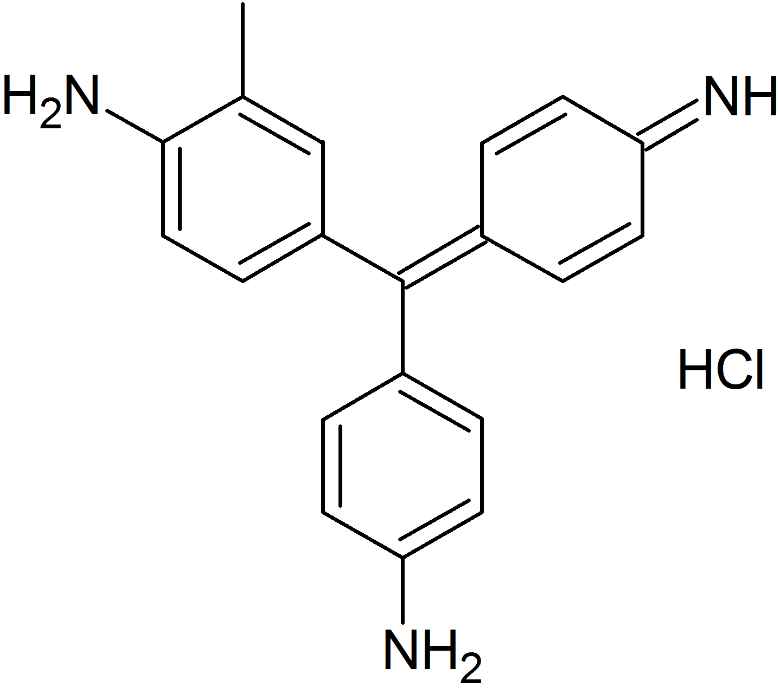

Figure 1. Chemical structure of Rosaniline [RND].

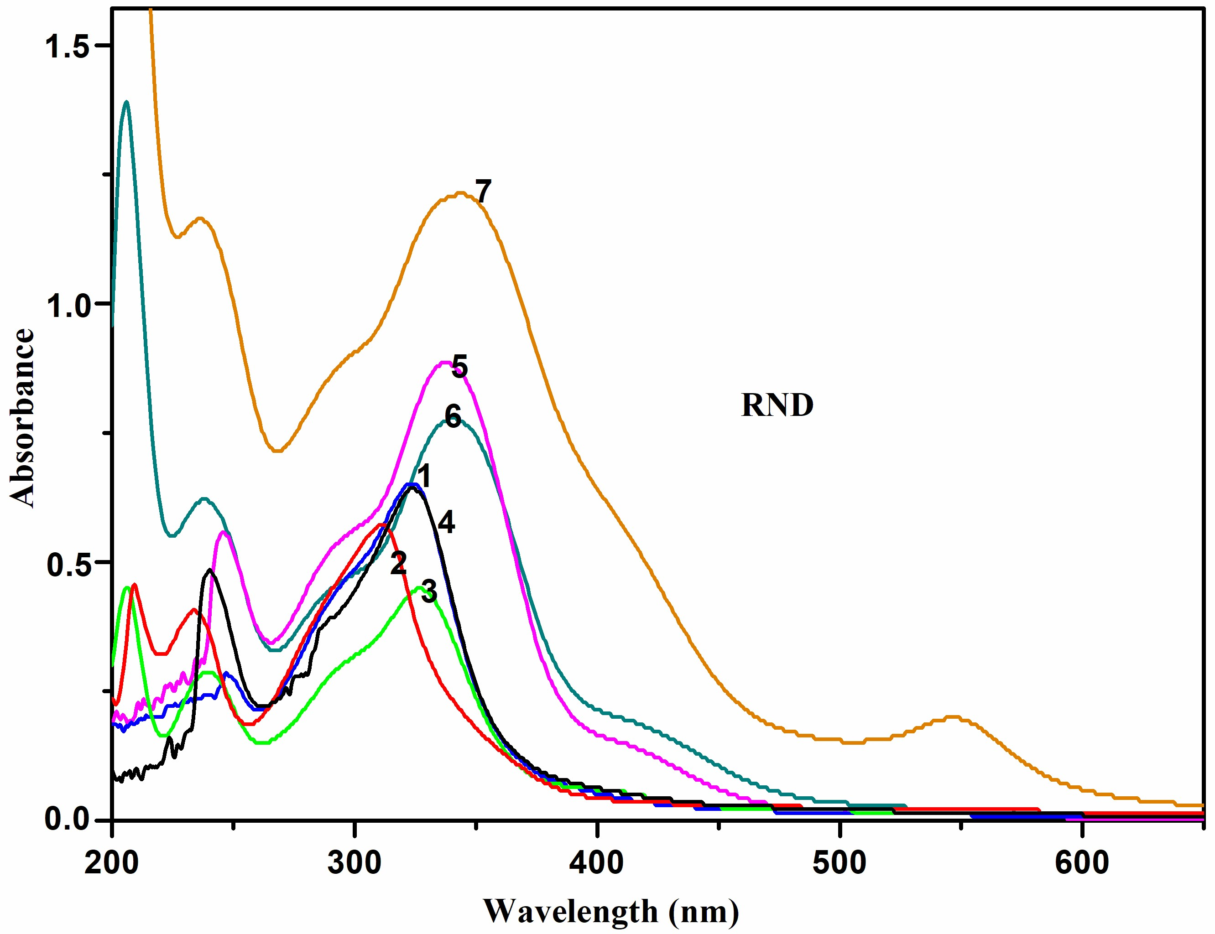
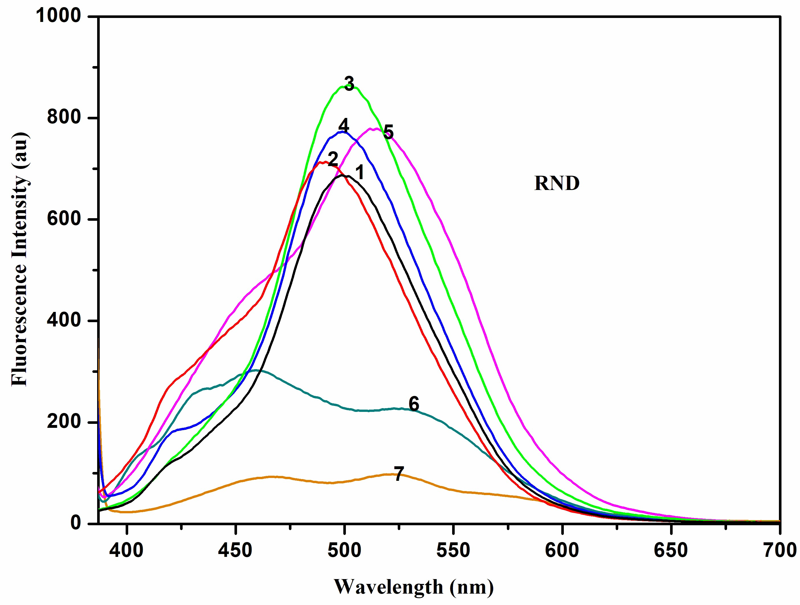

Figure 2. Absorption and fluorescence spectra of RND in different solvents at 303 K: 1) cyclohexane 2) 1,4-dioxane 3) ethyl acetate 4) acetonitrile 5) 2-propanol 6) ethanol 7) water.

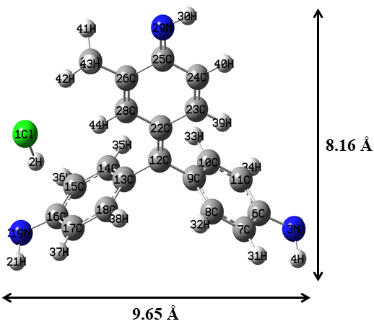
(a) PM3 optimized structure for RND 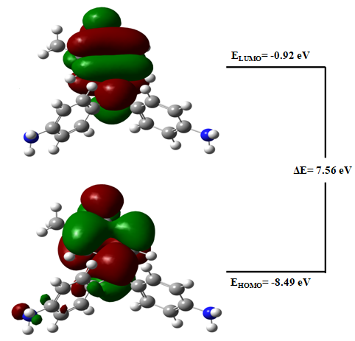
(b) HOMO, LUMO
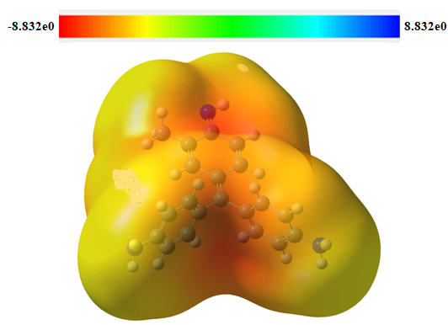
(c) MEP
Figure 3. PM3 optimized structures of (a) RND (b) HOMO, LUMO and (c) MEP of RND. The green and red colors represent the molecules' positive and negative phases, respectively, while the blue color shows the nitrogen atom.

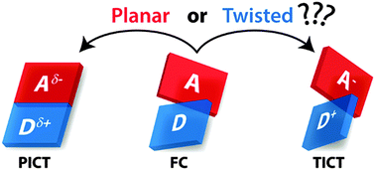

Figure 4 Donor–Acceptor (D–A ) type chromophore may twist or flatten in its excited state to form a TICT (twisted intramolecular charge transfer) state or a PICT (planar intramolecular charge transfer) state. FC- Franck Condon state.

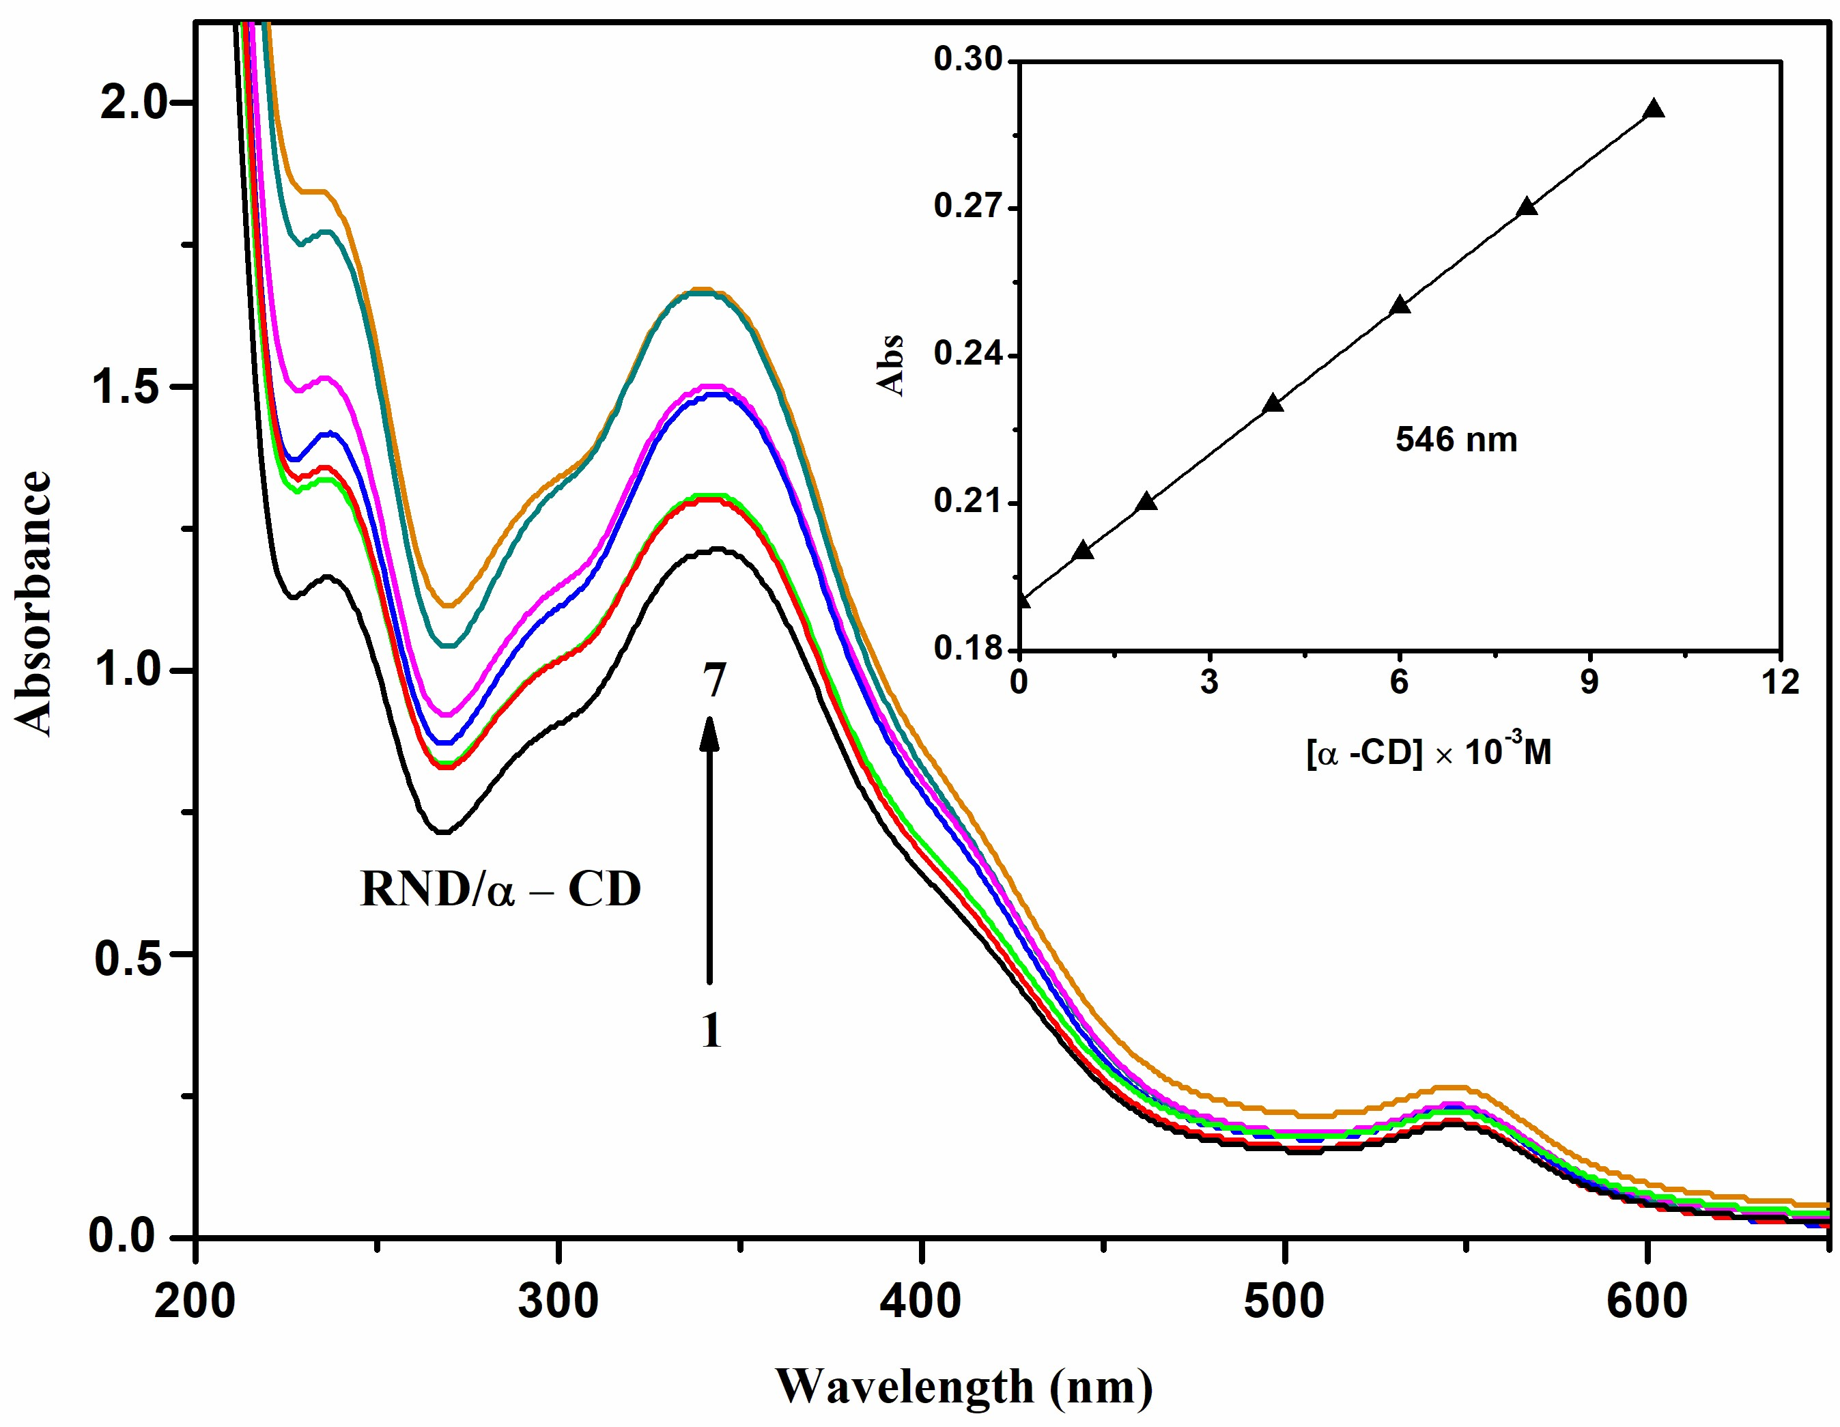

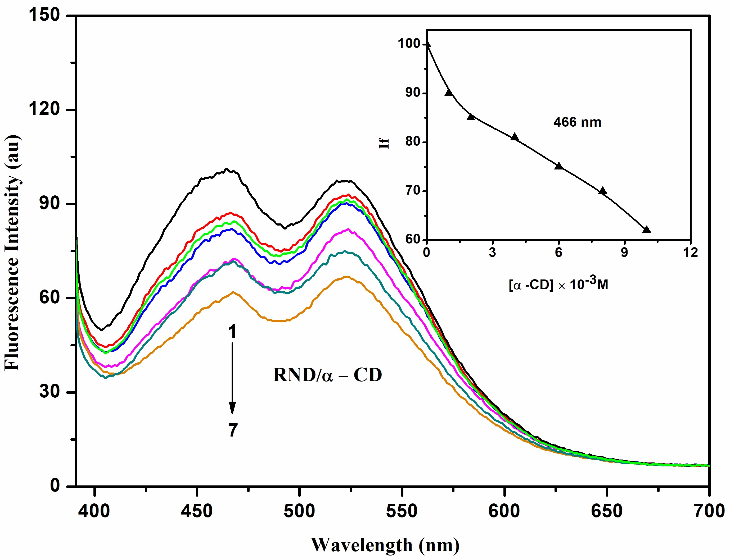

Figure 5. Absorption and fluorescence spectra of RND in different α-CD and β-CD concentrations (M): (1) 0, (2) 0.001, (3) 0.002, (4) 0.004, (5) 0.006, (6) 0.008, (7) 0.01. Insert figure: absorbance and fluorescence intensity vs [α-CD] or [β-CD].

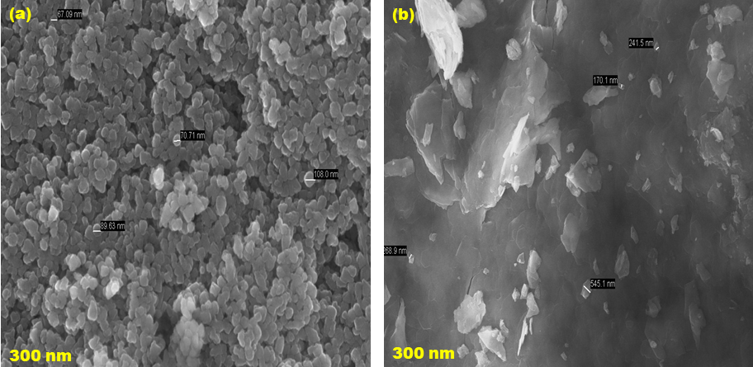
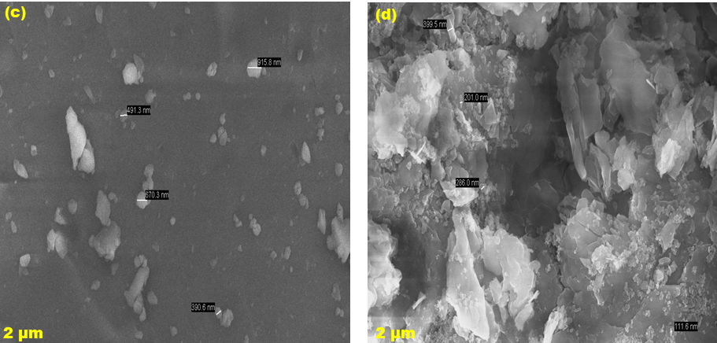

Figure 6. SEM images for (a) ZnO, (b) ZnO/β-CD, (c) RND, (d) ZnO/RND/β-CD nanocrystals.

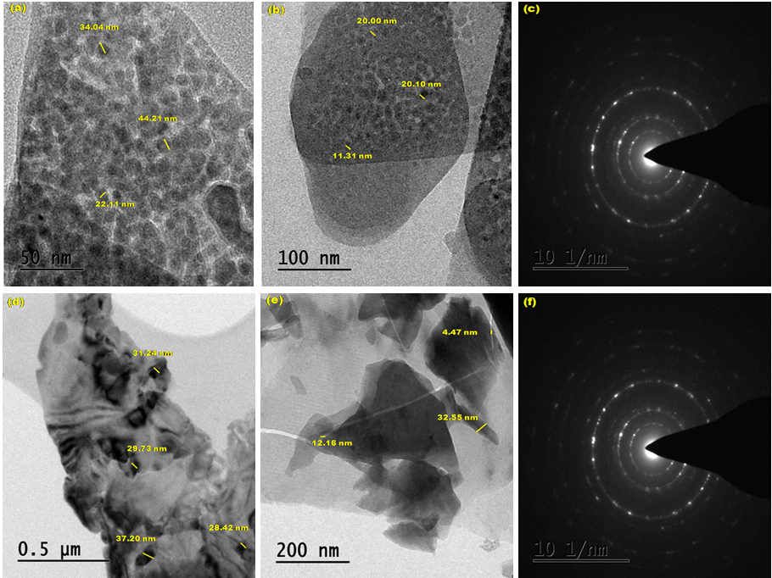
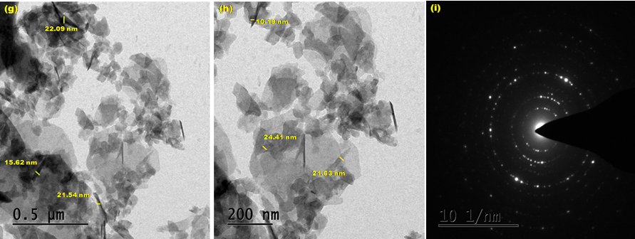

Figure 7. TEM images for (a-c) ZnO, (d-f) ZnO/β-CD, (g-i) ZnO/RND/β-CD.

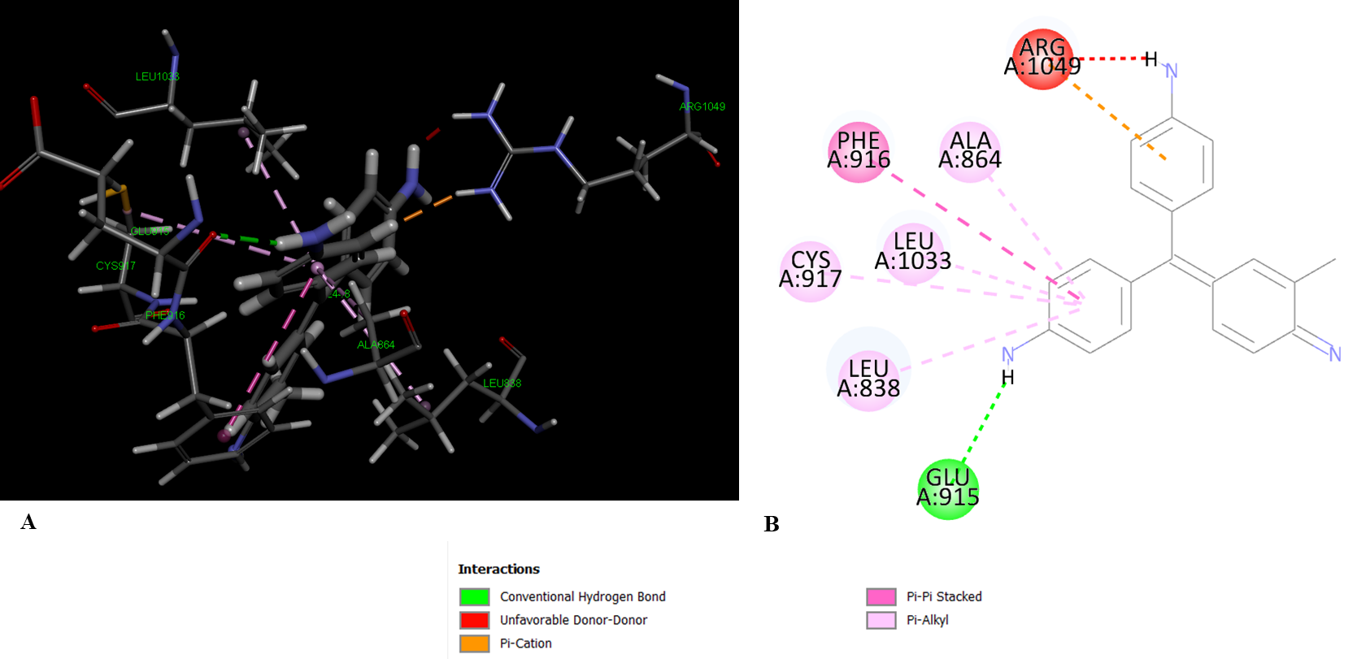
Figure 8. Molecular Docking of RND- 2OH4 interacting amino acid residues

