**Ekbom syndrome: A case series from West Africa**

**Abstract**

Ekbom syndrome or delusional parasitosis is a rare disorder characterized by the unshakeable and fixed belief that the skin is infested by insects or parasites. It is a monothematic delusion of hallucinatory origin, which can affect men or woman independent the old. We report the cases of three patients with delusional parasitosis in different clinical circumstances. All our patients had isolated delusional parasitosis. Case 1 was a woman aged 53 years who had been abandoned by her husband and found herself socially isolated. Her disorder had been evolving for over ten years, and adherence to treatment was difficult to achieve. Case 2 was also a woman aged 44 years whose husband had died. Her condition had been evolving for two years, with multiple consultations before being referred to psychiatry. Adherence to treatment was easily achieved. The case 3 involved a young unemployed man aged 38 years old whose syndrome had led to social isolation. These three clinical vignettes show that Ekbom syndrome affects both men and women, with similar psychopathological vulnerabilities. The therapeutic pathway in our context is punctuated by a long circuit prior to psychiatric treatment. It is important to raise awareness of this pathological entity among all those involved in the care chain, in order to optimize treatment times and costs. To this end, general practioners and dermatologists should be made more aware of the diagnosis of this syndrome.

**Keywords : Ekbom, delusional parasitosis, insight, Burkina Faso**

**Introduction :**

Delusional cutaneous parasitosis or delusions of cutaneous infestation, commonly known as Ekbom syndrome (ES), is a mental disorder characterized by the false belief of being infested by animate beings such as worms, bugs, bees, insects or flies. The prevalence of this syndrome in the general population is around 40 cases per million inhabitants [1]. Aetiologically, there is the form of primary SE without a psychiatric or somatic comorbid disorder, and the form of secondary SE underpinned by a mental pathology such as schizophrenia, dementia, depression, or a somatic pathology such as diabetes, neuropathy, stroke, menopausal conditions, human immunodeficiency virus, etc. [2]. More often than not, the psychiatrist only sees the patient in consultation after a long medical course, which can lead to delays in diagnosis and treatment. This is particularly true of primary forms of the disease. The patient's more or less absolute adherence to his delusion and skin discomfort are at the origin of scratching lesions and injuries during attempts to “extract the parasite” [2]. Complications such as skin infections are common, requiring multidisciplinary management. Some patients also gather evidence (parasites in boxes, pieces of dead skin on paper, etc.) to convince those around them, as well as the doctor, of the reality of their experience. This sign, known as the “matchbox sign” or “specimen sign”, is pathognomonic of SE [3]. We report a series of three cases seen in the psychiatry department of the Centre Hospitalier Universitaire Yalgado Ouédraogo in Ouagadougou.

**Case presentations**

**Case 1**

Mrs. SC, aged 53, not attending school, consults with her son for behavioral problems. For some fifteen years, she has been seen some “worms crawling under the skin” on her body, to which have been added over the years other types of animal, such as insects, ants emerging from her skin and locusts flying from her nostrils. She shows them to her children, who can't see them, and uses the slightest hint of skin, such as normal skin elevations, veins and scars, to illustrate the breaches through which insects or subcutaneous worms have emerged. She peels her skin to find the origin of the creatures emerging from it. This results in the lichenified dermatological lesions (Fig1) found on physical examination. She has no schizophrenia spectrum disorder, no depressive disorder and no obvious cognitive impairment. Her disorder began following her separation from her husband as a result of recurrent conflicts. Since then, Mrs. SC has been living alone, as her children have moved to another city for school.

Her therapeutic path was marked by alternating between traditional and conventional medicine, with no real success. Following a psychiatric consultation, the proposed treatment was refused, justifying this refusal by the lack of previous efficacy of several medications. The treatment consisted first and foremost in creating a good therapeutic alliance and working on the caregiver's insight. We asked her son to film his mother at home, without her knowledge. He realized that his mother sometimes gathered pieces of wood, dead tree leaves and peeled skin to support her delusions. This convinced him to accept neuroleptic treatment with haloperidol 10 mg/d orally in two doses, with criticism of the delirium. The evolution was marked by an improvement in symptomatology and a significant improvement in his quality of life after 6 months.

**Case 2**

Mrs LM, aged 44, widowed 7 years ago, illiterate, lives alone in an outlying district of Ouagadougou. She was referred to the psychiatry department of the dermatology service for pruritus resistant to antihistamine and corticoid treatments. The patient is the mother of 7 children, 4 deceased and 3 living, all of whom work in other towns in the country. She has no friends and has lived alone in her backyard since the death of her husband. Her symptoms began two years ago, marked by a sensation of a living creature crawling under her skin (scalp, trunk and limbs). Occasionally, she would feel stings from it, resulting in generalized itching and scratching lesions. Dermatological lesions of different ages are visible on skin inspection. Some have healed, while others are still active. Her course of treatment was marked by multiple consultations with traditional healers and general practitioners. When her condition persisted, she was referred to dermatology, where she was prescribed topical corticoids and antihistamines without any improvement in symptoms. The patient presented no other hallucinatory phenomena involving the other sense organs. A diagnosis of schizophrenia, depression or somatic complaints had been ruled out. The diagnosis of SE was made and neuroleptic treatment with haloperidol 10mg/day per os in two doses was prescribed, with the patient adhering from day one. Progression after 3 months was marked by a reduction in the intensity of cutaneous sensations and an improvement in quality of life.

**Case 3**

Mr D.I is 38 years old, unemployed, single and lives in an urban environment. He was referred to psychiatry by the dermatology department for persistent scratching lesions. The onset of symptoms was two years after his return from a gold-mining site. He was itchy day and night, and reported to his family that he felt insects moving over his body and biting him incessantly. He tried to remove them from his skin, which led to insomnia, an inability to sit still and social withdrawal. Mr D.I consulted a dermatology specialist, where a desloratadine-type antihistamine and a dermocorticoid combined with crotamiton, all in cream form, were introduced. As the symptoms persisted, the dermatologist referred him to psychiatry.

The clinical examination had ruled out another mental or organic disorder. We concluded that he was suffering from parasitosis delirium (SE), and antipsychotic treatment with haloperidol 10mg/day orally in two doses was initiated. The patient had been observant, and after seven months his progress was satisfactory, allowing the dose to be reduced to 2.5 mg haloperidol.

**Discussion**

Ekbom syndrome is a rare psychiatric condition affecting 40 people per million inhabitants[4]. In the literature, only a few cases have been reported in Burkina Faso[5].

The three (03) cases reported were all primary SE. There are cases of delusional parasioses secondary to psychiatric disorders such as schizophrenia, depression, bipolar affective disorder, dementia etc[6,7].

Two (02) cases (cases 1 and 2) were female and the ages of the patients were 53; 44 and 3 years. This female predominance has been reported in the literature, with an age of onset around fifty [8]. The role of social and emotional isolation (cases 1 and 2) and financial difficulties (case 3) in our series corroborates the data in the literature [ 1]. Several case reports and series have reported the same psychopathological factors in the emergence of SE [5,8,9]. It should be noted that SE can appear earlier or later in life, as reported by Gajbhiye et al [8] with patients aged 22 and 80. In our series, the disorder appeared at the age of 53 in case 1, 44 in case 2 and 38 in case 3. Late onset is most often secondary SE. The syndrome evolves insidiously and without spontaneous remission, as demonstrated by our series, which corroborates the data in the literature.

The specimen sign was observed in one patient (Case 1). This pathognomonic sign is not always present and could be linked to the duration of evolution, as the case had been evolving for more than 10 years and the other two cases for two years.

The most common psychiatric comorbidity is depression, followed by substance abuse and anxiety disorders [8]. In our series, no comorbidity was identified. What emerges from this case series is that SE evolves in patients for several years before they are seen by a psychiatrist.

On the one hand, this could be explained by the fact that the symptoms are at first sight considered by the patient and his entourage as non-psychiatric, but of mystical origin. On the other hand, multiple consultations with general practitioners failed to establish a psychiatric origin for the disorder. It is the absence of a favorable outcome that leads other health professionals to refer the patient to a psychiatric service, as we have seen in our cases.

Adherence to treatment is often difficult, as shown by Case 1, due to mystical beliefs. Working on insight (awareness of the illness) according to Minkowski's phenomenology enabled a therapeutic alliance to be achieved in Case 1. In Case 2, adherence to treatment was spontaneous. This raises questions about the relationship between the duration of the disorder's evolution and its accessibility to criticism, and the ease of obtaining the beginnings of insight and hence therapeutic compliance.

Collaboration with dermatologists, who are sometimes the referring physicians, is a multidisciplinary approach that needs to be strengthened, as demonstrated by cases 2 and 3.

Pharmacological treatment can be based on first- and second-generation antipsychotics[10]. In our series, all 3 patients benefited from 1st-generation antipsychotics, in this case haloperidol, due to its affordability. Progression was favorable in all cases, with improvement in quality of life.

**CONCLUSION**

Ekbom syndrome is a cutaneous infestation delirium that is most often encountered first in non-psychiatric healthcare professionals. Lack of awareness of the disorder on the part of patients and their families leads to long delays in consultations. Good knowledge of this syndrome among general practitioners could help reduce the cost of treatment, by avoiding repeated and fruitless complementary examinations. It could also improve the patient's therapeutic pathway. The results are satisfactory in terms of antipsychotic treatment. Also, dermatologists and general practioners should be sensitized about clinical manifestations and management of this syndrome.

**Consent**

As per international standards or university standards, patient(s) written consent has been collected and preserved by the author(s

**Disclaimer (Artificial Intelligence)**

We hereby declare that no generative AI technology and text-image generators were used during the writing of this manuscript.

**References**

1. **Espiridion ED, Charron L. Delusional Parasitosis Without Cutaneous Presentation: « I Have Moths in My Belly ». Cureus. juin 2024;16(6):e63185.**

**2. Lepping P, Freudenmann RW. Delusional parasitosis: a new pathway for diagnosis and treatment. Clin Exp Dermatol. mars 2008;33(2):113‑7.**

**3. Hinkle NC. Ekbom syndrome: a delusional condition of « bugs in the skin ». Curr Psychiatry Rep. juin 2011;13(3):178‑86.**

**4. Rodríguez-Alonso B, Álvarez-Artero E, Martínez-Goñi R, Almeida H, Casado-Espada NM, Jaén-Sánchez N, et al. Delusional parasitosis. A multicenter retrospective study in Spanish infectious disease services. Enfermedades Infecc Microbiol Clin Engl Ed. mai 2021;39(5):223‑8.**

**5. Ouédraogo NA, Korsaga/Somé NN, Nanema D, Ouédraogo MS, Zéba Lompo S, Tapsoba GP, et al. [Ekbom syndrome or delusional parasitosis: Three cases in Ouagadougou (Burkina Faso)]. Ann Dermatol Venereol. nov 2019;146(11):715‑9.**

**6. Lepping P, Russell I, Freudenmann RW. Antipsychotic treatment of primary delusional parasitosis: systematic review. Br J Psychiatry J Ment Sci. sept 2007;191:198‑205.**

**7. Freudenmann RW. Der „Dermatozoenwahn”. Fortschritte Neurol · Psychiatr. 11 oct 2002;70:531‑41.**

**8. Gajbhiye A, Ali T, Aziz S, Singh P, Gandhi S, Chaudhury S, et al. Delusional parasitosis: A case series. Ind Psychiatry J. nov 2023;32(Suppl 1):S258‑61.**

**9. Munoz H, Bayona L. Síndrome de Ekbom: a propósito de un caso. Rev Colomb Psiquiatr. janv 2015;44(1):61‑5.**

**10. Heller MM, Wong JW, Lee ES, Ladizinski B, Grau M, Howard JL, et al. Delusional infestations: clinical presentation, diagnosis and treatment. Int J Dermatol. juill 2013;52(7):775‑83.**

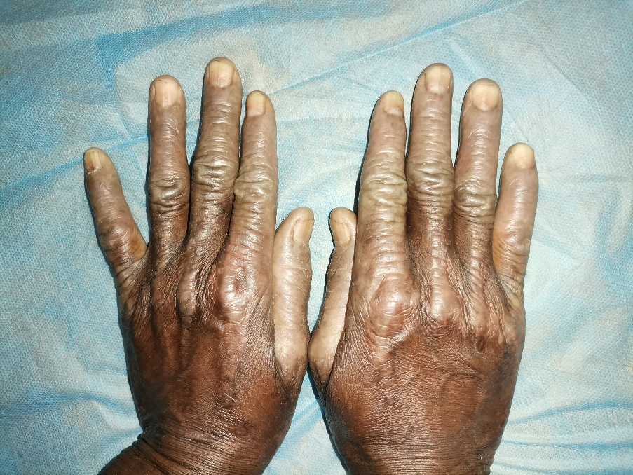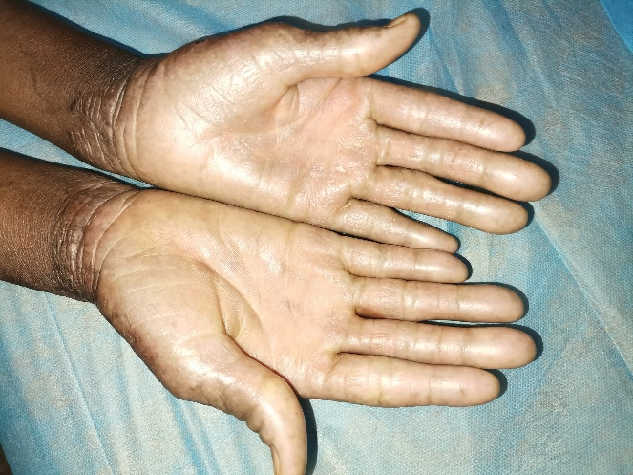

Figure 1 : Lichenified hand sores secondary to ulcerative self-mutilation (case 1)