Endodontic Management of Maxillary Molars with Uncommon Intraradicular Anatomy

ABSTRACT
Endodontic treatment is aimed at preventing apical periodontitis and facilitating bone healing. A comprehensive understanding of root canal morphology and its variations is crucial for achieving a successful treatment outcome. Accurate diagnosis and effective management of cases exhibiting atypical root canal morphology can be enhanced through the assessment of periapical radiographs from various angles, the application of advanced magnification techniques, and the utilization of Cone Beam Computed Tomography (CBCT) scanning. The occurrence of two palatal canals in the maxillary first and second molars constitutes a rare finding. This case report documents two instances of maxillary molars exhibiting two palatal canals.
KEYWORDS: Anatomic Variation, Maxillary First Molar, Palatal Root, Root Canal Anatomy, Root canal treatment, Palatal canal, instrument retrieval

INTRODUCTION
Intricate and complex variations in root canal anatomy renders endodontic treatment challenging and unpredictable. The presence of deviations from normal anatomy further adds to this challenge. Reasons for the failure of root canal treatment and a retreatment rate as high as 19% are attributed to the inability to identify the presence of additional canals. Therefore, detection of root canal variations prior to treatment, and refinement of related skills need to be addressed appropriately (Lin et al., 2025).
Generally,a majority of maxillary first molars are characterized by the presence of three distinct roots (mesiobuccal, distobuccal, and palatal roots). Among which the mesiobuccal root has two or more canals in 56.8% of cases. In contrast, the palatal root has the lowest variability, with a single canal in 99% and a single apical foramen in 98.8% of cases (Sung et al., 2021).
Variations in the palatal root of maxillary molars was first proposed by Stone and Stroner. As per the findings of Qun et al., the occurrence of variations in the palatal root of maxillary molars is merely 1.4% (Chen et al., 2022; Qun et al., 2009). Additionally, the prevalence of a maxillary first molar featuring two distinct canals within the palatal root is under 1% (Cleghorn et al., 2006).
In 1991, Christie et al proposed a classification for canal variations in the palatal root.
- Type I: Maxillary molars possessing two distinct palatal roots. The periapical radiograph reveals four root apices.
- Type II- Maxillary molars with four separate roots but shorter and blunted root apices. Radiograph may look like it has only a mesial and distal root.
- Type III - Maxillary molar has a narrow root structure, with the mesiobuccal, mesio-palatal, and distopalatal canals surrounded by a network of root dentin (Christie et al,1991).
Studies conducted by Baruwa et al. and Mashyakhy et al. indicate that approximately 82.6% to 90% of cases involving missed canals result in periapical pathology (Baruwa et al., 2020; Mashyakhy et al., 2021). These unaddressed canals often serve as reservoirs for bacteria within the root canal system, which can subsequently invade the periradicular tissues, potentially leading to persistent apical periodontitis. While anatomical anomalies in radicular structure are infrequently encountered, dental practitioners must maintain a high level of awareness for the existence of additional root canals or roots within a tooth (Kumar et al., 2012).

Case Presentation

CASE 1
A 70-year-old male patient presented to the department of conservative dentistry and endodontics with the chief complaint of intermittent pain and food impaction in his maxillary left second molar region. On clinical evaluation, severe attrition was noted on 27(maxillary left second molar). Thermal and electric pulp tests were non-responsive. A preoperative radiograph was taken, which revealed periodontal ligament widening and coronal radiolucency involving pulp (FIG. 1). The clinical diagnosis was pulp necrosis with symptomatic apical periodontitis. The patient was informed about the questionable prognosis of the post-endodontic restoration.
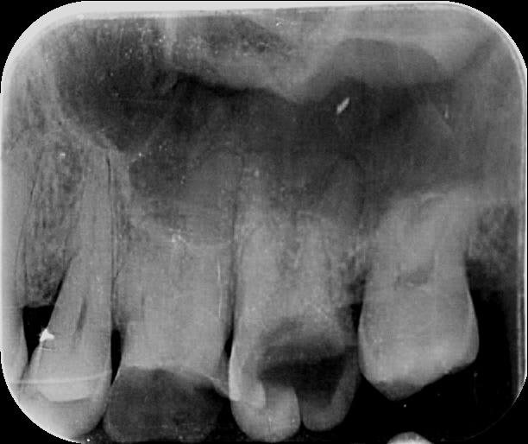
FIG 1: Preoperative radiograph of 27
On radiographic examination of 27, atypical anatomy of the roots was observed, and a cone beam computed tomography (CBCT) scan was taken for confirmation (FIG. 2). Local anaesthesia was administered, and the operating field was isolated with a rubber dam (COLTENE). Caries was excavated, followed by pre-endodontic buildup with composite (FIG. 3). Access opening was done. Exploration of pulp chamber revealed one mesiobuccal, one distobuccal and two palatal canals under magnification (Dental loupes 3.5x). The working length radiograph was taken using the bisecting angle technique (FIG. 4).
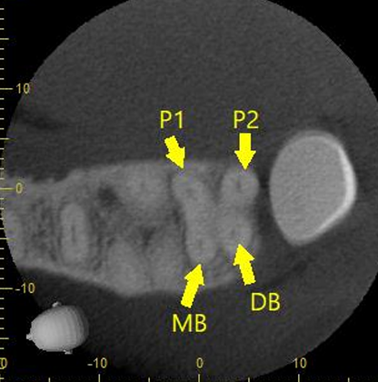
FIG 2: CBCT Image shows 2 palatal canals
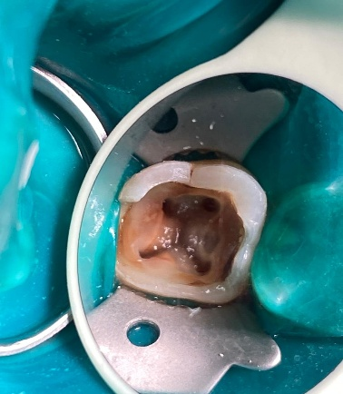
Fig 3: Pulp chamber with 4 root canals
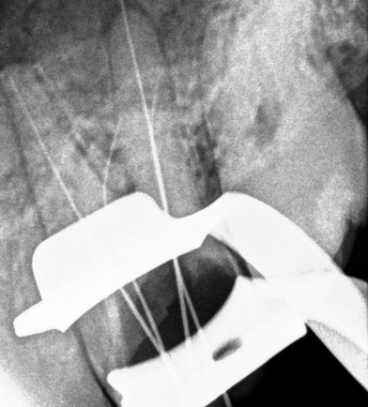
FIG 4: Working length determination
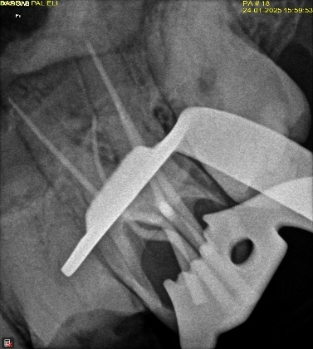
FIG 5: Mastercone radiograph
Initial instrumentation was performed with size 10 and 15 k files under irrigation with 2.5 % sodium hypochlorite. Root canal was prepared using the crown-down technique with Nickel Titanium (NiTi) rotary files (JIZAI, MANI, Japan). Further irrigation was completed with 2.5 % sodium hypochlorite irrigation, followed by 17% ethylene diamine tetraacetic acid (EDTA), then 5.25% sodium hypochlorite and a final rinse of normal saline. The root canals were dried with sterile paper points. Pre-obturation radiograph was taken with the master cones, and obturation was done with gutta-percha using cold lateral condensation technique (FIG. 5,6). Permanent restoration was complete with composite reinforced with ribbond.
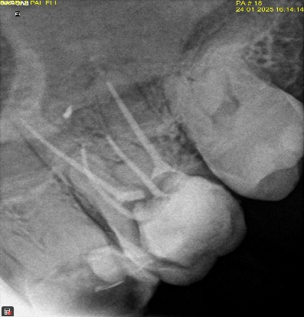
FIG 6: post obturation radiograph
CASE 2
A 35-year-old female patient presented to the department with the chief complaint of intermittent pain and sensitivity in her maxillary right first molar. On deeper clinical and radiographic evaluation, a gross proximal carious lesion was noted on 16(maxillary right first molar), and the tooth was tender on percussion (FIG. 7). Cold test demonstrated lingering pain for 50 seconds. The clinical diagnosis was symptomatic irreversible pulpitis with symptomatic apical periodontitis.
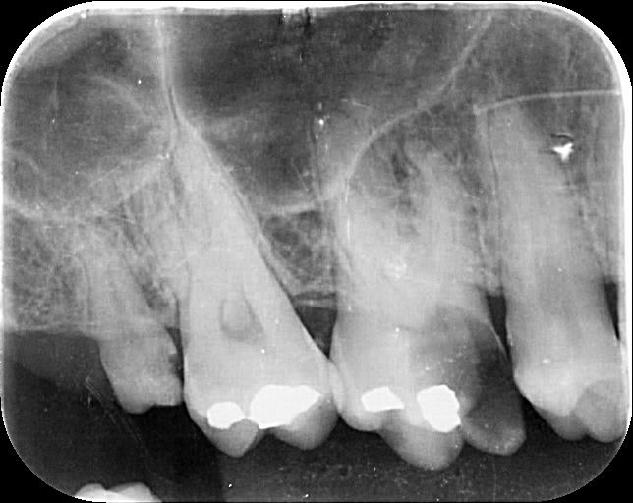
FIG 7: Preoperative Radiograph

Local anaesthesia was administered, and the operating field was isolated with a rubber dam. Caries was excavated, followed by pre-endodontic buildup with composite. Access opening was done. Initial exploration of the pulp chamber revealed two mesiobuccal, one distobuccal and one palatal canal. The pulp chamber was refined with ultrasonic tips, and further exploration of the pulpal floor with dental loupes (3.5x) revealed a second palatal canal. The working length radiograph was taken using the bisecting angle technique.. During preparation, instrument got separated in the coronal third, almost 2 mm from the canal orifice in the MB2 canal (FIG. 8).
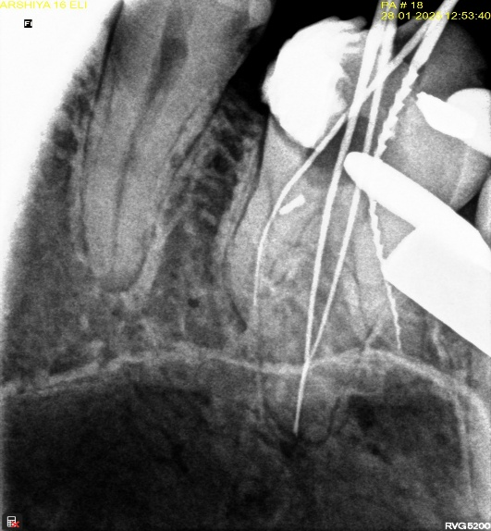
FIG 8: Working length radiograph with 2 palatal canals and fractured instrument in MB2
Further cleaning and shaping were completed with NiTi rotary files (JIZAI, MANI, Japan) after establishing a glide path with manual files. The canals were prepared using the crown down technique up to size 30/4% (MB1), size 30/6% (Distobuccal and P1) and size 30/4% (P2). Pre-obturation radiograph was taken with the master cones, then irrigation was done with 17% ethylene diamine tetraacetic acid (EDTA), 5.25% sodium hypochlorite and normal saline. The root canals were dried with sterile paper points, and finally, obturation of all canals except MB2 was done with gutta-percha using cold lateral condensation technique (FIG. 9). The Patient was recalled after one week.
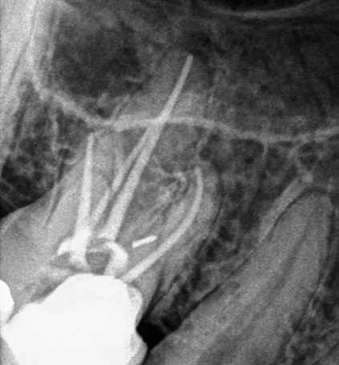
FIG 9: Post-Obturation radiograph of 4 canals
The broken instrument was first successfully bypassed, and the size of the canal was increased using K files. This created a staging platform for the placement of ultrasonic tips (Woodpecker E4 diamond-coated ultrasonic tips). The broken instrument was retrieved, and the canal was obturated (FIG.10,11). Mesial margin was elevated, and the access cavity was restored with composite, followed by an all-ceramic crown.

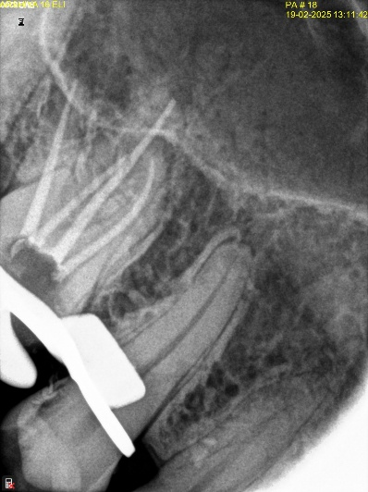
FIG 10: Radiograph after instrument retrieval from MB2
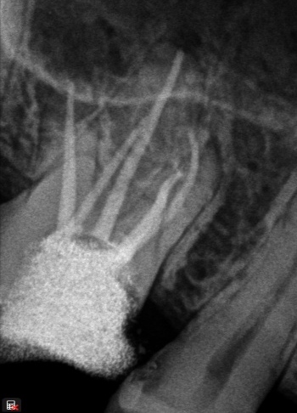
FIG 11: Post obturation Radiograph

DISCUSSION
This case report presents the non-surgical endodontic management of maxillary molars with atypical anatomy palatal root. The maxillary first molar is typically characterized by the presence of three roots and three to four root canals. Consequently, the occurrence of an additional palatal canal is considered to be relatively uncommon. The presence of additional canals in the palatal root of maxillary molars is reported to have a prevalence of approximately 2% to 5.1%(Krish, 2024). Dental practitioners can effectively identify and navigate these atypical configurations with a combination of magnification, illumination, proper access cavity preparation and careful canal exploration. Additional imaging tools, such as preoperative Cone Beam Computed Tomography (CBCT), are valuable and mandatory diagnostic adjuncts (Ali, 2020).
In case 1, two palatal canals have distinct orifices and exits, whereas in case 2, the 2 palatal canals seem to join at the apical third into a single exit. In accordance with Christie et al classification, case 1 may be described as a Type III molar. Palatal root of maxillary first molar shows a Type III , based on Vertucci classification. The access cavity had to be refined to a trapezoidal shape to enhance visibility for identifying additional canals. A thorough evaluation of the preoperative radiograph and careful examination of the pulp chamber floor, aided by effective visualisation and probing, enables the clinician to locate the canal orifices. Endodontic explorer, dental loupes, digital radiograph in various angulations, etc, have been useful in finding the additional canals. Meticulous evaluation of pulp chamber and floor for the potential presence of additional canals cannot be overemphasised preoperatively. It is crucial to identify and clean these extra canals to prevent endodontic mishaps. While the likelihood of encountering variations in radicular anatomy is generally low, practitioners must remain vigilant for the existence of supplementary canals or even additional roots (Ali, 2020; Sung et al., 2021).
Thorough observation of the preoperative radiograph helps reveal indistinct canal anatomy, which thereby cautions the clinician to be on lookout for canal variations. In case 1, the indistinct anatomy of the palatal canal was evident in the pre-operative radiograph (FIG.1), whereas in case 2, the working length radiograph (FIG.8) shows an off-centred appearance in the palatal canal. Dental loupes(3.5x) are utilised for magnification and illumination.
Instrument separation is a frequent occurrence that can happen even among experienced endodontists, with studies indicating an incidence rate of 94.8% in endodontists compared to 85.1% in general dentists (Madarati et al., 2008). To enhance the longevity of the affected tooth, it is crucial to make every effort to either bypass or retrieve the broken instrument without much structural damage to the tooth (Chauhan, 2024). In case 2, the initial attempts to bypass or retrieve the instrument were unsuccessful, and there was an additional risk of the instrument being lodged in other prepared canals during the retrieval process. Therefore, it was decided to obturate the remaining canals and postpone the instrument retrieval to a later appointment. During the follow-up session, the instrument was successfully bypassed and removed with a combination of copious irrigation using EDTA and ultrasonic activation. Ultrasonic devices have proven effective in loosening and eliminating various obstructions within root canals. The vibrational capabilities of endodontic instruments are useful and particularly recommended in cases where fractured segments are visible, enhancing the precision and effectiveness of the procedure (Glii et al., 2023; Shiyakov & Vasileva, 2014).
Properly designed and executed access cavities can help avoid numerous potential complications during canal preparation and filling. The utilization of magnification instruments, including dental microscopes and loupes, significantly enhances visualisation capabilities, facilitating the identification of anatomical irregularities (Buhrley et al., 2002 ). These tools enable practitioners to achieve a higher level of precision in their assessments and interventions, ultimately contributing to improved patient outcomes in dental practice. A larger and clearer perspective of the treatment area is achieved by increased magnification (Shetty et al., 2012). Such enhanced visualisation enables clinicians to recognise subtle anatomical characteristics and differentiate between canal orifices more efficiently (Manik et al,2024).

CONCLUSION
A comprehensive understanding of tooth anatomy is essential for effective practice. Thorough evaluations should be performed during both clinical and radiographic examinations of patients. Additionally, the utilization of endodontic microscopy and cone-beam computed tomography (CBCT) serves as valuable adjunctive techniques in endodontic treatment and the retrieval of instruments from the root canal. The decision to remove a fractured instrument is influenced by various factors, including the instrument’s position within the canal, the level of cleaning and shaping achieved at the time, and the length of the instrument. The clinician should approach root canal therapy with an open mind, avoiding any preconceived notions about the anatomy involved. It is essential to remain adaptable and ready to encounter variations that may not align with typical expectations. Embracing the unexpected will enhance the clinician's ability to effectively manage diverse clinical scenarios, ultimately improving patient outcomes.
CONSENT
All authors declare that ‘written informed consent was obtained from the patient (or other approved parties) for publication of this case report and accompanying images. A copy of the written consent is available for review by the Editorial office/Chief Editor/Editorial Board members of this journal
DISCLAIMER (ARTIFICIAL INTELLIGENCE)
Author(s) hereby declare that NO generative AI technologies such as Large Language Models (ChatGPT, COPILOT, etc.) and text-to-image generators have been used during the writing or editing of this manuscript.

References

- Lin X, Xie H, Ruan S, Ma X, Long J, Xie F. Five-canal maxillary first molar with calcified MB2 and low bifurcation of distal root canals: a case report. Frontiers in Oral Health. 2025 Mar 28;6:1511699.
- Sung KH, Hwang HK, Jo HH. Maxillary First Molars with Two Palatal Root Canals. Case Reports in Dentistry. 2021;2021(1):8885923.
- Chen, K., Ran, X., & Wang, Y. (2022). Endodontic Treatment Of The Maxillary First Molar With Palatal Canal Variations: A Case Report And Review Of Literature. World Journal Of Clinical Cases, 10(32), 12036–12044.
- Qun, L., Longxing, N., Qing, Y., Yuan, L., Jun, W., & Qingyue, D. (2009, April 1). A Case Of Asymmetric Maxillary Second Molar With Double Palatal Roots. | Ebscohost. Https://Openurl.Ebsco.Com/Contentitem/Gcd:43251665?Sid=Ebsco:Plink:Crawler&Id=Ebsco:Gcd:43251665
- Cleghorn BM, Christie WH, Dong CC. Root And Root Canal Morphology Of The Human Permanent Maxillary First Molar: A Literature Review. Journal Of Endodontics. 2006 Sep 1;32(9):813-21.
- Christie WH, Peikoff MD, Fogel HM. Maxillary molars with two palatal roots: a retrospective clinical study. Journal of endodontics. 1991 Feb 1;17(2):80-4.
- Baruwa AO, Martins JN, Meirinhos J, Pereira B, Gouveia J, Quaresma SA, Monroe A, Ginjeira A. The influence of missed canals on the prevalence of periapical lesions in endodontically treated teeth: a cross-sectional study. Journal of Endodontics. 2020 Jan 1;46(1):34-9.
- Mashyakhy M, Hadi FA, Alhazmi HA, Alfaifi RA, Alabsi FS, Bajawi H, Alkahtany M, AbuMelha A. Prevalence of missed canals and their association with apical periodontitis in posterior endodontically treated teeth: a CBCT study. International Journal of Dentistry. 2021;2021(1):9962429.

- Kumar, S. K., Sinha, S., Prabha, M. V., & Haragopal, S. (2012). Maxillary Molar With Two Palatal Canals. The Journal Of Contemporary Dental Practice, 13(6), 905–907. Https://Doi.Org/10.5005/Jp-Journals-10024-1251
- Krish, C. (2024). Management of extra palatal canal in a maxillary molar: A case report. IP Indian Journal of Conservative and Endodontics, 2024, 23410 https://doi.org/10.18231/j.ijce.2024.042

- Ali, M. (2020). Two Canals In Palatal Root Of Maxillary Molar: Case Series. Pakistan Journal Of Medicine And Dentistry. Https://Doi.Org/10.36283/PJMD9-1/020

- Madarati, A. A., Watts, D. C., & Qualtrough, A. J. E. (2008). Opinions And Attitudes Of Endodontists And General Dental Practitioners In The UK Towards The Intracanal Fracture Of Endodontic Instruments: Part 1. International Endodontic Journal, 41(8), 693–701. Https://Doi.Org/10.1111/J.1365-2591.2008.01425.X
- Chauhan, D. (2024). Retrieval Of A Separated Instrument Using Combination Of Ultrasonics And Braiding Technique- A Case Report. International Journal For Multidisciplinary Research, 6(5). Https://Doi.Org/10.36948/Ijfmr.2024.V06i05.28392
- Glii, W., Kikly, A., Brigui, F., Belguith, A. C., Zokkar, N., & Douki, N. (2023). Broken File Retrieval In The Lower Left Second Molar Using The Ultrasonic Technique. Mathews Journal Of Dentistry, 7(2). Https://Doi.Org/10.30654/MJD.10036
- Shiyakov KK, Vasileva RI. Success for removing or bypassing instruments fractured beyond the root canal curve–45 clinical cases. Journal of IMAB–Annual Proceeding Scientific Papers. 2014 Aug 19;20(3):567-71.
- Manik K, Ikhar A, Patel A, Chandak M, Bhopatkar J, Bhojwani PR, Rathod P, Manik Jr K. Diving Deep: Exploring Dual Palatal Canals in the Upper Second Molar. Cureus. 2024 May 28;16(5).
- Buhrley, L. J., Barrows, M. J., Begole, E. A., & Wenckus, C. S. (2002). Effect Of Magnification On Locating The MB2 Canal In Maxillary Molars. Journal Of Endodontics, 28(4), 324–327. Https://Doi.Org/10.1097/00004770-200204000-00016
- Shetty, P. P., Astekar, M. S., Jain, A., & Pandya, M. (2012). Maxillary First Molar With Two Palatal Roots Located Under Dental Operating Microscope. Clinics And Practice, 2(1), E26. Https://Doi.Org/10.4081/Cp.2012.E26

