Benign Yet Complex: Pleomorphic Adenoma of the Hard Palate

Abstract

Pleomorphic Adenoma is the most common tumor affecting both major and minor salivary glands and the most common intraoral site is the palate. 23 A male complained of a hard, painless mass over the left side of the hard palate, persisting for the last 2 years. On examination, a firm, well-circumscribed, smooth, non-tender, fixed mass over the hard palate measuring 2 cm × 2 cm. CBCT imaging showed a well-defined, lobulated enhancing lesion on the left half of the hard palate without signs of infiltration. Histopathology revealed a loosely arranged capsule. Tumor cells consisting of epithelial and myoepithelial cells arranged in sheets, strands, and cords in the matrix. Myxoid, myxochondroid, and osseous areas were seen. Squamous differentiation with keratin formation and lipomatous metaplasia is evident focally. The definitive treatment protocol for pleomorphic adenoma of the palate is its Complete surgical excision with removal of entire specimen to avoid recurrence. Pleomorphic adenoma can sometimes be difficult to diagnose due to its complexity. Specifically, in this clinical case, keratinization and lipomatous changes may help expand knowledge about PA, especially among professionals with less experience.

Keywords: Palate; Pleomorphic Adenoma; Salivary gland

Introduction
“Pleomorphic adenoma was first described by “Minssen” in Ahlbom’s monograph in 1874. The term PA was recommended by “Bechamp” due to its unique histological pattern. The tumor reveals a variety of names, also known as a benign mixed tumor, iceberg tumor, endothelioma, branchioma, enchondroma, and enclave. Frequently it occurs in the parotid glands (85%), followed by the minor salivary (10%) and submandibular glands (5%). Pleomorphic adenoma is the most common tumor of major and minor salivary glands and reports about 40%–70% of all salivary gland tumors; 6.4% occur in the minor salivary glands whereas palatal glands are more commonly involved in the case of minor salivary gland because multiple number of glands are situated on the palate”. [1] “The World Health Organization defines PA as a localized tumor that presents pleomorphic or mixed characteristics of epithelial origin and is interwoven with mucoid tissue, myxoid tissue, and chondroid masses”. [2] These tumor cells have the potential to differentiate epithelial cells such as ductal and non-ductal cells and mesenchymal-like chondroid, myxoid, and osseous tissues.

Case Presentation
A 23-year-old male patient reported to the department with the chief complaint of swelling on the left side of the palate for the last 2 years. The swelling had shown gradual enlargement and was asymptomatic with no associated pain and discomfort. No relevant past medical and dental history was reported, and no preceding history of trauma COVID-19, Diabetes, or Fungal infection. Intraoral examination, dental caries with tooth 26, which has undergone root canal treatment, however, the swelling persisted. A single sessile painless overgrowth was observed on the left side of the hard palate without crossing the midline. It extended from the mesial aspect of 25 to the distal aspect of 27 anteroposterior and from midline to teeth medially laterally. The swelling was coral pink in colour measuring approximately 2 cm × 2 cm in size, dome-shaped, and having well-defined margins, smooth and shiny surface overlying the growth. On palpation, the lesion was soft, non-tender, compressible but non-reducible, and fixed to underlying structures. Hence, based on clinical findings, a provisional diagnosis of benign minor salivary gland tumor i.e. PA was made. The differential diagnoses included Palatal abscess, torus, fibroma, lipoma, and malignancy such as mucoepidermoid carcinoma.
On radiographic investigation, a three-dimensional cone-beam computed tomography scan of the maxillary arch showed well-defined corticated radiolucency. And three-dimensional cone-beam computed tomography scan of the maxillary arch showed bony erosion with perforation of the palatal wall in sagittal [Figure 4], axial [Figure 2] sections & coronal [Figure 5]. And thinning of the floor of the maxillary sinus. A complete hemogram showed all blood cell counts to be within normal limits. Needle aspiration was performed and yielded negative results. Treatment included Complete surgical removal of the lesional part along with the small portion of surrounding healthy tissue. The specimen was sent for histopathological examination.
Under H and E stained sections showed glandular tissue partly encapsulated by loosely arranged capsules. The tumor comprises both cells consist of epithelial and myoepithelial cells arranged in the form of sheets, strands, and cords infiltrating the capsule. Myxoid, myxochondroid, and osseous areas were seen. Squamous differentiation with keratin formation and focal lipomatous metaplasia was also evident. Duct-like structures were lined by epithelial cells internally and surrounded by myoepithelial cells externally. Few round plump eosinophilic cells with granular cytoplasm evocative of oncocytes were seen. Myoepithelial cells showed varying morphology from angular, spindle to round cells characterized by eccentric nuclei and hyalinised cytoplasm giving a plasmacytoid appearance. Histopathologically identified crystals particularly tyrosine-rich crystalloids at a place, which were small, dense, pinkish floral bursts within the myxoid or hyalinized stroma. Immunohistochemistry was performed to differentiate from Carcinoma ex pleomorphic adenoma (CXPA). It showed ki-67 proliferative index was 20%, and the P53 expression was 30% which shows a negative for Carcinoma ex pleomorphic adenoma. Kim JW et al suggested positive rates for the p53 protein were 0% - 41% for PA and 45.2% - 75% for CXPA. Malignant transformation were not observed.
Follow-up after 3 months showed the healed area as in Figure 13
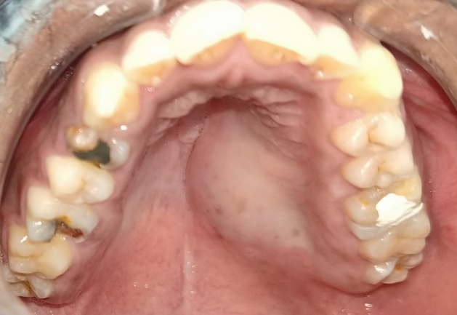

1

Figure 1: Intraoral photograph of swelling on left side of hard palate not crossing midline.

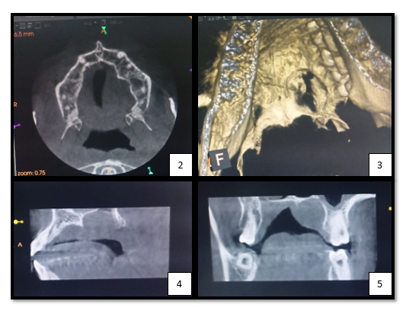

Figure 2: Occlusal radiographic view / Axial view
Figure 3: Skeletal view
Figure 4: Sagittal view of CBCT section showing palatal bone perforation.
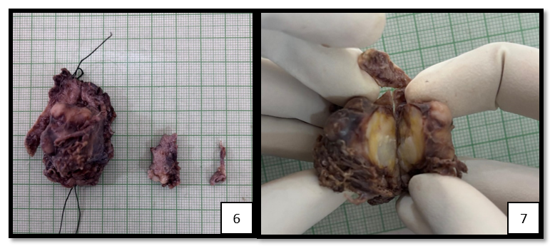
Figure 5: Coronal View on CBCT section showing erosion and perforation

Figure 6: Gross Pathology shows 3 soft tissue fragments brownish in colour and ranging from soft to firm in consistency.

Figure 7: Cut surface of the tumor appears white to grayish-white with areas of yellowish discoloration.

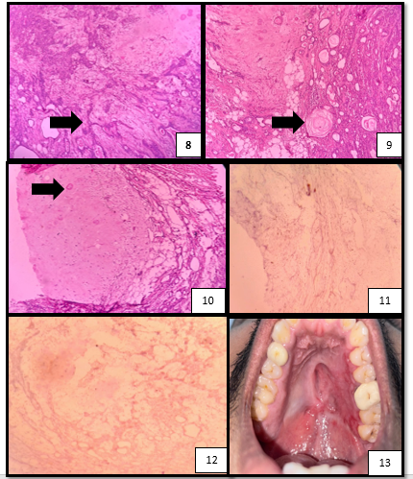

Figure 8: H and E stained section showing epithelial and myoepithelial cells arranged in the form of sheets, strands and cords infiltrating the capsule
Figure 9: H and E stained section showing Squamous differentiation with keratin formation and lipomatous metaplasia
Figure 10: H and E stained section showing Myxoid, myxochondroid and osseous areas
Figure 11: IHC stain of ki-67 proliferative index - 20%
Figure 12: IHC stain of P53 - 30%
Figure 13: Follow up after 3 months
Discussion
PA occurs mostly in major salivary glands with only 4-6% found in the minor salivary glands. 41%– 51% of palatal tumors. [3] Among tumors of the minor salivary glands, PA comprises around 70%, with the most common site in the oral cavity being the hard palate. Other less commonly affected areas include the lip, buccal mucosa, floor of the mouth, tongue, tonsils, pharynx, and gingiva. Pleomorphic pertains to mixed tumors that encompass both epithelial and mesenchymal tissue types that begin embryonically. It is assumed that these tumors arise from interstitial & myoepithelial cells.
“Diagnosis of PA is mainly based on histological examination, patient history, the clinical presentation of the lesion, and radiological investigation. PA of the hard palate is seldom allowed to attain a size greater than 1-2 cm in diameter as it causes difficulty in mastication, speech, and swallowing”. [14] When occurring on the hard palate, PA typically presents as firm, painless submucosal swelling without signs of tenderness, ulceration, / inflammation. These tumors often lack well-defined capsules and may extend to involve periosteum / underlying bone. Due to the structural distribution of minor salivary glands in the palate, they are usually positioned laterally and rarely cross the midline [12]. M. Chandra Sekhar et. al [13] reported an extent that didn’t cross the midline which was observed in this case report as shown in Figure [1]
Clinical differential diagnosis of such condition includes palatal abscess, cysts of odontogenic / non-odontogenic origin, as well as other soft tissue tumors. A palatal abscess can typically be ruled out during clinical examination, as this condition arises from a non-vital tooth, where earlier 26 was considered to be the culprit and hence it was treated for RCT, still swelling persisted. While examining a tumor, it is possible to rule out the presence of odontogenic and non-odontogenic cysts if the mass did not exhibit cystic consistency on palpation and for further clarity radiographic examination was advised.
Radiographically, PA typically does not show significant bony changes, Gupta SR et al. [12] reported three cases of PA with no underlying bony changes, i.e. benign neoplastic lesion over the hard palate without invasion of periosteum or bone. In the present case report, three-dimensional CBCT scan of the maxillary arch showed bony erosion with perforation of the palatal wall in sagittal, axial sections & coronal. Patait M et al [1] reported bony erosion with perforation of palatal vault biopsy was involved.
Pleomorphic adenomas classically are characterized by proliferating ductal and myoepithelial cells within chondromyxoid matrix. “These epithelial and myoepithelial elements may be arranged in various patterns within a stroma. Other stromal components hyaline / fibrous stroma are found to be rare. But extremely rare variant shows osseous or lipomatous changes in the stroma”. [7]. In certain tumors, luminal cells exhibit a range of focal differentiation into goblet, sebaceous, / squamous cells. About 25% of PA patients exhibit squamous metaplasia, which appears prominent and shows up as cysts filled with keratin. Similar findings in the present case report were observed. Despite the tumor being was asymptomatic, the tumor demonstrated histological features consistent with PA. Prominent squamous metaplasia was present and seems to be associated with non-luminal tumor cells.
“PA presenting extensive squamous metaplasia is uncommon and an incidental microscopic finding which signifies a potential pitfall in the histopathological diagnosis but squamous metaplasia has also been noted in non-neoplastic pathologies, like chronic sialadenitis, necrotizing sialometaplasia, and lymphoepithelial cyst. This change is commonly associated with repair following infarction and necrosis of the salivary glands. The metaplastic process might be triggered by minor trauma. The presumed etiology for this change is ischemia. This etiology is supported experimentally by the induction of squamous metaplasia in rat salivary glands by arterial ligation. Pathogenesis involves squamous metaplasia and keratin pearl formation in PA have been proposed as dedifferentiation of acinar cells and subsequent hyperplasia of acinar, ductal luminal, and myoepithelial cells. Keratin pearl formation and squamous metaplasia are frequently seen involving the minor salivary glands rather than the major glands. Hence, it is proposed that the epithelium of the minor salivary gland duct exposed to various sources of irritants may be the cause for keratin pearl formation in PA”. [8] In our case, the presence of bony perforation and the presence of squamous metaplasia was considered to be an aggressive lesion, and therefore carcinoma ex pleomorphic adenoma was meant to be ruled out.
CXPA is a rare malignant SGT that arises from the malignant transformation of a pre-existing PA. Although certain clinical features such as rapid growth, or radiological features such as irregularity, may increase the index of suspicion, histopathological examination of the tumor remains the key in diagnosing this entity. Pathological diagnosis, however, can be difficult as capsular invasion is the hallmark, which distinguishes it from PA. Kim JW et al suggested positive rates for the p53 protein were 0% - 41% for PA and 45.2% - 75% for CXPA, and some authors postulated that the p53 mutation was an early event in the malignant transformation of PA [9] In the present case, IHC revealed ki-67 proliferative index of 20%, P53 expression of 30% which shows negative for Carcinoma ex pleomorphic adenoma according to Kim JW et al.
Ki-67 antigen, a non-histone nuclear protein present in all active phases of the cell cycle. The percentage of cells staining positive with antibodies against Ki- 67 allows for the determination of the overall growth fraction of a tumor. [10] Immunohistochemical markers such as Ki-67 and p53 are widely used to assess the proliferative activity and potential malignancy of PA and CXPA. Ki-67 is a marker of cellular proliferation, and its expression is typically low in benign pleomorphic adenomas but significantly higher in malignant CXPA. Similarly, p53 is a tumor suppressor protein, and its expression is usually low in benign PA but elevated in malignant Carcinoma ex pleomorphic adenoma.
PA is benign tumor that transforms into Carcinoma ex pleomorphic adenoma. The use of immunohistochemical markers like Ki-67 and p53 helps in distinguishing between benign and malignant forms and assessing the aggressiveness of the tumor.
In the present case Complete surgical removal of the lesional part along with the small portion of surrounding healthy tissue. The primary treatment for PA of the palate is surgical removal. The approach depends on the tumor’s size, location, and individual patient factors. Complete Surgical Excision i.e. standard treatment involves removing the tumor with clear margins to minimize the risk of recurrence. This includes excising the tumor along with small portion of surrounding healthy tissue. Reconstruction, if tumor removal results in significant palatal defect, reconstructive techniques may be required. Local flaps, such as greater palatine artery-based palatal rotational flaps, can be used to restore function and aesthetics. Post-surgical care includes Regular follow-ups, including clinical examinations and imaging studies, which are crucial for monitoring recurrence. Radiation Therapy is advised if complete excision is not feasible / if there is a high risk of recurrence, radiation therapy may be recommended as an additional treatment. [11] [15]
Conclusion
This case of pleomorphic adenoma of the palate is particularly rare due to its presentation with palatal erosion, an unusually long duration before diagnosis, and the presence of squamous metaplasia on histopathological examination. The extensive palatal involvement necessitated careful surgical planning to achieve complete excision while preserving function. Additionally, histopathological findings of squamous metaplasia highlight the potential for misdiagnosis / malignant transformation if not properly evaluated. PA is a benign SGT that can transform into CXPA. Immunohistochemical markers, such as Ki-67 and p53, are valuable tools for differentiating PA from other salivary gland lesions. The combined assessment of Ki-67 and p53 can help identify potential malignancy and guide treatment decisions, ensuring early detection and appropriate management of CXPA. This case underscores the importance of early detection, thorough histopathological assessment, and long-term follow-up to ensure optimal patient outcomes.

Disclaimer (Artificial intelligence)
Option 2:
Author(s) hereby declare that generative AI technologies such as Large Language Models, etc. have been used during the writing or editing of manuscripts. This explanation will include the name, version, model, and source of the generative AI technology and as well as all input prompts provided to the generative AI technology
CHATGPT FOR MINOR REWRITING
References
- Patait M, Chaudhari V, Durugkar M, Thakare A, Shetty A, Tupsakhare S, et al. Palatal swelling: Pleomorphic adenoma – A case report. J Oral Maxillofac Radiol 2023;11:31-6.
- Matsumiya-Matsumoto, Y.; Morita, Y.; Uzawa, N. Pleomorphic Adenoma of the Salivary Glands and Epithelial–Mesenchymal Transition. J. Clin. Med. 2022, 11, 4210. https:// doi.org/10.3390/jcm11144210
- Pourgholi Takrami Z, Ebrahimi T. Abbasian F. Pleomorphic Adenoma of Hard Palate: A Case Report. J Craniomaxillofac Res 2024; 11(1): 60-64. DOI: 10.18502/jcr.vllil.16491
- Hanafiah, O. A., Dohude, G. A., Ayuni HG, A., Tanandika, J., & Wirsa, D. A. (2024). Long-standing pleomorphic adenoma in hard palate: A rare case report. Dental Journal, 57(4), 305–309. https://doi.org/10.20473/j.djmkg.v57.i4.p305-309
- AlSahman L, Alghamdi O, Albagieh H, AlRefai A, AlSahman R, Alnafea S. Pleomorphic adenoma of hard palate: Review of updated literature and “case report”. Medicine 2024;103:36(e39529).
- Tom JJ, Puthalath U, Sreejith VP, Nair AS, Vidhya Vijayan MC, Krishnan A. Pleomorphic adenoma of the palate: A case report. 2024; 13(1):1-3.
- Jain N, Keshwar S, Shrestha A, Jaisani MR, Maharjan IK, Agrawal N. Intraoral Pleomorphic Adenoma of the Minor Salivary Glands: A Case Series of 10 Cases With Emphasis on Histopathological Features. Case Rep Dent. 2025 Jan 13;2025:9151514. doi: 10.1155/crid/9151514. PMID: 39834626; PMCID: PMC11745558.
- Hosur MB, Puranik RS, Dandagi SG, Patil VM. Pleomorphic adenoma with extensive squamous metaplasia and keratinizing cysts: diagnostic and clinical pitfalls – A report of two cases and review of literature. J Oral Maxillofac Pathol 2024;28:689-93.
- Kim JW, Kwon GY, Roh JL, Choi SH, Nam SY, Kim SY, Cho KJ. Carcinoma ex Pleomorphic Adenoma of the Salivary Glands: Distinct Clinicopathologic Features and Immunoprofiles Between Subgroups According to Cellular Differentiation. J Korean Med Sci. 2011 Oct;26(10):1277-1285. https://doi.org/10.3346/jkms.2011.26.10.1277
- Yarman Y, Post R, Breslin Z, Solomides CC, Gargano SM. Utility of Proliferation Markers Ki‐67 and PHH3 in Predicting Malignancy in Basaloid Salivary Gland Neoplasms: A Study Using Digital Image Analysis of Cytology Cell Blocks. Diagnostic Cytopathology. 2025.
- Kadam SS, Kanitkar G, Jigjinni V, Kadam T. Pleomorphic Adenoma of Palate: A Case Report. Clin Oncol. 2020; 5: 1717.
- Gupta, S., Thorawade, V., & Khan, M. H. M. (2021). Pleomorphic Adenoma of Hard Palate: A Case Series. 12(1), 11–13. https://doi.org/10.5005/JP-JOURNALS-10003-1345
- Sekhar, M. C., Thabusum, D. A., Charitha, M., Chandrasekhar, G., & Dharani, K. S. (2019). Pleomorphic Adenoma of a Minor Salivary Gland of the Hard Palate Report of a Case. Journal of Advances in Medicine and Medical Research, 1–6. https://doi.org/10.9734/JAMMR/2019/V30I530199
- Arumugam P, Christopher PJ, Kumar S, Kengasubbiah S, Shenoy V. Pleomorphic Adenoma of the Palate: A Case Report. Cureus. 2019 Mar 25;11(3):e4308. doi: 10.7759/cureus 4308. PMID: 31183288; PMCID: PMC6538108.
- Kaushik, Eshaan 2023. “Surgical Management of a Large Palatal Pleomorphic Adenoma by Intra Oral Route: A Difficult Case”. International Journal of Otorhinolaryngology and Head and Neck Surgery 9 (8):668-71. https://doi.org/10.18203/issn.2454-5929.ijohns20232227

