Assessing Iron Fractions and Their Availability in Lateritic Soils of Kerala Using Structural Equation Modelling

ABSTARCT
Aims: The study aimed to investigate the different fractions of iron in the north central laterites of Kerala and their relative contribution to iron availability.
Study design: Soil sampling, characterisation, fractionation, and structural equation modelling
Location and duration of study: Department of Soil Science and Agricultural Chemistry, College of Agriculture, Vellanikkara, Thrissur, from January 2024 to May 2024.
Methodology: Thirty georeferenced soil samples were collected from Agro Ecological Unit (AEU) 10, representing the north central laterites of Kerala. The samples were characterised, and different iron forms were extracted. Fractionation procedures were carried out to separate specific iron pools. Structural equation modelling (SEM) was used to determine the soil properties and iron fractions contributing to iron availability.
Results: The results showed that the dominant fractions in the soil were residual iron (32.06%) and crystalline iron oxide occluded iron (28.97%). Acid-soluble iron (Aci-Fe), crystalline iron oxide-occluded iron (Cry FeO-Fe), and manganese oxide-occluded iron (MnO-Fe) positively influenced available iron (path coefficients = 0.28*, 0.26*, and 0.55**, respectively). In contrast, fractions such as amorphous iron oxide-occluded iron (Am FeO-Fe), organic matter-bound iron (OM-Fe), and residual iron showed more indirect effects on iron availability.
Conclusion: In the laterites of north central Kerala, most iron is present in stable forms and only a small fraction is present as plant-available iron. Its availability is controlled by dynamic interactions between amorphous, crystalline, and organically bound forms of iron. Although pH did not show a strong direct effect on iron availability, it may still play an indirect role by influencing the stability of organic matter and the transformation between different iron forms.
Keywords: Iron fractions, Iron availability, lateritic soils, crystalline forms, soil properties
1. INTRODUCTION
Iron (Fe) is a vital component of the soil system and an essential nutrient for plant growth and development, due to its key role in various physiological processes such as respiration, photosynthesis, and nitrogen fixation. In soils, Fe occurs mainly as oxides (magnetite, hematite, and maghemite), sulphides (pyrrhotite), and hydroxides (goethite and limonite) (Roberts, 2015). The formation of iron oxides is the result of chemical weathering and pedogenic processes, both of which are strongly influenced by the local climate (Reethu et al., 2023).
Iron in soils is predominantly in the insoluble Fe³⁺ form, although its speciation can vary considerably depending on soil pH and moisture conditions (Lindsay, 1981; Mengel, 1994). In highly weathered soils, such as Ultisols, Fe (III) oxides dominate (Sureshkumar et al., 2018). In soils, Fe occurs in a variety of forms, including exchangeable and soluble forms, and Fe associated with metal oxides, carbonates, and organic matter (Firnia et al., 2019). Additionally, iron occurs as residual forms bound to mineral structures. Each of these iron pools contributes differently to the availability of iron in the soil (Viets, 1962).
Selective chemical extractions are routinely used to quantify the different pools of Fe in soils. Dilute acids such as 0.1 M HCl are widely used to extract available forms of Fe mainly in acid soils (Sims and Johnson, 1991). Oxalate extraction targets the amorphous and poorly crystalline forms of Fe (Schwertmann, 1973), while citrate-dithionite extraction dissolves both crystalline and non-crystalline forms of Fe. The ratio of oxalate-extractable Fe (Fe_{OX}) to dithionite-extractable Fe (Fe_{CBD}), known as the active iron ratio, is an indicator of the degree of crystallinity. A low Fe_{OX}/Fe_{CBD} ratio indicates a high degree of crystallinity and advanced weathering (Torrent et al., 1980). In addition, citrate-dithionite extraction specifically removes free, non-silicate-bound Fe, distinguishing it from Fe that is part of silicate minerals (McKeague and Day, 1966).
The laterite soils of Kerala are classified as Ultisols, characterized by low pH, low cation exchange capacity (CEC), dominance of gibbsite, and 1:1 clay minerals such as kaolinite. These soils have been formed by an intense weathering process known as laterisation, which occurs under humid tropical conditions. During laterisation, extensive leaching of bases and silica from the parent material leads to the accumulation of chemically stable Fe and Al oxides and hydroxides, including goethite, hematite, and gibbsite (Kalpage, 1974). These well-developed soils are prone to oxidative losses of organic matter and commonly exhibit iron and aluminium toxicity (Sureshkumar et al., 2018).
In these acidic lateritic environments, although most of the Fe exists in the form of insoluble ferric oxides and hydrous oxides, both in crystalline and amorphous forms and phosphate complexes, deficiencies of iron are rare. The aim of this study is to investigate the fractions of iron that contribute to its availability in laterites of Kerala. The research will explore iron fractionation using selective chemical extractions. This will allow us to quantify iron pools and assess their bioavailability.
2. MATERIAL AND METHODS
2.1. Soil sampling
Soil sampling was carried out in Agro-Ecological Unit (AEU) 10, which represents the midland laterites of Kerala. A total of 30 representative surface soil samples (0–15 cm depth) were collected from georeferenced locations across the north central laterites. The samples were air-dried under shade, finely ground, and passed through a 2 mm sieve prior to storage. The processed soils were analysed for various physicochemical properties, extractable iron contents, iron fractions, and total iron. The details of the sampling location are represented in the map (Figure 1).
2.2. Soil Physico-chemical properties
The soil pH was measured potentiometrically in a 1:2.5 soil-to-water suspension. This was done according to the method described by Jackson (1958), using a pH meter (Model: EUTECH pH 700). The International Pipette Method (Robinson, 1922) was used to carry out the particle size analysis, with the aim to separate the sand, silt, and clay fractions. Organic carbon (OC) content was determined by the wet oxidation method of Walkley and Black (1934), followed by titration.
2.3. Extractable Fe in soil samples
The extraction of available Fe from the soil samples was carried out by shaking 2 g of soil with 20 mL of 0.1 M HCl, following the method of Sims and Johnson (1991). Ammonium oxalate-extractable Fe (Fe_{OX}) was obtained by shaking 0.25 g of soil with 10 mL of a 0.2 M ammonium oxalate and 0.2 M oxalic acid solution (pH 3), as described by McKeague and Day (1966). Citrate-bicarbonate-dithionite extractable Fe (Fe_{CBD}) was extracted by adding 40 mL of 0.3 M sodium citrate and 5 mL of 1 M NaHCO₃ to 4 g of soil, followed by heating the mixture in a water bath at 80 °C. Following the application of heat, 1 g of sodium dithionite was added, and the suspension was stirred continuously for 1 minute and occasionally for 15 minutes. At the end of the digestion period, 10 mL of saturated NaCl solution and 10 mL of acetone were added (Mehra and Jackson, 1958). The Fe content in all extracts was determined using an Atomic Absorption Spectrophotometer (Model: Perkin Elmer-PinAAcle 500).

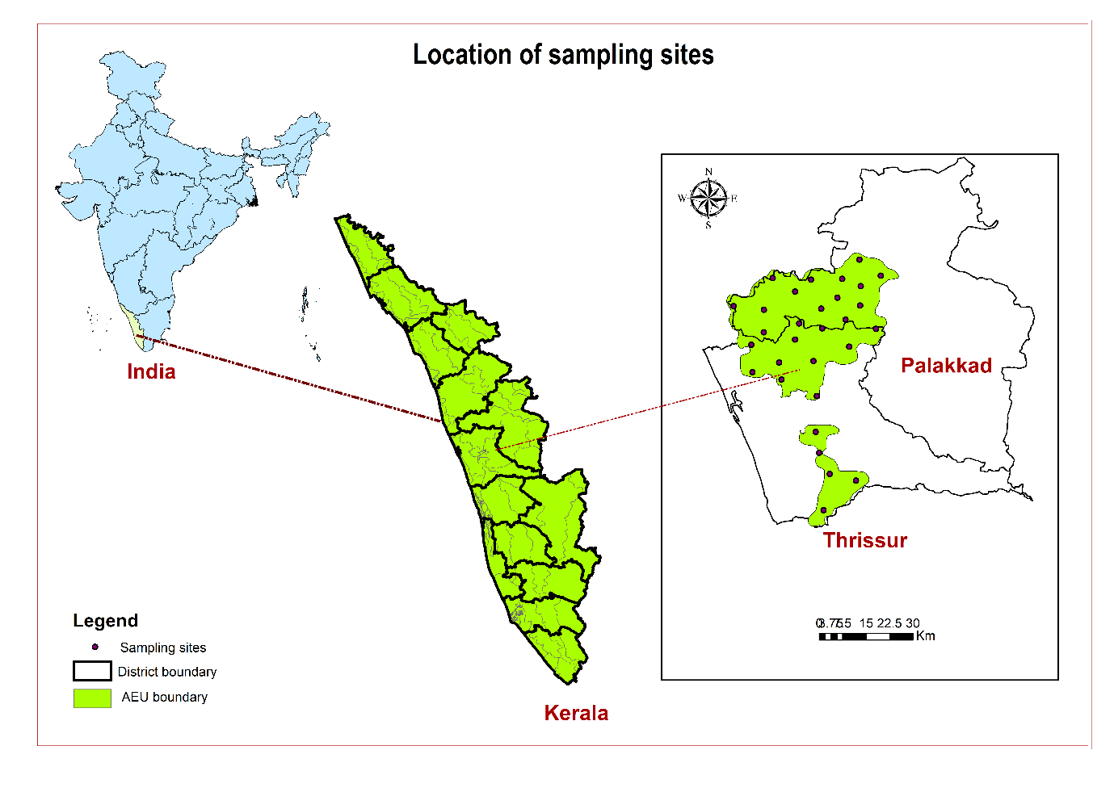
Figure 1. Locations of soil sample collection
2.4. Total Fe and Fractions of iron in soil
The soil samples were subjected to sequential fractionation of iron in accordance with the method proposed by Iwasaki et al. (1993). Three grams of soil were placed in a 250 mL centrifuge tube, and 30 mL of 1 M CH₃COONH₄ (pH 7) was added. The mixture was then shaken for 2 hours and subjected to centrifugation process in order to remove the exchangeable form of Fe (Ex-Fe). The soil residue was then shaken with 30 mL of 0.05 M Pb(NO₃)₂ buffered at pH 6 with 0.5 M CH₃COONH₄ for 2 hours. After centrifugation, the supernatant was decanted for Pb-displaceable Fe (Pb-Fe). Next, the residue was shaken with 30 mL of 0.44 M CH₃COOH for 2 hours and centrifuged to extract acid-soluble Fe. Following this, the residue was shaken with 150 mL of 0.1 M NH₂OH·HCl in 0.01 M HNO₃ for 30 minutes, centrifuged, and the supernatant collected to determine Manganese oxide occluded Fe (MnO-Fe) content. Subsequently, the residue was shaken with 150 mL of 0.1 M Na₄P₂O₇ (pH 10) for 24 hours to extract organically bound Fe (OM-Fe). After centrifugation, the residue was treated with 150 mL of Tamm's solution (0.1 M H₂C₂O₄ + 0.175 M (NH₄)₂C₂O₄ at pH 3.25) for 4 hours in a dark environment in order to extract amorphous Fe oxide-occluded Fe (Am FeO-Fe). The residue was then shaken with 150 mL of Tamm's solution containing 0.1 M ascorbic acid and heated in a boiling water bath for 30 minutes with occasional stirring to extract crystalline Fe oxide-occluded Fe forms (Cry FeO-Fe). The final residue was transferred into a 100 mL conical flask with 50 mL of deionized water and dried on a hot plate at 100 °C. The dried residue was then digested using a H₂SO₄–HNO₃–HClO₄ acid mixture (1:5:20 ratio) to extract residual Fe (Res-Fe).
The total Fe in the soil samples was determined using microwave digestion. For this procedure, 0.2 g of soil was placed in clean digestion tubes, and 10 mL of concentrated HNO₃ was added. After digestion, the extract was cooled and diluted to 100 mL. The iron concentration in all extracts was determined using an Atomic Absorption Spectrophotometer (Model: Perkin Elmer-PinAAcle 500).

2.5. Statistical analysis
Descriptive statistics, including the mean, median, standard deviation, minimum, maximum, and selected percentiles (25th and 75th), were calculated for soil physicochemical properties, Fe fractions, and Fe extracted using different reagents, using Excel 2019 (Microsoft Corporation, Redmond, WA, USA). Correlation analysis was performed to explore relationships among the variables, using IBM SPSS Statistics 25.0 (IBM Corp., Armonk, NY, USA). Structural equation modelling (SEM) was conducted using R (Version 4.4.2; R Core Team, 2024) within the RStudio environment (Version 2024.12.0; RStudio PBC, Boston, MA, USA) to evaluate the direct and indirect effects of different Fe fractions and pH on available Fe content. The model fit was assessed the chi-square test p-value, Root mean square error of approximation (RMSEA), the comparative fit index (CFI), and the Tucker–Lewis index (TLI). A satisfactory model fit was indicated by a P-value > 0.05, CFI and TLI values > 0.95, and RMSE value < 0.08 (Sathyanarayana and Mohanasundaram, 2024).
3. RESULTS AND DISCUSSION
3.1. Descriptive statistics of soil properties
The descriptive statistics of the soil properties are presented in Table 1. The soils exhibited limited variation in pH and organic carbon contents, with median values closely matching the means, indicating the absence of notable outliers. Similar results were reported by Adhilakshmi, (2023), who observed minimal variation in pH and EC in the AEU 10 of Kerala. The sand, silt, and clay contents exhibited considerable variation across the soils, sand ranging from 48.35% to 84.80%, silt from 5.07% to 33.65%, and clay from 5.08% to 33.57%. However, the distribution of these textural properties did not show significant outliers, as indicated by the close agreement between their mean and median values and the balanced spread between the 25th and 75th percentiles.
The available Fe exhibited considerable variability with values ranging from 8.19 to 101.60 mg/kg. The maximum value obtained was significantly higher than the 75th percentile (31.03 mg kg⁻¹), indicating the presence of soils with high available Fe. A similar variability in Fe content was observed in soils of Kerala by John et al. (2024). Oxalate and CBD-extractable Fe contents exhibited relatively limited variation, with median values closely matching the means, indicating a fairly uniform distribution across soils and the absence of notable outliers. The Fe_{OX}/Fe_{CBD} ratio displayed substantial variability among samples, with values ranging from 0.12 to 2.28. The high standard deviation relative to the mean reflected marked differences in the proportion of amorphous to crystalline Fe forms across soils. More weathered the soils, more will be the crystalline iron oxides and less will be the availability of iron (Mielki et al., 2016).
The contents of Aci-Fe, OM-Fe, Cry FeO-Fe, Res-Fe, and total Fe contents exhibited moderate to substantial variability, yet their distributions appeared relatively balanced across soils, as indicated by the close agreement between mean and median values and the absence of notable outliers. A similar range of high total Fe content was reported in some acid soils of India by Behera and Shukla (2014), which was attributed to the dominance of Fe-bearing minerals. MnO-Fe showed greater variability, with a maximum value (541.5 mg kg⁻¹) considerably exceeding the 75th percentile (252.44 mg kg⁻¹), suggesting enrichment in a few soils. Amorphous Fe oxides demonstrated a substantial range, varying from 476.88 to 15431.25 mg kg⁻¹, exhibiting a slight right skew.
3.2. Physicochemical properties
The soils exhibited a predominance of acidic characteristics, with pH values ranging from 4.55 to 6.41, and an average pH of 5.68, as indicated in the Table. The observed acidity can be attributed to the tropical climate, where heavy rainfall promotes intense leaching of basic cations (Chandran et al., 2005), as well as the influence of the acidic nature of the parent materials. The mean organic carbon content was found to be 1.10%, which is within the medium range for the majority of the samples analysed. In tropical climates, the oxidation of organic matter is known to be high due to the presence of favourable temperature and moisture conditions (Mubarak and Rosenani, 2003). Soils with higher clay content typically exhibit lower permeability to air and water, reducing aeration and thereby slowing organic matter decomposition. Moreover, fine soil fractions, with greater specific surface area and cation exchange capacity, tend to retain more organic matter than sandy soils (Kögel‐Knabner et al., 2008). As demonstrated in the study by Yang et al. (2021), the retention of organic matter in sandy soils is typically lower in comparison to other soil types. This is due to the fact that sandy soils possess both a reduced capacity for water retention and increased aeration. The lowest OC content observed in Sample No. 13, characterised by relatively high sand and low clay content, and the highest OC content in Sample No. 12, with the highest clay content, are consistent with these findings.
The soils exhibited higher sand content compared to silt and clay. The highest sand content was recorded in Sample No. 5, while the minimum was recorded in Sample No. 12. The clay content of the samples was found to vary significantly. The highest value was observed in Sample No. 12, and the lowest in Sample No. 1. The preponderance of sand over silt and clay in all samples suggests the presence of sandy loam to loamy sand textures, which are indicative of highly weathered, well-drained lateritic soils characteristic of Kerala. The high sand content in the samples may be attributed to intense leaching and erosion driven by the tropical climate and heavy rainfall of the region (Chandran et al., 2005).
3.3. Extractable Fe in soil
The mean available Fe content across the samples was 26.49 mg kg⁻¹, with all soils falling within the sufficient range (>5 mg kg⁻¹) (Table 1). The consistently adequate Fe levels reflect the inherently Fe-rich nature of laterite soils, resulting from intense weathering and subsequent accumulation of Fe oxides. Additionally, the solubilisation of amorphous hydrous Fe oxides under favourable moisture conditions promotes a steady release of Fe²⁺, enhancing Fe availability to crops (Sureshkumar et al., 2018). The acidic pH of these soils further supports the solubility and availability of Fe.
The CBD-extractable Fe content ranged from 5180.00 to 17,127.50 mg kg⁻¹, with an average of 10,799.33 mg kg⁻¹. The Fe_{OX} content varied between 1564 to 15,650 mg kg⁻¹, with a mean value of 5282.45 mg kg⁻¹. In most soils, Fe extracted by the CBD method was higher than that extracted by the oxalate method, suggesting that the majority of Fe oxides present are crystalline in nature. This is reflected in the Fe_{OX}/Fe_{CBD} ratio, which serves as an indicator of oxide crystallinity.
The Fe_{OX}/Fe_{CBD} ratio ranged from 0.12 to 2.28, with a mean of 0.53. The 75th percentile value was 0.56, indicating that most soils had a ratio below this threshold. A low ratio indicates the dominance of crystalline iron oxides and a highly weathered state. Shaw (2001), in a study on highly weathered Ultisols, suggested that low Fe_{OX}/Fe_{CBD} ratios and low oxalate-extractable Fe contents are associated with the predominance of crystalline Fe oxides. Similarly, Wuenscher et al. (2015), in a comparative study of different extraction methods, reported that an active iron ratio less than 0.5 suggests the dominance of crystalline Fe oxides, whereas a ratio greater than 0.5 indicates the presence of more amorphous Fe oxides.
3.4. Fractions of Fe
The samples exhibited a total iron content ranging from 22,140 to 84,660 mg kg⁻¹, with an average of 56,790.33 mg kg⁻¹ (Table 1). Based on the mean value of each fraction across all samples, the fractions followed the order: Aci-Fe < MnO-Fe < OM-Fe < Am FeO-Fe << Cry FeO-Fe < Res-Fe (Figure 2). The exchangeable and acid soluble forms of Fe is most readily available for plants (Walna et al., 2010). Exchangeable and lead-displaceable iron contents were below detectable limits in all samples, likely due to the sandy texture, low clay content of the soil, and the inherently low cation exchange capacity (CEC) of the dominant 1:1 clay minerals. These conditions limit Fe retention in easily available forms, favouring the formation of oxides or hydroxides instead. Consequently, most of the iron is presumed to exist in stable oxide- or mineral-bound forms that are not extractable by mild reagents. This inference is further supported by the higher Fe contents observed in oxalate and CBD extractions.
The acid-soluble Fe fraction, representing one of the most readily available pools for plants (Walna et al., 2010), ranged from 0.98 to 6.76 mg kg⁻¹, with an average of 2.35 mg kg⁻¹, indicating a relatively low proportion. The limited solubility of acid-soluble Fe can be attributed to the strong tendency of Fe to form insoluble oxides and hydroxides under soil conditions (Abollino et al., 2006). Manganese oxide-bound Fe contents varied from 34.65 to 541.50 mg kg⁻¹, with a mean of 198.72 mg kg⁻¹. This suggests limited surface reactivity of Mn oxides in these soils, resulting in relatively stable Fe retention through occlusion during Mn oxide precipitation. The organically bound Fe content ranged widely, from 76.88 to 2565 mg kg⁻¹, with an average of 1350.48 mg kg⁻¹. It has been demonstrated that organic ligands, particularly in the presence of acidity, are capable of forming robust complexes with iron. This process has been shown to impede the process of iron precipitation as oxides and to promote its retention within the soil matrix (Stevenson, 1994). The variability in this fraction likely reflects differences in soil organic matter content across the samples, as noted by Jayaprakash et al. (2022). Firnia et al. (2019) also observed a similar trend in acid soils.
Among the samples analysed, the amorphous iron oxide–occluded Fe content ranged from 476.88 to 15,431.25 mg kg⁻¹, with an average of 3409.11 mg kg⁻¹. In contrast, the crystalline iron oxide–occluded Fe content was considerably higher, ranging from 8512.50 to 33,906.25 mg kg⁻¹, with an average of 15,961.04 mg kg⁻¹, making it the second most abundant Fe fraction in the soils. This trend is further supported by the results of CBD and oxalate extractions, which indicate that a substantial portion of the iron is present within crystalline forms. The dominance of crystalline Fe oxides suggests prolonged pedogenic processes and advanced soil weathering, leading to the transformation of amorphous iron into more stable crystalline forms.
The residual iron fraction, with an average of 18,239.26 mg kg⁻¹, was the most dominant across all samples. This suggests that most Fe is present in highly stable, likely bound within silicate mineral structures, making it largely unavailable for plant uptake or microbial use (Miller et al., 1986; Firnia et al., 2019). The high residual Fe content further supports the notion that these soils are well-weathered, with most reactive Fe transformed into stable forms over time. Studies have shown that in soils with high iron oxide content, the CBD extraction step is insufficient to dissolve crystalline minerals like goethite completely. The iron remaining after this step is recovered in the residual fraction, explaining the relatively higher values observed. The high total Fe content in these soils is likely a result of the humid tropical climate and the associated laterisation process, which favours the leaching of silica and accumulation of iron oxides during soil development (Nair et al., 2011; Reethu et al., 2023).
Table 1. Details of physicochemical properties, fractions of Fe and extractable Fe (n=30)

Particulars | Mean | Median | Standard deviation | Minimum | 25th percentile | 75th percentile | Maximum
pH | 5.68 | 5.76 | 0.52 | 4.55 | 5.18 | 6.07 | 6.41
OC (%) | 1.10 | 1.07 | 0.27 | 0.48 | 0.96 | 1.29 | 1.57
Sand (%) | 68.72 | 70.72 | 10.76 | 48.35 | 63.82 | 77.03 | 84.80
Silt (%) | 16.83 | 15.50 | 6.25 | 5.07 | 12.73 | 20.50 | 33.65
Clay (%) | 14.45 | 14.04 | 7.60 | 5.08 | 7.69 | 18.05 | 33.57
Available Fe (mg kg⁻¹) | 26.49 | 19.25 | 19.94 | 8.19 | 14.59 | 31.03 | 101.60
Fe_{ox} (mg kg⁻¹) | 5282.45 | 4703.75 | 2541.09 | 1564.00 | 4099.88 | 6655.00 | 15650.00
Fe_{CBD} (mg kg⁻¹) | 10799.33 | 10722.50 | 2740.79 | 5180.00 | 9766.88 | 11950.00 | 17127.50
Fe_{OX}/Fe_{CBD} | 0.53 | 0.47 | 0.36 | 0.12 | 0.39 | 0.56 | 2.28
Aci-Fe (mg kg⁻¹) | 2.35 | 2.06 | 1.09 | 0.98 | 1.85 | 2.50 | 6.76
MnO-Fe (mg kg⁻¹) | 198.72 | 176.40 | 121.97 | 34.65 | 113.50 | 252.44 | 541.50
OM-Fe (mg kg⁻¹) | 1350.48 | 1301.88 | 561.03 | 76.88 | 1044.85 | 1544.54 | 2565.00
Am FeO-Fe (mg kg⁻¹) | 3409.11 | 2899.38 | 2930.10 | 476.88 | 1328.75 | 4214.54 | 15431.25
Cry FeO-Fe (mg kg⁻¹) | 15961.04 | 16265.63 | 4970.88 | 8512.50 | 13521.88 | 18189.06 | 33906.25
Res Fe (mg kg⁻¹) | 18239.26 | 17719.24 | 7206.78 | 6650.00 | 13880.77 | 20612.50 | 45230.77
Total Fe (mg kg⁻¹) | 56790.33 | 56840.00 | 15669.32 | 22140.00 | 48522.50 | 67442.50 | 84660.00

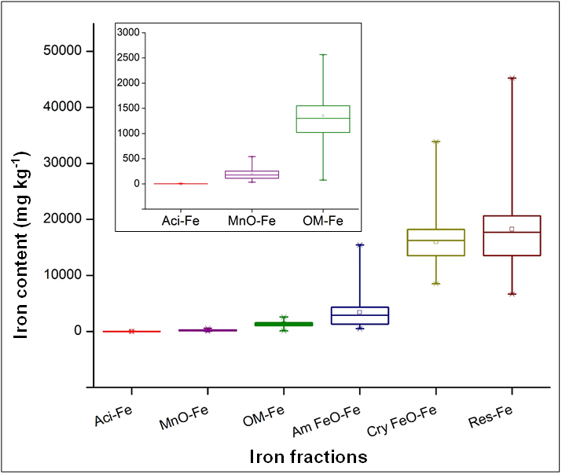
Figure 2. Distribution of iron fractions in the soil
Box plot representation of different iron fractions in the north central laterites of Kerala. Aci-Fe: acid soluble iron, MnO-Fe: manganese oxide-occluded iron, OM-Fe: organically bound iron, Am FeO-Fe: amorphous iron oxide occluded iron, Cry FeO-Fe: crystalline iron oxide occluded iron, Res-Fe: residual iron.
3.5. Relationship between soil properties and fractions of iron in soil
The correlation coefficient among soil physico-chemical properties and the fractions of iron in soil is provided in Table 2. The study demonstrated a significant positive correlation between OC and clay (0.412*) and a negative correlation between OC and sand (-0.432*). These findings indicate that organic matter is retained more effectively by finer particles such as clay and silt, than by sand. The clay fractions can bind soil organic matter by forming macroaggregates or organo-mineral complexes, which reduces and protects it from decomposition (Krull et al., 2003). The negative correlation of sand with Fe_{CBD} (-0.796**) likely reflects a relative low retention of Fe oxides in coarse-textured soils. Conversely, silt and clay were positively correlated with Fe_{CBD} (0.576**, 0.652**), suggesting the dominance of crystalline Fe oxides in finer soil fractions.
OC was positively associated with Av-Fe (0.385*), likely due to its role in enhancing nutrient release through mineralisation and increasing cation exchange capacity. The acidifying action of soil organic carbon reduces soil pH, thereby increasing the solubility of iron complexes. Similar results were reported by Ghode et al. (2020). The increase in Av. Fe content with rising organic matter may be explained by the formation of chelates between iron and organic compounds, as well as enhanced Fe solubility due to pH reduction caused by organic acids (Bhat et al., 2017). Organic carbon, through its chelation affinity, likely protected iron from oxidation and precipitation, thus increasing its availability (Prasad and Sakal, 1991). Available Fe was positively correlated with both Fe_{CBD} (0.371*) and Fe_{OX} (0.430*), suggesting that both crystalline and amorphous forms of iron contribute to Fe availability as these forms are in dynamic equilibrium.
The results of the study demonstrated a strong association between OC and OM-Fe (0.717**) and Cry FeO-Fe (0.464**), suggesting that organic matter plays a key role in stabilising both organically bound and crystalline iron fractions. This is supported by Jayaprakash et al. (2022), who reported that OM-Fe fractions vary with differences in soil organic matter content across samples. The positive correlation between OC and Cry FeO-Fe further implies that a substantial portion of crystalline Fe can be complexed with or stabilised by organic matter. Sand content shows negative correlations with OM-Fe (-0.466**), Cry FeO-Fe (-0.459*) and Res-Fe (-0.389*), and total Fe (-0.486**), indicating a relative depletion of these Fe fractions in coarser-textured soils. Whereas clay content exhibited positive associations with OM-Fe (0.562**), Cry FeO-Fe (0.371*), and total Fe (0.391*), reflecting the capacity of clay fraction to retain both organically bound and crystalline iron. Av-Fe was positively correlated with Cry FeO-Fe (0.375*) and Res-Fe (0.424*).
Fe_{CBD} displayed significant positive associations with OM-Fe (0.594**), Cry FeO-Fe (0.675**) and Res-Fe (0.490**) suggesting that the CBD extraction method effectively dissolves crystalline, as well as Fe from more stable residual pools. Fe_{OX} exhibited strong positive correlations with Am FeO-Fe (0.786**), indicating that oxalate extraction specifically targets amorphous Fe oxides, which are less crystalline. These findings emphasise the distinct selectivity of CBD and oxalate extractions in accessing different Fe fractions in soils.
Among the fractions, MnO-Fe was positively correlated with OM-Fe (0.473**) and Am FeO-Fe (0.374*), suggesting that these pools exist in dynamic equilibrium. Cry FeO-Fe displayed positive correlations with both OM-Fe (0.454*) and total Fe (0.617**). Res-Fe showed strong associations with Cry FeO-Fe (0.489**) and total Fe (0.758**). Am FeO-Fe, Cry FeO-Fe, and Res-Fe, which strongly correlate with total Fe, represent more stable pools that may not directly influence immediate P availability but help explain long-term P retention trends. These findings emphasise that amorphous, organic, and occluded Fe forms are central to regulating labile and moderately labile P, reinforcing the broader understanding of Fe-bound P availability in lateritic soils.
3.6. Structural equation model indicating Fe availability
A structural equation modelling was conducted to examine the influence of soil pH and iron fractions on Fe availability (Fig. 3). The model fit indices indicated good model performance, with the following parameters: P value (χ2) – 0.401, RMSEA – 0.040, Comparative Fit Index (CFI) - 0.986, Tucker-Lewis Index (TLI) - 0.978. The analysis revealed that Am FeO-Fe had a significant positive effect on Aci-Fe (path coefficient = 0.35*), confirming a good data fit. Amorphous iron oxides, which are more soluble than their crystalline counterparts, primarily govern the solubility of Fe³⁺ (Lindsay, 1981). The acid-soluble fraction includes amorphous Fe oxides like ferrihydrite, as well as metal-bound carbonates (Claff et al., 2010). These fractions are relatively loosely bound and are more available under acidic conditions (Abollino et al., 2006).
Both Res-Fe and OM-Fe positively influenced Cry FeO-Fe (path coefficients = 0.62**, 0.30*), with residual Fe exerting a stronger effect. A similar positive relationship between OM-Fe and Cry FeO-Fe fractions was observed in soils with pH ranges comparable to those in the present study (Jayaprakash et al., 2022). Soils abundant in crystalline Fe oxides tend to retain Fe through organic matter. The residual fraction, containing metals strongly bound to silicates and crystalline Fe oxides (Miller et al., 1986). The application of organic matter can mobilise Fe from crystalline fractions to organically complexed and amorphous Fe oxides (Saha et al., 1999), making it more available.
OM-Fe also exhibited a significant positive relationship with MnO-Fe (path coefficient = 0.45**), while soil pH had no notable effect. Fe fractions associated with organic matter contribute to Fe availability and are typically classified as oxidisable fractions (Walna et al., 2010; Wei et al., 2010). The positive correlation between OM-Fe and MnO-Fe can be attributed to the role of organic matter in mobilising both Fe from less available fractions by forming soluble organic-metal complexes. Wei et al. (2010) also reported the contribution of organically bound Fe to the availability of oxide-bound forms, further supporting this mechanism.

Table 2. Correlation coefficient between soil properties and fractions of iron
 | OC | Sand | Silt | Clay | Av- Fe | Fe_{OX} | Fe_{CBD} | MnO-Fe | OM-Fe | Am FeO- Fe | Cry FeO- Fe | Res-Fe | Total Fe
OC | 1
Sand | -0.432* | 1
Silt | 0.245 | -0.722** | 1
Clay | 0.412* | -0.822** | 0.199 | 1
Av-Fe | 0.385* | -0.226 | 0.381* | 0.007 | 1
Fe_{OX} | 0.021 | -0.102 | -0.017 | 0.159 | 0.430* | 1
Fe_{CBD} | 0.521** | -0.796 ** | 0.576** | 0.652** | 0.371* | 0.099 | 1
MnO-Fe | 0.259 | -0.164 | 0.056 | 0.187 | 0.354 | 0.551** | 0.215 | 1
OM-Fe | 0.717** | -0.466** | 0.119 | 0.562** | 0.354 | 0.276 | 0.594** | 0.473** | 1
Am FeO- Fe | -0.150 | 0.024 | -0.128 | 0.071 | 0.238 | 0.786** | -0.014 | 0.374* | 0.060 | 1
Cry FeO- Fe | 0.464** | -0.459* | 0.340 | 0.371* | 0.375* | -0.017 | 0.675** | -0.012 | 0.454* | -0.137 | 1
Res-Fe | 0.265 | -0.389* | 0.243 | 0.350 | 0.424** | 0.106 | 0.490** | 0.065 | 0.251 | 0.150 | 0.489** | 1
Total Fe | 0.313 | -0.486** | 0.362* | 0.391* | 0.468** | 0.357 | 0.659** | 0.127 | 0.336 | 0.482** | 0.617** | 0.758** | 1
** Correlation is significant at level 0.01
* Correlation is significant at level 0.05
Both Aci-Fe and Cry FeO-Fe positively influenced available Fe (path coefficients = 0.28* and 0.26*), with MnO-Fe exerting the strongest influence (path coefficient = 0.55**). MnO-Fe fractions, soluble under slightly acidic conditions, contribute to Fe availability (Abollino et al., 2006). These Mn and Fe oxide-associated fractions are reducible and potentially bioavailable (Walna et al., 2010), with Fe being released primarily through the dissolution of amorphous Fe oxides, and to a lesser extent, crystalline oxides (Zhang et al., 1998). Under favourable conditions (low pH, high organic matter, and high cation exchange capacity), oxide-bound Fe can be released into the soil solution, thus increasing Fe availability (Xue et al., 2006). Despite being relatively stable, Cry FeO-Fe showed a significant contribution to iron availability in the path analysis, likely due to its predominance in the soil, particularly when more labile fractions such as Aci-Fe and MnO-Fe were limited.
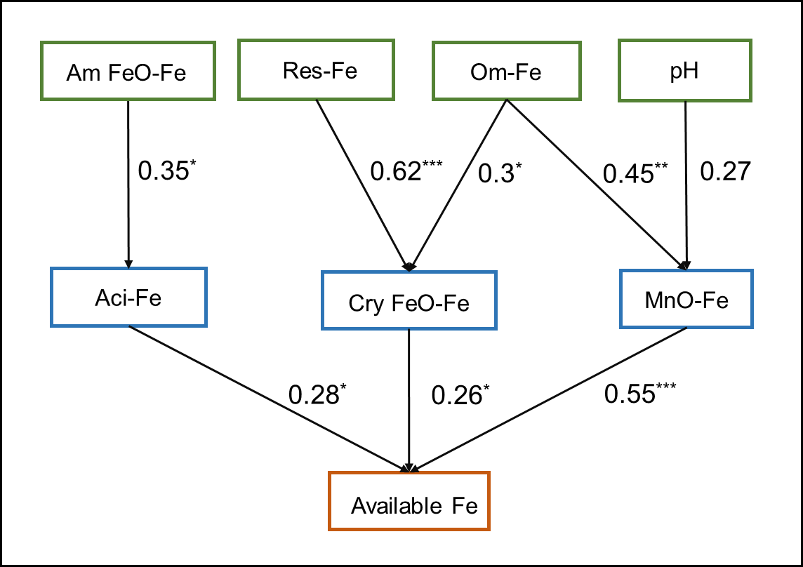

Figure 3. Structural equation model indicating Fe availability. * P < 0.05; ** P < 0.001
4. CONCLUSION
The study revealed clear trends in how soil properties influence different iron forms present in the laterites of north central Kerala. Most of the iron was tightly bound within the soil matrix, with only a small fraction present in available forms. Finer-textured soils, characterised by higher clay and silt contents, were positively associated with several iron fractions, while sand content showed negative relationships, highlighting the greater iron retention capacity of finer particles. Organic carbon was identified as a pivotal factor, demonstrating positive correlations with both available and bound forms of iron. These findings suggest that organic carbon plays a crucial role in enhancing both iron stability and bioavailability. Among the iron fractions, crystalline, amorphous, and organically bound forms all contributed to iron availability, with Mn oxide-bound iron exerting the strongest influence. Structural equation modelling further confirmed that iron availability is governed by the combined influence of multiple iron pools. Although soil pH had a limited direct effect, it likely influenced iron dynamics in laterite soils indirectly, through its interaction with organic matter and the solubility of iron compounds. These insights highlight the importance of maintaining organic carbon levels and improving soil structure to enhance iron availability. Practices such as applying organic amendments and maintaining soil pH at optimal levels can help farmers manage iron nutrition more effectively in lateritic soils.

COMPETING INTERESTS DISCLAIMER:
Authors have declared that they have no known competing financial interests OR non-financial interests OR personal relationships that could have appeared to influence the work reported in this paper.
Disclaimer (Artificial intelligence)
Option 1:
Author(s) hereby declare that NO generative AI technologies such as Large Language Models (ChatGPT, COPILOT, etc.) and text-to-image generators have been used during the writing or editing of this manuscript.
Option 2:
Author(s) hereby declare that generative AI technologies such as Large Language Models, etc. have been used during the writing or editing of manuscripts. This explanation will include the name, version, model, and source of the generative AI technology and as well as all input prompts provided to the generative AI technology
Details of the AI usage are given below:
1.
2.
3.
References
Abollino, O., Giacomino, A., Malandrino, M., Mentasti, E., Aceto, M., & Barberis, R. (2006). Assessment of metal availability in a contaminated soil by sequential extraction. Water, Air, and Soil Pollution, 173, 315-338.
Adilakshmi, K., Aparna, B., Rani, B., Gladis, R., Leno, N., & Thomas, U. C. (2023). chemical status of different agro-ecological units of Kerala: A comprehensive study. International Journal of Plant and Soil Science, 35(21), 627-637.
Behera, S. K., & Shukla, A. K. (2014). Total and extractable manganese and iron in some cultivated acid soils of India: Status, distribution and relationship with some soil properties. Pedosphere, 24(2), 196-208.
Bhat, Z. A., Padder, S. A., Ganaie, A. Q., Dar, N. A., Rehman, H. U., & Wani, M. Y. (2017). Correlation of available nutrients with physico-chemical properties and nutrient content of grape orchards of Kashmir. Journal of pharmacognosy and phytochemistry, 6(2), 181-185.
Chandran, P., Ray, S. V., Bhattacharyya, T., Srivastava, P., Krishnan, P., & Pal, D. K. (2005). Lateritic soils of Kerala, India: Their mineralogy, genesis, and taxonomy. Soil Research, 43(7), 839-852.
Claff, S. R., Sullivan, L. A., Burton, E. D., & Bush, R. T. (2010). A sequential extraction procedure for acid sulfate soils: partitioning of iron. Geoderma, 155(3-4), 224-230.
Distribution of forms of iron in soils under Arecanut based cropping systems in the coastal regions of Udupi district
Firnia, D., Anwar, S., Andreas, D., Nugroho, B., & Tedjo, D. P. (2019). Fractionation distribution of metal Al, Fe, Mn and microbial population in acidic soil horizon. IOP Conference Series: Earth and Environmental Science, 383(1), 1-11.
Ghode, M. K., Vaidya, P. H., Nawkhare, A. D., & Ingole, A. J. (2020). Relationship between soil physico-chemical properties, available macro and micronutrients and yield in cotton growing soils of Nanded district of Maharashtra. Journal of Pharmacognosy and Phytochemistry, 9(3), 2062-2065.
Iwasaki, K., Yoshikawa, G., & Sakurai, K. (1993). Fractionation of zinc in greenhouse soils. Soil Science and Plant Nutrition, 39(3), 507-515.
Jackson, M. L. (1958). Soil chemical analysis. Englewood Cliff, New Jersey: Prentice Hall, Inc.
Jayaprakash, S. M., Faijalahmadmulla, Thippeshappa, G. N. , Pruthvi Raj, H. M., Chaitanya, H. S., Naveen, N. E., & Lakshman. (2022). Distribution of forms of iron in soils under Arecanut based cropping systems in the coastal regions of Udupi district. The Pharma Innovation, 11(12): 4776-4780.
John, A. G., Reshma M. R., Beena V. I., Santhosh C., & Sajitha Vijayan M. 2024. Transformation of Phosphorus Fractions in Various Soil Types of Kerala: An Incubation Study. Journal of Scientific Research and Reports, 30 (7), 529-42.
Kalpage, F. S. C. P. (1974). Tropical soils classification, fertility and management. Culcutta: The Macmillan Company of India limited.
Kögel‐Knabner, I., Ekschmitt, K., Flessa, H., Guggenberger, G., Matzner, E., Marschner, B., & von Lützow, M. (2008). An integrative approach of organic matter stabilization in temperate soils: Linking chemistry, physics, and biology. Journal of Plant Nutrition and Soil Science, 171(1), 5-13.
Krull E. S, Baldock J. A, & Skjemstad J. O. 2003. Importance of mechanisms and processes of the stabilisation of soil organic matter for modelling carbon turnover. Functional Plant Biology, 30, 207–222.
Lindsay, W. L. (1981). Chemical equilibria in soils. Chichester, Sussex: John Wiley and sons.
McKeague, J. A. & Day, D. H. (1966). Dithionite- and oxalate-extractable Fe and Al as aids in differentiating various classes of soils. Canadian Journal of Soil Science, 46, 13-22.
Mehra, O. P. & Jackson, M. L. (1958). Iron oxide removal from soils and clays by a dithionitecitrate system buffered with sodium bicarbonate. Clays and Clay Minerals, 7, 317–327. doi:10.1346/ CCMN.1958.0070122.
Mengel, K. (1994). Iron availability in plant tissues-iron chlorosis on calcareous soils. Plant and Soil, 165, 275-283.
Miller, W. P., Martens, D. C., & Zelazny, L. W. (1986). Effect of sequence in extraction of trace metals from soils. Soil Science Society of America Journal, 50(3), 598-601.
Mielki, G. F., Novais, R. F., Ker, J. C., Vergütz, L., & Castro, G. F. D. (2016). Iron availability in tropical soils and iron uptake by plants. Brazilian Journal of Soil Science, 40.
Mubarak, A.R. & Rosenani, A.B. (2003). Soil organic matter fractions in humid tropics as influenced by application of crop residues. Communications in Soil Science and Plant Analysis, 34, 933-943. doi: 10.1081/CSS-120019100.
Nair, K. M., Kumar, K. S., Krishnan, P., Naidu, L. G. K., & Sarkar, D. (2011). Variability of lateritic soil development in humid tropical environment. Clay Research, 30(2), 12-20.
Prasad, R. & Sakal, R. (1991). Availability of iron in calcareous soils in relation to soil properties. Journal of the Indian Society of Soil Science, 39(4), 658-661.
Reethu, M., Jyothi, V., Sandeep, K., Rafaz, A. K., Aravind, G. H., & Jithin, J. (2023). Rock magnetic and mineralogical properties of lateritic soil profiles developed on two different parent rocks in Northern Kerala, South-Western India. Journal of Geosciences Research, 8(2), 110-117.
Robinson, G. W. (1922). A new method for the mechanical analysis of soils and other dispersions. Journal of Agricultural Science. 12, 306-321.
Roberts, A.P. (2015). Magnetic mineral diagenesis. Earth-Science Reviews. 151, 1-47.
Saha, J. K., Adhikari, T., & Mandal, B. (1999). Effect of lime and organic matter on distribution of zinc, copper, iron, and manganese in acid soils. Communications in Soil Science and Plant Analysis, 30(13-14), 1819-1829.
Sathyanarayana, S. & Mohanasundaram, T. (2024). Fit indices in structural equation modeling and confirmatory factor analysis: reporting guidelines. Asian Journal of Economics, Business and Accounting, 24(7), 561-577.
Schwertmann, U. (1973). Use of oxalate for Fe extraction from soils. Canadian Journal of Soil Science, 53(2), 244-246.
Shaw, J. N. (2001). Iron and aluminum oxide characterization for highly-weathered Alabama ultisols. Communications in Soil Science and Plant Analysis, 32(1-2), 49-64.
Sims, J. R. & Johnson, G. V. (1991). Micronutrient soil tests. In J. J. Mortvedt, F. R. Cox, L. M. Shuman, & R. M. Welch. (Eds.), Micronutrient in Agriculture (2nd ed., pp. 427-476). Madison, USA.: Soil Science Society of America.
Stevenson, F. J. (1994). Humus chemistry: genesis, composition, reactions. John Wiley & Sons.
Sureshkumar, P., Geetha, P., & Bhindhu, P. S. (2018). Chemistry and fertility-Management of humid tropical soils of Kerala as influenced by topography and climate. Indian Journal of Fertilisers, 14, 30-44.
Torrent, J., Schwertmann, U. G. S. D., & Schulze, D. G. (1980). Iron oxide mineralogy of some soils of two river terrace sequences in Spain. Geoderma, 23(3), 191-208.
Walkley, A. & Black, I. A. (1934). An examination of the Degtjareff method for determining soil organic matter, and a proposed modification of the chromic acid titration method. Soil Science, 37(1), 29-38.
Walna, B., Spychalski, W., & Ibragimow, A. (2010). Fractionation of iron and manganese in the horizons of a nutrient-poor forest soil profile using the sequential extraction method. Polish Journal of Environmental Studies, 19(5), 1029-1037.
Wei, X., Shao, M., Zhuang, J., & Horton, R. (2010). Soil iron fractionation and availability at selected landscape positions in a loessial gully region of northwestern China. Soil Science & Plant Nutrition, 56(4), 617-626.
Wuenscher, R., Unterfrauner, H., Peticzka, R., & Zehetner, F. (2015). A comparison of 14 soil phosphorus extraction methods applied to 50 agricultural soils from Central Europe. Plant, Soil and Environment, 61(2), 86-96.
Xue, N., Seip, H. M., Guo, J., Liao, B., & Zeng, Q. (2006). Distribution of Al, Fe, Mn pools and their correlation in soils from two acid deposition small catchments in Hunan, China. Chemosphere, 65, 2468-2476.
Yang, P., Hu, Z., & Shu, Q. (2021). Factors affecting soil organic carbon content between natural and reclaimed sites in Rudong Coast, Jiangsu Province, China. Journal of Marine Science and Engineering, (12), 1453
Zhang, T., Shan, X. & Li, F. (1998). Comparison of two sequential extraction procedures for speciation analysis of metals in soils and plant availability. Communications in Soil Science & Plant Analysis, 29, 1023–1034.

