Spatial distribution and mapping of available nutrients in paddy fields of north central laterites of Kerala, India

ABSTRACT

Abstract
Soil fertility assessment is crucial for sustainable crop production, particularly in intensive rice-growing regions. The present study aimed to assess the spatial distribution of available nutrients across the rice-growing areas of the north-central laterite of Kerala and generating soil fertility maps to understand potential constraints. A total of 35 geo-referenced samples (0-15 cm depth) were collected, processed and analyzed for various soil properties. The soil pH varied from 4.09 to 6.22, averaging 5.15, indicating an acidic nature. Electrical conductivity remained low (0.03–0.37 dSm⁻¹), ruling out salinity issues. Organic carbon content ranged from 04.20 to 30.0 g kg⁻¹. Macronutrient analysis revealed that these soils were low in available nitrogen (56.45–169.34 kg ha⁻¹) and potassium (30.24–119.24 kg ha⁻¹) and mostly medium to high in available phosphorus. Available calcium (487.50–3318.75 mg kg⁻¹) was sufficient in all samples, whereas 65.85% and 34.28% of samples were deficient in available magnesium and sulfur, respectively. Micronutrient assessment showed sufficient levels of available iron, copper, manganese, and zinc, while 62.85% samples were deficient in available boron. Nutrient index of nitrogen, phosphorous and potassium are categorised under low, medium and low classes, respectively. Spatial variability maps for available nutrients were generated using QGIS to visualize and interpret the nutrient distribution across the laterite rice-growing region. These maps revealed the prevalence of widespread multi-nutrient deficiencies in the north central laterite soils of Kerala. These findings provide valuable insights for optimizing nutrient management strategies to improve soil health and sustain rice productivity in north central laterites of Kerala.
Keywords: North central laterite, macronutrients, multi-nutrient deficiencies, nutrient index, soil mapping

- INTRODUCTION
Soil fertility plays a pivotal role in determining crop productivity, and a thorough understanding of a soil’s fertility status is critical for the sustainable management of land resources. Nevertheless, intensive agricultural practices combined with poor soil management can severely deplete soil fertility. Continuous rice cropping to maximize yields significantly depletes the soil nutrient reserves. Moreover, the over-reliance on chemical fertilizers with little application of organic manures, minimal recycling of crop residues, soil erosion, uneven terrain, unregulated irrigation practices, and inappropriate cultural methods collectively accelerate the degradation of soil quality. Various soil properties considerably influence the availability of essential nutrients to plants. Therefore, investigating the relationship between the physico-chemical characteristics of soils and the availability of macro- and micronutrients is vital to understanding nutrient deficiencies. Assessing soil fertility status and addressing nutrient limitations through judicious external fertilization tailored to crop requirements is essential for maintaining soil health. One effective approach to evaluate soil fertility is the nutrient index method, which involves determination of the available concentrations of essential plant nutrients as indicators of soil fertility. Additionally, advancements in geospatial technologies have provided powerful tools for the development and management of soil resources.
In the current context, where land availability is diminishing while the population continues to rise, the demand for staple foods such as rice has increased significantly. Rice remains a fundamental dietary component for more than half of the global population. However, in Kerala, the area under paddy cultivation has witnessed a drastic decline. The humid tropical climate of Kerala, characterized by intense weathering, has resulted in the leaching of basic cations and the subsequent accumulation of sesquioxide in the upper layers of soil. Consequently, the soils are predominantly acidic, contain low-activity clays, and exhibit limited capacities to retain water and nutrients [1]. These factors contribute to their relatively poor fertility status, necessitating strategic management interventions to achieve satisfactory crop yields. The situation is particularly concerning in the intensively cultivated rice-growing regions of Kerala’s lowland laterites, where nutrient depletion due to high crop nutrient uptake combined with insufficient replenishment is especially severe. Based on this context, it was hypothesized that continuous rice cultivation on lateritic soils could lead to significant nutrient leaching and the development of multiple nutrient deficiencies. Therefore, the present investigation was conducted with the objective of assessing the spatial distribution of plant nutrients across the rice-growing areas of the north-central laterite regions of Kerala and generating soil fertility maps for efficient soil fertility management techniques catered to this particular agro-ecological unit.

2. material and methods
Geo-referenced soil samples were collected from different panchayats of Thrissur and Palakkad districts representing north central laterite (AEU10) of Kerala. A total of 35 geo-referenced samples (0-15 cm depth) were collected from intensively rice cultivating areas. The collected samples were shade-dried, processed and passed through 2 mm sieve and stored in properly labelled polythene covers. Soil pH and electrical conductivity (EC) were determined using a 1:2.5 soil-to-solution ratio [2]. Organic carbon content was assessed through wet digestion method [3]. Available nitrogen levels were measured using the alkaline KMnO₄ method [4]. Available phosphorus was estimated employing Bray's extracting reagent [5]. Available potassium, calcium, and magnesium were determined using a neutral normal ammonium acetate solution [1]. Micronutrient contents were analyzed using a 0.1M HCl extraction method [6], while boron levels were estimated following the procedure by Gupta, 1972 [7]. The Nutrient Index (NI) was calculated using the method developed by Ramamoorthy and Bajaj, 1969 [8]. Descriptive and correlation analysis were done using GRAPES software and spatial nutrient variability maps were made using QGIS.
3. results and discussion
The physico-chemical properties of laterite soils varied significantly across the studied area and descriptive statistics of analytical results were represented in table.1.
3.1. Soil reaction (pH) and Electrical conductivity (EC)
Soil pH ranges from 4.1 to 6.2, with an average of 5.16, reflecting an overall acidic nature. Frequency distribution analysis revealed that 11.43% of the samples were classified
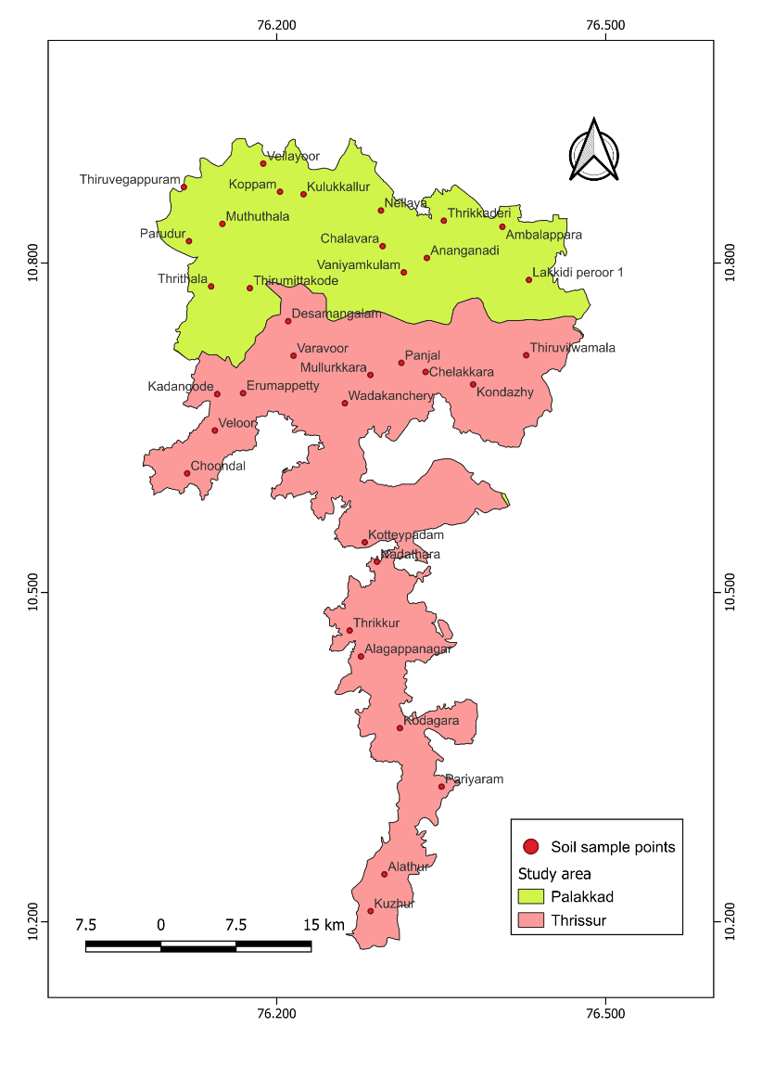
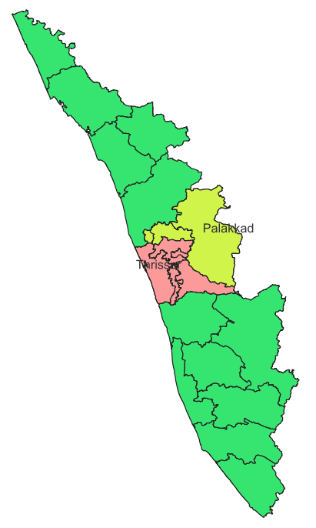
Fig. 1. Geographical location of study area
Table 1. Physico-chemical properties of soils
Soil parameters | Range |  | Mean±SD
Soil parameters | Min | Max | Mean±SD
pH | 4.09 | 6.22 | 5.15±0.52
EC (dS m⁻¹) | 0.03 | 0.37 | 0.10±0.07
OC (g kg⁻¹) | 4.20 | 30.00 | 12.3±5.40
Available N (kg ha⁻¹) | 56.45 | 169.34 | 92.11±24.14
Available P (kg ha⁻¹) | 2.59 | 89.88 | 22.01±17.61
Available K (kg ha⁻¹) | 30.24 | 119.84 | 65.02±25.38
Available Ca (mg kg⁻¹) | 487.50 | 3318.75 | 1053.84±512.11
Available Mg (mg kg⁻¹) | 25.94 | 651.56 | 118.63±107.04
Available S (mg kg⁻¹) | 1.18 | 56.98 | 12.53±12.66
Available Fe (mg kg⁻¹) | 5.75 | 375.63 | 100.78±85.34
Available Cu (mg kg⁻¹) | 1.28 | 9.58 | 4..48±2.06
Available Mn (mg kg⁻¹) | 0.63 | 115.63 | 26.09±29.24
Available Zn (mg kg⁻¹) | 1.50 | 11.13 | 3.93±2.13
Available B (mg kg⁻¹) | 0.002 | 1.07 | 0.41±0.25
as extremely acidic (11.43%), very strongly acidic (31.43%), strongly acidic (42.86%), moderately acidic (11.48%), and slightly acidic (2.86%) as represented in fig.2. In Kerala, hot and humid tropical climate with heavy rain fall accelerates intense weathering, leading to the leaching of base cations like calcium and magnesium. This process leaves behind iron and aluminum oxides, contributing to soil acidity [1]. Additionally, the acidic nature of the parent material like granite, from which these soils originate further lowers the pH. High rainfall, leaching of bases, mineralization of organic matter, addition of acid-forming chemical fertilizers and inappropriate agriculture practices are the major reasons for soil acidification and its intensification in humid tropical soils [9].

Fig. 2. Percentage Distribution of soil pH classes

​ The electrical conductivity of the soil remains low, ranging from 0.03 dSm⁻¹ to 0.37 dSm⁻¹, with an average of 0.10 dSm⁻¹ (table.1). These values suggest that the soils in these regions do not face any salinity-related problems. The consistently low EC levels across all samples can be attributed to the leaching of soluble salts, a common phenomenon in high-rainfall areas [10&11].

3.2. Soil organic carbon (SOC)
The organic carbon content in the soil exhibits considerable variation, ranging from 4.2 g kg⁻¹ to 30.0 g kg⁻¹ with an average of 12.4 g kg⁻¹ (fig.3). This variation is primarily influenced by the incorporation of rice stubbles and farmyard manure into the surface soil layers. Among the collected samples, 20% were deficient in SOC, 57.14% were in medium, and 22.85% were high in SOC. Higher SOC recorded might be due to continuous incorporation of rice straw stubbles in the soil. These findings suggest that continuous application of crop residues and organic manures can effectively enhance soil carbon levels [12]. In tropical paddy fields, SOC accumulation is influenced by management practices such as alternate wetting and drying and addition of organic amendments, which contribute to increasing SOC content. However, due to rapid decomposition rates in warm climates, the overall increase remains limited [13]. Higher levels of organic carbon not only provide part of nitrogen requirement of the crop plants but also enhance nutrient and water retention capacity of soils and create favourable environment.

Fig. 3. Percentage distribution of SOC classes
3.3. Available primary nutrients
The available nitrogen content in the soil varies from 56.44 kg ha⁻¹ to 169.34 kg ha⁻¹ with an average of 92.1 kg ha⁻¹. All collected soil samples exhibited low nitrogen levels (fig.4), indicating widespread nitrogen deficiency. Continuous and intensive cultivation of rice leading to high crop removal together with insufficient replenishment might be the reason for the high degree of nitrogen deficiency in soils. Additionally, this low level of available nitrogen content may be due to the presence of low to medium amount of organic matter in these soils. Available nitrogen showed a strong positive correlation with SOC (0.606***). These findings are in align with the results reported by Kumari, 2013 [14]. The nitrogen deficiency is because of its highly dynamic nature, particularly in its inorganic forms, which undergo various rapid transformations, including microbial immobilization, leaching, volatilization, and denitrification [15&16].

The available phosphorus (P) content in the soil varies widely, ranging from 2.59 kg ha⁻¹ to 89.88 kg ha⁻¹ with an average of 22.01 kg ha⁻¹. Among the collected soil samples, 17.14% were found to be low in available P, 54.28% and 28.57% were in medium and high classes, respectively (fig.4). This variability may be attributed to differences in soil formation processes and past P fertilization practices, as excessive application of phosphatic fertilizers can lead to phosphorus accumulation in soils. In soils with low available P, orthophosphate ions readily form complexes with aluminum (Al³⁺) and iron (Fe²⁺), making phosphorus less available for plant uptake. Furthermore, soils rich in manganese (Mn), iron (Fe), and aluminum (Al) have a high capacity to retain phosphorus, restricting its accessibility to plants [17&18]. Consequently, nearly 80% of the applied P becomes unavailable to crops, as observed in south central laterites of Kerala [1]. However, the addition of organic matter and its subsequent decomposition can enhance phosphorus availability in deficient soils by releasing it into the soil solution through mineralization [19].
The availability of potassium in the soil varied between 30.4 kg ha⁻¹ and 119.84 kg ha⁻¹ with an average of 65.02 kg ha⁻¹. Among the collected samples, 94.28% were found to be low in available potassium, while only 5.71% in medium level (fig.4). A significant positive correlation (0.432**) was observed between available potassium and SOC (table.2). The content of K in soil depends up on the soil properties, mineralogical composition, leaching, external K fertilization and crop removal. In general, the potassium status of Kerala soils is found to be low and the reason can be attributed to the tropical climate and predominance of kaolinitic clay mineral characterized by low K [20]. Kavitha and Sujatha, 2015 [21] reported that the probable reason might be the leaching coupled with strong acidity which does not permit retention of potassium on the soil exchangeable complex. Rajasekharan et al., 2013 [22] reported that the highly weathered and leached soils of Kerala developed under humid tropics do not have any significant amount of potassium bearing minerals. Additionally, low available K content can be attributed to low use of potassium fertilizers [23].

Fig. 4. Percentage distribution of available primary nutrients in soil
3.4. Available secondary nutrients
The available calcium content in the soil varies between 487.50 mg kg⁻¹ and 3,318.75 mg kg⁻¹, with an average value of 1,053.84 mgkg⁻¹. Available Ca was highly varied due to frequent application of liming materials and these cations are highly prone to leaching losses [24]. None of the collected soil samples exhibited calcium deficiency (fig.5). A significant positive correlation (0.436**) was observed between available calcium and soil pH.

Available magnesium concentrations in the soil range from 25.93 mg kg⁻¹ 651.56 mg kg⁻¹ with an average value of 118.63 mg kg⁻¹. Similar available magnesium levels have been reported in cultivated laterite soils by Jayaganesh et al., 2011 [25]. 62.85% of collected samples showed deficiency in available Ca and 37.14% showed sufficiency (fig.5). Magnesium being a weak competitor of exchange sites with aluminium and calcium, appears to accumulate in soil solution and is subject to leaching loss in acid soils which might be the reason for lower magnesium levels in soils despite the high calcium content observed in the same areas. Similar findings were also reported by Natarajan et al., 2013 [26].
Available sulfur levels exhibit considerable variation, ranging from 1.18 mg kg⁻¹ to 56.69 mg kg⁻¹, with an average of 12.53 mgkg⁻¹. Among the collected samples 34.28% of showed deficiency and 65.71% were in sufficient level (fig.5). These results were inconsistent with the findings of Sahu et al., 2022 [27].

Fig. 5. Percentage distribution of available secondary nutrients in soil
3.5. Available micronutrients
Available iron content varies widely, ranging from 5.75 mg kg⁻¹ to 375.63 mg kg⁻¹ with an average of 100.78 mg kg⁻¹. All the samples analysed were sufficient in available iron (fig.6). It shows that laterite soils have inherent capacity to supply sufficient amount of available iron. Available copper concentrations vary from 1.28 mgkg⁻¹ to 9.58 mg kg⁻¹ with a mean value of 4.48 mg kg⁻¹. All analysed soil samples exhibit sufficient available copper content (fig.6). The availability of copper in soil is primarily governed by factors such as soil organic matter (SOM), pH, and the overall concentration of available copper [28] Available manganese concentrations range from 0.625 mg kg⁻¹ to 115.62 mg kg⁻¹ with an average of 26.09 mg kg⁻¹. Among the collected samples, 5.71% are deficient, while 94.28% were adequate in available manganese content (fig.6). Available manganese exhibited a significant correlation with soil pH (0.598***). Laterite soils, which develop under intense weathering in tropical areas, undergo extensive leaching of soluble elements, leading to the accumulation of oxides, including manganese oxides and hydroxides [29]. The variation in available manganese content is largely influenced by the nature of the parent material and the degree of weathering. Available zinc concentrations range from 1.50 mg kg⁻¹ to 11.12 mg kg⁻¹, with an average of 3.92 mg kg⁻¹. Among the collected samples, none showed deficiency (fig.6). Available zinc exhibited a significant correlation with SOC (0.374*). Similarly, laterite soils used for arecanut cultivation also fall within this range [30]. Available boron levels vary from 0.09 mg kg⁻¹ to 1.07 mg kg⁻¹ with an average of 1.07 mg kg⁻¹. Among the collected samples, 62.85% are deficient, while 37.14% samples were adequate in available boron content (fig.6). Its availability in soil is influenced by factors such as pH, SOC, soil type, temperature, moisture levels, and management practices like liming. The low level of B might be due to leaching by high rainfall [20].
Av. Fe Av. Cu Av. Mn Av. Zn Av. B

Fig. 6. Percentage distribution of available micronutrients in soil
3.6. Nutrient index of primary nutrients
The calculated nutrient index (NI) value for available nitrogen was 1.00, indicating a low fertility status [8]. All 35 soil samples were classified under low category, suggesting severe nitrogen deficiency across the study area. This needs to be corrected by practising integrated nutrient management, involving application of organic manures, legume-based cropping, and addition of slow-release nitrogenous fertilizers should be adopted to enhance nitrogen availability and minimise losses due to leaching or volatilisation. For available phosphorus, the NI value was 2.114, indicating an overall medium fertility status. Among the samples, 6 were low, 19 were medium, and 10 were high in available phosphorus. Though the situation is moderate, site-specific P fertilisation is advisable. In low P areas, phosphatic fertilizers along with organic amendments such as farmyard manure (FYM) or compost could be added to improve phosphorus availability. Moreover, practices like band placement of fertilizers and liming in acidic zones can reduce phosphorus fixation by Fe and Al oxides. Available potassium showed an NI value of 1.057, reflecting a low fertility status. Among the samples, 33 samples were low, and only 2 were medium, indicating widespread K deficiency. Since laterite soils are poor in exchangeable potassium, regular application of potassic is essential. Additionally, incorporating crop residue rich in potassium can improve K cycling. Avoiding K depletion through balanced fertilisation and crop rotation with deep-rooted crops that mobilise subsoil K can also help sustain long-term soil fertility [23]. Organic amendments and regenerative management practices can restore soil function by overcoming nutritional limitations, improving physical and biological properties, and promoting general soil and crop resilience [31].
Table 2. Correlation between macronutrients and pH, EC and OC
 | N | P | K | Ca | Mg | S
pH | -0.09 | 0.132 | 0.057 | 0.436** | 0.302 | -0.104
EC | 0.711*** | -0.241 | 0.463** | 0.22 | 0.109 | 0.523**
OC | 0.606*** | -0.375* | 0.432** | 0.096 | 0.062 | 0.334
Table 3. Correlation between micronutrients and pH, EC and OC
 | Fe | Cu | Mn | Zn | B
pH | -0.063 | 0.082 | 0.598*** | 0.012 | 0.209
EC | 0.587*** | 0.262 | 0.296 | 0.621*** | 0.238
OC | 0.326 | 0.33 | -0.004 | 0.374* | 0.035
3.7 Spatial variability of soil properties
Spatial variability of soil characteristics was mapped using QGIS software. The soil maps for pH, organic carbon, and macronutrients viz., N, P, K, Ca, Mg and Swere prepared and presented in Fig.7 and Fig.8. The classes in which nutrients were present in north central laterite soils were shown in legend. As per categorization and availability of nutrients, the spatial distribution of each nutrient under low, medium and high classes were indicated by red, light orange and blue colour legends, respectively.

Create unique code for N, P, K and calculate using Raster calculator using Arc GIS so that one can depict all three nutrient in one single theme map (Major, Secondary and Micronutrient)

Category | N | P₂O₅ | K₂O
L | 100 | 10 | 1
M | 200 | 20 | 2
H | 300 | 30 | 3

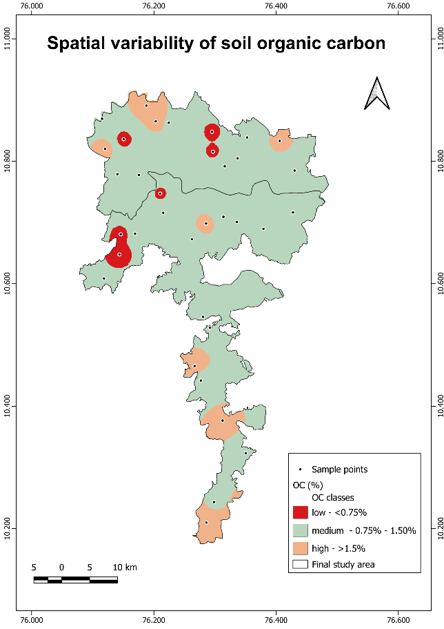
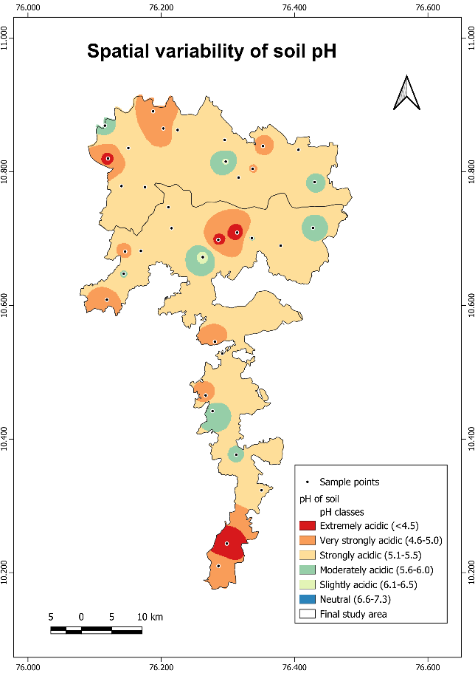
Fig. 7. Spatial variability of soil pH and soil organic carbon
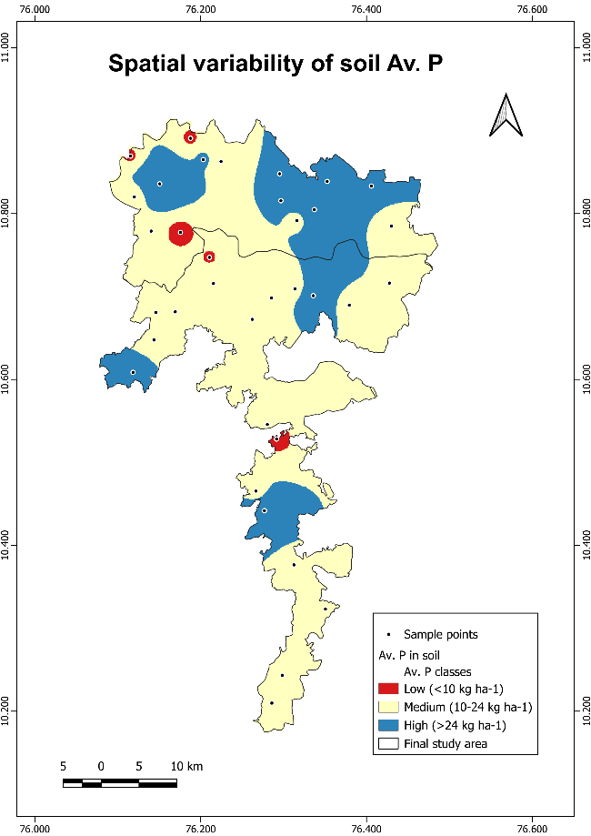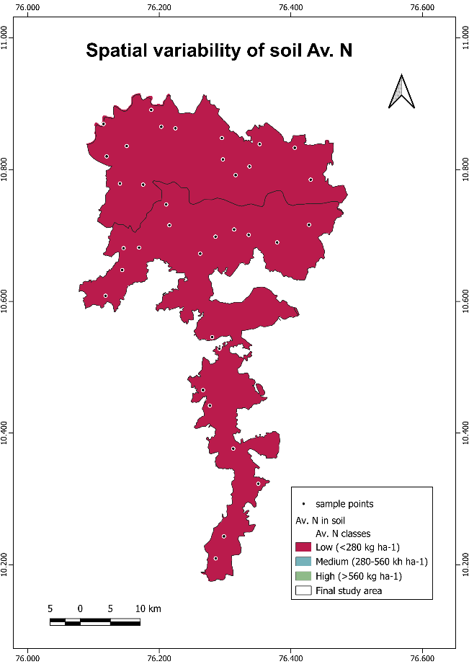
Spatial variability of Av. P in soil
Spatial variability of Av. N in soil

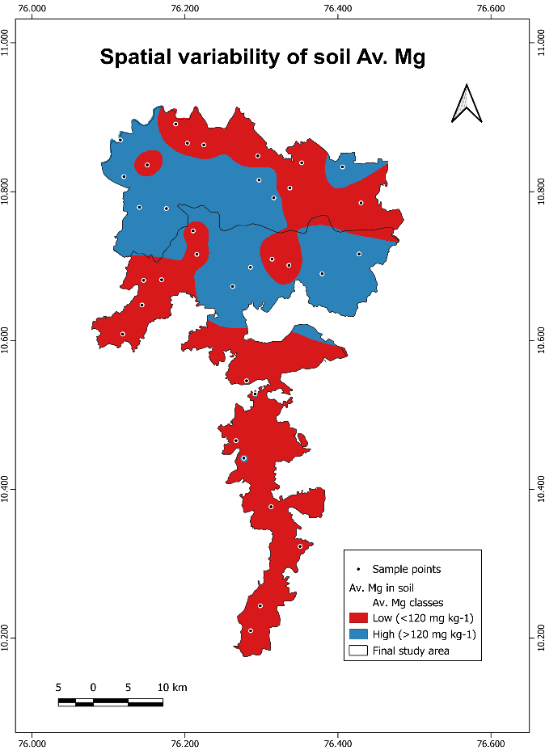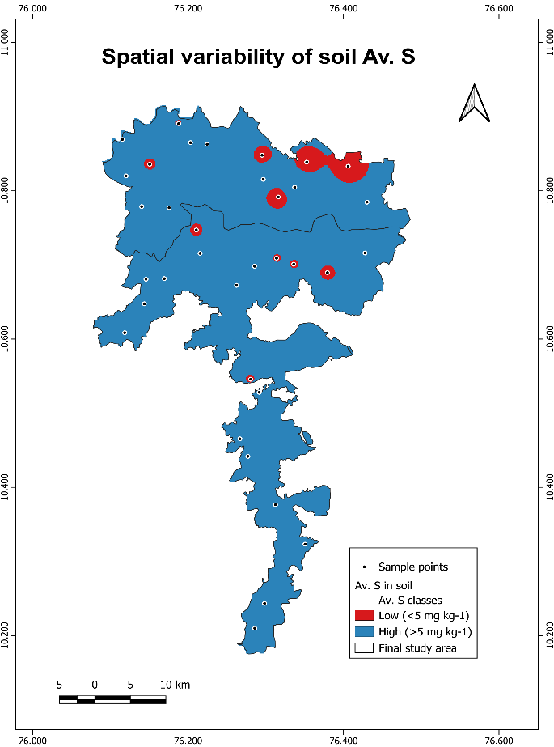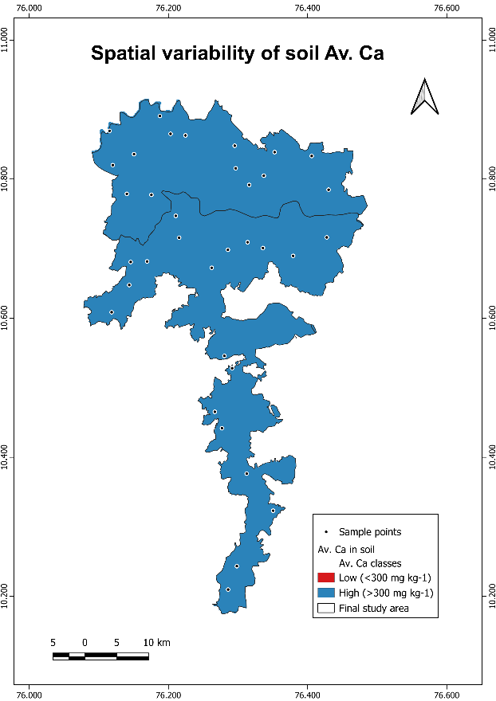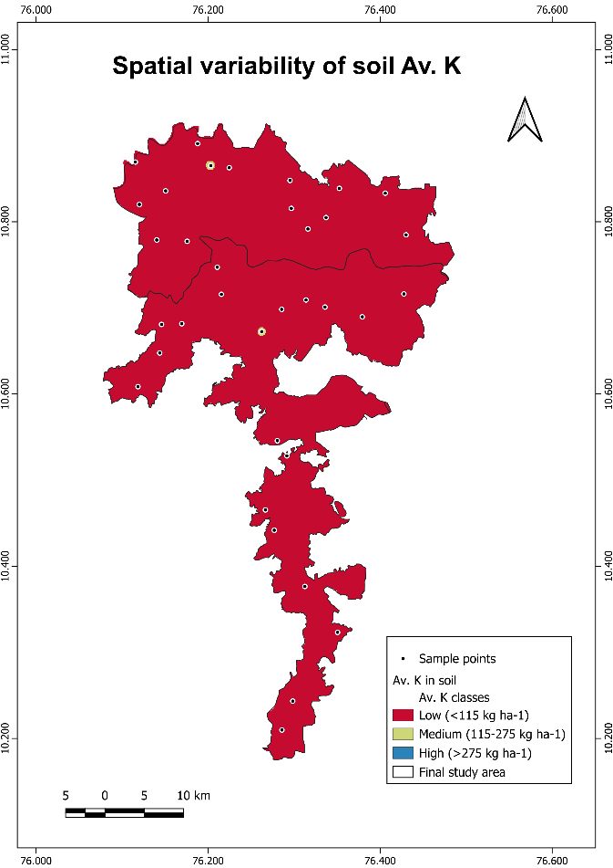Fig. 8. Spatial variability of soil macronutrients
Spatial variability of Av. Mg in soil
Spatial variability of Av. S in soil
Spatial variability of Av. Ca in soil
Spatial variability of Av. K in soil
4. Conclusion

The study revealed the prevalence of widespread multi-nutrient deficiencies, including deficiency of available nitrogen, potassium, magnesium, sulfur, and boron, across the intensively rice-cultivated regions of the north-central laterites of Kerala. The findings of the study underscore the need to reassess the nutrient management practices currently employed by farmers to prevent soil-related problems such as nutrient imbalances and nutrient depletion. Balanced fertilization, including site-specific nutrient management, is essential to address macro and micronutrient deficiencies. Implementing the strategies will enhance soil health and support sustainable rice cultivation in Kerala. Spatial variability maps serve as valuable tools to identify nutrient deficiencies, monitor soil fertility trends over time, and support predictive planning for maintaining long-term soil health and productivity.
Disclaimer (Artificial intelligence)
Option 1:
Author(s) hereby declare that NO generative AI technologies such as Large Language Models (ChatGPT, COPILOT, etc.) and text-to-image generators have been used during the writing or editing of this manuscript.
Option 2:
Author(s) hereby declare that generative AI technologies such as Large Language Models, etc. have been used during the writing or editing of manuscripts. This explanation will include the name, version, model, and source of the generative AI technology and as well as all input prompts provided to the generative AI technology
Details of the AI usage are given below:
1.
2.
3.

References
- Rajasekharan, P., Nair, K. M., John, K. S., Kumar, P.S., Kutty, M. N. and Nair, A. R. 2014. Soil fertility related constraints to crop production in Kerala. Indian J. Fertil. 10(11), pp.56-62.
- Jackson, M. L. 1958. Soil Chemical Analysis. Prentice Hall of India, New Delhi, p.29.
- Walkley, A. and Black, I. A. 1934. Estimation of soil organic carbon by chromic acid titration method. Soil Sci., 37, pp.29-38.
- Subbiah, B.V. and Asija, G.L. 1956. A rapid procedure for the estimation of available nitrogen in soils. Curr. Sci., 25, pp.259-260.
- Bray, R.H. and Kurtz, L.T. 1945. Determination of total organic carbon and available forms of phosphorus in soils. Soil Sci., 59, pp.39-45.
- Lindsay, W.L. and Norvell, W.A. 1978. Development of DTPA soil test for Zn, Fe, Mn and Cu. Soil Sci. Soc. Am. J., 42, pp.421-428.
- Gupta, U. C. 1972. Effects of boron and limestone on cereal yields and on B and N concentrations of plant tissue. Commun. Soil Sci. Plant Anal. 6: 439-450.
- Ramamoorthy, B. and Bajaj, J. C. 1969. Soil fertility map of India. Fertilizer News. 14(8): 25.
- Nair, K. M., Kumar, A. K. S., Lalitha, M., Shivanand, Kumar, R. S. C., Srinivas, S., et al. 2019. Surface soil and subsoil acidity in natural and managed land-use systems in the humid tropics of Peninsular India. Current Science. 116(7): 1201-1211.
- Patil, P.L., Bidari, B. I., Hebbara, M., Katti, J., Dilvaranaik, Samirkhan., Vishwanatha, S., Geetanjali, H. M. and Dasog, G.S. 2017. Identification of soil fertility constraints by GIS in Bedwatti sub-watershed under Northern Dry Zone of Karnataka for site-specific recommendations. J. Farm Sci., 30, pp.206-211.
- Abhiram, M., Leno, N., Rani, B., Anilkumar, K. S. and Rafeekher, M. 2023. Physical, chemical and biological properties of soils in Marayur Hills of Kerala, India. Pharma Innov. J., 12(2), pp.2887-2890.
- Sudhir, K., Jose, G., Prakasha, H.C. and Gowda, J.N.A. 2006. Organic carbon status of a laterite and a red soil under long-term rice cultivation in Karnataka, India. In: Proc. 18th World Congr. Soil Sci., pp.9-15.
- Arai, M. and Wagai, R. 2024. Does rice paddy management increase soil organic carbon in warm temperate and tropical regions? Geoderma Reg., 36, p.e00738.
- Kumari, S. L. 2012. Status Paper on Rice in Kerala. Directorate of Rice Research, Hyderabad
- Molin, D. S. J., Ernani, P. R. and Gerber, J. M. 2020. Soil acidification and nitrogen release following application of nitrogen fertilizers. Commun. Soil Sci. Plant Anal., 51(20), pp.2551-2558.
- Ishii, S., Ikeda, S., Minamisawa, K. and Senoo, K. 2011. Nitrogen cycling in rice paddy environments: Past achievements and future challenges. Microbes Environ., 26(4), pp.282-292.
- Afonso, S., Arrobas, M. and Rodrigues, M. A. 2020. Soil and plant analyses to diagnose hop fields irregular growth. J. Soil Sci. Plant Nutr., 20(4), pp.1999-2013.
- Mitra, D., Anđelković, S., Panneerselvam, P., Senapati, A., Vasić, T., Ganeshamurthy, A.N., Chauhan, M., Uniyal, N., Mahakur, B. and Radha, T.K. 2020. Phosphate-solubilizing microbes and biocontrol agent for plant nutrition and protection: Current perspective. Commun. Soil Sci. Plant Anal., 51(5), pp.645-657.
- Yusran, F. H. 2018. The relationship between phosphate adsorption and soil organic carbon from organic matter addition. J. Trop. Soils, 15(1), pp.1-10.
- Mini V. and Usha Mathew. Soil based nutrient management plan for Onattukara sandy tract of Kerala. Asian J. of Soil Sci. 2015;10(1):99-103.
- Kavitha C. and Sujatha M.P. Evaluation of soil fertility status in various agro-ecosystems of Thrissur District, Kerala, India. Inter. J. of Agric. Crop Sce. 2015;328-338.
- Rajasekharan P., Nair K.M., Rajasree G., Sureshkumar P. and Narayanakutty M.C. 2013. Soil fertility assessment and information management for enhancing crop productivity in Kerala. Kerala State Planning Board, Government of Kerala.
- Naidu, L.G.K., Sidhu, G.S., Sarkar, D. and Ramamurthy, V. 2011. Emerging deficiency of potassium in soils and crops of India. Karnataka J. Agric. Sci., 24(1).
- Sureshkumar, P., Geetha, P. and Bhindhu, P. S. 2018. Chemistry and fertility-Management of humid tropical soils of Kerala as influenced by topography and climate. Indian J. Fert., 14, pp.30-44.
- Jayaganesh, S., Venkatesan, S., Senthurpandian, V.K. and Poobathiraj, K. 2011. Vertical distribution of magnesium in the laterite soils of South India. Int. J. Soil Sci., 6(1), p.69.
- Natarajan P, Varghese J. J., Oommen, M., Soumiya, C. S., Jyothi, S., Kumar, K. V. S. et al. 2013. Fertility of soils of Kerala. In: Soil fertility assessment and information management for enhancing crop productivity in Kerala. Kerala State Planning Board, Thiruvananthapuram, Kerala. pp204 227.
- Sahu, M., Nisab, M. C., and Mondal, S. 2022. Availability of macronutrients and sulphur and their relationship with physico-chemical properties in lateritic soils of Birbhum district, West Bengal. Int. J. Econ. Plants, 9(3), pp.260-263.
- Wu, C., Luo, Y., and Zhang, L. 2010. Variability of copper availability in paddy fields in relation to selected soil properties in Southeast China. Geoderma, 156(3-4), pp.200-206.
- Li, H. and Xu, W. 2024. Geological and Economic Assessment of Manganese Deposits. Int. J. Ecol. Environ. Sci., 6(2), pp.28-31.
- Bhat, R., Sujatha, S., and Jose, C.T. 2012. Assessing soil fertility of a laterite soil in relation to yield of arecanut (Areca catechu L.) in humid tropics of India. Geoderma, 189, pp.91-97.
- Singh, N. K., Sachan, K., Ranjitha, G., Chandana, S., Manoj B. P., Panotra, N., and Katiyar, D. 2024. Building Soil Health and Fertility through Organic Amendments and Practices: A Review. Asian J. Soil Sci. Plant Nutri., 10(1), pp. 175-197.

