Impact of Biofertilizers and Integrated Nutrient Management on Transplanted Rice for improving the growth, yield and Soil Quality: A Review

Abstract
This review paper examines the role of biofertilizers and Integrated Nutrient Management (INM) in enhancing the growth, yield, and soil fertility of transplanted rice. Biofertilizers, which include beneficial microorganisms, contribute to soil nutrient cycling, nitrogen fixation, and overall plant health, while INM combines organic, inorganic, and biological inputs to optimize nutrient availability. For instance, combining 50% biofertilizer with 50% chemical fertilizer increased rice yield by up to 15–20% compared to chemical fertilizers alone, while improving soil organic carbon and reducing environmental degradation through lower nitrate leaching (Noraida et al., 2021; Kumar et al., 2023). The synergistic effects of these practices have shown promising results in improving rice productivity, soil structure, and sustainability in rice farming systems. The paper explores various studies that highlight the effectiveness of biofertilizers and INM in enhancing soil health, increasing nutrient use efficiency, and reducing dependency on chemical fertilizers. Furthermore, it discusses the potential challenges and future directions for integrating these practices into modern rice cultivation for long-term agricultural sustainability.
Keywords: Biofertilizers, INM, Nitrogen Fixation, Rice, Sustainability.
Introduction
Over 3.5 billion people rely on rice as a staple food, accounting for 19% of global dietary energy [22], and it is expected to remain a key part of diets worldwide (Lenaerts et al.,2021). With the global population projected to exceed 9 billion by 2050, food demand is anticipated to increase by 35% to 56% between 2010 and 2050 (Pame et al.,2023). To feed nearly 9 billion people by 2050, rice production will need to double sustainably. Notably, 79 million hectares of lowland irrigated land contribute to over 75% of global rice production. However, it is projected that 17 million hectares of flood-irrigated rice will experience physical water scarcity, while 22 million hectares may face economic water scarcity (Lal et al.,2013) and (Midya et al.,2017). This raises concerns about the sustainability of rice farming in traditional wetland ecosystems when flooded (Midya et al.,2021). Biofertilizers are gaining widespread use in many countries for various crops. These products contain either active or dormant strains of soil microorganisms, such as bacteria, algae, or fungi, which help improve the availability and absorption of mineral nutrients by plants. When applied to soil, seeds, or plant surfaces, biofertilizers containing living microorganisms, enable plants to access essential nutrients. Thanks to their biological activity and composition, they include living cells of beneficial microorganisms that enhance soil quality by making nutrients more accessible to plants Microorganisms rely on organic matter for their growth and activity in the soil (Nosheen et al.,2021). They also play a role in fixing nitrogen, solubilizing phosphorus, and producing compounds that promote plant growth, thereby making essential nutrients more accessible to plants. These microorganisms are cost-effective, environmentally friendly, and sustainable. While their effects on crops is generally slower compared to chemical fertilizers, they offer long-term benefits for soil health and plant nutrition (Vessey 2003). The application of beneficial microorganisms plays a crucial role in organic farming and regenerative agriculture, serving as key elements of sustainable agricultural practices. These microorganisms contribute to soil health, nutrient cycling, and overall farm sustainability (Velten et al.,2015). Microorganisms in the soil play a vital role in balancing plant nutritional needs and the decomposition of soil organic matter, ensuring that essential nutrients are made available to plants while maintaining soil health (Kalamulla et al.,2022). In sustainable agriculture, selecting and applying beneficial soil microbial inoculants can serve as a form of fertilizer, commonly known as a "biofertilizer" (Dahunsi et al.,2021) and (Dahunsi et al.,2018). To boost the growth, productivity, and soil health of transplanted rice, adopting integrated nutrient management (INM) practices is essential. This approach enhances nutrient availability and uptake by rice plants by strategically combining chemical fertilizers, organic manures, and biofertilizers (Singh et al.,2018). Organic manures like green manures, compost, and farmyard manure (FYM) help boost the organic matter content in the soil. These materials enhance the soil's structure, improve its ability to retain water, and support better nitrogen cycling (Kumar et al.,2019). Furthermore, the synergistic effects of combining organic manures, chemical fertilizers, and biofertilizers in INM systems lead to higher crop yields, improved soil health, and more efficient nutrient utilization (Kumar et al.,2019). By adopting INM practices, farmers can grow rice in a more sustainable way, reducing the negative environmental and health impacts often associated with the overuse of chemical fertilizers (Singh et al.,2018). A key element of this approach is Integrated Nutrient Management (INM), which boosts soil health, microbial activity, and fertility, ultimately increasing crop yields. INM achieves this by combining organic and inorganic fertilizers tailored to the specific needs of the soil and crop, along with farmyard waste. This method not only enhances the sustainability of rice farming but also helps reduce environmental pollution (Kumar et al.,2023). In addition to supplying essential nutrients to crops, INM has been shown to support broader production goals. The current study was conducted to explore the impact of integrated nutrient management on the growth, yield traits, productivity, and profitability of direct-seeded rice grown in rainfed conditions (Kumar et al.,2023).
1. Biofertilizer
A biofertilizer is a natural substance that contains beneficial live microorganisms, which play a crucial role in promoting root growth and improving seed germination. These microorganisms enhance soil fertility and help plants absorb essential nutrients more efficiently, leading to healthier and more robust crop development (Singh, J.S. et al., 2011). Biofertilizers enriched with beneficial microbes help improve phosphate availability, boost crop production, and enhance both the biological activity and chemical composition of the soil (Yosefi et al., 2011). Using microbial inoculants is an affordable method to enhance crop yields by minimizing the need for chemical fertilizers while improving the soil's ability to absorb nutrients efficiently (Noraida et al., 2021). The helpful microorganisms in biofertilizers enhance the supply of essential nutrients like nitrogen, phosphorus, and sulphur to plants while also playing a key role in managing the decomposition of organic matter (Venkatashwarlu et al., 2008). This process enhances the soil’s ability to retain nutrients, absorb more water, improve soil structure, and safeguard it against harmful effects from heavy metals, pesticides, and extreme pH levels (Chen, J. H. 2006).
2. Roles of some of the biofertilizers in crop production.
2.1 Azolla
Azolla is a water-loving fern that thrives in paddy fields and is commonly found in temperate regions. It plays a crucial role in enhancing soil fertility by fixing nitrogen in the surrounding environment. This fern has a mutualistic relationship with a type of blue-green algae, Anabaena azollae, which helps with the nitrogen fixation process. In ideal conditions, Azolla may quickly double its biomass in a matter of two to five days (Bhuvaneshwari and Singh, 2015).

2.2 Blue-Green Algae (BGA)
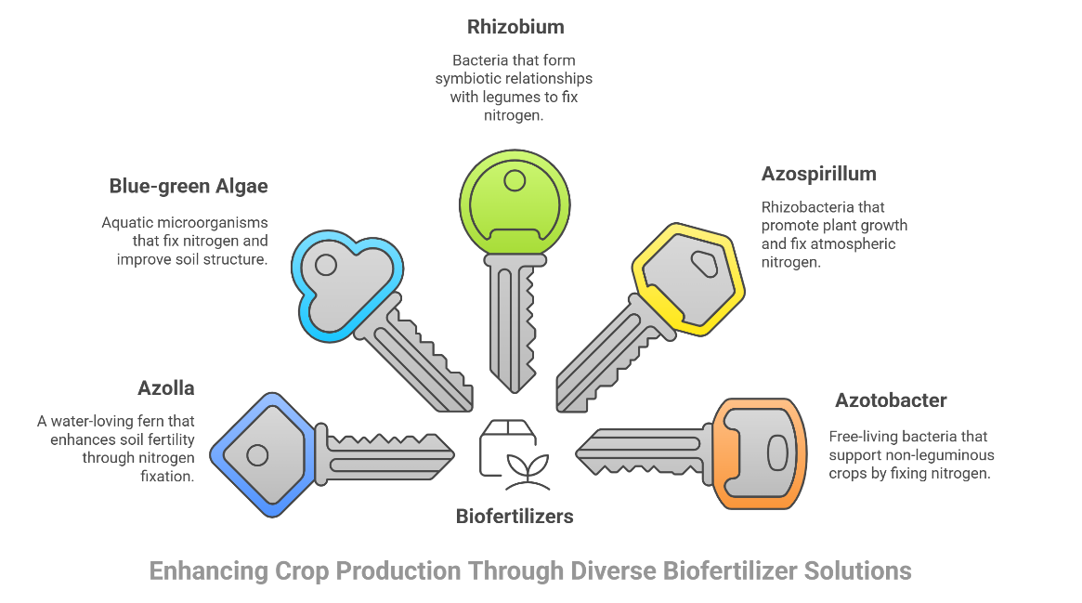
Cyanobacteria, also known as blue-green algae, are aquatic bacteria found in freshwater and marine environments. These microbes are capable of fixing nitrogen from the atmosphere. They are often used as biofertilizers in the cultivation of crops like rice and beans. During their decomposition, they help enhance soil fertility and improve its structure. The use of BGA is economically feasible, as it reduces the need for chemical nitrogen fertilizers by up to 25–30%, lowering input costs while maintaining yields (Naher et al., 2015; Chittora et al., 2020).
FIG 1. Enhancing crop production through diverse biofertilizer solutions
2.3 Rhizobium
Rhizobium, part of the Rhizobiaceae family, is well-known for its ability to fix atmospheric nitrogen in partnership with leguminous plants that form nodules on their roots. Some common species of Rhizobium include Rhizobium leguminosarum, Rhizobium lantis, Rhizobium japonicum, Rhizobium trifolii, Rhizobium phaseolii, Rhizobium alamii, and Rhizobium smilacinae. This bacterium forms a symbiotic relationship with legumes, fixing between 50 and 100 kg/ha of nitrogen. Optimal nitrogen fixation occurs in well-aerated, loamy soils with a pH of 6.0–7.0, moderate organic matter (2–5%), and low salinity. This process can benefit crops like green beans, red beans, chickpeas, lentils, and other pulses. However, the population of Rhizobium decreases significantly when leguminous crops are not grown in the field (Bhattacharjee and Dey, 2014).

2.4 Azospirillum
Azospirillum, a member of the Spirilaceae family, is regarded as one of the most effective rhizobacteria for promoting plant growth (PGPR). Not only does it help plants thrive, but it also fixes atmospheric nitrogen. Additionally, Azospirillum enhances plant growth by developing tolerance to both environmental and biological stress factors. It produces various plant growth hormones, including auxins, cytokinin, gibberellins, ethylene, and abscisic acid. Some strains of Azospirillum can also break down inorganic phosphorus, making it accessible to plants, which ultimately leads to improved crop yields (Dubey et al.,2019). The most significant non-symbiotic N-fixing bacterium in non-leguminous crops is Azospirillum. Azospirillum can improve plant growth and increase the yield of a number of significant crops in a variety of soil types and climate zones when the right circumstances are met. Azospirillum's positive effects on plants are mostly ascribed to improved root development, increased root uptake of water and minerals, the displacement of plant pathogenic bacteria and fungi, and, to a lesser extent, biological nitrogen fixation. (Fukami et al.,2018)
2.5 Azotobacter
The free-living, nitrogen-fixing bacterium Azotobacter enhances plant growth. It is part of the Azotobacteriaceae family and is both aerobic and heterotrophic. In the presence of root exudates are present, these bacteria assist plants in optimizing nutrient uptake. Additionally, Azotobacter generates and releases various active compounds that stimulate root development, including vitamin B, nicotinic acid, heteroauxins, and gibberellins, as noted by (Mahdi et al.,2010). It is recommended to apply this bacterium to non-leguminous crops like tomatoes, cotton, wheat, rice, and millets, since it thrives in neutral to alkaline soils. Nonetheless, its population ends to be low in uncultivated soils and cultivated plants rhizosphere (Sivasakthi et al.,2017). Kader et al., (2002) explored the effects of Azotobacter inoculants on wheat production and nitrogen uptake. The bacterium, a free-living nitrogen fixer in the rhizosphere zone, is recognized for producing and secreting biologically active compounds that enhance root growth, including biotin, auxins, gibberellins, nicotinic acid, pantothenic acid, and B vitamins.
3. Biofertilizers for Sustainable Food Production: Enhancing Soil Health and Yield
Rice cultivation largely relies on chemical fertilizers, especially urea, which contributes to groundwater pollution and global warming. The excessive use of nitrogen-based fertilizers leads to harmful environmental effects, such as nitrate leaching and nitrous oxide emissions. These issues can be mitigated by reducing dependence on synthetic nitrogen fertilizers or developing methods that enable plants to absorb atmospheric nitrogen without significant losses in the soil. Alongside nitrogen, phosphorus is a vital nutrient for plant growth, but soil pH strongly influences its availability. Although phosphorus is present in the soil, it is often in a form that plants cannot easily absorb. Certain bacteria can convert insoluble phosphorus into a more accessible form, thereby reducing the need for chemical phosphorus fertilizers. Microbial processes, such as biological nitrogen fixation by free-living bacteria and phosphorus solubilization by specialized microorganisms, play a crucial role in enhancing plant nutrition. Biofertilizers enriched with beneficial microbes such as phosphate-solubilizing bacteria, plant growth-promoting bacteria, and free-living diazotrophs help improve soil fertility and boost crop productivity. The use of these biofertilizers offers a sustainable alternative to chemical fertilizers, supporting eco-friendly farming practices while maintaining high agricultural yields. (Naher et al.,2015)
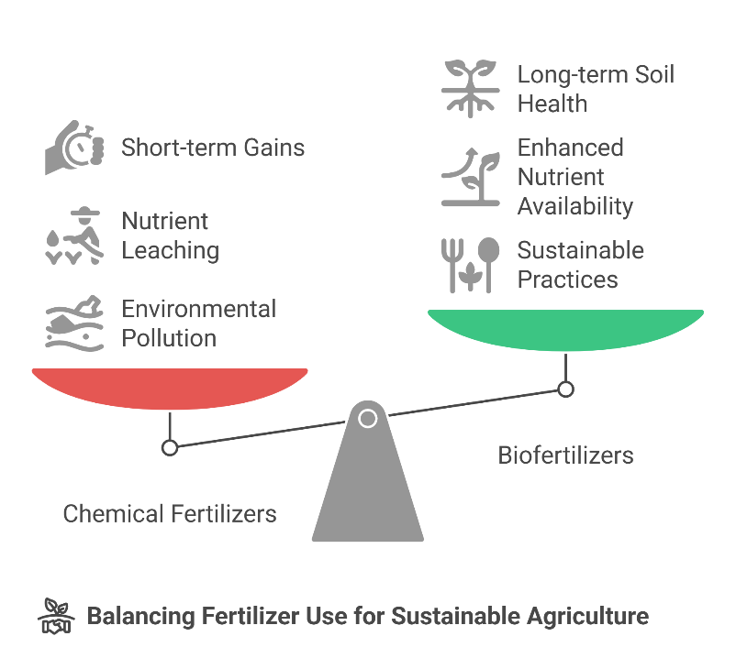

Fig 2. Balancing fertilizer uses for sustainable agriculture
Plant nutrients are essential to sustainable agriculture, playing a crucial role in crop growth and productivity. The use of biofertilizers enriched with beneficial microorganisms enhances nutrient availability, making it easier for plants to absorb essential elements. Providing crops with the appropriate fertilizers to meet their nutritional needs is vital to ensuring food security for a growing population. However, the increasing dependence on chemical fertilizers has raised concerns due to their negative impact on both human health and the environment. Therefore, integrating microbial bioinoculants with chemical fertilizers is regarded as one of the most effective approaches to improving soil fertility and promoting healthy plant growth while minimizing environmental harm (Prisa et al.,2023).
The ongoing depletion of natural resources, coupled with the excessive use of chemical fertilizers, raises significant concerns about the future of agriculture. As a sustainable alternative to harmful agrochemicals, biofertilizers are gaining increasing importance in promoting eco-friendly farming. Ensuring global food security requires both improved crop yields and the long-term preservation of soil fertility, both of which can be achieved through the use of biofertilizers. These beneficial microorganisms form symbiotic relationships with plants, enhancing their growth, development, and natural resistance to stress (Nosheen et al.,2021).
This review systematically examines the Eco physiological processes through which plant-growth-promoting microorganisms (PGPMs) contribute to enhancing rice productivity and quality, The Study results that PGPMs represent a promising tool with which to boost the sustainability and productivity of rice cultivation (Ríos-Ruiz et al.,2025).
4.1 Importance of biofertilizers in sustainable agriculture:
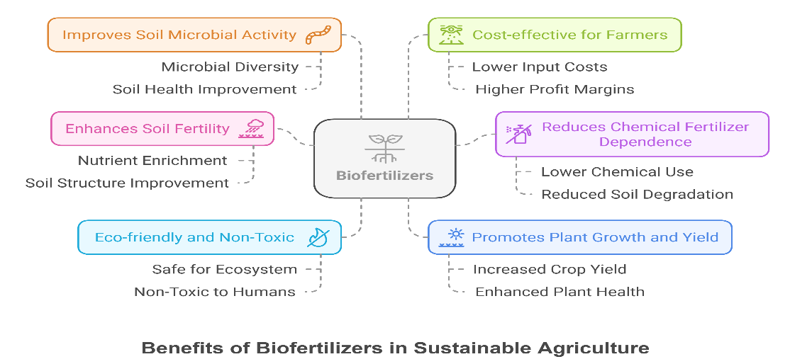

FIG 3. Benefits of biofertilizer in sustainable agriculture

- Enhance Soil Fertility: Biofertilizers enhance the soil's nutrient content by adding helpful microbes that fix atmospheric nitrogen, solubilize phosphorus, and break down organic materials.
- Reduce Dependence on Chemical Fertilizers: Biofertilizers reduce the need for chemical fertilizers by providing essential nutrients naturally, resulting in more environmentally friendly farming methods. (Chaudhary et al.,2022)
- Eco-Friendly and Non-Toxic: Unlike chemical fertilizers, which can harm and pollute the soil, biofertilizers are natural, non-toxic substances that do not pose a threat to the environment.
- Promote Plant Growth and Yield: Research indicates that biofertilizers enhance crop yields by improving plant health and increasing nutrient availability.
- Improve Soil Microbial Activity: Biofertilizers enhance nutrient cycling and soil health by increasing the number of beneficial soil microorganisms.
- Cost-Effective for Farmers: Biofertilizers provide farmers with a cost-effective choice by increasing crop yields and decreasing the demand for chemical inputs.

5. Impact of INM on growth, yield, economics, nutrient uptake, and soil health in Transplanted Rice.
5.1 Impact of Integrated Nutrient Management on Growth
The research conducted on the effects of integrated organic and inorganic fertilizers on the growth and yield of the indica rice variety Manawthukha and the japonica rice variety Genkitsukushi, indicated that integrating organic and inorganic fertilizers enhanced the growth parameters and yields of both Manawthukha and Genkitsukushi, while reducing the dose of chemical fertilizer (Moe et al.,2019). The experiment revealed that a significantly higher Plant height (cm), number of tillers (m⁻²), and leaf area index were observed with the application of 50% RDN through fertilizer + 50% RDN through compost + seed treated with Azotobacter @ 10 g kg⁻¹ seed compared to the other treatments (Kumar et al.,2023). The results showed that the residual effects of organic manures significantly improved the growth parameters and yield attributes; among the various residual treatments, the use of farmyard manure + 75% NPK exhibited maximum plant height (125.2 cm), and number of tillers (68.0 m⁻¹) (Dhaliwal et al.,2023; Singh et al., 2023). The application of chemical fertilizer alone or in combination with organic manure resulted in a significant increase in the growth of the rice crop (Anisuzzaman et al.,2021, Verma et al., 2023). A trial was conducted to study the effects of biofertilizer on the growth performance and yield of rice According to this research, rice grows more effectively when 50% biofertilizer and 50% chemical fertilizer are combined (Noraida et al.,2021; Prakash et al., 2023). Combining organic and inorganic manures increased plant height, the number of grains per panicle, the length of the panicle, and the number of fertile tillers per hill (Arif et al.,2014). According to Kumar et al. (2021), the application of 100% RDN (50% nitrogen through FYM and 50% chemical) produced the highest crop growth indices. followed by 80% RDN (50 percent nitrogen through FYM and 50% chemical) and 60% RDN (50% nitrogen through FYM and 50% chemical).
5.2 Impact of Integrated Nutrient Management on Yield
The findings showed that combining compost, vermicompost from Sasbania, green manure, and farmyard manure (FYM) with chemical fertilizers significantly improved rice yield and its contributing factors, compared to using these sources individually in most cases (Wolie et al.,2016). Rice grain and straw yields were considerably higher when organics and residues from crops were utilized together with biofertilizers than when the other treatments were used (Meena et al.,2020). The study says that the dosage of biofertilizer and its integrated application can become an alternative recommendation to increase yield on lowland rice at latosol soil (Arsana et al.,2022). The present investigation points out the significance of balanced and imbalanced use of nutrients, including FYM, in the rice-wheat cropping system for improving the yield of the rice crop (Bhatt et al.,2018). The most effective way to increase rice yield in Bangladesh's rice-fallow-rice system is by combining organic and inorganic nutrition sources (Haque et al., 2019, Bharti et al., 2024). The research conducted to study the effects of biofertilizer on the growth performance and yield of rice and revealed that, thus, from this trial, it has been proven that combining 50% biofertilizer with 50% chemical fertilizer enhances rice yield (Noraida et al.,2021, Maurya et al., 2023). He investigated "Effect of Integrated Use of Organic Manures and Inorganic Fertilizers on Yield and Yield Components of Rice. "Combining chemical fertilizers and organic manure may significantly improve rice yield (Arif et al.,2014).
5.3 Impact of Integrated Nutrient Management on Economics
The study conducted in the lower Indo-Gangetic Plain Zone (IGPZ) of West Bengal, India, suggests that the System of Rice Intensification (SRI) method, when combined with integrated nutrient management (using 25% RDN from vermicompost and 75% RDN from chemical fertilizers), can optimize economic profitability, value-cost ratio, and partial factor productivity of nutrients (Midya et al.,2021). The study concluded that by decreasing the cultivation costs, INM increases farmers' profitability (Bhanuwanti and Pratima Vaidya 2020). A field experiment assessed the impact of integrated nutrient management on protein content, yield, and the economics of transplanted rice (Oryza sativa L.). The results revealed that the T2 treatment yielded the highest gross return (Rs. 84,199 ha⁻¹), net return (Rs. 43,644 ha⁻¹), and B: C ratio (Rs. 1.08 ha⁻¹) with RDF 100% (150:60:60:20 NPK and zinc sulphate) (Patel et al.,2023).
5.4 Impact of Integrated Nutrient Management on Nutrient Uptake
The study also observed that the rice crop showed higher overall nutrient uptake when integrated nutrient sources were used. Furthermore, combining inorganic and organic fertilizers improved the soil's key physical and chemical properties, enhancing nutrient availability (Wolie et al.,2016). All rice genotypes demonstrated a significant increase in nutritional content (N, P, and K) when chemical fertilizers were applied alone or combined with organic manure (Anisuzzaman et al.,2021). The phosphorus (P) balance was enhanced when manure and inorganic phosphorus fertilizers were applied together over a prolonged period. As a result, in acidic paddy soils, the application rate of phosphorus inputs should be reduced when both manure and inorganic P fertilizers are used together (Qaswar et al.,2020). The combined use of organic and inorganic fertilizers resulted in higher nutrient uptake and improved nutrient utilization efficiency, leading to more favourable outcomes (Urmi et al.,2022).
5.5 Impact of Integrated Nutrient Management on Soil Health/Quality
The combined application of Azolla biofertilizer, well-composted organic manures, and silicate fertilizer could be practical approach to reducing the use of conventional urea fertilizer, decrease methane (CH4) emissions, and improving soil quality indicators (Ali et al.,2014). The highest concentrations of available nitrogen (N), phosphorus (P), potassium (K), and sulphur (S) in the soil were observed when farmyard manure (FYM) was applied in combination with green manure (GM) and biofertilizers (B) (Kumar et al.,2015 and Singh H. et al., 2024). The experiment on the impact of integrated nutrient management on rice (Oryza sativa L.) productivity revealed that using a combination of farmyard manure (FYM), green manure (GM), and blue-green algae (BGA) with 75% RDF + 25% N (FYM + GM + BGA) significantly enhanced soil health (Bharose et al.,2017). To improve soil organic carbon, it is recommended to apply organic manure in combination with the prescribed amounts of fertilizer (Bhanuwanti and Pratima Vaidya 2020). Combined fertilization, using both organic and inorganic fertilizers, not only boosts crop yields but also enhances soil health (Anisuzzaman et al.,2021). The current study clearly highlights the significance of using both balanced and unbalanced nutrient applications, including farmyard manure (FYM), in the rice-wheat cropping system. This approach helps improve various physicochemical soil quality indicators for rice crops over the long term (Bhatt et al.,2018). In a rice-fallow-rice system in Bangladesh, the most effective method for preserving soil fertility is the combined use of both organic and inorganic fertilizer sources (Haque et al.,2019). The results of the Integrated Plant Nutrient System (IPNS) trial indicate that regular application of manures and organic wastes can enhance soil fertility (Anik et al.,2017). The addition of organic fertilizer significantly influences the concentrations of organic carbon, total carbon, total nitrogen, ammonium nitrogen, nitrate nitrogen, soil pH, phosphorus, potassium, sulphur, calcium, and magnesium in post-harvest soil, reflecting an improvement in soil fertility. Therefore, regular use of both organic and inorganic fertilizers can help rejuvenate the soil and promote long-term agricultural sustainability (Urmi et al.,2022).
6. Conclusion
In conclusion, the integration of biofertilizers and Integrated Nutrient Management (INM) plays a pivotal role in advancing the sustainability and productivity of transplanted rice cultivation. With their ability to enhance nutrient cycling, nitrogen fixation, and overall soil health, biofertilizers offer an eco-friendly alternative to traditional chemical fertilizers. Their role in promoting soil fertility and plant growth, while reducing the dependency on chemical inputs, aligns with the goals of sustainable agricultural practices. The synergistic effects of combining biofertilizers with organic and inorganic fertilizers in INM systems have shown substantial improvements in rice growth, yield, and soil quality. The studies reviewed highlight that this approach not only boosts crop productivity but also contributes to the soil’s long-term health, enhancing its structure and nutrient-holding capacity. By optimizing nutrient availability and improving nutrient use efficiency, INM practices reduce environmental pollution and minimize the risks associated with excessive chemical fertilizer use. Moreover, INM, when implemented carefully considering local soil conditions, can enhance the economic profitability of rice farming by reducing input costs and improving yield quality. This integrated approach, therefore, stands as a promising solution for enhancing rice productivity while ensuring environmental sustainability.
DISCLAIMER (ARTIFICIAL INTELLIGENCE)
Author(s) hereby declares that NO generative AI technologies such as Large Language Models (ChatGPT, COPILOT, etc.) and text-to-image generators have been used during the writing or editing of this manuscript.
References
- Ali, M. A., Sattar, M. A., Islam, M. N., and Inubushi, K. 2014. Integrated effects of organic, inorganic and biological amendments on methane emission, soil quality and rice productivity in irrigated paddy ecosystem of Bangladesh: field study of two consecutive rice growing seasons. Plant and soil, 378, 239-252.
- Anik, M. F. A., Rahman, M. M., Rahman, G. M., Alam, M. K., Islam, M. S., and Khatun, M. F. 2017. Organic amendments with chemical fertilizers improve soil fertility and microbial biomass in rice-rice-rice triple crops cropping systems. Open Journal of Soil Science, 7(05), 87.
- Anisuzzaman, M., Rafii, M. Y., Jaafar, N. M., Izan Ramlee, S., Ikbal, M. F., and Haque, M. A. 2021. Effect of organic and inorganic fertilizer on the growth and yield components of traditional and improved rice (Oryza sativa L.) genotypes in Malaysia. Agronomy, 11(9), 1830.
- Arif, M., Tasneem, M., Bashir, F., Yaseen, G., and Iqbal, R. M. 2014. Effect of integrated use of organic manures and inorganic fertilizers on yield and yield components of rice. J. Agric. Res, 52(2), 197-206.
- Arsana, I. G. K. D., ArieF, R. W., Asnawi, R., Sudaryono, T., and mejaya, M. 2022. Rice growth and yield response on biofertilizer application on latosol paddy field of indonesia. Applied Ecology & Environmental Research, 20(4).
- Bhanuwanti and Pratima Vaidya 2020. A Review on Effect of Integrated Nutrient Management on Paddy. International Journal of Current Microbiology and Applied Sciences ISSN: 2319-7706 Volume 9 Number 10 (2020) Journal homepage: http://www.ijcmas.com
- Bharose, R., Kumar, S., Zaidi, S. F. A., Kumar, M., and Kumar, D. 2017. Effect of Integrated Nutrient Management on rice (Oryza sativa L.) productivity and Soil Fertility. Journal of Pharmacognosy and Phytochemistry, 6(6S), 278-280.
- Bharti, A.A., Shilpa, Sahrawat, V., Mallik, R.M., Kalyan, M.P., Mehta, S., Devi, N.D., Verma, R. and Dahiya, P. 2024. Innovative Approaches to weed management in Aerobic Rice: A climate-smart review, Plant Archives; 24(2), 63-70.
- Bhatt, M. K., Raverkar, K. P., Labanya, R., and Bhatt, C. K. 2018. Effects of long-term balanced and imbalanced use of inorganic fertilizers and organic manure (FYM) on soil chemical properties and yield of rice under rice-wheat cropping system. Journal of Pharmacognosy and Phytochemistry, 7(3), 703-708.
- Bhattacharjee, R., and Dey, U. 2014. Biofertilizer, a way towards organic agriculture: A review. African Journal of Microbiology Research, 8(24), 2332-2343.
- Bloemberg, G. V., Wijfjes, A. H., Lamers, G. E., Stuurman, N., and Lugtenberg, B. J. 2000. Simultaneous imaging of Pseudomonas fluorescens WCS365 populations expressing three different autofluorescent proteins in the rhizosphere: new perspectives for studying microbial communities. Molecular Plant-Microbe Interactions, 13(11), 1170-1176.
- Buragohain, S., Sarma, B., Nath, D. J., Gogoi, N., Meena, R. S., and Lal, R. 2017. Effect of 10 years of biofertiliser use on soil quality and rice yield on an Inceptisol in Assam, India. Soil Research, 56(1), 49-58.
- Chaudhary, P., Singh, S., Chaudhary, A., Sharma, A., and Kumar, G. 2022. Overview of biofertilizers in crop production and stress management for sustainable agriculture. Frontiers in Plant Science, 13, 930340.
- Chen, J. H. 2006. The combined use of chemical and organic fertilizers and/or biofertilizer for crop growth and soil fertility. In International workshop on sustained management of the soil-rhizosphere system for efficient crop production and fertilizer use (Vol. 16, No. 20, pp. 1-11). Land Development Department Bangkok Thailand.
- Chen, M., Arato, M., Borghi, L., Nouri, E., and Reinhardt, D. 2018. Beneficial services of arbuscular mycorrhizal fungi–from ecology to application. Frontiers in plant science, 9, 1270.
- Chittora, D., Meena, M., Barupal, T., Swapnil, P., and Sharma, K. 2020. Cyanobacteria as a source of biofertilizers for sustainable agriculture. Biochemistry and biophysics reports, 22, 100737.
- Dahunsi, S.O. and Ogunrinola, G.A. 2018. Improving soil fertility and performance of tomato plant using the anaerobic digestate of tithonia diversifolia as Bio-fertilizer. In IOP Conference Series: Earth and Environmental Science (Vol. 210, No. 1, p. 012014). IOP Publishing.
- Dahunsi, S.O., Oranusi, S., Efeovbokhan, V.E., Adesulu-Dahunsi, A.T., and Ogunwole, J.O. 2021. Crop performance and soil fertility improvement using organic fertilizer produced from valorization of Carica papaya fruit peel. Scientific reports, 11(1), 4696.
- Dhaliwal, S. S., Sharma, V., Shukla, A. K., Gupta, R. K., Verma, V., Kaur, M. and Singh, P. 2023. Residual effect of organic and inorganic fertilizers on growth, yield and nutrient uptake in wheat under a basmati rice–wheat cropping system in North-Western India. Agriculture, 13(3), 556.
- Dubey, M., Verma, V., Barpete, R. and Verma, N. 2019. Effect of biofertilizers on growth of different crops: a review. Plant Arch, 19, 1083-1086.
- Fukami, J., Cerezini, P., and Hungria, M. 2018. Azospirillum: benefits that go far beyond biological nitrogen fixation. Amb Express, 8(1), 73.
- GRiSP. Rice Almanac, 4th ed.; International Rice Research Institute: Los Baños, Philippines, 2013; ISBN 978-971-22-0300-8.
- Haque, M. M., Biswas, J. C., Islam, M. R., Islam, A., and Kabir, M. S. 2019. Effect of long-term chemical and organic fertilization on rice productivity, nutrient use-efficiency, and balance under a rice-fallow-rice system. Journal of Plant Nutrition, 42(20), 2901-2914.
- Kader, M. A., Mian, M. H., and Hoque, M. S. 2002. Effects of Azotobacter inoculant on the yield and nitrogen uptake by wheat. Journal of Biological Sciences, 2(4), 259-261.
- Kalamulla, R., Sandaruwan, D., Karunarathna, S. C., Stephenson, S. L., Tibpromma, S., Elgorban, A. M. and Suwannarach, N. 2022. Assessment of community dynamics of arbuscular mycorrhizal fungi in the Rice (Oryza sativa L.) Rhizosphere and potential application as biofertilizer. Sustainability, 14(24), 16537.
- Kumar, A., Biswas, A. K., Prasad, K. and Singh, Y. V. 2019. Integrated nutrient management for sustainable productivity and soil health in rice-wheat cropping system of Indo-Gangetic plains. International Journal of Chemical Studies, 7(1), 2453-2456.
- Kumar, D., Purakayastha, T. J., and Shivay, Y. S. 2015. Long-term effect of organic manures and biofertilizers on physical and chemical properties of soil and productivity of rice-wheat system. International Journal of Bio-resource and Stress Management, 6(Apr, 2), 176-181.c
- Kumar, N., Tiwari, B. K., Twari, R. K., and Gajbhiye, M. 2023. Effect of Integrated Nutrient Management on Growth, Yield Attributes, Productivity and Profitability of Direct Seeded Rice under Rainfed Conditions. International Journal of Environment and Climate Change, 13(4), 80-88.
- Kumar, V., Singh, M. K., and Raghuvanshi, N. 2021. Study on integrated nutrient management on crop growth indices in unpuddled transplanted rice (Oryza sativa L.). The Pharma Innovation Journal, 10, 680-684.
- Lal, B., Gautam, P., and Joshi, E. 2013. Different rice establishment methods for producing more rice per drop of water: A review. Int. J. Res. Biosci, 2, 1-12.
- Lenaerts, B., and Demont, M. 2021. The global burden of chronic and hidden hunger revisited: new panel data evidence spanning 1990–2017. Global food security, 28, 100480.
- Mahdi, S.S., Hassan, G.I., Samoon, S.A., Rather, H.A., Dar, S.A. and Zehra, B. 2010. Bio-fertilizers in organic agriculture, Journal of Phytology, 2(10): 42–54).
- Maurya, S., Kumar, R., Verma, R., Baboo, K., Prakash, R. and Singh, A.K. 2023. Effect of Different Crop Establishment Methods and Weed Management Practices on Growth Indices and Yield of Rice (Oryza sativa L.). International Journal of Plant & Soil Science 35(17): 31-37.
- Meena, A. L., Pandey, R. N., Kumar, D., Dotaniya, M. L., Sharma, V. K., Singh, G. and Bhanu, C. 2020. Impact of 12-year-long rice based organic farming on soil quality in terms of soil physical properties, available micronutrients and rice yield in a typic Ustochrept soil of India. Communications in Soil Science and Plant Analysis, 51(18), 2331-2348.
- Midya, A., Saren, B. K., and Pramanik, K. 2017. Aerobic rice culture, System of Rice Intensification (SRI) and System of Assured Rice Production (SARP): Emerging water savings production technologies for rice yield stability in tropics under shrinking water resource base. In Proceedings of the Souvenir Paper of 1st International Conference on Bio-Resource, Environment and Agricultural Sciences, Visva-Bharati, West Bengal, India (pp. 4-6).
- Midya, A., Saren, B. K., Dey, J. K., Maitra, S., Praharaj, S., Gaikwad, D. J. and Hossain, A. 2021. Crop establishment methods and integrated nutrient management improve: Part i. crop performance, water productivity and profitability of rice (Oryza sativa L.) in the lower indo-gangetic plain, India. Agronomy, 11(9), 1860.
- Midya, A., Saren, B. K., Dey, J. K., Maitra, S., Praharaj, S., Gaikwad, D. J. and Hossain, A. 2021. Crop establishment methods and integrated nutrient management improve: Part ii. nutrient uptake and use efficiency and soil health in rice (Oryza sativa L.) field in the lower indo-gangetic plain, India. Agronomy, 11(9), 1894.
- Moe, K., Moh, S. M., Htwe, A. Z., Kajihara, Y., and Yamakawa, T. 2019. Effects of integrated organic and inorganic fertilizers on yield and growth parameters of rice varieties. Rice Science, 26(5), 309-318.
- Naher, U. A., Othman, R., Panhwar, Q. A., and Ismail, M. R. 2015. Biofertilizer for sustainable rice production and reduction of environmental pollution. Crop production and global environmental issues, 283-291.
- Noraida, M. R., and Hisyamuddin, M. R. A. 2021. The effect of different rate of biofertilizer on the growth performance and yield of rice. In IOP Conference Series: Earth and Environmental Science (Vol. 757, No. 1, p. 012050). IOP Publishing.
- Nosheen, S., Ajmal, I., and Song, Y. 2021. Microbes as biofertilizers, a potential approach for sustainable crop production. Sustainability, 13(4), 1868.
- Pame, A. R. P., Vithoonjit, D., Meesang, N., Balingbing, C., Gummert, M., Van Hung, N. and Stuart, A. M. 2023. Improving the sustainability of rice cultivation in central Thailand with biofertilizers and laser land levelling. Agronomy, 13(2), 587.
- Patel, J. N., Singh, R. P., and Alam, M. S. 2023. Influences of nutrient alteration by organic and inorganic sources on protein content, their yield and economics of the transplanted rice (Oryza sativa L.). J. Pharm. Innov, 12(7), 3523-3528.
- Prakash, R., Kumar, R., Verma, R., Maurya, S. and Singh, A.K. 2023. Effect of Moisture Regimes and Weed Management Practices on Growth Indices under Drum Seeded Rice (Oryza sativa L.). International Journal of Environment and Climate Change 13(9): 270-276.
- Prisa, D., Fresco, R., and Spagnuolo, D. 2023. Microbial biofertilisers in plant production and resistance: A review. Agriculture, 13(9), 1666.
- Qaswar, M., Jing, H., Ahmed, W., Dongchu, L., Shujun, L., Lu, Z. and Huimin, Z. 2020. Yield sustainability, soil organic carbon sequestration and nutrients balance under long-term combined application of manure and inorganic fertilizers in acidic paddy soil. Soil and Tillage Research, 198, 104569.
- Ríos-Ruiz, W.F., Jave-Concepción, H.G., Torres-Chávez, E.E., Rios-Reategui, F., Padilla-Santa-Cruz, E., and Guevara-Pinedo, N.E. 2025. Plant-Growth-Promoting Microorganisms: Their Impact on Crop Quality and Yield, with a Focus on Rice. International Journal of Plant Biology, 16(1), 9.
- Sharma, D., and Vaidya, P. 2020. A review on effect of biofertilizers on paddy. International Journal of Ecology and Environmental Sciences, 2(4): 38-41.
- Simarmata, T., Turmuktini, T., Fitriatin, B.N., and Setiawati, M.R. 2017. Bioameliorant and Biofertilizers Application to Increase the Soil Health and Rice Productivity. HAYATI Journal of Biosciences.
- Singh, A. and Kumar, S. 2019. Impact of integrated nutrient management on soil quality parameters in rice-based cropping systems. Soil Science Society of America Journal, 83(4), 1021-1032.
- Singh H, Pal S, Kumar D, Kumar A, Verma A, Sachan R. 2024. Effect of Integrated Nutrient Management on Productivity and Quality of Rice. Int. J.Environ. Clim. Change;14(2):646-51.
- Singh, A.K., Singh, D., Verma, R., Yadav, A. 2023. Effect of nitrogen level on growth, yield attributes and yield of hybrid varieties of rice (Oryza sativa L.). Oryza-An International Journal 60(1): 191-195
- Singh, J. S., Pandey, V. C., and Singh, D. P. 2011. Efficient soil microorganisms: a new dimension for sustainable agriculture and environmental development. Agriculture, ecosystems & environment, 140(3-4), 339-353.
- Singh, Y.V., Prasad, K., Singh, A.K., Kumar, A. and Lal, G. 2018. Integrated nutrient management for improving productivity, soil health and economic returns from rice-wheat cropping system. Journal of Pharmacognosy and Phytochemistry, 7(1): 1136-1140.
- Sivasakthi, S., Saranraj, P., and Sivasakthivelan, P. 2017. Biological nitrogen fixation by Azotobacter sp.—a review. Indo Asian J Multidiscip Res, 3, 1274-1284.
- Sneha, S., Anitha, B., Sahair, R. A., Raghu, N., Gopenath, T. S., Chandrashekrappa, G. K., and Basalingappa, M. K. 2018. Biofertilizer for crop production and soil fertility.
- Tanuja, P., and Purohit, S. S. 2012. Biofertilizers Technology. Agrobios (India).
- Urmi, T.A., Rahman, M.M., Islam, M.M., Islam, M.A., Jahan, N.A., Mia, M.A.B. and Kalaji, H.M. 2022. Integrated nutrient management for rice yield, soil fertility, and carbon sequestration. Plants, 11(1), 138.
- Van Dijk, M., Morley, T., Rau, M. L., and Saghai, Y. 2021. A meta-analysis of projected global food demand and population at risk of hunger for the period 2010–2050. Nature Food, 2(7), 494-501.
- Velten, S., Leventon, J., Jager, N., and Newig, J. 2015. What is sustainable agriculture? A systematic review. Sustainability, 7(6), 7833-7865.
- Venkatashwarlu, B. 2008. Role of bio-fertilizers in organic farming: Organic farming in rain fed agriculture: Central institute for dry land agriculture. Hyderabad. Pakistan. pp, 85-95.
- Verma, R., Singh, Maurya, S., Prakash, R. and Singh, D. 2023. Effects of Nutrient Management on Growth Indices and Grain Yield of Different Crop Establishment Methods in Rice (Oryza sativa L.). International Journal of Plant & Soil Science 35(16): 67-73.
- Vessey, J.K. 2003. Plant growth promoting rhizobacteria as biofertilizers. Plant and soil, 255, 571-586.
- Wolie, A. W., and Admassu, M. A. 2016. Effects of integrated nutrient management on rice (Oryza sativa L) yield and yield attributes, nutrient uptake and some physico-chemical properties of soil: A review. Journal of Biology, Agriculture and Healthcare, 6(5), 20-26.
- Yosefi, K., Galavi, M., Ramrodi, M., and Mousavi, S. R. 2011. Effect of bio-phosphate and chemical phosphorus fertilizer accompanied with micronutrient foliar application on growth, yield and yield components of maize (Single Cross 704). Australian journal of crop science, 5(2), 175-180.

