Fungi Responsible for Storage Rot of Carrot (Daucus Carota L.)

.
ABSTRACT

Introduction: Carrot (Daucus carota L.) is mainly cultivated for its edible taproot, as a fresh or cooked vegetable. It is an excellent source of vitamin A, fiber and bioactive compounds such as β-carotene, which offer several health benefits, the root vegetable with the highest economic value (and the most consumed worldwide.
However, it is subject to fungal attack during storage, resulting in numerous losses. This study aims at identifying the fungi responsible for symptoms on carrots during storage.
Location and duration of study: Côte d'Ivoire, March to June 2022
Methodology: Samples of apparently healthy carrots marketed in three municipalities of Abidjan were collected and stored at room temperature (around 25°C). The phytosanitary condition of these stored carrots was assessed, and the fungi associated with symptoms were isolated on PDA medium and identified. A pathogenicity test was subsequently carried out with these different fungi.
Results: Black and white rot and grey soft rot were the symptoms identified after storage. Grey rot was the most recurrent symptom, with a prevalence of 40.46%. From symptomatic carrots, 11 fungi in 5 genera were isolated. These included Aspergillus, Botrytis, Colletotrichum, Geotrichum and Rhizopus. Pathogenicity test revealed that Botrytis sp. causing white rot and Rhizopus sp. causing black rot are pathogenic to carrots in storage.
Conclusion: This study enables us to envisage methods for controlling these post-harvest carrot fungi.
Recommandations: This study enables us to envisage methods for controlling the fungi responsible for losses on carrots during storage.

Keywords: carrot, fungi, storage, rot

1. INTRODUCTION

Carrot (Daucus carota L.) is mainly cultivated for its edible taproot, as a fresh or cooked vegetable (Wzamy, 2022). It is an essential agricultural product for many countries worldwide. Carrot is a root vegetable of global importance due to its high nutritional quality and wide application in food (Basso et al., 2021). It is attractive for human consumption due to its soft texture and pleasant taste. Carrot is an excellent source of vitamin A, fiber and bioactive compounds such as β-carotene, which offer several health benefits (Resende et al., 2016; Gomes et al., 2019). It is the root vegetable with the highest economic value (Carvalho et al., 2018; Patkowska et al., 2020) and the most consumed worldwide (Ding, 2024).
Like all fresh vegetables, carrots are subject to several factors that can reduce their post-harvest quality and shelf life. These include abiotic and biotic factors. Among biotic factors, plant diseases play a major role in yield reduction and carrot deterioration (Qiao et al., 2022). These diseases are due to the action of phytopathogenic agents, namely: bacteria, nematodes, viruses, and fungi (Ahmed et al., 2019). Fungi are the most formidable of all these agents. They not only reduce yield during cultivation, but also degrade product quality during transport and, above all, in storage conditions (Tanbir et al., 2020). During the storage period, carrots are vulnerable to numerous diseases and in-store losses of carrots vary between 10 and 40% (Franke, 2013) and can reach 50 to 60% (Bond, 2016). Several fungi have already been isolated on carrots in storage, the most abundant of which are Mycocentrospora acerina, Cylindrocarpon spp. Dictyostelium spp. and Fusarium spp. (Rizan, 2021). The negative influence of these fungi on the nutritional and commercial values of carrots is a real problem. This study aims therefore at identifying the fungi responsible for storage diseases of carrots.

2. MATERIAL AND METHODS

- Material
The material used consisted of two different varieties of carrot, commonly known as Lapin and 5 Doigts, collected from three markets in the Autonomous District of Abidjan (Côte d'Ivoire), notably the markets in the municipalities of Yopougon, Abobo and Adjamé. These different batches of carrots were contained in hermetically sealed packages and were available for sale.

- Assessment of the phytosanitary condition of carrots in storage

Three batches of carrots per variety were stored for 21 days at laboratory room temperature (± 25°C) to observe the possible appearance of symptoms. Symptomatic carrots were then grouped depending on symptom types and municipalities of collection, and described according to their appearance, color and shape.

- Determining symptom prevalence

Depending on the municipality of collection, the prevalence of each symptom was calculated using the following formula of Bernardo (2014):

P: prevalence;
Ni: number of carrots showing one type of symptom;
Nt: total number of carrots

- Determining symptom severity

Symptom severity was determined according to the 0 to 4 severity scale of Kora et al. (2005), with: 0: no symptoms; 1: symptom observed on 1% to 25% of the carrot surface; 2: symptom observed on 26% to 50% of the carrot surface; 3: symptom observed on 51% to 75% of the carrot surface; 4: symptom observed on 76% to 100% of the carrot surface.
Severity indices were calculated using the formula of Kobriger and Hagedorn (1983):
Is =

Is: severity index;
Nt: total number of carrots in a batch;
Ni: number of carrots having the same severity score in the batch;
Xi: severity score

- Isolation of fungi associated with symptoms

Isolation of fungi associated with symptoms observed on carrots was carried out on Potato Dextrose Agar (PDA) culture medium. Explants from symptomatic carrots were inoculated onto PDA media in Petri dishes. Several purifications were then carried out to obtain pure strains.

- Identification of fungal strains

Fungal strains were identified macroscopically based in characteristics such as color, growth pattern of fungal colonies, and microscopically by observation of mycelia and conidia. The Botton et al. (1990) identification key was also used.

- Assessment of the pathogenicity of isolated fungi

Three batches of apparently healthy carrots were collected. The carrots were then washed with water containing 10% bleach, rinsed with water and wiped dry with paper towels. These carrots were disinfected again with 70° alcohol. 5 mm-diameter circular openings were then made in these carrots, and 7-day-old fungi strains were individually introduced into the openings, and subsequently covered with cling film. Finally, they were incubated at 25°C for 10 days to observe possible symptoms.
After 10 days of incubation, the symptoms observed were described and the fungi associated with such symptoms were isolated and identified as described above. After isolation and identification of these fungi, they were compared with those previously inoculated, along with the symptoms they caused, to confirm that they were indeed responsible for the symptoms observed on the carrots.

- Statistical analyses

All the data obtained were subjected to statistical analysis using R software version 4.3.0. Bartlett's homogeneity of variance test was performed to determine the homogeneity of variances.
The one-way ANOVA test was used to compare the mean prevalence and mean symptom severity index depending on the municipality of collection. In the event of a significant difference at the 5% threshold, Fisher's LSD test was used to establish homogeneous groups.

3. results

3.1. Symptoms observed on carrots in storage

The main symptom developed on stored carrots was rot, which appeared in three different forms: grey soft rot, whitish soft rot, and black rot.
Gray soft rot was characterized by decomposition of carrot epidermis and fleshy mass, with a moist appearance and alternating colors ranging from brown to gray (Figure 1a); soft rot of carrot tissue covered with a whitish cottony mycelial mat (Figure 1b); and black rot with moist lesions (Figure 1c).

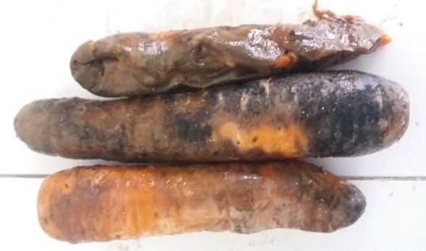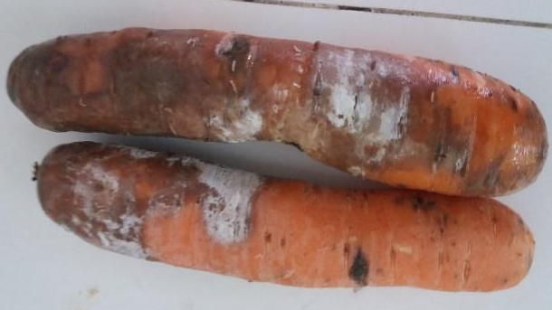
a
a

b
a

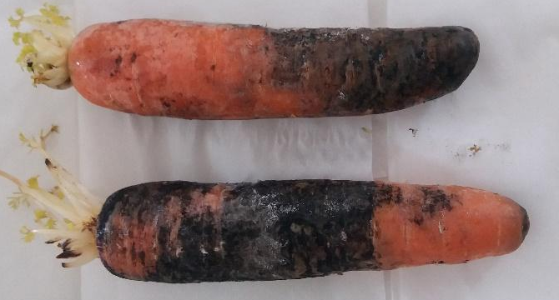
c
a

Fig 1: Symptoms of rot observed on carrots in storage

A: grey soft rot; b: whitish soft rot; c: black rot

3.2. Prevalence and severity of symptoms observed

Symptom prevalence ranged from 5.53 to 40.46. Thus, the highest prevalence was observed in carrots showing grey rot symptoms, while those affected by black rot showed the lowest prevalence. Statistical analyses showed a significant difference between prevalence of these different symptoms (Table 1).
As for the symptom severity index, it ranged from 5.38 to 5.74. Statistical analyses revealed no significant difference between them (Table 1).

3.3. Fungi associated with symptoms observed on carrots

Eleven fungi in 5 genera were isolated from symptomatic carrots. These included the genera Aspergillus, Botrytis, Colletotrichum, Geotrichum and Rhizopus. Thus, for carrots stored at room temperature, eleven fungi were associated with the different symptoms observed. Two strains of Colletotrichum, two of Rhizopus and one strain of Aspergillus were isolated from black rot. For soft rot, one Colletotrichum and one Aspergillus strain were isolated. As for white rot, two strains of Botrytis, one of Geotrichum and one strain of Aspergillus were associated with this symptom. Pathogenicity of isolated fungi.

Table 1: Prevalence and severity index of symptoms observed on stored carrots

Fungal symptoms | Prevalence | Severity index
Black rot | 5.5 ± 0.61 c | 5.70 ± 1.47 a
Grey rot | 40.46 ± 3.78 a | 5.74 ± 1.54 a
White rot | 35.34 ± 1.49 b | 5.38 ± 1.57 a
F | 4.36 | 10.17
P | 0.11 | 0.10

3.4. Symptoms induced by inoculated fungi and identification of pathogenic fungi

The symptoms observed on carrots after inoculation were the following: black rot identifiable by blackening of the surfaces, color rot with whitish cottony mycelium covering the carrot tissue, and rot with a cottony appearance.
Botritys and Rhizopus fungi, which respectively caused symptoms of white soft rot and black rot similar to those initially observed, and which were re-isolated from these symptoms with the same characteristics as the fungi previously inoculated, were identified as pathogens of carrot in storage.

4. DISCUSSION

A diversity of symptoms was observed on carrots in storage. This can be explained by the fact that the fungi associated with carrot diseases in storage can develop at different temperatures. In contrast, these would have optimal growth at low temperatures. Indeed, according to Niankan (2016), carrots are vulnerable to pathogens during storage, as they can develop at low temperatures and high relative humidity.
Among the symptoms observed, black rot was preponderant in all cases. It thus represents one of the major constraints involved in the deterioration of the nutritional and commercial value of carrots in storage. This symptom has been identified by a several authors on stored carrots in several countries. Indeed, Michel (2004), in his work on carrot disease identification and management in California, identified numerous diseases on stored carrots. He suggested that black rot is one of the most significant diseases involved in the deterioration of carrots in storage, leading to significant economic losses. Similarly, Heller et al. (2007) also pointed out that black rot is one of the main causes of deterioration in carrot quality during distribution.
Our study revealed that several fungal genera are associated with symptoms observed on carrots in storage, notably Aspergillus, Botrytis, Colletotrichum, Geotrichum and Rhizopus. This shows that there is a diversity of fungal genera associated with symptoms on stored carrots. Rizan (2021) also reported that during the storage period, carrots are vulnerable to many fungal diseases. However, of the fungal genera isolated during this study, only Botrytis and Rhyzopus were recognized as pathogenic to carrot in storage. The same results were obtained by Hermansen et al. (2012). They isolated and identified several fungal genera pathogenic to carrots, including Botrytis and Rhyzopus. Indeed, according to Ben-Yephet (1993), the Botrytis genus is highly polyphagous and attacks many vegetable crops by developing abundant white mycelia in the form of sclerotia. Similarly, Onuorah et al (2016) isolated Rhizopus stolonifer from spoiled carrots in Nigeria.

5. Conclusion

This study revealed a diversity of symptoms on stored carrots. Rot was the main symptom observed. It appeared in three forms: grey soft rot, black wet rot and whitish soft rot. Five fungal genera were associated with these symptoms. These included Aspergillus, Botrytis, Geotrichum, Rhizoctonia and Rhizopus. Moreover, only the genera Botrytis and Rhizopus were pathogenic to carrots in storage. This study enables us to envisage methods for controlling the fungi responsible for losses on carrots during storage.

Disclaimer (Artificial intelligence)
Option 1:
Author(s) hereby declare that NO generative AI technologies such as Large Language Models (ChatGPT, COPILOT, etc.) and text-to-image generators have been used during the writing or editing of this manuscript.
Option 2:
Author(s) hereby declare that generative AI technologies such as Large Language Models, etc. have been used during the writing or editing of manuscripts. This explanation will include the name, version, model, and source of the generative AI technology and as well as all input prompts provided to the generative AI technology
Details of the AI usage are given below:
1.
2.
3.

References

Ahmed, M.U., Bhuiyan, M.K.A., Hossain, M.M., Rubayet, M.T., Khaliq, Q.A. (2019). Efficacy of chitosan and bio-agent in controlling southern blight disease of carrot caused by Sclerotium rolfsii and improvement the crop production. Research in Agriculture and Veterinary Science, 3(3): 113-125.
(2021). Performance of agro-ecological based carrot cultivars affected by plant arrangement. Genetics and Molecular Research, 20 (4): 1-14.
Ben-Yephet, Y., Genizi, A., Siti, E. (1993). Sclerotinia survival and apothecia production by Sclerotinia sclerotiorum following lettuce drop epidemics. Phytopathology, (83): 509-513.
Bernardo P. (2014). Ecology, diversity, and plant virus discovery across two agroecosystems in a spatiotemporal framework using geometagenomics. Doctoral thesis. University of Montpellier, France. 278 p.
Bond R. (2016). Carrot Loss during Primary Production: Field Waste and Pack House Waste (Master's thesis). Elverum: Hedmark University of Applied Sciences, 48 ​​p. Botton, B., Breton, A., Feve, M., Gauthier, S., Guy, P.H., Larpent, J.P., Reymond, P., Sanglier, J., Vayssier, Y., Veau, P. (1990). Useful and harmful molds, industrial importance. Biotechnology Collection. 2nd edition, Masson, Paris 206 p.
Carvalho, D.F., Gomes, D.P., Oliveira, N.D.H., Guerra, J.G.M., Janaína, R.C.R., Fábio, L.D.O. (2018). Carrot yield and water-use efficiency under different mulching, organic fertilization and irrigation levels. Revista brasileira de engenharia agrícola e ambiental - agriambi, 7 (22): 445-450.
Franke, U. (2013). Carrot growth in primary production, Nordic Council of Ministers. Copenhagen: Nordisk Ministerråd, 89 p.
Gomes, J.S., Silva, A.K., Silva, A.F., Albuquerque, T.N. (2019). Physical-chemical characterization of blends composted by abacaxi, cenoura and incubator, adoçado com com mel. Revista Brasileira Gestão Ambiental, 13 (1): 7-12.
Heller, W., Crespo, P., Baumgartner, D., Kägi. A., Höhn, E. (2007). Preservation of carrot quality after harvest. Swiss Viticulture Review. Arboric. Horticulture, 39 (5): 327-331.
Hermansen. A. (2008). Plantevern and planthelse i økologisk landbruk. Bind 2 - Grønnsaker og potet. 2. opplied Bioforsk Fokus, 3(10): 47-78.
Kora, C., McDonald, M.R., Boland, G.J. (2005). Epidemiology of sclerotinia rot of carrot caused by Sclerotinia sclerotiorum. Canadian Journal of Plant Pathology, 27(2): 245-258. DOI: 10.1080/07060660509507222
Kobriger, K.M., Hagedorn, D.J. (1983). Determination of Bean root rot potential in vegetable production fields of Wisconsin’s central sands. Plant disease, 67(2): 177-178.
Niankan, K. (2016). Long-Term Storage Potential of Carrots After Induction of Natural Disease Resistance by UV Radiation. Doctoral Thesis. LAWAL University, Quebec, Canada, 221 pp.
Ding, H. and Liu, M. (2024), From Root to Seed: Unearthing the Potential of Carrot Processing and Comprehensive Utilization. Food Sci Nutr, 12: 8762-8778.
Onuorah, S., Nriagu, O., Obika, I. (2016). Isolation, Characterization, and Identification of Microorganisms from Spoilt Carrots Obtained from Ose Market, Onitsha, Nigeria. Universal Journal of Biomedical Engineering, 4 (1): 6-9.
Patkowska, E., Mielniczuk, E., Jamioÿkowska, A., Skwaryÿo-Bednarz, B. (2020). The Influence of Trichoderma harzianum Rifai T-22 and Other Biostimulants on Rhizosphere Beneficial Microorganisms of Carrot. Agronomy, 10 (11): 1637.
Qiao Y., Zhang M., Cao Y., Mi Q., Liang S., Feng J., Wang Y. (2022). Postharvest sclerotinia rot control in carrot by the natural product hinokitiol and the potential mechanisms involved. Int J Food Microbiol. doi: 10.1016/j.ijfoodmicro.2022.109939.
Resende, G.M., Yuri, J.E., Costa, N.D., Mota, J.H. (2016). Yield of carrot cultivars in organic farming system at high temperature. Horticulture Brassicaceae, 34 (1): 121-125.
Rizan, A.M.M. (2021). Identification of fungi that cause tip rot of carrot and determine effect of storage temperature and cultivar on tip rot development. Master’s thesis. Nowergian University of life sciences. Norway, 68 p.
Swamy K.R.M. 2022. “Origin, distribution, taxonomy, International Journal of Current Research, 14, (09), 22281 - 22294.
Tanbir, M. R., Farhana, P., Shamim, M. H., Minhaz, A., Abdullah, A. M., Khurshed, A. B. (2020). Use of non-chemical methods for the management of southern blight disease of carrot induced by Sclerotium rolfsii. Journal of agriculture and applied biology, 1 (2): 74-85.

