Response of Soil-Dwelling Insects and Weed Communities to Fertilizer Management
in Cassava Production: A Site
Comparison Study in Agusan
Del Sur, Philippines

.
ABSTRACT

Aims: Intensification of cassava production through improved fertilizer management requires understanding its impacts on agricultural biodiversity.
Study Design: A field experiment using a split-plot design with three replications.
Place and Duration of the Study: The study was conducted at two sites (Research Station and farmer's field) from April 2021 to March 2022.
Methodology: The study compared eleven fertilizer treatments across two cassava varieties (Lakan 1 and Golden Yellow). Soil-inhabiting insects and weed communities were assessed across all treatments.
Results: Soil-inhabiting insects showed significantly higher populations in unfertilized control plots compared to fertilized treatments, with predatory ground beetles (Carabidae) dominating both sites. Shannon's diversity indices (1.58-1.62) indicated moderate insect diversity across sites, suggesting simplified but functional communities. Weed assessments revealed distinct community structures between sites, dominated by perennial grasses from the Poaceae family. While fertilizer treatments significantly influenced soil insect abundance, weed community composition was more strongly affected by site-specific conditions, as demonstrated through cluster analysis.
Conclusion: The study demonstrates that agricultural intensification through fertilizer application may impact beneficial soil fauna while having limited effect on weed community structure. These findings suggest the need for integrated, site-specific management approaches that balance nutrient application with biodiversity conservation in cassava production systems.

Keywords: Agro-biodiversity, Cassava production, Fertilizer treatments, Soil insects, Weed communities, Carabidae, Species diversity, Site-specific management

1. INTRODUCTION

The Cassava (Manihot esculenta Crantz) is a key food security crop in tropical and subtropical regions, serving as food and industrial commodities in the Philippines [1, 2]. Its remarkable tolerance to drought and poor soils makes it essential for subsistence farming, while its versatility supports various industries, including animal feed, starch production, bioethanol, and food processing [3, 4]. In the Philippines, cassava cultivation accounts for 705,834 hectares across Northern Mindanao, Cagayan Valley, Bicol Region, and ARMM [5, 6], with the Caraga Region contributing 2,789 hectares yielding 8.8 t/ha [5]. However, cassava productivity faces challenges from declining soil fertility and increasing production pressure.
Rising global demand has intensified the need for improved cassava production through enhanced fertilizer management practices. The sustainable intensification employing ecosystem-based approaches and improved fertilizer application methods [7], the implementation of site-specific nutrient management (SSNM), and customized fertilizers have shown a potential to increase yields by 5.50 t/ha compared to traditional practices [8]. However, the risks of soil deterioration and pests and diseases by intensification necessitate integrated management considering productivity and ecosystem health [7, 9]. Agricultural biodiversity plays a crucial role in maintaining ecosystem services within cropping systems. Research has demonstrated that diversified farming practices enhance services such as pollination, pest control, nutrient cycling, and soil fertility without compromising yield [10]. Particularly significant are soil-inhabiting insects, especially Carabid beetles, which provide biocontrol services through complex spatial networks [11]. Similarly, weed communities contribute to soil stability and habitat diversity through microbiome interactions [12], with emerging evidence suggesting that "neutral weed communities" can enhance ecosystem services without adversely impacting crop yield [13]. However, fertilizer applications modify the above-ground and below-ground biological communities. Recent studies have shown that nitrogen fertilization increases plant biomass and reduces species richness and soil prokaryotic diversity [14]. Different fertilizer types show varying effects: mineral nitrogen and straw applications decrease bacterial alpha diversity, while manure applications increase it [15]. However, significant knowledge gaps remain regarding these effects in root crops like cassava, which concern the simultaneous response of beneficial insects and weed communities to fertilizer management. Various agricultural ecosystems require examination under varied conditions, considering both research station and farmer's field conditions. Field margins have been shown to maintain biodiversity and enhance crop pollination and pest control services [16]. Agusan del Sur's cassava production systems, influenced by agricultural practices and climate resilience requirements [17], provide an ideal setting for investigating these relationships.
This study evaluates the impacts of fertilizer treatments on agro-biodiversity within cassava production systems in Trento, Agusan del Sur, Philippines, examining the effects on soil insect diversity, weed composition, and interactions between fertilizer management and cassava varieties. It characterizes soil-inhabiting insect communities and weed flora responses across fertilizer regimes. It explores relationships between fertilizer applications and beneficial soil fauna, particularly ground beetles as soil health indicators, to understand fertilizer effects on biodiversity and cassava productivity.

2. material and methods

2.1. Study sites and experimental design
The study was conducted from April 2021 to March 2022 at two sites in Trento, Agusan del Sur, Philippines: the DA-Caraga Research Station and the Barangay Cuevas experimental site. The area experiences a Type II climate with no distinct dry season but with pronounced rainfall from December to January. Each experimental site utilized an area of 4,300 m². The experiment was laid out in a Split-plot design arranged in a Randomized Complete Block Design (RCBD) with three replications. The main plot factor was fertilizer treatment, while cassava variety was the sub-plot factor. Each plot measured 6m × 6m to accommodate 36 plants with 1m × 1m spacing.
The experiment consisted of eleven fertilizer treatments:
1. T1 (Ctrl) - Unfertilized control (0-0-0)
2. T2 (NPK) - Full NPK (200-100-350 kg N, P₂O₅, K₂O ha⁻¹)
3. T3 (PK) - N omission plot (0-100-350 kg N, P₂O₅, K₂O ha⁻¹)
4. T4 (NK) - P omission plot (200-0-350 kg N, P₂O₅, K₂O ha⁻¹)
5. T5 (NP) - K omission plot (200-100-0 kg N, P₂O₅, K₂O ha⁻¹)
6. T6 (SSNM) - Site-specific nutrient management
7. T7 (NFR) - National fertilizer recommendation (56-56-560 kg N, P₂O₅, K₂O ha⁻¹)
8. T8 (FFP) - Farmers' fertilizer practice
9. T9 (NPK Adjusted N) - Modified N rate (100-100-350 kg N, P₂O₅, K₂O ha⁻¹)
10. T10 (NPK Adjusted P) - Modified P rate (200-50-350 kg N, P₂O₅, K₂O ha⁻¹)
11. T11 (NPK Adjusted K) - Modified K rate (200-100-175 kg N, P₂O₅, K₂O ha⁻¹)
2.2. Land preparation and planting
Before planting, the experimental area was thoroughly prepared by deep plowing and harrowing three times using a tractor to achieve proper soil tilth and enhance root penetration. Soil samples were collected from each site in a Z-pattern to establish baseline soil properties, including soil pH, total nitrogen (N), organic matter (%OM), available phosphorus (P), and exchangeable potassium (K) [18]. Mature cassava stem cuttings of two varieties (Lakan 1 and Golden Yellow) were obtained from DA-Caraga, Trento Research and Experiment Station. High-quality stem cuttings with five nodes were selected and cut to uniform lengths. Planting was done upright at a spacing of 1 m between hills and 1 m between rows, accommodating 36 plants within each 6m × 6m plot. The planting materials were sourced from disease-free, 8–10-month-old mother plants to ensure good establishment and vigor.
2.3. Fertilizer treatment application
Fertilizer applications were carried out following specific timing and splitting schedules for different nutrients. The nitrogen source was Urea (46% N), applied in three equal splits: 30% at planting, 35% at 2.5 months after planting (MAP), and the remaining 35% at 5 MAP. Phosphorus, sourced from Solophos (18% P₂O₅), was applied entirely as a basal application at planting. Using Muriate of Potash (60% K₂O) as the source, potassium was applied in three splits following the same schedule as nitrogen (30:35:35 ratio at 0, 2.5, and 5 MAP).
Fertilizers were incorporated into the soil during the final harrowing operation for basal applications. Split applications were done through band placement 10-15 cm away from the plant base and covered with soil to minimize nutrient losses. Hilling-up was performed after the first fertilizer application, covering the fertilizer by hilling the soil to about 8-10 cm depth.
The specific fertilizer rates for each treatment were as follows:
Treatment 2 (NPK) received the full recommended rate of 200-100-350 kg N, P₂O₅, K₂O ha⁻¹. Treatment 3 (PK) received 0-100-350 kg N, P₂O₅, K₂O ha⁻¹, while Treatment 4 (NK) received 200-0-350 kg N, P₂O₅, K₂O ha⁻¹, and Treatment 5 (NP) received 200-100-0 kg N, P₂O₅, K₂O ha⁻¹. Treatment 6 (SSNM) rates were computer-generated based on site-specific conditions. Treatment 7 (NFR) followed the national recommendation of 56-56-560 kg N, P₂O₅, K₂O ha⁻¹. Treatment 8 (FFP) rates varied by site: Site 1 Research Station received 40-60-30 kg N, P₂O₅, K₂O ha⁻¹, while Brgy. Cuevas received 60-30-7 kg N, P₂O₅, K₂O ha⁻¹. Treatments 9, 10, and 11 received adjusted rates of either N (100-100-350), P (200-50-350), or K (200-100-175) kg N, P₂O₅, K₂O ha⁻¹, respectively.
2.4. Crop management
Off-barring was conducted one month after planting by plowing between the furrows to control weeds and improve soil aeration. Regular pest and disease incidence monitoring was carried out 60 days after planting until harvest, with observations conducted twice monthly. Weed management was performed through hand weeding and under-brushing to prevent weed competition and eliminate potential pests and disease hosts. The trial was maintained under rainfed conditions throughout the growing period. These management practices were uniformly implemented across all treatments to ensure that observed differences could be attributed to the fertilizer treatments rather than variations in cultural practices.
2.5. Biodiversity assessments
2.5.1. Soil-inhabiting insect sampling
Soil-inhabiting insects were sampled using pitfall traps installed one week before harvest. Seventy-two traps were systematically arranged within each plot following a grid pattern (Figure 1). The traps consisted of 1.5 L transparent plastic bottles measuring 5 inches in diameter and 6 inches in height. Each trap was filled with 250 mL of 75% ethyl alcohol as a preservation medium. Trapped insects were collected and carefully sorted into taxonomic groups. All specimens were preserved in 75% ethyl alcohol for subsequent identification. Using standard taxonomic keys, insects were identified at the family level, and population counts were recorded for each species or family group identified.
2.5.2. Weed assessment
Weed diversity assessment was conducted using a quadrat sampling (Figure 2). Three 0.5m² quadrats were randomly placed within each plot, resulting in 198 quadrats across all treatments. Within each quadrat, all weed species were identified and counted individually. The weeds were classified according to their growth form (annual or perennial), plant type (grass, sedge, or broadleaf), and family classification. For each species identified, parameters including species composition, individual counts per species, frequency of occurrence, and relative frequency were measured and recorded.
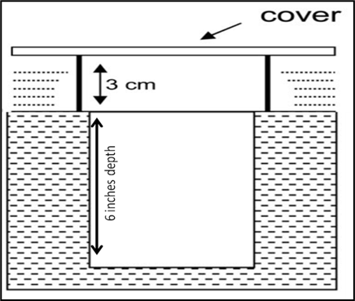
Figure 1. Pitfall traps

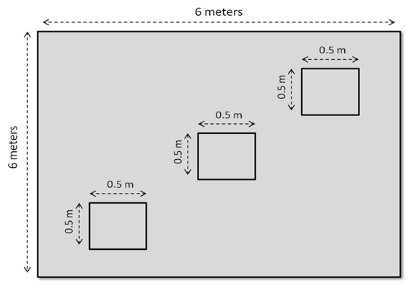
Figure 2. Weed species collection quadrat
2.5.3. Data analysis
The biodiversity data were analyzed using multiple statistical approaches to assess the effects of mineral nutrient applications comprehensively. Biodiversity indices, including the Shannon-Wiener diversity index (H'), species evenness, species richness, and relative abundance, were calculated to quantify the diversity patterns across treatments. Multivariate analysis was performed using PAST: Paleontological Statistics Software (version 4.02) to generate dendrograms, which visualized the similarities in species composition among different treatments through classical cluster analysis. For weed species assessment, the relative frequency was calculated using the formula: Relative Frequency = (Frequency of a species ÷ Total frequency of all species) × 100. This provided a standardized measure of weed species occurrence across the experimental plots. All statistical analyses were performed at a 5% significance level to ensure a robust interpretation of the results.

3. results and discussion
3.1. Diversity and abundance of soil-inhabiting insects
The assessment of soil-inhabiting insects at the two study sites revealed distinct patterns in species composition and abundance (Table 1). At Site 1 (Research Station), 183 individuals across seven species and five families were collected. Lasius niger (Formicidae) was the most abundant, with 76 individuals, followed by Pterostichus sp. (Carabidae) with 46 individuals and Pterostichus melanarius (Carabidae) with 29 individuals. Smaller populations included Archispirostreptus gigas (12 individuals), Melanoplus sp. (10), Vespula vulgaris (9), and Callidula sp. (1). At Site 2 (Brgy. Cuevas), 164 individuals across eight species were recorded, with Carabidae as the dominant family. Pterostichus sp. led with 70 individuals, followed by Ophionea nigrofasciata (44), Pterostichus melanarius (15), and Calleida decora (18). Smaller populations included Gryllotalpa africana (8), Dialytes sp. and Conococephalus longepennis (4 each), and Melanoplus sp. (1). Insect abundance varied significantly across fertilizer treatments and crop varieties (Figure 3). Control plots (unfertilized) consistently supported higher insect populations than fertilized plots for both varieties. In the Lakan 1 variety, control plots averaged 30 insects per plot, while NPK-treated plots averaged 15. A similar trend was seen in the Golden Yellow variety, with control plots averaging 28 insects and NPK-treated plots around 14. Diversity metrics differed between sites (Figure 4). Site 1 exhibited Shannon's diversity index of 1.58, evenness of 0.81, and species richness of 7. In contrast, Site 2 showed Shannon's index of 1.62, evenness of 0.78, and species richness of 8, indicating moderate diversity with relatively even species distribution at both sites.

Table 1. Taxonomic classification and relative abundance of soil-inhabiting insects collected from two cassava production sites in Trento, Agusan del Sur, Philippines
Inhabiting Insect Species | Family | Phylum | No. of individuals per taxon
Site 1 (Research Station)
Pterostichus melanarius | Carabidae | Arthropoda | 29
Pterostichus sp. | Carabidae | Arthropoda | 46
Melanoplus sp. | Acrididae | Insecta | 10
Archispirostreptus gigas | Spirostrepridae | Arthropoda | 12
Callidula sp. | Callidulilae | Arthropoda | 1
Lasius niger | Formicidae | Arthropoda | 76
Vespula vulgaris | Vespidae | Arthropoda | 9
Abundance |  |  | 183
Site 2 (Brgy. Cuevas)
Pterostichus sp. | Carabidae | Arthropoda | 70
Ophionea nigrofasciata | Carabidae | Arthropoda | 44
Pterostichus melanarius | Carabidae | Arthropoda | 15
Calleida decora | Carabidae | Arthropoda | 18
Melanoplus sp. | Acrididae | Insecta | 1
Dialytes sp. | Scarabaeidae | Arthropoda | 4
Gryllotalpa Africana | Gryllotalpidae | Arthropoda | 8
Conococephalus longepennis | Tettigoniidae | Arthropoda | 4
Abundance |  |  | 164

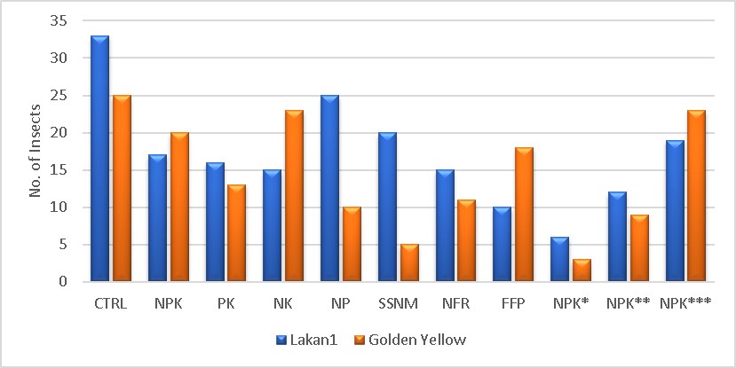

Figure 3. Mean soil insect abundance across fertilizer treatments for two cassava varieties
(Lakan 1 and Golden Yellow) at research station and farmer's field sites in
Trento, Agusan del Sur, Philippines

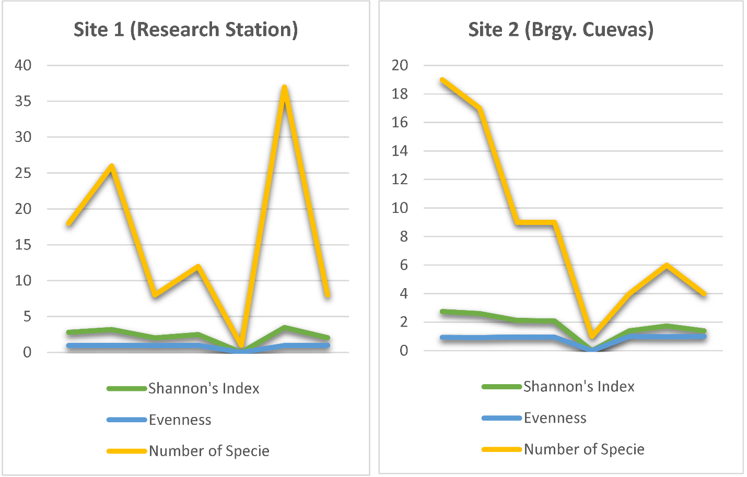

Figure 4. Comparison of soil insect diversity indices (Shannon's diversity index, evenness, and species richness) between research station and farmer's field sites in cassava production systems at Trento, Agusan del Sur, Philippines

The prominence of Carabidae (ground beetles) in the study sites supports previous research on their role in agricultural ecosystems. Carabid beetles are widespread in agricultural fields globally and serve as natural pest controllers through predatory behavior and diverse feeding habits [19]. Their population density in these environments is shaped by various environmental factors, including soil properties, microclimatic conditions, and management practices [20]. Typically, a single agricultural site can host 40-60 carabid species, with cropping sequences and pest management methods further influencing these populations [21]. The specific dominance of Pterostichus species reflects their adaptability to agricultural landscapes, as they effectively colonize field centers and edges across various cropping systems [22]. Studies suggest that sustainable farming practices can increase carabid activity density compared to conventional methods, though their populations remain sensitive to insecticide applications [23]. In cassava fields, the abundance of carabids indicates their potential contribution to biological pest control, as ground beetles are known to reduce pest populations in agricultural landscapes [24].
The inverse relationship between fertilizer application and insect abundance highlights the impact of fertilizers on insect populations in agricultural plots. Reduced insect populations in fertilized plots may result from several factors. Increased nutrient availability leads to a denser crop canopy, which alters soil surface microhabitat conditions such as light, temperature, and humidity, thereby discouraging insect species adapted to open areas. Queiroz and Ribas [25] found that such canopy modifications create microclimatic differences that negatively affect certain insect species. These findings align with Brygadyrenko [26], who demonstrated that denser canopy conditions significantly reduce litter-dwelling macrofauna abundance and alter community structure. Additionally, changes in soil chemistry due to fertilizer application may affect habitat preference of soil-dwelling insects. van Klink et al. [27] established that fertilizer-induced changes in soil chemistry directly influence habitat selection by soil-dwelling insects, while Chen et al. [28] showed that altered soil properties, such as pH and humidity, affect insect microhabitat preferences and survival rates. These studies collectively suggest that fertilizer application indirectly affects insect populations by modifying both the physical structure and chemical properties of their habitats.
The moderate diversity indices at both sites indicate stable insect communities. Despite lower total insect abundance, site 2's slightly higher Shannon's index (1.62 vs. 1.58) suggests a more even species distribution. This variation likely stems from differences in management approaches: research stations typically follow standardized practices for experimental consistency, creating uniform conditions that may favor certain species, while farmers' fields often maintain more diverse microhabitats through varied practices such as crop rotation, mixed planting, or less uniform planting density. These differences in management intensity and variety create distinct microhabitats supporting different insect communities, even if overall abundance varies.
The presence of both predatory (Carabidae) and herbivorous (Gryllotalpidae, Acrididae) insects suggests a functional food web within the cassava system. However, lower diversity indices than natural ecosystems indicate that agricultural practices impact soil insect community structure. While natural ecosystems support diverse insect populations through habitat heterogeneity, managed agricultural fields present more uniform environments with frequent disturbances, reducing available niches and limiting insect survival. Sądej et al. [29] found that soil management and fertilization significantly influence ground beetle assemblages, showing higher diversity in soils with increased organic carbon and nitrogen content. Alyokhin et al. [30] suggested that soil management history more consistently affects insect behavior than immediate fertilizer use, highlighting the long-term effects of agricultural practices on insect communities. Goulet [21] further demonstrated that each beetle species has specific requirements for soil type, moisture, pH, and light exposure, making these insects sensitive to habitat modifications and changes in environmental quality.
The observed differences in insect abundance and diversity between the two cassava varieties, Lakan 1 and Golden Yellow, suggest that crop genotype may influence soil insect communities, potentially through variations in root exudates or canopy structure. Plants release organic compounds through their roots, known as exudates, which vary across crop varieties and can affect soil chemistry and microbial communities, thereby influencing soil-dwelling insects. Specific exudates can attract or repel certain insect species, altering the composition of the soil insect community around each variety. Research indicates that root exudates play a role in regulating soil fungal community composition and diversity, with plants maintaining resident soil fungal populations while influencing nonresident populations [31]. Certain plant genes, such as ABC transporters, significantly impact root exudation profiles, which in turn shape soil microbial communities [32]. Additionally, different plant accessions within the same species, such as Arabidopsis thaliana, selectively influence rhizobacterial communities through variations in root exudation [33]. This interaction between crop variety and soil fauna warrants further investigation to support the development of more sustainable cassava production systems.
3.2. Weed species composition and distribution
At two study sites, eight distinct species representing four plant families were identified (Table 2). The Poaceae (grass family) dominated the weed community with five species, while Asteraceae, Cyperaceae, and Fabaceae were represented by one species each. The identified species exhibited diverse growth forms: three perennial grasses (Cynodon dactylon L., Panicum maximum, and Imperata cylindrica), one perennial sedge (Cyperus rotundus), one perennial forb (Mimosa pudica L.), one annual forb (Ageratum conyzoides L.), and two annual grasses (Eleusine indica L. and Dactyloctenium aegyptium L.). At Site 1 (Research Station), Cynodon dactylon L. was the most frequent species with a relative frequency of 17.378, followed by Panicum maximum and Dactyloctenium aegyptium L. at 14.399 each (Table 3). The dominance of these grasses suggests adaptation to the management practices at the research station. In contrast, at Site 2 (Brgy. Cuevas), Imperata cylindrica had the highest relative frequency (16.337), followed by Cynodon dactylon L. (14.134) and Eleusine indica L. (13.895). Dendrogram analysis of weed communities under different fertilizer treatments at both sites showed no clear differentiation in community composition across treatments (Figures 5 & 6). This indicates that site-specific conditions and existing seed banks influenced weed species composition more than nutrient management.
The predominance of Poaceae in the weed communities aligns with previous findings by Sagar et al. [33], who documented grass species from this family to be highly dominant in agricultural settings, particularly genera like Digitaria, Panicum, and Echinochloa. Schreiber et al. [34] similarly found that Poaceae consistently presented the largest number of species across diverse agricultural management systems.
Table 2. Growth form and family classification of weed species identified in cassava production systems at Trento, Agusan del Sur, Philippines
Weed Species | Growth Form | Family Name
Ageratum conyzoides L. | Annual Forb | Asteraceae
Mimosa pudica L. | Perennial Forb | Fabaceae
Cynodon dactylon L. | Perennial Grass | Poaceae
Eleusine indica L. | Annual Grass | Poaceae
Panicum maximum | Perennial Grass | Poaceae
Imperata cylindrica | Perennial Grass | Poaceae
Cyperus rotundus | Perennial Sedge | Cyperaceae
Dactyloctenium aegyptium L. | Annual Grass | Poaceae

Table 3. Frequency distribution and relative frequency of weed species in cassava production systems at research station and farmer's field sites in Trento, Agusan del Sur, Philippines
Species | Site 1 (Research Station) |  | Site 2 (Brgy. Cuevas)
Species | Frequency | Relative Frequency | Frequency | Relative Frequency
Ageratum conyzoides L. | 96 | 9.533 | 141 | 13.437
Mimosa pudica L. | 103 | 10.228 | 93 | 8.836
Cynodon dactylon L. | 175 | 17.378 | 148 | 14.134
Eleusine indica L. | 127 | 12.612 | 146 | 13.895
Panicum maximum | 145 | 14.399 | 137 | 13.048
Imperata cylindrica | 129 | 12.810 | 171 | 16.337
Cyperus rotundus | 87 | 8.640 | 104 | 9.959
Dactyloctenium aegyptium L. | 145 | 14.399 | 109 | 10.369
The identified weed community, comprising both annual and perennial species, presents distinct management challenges. Annual weeds, as demonstrated by Schwartz-Lazaro and Copes [35], contribute significantly to the soil seed bank through their single-season life cycle and prolific seed production. Travlos et al. [36] showed that these annuals, particularly spring-emerging species, respond distinctively to management timing. The high representation of perennial species (five of eight identified species) in our study sites indicates the establishment of persistent populations through their dual reproductive strategy - vegetative reproduction via belowground buds and sexual reproduction through seeds [37]. This reproductive flexibility, particularly evident in species like C. dactylon and I. cylindrica, enables stable population maintenance under various environmental conditions and management practices. These established weed communities, through soil conditioning effects, can modify soil conditions that influence subsequent vegetation dynamics [38], aligning with Petit et al. [39] findings on species-specific interactions in agroecosystems.
The dominance of different grass species at each site (C. dactylon at Site 1 and I. cylindrica at Site 2) underscores the impact of local management practices and environmental conditions on weed community structure. This finding aligns with Cordeau et al. [40], who reported that site-specific conditions account for 75.5% of the explained variation in weed community composition, while management practices explain 18.3%. Gibson et al. [41] similarly found that weed communities correlate most strongly with geographic location and secondarily with management practices. The higher relative frequency of C. dactylon at the research station reflects its adaptation to intensive management practices and regular disturbance, as supported by Travlos et al. [36] and Jung et al. [42], who found that such conditions favor species with rapid establishment capabilities while limiting competition from less adaptable species.
Annual and perennial species across sites indicate a complex weed community structure, presenting varied management challenges. Annual weeds complete their life cycle in a single growing season, producing large quantities of seeds that rapidly replenish their populations.

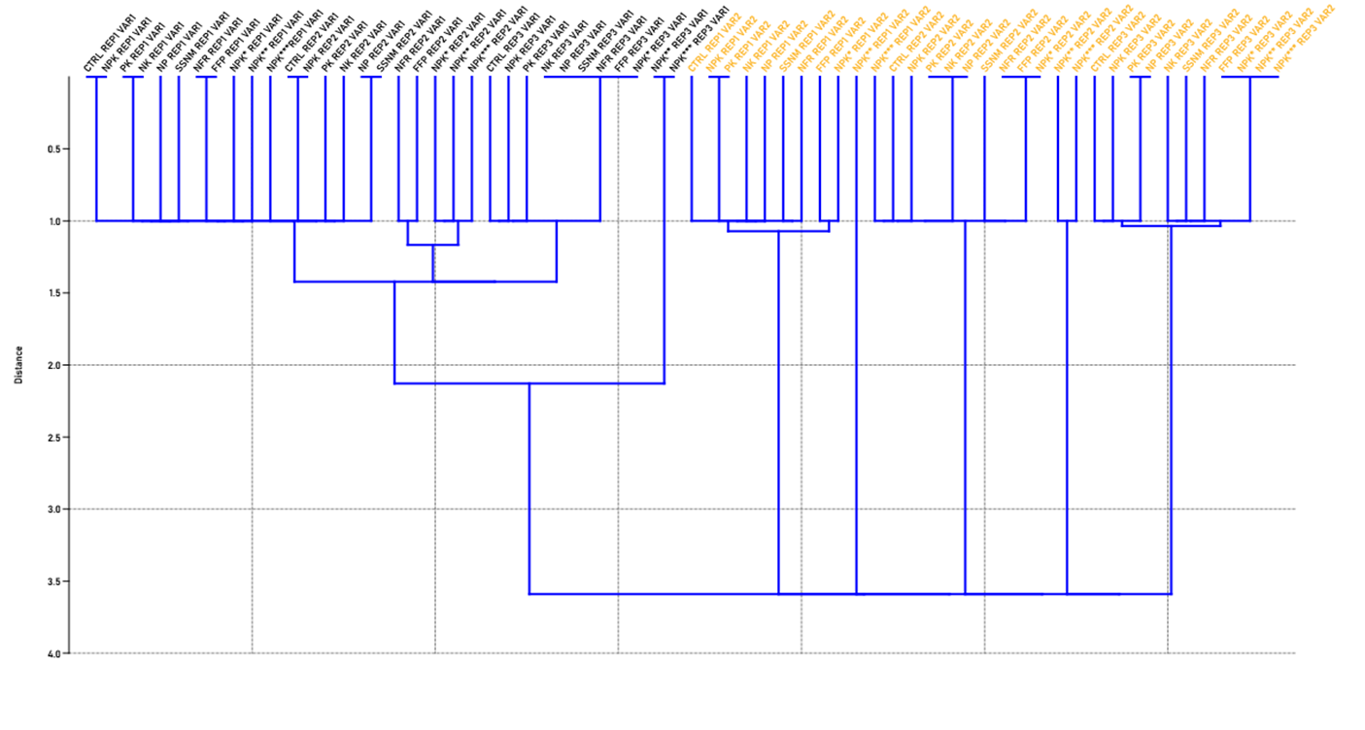
Figure 5. Hierarchical cluster analysis dendrogram showing weed community similarity patterns across fertilizer treatments
at the research station site in Trento, Agusan del Sur, Philippines
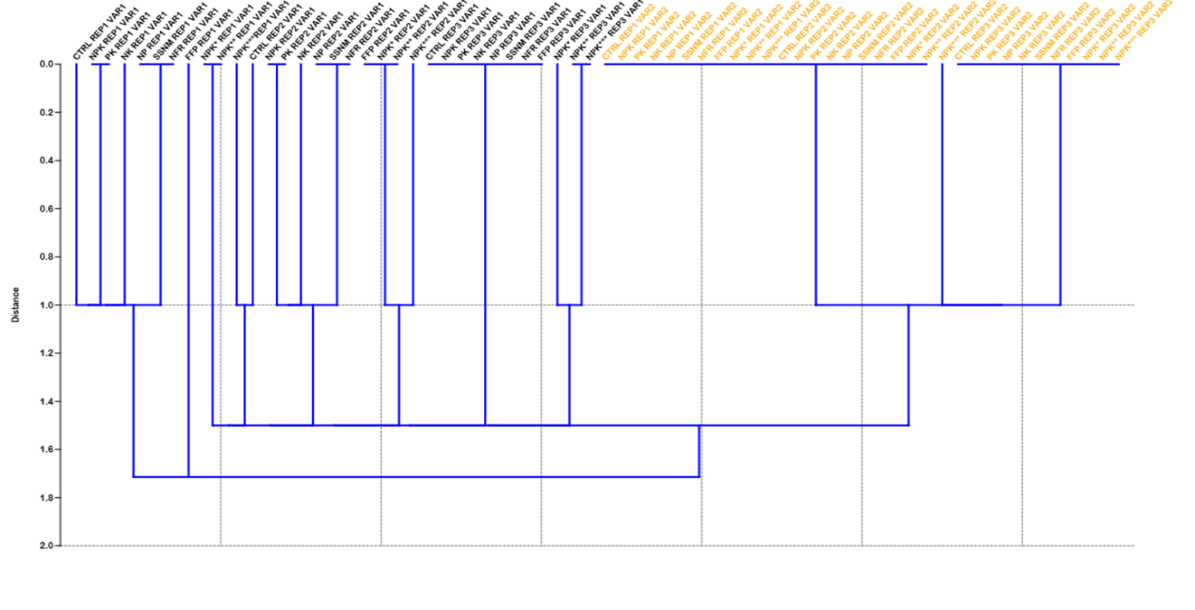
Figure 6. Hierarchical cluster analysis dendrogram showing weed community similarity patterns across fertilizer treatments
at the farmer's field site in Brgy. Cuevas, Trento, Agusan del Sur, Philippines

Schwartz-Lazaro and Copes [35] demonstrated that annual weeds contribute significantly to the soil seed bank, requiring management strategies that prevent seed production and deplete existing seed reserves. Management timing is critical, as Travlos et al. [36] showed that spring-emerging annual weeds respond differently to timing than later-emerging species, with early-emerging spring annuals being particularly sensitive to soil disturbance timing. In contrast, perennial species, especially the grass species identified in this study, use dual reproductive strategies: significant seed production and vegetative propagation (e.g., rhizomes or stolons). Perennial grasses maintain populations through a combination of vegetative reproduction via belowground buds and seed production, as documented by Ott and Hartnett [37], who found that perennial grasses produce a large reserve of dormant buds, with flowering tillers generating more and larger buds than vegetative tillers. This reproductive flexibility enhances their persistence in agricultural systems, complicating management. Mahé et al. [43] further emphasized that effective management of persistent weed populations requires understanding both above-ground vegetation and the soil seed bank, as the seed bank acts as a reservoir for future weed infestations.

The lack of clear differentiation in weed communities across fertilizer treatments, as shown in the dendrograms, suggests that short-term nutrient management has less influence on weed community composition than other factors. Cordeau et al. [40] demonstrated that timing of management practices, particularly tillage, explains approximately 50% of weed community variability at local scales, with weather conditions playing crucial roles in community assembly. The established seed bank serves as a persistent source of weed propagules influencing current populations [43], while historical land use creates lasting effects through soil property modifications and plant-soil feedbacks [42, 38]. The consistent occurrence of C. rotundus across all treatments demonstrates its adaptability to various nutrient conditions, while the relatively even distribution of A. conyzoides and E. indica across sites, despite different management intensities, indicates their broad ecological adaptability. However, their lower relative frequencies compared to perennial grasses suggests current management practices may be more effective in controlling annual species.
The presence of C. rotundus (nutgrass) across all treatments indicates its adaptability to various nutrient conditions, confirming its status as a problematic weed in tropical agricultural systems. Similarly, the consistent occurrence of M. pudica suggests its tolerance to various management practices, though at lower frequencies compared to grass species. The relatively even distribution of certain species like A. conyzoides and E. indica across sites, despite different management intensities, indicates their broad ecological adaptability. However, their lower relative frequencies compared to perennial grasses suggests that the current management practices may be more effective in controlling annual species.

4. Conclusion
This study demonstrates distinct patterns in how fertilizer management practices affect agro-biodiversity components in cassava production systems. Soil insect communities showed higher abundance in unfertilized plots, with beneficial predatory insects (particularly carabidae) dominating both study sites, suggesting that intensive fertilizer application may impact natural pest control services. The moderate diversity indices observed indicate that while these agricultural systems maintain functional insect communities, they represent simplified versions of natural ecosystems. Weed community structure proved more responsive to site-specific conditions than fertilizer treatments, with perennial grasses dominating both sites but showing distinct species dominance patterns between research station and farmer's field conditions. This suggests that effective weed management strategies should prioritize local conditions and historical management practices over universal fertilizer-based approaches.

Disclaimer (Artificial intelligence)

Option 1:

Author(s) hereby declare that NO generative AI technologies such as Large Language Models (ChatGPT, COPILOT, etc.) and text-to-image generators have been used during the writing or editing of this manuscript.

References

- Ferraro, V., Piccirillo, C., Tomlins, K. I., & Pintado M. E. (2016). Cassava (Manihot esculenta Crantz) and Yam (Dioscorea spp.) Crops and Their Derived Foodstuffs: Safety, Security and Nutritional Value. Critical Reviews in Food Science and Nutrition, 56, 2714 - 2727. https://doi.org/10.1080/10408398.2014.922045
- Li, S., Cui, Y., Zhou, Y., Luo, Z., Liu, J., & Zhao M. (2017). The industrial applications of cassava: current status, opportunities and prospects. Journal of the science of food and agriculture, 97 8, 2282-2290. https://doi.org/10.1002/jsfa.8287
- Howeler, R. H. (2010). International Center for Tropical Agriculture (CIAT). A new future for Cassava in Asia. Its use a free food and fuel to benefit the poor. CIAT, Cassava Program, Bangkok, TH.
- Panghal, A., Munezero, C., Sharma, P., & Chhikara N. (2019). Cassava toxicity, detoxification and its food applications: a review. Toxin Reviews, 40, 1 - 16. https://doi.org/10.1080/15569543.2018.1560334
- Philippine Statistics Authority (2018). Crops Statistics of the Philippines 2012-2016. Bureau of Agricultural Statistics, Department of Agri-culture, Quezon City, Philippines. https://psa.gov.ph/system/files/main-publication/Selected%2520Statistics%2520on%2520Agriculture%25202018.pdf
- National Academy of Science and Technology (2024). Unearthing the potential of the cassava industry. Available in: https://nast.dost.gov.ph/index.php/13-news-press-releases/793-unearthing-the-potential-of-the-cassava-industry#:~:text=The%20top%20producing%20region%20is,thousand%20metric%20tons%20(6.7%25).
- Howeler, R. H., Lutaladio, N., & Thomas, G. (2013). Save and grow: cassava: a guide to sustainable production intensification, Rome, 1-129.
- Byju, G., Nedunchezhiyan, M., George, J., Sunitha, S., Soman, S., & Hridya, A. C. (2020). Evaluation of fertilizer best management practices by SSNM and customized fertilizers for cassava (Manihot esculenta) cultivation in India. Current Horticulture, 8(1), 56-64. https://doi.org/10.5958/2455-7560.2020.00011.4
- Fermont, A. M. (2019). Cassava and soil fertility in intensifying smallholder farming systems of East Africa. Wageningen University and Research.
- Tamburini, G., Bommarco, R., Wanger, T. C., Kremen, C., Van Der Heijden, M. G., Liebman, M., & Hallin, S. (2020). Agricultural diversification promotes multiple ecosystem services without compromising yield. Science Advances, 6 (45), 1-8. https://doi.org/10.1126/sciadv.aba1715
- De Heij, S. E., & Willenborg C. J. (2020). Connected carabids: Network interactions and their impact on biocontrol by carabid beetles. BioScience, 70 (6), 490-500. https://doi.org/10.1093/biosci/biaa039
- Trognitz, F., Hackl, E., Widhalm, S., & Sessitsch, A. (2016). The role of plant–microbiome interactions in weed establishment and control. FEMS Microbiology Ecology, 92(10), 1-15. https://doi.org/10.1093/femsec/fiw138
- Esposito, M., Westbrook, A. S., Maggio, A., Cirillo, V., & DiTommaso A. (2023). Neutral weed communities: The intersection between crop productivity, biodiversity, and weed ecosystem services. Weed Science, 71, 301 - 311. https://doi.org/10.1017/wsc.2023.27
- Sun, S., Liu, C., Zhang, Y., Yue, Y., Sun, S., Bai, Y., & Xiong, W. (2024). Divergent impacts of fertilization regimes on below-ground prokaryotic and eukaryotic communities in the Tibetan Plateau. Journal of Environmental Management, 364, 121379. https://doi.org/10.1016/j.jenvman.2024.121379
- Dang, P., Li, C., Lu, C., Zhang, M., Huang, T., Wan, C., & Siddique, K. H. (2022). Effect of fertilizer management on the soil bacterial community in agroecosystems across the globe. Agriculture, Ecosystems & Environment, 326, 107795. https://doi.org/10.1016/j.agee.2021.107795
- Peters, J. S., Aguirre, B. A., DiPaola, A., & Power, A. G. (2022). Ecology of yellow dwarf viruses in crops and grasslands: interactions in the context of climate change. Annual Review of Phytopathology, 60(1), 283-305. https://doi.org/10.1146/annurev-phyto-020620-101848
- Varela, R. P., Apdohan, A. G., & Balanay R. M. (2022). Climate resilient agriculture and enhancing food production: Field experience from Agusan del Norte, Caraga Region, Philippines. Frontiers in Sustainable Food Systems, 6, 1-14. https://doi.org/10.3389/fsufs.2022.974789.
- Adajar, R. R., & Taer E. C. (2021). Application of foliar biofertilizers with and without NPK in cultivating white-glutinou s corn. Journal of Agriculture and Applied Biology, 2, 105-113. https://doi.org/10.11594/jaab.02.02.05
- Fei, M., Gols, R., & Harvey, J. A. (2023). The biology and ecology of parasitoid wasps of predatory arthropods. Annual review of entomology, 68(1), 109-128. https://doi.org/10.1146/annurev-ento-120120-111607
- Gašparić, H.V., Drmić, Z., Čačija, M., Graša, Ž., Petrak, I., & Bažok R., Lemić D. (2017). Impact of environmental conditions and agro- technical factors on ground beetle populations in arable crops. Applied Ecology and Environmental Research, 15, 697-711. http://dx.doi.org/10.15666/aeer/1503_697711
- Goulet, H. (2023). Biodiversity of ground beetles (Coleoptera: Carabidae) in Canadian agricultural soils. Canadian journal of soil science, 83, 259-264. https://doi.org/10.4141/S01-06
- Rose, R., & Dively, G. P. (2014). Effects of insecticide-treated and lepidopteran-active Bt transgenic sweet corn on the abundance and diversity of arthropods. Environmental Entomology, 36(5), 1254-1268.
- Ivanković Tatalović, L., Anđelić, B., Jelić, M., Kos, T., A Benítez, H., & Šerić Jelaska, L. (2020). Fluctuating asymmetry as a method of assessing environmental stress in two predatory carabid species within Mediterranean agroecosystems. Symmetry, 12(11), 1890. https://doi.org/10.3390/sym12111890
- Viric, Gasparic, H., Göldel, B., Emic, D., Pajac, Zivkovic I., & Bazok, R. (2022). Carabids as indicators of sustainability in arable crops. Applied Ecology & Environmental Research, 20(6). Https://doi.org/10.15666/aeer/2006_46454665
- Queiroz, A. C. M., & Ribas, C. R. (2016). Canopy cover negatively affects arboreal ant species richness in a tropical open habitat. Brazilian Journal of Biology, 76, 864-870. https://doi.org/10.1590/1519-6984.02015
- Brygadyrenko, V. V. (2016). Effect of canopy density on litter invertebrate community structure in pine forests. Ekológia (Bratislava), 35(1), 90-102. https://doi.org/10.1515/eko-2016-0007
- van Klink, R., van der Plas, F., Van Noordwijk, C. G. E., WallisDeVries, M. F., & Olff, H. (2015). Effects of large herbivores on grassland arthropod diversity. Biological reviews, 90(2), 347-366. https://doi.org/10.1111/brv.12113
- Chen, Y., Zhao, C., Zhang, D., Zhang, S., & Zeng, W., Li Z. (2022). The effect of amending soils with biochar on the microhabitat preferences of Coptotermes formosanus (Blattodea: Rhinotermitidae). Ecotoxicology and Environmental Safety, 232, 113240. https://doi.org/10.1016/j.ecoenv.2022.113240
- Sądej, W., Kosewska, A., Sądej, W., & Nietupski M. (2012). Effects of fertilizer and land-use type on soil properties and ground beetle communities. Bulletin of Insectology, 65, 239-246.
- Alyokhin, A., Nault, B., & Brown, B. (2020). Soil conservation practices for insect pest management in highly disturbed agroecosystems–a review. Entomologia Experimentalis et Applicata, 168(1), 7-27. https://doi.org/10.1111/eea.12863
- Zhu, S., Vivanco, J. M., & Manter, D. K. (2016). Nitrogen fertilizer rate affects root exudation, the rhizosphere microbiome and nitrogen-use-efficiency of maize. Applied Soil Ecology, 107, 324-333. https://doi.org/10.1016/j.apsoil.2016.07.009
- Sasse, J., Martinoia, E., & Northen, T. (2018). Feed your friends: do plant exudates shape the root microbiome?. Trends in plant science, 23(1), 25-41.
- Sagar, A., & Sarwar, A. G. (2018). Weed diversity of the family Poaceae in Bangladesh Agricultural University campus and their ethnobotanical uses: Poaceae grasses in BAU and their uses. Journal of the Bangladesh Agricultural University, 16(3), 372-379. https://doi.org/10.3329/jbau.v16i3.39398
- Schreiber, F., Scherner, A., Andres, A., Concenço, G., & Goulart, F. (2018). Competitive Ability of Rice Cultivars in the Era of Weed. Plant Competition in Cropping Systems, 39. https://doi.org/10.5772/intechopen.78342
- Schwartz-Lazaro, L. M., & Copes J. T. (2019). A review of the soil seedbank from a weed scientists perspective. Agronomy, 9(7), 1-13. https://doi.org/10.3390/agronomy9070369
- Travlos, I., Gazoulis, I., Kanatas, P., Tsekoura, A., Zannopoulos, S., & Papastylianou, P. (2020). Key factors affecting weed seeds' germination, weed emergence, and their possible role for the efficacy of false seedbed technique as weed management practice. Frontiers in Agronomy, 2, 1. https://doi.org/10.3389/fagro.2020.00001
- Ott, J. P., & Hartnett D. C. (2011). Bud production and dynamics of flowering and vegetative tillers in Andropogon gerardii (Poaceae): The role of developmental constraints. American Journal of Botany, 98(8), 1293-1298. https://doi.org/10.3732/ajb.1000264
- Espeland, E. K. (2013). A colonizing species has high fitness on soils with an exotic species legacy when conditioning effects are mitigated. Ecological Restoration, 31(2), 195-200. https://doi.org/10.3368/er.31.2.195
- Petit, S., Boursault, A., Le Guilloux, M., Munier-Jolain, N., & Reboud, X. (2011). Weeds in agricultural landscapes. Agronomy for Sustainable Development, 31, 309-317. https://doi.org/10.1051/agro/2010020
- Cordeau, S., Smith, R. G., Gallandt, E. R., Brown, B., Salon, P., DiTommaso, A., & Ryan M. R. (2017). Disentangling the effects of tillage timing and weather on weed community assembly. Agriculture, 7(8), 1-18. https://doi.org/10.3390/agriculture7080066
- Gibson, D. J., Gage, K. L., Matthews, J. L., Young, B. G., Owen, M. D., Wilson, R. G., & Jordan, D. L. (2013). The effect of weed management systems and location on arable weed species communities in glyphosate‐resistant cropping systems. Applied Vegetation Science, 16(4), 676-687. https://doi.org/10.1111/avsc.12039
- Jung, M., Rowhani, P., & Scharlemann, J. P. (2019). Impacts of past abrupt land change on local biodiversity globally. Nature Communications, 10(1), 5474. https://doi.org/10.1038/s41467-019-13452-3
- Mahé, I., Cordeau, S., Bohan, D. A., Derrouch, D., Dessaint, F., Millot, D., & Chauvel, B. (2021). Soil seedbank: Old methods for new challenges in agroecology? Annals of Applied Biology, 178(1), 23-38. https://doi.org/10.1111/aab.12619

