Original Research Article
Microbiological Assessment of Bioaerosolic Bacteria Isolated from Dumpsites in Madonna University, Elele, Rivers State, Nigeria

Abstract
Atmospheric transport plays a crucial role in the dispersal of bacteria and the transmission of airborne pathogens, which can significantly affect ecosystems, human health, and agricultural productivity. This study focuses on the microbiological assessment of bioaerosolic bacteria around dumpsites within Madonna University, Elele, Rivers State, Nigeria. A total of ten (10) air samples were aseptically collected from various dumpsites and control sites located 10 meters away, using the plate sedimentation method. Bacterial isolates were identified through cultural and biochemical techniques. The total heterotrophic bacterial count at the Girls' Hostel Dumpsite (GHDS) ranged from 130,000- 300,000(cfu/m³), while the corresponding control site recorded 5,000cfu/m³. At the School Area Dumpsite (SADS), bacterial counts ranged from 110,000-250,000(cfu/m³), with the control site showing a significantly lower count of 1,000cfu/m³. Biochemical identification revealed the presence of Micrococcus, Pseudomonas aeruginosa, Rhodococcus, Serratia marcescens, Pseudomonas oleovorans, and Escherichia coli. Among these, Micrococcus was the most frequently occurring organism, with 10(33.3%), while Serratia marcescens and Pseudomonas oleovorans had the lowest frequency, each with 2(6.7%). The Girls' Hostel Dumpsite exhibited the highest bacterial diversity and abundance, with 17(100%), compared to 13(100%) from the School Area Dumpsite. These findings indicate a significant level of airborne bacterial contamination in proximity to the dumpsites, in contrast to the relatively low counts at control sites. The high bacterial load, particularly at GHDS, underscores the impact of organic waste accumulation on bacterial proliferation which could endanger the livelihood of communities nearby hence make them more susceptible to respiratory, skin, and gastrointestinal infections as a result of pathogenic bacterial contaminating the groundwater, atmospheric space, and surrounding soil.This study supports existing research that highlights waste decomposition as a key contributor to bioaerosol formation and emphasizes the importance of monitoring microbial communities in and around waste disposal sites.

Key words: airborne pathogens, Dumpsites, Atmospheric transport, bioaerosolic bacteria, microbiological assessment

- Introduction
Nigeria and other developing countries are filled with garbage, plastics, bottles, disposable cups, tyres, and faeces, which are aesthetically unpleasant and cause odours (Agwananze et al., 2020). These refuse dumps are habitats for vectors and other nuisance organisms, which can transmit diseases like typhoid, infantile diarrhoea, and cholera. Refuse dumps are areas where material wastes from various sources and processes are deposited, including municipal solid wastes and industrial wastes (Akpeimeh et al., 2019). These dumps attract rodents and vector insects, which can transmit pathogenic agents of disease to humans and other animals (Magaji & Hassian, 2015). Also, bacteria suspended in the air around these dumps can cause contamination. Improper disposal of solid wastes can adversely impact the environment, especially the air, as microorganisms convert organic material into methane and carbon dioxide. More so, atmospheric transport is a key mode of microbial dispersal, and the transmission of airborne pathogens can have significant impacts on ecosystems, human health, and agricultural productivity (Yoo et al., 2017; Alhazmi, 2015).
Furthermore, bioaerosols are airborne biological particles, such as bacteria, fungal spores, viruses, and their derivatives, according to Yoo et al. (2017). Although these particles can be harmful to people's health, especially if inhaled into the respiratory system, they can also be effectively controlled. More so, they are sometimes referred to as ubiquitous microorganisms in the environment, based on records of occupying space (Frohlich-Nowoisky et al., 2016), these substances account for between 30 and 80 percent of particulate matter (PM).
The remaining portion is composed of organic carbon, geological components, ions (such as nitrate and sulphates), elemental carbon pollen, and atmospheric or air metals. (Frohlich-Nowoisky et al., 2016).
Bioaerosols have an impact on atmospheric physical and chemical processes like the global climate system (scattering and absorbing radiation) as well as cloud microphysical processes (cloud droplets, ice crystals, and precipitation) through global transport.
The formation and spread of bioaerosols in both indoor and outdoor contexts is a cause for worry for global public health, including severe acute respiratory syndrome (SARS-CoV-2), the H1N1 influenza pandemic, and allergy reactions ( Li et al., 2021).
Therefore, bacteria that could significantly impact human health and the climate may be present in high concentrations in bioaerosols (Xie et al., 2021). It is apparently crucial to microbiologically assessed the bioaerosolic bacteria around the dumpsite within Madonna University Elele, Rivers State, Nigeria.
- Materials and Methods
2.1: Study Area
This study was carried out at the selected dumpsites, located within Madonna University Elele Rivers State, between April and August 2024.
2.2: Sterilization of Materials
In order to gets adequate research outcomes, all materials used for this research work including media were sterilized utilizing the autoclave by autoclaving the culture media at 121ºC for 15mins at 15psi and other materials used were disinfected with ethanol (70%) alcohol. Throughout the bench work, aseptic procedures were consistently used.
2.3: Preparation of Media for Bacteria Analyses
The Nutrients media and MacConkey agar that were used for the isolation of bioaerosolic bacteria organisms were prepared according to manufacturer's specifications.
2.4: Sample Collection
A total of ten (10) air samples from different dumpsites and control samples within Madonna University Elele, Rivers State, were collected aseptically using the plate sedimentation methods as described by Makut et al. (2014). Petri dishes containing culture media suitable for bacteria growth were used for the determination of the total number of bacteria. The plates was set up at a height representative of the normal human breathing zone, five feet, 150cm, or 180cm above ground level. Thereafter, plates in duplicate were be exposed to air in each of the five waste dumpsites for at least 30 minutes to allow air microorganisms to settle gravitationally directly on the media surfaces of the plates and were be brought immediately to the laboratory for incubation analyses. The nutrient agar (NA) and MacConkey agar respectively were incubated at 37ºC for 24 hrs.
2.5: Bacterial Enumeration
The colonies were enumerated, and pure cultures of the isolates were obtained. The total number of colony forming units were enumerated and expressed as colony forming units per cubic meter of air (CFU/m3 ) (Ohagim et al. 2017) for the bacterial count.
2.6: Purification of Isolates
After incubation, pure isolates were be obtained by picking (with sterile inoculating loop) distinct culturally and morphologically different colonies from the various plates. These were subjected to streaking on sterile nutrient agar plates to obtain pure distinct colonies of the isolates.
2.7: Gram Stain Reaction
Gram staining was done as described by Cheesbrough (2006); Anele et al. (2019). "A loopful of water was placed in a grease-free sterile slide, and then a portion of the organism was spread to make a smear. The smear was air-dried and heat fixed. The smear was covered with crystal violet and allowed to stand for 60secs, the stain was washed off, and excess water was drained. The smear was covered with Gram's iodine and allowed to stand for 60secs. The excess iodine was drained off and rinsed gently. 75% alcohol was also used as a decolourizer and spread on the smear until the drops from the slide were a pale violet colour for 20secs. The slide was washed gently with water. The smear was counterstained with safranin for 2mins. It was washed with water, and the smear was allowed to blot dry. A drop of the immersion oil was placed on the smear, and the slide was viewed under the microscope at the 100x objective lens. Gram-positive cells appeared purple under the microscope, and Gram-negative cells appeared pink under the microscope.
2.8: Biochemical Test
The biochemical test that was carried out is as follows: Indole test, Sugar fermentation test, Oxidase test, Citrate test, Catalase test, Methyl Red Voges Proskauer test (MRVP), Motility test and Triple Sugar Iron test as described by Cheebrough (2006); Nworie et al. (2012) and Anele et al. (2019).
3. Results
3.1: Total Heterotrophic Bacteria Count obtained from the Air dumpsites in Madonna University Elele, Rivers State, Nigeria.
The total heterotrophic bacterial counts from the dumpsites at Madonna University, Elele, reveal significant microbial contamination, with counts considerably higher than the control samples: Girls Hostel Dumpsite shows a maximum bacterial count of 300,000 cfu/m³ at Point A, with counts decreasing to 130,000 cfu/m³ at Point E. School Area Dumpsite displays slightly lower counts, peaking at 250,000 cfu/m³ at Point A and declining to 110,000 cfu/m³ at Point E. Control Samples are substantially lower, with counts of 1,000 cfu/m3 for the Girls Hostel and 5,000 cfu/m³ for the School Area.
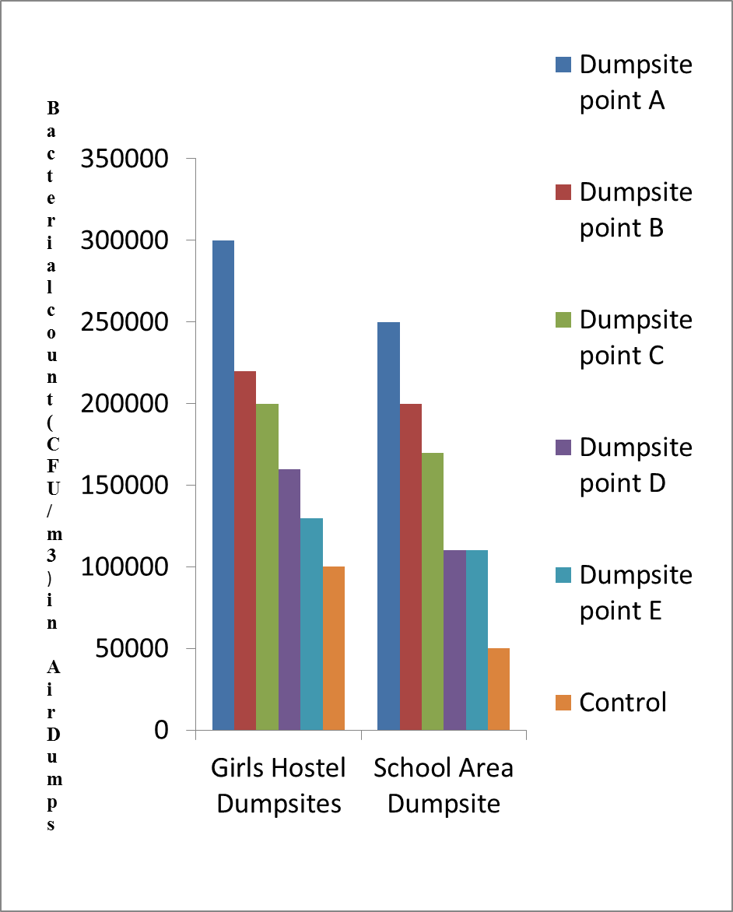

Figure 1: Total Heterotrophic Bacterial Count obtained from the Dumpsite at Madonna University Elele, Rivers State, Nigeria

3.2: Frequency of occurrence of Bacterial isolates obtained from Air Dumpsites from Madonna University Elele, Rivers State, Nigeria.
The bacterial isolates obtained from air dumpsites at Madonna University, Elele, are summarized in Table 1, 2 and 3, showcasing the frequency of occurrence at two different locations: the Girls Hostel Dumpsite (GHDS) and the School Area Dumpsite (SADS). The distribution is as follows: Micrococcus is the most frequently isolated genus overall, accounting for 33.3% of all isolates. It is particularly prevalent at GHDS (41.2%) compared to SADS (23.0%). Pseudomonas aeruginosa appears in 26.7% of the total isolates, with a higher prevalence at SADS (38.5%) compared to GHDS (17.6%). Rhodococcus represents 13.3% of the isolates, more common at GHDS (17.6%) than at SADS (7.7%). Serratia marcescens and Pseudomonas oleovorans each account for 6.7% of the total isolates, with Serratia only found at SADS and Pseudomonas oleovorans found exclusively at GHDS. Escherichia coli comprise 13.3% of isolates, evenly distributed between GHDS and SADS.
Table 1: Frequency of occurrence of Bacterial isolates obtained from Air Dumpsites from Madonna University Elele, Rivers State, Nigeria.
Bacterial Isolates Frequency (%) GHDS Freq (n=17) SADS Frequency(n=13)
Micrococcus 10(33.3) 7(41.2) 3(23.0)
Pseudomonas aeruginosa 8(26.7) 3(17.6) 5(38.5)
Rhodococcus 4(13.3) 3(17.6) 1(7.7)
Serratia marcesceus 2(6.7) 0 2(15.4)
Pseudomonas olevovas 2(6.7) 2(11.8) 0
Escherichia coli 4(13.3) 2(11.8) 2(15.4)
Total 30(100) 17(100) 13(100)

Table 2: Frequency of occurrence of Bacterial isolates obtained from Girls Hostel Air Dumpsites (GHDs) in Madonna University Elele, Rivers State, Nigeria.
Bacterial Isolates GHDs Frequency (%) (n=17)

Micrococcus 7(41.2)
Pseudomonas aeruginosa 3(17.6)
Rhodococcus 3(17.6)
Pseudomonas olevovas 2(11.8)
Escherichia coli 2(11.8)
Total 17(100)
Girls Hostel Air Dumpsites (GHDs)

Table 3: Frequency of occurrence of Bacterial isolates obtained from School Area Air Dumpsites (SADS) in Madonna University Elele, Rivers State, Nigeria.
Bacterial Isolates SADS Frequency % (n=13)

Micrococcus 3(23.0)
Pseudomonas aeruginosa 5(38.5)
Rhodococcus 1(7.7)
Serratia marcesceus 2(15.4)
Escherichia coli 2(15.4)
Total 13(100)
School Area Air Dumpsites (SADS)
- Discussion
The bacterial counts at both dumpsites are markedly higher than those observed in the control samples. The Girls Hostel dumpsite shows a maximum count of 300,000 cfu/m³ at Point A, while the School Area dumpsite reaches 250,000 cfu/m³ at the same point. These elevated counts indicate a significant level of microbial contamination at the dumpsites. Similar studies have reported high microbial counts in dumpsites due to the presence of decomposing organic matter, which provides a rich nutrient source for bacterial proliferation (Zhao et al., 2019). Both dumpsites exhibit a decreasing trend in bacterial counts from Points A to E. The decrease in counts could be attributed to the dilution of waste materials, varying degrees of waste degradation, or environmental conditions that influence bacterial growth. This trend aligns with findings from other research, which indicate that bacterial counts often decrease with distance from the central waste deposition areas due to reduced waste density and microbial competition (Hooda et al., 2016).
The control samples show considerably lower bacterial counts compared to the dumpsite samples, with the Girls Hostel control at 1,000 cfu/m³ and the School Area control at 5,000 cfu/m3. These values are significantly lower than those at the dumpsites, affirming that the dumpsites are sources of substantial microbial contamination. The elevated control count in the School Area compared to the Girls Hostel may suggest some level of environmental contamination or variations in control sampling methodology. Previous studies have noted that controls should be rigorously managed to ensure accurate baseline measurements (Smith et al., 2018). The observed bacterial levels are consistent with findings from similar environmental studies where dumpsites exhibit high microbial counts due to factors like waste composition, age, and environmental conditions (Ogunleye et al., 2021). The Girls Hostel dumpsite generally shows higher counts than the School Area, potentially reflecting differences in waste management practices or waste types at each location. These elevated counts align with findings from similar studies, which indicate high microbial loads in dumpsites due to organic waste decomposition (Zhao et al., 2019; Ogunleye et al., 2021). The decreasing trend in bacterial counts from points A to E at both dumpsites is consistent with research showing reduced contamination away from central waste areas (Hooda et al., 2016). The higher control counts in the School Area might suggest potential environmental contamination or variations in sampling methods (Smith et al., 2018).
Therefore, results underscore the significant microbial contamination at both dumpsites compared to control samples. The higher bacterial counts at the Girls Hostel dumpsite suggest more intensive waste issues or less effective waste management practices compared to the School Area. These findings highlight the need for improved waste management and monitoring practices to mitigate microbial contamination risks.
The data presented in Table 1, 2, and 3 respectively provides a detailed distribution of bacterial isolates from air dumpsites at Madonna University Elele, Rivers State, Nigeria. This analysis reveals notable variations in the prevalence of different bacterial species across two distinct types of air dumpsites: GHDS (Girls Hostel-Dumpsites) and SADS (School Area Dumpsites).
Micrococcus was the most prevalent bacterial isolate, representing (33.3%) of the total isolates, with a higher frequency in GHDS (41.2%) compared to SADS (23.0%). Micrococcus spp. are commonly found in various environmental niches, including air, soil, and water, often due to their ability to tolerate extreme conditions (Jukes et al., 2019). Previous studies have reported similar findings, where Micrococcus was frequently isolated from contaminated environments (Odum et al., 2020). This higher prevalence in GHDS could be attributed to the environmental conditions or higher organic load in these sites, which favor the growth of Micrococcus spp. (Obiekezie et al., 2019).
Pseudomonas aeruginosa showed a contrasting distribution, with a higher frequency in SADS (38.5%) than GHDS (17.6%). This finding aligns with studies indicating that Pseudomonas aeruginosa is commonly found in environments with significant organic contamination and is capable of thriving in various waste conditions (Joly et al., 2021). The increased occurrence in SADS might be related to specific waste types or lower density of microbial competition, which favors the growth of this opportunistic pathogen (Sanguinetti et al., 2018). Rhodococcus was found at 13.3% overall, with a higher prevalence in GHDS (17.6%) compared to SADS (7.7%). Rhodococcus spp. is known for their role in bioremediation, particularly in environments contaminated with hydrocarbons (Lazar et al., 2020). The higher frequency in GHDS could suggest that these sites have a more suitable environment for the bioremediation processes mediated by Rhodococcus spp.
Serratia marcescens and Pseudomonas oleovorans were less common, with Serratia marcescens only found in SADS (15.4%) and Pseudomonas oleovorans only in GHDS (11.8%). Serratia marcescens is often associated with waste environments and has been documented in studies involving landfill sites and polluted air. The presence of Pseudomonas oleovorans in GHDS might indicate a potential for bioremediation of oily waste due to its known capability to degrade hydrocarbons (Husain et al., 2022).
Escherichia coli had a consistent presence in both types of dumpsites (11.8% in GHDS and 15.4% in SADS). E. coli, typically associated with fecal contamination, reflects the general contamination level in the air dumpsites, as similar patterns have been observed in other studies of waste sites (Rodriguez et al., 2020). Previous research provides context for these findings. For instance, a study by Bollmann et al. (2010) emphasizes that diverse bacterial populations, including those isolated in this study, and are frequently encountered in contaminated environments due to their adaptability and metabolic versatility. Similarly, a study by Gentry et al. (2021) noted that high-density waste sites often support a broader range of bacterial species due to increased organic content and nutrient availability, aligning with the higher prevalence of Micrococcus in GHDS observed in this study.
Conversely, findings related to Pseudomonas aeruginosa are consistent with those of Lee et al. (2020), who reported its higher abundance in specific waste environments where it can outcompete other microbes. This aligns with the higher frequency of Pseudomonas aeruginosa in SADS observed in our study. The patterns observed for Rhodococcus and Pseudomonas oleovorans align with their known roles in environmental bioremediation, as discussed by Singh et al. (2021). The site-specific prevalence of these bacteria supports the notion that different waste types and environmental conditions can significantly influence microbial community structures.
- Conclusion
The findings from this study reveal a significant level of microbial contamination at both the Girls Hostel Dumpsite (GHDS) and School Area Dumpsite (SADS) compared to control samples. The marked bacterial counts, with GHDS showing a maximum of 300,000 cfu/m³ and SADS reaching 250,000 cfu/m³, highlight the impact of waste accumulation on microbial diversity and abundance. The prevalence of specific bacterial isolates, such as Micrococcus and Pseudomonas aeruginosa, underscores the varied ecological dynamics at play within these environments. This study aligns with existing literature, confirming that organic waste decomposition contributes substantially to microbial proliferation, further emphasizing the importance of monitoring microbial communities in waste sites.
- Recommendations
- We therefore recommend that there should be educational programs aimed at raising awareness within the university community regarding the importance of proper waste disposal and its implications for environmental health should be conducted. Such initiatives are vital for fostering responsible behaviours in waste management among students and staff.
- Also, Collaboration with Environmental Agencies (Federal Environmental Protection Agency, Local Government Sanitation Authority) is highly recommended in order to develop and implement sustainable waste management practices. Such partnerships can facilitate access to resources necessary for effective monitoring and remediation efforts.

- Contribution to Knowledge
This research offers valuable insights into the microbial diversity and contamination levels of bioaerosolic bacteria at dumpsites in Madonna University, Elele, underscoring the significant influence of waste management practices on environmental health. By identifying the predominant bacterial species such (Micrococcus, Pseudomonas aeruginosa ) and their distribution, this study advances the understanding of microbial dynamics in contaminated environments and lays the groundwork for future remediation efforts and public health initiatives.

COMPETING INTERESTS DISCLAIMER:
Authors have declared that they have no known competing financial interests OR non-financial interests OR personal relationships that could have appeared to influence the work reported in this paper.

Disclaimer (Artificial intelligence)
Option 1:
Author(s) hereby declare that NO generative AI technologies such as Large Language Models (ChatGPT, COPILOT, etc.) and text-to-image generators have been used during the writing or editing of this manuscript.
Option 2:
Author(s) hereby declare that generative AI technologies such as Large Language Models, etc. have been used during the writing or editing of manuscripts. This explanation will include the name, version, model, and source of the generative AI technology and as well as all input prompts provided to the generative AI technology
Details of the AI usage are given below:
1.
2.
3.

References
Agwaranze, D. I., Ogodo, A. C., Ezeonu, C. S., Brown, S. T. C., Nwaneri, C. B., & Husie, L. M. (2020). Microbiological assessment of indoor and outdoor air quality in a general hospital in North-East Nigeria. Research Journal of Microbiology, 15(1), 9–14.
Akpeimeh, G. F., Fletcher, L. A., & Evans, B. E. (2019). Exposure to bioaerosols at open dumpsites: A case study of bioaerosols exposure from activities at Olusosun open dumpsite, Lagos Nigeria. Waste Management, 89, 37–47.
Anele, B.C., Okerentugba, P.O., Stanley, H.O. & Ugoboma, C.J. (2019). Biodeterioration of classroom wall surfaces in the University of Port Harcourt Nigeria. Journal of Advances in Microbiology. 15(1): 1-8.
Bollmann, A., Palumbo, A. V., Lewis, K., & Epstein, S. S. (2010). Isolation and physiology of bacteria from contaminated subsurface sediments. Applied and environmental microbiology, 76(22), 7413-7419.
Cheesbrough, M. (2006). District Laboratory Practices in Tropical Countries (part 1) London Cambridge University Press, New York: pp; 19–24.
Frohlich-Nowoisky, J., Kampf, C. J., Weber, B., Huffman, J. A., Pöschl, U., & Andreae, M. O. (2016). Bioaerosols in the Earth system: Climate, health, and ecosystem interactions. Atmospheric Research, 182, 346–376.
Srivastava, R. K., Shetti, N. P., Reddy, K. R., & Aminabhavi, T. M. (2020). Sustainable energy from waste organic matters via efficient microbial processes. science of the total environment, 722, 137927.

de Smet, M. J., Kingma, J., Wynberg, H., & Witholt, B. (1983). Pseudomonas oleovorans as a tool in bioconversions of hydrocarbons: growth, morphology and conversion characteristics in different two-phase systems. Enzyme and Microbial Technology, 5(5), 352-360.

Hooda, P. S., Edwards, A. C., Anderson, H. A., & Miller, A. (2016). A review of water quality concerns in livestock farming areas. Science of the Total Environment, 547, 447–460.
Alhazmi, A. (2015). Pseudomonas aeruginosa-pathogenesis and pathogenic mechanisms. International Journal of Biology, 7(2), 44.
Odum, E.I., Idise, O.E.& Ogogo, D.I. (2020). Multidrug Resistant Bacteria in Dumpsites within Abraka, Delta State, Nigeria. FUDMA Journal of Sciences. 4(2) 639–644.
Obiekezie S.O., Ekeleme, I. K., Adamu Muktar, O.G. M. J., Onalo C., Sabo, 1, & Abdullahi, A. (2019). Assessment of microbiological quality of air environment around waste dumpsites within Keffi metropolis in Northern Nigeria. American Journal of Biological and Environmental Statistics. 5(4): 78-84
Yoo, K., Lee, T. K., Choi, E. J., Yang, J., Shukla, S. K., Hwang, S. I., & Park, J. (2017). Molecular approaches for the detection and monitoring of microbial communities in bioaerosols: A review. Journal of Environmental Sciences, 51, 234–247.
Zhao, Y., García-González, M., Mayol, E., Arrieta, J. M., Duarte, C. M., & Herndl, G. J. (2019). Long-range transport of airborne microbes over the global tropical and subtropical ocean. Nature Communications, 8, 201.

