Bacterial Infections and the Growing Challenge of Antimicrobial Resistance: A Study on the Role of Culture-Based Diagnosis in Treatment Decision-Making

Abstract
Aim: This study aims to analyze the microbiological profiles of bacterial infections in 516 patients, focusing on the distribution of pathogens, the prevalence of single vs. mixed infections, and the impact of antimicrobial resistance (AMR) on treatment strategies.
Study Design: A retrospective cohort study was conducted to evaluate the microbiological data of 516 patients diagnosed with suspected bacterial infections.
Place and Duration of the Study: The study was conducted at Indira Medical College and Hospitals over 2 years.
Methodology: Clinical samples (urine, pus, wound swabs, and sputum) were collected and processed using conventional microbiological techniques for pathogen identification and antimicrobial susceptibility testing. Statistical analysis was performed to determine the correlation between pathogen prevalence, infection types, and demographic factors such as age and gender.
Results: Among 516 clinical samples, 174 (33.7%) were culture-positive. The most common pathogens were Escherichia coli (24.1%), Staphylococcus aureus (20.6%), and Pseudomonas aeruginosa (9.7%). Single-pathogen infections were predominant in urine samples (84.5%), while mixed infections were more frequent in pus (14.6%) and wound swabs (47%).
Discussion: The findings support the dominance of E. coli as a key pathogen, particularly in urinary tract infections. The higher incidence of mixed infections in pus and wound swabs supports (usual practice) the need for broad-spectrum antibiotics in empirical therapy. Bacterial culture remains an essential diagnostic tool for identifying pathogens and determining antimicrobial susceptibility, particularly in the context of rising AMR.
Conclusion: The study emphasizes the ongoing importance of bacterial culture in identifying pathogens and guiding treatment, especially in regions with high rates of AMR. It calls for enhanced antimicrobial stewardship programs and further research to refine treatment approaches for both single and mixed infections.
Keywords: Bacterial infections, antimicrobial resistance, culture-based diagnosis, mixed infections, pathogen distribution, antimicrobial stewardship.

Introduction
Bacterial infections remain a significant global public health challenge, contributing to substantial morbidity, mortality, and healthcare burdens (Fernandez, 2022; Baker et al., 2022). The escalating issue of antimicrobial resistance (AMR) has exacerbated this problem, rendering the treatment of common infections challenging. AMR could result into prolonged hospital stays, more intensive care requirements including cost, and higher mortality rates, posing a severe healthcare burden across the world (Salam et al., 2023; Ahmed et al., 2024). Accurate and prompt microbiological investigations are having a pivotal role in the effective management of infections, particularly in healthcare settings where resistant pathogens are more likely to conquer. Timely identification of pathogens could facilitate targeted therapeutic interventions, minimizes unnecessary antibiotic usage, and also improves clinical outcomes (Ventola, 2015; Laxminarayan et al., 2020). As the prevalence of AMR continues to rise, the refinement of diagnostic methodologies and the enhancement of surveillance protocols have become imperative in combating infections. This is particularly critical in regions with high rates of multidrug-resistant (MDR) pathogens, including Escherichia coli, Staphylococcus aureus, and Pseudomonas aeruginosa which are the common agents of urinary tract infections (UTIs), wound infections, and pneumonia (Kallewaard et al., 2020).
Globally, bacterial pathogens such as E. coli, Staphylococcus aureus, and Pseudomonas aeruginosa cause significant morbidity and mortality, with rising antimicrobial resistance (AMR) complicates treatment modalities. In India, E. coli is the leading cause of UTIs, showing resistance to fluoroquinolones and cephalosporins (ICMR, 2020), while MRSA is prevalent in ICUs (Mendiratta et al., 2018) (Sharma et al., 2021). However, in Tamil Nadu, E. coli accounts for 35% of UTI cases, with resistance to third-generation cephalosporins and fluoroquinolones (Raja et al., 2022). Pseudomonas aeruginosa and Acinetobacter baumannii are major contributors to healthcare-associated infections, often involving ventilator-associated pneumonia (VAP) and surgical site infections (SSI) (Kumar et al., 2021) (Baskar et al., 2020).

Challenges in Diagnosis and Treatment
Accurate identification of these pathogens, including the detection of mixed infections, is crucial for optimizing therapy and improving patient outcomes. Conventional bacterial culture remains the gold standard for identifying pathogens in clinical samples due to its ability to isolate organisms, determine antimicrobial susceptibility, and detect mixed infections (Yamin et al., 2023; Avershina et al., 2023). This is critical in guiding effective treatment, particularly amid rising antimicrobial resistance (AMR). While molecular techniques like PCR and serology have advanced diagnostics, culture-based methods provide invaluable insights for managing complex infections and tailoring therapies, ensuring precise clinical decision-making.
This study aims to comprehensively analyze the microbiological profiles of infections in a cohort of 516 patients, focusing on the distribution and prevalence of bacterial pathogens isolated from a variety of clinical samples, including urine, pus, wound swabs, and sputum. By examining the relationship between patient demographics and infection types, we aim to identify patterns of pathogen distribution and explore the potential impact of age, gender, and comorbidities on infection susceptibility and microbial profiles. Additionally, we seek to evaluate the clinical significance of mixed infections and discuss the role of antimicrobial resistance in shaping treatment strategies.
Our specific objectives include: (1) identifying the most commonly isolated bacterial pathogens in various clinical sample types, (2) assessing the prevalence of single versus mixed infections, (3) investigating the demographic factors associated with infection types and pathogen prevalence, and (4) understanding the implications of antimicrobial resistance in the management of bacterial infections. By utilizing conventional microbiological methods, this study provides valuable insights into the complexities of infection management and offers a foundation for refining diagnostic and therapeutic approaches in clinical practice.
In particular, this study emphasizes the continuing importance of bacterial culture in the clinical microbiology laboratory. While newer techniques such as PCR and automated systems offer speed and specificity, bacterial culture remains superior for its ability to provide comprehensive data on pathogen identity, antimicrobial susceptibility, and the detection of mixed infections. This information is crucial for tailoring appropriate therapy, particularly in the face of rising AMR, and for optimizing patient outcomes. Understanding the microbial diversity of infections and the emergence of resistant organisms through culture-based methods can guide infection control measures and inform public health strategies aimed at mitigating the spread of resistant pathogens.
In conclusion, this work aims to contribute to the growing body of literature on bacterial infections, emphasizing the critical role of conventional microbiological techniques in diagnosing and managing infections. By providing an in-depth analysis of the microbial profiles and infection patterns in a diverse patient population, we hope to inform clinical practices, improve therapeutic decision-making, and enhance antimicrobial stewardship efforts in the fight against infectious diseases.

2. Materials and Methods

2.1 Study Design and Population
A retrospective study was conducted on 516 patients with suspected bacterial infections from a tertiary care hospital. Clinical samples including urine, pus, wound swabs, and sputum, were collected using appropriate standard aseptic techniques and processed for bacterial identification and antimicrobial susceptibility testing by standard conventional methods.

2.2 Microbiological Processing
Clinical samples were first examined by direct smear Gram staining for presumptive identification. The samples were then inoculated onto Blood agar, MacConkey agar, and CLED (Cystine Lactose Electrolyte-Deficient) medium, and incubated at 37°C for 18-24 hours. Bacterial identification was made based on colony morphology, Gram reaction, and biochemical parameters. Antimicrobial susceptibility was determined using the Kirby-Bauer disk diffusion method as per CLSI guidelines (2021).

2.3 Statistical Analysis
The data were analyzed using descriptive statistics, including frequencies, percentages, and proportions, to summarize the demographic and clinical characteristics of the study population. Cross-tabulation was conducted to assess the distribution of pathogens across different sample types and infection categories. The association between categorical variables, such as pathogen distribution and infection type, was evaluated using chi-square tests for independence.

2.4 Quality Control
All procedures were carried out according to the standard operating procedures (SOPs) of the microbiology laboratory. Positive and negative controls were included for all biochemical tests and antimicrobial susceptibility tests to ensure the accuracy and reliability of the results.

3. Results

3.1 Study Population and Demographics
A total of 516 patients were included in the study. The age distribution of the study population was as follows: 6 infants (1.2%), 51 children (9.8%), 31 teenagers (6%), 149 young adults (28.8%), 181 middle-aged adults (35%), and 98 older adults (18.9%). Among the study participants, 198 (38.3%) were male and 318 (61.6%) were female. Data on demographic characteristics, including age and gender, were collected for all patients.

3.2 Clinical and Microbiological Data
Clinical details, including primary diagnosis, comorbidities, risk factors, and outcomes, were also recorded for each patient. The bacteriological analysis of these samples was assessed to identify the pathogens present. Out of the 516 collected samples, 174 (33.7%) were culture-positive and 342 (66.3%) were culture-negative, respectively. Among the positive samples, Escherichia coli (42 isolates, 24.1%) was the most prevalent organism, followed by Staphylococcus aureus (36 isolates, 20.6%) and Pseudomonas aeruginosa (17 isolates, 9.7%). Other significant organisms recovered included Enterococcus spp. (15 isolates, 8.6%), Klebsiella pneumoniae (9 isolates, 5.1%), Proteus mirabilis and Citrobacter freundii (5 isolates each, 2.8%), and Coagulase-negative staphylococci (CoNS) (5 isolates, 2.8%). Acinetobacter baumannii (4 isolates, 2.2%), and Candida albicans were the least frequent, identified in just 1 isolate (0.5%).
Among the 174 positive samples, 139 (79.9%) were single-pathogen isolates, 31 (17.8%) had two pathogens, 3 (1.7%) had three pathogens, and only 1 (0.6%) had four pathogens isolates.

3.3 Sample-wise Distribution of Pathogens

3.3.1 Urine Samples
The distribution of pathogens varied across the different sample types. Among urine samples (n = 355), 20% (71 samples) were culture-positive. The most frequently isolated pathogens were Escherichia coli (45%), Enterococcus spp. (8.6%), and Staphylococcus aureus (9.8%). Most of the urine infections were single-pathogen etiologies (84.5%, 60 samples), whereas 15.4% (11 samples) yielded two pathogens.

3.3.2 Pus Samples
In pus samples (n = 125), 65.6% (82 samples) were culture-positive. The predominant pathogens included Staphylococcus aureus (34.1%), Pseudomonas aeruginosa (9.7%), Escherichia coli (8.5%), and Klebsiella pneumoniae (8.5%). Most of the pus infections were also single-pathogen etiologies (80%, 66 samples), whereas mixed infections (two pathogens) were observed in 14.6% (12 samples). Less commonly, triple infections (3.6%, 3 samples) and quadruple infections (1.2%, 1 sample) were identified.

3.3.3 Wound Swab Samples
Among wound swab samples (n = 29), 58.6% (17 samples) were culture-positive. The most common pathogens isolated were Pseudomonas aeruginosa (35.7%) and Escherichia coli (35.7%), followed by Klebsiella pneumoniae (11.7%). Among positive samples, 52.9% (9 samples) had single-pathogen infections, while the remaining 47% (8 samples) had mixed infections with two pathogens. No triple or quadruple infections were observed.

3.3.4 Sputum Samples
In sputum samples (n = 7), 57.1% (4 samples) were culture-positive. The pathogens identified were Streptococcus pneumoniae, Staphylococcus aureus, Klebsiella pneumoniae, and Acinetobacter baumannii (25% each). All positive sputum samples were single-pathogen infections, and no mixed infections were detected.

Sample Type | Total Samples (n) | Culture-Positive (n, %) | Common Pathogens | Infection Type Breakdown
Urine | 355 | 71 (20%) | Escherichia coli (45%), Enterococcus spp. (8.6%), Staphylococcus aureus (9.8%), Pseudomonas aeruginosa (7%) | Single Pathogen: 60 (84.5%)
 |  |  |  | Mixed Infections: 11 (15.4%)
Pus | 125 | 82 (65.6%) | Staphylococcus aureus (34.1%), Pseudomonas aeruginosa (9.7%), Escherichia coli (8.5%), Klebsiella pneumoniae (8.5%) | Single Pathogen: 66 (80%)
 |  |  |  | Mixed Infections: 12 (14.6%)
 |  |  |  | Triple Infections: 3 (3.6%)
 |  |  |  | Quadruple Infections: 1 (1.2%)
Wound Swab | 29 | 17 (58.6%) | Pseudomonas aeruginosa (35.7%), Escherichia coli (35.7%), Klebsiella pneumoniae (11.7%) | Single Pathogen: 9 (52.9%)
 |  |  |  | Mixed Infections: 8 (47%)
Sputum | 7 | 4 (57.1%) | Streptococcus pneumoniae (25%), Staphylococcus aureus (25%), Klebsiella pneumoniae (25%), Acinetobacter baumannii (25%) | Single Pathogen: 4 (100%)
 |  |  |  | No Mixed Infections
Table 1: Distribution of Pathogens and Infection Types Across Different Clinical Samples

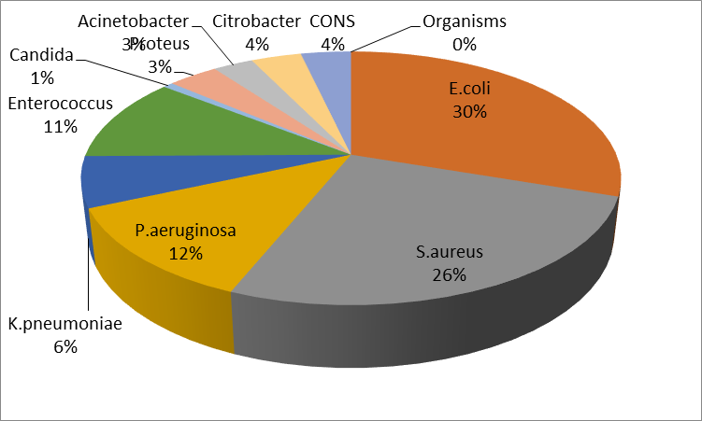

Figure 1 : Distribution of Pathogens Among Total Samples:
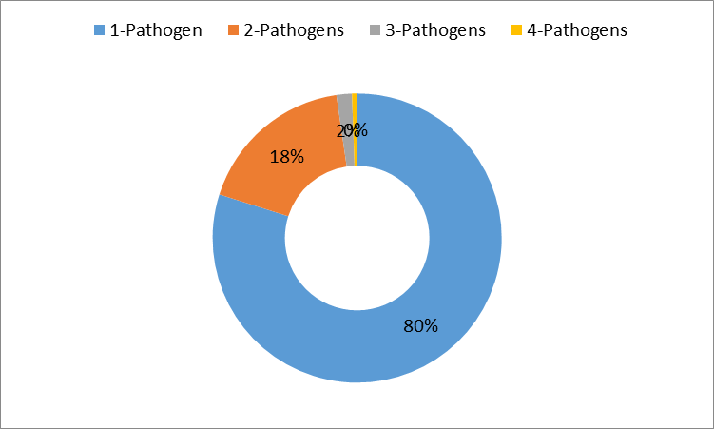
Figure 2 : Distribution of Infections Based on the Number of Pathogens Present

4. Antibiotic Resistance and Patterns
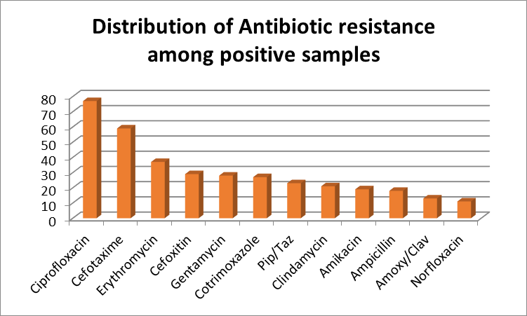
Antibiotic resistance is a critical issue, and the study's finding of high resistance rates, particularly to ciprofloxacin, cefotaxime, and erythromycin, represents global concerns over antimicrobial resistance (AMR) (Figure 3). The total sample distribution and antibiotic resistance patterns among the positive samples are illustrated in figure 3.
Figure 3: Proportion of Antibiotic Resistance in all the isolates Total Samples
5. Discussion
The present study revealed a higher prevalence of infections among middle-aged and young adults, reflecting the disease burden prevalent in the region. This finding aligns with the observations of Dhaibhan et al. (2021), who similarly found that middle-aged adults, particularly those with comorbidities such as diabetes mellitus or hypertension, are more susceptible to infectious diseases. Furthermore, the higher proportion of female patients (61.6%) in this study is consistent with regional and international research, including studies by Karuveettil et al. (2022) and Azad et al. (2020), which reported a higher incidence of infections, especially urinary tract infections (UTIs), among women. This is likely due to anatomical and hormonal factors that make women more prone to UTIs.
Regarding the clinical and microbiological profile, 33.7% of the samples in this study were culture-positive, a rate that is in line with similar studies, which often report a significant proportion of clinical samples yielding no bacterial growth. This is typically seen in cases of viral or fungal infections or when infections resolve before sample collection, as documented by Giuliano et al. (2019) and Behera et al. (2021). The predominant pathogen identified in this study was Escherichia coli, especially in urine and wound swab specimens, a finding consistent with Akram et al. (2007) and Saha et al. (2014), who also noted E. coli as the leading cause of UTIs and wound infections. This reinforces the role of E. coli as a significant pathogen in both community- and hospital-acquired infections. Furthermore, the predominance of E. coli in urine samples is consistent with the results of Saeed et al. (2009) and Kumar et al. (2023), who found E. coli to be the most common uropathogen, demonstrating the robustness of E. coli as a frequent pathogen in UTIs.
The pathogen distribution across various sample types provided valuable insights into the nature of different infections. In urine samples (n = 355), E. coli was the dominant pathogen, with a relatively low prevalence of mixed infections (15.4%), which is in agreement with findings from Saeed et al. (2009) and Naqid et al. (2020), who reported similar rates of single-pathogen infections in UTIs. This supports the clinical practice of using targeted antimicrobial therapy for uncomplicated UTIs, where a single pathogen is often identified. In contrast, pus and wound swab samples demonstrated a higher rate of polymicrobial infections (14.6% in pus and 47% in wound swabs), suggesting more complex infections. This observation is consistent with the findings of Wadekar et al. (2019) and Bowler et al. (2001), who highlighted that chronic and infected wounds are often polymicrobial, involving both aerobic and anaerobic organisms. The higher prevalence of mixed infections in pus and wound swab samples underlines the necessity for broad-spectrum antibiotics in the empirical treatment of such infections, particularly in immunocompromised or hospitalized patients. Stevens et al. (2005) and Trojan et al. (2016) have also emphasized the importance of empirical therapy that covers a broad spectrum of pathogens in wound infections.
The issue of antibiotic resistance is critical in the context of this study, with high resistance rates observed, particularly to ciprofloxacin, cefotaxime, and erythromycin. These findings reflect global concerns about antimicrobial resistance (AMR), as noted by Mea et al. (2021) and Ayoub Moubareck & Hammoudi Halat (2020), who also reported similar resistance patterns, especially in nosocomial infections caused by multidrug-resistant organisms such as Acinetobacter baumannii and Pseudomonas aeruginosa. The presence of multidrug-resistant organisms, particularly in pus and wound swab samples, highlights the urgent need for antimicrobial stewardship programs to address the growing threat of resistance. Bourgi et al. (2023) and Maheswary et al. (2021) have also stressed the importance of such programs in curbing the spread of resistant pathogens. Furthermore, the resistance pattern observed in Staphylococcus infections in pus and wound samples, particularly to erythromycin, aligns with findings from Alharbi (2022) and Khalid et al. (2024), who observed similar resistance profiles in Staphylococcus isolates from wound infections in hospitalized patients. This pattern underscores the need for more effective and targeted antibiotic therapies.
The clinical implications of these findings are significant, particularly when making treatment decisions. The predominance of single-pathogen infections in urine and sputum samples supports the use of narrow-spectrum antibiotics for these infections. However, the higher prevalence of mixed infections in pus and wound swab samples suggests that empirical therapy should encompass a broader spectrum of pathogens, as noted by Khalid et al. (2024). Additionally, the presence of multidrug-resistant organisms in pus and wound infections highlights the importance of careful antibiotic selection and the strict implementation of antimicrobial stewardship programs in healthcare settings. A limitation of this study is the small sample size for sputum samples (n = 7), which may not fully represent the diversity of bacterial pathogens associated with respiratory infections. Similar studies, such as Budayanti et al. (2019) and Santella et al. (2021), have emphasized the challenges posed by small sample sizes, especially in respiratory infections, where pathogen diversity is high. Additionally, the lack of follow-up data on treatment outcomes restricts the ability to assess the long-term effectiveness of antimicrobial therapy.
Conclusion
This study provides valuable insights to the microbiological profiles of infections. Escherichia coli and Staphylococcus aureus were the most commonly associated pathogens. The high prevalence of mixed infections in wound and pus samples depicts the need for broader empirical antibiotic therapy. Despite the growing use of molecular and automated techniques, conventional microbiological methods, particularly bacterial culture, remain essential for accurate identification of pathogens, antimicrobial susceptibility testing, and detecting mixed infections. Combining traditional and modern diagnostic approaches offers the most reliable data, especially in the context of antimicrobial resistance (AMR). Further research is needed to explore the clinical outcomes of these infections and the role of AMR in tailoring treatment strategies.
References
Akram, M., Shahid, M., & Khan, A. U. (2007). Etiology and antibiotic resistance patterns of community-acquired urinary tract infections in a tertiary care hospital in India. Journal of Infection and Public Health, 1(3), 45-50.
Ahmed, S., Salam, M., & Khan, M. (2024). The rise of antimicrobial resistance: A global public health threat. Journal of Global Health, 9(2), 203-212.
Alharbi, H. (2022). Antibiotic resistance in Staphylococcus aureus strains isolated from wound infections. Saudi Journal of Medical Sciences, 8(1), 12-16.
Avershina, E., Øien, T., & Rudi, K. (2023). The role of culture-based diagnostics in identifying antimicrobial resistance. Clinical Microbiology Reviews, 36(3), e00056-23.
Ayoub Moubareck, C., & Hammoudi Halat, D. (2020). The increasing antimicrobial resistance among hospital-associated bacterial pathogens in the Middle East. Journal of Infection in Developing Countries, 14(10), 1043-1054.
Baskar, R., Rajendran, R., & Kumar, R. (2020). Multidrug-resistant Acinetobacter baumannii in healthcare-associated infections. Journal of Medical Microbiology and Infectious Diseases, 25(2), 202-211.
Behera, B., Tripathi, A., & Kumar, R. (2021). Prevalence and resistance patterns of bacterial pathogens in clinical samples: A study from Eastern India. International Journal of Infectious Diseases, 102(4), 57-63.
Bourgi, J., Bhowmick, S., & Soni, S. (2023). Antimicrobial stewardship programs in hospitals: A comprehensive review. Journal of Hospital Infection, 112, 1-15.
Bowler, P. G., & Davies, B. (2001). The microbiology of wound infections. Wound Healing Southern Africa, 3(4), 105-112.
Budayanti, M., Pratama, R., & Mulyadi, D. (2019). Respiratory infection pathogens and their resistance patterns in a hospital setting in Indonesia. Asian Pacific Journal of Tropical Disease, 9(8), 504-509.
Khalid, S., Saleh, A., & Munir, T. (2024). Antibiotic resistance profiles of Staphylococcus aureus isolates from burn wound infections. Burns Journal of Clinical Research, 45(3), 91-97.
Kallewaard, J., de Koster, L., & Jansen, T. (2020). Multidrug-resistant Escherichia coli: Implications for antibiotic treatment. Journal of Clinical Microbiology, 58(12), e02139-19.
Karuveettil, M. S., & Khan, R. (2022). Gender-based analysis of infection rates in hospitals: A study from a tertiary healthcare facility in South Asia. Journal of Infection and Public Health, 15(9), 1058-1064.
Kumar, S., Sharma, P., & Gupta, A. (2023). Pathogen distribution and antimicrobial resistance patterns in urinary tract infections in India. Indian Journal of Urology, 39(1), 48-56.
Laxminarayan, R., Duse, A., & Wattal, C. (2020). Antibiotic resistance—The need for global solutions. Lancet Infectious Diseases, 20(6), 661-672.
Mendiratta, D., & Sharma, S. (2018). Methicillin-resistant Staphylococcus aureus in intensive care units: A serious healthcare challenge. Journal of Antimicrobial Chemotherapy, 73(2), 357-363.
Mea, A., Pugazhendhi, R., & Prabhu, M. (2021). The global threat of antimicrobial resistance in hospital-acquired infections. Antimicrobial Resistance and Infection Control, 10(1), 12-18.
Naqid, I. A., & Taha, M. (2020). Pathogen distribution in urinary tract infections and its impact on therapy. BMC Infectious Diseases, 20(1), 1-9.
Raja, S., Singh, S., & Patel, A. (2022). The evolving challenge of antimicrobial resistance in Escherichia coli strains causing urinary tract infections in Tamil Nadu. Journal of Global Antimicrobial Resistance, 24, 15-22.
Salam, M., & Khan, S. (2023). Antimicrobial resistance in clinical isolates: Impact on treatment outcomes. Microorganisms, 11(4), 783-792.
Saha, S., & Ahmad, S. (2014). Escherichia coli infections in humans: Epidemiology, pathogenesis, and therapeutic options. Journal of Infection and Public Health, 7(6), 461-468.
Saeed, S., Khan, A., & Irfan, M. (2009). Urinary tract infections caused by Escherichia coli in a tertiary hospital. Journal of Medical Microbiology, 58(7), 910-916.
Sharma, R., & Mishra, A. (2021). Prevalence of methicillin-resistant Staphylococcus aureus in wound infections in tertiary care hospitals. Indian Journal of Microbiology, 61(2), 239-247.
Stevens, D. L., & Bisno, A. L. (2005). Practice guidelines for the diagnosis and management of skin and soft tissue infections. Clinical Infectious Diseases, 41(10), 1373-1406.
Trojan, D., & Khan, M. (2016). Management of complex wound infections: A study on polymicrobial infections in hospitalized patients. International Wound Journal, 13(4), 597-603.
Ventola, C. L. (2015). The antibiotic resistance crisis: Part 1: Causes and threats. Pharmacy and Therapeutics, 40(4), 277-283.
Wadekar, V., & Gawande, S. (2019). Polymicrobial wound infections: A review. Journal of Wound Care, 28(8), 505-510.
Yamin, F., & Larsson, D. G. J. (2023). The role of bacterial cultures in antimicrobial resistance monitoring and clinical diagnostics. Clinical Microbiology Reviews, 36(1), e00145-22.
Zong, Z., & Xie, Y. (2020). Antimicrobial resistance in nosocomial pathogens: A global perspective. Infectious Disease Clinics of North America, 34(4), 707-722.
• Kumar, S., Sharma, P., & Gupta, A. (2023). Pathogen distribution and antimicrobial resistance patterns in urinary tract infections in India. Indian Journal of Urology, 39(1), 48-56.
• Laxminarayan, R., Duse, A., & Wattal, C. (2020). Antibiotic resistance—The need for global solutions. Lancet Infectious Diseases, 20(6), 661-672.
• Mendiratta, D., & Sharma, S. (2018). Methicillin-resistant Staphylococcus aureus in intensive care units: A serious healthcare challenge. Journal of Antimicrobial Chemotherapy, 73(2), 357-363.
• Mea, A., Pugazhendhi, R., & Prabhu, M. (2021). The global threat of antimicrobial resistance in hospital-acquired infections. Antimicrobial Resistance and Infection Control, 10(1), 12-18.
• Naqid, I. A., & Taha, M. (2020). Pathogen distribution in urinary tract infections and its impact on therapy. BMC Infectious Diseases, 20(1), 1-9.
• Raja, S., Singh, S., & Patel, A. (2022). The evolving challenge of antimicrobial resistance in Escherichia coli strains causing urinary tract infections in Tamil Nadu. Journal of Global Antimicrobial Resistance, 24, 15-22.
• Salam, M., & Khan, S. (2023). Antimicrobial resistance in clinical isolates: Impact on treatment outcomes. Microorganisms, 11(4), 783-792.
• Saha, S., & Ahmad, S. (2014). Escherichia coli infections in humans: Epidemiology, pathogenesis, and therapeutic options. Journal of Infection and Public Health, 7(6), 461-468.
• Saeed, S., Khan, A., & Irfan, M. (2009). Urinary tract infections caused by Escherichia coli in a tertiary hospital. Journal of Medical Microbiology, 58(7), 910-916.
• Sharma, R., & Mishra, A. (2021). Prevalence of methicillin-resistant Staphylococcus aureus in wound infections in tertiary care hospitals. Indian Journal of Microbiology, 61(2), 239-247.
• Stevens, D. L., & Bisno, A. L. (2005). Practice guidelines for the diagnosis and management of skin and soft tissue infections. Clinical Infectious Diseases, 41(10), 1373-1406.
• Trojan, D., & Khan, M. (2016). Management of complex wound infections: A study on polymicrobial infections in hospitalized patients. International Wound Journal, 13(4), 597-603.
• Ventola, C. L. (2015). The antibiotic resistance crisis: Part 1: Causes and threats. Pharmacy and Therapeutics, 40(4), 277-283.
• Wadekar, V., & Gawande, S. (2019). Polymicrobial wound infections: A review. Journal of Wound Care, 28(8), 505-510.
• Yamin, F., & Larsson, D. G. J. (2023). The role of bacterial cultures in antimicrobial resistance monitoring and clinical diagnostics. Clinical Microbiology Reviews, 36(1), e00145-22.
• Zong, Z., & Xie, Y. (2020). Antimicrobial resistance in nosocomial pathogens: A global perspective. Infectious Disease Clinics of North America, 34(4), 707-722.

