A Pituitary Stalk Interruption Syndrome Presenting with Metabolic Dysfunction Associated Steatohepatitis: A Case Report

.

ABSTRACT

Background:
Pituitary Stalk Interruption Syndrome (PSIS) is a rare congenital disorder characterized by the absence or thinning of the pituitary stalk, hypoplasia of the anterior pituitary, and ectopic posterior pituitary. This results in panhypopituitarism and related clinical manifestations. Emerging evidence suggests an association between PSIS and metabolic dysfunction, potentially progressing to advanced liver disease.
Case Report:
We present the case of a 31-year-old female with a known diagnosis of panhypopituitarism due to PSIS (diagnosed in 2014), with a history of primary amenorrhea and multiple episodes of adrenal insufficiency. She presented with complaints of fever, vomiting, and yellowish discoloration of the eyes. Clinical examination revealed icterus, right hypochondriac tenderness, hepatomegaly, and Cushingoid features. Laboratory evaluation demonstrated dyslipidaemia, hyperglycaemia, hyperbilirubinemia, and elevated liver enzymes. Imaging revealed hepatomegaly with severe hepatic steatosis. After exclusion of other common aetiologies of hepatitis, a liver biopsy was performed, confirming severe steatosis with fibrosis. In the absence of other identifiable causes, panhypopituitarism is considered a likely contributing factor in the development of hepatic steatosis in this case. Hence, a final diagnosis of metabolic dysfunction-associated steatohepatitis (MASH) secondary to PSIS was made.
Conclusion:
The pathophysiological link between PSIS and MASH has been recently described. Proposed mechanisms include altered STAT signaling pathways (e.g., STAT1/3 activation, STAT5 inhibition) leading to impaired hepatic lipid metabolism and increased insulin resistance. Evidence suggests that MASLD may progress more rapidly in patients with PSIS compared to other aetiologies. Hormone replacement therapy (HRT) remains the cornerstone of management and may help slow disease progression. Early recognition, routine liver function monitoring, and timely intervention are essential to prevent long-term hepatic complications in patients with PSIS.

Keywords:- Panhypopituitarism, PSIS, Metabolic dysfunction associated steatotic liver disease, Hormone Replacement therapy

1. INTRODUCTION

PITUITARY STALK INTERRUPTION SYNDROME (PSIS) is a rare congenital disorder causing panhypopituitarism due to anterior pituitary hypoplasia, interrupted pituitary stalk and an ectopic posterior pituitary. It leads to multiple endocrine deficiencies and metabolic disturbances, including insulin resistance and dyslipidaemia ^{(1).}

We report a female in her early 30s with PSIS diagnosed in 2014, presenting with icterus, fever, and vomiting. She had a history of primary amenorrhea and multiple adrenal insufficiency episodes. Examination revealed hepatomegaly, cushingoid features and right hypochondriac tenderness. Laboratory tests showed dyslipidaemia, hyperglycaemia, and elevated liver enzymes. Imaging and biopsy confirmed severe steatosis and fibrosis. Following a thorough evaluation to identify the cause of hepatitis in this young patient—with no prior history of metabolic syndrome or diabetes mellitus, all other common causes were ruled out. Notably, the degree of hepatic steatosis observed was unusually severe for a patient of this age and clinical background. In the absence of other identifiable causes, panhypopituitarism is considered a likely contributing factor in the development of hepatic steatosis in this case which further lead to a diagnosis of Metabolic Dysfunction-Associated Steato-hepatitis (MASH) secondary to PSIS.

The exact mechanism linking PSIS to MASH remains unclear, although altered STAT signaling pathways (e.g., STAT1/3 activation, STAT5 inhibition) leading to impaired hepatic lipid metabolism and increased insulin resistance have been proposed. Early recognition and hormone replacement therapy (HRT) are crucial in preventing progression. This case highlights the need for routine liver function monitoring in PSIS patients to detect metabolic liver disease early.

2. CAse presentation

PRESENTING HISTORY:-

A woman in her early 30s presented to our outpatient department with a two-week history of progressive yellowish discoloration of the eyes, intermittent fever (up to 38.5°C), right upper quadrant abdominal pain, and vomiting (3–4 episodes daily, non-bilious). She denied recent weight loss, altered bowel habits, or alcohol use. Her symptoms began insidiously, with fatigue preceding the onset of jaundice by one week.

She was diagnosed with PSIS in 2014 during evaluation for primary amenorrhea. Initially compliant with HRT (including steroids and estrogen), she discontinued therapy after achieving menarche, leading to secondary amenorrhea and recurrent adrenal insufficiency episodes (3–4 over the years). During these episodes, she received short-term steroids (e.g., hydrocortisone for one week) but did not maintain long-term therapy. She had no history of diabetes mellitus or alcohol consumption, was married for 5 years but nulligravid, and followed a mixed diet. Her developmental history was unremarkable, with attainment of mid-parental height and near-normal secondary sexual characteristics (Tanner’s III pubic hair, breast tissue)

EXAMINATION FINDINGS

On examination, she was obese (BMI 29 kg/m²), conscious, and oriented, with stable vital signs (blood pressure 110/70 mmHg, pulse 70/min, respiratory rate 14/min, SpO₂ 99%, capillary blood glucose 220 mg/dL). She had icterus and Cushingoid features (moon facies, buffalo hump, central obesity, purple abdominal striae) ^{(Fig 1)}.

Abdominal examination revealed tender hepatomegaly (4 cm below the right costal margin). Breast examination showed Tanner stage III development, while genital examination indicated Tanner stage I pubic hair with normal external genitalia. Fundoscopy, performed due to new-onset hyperglycaemia, showed no diabetic retinopathy.

DIAGNOSTIC CONSIDERATIONS

Given her history of pituitary dysfunction, features of metabolic syndrome, and new-onset liver involvement, we considered Acute hepatitis for evaluation, metabolic syndrome in our differential diagnosis. The presence of cushingoid features without chronic steroid intake raised concerns regarding endogenous hormonal imbalances contributing to her metabolic derangements. Hence, she was evaluated further to determine the aetiology of her acute hepatitis.

INVESTIGATIONS:

Investigation panel is presented in table 1
TABLE-1- Investigation panel
LAB INVESTIGATIONS | RESULTS | REFERENCE RANGE
Liver function tests:  Total bilirubin  Direct bilirubin  AST/ALT  ALP  Total Protein/Albumin  PT/INR/APTT | 4.6 mg/dl  2.4 mg/dl  186/65 IU/L  133 IU/L  7.7/4.3 g/dL  13.54 s /0.9/28.5 s | 0.3 - 1 mg/dl  0.1 - 0.3 mg/dl  10-40 / 10-40 IU/L  30-120 IU/L  5.5-9 / 3.5-5.5 g/dL  11-13 s/0.8-1.1/25-35 s
Haemoglobin  Platelet  WBC | 11.9 g/dl  96000/µL  13600/µL | 12 – 16 g/dl  150000 -450000 /µL  4000-11000 /µL
VIRAL MARKERS PANEL  (HbsAg, Anti-HCV,HIV,  IgM anti HAV,HEV, IgM- CMV,EBV,HSV) | NEGATIVE
TROPICAL ILLNESS PANEL  (SCRUB typhus, LEPTO MAT, QBC smear) | NEGATIVE
Auto immune Hepatitis Panel  (ANA, SMA, ANTI- LKM 1) | NEGATIVE
24 hr Urinary Copper  S. Alpha 1 anti trypsin  S. Ferritin  S. IgG | 15 µg in 24 hrs  150 mg/dL  100 ng/mL  900 mg/dL (WNL) | 0-100µg / 24hrs  150-350 mg/dL  24- 307 ng/mL  800-1500 mg/dL
Glycaemic profile:-  Fasting blood sugar  Post prandial blood sugar  HbA1C | 250mg/dL  300 mg/dL  7.5 % | 70-99 mg/dL  <140 mg/dL  4-5.6 %
Fasting Lipid Profile:-  Triglycerides  Total Cholesterol  High density Lipoprotein | 456 mg/dL  278 mg/dL  27 mg/dL | <100 mg/dL  <200mg/dL  >60 mg/dL
Urine Albumin- Creatinine ratio (ACR) | 20 mg/g | < 30mg/g
HORMONAL PANEL (BELOW NORMAL LIMITS)
Thyroid function test  S. TSH  S. FT4 | 5.00 µIU/mL  0.6 ng/dL | 0.5-4 µIU/mL  0.8- 1.8 ng/dL
S. Cortisol (8am) | 1.86 µg/dl | 5 – 25 µg/dL
S. LH  S. FSH  S. ACTH (after ACTH stimulation test) | <0.07 IU/L  0.32 IU/L  3 pg/mL | 1.9- 12.5 IU/L  1.1-9.9 IU/L  9-52 pg/mL
S. Oestradiol  S. Progesterone | 15 pg/ml  <0.21 ng/mL | 40-200 pg/mL  2-30 ng/mL
S. Testosterone | <2 ng/dL | 18-54 ng/dL
S. GH (after Insulin tolerance test)  S. IGF-1 | 0.06 ng/mL  25 ng/mL | >7 ng/mL  114- 492 ng/mL
ECG:- | Heart Rate -90bpm, normal axis, normal sinus rhythm, no ST-T segment changes
Abbreviations:-
ng- nanogram, pg- picogram, mg- milli gram, dL- decilitre, mL- millilitre, IU- International Unit,
µ-micro, AST- Aspartate aminotransferase, ALT- Alanine aminotransferase, ALP- Alkaline phosphatase,
PT- Prothrombin time, INR- International normalised ratio, APTT- Activated partial thromboplastin
time, WBC- White blood cells, HbsAg- Hepatitis B virus surface antigen, Anti-HCV- Anti hepatitis C virus antibody, HIV- Human immunodeficiency virus, anti HAV-Hepatitis A virus ,HEV- Hepatitis E virus, CMV- Cytomegalovirus, EBV- Epstein barr virus, HSV- Herpes simplex virus, LEPTO MAT- Leptospirosis Microscopic agglutination test, QBC- Quantitative buffy coat smear for malaria, ANA- Anti nuclear antibody, Anti-SmA – Anti Smooth muscle antibody, Anti- LKM 1—Anti Liver kidney microsomal -1 antibody, IgM- Immunoglobulin M, IgG- Immunoglobulin G, HbA1C- Glycated haemoglobin, GH- Growth Hormone, LH- Luteinizing hormone, FSH- Follicle Stimulating Hormone, ACTH- Adrenocorticotropic hormone, TSH- Thyroid Stimulating hormone, FT4- Free thyroxine T4, IGF- Insulin like Growth factor -1, ECG- Electrocardiogram
WNL- Within normal limits

Fig. 1: Cushingoid body habitus (purple abdominal striae)

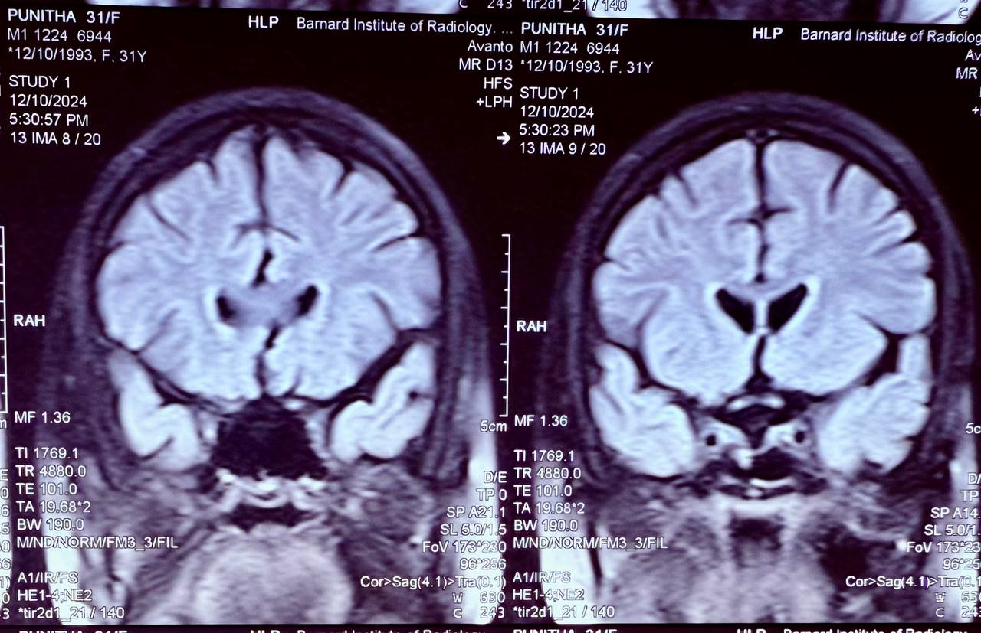
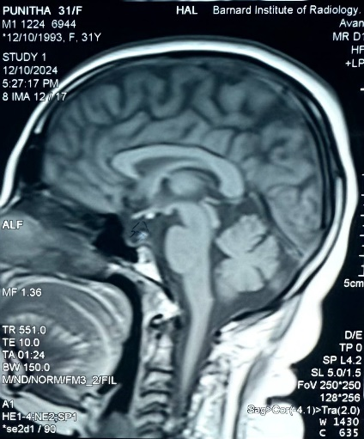
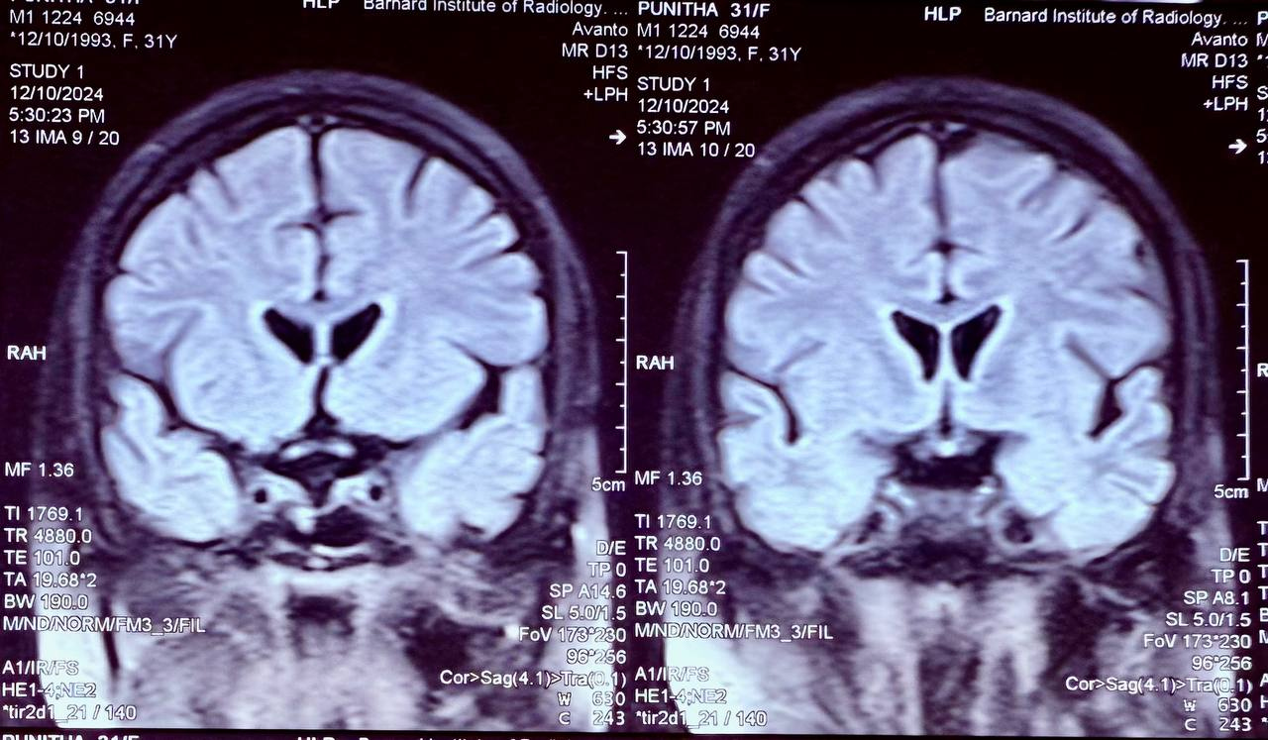

Fig. 2: Findings on pituitary magnetic resonance imaging(MRI) 2.1 sagittal T1W shows hypoplastic small anterior pituitary (yellow arrow),interrupted pituitary stalk(orange arrow), ectopic posterior pituitary (red arrow) ; 2.2 flair coronal T1WI hypoplastic anterior pituitary(red arrow); 2.3 flair coronal T1WI hypoplastic ectopic posterior pituitary(red arrow);

Source- Patient’s own MRI image

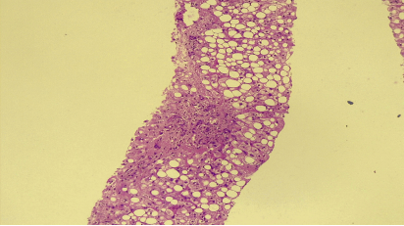
Fig. 3: Liver Biopsy. H&E stain: Deranged liver architecture with Hepatocytes showing severe macro vesicular hepatitis (black arrow)

Source- Patient’s own Liver biopsy Histopathology slide image

IMAGING MODALITIES:-
- USG ABDOMEN – Hepatomegaly with Grade III fatty liver, No free fluid ; Bilateral kidneys –normal size and echoes
- PORTAL VENOUS DOPPLER – Normal study
- CT ABDOMEN: Hepatomegaly with severe steatosis
Liver attenuation index – (-10) - (suggestive of moderate to severe steatosis)
- FIBROSCAN – Fibrosis grade F3 (10 kPa), CAP score- steatosis grade – S2 (266 dB/m)
- MRI PELVIS- Hypoplastic uterus & ovaries

- MRI BRAIN: Features suggestive of PSIS (absent pituitary stalk, hypoplasia of the anterior pituitary and an ectopic posterior pituitary) (Fig.2)

As all other causes of Acute hepatitis were ruled out, also patient fulfils the criteria for metabolic syndrome (increased waist circumference and triglycerides, low HDL) and imaging modalities revealed- severe hepatic steatosis, we proceeded for liver biopsy

LIVER BIOPSY:
Deranged liver architecture with hepatocytes showing severe macro vesicular steatosis (> 66%, score 3). On Masson trichrome, portal fibrosis with bridging septae & incomplete nodule formation +. Perl’s reaction (Iron)/ Rhodanine stain (copper) - negative (Fig.3).
Final report- Steatotic liver disease, Possibility of Non-alcoholic steato-hepatitis. NAS score: 6/8. Fibrosis score: F3(out of 4)

DIFFERENTIAL DIAGNOSIS
Getting into the causes of hepatitis, all common causes like viral infections, tropical illnesses, auto-immune hepatitis, Metabolic liver disease like Wilsons, hemochromatosis, alpha 1 antitrypsin deficiency were ruled out with the above investigation panel. Patient was diagnosed with new onset diabetes mellitus, dyslipidaemia (Metabolic syndrome) and anterior pituitary hormonal deficiency ( significantly cortisol levels were on the lower side). After this extensive workup, as patient did not have a history of diabetes or metabolic syndrome prior, following a thorough review of the literature to determine the underlying cause of severe hepatic steatosis and fibrosis in a young patient without traditional risk factors, we identified a direct relationship between pituitary stalk interruption syndrome and metabolic dysfunction-associated steato-hepatitis. Various novel mechanisms, including alterations in hepatic fat metabolism and insulin resistance, have been proposed to explain this association.The patient was ultimately diagnosed with Pituitary stalk interruption syndrome leading to metabolic dysfunction-associated steato-hepatitis (MASH)/Newly diagnosed Diabetes Mellitus

TREATMENT
The patient was initiated on thyroxine, corticosteroids, growth hormone, oral anti diabetic agents, and lipid-lowering therapy. Oestrogen and progesterone supplementation were deferred until resolution of the acute hepatitis.

OUTCOME AND FOLLOW-UP
With treatment, jaundice resolved completely by the second month and hormone therapy was fully optimized. The patient showed significant clinical improvement and has been kept under follow-up periodically screening her liver and hormonal parameters in an out-patient basis.

This case highlights a rare but critical cause of progressive liver disease, where timely hormone replacement therapy offers a unique opportunity to prevent cirrhosis and its complications at a young age. Routine monitoring of liver function and endocrine status is essential in patients with pituitary stalk interruption syndrome to facilitate early intervention

3. discussion

Pituitary Stalk Interruption Syndrome (PSIS) is a rare congenital anomaly with an incidence of 0.5 in 100,000 live births characterized by triad in MRI Brain such as thinning or disappearance of the pituitary stalk, anterior pituitary hypoplasia and an ectopic posterior pituitary ⁽¹⁾. The most common ectopic position is the median carina^{(2).} Perinatal adverse events such as breech delivery, hypoxia, dystocia (traumatic birth events) etc., may play a role in the occurrence and development of PSIS.
Genetic implications for PSIS have been found out. PSIS related gene mutations have been reported, including in HESX1, OTX2,SOX3, LHX4,PROP1, PROKR2, CDON, holoprosencephaly related gene TGIF, SHH, GPR161and ROBO1. It can also be due to a polygenic cause. Chromosome abnormalities like 18p deletion, 2p25 duplication, 2q37 deletion and 17q21.31 microdeletion have also been implicated.⁽¹⁾

CLINICAL FEATURES:-

PSIS in neonates can be manifested in form of Neonatal jaundice, hypoglycaemia and cryptorchidism or micropenis. Patients may present with isolated or combined anterior pituitary hormone deficiencies ⁽¹⁾ such as GH(most common), LH,FSH, ACTH, TSH presenting as dwarfism, absence of secondary sexual characteristics, adrenal insufficiency episodes, hypothyroidism etc.,⁽³⁾ The posterior pituitary gland generally has normal function and diabetes insipidus is rare. Some patients will get complicated with midline structural abnormalities and other cranio-facial malformation, such as corpus callosum atrophy, dysplasia of septum pellucidum, cleft lip, etc.,⁽²⁾ .On the other hand, patient can develop metabolic syndrome which would , further lead to MASH ⁽⁴⁾.

PSIS and MASH – Mechanisms:-(1,5)

Metabolic dysfunction-associated steatotic liver disease (MASLD) has become a prominent global health challenge. It is characterised by excess accumulation of hepatic lipids (hepatic steatosis), which can lead to inflammation (steato-hepatitis) and progressive fibrosis. Overlap between metabolic dysfunction-associated steato-hepatitis (MASH) and these endocrinopathies lead into the proposal of multiple novel mechanism which are explained as follows:-

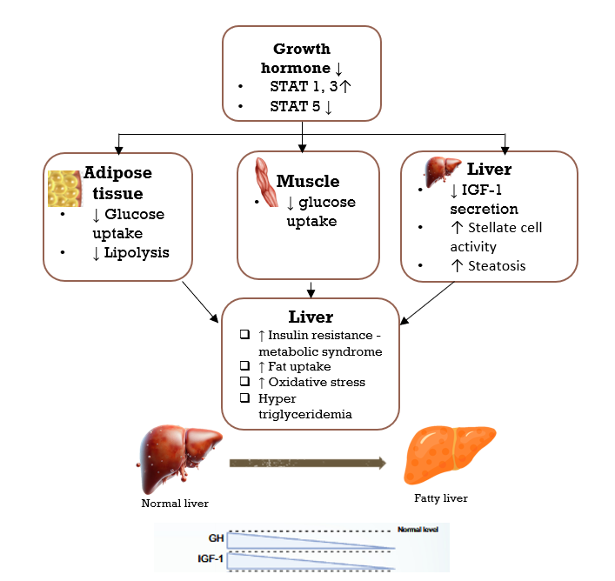
Growth Hormone(GH) and MASLD
Fig 4 – Growth Hormone and MASLD Mechanisms (self drawn using MS Powerpoint)

GH is produced in a pulsatile fashion by the anterior pituitary which in turn stimulates the production of IGF-1 via JAK2, STAT-5 primarily in hepatocytes(5). IGF-1 is responsible for reducing visceral fat, decreasing lipogenesis, improving insulin sensitivity, improves senescence of hepatic stellate cells- thereby reducing steatosis and fibrosis ^{(Fig- 4)}. Individuals with GH deficiency can progress into metabolic syndrome, insulin resistance, hepatic steatosis and progressively fibrosis. Ceramides inhibits Akt 2 phosphorylation and downstream insulin signalling, diacylglycerol activates protein kinase C – both being the key pathway for developing insulin resistance by increasing the oxidative stress ⁽⁶⁾

Thyroid hormone and MASLD
Fig 5- Thyroid hormone and MASLD mechanisms (self drawn using MS Powerpoint)

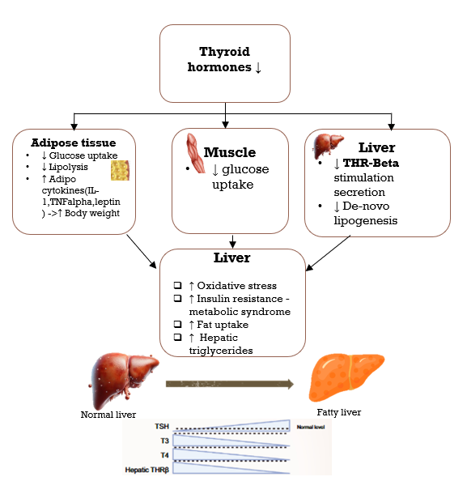
It has been reported that the prevalence of central hypothyroidism in patients with PSIS is 79.8 %, but another study found that only 5.6 % of PSIS patients with hypothyroidism have low TSH levels⁽¹⁾

Thyroid hormones are involved in various metabolic process including body fat distribution, lipid utilization and glucose homeostasis. Also, the THR- beta receptor present in liver is responsible for its action in the liver. Lower thyroxine levels, leads to decreased THR – beta stimulation(5), in turn leading to increased oxidative stress, fat uptake, metabolic syndrome leading to MASH which may further progress to MASLD and cirrhosis ^{(Fig -5)} . THR – Beta agonist – Resemitrom -recently FDA approved drug for MASH in 2024

Gonadal hormones and MASLD :-

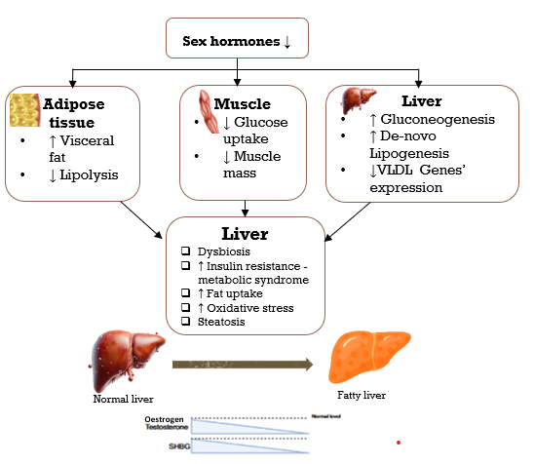

Fig 6 - Sex hormones and MASLD mechanisms (self drawn using MS Powerpoint)

Oestrogen plays an important role in hepatic lipid metabolism. Studies found that the prevalence of metabolic syndrome and MASLD in post- menopausal women has been increased. Hence, Oestrogen deficiency leads to decreased hepatic and muscle insulin sensitivity resulting in the progression of steatosis and further to CLD.

Androgen deficiency increases de-novo fat synthesis in liver and decreased expression of VLDL genes, thereby leading to steatosis. Also, it has an impact on intestinal microbiota such as increase in the ratio of firmicutes to bacteroides and an increase of lactobacillus species in the cecum. These microbes in the intestine maintains the Glucagon – like peptide-1 (GLP-1) levels thereby regulating insulin resistance⁽¹⁾. Decrease in these, can lead to metabolic syndrome further to MASLD ^{(Fig-6)}

OTHER HORMONES AND MASLD:- ^{(7,4,8–18)}

Prolactin has a positive effect on hepatic metabolism through PRL receptor mediated inhibition of fatty acid translocase/CD36. Its deficiency is associated with increase in CD 36 associated with development of insulin resistance progressing to steatosis ⁽¹⁾

Steroids use in the treatment of PSIS related MASLD is found to be a double-edged sword that increased or high dosage steroids itself has a probability of transforming to cirrhosis. So, the dosage must be titrated adequately & their liver chemistries must be monitored closely on a frequent basis.

MANAGEMENT:-
REPLACEMENT THERAPY:- ⁽²⁰⁾
The following are the recommended treatment modalities for this condition:

- ACTH deficiency:- Hydrocortisone – 10-20mg daily in divided doses, Cortisone acetate- 15-25 mg/day in divided doses

- TSH deficiency:- L-Thyroxine 0.05-2mg daily (according to T4 levels)

- FSH/LH deficiency:- Males—Testosterone enanthate 200mg IM every 2-3 weeks, Testosterone undecanoate 1000mg IM every 3-6 months, Testosterone skin patch 2.5-5 mg/day; Females- Oestradiol skin patch 4-8mg twice weekly, Oestradiol gel, Conjugated oestrogen 0.65mg daily, Micronized oestradiol 1mg daily, Oestradiol valerate 1-2mg

- For fertility – Males :- hCG three times weekly, or hCG + FSH or Menopausal gonadotropin or GnRH / Females :- Menopausal gonadotropin ,hCG or GnRH

- GH deficiency :- Adults- Somatotropin 0.2-1mg S.C daily, Children- Somatotropin 0.02-0.05 mg/kg/day

- THR – BETA AGONIST – RESEMITROM -recently FDA approved drug for MASH in 2024

Clinical trials of MASH -FGF 19 ANALOG – ALDAFERMIN,PPAR AGONIST- LANIFIBRANOR, ELAFIBRANOR,GLP-1 AGONIST- LIRAGLUTIDE, SEMAGLUTIDE, CCR 2/5 INHIBITOR – CENICRIVIROC, FXR AGONIST – TROPIFEXOR, CILOFEXOR (The above drugs are under phase 2 clinical trials for MASH)

CONCLUSION:-
- Panhypopituitarism can present with or exacerbate MASH, and should be considered in patients with unexplained hepatic steatosis, especially when accompanied by features of pituitary hormone deficiencies.
- Common causes of hepatitis, including viral, autoimmune, and metabolic aetiologies, must be thoroughly excluded before attributing liver dysfunction to endocrine causes like panhypopituitarism.
- Timely initiation of tailored hormone replacement therapy is essential, as it not only addresses systemic symptoms but may also halt or reverse hepatic injury progression in MASH associated with endocrine dysfunction.
- Liver function monitoring should be part of routine follow-up in patients with panhypopituitarism, particularly in those with risk factors for metabolic dysfunction or evidence of hepatic involvement.

Consent:

All authors declare that ‘written informed consent was obtained from the patient (or other approved parties) for publication of this case report and accompanying images. A copy of the written consent is available for review by the Editorial office/Chief Editor/Editorial Board members of this journal

Ethical approval:

All authors hereby declare that "Principles of laboratory animal care" (NIH publication No. 85-23, revised 1985) were followed, as well as specific national laws where applicable

ABBREVIATIONS:-
PSIS- Pituitary Stalk Interruption Syndrome
MASLD- Metabolic dysfunction-associated steatotic liver disease
STAT- Signal Transducer and Activator of Transcription
HRT- Hormone Replacement Therapy
GH- Growth Hormone
LH- Luteinizing hormone
FSH- Follicle Stimulating Hormone
ACTH- Adrenocorticotropic hormone
TSH- Thyroid Stimulating hormone
THR- Thyroid hormone receptor
IGF- Insulin like Growth factor -1
THR- Thyroid hormone receptor
JAK- Janus Kinase
CLD- Chronic Liver Disease
GLP- Glucagon – like peptide-1
VLDL- Very low-density lipoprotein
FGF-19- Fibroblast growth factor
CCR- Chemokine receptor
FXR – Farnesoid X Receptor
GnRH- Gonadotropin Releasing Hormone
hCG- Human Chorionic Gonadotropin
F/S/O- Features suggestive of
WNL- Within Normal Limits
H & E- Haematoxylin and Eosin Stain
NAS score - Non-alcoholic fatty liver disease score
CAP- Controlled attenuation parameter

Disclaimer (Artificial intelligence)
Option 1:
Author(s) hereby declare that NO generative AI technologies such as Large Language Models (ChatGPT, COPILOT, etc.) and text-to-image generators have been used during the writing or editing of this manuscript.
Option 2:
Author(s) hereby declare that generative AI technologies such as Large Language Models, etc. have been used during the writing or editing of manuscripts. This explanation will include the name, version, model, and source of the generative AI technology and as well as all input prompts provided to the generative AI technology
Details of the AI usage are given below:
1.
2.
3.

REFERENCES:-
1. Wu ZY, Li YL, Chang B. Pituitary stalk interruption syndrome and liver changes: From clinical features to mechanisms. WJG. 2020 Nov 28;26(44):6909–22.
2. Chang M, Wang SY, Zhang ZY, Hao HX, Li XG, Li JJ, et al. Pituitary stalk interruption syndrome complicated with liver cirrhosis: A case report. World J Hepatol. 2024 Nov 27;16(11):1348–55.
3. Zhang W, Qian F, Lu G, Wu Y, Li R, Xia L, et al. Pituitary stalk interruption syndrome. Medicine (Baltimore). 2020 Dec 11;99(50):e23266.
4. Guo Q, Zhao J, Yu S. Clinical Features and Analysis in Pituitary Stalk Interruption Syndrome. International Journal of Endocrinology. 2024 May 24;2024:1–10.
5. Hutchison AL, Tavaglione F, Romeo S, Charlton M. Endocrine aspects of metabolic dysfunction-associated steatotic liver disease (MASLD): Beyond insulin resistance. Journal of Hepatology. 2023 Dec;79(6):1524–41.
6. Gariani K, Jornayvaz FR. Pathophysiology of NASH in endocrine diseases. Endocrine Connections. 2021 Feb 1;10(2):R52–65.
7. Kanamoto M, Hinohara H, Saito S. A Case of Hypopituitarism Complicated by Non-Alcoholic Steatohepatitis and Severe Pulmonary Hypertension. Am J Case Rep [Internet]. 2021 Jan 4 [cited 2025 Feb 13];22. Available from: https://www.amjcaserep.com/abstract/index/idArt/928004
8. Dufour JF, Anstee QM, Bugianesi E, Harrison S, Loomba R, Paradis V, et al. Current therapies and new developments in NASH. Gut. 2022 Oct;71(10):2123–34.
9. Méndez-Sánchez N, Cerda-Reyes E, Higuera-de-la-Tijera F, Salas-García AK, Cabrera-Palma S, Cabrera-Álvarez G, et al. Dyslipidemia as a risk factor for liver fibrosis progression in a multicentric population with non-alcoholic steatohepatitis. F1000Res. 2020 Jan 28;9:56.
10. Deprince A, Haas JT, Staels B. Dysregulated lipid metabolism links NAFLD to cardiovascular disease. Molecular Metabolism. 2020 Dec;42:101092.
11. Martin A, Lang S, Goeser T, Demir M, Steffen HM, Kasper P. Management of Dyslipidemia in Patients with Non-Alcoholic Fatty Liver Disease. Curr Atheroscler Rep. 2022 Jul;24(7):533–46.
12. Gonzalez Rozas M, Hernanz Roman L, Gonzalez DG, Pérez-Castrillón JL. Panhypopituitarism due to Absence of the Pituitary Stalk: A Rare Aetiology of Liver Cirrhosis. Case Reports in Endocrinology. 2016;2016:1–5.
13. Gosi SK, Kanduri S, Garla VV. Pituitary stalk interruption syndrome. BMJ Case Rep. 2019 Apr;12(4):e230133.
14. Mabreh LQ, Al Rabab’ah AM. Pituitary stalk interruption syndrome (PSIS) presenting in a Jordanian male patient with short stature and delayed puberty: a case report. Egypt J Radiol Nucl Med. 2023 Mar 21;54(1):56.
15. Agha M, Sallam MSM, Abougabal AM, Abdelgawad MS. Pituitary stalk interruption syndrome (PSIS): do not miss this diagnosis. Egypt J Radiol Nucl Med. 2022 Aug 25;53(1):192.
16. Liu Z, Zhao W, Cao C, Wang Y, Xiao L, Wang X, et al. Pituitary stalk interruption syndrome and liver cirrhosis associated with diabetes and an inactivating KCNJ11 gene mutation: a case report and literature review. Front Endocrinol. 2023 Dec 13;14:1297146.
17. Ram N, Ali SA, Hussain SZ. Pituitary stalk interruption syndrome presenting as short stature: a case report. J Med Case Reports. 2014 Dec;8(1):445.
18. Ziad A, Khan Q, Farooq H, Rehman A, Siddique K. Pituitary Stalk Interruption Syndrome: A Case Report. Cureus [Internet]. 2022 Oct 12 [cited 2025 Feb 13]; Available from: https://www.cureus.com/articles/117400-pituitary-stalk-interruption-syndrome-a-case-report
20. Williams, Robert Hardin. 2020. Williams Textbook of Endocrinology. Edited by Shlomo Melmed, Richard J. Auchus, Allison B. Goldfine, Ronald Koenig, and Clifford J. Rosen. 14th edition. Philadelphia, PA: Elsevier. https://www.clinicalkey.com.au/dura/browse/bookChapter/3-s2.0-C20160054128. Chapter 8, Pg-235

