Case Report of Malattia leventinese Complicated by Choroidal Neovascularization: A Genetic Perspective

ABSTRACT
Malattia Leventinese (ML) is an autosomal dominant macular dystrophy with a homogeneous genetic makeup. From an ophthalmic perspective, it can be identified by a radial arrangement of parapapilla deposits, also known as Forni's verrucosities, and by drusen-like deposits in the macula.

KEYWORDS: Malattia Levenetinese, dominant familial drusen, choroidal neovascularisation, macular oct, anti vegf injections

INTRODUCTION
The dominantly hereditary macular dystrophy known as Malattia Leventinese (ML) is typified by a radial pattern of drusen in the macular region and on the nasal edge of the optic disc. In 1925 Vogt noted this particular kind of inherited drusen in a Swiss family residing in the Leventine valley [1]. A honeycomb-like appearance may result from increased confluence of these drusen [2]. A mutation in the EFEMP1 gene is the primary cause of inherited ML in most cases [2].
The majority of young adults maintain good eyesight and continue to be asymptomatic into their forties, despite the drusen present early in life. Choroidal neovascularization and regional atrophy may result from the disease's progression. Age-related macular degeneration (AMD), the most prevalent cause of vision loss in developed countries, and ML have similar characteristics.
CASE PRESENTATION
A 34-year-old emmetropic healthy female was referred by her primary ophthalmologist with the suspected diagnosis of multiple evanescent white dot syndrome (MEWDS). On presentation visual acuity was 10/10 OD and counting fingers OG. She was complaining from central scotoma preceeded by photopsia and metarmophopsia in left eye and she reported that her grandfather and one of her uncles had vision loss early in their lifes. Intraocular pressures were 14mmHg bilaterally. Slit-lamp biomicroscopy was unremarkable. Fundus examination revealed multiple yellow whitish deposits in the macular region and around the optic nerve extending to the mid-periphery in left eye, drusenoid deposits are present at the posterior pole, peripapillary area, center of the macula, and along vascular arcades. The deposits are radially elongated" or "honeycomb pattern" small drusen, but some are larger and more confluent. There was no pigmentary changes. In addition, there was subretinal hemorrhage with aspect of chorroidal neovascularisation in the left eye. The peripheral fundus exam was normal in both eyes (FIGURE 1).
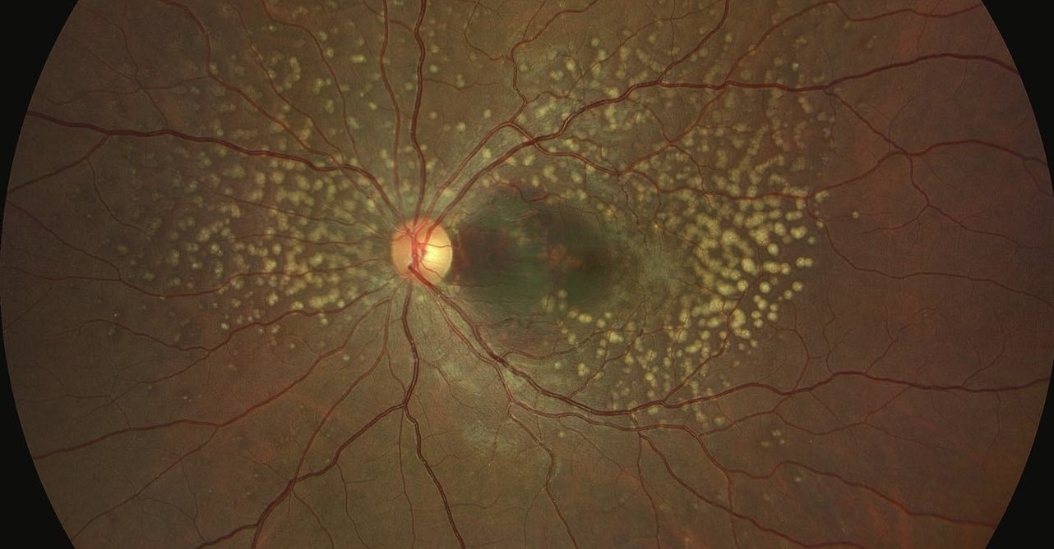
FIGURE 1: Fundoscopic examination of the left eye, note the with yellowish deposits avoiding the foveal region and the submacular hemorrage caused by CMNV
the macular octa of the left eye finds nodular deposits above the pigment epithelium with the presence of several areas of pigmented epithelium localised detachment with a huge PED caused by CMNV with hyporeflective hemorrhage and the presence of a few reticulated intraretinal deposits and a few areas of macular edema. FIGURE 2
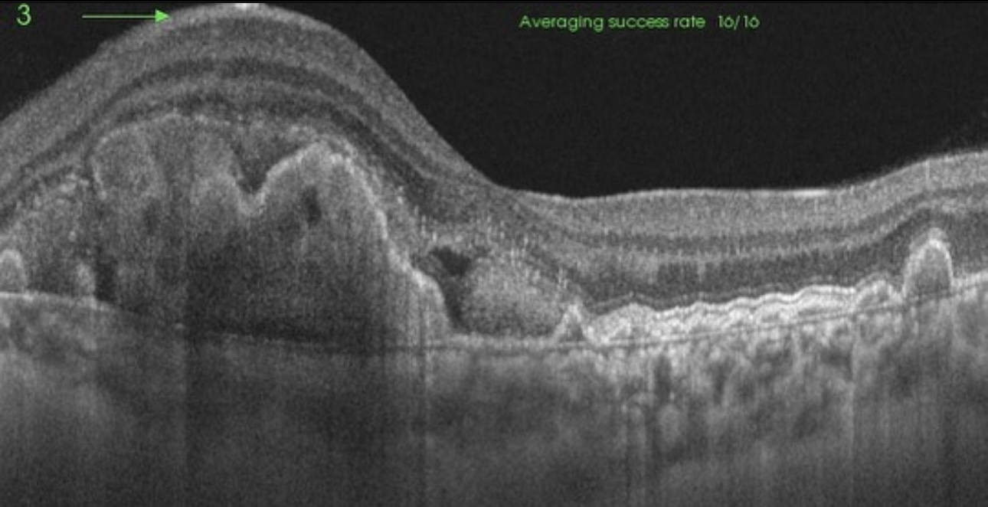
FIGURE 2: macular oct of left eye showing the pigment epithelium multiple detachment with hyperreflective hemorrhage and deposits below the PE
Given the aspect of the fundoscopic lesions and the age of the patient the diagnosis of Dominant Drusen or Doyne Honeycomb retinal dystrophy complicated with choroidal macular neovascularisation was approved after genetic testing to prove a EFEMP1 mutation and the patient went under 3 injections of anti-VEGF with good response and the visual acuity upgraded to 5/10 with regression of CMNV and hemorrhage in the macular oct after 3 months (FIGURE 3).
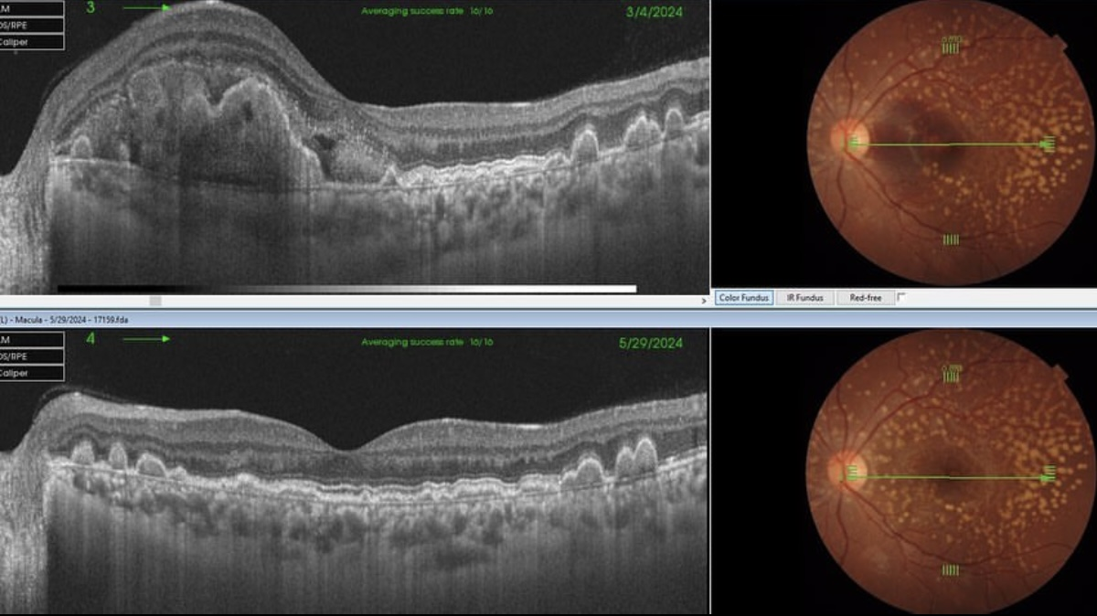
FIGURE 3 : regression of the CMNV and the hemorrage after 3 ANTI VEGF INJECTIONS

DISCUSSION
Doyne first reported the phenotypic characteristics of Doyne Honeycomb Retinal Dystrophy (DHRD) in four sisters in England in 1899[3]. He discovered that all of them had early-onset retinal dystrophies, which he named the "Honeycomb" pattern because of the closely spaced white lesions in the macula and disc area. The term Malattia Leventinese (MLVT) was first used in 1925 when Vogt reported a comparable phenotypic picture in a group of probably related individuals in the Leventine Valley of Switzerland [4]. For a while, ophthalmologists suspected that the two independently described entities probably referred to the same disease because of their similarities. In 1996, chromosomal 2 abnormalities were linked to both DHRD and MLVT; MLVT patients had this mapping done by Heon in 1996[5], and DHRD patients shortly after by Gregory (6). Despite this 1996 revelation, there was still speculation that the two illnesses might be distinct organisms. We currently regard DHRD and MLVT to be the same clinical entity since, in 1999, Stone et al. [2] found a single mutation in the EFEMP1 gene on chromosome 2 in both families with DHRD and MLVT. This finding confirmed that the two were minor phenotypic variations of the same disease.
By demonstrating that mice with an EFEMP1 R345W knockdown develop deposits between Bruch's membrane and the retinal pigment epithelium (RPE), Fu et al. (2007) (7) established the pathogenicity of the EFEMP1 mutation.
Diagnosis of Doyne Honeycomb Retinal Dystrophy is made clinically and must be confirmed with genetic testing to prove a EFEMP1 mutation.
Because of its many similarities to age-related macular degeneration (AMD), the most common cause of blindness in developed nations (Edwards et al., 1998; Wong et al., 2014) (8), DHRD/ML has drawn particular attention from researchers. While variations in extracellular matrix proteins have been documented, retinal drusen remains a characteristic of both DHRD/ML and AMD (Sohn et al., 2015). As of right now, no EFEMP1 mutation has been linked to AMD patients (Stone et al., 1999) (2).

There are no established guidelines for either medical or surgical care in DHRD/ML. The majority of current research is based on interventional case reports that suggest slight benefits from therapy with subthreshold nanolasers (Cusumano et al., 2019) and argon lasers (Lenassi et al., 2013). Administration of anti-VEGF (bevacizumab) has been tried in DHRD/ML when complicated by CNV development, suggesting some beneficial effect (Sohn et al., 2011). This is based on the experience in treating neovascular AMD (Lin & Rosenfeld, 2007). Three anti-VEGF treatments were administered in left eye in this instance, with improvement in visual acuity and a change in the retinal condition that were noted.
CONCLUSION
To the best of our knowledge, this is the first case of DHRD/ML in Morocco that has been confirmed by molecular genetics. All of the cases in the original investigation by Stone et al. (1999) showed evidence of a common ancestor; however, haplotype comparison indicated a de novo mutation in our index, even if parental data are still unknown.
Disclaimer (Artificial intelligence)
Option 1:
Author(s) hereby declare that NO generative AI technologies such as Large Language Models (ChatGPT, COPILOT, etc.) and text-to-image generators have been used during the writing or editing of this manuscript.
Option 2:
Author(s) hereby declare that generative AI technologies such as Large Language Models, etc. have been used during the writing or editing of manuscripts. This explanation will include the name, version, model, and source of the generative AI technology and as well as all input prompts provided to the generative AI technology
Details of the AI usage are given below:
1.
2.
3.
REFERENCES :

1. Klainguti R. Die Tapeto-retinal degeration im Kanton Tessin. Klin Monatsbl Augenheilkd 1932;3:89253±89254.
2. Stone E, Lotery A, Murnier F, et al. A single EFEMP1 mutation with both malattia leventinese and Doyne honey comb retinal dystropohy. Nat Genet 1999;22:199±202.
3-Doyne, R.W. Peculiar condition of choroiditis occurring in several members of the same family. Trans. Ophthalmol. Soc. UK 19, 71 –71 (1899).
4- Vogt, A. in Handbuch der gesammten Augenheilkunde. Untersuchungsmethoden (eds Graefe, A. & Saemisch, T.) 1–118 (Verlag von Wilhelm Engelman, Berlin, 1925).
5- Héon, Elise, et al. "Linkage of autosomal dominant radial drusen (malattia leventinese) to chromosome 2p16-21." Archives of ophthalmology 114.2 (1996): 193-198.
6- Gregory, Cheryl Y., et al. "The gene responsible for autosomal dominant Doyne's honeycomb retinal dystrophy (DHRD) maps to chromosome 2p16." Human molecular genetics 5.7 (1996): 1055-1059.
7-Fu, L. I., Garland, D., Yang, Z., Shukla, D., Rajendran, A., Pearson, E., Stone, E. M., Zhang, K., & Pierce, E. A. (2007). The R345W mutation in EFEMP1 is pathogenic and causes AMD- like deposits in mice. Human Molecular Genetics, 16(20), 2411– 2422. https:// doi.org/10.1093/hmg/ddm198
8- Wong, W.L,Su,X.,Li, X.,Cheung, C.M.,Klein, R.,Cheng, C.Y., Wong,T.Y. (2014). Global prevalence of age-related macular degeneration and disease burden projection for 2020 and 2040: A systematic review and meta-analysis. The Lancet Global Health, 2(2), e106-e116.
9-Cusumano, A., Falsini, B., Giardina, E., Casce lla, R., Sebastiani, J., & Marshall, J. (2019). Doyne honeycomb retinal dystrophy – Functional improvement following subthreshold nanopulse laser treatment: A case report. J Med Case Rep, 13(1), 5. https://doi. org/10.1186/s13256-018-1935-1
10-Lenassi, E., Troeger, E., Wilke, R., Tufail, A., Hawlina, M., Jeffery, G., & Webster, A. R. (2013). Laser clearance of drusen deposit in pa tients with autosomal dominant drusen (p.Arg345Trp in EFEMP1). American Journal of Ophthalmology, 155(1), 190– 198. https:// doi.org/10.1016/j.ajo.2012.07.003

