**Nutrient Dynamics in The Coastal Waters Off Padubidri, Karnataka, West Coast of India**

**ABSTRACT**

|  |
| --- |
| **Aim:** Study of nutrient input into the Arabian sea in relation to various environmental parameters  **Study design:** A stratified random sampling technique was used to conduct monthly in-situ sampling at seven selected stations.  **Place and duration of study:** Study was conducted along Padubidri coast from January, 2023 to December, 2024.  **Methodology:** Surface water samples were collected monthly from the coastal waters of Padubidri to evaluate several physicochemical properties. Air and surface water temperatures and transparency were measured at the sampling location using a mercury-in-glass centigrade thermometer and Secchi disc, respectively. At the same time, the analysis of the remaining parameters was conducted in the laboratory according to standard procedures. Water samples for dissolved oxygen analysis were collected in 125-ml glass bottles and preserved on the field using Winkler's reagents. Surface water samples for nutrient analysis were collected in clean polythene bottles, promptly placed in an icebox and transferred to the laboratory for further analysis.  **Results:** Surface water samples were collected monthly using a stratified random sampling method at seven stations and analysed for water temperature (28.39-33.24 oC), transparency (1.56-5.30 m), pH (7.37-8.20), salinity (26.64-38 psu), dissolved oxygen (4.43-7.43 mg/l), BOD (1.37-2.78 mg/l), TDS (31874.29-0525.71 mg/l) and TSS (131.14-577.14 mg/l) and nutrients including ammonia (1.49-13.73 µg-at/l), nitrite (0.56-2.72 µg-at/l), nitrate (0.73-3.81 µg-at/l), phosphate (0.87-4.35 µg-at/l) and silicate (13.07-82.80 µg-at/l). The findings underscore the influence of physicochemical dynamics on coastal water quality and provide a valuable baseline for assessing ecological health and managing coastal resources in monsoon-affected tropical regions. Correlation coefficient revealed positive as well as negative relationship between environmental variables and nutrient at 95 % (*p*<0.05) level of significance.  **Conclusion:** Results revealed seasonal fluctuations in environmental and nutrient parameters, driven by natural climatic cycles and runoff patterns. |

*Keywords: Nutrient dynamics, Environmental variables, Correlation, Coastal waters.*

1. **INTRODUCTION**

Estuaries and coastal seas serve as a dynamic interface between land and the open ocean, essential in marine biogeochemical processes and coastal productivity. Coastal marine ecosystems comprise around 7% of the world's ocean surface area yet contribute 30% of total net primary output (Borges, 2005; Bouillon et al., 2008). Population growth and rapid development put additional strain on coastal marine habitats, which again polluted by anthropogenic sources such as river discharge, wastewater discharges, fertilizer runoff from lawns and agricultural fields etc. Coastal waters are becoming increasingly nutrient-rich (Howarth and Marino, 2006; Ramesh et al., 2015; Hollister et al., 2013). Nutrients are crucial for primary productivity and play a significant role in the food web dynamics in the aquatic environments (Mackey et al., 2010; Lee et al., 2015). Their distribution and availability influence all aspects, from microscopic plankton proliferation to global climate regulation. Nutrients like nitrogen and phosphorus are essential for photosynthesis and cellular functions in phytoplankton, which constitute the foundation of marine food webs. Nitrogen facilitates protein synthesis, but phosphorus is crucial for energy transfer (ATP) and genetic material (DNA/RNA). Over the past three decades, a massive rise in anthropogenic nutrient loads (viz., nitrogen, phosphate, silicate, etc.) to the coastal areas has been reported (Conley, 1999; Conley et al., 2009). As a result of fertilizer inputs to coastal waters, which may contain hazardous elements such as heavy metals lead to growth of hazardous algal blooms in the aquatic environment as well as accumulate into aquatic organisms (Anderson et al., 2002; Smayda, 1990; Sikoki et al., 2021).

Aside from anthropogenic inputs, coastal waters receive nutrients through a variety of physical processes such as coastal upwelling, convective mixing, organic matter decomposition, nitrogen fixation by specific bacteria and algae, drainage basin mineralogy, dust deposition, and so on (Bakun, 1990; Madhupratap et al., 1996; Naqvi et al., 2000; Prasanna Kumar et al., 2004). The sources of nutrients to coastal marine environments are thus both natural and anthropogenic processes (Paerl, 1997); assessing nutrient fluxes into coastal waters and their impact on the spatial dynamics of nutrients and coastal productivity is a highly complex task (Dehairs et al., 2000; Talaue McManus et al., 2001). Compared to temperate regions, most tropical marine habitats are heavily influenced by anthropogenic loadings. Although nutrient inputs to coastal waters are rising globally, South Asian countries have been identified as the largest providers of inorganic nitrogen and phosphorus inputs (Seitzinger et al., 2010). India has the world's highest population and is one of the fastest-developing countries. Hence, the coastal waters of India could be very prone to eutrophication.

The Southwest coast of India is experiencing increased human activities such as fast urbanization, industrialization, and many engineering interventions, and the neighbouring coastal waters receive anthropogenic runoff through 22 rivers/rivulets distributed along the coast. The addition of nutrients from runoff in coastal waterways alters the dynamics of the surrounding environment. In order to preserve the quality of the water, several areas have laws restricting the release of nutrients. Monitoring makes ensuring that these guidelines are followed, which helps to stop pollution from urban, agricultural, and industrial sources. The southeastern Arabian Sea coastline spans approximately 1200 km (from Goa to Kanyakumari, 7°N to 14°N), serving as an upwelling zone during the southwest monsoon (June to September) and a convective mixing zone during the northeast monsoon (Naqvi et al., 2000; Prasanna Kumar et al., 2004). The semi-annual reversal of coastal currents in this area introduces a high degree of seasonal variability in the physico-chemical dynamics (Naqvi et al., 2000; Naqvi et al., 2006). Several studies have been conducted in India's southwest estuaries and coastal waters. Still, the majority of them were focused on the distribution of plankton communities, nutrients, and carbon dynamics during the southwest monsoon (peak discharge period) (Prasanna Kumar et al., 2004; Madhu et al., 2010; Lallu et al., 2014; Gupta et al., 2016). However, no comprehensive research has been conducted on estuarine flow and nutrient fluxes, nutrient dynamics, and primary production throughout India's southwest coast during the northeast monsoon. For the first time, we evaluated the input flux of dissolved inorganic nutrients from different water sources to the southeastern Arabian Sea for two years and their impact on nutrient dynamics in coastal waters.

1. **MATERIALS AND METHODS**
   1. **STUDY AREA**

The study area (Latitude 13o 7' 21.01" N and Longitude 74o 43' 10.20" E) is located in the Udupi district of Karnataka. With three distinct seasons and an average annual air temperature of 30.12 oC, the area has a tropical climate influenced by the southwest monsoon. The surrounding runoff significantly impacts the quality of the coastal water, particularly during certain seasons. Generally, the monsoon season lasts from June to September, the post-monsoon season lasts from October to January, and the pre-monsoon season lasts from February to May. The coastal waters support the abundance of various benthic flora and fauna. A stratified random sampling technique was used to conduct monthly in-situ sampling at seven selected stations from January 2023 to December 2024, except for the monsoon season (from June to September).

|  |
| --- |
|  |
| **Plate 1: Map showing sampling stations** |

* 1. **SAMPLE COLLECTION AND ANALYSIS**

Surface water samples were collected monthly from the coastal waters of Padubidri during two years, from January 2023 to December 2024, to evaluate several physicochemical properties. Air and surface water temperatures and transparency were measured at the sampling location using a mercury-in-glass centigrade thermometer and Secchi disc, respectively. At the same time, the analysis of the remaining parameters was conducted in the laboratory according to standard procedures (Parsons et al., 1984). Water samples for dissolved oxygen analysis were collected in 125-ml glass bottles and preserved on the field using Winkler's reagents. Water samples for determining Ammonia-Nitrogen (NH3-N) were collected in 125 ml amber glass bottles and processed using phenol-hypochlorite (Strickland and Parsons, 1972). Surface water samples for nutrient analysis were collected in clean polythene bottles, promptly placed in an icebox, and transferred to the laboratory. The water samples were filtered and analysed for Nitrite-Nitrogen (NO2-N), Nitrate-Nitrogen (NO3-N), Phosphate-Phosphorus (PO4-P), and Silicate-Silicon (SiO2-S) using standard methods (Strickland and Parsons, 1972). The absorbance for various parameters was quantified using a UV-VIS spectrophotometer. The correlation coefficient was calculated to understand the relationship between environment variable and nutrient parameters.

1. **RESULTS AND DISCUSSION**

**3.1 Fluctuation in Physicochemical properties**

Environmental variables are regarded as one of the most essential features capable of altering the marine environment, and there have been significant temporal and regional variances. Environmental factors, including air temperature, water temperature, transparency, pH, salinity, dissolved oxygen, biological oxygen demand (BOD), total dissolved solids (TDS), and total suspended solids (TSS), influence the diversity and distribution of living organisms.

**3.1.1 Air and water temperature**

The temperatures of the Air and water (Figures 1A and 1B) varied from 28.39 to 33.24 oC and 27.33 to 34.34 oC, respectively. The air temperature reached its minimum in January 2024 (27.33 oC) and its maximum in May 2024 (34.34 oC). The maximum water temperature was observed in November 2023 (33.24 oC), while the minimum occurred in January 2024 (28.39 oC). Many researchers have recorded the fluctuations in air temperature around the Indian coastline. Jasmine et al. (2015) reported that the air temperature varies from 27.0 to 33.5 °C. According to Sekar et al. (2012), seasonal air temperatures recorded off the coast of Tamil Nadu were 32.1 °C during the pre-monsoon season and 26.2 °C during the monsoon season. Likewise, Gopalakrishnan (1970), Philip (1970), and Ajin et al. (2014) recorded differences in air temperature over the West Coast, ranging from 19.9 to 30.4 oC, 32.8 oC, and 28 to 33 oC, respectively. The water temperature is perfectly proportional to the air temperature. The alteration in water temperature may be ascribed to the variation in air temperature.

**3.1.2 Transparency**

The water transparency ranges between 1.56 and 5.30 m (Figure 1C). The peak transparency value was recorded in April 2023 (5.30 m), whereas the lowest was noted in May 2024 (1.56 m). Ratnam et al. (2022) recorded the variation in transparency ranging between 3.15 and 7.39 m while researching along the Andhra Pradesh coast. Kim et al. (2015) reported mean transparency (3 ± 2 m) along the Korean Peninsula. Similarly, Yang et al. (2022) observed that the transparency value varied between 0.15 and 1.87 m along Jiaozhou Bay, China. Water clarity is directly correlated with total suspended solids. The increased concentration of suspended particles in the water in May 2024 due to terrestrial runoff could have diminished clarity.

**3.1.3 Water pH**

The month-wise water pH fluctuated between 7.37 and 8.20 (Figure 1D). The highest pH was reported in February 2024 (8.20), while the minimum occurred in November 2024 (7.37). The seasonal temperature fluctuations and elevated concentrations of dissolved inorganic substances in marine waters during February 2024 may influence the solubility of gases such as carbon dioxide, with higher temperatures resulting in

decreased dissolved carbon dioxide and increased pH levels. Lingadhal et al. (2023) documented the variance in water pH (8.0 to 8.6) in the nearshore waters of the southwest coast. Balakrishnan et al. (2017) 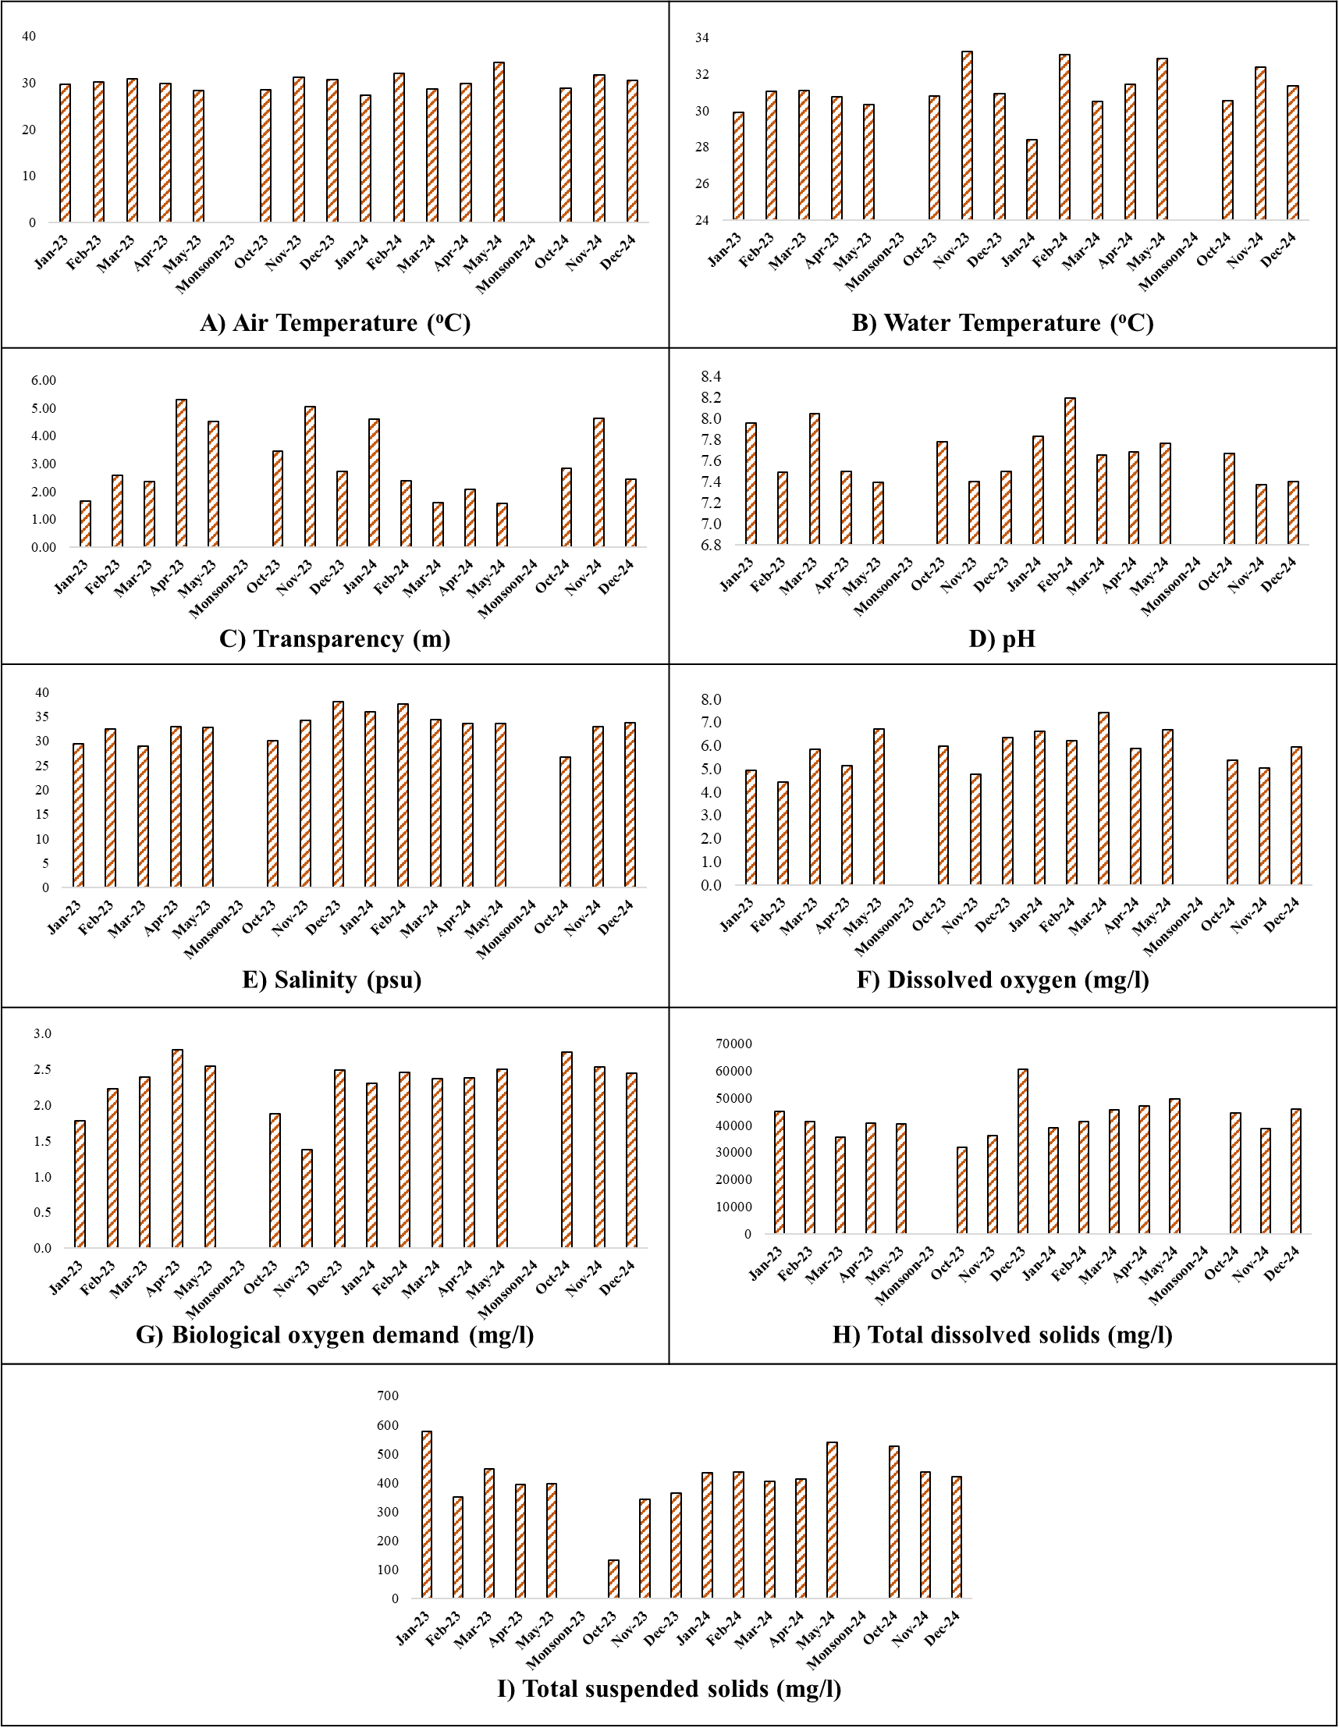found that the water pH varied from 8.0 to 8.5 along the coastal waters of Tamil Nadu.

**Figure 1: Graphical presentation of physicochemical properties of coastal waters recorded during the study**

**3.1.4 Salinity**

The monthly mean salinity ranged between 26.64 and 38.00 psu (Figure 1E). The maximum salinity was measured in December 2023 (38.00 psu), while the minimum salinity was measured in October 2024 (26.64 psu). According to a study, species diversity declined as salinity rose in nine coastal lakes near the southern Baltic Sea. However, particular diversity metrics suggested slight positive trends that lacked statistical significance (Mrozińska et al., 2021). According to Balakrishnan et al. (2017), the salinity of Tamil Nadu's coastal waters varied from 26.1 to 36.2 psu. Jasmine et al. (2015) reported that water salinity ranged between 34 and 34.8 psu from Gopalpur to the Machilipatanam shoreline along the east coast. According to Sekar et al. (2012), the water salinity along Tamil Nadu's coast varied from 33 to 34.3 psu.

**3.1.5 Dissolved Oxygen**

The concentration of DO in coastal waters is governed by various factors like temperature, organic matter degradation, primary production, respiration, etc. (Gupta et al., 2016; Sarma et al., 2013). The monthly dissolved oxygen ranged between 4.43 and 7.43 mg/l (Figure 1F). The highest level of dissolved oxygen was measured in March 2024 (7.43 mg/l), while it was lowest in February 2023 (4.43 mg/l). The lower dissolved oxygen levels in February may result from seasonal phenomena and oceanic circulations.

Additionally, several factors, such as the influence of elevated water temperatures on dissolved oxygen levels and the propensity of warmer water to exhibit increased buoyancy, inhibit the mixing of oxygen-rich surface water with deeper, oxygen-poor seas. Seasonal fluctuations in the dissolved oxygen level of Karnataka's nearshore waters were noted by Lingadhal et al. (2023). According to Balakrishnan et al. (2017), the dissolved oxygen content of Tamil Nadu's coastal waters varied from 4.125 to 4.963 mgl-1. According to Gopalakrishnan (1970), the dissolved oxygen value along the Okha coast ranged from 5.3 to 6.7 mgl-1 along the west coast.

**3.1.6 Biological Oxygen Demand (BOD)**

The biological oxygen demand (BOD) ranged between 1.37 and 2.78 mg/l (Figure 1G). The maximum BOD value was reported in April 2023 (2.78 mg/l), while the least was in November 2023 (1.37 mg/l). High BOD levels indicate significant organic pollution, leading to oxygen depletion as microbial decomposition consumes dissolved oxygen (DO). This oxygen stress creates hypoxic conditions (<2 mg/L DO), which restructure benthic communities through selective survival and migration (Levin et al., 2009).

**3.1.7 Total Dissolved Solids**

Total Dissolved Solids (TDS) affect marine benthic ecosystems by modifying water chemistry, osmotic equilibrium, and habitat appropriateness, with effects differing according to ionic composition and concentration. The monthly dissolved solids varied between 31874.29 and 60525.71 mg/l (Figure 1H). The highest total dissolved solids were measured in December 2023 (60525.71 mg/l), whereas the lowest were in October 2023 (31874.29 mg/l). Amaral *et al.* (2023) recorded the variation in TDS level from 119.2 to 586.9 μM along the coastal waters off Spain. The effects of TDS on benthic organisms could differ regionally depending on local environmental parameters such as temperature, salinity and depth. Investigations have indicated that different areas may exhibit diverse sensitivities to TDS changes, stressing the need for specialized investigations when addressing ecological effects (Adjovu *et al.,* 2023; Yousef, 2022). High salinity in December 2023 could be the cause of high TDS value. A high salinity level correlates precisely with a high TDS concentration in coastal regions. Essentially, the higher the concentration of dissolved salts (salinity) in the water, the higher the dissolved solids (TDS) level, owing to the considerable contribution of salt ions.

**3.1.8 Total Suspended Solids**

The total suspended solids (TSS) varied between 131.14 and 577.14 mg/l (Figure 1I). Maximum TDS was observed in January 2023 (577.14 mg/l), while the minimum TDS was in October 2023 (131.14 mg/l). Total Suspended Solids (TSS) considerably influence benthic ecosystems by modifying light penetration, sediment movements, and water chemistry, which shape habitat appropriateness and species distribution. High TSS levels, generally connected to erosion, industrial discharge, or coastal activities, disrupt marine benthic organisms through both direct physical consequences and indirect ecological cascades. The little rainfall and river runoff in October contributed to the low TSS levels. Several researchers reported the variation in TSS levels along the Indian coast. Jha et al. (2015) recorded that the TSS value ranged between 15 and 132.6 mg/l along the coastal waters of Andaman. Pandit and Fulekear (2017) observed that the TSS fluctuation varied from 13 to 37.7 mg/l along the Gujrat coast.

**3.2 Nutrient dynamic**

**3.2.1 Ammonia-Nitrogen**

The ammonia-nitrogen level ranged between 1.49 and 13.73 µg-at/l (Figure 2A). The maximum ammonia-nitrogen content was detected in March 2023 (13.73 µg-at/l), whereas the lower concentration was reported in October 2024 (1.49 µg-at/l). According to Gopinath et al. (2013), the coastal waters of Puducherry and Nagapattinam had ammonia concentrations ranging from 0.02 to 1.32 µg-at/l. In coastal waters near Mangaluru, Nayak (2015) measured ammonia-nitrogen levels ranging from 0.36 to 12.65 µg-at/l. Chethan (2012) and Kavitha (2020) have also reported similar values of ammonia concentration in the coastal waters of Mangaluru and Panambur. There was no apparent trend in ammonia-nitrogen, which might be attributed to its oxidation to other forms or the reduction of nitrate to lower forms in coastal waters.

**3.2.2. Nitrite-Nitrogen**

Nitrite-nitrogen is one of the intermediary forms of nitrogenous nutrients. The nitrite-nitrogen level varied from 0.56 to 2.72 µg-at/l (Figure 2B). The higher nitrite-nitrogen level was measured in December 2023 (2.72 µg-at/l), whereas the lower level was measured in January 2024 (0.57 µg-at/l). The new study levels are marginally lower than those from past research in the same location. Chethan (2012) and Shruthi (2016) discovered that the Mangaluru coastal waters have an annual range of 0.042 to 5.58 µg-at/l. Nitrite is changed to a nitrate state by nitrification or transforms to ammonia or ammonium form by denitrification processes (Hasegawa et al., 2015). The higher values recorded in coastal waters, which are mainly to receive sewage during the post-monsoon season, could be due to the oxidation of ammonia, reduction of nitrate and also the formation of the intermediate compound during the decomposition of autochthonous and allochthonous organic matters.

**3.2.3 Nitrate-Nitrogen**

The nitrate-nitrogen values ranged between 0.73 and 3.81 µg-at/l (Figure 2C). The maximum nitrate-nitrogen content was detected in February 2023 (3.81 µg-at/l), while the minimum was in November 2023 (0.73 µg-at/l). In coastal waters, Satpathy et al. (2010) discovered that the nitrate-nitrogen level varied from below detectable levels to 69.18 μmol l−1 for surface water and 0.03 to 69.91 μmol l−1 for sub-surface water samples. Similarly, Kumar et al. (2018) found a shift in concentration from 0.39 to 7.43 μmol l−1 and 0.77 to 6.95 μmol l−1 for surface and sub-surface waters from Pattinapakkam coastal waters. Physiological activities mainly produce variations in nitrate levels and inorganic compounds.

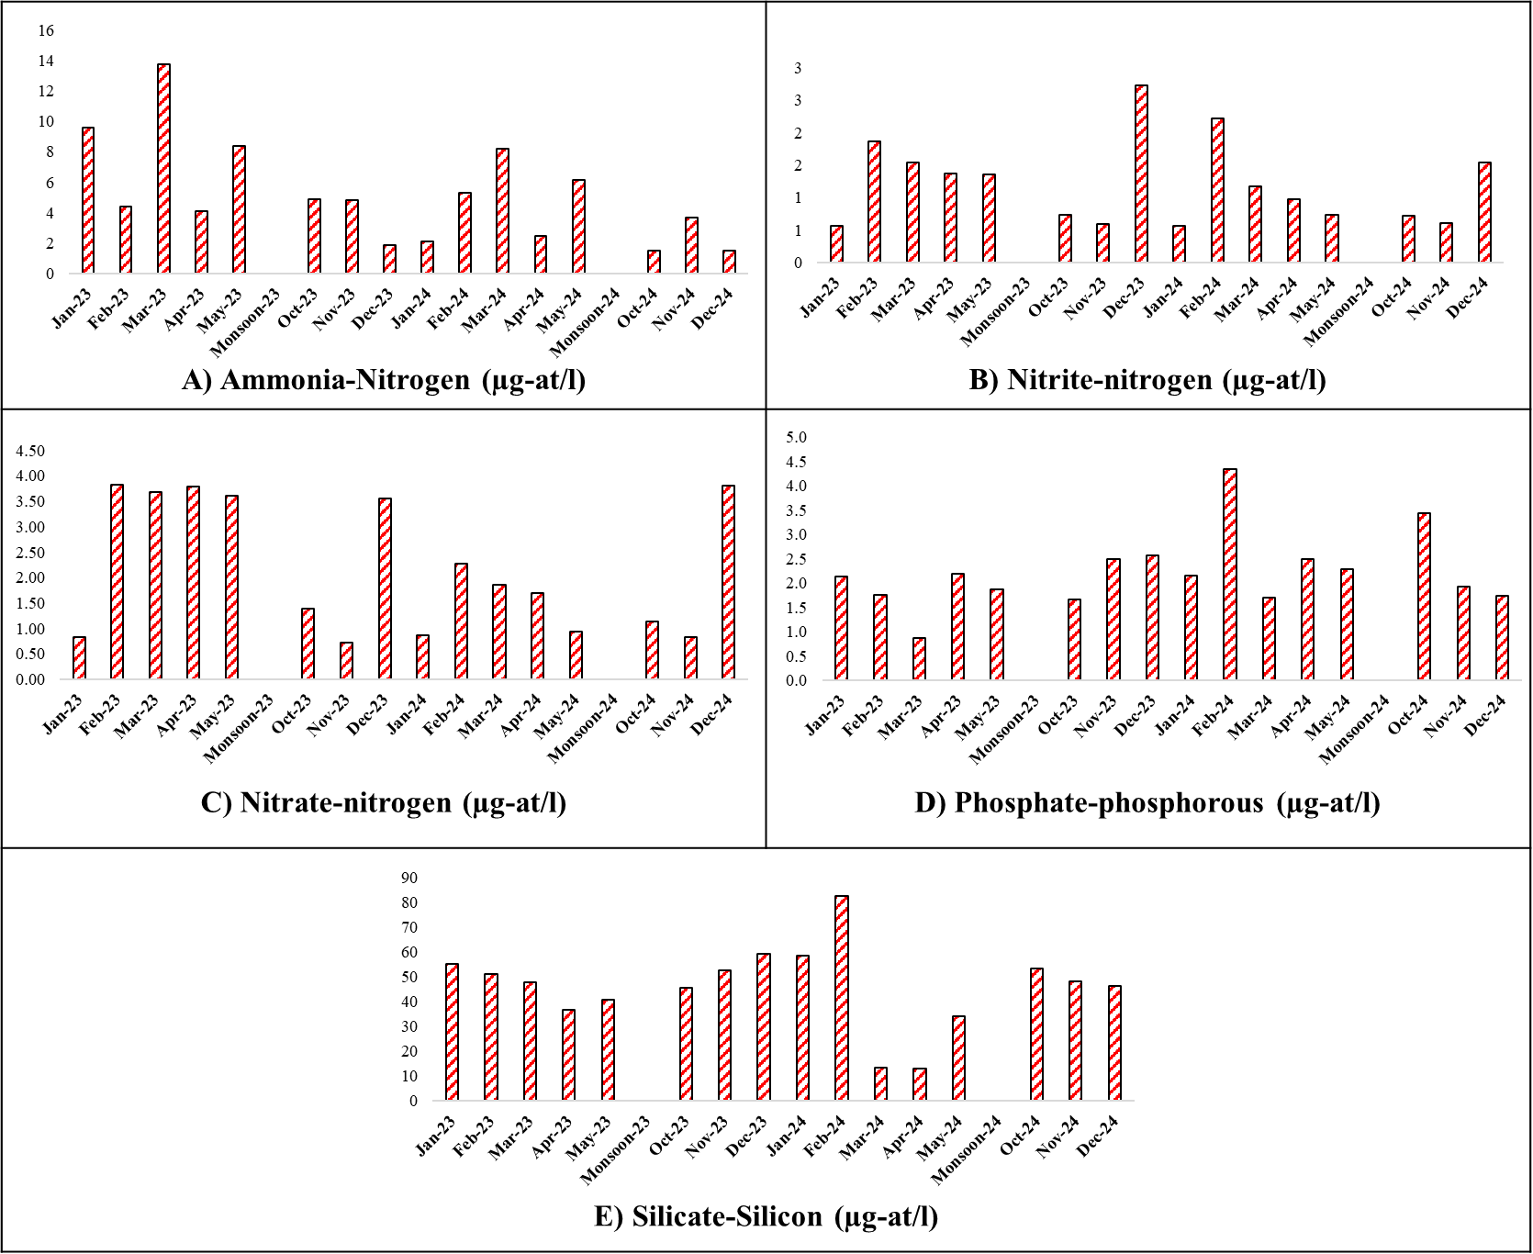

**Figure 2: Graphical presentation of nutrients of coastal waters along the Padubidri region**

**3.2.4 Phosphate-Phosphorus**

Phosphorus is a critical factor in life processes like photosynthesis, metabolism, creation of cell walls and energy transfer and is deeply associated with organisms in aquatic environments, which could be attributed to increased suspended particles that adsorb the phosphorus (Munn, 2019). The phosphate-phosphorus content varied from 0.87 to 4.35 µg-at/l (Figure 2D). The high phosphate-phosphorus concentration was reported in February 2024 (4.35 µg-at/l), while the low phosphate-phosphorus concentration was reported in March 2023 (0.87 µg-at/l). The suspended particles may absorb phosphorus and deposit it in the sediment. According to Bandyopadhyay and Biswas (2021), the coastal water in the southwest Bay of Bengal has a phosphorus-phosphate level of 1.03 µg-at/l. Along the Mangaluru coastline, Katti et al. (2003) reported phosphate concentrations ranging from 0.05 to 3.00 µg-at/l. High phosphate levels in coastal waters can lead to a significant problem known as eutrophication, where excessive algal growth occurs due to readily accessible phosphorus, resulting in lower oxygen levels.

**3.2.5 Silicate-Silicon**

The silicate-silicon content varied from 13.07 to 82.80 µg-at/l (Figure 2E). The highest silicate-silicon content was observed in February 2024 (82.80 µg-at/l), while the minimum was in April 2024 (13.07 µg-at/l). Muruganantham et al. (2012) found a silicate range from 3.2 to 54.92 µg-at/l on the Southeast coast of India. According to Sushanth and Rajashekhar (2012), the coastal waters of the Uttara Kannada district exhibit silicate concentrations ranging from 0.10 to 161.0 mg/l. A sudden fall in silicate levels from February 2024 to April 2024 may be caused by a considerable consumption of silicate by phytoplankton, notably diatoms, during a bloom, leading to depletion of accessible silicate in the water column.

**3.3 Relationship between environmental variables and nutrient**

The data showed a significant positive correlation (p<0.01) between Air and water temperatures. The total dissolved solids positively correlated with ammonia-nitrogen (p<0.05). The biological oxygen demand was negatively connected with silicate silicon (p<0.05). Ammonia-nitrogen showed a significant positive connection with nitrite-nitrogen (p < 0.01).

Chart 1. Pearson Correlation Matrix between environmental variables and nutrients

|  |  |  |  |  |  |  |  |  |  |  |  |  |  |  |
| --- | --- | --- | --- | --- | --- | --- | --- | --- | --- | --- | --- | --- | --- | --- |
|  | **1** | **2** | **3** | **4** | **5** | **6** | **7** | **8** | **9** | **10** | **11** | **12** | **13** | **14** |
| **1** | 1.00 |  |  |  |  |  |  |  |  |  |  |  |  |  |
| **2** | 0.87** | 1.00 |  |  |  |  |  |  |  |  |  |  |  |  |
| **3** | -0.21 | -0.06 | 1.00 |  |  |  |  |  |  |  |  |  |  |  |
| **4** | 0.03 | -0.07 | -0.48 | 1.00 |  |  |  |  |  |  |  |  |  |  |
| **5** | -0.08 | -0.20 | -0.28 | 0.22 | 1.00 |  |  |  |  |  |  |  |  |  |
| **6** | 0.28 | 0.23 | 0.11 | -0.10 | 0.38 | 1.00 |  |  |  |  |  |  |  |  |
| **7** | 0.22 | -0.01 | -0.47 | -0.14 | 0.29 | 0.39 | 1.00 |  |  |  |  |  |  |  |
| **8** | 0.21 | -0.03 | -0.35 | 0.25 | 0.00 | -0.15 | 0.38 | 1.00 |  |  |  |  |  |  |
| **9** | 0.02 | -0.02 | -0.25 | 0.43 | 0.13 | -0.33 | -0.31 | 0.17 | 1.00 |  |  |  |  |  |
| **10** | 0.31 | 0.19 | -0.29 | -0.05 | 0.18 | 0.48 | 0.51* | -0.08 | -0.13 | 1.00 |  |  |  |  |
| **11** | -0.01 | -0.09 | 0.00 | -0.22 | 0.02 | 0.14 | 0.17 | -0.20 | 0.12 | 0.79** | 1.00 |  |  |  |
| **12** | 0.21 | 0.33 | -0.05 | 0.28 | -0.01 | 0.30 | 0.26 | 0.24 | -0.45 | 0.11 | -0.27 | 1.00 |  |  |
| **13** | 0.21 | 0.18 | 0.01 | 0.31 | -0.04 | 0.45 | -0.09 | -0.12 | 0.12 | 0.31 | 0.02 | 0.12 | 1.00 |  |
| **14** | 0.12 | 0.14 | -0.15 | -0.07 | 0.39 | 0.44 | 0.43 | 0.12 | -0.52* | 0.19 | -0.31 | 0.41 | 0.14 | 1.00 |
| **Note:** 1. Air temperature (oC), 2. Water temperature (oC), 3. Transparency (m), 4. Water pH, 5. Dissolved oxygen (mg/l), 6. Salinity (psu), 7. Total dissolved solids (mg/l), 8. Total suspended solids (mg/l), 9. Biological oxygen demand (mg/l), 10. Ammonia-Nitrogen (µg-at./l), 11. Nitrite-Nitrogen (µg-at/l), 12. Nitrate-Nitrogen (µg-at/l), 13. Phosphate-Phosphorus (µg-at./l), 14. Silicate-silicon (µg-at/l)  **\*\* Correlation is significant at 0.01 level (2-tailed), *Correlation is significant at 0.05 level (2-tailed).** | | | | | | | | | | | | | | |

1. **CONCLUSION**

The study of environmental variables reveals their profound influence on the marine ecosystem, with marked temporal and spatial variability observed across multiple parameters. Air and water temperature, transparency, pH, salinity, dissolved oxygen, BOD, TDS, and TSS exhibit dynamic oscillations throughout the year, significantly affecting marine species variety, behaviour, and distribution. Variations in nutrient concentrations, including ammonia, nitrite, nitrate, phosphate, and silicate, further alter ecological processes and biological production. The interaction among these characteristics underlines the complexity of maritime habitats, where even slight changes can cascade into severe environmental repercussions. Understanding these patterns is crucial for monitoring ecosystem health, managing coastal resources, and minimizing anthropogenic impacts on marine biodiversity.

**Disclaimer (Artificial intelligence)**

**Option 1:**

**Author(s) hereby declare that NO generative AI technologies such as Large Language Models (ChatGPT, COPILOT, etc.) and text-to-image generators have been used during the writing or editing of this manuscript.**

**Option 2:**

**Author(s) hereby declare that generative AI technologies such as Large Language Models, etc. have been used during the writing or editing of manuscripts. This explanation will include the name, version, model, and source of the generative AI technology and as well as all input prompts provided to the generative AI technology**

**Details of the AI usage are given below:**

**1.**

**2.**

**3.**

**COMPETING INTERESTS DISCLAIMER:**

Authors have declared that they have no known competing financial interests OR non-financial interests OR personal relationships that could have appeared to influence the work reported in this paper.

1. **REFERENCE**
2. Borges, A.V., 2005. Do we have enough pieces of the jigsaw to integrate CO2 fluxes in the coastal ocean?. *Estuaries*, *28*, pp.3-27.
3. Bouillon, S., Borges, A.V., Castañeda‐Moya, E., Diele, K., Dittmar, T., Duke, N.C., Kristensen, E., Lee, S.Y., Marchand, C., Middelburg, J.J. and Rivera‐Monroy, V.H., 2008. Mangrove production and carbon sinks: a revision of global budget estimates. *Global biogeochemical cycles*, *22*(2).
4. Howarth, R.W. and Marino, R., 2006. Nitrogen as the limiting nutrient for eutrophication in coastal marine ecosystems: evolving views over three decades. *Limnology and oceanography*, *51*(1part2), pp.364-376.
5. Ramesh, R., Robin, R.S. and Purvaja, R., 2015. An inventory on the phosphorus flux of major Indian rivers. *Current Science*, pp.1294-1299.
6. Hollister, C.C., Bisogni, J.J. and Lehmann, J., 2013. Ammonium, nitrate, and phosphate sorption to and solute leaching from biochars prepared from corn stover (Zea mays L.) and oak wood (Quercus spp.). *Journal of environmental quality*, *42*(1), pp.137-144.
7. Mackey, K.R., Van Dijken, G.L., Mazloom, S., Erhardt, A.M., Ryan, J., Arrigo, K.R. and Paytan, A., 2010. Influence of atmospheric nutrients on primary productivity in a coastal upwelling region. *Global Biogeochemical Cycles*, *24*(4).
8. Lee, S.H., Joo, H., Lee, J.H., Kang, J.J., Lim, J.H., Yun, M.S., Lee, J.H. and Kang, C.K., 2015. Potential overestimation in primary and new productions of phytoplankton from a short time incubation method. *Ocean Science Journal*, *50*, pp.509-517.
9. Conley, D.J., 1999. Biogeochemical nutrient cycles and nutrient management strategies. *Man and River Systems: The Functioning of River Systems at the Basin Scale*, pp.87-96.
10. Conley, D.J., Carstensen, J., Vaquer-Sunyer, R. and Duarte, C.M., 2009. Ecosystem thresholds with hypoxia. In *Eutrophication in Coastal Ecosystems: Towards better understanding and management strategies Selected Papers from the Second International Symposium on Research and Management of Eutrophication in Coastal Ecosystems, 20–23 June 2006, Nyborg, Denmark* (pp. 21-29). Springer Netherlands.
11. Anderson, D.M., Glibert, P.M. and Burkholder, J.M., 2002. Harmful algal blooms and eutrophication: nutrient sources, composition, and consequences. *Estuaries*, *25*, pp.704-726.
12. Smayda, T.J., 1990. Novel and nuisance phytoplankton blooms in the sea: evidence for a global epidemic. *Toxic marine phytoplankton*, pp.29-40.
13. Bakun, A., 1990. Global climate change and intensification of coastal ocean upwelling. *Science*, *247*(4939), pp.198-201.
14. Madhupratap, M., Kumar, S.P., Bhattathiri, P.M.A., Kumar, M.D., Raghukumar, S., Nair, K.K.C. and Ramaiah, N., 1996. Mechanism of the biological response to winter cooling in the northeastern Arabian Sea. *Nature*, *384*(6609), pp.549-552.
15. Naqvi, S.W.A., Jayakumar, D.A., Narvekar, P.V., Naik, H., Sarma, V.V.S.S., D'souza, W., Joseph, S. and George, M.D., 2000. Increased marine production of N2O due to intensifying anoxia on the Indian continental shelf. *Nature*, *408*(6810), pp.346-349.
16. Prasanna Kumar, S., Narvekar, J., Kumar, A., Shaji, C., Anand, P., Sabu, P., Rijomon, G., Josia, J., Jayaraj, K.A., Radhika, A. and Nair, K.K.C., 2004. Intrusion of the Bay of Bengal water into the Arabian Sea during winter monsoon and associated chemical and biological response. *Geophysical Research Letters*, *31*(15).
17. Paerl, H.W., 1997. Coastal eutrophication and harmful algal blooms: Importance of atmospheric deposition and groundwater as “new” nitrogen and other nutrient sources. *Limnology and oceanography*, *42*(5part2), pp.1154-1165.
18. Dehairs, F., Rao, R.G., Chandra Mohan, P., Raman, A.V., Marguillier, S. and Hellings, L., 2000. Tracing mangrove carbon in suspended matter and aquatic fauna of the Gautami–Godavari Delta, Bay of Bengal (India). *Hydrobiologia*, *431*, pp.225-241.
19. Talaue McManus, L., Kremer, H.H. and Marshall Crossland, J.I. eds., 2001. Biogeochemical and human dimensions of coastal functioning and change in Southeast Asia. Final report of the SARCS/WOTRO/LOICZ project 1996-1999.
20. Seitzinger, S.P., Mayorga, E., Bouwman, A.F., Kroeze, C., Beusen, A.H., Billen, G., Van Drecht, G., Dumont, E., Fekete, B.M., Garnier, J. and Harrison, J.A., 2010. Global river nutrient export: A scenario analysis of past and future trends. *Global biogeochemical cycles*, *24*(4).
21. Naqvi, S.W.A., Naik, H., Pratihary, A., D'souza, W., Narvekar, P.V., Jayakumar, D.A., Devol, A.H., Yoshinari, T. and Saino, T., 2006. Coastal versus open-ocean denitrification in the Arabian Sea. *Biogeosciences*, *3*(4), pp.621-633.
22. Madhu, N.V., Jyothibabu, R. and Balachandran, K.K., 2010. Monsoon-induced changes in the size-fractionated phytoplankton biomass and production rate in the estuarine and coastal waters of southwest coast of India. *Environmental monitoring and assessment*, *166*(1), pp.521-528.
23. Lallu, K.R., Fausia, K.H., Vinita, J., Balachandran, K.K., Naveen Kumar, K.R. and Rehitha, T.V., 2014. Transport of dissolved nutrients and chlorophyll a in a tropical estuary, southwest coast of India. *Environmental monitoring and assessment*, *186*, pp.4829-4839.
24. Gupta, G.V.M., Sudheesh, V., Sudharma, K.V., Saravanane, N., Dhanya, V., Dhanya, K.R., Lakshmi, G., Sudhakar, M. and Naqvi, S.W.A., 2016. Evolution to decay of upwelling and associated biogeochemistry over the southeastern Arabian Sea shelf. *Journal of Geophysical Research: Biogeosciences*, *121*(1), pp.159-175.
25. Parsons, T.R., Maita, Y. and Lalli, C. M. 1984. A manual of chemical and biological methods for seawater analysis. Pergamon press, 173 pp.
26. Strickland, J. D. H. and Parsons, T. R. 1972. A practical handbook of seawater analysis. Bulletin, 167 (Second Ed), J. Fish. Res. Board Can, 310.
27. Jasmine, P., Jayeeta, D., Samir, H., Ghosh, A. K., Tripathy, B., Mukherjee, A. K. and Venkataraman, K. 2015. A preliminary investigation into the community structure and composition of intertidal fauna along the East Coast of India. Rec. Zool. Surv. India, 115(3): 281-289.
28. Sekar, V., Rajasekaran, R. and Fernando, O. J. 2012. Abundance of the onuphids polychaete Onuphis eremita in Tranquebar, Southeast coast of India Adv. Environ. Sci, 4(1): 22-28.
29. Gopalkrishnan, P. 1970. Some observations on the shore ecology of the Okha coast. JMBAI, 12: 15-34.
30. Philip, K. P. 1970. The intertidal fauna of the sandy beaches of Cochin. The symp. Mar. Intert. Ecol. 38: 317-338.
31. Ajin, A. M., Menon, N. R., Menon, N. N. and Prabhakaran, M. P. 2014. Trophic relation between Astrpecten indicus (Döderlein, 1888) and the spats of Donax incarnatus in the Indian Coast. Clim. Change Mar. Ecosyst, 122-129.
32. Ratnam, K., Jha, D.K., Prashanthi Devi, M. and Dharani, G. 2022. Evaluation of physicochemical characteristics of coastal waters of Nellore, Southeast Coast of India, by a multivariate statistical approach. Front. Mar. Sci., 9: p.857957.
33. Kim, S.H., Yang, C.S. and Ouchi, K., 2015. Spatio-temporal patterns of Secchi depth in the waters around the Korean Peninsula using MODIS data. Estuar. Coast. Shelf Sci., 164: 172-182.
34. Yang, L., Yu, D., Yao, H., Gao, H., Zhou, Y., Gai, Y., Liu, X., Zhou, M. and Pan, S. 2022. Capturing Secchi disk depth by using Sentinel-2 MSI imagery in Jiaozhou Bay, China from 2017 to 2021. Mar. Pollut. Bull., 185: p.114304.
35. Lingadhal, C., Padmanabha, A., Rajanna, K.B., Annappaswamy, T.S. and Lakshmipathi, M.T. 2023. Hydrographical studies in the nearshore waters of Keni and Belekeri, Ankola, Uttara Kannada district, Southwest coast of India. J. Pharm. Innov., 12(4): 227-236.
36. Balakrishnan, S., Chelladurai, G., Mohanraj, J. and Poongodi, J. 2017. Seasonal variations in physico-chemical characteristics of Tuticorin coastal waters, southeast coast of India. Appl. Water Sci, 7: 1881-1886.
37. Mrozińska, N., Glinska-Lewczuk, K. and Obolewski, K. 2021. Salinity as a key factor on the benthic fauna diversity in the coastal lakes. Animals, 11(11): 3039.
38. Sarma VVSS, Krishna MS, Viswanadham R, et al. Intensified oxygen minimum zone on the western shelf of Bay of Bengal during summer monsoon: influence of river discharge. J Oceanogr 2013;69:45–55.
39. Gopalkrishnan, P. 1970. Some observations on the shore ecology of the Okha coast. JMBAI, 12: 15-34.
40. Levin, L.A., Ekau, W., Gooday, A.J., Jorissen, F., Middelburg, J.J., Naqvi, S.W.A., Neira, C., Rabalais, N.N. and Zhang, J., 2009. Effects of natural and human-induced hypoxia on coastal benthos. *Biogeosciences*, *6*(10), pp.2063-2098.
41. Amaral, V., Santos-Echeandía, J., Ortega, T., Álvarez-Salgado, X.A. and Forja, J. 2023. Dissolved organic matter distribution in the water column and sediment pore water in a highly anthropized coastal lagoon (Mar Menor, Spain): Characteristics, sources, and benthic fluxes. Sci. Total Environ., 896: p.165264
42. Adjovu, G.E., Stephen, H., James, D. and Ahmad, S. 2023. Measurement of total dissolved solids and total suspended solids in water systems: A review of the issues, conventional, and remote sensing techniques. Remote Sens., 15(14): p.3534.
43. Yousef, E.A. 2022. The Impact of Some Environmental Factors on the Distribution of the Benthic Ostracod Species from of Safaga Island, Red Sea, Egypt. OJMS, 12(3): 83-107.
44. Jha, D.K., Devi, M.P., Vidyalakshmi, R., Brindha, B., Vinithkumar, N.V. and Kirubagaran, R. 2015. Water quality assessment using water quality index and geographical information system methods in the coastal waters of Andaman Sea, India. Mar. Pollut. Bull., 100(1): 555-561.
45. Pandit, P.R. and Fulekar, M.H. 2017. Quality characterization of Coastal water in Gujarat coast, India. JBB, 3(4): 8-15.
46. Gopinath, M., Jayasudha, S., Umamageswari, P. And Sampathkumar, P. 2013. Physico-biochemical variations in Parangipettai and Nagapattinam Coastal waters, Southeast coast of India. Int. J. Biol. Sci, 3(4): 149–156.
47. Nayak, H., 2015. Heavy metal concentration in commercially important finfishes exploited at Mangalore and Malpe Fishing harbours, Karnataka. Ph.D. Thesis, Karnataka Veterinary, Animal and Fisheries Science University, Bidar.
48. Chethan, N. 2012. Temporal variability of phytoplankton assemblage in the coastal waters of Mangalore. Ph.D. Thesis, Karnataka Veterinary, Animal and Fisheries Science University, Bidar.
49. Kavitha. C. 2020. Biodiversity of Macrobenthic infauna community in the inshore waters off Mangaluru. M.F.Sc. Thesis, Karnataka Veterinary, Animal and Fisheries Sciences University, Bidar.
50. Shruthi, G. 2016. Species diversity of diatoms in relation to hydrographical characteristics in the coastal waters off Dakshina Kannada and Udupi district. M.F.Sc. Thesis, Karnataka Veterinary, Animal and Fisheries Sciences University, Bidar.
51. Hasegawa, H., Rahman, I. and Rahman, M.A. 2015. Environmental remediation technologies for metal-contaminated soils. Environ. Remed. Techn. Met. Soil. 1–254.
52. Satpathy, K.K., Mohanty, A.K., Natesan, U., Prasad, M.V.R. and Sarkar, S.K. 2010. Seasonal variation in physicochemical properties of coastal waters of Kalpakkam, east coast of India with special emphasis on nutrients. Environ Monit Assess, 164: 153-171.
53. Kumar, S.B., Mohanty, A.K., Padhi, R.K., Selvanayagam, M. and Satpathy, K.K. 2018. Coastal water characteristics along Tamil Nadu, east coast of India during pre-northeast monsoon period. IJMS, 47(2): 308-318.
54. Munn, C.B. 2019. Marine Microbiology: ecology and applications. Crc Press., 3: 436 pp.
55. Bandyopadhyay, D. and Biswas, H. 2021. Impacts of variable nutrient stoichiometry (N, Si and P) on a coastal phytoplankton community from the SW Bay of Bengal, India. Eur. J. Phycol, 56(3): 273-288.
56. Katti, R. J., Venkateshmoorthy, K. S., Mohana Kumar, B., Ronald K. D’souza And Santhanagouda, A. H. 2003. Distribution on zooplankton and selected hydrographical parameters in the Arabian Sea off Chitrapur, southwest coast of India. Indian J. Mar. Sci., 7(1): 7-15.
57. Muruganantham, P., Gopalakrishnan, T., Chandrasekaran, R. And Jeyachandran, S. 2012. Seasonal Variations and Diversity of Planktonic Diatoms of Kodikkarai and Velanganni, Southeast Coast of India. J. Ocean. Mar. Environ. Syst. 2(1): 01-10.
58. Sikoki, F.D., Onojake, M.C., Omokheyeke, O. and Onyagbodor, P.O. 2021. Poisonous Metal Levels in Sediment and Selected Biota in Coastal Waters of Nigeria. Asian Journal of Chemical Sciences. 9(4): 37-43.
59. Sushanth, V.R. and Rajashekhar, M. 2012. Seasonal variation in diatoms in response to physico-chemical characteristics of coastal waters of Uttara Kannada district, West Coast of India. Int. J. Environ. Sci. 2(3): 1543-1552.