Forecasting yield of winter rice using SMLR and ANN techniques in Central Brahmaputra Valley zone of Assam, India

ABSTRACT
The present study was undertaken to develop pre-harvest yield forecast models for winter rice (Sali rice) at the F1 (vegetative) and F2 (mid-season) stages for two representative districts of the Central Brahmaputra Valley Zone (CBVZ), using yield data and weekly weather data from 1994 to 2019, applying a modified Hendrick and Scholl technique. The models were validated using an independent dataset from two years (2020–21). Model fitting was performed using stepwise multiple linear regression (SMLR) and artificial neural network (ANN) techniques. Model performance was evaluated based on the coefficient of determination (R²), root mean square error (RMSE), and normalized RMSE (RMSEn), while model accuracy was assessed through percent error (PE) between observed and predicted yields. The ANN models demonstrated higher efficiency, with significantly improved R² values and lower RMSE and PE compared to SMLR models, indicating a stronger ability to capture nonlinear relationships between weather variables and yield. This reflects the ANN model’s robustness in handling complex interactions among predictors, leading to more accurate and reliable yield forecasts. Temperature (both maximum and minimum) and relative humidity (morning and evening) emerged as the most influential weather parameters affecting winter rice yield in the CBVZ.

Keywords: Yield forecasting, Winter Rice, Multiple linear regression, ANN
Introduction
The economy of India is primarily agrarian. As much as 42.86 % of the Indian population is employed in the agricultural sector in 2022, according to the World Bank collection of development indicators (International Labour Organization modelled estimates database).A stable yield of agricultural products is necessary to ensure food security of the enormous population of the country. Out of all the factors that affect crop yield, weather conditions have a significant impact. Losses up to 30% of the annual agriculture production have been incurred in many countries due to abnormal weather conditions (Attri and Rathore, 2003). As such, development of accurate and reliable weather based yield forecast models would play a significant role in formulating effective food policies, forecast of trade trends, optimising resource allocation and identifying adaptive strategies in cases of yield loss or complete failure of crop.
In Assam, rice is the dominant cereal crop, grown in about 25 lakh ha area with an average yield of 2101 kg/ha (DES, 2021). It contributes about 67% of the gross cropped area and more than 90% of the total area under food grain crops in Assam, thereby holding a significant position in the economic scenario of the state. Assam has three distinct rice growing seasons, viz., Ahu or Autumn rice (February/March-June/July), Sali or Winter rice (June/July- Nov/Dec), and Boro or Summer rice (Nov/Dec-May/June). Winter or Sali rice is grown predominantly in the state covering an area of about 18 lakh ha with a production of about 33 lakh tonnes/ha (APY 2021-2022). Rice yield is affected by climatic factors in various ways during different growth stages. Rice, being a water intensive crop, is mostly affected by water stress during the reproductive stage, leading to depressing grain formation and premature abortion of the grains. Besides, rice is a thermal sensitive crop, having different temperature requirements at different growth phases. Overall, temperatures up to 35°C during day and night temperatures up to 25°C were found to be favourable for growth of rice crop (Verma, 2019). High temperatures affect developmental processes by shortening the grain filling duration and reduced fertility and grain quality. On the other hand, since rice production system in Assam is primarily rainfed, high variation in rainfall patterns aggravated by climate change, may pose a significant negative impact on rice yield in the state.
Crop yield based on weather data can be forecasted before harvest mainly by two approaches which can be classified into crop simulation models and empirical statistical models (Kumar et al., 2019). Crop simulation models (CSMs) are computerised approximations of the real world simulated through mathematical equations to represent the various agronomic and soil conditions, climatic factors and management practices. Meanwhile, statistical models are built on a matrix trained on historical weather data and several agrometeorological parameters. They are more commonly used for yield predictions as they establish a direct relationship between crop yield and the predictive variables. CSMs require rigorous parameterization and validation before large scale predictions and the data requirement is quite extensive which is not practical for large study areas. Statistical models are less parameter intensive but the results cannot be extrapolated outside the range of values for which the model is parameterized (Basso et al., 2013).In the recent years, with the evolution computing technology, Machine Learning (ML) techniques such as Artificial Neural Networks (ANNs) are being increasingly used for yield forecasting. Inspired by the biological neural system, ANN is a self-adaptive algorithmic method that can capture the non-linearity in the data and the complex relationship between the weather variables and crop yield(Gupta et al., 2024).
Several studies have been conducted in India and abroad to predict crop yield as well as to identify the factors influencing it using machine learning techniques. Setiya et al., (2022) “compared different weather-based wheat yield forecasting models for different districts of Uttarakhand using statistical and machine learning techniques and found that in terms of overall performance based on RMSE and RMSE_{n} values during validation, ANN outperformed ridge regression, stepwise multiple linear regression (SMLR), least absolute shrinkage and selection operator(LASSO), and elastic net (ELNET)”. Kakoti et al., (2022) conducted “a study to forecast rapeseed and mustard yield using multiple linear regression and ANN techniques in the Brahmaputra valley of Assam, North-East India and found that R² and RMSE values were improved using the ANN technique in all the districts considered. It was also observed that maximum temperature and morning and evening RH were the most important weather variables affecting R&M yield in most of the districts of the Brahmaputra valley of Assam at all the three stages under consideration”. Das et al., (2018) have developed “forecast models for rice yield for fourteen districts of West Coast using stepwise multiple linear regressions (SMLR), principal component analysis together with SMLR (PCA-SMLR), LASSO and ELNET, ANN and PCA-ANN based on the monthly weather indices”. It was found that LASSO was the best model which was found similar to SMLR and the effect of temperature was most prominent. Another study compared “the performance of linear models like stepwise multiple linear regression (SMLR), principal component analysis (PCA), least absolute shrinkage and selection operator (LASSO) and elastic net (ELNET) with non-linear regression model like artificial neural network (ANN) and PCA-ANN for district-wise coconut yield prediction models of the west coastal region of India” by Das et al., 2020. The performance of the models were in the order of ELNET > LASSO > ANN > SMLR > PCA SMLR >PCA-ANN. ANN had a better performance over SMLR. In this study, minimum temperature was found more important than maximum temperature. The present study was undertaken with an objective to develop and analyse the performance of a linear regression model (SMLR) and a non-linear regression model (ANN) for winter rice yield prediction in the Central Brahmaputra Valley (CBV) zone of Assam through utilization of long term weather and yield data.
Materials and Methods
Location
The Central Brahmaputra Valley (CBV) zone of Assam consists of the districts of Nagaon, Morigaon and Hojai (Fig.1). Hojai was carved out as a separate district out of Nagaon in 2016. The districts are bound by the mighty Brahmaputra river in its north and the hills of Karbi Anglong in the south and depicts a prominent sub-tropical climate with semi dry hot in summer and cold in winter. The zone is also characterized by many chars and chaparis and large number of wetlands. Based on the availability of dataset, the study was carried out in the two representative districts, Nagaon and Morigaon of CBVZ.
Dataset used
The yield data of winter rice for the period of 28 years (1993–1994 to 2020–2021) were obtained from the Directorate of Economics and Statistics, Government of Assam. Daily weather parameters—namely maximum temperature (Tmax in °C), minimum temperature (Tmin in °C), morning relative humidity (RH-I in %), evening relative humidity (RH-II in %), and rainfall (RF in mm)—were collected from two primary sources: the Regional Meteorological Centre (RMC), Guwahati, and the Regional Agricultural Research Station (RARS), Shillongani, Nagaon. These data were collected for the entire winter rice growing season, which spans from the 27th to the 37th standard meteorological week (SMW) each year.
Data preprocessing
The daily weather data were first subjected to a quality control process to identify and correct any missing, erroneous, or outlier values. In cases of missing data, nearby station interpolation were used to fill gaps, where feasible. The cleaned daily data were then aggregated every week to align with the standard meteorological weeks (SMWs). Specifically, temperature (Tmax and Tmin) and Relative Humidity (RH-I and RH-II) values were averaged over each week to obtain weekly mean values. Rainfall (RF) values were summed across each week to obtain weekly total rainfall. The weekly-aggregated values were then organized year-wise to form a structured dataset. These weekly values were subsequently used for calculating both weighted and unweighted weather indices to evaluate their relationship with detrended rice yield. Out of the 28 years of data, 26 years were used for model calibration, and the remaining 2 years (2019–2020 and 2021–2022) were utilized for model validation, in accordance with standard practices in operational crop yield forecasting (Devi et al., 2013; Ghosh et al., 2014; Gupta et al., 2018).
To ensure that the yield data reflected only the influence of weather variability and not other long-term trends, the original time-series data of rice yield were detrended prior to analysis. Over multiple decades, crop yields are affected by a variety of non-weather-related factors such as improvements in agricultural technology, seed varieties, mechanization, agronomic practices, and policy interventions. These factors introduce a non-stationary trend in the yield time series, which can obscure the true relationship between weather variables and yield outcomes. To address this, a linear or polynomial trend line was fitted to the yield data across the 26-year period. The residuals—i.e., the differences between the actual observed yields and the values predicted by the trend line—were then computed. These residuals represent the detrended yield values, which were subsequently used in correlation and regression analyses with the weather indices. This method ensures that the yield variability attributed to weather factors is isolated from technological or management-induced trends, thereby improving the robustness of the model (Setiya et al., 2022).
Methodology applied
Pioneering work on crop weather relationship was done by Fisher (1924) and Hendricks and Scholl (1943) and suggested models for it. In the current study, the modified Hendricks and Scholl model Agrawal and Mehta (2007) was used to develop rice yield forecast models. The details of the model along with its genesis were elaborately discussed by Ghosh et al. (2014).
Development of weighted and unweighted weather indices:
Different weather indices were generated using weekly values of the five weather parameters, viz., maximum temperature (°C), minimum temperature (°C), total rainfall (mm), morning relative humidity (%) and evening relative humidity (%). Two types of indices were calculated for each weather variable, one as simple total values of weather variables over different weeks (un-weighted index) and the other one as weighted total (weighted index), weights being correlation coefficient between de-trended yield and weather variable in respective weeks during the growing season of winter rice. For studying the joint effects, un-weighted and weighted indices for interaction were computed with products of weather variables taken two at a time (Tripathi et al., 2012). A total of 31 weather indices (simple or un-weighted and weighted) including time trend, T (year number) were taken as independent variables. Combination of weather variables for weather indices, thus generated, is presented in Table 1. The forecast models were developed at vegetative (F1: 27th SMW to 33rd SMW), and at mid-season stage (F2: 27th SMW to 37th SMW). The model is given as:
Y= A₀+$\sum_{i=1}^{P}{\sum_{j=0}^{i}{a}}$_{ij}Z_{ij}+$\sum_{i≠i^{'}=1}^{p}{\sum_{j=0}^{1}{a}}$_{ii’j}Z_{ii’j}+cT+e
Where,
Z_{ij}=$\sum_{w=1}^{m}{r}$^{j}_{iw}X_{iw} and Z_{i’ij}=$\sum_{w=1}^{m}{r}$^{j}_{ii’w}X_{i’w}
And
r_{iw}= correlation coefficient of yield with i^{th}weather variable in w period
r_{ii¹w} = correlation coefficient of yield with product of i^{th} and i¹th weather variable in w^{th}period
m = number of meteorological weeks considered for forecast
p = number of weather variable used
e = random error distribution as N(0,Ã2 )
T=technology factor
The steps involved in the model development are illustrated in Fig. 2.
Model development by stepwise multiple linear regression (SMLR)
A regression equation was developed between the 31 independent variables, and the dependent variable, i.e. yield of winter rice. The analysis was performed using SPSS software (IBM Corp., 2023), employing the stepwise regression method to identify the most significant predictors and develop the best-fitting regression model. Stepwise selection iteratively includes or excludes predictors based on their statistical contribution to the model, evaluated using the F-statistic. In this study, a predictor was retained in the model only if its F-value was less than 0.05, ensuring that only variables with a statistically significant contribution to yield prediction were included. To account for the effect of non-climatic factors, particularly technological advancements, a year number was introduced as a proxy for technological trends, under the assumption that such improvements generally lead to a gradual and consistent increase in yield over time. This helped separate the effect of climate variability from technological influence. Among the models generated, the final regression equation was selected based on the highest coefficient of determination (R²) and adjusted R², reflecting both explanatory power and model efficiency after accounting for the number of predictors. Thus, the resulting equation provides a clear, interpretable model for quantifying the influence of key weather parameters on winter rice yield. The most important variables are presented in Table 2. The model was fitted considering the entered variables obtained from individual stepwise regression analysis to predict the yield of winter rice for the subsequent 2 years (2020 and 2021). Before conducting regression analysis, multi-collinearity among the weather variables was checked using Durbin-Watson (DW) test. A DW value close to 2 indicates absence of collinearity (Setiya and Nain, 2021).
Model development by artificial neural network (ANN)
Artificial Neural Networks (ANNs) are advanced machine learning models inspired by the neural structure of the human brain and are widely used for modelling complex, non-linear relationships in agricultural systems. An ANN consists of interconnected processing units called neurons or nodes, which are organized into input, hidden, and output layers. Each node comprises two essential components: weights and activation functions. The weights, which are partially analogous to regression coefficients (Zhang et al., 2018), quantify the strength of the connection between nodes and are dynamically adjusted during training. Activation functions introduce non-linearity to the model, allowing it to learn complex patterns from the input data (Chen et al., 2020).
A single hidden layer feed-forward ANN was employed in this study using the "nnet" package in R, selected for its simplicity and computational efficiency (Dahikar & Rode, 2014). The input layer comprised 32 nodes—31 representing weekly weather indices and one capturing the technological trend factor (T)—while the output layer consisted of a single node representing detrended winter rice yield (Y). The network was trained using supervised learning with backpropagation, incorporating weight decay regularization to prevent overfitting. The optimal number of hidden nodes was determined through threefold cross-validation using the “train” function from the “caret” package in RStudio version 4.2.3 (R Core Team, 2023), with the model achieving the lowest RMSE across configurations selected as optimal. All input variables were normalized to a 0–1 scale using the “normalize” function in the “nnet” package. After training, the relative importance of predictors was assessed using Garson’s algorithm, implemented through the “NeuralNetTools” package. This approach quantified the contribution of each predictor to the output, providing interpretability by assigning normalized importance values between 0 and 1. These scores were used to rank the weather indices and technological trend factor presented in Fig 3 and 4, highlighting the most critical parameters driving yield variability in the study region.
Evaluation of model performance
The models developed were validated using yield data and weekly meteorological data of Nagaon and Morigaon during 2020 and 2021 with their corresponding observed yield data. The performance of the forecast models were evaluated based on percentage error (PE) for the predicted/forecasted yield (P_{i}) against observed yield (O_{i}) of winter rice during the abovementioned years along with other methods of error analysis, i.e. root mean square error (RMSE) and normalised RMSE (RMSE_{n}).
$$PE=(\frac{Observed yield\left( Oi\right)-Forecast yield\left(Pi\right)}{Observed yield\left( Oi\right)})×100$$
$$RMSE=\sqrt{\frac{\sum_{i=1}^{n}{(Pi-Oi)2}}{n}}$$
RMSE_{n}= [$\frac{ RMSE }{M}$ × 100]
Where, n is the total number of observations and M is the mean of the observed variable.
The forecast is considered excellent with RMSE_{n} less than 10%, good if the RMSE_{n} is 10-20%, fair if the RMSE_{n} 20–30% and poor if the RMSE_{n} is greater than 30% (Jamieson et al., 1991).
Results and discussion
The performance of the models was evaluated based on R², RMSE and RMSE_{n} values during both F1 and F2 stage forecasts (Table 2). During F1 forecast, the R² value was found to be 0.75 in Nagaon and 0.81in Morigaon with SMLR, while it was found to be 0.91 in Nagaon and 0.57 in Morigaon with ANN. During calibration, the RMSE values were found to be 179 kg/ha and 253 kg/ha in Nagaon and Morigaon respectively using SMLR, whereas the values were reduced to 100 kg/ha in Nagaon and 234 kg/ha in Morigaon using ANN. The RMSE_{n} values during calibration indicated that the performance of the yield forecasting models developed through SMLR technique was fair for both Nagaon and Morigaon, using ANN, the model performance was found to be excellent for Nagaon and fair for Morigaon.
In case of F2 forecast, it was observed that more than 75% variation in yield could be explained by using SMLR as indicated by the R² value. Improvement in R² was observed by using ANN technique which could explain more than 90% variation in yield for both Nagaon and Morigaon districts (Table 2). Similarly, comparison between RMSE values obtained using both SMLR and ANN techniques also indicated superiority of ANN models over SMLR models. On the other hand, the RMSE_{n} values during calibration indicated that the performance of the yield forecasting models was excellent for both Nagaon and Morigaon districts using both SMLR and ANN models. The better performance of ANN models may be due to underlying nonlinear relationship of rice yield with weather variables (Das et al., 2018).
Model evaluation based on percent error (PE)
From Table 3, evaluating the performance of the rice yield forecasting models using SMLR, the PE between observed and predicted yield was found to range from 4.37% to 12.19% during F1 forecast and from 4.71% to 17% during F2 forecast for both the districts of CBVZ. The PE values were found to be significantly lowered in both the districts using ANN except the F1forecasts of Morigaon in 2020 and of Nagaon district in 2021. Lowest PE (1.7%) was observed for F1 forecast of Nagaon in 2020 using ANN (Table 3).
Role of weather parameters in determining yield of winter rice
In the F1 stage of forecast model development using SMLR, weighted maximum temperature (Z11) and morning RH (Z41) were the most crucial parameter in Morigaon (Table 4). The ANN model identified weighted minimum temperature (Z21), weighted morning RH (Z41) and their interactions with afternoon RH (Z450, Z250) as key factors affecting yield. For Nagaon, the weighted interactions of temperature with afternoon RH and rainfall were captured by SMLR (Z151 and Z231) while the index derived from temperature were found to influence yield using ANN (Z11,Z10, Z121, Z240).
In contrast, in the F2 stage of forecast model development for Morigaon district, SMLR identified maximum temperature (Z11), the weighted product of maximum temperature (Z141), and rainfall (Z31) as significant parameters (Table 4). However, the weighted product of maximum and minimum temperature was found to have a negative influence on yield. ANN emphasized the influence of maximum temperature and morning RH (Z11, Z41, Z40). The weighted product of maximum and minimum temperatures was captured by both the methods. For Nagaon district, SMLR used weighted afternoon RH (Z51) and the weighted product of maximum temperature and rainfall as critical factors (Z131). ANN identified weighted maximum temperature and its interactions with other variables (Z11, Z121, Z140) and the interaction of morning and afternoon RH (Z451).
It was observed that temperature (maximum and minimum) and relative humidity (morning and evening), simple or weighted; alone or in combination with other parameters, were the most important weather variables affecting rice yield in the CBVZ (Table 4). Numerous researchers have developed pre-harvest rice yield forecasting models using weather variables as predictors (Devi et al., 2013; Ghosh et al., 2014; Biswas et al., 2015; Chutia et al., 2021; Setiya et al., 2022). Over the years, the methodologies employed to examine the influence of weather variables on yield have evolved significantly—from basic statistical correlation approaches to more advanced machine learning techniques. The effect of temperature on rice yield has been reported extensively (Sánchez et al., 2014; Jagadish et al., 2015; Sridevi and Chellamuthu, 2015;). In Morigaon significant effect of trend on yield was observed in both stages under consideration. The mean weekly maximum temperature of the study region during the rice-growing season ranged from 32.6°C to 33.7°C while the mean weekly minimum temperature ranged between 25°C and 25.6°C, which is very much within the optimum temperature requirement of winter rice. Morning RH during the rice growing season ranged between 91% and 93% while afternoon RH ranged between 71% and 75%. Ekanayake et al. (2021) found in their study that relative humidity and temperature, both had strong influence on rice yield in Sri Lanka. In Nagaon district, rainfall along with maximum and minimum temperature were also found to have a significant positive impact on rice yield during F1 forecast, which is in consonance with Dkhar, et al. (2017) who observed that quantum of June rainfall and monsoon maximum temperature had a positive and significant impact on yield of kharif rice in the North Eastern Himalayan region of India. Besides, technological trend was found to play an important role in impacting rice yield in the study area. Although the current study uses historical weather data for forecasting winter rice yield, the incorporation of seasonal forecasts—especially ensemble-based—into predictive models offers promising scope for improving pre-harvest estimates. This is particularly relevant in climate-sensitive zones like the Central Brahmaputra Valley, where inter-annual variability can strongly affect crop outcomes. Such approaches could further enhance early warning systems, risk management, and regional agricultural planning (Cantelaube and Terres, 2005).
Conclusion
In the present study, 28 years (1994 to 2021) yield data and weekly weather data were utilized to develop pre-harvest yield forecast models of winter rice for Nagaon and Morigaon districts of the Central Brahmaputra Valley Zone of Assam with the help of SMLR and ANN techniques, and the performance of the forecast models was evaluated based on R², RMSE and RMSE_{n} at F1, F2 and F3 stages. The R² and RMSE values were found to be improved using the ANN technique. Percent error between observed and predicted yield during the validation years of 2020 and 2021 were significantly lowered with ANN. Based on the performance of the models, it can be inferred that ANN technique can be successfully incorporated to generate reliable yield forecast models for winter rice in the study area considered.
Disclaimer (Artificial intelligence)
Option 1:
Author(s) hereby declare that NO generative AI technologies such as Large Language Models (ChatGPT, COPILOT, etc.) and text-to-image generators have been used during the writing or editing of this manuscript.

References
- Agrawal, R. and Mehta, S.C. (2007). Weather based forecasting of crop yields, pests and diseases - IASRI models. J. Ind. Soc. Agril. Stat., 61(2):255–463.
- Attri, S. D., and Rathore, L. S. (2003). Pre-harvest estimation of wheat for NW India using climate and weather forecast. Mausam, 54(3): 729-738.
- Basso, B., Cammarano, D., and Carfagna, E. (2013, July). Review of crop yield forecasting methods and early warning systems. In Proceedings of the first meeting of the scientific advisory committee of the global strategy to improve agricultural and rural statistics, FAO Headquarters, Rome, Italy (Vol. 241).
- Biswas, R.; Bhattacharyya, B. and Banerjee, S. (2015) Predicting wet season rice yield of Gangetic West Bengal through weather based regression model using Dummy variable. The Ecoscan. 9 (1and2):37–41
- Cantelaube P, Terres JM. 2005. Seasonal weather forecasts for crop yield modelling in Europe. Tellus A. 57(3):476–487.
- Chen, Y., Song, L., Liu, Y., Yang, L. and Li, D. (2020). A Review of the Artificial Neural Network Models for Water Quality Prediction. Applied Sciences. 10. 5776. 10.3390/app10175776.
- Dahikar, S. S., & Rode, S. V. (2014). Agricultural crop yield prediction using artificial neural network approach. International journal of innovative research in electrical, electronics, instrumentation and control engineering, 2(1), 683-686.
- Das, B., Nair, B., Arunachalam, V., Reddy, K. V., Venkatesh, P., Chakraborty, D., and Desai, S. (2020). Comparative evaluation of linear and nonlinear weather-based models for coconut yield prediction in the west coast of India. International Journal of Biometeorology, 64, 1111-1123.
- Das, B., Nair, B., Reddy, V. K., and Venkatesh, P. (2018). Evaluation of multiple linear, neural network and penlaised regression models for prediction of rice yield based on weather parameters for west coast of India. International Journal of Biometeorology., 62(10):1809-1822.
- DES (2021) Economic survey of Assam 2020-2021. Directorate of Economics and Statisctics, Planning and Development Department, Government of Assam.
- Devi, M., Hussain, R., Sarma, A., Sarmah, K., and Deka, R. L. (2013). Yield prediction of winter rice employing meteorological variables in central and upper Brahmaputra valley zone of Assam. Journal of Agrometeorology, 15(1), 162-166.
- Dkhar, D.K., Feroze, S.M., Singh, R. and Ray, L.I.P. (2017). Effect of Rainfall Variability on Rice Yield in North Eastern Hills of India: A Case Study. Agricultural Reearch, 6 (341–346).
- Ekanayake, P., Rankothge, W., Weliwatta, R., & Jayasinghe, J. W. (2021). Machine Learning Modelling of the Relationship between Weather and Paddy Yield in Sri Lanka. Journal of Mathematics, (1–14).
- Fisher, R. A. (1924). 037: The influence of rainfall on the yield of wheat at Rothamsted.
- Ghosh, K., Balasubramanian, R., Bandopadhyay, S., Chattopadhyay, N., Singh, K. K.and Rathore, L. S. (2014). Development of crop yield forecast models under FASAL- a case study of kharif rice in West Bengal. J. Agrometeorol. 16(1): 1-8.
- Ghosh, K., Balasubramanian, R., Bandopadhyay, S., Chattopadhyay, N., Singh, K. K., &Rathore, L. S. (2014). Development of crop yield forecast models under FASAL-a case study of kharif rice in West Bengal. Journal of Agrometeorology, 16(1), 1-8.
- Gupta, A. K., Sarkar, K. A., Dhakre, D. S. And Bhattacharya, D. (2024.) Weather based crop yield prediction using artificial neural networks : A comparative study with other approaches. Mausam, 74(3):825–832.
- Gupta, S., Singh, A., Kumar, A., Shahi, U. P., Sinha, N. K., & Roy, S. (2018). Yield forecasting of wheat and mustard for western Uttar Pradesh using statistical model. Journal of Agrometeorology, 20(1), 66-68.
- Hendricks, W. A., & Scholl, J. C. (1943). Techniques in measuring joint relationships the joint effects of temperature and precipitation on crop yield. North CarolinaAgric.Exp.Sta. Technical Bulletin, 74.
- https://data.worldbank.org/indicator/SL.AGR.EMPL.ZS?locations=IN
- https://nagaon.assam.gov.in/departments-level-two/introduction/district-agricultural-office
- IBM Corp. (2023). IBM SPSS Statistics for Windows, Version 29.0. Armonk, NY: IBM Corp.
- Jagadish, S.V.K., Murty, M.V.R. And Quick, W.P. (2015), Rice responses to rising temperatures. Plant Cell and Environent, 38: 1686-1698.
- Jamieson, P. D., Porter, J. R., & Wilson, D. R. (1991). A test of the computer simulation model ARCWHEAT1 on wheat crops grown in New Zealand. Field crops research, 27(4), 337-350.
- Kakati, N., Deka, R. L., Das, P., Goswami, J., Khanikar, P.G. and Saikia, H. (2022). Forecasting yield of rapeseed and mustard using multiple linear regression and ANN techniques in the Brahmaputra valley of Assam, North East India. Theoretical and Applied Climatology, 150: 1201-1215.
- Kumar, S., Attri, S. D., & Singh, K. K. (2019). Comparison of Lasso and stepwise regression technique for wheat yield prediction. Journal of Agrometeorology, 21(2), 188-192.
- R Core Team. (2023). R: A language and environment for statistical computing. R Foundation for Statistical Computing.

- Sánchez, B., Rasmussen, A. and Porter, J.R.,(2014). Temperatures and the growth and development of maize and rice: a review. Global Change Biology, 20(2):408-17.
- Setiya, P., & Nain, A. S. (2021). Development of yield prediction model of rice crop for hilly and plain terrains of Uttarakhand. Journal of Agrometeorology, 23(4), 452-456.
- Setiya, P., Satpathi, A., Singh, A. N. and Das, B. (2022). Comparison of weather-based wheat yield forecasting models for different districts of Uttarakhand using statistical and machine learning techniques, Journal of Agrometeorology, 24(3): 255-261.
- Sridevi, V. and Chellamuthu, V. (2015). Impact of weather on rice -A review. International Journal of Applied Research, 1(9): 825-831.
- Tripathi, M. K., Mehra, B., Chattopadhyay, N., & Singh, K. K. (2012). Yield prediction of sugarcane and paddy for districts of Uttar Pradesh. Journal of Agrometeorology, 14(2), 173-175.
- Verma, S. (2019). Impact of weather on rice production in India. International Journal of Advanced Research, 7 (Jul): 777-787. (ISSN 2320-5407).
Zhang, Z., Beck, M. W., Winkler, D. A., Huang, B., Sibanda, W., &Goyal, H. (2018). Opening the black box of neural networks: methods for interpreting neural network models in clinical applications. Annals of translational medicine, 6(11)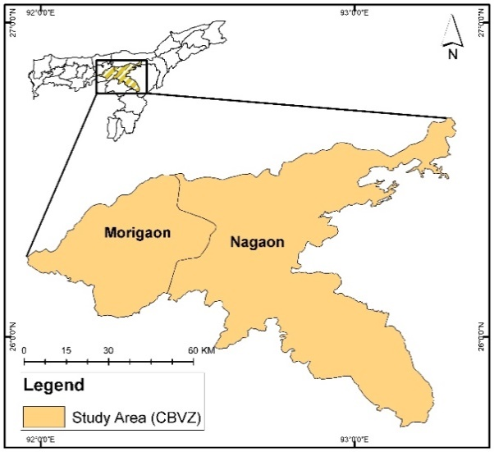
Fig. 1 Location of the study area

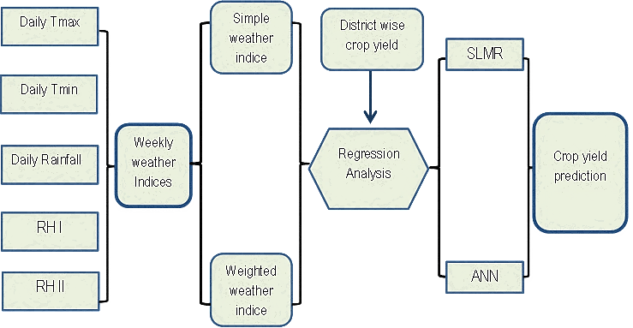
Fig 2: Steps involved in model development
a.

b.

Fig 3: Graphical representation of the top ten predictors utilized for model development using ANN during the F1 stage in Nagaon (a) and Morigaon (b)
a.

b.

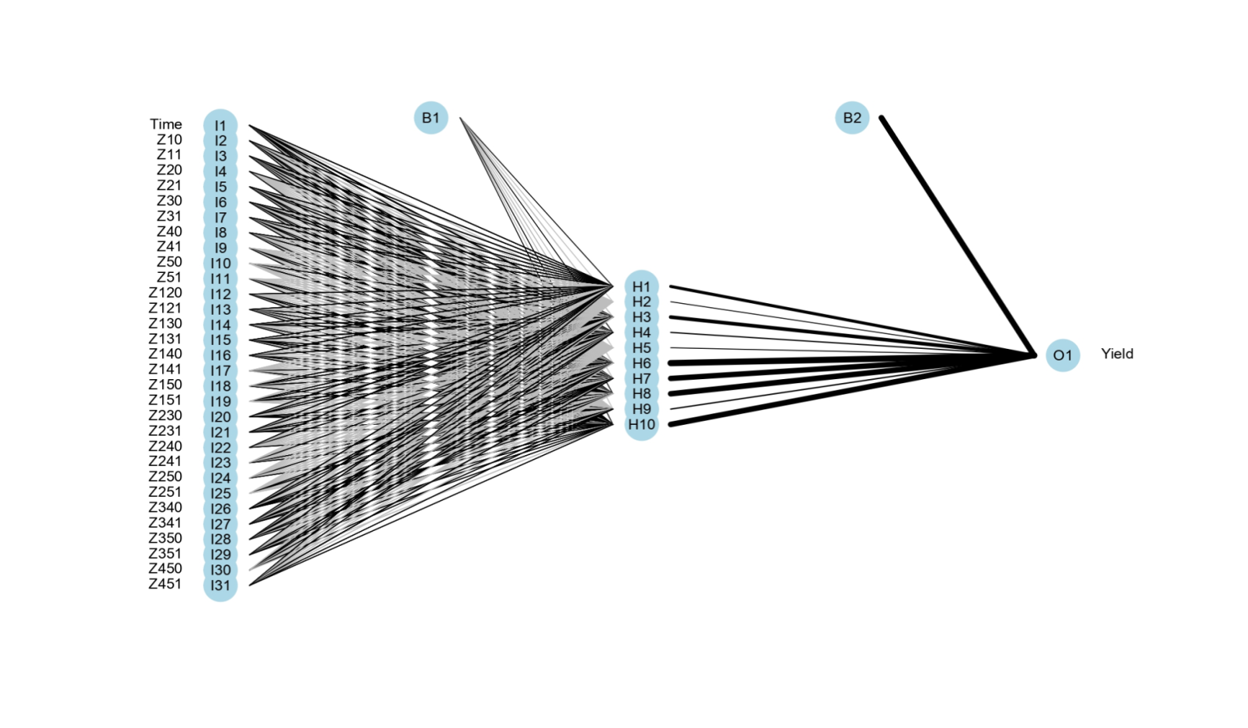
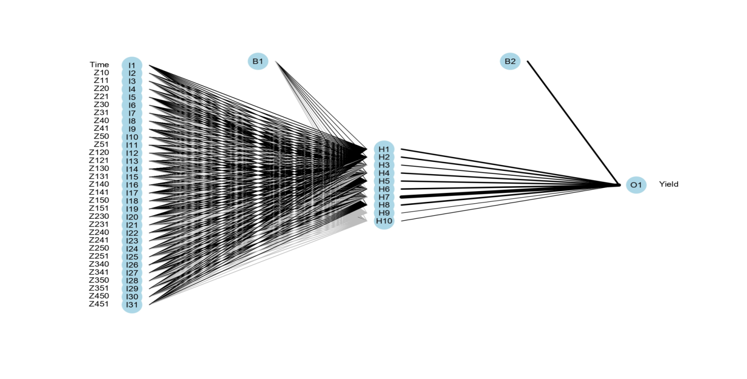
Fig 4: Graphical representation of the top ten predictors utilized for model development using ANN during the F2 stage in Nagaon (a) and Morigaon (b)
Nagaon F2: 10 hidden layers
Morigaon F2: 10 hidden layers

Table 1: Weather indices used in model using composite weather variables of 5 weather parameters
 | Simple weather indices |  |  |  |  | Weighted weather indices
 | Tmax | Tmin | RF | RH-I | RH-II | Tmax | Tmin | RF | RH-I | RH-II
Tmax | Z10 |  |  |  |  | Z11
Tmin | Z120 | Z20 |  |  |  | Z121 | Z21
RF | Z130 | Z230 | Z30 |  |  | Z131 | Z231 | Z31
RH-I | Z140 | Z240 | Z340 | Z40 |  | Z141 | Z241 | Z341 | Z41
RH-II | Z150 | Z250 | Z350 | Z450 | Z50 | Z151 | Z251 | Z351 | Z451 | Z51

Table 2: Comparison of yield forecast performance of the models between SMLR and ANN as indicated by R², RMSE and RMSE_{n} values during calibration during F1 and F2 forecast in Nagaon and Morigaon.
 | SMLR |  |  |  |  |  | ANN
F1 | Regression equation | R²_{cal} | RMSE_{cal} |  | RMSE_{n cal} |  | R²_{cal} | RMSE_{cal} |  | RMSE_{n cal}
Nagaon | Y=- 903.084+26.944*Time+0.267*Z151+0.095*Z231 | 0.75 | 179 |  | 11.8 |  | 0.90 | 100 |  | 5.53
Morigaon | Y= 6241.84+38.89*Time+207.66*Z11+31.90*Z41 | 0.81 | 253 |  | 10.9 |  | 0.56 | 234 |  | 14.4
F2
Nagaon | Y= -667.978+28.305*Time+6.786*Z51+0.085*Z131 | 0.78 |  | 160 |  | 9.5 | 0.92 |  | 108 |  | 6
Morigaon | Y= 5403.84+37.04*Time+325.29*Z11+571.26*Z21-8.81*Z121 | 0.87 |  | 101 |  | 6.9 | 0.98 |  | 61 |  | 3.76
Table 3: Model evaluation results based on Percentage Error (%)
 | ANN |  |  |  | SMLR
 | F1 |  | F2 |  | F1 |  | F2
 | 2020 | 2021 | 2020 | 2021 | 2020 | 2021 | 2020 | 2021
Morigaon | -10.4 | -7.3 | 1.9 | -1.9 | -4.78 | 12.19 | -15.26 | -13.34
Nagaon | 1.7 | 7.2 | -1.9 | 2.1 | 9.49 | 4.37 | 17.00 | 4.71

Table 4: Important weather indices impacting R&M yield as generated by SMLR and ANN
 | SMLR |  | ANN
 | F1 | F2 | F1 | F2
Nagaon | Time, Z151, Z231 | Time, Z51, Z131 | Z11,Z10,Time Z121, Z240 | Z11,Z121,Time Z140,Z451
Morigaon | Time, Z11, Z41 | Time, Z11,Z21, Z121 | Time,Z21,Z451, Z41, Z250 | Z11,Time,Z41 Z40,Z121

