Response of cumin (Cuminum cyminum L.) to different seed priming treatments on germination and seed quality parameters in laboratory condition under different temperature regimes
ABSTRACT

A laboratory experiment was conducted during Rabi 2023 to evaluate the Response of cumin (Cuminum cyminum L.) to different seed priming treatments on germination and seed quality parameters in laboratory condition under different temperature regimes. The study included three temperature conditions: T₁ (>30°C), T₂ (25 ± 1°C), and T₃ (<20°C), and six seed priming treatments: P₀ (Control), P₁ (Hydro priming), P₂ (PGPR 10 g/kg), P₃ (Trichoderma harzianum 4%), P₄ (Panchagavya 8%), and P₅ (Bijamrut 9%), all for 14 hours. Results showed that T₃ (<20°C) significantly improved seed germination (84.31%), seedling length (7.11 cm), fresh weight (152.95 mg), dry weight (11.96 mg), and vigour indices I and II (609.20 and 1021.39, respectively). Among the priming treatments, P₄ (panchagavya) recorded the highest germination (82.35%), seedling length (6.00 cm), and vigour indices (505.70 and 920.67), followed by P₃ (T. harzianum). The control treatment (P₀) consistently showed the lowest values across all parameters. The interaction effect between seed priming and temperature regimes was found to be non-significant, indicating their effects were independent. Overall, panchagavya proved to be the most effective seed priming treatment for improving cumin seed germination and seedling vigour, especially under cooler temperature conditions.

Keywords: Cumin, Seed priming, Panchagavya, Temperature regimes, Seedling vigour

INTRODUCTION

Cumin (Cuminum cyminum L.), commonly known as "jeera", is the second most widely used spice globally after black pepper (Hasan et al., 2016). It belongs to the Apiaceae family, known for aromatic plants with hollow stems and compound umbels, and ranks as the 16th largest flowering plant family (Heywood, 1993). Grown primarily as a rabi crop, cumin thrives in tropical and semi-tropical climates and exhibits good drought tolerance (Singh and Pandey, 2016).

A small, slender, annual herb, cumin reaches 20-30 cm in height, bearing grey-green glabrous stems, finely divided leaves, and white or pink flowers in umbels. The fruit splits into two oblong, ridged mericarps containing aromatic seeds. Native to Egypt and the Mediterranean, cumin requires a long, hot growing season and is best suited to sandy soils with good drainage. It is sensitive to rainfall during harvest, which can reduce seed quality due to fungal infection. One of the major challenges in cumin production is poor seed vigour, which increases the crop’s susceptibility to environmental stresses (Piri et al., 2019).

India is the largest producer, consumer and exporter of cumin, accounting for 70% of global production. Major growing states include Rajasthan, Gujarat and Haryana, with Rajasthan contributing about 52% (Mahajan et al., 2013). In 2022-23, India produced 6.27 lakh tonnes from 9.02 lakh ha, with Gujarat contributing 3.5 lakh tonnes from an equal area (Anonymous, 2023). Addressing challenges like variable weather conditions and price volatility through research on agronomic practices and climate adaptation remains crucial for sustaining productivity in cumin (Chaudhary et al., 2024).

Cumin economic importance lies in its essential oil content (2.3-4.8%), rich in cuminol, which imparts a distinctive aroma (Behera et al., 2004; Agrawal and Sharma, 1990). It is widely used in culinary applications and possesses medicinal properties, acting as a carminative and digestive aid (Lal et al., 2014). Its demand in domestic and export markets underlines its significance to the national economy.

Seed treatment, including priming and biological methods, plays a crucial role in improving germination, vigour and seedling establishment (Mandal and Basu, 1982; Afzal et al.,2020). Seed priming enhances germination speed, uniformity and tolerance to environmental stresses such as temperature and moisture extremes (Wan-li et al., 2004; Ashraf and Foolad, 2005; Farooq et al., 2006). These practices lead to better crop stands and higher yields, improving resilience and profitability in cumin cultivation.

Optimum germination and seedling emergence of cumin occur at 20-25°C, promoting maximum and rapid germination (Gohari and Saeidnia, 2011). Temperatures outside this range, especially in late winter or early spring, often lead to poor germination. Optimal temperatures not only enhance germination percentage but also accelerate the process (Oliveira et al., 2013). However, cumin cultivation faces challenges such as wilt, blight, pest attacks, and quality loss due to traditional harvesting and poor post-harvest practices (Trivedi et al., 2018). To improve productivity and seed quality, adoption of scientific cultivation and better post-harvest management is essential.

MATERIALS AND METHODS

An experiment was conducted during 2023 at the Seed Testing Laboratory, Department of Seed Science and Technology, College of Agriculture, Junagadh Agricultural University, Junagadh. Seeds of cumin variety GC-4 were obtained from the Agricultural Research Station, Junagadh Agricultural University, Halvad. A two-factor factorial experiment was conducted in the laboratory to evaluate the effects of temperature (T₁: >30°C, T₂: 25 ± 1°C, T₃: <20°C) and seed priming treatments (P₀: Control, P₁: Hydro priming (with water), P₂: Plant growth promoting rhizobacteria (10g/kg), P₃:T. harzianum (4%), P₄:Panchagavya (8%) and P₅: Bijamrut (9%). Seeds were soaked in respective concentration of each of the priming solutions for 14 hours, then dried back to their original moisture content. Observations were recorded on the following seedling parameters: germination percentage (%), root length (cm), shoot length (cm), seedling length (cm), seedling fresh weight (mg), seedling dry weight (mg), seedling vigour index I and seedling vigour index II. The data were analyzed using a Completely Randomized Design (Factorial) as described by Gomez and Gomez (1984).

RESULT AND DISCUSSION

Germination (%)

The final germination percentage, recorded on the 14th day, was significantly influenced by temperature regimes and seed priming treatments (Table 1 and Plate 1, 2 ). However, their interaction effect was non-significant. Among the temperature regimes, the highest germination (84.31%) was observed under T₃ (<20°C), followed by T₂ (25 ± 1°C) with 80.52%, while the lowest (75.39%) occurred under T₁ (>30°C). These results align with the findings of Khosh-Khui and Bonyanpour (2010), who reported 15-25°C as the optimal range for cumin germination.

Among the priming treatments, P₄ recorded the highest germination (82.35%), statistically at par with P₃ at 81.27%. The lowest (76.02%) was noted in the control (P₀). The improved performance with panchagavya is attributed to its rich composition of nutrients, natural growth promoters and beneficial microbes. These findings are supported by Trivedi et al. (2018), who reported 20°C as the optimal temperature for seed germination and storability of cumin under middle Gujarat conditions.
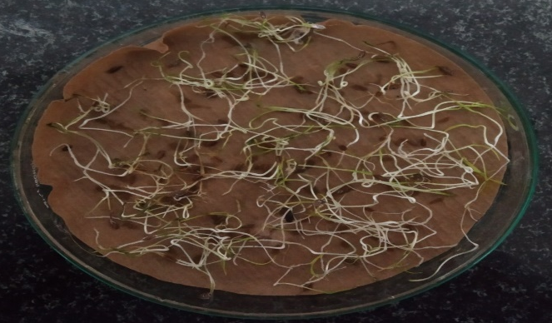 | 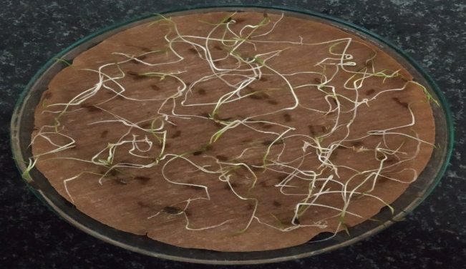
Plate 1 Effect of panchagavya and temperature (<20ºC) on germination | Plate 2 Effect of no priming treatment and temperature (>30ºC) on germination

Table 1: Effect of different temperature regimes and priming treatments on germination (%) and root length (cm)
Characters | Germination (%) |  |  |  | Root length (cm)
Factors | T₁ | T₂ | T₃ | Mean (P) | T₁ | T₂ | T₃ | Mean (P)
P₀ | 68.55 | 78.05 | 81.47 | 76.02 | 0.88 | 1.93 | 2.67 | 1.82
P₁ | 75.28 | 80.15 | 82.88 | 79.43 | 1.04 | 2.00 | 2.72 | 1.92
P₂ | 76.62 | 80.63 | 84.05 | 80.43 | 1.15 | 2.08 | 2.85 | 2.03
P₃ | 77.23 | 81.23 | 85.34 | 81.27 | 1.43 | 2.40 | 3.32 | 2.38
P₄ | 77.74 | 82.09 | 87.23 | 82.35 | 1.66 | 2.58 | 3.40 | 2.54
P₅ | 76.95 | 80.96 | 84.90 | 80.93 | 1.30 | 2.29 | 3.18 | 2.26
Mean (T) | 75.39 | 80.52 | 84.31 |  | 1.24 | 2.21 | 3.02
 | S.Em+ | CD at 5% | CV% |  | S.Em+ | CD at 5% | CV%
T | 0.44 | 1.25 | 2.69 |  | 0.02 | 0.05 | 4.04
P | 0.62 | 1.76 |  |  | 0.03 | 0.07
T x P | 1.08 | NS |  |  | 0.04 | NS

Root length (cm)

In comparison with temperature regimes, the maximum root length (3.02 cm) was recorded under T₃, followed by T₂ with 2.21 cm. The minimum root length (1.24 cm) occurred under T₁ (Table 1). These findings align with the results of Khosh-Khui and Bonyanpour (2010), Heidari and Sadeghi (2014), and Trivedi et al. (2018) in cumin, and Sharma et al. (2022) in wheat germination and early seedling growth, with germination percentages at 20 and 25°C.

Among priming treatments, P₄ resulted in the longest root length (2.54 cm), followed by P₃ at 2.38 cm. The shortest root length (1.82 cm) was recorded in the control (P₀). Panchagavya's efficacy in promoting root growth is due to its rich mix of nutrients, microbial population and plant growth regulators. Similar findings were reported in chickpea by Vaishnavi et al. (2021), where a panchagavya treatment at 3% for 12 hours recorded the highest results. In chili, Kumar et al. (2021) observed that seeds treated with Jeevamrutha at 9% performed better than other treatments. In pigeonpea, Reddy et al. (2021) found that treatment with panchagavya at 7% for 12 hours was the most promising, resulting in the maximum root length.

Shoot length (cm)

Under different temperature regimes, the maximum shoot length (4.17 cm) was observed under T₃, followed by T₂ at 2.45 cm, while the minimum (2.04 cm) was under T₁ (Table 2). These findings agree with earlier reports by Khosh-Khui and Bonyanpour (2010), Heidari and Sadeghi (2014), and Trivedi et al. (2018) in cumin and Sharma et al. (2022) in wheat all had demonstrated improved shoot length at temperatures of less than 20°C, further supporting the benefits of optimal temperature conditions for seedling growth across different crop species.

Across priming treatments, the maximum shoot length (3.32 cm) was recorded in P₄, followed by P₃ with 3.15 cm. The lowest shoot length (2.51 cm) was recorded in P₀. These results align with earlier reports across several crops as previously cited in root length.
Table 2: Effect of different temperature regimes and priming treatments on shoot length (cm) and seedling length (cm)
Characters | Shoot length (cm) |  |  |  | Seedling length (cm)
Factors | T₁ | T₂ | T₃ | Mean (P) | T₁ | T₂ | T₃ | Mean  (P)
P₀ | 1.70 | 2.11 | 3.72 | 2.51 | 2.58 | 4.05 | 6.29 | 4.31
P₁ | 1.82 | 2.24 | 3.89 | 2.65 | 2.99 | 4.31 | 6.48 | 4.59
P₂ | 1.95 | 2.34 | 4.03 | 2.77 | 3.15 | 4.46 | 6.72 | 4.78
P₃ | 2.28 | 2.67 | 4.51 | 3.15 | 3.83 | 5.27 | 7.86 | 5.65
P₄ | 2.44 | 2.87 | 4.66 | 3.32 | 4.10 | 5.74 | 8.16 | 6.00
P₅ | 2.07 | 2.47 | 4.23 | 2.92 | 3.42 | 4.73 | 7.16 | 5.11
Mean (T) | 2.04 | 2.45 | 4.17 |  | 3.35 | 4.76 | 7.11
 | S.Em+ | CD at 5% | CV% |  | S.Em+ | CD at 5% | CV%
T | 0.02 | 0.06 | 3.35 |  | 0.05 | 0.15 | 4.96
P | 0.03 | 0.08 |  |  | 0.07 | 0.21
T x P | 0.05 | NS |  |  | 0.13 | NS

Seedling length (cm)

Among the temperature regimes, the maximum seedling length (7.11 cm) was observed under T₃ followed by T₂ with a seedling length of 4.76 cm, while the minimum seedling length (3.35 cm) was recorded under T₁ (Table 2 and Plate 3,4). Our findings are in line with the findings of Khosh-Khui and Bonyanpour (2010) in cumin, Heidari and Sadeghi (2014) and Trivedi et al. (2018) in cumin and Sharma et al. (2022) in wheat all had demonstrated improved seedling length with cooler temperature.

Considering priming treatments, priming with panchagavya recorded the highest seedling length (6.00 cm) followed by the priming treatment of T. harzianum with a seedling length of 5.65 cm. In contrast, no priming recorded the lowest seedling length (4.31 cm). The better seedling length seen with panchagavya priming is due to its special ingredients, which provide essential nutrients, growth promoting substances and helpful microorganisms that improve seedling health and growth. These findings are in consistent with the results of Kumaravelu and Kadamban (2009) in greengram pre-soaking seeds in 4 per cent panchagavya significantly stimulated germination.; Vaishnavi et al. (2021) in chickpea panchagavya (3%) treatment for 12 hours recorded high; Kumar et al. (2021) in chili; Kumari et al. (2021) in ridge gourd panchagavya at 3% showed the highest seedling length.
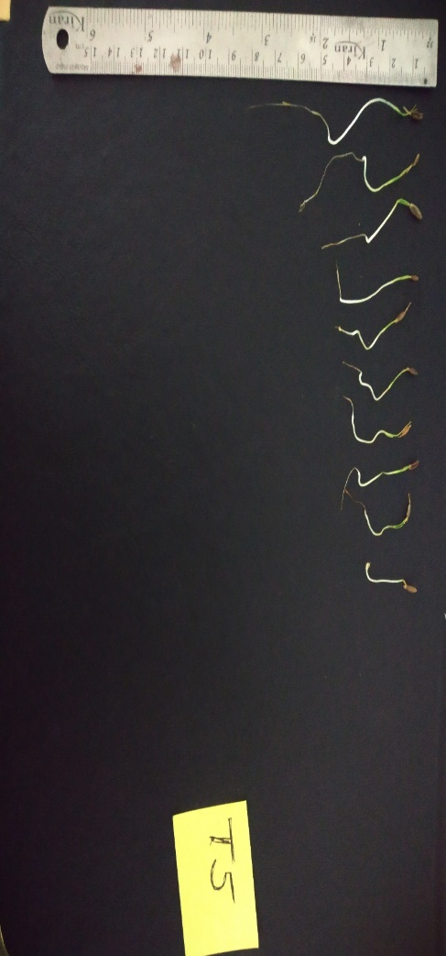 | 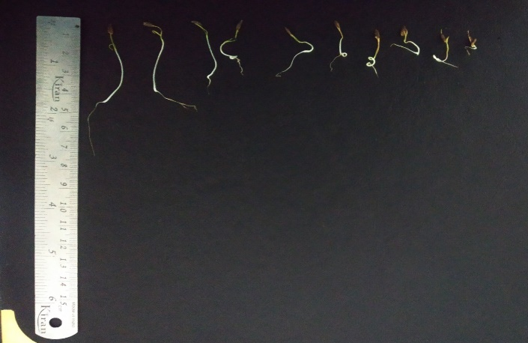
Plate 3 Effect of panchagavya and temperature (<20ºC) on seedling length (cm) | Plate 4 Effect of no priming treatment and temperature (>30ºC) on seedling length (cm)
Seedling fresh weight (mg)

Under different temperature regimes, the maximum seedling fresh weight (152.95 mg) was observed under T₃ followed by T₂ with a seedling fresh weight of 120.33 mg, while the minimum seedling fresh weight (67.79 mg) was recorded under T₁ (Table 3).These results are in align with the findings of Khosh-Khui and Bonyanpour (2010), Heidari and Sadeghi (2014) and Trivedi et al. (2018) in cumin, and with Sharma et al. (2022) in wheat all studies demonstrated improved seedling fresh weight with cooler temperature, providing further support for the benefits of cool temperature across different crop species.

Among the priming treatments, priming with panchagavya recorded the highest seedling fresh weight (127.08 mg) followed by the priming treatment of T. harzianum with a seedling fresh weight of 121.83 mg. In contrast, no priming recorded the lowest seedling fresh weight (95.91 mg). Similar results were reported earlier by Kumaravelu and Kadamban (2009) in greengram; Vaishnavi et al. (2021) in chickpea, where a panchagavya 3% treatment for 12 hours recorded high heighest seedling fresh weight; Kumar et al. (2021) in chili; and Reddy et al. (2021) in pigeonpea.

Table 3: Effect of different temperature regimes and priming treatments on seedling fresh weight (mg) and seedling dry weight (mg)
Characters | Seedling fresh weight (mg) |  |  |  | Seedling dry weight (mg)
Factors | T₁ | T₂ | T₃ | Mean (P) | T₁ | T₂ | T₃ | Mean  (P)
P₀ | 47.72 | 101.09 | 138.92 | 95.91 | 6.86 | 9.61 | 11.37 | 9.28
P₁ | 55.80 | 113.73 | 145.71 | 105.08 | 7.59 | 9.80 | 11.62 | 9.67
P₂ | 64.79 | 121.01 | 149.43 | 111.75 | 7.97 | 9.89 | 11.71 | 9.86
P₃ | 77.53 | 127.63 | 160.33 | 121.83 | 8.94 | 10.59 | 12.41 | 10.64
P₄ | 84.07 | 133.45 | 163.72 | 127.08 | 9.36 | 10.83 | 12.71 | 10.97
P₅ | 76.82 | 125.06 | 159.61 | 120.50 | 8.58 | 10.23 | 11.97 | 10.26
Mean (T) | 67.79 | 120.33 | 152.95 |  | 8.22 | 10.16 | 11.96
 | S.Em+ | CD at 5% | CV% |  | S.Em+ | CD at 5% | CV%
T | 1.14 | 3.23 | 4.90 |  | 0.08 | 0.23 | 4.00
P | 1.61 | 4.56 |  |  | 0.12 | 0.33
T x P | 2.79 | NS |  |  | 0.20 | NS

Seedling dry weight (mg)

Across the temperature regimes, the maximum seedling dry weight (11.96 mg) was observed under T₃ followed by T₂ with a seedling dry weight of 10.16 mg, while the minimum seedling dry weight (8.22 mg) was recorded under T₁ (Table 3). Similar findings were previously reported by Khosh-Khui and Bonyanpour (2010), Heidari and Sadeghi (2014), and Trivedi et al. (2018) in cumin all had demonstrated improved seedling dry weight with less than 20°C.

In comparison with priming treatments, priming with panchagavya (P₄) recorded the highest seedling dry weight (10.97 mg) followed by the priming treatment of T. harzianum (P₃) with a seedling dry weight of 10.64 mg. In contrast, no priming (P₀) recorded the lowest seedling dry weight (9.28 mg). Comparable findings were also documented by Kumaravelu and Kadamban (2009) in greengram; Vaishnavi et al. (2021) in chickpea; Kumar et al. (2021) in chili; Kumari et al. (2021) in ridge gourd; and Reddy et al. (2021) in pigeonpea.

Seedling vigour index I

The temperature regimes, the maximum seedling vigour index I (609.20) was observed under T₃ followed by T₂ with a seedling vigour index I of 389.66, while the minimum seedling vigour index I (257.85) was recorded under T₁ (Table 4). These results align with the findings of is optimal for the germination and seedling vigour of cumin reported by Trivedi et al. (2018) in cumin.

Under different priming treatment, priming with panchagavya recorded the highest seedling vigour index I (505.70) followed by the priming treatment of T. harzianum with a seedling vigour index I of 472.28. In contrast, no priming (P₀) recorded the lowest seedling vigour index I (343.90). A 4% panchagavya treatment resulted in the highest seedling vigour index I, as reported by Kumaravelu and Kadamban (2009) in greengram. Similar results were observed by Kumari et al. (2021) in ridge gourd and Reddy et al. (2021) in pigeonpea.

Table 4: Effect of different temperature regimes and priming treatments on seedling vigour index Ӏ and seedling vigour index ӀI
Characters | Seedling vigour index Ӏ |  |  |  | Seedling vigour index ӀI
Factors | T₁ | T₂ | T₃ | Mean (P) | T₁ | T₂ | T₃ | Mean  (P)
P₀ | 180.61 | 322.80 | 528.29 | 343.90 | 472.40 | 763.38 | 943.85 | 726.54
P₁ | 224.38 | 345.74 | 550.76 | 373.63 | 577.59 | 795.52 | 976.11 | 783.08
P₂ | 241.51 | 364.10 | 575.98 | 393.86 | 619.25 | 806.85 | 995.89 | 807.33
P₃ | 305.16 | 437.16 | 674.51 | 472.28 | 702.09 | 869.84 | 1068.42 | 880.11
P₄ | 328.37 | 478.24 | 710.48 | 505.70 | 744.61 | 899.69 | 1117.69 | 920.67
P₅ | 267.05 | 389.93 | 615.20 | 424.06 | 671.11 | 837.29 | 1026.36 | 844.92
Mean (T) | 257.85 | 389.66 | 609.20 |  | 631.17 | 828.76 | 1021.39
 | S.Em+ | CD at 5% | CV% |  | S.Em+ | CD at 5% | CV%
T | 3.88 | 11.01 | 4.54 |  | 8.69 | 24.65 | 5.15
P | 5.49 | 15.57 |  |  | 12.30 | 34.86
T x P | 9.51 | NS |  |  | 21.30 | NS

Seedling vigour index II

Considering temperature regimes, the maximum seedling vigour index II (1021.39) was observed under T₃ followed by T₂ with a seedling vigour index II of 828.76, while the minimum seedling vigour index II (631.17) was recorded under T₁ (Table 4). These findings are consistent with those of Trivedi et al. (2018), who reported the highest seedling vigour index II in cumin at 20 °C.
Among the priming treatments, priming with panchagavya recorded the highest seedling vigour index II (920.67) followed by the priming treatment of T. harzianum, with a seedling vigour index II of 880.11. In contrast, no priming (P₀) recorded the lowest seedling vigour index II (726.54). Similar effects of panchagvaya on seedling vigour have been demonstrated by Kumaravelu and Kadamban (2009) in greengram, Vaishnavi et al. (2021) in chickpea, Kumar et al. (2021) in chili, Kumari et al. (2021) in ridge gourd, and Reddy et al. (2021) in pigeonpea, providing further support for the benefits of panchagvaya across different crop species.

CONCLUSIONS

The study revealed the pivotal role of seed priming treatments and temperature regimes in enhancing the germination and seedling vigour of cumin. Among the treatments, panchagavya (8%, 14 hrs.) priming consistently outperformed others, significantly improving germination percentage, root and shoot lengths, seedling fresh and dry weights, and vigour indices. This treatment demonstrated its potential to strengthen the physiological quality of seeds and their ability to perform better under stress conditions. Furthermore, temperature regimes had a notable influence, with the best performance observed under cooler conditions (<20°C). This emphasizes the critical role of temperature in determining seedling vigour and the interaction between environmental factors and pre-sowing treatments. The study establishes that adopting effective seed priming techniques, especially with panchagavya, can provide a robust start to cumin cultivation, ensuring better establishment even under suboptimal temperature conditions.

ACKNOWLEDGEMENT
The authors express their sincere gratitude to Hon’ble Major Guide, Dr. J. B. Patel, Professor and Head, Department of Seed Science and Technology, College of Agriculture, Junagadh Agricultural University, Junagadh, for his valuable and inspiring guidance. We are also thankful to all the laboratory staff of the Department of Seed Science and Technology, College of Agriculture, JAU, Junagadh, for their support in conducting the experiment.
Conflict of Interest. None.

Disclaimer (Artificial intelligence)
Option 1:
Author(s) hereby declare that NO generative AI technologies such as Large Language Models (ChatGPT, COPILOT, etc.) and text-to-image generators have been used during the writing or editing of this manuscript.
Option 2:
Author(s) hereby declare that generative AI technologies such as Large Language Models, etc. have been used during the writing or editing of manuscripts. This explanation will include the name, version, model, and source of the generative AI technology and as well as all input prompts provided to the generative AI technology
Details of the AI usage are given below:
1.
2.
3.

REFERENCES

Afzal I, Javed T, Amirkhani M and Taylor A G. Modern seed technology: Seed coating delivery systems for enhancing seed and crop performance. Agriculture. 2020; 10(11): 526.
Agrawal S and Sharma R K. Variability in quality aspects of seed spices and future strategy. Indian Cocoa, Arecanut and Spices Journal.1990; 13(4): 127-129.
Anonymous. https://www.indianspices.com/sites/default/files/ Major spice state wise area production 2022-23.pdf Accessed on 6-12-2024.
Ashraf M and Foolad M R. Pre‐sowing seed treatment: A shotgun approach to improve germination, plant growth, and crop yield under saline and non‐saline conditions. Advances in Agronomy. 2005; 88: 223-271.
Behera S, Nagarajan S and Rao L J M. Microwave heating and conventional roasting of cumin seeds (Cuminum cyminum L.) and effect on chemical composition of volatiles. Food Chemistry. 2004; 87(1): 25-29.
Chaudhary S, Sharma, M, Pawariya V and Prakash O. Price volatility of futures and spot market of agricultural commodities: An evidence from Rajasthan. Agricultural Mechanization in Asia. 2024; 55(6):18149. https://www.researchgate.net/publication/38492021
Farooq M, Barsa S and Wahid A. Priming of field sown rice seed enhances germination, seedling establishment, allometry and yield. Plant Growth Regulation. 2006; 49(2): 285-294.
Gomez K A, and Gomez A A. Statistical Procedures for Agricultural Research, 2nd Edition. John Wiley and Sons, New York. 1984; 680 P.
Hansaliya D P, Parmar L D, Viradiya Y A, Prajapati K N and Gamit T D. Effect of seed priming treatment on cumin [Cuminum cyminum (L.)] yield and component characters. The Pharma Innovation Journal. 2022; 11(1):120-123.
Hasan A M, Sakure A A, Fougat R S and Kumar S. Estimation of nuclear DNA content of cumin. Interernational Journal of Seed Spices. 2016; 6(1): 96-99.
Heidari M and Sadeghi H. Germination and emergence of primed cumin (Cuminum cyminum L.) seeds with GA₃ under different temperature regimes. International Journal of Biosciences. 2014; 5(9): 266-72.
Heywood, V. H. (1993). Flowering Plants of the World, 2nd Eddition Oxford University, Peris, Oxford. 336 pp.
Khosh-Khui, M. and Bonyanpour, A. R. Effects of some variables on seed germination and seedling growth of cumin (Cuminum cyminum L.). International Journal of Agricultural Research. 2010; 5(6): 365-369.
Kumar A, Chaurasia A K and Marmat Sandip M. Effect of organic and inorganic seed priming on seed quality parameter in chilli (Capsicum annum L.) seeds. Biological Forum An International Journal. 2021; 13(3): 200-205.
Kumaravelu G and Kadamban D. Panchagavya and its effect on the growth of the greengram cultivar K-851. International Journal of Plant Sciences. 2009; 4(2): 409-414.
Kumari A, Chaurasia A K, Shukla P K, Patil P D and Dubey S. Impact of seed invigouration with panchagavya and bijamrut on seed quality parameters in ridge gourd (Luffa acutangula L.) under salinity conditions. The Pharma Innovation Journal. 2021; 10(9): 1823-1826.
Lal G, Saran P L, Devi G, Bijarniya D and Raj R. Production technology of cumin (Cuminum cyminum L.). In: Advances in Vegetables Agronomy, IARI, New Delhi. 2014; pp. 223-231.
Mahajan S S, Henry A and Bhatt R K. Effect of pre-sowing seed treatments on seedling emergence, seed yield and yield attributes of cumin (Cuminum cyminum L.). International Journal of Seed Spices. 2013; 3(1): 36-40.
Mandal A K and Basu R N. Alleviation of salt stress during germination and early seedling growth of wheat by hydration-dehydration pre-treatment. Indian Agriculturist. 1982; 26:121-128.
Piri R, Moradi A, Balouchi H, Salehi A. Improvement of cumin (Cuminum cyminum) seed performance under drought stress by seed coating and biopriming. Scientia Horticulturae. 2019; 257:08667.
Reddy A D, Chaurasia A K, Shukla P K and Singh R P. Effect of organic and botanicals priming on seed quality parameter of pigeonpea [Cajanus cajan (L.) Millspaugh]. Journal of Experimental Agriculture International. 2021; 43(7):1-5.
Sharma S, Singh V, Tanwar H, Mor V S, Kumar M, Punia R C, Dalal M S, Khan M, Sangwan S, Bhuker A, Dagar C S, Yashveer S and Singh J. Impact of high temperature on germination, seedling growth and enzymatic activity of wheat. Agriculture. 2022; 12(9): 1500.
Singh R and Pandey V. Drought tolerance mechanisms in Cuminum cyminum L. Journal of Applied Research on Medicinal and Aromatic Plants. 2016; 3(3):123-129.
Trivedi V, Kalyanrao N S, Sasidharan N and Patel D A. Influence on seed quality parameters under different temperature and artificial ageing treatment in cumin (Cuminum cyminum). Indian Journal of Agricultural Sciences. 2018; 88(1):121-124.
Vaishnavi D, Chaurasia A K, Kerketta A, Jyothi M. and Navya V. Effects of panchagavya, bijamrut, botanical seed treatment on seed quality parameters in chickpea (Cicer arietinum L.). Asian Journal of Microbiology, Biotechnology and Environmental Sciences. 2021; 23(4): 573-577.
Wan-li Z, Le-ihong L, Yuan-gang Z. and Perez, S. Effect of priming on the germination of Peltophorum dubium seeds under water stress. Journal of Forestry Research. 2004; 15(4): 287-290.

